Voluntary National Review 2021 Norway

Report on the Implementation of the 2030 Agenda for Sustainable Development

Opening statement by the Prime Minister
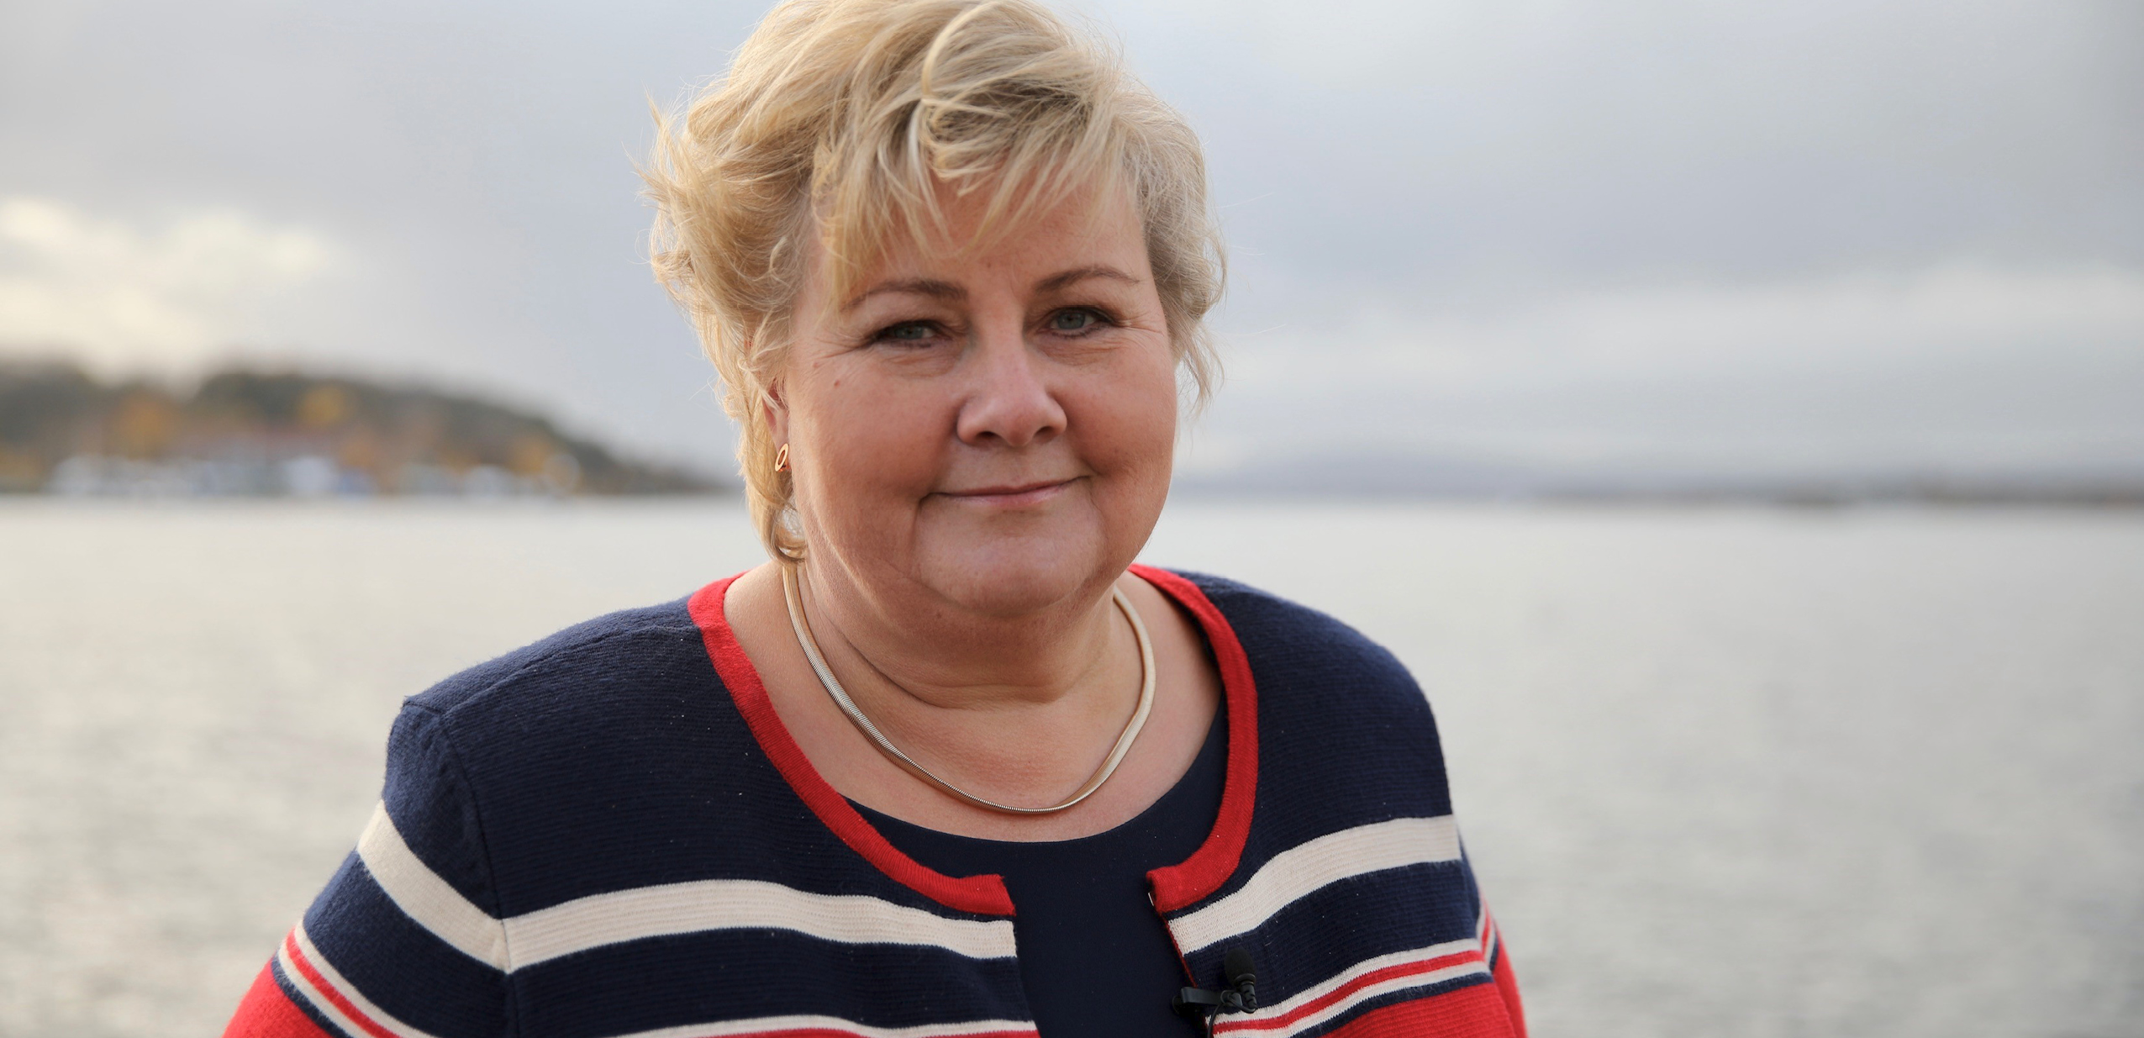
Photo: Eirin Larsen/Office of the Prime Minister
The COVID-19 pandemic has posed new challenges to our efforts to reach the ­Sustainable Development Goals. Progress on some goals has slowed and there have been setbacks on others. This presents us with a choice: we can choose to sit back, or we can view the challenges as a call to action. The enormous effort needed to bring life back to normal also provides an opportunity to build back better.
Norway’s second Voluntary National Review will serve as a roadmap. We identify our positive results and point out where we have not yet succeeded. Our ambition is to learn from the past and plan for the future.
Norway ranks high on the SDG Index. But we, too, have challenges to resolve. Although we have free, high-quality state schools, too many students are dropping out. And while women in Norway have the same legal rights as men, obstacles such as gender-based violence and labour market disparities are preventing us from achieving full gender equality. There is inequality between different groups in society. Mental health is an area of concern. Greenhouse gas emissions are decreasing, but due to unsustainable consumption patterns there is too much waste and emissions remain too high. There is much work that remains to be done.
The 2030 Agenda has become more integrated in Norwegian policy planning since 2016. Nonetheless, the Office of the Auditor General has pointed out that the follow­-up of the Sustainable Development Goals has not been coordinated effectively enough and that Norway needs a more comprehensive plan for ­implementation. The Government will present a White Paper and an Action Plan on this in 2021. These will set out national targets and indicators, identify challenges and provide a common platform for further action. We hope the plan will pave the way to a more integrated approach, greater coherence and more rapid progress.
I am very pleased to see the clear increase in knowledge, involvement and activities to achieve the 2030 Agenda throughout the Norwegian society. Today, 69 per cent of the Norwegian population is familiar with the 2030 Agenda. Eight out of ten consumers want to contribute to sustainable development through the choices they make. 73 per cent of Norway’s largest companies now give priority to the Sustainable Development Goals in their business strategies, which is three times higher than in 2017. Children have become actively involved. This gives me hope for the future and the important tasks ahead.
I hope that you will find our review useful reading. I would like to thank all the participants for their valuable contributions, views and recommendations during this process. Your efforts make it possible for us to continue to work towards a society that leaves no one behind.
Erna Solberg
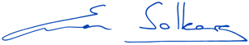
Prime Minister of Norway

Highlights of the report
Photo: Ørjan Aslaksen/Scream Media for Norad
Review process
Norway’s second Voluntary National Review (VNR) includes contributions from various government entities and civil society. The review builds on relevant findings from statistics, reports, evaluations and research. The review includes a progress report on the 17 Sustainable Development Goals (SDGs), made up of two independent assessments. The first assessment was conducted by line ministries and the second by civil society. The VNR also includes an assessment of the progress on the SDGs in regions and municipalities. The governments of Denmark and Indonesia have supported Norway in the preparatory stage of the VNR by discussing the process and reviewing the draft report.
Policy and enabling environment
Sustainable development is an integral part of Norwegian polices. The government reports on the progress of the SDGs to Parliament. This ensures that progress is reported annually through a well-established political mechanism.
In January 2020, Prime Minister Erna Solberg’s Government appointed the Ministry of Local Government and Modernisation as a coordinating body for national implementation of the SDGs. This has led to increased cross-sectoral cooperation and a holistic approach to sustainable development. The Government will submit Norway’s first national Action Plan for the implementation of the Sustainable development goals (SDGs) to Parliament in 2021. The Ministry of Foreign Affairs coordinates Norway’s global efforts on SDG implementation.
To improve the monitoring of progress on the 17 SDGs, Statistics Norway is coordinating the effort to develop a comprehensive set of indicators, adopted to national, regional and local needs.
Leaving no one behind
The Norwegian welfare society is key to ensure that no one is left behind, by securing opportunities for income and providing education and health services for everyone. The welfare society depend upon a strong national economy and well-functioning distribution mechanisms. To continuously improve the Norwegian welfare state is crucial for achieving the SDGs at the national level. A strong focus on equality and non-discrimination is key to ensure that no one is left behind. Norway is prioritising non-discrimination online and is at the forefront of developing legislation to ensure that websites, mobile applications and self-service terminals are accessible for everyone.
Human rights and gender equality are an integral part of Norwegian foreign and development policy. Norway seeks to increase awareness about discriminatory practices and reduce inequalities and promote inclusion on a global scale. Norway provides financial and political support to a vibrant and pluralistic civil society, which contributes significantly to the objective of leaving no one behind.
Progress on SDGs
According to the SDG Index, Norway’s performance on SDG 1 (no poverty), 3 (good health and well-being), 5 (gender equality), 7 (affordable and clean energy), 10 (reduced inequalities) and 17 (partnerships for the goals) is strong. Norway is currently ranked number 6 on the SDG Index. The key challenges for achieving the SDGs in Norway are related to unsustainable consumption patterns, greenhouse gas emissions and the state of biodiversity. Gender-based violence and labour market disparities remain and show that persisting or rising inequalities between groups of society must be addressed.
SDGs in Norwegian municipalities and regions
Achieving the 2030 Agenda depends strongly on the efforts and progress made at the local and regional level. SDGs concern all aspects of the local government sector’s work and contribution through regular service delivery, welfare production, local planning and development work is substantial. Implementation has gained momentum in municipalities and regional authorities. Most have started, some have advanced quite far. Political commitment is vital for the direction and speed. Networking, knowledge sharing and collaboration across levels of government foster success. Multi-level governance optimises the outcome.
Means of implementation
Norway values a multi-stakeholder approach to sustainable development. The Norwegian model of tripartite cooperation has long traditions in Norwegian working life and has paved the way for major reforms of the country’s welfare system. There are also long-standing traditions of involving civil society organisations in decision-making processes.
Norway supports global collective efforts to achieve the SDGs and remains a strong supporter, both financially and politically, of the United Nation (UN)’s work to promote sustainable development. Norway is committed to spending approximately 1 per cent of gross national income (GNI) on development assistance.

Introduction
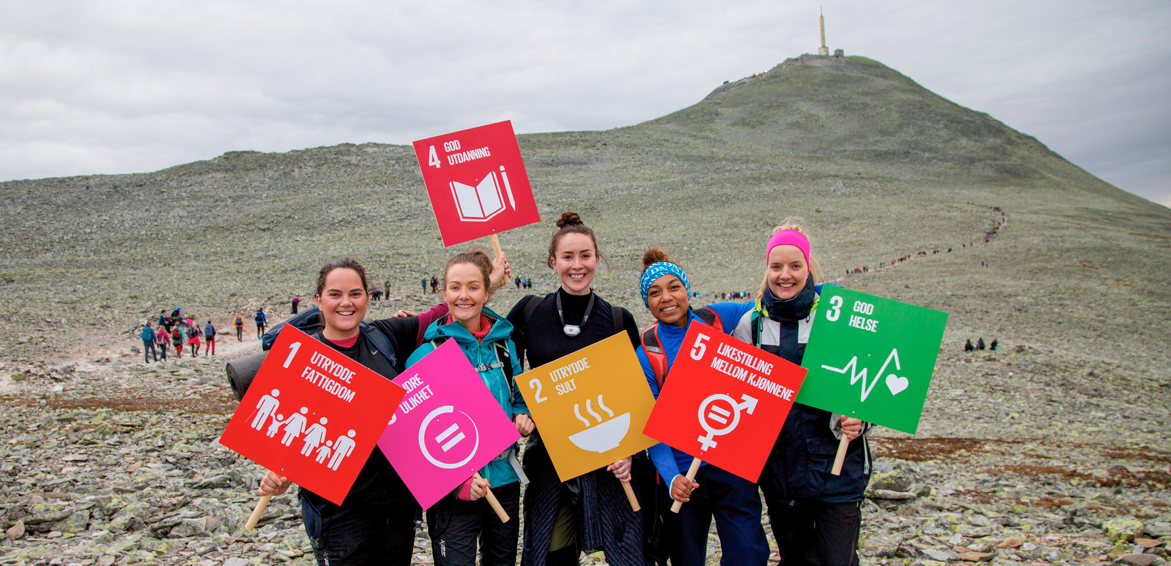
Photo: Norad
In 2016 Norway presented its first VNR to the UN. In the report, Norway elaborated on its commitment to the 2030 Agenda and the SDGs. The report identified several challenges to implementation of the 2030 Agenda at the national level, across the social, economic and environmental dimensions of sustainable development.
In this second VNR, we provide an overview of Norway’s progress towards the SDGs since 2016. For the first time we have included two comprehensive assessments of all the 17 SDGs, one conducted by the Government and another by civil society. The assessments identify achievements and challenges affecting implementation. The review follows the UN voluntary common reporting guidelines for VNRs.
Including relevant stakeholders has been a priority throughout the VNR-process. Civil society, the industrial sector and businesses and the school and academic sectors, have made valuable contributions to this report. In addition, the governments of Denmark and Indonesia have reviewed the draft report.
This report highlights some key changes to national follow-up and implementation over the past year. The Government has reported on its progress for the SDGs to Parliament since 2016, in annual budget proposals and reports. However, in 2020 the Government took several steps to ensure a more holistic approach to sustainable development. As a result of this process, Norway will have its first National Action Plan for implementation of the SDGs in 2021.
This report pays special attention to the SDGs in Norwegian municipalities and regions. Local and regional authorities provide a broad range of services and are responsible for community development through strategic processes. They play a key role in achieving the SDGs. In addition, the UN has emphasised localising the 2030 Agenda, in order to ensure that no one is left behind. This review presents an overview of key findings from the Voluntary Subnational Review (VSR), which has been conducted by the Norwegian Association of Local and Regional Authorities (KS) this year.
The Norwegian welfare society, which provides universal social benefits and has a strong focus on cooperation between employers, unions and government as well as civic inclusion, is key to achieving the SDGs at the national level. However, challenges remain, many of which are exacerbated by the ongoing COVID-19 pandemic.

Methodology and process for preparation of this review
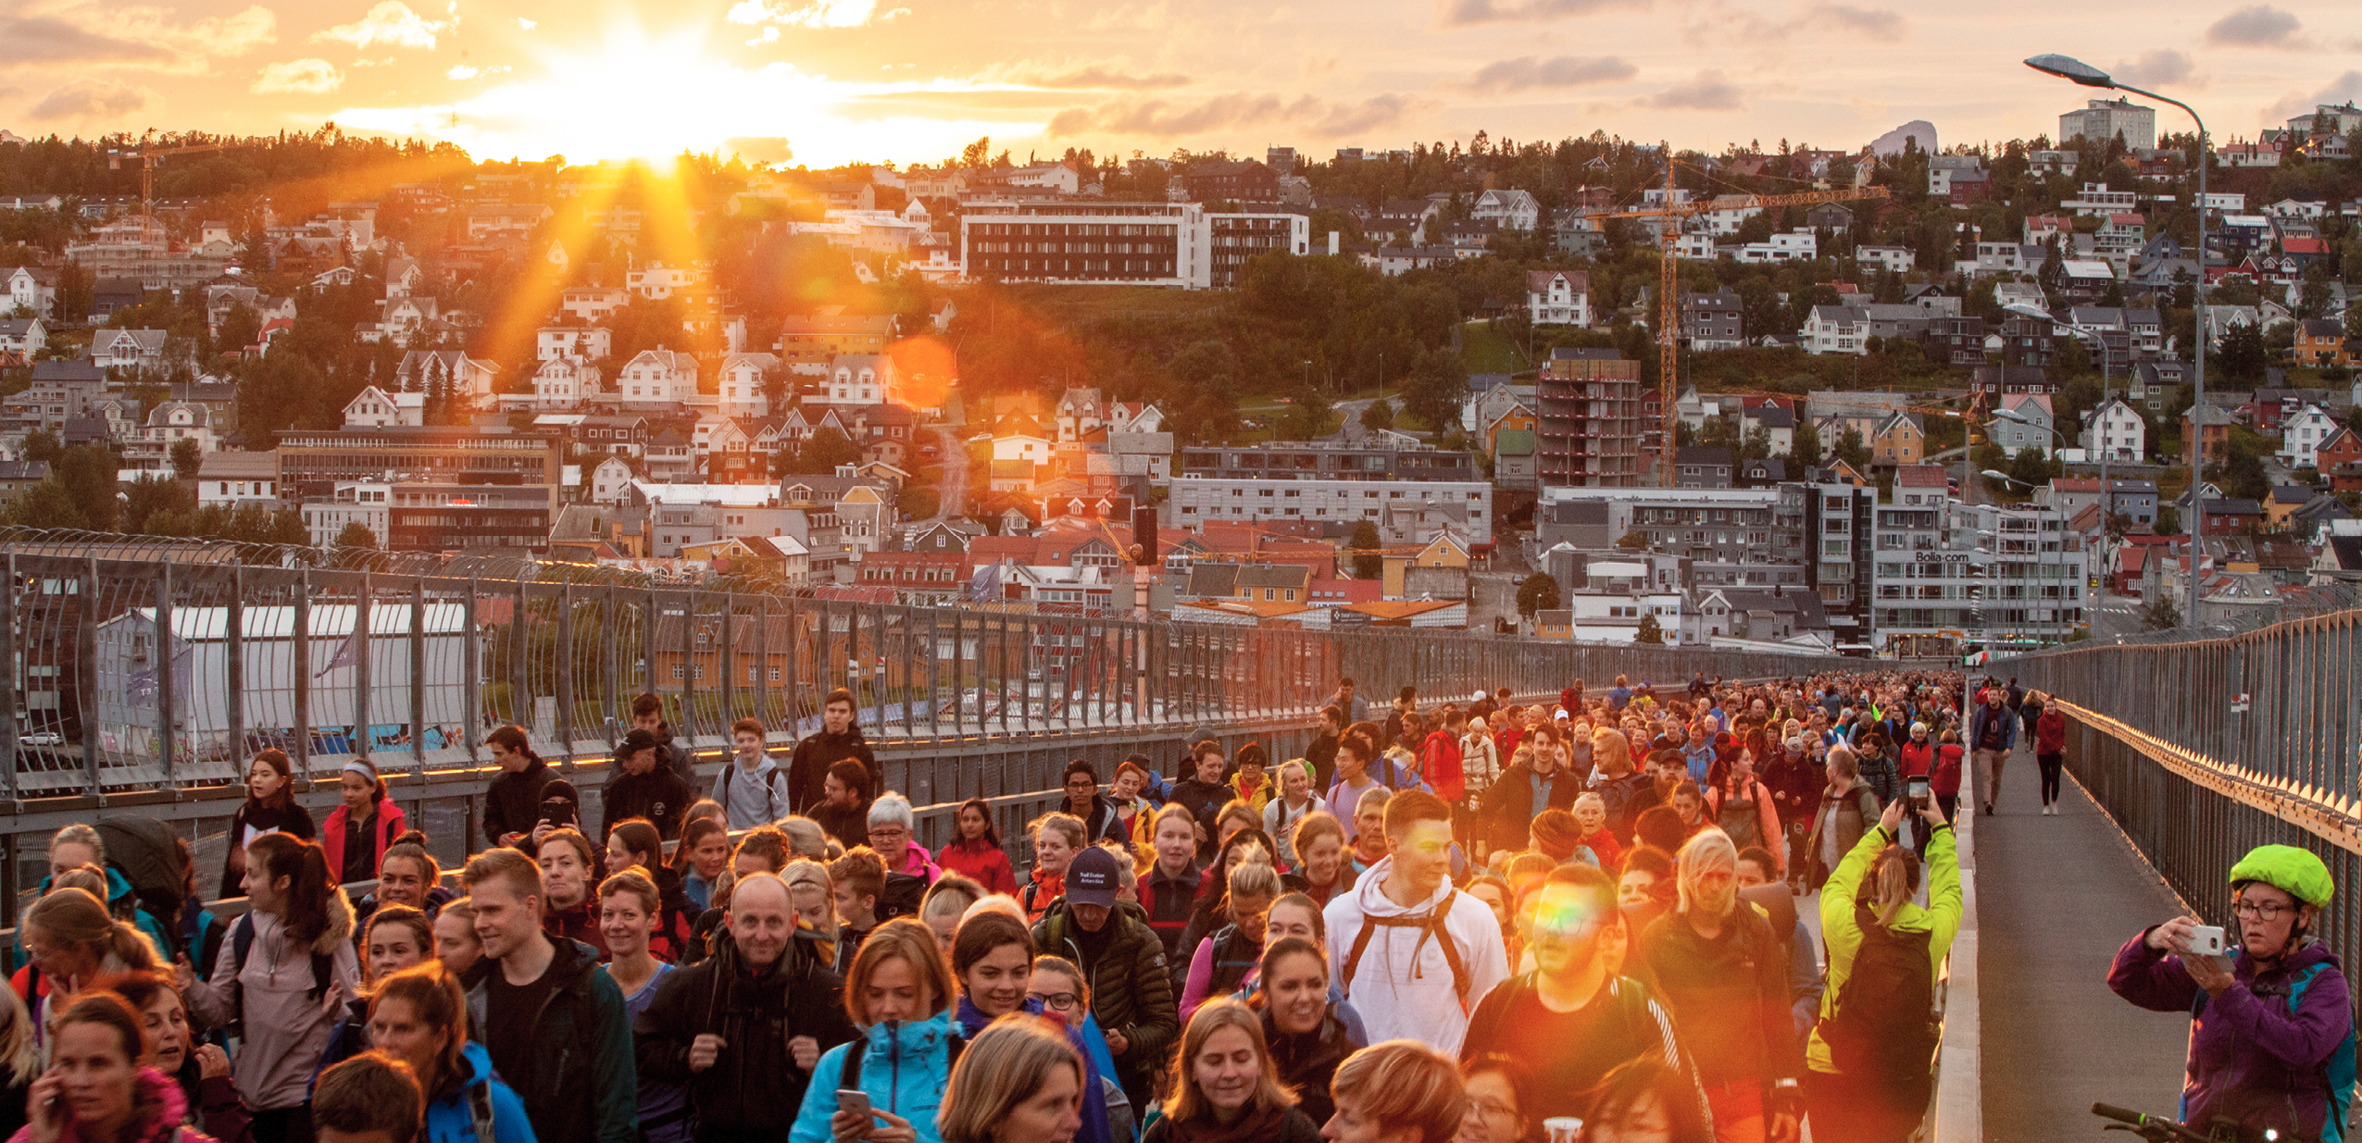
Photo: David González/Scream Media for Norad

Key changes/lessons learned
- The Ministry of Foreign Affairs was the coordinating body of Norway’s first VNR from 2016. For Norway’s second VNR, the Ministry of Local Government and Modernisation has been the coordinating body. This change affirms that national ownership and implementation lie at the heart of the 2030 Agenda.
- A whole-of-government approach to this VNR-process ensured that all line ministries made a greater contribution to this review than Norway’s first VNR.
- One of the challenges in performing Norway’s first VNR, was the lack of stakeholder involvement. For this VNR, stakeholders have written several chapters or sub-chapters, providing new perspectives and relevant examples. Norwegian civil society has performed an assessment of the progress on all the SDGs.
- Implementation of the SDGs in a regional and local context is a key component of this review. This is achieved through close cooperation with the Norwegian Association of Local and Regional Authorities.
- In a country-level peer dialogue, the governments of Denmark and Indonesia commented on the draft version of the VNR and provided valuable recommendations for its finalisation.

Preparation of the VNR
The Ministry of Local Government and Modernisation, in collaboration with the Ministry of Foreign Affairs, has been responsible for the preparation and coordination of this second VNR of Norway.
The State Secretaries’ committee for the sustainable development goals was established in April 2020. The committee is responsible for making strategic decisions in the area of sustainable development. In February 2021, a working group led by the Ministry of Local Government and Modernisation was established, with overall responsibility for the review and facilitating the writing process. The Office of the Prime Minister, all ministries and a number of government agencies have contributed to the review. The report follows the UN voluntary common reporting guidelines for VNRs and is inspired by the Finnish VNR from 2020.
Norway submitted its first VNR in 2016. Similar to the 2016-review, this report is based on existing data and recently published studies and reports. In the preparation for this review, we took a closer look at five challenges in achieving the SDGs in Norway, as identified in our 2016-review. The challenges were: 1) the lack of comprehensive data, 2) more involvement from stakeholders and civil society, 3) Norway’s advancement towards the goals, 4) more in-depth knowledge about work on the SDGs locally, and 5) the lack of peer reviews.
Access to high-quality data is essential for advancing the work on the SDGs. We have therefore included a report on the global indicators in the annex of this review. The statistical overview is created by Statistics Norway in collaboration with several government agencies.
To better incorporate the views and recommendations from stakeholders and civil society in this second review, the working group established contact with three key stakeholders and gave them responsibility for coordinating with other stakeholders. The Norwegian Forum for Development and Environment (ForUM) was responsible for coordinating feedback on Norway’s progress on all 17 SDGs from their network of 50 organisations working on development, environment, peace and human rights, as well as other civil society organisations working on issues related to one or several of the SDGs. The insight is presented in Chapter 6.2. UN Global Compact Norway was responsible for coordinating feedback from the industrial sector and businesses. SDG Norway contributed views and recommendations from the school- and academic sectors. The working group held extensive discussions with ForUM, UN Global Compact Norway and SDG Norway throughout this process in order to channel their knowledge into the report. The stakeholders also provided valuable input for the draft of this review.
Relevant information about Norway’s performance on the SDGs on a national level will be found in the draft of the Government White Paper on the sustainable development goals, which will be published by the end of summer. As the White paper and the VNR-report were both coordinated by the same ministry, information sharing and cooperation were easily facilitated. In the process of writing the White Paper, a public hearing was held, civil society actors were invited to share their views on how the global goals could be implemented in a national context. The responses provided valuable insights for this review.
To address the challenge of knowledge about SDG implementation in Norwegian municipalities and regions, the working group reached out to KS early in the VNR-process. KS represents all municipalities and county councils in Norway. A formalised agreement for cooperation was reached at an early stage. This ensured that this review had a clear focus on SDG implementation in municipalities and regions.
In parallel with contributing to this VNR, KS is preparing its own Voluntary Subnational review (VSR). The VSR relies on various data sources, including two surveys that were sent out to all municipalities and regional authorities, and was completed in March 2021. Thematically, the surveys were based on the ‘Policy and Enabling Environment’ chapter in the UN Department of Economic and Social Affairs (UNDESA)’s Global Guiding Elements for Voluntary Local Reviews of SDG implementation, with some adjustment to fit the local and regional context in Norway. In total, 33 per cent of the municipalities (118 out of 356) and 73 per cent of the regional authorities (8 out of 11) responded to the survey. Overall, the municipality sample has a good variation across geography, size and centrality, although the sample is not representative for the national basis. The VSR will be presented at the High-level Political Forum (HLPF) in July 2021. Chapter 7 presents a summary of the VSR, which includes recommendations to the Government.
One of the biggest regrets from Norway’s VNR-process in 2016 was the absence of close cooperation with other countries. Norway has therefore cooperated with Denmark and Indonesia this time to ensure a more inclusive and peer-reviewed report. The peer dialogue was key to share ideas and exchange experiences and best practices. In addition, Norway exchanged experiences from the VNR-process at a workshop organised by the Nordic Council, as well as in various UN-fora, particularly the workshops organised by UNDESA.

Main messages from the Peer Dialogue
Norway conducted a peer review with the Governments of Denmark and Indonesia. The peer review was done based on a draft report. As a result, Norway received several recommendations and questions that were taken into account in the finalisation of the report.

Denmark’s main message from the Peer Dialogue
The following text is written by the Danish Ministry of Finance and the Ministry of Foreign Affairs.
Denmark greatly appreciates the opportunity to conduct a VNR peer review with Norway, and we are grateful to be involved in meaningful peer learning with a close partner. One of the main lessons learned from our VNR preparations is how the exchange of knowledge, best practices, and mutual learning are essential aspects in advancing the overall 2030 Agenda and accelerating the implementation of the SDGs.
It should be noted that the following comments are based on the first draft of the report.
- Norway’s second VNR is very well-structured and provides a comprehensive overview of the Norwegian progress with the SDGs. The report discloses noteworthy leadership and ownership at all levels of society with broad support in the population. The change of the coordinating body from the Ministry of Foreign Affairs to the Ministry of Local Government and Modernisation shows that Norway prioritises shared national and local responsibility for SDG implementation. Norway recognises the need to further address policy coherence, which would be a beneficial addition to the next VNR.
- We would like to applaud how Norway addresses the main challenges in relation to SDG implementation. The report includes a clear explanation of assessments of the Norwegian progress on the SDGs with both main achievements and main challenges related to each goal. Priorities are transparent, coinciding with the SDGs, highlighted in lessons learned, and thoroughly described in terms of ambitions for the next period. This emphasises the Norwegian commitment and shows valuable insight and explicit paths to follow.
- While challenges are thoroughly described, future work could focus on an elaboration of or closer link between the challenges and the main policy initiatives related to the assessment of the progress on each goal.
- Norway has successfully increased cooperation with stakeholders through various contributions in the report. Meaningful stakeholder engagement of civil society is particularly evident in the assessment of the progress on each goal. The role of academic institutions would be interesting to incorporate as well.
- Norway includes a chapter on Leaving no one behind (LNOB) with a strong focus on actions, disaggregated data, and identification of the most important single factors that can result in being left behind. An interesting addition would be to link the progress on the SDGs to the LNOB agenda where relevant, showing how the agenda is mainstreamed in the implementation of the SDGs.
- We commend how the effects of COVID-19 are extensively reflected throughout the report: Issues are highlighted, resources are described, specific goals are set, and important considerations are made about adverse effects on vulnerable groups relevant for the LNOB agenda.
- The report provides a brief, yet thorough overview of Norway’s commitment to the SDGs when it comes to development cooperation, but also with regards to foreign, security and trade policy as well as European, Nordic and Baltic cooperation. In addition, the aspect of global responsibility is highlighted in each separate SDG chapter, which shows a strong understanding of the interdependence of SDG implementation on both national and international level.
Denmark would like to congratulate Norway on a comprehensive and successful VNR process.

Indonesia’s main message from the Peer Dialogue
The following text is written by the Indonesian National SDGs Secretariat.
- Data remains to be the focus of VNRs, therefore we suggest a display of data trends (maybe on the annex), especially data trends of pre-pandemic and post-pandemic to see better the changes happening amid the pandemic.
- It was mentioned that SDGs targets being the main direction for national (government period of 2013–2017 and the current government period of 2017–2021) and regional planning, are there any supporting documents in which states Norway’s SDGs’ achievement targets until the year of 2030?
- It was explained the businesses which have incorporated sustainability strategies in their business processes, and that this remains a challenge as Norway continue to encourage more businesses to be more sustainable and heading towards a more circular economy. Can it be further elaborated on how these businesses report their sustainability practices or the mechanism in which Norway ensures their compliance?
- The VNR 2021 centers on the COVID-19 pandemic, and the draft also includes a small section describing Norway’s effort in handling the pandemic. We suggest there is a specific section describing Norway’s effort in handling the pandemic at the beginning, as well as the country’s efforts and measures in preventing the spread of COVID-19, and maybe the rolling out of the vaccines.
- In this VNR draft it was mentioned the involvement of non-state actors, such as businesses and civil societies, are youth organisations, elderly, people with disability a part of the SDGs stakeholders? If so, we suggest that it could be stated in more details on their participation and contribution. Specifically, how is SDGs transformed and/or integrated within companies?
- How is SDGs financed in Norway? Is it financed solely by the government or are other stakeholders also participating in SDGs financing?
- The theme for the VNR 2021 centers on the pandemic and the reporting of 9 main goals (SDG1, SDG2, SDG3, SDG8, SDG10, SDG12, SDG13, SDG16 and SDG17). Based on Norway’s policies, are there any further analysis on the interlinkages between these goals?
- Norway could present and elaborate more on the effort to support developing countries in coping the COVID-19 pandemic through ODA. What actions were taken despite the pandemic. A ‘story’ in the box will be striking for the readers.
- Indonesia would like to take lesson from further analysis on how Norway government responds to Civil Societies Assessment to present that the VNR is country led report and both government and civil societies assessment are being considered by the Norway government as a whole and integrated country report, and how the country tackle the challenges together, since first VNR to the 2021 VNR.
Indonesia is very honored to review Norway’s 2021 VNR and we do hope our inputs are valuable for improving the quality of Norway’s 2021 VNR.

Sámediggi’s message to the Government
The following text is coordinated by the Sámediggi (the Sami Parliament).
In decision 008/19: Climate change and sustainable development, the Sámediggi deals with issues relevant for the 2030 Agenda for Sustainable Development.
The Sámediggi recognises that climate policy must be pursued to stop climate change that threatens all life on earth. The Sami people must contribute in line with other peoples in the world. Our homeland, Sápmi, and our culture must prepare themselves to become more resilient to climate change. Our traditional knowledge must be used actively in all climate work.
It is important that climate justice is assessed before measures in indigenous areas are planned. Indigenous peoples have not created the climate crisis, so it is reasonable that developments for renewable energy in their areas are not implemented by states or others until the affected indigenous peoples have given their free and informed prior consent.
Sami values such as community, solidarity and co-operation must be emphasised in work on climate adaptation in Sami areas. Values in the Sami languages, Sami culture, Sami industries, equality, respect for one’s own and others’ culture must find their natural place when adapting strategies.
Business and new industry in Sápmi must undertake due diligence assessments of Sami culture for their activity. Standards and ethical guidelines for achieving the SDGs and protecting the rights of indigenous peoples must be followed. The Sami Parliament reminds everyone that human rights are the first of 10 principles in the UN Global Compact, which is the world’s largest initiative for corporate social responsibility.
The Sámediggi is initiating work to have its own business certified as an Eco-lighthouse. At the same time, the Sámediggi encourages its grant recipients to do the same. The Sámediggi will help ensure that the grant recipients are motivated to become an Eco-lighthouse.
The Sámediggi will take the initiative to prepare a report that specifies what climate change will mean for sami culture, reindeer husbandry, outfield use, business and community life. Recommendations related to climate adaptation, increased resilience for sami communities, árbediehtu / sami knowledge and climate financing will be included in the report. Sami research and knowledge communities will be involved in the work on such a climate report.

Message to the Government from the university sector
The following text is coordinated by the National Committee for the 2030 Agenda in the Higher ­Education Sector (SDG Norway).
The Norwegian university sector’s main messages to the Government are as follows:
- The global networks of universities should be utilised, and policy processes should be based on knowledge at local, national, regional and global levels.
- When academic knowledge is utilised for policy development, it is important to apply the full range of academic disciplines and that the whole spectre of subjects and fields is considered.
- The interdisciplinarity and flexibility of the global university sector is unique and is critical in the development of new knowledge to push for the transformational shift that is needed to achieve the SDGs.
- Science advice mechanisms and science-to-policy methodologies are not fully developed, and governments need to place a special focus on strengthening and reinforcing the ecosystems for such mechanisms and method­ologies to evolve.
The Norwegian university sector and the SDGs
The universities are key actors in realising the transformative shift that the 2030 Agenda calls for. Given the consensus about the way forward, expressed as SDGs, new knowledge about how to develop means for achieving these goals is an important precondition for their realisation. To make a difference, the role of academic knowledge in the knowledge/policy interface needs to be strengthened at all levels, from the local level to the UN system.
In Norway, the universities, as institutions for research and higher education and based on their strong commitment to academic freedom and disciplinary flexibility, adopted at an early stage an active role as actors working with problems and challenges emerging from the SDGs. The National Committee for the 2030 Agenda in the Higher Education Sector was created in 2018 and consists of members from the five major Norwegian universities, as well as a representative from Universities Norway (UHR) and from the National Union of Students in Norway (NSO). The Ministry of Foreign Affairs, the Ministry of Education and Research, the Ministry of Local Government and Modernisation and the Norwegian Agency for Development Cooperation (Norad) also act as observers in the committee.
The committee is a bottom-up initiative from the universities, aimed at strengthening the universities’ role as a relevant player in the global debate on the societal challenges identified by the 2030 Agenda, both nationally and internationally. The committee aims to secure independent research-based knowledge and dialogues across sectors in the work for sustainable development and the social and economic transformations needed.
To strengthen its role as a promoter of the work with the SDGs, the National Committee fosters cooperation within the sector. This cooperation needs to be supported and promoted to give enough momentum to the voice of knowledge in the policy/knowledge nexus on which the 2030 Agenda seeks to build.
The global nature and integrated whole of the SDGs show the interconnectedness between fields of knowledge that only the university sector with its variety of research topics and disciplines can meet. There is a need to better utilise existing expert knowledge, but also to jointly develop new overarching disciplines crossing the human-nature science divide, and to promote activities in academia that strengthen the systems understanding that will be needed to achieve sustainability transitions.
In 2018, the National Committee organised the first national conference on the role of universities in the work with the Sustainable Development Goals; SDG Conference Bergen. Since then, the conference has been held annually, with the aim of establishing dialogue across sectors to build broad social involvement and dialogue on the challenges of sustainable development and the 2030 Agenda.
A database is being developed to register and disseminate new initiatives, new ideas and experiences with SDG-relevant teaching, courses, cross-disciplinarity, including cross-faculty cooperation, throughout the sector. This sharing of ideas and best practice initiative paves the way for a broad cooperation between universities and the spread of SDG-relevant teaching activities.
In cooperation with UNESCO, the National Committee has initiated a committee to ‘fast-track’ the debate on how universities can facilitate a transformation to better education and make research more relevant to the ‘transformative shift’ that the SDGs demand. The committee will in particular focus on:
- The role of inter- and trans-disciplinarity for curriculum development and research programmes.
- How to build on and promote knowledge that comprises a diverse range of traditions, institutions and epistemologies to promote a truly global knowledge base for the SDGs.
- How to strengthen the role of universities as partners with private, public and civil society actors in the work with the SDGs.
The collaboration between universities in Norway grew out of the idea that the strength of the universities as institutions – and not only their experts – is needed in the work with the SDGs. The ‘knowledge/policy’ interface, which is important for the shaping of the SDGs, made the universities aware from the start that they must promote themselves as strong(er) partners in the dialogue with all levels of politics, from the local to the global. The national SDG Conference Bergen has served as a link between the levels of government and knowledge, with input from different parts of the world.

Message to the Government from the private sector
The following text is coordinated by UN Global Compact (UNGC).
Challenges and opportunities in the future of business
The Confederation of Norwegian Enterprise (NHO) identifies four main opportunities for the future of Norwegian business:
- Shifting to a green economy, with clean energy as a main contributor as well as circular economy principles.
- Leveraging the possibilities within a digital economy, through utilising the value of data, automatisation and the potential for new business models.
- Scaling the service-based economy to more effectively meet demands in different sectors both nationally and internationally.
- Internationalising the Norwegian economy further, engaging with the world and contributing to innovation both at home and abroad.
Green shipping industry
As one of Norway’s largest industries, the shipping industry is a vital contributor to the achievement of the SDG 2030 Agenda in Norway and beyond. The necessary solutions do not yet exist in a form or scale that can be applied to large commercial ships, especially those engaged in deep-sea shipping. Norwegian shipping companies, represented by the Norwegian Shipowners’ Association (NSA), have set clear goals to cut emissions. The NSA climate strategy aims to make the entire Norwegian foreign fleet climate neutral by 2050, and to order vessels with zero emission technology by 2030. The entire industry, in collaboration with authorities, both nationally and internationally, must engage in developing new and profitable green technology (Norwegian Shipowners’ Association).

Scaling of sustainable business models and public-private cooperation
Innovation, implementation and scaling of new zero and low emission technologies in many industries and sectors are limited by access to necessary capital. This includes both knowledge capital and financial capital. Start-ups and small and medium-sized businesses struggle to secure the funds needed to scale their solutions, requiring more competence among investors in relation to sustainable projects. Investors cite capital risk and lack of projects as the main reasons for not investing, and disregard claims of lack of competence. Businesses and investors cite lack of clear political strategies for sustainable solutions and framework for risk aversion in investing (EY for UNGC).
Green electrical value chains
Building ‘green electrical value chains’ involves developing the advantages that Norwegian business and industry has in renewable energy in dialogue with the industry. Historically, Norway has had a high degree of electrification and taken the lead in the use of electric cars and ferries. In addition, changes in the energy system are driven by strong trends towards a more digital, distributed and efficient energy system. Electrification in all parts of the energy system is an important tool for being able to use renewable energy sources efficiently where needed. For Norwegian business and industry, green electrical value chains represent an investment in global renewable players, the supply chain for offshore wind, batteries, hydrogen, the maritime sector and the optimisation of power systems (NHO).

Circular economy and financing the green shift
According to the partly disputed Circularity Gap Report, Norway is only 2.4 per cent circular, highlighting the need for a clear policy framework to accelerate the move towards circular solutions. This move will require more partnerships across industries and sectors, in which innovation and development of technologies as well as knowledge, tools and new markets would be key outputs (UNGC Circularity Report).
Green sovereign bonds intended to finance sustainable solutions, such as alternatives to fossil-fuelled transport or energy production is another possibility. The Norwegian research institute CICERO is the world’s largest provider of independent assessments of green bonds and the Oslo stock exchange was the first to list green bonds, making such implementation a natural step for Norway.
Harnessing the power of SMEs, reporting and due-diligence processes
Ninety-nine per cent of all companies in Norway are SMEs. Today, too few of them have implemented non-financial reporting frameworks, and there is still a need to harness the power of SMEs towards the SDGs. Today there is little data on SMEs’ contribution to sustainability and Corporate Social Responsibility in Norway, and this is definitely an area that needs to be analysed in order to identify bottlenecks and opportunities.
A recent policy proposal for reporting and due diligence processes for finance actors building on the EU Taxonomy is a promising development. Another is a policy proposal on transparency regarding human rights and working condition standards, building on the UN Guiding Principles and the Ten Principles of the UN Global Compact. With regard to the ‘Transparency Law’, securing sufficient resources for the Consumer Authority is necessary to enable a thorough follow-up of the content of the transparency law.

Policy and enabling conditions
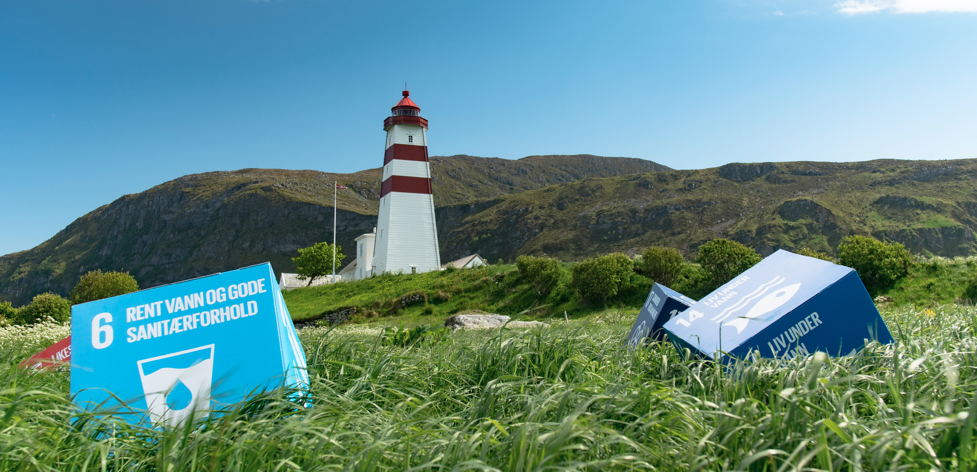
Photo: The North West / Ole-Martin Sæthermoen

Key changes/lessons learned
- In 2020, the Ministry of Local Government and Modernisation was appointed as a coordinating body for national implementation of the SDGs. This has led to increased cross-sectoral cooperation and a holistic approach to sustainable development.
- To improve the monitoring of progress on the 17 SDGs, Statistics Norway is coordinating the effort to develop a comprehensive set of indicators, adopted to national, regional and local needs.
- In Norway, there is an increasing awareness of regional and local authorities’ crucial role in achieving the SDGs. The report ‘National Expectations to Regional and Local planning’, launched in 2019, emphasised the importance of integrating the SDGs into regional and local strategies and plans.
- Several information campaigns aimed at increasing the Norwegian population’s knowledge of the SDGs have been conducted since 2016.
- Stakeholders from all sectors of society have increasingly integrated the SDGs into their strategies since 2016.

Creating ownership of the SDGs

Whole-of-government approach
The whole-of-government approach and national architecture are also described in Chapter 5.5 Incorporation of the SDGs in national frameworks and Chapter 5.7 Institutional mechanisms.
Government
The Government has the overall responsibility for implementation of the 2030 Agenda in Norway. Since the adoption of the 2030 Agenda in 2015, sustainable development has been an integral part of Norwegian policies. The responsibility for implementation and reporting on the individual goals is divided between the ministries, in accordance with their responsibilities. Each ministry reports on the SDGs in budget documents presented to parliament. This ensures that progress on each SDG is reported annually through a well-established political mechanism.
In the period 2016–2019, the Ministry of Finance was responsible for coordinating the report on national implementation of the SDGs, which was presented to parliament in the national budget. In January 2020, Prime Minister Erna Solberg’s Government appointed the Ministry of Local Government and Modernisation as a coordinating body for national implementation of the SDGs. This has led to increased cross-sectoral cooperation and a holistic approach to sustainable development. The Government will submit Norway’s first national Action Plan for the Implementation of the SDGs to parliament this summer. Moreover, Norway is committed to submitting its Voluntary National Review (VNR) to the High-level Political Forum (HLPF) every four years.
The Storting (the Norwegian Parliament)
Parliamentary committees monitor 2030 Agenda matters through ordinary committee work. There are 12 standing committees responsible for different areas.
The Office of the Auditor General of Norway (OAG)
The Office of the Auditor General of Norway (OAG) is an important tool for parliament to ensure sufficient follow-up on the SDGs by government. In 2020, the OAG assessed how the Government implemented the 2030 Agenda in the period 2016–2019/2020. The OAG audit is elaborated upon in Chapter 5.5.2 The Norwegian Parliament’s role in the implementation of the 2030 Agenda.
Sámediggi (the Sami Parliament)
Sámediggi, the Sami Parliament of Norway, is consulted on matters that may affect Sami interests directly, in relation to the SDGs and otherwise. This procedure for consultation between the central government and the Sámediggi was agreed on 11 May 2005. The consultation procedures were developed in accordance with Article 6 of ILO Convention No. 169; the duty to consult indigenous peoples in decision-making processes that affect their rights. The consultation procedure applies to the Government and its subordinate agencies. In February 2021 the Government submitted to the Storting a proposal to codify rules on consultations in a new chapter of the Sami Act. It is proposed that the duty to consult should apply to authorities at all levels: the national, regional and municipal level.
Local and regional authorities
Local and regional authorities form an integrated component of Norway’s multi-­level governance model. In the Norwegian model, welfare for and services to citizens are mostly delivered by local and regional authorities. What should be delivered and to what standard are specified in legal acts and public budgets adopted by parliament. Consultation between tiers of government is a key feature when formulating policy and enacting new legislation. For the past two decades, the Government has systematically consulted local and regional authorities represented by their association in three formal annual meetings on relevant policy, budgets and legislation.

Whole-of-society approach
The Advisory Forum on Policy Coherence
Prime Minister Erna Solberg’s political government platform highlights Policy Coherence for Development (PCD) as a critical success factor for achieving the SDGs. Because the SDGs are tied to multiple policy areas, the Government has made the commitment to embark on a policy coherence reform.
A key element in the reform progress was to establish a Forum on Policy Coherence in 2018. The private sector, civil society organisations, academia and labour organisations are represented in the forum. In the period 2018–2020, the forum was chaired by the Ministry of Foreign Affairs at the political level. Since 2020 onwards, the Ministry of Local Government and Modernisation has been co-chair, and the forum has been renamed the Advisory Forum on Policy Coherence (Innspillsforum for samstemthet). The name change reflects a broader participation and focus going forward.
Civil society engagement
Civil society has a significant role in the planning, implementation and revision of the SDGs, nationally and globally. Civil society contribute to a sustainable world both through their own work and through influencing the political agenda. In Norway, civil society represents numerous interest groups and possesses extensive knowledge and experience. Business, the culture sector, sports associations, congregations and non-governmental organisations (NGOs) work towards the achievement of the SDGs. The engagement is particularly relevant for work related to the social and environmental dimensions of the SDGs, to which civil society mobilises substantial resources.
In addition to the wide-ranging mechanisms in place for consultation and cooperation with civil society actors, the Government seeks to facilitate fruitful conditions for civil society stakeholders to utilise their engagement and innovative power. NGOs, trade unions and business organisations continue to manifest their commitment. Actors such as social entrepreneurs, start-ups, clusters and networks are increasingly prevalent. The following cases present a few examples of the diversity of civil society actors and their commitment to achieving the 2030 Agenda in Norway.
ForUM
The Forum for Development and the Environment (ForUM) is an important network of expertise for NGOs and a facilitator of collaboration across organisations. It is an umbrella organisation with 50 members, which represents a large and diverse part of Norway’s population. ForUM is a central member of the Advisory Forum on Policy Coherence and participates in relevant international networks. On behalf of civil society, ForUM coordinated the progress report on each SDG in Chapter 6.2 of this report.

Young Sustainable Impact
Young Sustainable Impact (YSI) gathers young talent from all around the world to develop impact start-ups, with the 17 SDGs as a framework. YSI do this through a threefold mission. Firstly, by creating youth-driven sustainable business through an online innovation programme. Secondly, YSI has built and is building a youth-led movement focusing on sustainability, called Earthpreneurs. Thirdly, through working to influence established businesses and organisations on sustainability-related challenges.

Ferd
Ferd is a Norwegian investment company that focuses on value-creating ownership in companies and financial investments. The company has two investment mandates within impact investment: Ferd Social Entrepreneurs (Ferd SE) covers social impact, while Ferd Impact Investing covers environmental impact.
Ferd SE invests in social entrepreneurs who create good social and economic results. Ferd SE contributes capital, expertise and networks in active partnership with the social entrepreneurs, with clear milestones and social ambitions. Ferd SE also helps to strengthen the social entrepreneurship field in Norway by increasing knowledge of social entrepreneurship, business development and how the public sector and others can use innovative, small actors to create social results. Currently, Ferd SE has 10 companies in its active portfolio.
Ferd Impact Investing invests in early-stage companies that have the potential to deliver both a positive effect on the SDGs and a solid risk-adjusted return.

Norway Unlimited
Norway Unlimited (Norge Unlimited) is a platform and a network with an associated methodology that seeks to support public, private and voluntary actors who want to establish and run a neighbourhood incubator. A neighbourhood incubator is a workplace, a resource centre, and a learning community for residents with ideas on how to solve complex local challenges through social entrepreneurship. The main idea is that experience with the current challenges can contribute to good solutions, which with a little support can create transformative change in the neighbourhood and have a ripple effect far beyond this. So far, Norway has three neighbourhood incubators: in Tøyen (Oslo), Storhaug (Stavanger) and Fjell (Drammen).

The Children’s Panel on Climate Change
The Children’s Panel on Climate Change was established by the Eco-Agents (Miljøagentene) in 2015. It is renewed with new members every year. The purpose of the panel is to give children a bigger voice, by communicating their opinions to decision-makers and influence their ability to define their own future. For example, the panel has met with representatives of parliament and the Government to express children’s views on environmental issues. A report is handed over to decision-makers at home and abroad every year. Representatives of the panel have participated in UN climate change conferences in Paris, Marrakech, Bonn and Katowice. In the long term, the ambition is to create an international climate change panel for children, consisting of children from all UN member states. This way, children’s views on environmental issues can be made visible and have greater political significance.

The importance of the private sector
The private sector plays a key role in realising the 2030 Agenda. Through their investments, the private sector mobilises financing for the creation of vigorous businesses that contribute innovation, technology, knowledge and experience that can solve our societal challenges. Norway has a competent and well-organised private sector with fruitful conditions for contributing to the achievement of the SDGs and for utilising the value creation potential that the 2030 Agenda represents.
Several Norwegian companies base their work on the SDGs, and are well on their way to integrating sustainable development into their strategies and adapting their products, services and business models. Collaboration has also been established between companies in areas that span across industries and sectors. One such example is the action platforms that UN Global Compact (UNGC) Norway facilitates. An action platform is a planned process based on an area that runs across several industries and sectors. The purpose is to develop concrete solutions through four phases: pre-project, idea phase, discussion phase and implementation. UNGC has launched national action platforms on issues such as sustainable business in the Arctic region and sustainable ocean business. Furthermore, through participating in the organisation, companies undertake to comply with principles for responsible business in their operations and report on them annually. More than 200 companies are members of UNGC Norway. On behalf of the private sector, UNGC Norway has coordinated a text about the private sector’s perspective on the Government’s implementation of the SDGs, in Chapter 4.
Individual companies, but also organisations such as the Confederation of Norwegian Enterprise (NHO), are important drivers for sustainable transformation in Norway. NHO is Norway’s largest organisation for employers and the leading business lobbyist. The confederation aims to create and sustain conditions that safeguard the competitiveness and profitability of business and industry in Norway. In 2020, NHO launched a comprehensive report, Next step – roadmap for the future of business (Neste trekk – Veikart for fremtidens næringsliv), which sets out Norway’s way out of the COVID-19 crisis and into a digital, global and greener future.
Trade union membership and tripartite cooperation are well-established mechanisms in the Norwegian welfare system. NHO, together with the Norwegian ­Confederation of Trade Unions (LO) has provided a comment on tripartite cooperation in Norway in Chapter 5.7.2.
Innovation Norway
Innovation Norway (IN) is the Norwegian Government’s most important instrument for innovation and development in relation to Norwegian enterprises and industry. A key goal in IN’s strategy is to help develop a more versatile and sustainable Norwegian business community that is able to solve major common societal challenges. Therefore, since 2015, in addition to assessing the value creation potential of a project, IN also assesses the effect that projects will have on society and the environment. The projects are assessed according to predetermined criteria for environmental and social impact and provide a good basis for monitoring the portfolio. In 2020, IN triggered environmental projects worth more than NOK 6 billion; double that of previous years. The large increase in 2020 relates to the additional grants provided in relation to the COVID-19 pandemic.
All IN’s work is in line with SDGs 8 (Decent work and economic growth) and 9 (Industry, innovation and infrastructure). However, the established system for measuring the environmental and social impact also makes it possible for the agency to see which SDGs are being met by the projects they finance. IN is working to improve the indicators for both the environmental and the social impact, which will be assessed in accordance with the EU’s taxonomy.

The SDGs in Norwegian counties and municipalities
Regional and local authorities are instrumental in implementing and following up on the SGDs in Norway for three main reasons. Firstly, they are responsible for deciding political priorities at the regional and local level. Secondly, the counties and municipalities are familiar with the opportunities and challenges of individuals, local organisations, and businesses. Lastly, they are responsible for most of the social and physical infrastructure that influences people’s lives and local development possibilities. Regional and local authorities are community developers, property owners and employers. It is also worth mentioning that many Norwegian counties and municipalities participate in national and international networks dedicated to the regional and local implementation of the SDGs.
Since Norway presented its first VNR report, considerable progress has been made towards the SDGs and targets in counties and municipalities. To highlight their efforts, the work on the SDGs in Norwegian counties and municipalities is the main focus of this VNR report. The timing is particularly good as the Norwegian Association of Local and Regional Authorities (KS) is conducting a Voluntary Subnational Review (VSR). A detailed account of the VSR, as well as more information on the work and progress on the SDGs in Norwegian municipalities and regions can be found in Chapter 7.

Dissemination and communication
If the SDGs are to be achieved, they must be known to the public. According to a recent study by polling company Opinion, 69 per cent of the Norwegian population is familiar with the 2030 Agenda and 8 out of 10 Norwegian consumers want to contribute to sustainable development through the business they support and choices they make. The Norwegian Agency for Development Cooperation (Norad) has been instructed by the Government, through a mandate by parliament to carry out an information campaign to raise awareness of the SDGs in the Norwegian population. Since 2016, Norad has carried out several information campaigns. Read about their campaigns in the case box below.
Since 2016, several initiatives have been implemented to raise awareness and increase knowledge about the 2030 Agenda. Translating the SDGs to the three official Norwegian languages (Bokmål, Nynorsk and Sami) has been a priority. The translations are used in official communications, educational material and municipal strategies.
In 2020, the Government established a website that functions as a two-way communication channel in the development of the National Action Plan for Sustainable Development. The main purpose of the website is to provide knowledge about the SDGs in a national context and engage stakeholders and the public in the development of the Action Plan. The Government will improve the quality of information about Norway’s follow-up of the 2030 Agenda, both globally and nationally.
In June 2021, the Government arranged a digital conference on sustainable development in connection with the action plan. The conference gathered stakeholders from civil society and the private and public sector to shed light on the possibilities and challenges that the SDGs present in a national context. Before the conference, the Government also co-hosted several webinars focusing on different aspects of sustainability.
Prime Minister Solberg has for many years been actively engaged in the follow-up of the 2030 Agenda. Since 2016, Prime Minister Solberg has co-chaired the UN Secretary General’s SDG Advocacy Group, together with the President of Ghana, Mr Akufo-Addo. And, as of 2018, Prime Minister Solberg co-chairs the High-level Panel for a Sustainable Ocean Economy (Ocean Panel) for building momentum for a sustainable ocean economy, together with the President of Palau, Surangel Whipps Jr. In November 2020, Prime Minister Solberg launched the social media campaign #Taketheball, encouraging people around the world to take action towards the SDGs. The Minister of Local Government and Modernisation, Nikolai Astrup, later launched the campaign in Norway (#Taballen), encouraging key stakeholders in Norway to take action.
Civil society plays an important role in providing information about the 2030 Agenda, both through campaigns and participation in the public debate. With financial support from Norad, NGOs raise awareness about the SDGs and about Norway’s planning and implementation of the SDGs, as well as the reporting and revision processes. Civil society plays a particularly important role in highlighting the perspectives of marginalised groups.
One example is the United Nations Association of Norway (UNA Norway), which hosts seminars and debates across the country and offer lectures to schools and organisations. In cooperation with teachers and students, the organisation has developed interdisciplinary learning resources about the SDGs that are free of charge and available online. UNA Norway also hosts a dynamic and up-to-date website that provides the Norwegian population with information about the SDGs. The pages about the SDGs are the most read, with 1.1 million views in 2020. The organisation is run independently without any political affiliations and has 48 member organisations across Norway. More than 750 schools and kindergartens are currently members of the UNA Regional Offices network.
UngDebatt
UngDebatt (Young Debate) is a toolkit developed by YGlobal in partnership with YWCA-YMCA of Norway to create an inclusive, safe space on the local level for the youth to speak their minds on issues related to the SDGs. The debates are hosted by young people, and decision-makers are invited to come and listen to the youth and their perspectives on issues related to the SDGs.

The world’s most important goals
Text by Norad
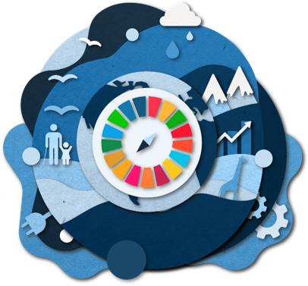
Since 2016, Norad has carried out campaigns to spread knowledge about the SDGs. The main concept has been the SDG Night Treks and Festivals. Norad has arranged SDG Night Treks and Festivals throughout the country, in eight different towns and cities. Over 70,000 trekkers have walked for the SDGs on a mountain top. Even more people have engaged in the costal clean-ups, school quizzes, debates and seminars in the SDG Festivals. The Night Treks and Festivals have led to spectacular moments in the focus on the SDGs, which have also been filmed and distributed in traditional and social media. The clips have been viewed 13 million times.
As a result of the COVID-19 pandemic, the Night Treks and Festivals have been discontinued, but in the autumn of 2020, Norad carried out a new and different digital campaign, disseminated in social media. In The World’s Most Important Goals campaign, Norad invited the population to test which SDGs were closest to their own interests. About 50 partners, from some of the largest private companies in Norway to big civil society actors, and municipalities, distributed the test in their own networks. Over 110,000 people took the test. The test will be used in schools to educate youths about the SDGs in the years ahead. An introductory film about the campaign can found here.
In 2016, 35 per cent of the Norwegian population had some knowledge of the SDGs. The corresponding figure in 2020 was 69 per cent.
The SDGs will form the framework for Norad’s work and communication in the years ahead.

MISSION IMPACT
In 2019, the Forum for Development and Environment (ForUM) launched the online series, MISSION IMPACT, to raise awareness about the SDGs. The series follows three young Norwegians in their mission to fight climate change, arms trade and tax havens as they learn about three of our greatest challenges: climate change, war and poverty. The series was an initiative to engage youths with limited knowledge of the SDGs, and each video had a reach of at least 200,000 on Facebook. In addition to the videos published online, the series has been adapted for use in schools, with assignments and activities linked to MISSION IMPACT.

Incorporation of the SDGs in national frameworks

Key changes/lessons learned
- The Norwegian Government decided in 2016 that the 2030 Agenda and the SDGs shall provide the main direction for Norwegian national and international policy,
- The SDGs are incorporated into all policy documents, including budgets, strategies and action plans, but ensuring policy coherence and a cross-sectoral approach is a challenge.
- In 2020, the Office of the Audit General (OAG) audited the national implementation of the SDGs from 2016–2019/2020. Based on the audit report, parliament requested the Government to present a progress report and an action plan on the SDGs. In response, Prime Minister Erna Solberg’s Government will present a progress report and Norway’s first national action plan on the implementation of the 2030 Agenda to parliament in 2021.
- The SDGs are integrated into education policy on all levels.
- All state agencies will report on the implementations of the SDGs in their annual reports.
- Regional and local authorities use the SDGs in their regional and local planning.

The Norwegian Parliament’s role in the implementation of the 2030 Agenda
The Government is responsible for reporting on the implementation of the 2030 Agenda and the SDGs to parliament. Since 2016, the Government has reported to parliament on the 2030 Agenda and the SDGs through the annual budget proposals and the National Budget Report. A regular report on policy coherence has also been delivered.
The Norwegian Parliament represents the people. It governs the country, introduces legislation, authorises public spending, imposes taxes, and supervises and regulates the work of the Government and public administration. Government proposals are discussed in the relevant committee. After reaching a conclusion, the committee presents its recommendations to parliament, which then votes on the recommendations. Parliament can obtain more information on certain issues through questions and interpellations.
The Committee on Scrutiny and Constitutional Affairs reviews and makes recommendations on matters concerning supervision of the Government. The OAG is the most important supervisory body, examining the activities of the national administration to ensure that the state assets are utilised and managed according to sound financial principle and in keeping with parliament’s decisions and intentions.
In 2020, the OAG provided parliament with an audit of the national follow-up on the SDGs in the period 2016 to 2019/2020. The OAG had the following four recommendations:
- Better coordination of the national implementation to secure a more holistic approach, coherence and progress.
- Develop a national plan for the 2030 Agenda, with national targets and priorities.
- Develop national indicators and statistics as important tools for the implementation.
- The report to parliament should have more focus on challenges and progress and a holistic and cross- sectoral approach.
Based on the audit report, the Committee on Scrutiny and Constitutional Affairs formally requested the Government to present a progress report and an action plan on the SDGs. In response, the Government will present a White Paper and an action plan to parliament by the summer of 2021. The Government has also taken steps to increase effective implementation and reporting on the SDGs (see Chapter 5.2.1 for more information).

The Government’s policy priorities 2016–2021
The implementation of the 2030 Agenda started during the first term of Prime Minister Erna Solberg’s Government, in the period 2013–2017. The main priority during this time was development policy.
During Prime Minister Solberg’s second and current government term (2017–2021) the political platform states that the 2030 Agenda shall constitute the political superstructure of the Government’s work both nationally and internationally. Throughout this government term, eight projects have been given priority, which largely coincides with the SDGs. The Government’s eight priority projects are:
- Equal access to welfare
- A society where everyone can participate
- Work in more sustainable ways
- Sustainable communities and local communities
- A carbon-neutral society
- Good utilisation of resources in the economy
- A lifestyle that considers the capacity of nature
- Decision-making with respect for nature
This indicates an accelerated focus on implementing the 2030 Agenda in national policy. The shift was made explicit in the report National Expectations regarding Regional and Local planning in 2019.

Incorporation of the SDGs into ministries’ strategies and programmes
The SDGs have been an integral part of Norwegian policy for many years. The existing policy and legislative framework, as well as the commitment to international agreements and strategies, provide a strong basis for the national implementation of the 2030 Agenda.
An assessment of the Government’s policy since 2016 shows that present strategies and policy objectives underpin and affect all the 17 SDGs. In Chapter 6.2, the ministries provide a more detailed list of the strategies that have been implemented in connection with the goals.
The OAG’s audit of the management and review of the national follow-up of the SDGs found that Norway is lacking a comprehensive plan for implementation of the 2030 Agenda and the SDGs. When the Government now submits its second White Paper and action plan to parliament, the focus is on providing a comprehensive plan for the national implementation of the 2030 Agenda (Read about the action plan in Chapter 5.5.5). The Government first submitted a White Paper on the 2030 Agenda and the SDGs in 2017. The White Paper was submitted by the Ministry of Foreign Affairs and focused on Norwegian development policy and Norway’s international responsibility for the follow-up of the 2030 Agenda.
In 2020, the Government decided on two important measures that will increase the integration of the SDGs into sectorial policies and strategies towards 2030. The first measure is that all strategies, action plans and white papers provided by the ministries must review the SDGs when relevant. The second measure is that all ministries include the SDGs in their guidance and performance agreements (letter of appropriation) with their state agencies and institutions.

The National Action Plan for SDGs
In 2020, the Government decided to develop a national action plan for the 2030 Agenda and the SDGs. The National Action Plan will be presented to the Norwegian Parliament, by summer 2021 as a White Paper. The action plan sets the SDGs in a national context and proposes national targets for each goal. The plan describes existing national policy and suggest new policy needed to achieve the goals by 2030.
The action plan will establish measures to secure better coordination between government sectors and levels, and strengthen cooperation across regional and local administration, the private sector and civil society.
The Government emphasises the importance of research and science and of developing tools for a knowledge-based approach, particularly technological tools.

The SDGs in national planning and budgeting processes
The 2030 Agenda and the SDGs are included in the White Paper, Long-term ­Perspectives on the Norwegian Economy 2021, the National Transport Plan 2022–2033 and several other long-term sectoral plans. The goals are also integrated into ordinary policy documents and in the budget process on a national level.
Consideration of the SDGs is a main component of social and land-use planning. The planning system is regulated by law in the Norwegian Planning and Building Act. The purpose of the law is to promote the SDGs and to coordinate public interests in all sectors and levels. Every four years, the Government maps out its expectations for strategies and plans at the regional and municipal level, in an effort to promote the SDGs across the entire country. This requirement is stated in Section 6-1 of the Planning and Building Act. The national expectations must be considered by county and municipal authorities when they develop their strategies and plans. The latest edition of the National expectations regarding regional and municipal planning, emphasised the important role of the regional and local level in achieving the 2030 Agenda and the SDGs, and encouraged regional and local authorities to make the SDGs the foundation of their planning process.

Incorporation of the 2030 Agenda into the education system at all levels
Norway has 10 years of compulsory primary and lower secondary education that is publicly funded. In 2020, the Government introduced sustainable development as an interdisciplinary topic in primary and lower secondary school curriculums. The aim is to spread knowledge about sustainable development and give pupils an understanding of some of the dilemmas related to this topic. The two other interdisciplinary topics (health and life skills, democracy and citizenship), will also provide pupils with the competence to understand where we can find solutions through knowledge and collaboration, and they must learn about the relationship between actions and consequences.
In 2015, the Government launched a 10-year plan for research and higher education. The plan sets the course for policy development and investments in research and higher education and is revised every four years to accommodate changes in the political and societal landscape. Several measures in the current long-term plan (2019–2028) are relevant to the SDGs, including:
- encourage increased research and development in the private and public sectors in order to promote restructuring towards a greener economy, enhance competitiveness and strengthen innovation capacity;
- facilitate new, research-based business activities and better interaction between academia and the private and public sectors;
- lay the foundation for increased digitalisation and use of new technology.
Moreover, several universities and colleges in Norway have developed their own strategies for sustainable development or integrated the SDGs into existing strategies. For example, the new strategy of the Norwegian University of Science and Technology (NTNU) highlights specific education, research and innovation activities that are targeted at the 17 SDGs. This helps new students to choose a study programme based on the goals they consider to be most important.
After the inaugural SDG Conference Bergen in February 2018, the University of Bergen took the initiative to establish the National Committee for the 2030 Agenda in the university sector. The National Committee consists of members from the five major Norwegian universities, Universities Norway (UHR) and the National Union of Students in Norway (NSO). The Ministry of Foreign Affairs, the Ministry of Education and Research, The Ministry of Local Government and Modernisation and the Norwegian Agency for Development Cooperation (Norad) also act as observers in the committee. The aim of the committee is to strengthen the universities’ role as a relevant player in the global debate on the societal challenges that the 2030 Agenda focuses on, both nationally and internationally. The committee, chaired by the University of Bergen, also hosts the annual high-level SDG Conference Bergen – a meeting point, bringing together the university sector with stakeholders from politics, government, civil society and industry, as well as diplomats and UN officials to critically engage with the 2030 Agenda and the SDGs.
Sustainability portal for researchers and students
In collaboration with the National Committee for the 2030 Agenda, the Norwegian University of Life Sciences (NMBU) is in the process of creating a platform for the sharing of best practice in higher education. The platform will serve as an interactive ‘meeting place’ for researchers and students working with the same or related sustainability dilemmas, and welcomes interdisciplinary collaboration, preferably with a focus on a specific complex challenge. A pilot project for the sustainability portal was initiated in November 2019 with two portals, one focusing on research and another on education. The knowledge that can be extracted from these portals can be used to define targeted research programmes supported by the Research Council of Norway and to make knowledge-based decisions regarding the SDGs. This will be the first national platform of its kind, underlining the strong engagement with the 2030 Agenda and the SDGs in Norway’s university sector.

No sustainable development without health, equality and education
In 2018, Sex og Politikk – IPPF Norway, launched new teaching material for upper secondary schools on the SDGs related to sexual and reproductive health and rights (SRHR). The purpose is to help pupils understand their rights in an international perspective, and the connections between their own and others’ rights.
The material consists of a free to use booklet for teachers and an exercise booklet for pupils. It is intended to be a practical and comprehensive tool for building knowledge, insight, reflection and engagement in schools on issues related to SDGs 3, 4 and 5. It touches upon topics like sexual rights, the UN Convention on the Rights of the Child, gender equality, abortion, HIV and AIDS and contraception. The material has proved to be very popular among teachers. By April 2021, more than 2,200 teachers had registered that they would use the material, covering a total of 140,000 pupils. The material is financed through the Norwegian Agency for Development Cooperation (Norad).

Incorporation of the 2030 Agenda into development, foreign and security and trade policy
The 2030 Agenda also establishes an agenda for Norway’s development, foreign, security and trade policy. Prime Minister Erna Solberg’s co-chair role in the UN Secretary-General’s Sustainable Development Goals Advocacy Group is a clear testimony to this commitment.
The Government’s main goal in its development policy is to fight poverty and promote economic development and welfare in low-income countries within the framework of the 2030 Agenda and SDGs. The MFA White Paper ‘Common Responsibility for Common Future – The Sustainable Development Goals and Norwegian Development Policy’ describes Norway’s global efforts in more detail, as does Chapter 8.3 in this report.
The SDGs are also an important basis for Norway’s relationship with bilateral development partners. Many of these partnerships are evolving, from a traditional cooperation based on development assistance to a more comprehensive and mutual partnership based on common interests and enhanced cooperation on multilateral issues, trade, investments, culture and research.
Multilateral cooperation and a rule-based multilateral order are key Norwegian foreign policy interests. A key goal for Norwegian foreign policy in the coming years is therefore to support binding international cooperation and safeguard this system. This includes ensuring that the 2030 Agenda is pursued and acted upon globally, and even more so in a time of a pandemic crisis.
The Government’s global leadership on oceans policy illustrates Norway’s multilateral outlook on the SDGs. Norway has world-leading expertise on the marine environment and sustainable management of marine resources, supporting common political commitments to ensure a sustainable ocean economy. Prime Minister Erna Solberg’s initiative to set up the High-level Panel for a Sustainable Ocean Economy is a key example. Another example is our efforts related to COVID-19, where Norway has taken steps to bring the issue of equal access to vaccines to developing countries to the forefront on the multilateral agenda. In a pandemic, no one is safe until everyone is safe.
Norwegian foreign- and development policies are based on a conviction that respect for individual rights and freedoms and democratic rules of the game are prerequisites for sustainable development. By strengthening the rule of law at both national and international levels, we contribute both to creating more predictable conditions for development, and to more inclusive, just, and peaceful communities locally.
Cooperation with the rest of Europe, both the EU and other European countries, is another cornerstone of our foreign policy. Even if not a member of the EU, Norway pursues and enjoys very close relations with the EU – most importantly through the European Economic Area Agreement (EEA Agreement). Besides guaranteeing access to the single market, the EEA Agreement covers cooperation in other important areas such as research and development, education, social policy, the environment, consumer protection, tourism and culture. Fighting climate change and promoting climate neutral growth is a defining task of Norway’s cooperation with the EU. Norway shares the European Commission’s vision for a European Green Deal. Norway will actively participate in policy and regulatory development under the European Green Deal in line with Norwegian interests. Large parts of the EU’s policy development will be of relevance to the EEA Agreement.
Policy rooted in the SDGs is also relevant for security policy. Climate change can multiply factors that may create or intensify conflicts. Although Norway significantly contributes to peace and reconciliation in many conflict areas today, systematic work against such risk-multipliers is important to the Norwegian Government. Realising the importance of the need for sustainable development, NATO has therefore put the threat of climate change high on the agenda. It is expected that this year’s NATO summit will launch a process to revise NATO’s strategic concept so that it considers future security policy challenges. Norway supports this process. For Norway, NATO membership is our primary security guarantee. But security is also a question of cooperative security with partner countries. Since 2007, Norway has been actively involved and is one of the leading nations in strengthening institutions through integrity building and anti-corruption work. This contributes to partner countries being able to achieve the SDGs more easily.
As for Norwegian trade policy, integration into the global economy has proved to be a prerequisite for sustainable economic growth over the past decades. Our belief is that participation in the rules-based multilateral trading system, including implementation of World Trade Organisation (WTO) rights and obligations, enhances foreign investment, business development and competitiveness. Norway’s top trade policy priority is preserving and strengthening the WTO. Development must be at the heart of WTO and the ongoing reform discussions. As a donor, we contribute to technical assistance and capacity-building within trade since these are important components of an enabling approach for developing members. Norway also negotiates free trade agreements mainly through the European Free Trade Association (EFTA). In all current and future free trade agreements, we strive to include comprehensive chapters on trade and sustainable development.

Linkages to the work of the EEA, the Nordic Council of Ministers, Arctic Council, Barents Sea Cooperation and Council of the Baltic Sea States
Norway regards regional cooperation as an integral part of its effective realisation of the 2030 Agenda. As members of the EEA Agreement, Norway and the EU have a close climate partnership. Norway and the EU also have an agreement from 2019 to cooperate to meet 2030 climate targets. Norway contributes by cutting emissions through our participation in the EU Emissions Trading System (ETS) and joint fulfilment of emission reductions in sectors outside the ETS. The EEA and Norwegian grants for the period 2014–2021 amount to EUR 2.8 billion, which was paid to 15 of the EU’s less prosperous member states, ending in 2025. The grants support the SDGs and in particular the development of a green, competitive and inclusive Europe. In 2021, the budget approved by parliament is approximately EUR 600 million. The support of the European Green Deal is an important part of this budget.
Besides the cooperation with the EU, Norway is also part of a large and comprehensive cooperation framework with neighbours in northern Europe, from the Arctic in the north to the Baltic and North Sea shores in the south, from the western Atlantic to the Russian taiga in the east. The framework rests on strong bilateral relations, but particularly also on regional cooperation formats and strategies focusing on the exchange of best practices and coordinated and harmonious implementation of the environmental, economic and social dimensions of sustainable development.
The Nordic countries work closely together in the follow-up of the SDGs. This work was intensified when, in August 2019, the Nordic prime ministers decided to strengthen the joint work on sustainability. In the new Nordic vision for 2030, the Nordic countries agree that ‘the Nordic region will be the world’s most sustainable and integrated region’. The action plan for 2021–2024 includes increased efforts and new impetus in the co-operation for a sustainable Nordic region along three strategic priorities: 1) A green Nordic region, 2) A competitive Nordic region, and 3) A socially sustainable Nordic region. These priorities are followed up in the action plan for 2021–2024.
A recent report from the Nordic research institution Nordregio indicates that increasing attention has been dedicated to how local and regional levels are working with the 2030 Agenda across the Nordic countries, and that there is a great deal of potential to amplify shared Nordic ambitions.
Norway is a founding partner and member of the Council of the Baltic Sea States (CBSS) and holds its presidency 2021–22. In 2016, the eleven member countries agreed to create an action plan for cooperative and synergetic work to advance the 2030 Agenda and the SDGs in the Baltic Sea Region. The following year, the Baltic 2030 Action Plan was adopted, with six focus areas: partnerships; transition to a sustainable economy; climate, equality and social wellbeing; sustainable and resilient cities; quality education and lifelong learning. Six corresponding ‘activation processes’ have been agreed in the action plan to coordinate implementation under the guidance of the rotating CBSS presidency and the permanent secretariat in Stockholm.
The Barents cooperation has been a cornerstone of regional cooperation in the Arctic since 1993, and Norway is chairing the Barents Euro-Arctic Council (BEAC) in 2019–2021. One of the priorities of the Norwegian chairmanship is knowledge and sustainable development of the region. The report ‘Barents 2050 – Impacts, opportunities, and risks of climate change and climate change mitigation‘ underlines the importance of innovation and the implementation of low-carbon technologies in the Barents region. The Barents Action Plan on Climate Change is currently being updated by the BEAC working group on environment. Through continued efforts on climate, sustainable forestry, low-emission transport and infrastructure, biodiversity, education, and innovation, in addition to a focus on indigenous peoples and youth, the BEAC aims to build a more sustainable and resilient Barents region in line with the 2030 Agenda.
The Arctic Council is the leading intergovernmental forum promoting cooperation, coordination and interaction among the Arctic States and Arctic indigenous communities on common Arctic issues, in particular on sustainable development and environmental protection in the Arctic. The work is primarily carried out in six working groups, all working to advance the 2030 Agenda, ranging from reducing emissions of pollutants, monitoring the Arctic environment, ecosystems and human populations, biodiversity and the sustainability of the Arctic’s living resources, the protection of the Arctic marine environment, sustainable growth and the blue bioeconomy. The Arctic Council provides scientific advice to the Intergovernmental Panel on Climate Change (IPCC) and other international organisations and governments on global mitigations of emissions of greenhouse gases and short-lived climate pollutants (SLCPs).

Leaving no one behind (LNOB)

Key changes/lessons learned
- Efforts aimed at those who are furthest away from achieving the goals are given priority, at home and abroad.
- In the national context, the welfare society is the backbone of the Norwegian LNOB policy.
- Securing employment for all is challenging, especially considering the impacts of the COVID-19 pandemic.
- Lack of knowledge, competence and education, in addition to discrimination, are the most important single factors that can result in being left behind.
- The White Paper National Minorities in Norway. A Comprehensive Policy, outlines plans to strengthen the minorities’ languages, culture and position in the Norwegian society. The White Paper concludes that the formal rights of the minorities are essentially met in Norway, but that implementing the rights can still be challenging in some areas.
- The principle of leaving no one behind is a central premise for Norwegian foreign policy and development policy.

Upholding the LNOB principle nationally
For the Norwegian Government, leaving no one behind is a central premise for political, social and economic development. A strong focus on equality and non-discrimination is key to ensuring that no one is left behind in the implementation of the 2030 Agenda. In Norway’s previous VNR report from 2016, the principle Leave No One Behind (LNOB) was primarily addressed in the context of development cooperation. The principle resonates well with Norwegian domestic and international policy, where supporting and protecting vulnerable and marginalised groups is a key priority. While LNOB remain at the heart of our development cooperation, this review will complement the previous review by giving special attention to non-discrimination, social policies and labour policies in a national context.
Norwegian policy is consistent with the principles and obligations set out in human rights conventions ratified by Norway. All people must have the same opportunities, irrespective of their gender, ethnicity, age, race, religion or belief, indigenous identity, sexual orientation or disability.
The Norwegian welfare society is key to ensuring that no one is left behind, by securing opportunities for income, providing education and health services for everyone. The welfare society depends on a strong national economy and well-functioning distribution mechanisms. Continuous improvement to the Norwegian welfare society is crucial for the national implementation of the 2030 Agenda.
In Norway, our labour market has been heavily disrupted by the COVID-19 pandemic. It makes providing good jobs for everyone an even more challenging task. Many of the unemployed face complex living conditions and other challenges, such as mental health problems. Mental health problems are also a major cause of sick leave and for claiming disability benefit. Participation in the labour market is vital to ensuring equality in society, by decreasing income differences and contributing to societal inclusion, social mobility, better mental and physical health and learning. Meeting the target of full and productive employment for all, including young people (SDG target 8.5), has proven to be a challenge.
The Introduction Programme aims to provide refugees and their family members with basic proficiency in the Norwegian language and to prepare them for employment or further education as well as participation in Norwegian society. On 1 January 2021, a new act on integration through education, training and work (the Integration Act) was implemented. One of the objectives of the new act is for more refugees to obtain a formal education through the Introduction Programme. Ensuring easier access to the labour market for immigrant groups is a priority in Norwegian labour policy, because many immigrant groups currently have low labour force participation.
Vulnerable children and youth are at a high risk of being excluded from important social arenas. Several efforts have been launched by the Government to promote equal opportunities for children and youth. In the autumn of 2020, the Government presented a strategy that focuses on increased participation for children, young people and parents in low-income families in kindergarten, school, after-school programmes and leisure activities. Increased participation in these arenas could prevent low income and societal exclusion from being passed on to the next generation.
People with disabilities face challenges when it comes to access to the labour market and good-quality education. The Government aims to empower people with disabilities to pursue education and participate in the Norwegian labour market in the same manner as those without disabilities.
Among the senior population many can meet ageist attitudes and invisible and visible barriers for participation in the working life and in the society. With the increased digitalisation of public and private services, many older people find it difficult to use them. With population ageing, the Government has appointed the first independent Ombud for older people, with a mandate to speak on behalf of older people on all areas of society.
Racism and discrimination are democratic challenges that exclude people from many arenas and prevent them from participating fully in society. The Government aims to fight racism, religious discrimination, anti-Semitism and prejudice based on ethnicity. The Government is currently seeking to implement measures to combat discrimination in the labour and housing markets. The new Action Plan Against Racism and Discrimination on the Grounds of Ethnicity and Religion 2020–2023, set out a renewed and intensified effort to fight racism and discrimination.

Five national minorities
The five national minorities in Norway are Kven/Norwegian Finns, Forest Finns, Roma, Tater/Romani people and Jews.
In December 2020, the Norwegian Government presented a White Paper to the parliament, National Minorities in Norway. A Comprehensive Policy. The White Paper reviews the policy aimed at the national minorities over the last 20 years and outlines how the Government plans to strengthen the minorities’ languages, culture and position in Norwegian society in the years ahead. The White Paper underlines how the formal rights of the minorities are essentially met in Norway today, but that implementing the rights can still be challenging in some areas.
The Council of Europe’s Committee of Ministers adopted the Framework Convention for the Protection of National Minorities (the Framework Convention) in 1994. The Framework Convention entered into force in 1998 and was ratified by Norway in 1999.
A fundamental principle of the Framework Convention for the Protection of National Minorities is that the groups in question should be involved in the work on issues that affect them. This principle is also consistent with SDG target 16.7 to ensure responsive, inclusive, participatory and representative decision-making at all levels.
To enable the national minorities to participate in implementing the Framework Convention, a separate grant scheme for national minorities was established in 2000. The grant scheme has been increased considerably over the last eight years.
The Norwegian Government aims to develop a comprehensive policy in consultation with the national minority organisations. The national minority organisations participate in the annual Contact Forum between the national minorities and state authorities. In addition, ministries and directorates initiate dialogue meetings with national minorities whenever relevant, and the minorities are entitled to give input at public hearings on an equal footing with other parties.
Another important measure in the policy aimed at the national minorities is to ensure that the minorities have an equal right to education, both at primary and secondary level, that leads to relevant and beneficial learning outcomes.
The pursuit of an active and comprehensive policy against all forms of racism and discrimination is vital. In 2014, a new chapter on human rights was incorporated into the Norwegian Constitution, thereby establishing by constitutional principle the right of equality under the law and the prohibition of discrimination in Article 98 of the Norwegian Constitution. In recent years, the Norwegian Government has presented and implemented plans against racism and discrimination, antisemitism and hate speech.

Promotion of the LNOB principle in foreign and development policy
The principle of leaving no one behind is a cen­tral premise for development. Human rights and gender equality are cross cutting issues in Norway’s foreign and development policy, along with anti-corruption and climate and environment. By mainstreaming human rights and gender equality in all development cooperation, we help to reduce inequalities and discrimination and promote inclusion. By applying a long-term perspective, we contribute to raising awareness, building competent institutions, inclusive and representative decision processes, strengthening the rule of law and combatting corruption to increase impartiality.
The figure below shows that gender equality was an important objective in more than 40 per cent of the bilateral development assistance in 2020.
          - Gender equality in bilateral aid
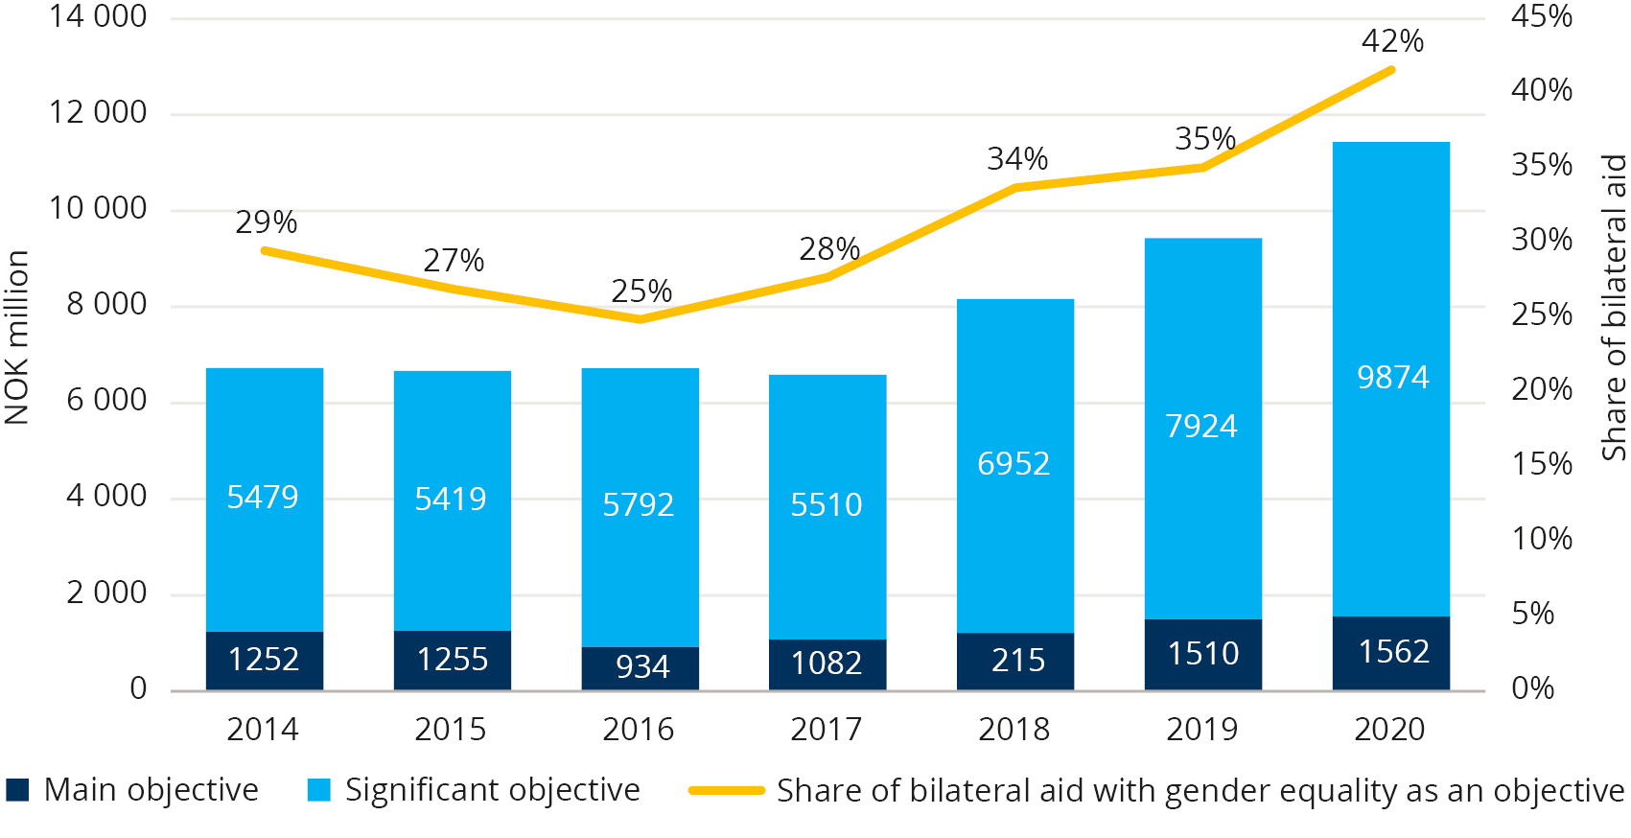
Source: Norad
In 2020, the most vulnerable were hit particularly hard by COVID-19. In international fora, Norway has worked to limit this negative effect by emphasising that the response to the pandemic must be non-discriminatory and inclusive, based on human rights, and by applying a gender perspective.
Support for national human rights institutions and for ensuring independent and competent judiciaries, is vital in ensuring that the rights of minorities and vulnerable groups are not left behind. This includes, but is not limited to, religious minorities, the LGBTI community, people with disabilities and indigenous peoples. Civil society has managed to reach target groups that would otherwise be difficult to reach. Norway provides financial and political support for an independent, vibrant and pluralistic civil society, which contributes significantly to the objective of leaving no one behind through inclusive and peaceful participation and realisation of human rights. Results related to our efforts in preventing normative backsliding, supporting human rights defenders and protecting the existing international human rights instruments and institutions are also highly relevant, as these instruments, institutions and organisations have equality and non-discrimination at the core.
Norway is preparing a strategy on disability inclusion, providing guidelines for future Norwegian involvement and efforts to ensure the inclusion of people with disabilities in our development cooperation. This is especially important in the present difficult situation – where results achieved are reversed due to COVID-19.
The risk of becoming a victim of modern slavery is thought to have increased considerably during the pandemic. Norway has strengthened its efforts to combat modern slavery in its development cooperation. A development programme was launched in 2020, and a new strategy is being developed.

LNOB in national follow-up and disaggregation of data
Statistics Norway and numerous other public agencies produce official data and statistics about the Norwegian population. The National Population Register is key in the production of statistics and is used in combination with other administrative registers and traditional statistical surveys and georeferenced data. Using a range of statistical variables, such as age, sex, nationality, migratory status and geographical location, Norway is well placed to cover the whole population with timely statistics as well as providing researchers with data to develop appropriate analyses about the Norwegian population. Statistical products disseminated by Statistics Norway and other producers of official statistics are published with relevant disaggregation. Some statistical products are also broken down by, for example, disability category when this information is collected through surveys.
In the 2030 Agenda, ethnicity are also desired disaggregation variables. Norway’s indigenous population, the Sami, have their traditional territories in the northern parts of the country that are part of Sápmi, an area which also stretches over northern Sweden and Finland as well as the Kola Peninsula in Russia. There are no official statistics that cover the entire Sami population. Thus, no basis is available for producing individual-based statistics on people with Sami ethnicity.
Norwegian official statistics include products describing the Norwegian parts of Sápmi, which means that statistics about the Sami produced by Statistics Norway are limited to certain geographical areas. Groups with a long-standing attachment to the country are defined as national minorities. The five national minorities (see Chapter 5.6.3 for more information) make up only a small part of the Norwegian population. Ethnic identification is based on the principle of self-identification. There is no official registration of ethnicity in the National Population Register.
The global indicators for the SDGs are presented by Statistics Norway at national level. In the future, this national reporting platform will include more disaggregated data for relevant indicators in order to meet national and sub-national user needs. In cases where certain variables, such as ethnicity, are not included in official statistics or in other sources for SDG monitoring indicators, this information should be sought in consultation with specific groups and through relevant research.

LNOB online – web accessibility
A key factor for success in leaving no one behind is ensuring equal access to digital platforms and arenas used by the population in their everyday life. Universal design of the built environment has been on the agenda for a long time. However, as society becomes more and more digitalised, the need for universal design of the digital environment has become a priority.
Norway is a highly digitalised society. The population has to cope with several digital solutions for filling out and sending applications and forms. Digital solutions are used for banking, public services, shopping, education, work, buying tickets, accessing news and media content, socialising etc. Without universal design of these ICT solutions, a large group of the population will either be denied access to essential services or be dependent on others. The issue is not necessarily the digital services themselves, because digitalisation can also make society more accessible. For example, a paper form is not accessible for a blind person, but a blind person can use a digital form if it is coded correctly. Universal design of ICT solutions is essential for achieving several of the SDGs (e.g. 3, 4, 8, 9, 10 and 16).
Norway has for many years had one of the world’s most progressive regulations on universal design of ICT, applicable to both the public and private sector. The regulations ensure universal design of websites, mobile applications and self-service terminals. Laws on technical requirements are just the first step to ensuring equal access to ICT. The next step is enforcing these laws. The Norwegian Authority for Universal Design of ICT audits providers of websites, mobile applications and self-service terminals, and has the power to issue fines when requirements are not met. Moreover, the Norwegian Anti-discrimination Tribunal handles complaints and appeals regarding universal access to ICT. The two administrative bodies have been crucial for putting universal design of ICT on the agenda in Norway.
Despite having a legal framework and executive bodies in place, there is still some way to go before the legal requirements are in place to ensure equal access to all aspects of society, such as the labour market. The lack of requirements on universal design of ICT within the labour market excludes many individuals from partaking in perhaps the most important social arena for adults in Norway. This is challenging both for individuals who are not able to practice their professions and for employers who are unable to benefit from the full potential of the labour force.
While there is still some way to go, the potential for inclusion in the digital era has never been greater.

Institutional mechanisms

Key changes/lessons learned
- The SDGs can only be achieved through enhanced cooperation across sectors, and the Government is considering several initiatives to facilitate this.
- From 2021 onwards, all government agencies are required to report on the status of their work on the SDGs in their annual reports to the Government.
- Since 2020, all line ministries are now represented in a State Secretaries’ committee for the the SDGs goals.
- Tripartite cooperation has a long history in Norway and contributes to a competitive labour market and a high unionisation rate.
- Short-term economic and political considerations displace long-term strategic policies and initiatives, which represent a challenge to achieving the 2030 Agenda.
- The structural issues that were present in Norway before the COVID-19 pandemic have become more prominent.

Governmental mechanisms
The SDGs can only be achieved through enhanced cooperation across sectors, and increased cooperation within the Government’s organisational structure.
          - Governmental organisation
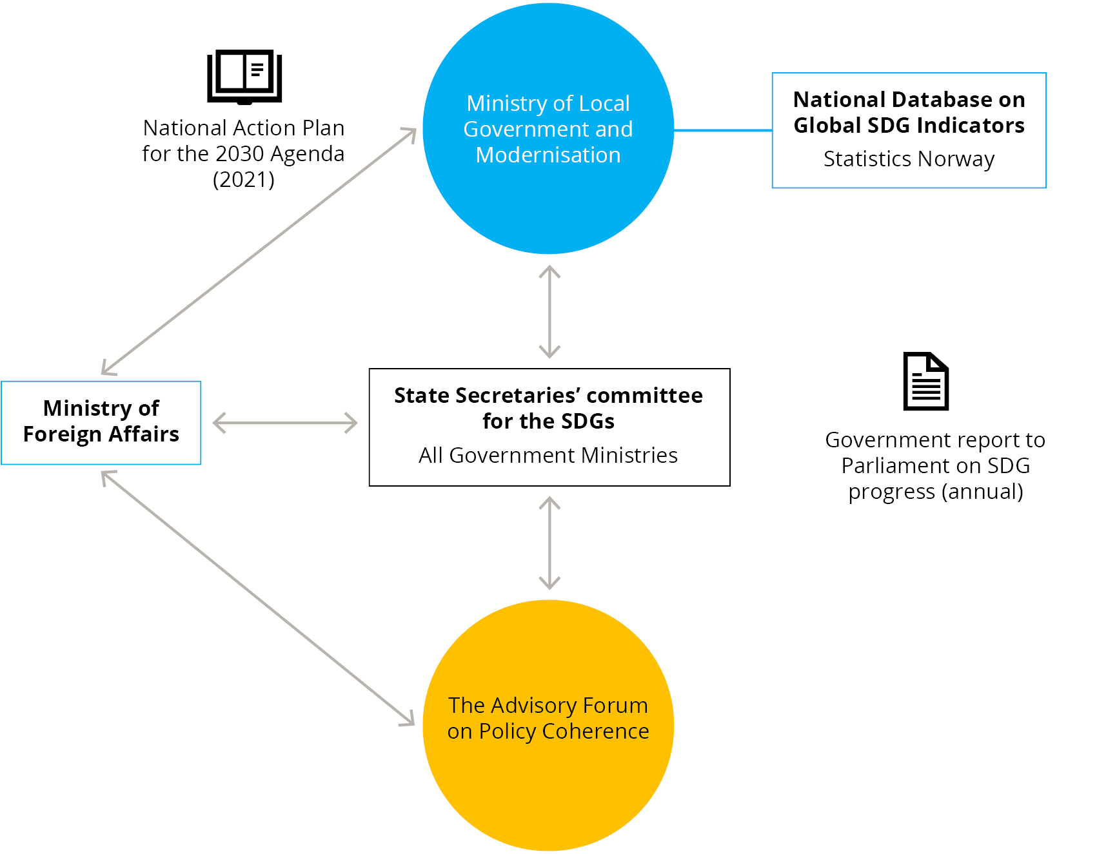
Source: Ministry of Local Government and Modernisation
In Norway, the different ministries are assigned responsibility for separate SDGs. Following the reorganisation of the national follow-up of the SDGs in 2020, the Ministry of Local Government and Modernisation is responsible for coordinating the national follow-up, whilst the Ministry of Foreign Affairs remains overall responsible for the international follow-up. All line ministries with responsibility for one or more SDG are represented in a State Secretaries’ committee for the the SDGs. The committee, which is led by the Ministry of Local Government and Modernisation, is responsible for coordinating reports and activities and ensuring a holistic approach to sustainable development in Norway. The ministries are required to consider the effects of proposed measures on the SDGs and describe the effects in official reports, strategies and propositions. Collaboration and involvement of stake­holders outside the public sector are maintained through the Advisory Forum on Policy Coherence. The forum seeks to involve a wide range of actors and organisations and is co-chaired by the Ministry of Local Government and Modernisation and the Ministry of Foreign Affairs.
The Government will, in the National Action Plan, consider different mechanisms to ensure dialogue and coherent follow-up, for instance establishing an expert panel and a National Forum for the 2030 Agenda. The National Action Plan will be presented to parliament this summer.
Government agencies
Most government agencies perform tasks that directly contribute to achieving one or more of the SDGs. From 2021 onwards, all government agencies are required to report on the status of their work on the SDGs in their annual reports to the Government. The reports should describe which SDGs their work has contributed to, what challenges were identified, and how their work can be aligned even more closely with SDGs in the future. These reports will provide valuable input to the Government’s annual report on the SDGs to parliament, and to future VNR processes.
Tripartite cooperation
In Norway, tripartite cooperation has a long history. Our system of wage formation with centralised collective bargaining between a few strong organisations on the workers’ and employers’ side is an important part of the model. A key feature of the model is what often is referred to as the ‘frontrunner model’ or the ‘pace setting model’ (frontfagsmodellen). According to this model, the sectors most exposed to foreign competition are the first to negotiate. The pay increase that the parties agree on for these sectors sets the norm for the other sectors, which subsequently start their bargaining.
The organisations can consider the impact that wage increases have on the level of unemployment, given their size and representativity. The centralised aspect of the negotiations also facilitates a relatively equal distribution of income. Combined with a well-functioning insurance system for the unemployed and strong institutions, the Norwegian model has contributed to a flexible labour market.
Of great importance is also the model’s system for avoiding conflicts and conflict-solving measures when a conflict has arisen. The National Mediator and the Labour Court are both vitally important institutions that both parties trust. As long as a collective agreement is in force, no industrial action (strike or lockout) can take place. This secures predictability and industrial peace for long periods, and makes the system work well. Social dialogue, in particular collective bargaining, has secured influence for the social partners, and it plays an important role in securing decent work for all employees. The Norwegian model has proven its strength in challenging times when the economy has been under pressure. The model has also paved the way for reforms in the welfare system such as the pension system.

Structural issues
Achieving the SDGs by 2030 is a formidable challenge. The obstacles are well known. Short-term economic and political considerations displace long-term strategic policies and initiatives. Achieving the SDGs requires cooperation between policy areas, levels of government and between the public, private and voluntary sectors. Public budgets are adapted to the sector division, which makes this type of cooperation difficult, but not impossible.
A study by the OECD showed that the biggest challenge the countries experienced was coordinating the efforts between the ministries. The report points out that effective coordination requires a cultural shift, more so than changes in technical solutions and routines. These are recognisable challenges in the Norwegian context. The societal challenges in the sustainability agenda are complex, and joint efforts are required across sectors and levels of government. Different goals, values, activities and resources must be seen in context, and be prioritised, weighed and adapted to each other.
The challenges lie in the complex issues that cannot be solved separately in sectors or by single actors. Tools and instruments such as innovation, research and planning regionally and locally need to be implemented to be successful.

Structural issues in the context of COVID-19
The structural issues that were present in Norway before the COVID-19 pandemic have become more prominent. The pandemic has deepened socioeconomic inequalities. For many vulnerable individuals and groups, the pandemic has led to a worsening of their situation. However, the pandemic has also accelerated ongoing processes such as the digitalisation of society. The recovery from the pandemic represents both challenges and opportunities for change. For the recovery to support the achievement of the SDGs, decisive action is needed.
As a direct effect of the pandemic, the living situation for many vulnerable people has been aggravated. People with a permanent illness have been harder hit than healthy people, low-income employees have to a greater extent lost their jobs, the shutdown of society has been harder to tackle for people living in small flats. People have also been hit by the economic effects of the pandemic.
The national economy was negatively impacted by the pandemic. The Gross National Product for mainland Norway fell 2.5 per cent from 2019 to 2020, and there was a dramatic rise in unemployment in this period. Most employees who lost their jobs (temporarily or permanently) belonged to low-income, low-education groups. Customer services (tourism, accommodation, catering, transport and culture) were severely impacted. The employees in these sectors are mainly young and unskilled workers. There is a risk that some individuals will be excluded from the labour market permanently. Individuals who are out of work for a long period of time may lose competence and attractiveness as employees.
The use of digital tools and technology during the lockdown period helped to reduce some of the negative effects. A prolonged lockdown period starting in March 2020 led to a sharp increase in the number of individuals teleworking. In March and April 2020, the proportion of employees working from home on a regular basis was estimated at 60 per cent. It is recently estimated that more than 40 per cent of Norwegian employees could perform their work from home in the future.
Both the private and public sector have made use of digital tools and technology. A public-private partnership developed a digital solution for the compensation scheme for businesses and industries hardest hit by the pandemic. The digitalisation of society may have positive effects on the climate and the environment going forward, for example if some business meetings and seminars can be held online. This may reduce the need for investments in transport infrastructure and office buildings. On the other hand, the demand for new digital infrastructure will increase, for example broadband coverage.
The pandemic has made progress towards meeting SDG target 5.2 more challenging. Preliminary reports suggest that domestic violence has increased during the pandemic, while other types of crimes have decreased. Furthermore, we face challenges related to SDG 8 Decent work and economic growth. Measures must be taken to prevent people being permanently locked out of the labour market, and to prevent inefficient dismantling of existing production facilities. However, measures to preserve existing jobs could delay the green transformation, cf. SDG 12 Responsible consumption and production. As a result of the crisis, the trend towards digitalisation has accelerated. This transformation has immediate positive effects on SDG 13 Climate action, and more long-lasting effects due to, among other things, less commuting to work, innovation and development of climate and environmentally friendly products.
The value of effective multi-level governance has become even more important during the COVID-19 pandemic. Municipalities and regions are key partners of national governments for the restoration of the economy, social life and normal democratic functioning at the local and regional level after the COVID-19 pandemic. As partners in multi-level governance, they must be involved in setting up mechanisms and procedures to tackle future emergency situations. In Norway, local and regional authorities have been instrumental in maintaining a low infection rate, by implementing local measures and undertaking contact tracing and testing, as well as vaccination, and ensuring that citizens are informed. The Norwegian Association of Local and Regional Authorities (KS) has acted as the contact point and coordinator for the local government sector and national authorities.
The Government was faced with many dilemmas when deciding which policies to implement to curb the spread of the virus. For instance, the decision to shut down large parts of the society in March 2020 affected the economy and the labour market. Difficult prioritisations between groups of people continuously had to be made, for example with respect to who should be prioritised for the COVID-19 vaccine. The Government appointed an independent commission to exam and evaluate of the Government’s management of the COVID-19 pandemic. The commission’s first report from April 2021 concluded that the Government handled the situation well overall, despite flaws in the Government’s emergency preparedness.

Monitoring and review mechanisms – development of national indicators
Monitoring progress is an important part of the SDGs, and the Government will submit a Voluntary National Review (VNR) to the UN every four years. The VNRs will be developed in cooperation with civil society, the private sector and local and regional authorities.
An important part of the work will be to develop a more comprehensive set of indicators. The National Action Plan proposes a set of national targets and indicators that needs to be developed further. Statistics Norway will, together with different government agencies, organisations and regional and local authorities, develop indicators for different monitoring and reviewing purposes. The indicators will, where possible, be based on existing national statistics and indicators. The statistics will be published on the official website.

Institutional mechanisms for involving civil society
There is broad political consensus in Norway on the importance of involving civil society in decision-making processes. Civil society organisations function as watchdogs over national, regional and local authorities and are a cornerstone of the Norwegian democracy. Civil society highlights important issues such as good governance and respect for human rights, and provides channels of influence and participation through a community-based, bottom-up approach.
Civil society organisations and other stakeholders are important consultative bodies to the Government. An issue is put out to consultation when a ministry wants to consult affected parties on a suggested bill or act. Consultations are used to allow the public, organisations and the business community to state their opinion, and to control how the public administration works and performs its tasks.
Among the issues put out to consultation are suggested laws and regulations to regulate people’s right and duties, suggested changes in how the public administration is organised (for instance relocation), jurisdiction changes, as well as reports.
Participation of stakeholders in regional and local policy processes is regulated by law. According to the Local Government Act, local authorities have to establish a council for senior citizens, a council for persons with disabilities and a youth council or other representative bodies for young people, to secure their interests.
The Planning and Building Act requires all planning proposals to be put out to consultation to all relevant stakeholders, including private organisations and institutions. Local authorities have a special obligation to secure active participation by vulnerable groups, especially children and youth.
The Government has a consultation scheme with the municipal sector on state framework conditions and goal achievements within the sector. The main theme for the consultation is the economic framework in the state budget. The Government also has a consultation agreement with the Sami Parliament, described in Chapter 5.2.1.
In addition to what is required by law, it is also tradition to cooperate closely with relevant stakeholders and establish arenas for knowledge sharing on specific issues, such as conferences and workshops. Networks such as the Forum for Development and Environment (ForUM) and the Norwegian Children and Youth Council (LNU) are important mechanisms for coordinating input from their member organisation on several topics related to the SDGs. Additionally, ForUM participate in the Norwegian delegation to the High-level Political Forum (HLPF) and LNU appoints youth delegates to UN forums on several topics related to the SDGs and provides a grant scheme that supports projects promoting one or more of the SDGs for children and youth organisations.
The Government want to strengthen the cooperation with civil society on the implementation of the 2030 Agenda, and is considering the establishment of a National Forum for the 2030 Agenda and an expert panel in relation to the government decision on the national action plan.

Progress on Goals and targets
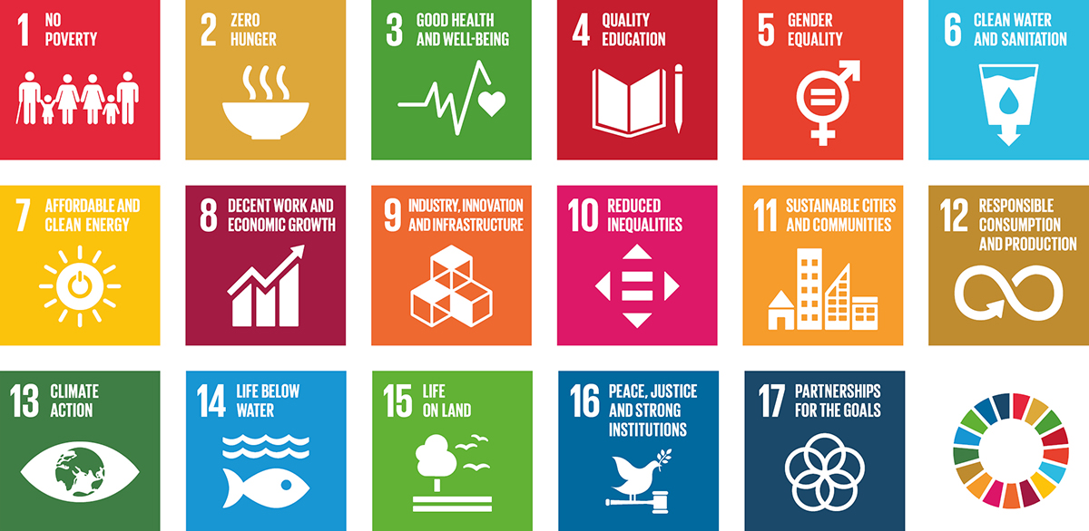

Current state and key changes 2016–2021
Norway generally ranks high in many international indexes that measure welfare and development, e.g. the Human Development Index (HDI). In the SDG Index, Norway is currently ranked at number 6. Norway often has a high ranking because of our strong economy, universal welfare system, well-functioning legal and democratic institutions, and a high level of trust in the government.
According to the SDG Index, Norway’s performance is particularly high for SDG 1 (no poverty), SDG 3 (good health and well-being), SDG 5 (gender equality), SDG 7 (affordable and clean energy), SDG 10 (reduced inequalities) and SDG 17 (partnerships for the goals). However, significant improvement is needed in relation to several SDG targets. This includes targets 6.5 and 6.6 on water management and restoring degraded water ecosystems, target 9.1 on sustainable infrastructure, and targets 12.2 and 12.5 on sustainable management and efficient use of natural resources and reducing waste generation.
Like many other Western countries, Norway is among the top 30 countries with the highest greenhouse gas emissions per capita. In the SDG Index, Norway’s performance is lowest when it comes to SDG 12 (responsible consumption and production) and SDG 13 (climate action). Norway did not meet any of the 20 Aichi Biodiversity Targets set for 2020, thereby failing to achieve the international biodiversity goals.

Progress in SDGs
The following progress report reflects the overall status and progress in the SDGs since Norway’s first Voluntary National Review (VNR) in 2016. The assessment is based on available data. Civil society has performed a separate assessment. A detailed progress report on the status and progress in the global indicators is found in the annex. The structure of the report on each SDG is inspired by Finland’s VNR in 2020.
The government assessments are illustrated using the following:
Norway has met the target
Norway has not met the target, but is close
Norway has not met the target
The progress is positive
The progress is small, but slow
The progress is negative or has stagnated

The civil society assessments uses the following symbols to indicate performance:
Norway has made positive progress towards achieving the goal
Norway’s progress towards achieving the goal has stagnated
Norway’s progress towards achieving the goal has slowed down

1 No poverty
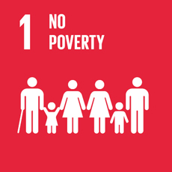
End poverty in all its forms everywhere

Government assessment
1.1 | Due to universal welfare schemes, no one in Norway is living in extreme poverty.
1.2 | The proportion of persons living in low-income households has gradually increased from 8.1 per cent to 10.1 per cent in the last ten years. The risk of poverty due to lack of basic material needs remains at a stable and low level.
1.3 | Norway has a well-developed public welfare system, and offers comprehensive social security covering to the whole population.
1.4 | The entire population has equal rights and access to economic resources, financial services, and basic welfare services, such as health care and education.
1.5 | The National Insurance Scheme provides income in the event of sickness, unemployment, disability, loss of breadwinner and old age, and parental and child benefits.

General status: From an international perspective, inequalities in income and the incidence of poverty in Norway are low. A minority of the population has a persistently low income. The persistent at-risk-of-poverty rate has increased somewhat in the last ten years. In recent years, the real income growth has weakened, and the income increase in the lowest income group has been weaker than in the rest of the population. The risk of poverty due to lack of basic material needs remains at a stable and low level.
          - Population living with a persistent low income 1997–2019 (EU scale 60 per cent below median income, three-year consecutive years)
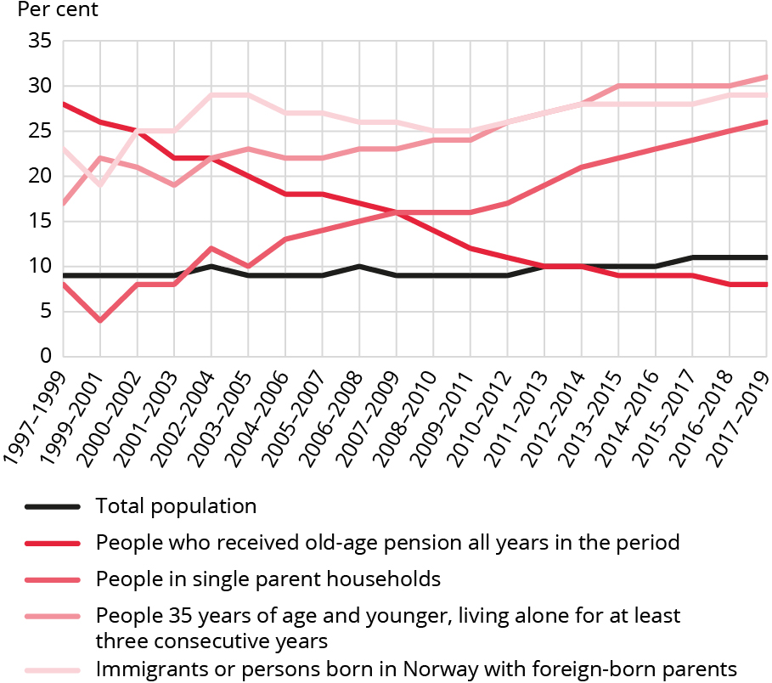
Source: Statistics Norway
Main achievements: High labour market participation and policies to promote economic growth have reduced the extent and severity of poverty. Universal welfare schemes and a comprehensive welfare state have improved general living conditions, especially for low-income and vulnerable groups. Low income among elderly people has been significantly reduced over time.
Norway’s main challenge is to maintain equal income distribution, increase participation of vulnerable groups in the labour market and prevent the intergenerational transmission of poverty. The increase in child poverty, especially among families with immigrant backgrounds, is of particular concern due to the negative consequences of poverty on children’s quality of life and life prospects.
Global responsibility: Norway’s objective is to eradicate extreme poverty. A high priority is given to the least developed countries. Norway has launched a development program to combat modern slavery and a strategy against harmful practices. A strategy for inclusion of persons with disabilities is currently being developed.

Main policy initiatives 2016–2021
- Reinforced the youth effort to improve employment and activity of persons under age 30 (2017).
- Nationwide labour market inclusion effort (2018).
- White paper on the Government’s strategy to counteract inequality (2019).
- Integration measures to improve language skills, job skills and employment of the immigrant population.
- National Strategy to Reduce Child Poverty (2015–2017) followed by a Strategy for Children and Youth in Low-income Families (2020–2023).
- Increased the universal child benefit.
- Measures to give children in low-income families’ equal opportunities to participate in social and learning activities.
- Increased the national grant scheme for the inclusion of children and youth in leisure and holiday activities and introduced a national pilot scheme with leisure cards for children aged 6–18 years to cover participation fees for sports, cultural or leisure activities.
- Discount schemes for children from low-income families in kindergarten. 20 hours per week of free kindergarten care for children in low-income families. A discount scheme for before and after-school programme fees has also been established.

Civil society assessment
The following organisations have participated in this assessment: UNICEF Norway, Strømme Foundation, the Salvation Army Norway, the Development Fund Norway, YGlobal, SOS Children’s Villages Norway and the Norwegian Forum for Development and Environment (ForUM).
Trend: Negative
Norway has succeeded in that poverty levels remain low in Norway. Extreme poverty is virtually non-existent. In 2018, the estimated ratio of people in Norway living on less than PPP $1.90 a day was 0.3 per cent. However, challenges remain pertaining to relative, multi-dimensional poverty.
Internationally, Norway has maintained Official Development Assistance (ODA) levels at a commendable yearly average of around 1.04 per cent of Gross National Income (GNI) in the 2016–2020 period, surpassing the 0.7 per cent ODA/GNI target. In 2020, ODA peaked at a record 1.11 per cent of GNI. The share of Norwegian ODA targeting least developed and low-income countries has grown from 48 per cent (2016) to 56 per cent (2020).
Norway’s challenge is that too many people in Norway still suffer adverse health and social outcomes related to economic, social and material deprivation, including social exclusion and psychological trauma. In 2019, 24 per cent of people aged 16 and over reported not being able to afford an unexpected expense of approximately $2,045 (NOK 18,000). Five per cent reported not being able to afford dental care.
The COVID-19 pandemic has only exacerbated the situation for the poor, and has substantially increased the number of people at risk of poverty. Norway has had a steady increase in the proportion of children growing up in households with persistently low incomes. From a rate of around 7.7 per cent in 2011, the rate increased to 11.7 per cent in 2019. This is particularly troubling, seeing as deprivation in childhood not only threatens children’s rights, but may feed a cycle of poverty, affecting individuals’ future health and well-being. There were 115,000 children living in low-income households in 2019. Over half of these children had immigrant backgrounds. Statistics Norway highlights weak attachment to the labour market as the main risk factor for households.
Unemployment rates more than doubled when the pandemic hit. Subsequently, unemployment has decreased to around 205,800 persons registered in mid-March 2021. This translates to approximately 7 per cent of the workforce; an increase compared to 2016, when the rate was approximately 4.8 per cent. At-risk groups (e.g. persons with immigrant backgrounds) are overrepresented. A total of 9.2 per cent of immigrants were registered as unemployed in Q4 2020.
Even if Norwegian ODA is contributing cross-sectorally to combating poverty, the share of development assistance aimed at protecting the most vulnerable against future shocks through climate adaptation is still relatively low, despite ambitious plans.

Norway must:
- re-integrate and include more people in the labour market, including persons with immigrant backgrounds;
- strengthen comprehensive, inclusive and universal social protection and welfare systems for all inhabitants, minimising geographical and other disparities;
- expand child-sensitive social protection programmes, including universal cash benefits for children. Child benefits should be index-linked, and should not entail deductions from other necessary welfare benefits for recipients;
- maintain support for significant and enhanced ODA commitments to accelerate implementation of the 2030 agenda. Norway must continue to commit at least 1 per cent of GNI to ODA, and should commit to further ODA increases in light of post-pandemic challenges;
- through development policies, promote universal welfare solutions that reach everyone, including universal health coverage and education;
- enhance post-pandemic efforts to support resilient livelihoods for the extremely poor and those most vulnerable to conflicts, climate change and natural resource depletion.

2 Zero hunger
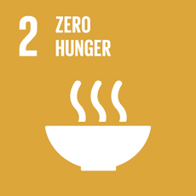
End hunger, achieve food security and improved nutrition and promote sustainable agriculture

Government assessment
2.1 | Norway has ensured that everyone has access to enough healthy and safe food that meets nutritional needs and food preferences, all year round.
2.2 | No significant malnutrition exists in the Norwegian population. Nutritional challenges are primarily related to overweight and obesity, and risk of malnutrion among older frailty persons.
2.3 | There are well-developed institutions in both the agricultural and maritime sector that provide equal access to knowledge, financial services, technology and other productive resources.
2.4 | Land suitable for arable crops is limited in Norway, but we have a variety of fisheries, grasslands and cultural landscapes that are managed for food production. Land degradation is of little concern in Norway, however we have targets to limit the conversion of cropland to other uses and these have been met in recent years. Climate change and other environmental change challenge food production. There is a continuous need for adaptation to such change and to address environmental pressures and enable co-benefits that arise.
2.5 | Cultivated plants are maintained in a joint Nordic gene bank and national clone archives, and livestock worthy of preservation through conservation herds and subsidy schemes.

General status: Food security in general is good in Norway as a result of a combination of political ambitions at national level and international cooperation and regulations to ensure safe food through international trade. However, lack of physical activity and unhealthy diets that trigger obesity remain a challenge. People in general consume too much salt, added sugar and saturated fat, and not enough fruit, berries, vegetables, whole grains and fish.
          - Agricultural area transferred to non-agricultural uses under the provision of the Land Act and The Planning and Building Act
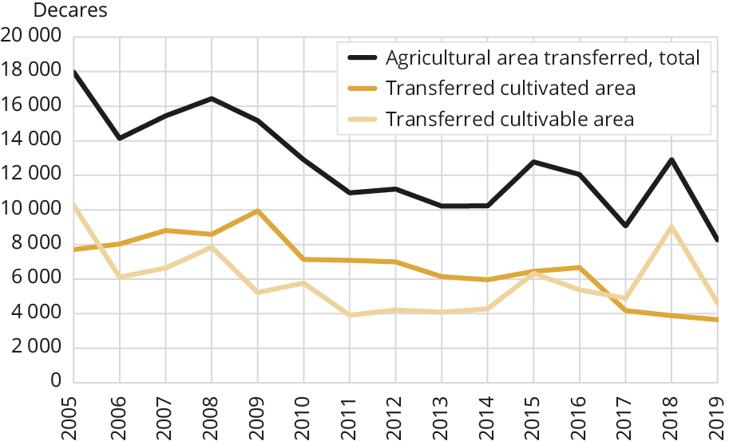
Source: Statistics Norway
Main achievements: The overall good status of national food security is based on the following three pillars: sustainable management of resources for food production, continuous production of safe food from land and sea, and trade. The Norwegian fisheries and agriculture sectors are amongst the highest value-creating primary industries in the world. Both sectors have well-developed institutions that provide access to knowledge, capital, technology and other production resources. Reindeer husbandry is an important industry in some parts of the country. Norway has established the Svalbard Global Seed Vault, in which 1,081,026 seed samples from 87 gene banks are securely stored.
Main challenges: With global environmental change, food production in our latitudes may become more important. For such production to last, we must manage resources long-term and ensure recruitment and income for households involved in food production. Climate change and other environmental change challenge food production in Norway. Agricultural production has to adapt to changing climatic conditions, and soil resources have to be protected to ensure food production. Mapping protecting soils have generated comprehensive knowledge of Norwegian soil resources. As a result, soil health has been given priority in agricultural policy. Maintaining the good status of animal and plant conditions is a challenge given that climate change is a risk factor. Securing sustainable reindeer husbandry depends on adequate grazing land. The availability of grazing land is increasingly challenged by external elements, such as the land use of other sectors.
Global responsibility: Ending hunger is a high priority in Norway’s foreign and development policy. Norway’s Action Plan for Sustainable Food Systems is designed to assist low-income countries in feeding their own population by focusing on 1) increased sustainable climate-resilient food production, 2) higher sustainable value-creation and improved markets, 3) healthier nutrition and diets and 4) better policy and governance. Norway supports more than 50 projects and programs in developing countries in the implementation of the Action Plan. The main result is increased food security for millions of poor people.

Main policy initiatives 2016–2021
- White Paper, Meld. St. 11 (2016–2017) Change and development – agricultural production for the future.
- White Paper, Meld. St. 32 (2016–2017) on the current policies for reindeer husbandry.
- The Government’s cross-sectorial Action Plan for Healthier and Better Diets (2017–2021).
- National Strategy, Securing the Gene Pool for Future Agriculture and Food production, for conservation and sustainable use of genetic resources for food and agriculture (2019).
- National Strategy on Protection of Agricultural, latest revision 2021.
- Norway’s Action Plan on Sustainable Food Systems 2019–2023.
- National Strategy for Urban Farming (2021).
- Norway’s Strategy on Climate Adaption, Prevention of Climate­-Related Disasters and Fighting Hunger (2021).
- Norway’s Climate Action Plan for 2021–2030.
- The Government’s cross-sectoral strategy to develop Norway as a ‘Food Nation’.
- National strategy on pollination.

Civil society assessment
The following organisations have participated in this assessment: the Norwegian Agrarian Association, Caritas Norway, FIAN Norway, the Norwegian Forum for Development and Environment (ForUM), the Norwegian Grandparents Climate Campaign, the Royal Norwegian Society for Development, Norwegian Church Aid (member of ACT Alliance), Spire and the Development Fund Norway.
Trend: Stagnant
Norway has already succeeded in securing food for many generations, and hunger is eradicated in Norway. The farmers’ unions and the Government have signed agreements to secure the multi-functionality in agriculture. Norway has committed to implementing the 4 per 1000 Initiative in order to increase the soil carbon stocks. Farmers’ organisations have made plans to cut GHG emissions. Norway has increased the political focus on the importance of small-scale food producers (farmers, fishermen, pastoralists, gatherers) as key actors for ensuring food security (food from agriculture and sea, fresh waters) in development policy. Together with developing countries, Norway holds and promotes a clear and strong position on farmers’ rights to seeds in order to ensure food security and climate adaptation. Norway supports research on sustainable food production systems both nationally and internationally. The Government, farmers’ organisations and the food industry have made an agreement to reduce food loss. Production of biogas from food waste is increasing.
Norway’s challenges include that a third of elderly people in Norwegian hospitals and municipal health-care services are malnourished or at risk of malnutrition. Meanwhile, the obesity rate for children in Norway is 15 to 20 per cent, and Norway has the most obese population among the Nordic countries. The self-sufficiency ratio for food produced in Norway is only 40 per cent. The grocery retail market is dominated by only three grocery retail chains, which in combination hold a 98 per cent market share. In relation to Norway’s contribution to SDG 2 internationally, the country’s main challenge is to follow up its Action Plan for Sustainable Food Systems with an increase in Norwegian development aid to support food security and agriculture. Only 6 per cent (2017) of the Norwegian development aid is used to support these areas. Small-scale food producers need predictable support and long-term perspectives. A key challenge is to raise the discussion on food in relation to other SDGs and how these are influenced by what we eat, how food is produced, where it is produced and how it is used (food loss).

Norway must:
- develop a plan for each municipality for the realisation of rights to food and health according to the concluding observations of the UN Committee on Economic, Social and Cultural Rights;
- mitigate risks stemming from the limited number of food retail chains (3) in Norway;
- promote sustainable food systems that address control over feed and food production and natural resources, increase self-sufficiency and the population’s need for a healthy and sustainable diet, fair trade and investments;
- shift subsidy schemes from volume production to area production in order to safeguard self-sufficiency, the social mission of agriculture, cultural landscape and the world’s resource base;
- support the genetic diversity of plants and seeds and local communities’ rights to harvest and share these in international fora and through own trade agreements;
- increase support for small-scale producers, through improved access to financial support and support for cooperatives and extension services;
- double foreign development aid in food security and agriculture (excluding humanitarian assistance) and recalibrate the support in response to COVID-19;
- acknowledge that the Paris Agreement defines support for climate adaptation in developing countries to protect the most vulnerable, which is equally important to mitigating efforts, and increase Norway’s support for adaptation to 50 per cent of all climate finance;
- promote and finance a human rights approach that takes into account minimum living conditions. A useful tool is the Human Rights Measurement Initiative;
- provide information and background for relevant discussions and decision-making processes connected to food in a global perspective.

3 Good health and well-being
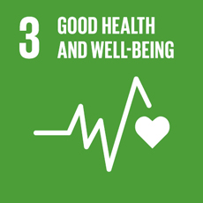
Ensure healthy lives and promote well-being for all at all ages

Government assessment
3.1 | Norway has a very low maternal mortality rate and safe maternity care with a high level of skilled personnel.
3.2 | The mortality rate for infants and children under 5 years is less than 3 per 1,000. Risk births are followed closely.
3.3 | There is a low level of deaths by communicable diseases, and hardly any water-borne diseases. A vaccination programme has reduced chlamydia among young people.
3.4 | Non-communicable diseases represent the biggest burden of disease in Norway. Challenges are linked to risk factors like decreasing physical activity, unhealthy diets and smoking. These are related to social inequity. Mental health problems are important and increasing among younger people. The suicide rate is too high.
3.5 | Harmful alcohol consumption has gone down, but alcohol use is still an important health risk. Treatment for substance abuse is improving, but the number of overdoses is stable.
3.6 | Deaths and injuries in road accidents have fallen significantly.
3.7 | Universal access to sexual and reproductive health-care services is very good for all, not dependent on gender, age, ethnicity or sexual orientation.
3.8 | The level of universal health coverage is very good, with limits on out-of-pocket payments. Dental care coverage is limited to some groups.
3.9 | Deaths and illnesses from pollution and contamination are few, but air pollution is a health risk in some areas.

General status: Norway has a well-developed system of universal health coverage and access to quality health care for all. Life expectancy is high and increasing; in 2020 it was 85 years for women and 81.5 years for men. However, non-communicable diseases and social inequities are still public health challenges. Women and men with a short education (primary/lower secondary level) can expect to live about five years less than those with a long education.
          - Suicide mortality rate
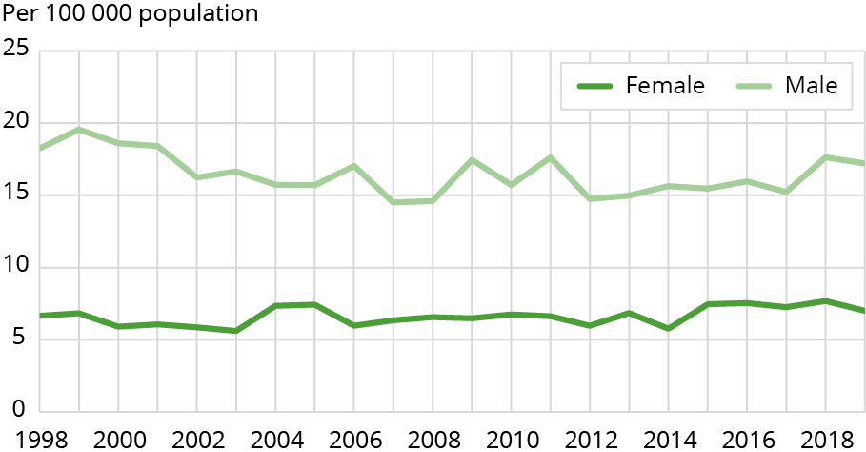
Source: Norwegian Institute of Public Health
Main achievements: Life expectancy and healthy life years are going up for both men and women. The reduction in smoking and better medical interventions have significantly brought down the number of premature deaths from cardio-vascular disease and cancer in the last ten years. Norway has a well-developed health system, with universal health coverage, and most health services are financially accessible to all. Access to sexual and reproductive health services is very good for all, not dependent on gender, age ethnicity or sexual orientation. Preventive programs for HIV- risk groups have been introduced. The level of air pollution is decreasing.
Main challenges: Decreasing physical activity as well as obesity and unhealthy diets are a public health challenge. Despite a drop in the number of daily smokers, smoking is still the main contributor to illness and premature death, and is significant for social inequality in health. Mental health issues are increasing. Suicides account for an important part of premature deaths in men. Alcohol use is a risk factor in the loss of healthy life years. The death rate from overdoses of illegal drugs is relatively high in Norway. Social inequalities persist as a major risk factor for inequities in health.
Global responsibility: Financial support has been increased considerably during the COVID-19 pandemic, including for mobilising resources for access to vaccines, testing and other COVID-19 tools. Norway’s contribution to the ACT Accelerator is in excess of USD 500 million. Norway provides substantial financial support to Gavi, the Coalition for Epidemic Preparedness Innovations, the Global Fund to Fight Aids, Tuberculosis and Malaria, WHO, UNAIDS and the Global Financing Facility in their work. Additionally, Norway support institutional collaboration at bilateral level to strengthen public health and health systems. A strategy on non-communicable diseases (NCDs) has been launched, which includes a focus on mental health. Norway endorses the Doha Declaration on the TRIPS Agreement and Public Health.

Main policy initiatives 2016–2021
- National Action Plan for Better Nutrition (2017–2021).
- Strategy for Sexual Health 2017–2022: Talk about it!
- Strategy for Good Mental Health 2017–2022, followed by an Action Plan for Mental Health in Children and Youths (2019–2024).
- National Programme for an Age-friendly Norway (2019–2023).
- National Alcohol Strategy (2020–2025).
- Dementia Plan 2020 and Dementia Plan 2025.
- The Government’s Action plan for Physical Activity (2020–2029) ’Together for physically active lives’.
- White Paper No. 19 (2018–2019) Public Health Report – A Good Life in a Safe Society.
- Better Health, Better lives. Combating Non-Communicable Diseases in the Context of Norwegian Development Policy (2020–2024).

Civil society assessment
The following organisations have participated in this assessment: FORUT – Campaign for Development and Solidarity, the Norwegian Medical Students´ Association (NMSA-Norway), SOS Children’s Villages Norway, UNICEF, Save the Children Norway, IPPF-Norway, the Norwegian Association for Outdoor Organisations, the Norwegian Trekking Association, the Norwegian Cancer Society, Unio (the Confederation of Unions for Professionals and Poly Norway.
Trend: Stagnant
Norway has succeeded in having a well-developed health system and a population in general good health. The goal of reducing premature deaths from non-communicable diseases (NCDs) by 25 per cent by 2025 has been achieved, and was adjusted to a reduction by a third by 2030. Important factors are recognising voluntary work as an important role in good public health, as well as maintaining one of the world’s strictest tobacco policies.
Norway has succeeded in playing a leading role within global health. Norway has contributed heavily in financial terms to GAVI, CEPI and COVAX. Norway’s development policy has advocated for sexual and reproductive health and rights (SRHR), and has helped raise awareness of harmful traditional practices.
Norway’s challenge is the lack of political follow-up of goals and measures, especially goals related to physical activity, diet, overweight and obesity, and social inequalities in health. The UN has criticised Norway for not giving the same health rights to undocumented migrants. Higher education adds 5–6 years to a person’s life, compared to those with low levels of education. The mortality rate of drug-related deaths is high compared to other countries. Access to services connected to SRHR in Norway is undemocratic and unequal, especially when it comes to the Sáami population and other minorities. Sex workers are also excluded from universal sexual and reproductive health-care services, especially in the wake of COVID.
Norway’s challenge is that studies by the Norwegian Institute of Public Health show levels of heavy metals, arsenic and mineral manganese, measured in maternal blood during pregnancy, associated with increased risk of ADHD and/or autism. Diseases caused by climate change, environmental toxins and antibiotic resistance are in danger of increasing and must be monitored.
Norway has launched an NCD strategy and an action plan, in which mental health has been included as a factor for early death for the first time. However, Norway has yet to prioritise NCDs in Norwegian development policies even though they represent one of the greatest threats to achieving the SDGs.

Norway must:
- implement economic incentives on health-damaging products such as alcohol, various foods, tobacco and drugs;
- make health-promoting goods more available for the whole population;
- involve the voluntary sector as a key player in preventive and health-promoting work;
- introduce one hour of daily physical activity in schools, and ensure good-quality outdoor areas in school, pre-school and nursery facilities;
- give nature a higher priority in spatial planning and introduce a national goal of a maximum of 500 metres to the nearest walking trail or nature area;
- recognise nature as a tool in preventing mental health issues, and prioritise health-promoting work related to mental health and well-being;
- in line with UN drug conventions, focus on prevention, holistic treatment and rehabilitation programmes to replace incarceration and fines as a reaction to minor drug offences;
- implement an equitable health system that includes dignified follow-up for asylum seekers and stateless persons;
- lead the international effort to integrate NCDs into the development agenda, especially in relation to mental health, and include civil society in its implementation;
- increase its support for the SAFER initiative to assist low- to middle-income countries;
- take the international lead to shape and coordinate an improved system for pandemic preparedness and response, including fair and equitable development of medicines and vaccines.

4 Quality education
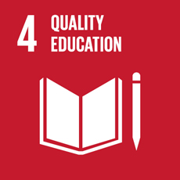
Ensure inclusive and equitable quality education and promote lifelong learning opportunities for all

Government assessment
4.1 | Primary and secondary education is free and accessible for all. Completion rates for secondary education remain a challenge.
4.2 | All children have access to pre-primary education.
4.3 | Tertiary education in Norway is free for all and maintains a good quality.
4.4 | Measures have been taken to raise the status of vocational subjects and reduce the high dropout rate.
4.5 | Gendered differences in learning outcomes still persist in the Norwegian educational system.
4.6 | Ten per cent of the Norwegian population has poor reading skills, about 15 per cent has a poor understanding of numbers.
4.7 | Sustainable development is one of three interdisciplinary topics in the new curricula for primary school.

General status: Norway can demonstrate solid results and progress on many SDG 4 indicators. Education in Norway maintains a good quality and is accessible to all. However, some challenges remain. Over 20 per cent of pupils fail to complete secondary education. Gendered differences in learning outcomes and higher education enrolment is another area in need of improvement. The last few years have seen several educational reforms.
          - Proportion of pupils at the end of lower secondary school (year 10) achieving at least a minimum proficiency level in reading and mathematics
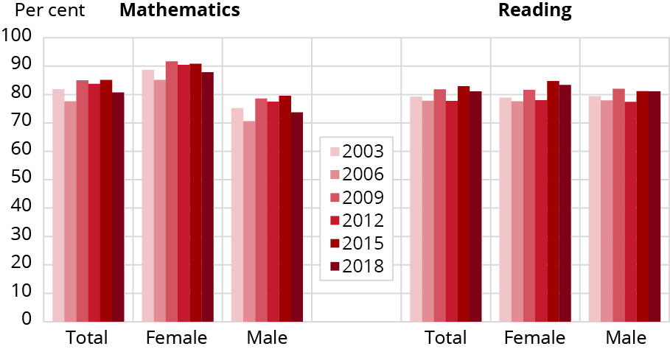
Source: UN Global Database, OECD, Ministry of Education and Research

Main achievements:
- In 2019, 98 per cent of children aged five attended kindergarten.
- All children have a right and an obligation to attend primary and lower secondary education. Nighty-eight per cent continued into upper secondary education in 2019.
- Schooling and higher education are mainly free, which is why Norway scores high on the SDGs regarding access to education.
- Norwegian 15-year-olds perform slightly above the OECD average in reading and mathematics, and equal to the OECD average in science.
- Norway has a relatively high proportion of people with primary and lower secondary education.

Main challenges:
- Completion rates in upper secondary education remain a challenge. Of the cohort that started in 2013, 78.1 per cent completed within five or six years, up 6 percentage points compared to the cohort starting in 2006.
- Boys consistently score lower than girls in reading and most other subjects throughout primary and secondary education.
- Gender differences are reflected in higher education enrolment. Fifty-eight per cent of women aged 25–34 had a higher education or a higher vocational education in 2019, compared to 40 per cent of men.
- Sixty-four per cent of students with physical disabilities do not complete their education.
Global responsibility: Quality education for all is a priority area in Norway’s development policy. About two-thirds of Norway’s aid for education is channelled through multilateral partners such as UNICEF, the Global Partnership for Education, Education Cannot Wait and UNESCO. Programmes funded by Norway focus on quality and inclusion and many of them have a component of teacher training. Norway has focused its aid on low-income countries, and countries affected by crisis and conflict. Inclusion of girls and marginalised groups, including children with disabilities, is a key priority. Norway also focuses on quality education in emergencies.

Main policy initiatives 2016–2021
- White Paper, Meld. St. 4 (2018–2019) Long-term plan for research and higher education 2019–2028.
- White Paper, Meld. St. 6 (2019–2020) Early intervention and inclusive education in kindergartens, schools and out-of-school-hours care.
- White Paper, Meld. St. 14 (2019–2020) Skills Reform.
- White Paper, Meld. St. 21 (2020–2021) Completion reform in upper secondary education.
- Fagfornyelsen: renewal and implementation of core curriculum and subject curricula in 2020.
- Measures to improve opportunities for young people after the pandemic, including: measures to ensure employment for apprentices, funding for more student places and student jobs.

Civil society assessment
The following organisations have participated in this assessment: the United Nations Association of Norway, UNICEF Norway, Junior Achievement, the Strømme Foundation, the Norwegian Library Association, ADRA Norway, SAIH, the Foundation for Environmental Education (FEE) Norway, the Norwegian Association for Outdoor Organisations, Save the Children Norway, the Salvation Army, IPPF Norway, the Norwegian Guide and Scout Association, CISV, the Norwegian Forum of Disabled Peoples’ Organisations SAFO, Dyslexia Norway, the National Union of Students in Norway, NITO, CCL, the RORG network, Unio (the Confederation of Unions for Professionals and SOS Children’s Villages.
Trend: Stagnant
Norway has succeeded in building a very good and robust educational system, which guarantees all children equal access to free, standardised education. In 2020, Norway integrated Education for Sustainable Development (ESD) into the general curriculum by creating three cross-disciplinary school subjects; ‘Sustainable Development’, ‘Democracy and Citizenship’ and ‘Public Health and Life Skills’.
Internationally, Norway has increased education aid for low-income countries and strengthened the Tax for Development programme that enables development countries to improve domestic financing for education. Norway also participates in various student exchange programmes with universities across the world.
Norway’s challenge is a shortage of qualified school teachers and kindergarten employees. While sustainable development is anchored in the new curriculum, teacher education programmes do not include specific training for teaching sustainable development. Without proper training on social, economic and environmental sustainability, teachers could not be expected to take ownership of ESD. This would, in turn, limit the momentum of the new curriculum. The teacher education programmes also lack sufficient training in Comprehensive Sexuality Education (CSE). As we see more nationalist and isolationist sentiments across Europe, more focus is also needed on global citizenship education.
The PISA 2018 survey shows that one in five Norwegian 15-year-olds are ‘low-performing’ readers. Systematic use of school libraries in education would have a positive impact. It is also important to identify reading difficulties at an earlier stage, especially among ethnic minorities. Translating and adapting teaching material to Sámi languages is still a challenge. The extent to which pupils with disabilities are included in schools is not satisfactory. This challenge increases with age, and at present, only 30 per cent continue to upper secondary school alongside their peers. Another challenge is the high percentage of dropouts at the upper secondary school level, which is worst among boys and in vocational training programmes.

Norway must:
- integrate ESD as part of the teachers’ education and provide schools with the necessary tools to ensure active-based learning for all pupils so they acquire the knowledge and skills needed for sustainable development;
- implement valid indicators for measuring, evaluating and reporting on target 4.7, that includes non-formal sectors;
- strengthen the efforts to recover learning losses and physical as well as psychological impacts of COVID-19 nationally and globally;
- introduce more inclusive, formal and non-formal child and youth-centred quality education with a focus on individuality, diverse practices, creative activities and a more flexible transition from lower to upper secondary school;
- ensure satisfactory outdoor areas for daily physical activities and outdoor teaching;
- use laws, regulations and earmarked funds to ensure the full inclusion of pupils with disabilities at all levels of their education;
- strengthen anti-bullying efforts, especially regarding cyber-bullying;
- provide flexible digital learning nationally, and extend these same opportunities globally;
- earmark 15 per cent of development aid to education and increase support to relevant education funds and partnerships, UN organisations and civil society actors. Stop all ODA funding to for-profit schools. Providing free, inclusive, public, quality education should be the cornerstone of Norwegian development aid, in line with human rights, SDG 4 and our domestic education policy;
- continue its global leadership role for the right to quality education, systematically promoting equality and accessibility in quality education, and safe schools, globally and at home.

5 Gender equality
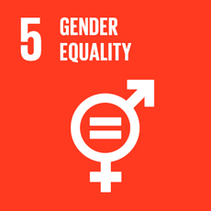
Achieve gender equality and empower all women and girls

Government assessment
5.1 | The gender equality situation is very good, but there is still room for improvement.
5.2 | Norway still has a problem with violence against women, but has several local and national initiatives to mitigate this.
5.3 | Harmful practices are prohibited by law, but challenges still remain.
5.4 | The public services and social rights in Norway ensure equal opportunities to work and raise a family. The parental leave period has been divided into three equal parts.
5.5 | There is gender equality in politics and the public sector, but there are still challenges in the private sector.
5.6 | Everyone in Norway has access to good sexual and reproductive health care. Comprehensive sexual education, birth control and safe abortions are easily accessible.

General status: Norway has a high degree of gender equality. The employment rate is nearly as high for women as for men. There are good parental benefits, extensive flexible work arrangements, a statutory right to leave to care for sick children and an entitlement to part-time work in connection with the care of children under 12. Parents of young children have a statutory right to day care with a price cap, and day care is offered to young schoolchildren outside school hours.
          - Proportion of seats held by women in local government, per election year
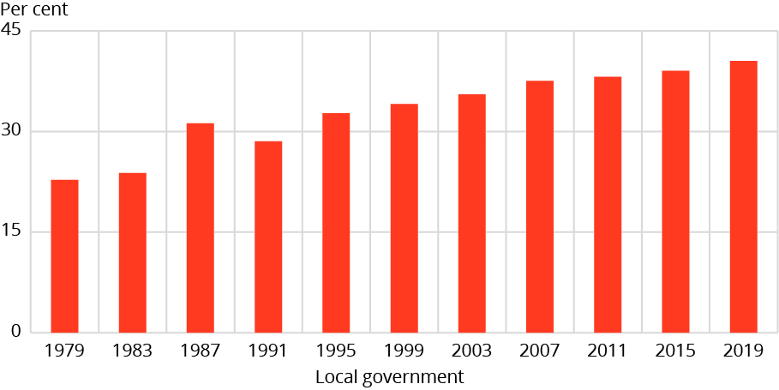
Source: Statistics Norway

Main achievements:
- Norway is ranked 2nd out of 153 countries in the World Economic Forum’s Gender Gap Report 2020. This is due to political agreement over decades that initiatives to promote gender equality are necessary, good legal protection against discrimination and a low-threshold system for enforcing the protection against discrimination.
- An increasing number of women complete previously male-dominated higher education, such as medicine, law, economics and engineering.
- The long trend shows a reduction in the gender wage gap. In 2020, women’s wages were on average 87.5 per cent of men’s wages.
- Never before have fathers taken out so many days of parental leave as in 2020.
- Equal representation in politics and at management level in the public sector.

Main challenges:
- Norway has challenges relating to violence against women. This includes domestic violence, sexual harassment, rape, social control, honour-related violence and forced marriages.
- Women are still vastly underrepresented in positions where financial decisions are made in the private sector.
- Among the CEOs of the 200 largest companies in Norway, 14 per cent are women (2020).
Global responsibility: Promoting women’s rights and gender equality are fundamental in Norway’s foreign and development policy, both through targeted initiatives and as a cross-cutting issue. Giving priority to women’s political participation and economic empowerment is crucial. Promoting sexual and reproductive health and rights is a main priority. Norway has stepped up its efforts to combat sexual and gender-based violence in humanitarian crises and has intensified its focus on eliminating harmful practices such as child marriage, female genital mutilation, and son preference. Likewise, ensuring women’s participation in peace and reconciliation processes is a key Norwegian priority.

Main policy initiatives 2016–2021
- White paper, Meld. St. 7 (2015–2016) Equality in practice – Equal opportunities for women and men.
- Action Plan for Women’s Rights and Gender Equality in Foreign and Development Policy (2016–2020).
- Action Plan to Combat Negative Social Control, Forced Marriage and Female Genital Mutilation (2017–2020).
- Escalation Plan to Fight Violence and Abuse (2017–2021).
- Action Plan for Female Entrepreneurship (2019).
- Norway’s International Strategy to Eliminate Harmful Practices (2019–2023).
- Norway’s National Action Plan on Women, Peace and Security (2019–2022).
- National Action Plan to Prevent and Combat Rape (2019–2022).
- Action Plan to Combat Negative Social Control and Honour-related Violence (2021).
- Action Plan against Domestic Violence (2021).

Civil society assessment
The following organisations have participated in this assessment: IPPF Norway, Bibi Amka Woman Wake Up, FOKUS – Forum for Women and Development, FRI, KFUK-KFUM Global, KUN Centre for Equality and Diversity, the Centre for Equality, LO Norway – the Norwegian Confederation of Trade Unions, the Royal Norwegian Society for Development, the Norwegian Guide and Scout Association, Plan International Norway, Poly Norway, Save the Children, the Sámi Women’s Network, the Norwegian Youth Network for Sexual Politics, the Centre for Gender and Equality, Sex and Society, Unio (the Confederation of Unions for Professionals and Soroptimist Norway).
Trend: Stagnant
Norway has succeeded in strengthening active equality efforts, and as of 2020, employers must make systematic efforts to promote gender equality and prevent discrimination. A legislative update on hate crime from 2021 is also now providing necessary legal protection for trans women. The Action Plan to Combat Negative Social Control, Forced Marriage and Female Genital Mutilation was launched in 2017.
Norway is a strong international advocate for gender equality and sexual and reproductive health and rights (SRHR), with a particular focus on eliminating harmful practices. Norway has actively contributed to putting sexual violence in humanitarian crises on the international agenda. A development programme against modern slavery was established in 2020.
Norway’s challenges are systematic inequalities between men and women in economy, politics and business. In employment, the gender-segregated labour market, part-time working and the gender pay gap are all still issues. Minority women are especially vulnerable. Shrinking civic space, hate speech, discrimination and online harassment are barriers to girls’ and women’s free speech and democratic participation. The new Norwegian Climate Action Plan is gender blind, even though climate change has clear gendered effects.
Access to SRHR services in Norway is undemocratic and unequal, partly because of geographical distances. In 2019, the Norwegian abortion law was tightened, and foetal reduction in cases of multiple pregnancies now needs approval as opposed to being ‘on demand’. Pupils are calling for more comprehensive sexuality education. Increased competence on gender equality, diversity and norm-critical pedagogy in kindergartens and schools is needed. Police, education and health institutions do not use existing knowledge from minority and Sáami communities. Direct cooperation with the communities, Sámi Parliament and scholars is needed to make information and services available in all relevant languages.
At a global level, the COVID-19 pandemic has serious negative effects on women’s rights and gender equality. Violence against women has increased. Economic uncertainty and unemployment are hitting women hard, especially women in rural areas.

Norway must:
- continue nationally and internationally to strengthen efforts to combat all forms of violence against women and girls, including digital forms;
- follow up the Istanbul Convention;
- launch a new action plan against domestic violence;
- prohibit sexual actions without consent in criminal law;
- ratify the ILO Convention against Violence and Harassment and adopt ILO recommendation no. 206;
- ensure a strong gender perspective in post-pandemic politics, nationally and internationally, including an active policy to create new jobs, ensuring strong workers’ rights and reducing income inequalities;
- strengthen the intersectional approach in all work to achieve gender equality, and not limit gender equality policies and efforts to a binary model;
- follow up the Norwegian Official Report NOU 2019: 19 on gender equality challenges for children and youth, including substantial investments to counteract the gender divide in the choice of educational programmes and vocational training;
- fulfil the commitment to increase bilateral development assistance that has women’s rights and gender equality as a primary or significant goal to 50 per cent;
- develop a feminist foreign policy, for Norwegian development aid to truly become gender transformative.

6 Clean water and sanitation
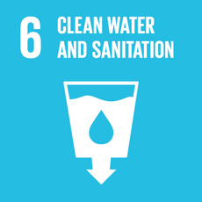
Ensure availability and sustainable management of water and sanitation for all

Government assessment
6.1 | Norwegians enjoy universal access to safe and affordable drinking water, adequate and equitable sanitation and sewerage for all.
6.2 | Norwegians enjoy universal access to adequate and equitable sanitation and hygiene for all and end open defecation.
6.3 | The general water quality is good, but there are challenges linked to wastewater and pollution.
6.4 | The supply of fresh water is good, but upgrades and adaptation of the water and wastewater system are needed.
6.5 | The goal is to a large extent achieved for integrated water management and transboundary waters.
6.6 | There are still improvements needed, especially for forest protection. Peatland, wetland and river restoration need to continue.

General status: Norwegians enjoy universal access to safe and affordable drinking water, and adequate and equitable sanitation for all. The disinfection of drinking water at water treatment plants in Norway has improved over the last 20–30 years, partly as an effect of the National Programme for Water Supply. Figure 6.6 shows that the number of waterworks that distribute uninfected surface water has been severely reduced since 1994.
          - Trend – the number of water works (subject to approval)/persons supplied with non-disinfected ­surface water
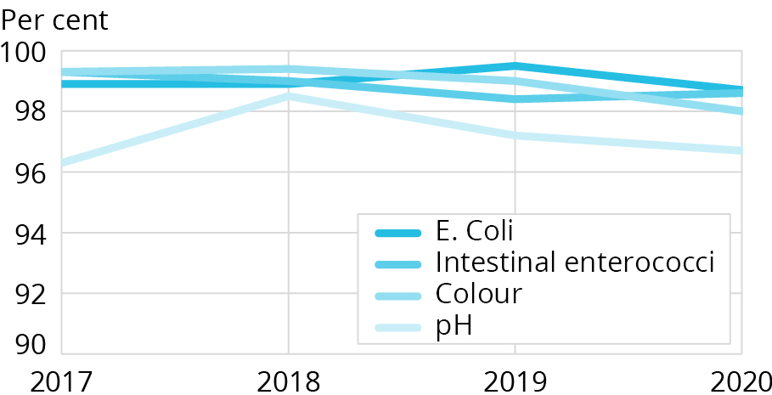
Source: The Norwegian Public Health Institute

Main achievements:
- Almost 100 per cent of the Norwegian population have access to treated drinking water from waterworks that meet high quality standards.
- Most wastewater is treated, and the majority of the population is connected to municipal wastewater systems.
- Norway is working towards integrated water resources management implementation through implementation of the EU Water Framework Directive.
- Norway has protected many areas that are important for water-related ecosystems, and a concept is being developed for a comprehensive management plan for wetlands. New cultivation of bogs has been illegal since June 2020.
- Norway has established funding for the restoration of rivers and improved joint management of transboundary waters with neighbouring countries.

Main challenges:
- A significant part of the Norwegian pipeline network is old, and the low rate of replacement of deteriorating pipelines is a challenge. On average, 30 per cent of the water leaks out before it reaches the consumer.
- Parts of today’s water and sanitation systems are not adapted to climate change. Increased precipitation, floods and rising sea levels will in the future be a challenge in many municipalities.
- There is insufficient information about private wells and other small water plants that do not require approval. These supply water to approximately 525,000 inhabitants.
- Coordination across sectors and levels of government still poses some challenges.
Global responsibility: In 2020, Norway spent approximately 100 million NOK on water and sanitation in developing countries. Through the Norwegian Church Aid, Norway has provided WASH services for an estimated 1,443,247 women, men, boys and girls affected by crises in 12 countries. In Somalia, Norway is supporting a programme to assess the potential for deep ground water, which potentially could help to alleviate the long-term water crisis in the country. Water and sanitation is also a component of Norway’s humanitarian support (6,3 billion NOK budgeted in 2021).

Main policy initiatives 2016–2021
- The revised Norwegian National goals for Water and Health (2017).
- The emergency advisory service unit for waterworks (2017).
- Plan for the restoration of wetlands in Norway (2021–2025).
- Strategy for the Restoration of watercourses related to the UN-Decade of Ecosystem Restoration (2021–2030).

Civil society assessment
The following organisations have participated in this assessment: UNICEF Norway, Sabima, the Norwegian Association for Outdoor Organisations, the Norwegian Hunters’ and Anglers’ Association, WWF Norway, the Norwegian Trekking Association, Friends of the Earth Norway.
Trend: Stagnant
Norway has succeeded in providing safe drinking water and good sanitary conditions domestically.
Norway is on the right path in terms of implementing integrated water management through implementation of the EU Water Framework Directive. This ensures a higher degree of public participation and a transparent process. The work has improved the level of knowledge on the management of freshwater and coastal resources, and is receiving more attention and resources from the Government, albeit at a very slow pace. A small but important improvement for protecting freshwater ecosystems is the recent prohibition of agricultural conversion of mires and boglands.
Norway’s challenges include insufficient investment in the maintenance of drinking water and sewage network. Leakage from the drinking water supply system is estimated to be 30 per cent. This is not just a waste of clean water and energy, but also poses a risk of contaminating the drinking water supply.
Integrated water management goes beyond preventing water ecosystems from deterioration, and also encompasses ecological restoration of degraded lakes, rivers and wetlands. Implementation of integrated water management is slow, underfinanced and characterised by strong sectoral division. Norway has a long way to go to fully meet its obligations under the EU Water Framework Directive. Norway is not investing enough in restoring contaminated or physically degraded freshwater ecosystems. Thirty-five per cent of the lake and river water bodies are subject to various types of degradation and in need of environmental measures, while 12 per cent of the freshwater water bodies are categorised as heavily modified and will not meet general environmental objectives. In general, the surveillance of chemical water and the quality of freshwater resources are weak.
The municipalities play a critical role in Norwegian water management, but often lack the necessary resources and competence. Norwegian legislation gives municipalities a large margin of discretion to exempt projects from rules that are meant to preclude environmental degradation. Hence, Norwegian freshwater ecosystems are under threat from the phenomenon known as ‘piecemeal degradation’, where allowances are given without reference to the accumulated and often synergetic ecosystem degradation.
Norway’s negative footprint on aquatic ecosystems globally should be reduced. This includes the ‘outsourced’ environmental impact on water ecosystems, such as water use, ecotoxicity, eutrophication as well as physical degradation of water bodies. Assessing Norway’s total water footprint would allow a holistic systemic approach to developing and implementing more responsible regulations and policies in accordance with SDGs 8 and 12.
While UN-Water has called for increases in aid commitments to meet growing demands and extend WASH services to the most vulnerable populations, Norway’s commitments earmarked for this sector have remained at around 0.4 per cent of the annual ODA budget.

Norway must:
- increase its efforts to meet its goal of restoring 15 per cent of degraded ecosystems by 2025, including water-related ecosystems. If more effort is not made, Norway is unlikely to meet this 2025 target, as was also the case for the target set for 2020;
- strengthen the implementation and the transparency of the Government Pension Fund Global’s expectation document on water management and introduce exclusion criteria based on excessive water consumption;
- set numerical requirements for more efficient water use for Norwegian companies operating in water-intensive sectors, and in countries where access to water is limited. Companies must report on water footprint and measures for water efficiency in their annual reports;
- introduce labelling of imported goods’ water usage;
- increase aid commitments and strengthen investment in water, sanitation and hygiene (WASH) humanitarian work.

7 Affordable and clean energy
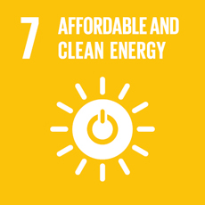
Ensure access to affordable, reliable, sustainable and modern energy for all

Government assessment
7.1 | In Norway we have universal access to affordable, reliable and modern energy services for all.
7.2 | Norway has a very high proportion of renewable energy in the energy mix and almost all electricity production comes from renewable energy sources.
7.3 | In Norway energy intensity is low and continues to steadily improve.

General status: Securing an efficient, climate-friendly energy supply requires assessing supply security, climate change and economic development together. Norway has universal access to affordable, reliable and modern energy services for all, so virtually all SDG 7 targets on energy have been met at the national level. Compared to other countries, Norway has a very high proportion of renewable energy in its energy mix.
          - Renewable energy share in the total final energy consumption
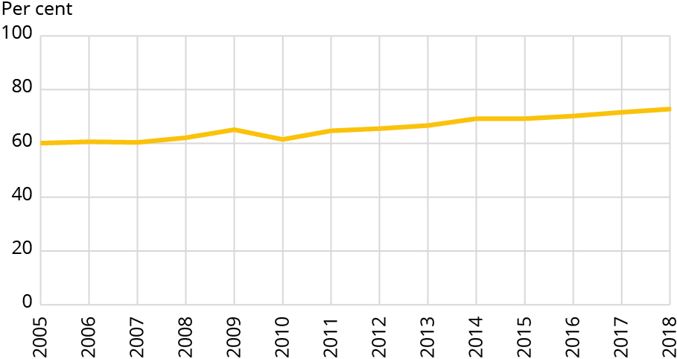
Source: Statistics Norway
Main achievements: Almost all electricity production comes from renewable energy sources, mainly flexible hydropower. Wind power is also an increasing part of Norway’s electricity production. The share of renewable energy in Norway’s total energy consumption is around 73 per cent, calculated according to the definition in the EU Renewable Energy Directive. Norway safeguard universal access to affordable and sustainable energy through a well-functioning and efficient energy system. This provides consumers with security of supply and helps keep electricity prices down. In a normal year, Norway has surplus electricity production. Norway is expected to have surplus electricity production in the coming years, and major investments are being made to strengthen the power grid. The energy intensity is low, which implies that Norway is one of the countries that uses least energy for each unit produced. Energy intensity has fallen over the last 30 years, measured in relation to GDP, and Norway has had a stable improvement in energy intensity. The Government has a goal of improving energy intensity by 30 per cent by 2030 compared with 2015. Norway has a number of policies and instruments that contribute to energy efficiency.
Main challenges: In the coming years electricity consumption is expected to increase in several sectors and in new areas of application, especially due to the electrification of industry and transport, as well as new electricity-intensive industries. Norway has a surplus of electricity, but massive electrification can cause some challenges linked to the demand for power and transmission capacity in some regions. Continued efforts to improve energy efficiency will be important for the transition to a more sustainable society.
Global responsibility: Norway supports access to affordable, sustainable and clean energy in many developing countries, both bilaterally and through multilateral partners. These efforts will also contribute to reduced greenhouse gas emissions. The Norwegian Investment Fund for Developing Countries (Norfund) is one of the main instruments for investments in, inter alia, energy production in low and middle-income countries. Norfund’s largest business priority sector is clean energy with a committed portfolio of NOK 11.9 billion (USD 1.4 billion) by the end of 2019 – almost half of Norfund’s total portfolio. Investments in renewable power plants by Norfund reduced CO2 emissions by 4.6 million tonnes in 2019.

Main policy initiatives 2016–2021
- White Paper, Meld. St. 25 (2015–2016) Power for change – an energy policy towards 2030.
- White Paper, Meld. St. 28 (2019–2020) Land-based wind power.
- The Norwegian Hydrogen Strategy (2020).

Civil society assessment
The following organisations have participated in this assessment: Friends of the Earth Norway, WWF Norway and the Norwegian Forum for Development and Environment (ForUM).
Trend: Stagnant
Norway has succeeded in developing an electricity sector fully based on renewable energy (except for offshore industry and on the archipelago of Svalbard). Norway has taken important steps in electrification. Fossil fuels have been phased out in the building sector/space heating and are currently being phased out in the transport sector. More than 50 per cent of all new cars are electric and only electric cars will be sold from 2025. The Government has announced steep increases in the CO2 tax level to 200 EUR/tonne in 2030.
Norway has universal access to modern, reliable and affordable energy and practically no energy poverty.
Norway’s development aid for energy has been reduced since earlier periods but is still at a high level due to investment in renewable energy. The Government Pension Fund Global has made its first investment in renewable energy infrastructure in Europe.
Norway’s challenge is its high per capita energy consumption. Despite a high share of renewable energy in mainland Norway’s energy consumption, the total share of renewable energy use, including energy use in offshore oil and gas production, is only 51 per cent. Almost 100 per cent of Norway’s electricity production is renewable. The most significant renewable sources: hydropower and wind power, have a negative influence on nature, and further development will undermine other SDGs, including SDGs 14 and 15.
Norway’s prospecting for new oil and gas reserves will increase emissions from production as well as the need for renewable energy for electrification of offshore installations (diverting renewable energy from other uses), and will add to the already too high consumption of fossil fuels worldwide.
Norway continues to develop transport infrastructure facilitating high speed and increased use of passenger cars and freight trucks, without regard for the increase in energy consumption that will follow.
Norway’s existing building stock has huge potential for efficiency gains. There are no action plan or measures in place to meet the efficiency target for the sector set by the Government. Energy efficiency is often highlighted as the most important measure to reach SDG 7 without compromising SDGs 13, 14 and 15. Norway’s efforts to meet target 7.3 to double the improvement rate of energy efficiency have slowed down, and Norway has no comprehensive policy in place to address the energy efficiency target.

Norway must:
- set an energy efficiency target and develop strategies to meet target 7.3 on energy efficiency;
- stop new licences for oil and gas drilling and phase out the use of fossil energy by 2040, cf. the IPCC’s call for a 90 per cent reduction in oil production by 2050;
- increase the focus on basic access to modern, reliable and affordable energy services for households in development aid and international cooperation;
- use the most environmentally friendly measures for new renewable energy production, which is positive for the phasing out of fossil energy use, for the climate and biodiversity;
- assess current and future energy production no longer only on the basis of economic profitability, jobs, market interests and isolated climate gains, but to a much greater extent build on the real importance and value of intact ecosystem services, rich biodiversity, and large contiguous land areas for society as a whole;
- utilise the energy we already produce in a more efficient way before we consider new area-intensive energy developments. Among other things, it is crucial to increase financial support for energy efficiency in buildings;
- realise energy and climate measures that safeguard ecosystems, such as wetlands, as the most cost-effective solution for storing and increasing carbon uptake.

8 Decent work and economic growth
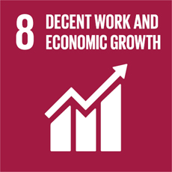
Promote sustained, inclusive and sustainable economic growth, full and productive employment and decent work for all

Government assessment
8.1 | Norway’s GDP per capita is among the highest in the world.
8.2 | Norway’s productivity level is among the highest in the world.
8.3 | The business sector in Norway has a strong innovation performance, and has increased relative to that of the EU.
8.4 | Emissions of greenhouse gas per unit of GDP have decreased significantly in recent decades. Since 1990, emissions per unit of GDP have roughly halved.
8.5 | Notwithstanding a setback during the pandemic, Norway has had comparatively high employment and low unemployment in recent decades.
8.6 | Norway’s NEET rate is relatively low compared to other countries, but is nevertheless challenging.
8.7 | Norway has joined Alliance 8.7 to end forced labour, modern slavery and trafficking. Compared with other countries, this is not a major challenge in Norway, but we still have work to do.
8.8 | Norwegian employers are responsible for ensuring that the workplace environment is safe and sound. The Norwegian Labour Inspection Authority reported 28 work injury deaths in 2020, so we still have work to do.
8.9 | Norway provides education and certification for sustainable destinations.
8.10 | Norway supports the International Labour Organization’s work to obtain decent work and social justice for all.

General status: In recent decades, Norway has had high economic growth and low unemployment. GDP per capita is high compared to other advanced economies. Productivity levels are among the highest in the world, although its growth has slowed in recent decades and in particular since the global financial crisis. Sound macroeconomic management, open and flexible markets with high labour force participation have contributed to this development.
The outbreak of COVID-19 and the measures that have been implemented to limit the spread of the virus have negatively impacted on the Norwegian economy and the labour market. The long-term effects of the crisis remain uncertain.
Main achievements: Norway has succeeded in promoting development-oriented policies that support entrepreneurship and innovation. In 2019, 65,600 companies were established, which is a 40 per cent increase since 2011.
The Norwegian labour model and Norwegian legislation protect workers’ rights and ensure a safe working environment for all. In comparison with other countries, Norway has a relatively high employment rate. In 2019, an average of 76.5 per cent of those between 20 and 66 years of age were employed. However, in the last few years, developments in the employment rate have been weaker than in several other European countries as a result of the oil-driven economic downturn that hit Norway in the period 2014–2016.
Main challenges: Norway faces skills and changes related to population ageing. The old age dependency ratio is set to increase markedly over the coming decades. This will burden public finances and could dampen productivity growth. It is necessary to increase employment rates among certain groups, including people with disabilities or discontinuous work experience, certain immigrant groups and young people who have not completed their education.
Global responsibility: Norwegian funding for Aid for Trade is focused on the least developed countries, including the Enhanced Integrated Framework. Norway promotes the UN Guidelines for Business and Human Rights and is working to establish a national law that will require companies to report on human rights, decent work and due diligence in their value chains. Norway has strengthened its efforts towards vulnerable groups, including the launch of a separate development programme against modern slavery in 2020. Norway also supports the International Labour Organization’s efforts to obtain decent work and social justice for all and to achieve the objectives of the ILO Centenary Declaration for the Future of Work (2019).

Main policy initiatives 2016–2021
- Measures to motivate young people who drop out of school or working life to engage in work, education or other activities (2017).
- Strategy on work-related crime (2015). Updated 2017, 2019 and 2021.
- White Paper, Meld. St. 5 (2019–2020) Living communities for the future.
- White Paper Meld. St. 19 (2016–2017) Experience Norway – a unique adventure.

Civil society assessment
The following organisations have participated in this assessment: the Norwegian Forum for Development and Environment (Forum), the Salvation Army Norway, Lightup Norway, the Norwegian Confederation of Trade Unions, the Christian Council of Norway, the Royal Norwegian Society for Development, Norwegian People’s Aid, Plan International Norway, Unio (the Confederation of Unions for Professionals and Save the Children Norway.
Trend: Stagnant
Norway has succeeded in proposing a due diligence law that would require all larger companies to disclose information about their due diligence assessments to prevent negative impacts on human and workers’ rights. The proposal also suggests companies disclose information on incidents and about their value chains on request. If implemented, the proposed law would give Norway one of the strongest due diligence frameworks in the world.
In general, Norway has a strong framework for workers and several government agencies to ensure workers’ rights are not violated. However, vulnerable groups such as immigrant workers often face the risk of exploitation due to low unionisation rates and lack of coverage in the labour welfare system and collective agreements.
Norway’s challenge is the lack of coherence between different policies related to SDG 8. For instance, Norway has created an aid programme to combat anti-slavery, but it does not include any measures to combat sexual exploitation. There is also great concern that human rights, workers’ rights and environmental rights repeatedly lose out to trade interests when Norway negotiates trade agreements with countries where these rights are at serious risk.
Nationally, there are vulnerable groups in Norwegian society who face exploitation in the job market. Government agencies have limited resources to supervise businesses or regulate the market, creating opportunities for rogue actors to violate workers’ rights in order to maximise profits. The risk has been exacerbated by the COVID-19 pandemic, which has caused a strong rise in unemployment in Norway, increasing the risk of exploitation of vulnerable groups.

Norway must:
- strengthen its focus on the economic empowerment of marginalised youth, especially young women, in its development policies. Gender equality and inclusion of minority groups, the freedom of association, collective negotiations and living wages must form an integral part of Norwegian development assistance to private sector development and job creation;
- be a driving force in promoting a strategy for the prevention of digital sexual exploitation of vulnerable children and young people internationally;
- enact ambitious corporate responsibility legislation with due diligence in mandatory and gender-responsive human rights. Due diligence legislation should also include environmental risks, and the duty to inform consumers and any other enquirers on value chains and production sites;
- implement specific, long-term measures to prevent sexual exploitation, including digital forms of exploitation, and include youth, women and faith-based actors in this work;
- ensure protection, legal rights and remedies for survivors of sexual exploitation;
- enact appropriate requirements for employers to ensure that all employees, including foreign workers, enjoy Norwegian standards of workers’ rights;
- employ concrete measures to increase the unionisation rate of workers, such as increasing the union fee tax deduction and strengthening the regulatory framework in order to restrict exploitative and anti-union work practices;
- increase funding of governmental agencies, such as the Norwegian Labour Inspection Authority, to ensure that workers’ rights are respected and prevent worker exploitation;
- implement stricter sustainability requirements for the Government Pension Fund Global’s investment policy, ensuring that companies breaching core ILO conventions are excluded from the fund;
- include environmental sustainability standards and adherence to ILO core conventions in trade treaties.

9 Industry, innovation and infrastructure
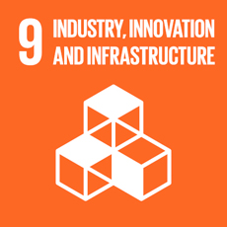
Build resilient infrastructure, promote inclusive and sustainable industrialization and foster innovation

Government assessment
9.1 | Norway has a well-developed infrastructure and large investments in communications infrastructure.
9.2 | Norwegian industry and business have for many years adjusted in a more sustainable direction.
9.3 | The Norwegian capital market is largely well-functioning and firms’ access to capital from banks and securities markets is good.
9.4 | Norway has a well-regarded set of measures for research and development (R&D) and innovation activities in the business sector. Sustainability issues are high on the agenda.
9.5 | Public research funding has increased in recent years. The challenge is to stimulate a sustainable, innovative and competitive private sector that contributes to the green shift.

General status: Norway has a reliable and well-developed infrastructure, and investments in communications infrastructure are higher than ever. The current government has made transportation one of its main priorities. A key objective is to implement the highly ambitious National Transport Plan 2018–2029 and to introduce an equally ambitious and realistic National Transport Plan for the period 2022–2033 aiming for an efficient, sustainable and safe transport system in 2050.
Regulation of the Norwegian financial sector and capital markets is aimed at providing access to sound financial services for all types of economic units. The Norwegian capital market is largely well-functioning and firms’ access to capital from banks and securities markets is currently good.
Norwegian business and industry has generally good adaptability. Public research efforts have increased in recent years, and are aimed at technologies and research that contribute to increased value creation within a sustainable framework.
          - Research and development expenditure as a proportion of GDP
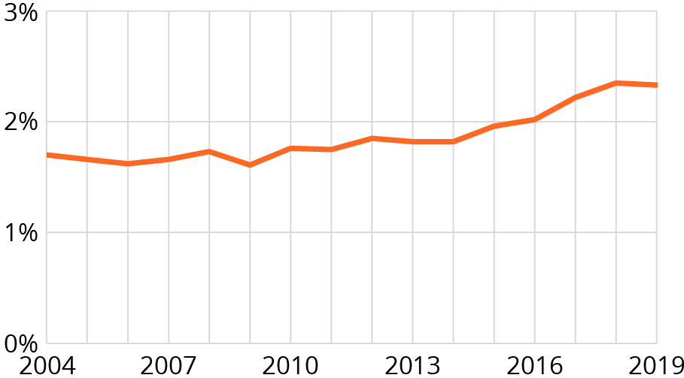
Source: Statistics Norway
Main achievements: Norway has succeeded in developing a solid infrastructure for electronic services, including financial services, mobile communications and broadband networks. Close to 100 per cent mobile coverage has been achieved for 4G, and the first 5G network opened in March 2020.
Technology and knowledge play a key role in facilitating the transition to a low-emission society. The Government promotes expanded use of clean and environmentally sound technology and industrial processes by strengthening its focus on relevant research and development (R&D). As a share of GDP, R&D expenditures in Norway amounted to 2.06 per cent in 2018, which is an increase from 2.04 per cent in 2016.
Main challenges: One of the greatest challenges is to make Norwegian industries more sustainable. Even though Norwegian businesses are used to adapt, there is a need for industry and businesses to facilitate more climate-friendly operations and reduce their emissions. The main source of greenhouse gas emissions in Norway are oil and gas extraction, industry and transport. Norwegian greenhouse gas emissions are declining. Norway aims to be a low-emission society by 2050, with an 90–95 per cent reduction in emissions compared to 1990.
Global responsibility: Through solid and multi-year contributions to the UN and the multilateral development banks, Norway supports investments in necessary infrastructure such as roads, railways, ports, industrialisation and digital infrastructure. The emphasis is on the most marginalised countries in Africa and significant efforts to promote intra-regional trade. Norway has taken a leading role in the global Digital Public Goods Alliance, which contributes to the availability of digital solutions for developing countries. The Alliance supports selected pathfinding countries that help to develop, pilot and adapt digital common goods at the national level.

Main policy initiatives 2016–2021
- Strategy for the Norwegian Bioeconomy (2016).
- National Transportation Plan 2018–2029 and 2022–2033 aiming for an efficient, sustainable and safe transport system in 2050.
- Forum for cooperation in the processing industry (Process21) and a top management forum for digitisation in the industry.
- Partnership with the World Bank, contributing to the goal of providing the entire population of Africa with access to information and communications technology (2019).
- White Paper, Meld. St. 4 (2018–2019) Long-term plan for research and higher education 2019–2028.

Civil society assessment
The following organisations have participated in this assessment: Attac Norway, the Norwegian Medical Association (NMA), the Norwegian Seafarer’s Union, the Norwegian Union of Railway Workers (NJF) and Norwegian Church Aid (member of ACT Alliance).
Trend: Stagnant
Norway has succeeded in launching a white paper on digitalisation in development policy, recognising the digital divide and the importance of digitalisation in societal development. Grant schemes facilitating business engagement in innovation and development projects are a positive initiative for engaging businesses in the 2030 Agenda.
Norway’s challenge is that the long-term transportation plan proposed by the Government, Nasjonal Transportplan (NTP), lacks focus on building a sustainable transportation sector – both when it comes to building the infrastructure in itself and how the new infrastructure affects the transport patterns in Norway. To reduce climate change and the destruction of nature, it is vitally important to make a modal shift from road to sea or railway in freight transport in Norway. Investment in existing harbours could make sea freight more efficient and reduce the need to build new roads. Improving railways and terminals would enable freight transport capacity on the rail system to be increased by 40 per cent without building new tracks.
Norway is dependent on importing medical specialists. One in five newly approved specialists in Norway has received their specialty training in other Nordic countries or the EU. This is not sustainable in the long run, and Norway should take greater responsibility in educating the medical specialists we need. Norway is highly dependent on importing essential medical supplies from foreign medical companies in emergencies, and lacks adequate production capacity to help meet the current need for increased vaccine production. There is also a need for more focus on medical research, innovation and investment in addressing women’s health.
Internationally, Norway does not support regulations that facilitate technology transfer in the e-commerce negotiations currently taking place in the WTO. Depriving countries in the global south of the opportunity to transfer knowledge and technology from the multi-national technology companies operating in these countries impedes the development of poor countries’ own digital industry.
Grant schemes financing innovation projects for sustainable development should not be used as a tool for promoting Norwegian business abroad, but rather place emphasis on promoting innovation and transfer of competence to developing countries. Strict commercial requirements for Norwegian businesses in these schemes are a barrier to engaging companies in projects with considerable socio-economic benefits in developing countries.

Norway must:
- change mode of freight transport from road to sea or rail by investing in the existing rail infrastructure and existing harbours to increase the capacity for freight transport and make it more efficient;
- increase support to programmes developing new ships that are fully electric, hybrid or have hydrogen propulsion with strongly reduced climate emissions;
- ensure better framework conditions for medical research and professional development, to ensure better quality and safety in the health services provided;
- build competence and domestic production capacity of critical medicines, infection control equipment and medical equipment, as well as strengthen Nordic and international cooperation to ensure better access;
- focus on exporting the infrastructure and expertise we can offer to help the world’s poorest countries to benefit from new technology, such as broadband, cloud storage and server capacity, as well as supporting regional data centres;
- support regulations in international trade agreements that facilitate technology transfers to developing countries. Countries should have access to demand local storage of data collected domestically and leeway for regulation of their digital development;
- adapt grant schemes for innovation and development projects to facilitate businesses’ engagement in sustainable development projects in partnership with NGOs.

10 Reduced inequalities
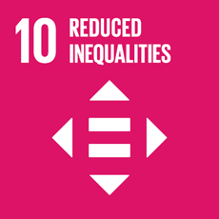
Reduce inequality within and among countries

Government assessment
10.1 | Income inequality levels are lower in Norway than in most other countries. Since 1992, the income growth of the bottom 40 per cent has been close to the median.
10.2 | Norway has a high degree of gender equality. Challenges in racism and discrimination remain.
10.3 | The principles of equal opportunity and social mobility underpin the Norwegian welfare system.
10.4 | Redistribution through taxes and transfers has been stable since 1992. Taxes and fees help to finance public services that also have an equalising effect.
10.5 | Norwegian financial market regulation is largely based on international standards and recommendations. Since 2008, regulation and supervision has improved significantly.
10.6 | Norway has supported enhanced representation of developing countries in decision-making in international economic and financial institutions.
10.7 | Norway has a well-functioning migration governance system, which continuously strives to respond and adapt adequately to evolving migration challenges.

General status: Economic inequalities between countries have decreased in recent decades, but inequalities within many countries, including Norway, have increased. Even so, Norway still has relatively small income differences and a high living standard. The Norwegian welfare model provides social mobility and opportunities for all. Discrimination is prohibited by law.
          - Redistributive impact of fiscal policy (prefiscal income and postfiscal disposable income), Gini index
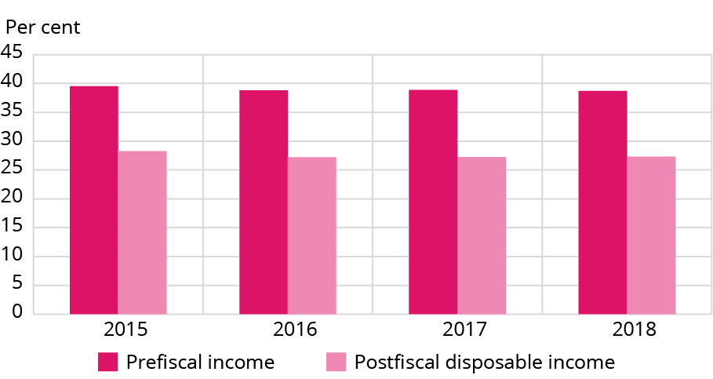
Source: UN Global Database / OECD / Statistics Norway
Main achievements: Good macroeconomic management, an active labour market policy and coordinated wage formation contribute to high labour market participation and low unemployment. The tax and transfer systems provide substantial income redistribution. The welfare benefits system provides compensation for loss of income due to illness, old age, unemployment etc. Citizens have free universal access to education and health services, and low-cost access to nursing and care services.
Main challenges: Although the employment rate in Norway is high, the proportion of people who are out of work as a result of illness or reduced working capacity is also relatively high. The percentage of the population living in low income households has increased. To reduce inequality, Norway’s educational system must give children and young people appropriate skills. Norway must also ensure that the labour market works efficiently. Both the tax system and benefit schemes must encourage value creation and high labour force participation.
Global responsibility: Inequality is a systemic issue. Norway works to promote responsibility in the private and public sectors, including gender equality, respect for workers’ rights, payment of taxes and zero tolerance for corruption. Norway works to promote fairer international trade, tax rules and regulations and support the construction of better tax systems and welfare societeties in developing countries. Targeted efforts are supported with a view to reaching the most vulnerable groups.

Main policy initiatives 2016–2021
- White Paper on inequality stating that the Government’s policy for a lasting reduction in economic inequality focuses on employment, education and integration (2019).
- In 2018, the Equality and Anti-discrimination Act entered into force and the Discrimination Tribunal was established. In 2020, a low-threshold service was established for dealing with cases of sexual harassment. The activity and reporting duties in the Equality and Anti-discrimination Act were strengthened at the same time.
- The Government has presented several action plans and strategies as part of the work for equality and against discrimination. In 2021, the Government aims to present an Action Plan on Universal Design, a new Action Plan on LGBTIQ Equality and a Strategy on Gender Equality in Education and Working Life.

Civil society assessment
The following organisations have participated in this assessment: the Norwegian Forum for Development and Environment (ForUM), Norwegian People’s Aid, Unio (the Confederation of Unions for Professionals), YGlobal, Norwegian Medical Students’ Association, Salvation Army Norway, LO Norway, Norwegian Library Association and the Church of Norway Council on Ecumenical and International Relations.
Trend: Negative
Norway has succeeded in being among the top countries in the world when it comes to economic and social equality. Norway is one of the highest achievers in reducing income inequality, which is linked to its high unionisation rate and largely coordinated wage formation. There are fewer inequalities among certain groups in Norway compared to other countries, and recent research has also shown greater social mobility.
Norway has increased funding for the Tax for Development programme, which is an important contribution to strengthening the capacity of tax administrations in developing countries. Norway has also doubled its global support to strengthen national universal primary education systems in developing countries.
Norway’s challenge is that social and economic inequalities in Norway have increased since the 1980s. Despite having a national universal health-care system, Norway has greater social inequalities in health than many other European countries, and this is particularly reflected in the attainment gap and the gender gap. The poverty level among children is also worrying, with currently 11.7 per cent of Norwegian children living below the national poverty line.
The current pandemic has intensified inequalities. The risk of long-term unemployment and exclusion from employment has increased, a higher proportion of the population is at risk of a persistent low income and a whole generation of youth have lost education and employment opportunities. Concurrently, the economic space for curbing inequalities has become more restricted. Over the last 10 years, real earnings in certain sectors with a low unionisation rate have remained at a standstill, while the general increase elsewhere is 10–15 per cent. In the same parts of the labour market, the learning opportunities and job security are weaker than elsewhere. In addition, social mobility related to education attainment is less than economic mobility across generations.
At the global level, the pandemic has revealed a need for urgent action to curb global inequality and ensure effective in-country redistribution systems. Financial secrecy, tax havens and weak international regulations are among the drivers of economic, social and political inequality in the world. Most industrialised countries have reduced corporate taxation since 2007, which has led to an increased tax burden on individual citizens.

Norway must:
- protect and enhance crucial institutions in the Nordic model, such as coordinated wage formation, universal welfare and a high unionisation rate. The social dialogue between the Government, employers’ organisations and trade unions must be strengthened locally, regionally and nationally;
- integrate the inequality dimension in all major policy areas;
- strengthen universal welfare services in education and health care, and increase the universal child benefit;
- continuously strengthen and secure access to libraries to enable all citizens to empower themselves through free access to information, cultural integration and social inclusion;
- disabled persons must have the same opportunities as others to choose their place of residence, where they live and with whom;
- increase support for the decent work agenda globally, and the capacity, establishment and protection of trade unions;
- take a leading role in pushing for the implementation of the recommendations of the FACTI report, including working for a UN tax convention, an intergovernmental tax body under the UN and a global minimum corporate tax;
- support country-by-country reporting (ECBCR), which will be an important contribution to tackling strategic tax planning and tax havens;
- Norway should actively fight discrimination based on gender, disability, caste or sexual, religious or other minority status, and support groups who promote equal rights.

11 Sustainable cities and communities
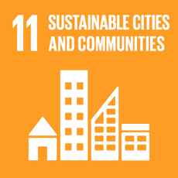
Make cities and human settlements inclusive, safe, resilient and sustainable

Government assessment
11.1 | Almost all housing in Norway is adequate, and the number of homeless persons is very low and decreasing.
11.2 | There are few traffic fatalities and serious traffic accidents, and the numbers are decreasing.
11.3 | The Planning and Building Act needs to be supplemented with new implementing tools to meet the ambitious goals on climate change, nature management and social challenges.
11.4 | There are well-functioning management systems for cultural and natural heritage, but changes in land use and climate change put pressure on these resources.
11.5 | There are relatively few deaths in Norway due to disasters, but the financial cost is relatively high and is expected to increase due to climate change.
11.6 | Ambient air quality in the main cities has been significantly improved in the past few years, but is still a challenge.
11.7 | The share of safe, open spaces for public use for all is relatively high.

General status: About 80 per cent of Norwegians live in cities and communities. More than 80 per cent own their own home, and the number of homeless persons is very low. Most Norwegians have a high standard of living, with access to basic services, waste management, transport systems, good air quality and green and safe public spaces. However, people with disabilities have more limited access to these services than the general population.
          - Annual mean levels of fine particulate matter (PM2.5) in Norwegian municipalities, by inhabitants per municipality
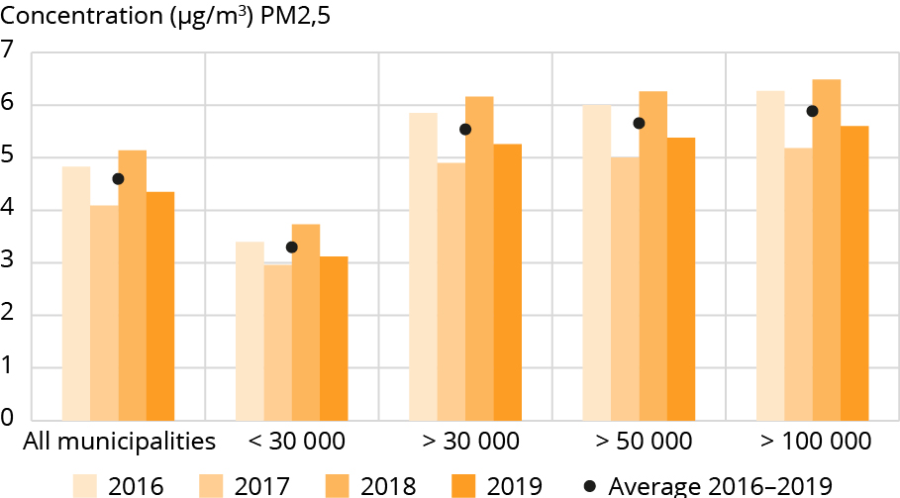
Source: The Norwegian Meteorological Institute
Main achievements: Comprehensive urban growth agreements have helped reduce the growth in car traffic and have provided a clear direction for transport and land use policy in urban areas. Over 50 per cent of private cars purchased in 2020 were electric. Norway has a low level of air pollution, and local air quality has improved over the last decade. The number of premature deaths due to road traffic emissions is among the lowest in Europe. There are few traffic fatalities and serious traffic accidents, and the numbers are decreasing, even though the number of cars is increasing.
Main challenges: Increasing risk of flooding, landslides and heatwaves is already affecting infrastructure and land use. Green areas for outdoor life and recreation are under pressure when cities and towns densify and expand. More remote areas are experiencing a population decline coupled with a rising elderly population. Securing affordable, adequate and accessible housing for low-income groups, the elderly and people with disabilities is a challenge, particularly in the larger cities. Local air pollution is a challenge in some Norwegian cities. Some of the larger cities have areas with high rates of multiple socio-economic problems.
Global responsibility: On the international level, Norwegian support has been channelled through UN-Habitat, which focuses on support to governments and local authorities to identify and implement laws that regulate land use, urban planning, taxation, housing, infrastructure and safety. Norway also supports efforts to reduce ambient and household air pollution in developing countries. Norway endorsed the New Urban Agenda in 2016 and is an active participant and contributor at the World Urban Forum. Norway also supports capacity building and conservation of natural and cultural heritage internationally through various instruments.

Main policy initiatives 2016–2021
- Norway is a member of the UNESCO World Heritage Committee 2017–2021.
- National Expectations for Regional and Local Planning (2019).
- White Paper, Meld. St. 16 (2019–2020) New Goals for Norway’s Cultural Environment Policy – Involvement, Sustainability and Diversity.
- National Strategy for Social Housing Policy 2021–2024.
- National Action Plan for Outdoor Life.
- Integrated area-based urban regeneration programmes.
- Urban growth agreements and reward schemes for public transport in urban areas.

Civil society assessment
The following organisations have participated in this assessment: Spire, the Norwegian Forum of Disabled Peoples’ Organizations SAFO, the Norwegian Association for Outdoor Organisations, the Norwegian Federation of Cultural Heritage Organisations, Sustainable Living Norway and the Church of Norway.
Trend: Negative
Norway has succeeded in customising the SDGs to a local context in some cities. Examples are Oslo with cycle paths, public transport and efforts regarding a circular economy, and Hurdal, which developed an urban eco-village. Norway has also succeeded in the use of digital tools to make it easier for people (including children) to participate in urban planning processes.
Norway’s challenges are related to divided sectors both at the national and local levels. There is no holistic approach and a lack of understanding of the connection between the different SDGs. The Government has recently delegated a number of tasks to the municipalities without sufficient funding or guidance. This has, inter alia, contributed to the degradation of nature, outdoor areas and green structures in and around the cities. There is also a need to strengthen the efforts to protect and safeguard the world’s cultural and natural heritage.
The Government recently presented the national transport plan for the period 2022–2033, but there is a lack of investment in sustainable transport systems and public transportation despite the benefits this would bring for the local and global environment, people’s health and mobility.
Social and economic inequalities within cities is another challenge in Norway. An inaccessible and unregulated housing market (both for ownership and renting) with prohibitively expensive housing of poor quality or insufficient space (SSB 2020) is one such example. This reinforces social and economic inequalities. Housing is built without access to, for example, green areas or without proper bedrooms. There are also barriers in the built environment that exclude disabled people from being fully included in society.
Furthermore, Norway is neglecting the urban challenges and projects in international aid programmes. The two last deposit reports do not even mention urbanisation, and only about 5 per cent of development aid is directed towards urban areas. The global aspect is also overlooked at the local level, as municipalities are not sufficiently aware of the global implications of how their actions influence social and environmental aspects.

Norway must:
- ensure sufficient investments in more sustainable transport systems and public transport;
- strengthen the municipalities’ knowledge of nature values. This can be done by developing ecosystem accounting for the municipalities;
- ensure better access to green spaces and meet target 11.7;
- support cities in implementing holistic strategies based on a circular economy (like a doughnut economy) to create sustainable cities to secure good lives for their inhabitants within the earth’s limitations;
- increase the efforts to protect natural and cultural heritage;
- support urban development projects, and direct more aid funds toward urban areas;
- support Neighbourhood Houses, which creates local social meeting arenas across social groups;
- support a third housing sector, giving more people access to decent accommodation;
- include all social groups in urban planning and real participation processes;
- specify clear deadlines for universal design in laws and regulations. Sanctions for non-fulfilment of obligations must be included.

12 Responsible consumption and production
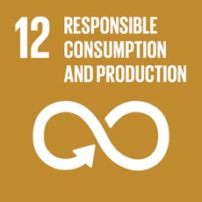
Ensure sustainable consumption and production patterns

Government assessment
12.1 | Norway is part of the 10 YFP and will present a national strategy on a circular economy in 2021.
12.2 | Material (natural resource) consumption per capita above the global and the European average.
12.3 | Agreement to reduce food waste by 50 per cent by 2030 and this applies to the entire food value chain, from primary production to consumers.
12.4 | One substance banned globally and two more nominated under the Stockholm Convention, contributed to the restriction of several substances at the European level.
12.5 | The Government is working on legislation to increase recycling rates.
12.6 | All enterprises are expected to follow international guidelines for responsible business practices and the Government is working on a law proposal for a due diligence law on human rights in international supply chains.
12.7 | Legislative and administrative frameworks related to green and innovative public procurement are in place, including guidance for public procurers.
12.8 | Sustainable development is integrated into all levels of education.

General status: Norway is a wealthy society with one of the highest consumption rates in the world, and the trend is still increasing. The Government considers it important to develop a green, circular economy, and will present a national strategy to support a transition to a circular economy in 2021.
          - Hazardous waste, proportion treated, by type of treatment
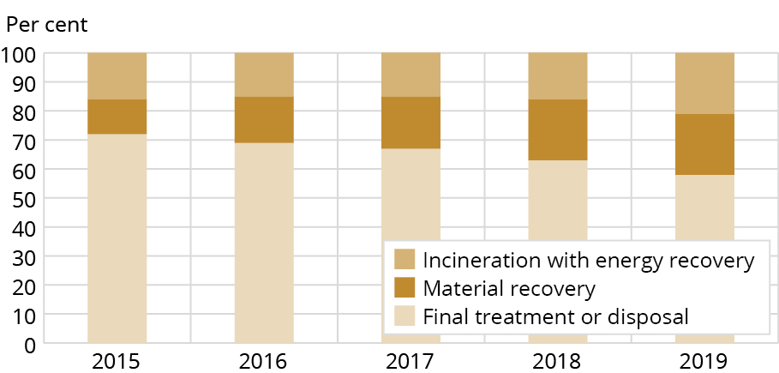
Source: Statistics Norway
Main achievements: In 2017, five Norwegian ministries and 12 food industry organisations signed an agreement to halve food waste in Norway by 2030. From 2015 to 2019, food waste was reduced by 12 per cent per inhabitant. The impact of chemicals and waste on health and the environment is being reduced. Waste continues to grow in step with GDP growth. Hazardous waste is collected and treated separately, in accordance with environmentally sound management. Public entities are obliged by law to pursue green public procurement strategies. Materials recovery has increased dramatically in recent decades, thus reducing the environmental footprint of waste. Enterprises are expected to be familiar with and follow OECD Guidelines and UNGP. Companies where the state has direct ownership interests are expected to be at the forefront of responsible business practices sustainable practices.
Main challenges: In Norway, targets 12.2, 12.3, 12.5 and 12.6 have been singled out as particularly challenging and notably the transition from relative to absolute decoupling, i.e. from improved efficiency in the use of materials (natural resources) to an absolute reduction. Food and food waste are of concern in the national implementation of SDG 12, as well of SDGs 2 and 14. Waste generation is growing. In 2019, the average Norwegian disposed of 776kg of municipal waste, which is substantially higher than the European mean of 502kg.
Global responsibility: Norway supports international measures to reform subsidies for fossil fuel consumption, and supports international environmental agreements aimed at increasing professional capacity and strengthening institutions’ development of strategies for green growth and economic development. The support to six research institutes in Sub-Saharan Africa has yielded ground-breaking research. Research has been carried out into innovative cultivation methods without pesticides that prevent pests whilst increasing crops, food security and income. Research has also resulted in new and sustainable ways of rehabilitating land degraded by coal mining.

Main policy initiatives 2016–2021
- Low Emission Strategy/Climate Plan 2030.
- National strategy to support a transition to a circular economy.
- Updated national target on waste management to increase material recovery.
- White Paper, Meld. St. 22 (2018–2019) Public Procurement.
- White Paper, Meld. St. 8 (2019–2020) The state’s direct ownership of companies – sustainable value creation.
- In April 2021, the Government proposed a new act concerning enterprises’ transparency and work in fundamental human rights and decent working conditions.
- Amendments to the Accounting Act, section 3-3 c – requirement to report on social responsibility.

Civil society assessment
The following organisations have participated in this assessment: the Norwegian Forum for Development and Environment (ForUM), the Norwegian Grandparents Climate Campaign, the Norwegian Consumer Council, the Salvation Army Norway, the Norwegian Society for the Conservation of Nature, the Royal Norwegian Society for Development and Spire.
Trend: Negative
Norway has succeeded in recycling a high share of metals, glass and brown paper, and has achieved a good collection rate of plastic bottles and cans. This is a good starting point for increased circularity of plastic and metal use. Furthermore, Norway has managed to reduce food waste through voluntary commitments by actors across the food value chain. However, our assessment is that the ‘low hanging fruits’ may already have been picked, and in order to reach the 50 per cent target, we need legally binding measures. Additionally, Norway has so far chosen a minimum level response to the EU’s single use plastics directive.
Norway is at the forefront in Europe when it comes to regulatory changes and restrictions in the use of the most harmful chemicals. However, the only consumer-facing information site, erdetfarlig.no, was taken down in 2019, with no alternative source of official information on chemicals in everyday products put in place.
Norway’s main challenge is that we have one of the world’s highest consumptions per capita, consuming 44 tonnes of natural resources each year. Norway’s overshoot day this year was 12 April, meaning that it would take 3.2 Earths if everyone had the same consumption as Norwegians.
Scientists at SINTEF conclude that the main cause of our high and growing consumption is that we replace products long before their technical lifetime is over. Norway lacks policies that ensure the right to repair, access to spare parts and to easily accessible and affordable repair services. This also applies to policies to incentivise second-hand markets and improve the utilisation of resources that have already entered the economy, such as leasing and renting.
Additionally, Norway is lagging far behind in the process towards a more circular economy, where resources are repaired, reused and recycled. According to the Circularity Gap Report, Norway’s circularity is 2.4 per cent, which means Norway has one of the lowest circularities in Europe.
Finally, the political focus in Norway is almost exclusively on reducing national emissions, and a holistic strategy to addressing imported emissions and established consumption patterns is lacking.

Norway must:
- prepare a concrete and holistic plan for transitioning from a linear to a circular economy. Policy measures that ensure change in consumption patterns must be an integral part of such a plan;
- account for consumption-based emissions, through relevant indicators to be adopted alongside more traditional economic indicators such as the GDP;
- move from voluntary to legally binding measures to reduce food waste;
- ensure that consumer information is provided on chemicals in consumer products;
- review the tax system to see how taxes can be used in a fair and efficient way to make a shift towards more circular consumption;
- phase out subsidies that encourage overconsumption and subsidise businesses that extend product lifetime;
- strengthen consumer rights by demanding that companies produce higher quality products with an extended product lifetime, including the right to repair;
- promote public procurement practices that are sustainable in a social, economic and environmental perspective.

13 Climate action
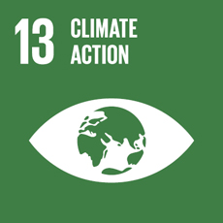
Take urgent action to combat climate change and its impacts

Government assessment
13.1 | Norway is relatively resilient and has good capacity to adapt to climate-related hazards and natural disasters, but adapting to future climate changes will be a challenge, and the cost are expected to increase.
13.2 | Measures to combat climate change are integrated into national policies and strategies. The Government recently presented a new White Paper on how it intends to meet the climate target for 2030. Norway has a comprehensive set of measures covering almost all emissions of greenhouse gases as well as removals. A large proportion of emissions in Norway is covered by economic measures. Green taxes and quotas (EU ETS) cover more than 80 per cent of greenhouse gas emissions. In addition, some emissions are regulated through the Pollution Control Act, standards, agreements and grants for emission reduction measures.
13.3 | The Government is working to make society less vulnerable to climate change, including facilitating knowledge for use by municipal authorities and others. The Klimatilpasning.no website is an example of how we contribute to disseminating knowledge and guidance on climate change and climate adaptation.

General status: In February 2020 Norway submitted an enhanced climate target (NDC) under the Paris Agreement. The 2030 target was strengthened from 40 per cent emission reduction to at least 50 and up towards 55 per cent compared to 1990 levels. Norway’s long-term target is to be a low emission society by 2050. This means a society with low emissions in all sectors and emission reductions in the order of 90–95 per cent compared to 1990.
          - Total greenhouse gas emissions per year
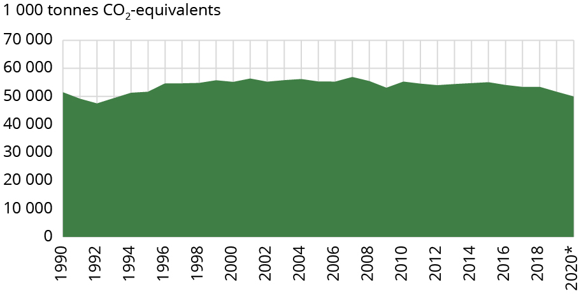
Source: Statistics Norway
*Preliminary figure
Main achievements: Preliminary figures show that the total Norwegian emission of greenhouse gases in 2020 were 50 million tonnes of CO2 equivalents. This is the lowest level since 1993, 12 per cent below the peak level in 2007 and a reduction of 1.5 million tonnes since 1990. Emissions from Norway have remained fairly stable since the 1990s despite strong growth in the economy – about 85 per cent since 1990. The Government presented a White Paper in 2021 describing its Action Plan for the Transformation of Norwegian Society as a Whole by 2030. The main emphasis of the plan is on emissions that are not included in the Emissions Trading System, known as non-ETS emissions. This Action Plan will enable us to exceed Norway’s assigned target from the EU for non-ETS emissions, which is 40 per cent, and we plan to achieve this through domestic emission cuts.
Main challenges: The biggest challenges for Norway are meeting our 2030 targets and becoming a low-emission society by 2050. Climate policy cannot be seen in isolation, but as the sum of policies in several areas. Good coordination and a comprehensive policy for sustainable development in all sectors are necessary to achieve the climate goals and to reduce Norway’s vulnerability. Climate change is already affecting Norwegian nature and society in various ways. We are expecting more storms, heavy rainfall, flooding and landslides.
Global responsibility: Support for climate action is a high priority in Norwegian development policy. Our climate funding for developing countries in 2019 was NOK 6.3 billion. The largest single programme is Norway’s International Climate and Forest Initiative, which supports efforts to reduce greenhouse gas emissions from deforestation and forest degradation in developing countries. Support is also channeled through multilateral, regional and bilateral partners, including the Green Climate Fund. Norway has strengthened its support for climate adaptation and building climate resilience with a focus on climate vulnerable countries and groups. Cooperation on mitigation efforts will also remain important.

Main policy initiatives 2016–2021
- The Climate Change Act.
- White paper on Climate Action Plan.
- New national guidelines for climate and energy planning and climate change adaption.

Civil society assessment
The following organisations have participated in this assessment: the Norwegian Medical Students Association, WWF Norway, Sustainable Living Norway, the Norwegian Grandparents Climate Campaign, the Norwegian Forum for Development and Environment (ForUM), Norwegian Church Aid (member of ACT Alliance), Spire, Caritas Norway, Save the Children Norway, the Development Fund Norway, Friends of the Earth Norway and Unio (the Confederation of Unions for Professionals).
Trend: Stagnant
Norway has succeeded in raising CO2 taxes and creating some incentives for the public to make green choices, like significant tax discounts and other advantages for electric vehicles and recycling systems. Climate targets have been upgraded and enshrined in the Climate Change Act. Public funding for organisations that are working to implement SDG 13 increases the opportunities for civil society to influence and strengthen policies.
Norway’s challenge is to have coherent policies. As a significant producer and exporter of oil and gas, Norway is a major contributor to climate change, with both high domestic and exported emissions. With emissions reduced just 2.4 per cent since 1990, the 50–55 per cent emissions reduction target for 2030 remains a long way off. To succeed in cutting emissions, an action plan is needed for rapidly phasing out the oil and gas industry in a manner that safeguards jobs, pensions and the welfare state.
There is a need to create a child-friendly version of the Norwegian action plan for the SDGs. Children and youth need to be empowered to take action on climate change. Children will bear the burden of climate change and must be acknowledged as equal stakeholders and be given opportunities to exercise their right to meaningful participation at all levels.
Natural solutions must be applied in an eco-friendly way. Natural capture must not be at the expense of undisturbed nature and utilisation of Norway’s natural resources. A larger share of the national budget and Norway’s sovereign wealth fund must be allocated to investments in sustainable development. Climate finance should include mitigation, adaptation and loss and damage in accordance with the Paris Agreement. The transition to a low-emission society must be just and coherent, and not be detrimental to other SDGs.

Norway must:
- meet the 2030 emission target through real domestic emission reductions, and not emissions trading, while also pledging Norway’s fair share of support for climate action in countries in the global South;
- increase climate finance to low-income countries to a fair level, given Norway’s oil and gas-based wealth and disproportionately high historical contribution to global warming;
- incorporate climate change and sustainability awareness and innovation into education at all levels;
- introduce an annual climate budget, quantifying the state budget’s impact on national emissions;
- introduce a goal for increased natural carbon capture in the climate law, securing the carbon stock and uptake in ecosystems additional to forests. This carbon capture must be counted as zero in the climate law;
- promote new and sustainable industries. Investments must be moved from oil and gas to renewable energy and energy efficiency;
- immediately stop oil and gas exploration and change the gas and oil tax system. Generous subsidies and tax exemptions that incentivise the opening of unprofitable oil and gas fields must be reviewed immediately;
- change the food production system and consumption practices in order to lower emissions and reduce other environmental impacts in Norway and globally;
- increase investments in public transport, and rail infrastructure in particular must be scaled up.

14 Life below water
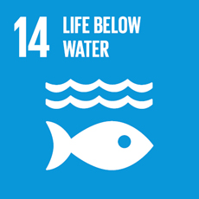
Conserve and sustainably use the oceans, seas and marine resources for sustainable development

Government assessment
14.1 | Norway is putting in place measures to prevent and reduce marine plastic litter and microplastics from land-based sources, but data remains limited. The levels of pollution are reported to be stable or declining in the Norwegian seas.
14.2 | Norway has implemented an integrated approach to marine and coastal management that will promote conservation and sustainable use of marine ecosystems and underpin a sustainable ocean economy.
14.3 | Ocean acidification is monitored in Norwegian waters, and results show acidification in some ocean areas.
14.4 | Fish stocks targeted directly by commercial fishing are all within safe biological limits.
14.5 | Norway has recently started to develop a more systematic approach to marine conservation measures and will continue to work on this in relation to integrated ocean management.
14.6 | No subsidies contribute to IUU.
14.7 | Norway supports Small Island Developing States implementing UNCLOS, building ocean governance capacity, fighting IUU and adapting to climate changes.

General status: The ecological quality of Norwegian coastal waters is good. Integrated ocean management is implemented through integrated management plans for three Large Marine Ecosystems. Coastal areas are managed with the objective of achieving good ecological and chemical status for all water bodies by 2021. To this end, 11 regional water management plans have been adopted. Monitoring of the ecological and chemical status of coastal waters has been substantially increased.
Main achievements: The Norwegian Government continues to develop additional measures to prevent and reduce marine litter and microplastics from identified sources. A national competence centre has been established. Forty-four per cent of all areas under Norwegian fisheries’ jurisdiction is subject to effective area-based management measures. A reform of fisheries control has been initiated including utilisation of new digital technologies. Nine new marine protected areas were established in Norwegian coastal waters in 2020. Norway is investing heavily in research, infrastructure, mapping and monitoring.
Main challenges: In some marine areas challenges remain due to the impacts of eutrophication, unsatisfactory status for certain species and the spread of alien species. Data remains limited on the presence and impact of plastic litter and microplastics on ecosystems and species in Norway.
Global responsibility: Norway contributes to a sustainable and inclusive ocean economy both nationally and internationally, including through capacity-building programmes in fisheries and ocean management. In 2018, Norway established a development aid fund to combat marine litter and microplastics that will run for six years. Norway contributes to the UN Decade on Ocean Science, and is a member of the Ocean Decade Alliance, of which the Norwegian Prime Minister is patron.
In 2020, Norway entered into a four-year agreement with DOALOS on cooperation on capacity-developing activities in the Caribbean, Pacific and African regions.
In 2018, Norway initiated an international declaration against transnational organised crime in the global fishing industry and launched the Blue Justice Initiative in 2019.

Main policy initiatives 2016–2021
- White Paper, Meld. St. 22 (2016–2017) The place of the oceans in Norway’s foreign and development policy.
- In 2018 Prime Minister Solberg initiated the High-level Panel for a Sustainable Ocean Economy. The 14 member states have now committed to a transformational action agenda for a sustainable ocean economy, at the core of which is the commitment to sustainably manage 100 per cent of our national ocean territories by 2025.
- Norway hosted the Our Ocean Conference in 2019. New commitments were presented by the participants.
- An updated governmental ocean strategy was released in 2019.
- In 2020, updates of Norway’s three integrated ocean management plans were presented together, with new knowledge and a harmonised goal structure.

Civil society assessment
The following organisations have participated in this assessment: Friends of the Earth Norway, WWF Norway, the Norwegian Biodiversity Network (Sabima) and Spire.
Trend: Negative
Norway has succeeded in developing ocean management plans for the Barents Sea, the Norwegian Sea and the North Sea, and has identified important areas for biodiversity (SVO). Several of the commercially exploited fish stocks in Norwegian waters are sustainably managed. Internationally, Norway plays an important role in the work to create a global agreement on marine litter, as well as support for initiatives to clean up ocean debris. The Fish for Development Programme and the support for SIDS Norway, makes a substantial contribution to knowledge transfer between Norway and selected developing countries. Norway has ratified the Nagoya protocol and will be implementing it soon.
Norway’s challenges include the insufficient integration of biodiversity and ecosystem values into development strategies, both at national and local levels. Ocean management plans are not ecosystem-based and rely on sector-based management measures prioritising commercial species. There are no national plans or significant initiatives to restore damaged coastal or marine habitats, and there is limited knowledge of the relationship between species (especially non-commercial) and their habitats. Bycatch in fisheries, including endangered species, is a major challenge. Norway lacks a protection plan for seabirds and has not met the national target for sustainable and robust seabird populations.
Norway lacks a legal instrument for establishing Marine Protected Areas (MPA) within the EEZ outside 12 nm. MPAs make up well below the 2020 target of 10 per cent (3.7 per cent within 12nm, and 0.5 per cent within EEZ). MPAs are not representative, nor fully protected (from bottom trawling). There are virtually no no-fishing zones. Norway has over-reported the protection achieved in its MPAs. Only a small proportion of known coral reefs have any kind of protection, and only from bottom-trawling. The important and biologically valuable ice edge zone has been opened to petroleum activities.
Harmful subsidies, for example, in the petroleum and forest industries, harm coastal and marine ecosystems. Pollution of coastal waters from industry, transport and urban areas remains a major challenge. Despite several measures, nutrient run-off from agriculture remains a challenge. There is limited control of the aquaculture industry and its negative impacts on the marine environment remain significant, with the continuously increasing discharge of nutrients and use of chemical pesticides to tackle salmon lice. Fisheries and aquaculture remain major sources of plastic pollution. Large-scale dumping of tiles and waste from mining has been authorised in several Norwegian fjords in recent years, destroying benthic ecosystems and increasing local marine pollution. Norway remains positive to deep-sea mining.

Norway must:
- revise its Nature Diversity Act to enable designation of MPAs and protection of SVOs within the EEZ outside 12 nm;
- ensure the advice of environmental experts is used in management decisions;
- strengthen the capacity and competence of municipalities in assessing nature risk;
- increase restoration of destroyed and degraded marine and coastal nature;
- phase out subsidies that are detrimental to the marine and coastal environment;
- prioritise implementation of a national marine protection plan to meet the new target of 30 per cent by 2030, and ensure that currently planned/proposed MPAs are quickly finalised and enforced;
- develop and implement a nature-based spatial accounting system for coastal and marine areas;
- halt the current opening of deep seabed mining on the Norwegian continental shelf and Norwegian support for deep-sea mining internationally.

15 Life on land
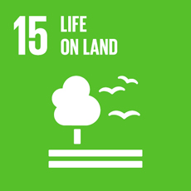
Protect, restore and promote sustainable use of terrestrial ecosystems, sustainably manage forests, combat desertification, and halt and reverse land degradation and halt biodiversity loss

Government assessment
15.1 | 17,5 per cent of Norway’s mainland area is legally protected. Plans for conservation are on track, as well as plans for restauration of freshwater ecosystems. Criteria for sustainability and actions for restauration of other ecosystems are being developed.
15.2 | 37 per cent of Norway’s land area is covered by forests whereof nearly 100 per cent is certified by global forest management certification systems. Action is being taken to reduce deforestation.
15.3 | Norway has a national strategy for the protection of agricultural areas, and the loss has been within national targets in recent years.
15.4 | 34 per cent of Norway’s mountain ecosystems are protected areas, and a quality standard for wild reindeer has been established.
15.5 | Nature protection legislation is in place and action has been taken. More measures and plans have still to be put into effect.
15.6 | National regulations to enable the fair/equitable distribution has been put out to public consultation. Norway contributes annually to the Benefit-sharing Fund.
15.7 | National, EU and international law is implemented to end poaching and trafficking of protected species, e.g. in keeping with the CITES.
15.8 | Regulation on introduction of alien species in place and adoption of action plan to combat invasive alien species.
15.9 | Biodiversity values are integrated into relevant legislation.

General status: Norway’s management of ecosystems on land is based on knowledge, goals and laws on sustainability. There are policies for most of those targets and those targets will be met when they are fully implemented.
Main achievements: Comprehensive legislation for sustainable use and conservation of nature is in place through the Planning and Building Act, regulations on environmental impact assessment, the Nature Diversity Act, and sector laws like the Water resources Act and Forestry Act. Protection of Norway’s mainland is up from 17 per cent in 2016 to 17,5 per cent in 2020, including the protection of forests within legally established protected areas (IUCN I-IV) up from 4 per cent to 5,1 per cent. In total, 25 per cent of Norway’s land area is protected. Nearly 100 per cent of the forest area is certified by global forest certification systems. A total of 390 watercourses are protected. Integrated ecosystem management plans are in place for all watercourses. A comprehensive national biodiversity Action Plan was decided on by the Norwegian Parliament in 2016.
Main challenges: Land-use and land-use change are the biggest threats to protection and sustainable use of terrestrial ecosystems nationally, along with climate change, invasive alien species and pollution. Safeguarding threatened species and habitats is challenging. Of the 21000 assessed species in Norway, 2355 are under threat of extinction. 66 of the 211 assessed habitat types are considered under threat. Meeting the target for invasive alien species is also difficult (target 15.8, indicator 15.8.1) as only a few are currently controlled or eradicated. The negative effects of climate change on biodiversity will increase these challenges. Valuation of biodiversity and ecosystem services is also challenging.
Global responsibility: Over the last decade Norway has more than doubled the biodiversity related to international financial resource flows to developing countries. Norway has taken a leadership role in halting and reversing deforestation and forest degradation in tropical countries through Norway’s International Climate and Forest Initiative, which works with forest countries, civil society, multilateral institutions, the private sector and other actors. Reducing the loss of forests is pivotal to halting the loss of biodiversity. Norway also supports other initiatives such as the BIOFIN initiative of UNDP, which assists developing countries into incorporating biodiversity comprehensively into their national development planning and financial strategies, including their NBSAPs.

Main policy initiatives 2016–2021
- National Biodiversity Action Plan.
- A specific goal on protection of 10 per cent of Norway’s forests.
- Establishing cross-sectoral targets for ecological status of terrestrial ecosystems.
- Action Plan for Threatened Nature.
- Action Plan for Management of Protected Areas.
- Action Plan for Alien Organisms.
- A national ban on peatland conversion to agriculture.
- Strengthened environmental concerns in forestry.
- A White Paper on environmental crime.
- National Strategy for Conservation and Sustainable use of Genetic Resources for Food and Agriculture.

Civil society assessment
The following organisations have participated in this assessment: Friends of the Earth Norway, the Rainforest Foundation Norway, WWF Norway, the Norwegian Biodiversity Network (Sabima), Spire, the Norwegian Trekking Association and the Norwegian Association for Outdoor Organisations.
Trend: Negative
Norway’s successes include some progress on protecting land areas, although these are not representative and often not enforced in accordance with international agreements. There is now more knowledge available about species and ecosystems than before, and some good strategy documents have been developed. Norway has maintained its commitment to and financing for international rainforest protection.
Norway’s challenges include a failure to prioritise biodiversity and ecosystems ahead of resource exploitation. Norway has failed to meet the SDG restoration targets and is not on track for meeting them. Furthermore, the target of ecosystem protection is far from met, and the ecosystem components that do have some degree of protection are not representative.
The Aichi Biodiversity Targets, which are the basis for several of the SDG 15 targets, expired in 2020. Hence, several of the targets under this goal should already have been met. However, as the report State of the Nature 2020 revealed, Norway had not met any of the Aichi targets by 2020.
Sustainable use of nature and integration of biodiversity and ecosystem values into all sectors of society is another area in which Norway has failed. Several current policies are harmful to nature and ecosystems, including subsidies to harmful practices in the forestry sector. Furthermore, the authorities have been criticised for not taking biodiversity and ecosystems into account when planning infrastructure development and for weakening the legal framework in connection with such development.

Norway must:
- let the consideration for nature and biodiversity weigh significantly heavier than is currently the case;
- avoid large-scale infrastructure development in intact nature. Where such projects in nature are deemed absolutely necessary, land use neutrality principles must apply (i.e. restoration of habitat of at least the same size and quality);
- ensure sufficient funding for the implementation of national strategies and international obligations for nature and biodiversity protection;
- ensure that Norwegian legislation safeguards nature and recreational values in a satisfactory manner, making it possible to meet the Aichi Biodiversity Targets and achieve the goals of the Convention on Biological Diversity to which Norway has committed. Existing legislation must therefore be tightened and strengthened in several areas, not liberalised and weakened;
- ensure that there is sufficient funding for appropriate environmental expertise and capacity in the municipalities. This is a prerequisite for being able to make local plans that safeguard nature;
- develop and introduce national, regional and municipal spatial accounting systems. It is important to know what we have and what we are destroying, losing or diminishing;
- ensure sufficient and representative protection of Norway’s land areas, in line with the proposed 30 per cent target from the UN;
- manage, protect and facilitate nature-based solutions for climate adaptation in the face of the more extreme weather conditions expected due to climate change, to prevent loss and damage of species and habitats;
- prioritise and expedite the process of meeting the 2020 Aichi Biodiversity Targets and SDG targets;
- ensure that species conservation in Norway follows international commitments and national legislation, and is driven by solid scientific principles rather than short-term political decisions (for example regarding large carnivore management);
- step up funding for the Norwegian Climate and Forest Initiative, which is Norway’s most important climate and nature initiative internationally;
- ensure that indigenous peoples and environmental defenders become a central target group in Norwegian development aid policies and practices, as they are crucial for protecting vulnerable nature and ecosystems;
- ensure that Norway is tropical deforestation free by 2025.

16 Peace, justice, and strong institutions
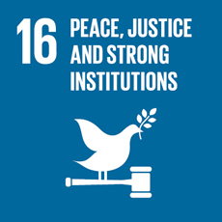
Promote peaceful and inclusive societies for sustainable development, provide access to justice for all and build effective, accountable and inclusive institutions at all levels

Government assessment
16.1 | Norway has a very low homicide and violence rate, but a challenge exists with intimate partner homicides and domestic violence.
16.2 | Abuse, trafficking and violence against children is relatively low, however digital arenas may be concealing a greater problem.
16.3 | The Norwegian society is based on rule of law and access to justice.
16.4 | The fight against illicit financial flows continues.
16.5 | Corruption and bribery are not considered to be a major problem in Norway. In the annual Corruption Perceptions Index from Transparency International, Norway is reported as having a low prevalence of corruption.
16.6– 16.7 | Norway scores high on the democracy indexes.
16.8 | Norway promotes inclusive participation by governments and other stakeholders in institutions of global governance.
16.9 | Birth registration and legal identity are regulated by law.
16.10 | Access to information and protection of fundamental freedoms are secured in both the Constitution and in statutory law.

General status: Norway is a comparatively peaceful society with a low and decreasing prevalence of crime. Enshrined in the Constitution are the principles of popular sovereignty, separation of powers, parliamentarism and human rights. This secures the foundation for a well-governed democracy adhering to the rule of law. The state institutions are accountable, transparent and open, subjected to constraint on powers. Norwegian courts ensure that the state respects and secures human rights and freedoms, including equality of the law and non-discrimination. Norway has a relatively high participation rate in both local and national elections. Legislation safeguard transparency, predictability and participation in public decision-making.
          - Number of victims of intentional homicide, by sex (persons)
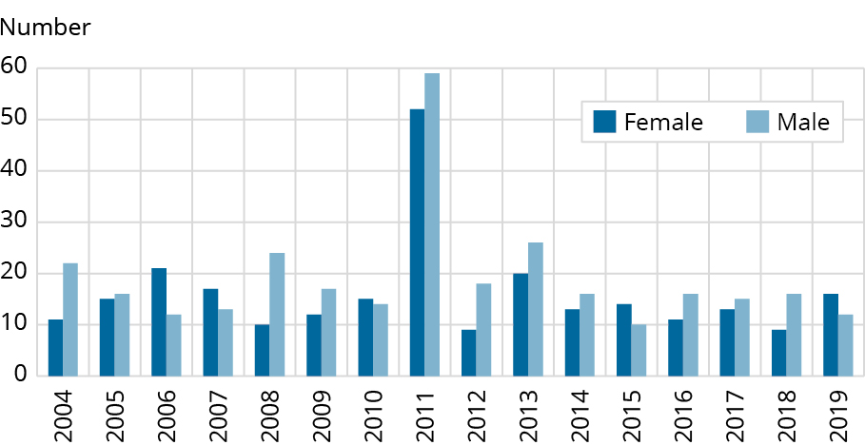
Source: Statistics Norway
Main achievements: To facilitate for a more effective fight against corruption and money laundering Norway enacted a law on beneficial ownership in 2019. Norway continues to make complementary regulations, including a beneficial ownership register, which is intended to enter into force soon.
Several legislatory works are in progress with a view to strengthening and securing the rule of law. A reform to streamline and strengthen courts’ competency will be legally enacted in 2021. A new public administration act has been under development since 2015. To improve legal security a reform on free legal aid was initiated in 2018.
The Equality and Anti-discrimination Act 2018 prohibits discrimination against several identified groups.
Main challenges: The homicide rate in Norway is approximately 0.6 per 100,000 inhabitants per year, a relatively low figure globally. However, in 2018, 25 per cent of homicides in Norway were intimate partner homicides. Domestic violence remains a challenge. Another priority for the Government is combating violence and sexual abuse of children. Abuse, trafficking and violence against children is relatively low, but there is reason to believe that digital arenas conceal problems.
The Government is concerned about criminal activity among children and adolescents, including gang crime. In addition, the Government has placed the challenge off radicalisation and violent extremism high on the agenda.
Global responsibility: Norway contributes to building inclusive, transparent and accountable societies based on a broad democracy concept, underpinned by human rights and rule of law. Norway is engaged in international efforts to prevent and combat tax evasion, corruption and illicit financial flows. This has a considerable potential to increase the mobilisation of resources for sustainable development. Technical assistance to support competence and capacity building in public bodies is offered in areas such as resource management, tax, and anti-corruption. Norway is a partner in conflict prevention, conflict resolution and peacebuilding, including the implementation of the Action Plan for Women, Peace and Security.

Main policy initiatives 2016–2021
- New Public Administration Act (2015–ongoing).
- The Escalation Plan against Violence and Abuse (2017–2021).
- The Norwegian Government established a commission on intimate partner homicide (2018).
- The new Equality and Antidiscrimination Act (2018).
- New law against laundering of proceeds of crime (2018).
- Reform of free legal aid (2018–).
- Law on beneficial ownership (2019–2021).
- Reform of the court system (2019–2021).
- The Government’s new strategy to combat money laundering, terrorist financing and the financing of proliferation of weapons of mass destruction (2020).

Civil society assessment
The following organisations have participated in this assessment: the Norwegian Forum for Development and Environment (ForUM), the United Nations Association of Norway, UNICEF Norway, Norwegian People’s Aid, Save the Children, Digni, the Norwegian Guide and Scout Association, Changemaker, CISV, Oslove Noereh, the Norwegian Medical Students’ Association, the Norwegian Forum of Disabled Peoples’ Organizations SAFO and the Norwegian Children and Youth Council.
Trend: Stagnant
Norway has succeeded in building a viable, egalitarian and democratic society. The civil society comprises a diverse community of actors organised across sectors within different interests. There is robust cooperation between the Government and non-governmental actors on many levels.
Internationally, Norway has a long history of facilitating peace and reconciliation processes to end conflicts around the world. Norway has contributed to nation-building programmes through the UN system and through development aid. Strengthening civil society is a development goal.
Norway’s challenge is preventing discrimination and reducing hate speech, racism and polarisation. Violence and abuse of children has gone up, especially during the COVID-19 pandemic. There has also been an increase in violence against women and in the number of female murder victims over the last couple of years. In addition, there have been cases of human rights violations in Norway. In 2019, for example, the European Court of Human Rights found the Norwegian Child Welfare Services guilty of violating the UN Convention on Rights of the Child. There have also been complaints about issues related to the treatment of refugees and asylum seekers, on investments made by the Government Pension Fund Global, and on the treatment of psychiatric patients. It is worth pointing out that Norway does not have a clear definition of statelessness in its legislation, nor a procedure for granting stateless persons a residence permit, which violates the UN Convention on the Reduction of Statelessness.
Norway faces challenges related to international organised crime. In 2018, approximately 9,000 victims of human trafficking were living in Norway under conditions that could be described as modern-day slavery. Norwegian banks are often the target of foreign and domestic white-washing schemes and illicit financial activities. Norwegian police have singled out tax evasion as one of the biggest threats to the Norwegian welfare state.
Norway’s reputation as a champion for peace is under pressure because of its involvement in the weapons industry and military operations abroad. Ten years after the 2011 military intervention, the humanitarian crisis in Libya is worse than ever. The income of the Norwegian arms industry increased by almost 50 per cent from 2019 to 2020.

Norway must:
- implement the UNSCR 2250 on Youth, Peace and Security;
- increase support to democratic institutions through the Norwegian Development Cooperation programmes, and increase funding of civil society organisations in countries where human rights are under pressure;
- be an advocate for the rights of civil society actors; promote increased political space for trade unions and women’s organisations, and active engagement of children and youth in civic actions everywhere;
- universally defend fundamental human rights like freedom of speech, freedom of religion or belief, and the rights of women and the LGBTQ community;
- condemn laws that limit democratic rights and impede participation in civic duties, including restrictions on NGOs and the use of anti-terrorism laws to stifle civil society;
- adopt independent Norwegian legislation for sanctions against individuals responsible for human rights violations;
- legislate for stateless persons’ right to social services and necessary health care;
- substitute the current Guardianship Act with a law on decision support;
- sign the UN’s Treaty on the Prohibition of Nuclear Weapons;
- increase the participation of civil society, academia, professionals and the private sector in the 2030 Agenda and in the national action plan as well as its future revisions.

17 Partnership for the goals
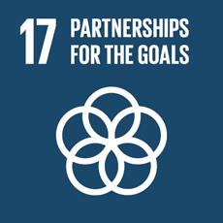
Strengthen the means of implementation and revitalise the global partnership for sustainable development

Government assessment
17.1 | Norway met the target of doubling official development assistance (ODA) to support domestic resource mobilisation in low-income countries in 2019, c.f. the Addis Tax Initiative (2015). 2020 was difficult due to COVID-19, but we hope to get back to fulfilling the goal in 2021.
17.2–17.5 | The Norwegian Government stands by its commitment to provide 1 per cent of GNI as official development assistance (ODA), and to meet the UN target of providing a minimum of 0.20 per cent of its GNI as ODA to the Least Developed Countries (LDCs). Norway supports the G20/Paris Club Debt Service Suspension Initiative (DSSI) and the Common Framework for debt restructuring for countries in immediate debt distress, as well as efforts by the World Bank and the IMF to support debt relief under the Common Framework and beyond (in LDCs).
17.6–17.8 | Norway supports the technology mechanism under the Paris Agreement and the Climate Change Convention, co-leads the Digital Public Goods Alliance and supports several digital public goods that are available for education, health and businesses.
17.9 | Norway offers technical cooperation, upon demand, to support competence and capacity building in public bodies in areas such as resource management, taxation, anti-corruption, statistics, digitalisation and gender equality.
17.10–17.12 | Norway is actively engaged in the development dimension of the WTO and in the cooperation for increasing exports from low-income countries. LDCs and other low-income countries have free access to the Norwegian market without customs duties or quotas.
17.13–17.17 | Political commitment, a whole-of-government approach and multi-stakeholder engagement are in place to foster policy coherence for sustainable development.
17.18–17.19 | Statistics Norway plays an active role in the national as well as the international work to develop indicators for the SDG targets. The institution also has a long-standing commitment to support statistical capacity building in developing countries.

General status: Norway is a proactive member of the global community and a firm supporter of the multilateral system. National policy as well as development cooperation are based on the 2030 Agenda, the Addis Ababa Action Agenda and the Paris Agreement.
          - Net official development assistance (ODA) to SIDS, LDCs, LLDC and total ODA as a percentage of GNI
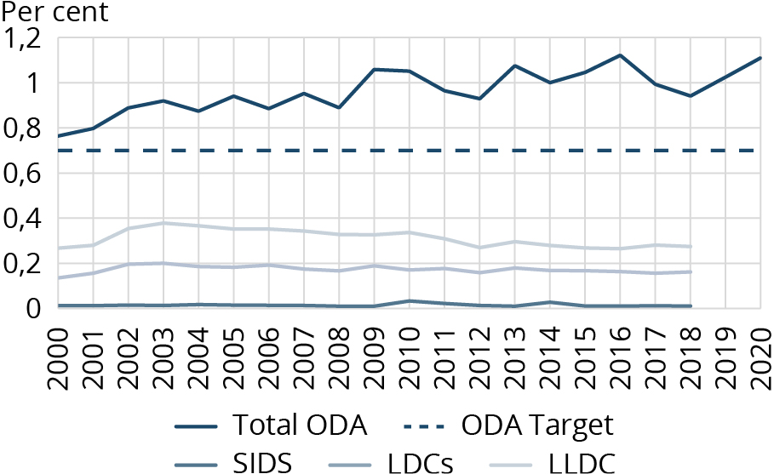
Source: OECD, Norwegian Agency for Development
Main challenges: Norway faces dilemmas in balancing the social, economic and environmental dimensions of sustainable development, including between national and international aspects and between current and future generations. Procedures have been developed for policy coherence, but difficult decisions still have to be made.
Main achievements: The level of the development budget at 1 per cent of GNI has been maintained for several years and enjoys broad political and public support. The Knowledge Bank was established in 2018 with the mandate to strengthen and coordinate a range of technical cooperation programmes. Norway promotes multilateral cooperation in relation to enhanced norms, standards and operative measures to prevent and combat corruption, tax evasion and illicit financial flows. This has considerable potential for increased mobilisation of resources for sustainable development. Norway has a long tradition of inter-ministerial coordination and cooperation with civil society, the private sector, academia and other stakeholders.

Main policy initiatives 2016–2021
- White Paper, Meld. St. 24 (2016–2017) Joint Responsibility for a Common Future. The 2030 Agenda and Norway’s development cooperation policy.
- Evaluation of Norway’s Anti-corruption Efforts as part of its Development Policy and Assistance, Report no. 5/2020.
- Norway has spearheaded the inclusion of ‘large-scale corruption’ and ‘illicit financial flows’ on the international agenda.
- The president of ECOSOC (Norway) and the president of the UN General Assembly (Nigeria) launched the UN High Level Panel on financial accountability, transparency and integrity (the FACTI Panel) in 2020. The Panel’s final report, launched in 2021, calls for a Global Pact on financial integrity for sustainable development.

Civil society assessment
The following organisations have participated in this assessment: the Norwegian Forum for Development and Environment (ForUM), Debt Justice Norway, Save the Children, the Norwegian Children and Youth Council (LNU), the Rainforest Foundation Norway, the Church of Norway Council on Ecumenical and International Relations, CISV, the Norwegian Federation of Cultural Heritage Organisations, the United Nations Association of Norway, Sustainable Living Norway, Norwegian Church Aid (member of ACT Alliance) and Norwegian People’s Aid.
Trend: Stagnant
Norway has succeeded in achieving a high level of trust between citizens, organisations and authorities, and there is a strong voluntary sector. Norway has maintained a high level of development aid and has strengthened programmes to help increase national resource mobilisation in developing countries. The forthcoming National Action Plan for Implementation of the 2030 Agenda is a sign of the improved efforts to achieve the SDGs.
Norway’s challenges include weak coordination between different ministries. There is a need to integrate policies across sectors to achieve policy coherence for sustainable development. The Office of the Auditor General’s investigation of the management and review of the national follow-up of the SDGs shows that the progress has been insufficient and that coordination between different policy areas is weak. The lack of a comprehensive plan for implementation of the SDGs has also slowed down the progress to achieve the SDGs, across several levels and sectors. Norway has not satisfactorily involved Statistics Norway to work with the SDGs. On the national level, there is too little funding for and access to useful exchanges of knowledge between civil society, academia, business and authorities.
All over the world, we are now seeing that progress towards achieving the UN’s SDGs is slowing down. In all probability, we are now on the cusp of a long-term economic downturn that will particularly impact on the most vulnerable. It is not time to lower our ambitions for development policy and we hope the Government will continue its high level of Norwegian development assistance. There is also a need for more investment in developing countries.
Norway’s engagement in meeting target 17.4 has lost headway. There is still a need to strengthen the global systems in order to ensure responsible sovereign lending and borrowing and the orderly, equitable and efficient resolution of sovereign debt crises.

Norway must:
- maintain 1 per cent of the gross national income (GNI) as aid for developing countries;
- ensure policy coherence for sustainable development on all levels of government, as well as harmonise all laws with the SDGs;
- place the overall responsibility for coordinating the implementation of the SDGs at the Prime Minister’s office;
- share and communicate public data relevant to work on the SDGs more efficiently with organisations and citizens;
- support developing countries’ institutional capacity and improve tax systems, including continuing to build the Tax for Development programme, in order to strengthen systems for education, health and social safety nets. Norway should work for the establishment of an intergovernmental tax body in the UN;
- introduce extended country-by-country reporting legislation to help disclose illicit capital flight and increase domestic resource mobilisation;
- re-engage in UN discussions on how to strengthen global debt architecture to secure sovereign debt sustainability and show leadership in the process towards global consensus on responsible lending and borrowing;
- strengthen the partnership between the public, private and civil society in Norway and enhance global partnership on all levels abroad, especially within the UN framework.

Norway’s performance 2016–2020 according to the SDG-Index and Dashboard
The Nordic countries and several other Western countries score high on the SDG-index and Norway is ranked number 6. Norway scores high on no poverty (SDG 1), god health and well-being (SDG 3), gender equality (SDG 5), affordable and clean energy (SDG 7), reduced inequalities (SDG 10) and partnership for the goals (SDG 17).
Norwegians have also a high level of material consumption and greenhouse gas emissions, which gives Norway a low score on responsible consumption and production (SDG 12) and climate action (SDG 13). The index also shows that Norway and other Western countries scores lower on the spillover indicators. Norway scores 54.1 on the spillover score. This is due to the negative impact on climate and environment embodied in Norwegian imports, as well as export of weapons.
          - SDG Index
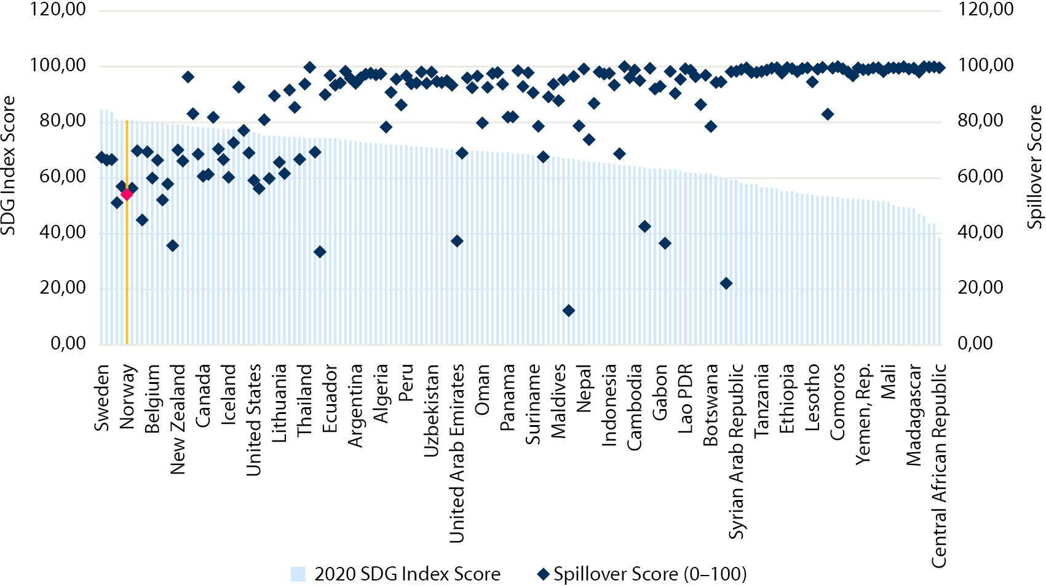
Source: Sachs, J., Schmidt-Traub, G., Kroll, C., Lafortune, G., Fuller, G., Woelm, F. 2020. The Sustainable Development Goals and COVID-19. Sustainable Development Report 2020. Cambridge: Cambridge University Press. Visualisation: Ministry of Local Government and Modernisation, Norway

Policy coherence for the 2030 Agenda
Norwegian development policy is based on the long-standing vision of sustainable development through a balanced interface between the economic, social and environmental dimensions. The concept of sustainable development was established by the Brundtland Commission in the ground-breaking ‘Our Common Future’ report from 1987, and has been an enduring policy principle for all Norwegian governments.
Norway’s ambition for policy coherence means that Norwegian policies should contribute to global development, in accordance with the SDGs. As a minimum, Norwegian policies should not impact negatively on goal achievement for developing countries. This ambition holds true for all policy areas, including trade, agriculture, human rights, migration, investment, climate, environment, energy, security and foreign policy.
The Government’s policy platform from 2019 states that the Government will ‘pursue a development policy where the SDGs are used as a basis and where various initiatives to the greatest possible extent pull in the same direction‘. Likewise, working for better policy coherence for development also requires awareness of the possible negative consequences that Norwegian national policy in various areas may have for the development policy area.
Within the framework of our OECD collaboration, we work with other members to implement the OECD Recommendation on Policy Coherence for Sustainable Development, including peer learning and exchanging best practices.
In order to address such issues, nine reports on policy coherence have been prepared by the Government as part of the annual budget proposal to parliament: ‘Global Common Goods’ (2011), ‘Investments in the Energy Sector’ (2012), ‘Distribution and Economic Growth’ (2013), ‘Norway and the new Sustainable Development Goals’ (2014), ‘Peace, Security and development’ (2015), ‘Sustainable Development Goal 16 on peaceful and inclusive societies with well-functioning legal systems and responsible institutions at all levels’ (2016) and ‘Sustainable Development Target 16.5 on combating corruption’ (2017) and on the ‘Policy Coherence Reform’ (2018) and ‘Climate and Environment’ (2019). The reports have been prepared by the Ministry of Foreign Affairs in collaboration with other ministries.
In addition, Norwegian civil society organisations have played an active role in monitoring the area of policy coherence for development, compiling their own reports and performing their own assessments, such as the Norwegian Church Aid 2020 report. The input from civil society is important for holding the Government to account and ensures a continued public focus on policy coherence issues.
All governments face multiple difficult dilemmas in their policy coherence work. Political decisions must be made in cases where the optimal balance between economic, social and environmental factors may be hard to find, and cases where different groups and political parties may have differing views.
Democracy itself is designed to stimulate discussion and take different perspectives into account, including the global effects of any policy and the interests of future generations. Regular routines for policy formulation, planning and safeguarding policy coherence are put in place in the Norwegian Government, with extensive rounds of external consultation with relevant stakeholders. There are also rule-bound inter-ministerial processes for government decision-making. For the most part, both the inclusive democratic processes and the inter-ministerial processes are working well – also in terms of safeguarding policy coherence for development.
However, developing country representatives and future generations are not at the table to take part in policy-making in Norway. Intrinsically, there is a potential risk that all relevant perspectives on policy coherence are not taken sufficiently into account. Thus, there is a need for special attention to the area of policy coherence for development, and Norway has tried using various models to improve.
Since 2018, the work on policy coherence has been gradually reformed to be more targeted. In 2020, the Government replaced the deliberative ‘Policy coherence forum’ (‘Samstemthetsforum’), established in 2018, with the Advisory Forum on Policy Coherence (‘Innspillsforum for samstemthet’) (see Chapter 5.2.2).
The participants come from the business community, academia, civil society, the business associations and labour organisations to represent civic life in Norway in the broad sense. The advisory forum deliberates general issues and concerns related to policy coherence and voices its views directly to the Government.

SDGs in Norwegian Municipalities and Regions
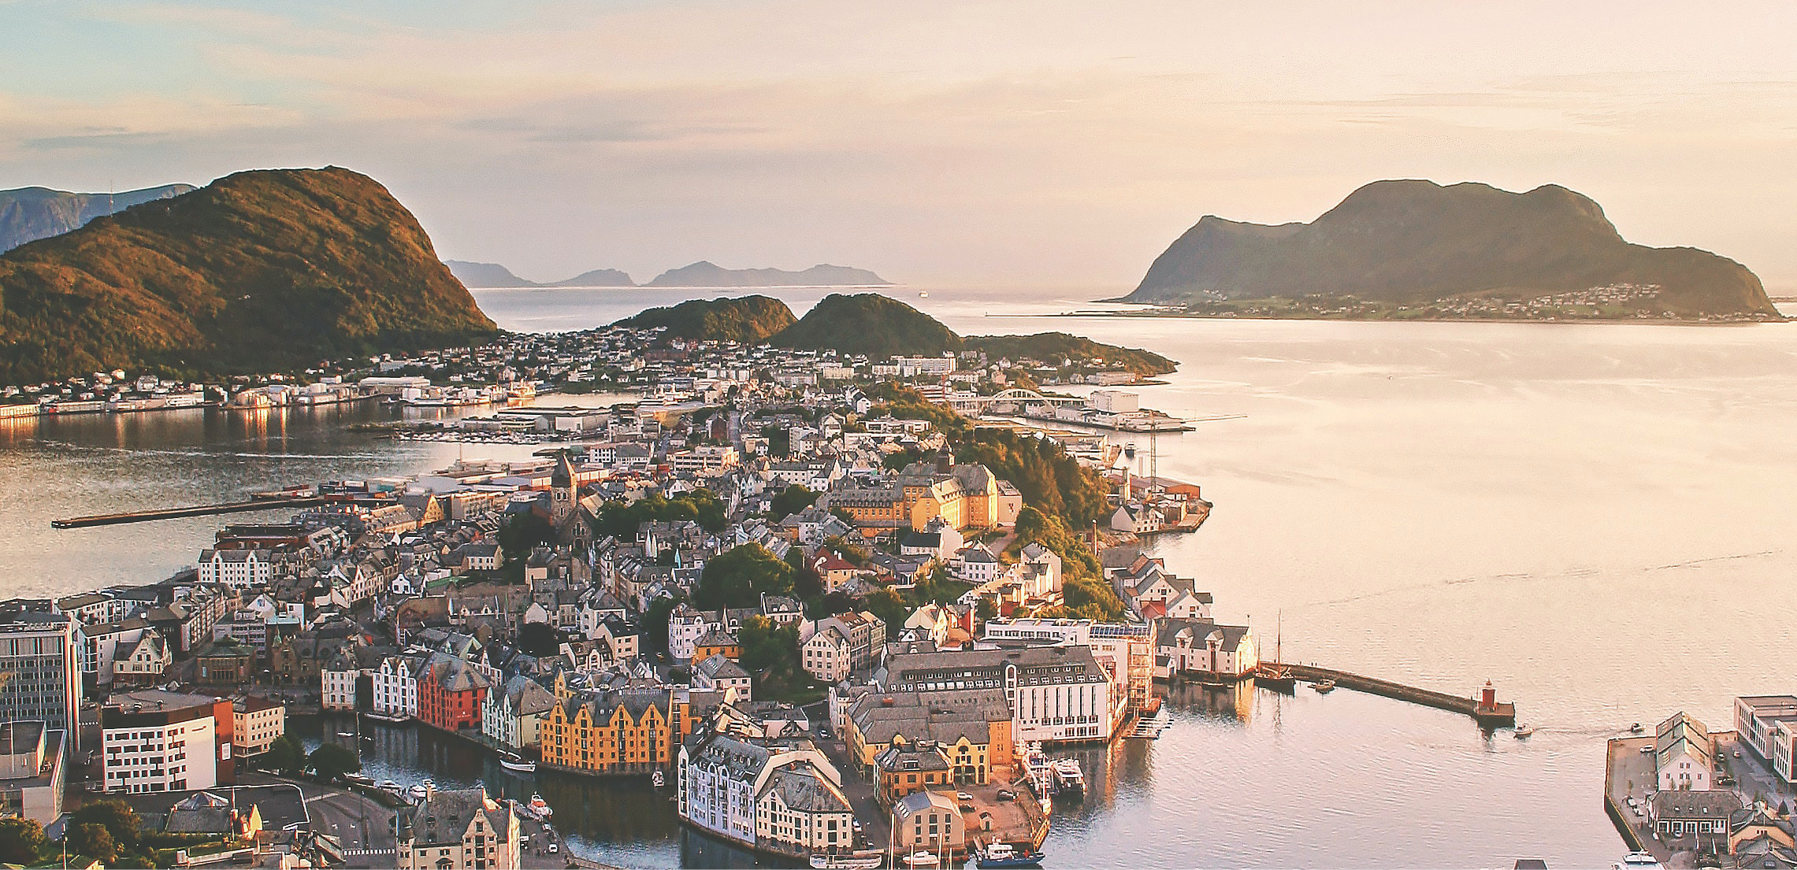
Photo: Jarand K. Løkeland on Unsplash
The following chapter is written by The Norwegian Associations of Local and Regional Authorities.

Key changes/lessons learned
- Achieving the SDGs largely depends on local and regional authorities’ efforts.
- Political commitment is vital. The political focus impacts on the direction and speed of the SDG localisation.
- Most municipalities and regional authorities have initiated the work. There is, however, a large variation in maturity when it comes to working with the SDGs in the Norwegian municipal sector.
- Recently merged, large, central and network-oriented municipalities have come further, but being ‘big and strong’ is not a prerequisite for success.
- Networks, knowledge-sharing and collaboration across levels of government play a huge role, and the synergies between local and regional level are being exploited to a large degree.
- Only the most mature have operationalised and integrated the SDGs into strategic plans and management processes. These are frontrunners setting an example to the remaining municipalities.
- Although no good benchmarking is available, municipalities and regional authorities contribute substantially to SDG achievement through their regular service delivery, welfare production, planning and development work.
- Further statistical evidence is necessary to reveal how the SDGs have been infused into this work.

The municipal sector’s significance for the SDGs
The 2030 Agenda commits national governments. Achieving the SDGs, however, depends heavily on the efforts and progress made at the local and regional level. The SDGs cover all aspects of the local government sector’s work, and the international community widely recognises that at least 105 of the 169 targets underlying the 17 SDGs will not be achieved without local and regional authorities. Local and regional authorities are close to citizens, business and civil society.
Effective multi-level governance requires mutual trust. Achieving the SDGs is a shared responsibility; local and regional authorities need to exercise their own powers, to have administrative structures and financial resources, in line with the European Charter of Local Self-Government. The Norwegian Association of Local and Regional Authorities (KS) coordinates consultation between the government and local and regional authorities. Formal, structured and regular consultations three times a year for more than two decades has fostered multi-level governance dialogue in Norway and common intra-government understanding. It has also reduced the need for national regulations or earmarking in budgets, ensured stable funding of local and regional authorities, enhanced local decision-making thereby securing efficient use of resources, and enabled local democracy.
The main localising activities in Norway are initiated by local and regional authorities. Localising has gained momentum and the pace of implementation is considerable. Local and regional authorities collaborate extensively, such as in the Network of Excellence on SDG City Transition consisting of municipalities and regions, which focuses on local SDG initiatives across the country. The network was initiated by several local and regional authorities and organisations, together with KS and the UN Charter Centre of Excellence in Trondheim. To strengthen the efforts of the Norwegian Network of Excellence on SDG City Transition, KS is also working together with the Confederation of Norwegian Enterprise (NHO) and the Norwegian Confederation of Trade Unions (LO) to develop a national sustainability pledge to strengthen the progress on fulfilling the 2030 Agenda.

Local and Regional governments’ efforts to localise the SDGs
Over the past couple of years, local and regional governments in Norway have taken significant steps in their efforts to work with, and towards, the SDGs. In fact, in a recent survey conducted in relation to the Voluntary Subnational Review (VSR), 95 per cent of the municipalities and all the regional authorities that responded report that they have started working with the SDGs. However, when asked to evaluate how far they have come, municipal responses are more modest and there are apparent variations as to who has made significant progress in working with the SDGs in a local and regional context. The following paragraphs will elaborate on these variations and outline other key, overarching findings relevant for describing the status and progress on working with the SDGs in the local and regional government sector.
There are large variations between municipalities in terms of commitment, progress and implementation although parts of that variation can be explained. There are large variations in terms of commitment to and implementation of the SDGs across the municipalities. Larger municipalities have a tendency to have worked longer with the SDGs, and these municipalities also seem to be more committed and have come further in implementing the goals. They have also typically come further in leveraging measures to cooperate with both internal and external stakeholders. A similar but less apparent correlation is found for centrality, and in addition, there seems to be higher political priority in more central municipalities. However, there is no clear correlation between budgetary constraints and implementation of the SDGs in the municipal context. This indicates that although financial resources and capacity can be an enabler, large financial and budgetary constraints do not seem to have influenced the speed and progress of the municipalities’ implementation of the goals. Engagement in networks and regional activity, on the other hand, seem to play a key role, particularly when it comes to commitment, cooperation with stakeholders and implementation in management processes.
Although the aforementioned dimensions explain some of the variation in the municipality responses, variation within these dimensions and other unexplained variation mean that there are individual differences between municipalities. As such, although being ‘big’ and ‘central’ may increase the likelihood of being ahead in working with the SDGs, there are several cases where municipalities with fewer available resources thrive in this space.
The Norwegian Network of Excellence on SDG City Transition
Several municipalities, regional authorities and organisations, together with KS, formed a network to join forces in localising the SDGs, demonstrate local adaption and accelerate impact by linking local action to regional, national and international partners for knowledge-sharing and funding. The network is an ongoing prototyping of a multi-level and multi-stakeholder approach to sustainable development and is collaborating closely with the UN initiative United for Smart Sustainable Cities (U4SSC). The network, which is expanding rapidly, builds on the Stavanger Declaration and sets out to:
- spread knowledge about the status to the community;
- develop plans for community development that illustrate how to achieve the SDGs;
- mobilise and support citizens, businesses, organisations and academia that contribute to sustainable development;
- measure and evaluate the effort, through the U4SSC Implementation programme and other methods.

The regional authorities mobilise and engage the municipalities in their work with the SDGs. Lack of guidelines and support from national authorities are key barriers at the regional level. While the municipalities look to the regional authority, KS and other municipalities for collaboration and support, the regional authorities seem to rely more heavily on support from the national level. There is considerable collaboration and network activity across local and regional government level. The majority of the municipalities have participated in regional networks or programmes, and the regional authority is their most used collaboration partner. Likewise, all the regional authorities have used establishment of or participation in networks as a means of involving the municipalities. As such, the synergies between the local and regional level seems to be leveraged to a large degree. The regional authorities, however, report lack of support and clear guidelines from the national level as a key barrier.
The Sustainability County Møre og Romsdal
The Sustainability County Møre og Romsdal is a regional authority initiative to collectively boost the work on sustainability in the region. With this initiative, the county wants to position themselves as a clear contributor in developing a sustainable society for the future. The goal is to direct the regions’ efforts towards achieving the SDGs in a methodical and coordinated manner. To achieve this, on the regional authority’s initiative, all the municipalities in the region have collected data and measured performance and progress according to U4SSC’s KPIs. This is to ensure that all the municipalities and the regional authority have a common knowledge base for further work. Cooperation with businesses, associations, the voluntary sector, the culture sector and the research community in the county is also central to the efforts in the sustainability county.

Municipalities and regional authorities have incorporated the SDGs into their strategy and vision. Asker, Kristiansund and Arendal, among others, use the SDGs as a basis for municipal plans and incorporate the goals into management systems. Large or recently merged municipalities have had a head start in implementing the SDGs in the municipal planning system. Municipal master plans best provide evidence for SDG incorporation. There is currently a large variation in the implementation of the goals in the municipal planning system. This is expected to change when all municipalities and regional authorities have updated their plans before the end of the current council period, in compliance with the national planning expectations. Some municipalities have already made good progress in fully integrating the SDGs in budgeting and procurement processes. Many municipalities and regional authorities point to operationalisation as both a key success factor and a barrier. Several municipalities report that it is challenging to work systematically, strategically, knowledge-based and plan-driven with the SDGs.
The most mature municipalities have measures and report on progress towards the goals. Half of the regional authorities and a quarter of the municipalities have measured progress on the SDGs. The majority of those that have not yet conducted monitoring are planning for it, which indicates a positive future development in this field. For both the regional authorities and the municipalities, participation in the Norwegian Network of Excellence on SDG City Transition seems to trigger this process. The Network collaborates closely with U4SSC, and several of the participants have used the U4SSC’s set of KPIs to monitor progress and measure how smart and sustainable they are. Additionally, Viken regional authority has used the OECD’s set of indicators to measure progress and has developed a Knowledge Base using the SDGs as the overall framework. Statistics Norway has, on commission from KS, developed a classification of SDG-related indicators that will facilitate a common approach to monitoring. As such, there are frontrunners leading the way when it comes to measuring and reporting progress on the SDGs.
Taxonomy for classification of SDG-related indicators
Stimulated by the need for useful tools to connect the global goals to local and regional activities and projects, KS partnered with Statistics Norway to develop a taxonomy for SDG indicators. Applying a common standard taxonomy to all SDG indicators helps to clarify their use and usability. The taxonomy proposes three dimensions for sorting SDG indicators; Goal, Perspective and Quality, and together they cover the central properties of any SDG indicator, with respect to its target, use and usability.

There are large variations when it comes to access to appropriate tools and methods for implementing the SDGs, both for the municipalities and the regional authorities. The small municipalities seem to be at a disadvantage. There is scope for devising new methods and tools and making these accessible to all. Participation in networks, and particularly the Norwegian Network of Excellence on SDG City Transition has a positive impact on access to relevant tools and methods. This indicates the importance of networking and knowledge-sharing.
Recently merged municipalities have made more progress in implementing the SDGs across strategy, plans and operationalisation. Merger processes seem to be a trigger for change and a stronger focus on the SDGs. This process serves as a clean slate for developing strategies and management systems, in which the SDGs seem to have stood out as a relevant framework for structuring the work, while providing a common direction and purpose for the new municipality.
The SDGs and Norwegian territorial reform
In the merger between Hurum, Røyken and Asker, the new Asker municipality decided to set up the new municipality based on the SDGs, and used the goals as a framework for the municipal plan and underlying plans. They wanted to demonstrate that the global goals also have local relevance, and thereby engage citizens, businesses and voluntary organisations and encourage teamwork in achieving the goals. Asker’s innovative merger process has inspired others, including Nordre Follo municipality and Viken county, who like Asker, built their new authority with the SDGs as a foundation.

Political commitment is vital. The municipalities with a political focus on the SDGs have generally come further when it comes to integrating the SDGs in the municipality plans. This indicates that the political level has the potential to impact the direction and speed of the SDG localisation. Lack of political prioritisation is also considered an important barrier by several of the municipalities and regional authorities. The municipalities Aremark and Bodø, as well as Viken regional authority, and others, have established a systematic approach for involving the political level in the operationalisation of the SDGs using templates to manage and process background documents. Consequently, the SDGs become an integral part of political decisions.
There is consensus that the SDGs have potential to create new ways of working, cross-sectoral partnerships and innovation. Most regional authorities and one third of the municipalities use the SDGs to create new ways of working and new partnerships. Regional authorities use the SDGs to create new partnerships internally in the administration, with external stakeholders and across levels of government. Using the SDGs as a trigger for new, value-driven initiatives is key to leveraging the SDG framework’s potential.
COVID-19 does not seem to have had a significant impact on the regional management level’s SDG efforts. The pandemic has tied up resources, which has reduced municipalities and regional authorities’ capacity for working with the SDGs. There is potential in working holistically and cross-sectorally, and a value in creating a sense of cooperation and mutual recognition of facing a difficult situation together. This can and should be translated into a broader SDG perspective following the pandemic.

Progress on SDGs and targets
Municipalities and regional authorities make a substantial contribution to the achievement of the SDGs through their regular service delivery, welfare production, planning and development work. It should be noted that even though the municipal sector is performing well on many of the SDGs and targets compared to national and international standards, many are striving to improve performance even more.
SDG indicators are still lacking for regional and local authorities. However, progress can be monitored using existing data sources. A holistic approach, demonstrating inter-connectivity between SDGs and targets, becomes clear when structured around the municipal sector’s own six priority policy areas, as committed to in KS’s National Congress in 2020.
More than 30 municipalities have conducted KPI monitoring according to the U4SSC. Norway was the first country to apply the U4SSC KPIs for smart and sustainable cities to an entire network of cities.
          - U4SSC Norway Disc
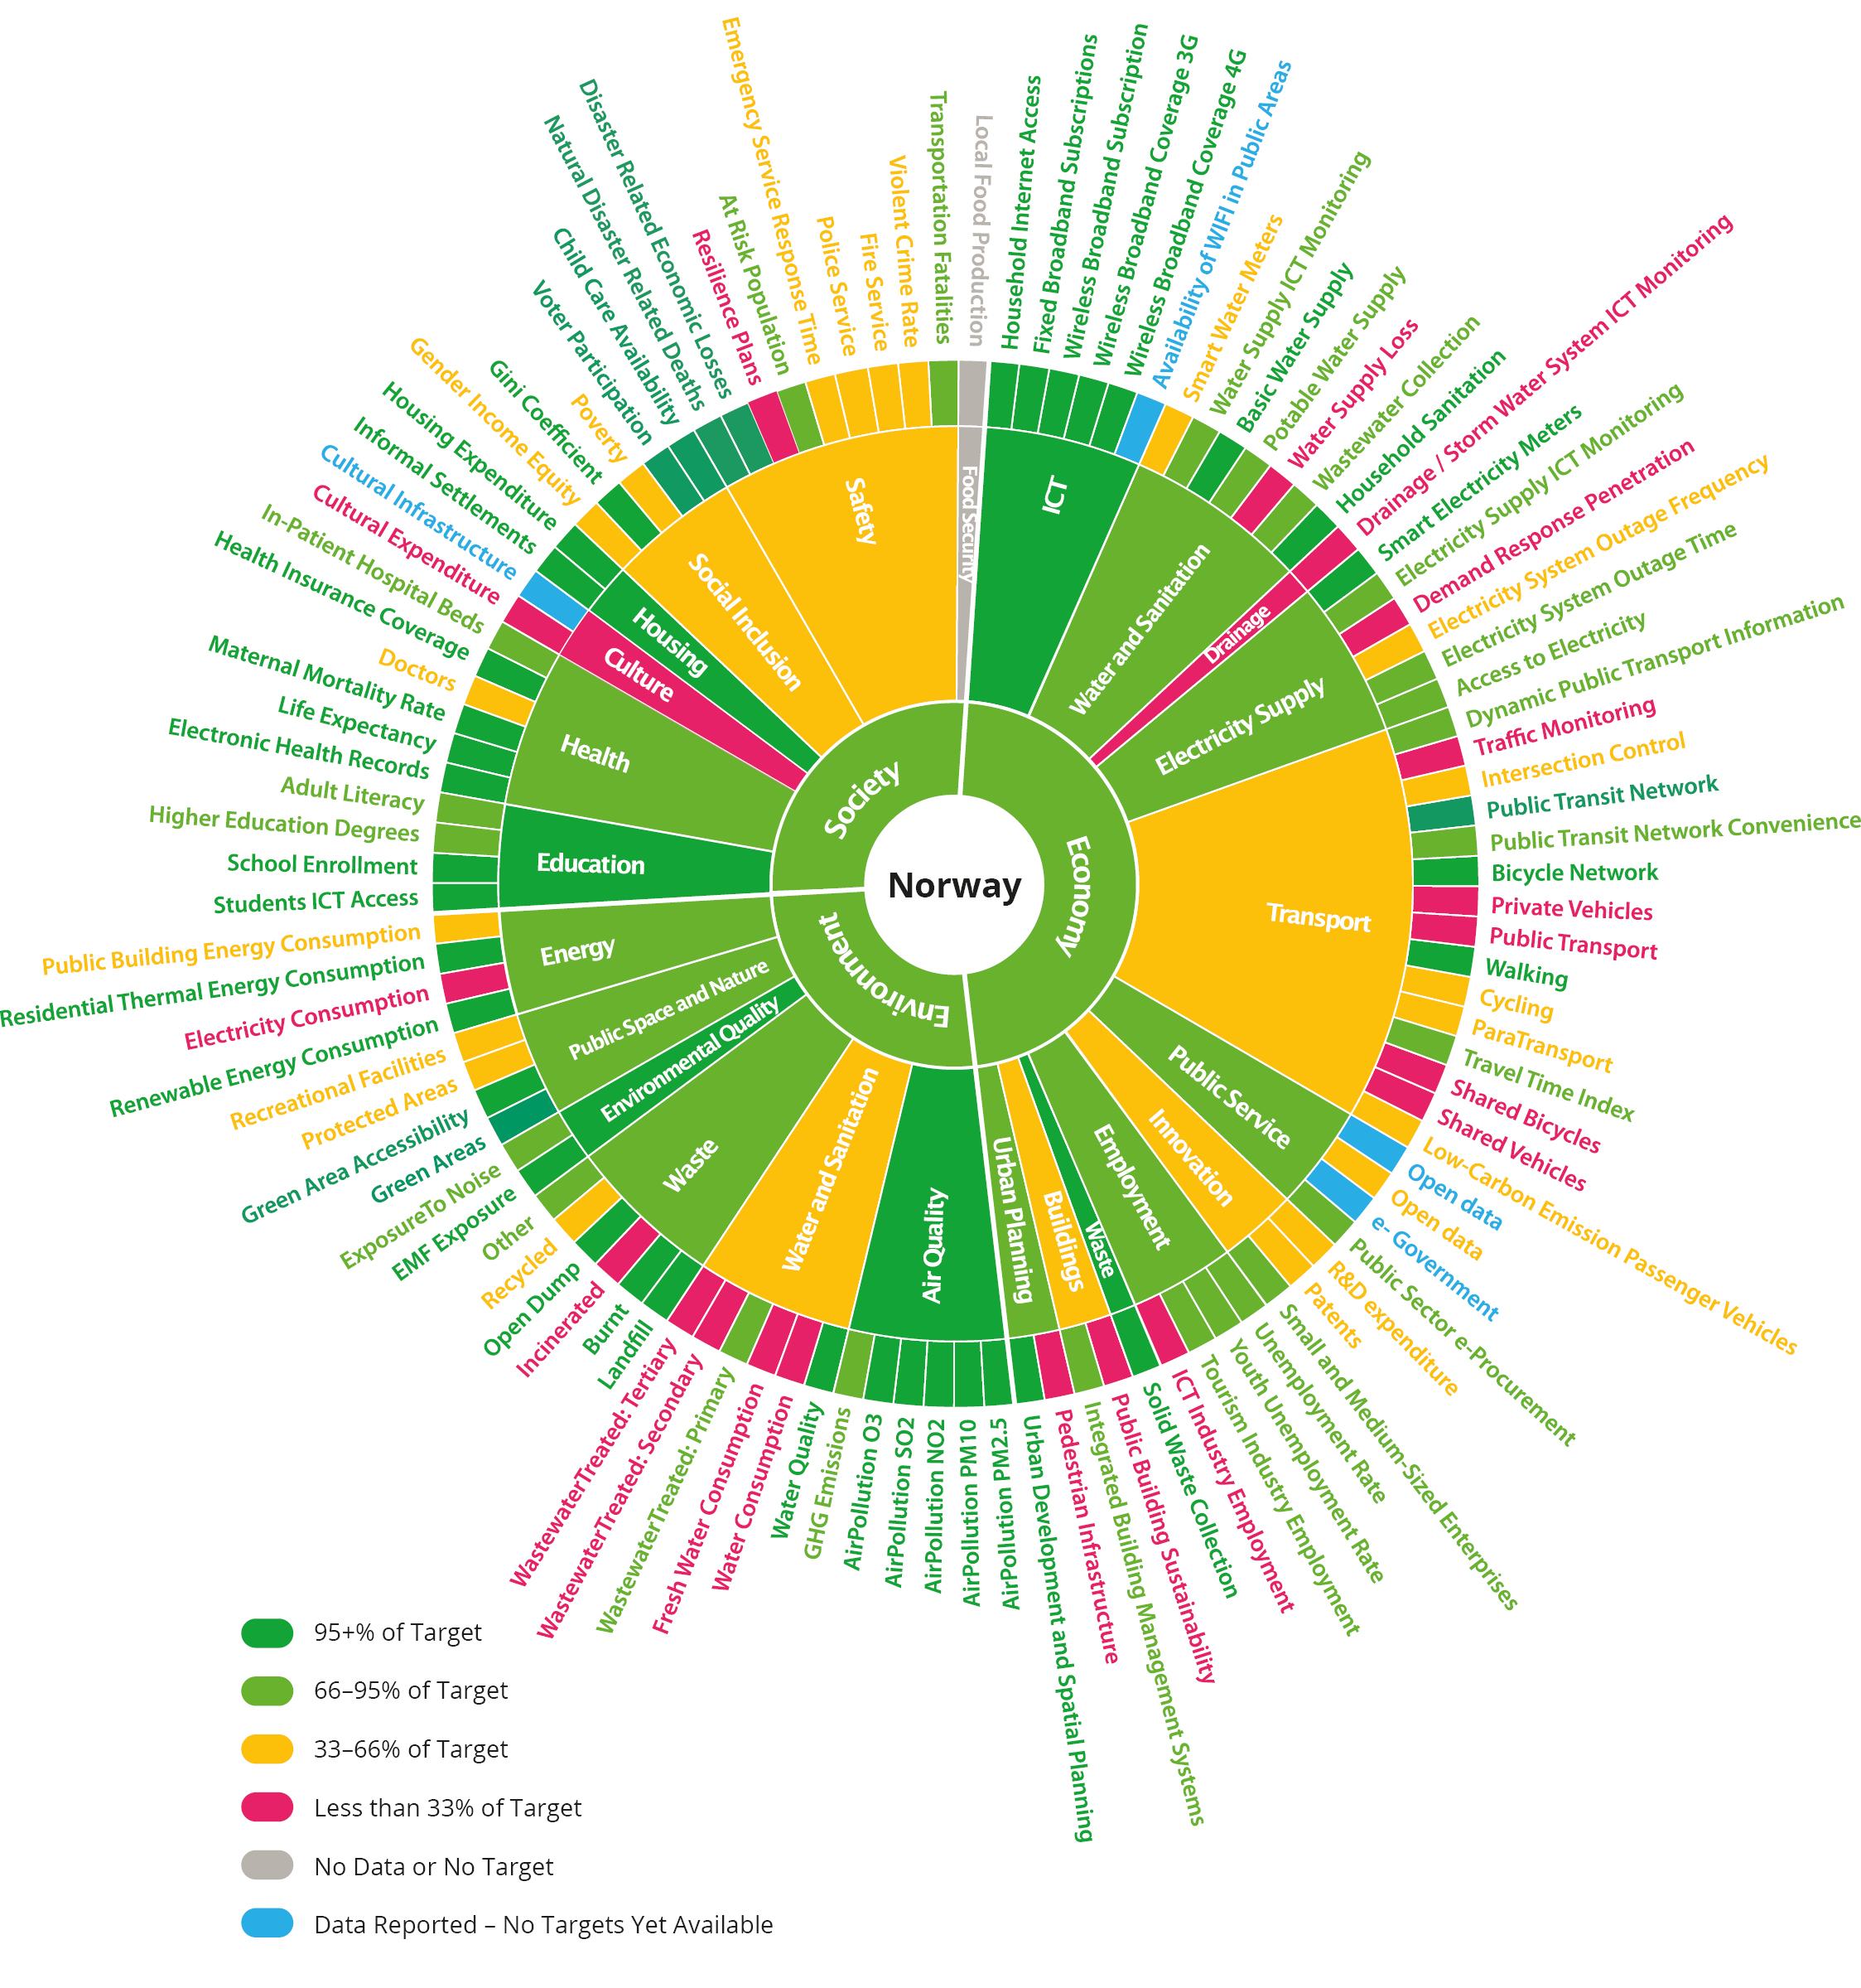
Source: U4SSC

Adolescents and quality of life (SDGs 1, 2, 3, 4, 5, 8, 10, 16 and 17)
The municipal sector facilitates most of the health services, well-being, attractive centres, good meeting places, inclusion, higher upper secondary completion rates and social equality. The municipal sector’s targeted work seeks to provide good conditions for adolescents, the local environment, public goods, participation in work, activities and social life and opportunities for quality of life and life management, regardless of age and living conditions.
The municipal sector is making good progress and performing well in terms of U4SSC, especially within education and health. These findings are substantiated by a biannual citizens’ satisfaction survey, which shows that three-quarters of Norwegians are satisfied with their municipalities.
          - Perception of municipalities
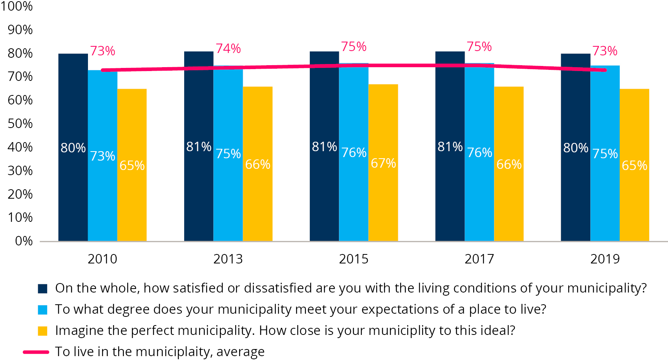
Source: The Norwegian Agency for Public and Financial Management (DFØ)
Youth are less satisfied with their local communities than the rest of the population, and feel lonelier. The feeling of loneliness among young people has increased during the pandemic lockdown.
          - Loneliness among upper secondary school pupils
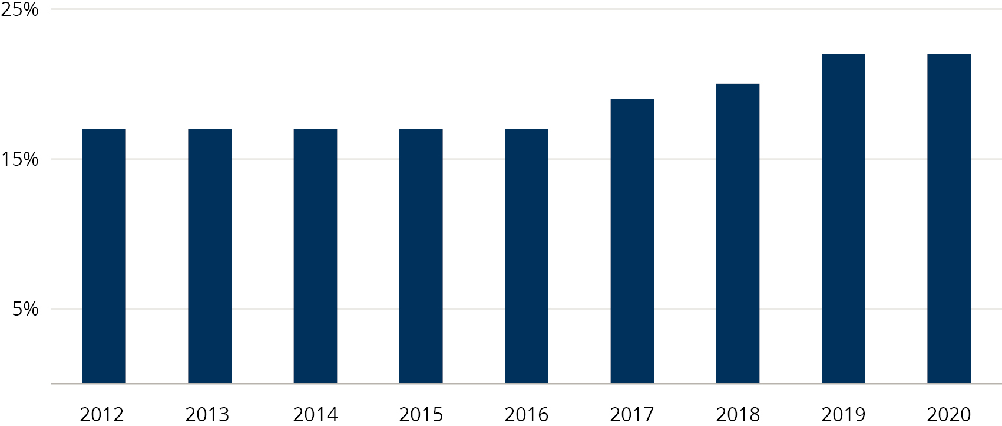
Source: Norwegian Institute of Public Health

Climate and environmentally friendly development (SDGs 6, 7, 9, 11, 12, 13, 14, 15 and 17)
The municipal sector is taking active leadership in the transition to a climate-friendly and environmentally friendly society. Municipalities and regional authorities have set ambitious climate targets and aim to be forward-looking in the green transition. Many of the targets are far more ambitious than the national goals. The strategies to achieve these goals include transforming into a low-emission society, facilitating land use and infrastructure that reduce emissions and energy consumption, and implementing necessary measures to limit the effects of a changing climate.
Regional authorities are phasing in electric transport. More than 70 emission-free battery-driven ferries will soon be in operation, which accounts for around one third of the total fleet. The number of electric buses more than doubled in 2020, to a total of 410. Around 120 new electric buses have been contracted for 2021.
          - Passengers on public transport
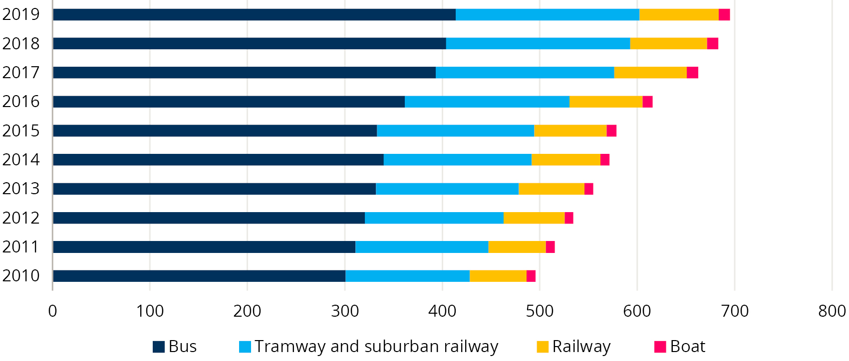
Source: Statistics Norway
The number of journeys using public transport increased by half a per cent in 2019 to 695 million. Almost 90 per cent of passengers use regional authority transport. Nevertheless, according to U4SSC, the Norwegian municipal sector may perform better in the transport sector. The development has largely been driven by the city centres, and there has been poor utilisation of more mobile and innovative modes of transport, as well as systematic use of monitoring data. For obvious public health reasons, use of public transport has decreased during the COVID-19 pandemic. It is expected that some of the decrease will be permanent due to the increased use of home offices and greater awareness of congestion.
Sustainable land management is an important part of the work to preserve biodiversity, secure food production and reduce climate emissions.
          - Reallocation of arable land
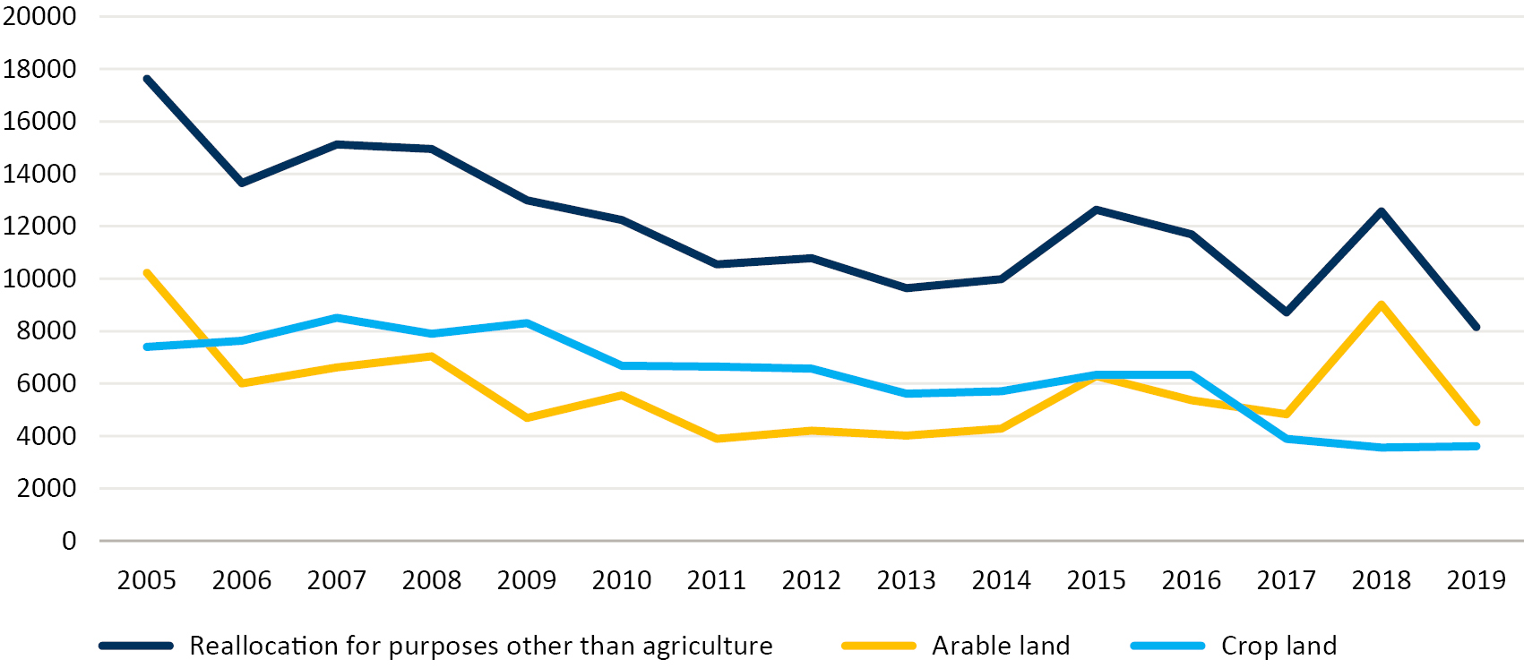
Source: Statistics Norway
Land use changes are the main source of loss of biological diversity. Areas used for cultivation and areas that can be used for cultivation are repurposed for transport infrastructure, housing, commercial buildings and energy production. This trend has been declining in recent years. Production of electric power has increased in recent years to a total of 154.2 Twh. At the end of 2020, 297 square kilometres was required for wind power alone, an area that is rapidly growing. The species database currently classifies 2,000 species and 74 habitats as endangered.
          - Repurposed land
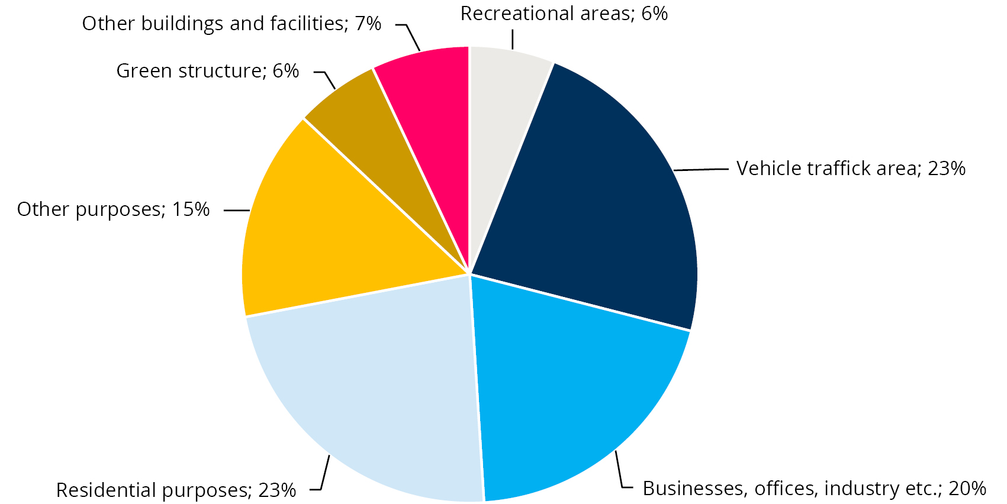
Source: Statistics Norway

Adaptable business community (SDGs 8, 9, 11, 12 and 17)
As community developers, the municipalities and regional authorities set out to facilitate sustainable development, innovation and value creation in the private and public sector. New technology and collaboration between business, academia and the public provide robust infrastructure and commercial opportunities, ensuring that everyone has somewhere decent to live, good welfare services and attractive communities. For businesses, good conditions for green restructuring as well as digital and physical infrastructure are important for maintaining and expanding commercial activity and creating jobs. The development and use of new technologies can help solve major environmental and climate challenges. Municipalities and regional authorities play an important role for the private sector through procurement and investment projects. The public sector must lead the way in green restructuring, inclusive workplaces and professionalism.
A prerequisite for an adaptable business sector and a digital public sector is that businesses, public agencies and residents in the municipality have access to high-speed broadband. The national goal of 90 per cent of households with at least 100 Mbit/s internet access by 2020 has nearly been achieved. In 2020, the responsibility for distributing development grants for internet access was transferred to the regional authorities. The coverage has increased sharply in areas with the lowest coverage. Despite good infrastructure, high competent businesses and residents who are quick to adopt the technology, U4SSC shows that the technology is not sufficiently used to innovate and further develop businesses and services.
          - Internet connection
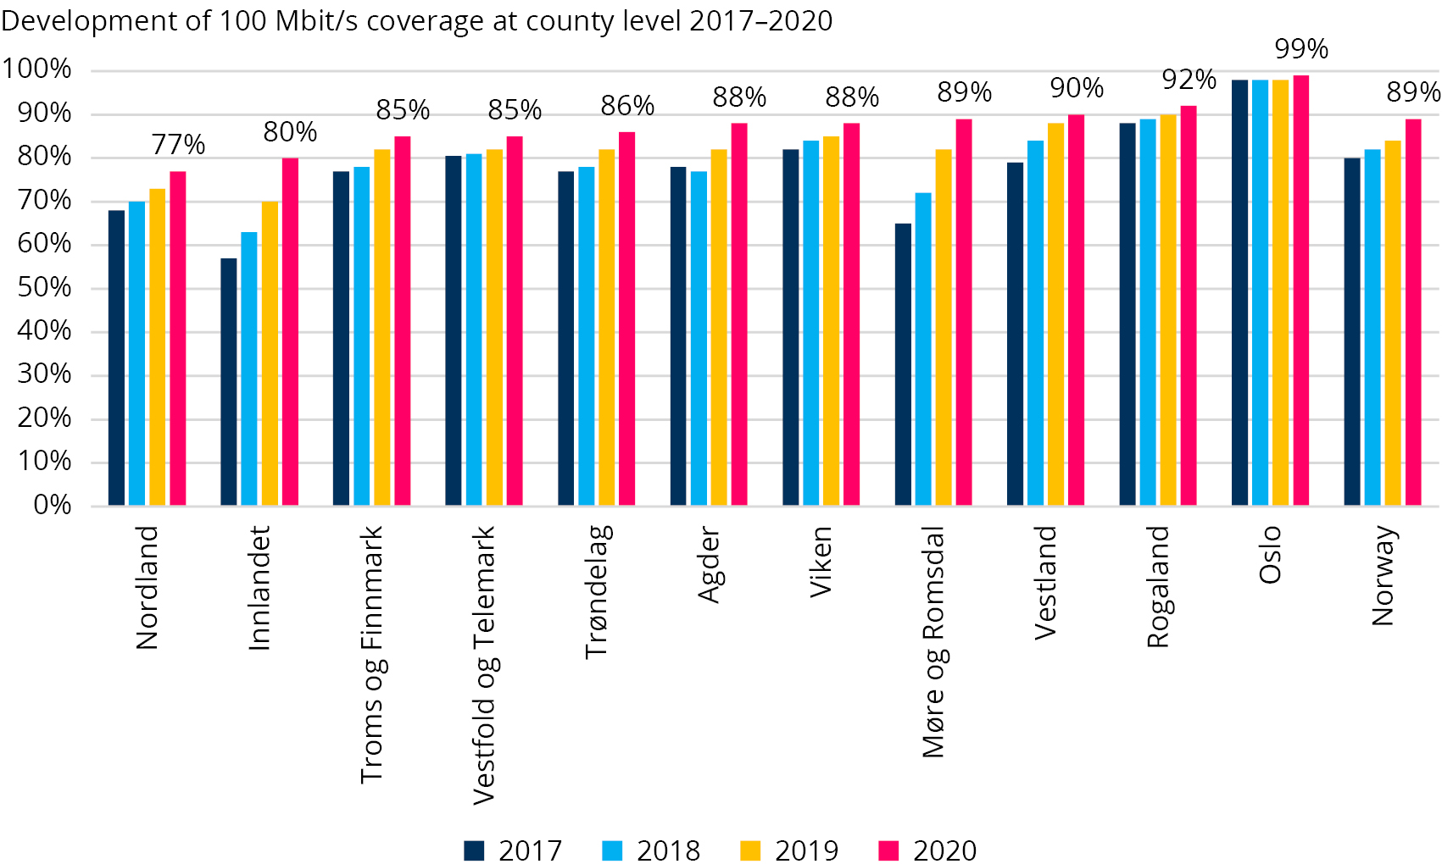
Source: Norwegian Communications Authority (Nkom)
Procurements are another important means for the municipal sector to facilitate an adaptive business sector. Seventy-five per cent of the regional authorities and 59 per cent of the municipalities have a procurement strategy. This is higher than authorities at the national level, where 48 per cent have a procurement strategy. The municipality sector places an emphasis on climate and environment, ethics, wages and working conditions and social responsibility. Innovative public procurements represent a small percentage of the total procurements.
          - Public procurement
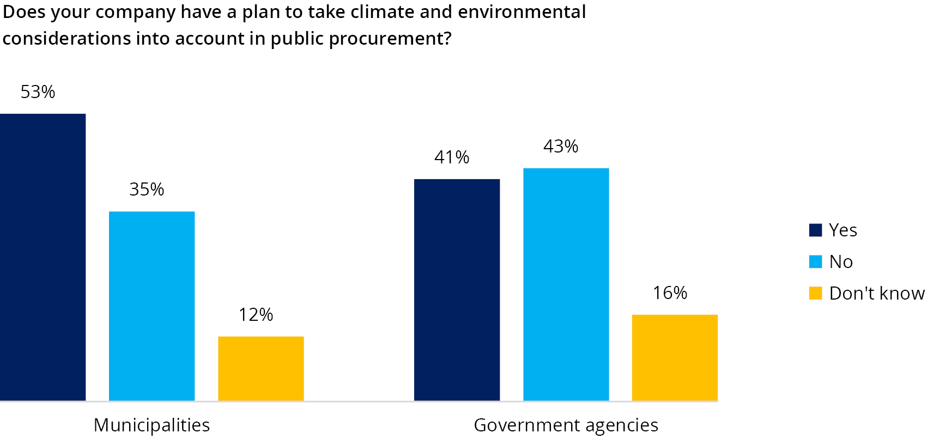
Source: The Norwegian Agency for Public and Financial Management (DFØ)

Attractive places and cities (SDGs 3, 6, 9, 10, 11 and 17)
Developing attractive places is important for the climate, living conditions and business. The municipal sector develops vibrant communities with good meeting arenas for people. Through regional plans, the regional authorities work on coordinating housing, land and transport planning. The emphasis on attractive places and cities is partly a reaction to the loss of business and activity in the local city areas over time , and partly due to a desire for positive development and better quality.
Many municipalities are working to increase attractiveness for people and businesses. Important factors are clean air and clean water, absence of noise and good access with short distances to workplaces, public transport and service, leisure and cultural facilities. According to U4SSC, the municipalities score highly on important factors such as noise, dust and water. These findings are reflected in a citizens’ satisfaction survey, which indicates that the population has a positive perception of waste management, safety, the environment and proximity to primary schools. The population’s view of the possibility of engaging in activities has weakened somewhat in recent years.
          - Perception of public services
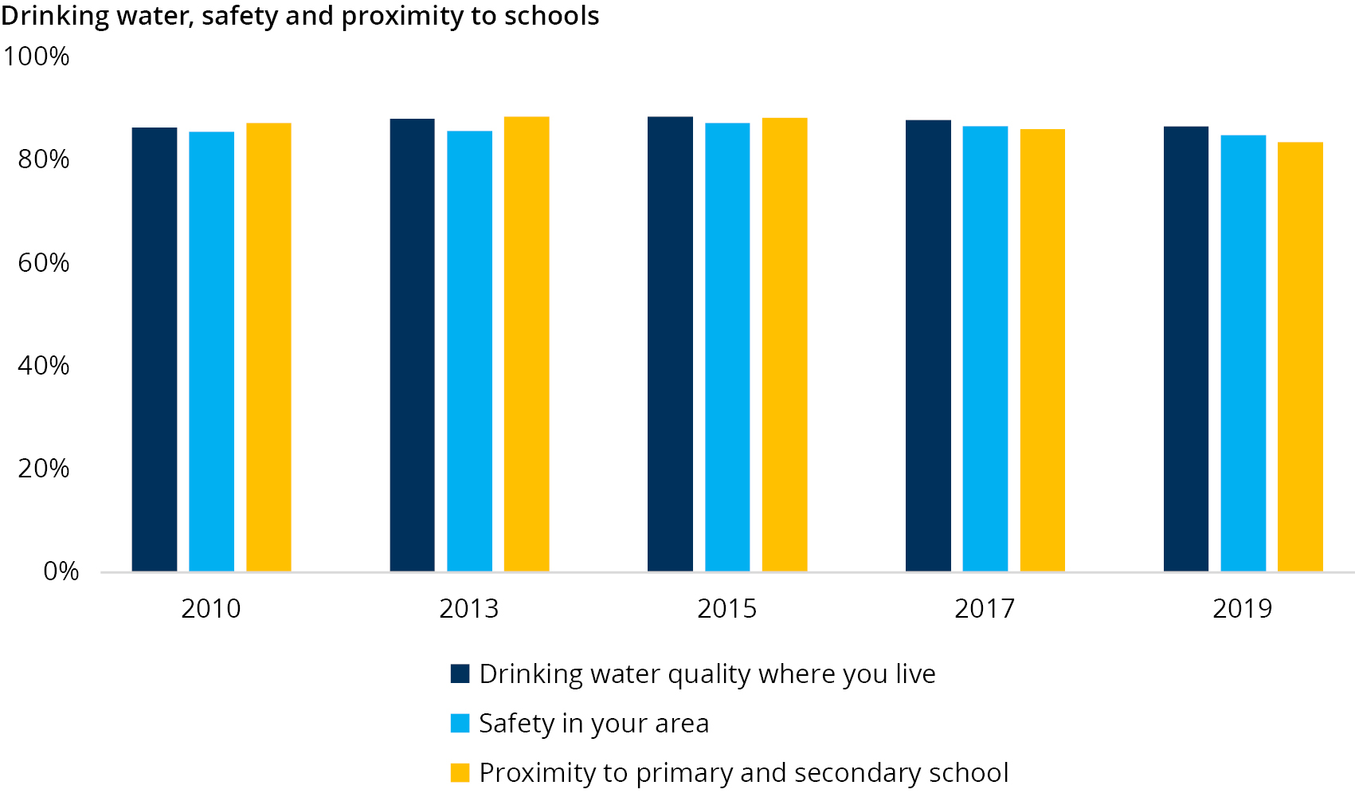
Source: The Norwegian Agency for Public and Financial Management (DFØ)
Social dialogue is an integral part of the Norwegian welfare model, and has resulted in permanent employment and decent pay, good working conditions and high productivity and flexibility. There is a close and satisfactory cooperation between the municipal sector and local trade union representatives.
          - Social dialogue
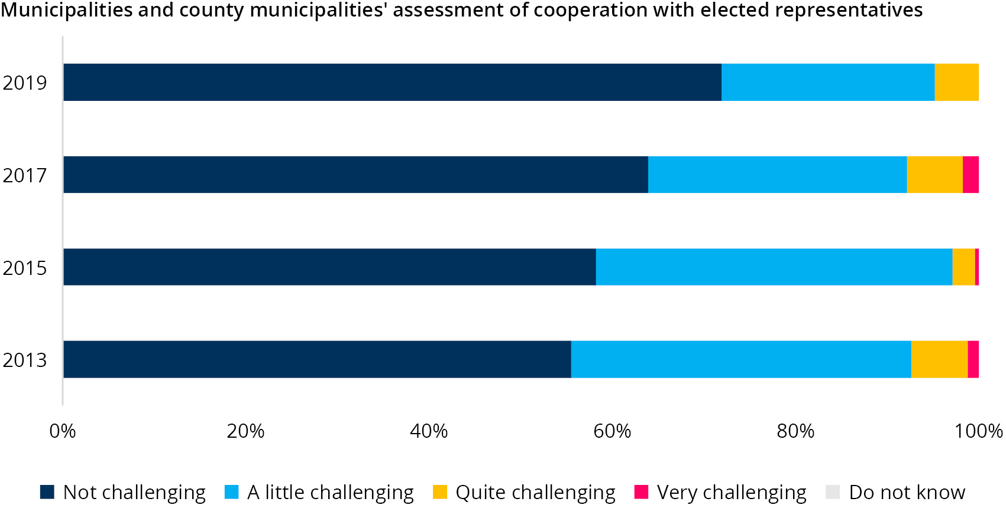
Source: KS

Diversity and inclusion (SDGs 1, 3, 4, 5, 8, 10, 16 and 17)
Diversity and inclusion are linked to public health, attractive locations, business, upbringing and education. Diversity and inclusion require respect for other people, regardless of sexual orientation, beliefs, opinions and cultural expressions. Inclusion is also largely about the inclusion of newcomers and asylum seekers and about inclusion in local communities and working life. Society is built from the bottom up.
Norway is a diverse society. Results from U4SSC, as well as other statistics, raise concerns about trends in diversity and inclusion, particularly among children and youth. The proportion of children growing up in families with a persistent low income has increased. Overcrowding is increasing for those with the lowest incomes. Cramped conditions make it difficult to bring friends home and to have space and peace for schoolwork.
          - Household poverty
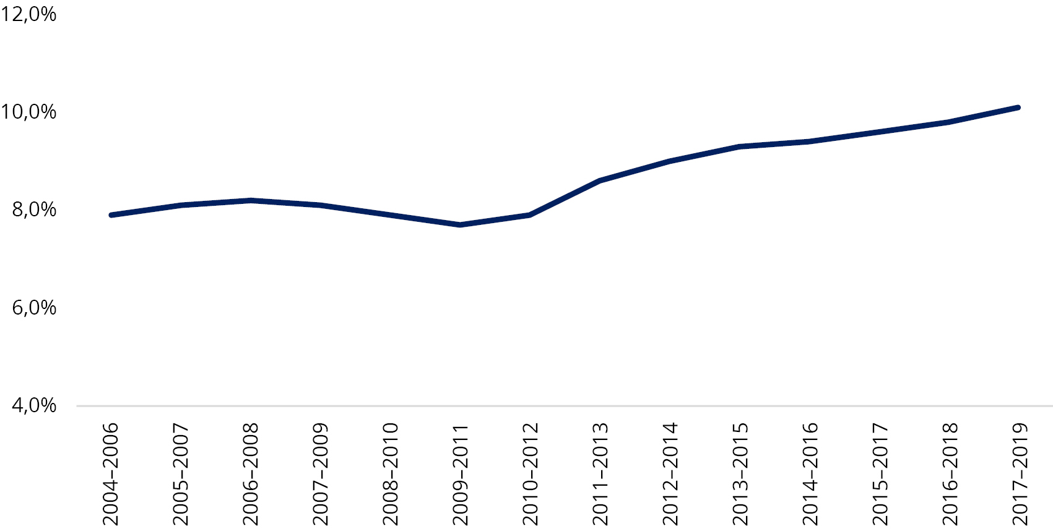
Source: Statistics Norway
Exclusion of youth is still a challenge in the Norwegian society. Although drop-out rates have fallen in recent years, numbers are too high. This is especially true for vocational subjects. Drop-out rates amongst immigrant, especially refugee, children are higher than amongst children in general. The reasons for dropping out are many and complex, but it is partly related to the pupil’s results from primary school, background and motivation for schoolwork.
The proportion of people of working age who receive disability benefits is high, and the proportion of youth in this group is increasing. An estimated 120,000 young people between the ages of 20 and 30 are not in education, employment or training. Mental disorders are an important cause of disability among young people and those who drop out of education and working life, generating high life-span costs.

Citizens’ participation (SDGs 5, 10, 16 and 17)
The municipal sector is committed to promoting participation in a transparent, vibrant and engaging local democracy that interacts with the private and the voluntary sector. The municipal sector is committed to providing meeting places and venues, adopting new methods for dialogue, working with clear language and transmitting active information and communication. Involving citizens in the political processes increases the opportunities for democratic participation and influence.
Election turnout increased significantly in 2019, with the largest increase among youth. The citizens prefer to have elected representatives in their own municipal council as a channel for promoting their interests. However, they are not completely satisfied with how politicians involve citizens and listen to their views.
Trust in both national and local institutions and actors has decreased somewhat from 2007 to 2019, and more so for national than local institutions. Numbers from 2020 suggest that public trust is growing again.
          - Public trust
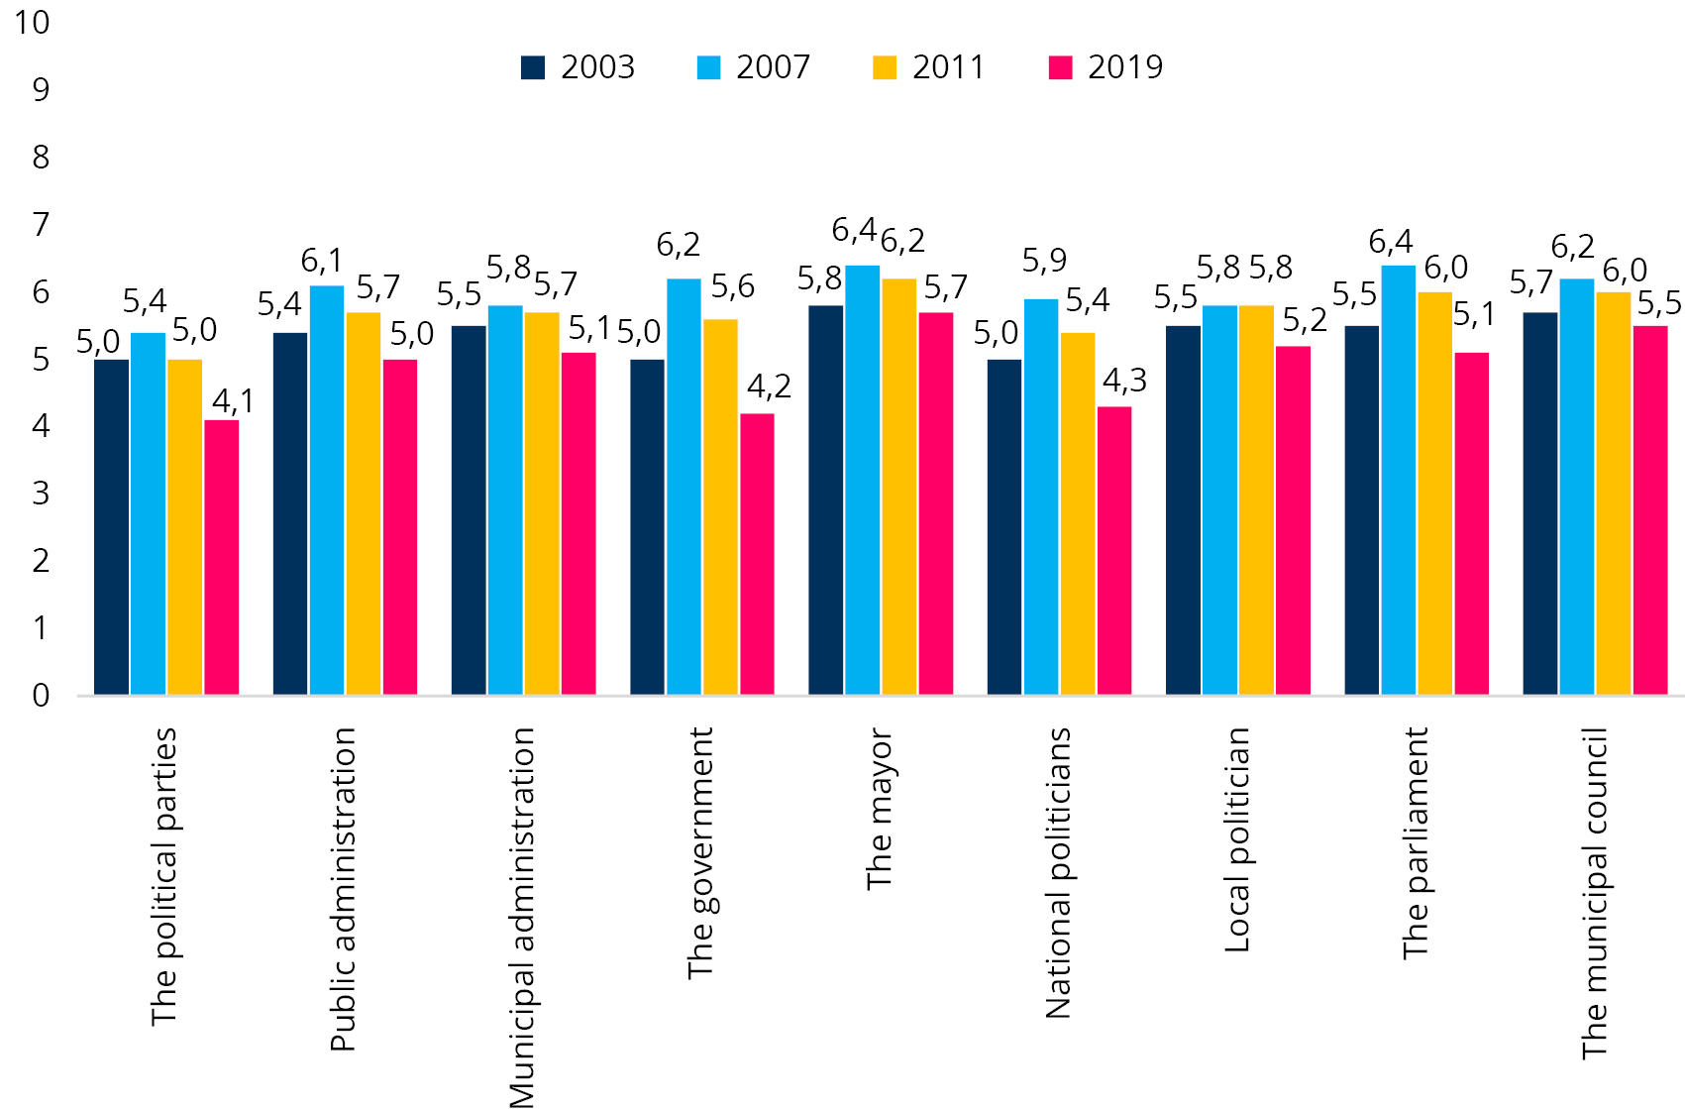
Source: Institute for Social Research
Hatred and threats prevent participation. Forty per cent of local politicians have been exposed to hate speech or specific threats. Younger politicians are more exposed. The large scale of hate speech and concrete threats against local elected representatives is a danger to freedom of expression and democracy.

Local governments’ message to the Government
Based on assessments of local and regional authorities’ efforts and progress on the SDGs, KS recommends the following;
- Political commitment and leadership at all levels of government is required to achieve the SDGs.
- Upholding multi-level governance, policy coherence and multi-stakeholder partnerships is essential for SDG implementation. Identifying critical interdependencies between action areas to pursue a coherent approach to SDG implementation and limit negative spillovers.
- Local and regional authorities must be fully consulted at each step of the national decision-making process. Periodic progress assessments (VNR and VSR) must expedite and determine the direction of SDG fulfilment.
- Regional authorities need adequate support mechanisms and tools to mobilise and engage the municipalities, such as appropriate SDG indicators for regional and local authorities.
- Continued sharing and learning from peers, as well as to emphasise experimentation and innovation with a view to finding better solutions to common challenges.

Means of implementation
Photo: Aleksander Myklebust

Key changes/lessons learned
- International cooperation and development assistance are important for supporting developing countries, but a focus on coherence is also necessary.
- Technology is an important tool for developing and sharing knowledge, monitoring and reviewing.

Sustainable development in the Norwegian state budget
One of the main priorities in the Norwegian state budget since 2016 has been to promote the transition to a carbon-neutral society by 2050. In 2020 the Government allocated approximately NOK. 4,5 billion to a green transition package to reduce the negative effects of COVID-19. The funding was allocated to research, innovation and the transition to a climate-neutral society in the private sector and municipalities. NOK 11 billion, (approximately EUR 1,1 billion ) has been added to the budget for 2021 to promote climate and environmental efforts. This is followed up by the revised budget for 2021.
The Government has allocated NOK 1 billion to the Green Platform, a commitment over a three-year period. The Green Platform, will promote a coordinated, enhanced and more focused effort to stimulate the transition to a carbon-neutral society, and NOK 333 million is allocated in 2021. The platform builds on established schemes in Innovation Norway, The Research Council of Norway (RCN), SIVA and ENOVA.
The RCN granted NOK 193 million to innovation projects in the public sector in 2020. Approximately NOK 50 mill was granted to a planning programme. One of the projects focuses on developing a framework for localising the SDGs in regional and local planning.
The switch to electric cars is a priority. Norway now has one of the largest share of electric cars in Europe, due to the taxation system. ENOVA plays an important role in supporting investments in infrastructure for charging electric cars in parts of the country where the market is not sufficient.

Norway’s official development assistance
Norway has for several years given around 1 per cent of GNI in official development assistance (ODA). As shown in the figure below, Norway was one of the six member countries of the Development Assistance Committee (DAC) which met or exceeded the United Nations’ target of 0.7 per cent of GNI going ODA in 2020.
          - Development assistance as a share of GNI
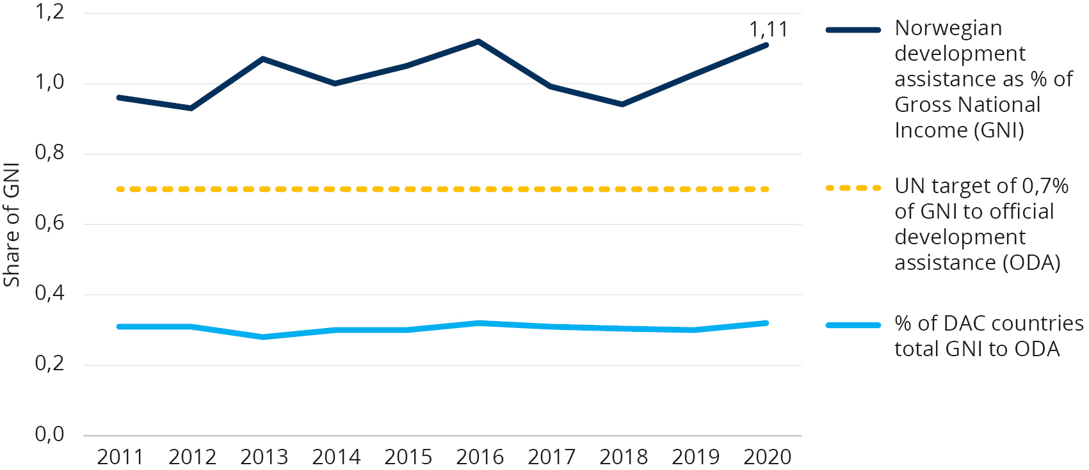
Source: Norad
In recent years the share of Norwegian official aid to the least developed countries (LDC) has been above 0.25 per cent of GNI. The UN target is to give between 0.15 and 0.20 per cent of GNI to LDCs.
The main goal of the Norwegian development policy is to combat poverty and promote economic growth and welfare in developing countries, within the framework of human rights, the SDGs and the Paris Agreement, and in support of the overall target of developing countries to become aid independent.
Norwegian development assistance has grown substantially over the last decade and totaled NOK 39.5 billion (USD 4.2 billion) in 2020. The SDGs are interconnected, and most development projects contribute to several goals. The figure below gives a simplified and aggregated overview of Norwegian development assistance based on the SDG for each development project. The size of each SDG represents the share it makes up of Norway’s total development assistance in 2020. The illustration is partly based on the OECD’s methodology for reporting the SDG focus on development co-operation activities.
          - Norwegian development aid by SDG, 2020. Share of total aid
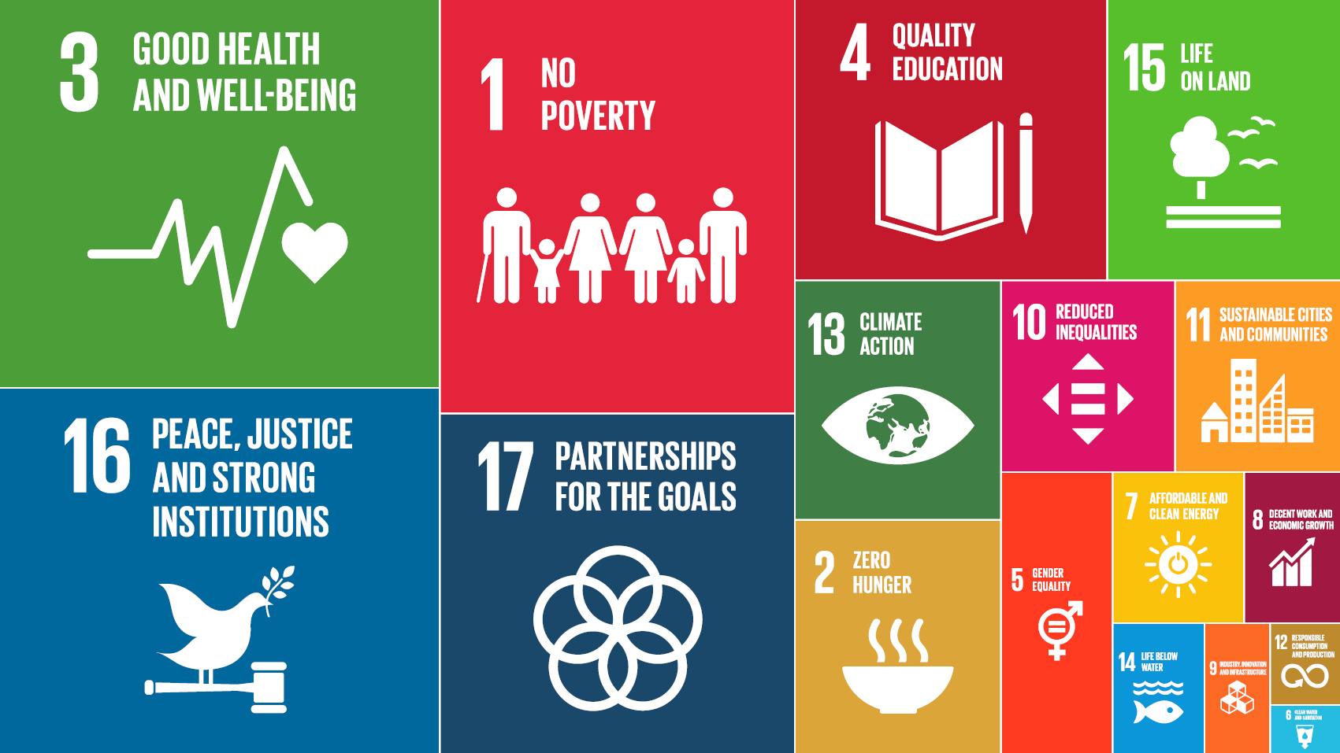
Source: Norad
Norwegian development cooperation is concentrated in five priority areas: education; health; climate, environment and oceans; private sector development, agriculture and renewable energy; and humanitarian assistance.
Women’s participation and gender equality is a priority area as well as a concern underpinning all Norwegian development assistance. Other such cross-cutting issues are human rights, anti-corruption and climate/environment.
The health of oceans
Norway has initiated and is leading international processes to safeguard the health of the oceans. Together with partners in the High-level Ocean Panel, Norway promotes a sustainable ocean economy. In December 2020, 14 heads of state and governments in the Ocean Panel committed themselves to sustainably managing 100 per cent of national ocean territories by 2025. The Panel urges other coastal and ocean states to join this effort so that all ocean areas under national jurisdiction are sustainably managed by 2030. Norway will continue to play a central role in the implementation of the Ocean Panel’s action plan.

Special attention is given to the inclusion of vulnerable and marginalised groups, to leave no one behind. Programmes and strategies are being developed to fight modern slavery and to include persons with disabilities.
During the pandemic, the digital divide has become increasingly visible, and Norway is working to digitalise our development cooperation. The use of technology and digital solutions makes it easier to reach the most vulnerable.
The Norwegian Agency for Development Cooperation, Norad, administers a big part of the Norwegian development budget and has a main role in evaluation and knowledge building. The Norwegian Agency for Exchange Cooperation, Norec (formerly FK – Fredskorpset) is responsible for exchange programs between private companies and organisations.
International organisations like the UN agencies and the World Bank and other development banks are main channels for Norwegian development assistance. Core support for multilateral institutions is a Norwegian priority and accounts for a large proportion of total Norwegian development aid. This Norwegian policy is in recognition of the key role that the multilateral institutions have in global efforts to achieve the SDGs. Core support is of vital importance for the activities of multilateral institutions and for securing a coherent multilateral response. Civil society organisations also manage a substantial part. The Norwegian Investment Fund for developing countries, Norfund, is a central vehicle for mobilising funding from the private sector for joint investments and job creation in developing countries.
During the COVID-19 pandemic, Norway has increased its efforts in the area of health and vaccines. The pandemic has had devastating effects on the world economy, and the poorest and most vulnerable have been hit the hardest by the measures to curb the contagion. In order to be able to open up societies and get schools and businesses running again, broad access to vaccines is essential. Through the Access to COVID-19 Tools Accelerator (ACT-A) our focus has been on strengthening health systems in general and providing equitable access to diagnostics and treatment as well as vaccines.

The Knowledge Bank
Technical assistance plays an important role in Norwegian development cooperation. Many low- and middle-income countries request knowledge and the sharing of experiences rather than funding. Norway has been involved in technical cooperation between Norwegian public institutions and equivalent institutions in partner countries. In 2018, Norway established a platform to strengthen and coordinate such programmes, known as the Knowledge Bank. The Knowledge Bank is managed by Norad.
The Knowledge Bank contributes to increased competence and capacities in public institutions in partner countries in areas in which Norway and/or multilateral organisations have relevant and sought-after competence.
The technical cooperation aims to foster good governance characterised by effective, accountable, transparent and inclusive institutions, in line with SDG 16. Technical cooperation shall also strengthen mobilisation of national resources for sustainable development, thereby contributing to SDG 17. The Knowledge Bank includes programmes in several sectors, which are also linked to other SDGs.
The ‘Tax for Development’ programme is aimed at improving tax systems and increasing tax revenues in developing countries (SDG 17). The Fish for Development programme aims to increase the ability of fishery and aquaculture sectors to contribute to socio-economic development (SDGs 14, 1 and 2). Oceans for Development programme is closely interlinked with the Fish for Development programme and promotes a strengthened, sustainable and inclusive ocean economy in cooperating countries (SDG 14). The Oil for development programme contributes to economically, environmentally and socially responsible management of petroleum resources (SDGs 1, 16, 17). This programme is under revision to align it better with the Paris Agreement on climate change. The Gender Equality for Development programme aims to strengthen the capacity of developing countries to prepare and implement legislation and policy that yield results for women’s rights and gender equality (SDG 5). The Cooperation on Statistics and Registries shall increase the demand, availability and quality of statistics and statistical analysis with a view to strengthening evidence-based policy-making and good governance (SDGs 16, 17). A programme on Anti-corruption and Good Governance includes support for countries for implementation of the United Nations Convention against Corruption (SDG 16). The Knowledge Bank also comprises a programme for digitalisation (various SDGs), renewable energy (SDG 7), higher education and research (SDG 4 and others). Agriculture for Development programme is under establishment (SDG 2).
Several Norwegian public institutions contribute to the Knowledge Bank. Bilateral institutional collaboration is complemented by support for multilateral organisations that develop norms, contribute to policy development and offer capacity-­building of the public sector in partner countries.

Research and innovation enhancing SDGs
Research and innovation are crucial components for achieving the SDGs. The complexity of the challenges ahead requires better structures for research and cooperation across sectors, funding sources and countries. At the same time, these compound challenges mean that it is essential to view basic research, applied research, innovation and value creation as a whole.
The main strategy of the Research Council of Norway (RNC), Research for Innovation and Sustainability 2015–2020, states that Norway is well positioned to support research that will promote achievement of the SDGs.
Norway’s main public funding organisations for research and innovation, e.g. the RCN and Innovation Norway (IN) have integrated the SDGs into their strategies for the next years in order to generate knowledge and identify solutions to the SDG challenges. The RCN has also named sustainable development as one of the three main objectives of its new strategy (2020–2024). To better address major global societal challenges, the RNC will further refine its funding instruments for research and innovation, and increase efforts to facilitate collaboration across countries, academic disciplines, sectors and funding sources. Innovations Norway contributes to sustainable growth and exports for Norwegian businesses through capital and expertise. Innovation Norway has taken a proactive role in the effort to steer companies towards thinking and acting in a more sustainable way. Today, about 50 per cent of the total financial portfolio has an environmental focus.
Close collaboration with the university sector and international expert communities helps give direction to and increases the national pace of innovation. Norway’s participation in the EU’s regional cooperation programme Interreg 2021–2027 gives regional and local stakeholders access to knowledge, competence and experiences that boost sustainability through for example green transformation and future-oriented services.
In 2020 the Government issued a White Paper on Innovation in the Norwegian Public sector. The document outlines three main principles for innovation in the public sector:
- Politicians and officials must provide a framework and incentives for innovation.
- Decision-makers must develop the capability and culture for innovation, where contributors has the courage to think outside the box and learn from mistakes and successes.
- Public entities must seek new forms of cooperation.
Following the White Paper, the Government also presented ten political measures to accelerate innovation in the public sector. One of them is enabling the public sector to use testing and piloting more systematically in developing and implementing innovative solutions to ensure a sustainable society.
PILOT-E
The Research Council of Norwegian, Innovation Norway and Enova have established a funding scheme, called PILOT-E, to accelerate development. The main goal is to support more rapid development and use of new products and services that support the green transition in Norwegian markets and abroad.
For several years, PILOT-E has funded research and innovation in areas such as emission-free transport, climate-neutral industry, hydrogen value chains and building and construction activities. The scheme has contributed to the development of electric and hydrogen-powered trucks and excavators. At sea, PILOT-E has contributed to the financing of electrified ferries and tourist vessels and hydrogen supply systems.
Future of the fjords is an example of an electrified speedboat that was developed with support from PILOT-E. Electrical technology makes the boat both noise-free and emission-friendly, which makes it possible to visit vulnerable sea areas in a gentle way.

SINTEF and Eco-Solar
For more than 70 years, SINTEF has been developing solutions and innovation for society and customers all over the world. In recent years, the organisation has strengthened its sustainability efforts, where the SDGs guide research projects and the establishment of start-up companies. One such example is the EU-project Eco-Solar, withs is coordinated by SINTEF in collaboration with business partners and researchers. Eco-Solar envisions an integrated value chain to manufacture and implement solar panels in the most ecologic way by maximising resource efficiency, taking into account reuse of materials during production and repurposing solar panel components at end-of-life stage. The project has helped reduce the ecological footprint from solar cell production by 45 per cent, whilst also reducing costs by nine per cent. This shows the importance of focusing on technological innovation and commercialisation of discoveries in a way that both contributes to profitability and the achievement of the SDGs.

Conclusions
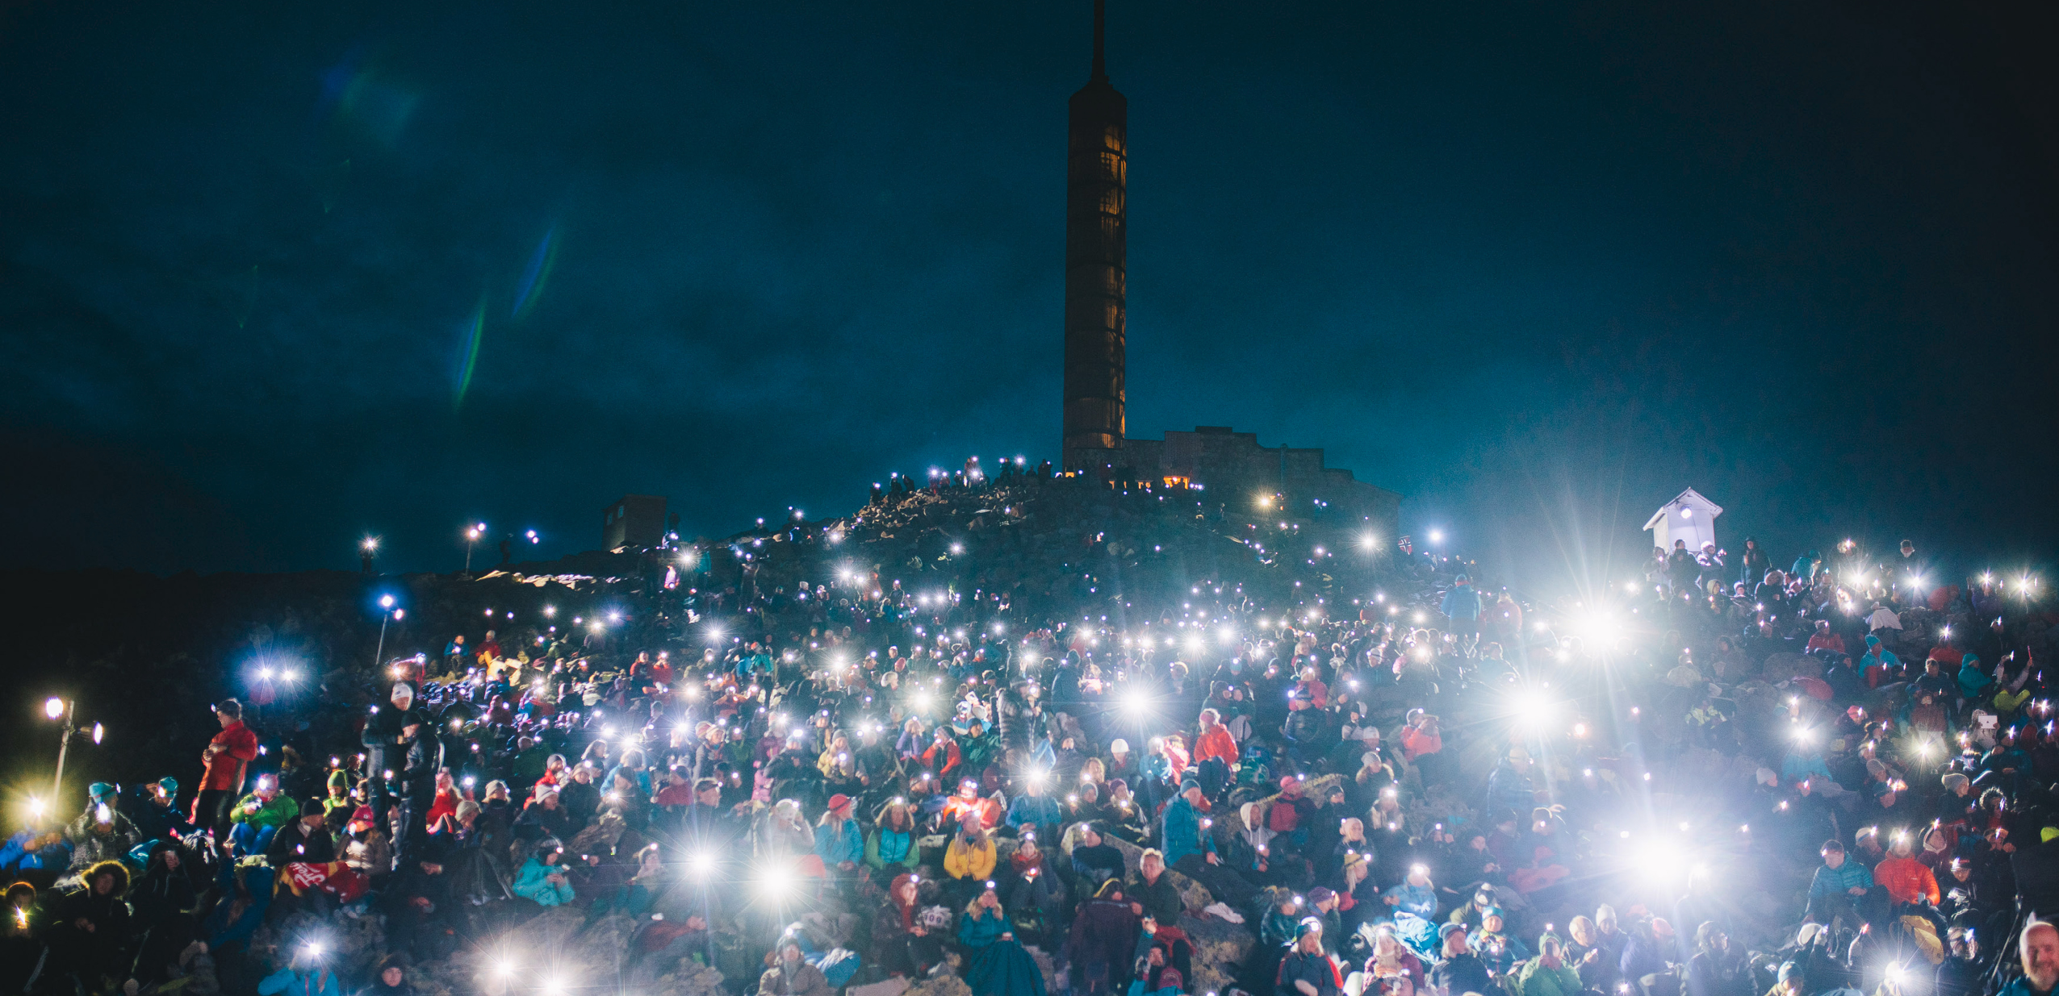
Photo: Michael Ray Vera Cruz Angeles / Norad
Norway’s work and progress towards achieving the 2030 Agenda in the last five years has been detailed in this Voluntary National Review (VNR) report. The VNR process has been an essential component in putting the spotlight on SDGs and bringing together government and non-government actors to facilitate a holistic approach moving forward. The non-government actors have provided valuable input and recommendations. The government is already working on several of the issues raised and will take the recommendations into consideration going forward.
Norway is committed to achieving the SDGs by 2030, and as this report shows, effort by society as a whole has had a positive impact. The progress report on the SDGs and targets illustrates that Norway has achieved many of the goals and has made good progress in implementing the 2030 Agenda since 2016. The main challenges are linked to our high consumption of resources and energy, and our high level of greenhouse gas emissions. However, Norway has a statutory commitment of becoming a low-emission society by 2050.
The Government will work on all SDGs, with a special focus on national challenges. The Government provides policies on all sectors included in the 2030 Agenda, with goals, strategies and means of implementation. Implementation is, however, dependent on efforts in all parts of society and from all stakeholders.
The 2030 Agenda and the SDGs have gradually become more integrated into Norwegian policy and society in all areas since 2016. Knowledge about the 2030 Agenda and the goals is increasing in the public and private sector. The number of networks that have been established in recent years to work with the 2030 Agenda and the SDGs, illustrates the increasing interest and engagement in implementing the goals.
The 2030 Agenda, including the SDGs, is the framework for Norwegian foreign policy and for Norwegian development policy. International cooperation through the multilateral system is indeed a prerequisite for success. It is through multilateral cooperation that Norway can best contribute to addressing both our own and global interests. The continued engagement by the Norwegian Prime Minister as co-chair, together with the President of Ghana in the Sustainable Development Goals Advocacy Group, underlines Norway’s commitment to the joint work ahead. COVID-19 measures have led to severe social and economic setbacks that cannot be ignored. Norwegian development policy will contribute to getting the world back on track in achieving the SDGs, in a greener, fairer and more resilient manner. The Government’s long-term commitment to allocate 1 per cent of gross national income (GNI) to development will continue.
The White Paper and National Action Plan with national targets, possible indicators and identification of challenges, will provide a common platform for further action, and pave the way for a more holistic approach, coherence and progress. Better national coordination and cooperation between different stakeholders is a priority in the next period. The Government will also continue the work on developing a more comprehensive set of national indicators and develop statistics. This will improve the reporting to parliament and the next VNR, which Norway will present at the High-level Political Forum (HLPF) in 2025.
Norway’s next VNR will build on the experience from the process of this VNR and the new National Action Plan. The process of producing these reports has been comprehensive, and has involved many actors. The Government will continue the dialogue and develop arenas for further cooperation. This will provide a solid foundation for further work towards the 2030 Agenda and the SDGs.

Next steps
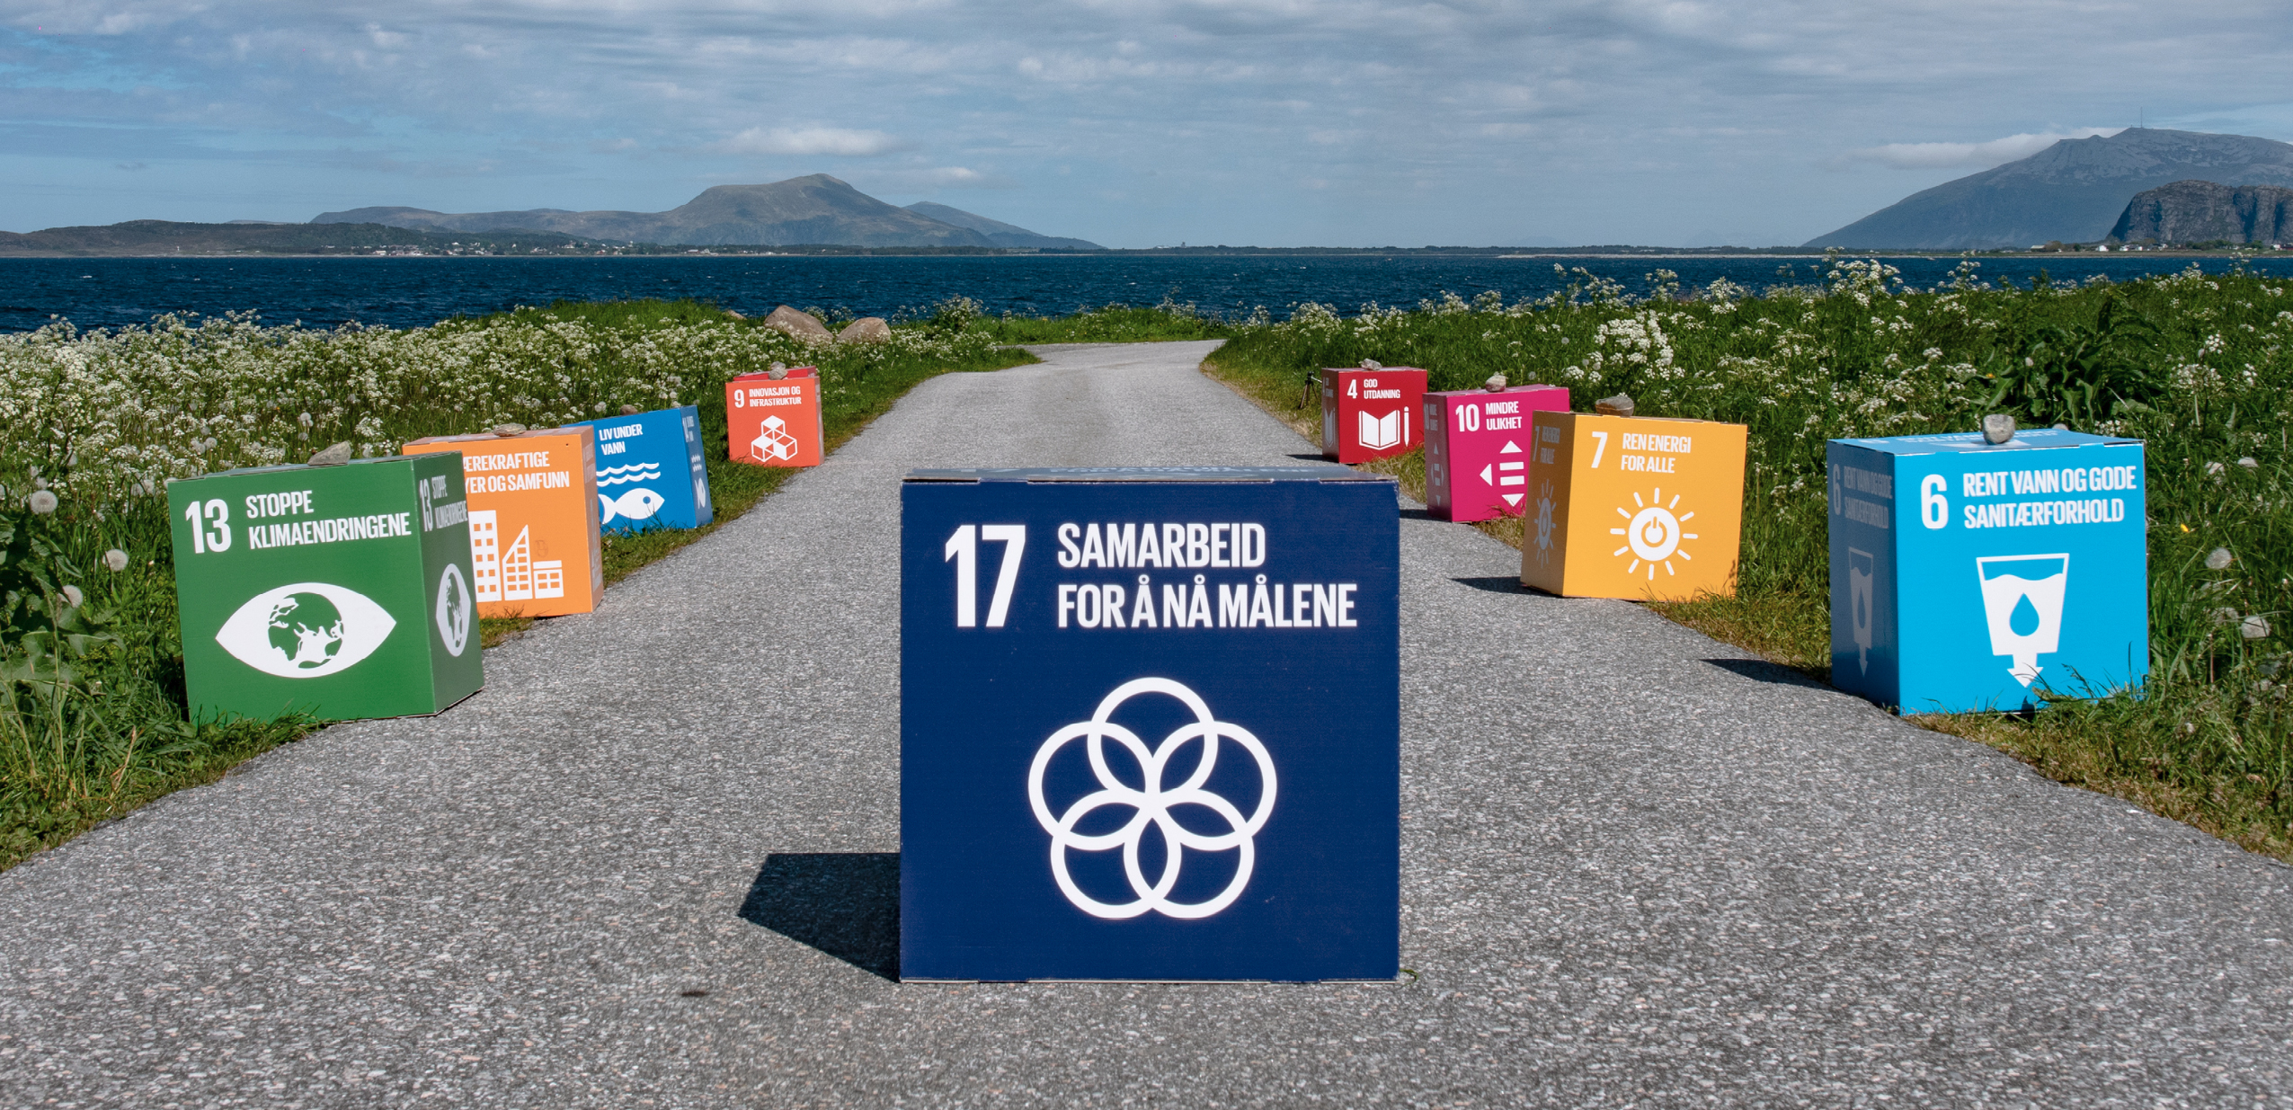
Photo: The North West / Ole-Martin Sæthermoen
The Government wants to be the main facilitator of everyone contributing to Norway being able to achieve the SDGs by 2030.
Technology and knowledge
Norway needs to focus more on a data-driven economy that is founded on well-functioning digital ecosystems. These can be central to achieving global climate and environmental goals, green transformation and more sustainable production and consumption. Establishing global digital ecosystems for environmental data requires broad collaboration between the private sector, research communities and governments. Estonia has taken the initiative to establish an alliance of countries, the Data for the Environment Alliance (DEAL). This is in line with the Norwegian Government’s objectives in the White Paper on Digital Transformation and Development Policy (2019–2020). In addition to strengthening the collection of environmental data that is open, accessible, comparable and of high quality, the goal is for such an alliance to contribute to SDGs by creating financial incentives for the private sector.
Digital technologies need to contribute to green transformation and sustainable use of resources in several sectors. Society is becoming more and more connected, both between people, human to machine and machine to machine. Among other things, this paves the way for streamlining the energy sector and for energy efficiency in existing and new buildings. Furthermore, the new technology enables new solutions in transport and mobility. Autonomous vehicles, intelligent traffic management and sharing mobility, more efficient and resource-saving food production through smart solutions for fertilisation and feeding in agriculture and aquaculture are all examples of how technology can contribute to sustainable solutions.
Universities, colleges and research institutes contribute to the development of knowledge and innovation in business and the public sector. More attention needs to be given to the interaction between those who develop and those who will use the knowledge, whether this is the business community, organisations, the municipal sector or the state. Furthermore, we need to focus more on open access to research, so that more people get the chance to contribute to solutions that make people’s lives better. Knowledge must be shared in order to be aligned with the intention of increased collaboration across the board to achieve the SDGs.
Engaging civil society and the private sector
Civil society has a significant role in development work, both nationally and globally. This role is particularly significant in the efforts in social and environmental sustainability, where the organisations mobilise significant resources in the work. Voluntary organisations, private foundations and social entrepreneurs make important contributions to the efforts to include vulnerable groups in working life and society. The Norwegian Government will continue its efforts to improve the conditions for social entrepreneurs so that they can contribute to solving challenges in society, especially by getting more people into working life.
The business community’s efforts are central. The ability to innovate, the competence and the capital in the private sector is crucial to achieving the SDGs. Many private companies are well on their way to developing strategies for their efforts. Companies that are adapting their products, services and business models to sustainable solutions.
Supporting regional and local municipalities
County and local authorities are key players in realising sustainable development. They are closest to the population, companies and organisations, and are responsible for large parts of the social and physical infrastructure that affect the population’s living conditions and development opportunities. County and local authorities are service providers, property managers, employers and purchasers, and through this have a great influence on development locally and regionally.
The county authorities are responsible for the regional social development in their own county. The public sector has a key role in working with the SDGs, across the administrative levels and the sectors. The administration can be a driving force and facilitator to help ensure that the available instruments and the many actors pull in the same direction.
We need to implement a comprehensive approach within the public sector that drives and facilitates measures that will help us achieve the 2030 Agenda. Laws and regulations, economic instruments and budgets, research, public procurement, digitalisation and technology – together with new cross-functional collaborations – need to work together to create solutions and deliver the changes we need.
Using procurement to change the market
Every year, the public sector purchases goods and services to the tune of NOK 560 billion. How this money is used has an impact on how sustainable, digital and innovative the public sector will be. By setting requirements and demanding new and more sustainable solutions, public purchasers can contribute to new thinking and innovation in the supplier market. The Norwegian Government will use public procurement as a tool to stimulate markets to think sustainably and contribute to achieving the SDGs. The new and simplified regulations for procurement that came into force on 1 January 2017 provide a framework for that. The new regulations entail significant simplifications and more flexibility. The state and the municipal sector need to use the procurement regulations to promote sustainability to a larger degree.
Getting several types of instruments and many actors to pull in the same direction is a challenge for everyone. In Norway we need to work towards a whole-of-government approach, where different authorities and sectors work together to achieve the goals in the 2030 Agenda.
Strengthening government coordination and coherence
The societal challenges in the sustainability agenda are complex, and joint efforts across sectors and levels of government are required. The ministries must work together to solve societal challenges, and working effectively across policy areas and across the interfaces between the functions is a challenge. The Ministry of Local Government and Modernisation therefore appointed a working group whose remit was to submit a proposal for a new strategy for the development of the ministerial community for the period 2021–2025. The proposals in the report Good on our own – best together (2021–2025) relate to working more as a group, strengthening the connections in policy implementation and utilising resources better. By working in networks, the prerequisites for handling complex connections can be improved. One proposal is to establish core groups in selected areas that will work with complex issues. These have participants from the ministry management and work with areas where the ministries are dependent on each other to achieve the goals. Core groups are underway in two areas: better coordination of work for vulnerable children, and young people and joint competence initiatives in the ministries.
The Government is considering establishing a core group for the SDGs. The purpose is to develop a common knowledge base and understanding of the further work, and through this strengthen the coordination ambitions for the SDGs in the ministry community. A common knowledge base is crucial for being able to follow up complex issues and develop new policies to achieve the SDGs.

Annex
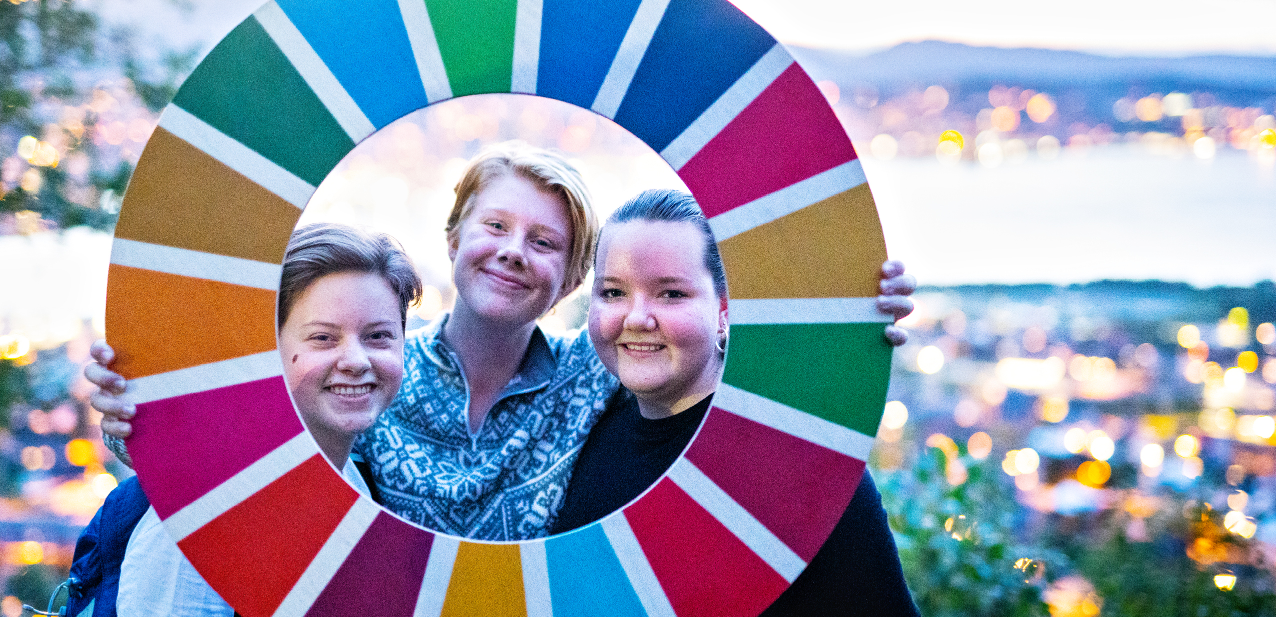
Photo: Ole-Martin Sandness / Scream Media for Norad
Statistical Annex to the Norwegian Voluntary National Review 2021.
Provided by: Statistics Norway.

