Our new digital world
Digitalisation in Norway during the coronavirus pandemic

Foreword
2020 has been a different and challenging year. The coronavirus pandemic has presented businesses with major challenges, but we have also seen an increase in the rate of digitalisation. The Government has introduced a number of measures to meet the challenges and to ensure that our businesses are as adaptable and robust as possible.
Photo: Martin B. Andersson/Norwegian Ministries
In my role as Minister of Regional Development and Digitalisation I am keen to see economic development in all parts of the country, and I am confident that digitalisation will make it more attractive to live and work in rural areas. I want to facilitate the creation of more regional jobs in technology through our broadband policy and our work on data sharing in business and across the public and private sectors.
The coronavirus crisis has demonstrated that it is possible to work effectively and efficiently from places other than an office in the city. Thanks to good communication and collaboration platforms it is possible to work together without being together.
How can we make sure that we bring with us the best aspects of this period of coronavirus restrictions as we proceed to resume normal life? I believe that many people have started to think differently about digitalisation. Many of those who already had access to digital tools, but perhaps found it difficult to get going, have in a short period of time become experts in video conferencing and e-learning platforms.
In June 2020 I invited around 30 exciting businesses to attend a roundtable meeting. The participants represented important Norwegian sectors like health and social care, aquaculture, agriculture, tourism and ICT. The topic of our discussions: ‘How can the public sector contribute to digital business development, new opportunities for export, and job creation in the regions?’ Many of the contributions from this meeting are reflected in this document.
The time since 12 March 2020 has been difficult for many industries, while others have suddenly experienced a hike in demand. Yet others have found completely new market segments and business models as a consequence of the pandemic. I believe that we are facing a future with more flexible and varied forms of working, fewer commutes to work, and fewer business trips. Perhaps this will be a more people- and family-friendly jobs market, more cost effective and more sustainable!
This document is not an exhaustive overview of government policies with respect to the themes and sectors covered – whether before or after COVID-19. However, I hope it will serve to raise awareness of the opportunities that exist – by describing measures introduced by the Government and through the many case studies. The idea is to showcase initiatives that can contribute to or inspire digital business development in all parts of the country. I believe we can get better at highlighting good examples and applauding the success stories. That is exactly what I want this document to do!

Linda Hofstad Helleland
Minister of Regional Development and Digitalisation

Norway was well positioned to meet the coronavirus crisis
When the coronavirus crisis hit Norway, the ‘new normal’ suddenly became home working, home schooling and minimal physical contact. The date when the most intrusive measures were introduced is easily identified when we look at phone network traffic data for March 2020. Nationally, speech traffic doubled over night – it was clear that Norwegians needed to talk to one another in order to get to grips with the dramatic situation.
Photo: © Kongsberg Group. Used by agreement.
The data traffic moved from the office to the home. Capacity was needed for essentials such as home working, home schooling, online medical consultations and – for those who needed it – applications for financial support from the Labour and Welfare Administration (NAV). But there was also a demand for online entertainment, cultural input and social contact with friends, family and work colleagues.
Luckily, the country was in a good position to take on the challenges of remote working and contactless interaction. Norway has a robust digital foundation. The population is digitally literate. For years, the public sector has been investing in digital gateway solutions that provide highly effective online public services. This means that our society and our government agencies can take rapid action when something happens.
Norway has gone digital
Norway is one of the most extensively digitalised countries in the world. Every year, the EU surveys Europe’s digital performance status through the Digital Economy and Society Index, DESI. DESI 2020 shows that Norway is clearly improving in the areas of digital infrastructure (broadband and mobile network coverage), digital public services and digital skills. Norway tops the ranking, with the other Scandinavian countries. According to the survey, Norway’s population has the highest rate of internet activity, and more than 90 per cent make use of digital public services or contact government agencies online. Norway’s score is particularly high when it comes to online public administration processes and digital services for business. Along with Denmark, Norway’s access to mobile networks and broadband connectivity is the best in Europe.
Norwegian local authorities are also performing well compared to their international counterparts. The Nordic Digital Municipality Index compares 60 municipalities in Norway, Sweden, Denmark and Finland. These municipalities are diverse in terms of size, population and geographic spread. The survey, commissioned by Telenor, shows that Norwegian local authorities are good at delivering digital services to their local residents. The digitalisation of large cities and municipalities has progressed the furthest, but small and medium-sized Norwegian municipalities also achieve very high scores in the survey.
A robust digital foundation
The spring and summer of 2020 put the resilience of Norway’s digital foundation to the test. And this was a test it passed. The Norwegian telecom networks and data centres were built to cope with heavy traffic, and they are well run. Local, regional and national companies all play a part in this important undertaking. Since 2012, more than NOK 70 billion has been invested in the digital infrastructure, and substantial resources have been expended to ensure that it is safe and well prepared to withstand the onslaught of harsh weather as well as cyberattacks.
By the end of 2020, Norway had reached the target of 90 per cent of households being offered high-speed broadband of more than 100 Mbit/s. The new target is that 100 per cent of households should have access to 100 Mbit/s by 2025. In 2019 the private network companies invested more than NOK 12 billion in mobile and broadband networks. The government contributes with subsidies for the development of broadband connectivity in areas where this is not profitable for commercial developers. Since 2014, more than NOK 1.5 billion has been allocated for this purpose. These funds are distributed so that those with the greatest unresolved requirements receive the most, with county councils being responsible for allocating the money. Additionally, there is government support for telecom safety and emergency preparedness.
The Broadband Development Act came into force on 1 July 2020. This legislation is intended to make it simpler for developers to access existing infrastructure like utility poles and pipes, thereby reducing the complexity and cost of further developing the broadband. The Government expects that this will speed up the development of high-capacity networks and give Norwegian citizens more broadband at a lower cost. The Norwegian Communications Authority (Nkom) will develop a website to provide information about such existing infrastructure and planned building works.

RAUMA: Mobile coverage at Trollstigen
Until the summer of 2020 there was an 11-kilometre section of road between the Trollstigen plateau and the Langdal valley that had no mobile coverage. The area sees significant traffic during the tourist season, and being able to call for help can be a matter of life and death in an emergency situation.
Telia Norway won the contract for a pilot project intended to provide mobile phone coverage in this area, the challenge being access to power. The chosen solution is based exclusively on green energy. The station is powered by solar panels and wind turbines, using hydrogen as a backup power supply. Water vapour will therefore be the only emissions involved.
The project shows the importance of partnerships between central and local government and private businesses that control critical infrastructure.
Photo: Telia Norway. Used by agreement.

5G and the Internet of Things (IoT)
Norway is well served by fourth generation mobile networks (4G) that provide very good coverage. The Government has also acted early to facilitate the next generation of networks (5G) by purchasing available frequencies and awarding spectrum through auctions. By doing so, and by making plans for further frequency auctions, Norway will be in a position to make early use of the considerable opportunities for innovation and value creation that follow from 5G.
The 5G networks can be built so that providers easily can put up tailored services (virtual networks) for various purposes. This is referred to as network slicing. This sliced architecture makes it possible to offer tailored services for e.g. communication, control and process monitoring. 5G infrastructure will be essential for a full-scale roll-out of IoT with a capacity which is beyond the capabilities of today’s technology. This will open up entirely new areas of use, e.g. within emergency response and preparedness, for the transport sector, manufacturing industry, agriculture, health and social care, and smart cities.
Not all IoT applications need to transmit large volumes of data. The sensor will often need to send only simple measurements or signal a change of status. In this case, Narrow Band IoT technology can be used instead of 5G. NB-IoT is based on the existing 4G network and is a so-called low-power wide-area network (LPWAN) technology. LPWAN work in a wide area with low power consumption at low transmission speeds, allowing the batteries to last for years.

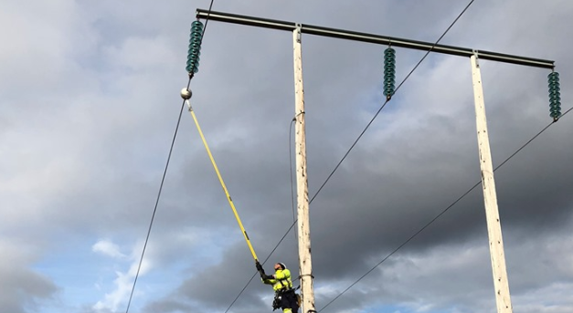
SANDNES: IoT in the National Grid – Heimdall Power
Heimdall Power has developed a sensor that can monitor National Grid power lines and trigger an alarm before there is a fault. The sensors are built into a ball that is mounted on the power line. They gauge temperature, vibration and line inclination. Realtime data from the sensors are sent to the power company via NB-IoT, so that they can despatch their maintenance crews as required. They also send information about spare network capacity, so that the companies can plan for better utilisation. This may reduce the need for investment in new power lines.
The sensor balls are developed and produced by Heimdall Power in Norway. Heimdall serves a global market and they have installations in several European countries.
www.heimdallpower.com
Photo: Heimdall Power. Used by agreement.

Digital participation and literacy
Norway’s population is among the most digitally literate in the world. As public services increasingly go online, it is important that no-one is excluded because they are unfamiliar with the technology.
Since 2014, the Ministry of Local Government and Modernisation has granted more than NOK 30 million in funding to various initiatives designed to increase the level of digital participation in the population. It is a clear objective for the Government that everyone who wants it, should be given an offer of basic digital training.
The Norwegian Association of Local and Regional Authorities (KS), Skills Norway and the Ministry of Local Government and Modernisation work in partnership to provide the Digihjelpen service, an offer of digital assistance provided locally for those with little or no basic digital skills. There is also a support scheme available to local authorities and voluntary organisations that wish to offer local digital literacy courses and guidance sessions. So far, more than 100 local authorities have received such support. Additionally, the Seniornett scheme receives funding to run digital literacy courses specifically for the elderly.
Moreover, Norway has put in place legislation to ensure that websites, mobile applications and other systems with a public user interface, such as ticket machines and cashpoints have a universal design so that they are accessible to people with disabilities.
Specialist expertise
Norway is among the world’s leading countries in terms of basic digital skills among the population, but there is a need for more IT specialists. Nevertheless, recent years have seen a positive trend: since 2015, the Government has given special priority to ICT-related study programmes. This has meant that every year, nearly 1600 additional students can start a degree course in ICT, and the first cohort of students are now about to graduate. In recent years, we have also seen universities and colleges create an increasing number of student places in fields of study that are in particular demand on the jobs market, like cyber security, artificial intelligence and data science.
Nevertheless, the demand for IT specialists remains significant. The 2020 Education Boost initiative meant 5000 additional student places, many of them in ICT. The initiative was put in place to meet increased demands for student places because of the Coronavirus pandemic.
Courses and continuing education
The technological development means that many jobs are changing. Some tasks are done away with while other tasks, that need different skills, are introduced.
A survey conducted by KPMG about digitalisation in business shows that Norwegian companies believe the greatest barrier to digitalisation is lack of necessary skills required to introduce digital solutions in the organisation. One third of all respondents consider it a challenge that the organisation lacks understanding of what digital solutions would be appropriate and beneficial for the company.
According to OECD, Norwegian workers – graduates as well as non-graduates – benefit from more in-service training than workers in most other countries. About under half the workers attend courses or other training initiatives every year, normally funded by the employer.
Many businesses take part in clusters and other industry groupings where they share their own expertise and knowhow with other businesses. Some work in partnership with each other and with educational institutions to develop courses on topics of importance to their own business or industry.
In 2020, a new skills reform was introduced: ‘Lifelong learning’. The aim is to ensure that no-one is left behind due to a lack of skills, and that the jobs market have access to the skills and competencies required. A scheme for flexible education at universities and university colleges has been set up as part of the scheme. This makes it easier for more people to acquire top-up qualifications irrespective of their work situation and where they live.
The Government has also provided funding for the development of flexible continuing education schemes that are geared towards the needs of the jobs market, particularly the skills that are required to digitalise businesses. In 2021, initiatives that will enhance digital competencies, Cyber security and green transition/sustainability skills will be prioritised.

OSLO: Industrial Digital Academy (IDA)
The Industrial Digital Academy (IDA) is a collaboration between Cognite, Aker ASA and Digital Norway. IDA offers courses in industrial data and digitalisation – important subjects for established engineers and others who work in industry. The courses focus on data science, industrial data platforms, artificial intelligence and blockchains. All programmes are free.
www.cognite.com/ida
The more practical courses make use of industrial data sets from Open Industrial Data (OID). OID is the result of collaboration between Aker BP and Cognite. It is based on live streaming of data from a compressor on the Valhall oil platform in the North Sea. The idea is that the data sharing will accelerate innovation in fields such as condition monitoring and advanced visualisation techniques
www.openindustrialdata.com
Photo: Cognite. Used by agreement.

Continuing education during the coronavirus crisis
When the coronavirus pandemic hit Norway, it soon became clear that many workers would be laid off. In normal circumstances it is unlawful to claim unemployment benefit while in education or training. Due to COVID-19, this has been changed. From 20th April 2020 until 1 July 2021, anyone in education or training who does not already receive funds from the Norwegian State Educational Loan Fund, is entitled to unemployment benefit if they otherwise qualify for this. This enables people who have been excluded from employment due to COVID-19 to spend their time on acquiring relevant and up-to-date knowledge. This is a good thing for the individual employee, for employers and for society at large. All types of courses, classes and training are covered by the scheme.
The Government upscaled the flexible education scheme in response to the coronavirus crisis. For example, a funding pot of NOK 100 million was made available to educational institutions that were able to quickly upscale courses that could be made available online for the unemployed and for laid-off workers.
In 2021, the Government has allocated a total of NOK 132 million to subsidise flexible education initiatives. The funds will be advertised by Skills Norway and the Norwegian Agency for International Cooperation and Quality Enhancement in Higher Education (Diku).

COVID-19 – a catalyst for digitalisation
The outbreak of the virus and the measures to reduce the infection rate have affected large parts of Norway’s business community and Norwegian society. Many businesses have been forced to close down or re-organise in response to the infection control measures. Others have experienced reduced demand or restrictions put on their production due to a lack of manpower or late deliveries. Other parts of the business community have experienced rising demands, changing distribution channels and new market opportunities.
Photo: Chris Montgomery on Unsplash. Free content.
The coronavirus crisis has accelerated developments in several areas of digitalisation. It is likely that this will leave its mark on working life and society in general for years to come.
Remote working
Extensive use of video conferencing and collaboration tools may well be the most obvious effect for the average citizen after periods of home schooling and home working. A survey conducted by Norstat on behalf of the IT company Computas shows that as many as 8 out of 10 businesses have implemented digitalisation measures as a consequence of COVID-19.
More than 50 per cent have rolled out collaboration tools for their own staff, and almost as many have developed new solutions and services. Approximately one third have provided training for their staff in how to use new technology and digital tools. These are skills and ways of working together that will not disappear with the virus.
Working from home and changes to patterns of travel
In some periods, everyone who was able to work from home was encouraged to do so. This worked well for some people, while others missed the physical and social working environment of the office. Many find it lonely to be working long days without meeting up with work colleagues. Others enjoy the additional time freed up for leisure by not having to spend hours on commuting every week. It is difficult to tell what the long-term consequences will be for people’s work situation. It is likely that where possible, employers will continue to offer more flexibility in terms of where and when work is carried out, even after the coronavirus crisis.
The coronavirus pandemic has affected people’s travel habits. In the second quarter of 2020, Statistics Norway measured a 65 per cent drop in domestic travel for work and a 94 per cent drop in international business travel compared to 2019. The largest drop is in the number of flights, but fewer people travel by train, bus and ferry. The reason is likely to be that people work from home, meet up online and use video conferencing tools.
If working from home becomes more of a standard practice even after the coronavirus crisis, this may influence the long term demand for transport and office premises. Greater flexibility with regard to core working hours may reduce peak-time pressures on roads and public transport in the big cities. If living near your place of work becomes less important because digital interaction is the norm, we may see changes in residential patterns around the big cities.
Changes to shopping habits – more online shopping
The coronavirus pandemic and infection control measures has affected cross border shopping and the production and sales of food and drink in Norway. The sale of groceries and alcohol increased by 18 per cent in 2020, compared to 2019 according to Statistics Norway. This was probably caused by people eating and drinking at home, rather than in cafes and restaurants, and the fact that crossing the border to shop meant you had to go into quarantine. According to Statistics Norway, the value of online shopping was up by 48.2 per cent in December 2020, compared to December 2019.
Fewer cash transactions
In the middle of March, the advice given by the Norwegian Directorate of Health was that contactless payments were preferable and that cash should only be used in exceptional circumstances. In Norway, the use of cash was already among the lowest in the world. In autumn 2019, cash transactions amounted to 7 per cent of payments. In spring 2020, this has fallen to 3 per cent.
There is a changing trend in how electronic transactions are made at Norway’s physical payment points. There has been considerable growth in contactless card payments after the supermarket chains introduced this facility, and particularly after the health authorities encouraged the use of contactless card payment for reasons of infection control. Nearly 65 per cent of all BankAxept payments made by a physical card are now contactless.
Changes in the health sector
When society went into lockdown on 12 March 2020, it soon became clear that digitalisation in the health and care sector could help reduce the risk of transmission during the pandemic by moving treatment and follow-up monitoring online. The importance of digital solutions in the health and care sector is increasing.
In 2020, a number of e-health services have seen a rise in use due to the coronavirus situation. Digital health services were important for reducing transmission rates, because they made it possible for healthcare personnel and patients to meet without being in physical contact. Doctors could conduct consultations online, and the home-based services could use welfare technology to reduce the number of physical home visits while ensuring that service users were looked after and could feel safe. Healthcare personnel like psychologists and physiotherapists, who were not allowed to meet with patients in the early stages of the pandemic could continue practicing thanks to video technology.
Public portals like helsenorge.no provides quality-assured healthcare information and access to administrative services, such as booking appointments and ordering repeat prescriptions, as well as e-consultations and messaging the doctor. Several million residents made use of these services during the period of strictest infection control restrictions. Helsenorge.no was crucial for the work to put in place new digital solutions in the health and care sector. The platform helps reduce barriers and stimulates increased use of digital tools in the treatment of patients.

OSLO: Eyr – medical video consultations
Eyr offers medical video consultations through a mobile app. The company has a workforce of 40 employed in Norway and Denmark, of whom 20 are doctors.
The solution was developed in response to long waiting times and little digital interaction in the primary health service. Approximately one million Norwegians have access to Eyr's service through their insurance policy, but the value of a digital service has become clearer to many during the pandemic. In the summer of 2020 the company undertook a NOK 50 million share issue. The state-run investment trust Investinor holds a NOK 8 million stake in the company.
Eyr’s ambition is to enter the international market.
eyr.md
Photo: Eyr. Used by agreement.

Online consultations
In 2018, the Norwegian Consumer Council conducted a survey showing that the population was keen to communicate and consult with their doctor digitally. Even though the technology has been available for several years, the survey showed that only 8 per cent of doctor's offices were able to offer video appointments. The coronavirus pandemic has led to an increased demand for online consultations. More doctors have acquired video technology and put it to use for the first time in order to reach out to the people with respiratory symptoms who were barred from attending the doctor's office in person, but also to other vulnerable patients who preferred to avoid crowded places.
The health authorities have introduced several initiatives in order to support the use of technology. Online consultations were put on par with physical consultations with respect to remuneration. Doctors could communicate digitally with personnel in the primary health and care service. Telephones were also accepted as an e consultation tool during the pandemic, and as from the summer of 2020 telephone consultations were put on an equal footing with physical consultations in the accounting system. Reimbursement schemes have also been introduced for other types of digital follow-up services in the specialist health service.
The Norwegian Directorate for eHealth issued guidance to help healthcare personnel get going with secure video consultations, and set up a website with practical advice about appropriate use of video technology.
These measures have had an impact: e-consultations increased from approximately 3 per cent before the pandemic to more than 40 per cent in the first weeks after 12 March 2020 when the strict infection control measures were introduced. Throughout 2020, more patients have been returning to physical consultations, and e-consultations have stabilised at between 25 and 30 per cent of appointments.
The coronavirus pandemic also caused a significant increase in e-consultations provided by private-sector medical services. Thanks to working in partnership with the insurance industry, they were able to help many Norwegians abroad.
There are several benefits from digital solutions, such as video or text consultations or remote health monitoring: the patients save time that they would otherwise have spent on travelling and waiting, and both society and patients save the cost of travel. This can also help healthcare personnel rationalise their use of time, and help patients and citizens feel safer and more in control when in their meeting with the health services.

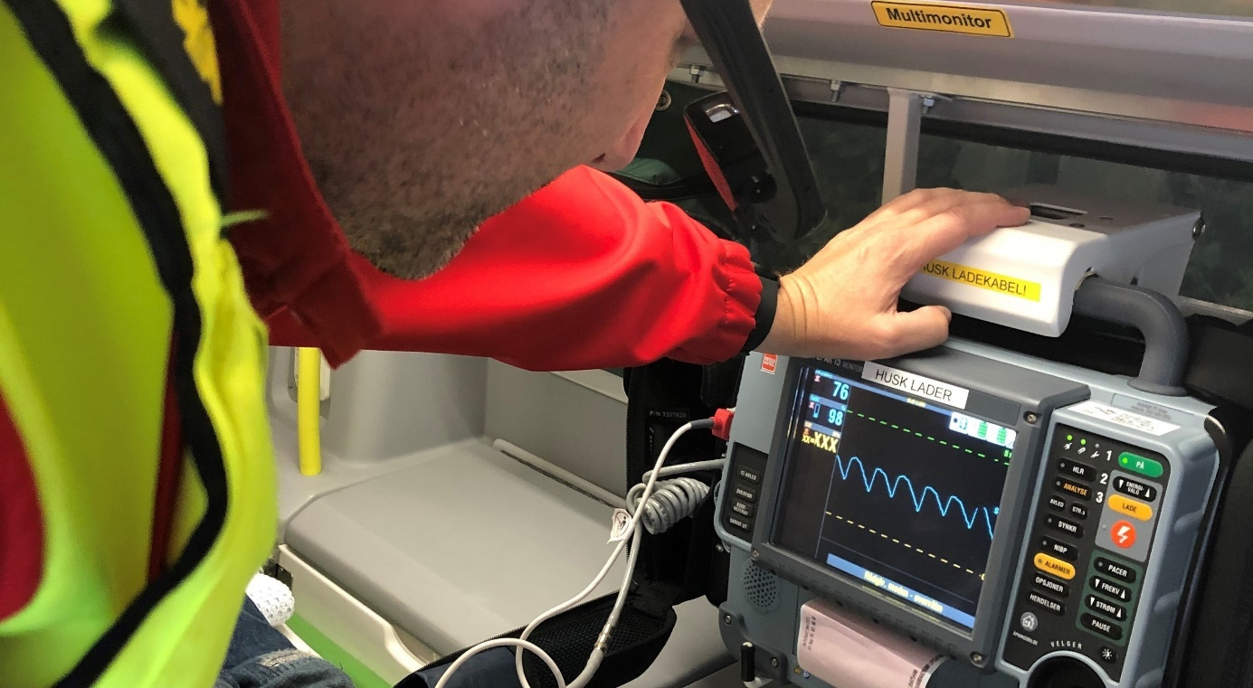
ELVERUM: Innlandet Hospital Trust – 5G in ambulances
When someone gets ill and needs treatment, it is important that help is at hand quickly and efficiently. In a pilot project at the Innlandet Hospital Trust, ambulance personnel have been kitted out with a tablet, phone or speech-controlled camera that will provide guidance and quick decision support from the air ambulance service, A&E or a hospital doctor in critical and unclear situations.
Most ambulances are currently fitted with mobile broadband to make sure that staff can easily receive guidance or get in touch with the correct person. By using a tablet, a phone or a speech-controlled camera over Telenor’s 5G network, they can livestream video and speech direct to the on-duty doctor who can give the ambulance personnel appropriate guidance in how to care for the patient in the best way possible.
Photo: Innlandet Hospital Trust. Used by agreement.

Digital contact tracing tools
Infection tracing and testing are important parts of the Norwegian strategy against COVID-19. Everyone who experiences symptoms should get tested, and everyone who has coronavirus infection confirmed, must self-isolate. It is important to trace infections among those who have been in close contact with confirmed cases of COVID-19 in order to reduce and quickly stop further transmission of the virus in the community. Local authorities carry the prime responsibility for infection tracing in Norway.
Infection tracing by local authorities
When the pandemic hit, local authorities had no tools for tracing infection. However, the market soon produced solutions that were made available to local authorities. Virtually all local authorities have now introduced digital infection tracing tools, which make the job simpler and more efficient. This makes it easier for them to co-ordinate their tracing efforts, and to follow up on those who are infected or in quarantine. It also gives the Norwegian Institute of Public Health a better picture of the national situation.
The infection spreads fast, and it is important to break the chains of infection as soon as possible. In December 2020, the Norwegian Institute of Public Health launched a new version of its mobile phone app for infection tracing: ‘Smittestopp’. Anyone over the age of 16 can download and use the app, which is designed to quickly notify anyone who has been in close contact with someone with confirmed COVID-19 infection. By April 2021 more than one million people had downloaded the app.
Using technology to locally monitor COVID-19
The interest in using welfare technology and digital monitoring of patients in their own homes has increased considerably as a consequence of the coronavirus pandemic. With great success, several local authorities have offered digital monitoring at home to COVID-19 patients. For example, the use of a pulse oximeter – a device attached to the finger of people with COVID-19 – and an app installed on the patients’ smart phone or tablet, has enabled healthcare personnel to remotely monitor the oxygen saturation of their patients’ blood and other vital measurements. Oxygen saturation is a particularly important indicator for those infected by the coronavirus.
Regional testing of such home monitoring technologies has had good results. For example, monitoring of patients in their own home means that local authorities have been able to maintain a good level of service during the pandemic while also protecting patients and staff from infection from direct personal contact.
This reduces the need for personal protective equipment, which was particularly important during the early stages of the pandemic when there were challenges associated with procuring such equipment. Remote monitoring of coronavirus patients can be used for patients is in hospital or at home.
Six local authorities and municipal partnerships have taken part in the project ‘Digital home monitoring of the chronically ill’, which provided a framework for the use of pulse oximeters to monitor coronavirus patients. Before the pandemic, the local authorities were testing various digital home-monitoring technologies for patients with chronic illnesses such as COPD, heart disease and diabetes. The project is a part of a national welfare technology programme run in partnership by the Norwegian Association of Local and Regional Authorities and the health authorities.
The programme aims to ensure that more local authorities introduce welfare technologies. Experience tells us that appropriate use of welfare technology can contribute to more cost efficient use of resources in the primary health and care service, and enhance the sense of safety and independence among patients.

OSLO: Technology for the clinically vulnerable: No Isolation
No Isolation is a Norwegian technology company that works to reduce involuntary loneliness and social isolation. No Isolation has developed the AV1 robot to help children who for various reasons cannot attend school in person. By using AV1 they can nevertheless attend lessons and keep in touch with their friends – without being there.
Another important product is KOMP – a screen with only one button, designed for those who are unable to use smart phones and tablets. By using KOMP, the whole family can easily hook up via an app, send images and messages and conduct two-way video conversations with other people, like granny or grandad.
No Isolation has seen a significant increase in product sales during the coronavirus crisis. Sales of the KOMP product for seniors were twenty times higher in March and April 2020 compared to 2019. Demand for the AV1 school robot has continued to be high even after the schools re-opened in April 2020.
www.noisolation.com
Photo: Estera Kluczenko/No Isolation. Used by agreement.

A pioneering public sector
Even before COVID-19, Norway’s public sector was one of the most extensively digitalised in the world. When the crisis hit, a number of initiatives were launched in order to digitalise areas that had yet to go fully digital. In this way, Norway was able to maintain a good service level, despite the coronavirus restrictions.
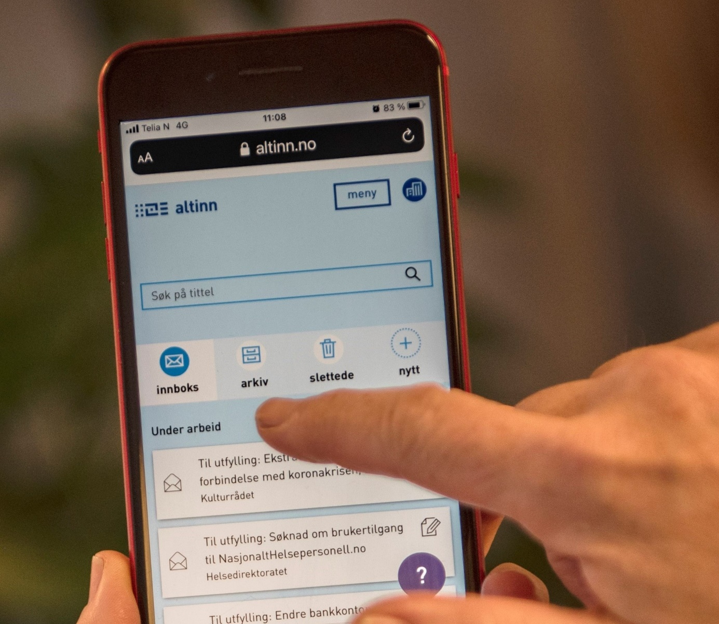
Photo: The Norwegian Digitalisation Agency on Flickr. CC BY 2.0
The public sector as an engine for digital transformation
The public sector is an important driver of digitalisation in Norway – both in its role as a supplier of digital services to residents and businesses, and as an important client for industries such as the ICT-industry.
Public-Private Digital Cooperation (DSOP)
This is a collaborative project involving the Norwegian Tax Administration, the Brønnøysund Register Centre, the Norwegian Digitalisation Agency, the Norwegian Labour and Welfare Administration, the Police, the Norwegian Mapping Authority and the financial services industry. Together they are working to digitalise important societal processes through the DSOP programme. An example is the consent-based loan applications. Bank customers no longer need to submit tax returns and pay slips to the bank when they apply for a loan, but can instead give digital consent through Altinn to allow the Tax Administration to share information on income, debts and net assets with the bank. This saves time and effort for both bank and customer.
The National Program for Supplier Development
Every year, the Norwegian public sector buys goods and services to an amount in excess of NOK 500 billion. These procurements can be used to promote innovation and use of new technologies. The National Program for Supplier Development has been put in place in order to increase the innovation effect of public procurements. Innovative procurement is all about buying better products and services by utilising the opportunities provided by regulations and policy instruments.
Since its launch in 2010, the programme has assisted public sector enterprises with more than 150 procurements and developed innovative public procurement methods. The Program for Supplier Development is a partnership project involving the Confederation of Norwegian Enterprise (NHO), the Association of Local and Regional Authorities (KS), the Norwegian Agency for Public and Financial Management (DFØ), Innovation Norway and the Research Council of Norway.

KONGSBERG: YETI MOVE – autonomous snowploughs
Every winter, snow causes disruptions to air traffic. In 2018, testing of autonomous snowploughs commenced at Gardermoen Oslo Airport to see if this could make snow clearance of runways a more efficient operation. This project stems from a market-wide challenge to develop new and pioneering technology for machine/vehicle control and steering within the perimeters of the airport. The objective was to optimise operations in respect of costs, safety, environmental impact and efficiency.
The autonomous snowplough solutions were developed by YETI MOVE, a company formed from the inspiring technology cluster at Kongsberg. There has been significant international interest in this solution, and in December 2019 Yeti and Øveraasen signed a major contract with Swedavia, the operator of Sweden’s ten busiest airports, for use of the technology. As a result of this agreement, YETI MOVE has secured further industrial autonomy contracts in fields such as road construction, manufacturing, harbour logistics and defence.
www.yetimove.com
Photo: YETI MOVE. Used by agreement.
Data and data-driven innovation
The data-driven economy is the fastest-growing part of the world’s GDP, and the Government would like to see more of this growth in Norway. Our country has good public data, and many of these datasets are already publicly available. But there is room for improvement. The public sector can get better at sharing data, and at making datasets available to the corporate sector. The corporate sector can get better at making use of their own data and publicly available data, and at sharing data across businesses, for example within a specific trade or industry. Industry initiatives in aquaculture, where fish farming businesses and seafood suppliers to work together on introducing joint standards for collecting and sharing data, are good examples of this.
In order to assist businesses with sharing and utilising data, the Norwegian Digitalisation Agency has established a resource centre for data sharing. This centre will work as a driver for data-sharing initiatives, but will also provide guidance.
Regulatory sandboxes
Regulatory sandboxes are primarily tools for promoting responsible innovation. The idea is to give businesses an opportunity to trial new technologies and/or commercial models. The Government has already established regulatory sandboxes in the transport sector, in the form of legislation that facilitate the trial projects with driverless autonomous vehicles. Driverless buses are currently in operation in several Norwegian towns. Since 2016, a number of test areas for autonomous ships have been established in Norway.
As a part of a follow-up to the National Strategy for Artificial Intelligence, the Government has supported the establishment of a regulatory sandbox for artificial intelligence at the Norwegian Data Protection Authority (DPA). This sandbox will allow businesses to develop innovative services based on artificial intelligence, under the guidance of the DPA. The sandbox will not facilitate dispensations from GDPR, but the Authority will be able to grant exemption from enforcement measures during the project’s development stage. This is to enable experimentation in the search for good solutions that will also serve to enhance the level of personal data protection. The sandbox will be open to businesses and public sector agencies that utilise personal data in their work to develop innovative products and services that can demonstrate a public benefit.
Quick establishment of new schemes after COVID-19
Among all public sectors, the health sector was probably the one to be hardest hit when the coronavirus caused the country to go into more or less complete lockdown on 12 March. However, other sectors were also facing major challenges. After 12 March, many employees were laid off. This necessitated a number of new schemes to compensate both employees and enterprises for their income shortfall.
The Norwegian Labour and Welfare Administration (NAV)
The Storting’s decisions to strengthen the economic safety net during the coronavirus pandemic were rapidly formulated into statutes and regulations. It was essential to make the regulations easily applicable, thus to ensure that appropriate schemes and data systems could be rapidly put in place.
A solution for handling applications for advance payment of unemployment benefit was in place already on 30 March. In addition, a number of schemes – with associated ICT systems – have been developed to protect the incomes of employers, employees and the self-employed.
For NAV to be able to cope with the increased caseload in all these areas, the processing of cases had to be automated wherever possible. In April 2020, a temporary regulation that authorised fully automatic processing was therefore added to the National Insurance Act. Many of the new solutions that were established in NAV to tackle the challenges associated with COVID-19 are fully automatic. In the autumn of 2020, the Storting adopted a government proposal to permit fully automatic case processing in NAV on a permanent basis. The statute was added to the NAV Act and entered into force on 4 December 2020.
The Norwegian Tax Administration
One of the largest programmes for tackling the economic consequences of the coronavirus outbreak is the compensation scheme for businesses. The scheme awards financial support to enterprises that have suffered a major loss of income as a result of the coronavirus situation, so they can cover fixed costs. Owing to cutting-edge digital infrastructure, advanced digital skills and joint effort, the Norwegian Tax Administration together with the Norwegian Digitalisation Agency, the financial infrastructure company Bits and the financial services group DNB was able to develop the complicated support scheme in only three weeks. During the coronavirus crisis, the shared solutions ‘ID-porten’ and ‘Altinn’ have proven crucial for establishing further new digital systems for employees who have been laid off, for the health services and for industry.
The courts of law
The measures taken to halt the spread of COVID-19 had major consequences for the Norwegian judicial system. Between 80 and 90 per cent of all court proceedings were either postponed or cancelled in March 2020. To prevent accumulation of a large backlog, the Government temporarily changed the procedural regulations for the courts. These changes include extended opportunities to hold video meetings and undertake questioning by telephone or video conferencing, and to sign judgments digitally.
A project to fully digitalise court proceedings was underway already before the COVID-19 outbreak.
Strong rise in the use of gateway websites
The government portal ‘ID-porten’ and the Common Contact Register (KRR) have served as crucial digital building blocks in the acute situation that arose during the coronavirus pandemic. A large demand for stable common solutions emerged, and new services had to be quickly developed.
The number of searches in the Common Contact Register doubled in March 2020. The register enabled the health services, local councils and other public agencies to distribute important information to the population. The ‘ID-porten’ website was crucial for establishing new digital solutions such as the compensation scheme for the self-employed. Despite the strong increase in traffic from March 2020 onwards, the gateway websites have remained stable with high uptime.

LEIKANGER: MinID Passport
The Norwegian Digitalisation Agency has established a new form of eID, the ‘MinID Passport’. Instead of having to go to a Norwegian embassy or consulate to have their ID verified, users can now scan their own passport with a mobile app and use facial recognition for authentication.
At the early stage of the pandemic, this was especially important for people who lived abroad and were entitled to services from NAV, but did not have an electronic ID. After its launch in June 2020, more than 5000 users in 40 countries have started using this solution. Work on the MinID Passport had started before the coronavirus pandemic, but the solution was completed in record time.
MinID Passport is a temporary solution, but the directorate is considering how to develop it further.
registration.minid.digdir.no
Photo: Norwegian Digitalisation Agency on Flickr. CC BY 2.0

Digitalisation in local government
In recent years, local councils have been given more say in national digitalisation initiatives. In the autumn of 2020, the Ministry of Local Government and Modernisation and the Norwegian Association of Local and Regional Authorities (KS) signed an agreement that grants even more influence to the local councils, including through an annual consultation meeting between KS and six ministries.
Local authorities value their autonomy highly, but when it comes to matters related to digitalisation, they see a need for more coordination with central government. The goal is to produce digital solutions that are well adapted to local needs. This calls for collaboration. Key candidates for partnership include electronic patient records and digital programmes for schools and child welfare services.
When the coronavirus pandemic hit Norway, it also posed challenges to the local authorities’ preparedness and adaptability. Many local councils were quick to restructure and find good solutions for dealing with the new challenges, and many were good at sharing both their experiences and practical solutions with other municipalities.

TOTEN: Digital toolbox for Østre Toten
In seven days, Østre Toten municipality developed a digital toolbox to manage the acute situation that arose after the infection control measures were introduced in Norway. The local council based its digital toolbox on a number of solutions from Norwegian start-ups:
NyBy (nyby.com) was used to register and deal with individuals who needed assistance, as well as volunteers with and without a healthcare background. Nyby was also used to link needs in agriculture to workers with spare capacity.
Kura (www.kura.no) was used as a tool to communicate with the families of nursing home residents, and Whereby (www.whereby.com) was used as a video conferencing solution for residents in institutions. Sessions were scheduled through Kura.
Confrere (www.confrere.com) was used as a secure video conferencing tool in the healthcare sector. The tool was pre-approved by the Norwegian Health Network. This was essential to maintain services in areas such as Mental Health and Addiction, and proved to be a great relief for the home-based services.
Østre Toten informed other local councils about their toolbox, so that they could learn from the experience gained.
Photo: Erik Hansen. Used by agreement

Digital transformation
Norwegian industry is undergoing change – not primarily because of the coronavirus crisis, although it has affected many businesses. Increased globalisation decades has affected the framework conditions for Norwegian industry. In addition, climate change means that society, in Norway as in the rest of the world, needs to restructure to become more sustainable.
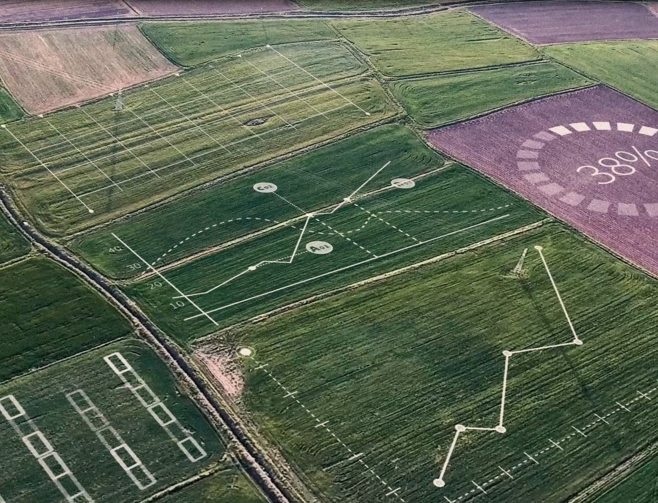
Photo: © Yara International. Used by agreement
At the same time we see technological developments – especially related to digitalisation – that require new skills and ability to restructure at a fast pace. This can include automation and digitalisation, but also new value chains and business models.

Status
In a survey undertaken by KPMG for the Ministry of Local Government and Modernisation on digitalisation in industry, 93 per cent of respondents report to have engaged in digitalisation projects during the last two years. Altogether 65 per cent state that the project has been successful, and 95 per cent believe that their business will benefit from increased digitalisation.
In the digitalisation projects that have been implemented, the most frequently used technologies include automation, digital collaboration tools and the use of cloud services and platforms. The businesses have to a varying extent incorporated technologies such as artificial intelligence and IoT. More than one-third state that these technologies are not relevant for them at the moment, while less than ten per cent have adopted these technologies. On the other hand, these technologies are relatively new, so the fact that approximately 40 per cent report to have started using such technologies at all shows that there is interest in as well as a potential for their expanded use in the years ahead.
The main motivation for digitalising is to enhance efficiency, but more than one-half also report that they digitalise to provide a better experience for their customers. As many as one in every three respondents report using digitalisation in order to increase the sustainability of their value chain.
Norwegian industry is diverse in terms of digitalisation. Some industries have come far, while others have traditionally not been very digital. Some industries have been strongly affected by the coronavirus, but not all. In this document, we have selected two sectors that are especially important for Norway – aquaculture and the maritime sector. We also take a look at a sector in which digitalisation has not traditionally been prominent, but where there has been a good development in recent years – agriculture. And we examine the tourist industry, which has been especially hard hit by COVID-19.
Aquaculture
The seafood industry is Norway’s second largest industry. In 2020, Norway exported seafood worth NOK 105.7 billion, and employment in the industry and its supply chain amounted to an equivalent of 44 000 fulltime jobs, mostly outside of the major cities. Traditionally, aquaculture has mostly involved manual labour, with little use of data for purposes of process improvement. However, constantly growing production volumes, stricter government regulations, consumer demands and increased global competition have spurred a rapid development towards automation and use of new technologies.
When it comes to understanding the value of sharing and collaborating over data, the aquaculture industry is in a unique position. Different companies have installations in the same fjord systems, use the same methods of operation, and share the same challenges. The industry is progressing from a situation with a few daily manual measurements to a continuous stream of data from sensors all day, year-round. This makes for a range of new opportunities, but also requires new and modern technology, new specialist skills, and new ways to collaborate over data. The key technologies will include sensors that collect data automatically, transmission of data from the installations and the environment to the cloud, and artificial intelligence that can provide new insight.
Technology that can help ensure sustainable aquaculture is a precondition for long-term growth in this industry. Industrial clusters are an instrument that can be suitable for promoting industrial development based on technology. Norwegian Innovation Clusters is a collaborative effort by Innovation Norway, the Research Council of Norway and SIVA. The Norwegian Centre of Expertise (NCE) Seafood Innovation Cluster is recognised as one of the world’s most complete industrial clusters and knowledge hubs in the seafood industry. The cluster encompasses 70 partners that represent a total of 150 small and medium-sized enterprises. The cluster is concentrated in Hordaland county, but is represented along the entire Norwegian coast as well as in international seafood regions. The cluster is responsible for AquaCloud, an initiative that seeks to transform the industry with the aid of Big Data.

BERGEN: Data sharing in the fish farming industry
Data collected at individual fish farms can have a range of applications with value for the installation itself, neighbouring installations/enterprises and public administration, as well as for research and commercial development groups. AquaCloud seeks to develop guidelines and protocols for data and data exchange based on open standards in three main areas: sensor data, environmental data and fish health data. This will permit, for example, early warning of a rise in sea lice and algae populations or impending critical weather conditions. Large-scale real-time data can help improve environmental management by permitting constant assessment of environmental sustainability and impact on the fjord system. Today, lack of access to sufficient volumes of high-quality data hinders software developers and enterprises in bringing out new innovations and new data-based products. Simplified access to data in APIs through AquaCloud will increase the provision of new solutions and lower the threshold for innovation. AquaCloud is an initiative from the NCE Seafood Innovation industrial cluster.
www.aquacloud.ai
Eide Fjordbruk has since 2015 collaborated with software company Searis in order to develop technology that will provide fish farmers with a better overview of conditions affecting fish and fjord systems, thus helping them make better choices at an early stage. They are developing an interactive solution – Clarify – that uses AI, machine learning and Big Data to combat sea lice.
www.efb.no – www.clarify.us
Photo: Eide Fjordbruk. Used by agreement
The maritime industry
The Norwegian maritime industry includes shipping lines, shipbuilders and suppliers of equipment and specialised services. In 2018, the industry created values to the tune of approximately NOK 89 billion and employed nearly 84 000 people all over the country. The maritime industry has been severely affected by COVID-19. The crisis has had a dramatic impact on activities, jobs and finances at a time when the industry already had been rendered economically vulnerable by the fall in oil prices in 2014.
Digitalisation and automation are increasingly prominent characteristics of the maritime industry, in the form of automated processes on board vessels and more integrated systems. This makes it possible to optimise activities and improve communication and safety. Digital transformation is set to affect trade patterns, production methods, monitoring and operations. As a result, the maritime industry produces more data that can be used for such purposes as machine learning. This has the potential to ensure more efficient, safe and environmentally friendly shipping and increase value creation.
The Research Council of Norway’s programme for maritime activities and offshore operations, MAROFF, supports research and development that help increase value creation in the maritime industry. Autonomous and remote-controlled vessels and digitalisation of the maritime industry are prioritised programme areas.
In association with the Government’s economic policies to counter the virus outbreak, funds were granted in 2020 to construction of two new research vessels for the Institute of Marine Research and the Geological Survey of Norway, and to upgrading and maintenance of existing research vessels.
Digital twins
In recent decades, vessels have become increasingly complex, with lots of software and integration between technical solutions provided by a range of different suppliers. It is challenging to ensure optimal interaction between the various components without being able to simulate how they will impact on each other, for example in order to assess possible consequences of an upgrade or change in one of the constituent parts.
The maritime sector has a long tradition of using scale models to optimise ship designs and test their stability. The concept of ‘digital twin’ has a resemblance to such models, by being a digital representation of a physical object – such as a vessel – normally with additional data to reflect its context, production and other information. Digital twins can be used for purposes such as optimisation of design, construction and operation of vessels, and for simulating the interaction between components.

TRONDHEIM: Open Simulation Platform
Open Simulation Platform (OSP) is an industry initiative based on open source code. OSP will provide the industry with tools and processes to construct and maintain digital twins for system integration, testing and control. The idea is to be able to simulate maritime equipment, systems and vessels.
OSP will enable the reuse of simulation models across organisations without exposing business secrets – the models and software are protected in a ‘black box’. The project will also develop standards for linking models and control systems into large, shared simulations.
Work on the OSP was started in 2017 by DNV, Kongsberg Maritime, SINTEF and NTNU, and has since been expanded with a number of international partners. Parts of the technical development of the OSP takes place in projects supported by the Research Council of Norway.
www.opensimulationplatform.com
Photo: © Open Simulation Platform. Used by agreement
Agriculture
Norwegian agriculture is important to maintain food security, value creation, dispersed settlement and the cultural landscape. There are farms all over the country, and agricultural properties account for more than three-quarters of the mainland area.
Norway is a high-cost country with a climate and topography that affect the economics of food production. These cost disadvantages mean that Norwegian food production needs to become more efficient in order to stay competitive, while the unique features are upheld. Norwegian farmers have been quick to adopt new technology to optimise their own production. Technological development, such as new machinery and automation, has boosted productivity and saved labour, and this has reshaped agricultural methods. Over the last ten years, Norwegian agriculture has seen its labour productivity grow by 1.7 per cent per year. In the same period, average growth in mainland Norway amounted to 0.9 per cent.
Research and development in combination with domestic production of new agricultural machinery, has helped ensure that Norwegian agriculture has stayed innovative and adopted new technology on a large scale. In a global context, Norwegian agriculture is highly mechanised.
Precision agriculture with the aid of robotic weeding, crop spraying and fertilising helps reduce costs and environmental impact, while increasing crop yield. Precision agriculture is a strategic priority for the research communities as well as for suppliers of agricultural equipment. For example, many farmers have started to use sensor technology to optimise their production process. This helps reduce costs for fertiliser and pesticides, while increasing crop yields and product quality.
Agricultural technology – agritech
Agritech means to use technology in agriculture to increase yields, efficiency and profitability. In many cases, such solutions will also be more sustainable. A study undertaken by the Norwegian Institute of Bioeconomy Research (NIBIO) points to a clear potential for increasing the competitiveness of horticulture through automation of manual tasks with the aid of robotics, such as mobile robots for plant care, equipment for targeted thinning of fruit-tree blossoms and harvesting robots for strawberries, raspberries and broccoli. In plant production, small unmanned drones have also become a useful tool, through their ability to carry sensors that can collect data on cultivated areas and crop status. This can help the farmers adjust their input factors through the growing season.
Public/private sector development
A project is currently being implemented to increase the competitiveness of agriculture and modernise the management of the sector. The agricultural industry collaborates with ministries, government agencies and R&D institutions on issues such as consent-based access to both privately and publicly held industry data, better decision support systems for farmers, digital applications for agricultural loans, and guidelines for ownership to data in Norwegian agriculture.
Data flow in agriculture
Historically, Norwegian agriculture has not shared much data across sectors – for example across livestock and plant production, or with external communities. A shared log-on system has simplified the exchange of electronic data in agriculture, and the establishment of ‘Landbrukets Dataflyt’ (‘Data flow in agriculture’) has facilitated data-sharing across sectors.
‘Landbrukets Dataflyt’ has developed solutions for farmers, purchasers, suppliers, accountants, banks, public agencies and research institutions. The IT systems are integrated and share data through different interfaces, such as APIs. The enterprise also operates a shared authentication solution that works for machine-to-machine authentication and can authenticate such installations as milking robots. This is the start of an IoT register in agriculture, where dataflows and ownership of data associated with IoT can be linked to individuals and organisations.

LANGHUS: Smart pest control – Kilter AX-1
Adigo is a Norwegian company that works across the areas of industrial design, machine engineering, technical cybernetics, informatics and thermodynamics.
Through the Asterix project the enterprise has developed an autonomous spraying robot, AX-1. The robot uses deep learning and neural networks to recognise plants and sprays pesticide only on the weeds, not on the crop plant or the ground. This reduces the use of pesticides by up to 95 per cent.
Since the robot weighs only 200 kg, it can start working on wet soil in early spring without compressing it, like a heavy tractor would do.
The Asterix project has received funding from Horizon 2020, the Research Council and Innovation Norway.
www.asterixproject.tech
Photo: Anders Brevik. Used by agreement

Tourism
Before the coronavirus pandemic, tourism was one of the world’s fastest-growing industries. This industry is important for jobs and local development, not least in many rural communities. Norway has grand scenery, a diverse cultural heritage and a cultural life that attracts international attention in a growing number of areas.
Tourism is one of the industries that has been hardest affected by the coronavirus pandemic. The fact that Norwegians largely spent their holidays at home in 2020, cannot compensate for the shortfall of foreign visitors and the drastic restrictions on fairs and conferences. In addition, future trends are uncertain. Parts of the customer base are expected to return when corona restrictions are lifted, but the pandemic may result in long-term and even permanent changes in demand, to which the sector will have to adapt. Experience from 2020 has resulted in a need for change and improved cost effectiveness in the industry. The major operators are to some extent able to invest in this type of development work, but this could pose a challenge to SMEs.
The opportunities inherent in digitalisation of society have changed large segments of the traditional tourism industry. The internet, smartphones, Big Data, electronic payment solutions and social media have changed the visitor expectations, how new destinations are discovered, trips are booked, new destinations are navigated, choice of accommodation and attractions, and how memories from trips are shared even before returning home. The industry has embraced the opportunities that digitalisation provides and increased its productivity, including through more efficient processes and new ways to reach out to customers. At the same time, the industry is also impacted by global online operators such as TripAdvisor, Airbnb, Google and Expedia.
Forskerpool is a scheme linked to the R&D tax incentive scheme SkatteFUNN. Through Forskerpool businesses can apply for up to 50 hours of assistance from a researcher to develop an idea or receive input to solve a problem. Since 2019, the scheme has targeted enterprises that need assistance with research related to ICT and tourism.

BODØ: Digital travel guide – Baahdy & Birdy
Baahdy & Birdy develops travel guides for the whole family and helps knowledge-based visitor attractions appeal to families with children. They do so by providing a customised solution that conveys the material to children on their own terms.
Baahdy is a goat that loves fish patties made from fish waste. If he eats enough of them, he gets so gassed up that he turns into a balloon that can fly. Birdy the bird cannot fly, but with the aid of Baahdy’s biogas and Birdy’s navigation skills, they set out on a balloon journey to save children who are bored while on holiday.
The travel guide covers a wide range of attractions in Northern Norway. The Sámi Parliament and Nordland County Administration have granted support ensuring that the Baahdy & Birdy app now is available also in the northern Sámi language.
www.baahdybirdy.com
Photo: © Monica Jakobsen Lunderøy. Used by agreement

The road ahead
The coronavirus pandemic has presented us with challenges, but has also shown that Norwegian employees and businesses are robust and adaptable. However, it is difficult to make plans and launch long-term measures while in the middle of a crisis of unknown duration.
Photo: invisiblepower on Unsplash. Free content
Over the last year, the Government has adopted a range of measures to combat the crisis, but also to prepare Norway for the road ahead. Some of the measures were intended to alleviate the difficult economic situation prevailing during the pandemic. However, many of the measures presented in this document – such as those related to competence enhancement or development of digital public services – will not only help cope with the coronavirus crisis, but also leave Norway in a stronger position once the crisis is over.
The Government’s work on digitalisation and innovation
In the middle of a crisis, quick action is required. However, it is also essential to continue efforts that are already underway. In the summer of 2019, the Government published its digitalisation strategy for the public sector, and in 2020, the Government has been preparing a number of strategies and white papers that will help drive forward the work on innovation and digitalisation in the years to come.
The national strategy for artificial intelligence
The Government launched its strategy for artificial intelligence in January 2020. The strategy stipulates that Norway shall make use of the innovative potential inherent in the use of artificial intelligence, and seek to assume a leading position in the use of artificial intelligence, especially in areas where Norway has good qualifications and strong scientific communities. The Government wants Norway to become a pioneer in the development and use of artificial intelligence respecting individual rights and liberties. Artificial intelligence in Norway shall be based on ethical principles, respect for privacy and good digital security.
Report to the Storting no. 30 (2019–2020) on innovation in the public sector
The Government’s goal is an efficient public sector that provides high-quality services to citizens, enjoys a high degree of trust among the population and finds new solutions to the challenges society is facing in collaboration with private individuals, industry, research communities and civil society. To achieve this goal, the public sector needs to rethink old solutions.
The Government presents three main principles for innovation in the public sector:
- Politicians and authorities must provide space and incentives for innovation.
- Leaders must develop a culture for and skills in innovation, and foster courage to rethink old ways and learn from failures and successes.
- Public enterprises must search for new forms of collaboration.
Report to the Storting no. 22 (2020–2021) on the data-driven economy and innovation
The Government wants to create more value and new work opportunities in all parts of the country using data as a resource. Data is increasingly contributing to value creation in many sectors and business areas, but there is still a potential for growth in the years to come. Better utilisation of data will promote the digital green transition and reinforce the competitiveness of Norwegian industry. Data should be shared in accordance with the FAIR data principles.
Report to the Storting no. 28 (2020–2021) on electronic communication
Digital development in society presumes that residents, businesses and authorities have a stable and good access to electronic communication networks. A growing range of critical societal services rely on a well-functioning electronic communication network. The government has therefore put forward a report to Parliament on mobile, broadband and internet services, focusing especially on the need for secure and robust electronic communication services.
Revision of the strategy ‘Powered by nature’
The large growth in data volumes means a need for more data centres, and the data centre industry is currently the world’s fastest growing energy-intensive industry.
An analysis undertaken for the Ministry of Local Government and Modernisation in 2020 shows that there are 18 data centres in the Norwegian market. The data centre industry is growing quickly, and it has been estimated that as of 2020, the industry accounts for approximately 2000 jobs and provide NOK 3.1 billion to the economy. This growth is expected to continue.
The Government wants Norway to be an attractive nation for data centres and other data-based businesses. In 2018, a separate data centre strategy was therefore launched, including measures such as a lower consumer tax on electricity for data centres, and a clearer land-use planning procedure for data centres. A revised data centre strategy will be ready in 2021.
A digital marketplace for cloud services
In 2021, the Government will establish a marketplace for cloud services at the Norwegian Agency for Public and Financial Management (DFØ). The marketplace will make it easier for the public sector to procure secure, legally compliant and cost-effective cloud services. The marketplace will provide an overview of compliant cloud services, as well as framework agreements. There will also be provide guidance on risk assessments and security requirements for cloud services.

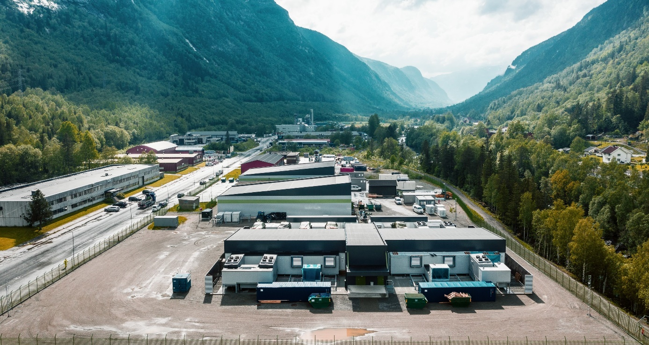
RJUKAN: Green Mountain
Green Mountain operates multiple data centres in Norway. The first one was located inside a mountain on a former NATO base near Stavanger. Further centres have been opened in Rjukan and near Oslo. All centres provide a high level of security and use renewable energy. Green Mountain has a number of international clients.
Rjukan is uniquely positioned in central southern Norway, with good connections to the rest of the country and the continent. The valley boasts six hydropower plants, making for an abundant supply of renewable energy.
In 2019, the Volkswagen Group established a centre for high-performance computing at Green Mountain’s premises in Rjukan. Here they perform energy-intensive computations, such as crash test simulations.
www.greenmountain.no
Photo: Volkswagen Group. Used by agreement

Coronavirus commission – ‘Norway towards 2025’
The coronavirus pandemic may have given rise to permanent changes that affect the basis for value creation, production, employment and welfare in Norway. Consumption patterns, production patterns, industry structures and conditions in working life may change. Internationally, trade patterns and commercial relations may change.
The Government appointed a commission in May 2020. The objective was to get a good analyses of how the coronavirus pandemic will affect value creation, production, employment and welfare in Norway in the years to come. The results were presented in a Norwegian Official Report – ‘Norway towards 2025’ in March 2021.The commission recommends measures for stronger competitiveness, reduced emissions of greenhouse gases and green growth, a well-functioning labour market and high employment, and economic sustainability. Coronavirus measures that limit the ability to restructure the Norwegian economy should be terminated as soon as it is prudent to do so. Compensation schemes should support restructuring that are needed, regardless of the pandemic. It is of particular importance that young people and other employees with a weak connection to the labour market return to work as quickly as possible.
Increased grants for digital restructuring in industry
Innovation Norway is the main instrument that central government and county authorities use to instigate value-creating industrial development all over the country. Innovation Norway’s remit includes helping to promote entrepreneurship, more viable enterprises and innovative business communities.
In recent years, Innovation Norway’s portfolio has seen a growth in the number of digital projects. In 2020 the growth in this area was especially high – the number of ICT projects tripled compared to 2019. Digitalisation projects are found in all sectors.
The coronavirus effect
The marked growth in ICT projects is associated with the coronavirus crisis. The crisis has helped speed up the pace of digitalisation. Many enterprises see how increased digitalisation helps reduce location disadvantages, especially in relation to European markets. Digitalisation is increasingly regarded as a prerequisite for competitiveness: in a study undertaken during the coronavirus crisis among Innovation Norway’s clients, more than 70 per cent of the respondents state that digitalisation is essential for them to succeed in the future.
Much of the digitalisation undertaken in 2020 has involved efficiency enhancement, such as digitalisation of communication and contact in markets and value chains. There has been a slowing down in the number of large restructuring projects involving major changes to production and business models. These are more long-term investments in digitalisation for permanent restructuring and will be crucial in the years ahead. Innovation Norway will prioritise services that support future restructuring needs while factoring in the prevailing situation, for example by providing new skills, new venture capital and access to new clients. The Government has doubled the allocation for innovation support to industry through Innovation Norway, from NOK 7 billion in 2019 to NOK 14 billion in 2020.
The Digital Europe Programme (DIGITAL)
The EU has proposed to establish a comprehensive digitalisation programme, the Digital Europe Programme (DIGITAL), for the years 2021–2027. This is the first time the EU proposes a separate programme dedicated to digitalisation in society and industry.
The DIGITAL is a key element in the EU Commission’s work on digital transformation and targets areas where individual countries by themselves will not have the resources needed to succeed. The programme aims to establish the EU as a driving force for the digital transformation and promote future-oriented technologies that are expected to have a major impact on growth and employment in Europe over the next years. The programme will also seek to help small and medium-sized businesses to adapt to changes that follow from technological development, for example in the areas of digital transformation and artificial intelligence.
The programme is proposed to have an economic framework of EUR 7.17 billion, divided into five main areas: High-performance computing (HPC), artificial intelligence, cybersecurity, digital transformation and advanced digital skills.
The Government proposes full Norwegian participation in DIGITAL 2021–27. A final decision on Norwegian participation in DIGITAL will be taken by Parliament in 2021.
Special focus on SMEs and start-ups
Small and medium-sized enterprises account for a large part of Norwegian business life. Enterprises with fewer than 50 employees provide employment for more than one million people in Norway. These enterprises are essential for building and maintaining vibrant local communities. On the other hand, small enterprises and businesses in the start-up phase will tend to focus on production and day-to-day operations. This may make it difficult for them to devote resources to development and restructuring.

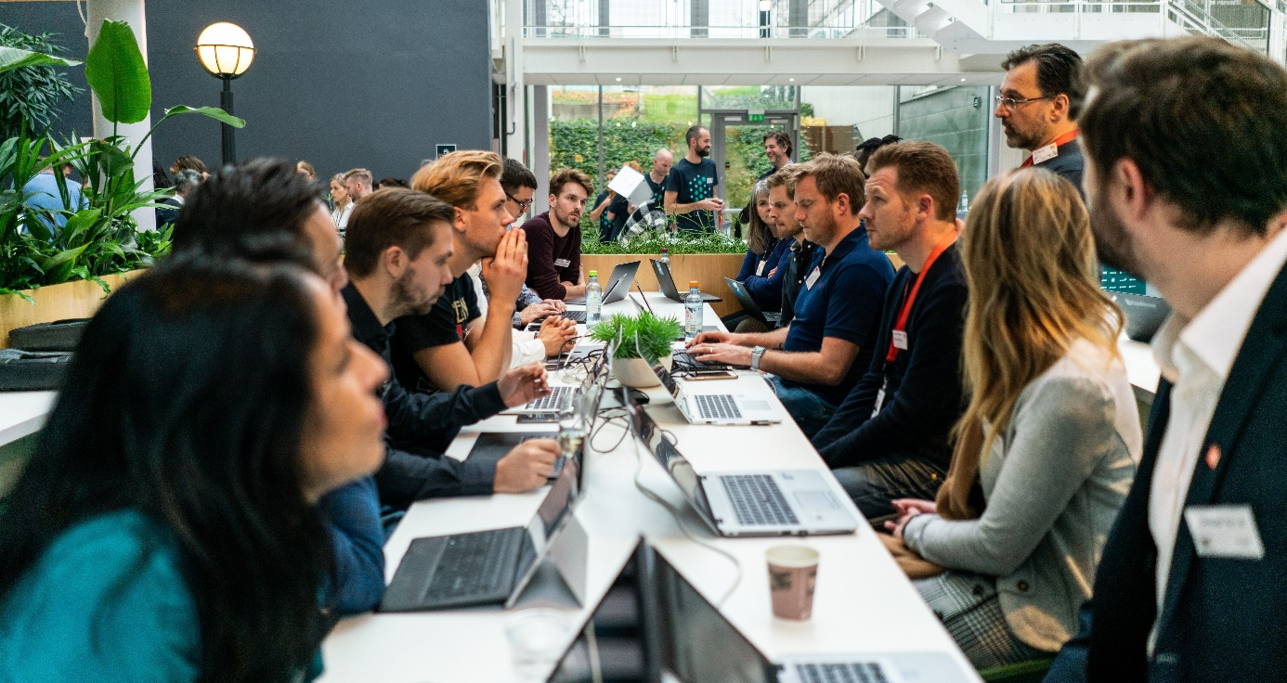
OSLO: DigitalNorway
DigitalNorway is a non-profit initiative started in 2017 by 15 committed businesses with support from the public sector, with a view to speed up the digital transformation of Norwegian industry, especially in SMEs.
It is important to enable SMEs to participate in the data-driven economy. DigitalNorway will therefore foster major collaboration projects involving sharing of data in various industries. In alliance with the Norwegian Digitalisation Agency, DigitalNorway will have a key role in the Government’s programme to establish a Data Factory.
As one of five Norwegian Digital Innovation Hubs (DIHs) under the EU’s Horizon 2020 programme, DigitalNorway is engaged in a number of EU projects. DigitalNorway undertakes information activities related to research, technology and innovation, with a particular focus on SMEs.
DigitalNorway also delivers free online guides and training courses in topics such as innovation, data use or digital marketing. The training courses range from brief, online sessions to more comprehensive further education programmes developed in collaboration with major seats of learning.
www.digitalnorway.com
Photo: DigitalNorway. Used by agreement
European Digital Innovation Hubs (EDIHs)
The digital innovation hubs play a key role in the Digital Europe Programme (DIGITAL). EDIHs are one-stop shops that will help companies become more competitive with regard to their business/production processes, products or services using digital technologies. EDIHs provide access to technical expertise and experimentation, so that companies can ‘test before invest’. They also provide innovation services, such as financing advice, training and skills development that are needed for a successful digital transformation.
EDIHs will be established all over Europe. Those who use the EDIHs will therefore have access to other European knowledge communities, which may have ‘know how’ or test facilities that are not available in Norway. It is expected that Norway can establish 2–4 EDIHs under DIGITAL.
Programme for start-ups
Young, innovative enterprises may find it especially difficult to get into position to win contracts with public sector organisations. The Government wants to make provisions for the public sector to make better use of the opportunities provided by start-ups, and has therefore established a programme for procurement of innovations from such enterprises. The core of the programme will see public agencies formulating challenges and needs, to which start-up communities and other innovative actors can find solutions.
The ‘Data Factory’
In order to realise value from data, they need to be processed and analysed. This requires data of the correct technical quality, management of intellectual property rights, and clarification of issues related to privacy. Addressing all these concerns requires specialist competence of a kind that few Norwegian enterprises have in-house.
The data factory will be able to clarify such matters, as well as distribute data from a range of different sources. The data factory will help SMEs and start-ups obtain relevant data and provide support for data-processing. The data to be distributed through the factory will come from private businesses as well as the public sector. The data factory will be developed and operated by DigitalNorway in collaboration with the Norwegian Digitalisation Agency.

Further reading/references
Photo: Susan Yin on Unsplash. Free content
White papers, strategies and reports from the Government
Report to the Storting no. 27 (2015–2016) Digital agenda for Norway in brief
Meld. St. 14 (2019–2020) Kompetansereformen – lære hele livet (‘Lifelong learning’)*
Report to the Storting no. 10 (2018–2019) The health industry – summary
Report to the Storting no. 19 (2016–2017) Experiencing Norway – a unique adventure
Blue Opportunities – The Norwegian Government's Updated Ocean Strategy 2019
Meld. St. 30 (2019–2020) En innovativ offentlig sektor (‘An innovative public sector’)*
Meld. St. 22 (2020–2021) Data som ressurs (‘Data as a resource’)*
Meld. St. 28 (2020 – 2021) Vår digitale grunnmur (‘Our digital infrastructure’)*
One digital public sector: Digital strategy for the public sector 2019-2025
National Strategy for Artificial Intelligence, 2020
Strategy: Powered by Nature – Norway as a data centre nation, 2018
NOU 2021: 4 Norge mot 2025 (Official Norwegian Report ‘Norway towards 2025’)*
Other reports, indices and statistics
KPMG 2020 Hindre for digitalisering av forretningsprosesser (‘Barriers to digitalisation’)*
Norges bank papers 1/2020 Retail payment services 2019
European Commission – Digital Economy and Society Index: DESI: Norway
Telenor Group 2020 Nordic Digital Municipality Index
Statistics Norway: Internet usage in households: www.ssb.no/en/ikthus/
Statistics Norway: Statistics on the coronavirus crisis: www.ssb.no/korona*
Norwegian Digitalisation Agency: Reports and statistics*
* Not available in English

Printed publications can be ordered from: Norwegian Government Security and Service Organisation. publikasjonsbestilling@dss.dep.no
Front page design: Konsis. Photo: Jennifer Nilsson/Johnér and Eide Fjordbruk AS

