Digital agenda for Norway in brief
– ICT for a simpler everyday life and increased productivity
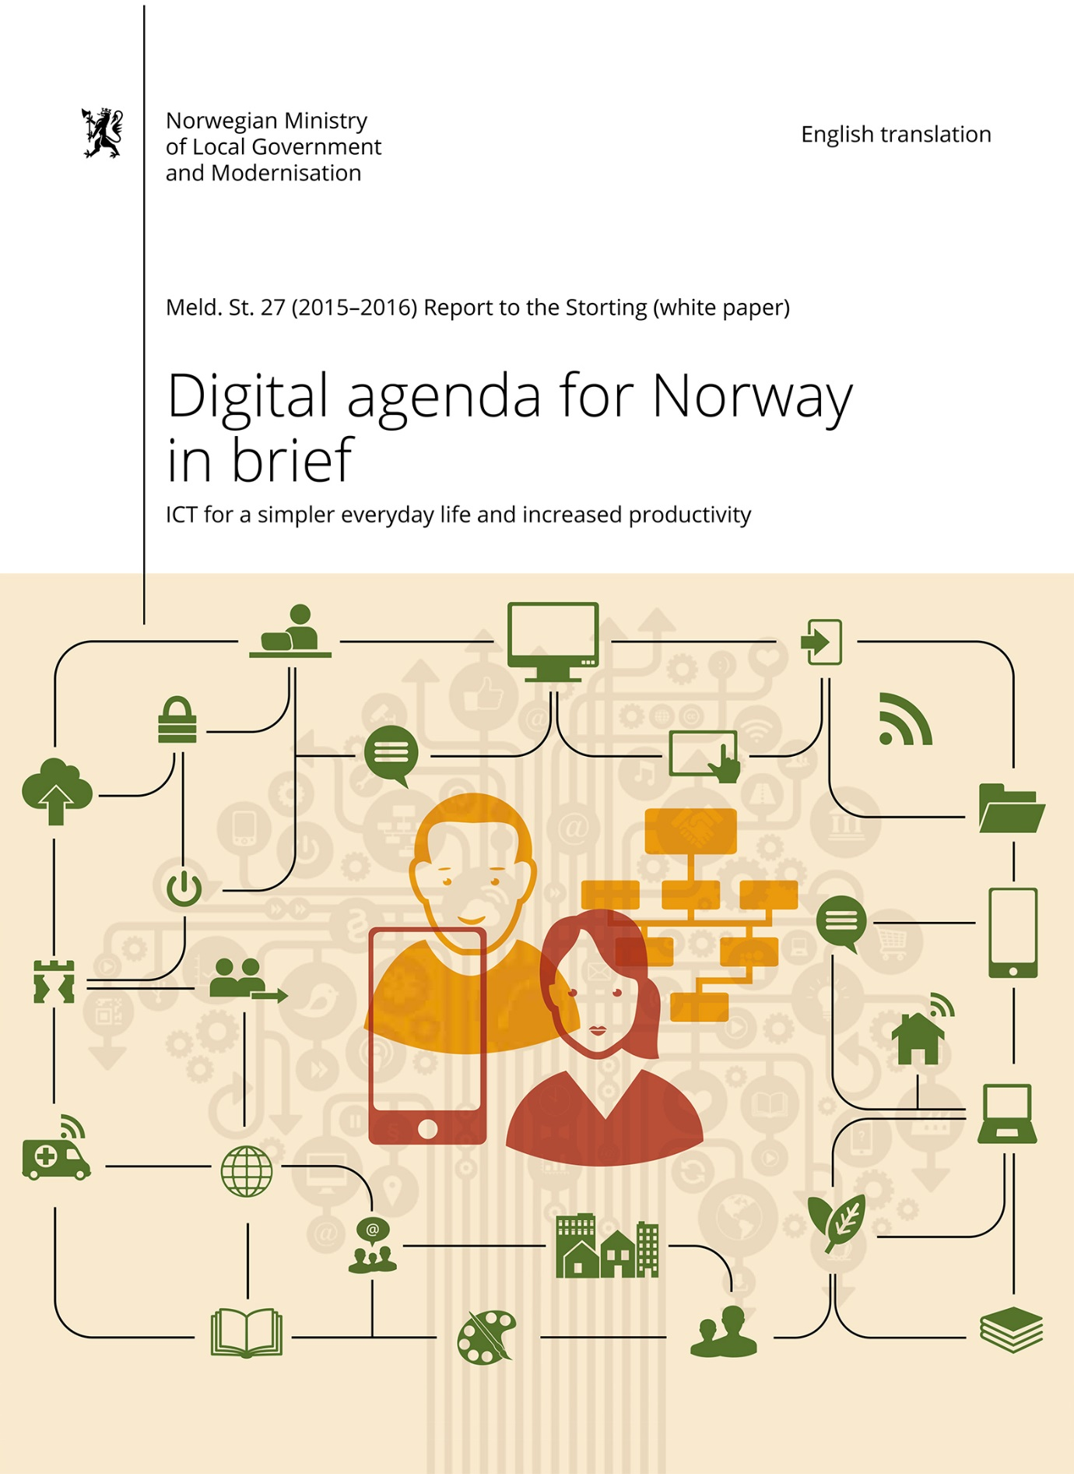

Introduction
A simpler everyday life and increased productivity
The purpose of this white paper is to present the Government's policy on how Norway can exploit ICT in the best interests of society.
The ICT policy must be based on the major, real challenges the public and private sectors are facing with respect to productivity, restructuring and rationalisation.
In light of this, the Government's ICT policy has two main objectives:
- A user-centric and efficient public administration
- Value creation and inclusion
Digitisation is a cross-sectoral issue
The Government holds high ambitions for modernising, simplifying and improving the public sector, while private citizens and business and industry are expecting solutions that will simplify everyday life. By using ICT and taking full advantage of the opportunities that digitisation offers, we can achieve both these goals.
Digitisation implies challenges which individual sectors cannot resolve alone. The Government therefore sees the need to raise cross-sectoral digitisation issues for which a national, coordinated approach will bring added value to society.

Key priorities in the ICT policy

The Government has set five key priorities that give the policy direction and highlight which areas should be focused on going forward.
I. A user-centric focus
The users (inhabitants, public and private enterprises and the voluntary sector) and their needs shall be the starting point. Users shall perceive public services as seamless and integrated, regardless of which public agency provides them. Public administration shall reuse information instead of repeatedly asking users for information they have already provided.
II. ICT constitutes a significant input factor for innovation and productivity
Efficient use of ICT strengthens industry's competitive ability and increases society's overall productivity. This is a precondition for financing future welfare services. The Government wants to make it easier for business and industry and wider society to exploit the opportunities that digitisation offers. The authorities shall accommodate increased digital innovation by adapting regulations, creating favourable framework conditions, removing obstacles to digitisation, and facilitating a world-class infrastructure providing high-quality electronic communication networks and services. Norway shall participate in Europe's digital single market.
III. Strengthened digital competence and inclusion
From primary education up through all life phases, digital competence shall be improved to ensure inclusion to and confidence in digital solutions. Digital services shall be easy to understand and to use. Advanced ICT competence and ICT research constitute fundamental preconditions for the digitisation of Norway.
IV. Effective digitisation of the public sector
Public digitisation projects shall be planned and implemented professionally and in a way that reduces complexity and risk so that benefits are realised. The market shall be used where appropriate. Central and local government and the different sectors shall use common solutions to meet common needs. Common solutions shall be used to create effective, user-friendly digital services for the whole of the public sector. Interoperability with European solutions shall be facilitated.
V. Sound data protection and information security
Data protection and information security shall be integrated elements of the development and use of ICT. Citizens shall, as far as possible, have control over their own data. Processing of personal data shall be based on sound proportionality considerations according to purpose. Information security and ICT security are preconditions for maintaining confidence in digital solutions. Information security shall be maintained using a risk-based approach based on updated threat and vulnerability assessments, and shall be monitored by a sound system of internal controls.

Development trends and challenges
Over the past 20 years, the internet and digitisation have fundamentally changed society. Initially a technology for a small group of specialists, digital technology is now a universal technology and platform for communication that permeates all areas of society and the economy.
The internet gained 50 million users in the first three years as a commercial network. Today it has around 3 billion users, and is the world's most important arena for communication, with a vast potential market. The internet is connected not only to people, but also to 'things', sensors, different types of equipment, and even clothing, hence the concept 'the internet of things', a fast-growing global network of 15 million devices.
Another important driving force for the growth of internet users is the high use of mobile phones. According to the Economist, in 2015 around half of the world's adult population owned a smartphone. This proportion is expected to rise to 80 per cent by 2020. This means that 80 per cent of the global population are potential users of the internet, with all the possibilities and challenges this brings with it. Other estimates suggest that 90 per cent of the global population aged over six will own a mobile phone by 2020. Simultaneously, the global mobile network is being developed to have the capacity to deliver data traffic increasingly faster.
Widespread availability of high-capacity broadband facilitates convergence of different media. Audiovisual media (audio and video), conventional broadcasting, and a whole host of other digital services are merging together.
Simultaneously, ICT-based innovation is forming the basis for automation that lead to some jobs disappearing and new ones being created. This situation also presents opportunities. The Productivity Commission points out that automation of case processing and the possibility for communication between IT systems may affect how public-sector tasks are organised and designed in the future.
The development of big data is possible due to the increasing capacity of computers and networks and to the vast stream of data flowing from all devices connected to the internet. New analytical methods lead to new insights and business opportunities at the same time as they challenge data protection in new ways.
Personal data has become a new means of payment online. Many users seem to accept this development in exchange for 'free' access to social platforms and other services.
Cloud services are becoming the dominant method for delivering ICT services, particularly to consumers and businesses, and the public sector is following suit. The scalability and the pay-as-you-go model can be good solutions for ICT buyers looking for cost-effective solutions.
Climate change is one of the major challenges the world faces today. Developing and using new technology is a precondition for achieving climate goals, both nationally and globally. ICT offers important opportunities to help reduce greenhouse gas emissions and improve the environment. For example, smart use of digital technology can provide more efficient ways of exploiting resources and consuming energy.
The dramatic growth of social media is another important trend. By extension, we have the sharing economy and popular services such as the accommodation service Airbnb and the taxi app Uber. Revenues from the global sharing economy are estimated at NOK 40 billion and are said to be growing by 25 per cent annually. The sharing economy often represents a competitive challenge for established businesses, but it also offers users more choice and represents a significant opportunity for innovation and new jobs.
Net-based platforms (such as Google, Facebook and Amazon) are playing increasingly important social and economic roles. The sheer size of these platforms give their owners significantly dominant positions and influence on the competitive conditions for other service providers on the internet. This situation poses challenges for regulatory authorities, as does the fact that these platforms are used all over the world.
The issue of net neutrality concerns challenges related to non-discrimination of communication and content distribution online. This is a topic that becomes increasingly relevant in line with the growing trend of media convergence when around 150 websites (such as Netflix and YouTube) account for most of the traffic.
Most critical infrastructure and functions today are digitised. The level of complexity and interdependence of ICT systems is constantly rising. This is creating new types of vulnerabilities to be managed. These challenges are exacerbated by a growing gap between the supply and the demand of advanced ICT competence.
The priorities stated in the national ICT policy are affected by international trends. ICT policy therefore constitutes an important area for international cooperation. Norway's efforts are particularly directed at the EU, OECD and Nordic cooperation. In Europe there is consensus that many of the major challenges in ICT policy are common ones and can best be resolved together. One example is EU's efforts to promote a digital single market in Europe.
Technological developments create organisational and governance challenges, but also opportunities. Technological development and digitisation of the public sector drive administrative and service development. Digitisation changes the relationship between public service providers and the public in many ways, such as the emergence of new forms of collaboration. Changes in information flows challenge established areas of responsibility between agencies and sectors and create governance challenges.
The Norwegian economy is facing significant challenges. The decrease in demand from the Norwegian continental shelf is impeding economic growth. The decline has been exacerbated by the sharp drop in oil price. Unemployment has risen, particularly in the counties associated with the oil sector. This also has consequences for other industries. Although the oil sector will remain an important sector in the Norwegian economy, over time Norway will have to restructure to more knowledge-based industries. Meanwhile, productivity growth has fallen. The crisis involving asylum-seekers and refugees is putting our restructuring and productivity abilities to the test. Economic challenges are being faced all over the world. Technology development could help resolve these types of challenges. If we are to achieve this, we need to find new ways of working, processing information and resolving tasks.
Box 2.1 Blockchain
The blockchain protocol is a method of securely transferring value over the internet. The method was developed to support a digital currency, the Bitcoin, but can also be used in many other areas such as finance, insurance, public administration, contract law and administration of copyright. A key feature of blockchain technology is that it can ensure confidence in digital transactions through the use of advanced cryptographic methods without having to rely on a third party. Further expansion of this technology depends on a number of regulatory and policy challenges being resolved, including regulation in the areas of finance, tax policy and crime prevention.

The contribution of ICT to the economy

Features of ICT
Information and communication technology (ICT) has some distinctive features. First, ICT is often referred to as a general-purpose technology in the sense that the technology can be applied to many different purposes. Other examples of this are electricity, the internal-combustion engine and biotechnology. Second, ICT benefits are network benefits, meaning that the usefulness of the benefits increases proportionally with the number of users. Third, ICT can be used to produce digital benefits that cannot be produced in any other way. Such benefits can be reproduced without generating additional costs. These features of ICT mean that integrating ICT into the economy can lead to substantial productivity benefits.
Many studies have looked at the significance of ICT for economic value creation. Although historically it has been difficult to quantify ICT's contribution to productivity growth, the conclusion is that ICT has made significant contributions to economic growth. One study shows that digitisation account for 30 per cent of Norway's productivity growth between 1995 and 2005 and for around 50 per cent between 2006 and 2013. An international study shows that between 2001 and 2011 digitisation accounted for 30 per cent of GDP growth in Europe. Several studies also suggest that strong growth effects can be achieved from investing in ICT infrastructure (broadband).
At the same time, another trend is emerging that is often not captured in official statistics. An example of this is the development that has taken place in the camera and photography industry. Previously this was an industry that had high employment and extensive support services. Much of this industry disappeared with the growth of digital photography and file-sharing services. On the other hand, the products and the taking and sharing of pictures have become virtually free for consumers. The contribution by photography-services related to GDP has most likely declined, while their use has increased dramatically and services to consumers are now far better and cheaper than before.

The ICT industry
Given the significance of digitisation, it is important to emphasise that Norway has a thriving ICT industry delivering goods and services that support digitisation in both the public and private sectors.
Compared with other industries, the ICT industry has experienced dramatic productivity growth. In 2013 the industry accounted for 4.9 per cent of value creation in Norway and 3.8 per cent of mainland employment. Customised IT services represent the largest component in Norway's ICT industry, with 36.6 per cent of value creation in 2013, followed by telecommunications with 22.8 per cent. Of the four largest Nordic countries, Norway has the largest ICT industry in proportion to its population.
Because the ICT industry is a major supplier to the oil sector, Norway's ICT industry has also been affected by the downturn in the Norwegian oil industry. For this reason, digitisation of the rest of Norway's business and industry and of the public sector will be a key priority area in the coming years.

Outlook
In recent years product development in Norway has stagnated after a period of rapid growth in the 1990s and early 2000s. The same trend is found in a number of other countries, and is one that raises concerns for future economic growth and prosperity.
In 2014 the Government appointed the Productivity Commission to examine productivity in the Norwegian economy. In its first report, the Productivity Commission stressed that expanded and improved use of technology would be decisive for increasing productivity in both the public sector and industry (NOU 2015: 1).
In its second report (NOU 2016: 3) the Productivity Commission highlights the need for Norway to restructure from a resource economy to a knowledge economy. Norway's natural resource abundance has generated vast revenues, but it has also had a substantial effect on the country's industrial structure and may have weakened incentives for education, research, entrepreneurship and innovation. A poorly diversified economy is particularly vulnerable to fluctuations in the price of commodities, something which Norway is now experiencing with the drop in oil price. While the Productivity Commission acknowledges that the oil sector will continue to be important in the Norwegian economy, over time Norway will have to make the transition to a more knowledge-based economy. Such restructuring will necessitate ICT playing a key role.
The white paper entitled Long-term Perspectives on the Norwegian Economy 2013 (Meld. St. 12 (2012–2013) emphasises the challenge of Norway's ageing population. In 2060 there will be four people aged over 67 for every ten people of working age, compared with 2.2 people in 2012. This represents almost a doubling of the old-age dependency ratio per working-age person. Simultaneously, Norway is experiencing an increased influx of asylum seekers and refugees. There is reason to expect that the refugees arriving now will have a markedly lower level of labour-market participation than the rest of the population, at least in the short term. This will further reduce the proportion of labour-force participants compared with the proportion of non-participants in the population.
These demographic changes entail a need for extensive adaptations. We must become more productive. That is to say we must be able to produce more goods and services from a given resource input. Enhanced automation of communication and case processing procedures within and between agencies and between agencies and citizens and industry can be an important measure. Another example is welfare technology that can address the need for manual assistance by elderly and people in need of assistance. Both the Productivity Commission's report and the white paper on the long-term perspectives on the Norwegian economy emphasise that use of technology is central to improving and modernising the public sector in Norway, and that there is huge untapped potential for rationalising the public administration by means of ICT.

Norway's digital performance

Digital life
When the previous white paper on ICT policy – Digital Agenda for Norway – ICT for Growth and Value Creation – was published, Norway was already a mature internet market. A large proportion of the population had access to internet, and a large proportion used the internet on a daily basis. Since then, Norway has maintained its position as one of the leading countries in this respect, and Norwegians' internet usage has continued to grow. Even more citizens have gained internet access, and more of them are using it daily.
In 2015 Q4, 97 per cent of the population aged over 12 had internet access at home, at school or work, or elsewhere. 90 per cent were using the internet daily. In 2011, 92 per cent had internet access and 79 per cent were using the internet on an everyday basis.
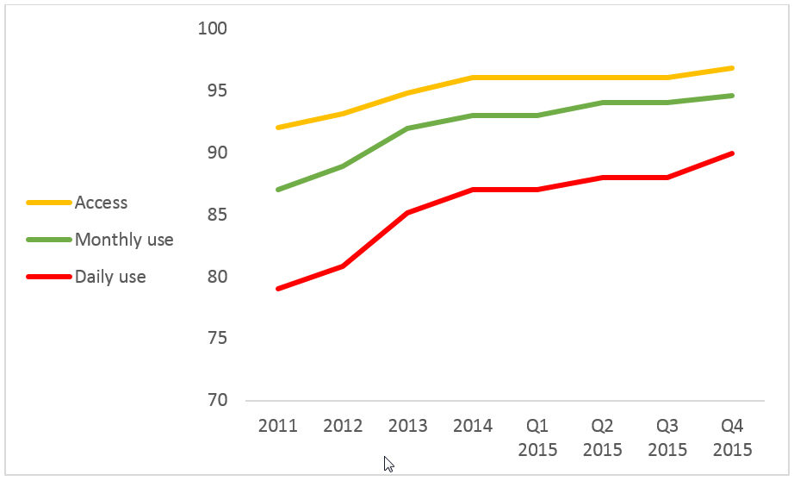
Figure 4.1 Proportion of the population with internet access, as percentage using the internet monthly and daily.
Source: TNS Gallup Forbruker & Media.

The average broadband speed has increased markedly. There have also been changes in the choice of device we use to connect with the internet. Smartphones and tablets have made their entry during this period, see figure 4.2

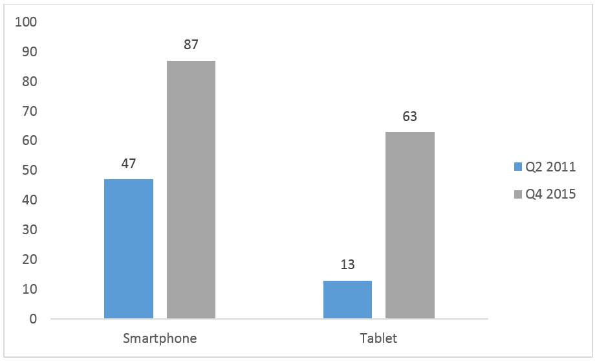
Figure 4.2 Proportion of the population with access to smartphones and tablets in 2011 and 2015.
Source: TNS Gallup Interbuss 2011 Q2 and 2015 Q4.

The growth in digital infrastructure has made use of digital services an integrated part of everyday life.
Digitisation is manifesting itself in new behaviour and new expectations in several areas. For example, we are now online 24 hours a day, and we expect information to be accessible online whenever we want it.
We also spend more time online, from 112 minutes in 2013 to 120 minutes in 2014. The population's average time spent online has never been higher.
ICT usage in industry
Statistics Norway publishes annual figures on ICT usage in industry. The survey shows clear differences in ICT usage between small and large enterprises, the largest being the most active users. Furthermore, Statistics Norway's surveys show that use of social networks such as Facebook and LinkedIn by enterprises with at least 10 employees has steadily increased over the past two years. In 2015, six of 10 enterprises used social networks. Statistics Norway's survey also shows that the proportion of enterprises using cloud services rose from 29 per cent in 2014 to 38 per cent in 2015. The proportion of enterprises with fast broadband has also risen steadily in recent years. In 2011, 17 per cent of enterprises had broadband with a minimum download speed of 30 Mbit/s, whereas in 2015 this proportion was 37 per cent. In 2015, 80 per cent of enterprises had their own website.

Digitisation of public services
Norway has succeeded in many areas in its efforts to digitise public services. Government agencies and municipalities increasingly offer digital services, and use of these services is growing dramatically. Use of public services online increased by 235 per cent between 2010 and 2015.

Strong growth in use of the common login solution
The eID Gateway is a common login solution for public services online. In 2010, 20 million logins to public services were made via the eID Gateway. In 2015 the number of logins totalled almost 67 million.
Figure 4.3 shows key figures for the eID Gateway for the past four years. The number of public agencies using the eID Gateway for their login solution and the number of digital services requiring login via the eID Gateway are showing significant growth. The Agency for Public Management and eGovernment (Difi), which administers the eID Gateway, expects the growth to continue by around 20 per cent annually.

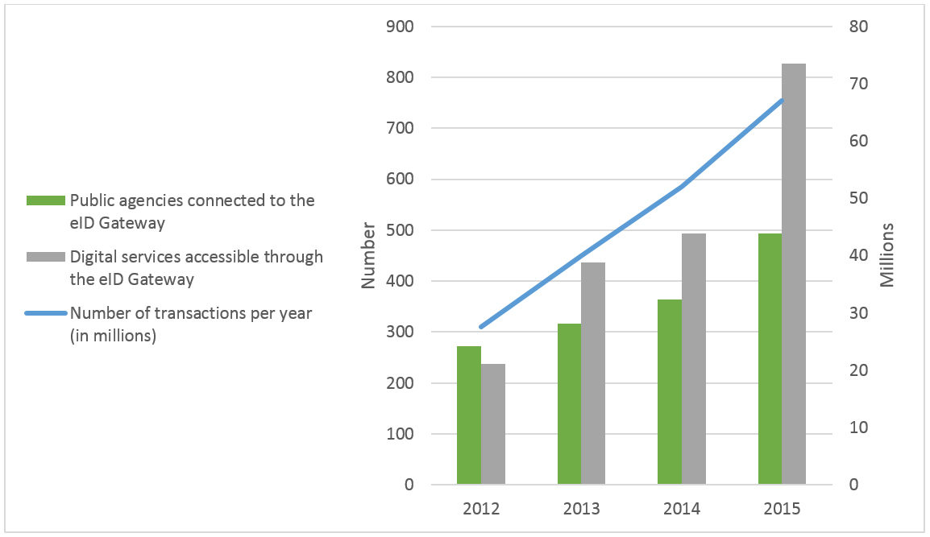
Figure 4.3 Key figures for eID Gateway.
Source: Difi.

The figures for the eID Gateway show that the scope of digitisation in the public sector in recent years has been substantial. Many hundreds of services are now digitised and accessible online via the login solution. During this period 220 new enterprises have begun using the eID Gateway for digital services, and the transaction figures show that these services are widely used.

Widespread use of electronic services in business and industry
Since its launch in 2003, Altinn has played a significant part in the expansion of electronic forms and services. Hardly any other country can show similar expansion of electronic services to business and industry. Altinn was specifically developed to facilitate coordination of digital services across public administration to make user dialogue with the public sector easier and faster. The Altinn platform handles data exchange with enterprises, voluntary organisations and private persons. Users can submit forms via any web portal or directly from an agency's computer system. Public agencies can send messages back to the user's message box or give access to relevant information.
Since its launch, over 200 million digital forms and messages have been transmitted via Altinn. Figure 4.4 shows the growth in recent years. In 2015 service owners delivered more than 28 million messages to Altinn's message box. Almost 3.5 million private users opened messages like these in 2015.
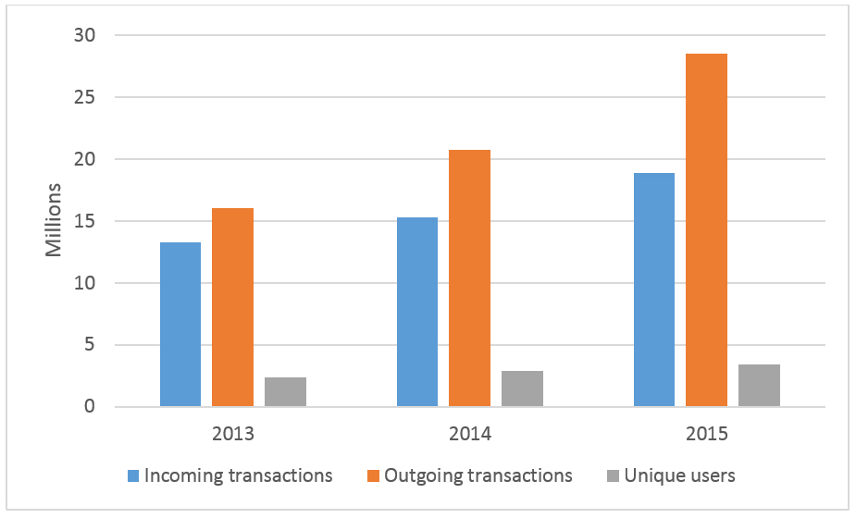
Figure 4.4 Key figures for Altinn 2013–2015.
Source: Brønnøysund Register Centre.From consent to opt-out: citizens are ready

From consent to opt-out: citizens are ready
Amendments to the Public Administration Act and the Electronic Public Administration Regulations came into force in 2014. The requirement to obtain consent from recipients before corresponding online with private citizens, enterprises and others was abolished. For private citizens the requirement for consent was replaced by an option to opt out from receiving digitally individual decisions and other important messages from public administration. Business enterprises and other user groups do not have a similar option.
Few people have chosen to opt out. At 31 March 2016, 96,831 private citizens had opted out from receiving digitally individual decisions and other important messages from public administration. This constitutes around 2 per cent of the population aged over 15. Combined with the increased use of public digital services, the small number of citizens opting out shows that Norway's citizens are ready to communicate online with the public sector. The transition from the requirement to consent to the option to opt out has also made digital communication with citizens significantly easier for public administration.

Box 4.1 Digital mail to enterprises
Altinn was selected as the solution for managing digital mail from the public sector to enterprises. All enterprises shall receive digital messages from the whole of the public administration via their message box in Altinn.
All public authorities shall be able to send mail to enterprises via Altinn, including those who do not currently own services in Altinn under cooperation agreements.

Box 4.2 Digital mail to citizens
The digital mailbox for citizens provides public agencies with an easy and secure method of sending mail digitally to citizens.
Difi has entered into contracts on behalf of the entire public sector with mailbox providers e-Boks and Digipost. Citizens can choose which of these two mailboxes they wish to use. When new mail from the public sector arrives in the mailbox, citizens are notified via text message or e-mail. Subscribing to a digital mailbox is voluntary and free. At 31 March 2016, 875,510 citizens had opted to use a digital mailbox.
All public administrative bodies must have implemented or prepared a plan for implementing the digital mailbox by the first quarter of 2016. Tax deduction statements and tax assessments must be sent to citizens' chosen digital mailbox. The Government expects to have this in place by the time tax deduction statements for income year 2017 are ready to be issued in December 2016.

Table 4.1 Digital mailbox for citizens.
Year | Q1 2016
No. of persons who have opted for mailbox | 875 510
Letters sent | 1 000 000

Source: Difi.

Tax returns
The transition form consent to opt-out has had significant consequences for the Norwegian Tax Administration. Three of four taxpayers now receive their tax returns and tax assessments electronically.

Table 4.2 No. of persons with electronic tax returns over time.
Income year | 2012 | 2013 | 2014
No. of persons with electronic tax returns | 552 620 | 871 721 | 3 432 177
Source: Norwegian Tax Administration.

Digital services in the Norwegian Labour and Welfare Administration
The Norwegian Labour and Welfare Administration (NAV) is an agency that has widespread contact with the population. Around 2.8 million citizens receive benefits such as child allowance, sick pay, pension, and unemployment benefit from NAV.
In 2014 NAV handled around 130 million enquiries. The nature of these enquiries varied, and around 64 per cent of them were handled via nav.no.
Table 4.3 shows the percentage of digital submissions in 2015 for some key services.
E-prescription in brief
Instead of a paper prescription, the physician issues an electronic prescription (E-resept). The patient can then collect the medicine from pharmacies all over the country. When redeeming her prescription, the patient states her personal identity number or name and date of birth. She must also provide proof of identity. Patients may authorise others to collect their medicine for them. E-resept contributes to a better, more secure way of handling drugs, a better overview of drug consumption, fewer fake prescriptions, easier settlement, and simpler renewal processes. The ‘My Prescriptions’ service in helsenorge. no provides citizens with a summary of active prescriptions, medicines dispensed during the past 30 days, and how many repeat prescriptions are left.

Helsenorge.no: Quality-assured health information
Helsenorge.no is the Health and Care Services' portal for health information and self-service solutions for the population. Launched on 15 June 2011, the portal is a guide to the health services and self-service solutions available in the health sector. The portal also provide information on health, preventive health, healthy living, medical conditions, treatments and patients' rights.
Table 4.3 Percentage of digital submissions to NAV in 2015 for some key services.
Service | Percentage digital submission
Unemployment benefit | 75%
Employment status form | 89%
Registration as a jobseeker | 82%
Work assessment allowance | 58%
Pension | 58%
Parental benefit (first-time application) | 55%

Source: NAV.

Helsenorge.no will be further developed to become the central guide to the health services, with interactive services adapted to individual needs. On helsenorge.no users can log in to 'My Health' and gain access to personal services such as: 'My Prescriptions'; 'My Vaccines'; 'My User Fees'; and 'My Patient Record'. Citizens are also gaining access to their own Summary Care Records the service is gradually implemented throughout the country. At March 2016, over half of Norway's citizens have their own Summary Care Record. More services are under development, and some are being tested in selected areas.
Figure 4.5 shows the number of visits to helsenorge.no from February 2015 to January 2016.
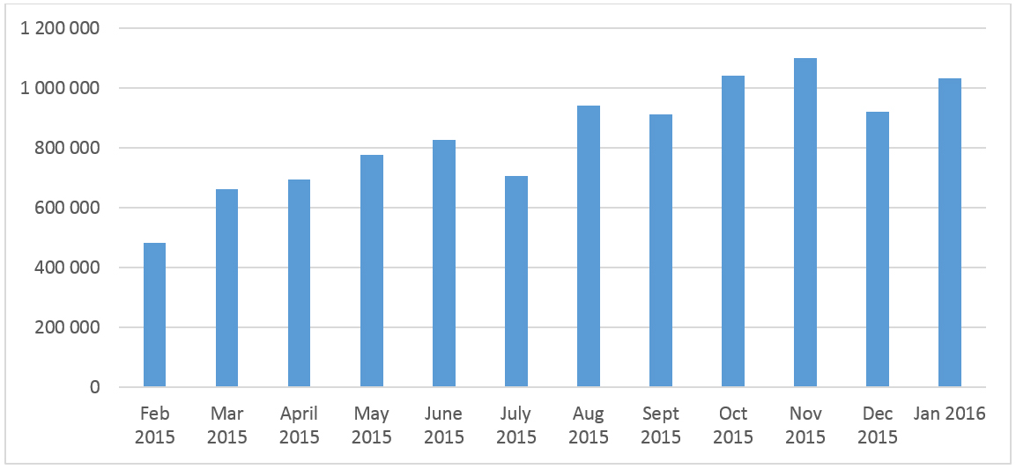
Figure 4.5 Number of visits to helsenorge.no: February 2015 to January 2016.
Source: helsenorgebeta.net

Electronic prescription service
E-resept, the electronic prescription service, is now almost fully digitised. E-resept is both an important service for individuals and a coordinated service between actors handling prescriptions and drug information. E-resept is widely used by general practitioners, surgical appliances suppliers and pharmacies nationwide. E-resept is now being implemented in hospitals in all the regional health authorities.

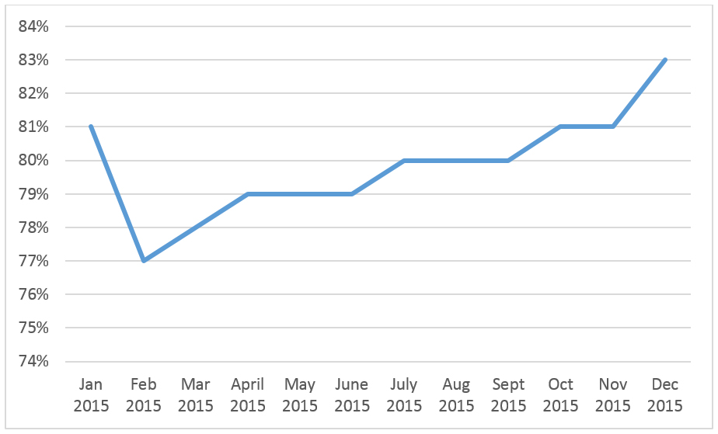
Figure 4.6 Proportion of packages sold via electronic prescriptions of the total number of prescriptions in 2015.
Source: Norwegian Pharmacy Association/FarmaPro.

Box 4.3 E-prescription in brief
Instead of a paper prescription, the physician issues an electronic prescription (E-resept). The patient can then collect the medicine from pharmacies all over the country. When redeeming her prescription, the patient states her personal identity number or name and date of birth. She must also provide proof of identity. Patients may authorise others to collect their medicine for them. E-resept contributes to a better, more secure way of handling drugs, a better overview of drug consumption, fewer fake prescriptions, easier settlement, and simpler renewal processes. The 'My Prescriptions' service in helsenorge.no provides citizens with a summary of active prescriptions, medicines dispensed during the past 30 days, and how many repeat prescriptions are left.

Brønnøysund Register Centre: Digital registry services
The percentage of electronic submissions to the Brønnøysund Register Centre has been increasing for many years, and in 2014 totalled around 80 per cent. Since March 2014 all submissions delivered digitally to the Central Coordinating Register for Legal Entities and the Register of Business Enterprises have been answered digitally in Altinn within one hour after a decision was made.
From 2015 all submissions of annual accounts to and all decisions issued by the Register of Company Accounts have been conducted electronically.

A-ordningen: One electronic message, three national agencies
A-ordningen is a digital coordinated reporting scheme that was implemented on 1 January 2015. The scheme covers reporting information concerning employment and income to the Norwegian Tax Administration, the Norwegian Labour and Welfare Administration and Statistics Norway. Five forms, some containing the same information, have been turned into one monthly report called A-melding. Previously, some of the information employers submitted to these agencies was the same, though at different times depending on requirements stated on the individual forms. Now, reporting is conducted either from payroll systems or by registering in Altinn and then transmitted via one common channel to the Norwegian Tax Administration's receiving system. Paper forms can only be used in exceptional cases. Information is then forwarded to the agency concerned, based on the agency's authorisation to receive it.

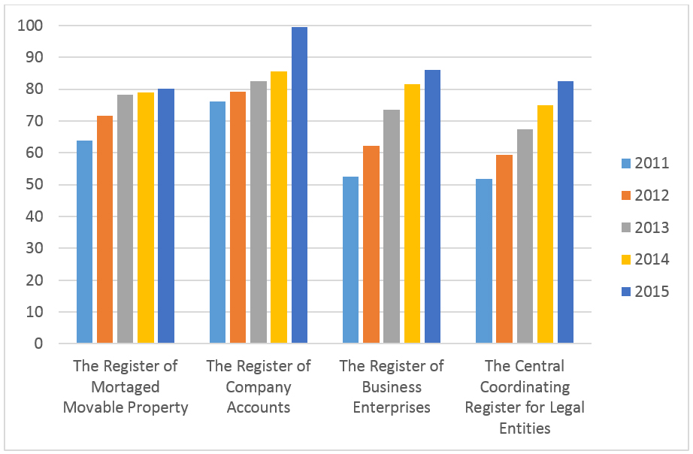
Figure 4.7 Proportion of electronic registrations in the Brønnøysund Register Centre, 2011–2015.
Source: Prop. 1 S (2015–2016). NFD.

The A-ordningen scheme has meant that reporting to the agencies is now largely conducted electronically, and has made reporting simpler and cheaper for employers and others with reporting obligations. The scheme is based on a common set of regulations with common terms for all three agencies: the Act concerning Employer Reporting of Employment and Income Information, etc.

New public digital services
The above discussion and figures show how the development of some central services and common solutions. Extensive work on digitisation is going on in public administration. Annex 1 contains a list of new digital services for citizens, the voluntary sector and business and industry. The list includes services that were launched after 1 January 2013.

International comparisons
Norway generally scores high in international rankings of ICT development. Nonetheless, the rapid pace of development means that we must constantly improve to keep up with the best and to take even more advantage of the potential digitisation offers for increasing productivity.

EU
EU's Digital Economy and Society Index (DESI) is an index that measures European countries digital development level. The index consists of indicators along five dimensions (Figure 4.8):
- Connectivity
- Human capital
- Use of internet
- Integration of digital technology
- Digital public services
Based on the results of these indicators, countries are divided into four groups (Figure 4.9): falling behind; catching up; lagging ahead; and running ahead. Norway is in the group 'running ahead' along with the Netherlands, Estonia, Germany, Malta, Austria and Portugal. The countries in this group scored above the EU average and have developed faster than the EU average over the past year. Norway scores well above the EU average on all five dimensions. Norway also scores above the average score for the countries in the group 'running ahead' on all dimensions. Compared with the 28 EU countries, Norway ranks number 2 overall after Denmark. On the indicator for growth last year, Norway ranked number 3 after Portugal and Hungary.

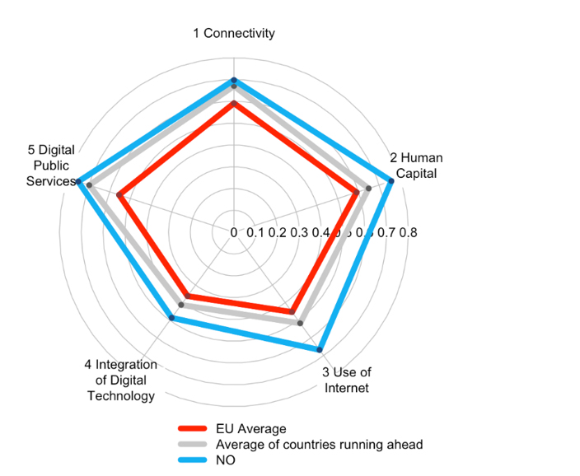
Figure 4.8 Norway’s ranking along the five dimensions in the DESI index for 2016.
Source: European Commission. 2016.

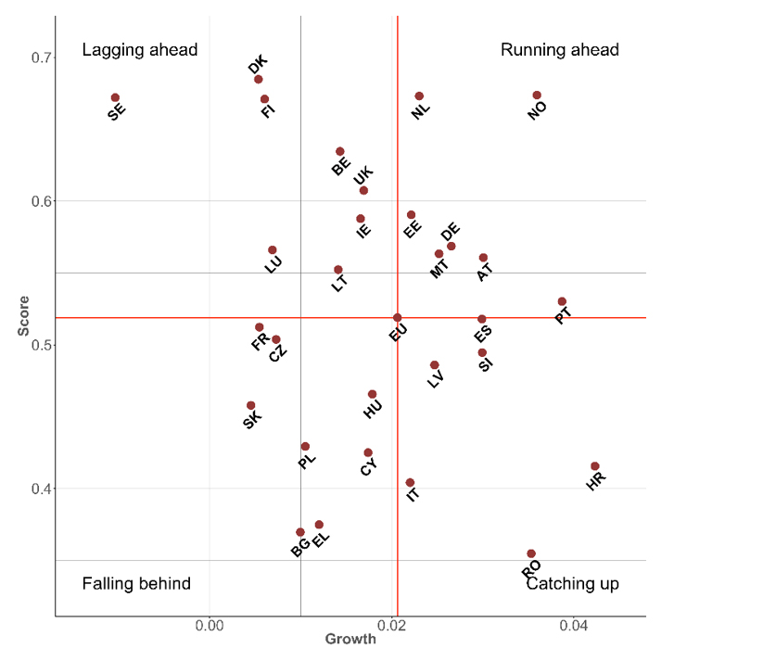

Figure 4.9 Norway’s ranking in the DESI index for 2016, given overall score and growth rate.
Source: European Commission. 2016.

The EU's Digital Agenda Scoreboard shows that 88.7 per cent of Norway's citizens (aged between 16 and 74) were frequent internet users in 2015, while the EU average was 67.4 per cent. A total of 81.3 per cent of Norway's citizens interacted with public authorities over the past 12 months, while the EU average was 46.2 per cent of Norway. Furthermore the EU's figures show that in 2015 only 1.46 per cent of Norway's population (aged between 16 and 74) had never used the internet. By comparison, 16.4 per cent of the EU population had never used the internet during the same period.
In the European Commission's eGovernment Benchmark Report for 2015, Norway was ranked in the group for technologically mature countries, along with Denmark, Finland, Iceland, the Netherlands and Sweden.

UN rankings
The UN also conducts international comparisons and countries The United Nations e-Government Survey compares the e-government development status of the 193 United Nations member states.
In 2014 Norway ranked number 13 overall. This represents a decline in the ranking from 2012, when Norway ranked number 8. Norway scores high on digital skills and digital infrastructure in 2014, while the score for digital services was lower. From ranking highest on digital services in 2008, Norway fell to 18th place in 2014. It is for the more advanced services that Norway's public administration scores relatively low.
As shown in Figure 4.10, total operating expenditure allocated in the national budget has risen significantly since 2007. The public sector also invests several billion (NOK) in ICT every year. See also the discussion of expenditure on ICT procurements in the public sector in chapter 12.

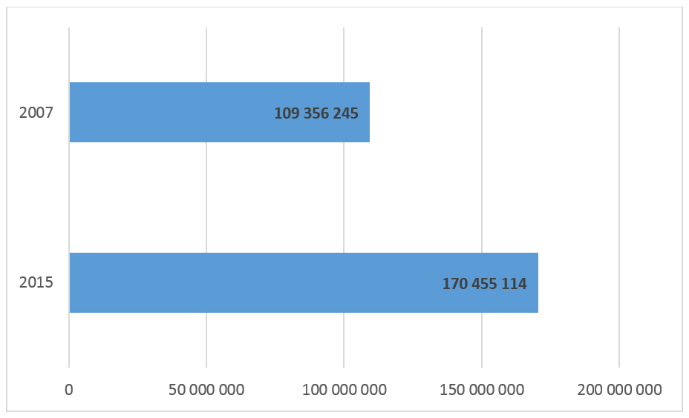

Figure 4.10 Operating expenditure in the national budget for 2007 and 2015, in NOK.
Source: Norwegian Government Agency for Financial Management, adapted by the Ministry of Local Government and Modernisation.

The Productivity Commission (NOU 2016: 3) finds that a strong motivation for many of the countries showing progress is that the financial crisis in 2008 necessitated measures to limit public spending. They have invested in digitisation to help rationalise public services and reduce expenditure in the public sector. Norway's public sector has not had the same motivation. This may offer significant potential which Norway must exploit as it, too, now faces a tighter economic climate.

The white paper in brief

Part I Background: Development, trends and international comparisons
Part I describes the Government's key objectives and priorities in its ICT policy. It also discusses key development trends and presents international comparisons.
The Government holds high ambitions for modernising, simplifying and improving the public sector, while citizens and business and industry are expecting solutions that will simplify everyday life. By using ICT and taking full advantage of the opportunities that digitisation offers, we can achieve both these goals.
The priorities stated in the national ICT policy are affected by international trends. ICT policy therefore constitutes an important area for international cooperation.
Many studies have examined the significance of ICT for economic value creation. Although historically it has been difficult to quantify ICT's contribution to productivity growth, the conclusion is that ICT has made, and continues to make, significant contributions to increased productivity and economic growth.
In its first report, the Productivity Commission emphasised that expanded and improved use of technology would be decisive for increasing productivity in both the public sector and industry (NOU 2015: 1). While the Productivity Commission acknowledges that the oil sector will continue to be important in the Norwegian economy, over time Norway will have to make the transition to a more knowledge-based economy. Such restructuring will necessitate ICT playing a key role.
Norway is a digitally mature market. A substantial proportion of the population has access to internet, and a large proportion of these use the internet on a daily basis. Several service industries, such as banking, finance and tourism, have come a long way in digitising their business processes and have achieved huge efficiency gains as a result. Norway has also succeeded in many areas in its efforts to digitise public services. Government agencies and municipalities increasingly offer digital services, and the use of these services is growing dramatically.
Norway generally scores high in international rankings of ICT development. Nonetheless, the rapid pace of development means that we must constantly improve in order to keep up with the best and to take even more advantage of the potential that lies in digitisation for restructuring and increasing productivity.

Part II ICT policy for a user-centric and efficient public administration
Digitisation can generate significant productivity gains, and this represents a significant improvement potential that must be exploited. Part II of the white paper discusses how the Government will enable the public sector to realise these gains through a stronger, more strategic initiative. Through this white paper the Government is launching an accelerated pace of digitisation and higher ambitions. The Government is putting user needs at the forefront. Services shall be perceived as integrated and cohesive.
Public agencies have different starting points for digitisation. Many sectors have come a long way in their digitisation efforts, but generally much remains to be done. In this white paper the Government declares its intention to strengthen the digital-by-default strategy and continue the efforts towards digital self-service and what is often referred to as automated case processing. This entails, for example, that decisions can be made and services provided without inhabitants having to apply for them. The Government wants systematic work to be done to this end. The sectors must identify how the digital-by-default strategy can best be executed in their respective areas and prepare specific plans for doing so.
Improved digital services are contingent on the public administration's strengthening its efforts in the area of information management. It could also generate considerable economic gains. Instead of having to repeatedly ask users for information they have already provided to public administration, such information would only need to be provided once. To make this work in practice, public administration must have a better overview of the information it has, and this white paper launches several initiatives to facilitate this.
This work also requires public administration to reuse information or solutions that meet the needs of multiple agencies. The white paper affirms that central and local government and the respective sectors should use common systems for creating user-friendly and seamless digital services. The white paper also presents strategic principles that should underpin this work. Facilitating interoperability with solutions in other countries is also important. This can be achieved through Norway's participating in the EU programme CEF Digital, which supports the establishment of a common European digital infrastructure.
Most public-sector services are municipal. The white paper therefore expects government agencies to take more responsibility for developing services that can also be used by the municipal sector. Difi and the Norwegian Association of Local and Regional Authorities will play a key role in facilitating this. The white paper also sets out national priorities and a road map for promoting digital solutions in the health and care sector.
The white paper describes its strategic approach to the governance and coordination of digitisation activities. The Government wants each sector to continue to have responsibility for its own strategy development using digitisation as a tool. At the same time, Difi will be strengthened as a coordinating body in the public sector, in cooperation with other key actors such as the Norwegian Association of Local and Regional Authorities and The Brønnøysund Register Centre.
The Government sees a need for national measures to achieve increased digitisation of tasks that need to be performed across public administration, and launches a number of initiatives in the white paper to support this. In many areas government agencies will have greater collective expertise and more resources than, for example, an individual municipality. Government agencies are therefore better equipped to drive and coordinate the work on developing good digital services across different administrative levels.
A conservative estimate of ICT procurements in the public sector in 2014 is put at NOK 16.6 billion. It is important to secure the best possible returns on these investments. Creating more professionalised digitisation projects in the public sector is a key element to this end. Such professionalisation will also help stimulate innovation within industry.
To help government agencies succeed with their digitisation projects, the Government has in 2016 established the Digitisation Council. It will provide quality assurance in all phases of digitisation projects and help ensure that fewer projects overrun their budgets. A new co-financing scheme for government digitisation projects has also been established in 2016. This is an incentive initiative to speed up the pace of digitisation and realise actual benefits.

Part III ICT policy for value creation and inclusion
Part III describes how the digital economy can contribute to growth and employment. The Government will make it possible for Norway to exploit the opportunities for value creation and innovation which ICT usage offers by adapting regulations, creating favourable framework conditions and removing obstacles.
The challenges linked to the internet are universal, and international cooperation is imperative for ICT policy to succeed. The EU has established an efficient market for physical goods and services in which Norway participates. However, several obstacles remain to the free flow of digital services across national borders, a situation which the EU is addressing by developing a strategy for the digital single market (Digital Single Market strategy). The EU's strategy for a digital single market constitutes an important basis for this white paper.
The Government emphasise the importance of digitisation and digital technology for the general development of society, on its ability to innovate, and on ensuring that future opportunities for increased productivity and economic growth be exploited to support the restructuring process which the Norwegian economy must undergo at the end of the oil age. The Government will therefore make it easier for us to exploit and understand data-driven innovation and technology so that we can reap the benefits and manage the challenges. Examples are the growth of the sharing economy, re-use of public sector information, use of big data and development of smart cities.
To respond to these developments, the government must keep up with the rapid pace of innovation and facilitate growth of new innovative products and services. This applies not least to the sharing economy, where the Government is concerned about findingand finding the right balance between taking account of important societal values and opening the door to innovation. In this connection it is important to be cautious about imposing regulations and obligations on new sharing services that may limit their potential for innovation and economic growth.
Although the level of ICT usage in the Norwegian population is high, many individuals for various reasons are unable to participate in the digital development. One of the key priorities in the ICT policy is increased digital competence and inclusion. From primary education up through all life phases, digital competence shall be improved to ensure inclusion to and confidence in digital solutions. The universal design of ICT is based on the idea that digital services should be accessible to everyone, regardless of age, functional ability or level of education, and is a key element of the Government's ICT policy.
To avoid a digital divide in the population, the Government believes that all municipalities should provide a guidance service to inhabitants who need help with digital inclusion. This could be incorporated into guidance services offered by public libraries, municipal services offices or by municipal specialist units. The white paper affirms the Government's plan to enter into a cooperation agreement with the Norwegian Association of Local and Regional Authorities on such a concept. The concept will be developed in cooperation with the Norwegian Association of Local and Regional Authorities and relevant government agencies that administer multiple citizen-centric services. The health and care sector faces major challenges in the coming years. The white paper affirms the Government's intention to facilitate expanded use of welfare technology and mobile health technology to enhance users' coping abilities in everyday life and to make better use of health and care service resources.
Digitisation has had major economic and structural consequences for the media industry. Technology development also creates new challenges in, for example, copyright law and regulation of the media, areas where the Government is engaged in ongoing processes.
ICT competence and ICT research constitute fundamental preconditions for the digitisation of Norway. Compulsory education must therefore be prepared to provide training in effectively using ICT and in the creative potential of ICT. High-quality ICT research helps ensure Norway's competence in and access to new ideas in Norwegian industry and public administration and thereby creates favourable conditions both for new business start-ups and for increased industrial productivity.
Digital development challenges established principles of data protection. On the other hand, new technology also offers opportunities to strengthen data protection. Personal data are registered and stored in increasingly larger volumes, making them more easily accessible and easier to combine with other data. Sound data protection is one of the key priorities in the Government's ICT policy. Data privacy protection shall be an integrated part of ICT development and use. The Government will ensure that citizens have, as far as possible, control over their own data. Processing of personal data shall be based on sound proportionality considerations according to purpose.
Most critical infrastructure and functions today are digitised. This situation creates new vulnerabilities. Digitisation has made different areas of society mutually dependent, making the situation more complex. A fundamental condition therefore is that digital systems be secure and reliable and that agencies and private individuals must be confident that the systems and networks work as they should. Information security shall be maintained using a risk-based approach based on updated threat and vulnerability assessments, and shall be monitored by a sound system of internal controls.

Part IV National plan for electronic communication: Electronic communication for increased productivity and a simpler everyday life
The Storting has asked the Government to produce a national electronic communications plan. The Storting's request presents a timely opportunity for the Government to present important elements of the electronic communications policy. The plan therefore discusses more topics than those requested by the Storting.
The Government presents a national plan for electronic communications that will create favourable conditions for competition and innovation and that will also ensure that people throughout the country receive secure and high-quality services. The electronic communications policy must be flexible to tackle rapid changes. At the same time we must ensure secure electronic communication services for all users and stable market conditions for electronic communication service providers who annually invest heavily in faster mobile and broadband networks throughout the country.
High-quality electronic communications promotes increased productivity and a simpler everyday life. Recent years have seen dramatic changes in the way electronic communication services are produced and, not least, in how people use the services. Fixed-line telephones are rapidly being replaced by mobile phones and social media. New net-based services are challenging both service providers and the electronic communications authority. The Government wants to see the establishment of regulatory principles such as minimum regulation, technology neutrality and predictable framework conditions. Simultaneously, regulation should allow for the major changes the industry is currently experiencing.
The Government will work to ensure that the internet continues to be open and non-discriminatory for all types of communication and content distribution.
The service obligation for telephony services has been a core element of electronic communications policy for many years to ensure that all households and businesses throughout the country receive a minimum level of electronic communication services. Telenor has been obligated to provide services such as telephony, digital lines, public pay phones, telephone directories, and services for the disabled and other end users with special needs. Several of the services under this obligation are no longer in demand or have been replaced by new services. The Government is in favour of removing the service obligation for public pay phones, electronic telephone directories and the directory enquiries service. The possibility of introducing better and more effective schemes than those provided today for groups with different disabilities will also be considered. The plan also discusses whether the service obligation for traditional telephony could gradually be replaced by broadband access.
The broadband policy is important for the Government in order to achieve the objectives that have been set in several other areas of society. Access to and use of broadband in both the private and corporate market continues to grow. The Government will facilitate the continued rollout of mobile and fixed broadband services. Mobile broadband and use of electronic communication services on public transport will become an increasingly important element of broadband policy, and mobile broadband providers are currently rolling out better coverage along roads and rail lines.
Electronic communication service providers carry assets of great value to others. Electronic communication networks and services must be highly secure and robust against outages and attacks. Norway's electronic communication networks are now more secure and more stable than ever before. At the same time, society's ever increasing demand for electronic communication networks and services make security and emergency preparedness important aspects of the work of the electronic communication authority. Changes in electronic communication networks and threats against communications must be followed by changes in the way we maintain security in our electronic communication systems. Moreover, sound protection of privacy in electronic communication is vital for public confidence in electronic communication services.
Radio-frequencies is a decisive input factor for providers of mobile electronic communication services and for other critical infrastructure. Moreover, access to frequency resources is important for many different user groups, such as the cultural sector, non-profit organisations, industry, building and construction, and research. The Government will facilitate effective use of frequencies that improve the coverage of mobile services.
Governance and administration of internet infrastructure will become increasingly important in line with the growing importance of the internet for communication and commerce. The Government will work internationally to promote sound administrative principles such as openness, accountability, transparency, representation and competence in the organisations that control fundamental parts of the internet.
An increasing volume of traffic on the electronic communication networks is transmitted via automated services. A wide range of gadgets and systems that communicate with each other is already available. Sensors talk to alarm systems and heart rate monitors which in turn notify mobile phone users about the status of their home or physical health. This phenomenon is known as 'the internet of things', and is an area in rapid growth. Norway is a highly digitised country, and people are eager to try out new solutions. The Government will facilitate healthy development of the internet of things in Norway.
The Government has set the following goals for future electronic communication policy: Mobile and broadband for growth and inclusion.
- 90 per cent of all households shall have access to at least 100 Mbit/s by 2020, based on commercial rollout in the market.
- The long-term goal is that all households shall have access to high-speed broadband.
- Mobile coverage where people live, work and travel.
- Good electronic communication networks shall be a competitive advantage for business and industry nationwide.
- The electronic communication authority shall map demand for and access to infrastructure that can be used by data centres.
- It shall be easy to deploy broadband networks.
- The regulations for laying broadband cables along municipal and county roads shall be as uniform as possible.
- Electronic communication service providers shall have fast access to available frequency resources to meet their needs.
Freedom of choice for internet users
- Users of electronic communication shall have internet access to content and applications of their choice.
- Norway shall work internationally to keep the internet open and non-discriminatory.
Secure and robust electronic communication networks
- Electronic communication networks and services shall be adequately protected against extreme weather conditions and failures.
- Electronic communication networks and services shall be adequately protected against physical and logical attacks.
- Communicating via electronic communication networks shall be safe.
- Electronic communication networks shall be capable of providing future services for the emergency services.
- The electronic communication authority shall advise public administration on procurements of electronic communication services for critical functions.
Regulation to promote innovation and sustainable competition
- There shall be at least three competing mobile networks.
- Users of electronic communication shall be given fast access to new services and technologies.
- It shall be profitable to invest in electronic communications.
- It shall be easy to be a customer of electronic communication services.

Key measures presented in the white paper

Part II ICT policy for a user-centric and efficient public administration
Chapter 6.2
- The Government wants genuine user participation to ensure that users' views and needs are addressed in the development of digital services.
- The Government will encourage new attempts using service design to create more good, user-centric services.
- The Government will move the work on the digital-by-default strategy forward by mapping how digital by default can best be accomplished within sectors and across sectors and administrative levels.

Chapter 7.4.2
- Each agency shall have an overview of what data it handles, what the data signify, what they can be used for, what processes they are part of, and who can use them.
- Agencies shall particularly consider the exchange of information in specific areas where this is not already implemented or where processes can be improved.
- The Government will begin work on establishing a common framework for integrated information management and pilot projects for a common data directory.

Chapter 8.3.3
- The Government emphasises that each sector is responsible for using common solutions and for complying with common frameworks and requirements.
- The Government points out that each agency and sector has a clear responsibility to assure the interest of the public sector as a whole when implementing new technical solutions.
- Agencies shall endeavour to find solutions together wherever successful digitisation is contingent on close cooperation.
- The Government wants stronger governance and coordination where tasks need to be performed by multiple agencies or across administrative levels or sectors.
- All ministerial units shall complete the competence development scheme Strategic ICT for Managers by spring 2017.

Chapter 9.3.2
- Government agencies shall take more responsibility for developing integrated digital solutions which can also be used by the municipal sector in the cases of tasks that are resolved across central government and the local government sector.
- Difi shall prepare an overview of planned and ongoing digitisation measures in the public sector that affect the municipal sector, including an overview of potential benefits in the measures and plans for realising them.
- Each public agency shall collaborate with Difi and the Norwegian Association of Local and Regional Authorities on digitisation matters.
- The Government will prepare a general overview of important orders and recommendations concerning digitisation in the municipal sector.

Chapter 10.4.6
- The Government will work towards increasing the use of common ICT solutions across actors and levels in the health and care sector. Governance and financing models that can support this development shall be tested.
- The Government will regularly consider whether current legal bases sufficiently support achieving the goals of integrated ICT functionality.

Chapter 11.4.2
- The Government will facilitate the use of national common components by the entire public sector, meaning government and municipal agencies and others who perform public administrative tasks.
- Common component administrators and service owners shall observe the strategic principles for using and developing national common components.
- Modernisation of the National Population Register.
- The Government will use electronic identification solutions from the market wherever the market can offer satisfactory solutions and where doing so is otherwise expedient.
- The Government will issue national ID cards, possibly with electronic identification, from 2017.
- The Government will continually review the current strategy for using electronic identification in the public sector in light of current developments.

Chapter 12.6.4
- The Government will reduce the size of individual digitisation projects in terms of both budget and duration in order to reduce complexity and risk.
- The Government will set requirements for public agencies regarding the use of project models, based on good practice.
- The Government will use the Digitisation Council to contribute to quality assuring public-sector digitisation projects.
- The Government will support more profitable ICT projects through the co-financing scheme.
- The Government will set requirements for all agencies to have a sourcing strategy of relevant scope.
- The Government will continue the supplier development programme and ensure that public-sector digitisation projects generate more innovation.
- The Government will present a national strategy for using cloud services.

Part III ICT policy for value creation and inclusion
Chapter 13.2
- The Government will continue to pursue an active European policy in the digital area, closely monitor ongoing processes in the EU, and actively contribute with proposals and opinions that align with Norwegian interests.

Chapter 14.4
- The Government will initiate studies to map the sharing economy from a Norwegian perspective, including current initiatives and the economic and value-adding potential.
- The Government will support the work, and consider following up the recommendations, of the committee appointed to assess the challenges and opportunities presented by the sharing economy.
- The Government will make certain amendments to the Freedom of Information Act's provisions concerning reuse of public-sector information. These amendments will make it easier to make public-sector data accessible, with a view to making more datasets accessible and increasing reuse.
- The Government will prepare strategies and action plans for increasing the accessibility of data pertaining to culture, geodata, and public expenditure by the end of 2016.
- A strategy for making transport-sector data accessible shall be included in the new National Transport Plan due to be presented to the Storting in 2017.
- The Government will prepare a strategy or action plan for making research data more accessible by the end of 2017.
- The Government will follow up requirements for machine-readable formats by revising Guidelines for making public data accessible.
- The Government will monitor technology developments in big data and consider the need for a strategy for using big data in the public sector.
- The Government will strengthen participation by Norwegian public agencies in relevant EU research projects.
- The Government will return to the use of ITS in connection with the white paper on the National Transport Plan 2018–2029 due to be presented to the Storting in spring 2017.
- The Government will assess the need for facilitating smart city development in Norway.

Chapter 15.4
- The Government will enter into an agreement with the Norwegian Association of Local and Regional Authorities to establish a guidance service for citizens who need help using municipal digital services. Government agencies providing services to the public will be invited to cooperate.
- The Government will ensure that the public libraries play a key role in the work on providing the population with a better guidance service in basic digital competence.
- The Government will facilitate increased use of welfare technology and mobile health technology to strengthen users' coping ability in everyday life and to better utilise health and care service resources.
- The Government will strengthen innovation and business development inside welfare technology through the use of open standards and wider use of innovative procurements.
- The Government will follow up the Government's action plan for universal design for 2015–2019.
- The Government will consider expanding the scope of application of regulations concerning universal design of ICT in the school and education sector.

Chapter 16.4
- The Government will launch a proposal to revise the Copyright Act.
- The Government will launch a proposal for a new financing model for NRK by the end of 2016.

Chapter 17.2
- The Government will facilitate innovation and value creation by ensuring that industrial policy instruments are also available to ICT companies.
- The Government will prepare a white paper on framework conditions for the industry that will also discuss automation and digitisation.

Chapter 18.5.3
- The Government will initiate a pilot project on ICT programming as an optional subject at lower secondary level to provide a basis for considering whether the subject should be introduced on the same level as other optional subjects.
- The Government will consider creating more study places in ICT in the annual budgeting processes.
- The Government will encourage the industry and public actors to enter into dialogue with educational institutions regarding the structure of basic education programmes, the content of education programmes, and the development of relevant continuing education and training programmes.
- The Government will consider a further increase in ICT-related positions in connection with the Long-term Plan for Research and Higher Education and encourage industry to use the industrial Ph.D. scheme to enhance its advanced ICT competence and innovative ability.
- The Government will consider reinforcing its commitment to enabling technologies within the time frame of the long-term plan.
- The Government will present a white paper to the Storting on school content. Digital skills and use of digital tools in school education will be more closely considered in connection with this white paper.
- The Government will present a white paper to the Storting in 2017 on quality in higher education, in which the application of ICT in higher education will be discussed.

Chapter 19.3.5
- The Government will actively ensure sound data protection through its ICT policy.
- IT systems in public administration shall safeguard the principles for built-in data protection, including standard privacy-friendly settings.
- The Government will strengthen data protection for consumers using digital services.
- The Government will ensure a good balance between safeguarding data protection and facilitating research so that citizens have, as far as possible, control over their own data.
- The Government will implement the EU's new data protection regulations, make proposals for new national regulations, and assess the need for action other than regulatory measures that can strengthen data protection and help resolve relevant data protection challenges. In this connection, data protection considerations must be weighed against important societal interests.

Chapter 20.8
In line with following up the national strategy for information security, the Government will:
- Strengthen coordination of the ICT security regulations nationally and across sectors.
- Provide for a secure and robust ICT infrastructure.
- Follow up the work on strengthening information security in public administration.
- Establish sectoral response environments.
- Execute national cybersecurity exercises.
- Promote greater openness about cyber incidents.
- Strengthen preparedness and efforts to prevent cybercrime.
- Make continuous efforts to raise awareness and competence.
- Contribute to ensuring high quality in national research and development in the field of cybersecurity.
- Contribute to greater public-private cooperation on cybersecurity.
- Increase Norway's participation in international cybersecurity arenas.

Part IV National plan for electronic communication: Electronic communication for increased productivity and a simpler everyday life

Chapter 25.3
- Sector-specific competition rules shall accommodate at least three competitive mobile networks.
- Regulation shall be based on the principles of technology neutrality and minimum regulation.
- There shall be a good balance between flexibility in regulation and the predictability providers need for making investments.
- The Government will establish a broadband forum for electronic communication service providers with a view to facilitating sound agreements on access and modernisation of existing access networks. The broadband forum shall contribute to reducing unnecessary conflicts and improving competition in the market. The forum will be headed by the Norwegian Communications Authority.
- The electronic communications authority shall offer constructive input to the ongoing work on revising the pan-European framework for electronic communications in order to develop a future-oriented and flexible framework that can adapt to changing market conditions.

Chapter 26
- The Government will incorporate the pan-European rules on net neutrality into Norwegian law.
- The electronic communications authority shall continue to pursue active dialogue on net neutrality with the electronic communications industry, consumers, content providers and other stakeholders.
- The electronic communications authority shall contribute to developing European guidelines for enforcing regulations and needs for national adaptations.
- The electronic communications authority shall actively promote Norwegian interests in different forums where methods of regulating net neutrality are discussed.

Chapter 27.2
- The established subsidy scheme for broadband rollout shall continue to be directed at broadband rollout in areas where new commercial rollout in the coming years cannot reasonably be expected. One goal for this scheme is to help households and enterprises without a commercial broadband service with a minimum download speed of 4 Mbit/s and upload speed of 1 Mbit/s to receive a broadband service from at least one service provider. Such services should not be based on satellite services.
- The Government may consider other measures to ensure a permanent broadband service to everyone if this goal is not achieved through commercial rollout and with the help from the established subsidy scheme.
- The Government will consider maintaining the service obligation for telephone services and dial-up internet access for citizens who do not already receive a broadband service and/or telephone service.
- The Government will consider the possibility of implementing better, more effective schemes than those currently available for groups with different types of disabilities.

Chapter 28
- The Government will facilitate healthy, sustainable competition in the broadband market through effective market regulation.
- The Government will maintain the scheme for government funding of broadband rollout. The funding will primarily be directed at areas with no broadband service and at areas that have a broadband service but where the service will not meet future needs. The funding shall only be used where no basis exists for further commercial rollout. The scheme shall be administered by the Norwegian Communications Authority.
- To further facilitate rollout in areas not normally commercially attractive and to reduce rollout costs, the Government will:
- Contribute to increasing the reuse of existing infrastructure and to coordinating construction work between different infrastructure owners.
- Contribute to rendering accessible information on the location of existing infrastructure and on planned construction work.
- Ensure that public buildings and property are placed at the disposal of service providers on reasonable terms.
- The Government will consider common regulations for laying cables along municipal and county roads with a view to establishing as uniform a practice as possible.
- The Government will, via the electronic communications authority, guide public agencies and institutions on the procurement and use of broadband, in light of the fact that public administration is a major procurer of broadband services.
- The electronic communications authority shall facilitate consumer portals for electronic communication services that include overviews of broadband coverage, relevant local service providers, and price and capacity offerings.
- The Government will continue the work on facilitating sufficient frequencies for mobile broadband.
- To ensure good indoor mobile coverage, particularly for voice connectivity, the Government will facilitate the installation and deployment of infrastructure in connection with erecting new energy-efficient buildings.
- The Government will ensure that the electronic communications authority follows work being done in other countries and engage in dialogue with market actors to reach a common understanding of how best to improve coverage indoors, in sparsely populated areas, and in other areas frequented by people.

Chapter 28.1
- The electronic communications authority shall, together with relevant ministries, facilitate sound communication solutions for the emergency services and preparedness agencies.
- The Government will work to ensure that the public electronic communications networks have the best possible capability to support future services for the emergency services and agencies.

Chapter 28.2
- The Norwegian National Rail Administration shall continue to facilitate reuse of its GSM-R infrastructure so as to support increased coverage along the rail network.
- The Norwegian National Rail Administration shall work on improving coverage in tunnels.
- The Government will facilitate best possible cooperation between the Norwegian National Rail Administration, train companies and mobile phone service providers to improve mobile phone coverage for train passengers.

Chapter 28.3
- The Government will introduce reduced taxes on electricity supplies to large data centres from 2016.
- The electronic communications authority shall map demand for and availability of infrastructure that can be made use of by large data centres.
- The Government will assess how to facilitate economically profitable laying of fibre-optic cable to other countries to strengthen the basis for establishing large data centres and other data-based industry in Norway.
- The Government will develop a strategy for the economically profitable development of large data centres in Norway.

Chapter 29.1
- The Government will further develop regulations and supervision so that information on threats, technological and market developments and society's need for electronic communication services are up to date at all times.
- The electronic communications authority shall conduct active guidance and advisory activities. The electronic communications authority shall guide service providers on the content of legal standards pertaining to security and robustness. This role shall also apply to the cyber area.
- The electronic communications authority shall serve as a driver for establishing expedient regulation at European level addressing security challenges related to outsourcing and internationalisation and including supervision, control and cross-border cooperation.

Chapter 29.2
- The electronic communications authority shall consider policy instruments that facilitate establishment of nationwide, viable alternatives for network services to strengthen the national electronic communications structure.
- The electronic communications authority shall investigate how the different nationwide networks can best be utilised to enhance robustness in the overall national electronic communications infrastructure.
- The electronic communications authority and relevant industry actors shall investigate the need and alternative solutions for establishing more communication lines between Norway and other countries.

Chapter 29.3
- The Government will work to encourage the authorities and the industry to contribute to research and development in security and preparedness in electronic communications networks and services.
- Cooperation between the security authorities and the industry shall be further developed to handle threats, including those in the cyber domain and internationalisation.

Chapter 29.4
- The electronic communications authority shall investigate whether and how public agencies ought to attach importance to relevant security and preparedness when procuring electronic communication services.
- The electronic communications authority shall prepare guidance on security requirements in connection with procuring electronic communication services.
- The electronic communications authority shall work actively to see that old technology is phased out when new, more secure technology is available.

Chapter 29.5
- The work on nettvett.no shall be continued through development of cooperation between the Norwegian Communications Authority, the Norwegian National Security Authority, the Norwegian Centre for Information Security and possibly other public and private actors.

Chapter 30.1
Better mobile coverage:
- Begin using the 700 MHz band for mobile services.
- The Government will work actively to ensure area coverage for mobile broadband in areas which electronic communication service providers do not consider commercially attractive to roll out infrastructure by, among other things, facilitating cooperation over rollout or by sharing network components or frequency resources.
- To help improve coverage in areas not commercially attractive to roll out, including improving area coverage, the Government may, in line with normal practice, consider using coverage requirements in each individual case when allocating frequency resources with good coverage properties.

Chapter 31.1
- The Government will facilitate public-private cooperation in priority areas of the internet policy and national dialogue between the authorities and industry.
- The Government will continue to promote freedom of information and basic human rights online.
- Norway shall, in cooperation with other European countries, continue to support an open and freely accessible internet (freedom of expression clause).
- The electronic communications authority shall be represented and actively participate in the debate on development of the internet in the international arena.
- The electronic communications authority shall, in the work done internationally, emphasise the important of improving the multi-stakeholder model, as well as good administrative principles such as openness, accountability, transparency, representation and competence in the organisations controlling basic internet resources such as ICANN/IANA.
- Regulation of the internet in Norway should be kept to a minimum.

Chapter 31.2
- The Government will continue to work to ensure that the .no domain remain a secure and safe resource providing Norwegian industry with incentives for innovation and business development.
- The Norwegian authorities shall work towards and facilitate national dialogue between the authorities and industry to establish and entrench priorities for rolling out national services on the internet.
- The electronic communications authority shall, together with Norid, work on internet security, stability and robustness, including key infrastructure and important logical functions.
- The Norwegian authorities shall further develop and protect national interests in domain name administration and promote good global and regional administration of internet resources such as domain names and IP addresses.

Chapter 32
The electronic communications authority shall further develop and improve the quality of emergency calls in Norway, in cooperation with the relevant sectoral authorities. Potential changes to be considered in this connection are:
- Introduce requirements that improve the accuracy of the location data of the caller. The possibility to send and receive positioning data on handsets should be available.
- Strengthening of positioning based on the electronic communication network.
- Increased preparedness in the National Reference Database to ensure better accessibility to origin information.
- Strengthen accessibility by hearing-impaired or speech-impaired to make emergency calls.
- Implementation of the emergency call solution eCall in vehicles.
- Increase accessibility to emergency calls and strengthen origin information for IP-based calls (including emergency calls from OTT telephone services).

Chapter 33
Regulation of privacy in electronic communications for electronic communication services:
- Norway shall actively contribute to revising the EU directive on the protection of privacy in electronic communications and in the debate on the directive's scope of application.
- The electronic communications authority shall assess whether there is a need for national requirements for protection of privacy in electronic communications within the framework of the EEA Agreement.
Privacy protection in electronic communications as a competitive advantage:
- The electronic communications authority shall work towards making strong protection of privacy in electronic communications a competitive advantage for Norway when decisions are being made on the location of international service production, data centres and other data-based industry.
The relationship between crime fighting, intelligence and privacy in electronic communications:
- The effectiveness of and genuine need for measures that encroach on privacy in electronic communications must be documented with respect to crime fighting and intelligence.
- The electronic communications authority shall regularly review the overall level of encroachment on privacy in electronic communications.
Information to users:
- The electronic communications authority shall monitor the quality of the information provided by the industry to users regarding what personal data are processed and how the data will be used.
- The electronic communications networks shall strengthen users' freedom to make informed choices concerning privacy in electronic communications in electronic communications networks and services.

Chapter 34
- The electronic communications authority shall assist the industry in adopting common standards to ensure interconnection and operability between different products and types of equipment, and shall promote Norwegian interests in international standardisation bodies.
- The electronic communications authority shall, in cooperation with the industry, speed up the transition from IPv4 to IPv6.
- The Government will review the body of rules pertaining to electronic communications with a view to removing any obstacles impeding development of the internet of things.
- The Government will facilitate well-functioning communications architecture and infrastructure, which are decisive for development of a smart society in all relevant sectors. The electronic communications authority will take the initiative to increase collaboration across sectors (energy, finance, health, transport and electronic communications).
- The Government will facilitate information and guidance for both users and producers of smart solutions regarding relevant requirements for equipment, radiation, security and data protection.

Planet of the phones. The Economist. 28. February 2015.
Ericsson Mobility Report. Ericsson. November 2014.
The Productivity Commission was appointed by the Government in 2014 to investigate the causes of weaker productivity growth, and to promote concrete proposals that can strengthen productivity and growth potential in the Norwegian economy.
ICT's contribution to value creation in Norwegian industry and the public's role as facilitator for growth towards 2020. Menon publication nr. 26/2015.
ICT and productivity – the importance of ICT for growth in productivity. Ny Analyse AS. 2015.
Unlocking the ICT Growth Potential in Europe: Enabeling People and Businesses. The Conference Board for the European Commission. Van Welsum, D. et al. 2013.
ICT's contribution to value creation in Norwegian industry and the public's role as facilitator for growth towards 2020. Menon publication nr. 26/2015.
Prop. 1 S Tillegg 1 (2015-2016). Norwegian Ministry of Finance.
Meld. ST. 23 (2012-2013). Norwegian Ministry of Government Administration and Reform.
Survey on ICT usage in households and by individuals. Eurostat. 2014.
TNS Gallup's survey on consumers and media 2011 and Q4 2015.
Norwegian media benchmark. Statistics Norway. 2014.
ICT usage in industry and businesses. Statistics Norway. 2015.
Number of logins through the eID Gatway.
Financing SMEs and Entrepreneurs. OECD scoreboard. 2015.
The Summary Care Records collects the most critical health data and make them available to health personell when needed, as well as the patients them self.
The Act concerning Employer Reporting of Employment and Income Information (LOV 2012-06-22-43)
eGovernment Benchmark Report. The European Commission. 2015.
United Nations E-Government Survey 2014: E-Government for the Future We Want. UNPAC. 2014
The following countries were ranked higher than Norway: Spain, Canada, Finland, New Zealand, UK, USA, Japan, Holland, France, Singapore, Austrailia and South Korea.
Norwegian Government Agency for Financial Management, data adapted by the Ministry of Local Government and Modernisation. Internal ICT costs, such as sallaries to employees, are excluded.

