Norwegian data centres
– sustainable, digital powerhouses

Preface
As Minister of Regional Development and Digitalisation I am a strong supporter of facilitating industrial development in all parts of the country. We want to lay the foundation for creating more jobs for the labour market of the future. Data centres are one of several key elements of the digital economy. Much of the data processing that business and industry need for value creation depends on the services of data centres. Going forward, strong growth is expected in the data-driven economy, and Norway can contribute to this with sustainable solutions in Norwegian data centres – to the benefit of welfare services, aquaculture and much else besides.
In our daily lives, we also use services from cloud solutions in data centres. Virtually everything we do on our computers and smartphones is routed via a data centre, whether saving a photo, checking a blood test, playing songs or videos or writing a message. The data are processed and stored in the data centre. Most of those who are reading this strategy have probably downloaded it from a data centre.
I believe that we need to work to attract even more data centres to Norway. The advantages are manifold. Data-driven value creation, spurred by, for example, artificial intelligence and big-data analyses, could double our GDP growth by 2030, and a good digital infrastructure and secure data centres are essential for achieving this. Data centres are already providing 2400 jobs in Norway and are set to create far more in the future, not least in rural areas. To achieve this, it is crucial that we facilitate growth in this industry. Having data centres in Norway is also crucial for ensuring a robust national infrastructure that provides fast, reliable and flexible digital services throughout the country.
We have an excellent starting point in Norway, with ample and secure access to sustainable energy, a solid digital infrastructure, a highly skilled labour force and stable framework conditions. However, the competition is global and we constantly need to improve. Furthermore, it is essential to work actively to ensure local endorsement. Therefore, we are now updating the national data centre strategy – only three years after it was first launched. The pace of change in the digital economy is accelerating. I will work to ensure that the Norwegian data centre industry can create new jobs in a future-oriented and not least sustainable business sector.
Norway shall be a pioneering country in the development of a sustainable and circular economy that makes better use of its resources. There is a large potential to increase the use of waste heat from data centres in the future, and we have already seen good examples of how Norwegian data centres can support value creation in other industries. Enabling efficient use of waste heat from the data centres will help us achieve the goal of a sustainable and data-driven economy that makes use of regional competence and creates jobs for the labour market of the future.
Thanks for all of the useful input to this work!
Linda Hofstad Helleland
‘Data centres are key building blocks in the modern digital infrastructure. By strengthening the marketing of the opportunities in Norway and expanding the digital infrastructure both domestically and internationally we facilitate continued growth in the Norwegian data centre industry. This will benefit both industry and individuals all over the country through increased value creation, new jobs in rural areas and digital services for all.’
Linda Hofstad Helleland (Conservative Party)
Minister of Regional Development and Digitalisation

‘One of the Government’s priority areas in energy policy leading up to 2030 is industrial development and value creation through effective use of profitable renewable resources. Efficient power grid connections, a heat map to improve resource utilisation and requirements for waste heat analysis in data centres will increase the competitiveness of the Norwegian data centre industry. This will help realise the potential for growth that this industry represents.’
Tina Bru (Conservative Party)
Minister of Petroleum and Energy

‘We must continue our efforts to expand and further improve the already advanced digital infrastructure in Norway and strengthen our position as an attractive location for data centres. Roads and railways are both important transmission routes for digital infrastructure, and modern transport solutions depend on digital solutions. We must therefore make way for good and effective use of communication infrastructure that can help ensure further expansion of a future-oriented and secure digital infrastructure throughout Norway.’
Knut Arild Hareide (Christian Democratic Party)
Minister of Transport

‘Norway must make use of the opportunities that data represents with regards to increased value creation, more jobs all over Norway, and a public sector that supports industry. Accessible and secure digital infrastructure is required for Norway to successfully transition to a more sustainable society and a green economy.’
Iselin Nybø (Liberal Party)
Minister of Trade and Industry

‘Establishing sustainable businesses and new jobs in Norway should be easy. A well-functioning public administration and good information are crucial for us to succeed in this.’
Nikolai Astrup (Conservative Party)
Minister of Local Government and Modernisation

Introduction and summary
Worldwide, approximately 40 000 searches are made in Google every second. At the same time, three hundred hours of video are posted on YouTube every hour. Furthermore, smart sensors and processors produce more than 5 quintillion bytes of data on a daily basis.Put together, these examples point to a trend where the volume of data produced, stored, copied and consumed worldwide is growing at lightning speed. Over the last two years alone, more data has been produced than in the entire history of mankind prior to this.
A data-driven economy means increased demand for data centre services. Many key functions in society, such as health care, policing and transport, rely on services provided by data centres.
When Norwegian industry and public administration are given access to data services from a data centre, this could have a number of effects on the productivity of the enterprises through cost savings, more flexibility and use of new technology. Although such effects could also be achieved to some extent when using a data centre in another country, for example in Sweden or Denmark, they are likely to be greater when using a data centre in Norway with a closer geographical proximity.
Norway has many features that make us a very attractive country for establishing data centres, with a surplus of renewable energy, low electricity prices, good digital infrastructure, a cool climate, political and economic stability and reliable operational conditions (interruption-free, low-cost and scalable electricity supply). Norway can offer clean and green solutions, and thus contribute to a more sustainable global data economy. The Norwegian Government launched its data centre strategy in 2018, which was one of the first in the world. The objective of this strategy was to attract and develop new industries that can create jobs and boost value creation in Norway. The investment in Norwegian data centres has increased since the strategy was launched, and the data centre industry reports that the strategy has contributed to this development.
Norwegian authorities received an award for stimulating investment in data centres
Source: Datacloud Global Awards
The Government wants Norway to be an attractive investment destination for data centres and other data-based industries, and will devise measures that can help boost growth in the data centre industry in the years to come, whilst also ensuring that this development is sustainable.

The Government will:
- Strengthen the marketing of Norway as a data centre location
- Strengthen Invest in Norway, including with a view to better facilitating investment in data-based value creation and data centres in Norway.
- Continue its dialogue with Norwegian industry and leading international technology companies to obtain input on the work to facilitate investment in data-based value creation and data centres in Norway.
- increase competitiveness
- Produce a guide in English (website) with relevant information on how to establish a data centre in Norway.
- Ensure continued stable framework conditions for the data centre industry.
- Consider how processes related to the expansion and licensing of the transmission network can be streamlined. The Government has appointed a public commission to consider this and other issues.
- Continue the efforts to develop ICT competence in Norway.
- The Government will make provisions for the actors in the data centre industry to sign partnership agreements with educational institutions.
- Facilitate sustainable development
- Establish a national heat map to ensure better utilisation of waste heat.
- Help facilitate sustainable development of the data centre industry in Norway – including by introducing requirements for waste heat in data centres.
- Participate actively in the European cooperation to develop appropriate, and primarily pan-European, solutions that ensure digital security, combat crime and protect national security interests associated with data centre activities.
- Assess data centres with a view to regulate within the scope of the Electronic Communication Regulations and other appurtenant regulations to ensure digital security and protect national security interests.
- Reinforce the digital foundation
- Undertake thorough risk and vulnerability analyses in at least five new, vulnerable regions, and phase in new measures after annual reviews.
- Continue to facilitate commercial expansion of networks that connect Norway to other countries.
- Continue state grants to broadband expansion in rural areas.
- Continue to take a long-term perspective of state investment in fibre infrastructure, help ensure that more capacity is built into the system than initially needed, and ensure that provisions are made for market-based leasing of capacity on open and transparent terms.
The updated data centre strategy is part of a comprehensive government initiative aimed at digitalisation and the data-driven economy, which is reflected in separate reports to the Parliament (Stortinget) on the data-driven economy and innovation and our shared digital foundation. The revision of the data centre strategy is part of this comprehensive initiative. Through its updated data centre strategy, the Government seeks to devise further measures that can help boost growth in the data centre industry in the years ahead, while ensuring that this development is sustainable.
The Government wants to ensure that the potential for growth that the data centre industry represents is realised, and describes below some of the main efforts being undertaken in the areas that are relevant for this industry.
In this strategy we will look at the following areas in particular:
- The economic impact of the data centre industry
- Security in Norwegian data centres
- Data centres – a sustainable growth industry
- Renewable energy – grid connection
- Digital infrastructure – transmission routes
- The need for ICT skills
- Internationalisation and investment
- Framework conditions
The data centre strategy 2018
The strategy ‘Norway as a data centre nation’ was launched in February 2018 and its main goal was to make Norway an attractive location for data centres and other data-based industries.
The previous strategy included a number of provisions to promote the establishment of data centres in Norway. For example, the Government abolished the property tax on production equipment and installations under construction and in use, facilitated fibre networks linking Norway to other countries, established a pilot project for an alternative core network, introduced new rules for laying cables along public roads, and initiated efforts to make information on setting up a business accessible, including in English.
The 2018 strategy described a number of framework conditions that are important for the data centre industry in Norway, and pointed out many of the advantages that Norway offers as a data centre location, such as access to renewable, stable and competitive energy, stable frameworks and access to high-quality electronic communication with supply security.
The strategy also pointed out areas where further efforts were desirable, such as taxes and charges, broadband connectivity, land use and skills development.

What is a data centre?
A data centre is a facility that consists of servers and other components that are used to organise, process, store and transmit large amounts of data.
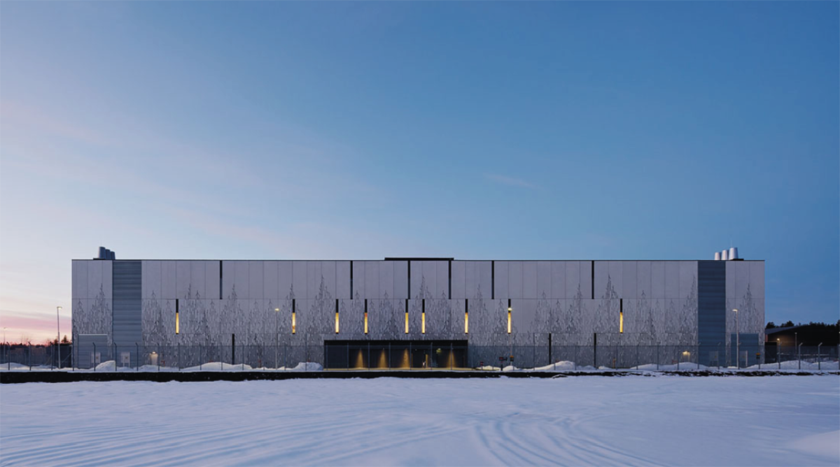
The Digiplex data centre at Fetsund in Lillestrøm municipality
Source: Digiplex
The size of a data centre can vary from a small room in a basement to huge halls covering hundreds of thousands of square metres. A data centre can be part of the internal infrastructure of a business, or it can be a core activity in the form of data centre services that are supplied to external clients. All businesses send and receive data, and the data centre is therefore a critical component for the operations of many business. Data centre services are provided according to different business models with varying service levels.
Data centres can be roughly divided into three categories: Hyperscale, Colocation and Edge.
- Hyperscale (large, dedicated data centre): These data centres tend to be owned and operated by Big Tech actors such as Facebook, Microsoft, Apple, Amazon and Google to allow them to deliver their own services, in the form of infrastructure (data storage and processing), platform services or computer software supplied as a service. These services are used by many different users, and depending on the type of service, can be marketed to businesses and/or consumers.
- Colocation (co-located data centres): These data centres are owned and operated by a data centre operator, such as Digiplex, Bulk and Green Mountain in Norway or companies such as Equinix, NTT and CenturyLink internationally. The operator sells storage space, cooling, network connections or power to a range of different customers operating their own IT systems, or else IT operations are sold as a service. Microsoft, for example, runs some of its cloud services aimed at Norwegian customers from co-located data centres in Norway.
- Edge: These are often smaller installations (typically the size of a container). Edge centres are always located close to the place where the data are being generated. Such centres tend to be owned and operated by telecom companies or large IT operators that sell data processing as a service.

Data as a resource
Today, nearly all financial transactions in Norway are made electronically via systems that rely on data centres. In the spring of 2021, 97 per cent of all payments in Norway were made electronically.
In recent years, there has been a growing demand for cloud services to meet data processing and storage needs, both in the private and public sector. This has created added flexibility and the reaping of economies of scale, as well as contributed to growth in the market for storage and data processing.
According to the IT company Cisco, the number of large hyperscale data centres has increased globally from 259 in 2015 to 597 at the end of 2020. The Gartner analytics company estimates that the use of cloud services will increase by 23 per cent in 2021 to USD 332 billion. Investment in cloud solutions is expected to rise even further, in pace with the development of cloud services.
Services critical to society need data centres
Stavanger municipality has 150 000 inhabitants, and the local authority provides a range of services that are critical to society in areas such as health, social care, education and infrastructure etc. These services rely on a number of IT systems that handle finances and wages, medication for patients, school examinations, access systems, public information and many others. In 2015, the local authority decided to wind up its own data centre in favour of a colocation with the Green Mountain data centre. This enables the local authority to focus on its core activities. With a back-up solution in a separate location and professional operation of its data centre, the local authority now has a more reliable solution for its critical systems and data.
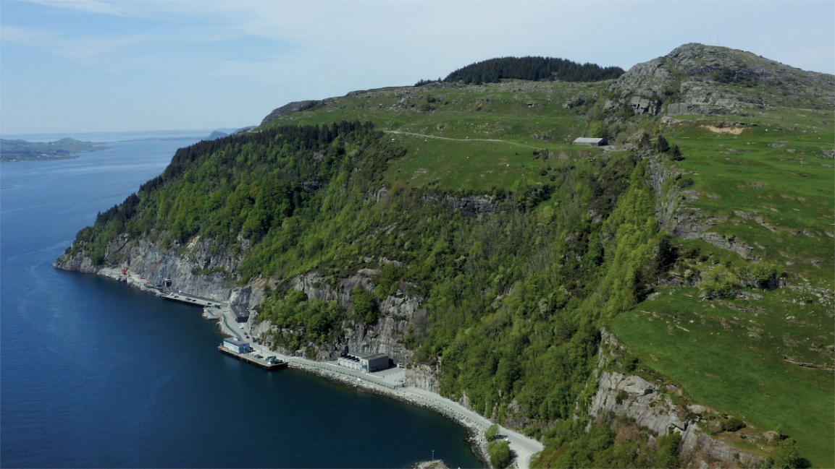
DC1-Stavanger lies deep inside a mountain that previously housed a NATO munition depot. The adjacent fjord is used as coolant.
Source: Green Mountain
Also in Norway, there is a growing demand for cloud services among businesses. According to Statistics Norway, 64 per cent of businesses with at least 10 employees used cloud services in 2020. This is an increase from 51 per cent in 2018 and 29 per cent in 2014. In businesses with at least 100 employees, 82 per cent used cloud services in 2020, an increase from 73 per cent in 2018. The general trend is for large businesses to use cloud services more frequently than smaller businesses. As of 2021, 92 per cent of all government enterprises use one or more services delivered via the cloud. The need for video conferencing solutions and virtual meeting rooms is assumed to have played an important role in this development.
The emergence of the data economy is expected to be an increasingly important driver of economic growth. A data economy is a system in which value creation occurs when data constitute an important input factor in the production of goods and services, or when data are a catalyst for innovative solutions. The Government wants Norway to exploit the potential that data represent for increased value creation, more new jobs throughout the country and an efficient public sector. In the spring of 2021, the Government presented the Storting with a special report on data as a resource.
The data economy is set to have a large potential for growth in the years to come. In its data strategy, the European Commission (2020) estimates that the value of the data economy in the EU27 will grow from EUR 301 billion in 2018 to EUR 829 billion by 2025. In 2019, Menon estimated that the Norwegian data economy would create value to the tune of approximately NOK 150 billion and the equivalent of 100 000 jobs in 2020, with a potential for value creation approaching NOK 300 billion by 2030.
As a whole, this development represents huge economic potential for Norwegian industry, including for data centre operators.

Sharing and using data
Source: AdobeStock
New technology is continuously being developed that makes it possible to process and utilise large data volumes using increasingly faster processes, artificial intelligence and machine learning. This type of data utilisation is important for Norway to succeed with its transition to a more sustainable society and green economy. The Government’s ambition is for more data to be shared in industry and between the public and private sectors.
The Government has established a set of principles for data policy intended to support effective sharing and use of data within a secure and accountable framework and to ensure that the data are used to create value for the benefit of industry, the public sector and society:
- Data shall be open when possible and protected when needed.
- Data should be accessible, retrievable and useable, and lend themselves to collation with other data.
- Data shall be shared and used in ways that generate value for industry, the public sector and society.
- Data shall be shared and used in ways that respect fundamental rights and freedoms and protect Norwegian societal values.
These principles should also help ensure trust between those who share and use each other’s data, and ensure public confidence in the data being shared and used in ways that benefit society.

EU regulations that impact on the exchange of data across national borders
The sharing of data is more important than everwith regards to our ability to deliver better digital services to the population, promote industrial development and enhance the efficiency of public administration. However, in order to maintain trust in the administration, we must be certain that the data are shared and used appropriately. The Government wants new technology to be used in ways that protect the privacy of individuals and do not have an adverse impact on them. Access to and use of data must always be weighed against concerns for privacy and legal safeguards.
The General Data Protection Regulation (GDPR)
If data contain personal information, they must be shared and processed in compliance with prevailing privacy legislation. One of the objectives of this legislation is to promote the sharing of data within the framework that safeguards privacy. The Data Protection Act incorporates the General Data Protection Regulation (GDPR) in Norwegian law, cf. Section 1 of the Data Protection Act. The GDPR establishes consistent rules for the sharing of personal information, and thereby also a consistent framework for the transfer and processing of personal information, throughout the EEA area. This is important for the ICT industry and the data centre industry, among others, in ensuring a level playing field.
The GDPR defines separate rules for sharing personal information outside the EEA area, cf. Chapter V of the directive. These rules are intended to ensure the same high level of protection for personal information irrespective of what country it is processed in, thus preventing European protection from being undermined. The transfer of personal information to countries outside the EEA area must have a legal basis. There are several alternative legal frameworks for data transfer, including the European Commission’s adequacy decisions, Binding Corporate Rules and Standard Contractual Clauses adopted by the European Commission.
An adequacy decision is a decision on whether a country offers an adequate level of data protection. The decision means that each individual enterprise does not need a special legal framework, thus resulting inthe least resource-intensive solution for the enterprises. In its adequacy decisions, the European Commission has assessed the legislation of recipient countries and found that they provide an adequate level of protection for personal data. Such assessments have been made for Canada, New Zealand, Israel, Uruguay, the Faroe Islands and Japan, for example.
The United States also used to have an adequacy decision – the Privacy Shield. The Privacy Shield was an adequacy decision based on an agreement between the EU and the United States to the effect that personal data could be transferred from the EU to the United States under specified conditions. The decision entailed the United States being treated as a third party with a sufficient level of protection in compliance with Article 45 of the GDPR for those enterprises that had joined the scheme. However, in the Schrems II ruling, the Privacy Shield was deemed invalid. In this ruling, the EU Court of Justice concluded that the United States did not provide a sufficient level of protection to comply with the GDPR, and the adequacy decision was therefore invalidated. The court stated, however, that other legal frameworks could be used, on the precondition that the personal information involved was granted sufficient protection. In the wake of the Schrems II ruling, some uncertainty has arisen regarding the transfer of personal information to countries outside the EEA area.
The ruling has been criticised for hampering Europe’s opportunity to be part of the international market, but also for hindering investment in the internal European market. This issue is especially salient for purchasers and suppliers of cloud services.
As an EEA country, Norway is bound by EU legislation in the area of data protection. This means that Norway, like the EU member states, is dependent on a new decision from the European Commission before personal data can be transferred to the United States in the same way as before. Until this happens, other legal frameworks must be used for the transfer of personal data from Norway to the United States.
Norway wants to see further efforts to find a balanced solution to these challenges, in which the need to transfer this type of data and the concerns for data protection are both satisfactorily addressed. This issue needs to be solved at the European level. The European Commission is currently working on a new adequacy decision for the United States, but this is expected to take some time. Norway plans to implement the new adequacy decision as soon as it becomes available.
Regulations on the free flow of data other than personal data
Insufficient data mobility is one of the main barriers to establishing a digital internal market and a data-driven economy in the EU. In 2018, the EU adopted a regulation that introduced the principle of free flow of non-personal data in the EU; the FFD Regulation. The objective of the regulation is to invalidate national requirements for data to be located in a specific place. In combination with the GDPR, the FFD Regulation constitutes a legal framework intended to ensure free flow of data throughout the EU/EEA area. Data that concern public security are exempt from this. The regulation is currently being considered by the EFTA countries, and the Ministry of Local Administration and Modernisation is working to implement the regulation in Norway.

Technological drivers for data centres

Cloud services
Cloud services involve external storage and processing of data, most often in large data centres. A characteristic of cloud services is that payment is charged according to the amount of capacity used. Such services are often delivered by large international companies that also offer additional services such as security, statistics and analytics, machine learning etc. Many businesses are dependent on using cloud services and data centres to be able to exploit the potential of computer science and artificial intelligence, because such services give them access to computing power and a framework for machine learning that they would be unable to provide themselves.
In the spring of 2016, the Government launched a strategy for the use of cloud services. The Government believes that increased use of cloud services will provide for:
- more cost-efficient ICT systems;
- increased professionalisation and better security for many actors, especially small businesses and local authorities;
- flexibility for innovation, where an affordable testing and development facility can be set up relatively simply and new services can be tried out.
Since 2016, government enterprises have had a duty under the Digitalisation Circular to assess cloud services on a par with other alternatives when procuring new ICT solutions, where no special hindrances are indicated. Increased outsourcing of services in areas where this is appropriate can help ensure more cost-efficient use of ICT in public administration.

Sensor technology, 5G and the Internet of Things
The Internet of Things (IoT) is a network of objects (things) that are embedded with sensors, software and communication technology for the purpose of communicating with other objects that are linked to the internet. As developments in sensor technology have resulted in better, smaller and cheaper sensors, and wireless communication technologies have been updated, this network of objects has grown. Various sources estimate that at the end of 2020, a total of 20–30 billion objects were connected to the internet worldwide. The volume of data from such objects has grown exponentially in recent years, and further strong growth is expected in the years to come.
When these objects are used in services that rely on calculations in real time, for example in autonomous vehicles or sophisticated production processes, the data processing often needs to be undertaken locally or close to the object (edge computing) – i.e. in the vehicle itself or very close to a sensor network in a data centre. Such solutions would lend themselves to upscaling with the use of new technology, such as the latest generation of mobile networks, 5G, for fast and secure communication.

Big data analytics
Big data analytics refers to analyses of large data volumes retrieved from many different sources, and can include structured, unstructured and real-time data. The objective is to find new correlations and insights, for example in medical diagnostics, consumer behaviour or crime prevention, that cannot be drawn from traditional data analysis.

Artificial intelligence
Artificial intelligence is a generic term for information technologies in which machine learning, machine reasoning and robotics are key features. Artificially intelligent systems perform actions, physically or digitally, based on the interpretation and processing of structured and unstructured data. Systems based on artificial intelligence are also able to ‘learn’ and adapt by considering and analysing the outcome of earlier actions. Examples of practical applications of artificial intelligence include pattern recognition, language technology and autonomous vehicles. To exploit the potential of artificial intelligence, access to high-quality data is crucial.

High performance computing (HPC)
Businesses that process extremely large data volumes often require more computing power than they are able to provide themselves or procure through traditional cloud services. High performance computing is growing in importance, both in industry and public administration, for example for analyses of the large data volumes that are generated from genome sequencing, satellite observations or climate models. Norwegian actors have access to European HPC services through the EuroHPC cooperation.

Value of the data centre industry
The last two years has shown an unprecedented rise in the amount of working from home and home-schooling. .Digital communication has enabled education and business activity to continue to some extent, whilst limiting the spread of infection during the COVID-19 pandemic. During the pandemic, the use of video conferencing solutions has grown among businesses and schools, and because these solutions are largely based on cloud services, they could quickly be scaled up as usage increased. We would probably have struggled more to keep society running in the past, but considerable investment in the expansion and operation of broadband and mobile networks in recent years has enabled us to cope with theincreased load. This has been crucial to many issues ranging from maintaining social contact to continuing to be a productive society.
Norwegian data centres and electronic communication networks are built to handle large volumes of traffic, and they are expertly operated. Since 2012, private developers have invested more than NOK 80 billion in digital infrastructure in the form of mobile and broadband networks. In addition, the data centre industry has invested considerable amounts in data centres in Norway, to the tune of NOK 2.7 billion in 2019 and 2020 alone. This has provided Norway with a solid digital foundation that ranks highly in international comparisons and has meant that many sectors have avoided full or partial lockdown. This is likely to reduce the scope and length of the economic downturn by helping to maintain employment and production levels.
Norway needs a strong and green data centre ecosystem in order to ensure a fundamental digital infrastructure that is robust, secure and handled by a skilled workforce, and thus helps facilitate efficiency enhancement and innovation among its users.
In our modern and increasingly digitalised society, data centres represent a fundamental infrastructure for important areas of society, such as health care, energy and transport. The Norwegian public sector depends on a robust digital infrastructure in order to function effectively, and Norwegian industry needs to continuously engage in digital innovation to increase its competitiveness.
Whether data centres process health data or data from autonomous cars, the data centres and the fibre networks that connect them constitute the basic infrastructure of the digital ecosystem.

Economic impact analysis – an industry in growth
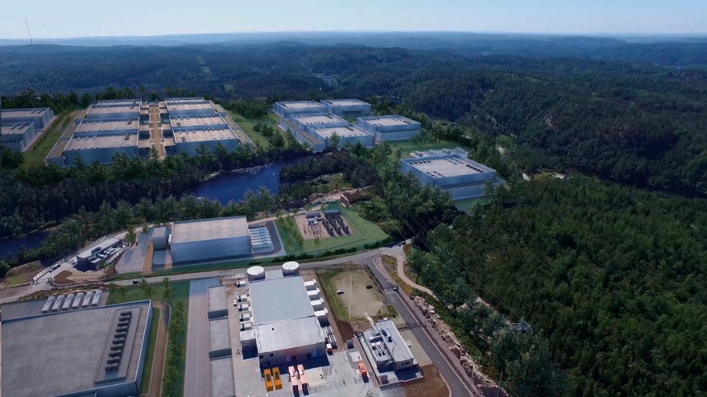
The Bulk data centre in Vennesla near Kristiansand. Existing buildings are shown in the foreground, while those in the background illustrate Bulk’s vision for expansion in the years ahead.
Source: BULK
As part of its follow-up of the previous data centre strategy, the Ministry of Local Government and Modernisation has commissioned an economic impact analysis of potential and completed data centres in Norway.
The first part of the study follows up the Government’s initiative in the previous data centre strategy to map the Norwegian data centre industry. Furthermore, the report describes the economic impact of the industry as it was at the time of analysis, and the potential economic effects of establishing data centres in the future.
The economic impact analysis distinguishes between short-term (so-called direct, indirect and induced effects) and long-term effects (so-called catalytic effects) of data centres. In brief, direct effects refer to the direct impact of the activity in the data centres during their construction (such as construction workers) and operation (such as maintenance, jobs for technicians etc.). Indirect effects refer to activities created among sub-contractors during both construction and operation, such as contracting. Induced effects refer to activities created when data centre employees and sub-contractors spend their wages, for example on shopping and in restaurants. These effects are also often referred to as gross effects.
The report also analyses the long-term (catalytic) effects of the existing data centre industry. In the report, it is estimated that the catalytic effects of the current data centre industry are considerable. According to the economic impact analysis, a cautious estimate indicates that these effects will be equal to the direct, indirect and induced effects combined, which have been estimated at NOK 3 billion for the existing data centre industry.
The economic impact analysis shows that the data centre industry highlights predictable framework conditions, effective processing of licence applications and good access to manpower and training as key areas for Norway to succeed as a data centre location.

Mapping out the industry
As mentioned above, the first part of the study follows up the Government’s initiative and maps out the data centre industry in Norway and its economic impact at the time of analysis. According to the economic impact analysis, 18 data centres can currently be characterised as colocation data centres. In addition, there are numerous smaller data centres and some crypto data centres.
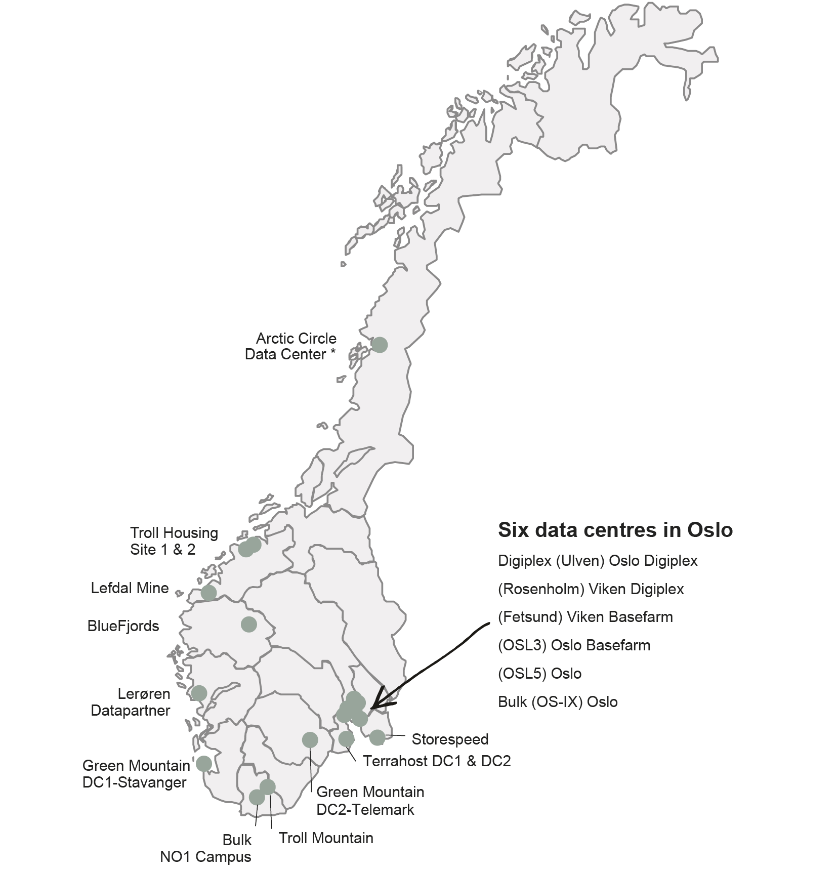
Overview of Norwegian data centres
* Arctic Circle Data Center filed for bankruptcy in January 2020
Source: Implement Consulting Group
The Norwegian data centre industry consists of six large companies and a handful of smaller operators. The six largest companies account for approximately 70 per cent of the capacity and have an average installed capacity of 16 MW. The smaller companies have an average capacity of approximately 1 MW. One of the smallest facilities in the overview is Terrahost, with 0.25 MW, while Green Mountain in Stavanger is one of the largest, with 15 MW.
According to the economic impact analysis, the Norwegian data centre industry represents an established capacity of approximately 105 MW. A recent estimate by the Norwegian Water Resources and Energy Directorate (NVE) shows a larger total installed effect of 174 MW, but the estimate indicates that only 99 MW of this capacity is being used.
Some new data centre locations have been established since the economic impact analysis was undertaken in 2020, and we can therefore assume that the total capacity is somewhat larger than what is presented here. According to the economic impact analysis, massive investments have been made in colocation data centres in Norway in recent years. The analysis reports that a strong increase in investment activity was observed in the period 2019–2020, with at least NOK 2.7 billion invested in new colocation data centres in this period. The investment is driven by demand both in Norway and abroad.
On the whole, the development has been positive since the launch of the data centre strategy in 2018, with a number of new centres being established. For example, Digiplex, Green Mountain and Bulk all built new data centres in 2019. Furthermore, in 2019 the telecom company Orange bought the Norwegian data centre operator Basefarm. Google has also announced the procurement of a large piece of land in Skien, and Microsoft has opened data centres in Oslo and Stavanger. Many actors report increased interest from global investment funds with a climate profile. The Columbia Threadneedle European Sustainable Infrastructure Fund’s acquisition of a majority stake in the Lefdal Mine Data Center is a good example. Norwegian data centres also appear to have strengthened their position when it comes to attracting investment and establishing high performance computing services. For example, Volkswagen has moved its most processing-intensive and therefore most energy-intensive crash testing to the Green Mountain data centre in Rjukan.
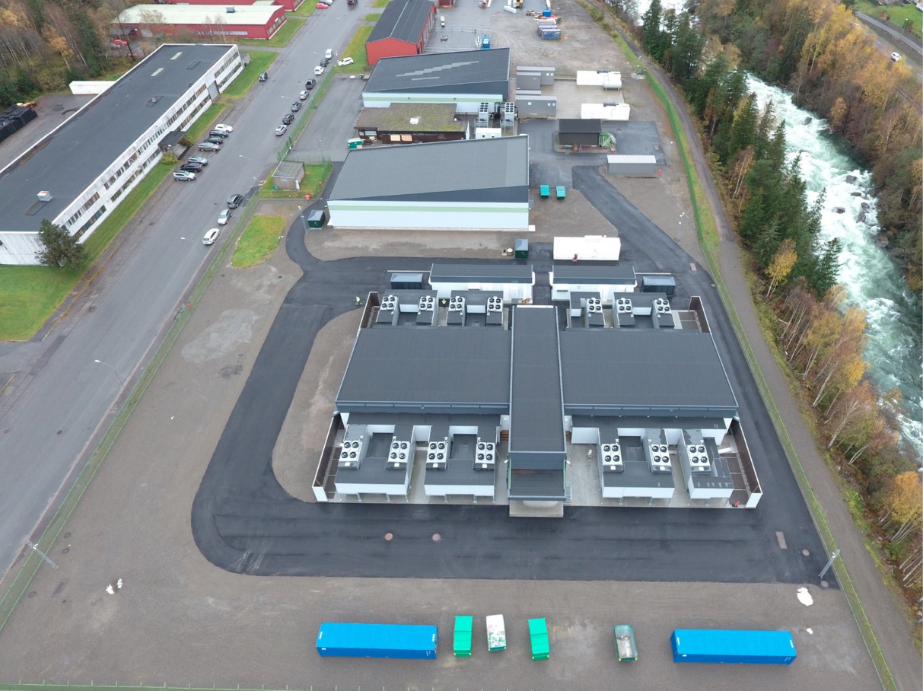
The Green Mountain DC2-Telemark data centre is located in Rjukan and surrounded by a number of large hydropower plants. The largest land-based aquaculture facility in the world will be constructed no more than 800 metres away and will use waste heat from the data centre.
Source: Green Mountain
Since the economic impact analysis in 2020, we have seen further growth in the Norwegian data centre industry. For example, the German company Aquila is currently building a data centre at Kilemoen in Ringerike municipality, and the existing Lefdal Mine Data Center in the county of Sogn og Fjordane recently announced that it had a new German customer for 4.5 MW. Other examples include the contract between Bulk Infrastructure and a British financial institution, and shortly after opening a new data centre in Eastern Norway, Green Mountain bought land for further expansion in Tysvær municipality.
Going further back in time, the data centre capacity in Norway has increased by 17 per cent per year since 2010. In the period 2001–2009, hardly any data centres were opened. During the two last years, however, investment has really picked up speed. According to the economic impact analysis, the total installed capacity in 2019 amounted to 135 MW, and a further 19 MW was planned for 2020.
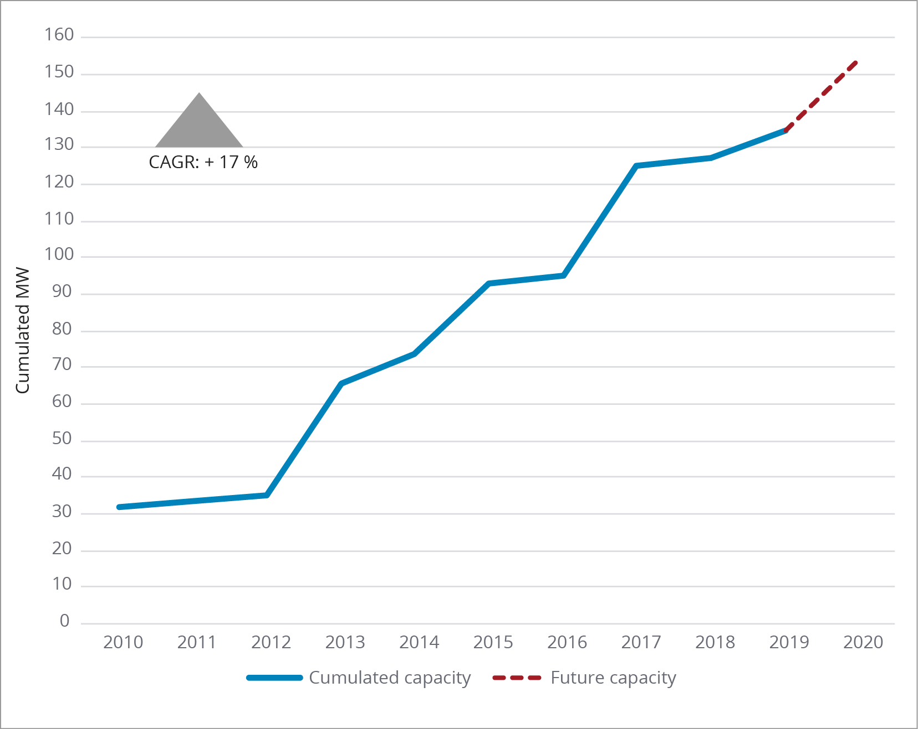
Development of data centre capacity – cumulated in MW
CAGR: Compound annual growth rate
Source: Implement Consulting Group
Since 2015, Norwegian data centres have seen average annual growth of 19 per cent in sales revenues, i.e. faster than the growth in capacity. This is because most data centres still have a lot of unused capacity and are thereby able to generate more sales revenues.
Index 2015 = 100
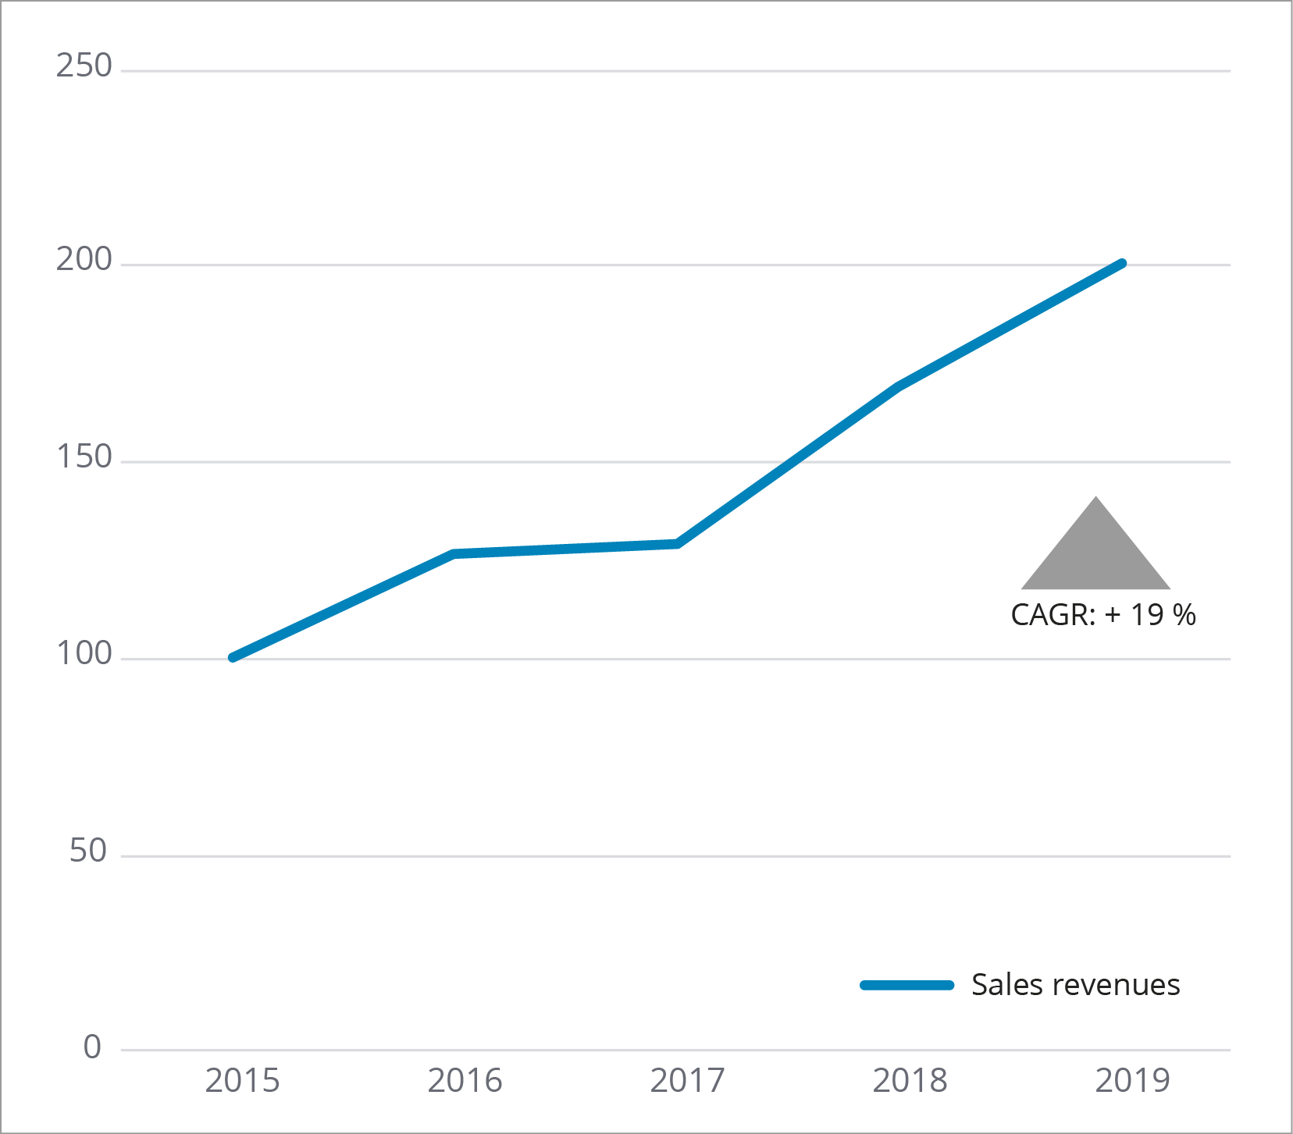
Figure: Trend in data centre sales revenues
CAGR: Compound annual growth rate for sales revenues.
Source: Implement Consulting Group
The Norwegian data centres are used by a number of different clients. In most cases, the data centres supply so-called ‘wholesale’ capacity, i.e. storage space, cooling, network connection and electricity, while the clients install and operate server hardware in the form of cabinets and racks themselves. Other operators also sell ‘retail’, meaning that in addition to cooling, network connection and electricity, they also provide server hardware. The data centres also differ in terms of client types.
Many of the Norwegian data centres are used by clients who need large computing capacity and can be located far from where the data are being generated. This also means that many of the data centres’ main customers are outside Norway.

High performance computing in Norway
An example of data centres being used to provide high performance computing capacity is that of Volkswagen Group, which has chosen to move its heavy computer operations – crash test simulation for use in developing new models – to the Green Mountain data centre in Norway.
The Norwegian data centres are attractive for such clients because of the CO2-free electricity, low electricity prices, high levels of security and stability.
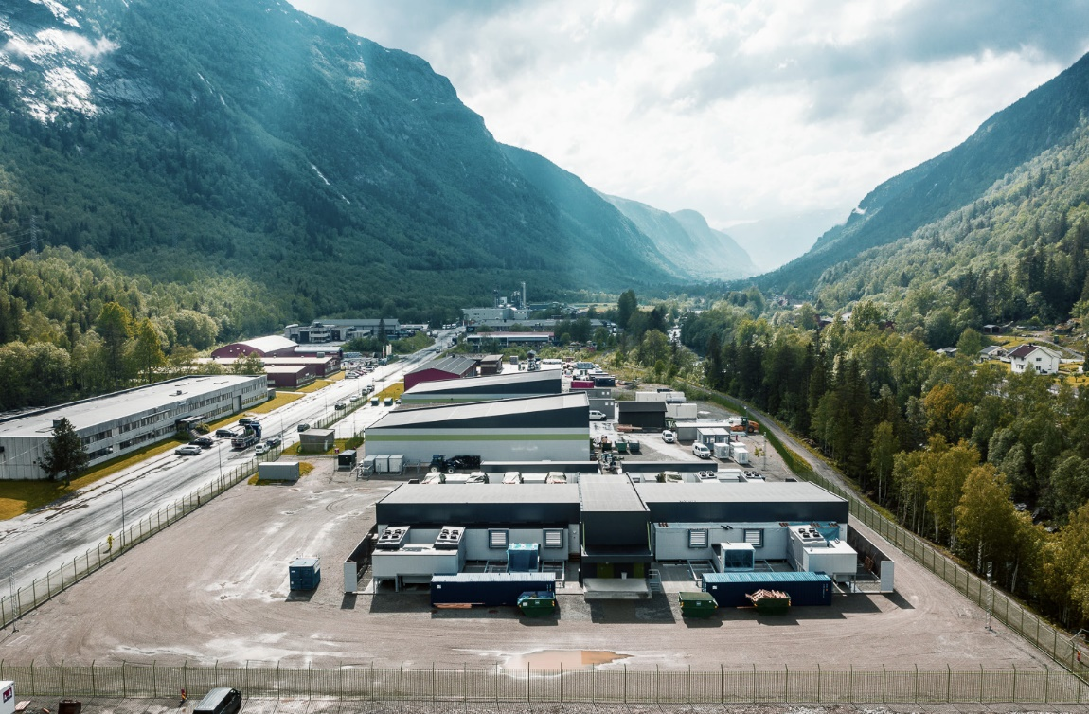
Volkswagen Group is among the clients that have chosen the Green Mountain data centre in Rjukan.
Source: Volkswagen Group
Other data centres, however, primarily serve Norwegian clients and offer services that require closer proximity to where the data are generated and where the clients want more flexibility to scale their consumption up and down, and use various types of computing power and data storage.
No data centres in the hyperscale category have yet been established in Norway. Nor have edge data centres become widespread in Norway, but more are expected as the market expands. For example, the Green Edge Compute company has announced plans to build its first edge data centre in Trondheim so that it can be closer to the end users and shorten delay times when utilising the Internet of Things and 5G. In addition, the Miris company plans to build 15 regional and 25 local edge data centres in the Nordic region.
The economic impact analysis estimates that in 2019, the data centre activity in Norway represented a turnover of approximately NOK 1.6 billion and employed nearly 300 people.

Economic impact and value creation
The second part of the economic impact analysis investigates the wider economic ramifications of the established data centre industry in Norway. According to the analysis, the data centres generated NOK 1.5 billion in direct value to the Norwegian economy in 2019. Of this, NOK 0.9 billion stemmed from the operation and maintenance of the data centres and NOK 0.5 billion from construction work associated with building them. Through their consumption of goods and services from sub-contractors, the data centres created NOK 1.1 billion of added value. According to the analysis, the data centres employed 1023 persons in 2019. The private consumption of these employees contributed to the employment of 541 further persons. In 2019, the data centres accounted for a total of 2376 jobs in Norway. Most jobs that data centres create are associated with the construction of premises and installation of servers.

Potential economic impact
The researchers have used four scenarios to analyse the economic impact of the potential establishment of data centres in Norway, where the number and type (hyperscale, colocation and edge) of data centres vary. The analysis also includes a discussion of elements that will be critical for achieving the goals in the different scenarios.
Value chains create jobs
Only a small proportion of Basefarm’s 750 employees actually work in the company’s data centre. However, hundreds of Basefarm employees and thousands of its clients’ employees work on solutions that the data centre supplies. Employees are working with, for example, operating infrastructure, artificial intelligence and security. The clients, such as banks, manufacturing companies or public sector actors (such as Altinn and Bane NOR), use the data to make their services more competitive. The quality of the value chain depends on high quality and competence in its digital foundation, the data centre, as well as other components.
Source: Basefarm
According to the economic impact analysis, the data centre industry represents considerable potential for Norway. In one of the scenarios described in the analysis, which assumes an annual capacity growth of approximately 25 per cent, the data centre industry could potentially employ a total of 11 100 persons in 2025 and 24 900 in 2030. In this scenario, these are made up of approximately 9 700 employees in colocation data centres, 3 000 in hyperscale data centres and 12 200 in edge data centres.
In the same scenario, the industry could contribute NOK 14 billion to GDP in 2025, primarily on the basis of colocation data centres. Furthermore, the industry could represent NOK 30.9 billion of GDP in 2030, divided into approximately NOK 12.7 billion from colocation, NOK 3.9 billion from hyperscale and NOK 14.3 billion from edge data centres.
Construction of data centres creates jobs
Green Mountain’s 22 000 square metre data centre at Rennesøy in the county of Rogaland was built with the aid of 26 sub-contractors, in addition to Cowi and NCC, who were consultants and the general contractor respectively. The first phase involved the fitting of one of the six halls.
A review shows that to date, the suppliers involved in the construction of three halls for the new DC1 Stavanger data centre have worked a total of 400 000 man-hours . Another 200 000 hours are expected to be needed to complete the two remaining halls. Green Mountain’s calculations show that 70 per cent of these man-hours have been supplied by local contractors. This construction project shows how building data centres supports a wide range of sub-contractors whose services range from administration to plumbing, cooling systems, access control, security and machinery leasing.
Source: Green Mountain
It should be noted that this scenario assumes a very high growth rate, and other scenarios in the economic impact analysis that also assume high growth could be regarded as somewhat more realistic. This scenario was included to provide a perspective on the economic impact of a situation with very high growth in the data centre industry. In order to achieve such a growth rate, Norway would need to make the necessary provisions for the data centre industry in the years ahead and exceed the global rate of growth in the industry. However, in light of their planned future expansion, some leading industry players claim that the potential for growth could be even greater than what is outlined in this scenario. Scenario analyses are fundamentally uncertain and based on a number of assumptions, and the figures referred to here should only be used as an illustration of the potential that this industry represents.

Norway as a data centre location
The Government wants Norway to exploit the opportunities that data presents for increased value creation, more jobs throughout the country and an efficient public sector.

Security in Norwegian data centres
Norwegian data centres play a key role in the digitalisation of Norway, and support digital services that are increasingly important for society. Adequate security in complex digital value chains is therefore a priority, in Norway as well as in the EU and the rest of the world. In order to succeed in the Norwegian and international markets, Norwegian data centres must therefore be able to document adequate security over time. The security of Norwegian data centres is a key competition parameter.
Digital infrastructures and systems are becoming increasingly complex, extensive and integrated. Dependency and vulnerability are created across fields, sectors and countries. Digital services are expected to be available at all times. Successful digitalisation also means that the solutions comply with requirements for security and data protection, and that we have confidence in digital solutions functioning as intended.
One of Basefarm’s two data centres outside Oslo
Source: Basefarm

Increased domestic market potential for Norwegian data centres
Data centres whose services are located in Norway can be used for societally crucial functions and sensitive information systems to a greater extent than those that are located abroad.
In its report on the digital risk profile (Helhetlig digitalt risikobilde 2020), the Norwegian National Security Authority (NSM) highlights issues associated with using cloud services located abroad, especially for services and functions that are critical to society.
Cloud services delivered from and with infrastructure in Norway will make a positive contribution, since this can help safeguard national autonomy and protect sensitive systems and information. The Security Act and appurtenant regulations lay down requirements for certain types of data to be stored and processed in Norway. Services that need especially short response times (edge data centres) will also create a market for data centre services located in Norway.
Critical infrastructure in Norwegian data centres
Norway is subject to the GDPR in the form of the Personal Data Act, as well as the NIS directive that ensures free flow of data within the entire EEA area. This directive is also intended to ensure that data centre services in the EEA area maintain the required security standard.
However, the Security Act and appurtenant regulations also lay down requirements for certain types of data to be stored and processed in Norway. The use of other types of data may require the data centre to be located close to users, for example real-time data for optimisation of critical infrastructure in areas such as energy and transport.

Regulation of data centres
Due to data centres’ increasingly important role in the development of society and the digital foundation, the Government proposes that consideration is given to relevant and appropriate regulation of such centres under the rules for electronic communication. The aim would be to monitor the general risk and vulnerability in data centres that coordinate and perform activities for a large customer base. The new proposal for an EU directive on ensuring a high level of cyber security, the NIS 2 directive, includes rules for the activities of data centres. This proposal is currently under deliberation in the European Parliament and Council. Pending a final decision, the implementation at the national level is still awaiting consideration. In the first phase, the Government plans to hold consultations on a framework regulation for data centres in association with the new Electronic Communications Act, which was put out to consultation in the summer of 2021. The Government will continue to follow up these efforts, and will invite the data centre industry and relevant public authorities to take part in a broad dialogue.
- The Government wants data centres to be considered for regulation in the rules for electronic communication and other relevant regulations to ensure digital security and safeguard national security interests.
The industry offers infrastructure leasing that can be supplied from both domestic and international cloud platforms or as dedicated infrastructure. It is difficult for the police to trace any criminal or terror-related use of the equipment or services because there is currently no requirement for users to register or to give details of what they will use them for. Nor are data centre owners subject to any requirements or registration, beyond those that apply to landowners . This presents challenges in the handling of incidents and police investigations. Measures to address this situation are being discussed at the EU level, and it is important for Norway to participate in this work. Mandatory registration of data centre operators is a possible measure that is being called for. A review of possible regulatory changes in this area will aim to address the fight against crime and protect national security interests within the framework of the EEA Agreement and other international commitments.
- The Government will participate actively in the European cooperation to develop appropriate, and primarily pan-European, solutions that ensure digital security, combat crime and protect national security interests associated with data centre activities.

Data centres – a sustainable growth industry

Norway’s renewable energy – a competitive advantage
Source: AdobeStock
One of the Norwegian Government’s priority areas in energy policy for the period up to 2030 is industrial development and value creation through effective utilisation of viable renewable resources.
In Norway, the country’s renewable resources and well-functioning energy sector represent competitive advantages. The power supply in Norway is renewable, flexible and secure, and electricity prices are currently the lowest in Europe. However, the introduction of new energy-intensive customers could create a need for investment in the power grid and increase the peak demand. How higher electricity consumption will impact on the power system’s ability to ensure hourly balancing between consumption and production throughout the year will be seen in the years ahead.
The location of a data centre can determine how quickly it is connected to the power grid and how effectively the existing transmission network is utilised. It is therefore important that the site developer contacts the relevant transmission system operator (TSO) at an early stage. Securing agreements with new major consumers who want access is also crucial to ensuring efficient utilisation of the capacity in the grid. Instruments to aid these efforts will be identified at a later stage.
The European power markets are undergoing a large-scale transition from fossil energy to renewable energy, and largely inflexible power generation. Norway is one of the few countries in the world whose power production is already virtually emission-free and based on renewable sources, as well as highly flexible. Hydropower is the largest source of flexibility in the Norwegian power supply, and one of its special features is its capability to store energy. Half of Europe’s total storage capacity is found in Norway, and over 75 per cent of Norwegian hydropower capacity is flexible. Reservoir power plants offer a large degree of flexibility, and production can quickly be adjusted upwards or downwards as needed, at a low cost.
Norway was one of the first countries to introduce market-based power sales. Today, all Nordic countries are closely integrated in a common power market, both physically and financially. The Nordic system is further integrated with the European system. The interplay between the flexible hydropower and the rest of the Nordic power supply helps to maintain a high level of security in the supply at a relatively low cost. This is also reflected in the low power cost to business and industry in Norway compared with other countries. Norway enjoys generally lower operational costs in the power system due to the access to flexible hydropower and a well-developed transmission network.
The growth in renewable energy in Norway is higher now than for several decades. The Norwegian power system generates record surpluses of renewable power in years with normal weather conditions. In the last ten years, Norway has had a net export of power every year, with the exception of 2019. Renewable power production is also undergoing considerable expansion in neighbouring countries, with whom Norway has close ties. Norway is well placed to meet the annual power demand in the years ahead, even if consumption increases. In addition to the current power surplus, Norwegian production capacity is expected to increase in the years ahead.
In Report no. 36 to the Storting on long-term value creation from Norwegian energy resources (Meld. St. 36 (2020–2021) Energi til arbeid – langsiktig verdiskaping fra norske energiressurser), the Government presented an electrification strategy aimed at capitalising on Norway’s favourable starting point in the power supply. The strategy includes long and short-term measures aimed at balancing the expansion of the power supply. The long-term expansion of the power market must be designed to maintain the well-functioning and low-cost nature of the market. This is best achieved by optimising efficiency in terms of utilisation and expansion of the transmission network, which in turn can be achieved by facilitating efficient energy use and offering the right market incentives to realise a social return on investment in renewable power production.
Power price expectations
Developments in Norwegian power prices in the next decade will depend on conditions both domestically and internationally. The Nordic and European energy supply is undergoing major changes. In the Nordic countries, the percentage of inflexible renewable energy is increasing rapidly, non-renewable energy is being phased out and Norwegian and Nordic power surpluses are increasing. The Nordic and European power markets are also becoming more closely integrated, and trends in the European power market will have a steadily greater impact on Norwegian power prices.
NVE estimates that the average power price in Norway will increase slightly as we head towards 2040, to between 38 and 42 øre/kWh. This is mainly based on an expectation that the price of carbon credits will increase in Europe in the future as the carbon allowance is reduced to meet the emission targets. This will drive up the cost of producing power from fossil fuels and raise the price level in the countries we exchange electricity with. NVE also assumes rising gas prices. Although CO2 and fuel prices will have a major impact on the power price level over time, variations in hydrology and wind conditions could result in large fluctuations in Norwegian power prices from year to year. NVE’s analyses show that the variation in annual power prices between different weather years will increase towards 2040. This is linked to the growth in inflexible power production in the Nordic region and in Europe.

Waste heat requirements for data centres
- The Government will facilitate sustainable development of the data centre industry in Norway – including by introducing requirements for waste heat in data centres.
The establishment of new data centres, combined with other electrification in society, will increase the pressure on the power supply. It will therefore be even more important to utilise the energy we already have, and to do so more efficiently. On behalf of NVE, Oslo Economics and Asplan Viak have surveyed the potential for improving efficiency in heating and cooling in Norway. The findings show that data centres will represent the greatest potential for optimising the utilisation of waste heat in the future. According to NVE’s estimates, the demand for electricity in data centres will increase to between 4 and 9 TWh per year in 2040. Most of this electricity will be used for cooling and will be expunged as waste heat. Based on the report from Oslo Economics and the requirements in the Energy Efficiency Directive (EED), the Government has proposed introducing a requirement to assess the utilisation of waste heat when establishing or upgrading facilities with a high energy consumption. The proposal includes a requirement to perform an analysis of waste heat utilisation when building power plants, industrial plants, district heating plants, district cooling plants and energy production plants with more than 20 MW of supplied heating effect. In addition, it is proposed that actors who plan to build a data centre with capacity exceeding 2 MW, and other plants with more than 20 MW of supplied electrical power, should perform a waste heat analysis. The lower threshold value proposed for data centres reflects the fact that data centres are often expanded in stages. Furthermore, small data centres will, in many cases, be particularly well suited for waste heat utilisation, as they are often located in densely populated areas. The aim of the proposal is to show actors planning to build or upgrade plants with waste heat how they can utilise waste heat. It will not be made mandatory for data centres to utilise waste heat, even if the analysis indicates that it would be beneficial.
The proposal was put out for consultation, and the responses are mainly positive to facilitating better utilisation of surplus heat. Some actors think the Government’s proposals go too far, based on the view that special Norwegian waste heat requirements may lead to industrial and data centre actors taking their operations abroad. The stricter requirements for data centres than for other electrical installations were also questioned. However, several of the responses called for the Government to go further, suggesting that requirements should also be introduced for other industries and that the threshold for performing an analysis is too high.

Heat map – heating needs and heat sources
- The Government will establish a national heat map to ensure better utilisation of waste heat.
NVE has been working on a national heat map with a view to facilitating sustainable business development for data centres and other power-intensive industries. This is now ready for use and can be accessed on NVE’s website: https://temakart.nve.no/tema/varme
The goal is for the map and the source data to aid the planning of heat resource utilisation. The map will show heating needs and potential heat sources, and currently includes information on the following:
- district heating (licence limits, installed capacity, production)
- data centres
- waste incineration plants
- industrial companies with waste heat
- heating needs, i.e. heating of buildings and water
The map is an information, search and planning tool that can be used by commercial actors and local authorities. The information can also be used in research and analysis, and will be open access and available on NVE’s website. NVE will use the map in the follow-up of district heating actors and to keep track of large actors’ energy consumption.
Information about the various sectors will be developed and improved in stages, with updates several times a year.
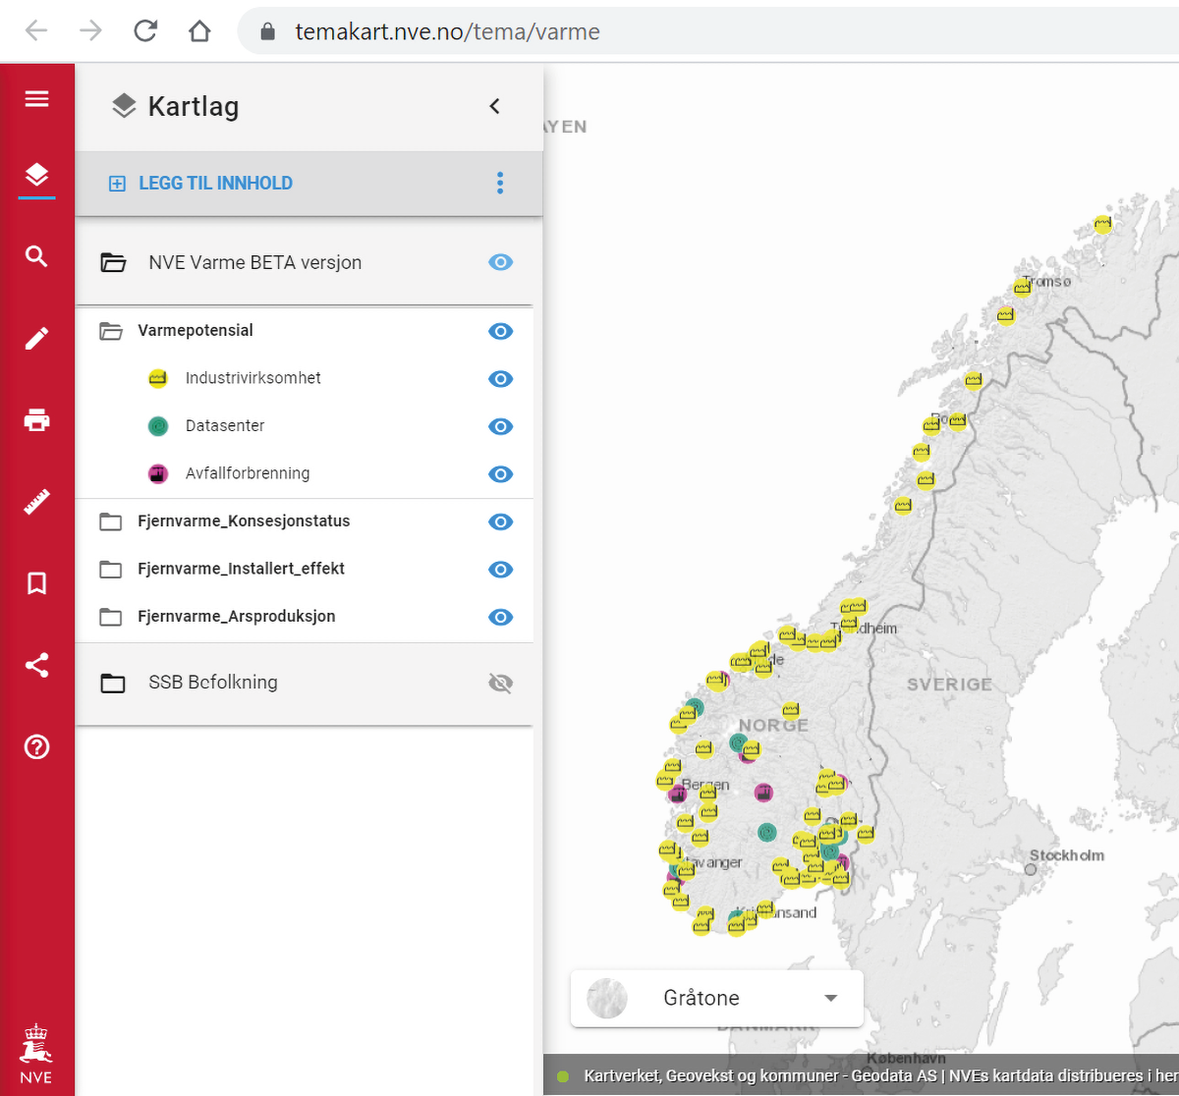
Screenshot – NVE’s beta version of the heat map
Source: NVE

The green data centre industry
The Norwegian data centre industry wants to identify climate-neutral solutions. This is reflected in, for example, the large number of positive responses to the proposal to introduce requirements to assess the utilisation of waste heat when establishing or upgrading plants with a high energy consumption. Another example is seen in the pledge by ICT Norway and the data centre industry under the Climate Neutral Data Centre Pact to achieve climate neutrality by 2030.
The European Green Deal is a set of pan-European policy initiatives aimed at making Europe the first climate neutral continent. Europe will need green computing power if it is to mitigate the climate challenges.
Norwegian data centre industry participating in a binding climate initiative
ICT Norway’s Data Centre Forum, with representation from most parts of the Norwegian data centre industry, has signed up to the CISPE (Cloud Infrastructure Services Providers in Europe) initiative, which aims to make European data centres climate neutral by 2030.
The initiative places the main emphasis on five areas: energy efficiency, climate-friendly energy sources, water, the circular economy and recycling surplus heat. Seventeen European trade associations support the initiative, and more than 20 data centres have already pledged to work actively to achieve this goal. Norway is in a unique position in the European context in terms of renewable energy. The aim of the Climate Neutral Data Centre Pact is for data centres to be climate neutral by 2030. This work is being carried out in collaboration with the European Commission in the form of grants and improved framework conditions, and through the funding of large EU budgets aimed at digital expansion.
Source: ICT Norway
Digitisation and automation require a great deal of computing power, which in turn requires extensive predictable access to renewable energy.
‘There will be no Green Deal without digital technologies.’
Source: Margrete Vestager, Vice President of the Von der Leyen Commission, whose work covers ‘a Europe that is ready for the digital age’.
One of the main challenges with the large data centre locations around Europe is that the local transmission networks do not have enough capacity for renewable energy. This is one of the reasons why, in 2019, Amsterdam temporarily halted its expansion of the data centre industry. Norway can offer unique, green power production, and the highest share of renewable energy and lowest emissions in Europe, along with scalable production. More renewable energy is also now being built in Norway than for many decades. It is not just Norway’s power that makes the country an ideal location for large-scale data centres; it also has a lot of space, a cool climate, a stable political framework, a well-educated population and a good digital infrastructure.
Not all data centre operations can be moved to Norway. Some data does not tolerate delays; so-called ‘fresh data’ needs to be in relatively close proximity to the user. One such example is self-driving cars, which require information about the traffic around the next bend.
Residual heat is re-used for trout farming
Hima Seafood plans to build the world’s largest land-based trout farm at Rjukan. Green Mountain’s data centre is just 800 metres from the farm. By connecting the two plants with a pipe system, Green Mountain can supply heated water to Hima. This is energy that would otherwise have been released into its surroundings and wasted. Heat exchanger technology will ensure that the Hima plant can use the energy from the water to achieve the correct water temperature in the RAS solution. The same water is subsequently returned to Green Mountain after use. At this point, the water will have a lower temperature and can be used to cool the data centre. Consequently, a circular process is achieved. When the plant is fully operational in 2023, residual heat from the data centre will contribute to the production of 9000 tonnes of trout annually.
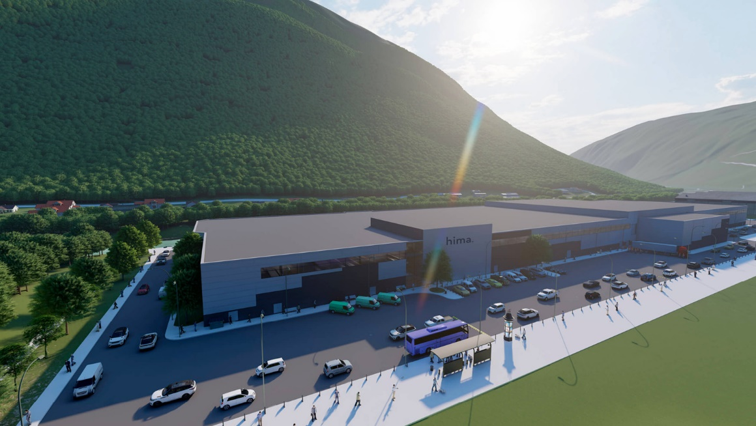
Hima Seafood Facility
Source: Green Mountain

However, there are many examples of heavier computer operations – often involving artificial intelligence – that do not need to be performed in close proximity to the user as they are less sensitive to delays. Volkswagen has moved its heavy computer operations to Norway – crash test simulation for use in developing new models – and established data centre operations at Green Mountain in Rjukan. Performing such analyses is very energy-intensive, and it is therefore beneficial to the environment for the data to be processed in a country where the energy is both renewable and stable. Norway’s cold climate will also help reduce energy needs and cooling costs.
Climate-friendly high-performance computing
High-performance computing (HPC) is power-intensive data processing that should take place where an abundance of renewable power is available.
One example of HPC in Norway is found at Lefdal Mine Data Center, where German customers have proprietary artificial intelligence solutions that are run on so-called HPC equipment. HPC was previously only used in research, for example in climate modelling, and is extremely power-intensive. It does not require proximity to the customer, but proximity to large amounts of power is needed, preferably renewable power.
Today, HPC is no longer solely a research tool; businesses at the forefront of the digital transformation are using HPC on a large scale, e.g. the Internet of Things and artificial intelligence. This type of data processing is therefore a driver of scientific, industrial and social development.
Source: Lefdal Mine Data Center

Using residual heat from a data centre in lobster farming
At the Green Mountain data centre on Rennesøy, Norwegian Lobster Farm plans to build the world’s first land-based lobster farm. Optimum lobster growth requires a seawater temperature of 20°C. This is the same temperature of the seawater after it has been used to cool IT equipment in the data centre. The energy can therefore be reused by Green Mountain feeding the heated seawater directly to the fish farm. The project will generate significant energy savings and is a good example of the circular economy in practice.
Lobster from seawater heated at the data centre
Source: Green Mountain

Support schemes
The Enova scheme is one of the Norwegian Government’s most important climate instruments. In 2020, Enova provided approximately NOK 3.3 billion in support to almost 13 000 energy and climate projects in Norway. In the new agreement for the period 2021–2024, the Government has fine-tuned Enova’s role as a technology and climate instrument.
The object of Enova is to help achieve Norway’s climate commitments and contribute to the transition to a low-emission society. Enova will also help identify good solutions that take into account the need for an efficient energy system. Through its activity, Enova promotes innovation and the development of new climate and energy solutions. Enova can support the transition to low-emission technologies in all sectors. Enova’s activity will be aimed at the parts of the innovation chain that focus on late-phase technology development and early market introduction. Enova’s activity will also be aimed at late-phase technology development, with a view to achieving a permanent shift in the market, whereby solutions that are adapted to the low-emission society will eventually become the preferred choice, even after support comes to an end.
Enova has several schemes that may be relevant to data centres, and which will contribute to the energy transition in various sectors:
- Piloting new energy and climate technology
- Demonstrating new energy and climate technology
- Full-scale innovative energy and climate technology
Since 2009, Enova has supported about 100 projects relating to the utilisation of waste heat in various sectors. An example of this is Fortum Varme – a project aimed at utilising waste heat from the data centre at Ulven in Oslo. This can cover the demand for heating in 5000 homes. For smaller companies, Enova offers information and advisory services in energy mapping.

Renewable energy – grid connection
A data centre can be connected to the grid at different voltage levels. Connection in the regional and transmission networks is initiated by the TSO assigning a point of connection. Meanwhile, the new consumer is responsible for applying for a licence and building the network infrastructure from its own premises to the connection point. In the distribution network (a maximum of 22 kV), TSOs with an area licence have a duty to build infrastructure to connect all consumers.
The size of the data centre is the main determinant of the voltage level it is connected to. In some cases, rapid connection to the distribution network will be possible for small data centres. Large data centres, particularly those that will have in excess of 100 MW capacity, may require investment in a new network, either at regional or transmission network level, depending on the location and capacity of the existing network. TSOs have a duty to connect consumption at all network levels. Statnett is the responsible party in the transmission network, while at a lower network level it will be the TSO that owns the network in the relevant area. TSOs must identify, apply for and build networks without undue delay to ensure that they are able to connect consumers as quickly as possible.
Necessary grid investments often take longer to put in place than the new power demand. When a TSO has to assess a new network measure, it is often unknown whether the project in question will actually be realised. It is also uncertain in many cases how large the power demand will be. Many of the data centres are initially designed with a power capacity of 5–50 MW, but with the option to expand this later. Provided that the data centres attract enough customers, the total power output for a single data centre can be in excess of 100 MW. In order for the necessary measures in the network to be assessed and implemented in time, the TSOs must be kept up to date about any large increases in consumption. Binding agreements between the relevant TSO and the party being connected can facilitate coordination and reduce the risk of unnecessary assessments and bad investments for both parties.

Location of the power grid
Since grid investment is both costly and time-consuming, it is helpful to give actors an indication of where there is room in the existing transmission network. This can help them decide where to locate their operations. Various schemes have been set up for this purpose. Power system assessments are regularly carried out for 17 regions in Norway. In addition, Statnett is preparing a network expansion plan for the transmission network. These reports are updated every two years. Overall, they provide a good overview of trends and planned grid investments, and provide actors with information on how the location of production and consumption will affect the power system.
The TSO determines and charges an investment contribution when a customer triggers the need for investment in the transmission network. The rules on investment contributions ensure that these actors pay a share of the costs. Investment contributions will reflect the cost of a new connection or expansion of an existing connection, and will motivate customers to take steps to reduce the need for grid investment. However, the arrangement also helps to achieve a fairer cost distribution between the customers who trigger a need for grid investment and the TSOs’ other customers. For customer-specific facilities, the investment contribution is 100 per cent. Investments in transmission and regional networks tend to benefit a large number of customers. In the transmission and regional networks, only part of the investment cost can therefore be covered through an investment contribution. The remaining costs must be covered by the grid customers through the grid tariff. In addition, both the marginal loss factor in the grid tariff and the subdivision into power price zones are indicators of where it might be beneficial to establish a data centre.

Clarification of land use pursuant to the Planning and Building Act
Most land use and development issues in Norway are dealt with by the local planning authority pursuant to the Planning and Building Act. The object of this legislation is to promote sustainable development for the individual, society and future generations. Decisions on where and when building can take place are made at policy level. Development and land use usually have implications for various conflicting and overlapping interests, and during planning, different considerations and interests are viewed and balanced with each other. The planning process also aims to ensure the participation of citizens, businesses, organisations and higher authorities. In planning matters, the local authority is not only responsible for protecting its own interests, but also national and regional interests, and for considering issues such as protection of farmland, biodiversity, cultural heritage, natural hazards, children and young people’s interests and transport.
The local authority is responsible for ensuring that new or changed land use is clarified in the municipal plan’s section on land. All local authorities’ municipal plans have such a section showing where development can take place and on what terms, and what areas are to be set aside for agriculture, nature or human activity. The land use stipulated in the municipal plan is binding, and no conflicting developments can be built. This means that if an area is to be purposed for industrial use, for example, this must be specified in the municipal plan.
All major developments also require a zoning plan. A zoning plan is far more detailed than the municipal plan, and sets out the use, protection, design and physical surroundings of a defined area. Private individuals can propose a zoning plan, but there is a statutory requirement for the plan to be drawn up by professionals. Adopted zoning plans give details of the development and use that is permitted in an area. In order to be adopted, zoning plans must be approved by the local council, and approved plans are binding in relation to future land use. When a subsequent building application is submitted that is in accordance with the zoning plan, approval will be granted.
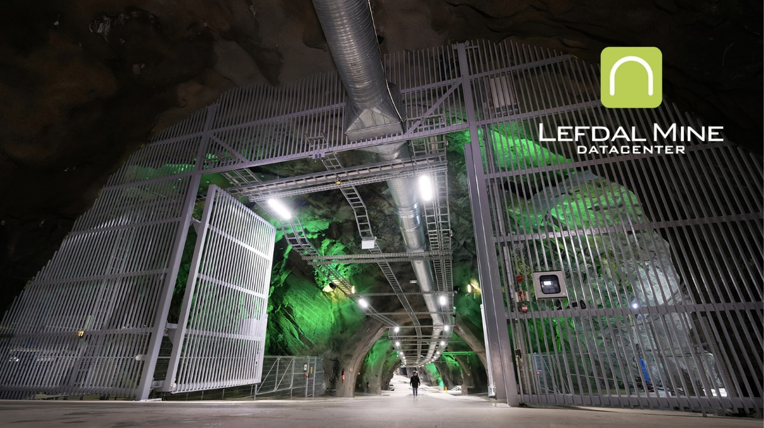
Lefdal Mine Data Center opened its data centre in an old olivine mine near Måløy in the county of Sogn og Fjordane in May 2017
Source: Lefdal Mine Data Center

Useful information for actors who want to be connected to the grid
NVE is currently reorganising its website to make it easier for different types of grid customers to access information about regulations and processes for getting connected to the power grid.
In 2018, NVE also prepared a fact sheet in English, which describes the Norwegian power system, the process of connecting to the Norwegian transmission network and the associated costs.

The licensing process for grid connection for power-intensive industries
Both the TSOs and the energy authorities are experiencing a high demand from actors with consumption plans within electrification and industrial development who want to be connected to the transmission network. In recent years, NVE has processed a large volume of applications for grid connection, and has subsequently issued a guide on what data centres and other energy-intensive industries need to have in place before submitting a licence application for grid connection.
This includes the requirement for the area in question to be purposed for industry or other suitable use in the municipal plan, or to be regulated for the purpose under a statutory provision. The TSO must also have considered whether the grid connection is viable, or whether investment is needed in the regional or transmission network to connect the consumption to the grid. If adding new consumption to the grid requires major investment in the regional or transmission network, such as new transmission lines and substations, NVE may require the applications to be processed at the same time.

Better utilisation of the transmission network
The Government believes it is important to consider how the transmission network can be better utilised in the future. In Report no. 36 to the Storting on long-term value creation from Norwegian energy resources (Meld. St. 36 (2020–2021) Energi til arbeid – langsiktig verdiskaping fra norske energiressurser), the Government describes how optimum utilisation of the transmission network can be facilitated.
To this end, the Government has introduced power-based tariffs in the distribution network. This will also ensure a more equitable distribution of grid costs between customers and reduce the need to expand the grid.
In the spring of 2021, the Government also approved an amendment to the regulations that offers an alternative to grid investment; consumer agreements that provide for disconnection or a reduced power supply. This is a voluntary solution, with no compensation in the event of disconnection or a reduction in supply. The alternative to such agreements will be full connection, and where investment is needed in the transmission network, a consumer investment contribution will also be required.
The regulation described above will make it possible in many cases to implement new grid connections or accommodate increased consumption without the need to invest in a new network. Consequently, both the TSO and the customer will avoid the expense of grid investment. In many cases, this solution will also expedite connection. The new method will help improve utilisation of the existing transmission network and reduce the need to invest in a new network.

Public commission – power grid expansion
- The Government will investigate how processes related to the expansion and licensing of the transmission network can be streamlined. The Government has appointed a public commission to consider this and other issues.
The Government will assess the system with a view to grid expansion in light of increasing electrification, as described in Report no. 36 to the Storting on energy resources (Meld. St. 36 (2020–2021)). The Government has recently appointed a public commission to consider issues related to the expansion of the transmission network. The aim is to look at how we can streamline processes related to the expansion and licensing of the transmission network. Expanding the grid takes time and has implications for the environment and other societal interests. Spare capacity tends to be limited, at least in the short term. The commission will therefore also consider whether a criterion can be introduced for how Statnett and TSOs prioritise new grid connections.
The commission will consider three overarching issues: measures to reduce the time it takes to expand and license new grid facilities, the principle of ensuring a social return on investment in the expansion of the transmission network at a time of great uncertainty about consumption trends, and possible improvements in the system for mandatory grid access. The commission will report its findings by 15 June 2022.

Data centres in rural areas
The Norwegian Government wants to see vibrant local communities and profitable businesses throughout the country, and strives for regional balance through growth, equality in living conditions and sustainability, cf. Report no. 22 to the Storting (Meld. St. 22 (2020–2021)). The construction, establishment and operation of a new data centre will create jobs with a large number of local suppliers and subcontractors. Digital infrastructure and digital competence are pivotal to industrial development in rural areas.
5G in ambulances – Innlandet Hospital
When we are sick and require treatment, we need quick and efficient help. In a pilot project at Innlandet Hospital Trust, ambulance personnel have been equipped with a tablet, mobile phone or voice-controlled camera where they can receive guidance and quick decision-making support from the air ambulance, A&E departments or hospital doctors in critical and challenging situations. Most ambulances today have mobile broadband so that staff can receive guidance or get in touch with service users. Using a tablet, mobile phone or a voice-controlled camera connected to Telenor’s 5G network they can live-stream the doctor on duty, who can advise them on how to treat the patient.
5G service in ambulances
Source: Innlandet Hospital Trust
Both Menon and Asplan Viak have examined the criteria that make regions attractive for establishing data centres, such as a labour force with the skills that data centres need (computer engineers, electricians), as well as other criteria, such as access to electricity and fibre broadband, land, access to roads, airport, distance to the nearest town/populated area and the existence of regional cooperation.
There are several examples of data centres successfully being established in rural Norway, such as Lefdal Mine and BlueFjords, both in Western Norway, and Green Mountain at Rjukan.
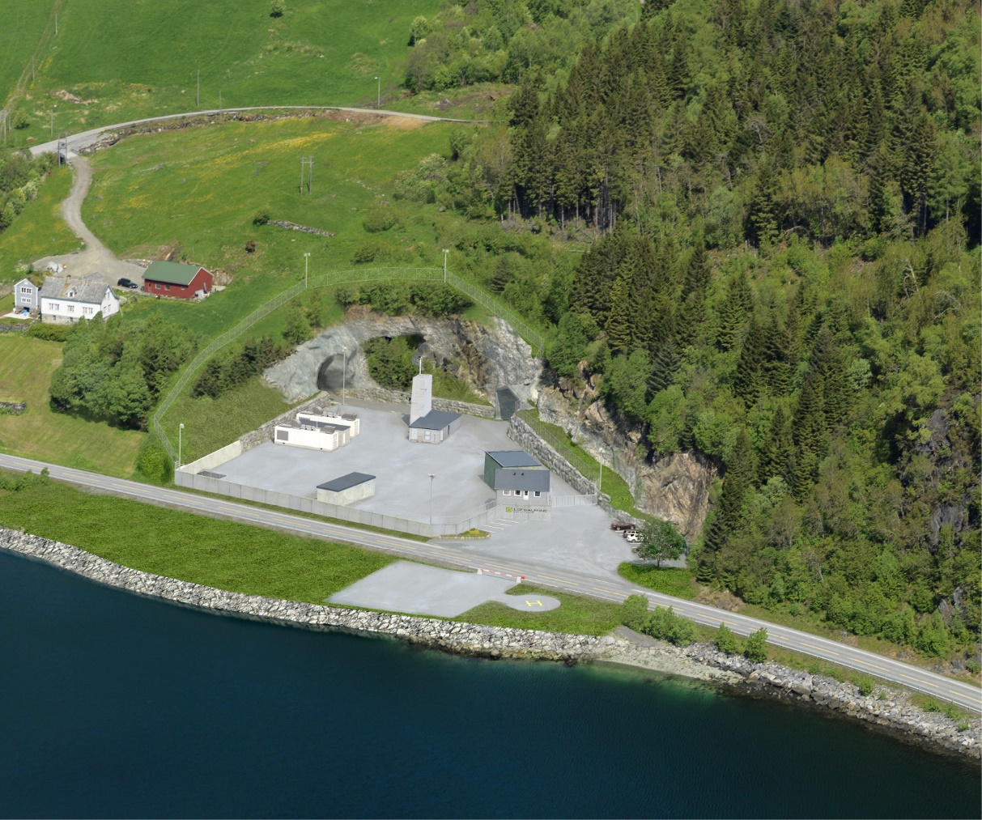
Lefdal Mine Data Center in Måløy
Source: Lefdal Mine Data Center
In several typically rural industries, such as aquaculture and agriculture, digitalisation and better utilisation of data are playing a steadily more important role. Efficient use of data in these industries requires a well-developed digital infrastructure and access to data centres, not only where people live, but also where they work. There is also huge potential for data-driven innovation and value creation within the health sector in rural areas. For example, low latency in the network could support the use of remote-controlled robots for diagnostics and surgical procedures at hospitals and nursing homes. Additionally, high-density sensors and edge data centres will enable communication across emergency services via high-quality live-streaming.
It is expected that the emergence of 5G, in combination with the Internet of Things, artificial intelligence and edge data centres that are established in close proximity to industry, will open up opportunities for industrial development in rural areas (e.g. by improving the local value chain and making Norwegian suppliers more competitive compared to the import market). One such example is the Norwegian aquaculture industry, which is already a leader in the development of new technology to increase productivity and improve competitiveness. This technology involves using tens of thousands of sensors in net cages to control and monitor fish farming. Other solutions are based on highly advanced camera sensors. The capacity of 5G is a key factor in the capability to handle the transfer of data from a large number of sensors where advanced software platforms are used to analyse, make decisions and control processes.
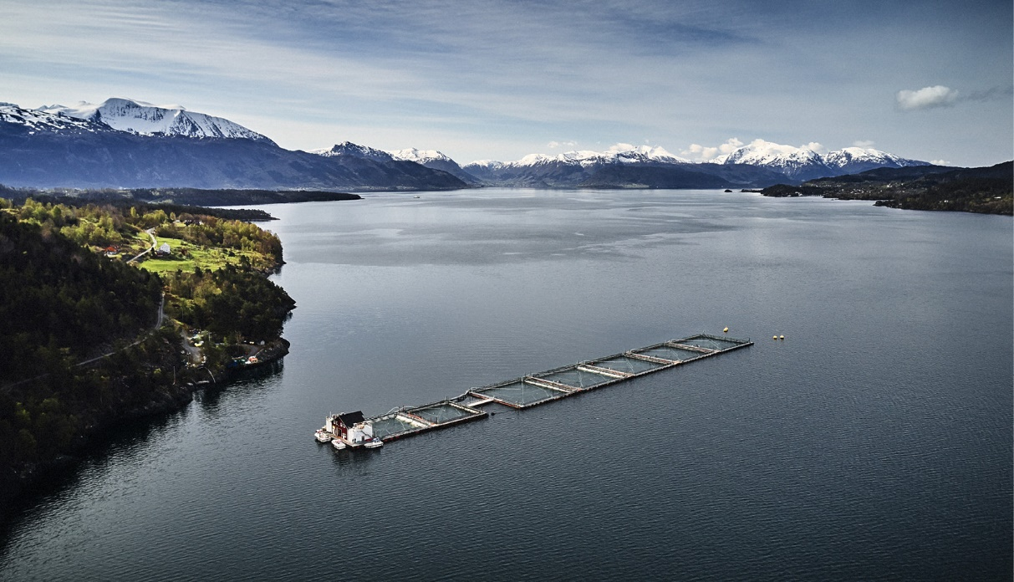
Fish farming in Norwegian fjords
Source: Eide Fjordbruk AS

Digital infrastructure – transmission routes
Those who purchase data centre services depend on functioning services that do not have downtime. Good and robust capacity in the fibre network nationally and internationally is therefore crucial, both for existing data centres and for those planning to establish new data centres. Demand for transmission speed, capacity and a sufficient number of transmission routes is high, both in Norway and for inbound and outbound routes vis-à-vis other countries. Fibre network developers play an important role for data centres, and by the same token, data centres are important customers for the fibre industry.

Transmission routes – international communication
In 2016 and 2017, the Norwegian Communications Authority (Nkom) identified a vulnerability as a result of the bulk of Norway’s international internet traffic flows going via Sweden. One of the goals of the data centre strategy in 2018 was to ensure a wider geographical distribution of Norwegian traffic flows abroad. The aim was to reduce the country’s vulnerability as a result of being dependent on a single country and due to the physical concentration of fibre networks and central hubs.
The Government has allocated a total of NOK 100 million for new fibre cables that link to abroad. The money will mainly go towards reducing the vulnerabilities associated with one-way routing of internet traffic, but will also stimulate data-based business activity. The investment has so far led to Nkom awarding a contract to establish a new subsea fibre network between Kristiansand and Esbjerg in Denmark. This network will be operational in 2022 and will increase the geographical distribution of electronic traffic.
There has also been a positive development within fibre infrastructure in the commercial market in recent years. Several new subsea fibre cables have been planned, financed and realised. Altibox Carrier (the Skagen fibre cable system and the NO-UK cable system), Tampnet and Bulk (the Havsil and Havfrue fibre cable systems) have recently laid or are currently laying new subsea fibre cables that link southern Norway to the United States, the UK and Denmark. Leif Erikson, Celtic Norse and Arctic Connect are also planning further initiatives. Collectively, these measures will strengthen Norway’s appeal as a data centre location, whilst also making Norway’s digitalised society less vulnerable.
The steady expansion of new networks will increase redundancy in the system, which in turn will reduce downtime even if a connection is broken. The capacity and performance of traffic to European hubs such as Amsterdam, Frankfurt and London will also be improved as a result of such expansion.
- The Government will continue to facilitate commercial expansion of networks that connect Norway to other countries.
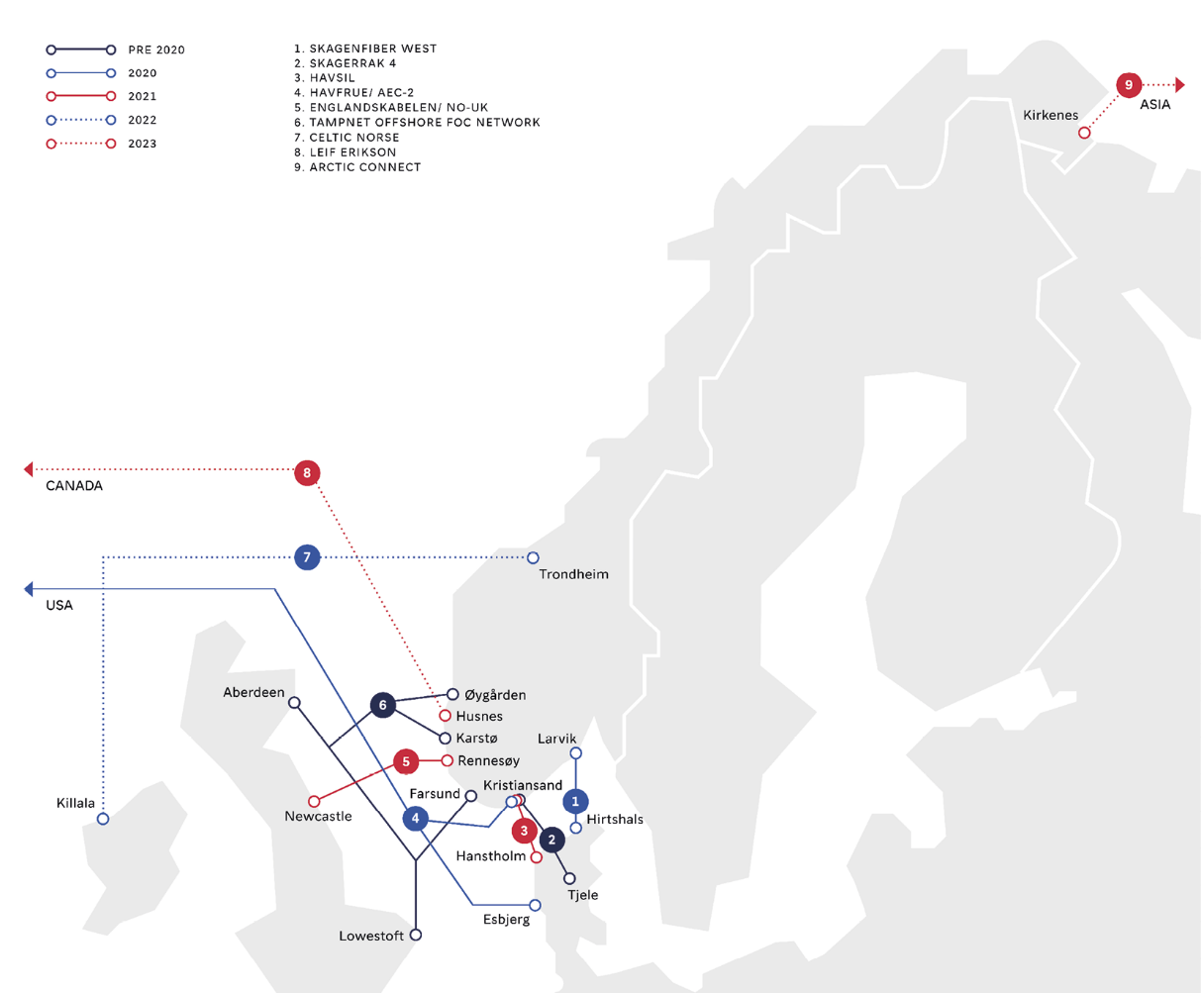
International fibre cables
Source: Invest in Norway

National transmission routes – major expansion throughout the country
Norwegian broadband policy is market-based, and fibre network expansion mostly takes place on a commercial basis. The Government will continue to facilitate market-based expansion. Investment in electronic communication infrastructure has increased considerably in recent years, from less than NOK 8 billion in 2013 and 2014 to a record NOK 12.6 billion in 2020, of which almost NOK 7 billion relates to fibre networks alone.
The investment has led to a large-scale expansion of fibre optic transmission routes throughout the country, resulting in a much more robust trunk network in many areas. The trunk network can be viewed as a digital highway that transports broadband and mobile traffic from many different service providers across the country, regions and towns. These transmission routes, and preferably a number of independent ones, are crucial to data centres.
Important synergies can be realised through data centre activity and the expansion of electronic communication services, both nationally and regionally. Data centre operators are demanding robust fibre transmission routes with redundancy in the trunk network, which in turn will increase national transmission capacity. Meanwhile, expanding the trunk network to meet the business and household sectors’ growing demand for future-oriented mobile and broadband services will strengthen Norway’s appeal as a data centre location due to the infrastructure this expansion will bring with it.

Status – Norway a European leader
The supply of fast broadband has increased throughout Norway due to the high investment level. At the turn of the year 2020/2021, about 90 per cent of households could access fixed broadband (100 Mbit/s), and more than half could sign up for gig speed.
Norway still enjoys a high rating in international comparisons of mobile and broadband infrastructure, including in the statistics from the OECD’s Broadband Portal 2020. The EU’s Digital Economy and Society Index (DESI) for 2020 – which consists of multiple indicators – states that Norwegians are the most prolific internet users in Europe. It further notes that Norway, together with Denmark, is the European leader in terms of mobile and broadband access. Norway has a particularly high rating in high-speed broadband coverage.
Developments in recent years have benefited the whole country, as reflected in the five-fold increase in fibre broadband provision for rural households, from 11 per cent of households in 2013 to 55 per cent in 2020. The difference in the availability of services between densely populated and sparsely populated areas is linked to the much higher customer development cost that businesses face in rural areas. The Government has given more than NOK 1.6 billion in grants for broadband expansion in such areas since 2014.
- The Government will continue the government grants for broadband expansion in rural areas.

Need for further improvement in rural areas
In NOU 2015: 13 and Nkom’s ROBIN report from 2017, it was pointed out that the country is vulnerable due to its dependence on Telenor’s trunk network. The Government has therefore placed a large emphasis on increasing redundancy in the trunk network.
NOK 80 million has been allocated to a pilot scheme for an alternative core network/trunk network. This funding has helped to connect the Svalbard fibre network to two independent trunk networks on the mainland, and to finance measures to a value of around NOK 70 million in Finnmark, including several alternative transmission routes, which will significantly strengthen the digital foundation in the region.
Furthermore, the Government will perform thorough risk and vulnerability analyses in at least five new vulnerable regions, and phase in measures following an annual assessment. NOK 25 million was approved for measures in Troms in the revised national budget for 2021, and together with the improvements in Finnmark, this will substantially increase capacity and lead to more robust networks in northern Norway.
In addition to increasing security and enabling more robust networks in the region, improving the fibre infrastructure in northern Norway could also help optimise utilisation of any new transcontinental cables laid in northern Norway for data-based industries in the region.
- The Government will perform thorough risk and vulnerability analyses in at least five new, vulnerable regions, and phase in new measures following an annual assessment.
Arctic Connect – fibre initiative through the Northeast Passage
The Arctic Connect project aims to build the first trans-Arctic fibre optic subsea cable system linking Europe and Asia. The project is being executed through a separate SPV (Special Purpose Vehicle) based in Finland.
The system spans more than 13 800 kilometres, and has an expected cost framework of between USD 0.8 and 1.2 billion. The plan is to carry out the development phase of the project in the period 2020–2022, and to make the final investment decision for potential construction at a later stage, following a separate assessment.
A trans-Arctic subsea cable between Europe and Asia, via northern Norway, could potentially provide a major boost for industry in the region and opportunities for sustainable value creation in the form of new digital hubs, data centre projects and business clusters.
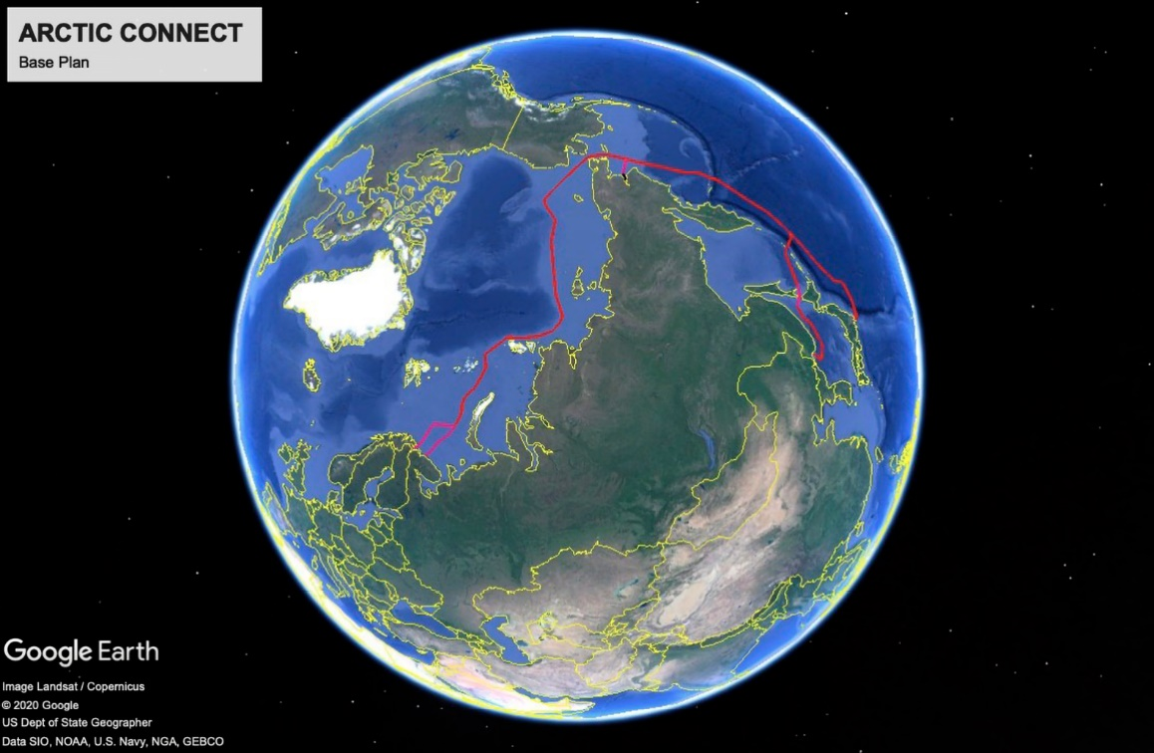
Planned route in Arctic Connect
Source: ICT Norway

Fibre optic – lease of capacity from state-owned companies
Bane NOR operates an extensive fibre optic infrastructure where the different parts of its digital railway management system communicate. Many different areas in the railway sector benefit from communication via fibre networks, such as customer information, signalling and security systems, track systems and train management. The fibre infrastructure is critical for the operation of, for example, the train radio system and the new, digital European Rail Traffic Management System (ERTMS). Expanding fibre infrastructure is expensive, and when this is proposed by a state-owned company such as Bane NOR, future needs are therefore also taken into account.
Statnett is another example of a state-owned company that makes long-term fibre investment decisions and provides for the leasing of capacity.
- The Government will continue to take a long-term perspective of state investment in fibre infrastructure, help ensure that more capacity is built into the system than initially needed, and ensure that provisions are made for market-based leasing of capacity on open and transparent terms.
Access to fibre capacity that is built by state-owned companies is important for establishing new data centres in Norway, particularly in rural areas.

The need for ICT skills
The Government’s goal is for both the public sector and the business community to have good access to ICT expertise. Access to advanced ICT expertise is important both for data-based industries in general and for the data centre industry in particular.
The Government has given special priority to ICT-related education in recent years. The number of ICT-related study places has increased, and the number of students in these subjects rose by more than 2150 in 2020 compared to 2014. In the long term, a larger share of the labour force will have advanced ICT competence, cf. the discussion in Report no. 22 to the Storting on data as a resource (Meld. St. 22 (2020–2021) Data som ressurs). The speed of digitalisation and technological advancement is accelerating, and new subjects and study programmes within ICT have therefore been created. Since 2018, study programmes covering artificial intelligence and computer science have been introduced, and around 350 new study places were planned within artificial intelligence, robotics and computer science in autumn 2020.
There are also good examples of partnership agreements and new educational fields aimed at raising competence levels in the data centre industry. The University of Stavanger and Green Mountain have formed a partnership with a view to raising competence levels in ICT and data centre operations, while Tinius Olsen Vocational College has introduced an online training course for skilled workers to learn specialist data centre skills.,
As digitalisation continues and the need for data centres grows, access to a qualified workforce with specialist expertise will be an important prerequisite for further growth in the data centre industry in the years ahead.
- The Government will continue its efforts to develop ICT competence in Norway.
- The Government will help ensure that data centres can form partnerships with education institutions.

Internationalisation and investment
Øvre Forsland hydropower plant in Nordland is an example of environment-friendly hydropower.
Source: Stein Hamre Arkitektkontor

Boosting the marketing of Norway as a good country for investment
In order for the Government to achieve its goal of making Norway an attractive country for data centres and other data-based industries to invest in, and an attractive host for international investors and entrepreneurs, it is important that international investors can easily access information about Norway’s benefits and that Norway is marketed as a good country to invest in. They must also be offered support in their due diligence and be put in touch with relevant parties, such as landowners, local authorities, power companies and fibre optic companies. Innovation Norway’s investment promotion agency, Invest in Norway, is a useful and effective instrument here.
Invest in Norway helps facilitate new international business in Norway, and its customers are international actors who are considering setting up in Norway. In addition to handling enquiries, the agency’s efforts are aimed at certain segments: the value chain for battery technology, data centres and other green industries (mainly hydrogen-based). Invest in Norway’s efforts to make Norway an attractive country for international investors and entrepreneurs are carried out in partnerships with regional authorities, clusters and industry.
Investment in data centres in Norway has increased in recent years, cf. Chapter 2. In relation to the Ministry of Local Government and Modernisation’s updated data centre strategy, international actors in the data centre industry have indicated that Norway should do even more to market its many benefits. Key players in the Norwegian data centre industry have also said the same. Experiences from neighbouring countries show that targeted efforts in such endeavours yield results.
Boosting Invest in Norway’s efforts could help achieve the Government’s goal of making Norway an attractive country for data centres and other data-based industries and facilitating viable expansion of the data centre industry in Norway. Stimulating international investment in data-driven value creation and data centres in Norway will also increase value creation and create new jobs.
- The Government wants to strengthen Invest in Norway, including with a view to better facilitating investment in data-based value creation and data centres in Norway.

How to establish data centres in Norway
The Government has a clear ambition and a desire for Norway to be an attractive destination for establishing data centres and other data-based business activity.
In order to foster positive market development in the data centre industry in the future, the Government wishes to boost the marketing of Norway as a data centre country and provide support for investors to establish data centres and other data-based business activity in Norway. The Ministry of Local Government and Modernisation has therefore initiated efforts to produce an easily accessible overview of relevant information for investors who are considering investing in and setting up a new business in Norway.
Based on analyses of the data centre industry and other power-intensive industries, in addition to feedback from Invest in Norway, several major international players appear to consider Norway to be a suitable host country.
A guide will be devised that sets out regulatory and licensing processes, and gives a timeline of the licences needed to establish a business. The guide will also provide contact details for relevant parties and an overview of related information such as heat maps, infrastructure and connecting to the transmission network. The guide will reinforce and communicate the benefits and competitive advantages that Norway can offer.
The information brochure/website will include the following:
- An overview of relevant information related to establishing a data centre in Norway, including a brief summary of the benefits of setting up a business in Norway.
- A guide that sets out relevant regulatory and licensing processes, including a timeline of the licences needed to establish business activity in Norway, and an overview of relevant alternatives, such as the build-to-suit leasing arrangement where an agreement is made for a custom-built facility for lease.
- An overview of relevant contacts, including Invest in Norway and relevant local authorities.
- A clear, concise and informative one-page summary.
- Input from other actors, such as fibre cable maps, heat maps (waste heat) and NVE’s fact sheet on connecting to the power grid.

- The Government will produce a guide in English (website) with relevant information on how to establish a data centre in Norway.
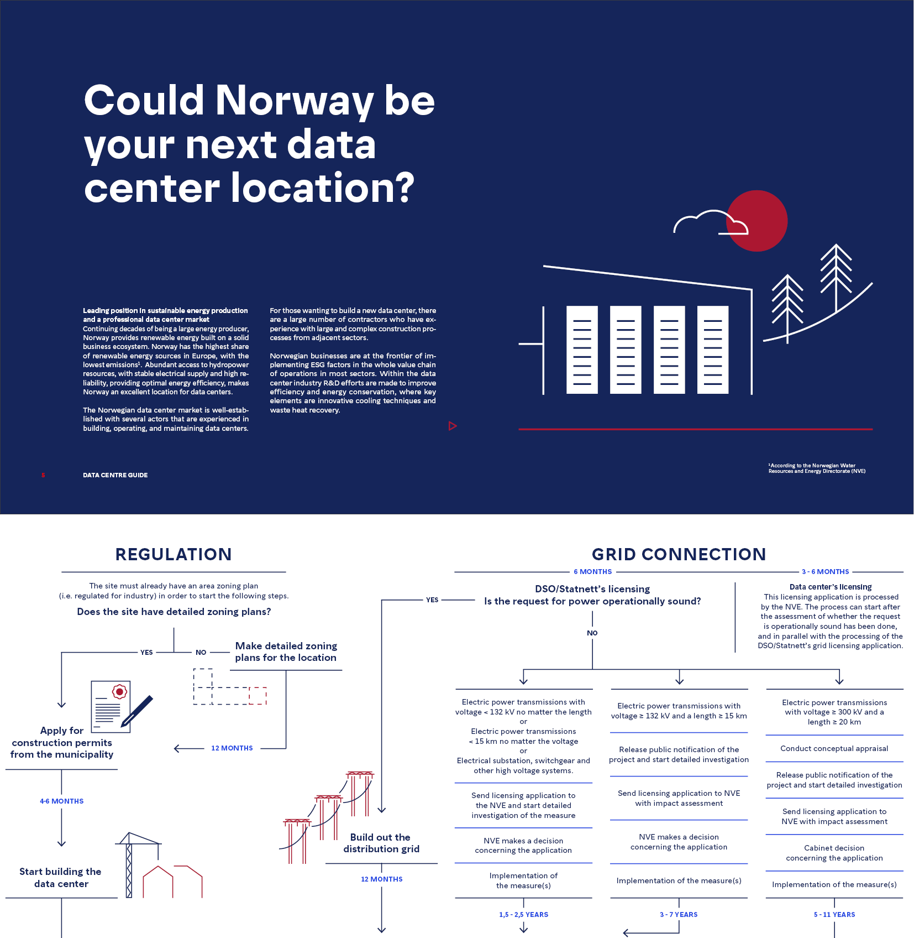
Menon Economics was commissioned by the Ministry of Local Government and Modernisation to produce the guide. Invest in Norway assisted in this work.

Dialogue with Big Tech
The Government has listened to the Norwegian data centre industry and initiated a closer dialogue between the Government and the Big Tech companies driving global investment in data centres.
In the spring of 2020, the Ministry of Local Government and Modernisation was scheduled to meet ten Big Tech companies to discuss data centre investment, artificial intelligence, information security and sustainability. The meeting was arranged as part of a collaboration between the Ministry of Local Government and Modernisation, Invest in Norway and the Norwegian Consulate in San Francisco.
Technological developments and key terms of digitalisation are largely driven by the Big Tech companies. The trip was cancelled due to the COVID-19 pandemic, but the meeting was held remotely. Follow-up meetings have also been held with some companies.
In 2020, various Government representatives held several meetings with representatives from Microsoft’s US and global management. The main theme was sustainability issues that could be relevant to Microsoft’s pledge to be carbon negative by 2030. Microsoft has expressed great interest in the Norwegian carbon capture and storage project, Longship. Equinor also participated in one of the meetings, together with the Ministry of Petroleum and Energy. The dialogue resulted in a memorandum of understanding (MOU) between Equinor’s transport and storage project Northern Lights and Microsoft, and a press conference with Norway’s Prime Minister, Erna Solberg, the Minister of Petroleum and Energy, Tina Bru and Microsoft President, Brad Smith.
- The Government will continue its dialogue with Norwegian industry and leading international technology companies to obtain input to the work to facilitate investment in data-based value creation and data centres in Norway.
Northern Lights
The MOU includes the following four items:
Equinor and Microsoft have agreed the following:
- Explore a technology collaboration to incorporate Microsoft’s digital expertise into the Northern Lights project.
- Microsoft will explore the use of Northern Lights’ carbon transport and storage infrastructure as part of its portfolio of carbon capture, transport and storage projects.
- Explore the potential for Microsoft to invest in the development of Northern Lights.
- Explore and establish policy advocacy to advance the role of carbon capture and storage in meeting Europe’s climate targets.

Stable framework conditions – prerequisites for long-term investment
- The Government will ensure continued stable framework conditions for the data centre industry.
The overall objective for business policy is to maximize overall value creation in the Norwegian economy – within a sustainable framework. Good framework conditions for the business sector as a whole provide a foundation for new, more profitable and sustainable companies and industries to emerge, leading to an increase in overall value creation and the improved welfare of the nation. Business policy should be designed to enable transition, whereby the business community is able to adapt when foreseen and unforeseen events occur.
Internationalisation increases competition in multiple domestic markets and incentivises Norwegian companies to develop better products and streamline production. International competition in both the export and the import market is therefore important for productivity and the future welfare of the nation. Good framework conditions that make it attractive for Norwegian and international actors to invest in Norway are an effective instrument for growth. An increase in the number of data centres will create a larger market for industries that supply goods and services to data centres. Larger markets also mean that production can be scaled up and economies of scale can be achieved. This in turn will reduce unit costs and improve resource utilisation.
A degree of continuity and a long-term perspective are needed in business policy if companies are to have the opportunity to make larger investments and improve their sustainability credentials. Changes in tax policy following major investment decisions could have implications for large investments, such as those needed to establish new data centres. Expectations of new framework conditions that reduce the profitability of an investment project impact on the willingness to invest in the data centre industry. It is crucial for this industry that business policy and the general framework conditions have some degree of predictability.
The Government is prioritising taxation changes that will strengthen the growth potential in the economy, facilitate the energy transition and create new jobs. The tax rate on ordinary income has been reduced from 28 to 22 per cent. Wealth tax has been set at a lower rate and the tax-free threshold has been increased. In 2017, a 10 per cent valuation discount was introduced in the wealth tax for shares and fixed assets etc. The aim is to channel more Norwegian capital towards investment in business activity, which will enable new and existing businesses to create jobs and increase the overall value creation. The tax rate has subsequently been increased several times. In 2021, the valuation discount will be increased to 45 per cent for shares, the share component of securities, equity certificates, shares in businesses assessed as partnerships and fixed assets, including commercial property. The charge for electricity supplied to data centres with a power capacity exceeding 0.5 MW has also been reduced.

Implement Consulting Group (2020): Datasentre i Norge – Ringvirkningsanalyse av gjennomførte og potensielle etableringer
Some of these measures are presented in Report No. 28 to the Storting (2020–2021) Vår felles digitale grunnmur – Mobil-, bredbånds- og internettjenester.
https://www.norges-bank.no/aktuelt/nyheter-og-hendelser/Publikasjoner/Norges-Bank-Memo-/2021/memo-22021/
https://www.gartner.com/en/newsroom/press-releases/2021-04-21-gartner-forecasts-worldwide-public-cloud-end-user-spending-to-grow-23-percent-in-2021
SSB (2020): Bruk av IKT i næringslivet
Statistics Norway (2020): Bruk av IKT i offentlig sektor
Meld. St. 22 (2020–2021) Data som ressurs – Datadrevet økonomi og innovasjon
Menon Economics (2019): Er verdiskaping med data noe Norge kan leve av? Menon-publikasjon nr. 88/2019
’Personal data’ includes all information about an identified or identifiable physical person, cf. Article 4 no. 1 of the GDPR.
https://www.regjeringen.no/no/dokumenter/digitaliseringsrundskrivet/id2826781/
Implement Consulting Group (2020): Datasentre i Norge – Ringvirkningsanalyse av gjennomførte og potensielle etableringer
The economic impact analysis does not address any alternative uses of manpower, capital or other resources in the data centre industry, nor the value creation or employment effects that could stem from such alternative use. These resources could potentially have been used more efficiently in other industries, and the data centre industry might crowd out existing value creation and employment. The overarching goal for Norwegian business policy is to maximise overall value creation in the Norwegian economy within a sustainable framework.
The figures are based on known investments in data centres at the time of the economic impact analysis and in centres that were opened in 2019 or 2020.
https://propertyeu.info/Nieuws/Aquila-Capital-enters-data-centre-market-with-Norway-deal/3c4d102a-6b64-4536-b172-4fbbc285d5a0
https://www.lefdalmine.com/go2cloud-signs-45-mw-data-center-capacity/
https://bulkinfrastructure.com/newsroom/uk-quant-hedge-fund-chooses-bulk-data-centers-to-support-trading-analytics
Press release from Green Mountain 21 April 2021.
The graph showing sales revenues is based on accounting data for companies whose sole activity is operating a data centre. These account for approximately 40 per cent of total capacity in 2019. The development for the ‘pure’ data centre companies is not necessarily representative of the total revenues in companies that also engage in other activities.
Implement Consulting Group (2020): Datasentre i Norge – Ringvirkningsanalyse av gjennomførte og potensielle etableringer
Oslo Economics and Asplan Viak (2020): Kartlegging og vurdering av potensialet for effektivisering av oppvarming og kjøling i Norge. NVE – external report no. 8/2020 on the potential for efficient heating and cooling in Norway.
http://publikasjoner.nve.no/faktaark/2018/faktaark2018_03.pdf
https://www.nve.no/nytt-fra-nve/nyheter-konsesjon/nve-onsker-mer-effektiv-saksbehandling-for-kraftkrevende-naeringer/
Menon Economics (2017): Gevinster knyttet til etablering av et hyperscale datasenter i Norge. Menon publication no. 39/2017 (Economic Impact of a Hyperscale Data Center Establishment in Norway – summary available in English)
Asplan Viak (2021): Etablering av datasenter – kunnskapsgrunnlag
See, for example, Nkom’s reports ‘Kartlegging av vurdering av infrastruktur som kan nyttiggjøres av datasentre’ from 2016 and ‘Robuste og sikre nasjonale transportnett – målbilder og sårbarhetsreduserende tiltak’ from 2017.
See also ‘Update on Networks and Connectivity’ from Invest in Norway, March 2021: https://invinor.no/wp-content/uploads/2021/03/Networks-and-Connectivity-March-2021-1.pdf
NOU 2015: 13 Digital sikkerhet – sikkert samfunn – Beskytte enkeltmennesker og samfunn i en digitalisert verden
Nkom (2017): Robuste og sikre nasjonale transportnett – målbilder og såbarhetsreduserende tiltak
http://ikttelemark.no/nyheter/datasenterstudie-moeter-etterspoerselen-i-bransjen
https://greenmountain.no/2018/03/12/samarbeid-uis-green-mountain/

