Ministry of Climate and Environment
A changing climate – united for a climate-resilient society
Meld. St. 26 (2022–2023) Report to the Storting (white paper)
Ministry of Climate and Environment
A changing climate – united for a climate-resilient society
Meld. St. 26 (2022–2023) Report to the Storting (white paper)
Recommendation from the Ministry of Climate and Environment of 16 June 2023,
approved by the Council of State on the same day.
(Støre Government)

Introduction
Anthropogenic climate change has already led to serious and, in part, irreversible consequences for nature and communities across the world. Climate change is happening faster than expected, and the consequences are more extensive and dramatic than previously thought. The last eight years are globally the eight warmest on record.
If the world fails to meet the Paris Agreement goals of limiting warming to well below 2 degrees Celsius, and preferably 1.5 degrees Celsius, climate change will further intensify, with even more serious and far-reaching consequences over the course of this century. Based on the emission reduction targets adopted under the Paris Agreement, the world is now, in 2023, on track towards 2.5 degrees Celsius of warming towards the end of the century. Due to previous emissions, warming will continue for decades to come even if the extensive emission reductions required in the next few years are successful.
Globally, between 3.3 and 3.6 billion people now live in areas, or in ways, that make them highly vulnerable to the consequences of a changing climate. Drought and flooding make land uninhabitable. Rising sea levels endanger cities and communities in vulnerable coastal areas. High temperatures, extreme weather and natural disasters threaten the world’s food production.
Norway is also experiencing the changing climate. Climate change has consequences for nature and for society at large. Almost all sectors, from agriculture, fisheries and aquaculture to health, transport, culture and energy are affected. Climate change has consequences for public security and for foreign, defence and security policy. An open economy and extensive international trade and cooperation make Norway vulnerable to the effects of climate change in other parts of the world, in addition to what takes place within our national borders. Climate-related risk interacts closely with other threats and risk factors globally and nationally, complicating the challenges we face.
The magnitude and severity of climate change underscore the need to adapt to a changed climate and simultaneously reduce greenhouse gas emissions significantly in Norway and globally. We must transition to a low-emission and climate-resilient society. And time is of the essence. The longer we delay action to reduce emissions and adapt, the more severe the impact on nature and society.
Norway is well positioned to achieve a successful transition while safeguarding the safety and welfare of the population and maintaining healthy ecosystems. However, we also have a responsibility to contribute to the far-reaching efforts required worldwide, especially in particularly vulnerable areas. Reducing vulnerability in other parts of the world is not only a matter of solidarity; it will also reduce the risks facing Norway.
If we are to succeed in creating a climate-resilient society, both in Norway and in the world as a whole, the transition must take place in all areas of society and everyone must contribute – government authorities, businesses, private and non-profit organisations and individuals. The transition will require broad involvement and coordination, good planning and effective governance by the authorities.
The Office of the Auditor General of Norway has assessed the authorities’ work
In 2022, the Office of the Auditor General of Norway presented the results of its study on the authorities’ work on climate change adaptation of infrastructure and buildings (Document 3:6 (2021–2022) Riksrevisjonens undersøkelse av myndighetenes arbeid med å tilpasse infrastruktur og bebyggelse til et klima i endring (in Norwegian only). The aim of the survey was to assess state and municipal authorities’ efforts to adapt infrastructure and buildings to a changing climate. The Office of the Auditor General focused in particular on national transport infrastructure.
The study primarily covered the period from 2013, following the consideration of Norway’s first white paper on climate change adaptation, Report No 33 to the Storting (2012–2013) Climate change adaptation in Norway (white paper), up until 2021. The study shows that the authorities have inadequate knowledge of how vulnerable existing buildings and transport infrastructure are to natural hazards in a future climate. There is a risk that inadequate knowledge will prevent implementation of the necessary preventive measures. The study also points out that the authorities do not have an overview of how far Norway has come in its work on climate change adaptation, and that there is insufficient coordination between the national authorities.
The Office of the Auditor General considers it serious that the authorities have not acquired a sufficient overview and have not implemented the necessary measures to secure existing buildings and infrastructure. The study states that this may lead to unnecessarily high costs for society, and consequences for the population’s security.
The Government is stepping up its climate change adaptation efforts
An important objective of this white paper is to establish a framework for integrated and coordinated climate change adaptation efforts. A better governance system for national adaptation efforts will help ensure that climate considerations are routinely assessed and systematically implemented in all sectors, and that a more uniform and coordinated approach is taken to this work. This will also help us gain more knowledge about risk and vulnerability trends for Norway and about the effects of efforts and action.
              - Climate change adaptation
Climate change adaptation involves understanding the consequences of the changing climate and taking action to prevent or reduce damage, on the one hand, while taking advantage of the opportunities that such changes entail, on the other.
[Boks slutt]
Nature plays an important role
Anthropogenic climate change is one of the main causes of the accelerating and dramatic loss of biodiversity observed across the globe. The strong link between the state of nature and society’s vulnerability to climate change requires us to consider measures to adapt, reduce emissions and protect nature in context.
Resilient and healthy ecosystems can provide important ecosystem services such as temperature regulation, flood mitigation, landslide prevention, water regulation and protection of groundwater, protection of coastal areas from rising sea levels and erosion. Ecosystems can thus be an important tool in society’s adaptation to climate change. The Government therefore places particular emphasis on the value of ecosystems for climate change adaptation and will expand Norway’s goal to include ecosystems: ‘Society and ecosystems must be prepared for and adapted to climate change’. The Government will also continue to invest in nature-based solutions.
Climate change adaptation is rooted in global goals
In addition to national targets, international goals and commitments guide climate change adaptation in Norway. The 2015 Paris Agreement set a global goal for countries to increase their adaptability and climate resilience, and reduce vulnerability to climate change, while contributing to sustainable development through their efforts to adapt. The consequences of climate change and climate change adaptation have also been mentioned in a number of other international agreements, including the Sendai Framework for Disaster Risk Reduction, the Convention on Biological Diversity and the World Heritage Convention. The UN 2030 Agenda’s Sustainable Development Goals include adaptation to climate change as part of sustainable development.
Municipalities are important actors in climate change adaptation efforts
The municipal authorities play a key role in tackling the increasingly widespread consequences of climate change and developing climate-resilient communities throughout the country. However, many municipalities report finding their climate change adaptation roles and responsibilities unclear, both in relation to central government sectors and the levels of public administration. One important goal of improving the national coordination of climate change adaptation efforts is to clarify tasks, responsibilities and guidelines for the municipal authorities.
Many of the actions presented in this white paper aim to facilitate adaptation efforts at the local level. Among other things, the Government will consider allowing municipal authorities to charge a separate fee to fund stormwater measures. Furthermore, the Government will help to ensure that climate change considerations are addressed in risk and vulnerability analyses at the local and regional level, and look at how to ensure that land-use plans are updated when new knowledge becomes available about hazard areas and the consequences of future climate change.
The work will build on the current framework
More than ten years have passed since the publication of Norway’s previous white paper on climate change adaptation. Report No 33 to the Storting (2012–2013) Climate change adaptation in Norway (white paper) was the first white paper on adaptation and provided an important foundation for these efforts in Norway. Key principles and guidelines set out in that white paper are also included in this white paper.
The principle of responsibility, i.e. that responsibility for adapting to climate change lies with the person or entity responsible for the task or function it affects, implies that everyone in society is responsible for climate change adaptation – public authorities, companies and private individuals alike.
The public authorities have sector responsibility. All sector authorities must therefore have an overview of the risks – both direct and indirect – related to climate change within their sectoral areas and assess the need for efforts and action to manage this risk. The Ministry of Climate and Environment is responsible for the Government’s comprehensive efforts on climate change adaptation and coordinates the work between the ministries.
The precautionary principle, i.e. that the high end of the range from the national climate projections should be used for considering climate change, stands firm. Emphasis on the importance of climate change in each case must be balanced against other important social considerations.
The Government has received a lot of good input in connection with its work on the white paper
This white paper has been prepared by the Ministry of Climate and Environment, in close cooperation with a number of other ministries through an inter-ministerial working group.
The Government has received a lot of good input in connection with its work on the white paper. In autumn 2022, the Minister of Climate and Environment held two input meetings. Public actors (mainly municipal and county authorities) attended one meeting while researchers, business and industry representatives, NGOs and other special interest organisations attended the other. These meetings attracted a great deal of interest, with a total of around 120 participants. In addition, the Ministry of Climate and Environment received around 60 written inputs. Much of the input focused on the urgency of action and increasing efforts to adapt to climate change, as well as the need for better coordination and more funding. Nature’s contribution and the value of nature-based solutions for adapting to climate change were also highlighted in numerous submissions. The Sami Parliament has been consulted in the work on the white paper.
Structure of the white paper
This white paper is threefold. Part 1 describes climate change and its consequences for nature and society. Part 2 presents an improved governance system for Norway’s climate change adaptation work that sets out a framework for increasing efforts within and across sectors. Part 3 describes priority areas and actions for the four-year period 2024–2028, both across sectors and within individual areas.
Part I
Background – climate change and its consequences

The climate and climate change
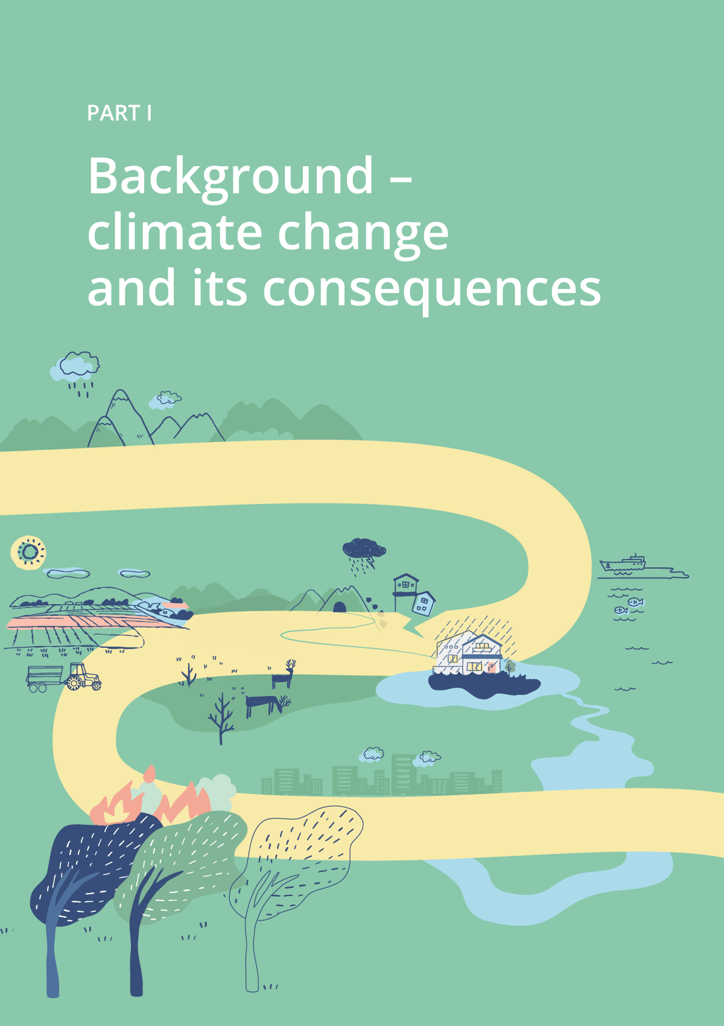

The weather is a snapshot of temperature, precipitation and wind. The climate is the average weather over a long period of time, often 30 years. We can thus say that the climate tells us what weather it is reasonable to expect in an area. When the climate clearly changes at a global level over many decades, we are talking about climate change. This chapter provides a brief summary of observed and expected climate changes in Norway.

The climate is no longer stable
The climate on Earth has always been changing, but it has been relatively stable for the past 10,000 years. It was in this stable climate that agriculture, civilisation and eventually modern society emerged. Due to anthropogenic greenhouse gas emissions, however, the climate is no longer stable. The global temperature is now rising faster than it has done for at least 2,000 years (see Figure 2.2), and the entire climate system is changing. The development is more rapid, and the impact of climate change on nature is more extensive and dramatic than previously thought. Globally, we are therefore neither well adapted to the current climate nor to the climate change that lies ahead.
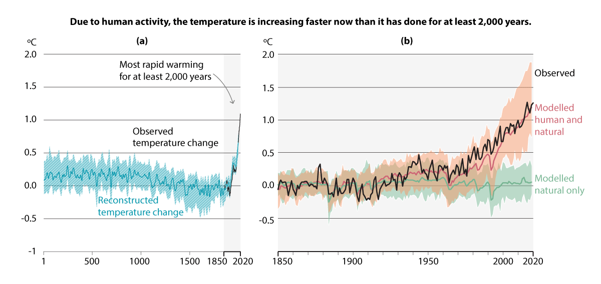
          - Development of global surface temperature. Part (a) shows the reconstructed and observed temperature in the period from year 1 to the year 2020. Part (b) shows the observed and modelled temperature in the period from the year 1850 to the year 2020. Both are compared with the average temperature in the period 1850–1900. The shaded area around the graphs represents the uncertainty of the reconstructions and models in (a) and (b), respectively.
Source: Simplification of Figure SPM.1 from Climate Change 2021: The Physical Science Basis (IPCC, 2021) was carried out by the Norwegian Environment Agency as the national focal point for the Intergovernmental Panel on Climate Change (IPCC).

Most rapid warming in the north
In Norway, warming is taking place faster than the global average. While the world is about 1.1 degrees Celsius warmer than during the latter half of the 19th century, the average temperature in mainland Norway is now more than 1.2 degrees Celsius higher than at the beginning of the 20th century.,
The temperature is rising more rapidly on Svalbard than any other place on the planet. In Longyearbyen, the average temperature has increased by more than 4 degrees Celsius since 1991 alone, and new records are constantly being set.
The strong warming in the Arctic is linked to the decline of sea ice in the Barents Sea and in the fjords of Svalbard. With less sea ice, the sea becomes more open and darker and absorbs more heat. This, in turn, melts more sea ice. More open and warmer seas will re-radiate heat to the air during large parts of the year, which will further increase warming.

Norway has become wetter
As the world warms, precipitation patterns also change. Put simply, dry areas of the world are becoming drier, while wet areas are becoming wetter. The average annual precipitation in Norway has increased by 18 per cent since 1900. At the same time, episodes of heavy precipitation have become more intense and more frequent.
Higher temperatures also cause more precipitation to fall as rain rather than snow, resulting in shorter snow seasons and earlier spring floods. The glaciers have also retreated significantly over the past century. Overall, these changes have contributed to increased runoff, with the greatest increase in winter and spring on the mainland and in summer and autumn on Svalbard.

Climate models show potential climate change in the future
Climate models and scenarios are used to estimate the scale and pace of climate change. Climate models calculate changes in the atmosphere, ice, sea and land based on physical and chemical laws. The climate models use assumptions about future greenhouse gas emissions. The level of emissions depends on the choices the global community makes in terms of energy sources, land use, population growth, governance and lifestyles.
These assumptions about the future are uncertain, and to explore this uncertainty, the Intergovernmental Panel on Climate Change (IPCC) uses different scenarios. The results from the climate models are called climate projections and tell us what kind of climate change to expect in different scenarios. The scenarios differ from each other primarily in relation to their future greenhouse gas emission assumptions.
The climate projections describe expected changes in temperature, precipitation, snow and other climate variables. The projections are used as a knowledge base for climate change adaptation in various ways, for example in land use and social planning, for dimensioning infrastructure and in risk and vulnerability analyses.

Climate change in the next few decades is largely given
Irrespective of how much greenhouse gas emissions the global community reduces today, the global temperature will continue to rise towards the middle of the century because it takes time to see the effect of emission reductions on the climate system. Global warming is likely to pass 1.5 degrees Celsius over the next 20 years.
In Norway, the trends we are already experiencing, with a warmer and wetter climate, are likely to continue over the next few decades. The differences in the changes in the scenarios are therefore relatively small in the short term. From the middle of the century, however, there is greater uncertainty about how climate change will develop, and the difference between the scenarios is greater.

Climate change towards the end of the century may be significant
This section discusses climate change in Norway towards the end of the century. Unless otherwise specified, the changes apply to the period 2071–2100 compared with the reference period 1971–2000 and are based on the high end of the range from the Norwegian climate projections.

Norway is getting warmer
The average annual temperature in Norway may become more than 4 degrees Celsius higher during the 21st century. The biggest change in temperature will be during winter. The increase will be greater the further north you go, with Svalbard potentially becoming up to 10 degrees Celsius warmer.
A warmer climate may result in more days of unusually high temperatures in Norway. The maximum temperatures may increase, and we must expect new temperature records.
Densely populated city centres with extensive areas of asphalt and dark surfaces may become particularly hot. Few cooling elements such as trees, parks and open water, and poor air circulation, will intensify this effect. On hot days, the temperature in the cities may be several degrees Celsius higher than in the surrounding areas.

More water causes additional problems
The average annual precipitation may increase by just under 20 per cent across mainland Norway and by more than 60 per cent in Svalbard during the 21st century.
Episodes of heavy precipitation will occur more frequently and become more intense. For mainland Norway, this could entail almost twice as many days of heavy precipitation. More precipitation, especially over short periods of time, increases the risk of stormwater and of more frequent and extensive rainwater flooding. Urban areas and small watercourses are particularly vulnerable to intense precipitation, especially when the ground is frozen or saturated with water, or has many impenetrable surfaces.
Higher temperatures will cause more precipitation to fall as rain rather than snow in winter, thereby increasing the winter water flow. In spring, snowmelt floods will come earlier and be smaller. More precipitation is expected in summer, but higher temperatures will also increase evaporation. If evaporation increases more than precipitation, the likelihood of summer droughts increases.
Landslide risk is strongly related to the local terrain, but weather is an important trigger. Periods of heavy precipitation may especially result in more landslides and debris floods. In the mountains, increased precipitation can lead to more naturally triggered wet snow avalanches, but fewer dry snow avalanches. Increased erosion resulting from more frequent and larger floods can trigger more quick clay landslides, although such landslides are often triggered by human activity. All types of avalanches and landslides can also be affected by natural changes in vegetation and human intervention in the terrain.

Snow and ice melting
In a warmer climate, winter temperatures in parts of the country will fluctuate more around freezing point. This will generally result in more icy conditions and more episodes of snow melting quickly or rain falling on cold ground. Across Norway, except on the high mountains and on Finnmarksvidda, snowfall could be halved or non-existent.
Permafrost is now thawing at an ever-increasing rate and will continue to do so throughout the 21st century. As a result, it may only be possible to find permafrost in the highest mountain areas on the mainland. In the low-lying areas of Svalbard, the uppermost metres of permafrost may thaw completely.
Ice will also retreat or disappear. In the Barents Sea and in the fjords of Svalbard and Northern Norway, the sea ice will decrease, while rivers and lakes in southern and low-lying areas of Norway may be ice-free throughout the year. The glaciers on the mainland could shrink by 80–100 per cent. On Svalbard, glacier ice will still cover a significant part of the land towards the end of the century, but more melting is also expected here.

The ocean is entering a new state
The ocean is entering a new state due to climate change. It is getting warmer, more acidic and less oxygen-rich. Ocean currents are changing, and the sea level is rising due to increased volume in step with the temperature increase as well as extensive ice melting on land. Since the processes in the ocean are slow, the ocean will continue to warm, acidify and rise, even after the year 2100.
Norwegian waters and coastal areas are also becoming warmer and more acidic. The Barents Sea is expected to warm the most, while coastal areas will undergo the most acidification. Marine heatwaves are expected to occur more frequently, become more intense and last longer.
Rising sea levels constitute a permanent change over hundreds to thousands of years. Globally, sea levels will continue to rise far beyond the 21st century, even if emissions are rapidly reduced. The sea level along the coast of Norway is now rising by just above three millimetres per year. This is expected to accelerate in future, although land uplift after the last ice age will reduce the effect in some coastal areas. Expected sea level rise ranges from around 15 centimetres in the inner Oslofjord and fjords of Nordland, to around 50 centimetres in Lofoten and south-western Norway.

No major changes expected in wind conditions
No significant changes are expected in the wind conditions over mainland Norway and Svalbard in the coming future. Nevertheless, great uncertainty is associated with wind because it is affected by local conditions that the climate models do not adequately capture. There is also some uncertainty regarding how storm activity, including thunderstorms, will be affected by climate change at our latitudes.

Concurrent weather events may have major consequences
As global warming increases, so does the likelihood of extreme weather and concurrent weather events. Several extreme events occurring simultaneously will pose an increased risk to society and nature. Prolonged drought combined with heat and strong winds, for example, may increase the risk of forest fires.

Tipping points in the climate system may affect Norway
Ocean circulation in the Atlantic, the Greenland ice sheet, carbon in permafrost and boreal forests are examples of tipping elements in the climate system. Such elements could shift from a stable state to a new and different state if global warming passes a temperature threshold. This is called their tipping point, and often entails a relatively abrupt change that is irreversible on the human timescale.
In the Atlantic, ocean circulation may slow down significantly and reduce heat transport towards our latitudes. The ice sheets of Greenland and West Antarctica may already have passed a point where they will continue to melt for centuries to come, thus accelerating sea level rise. Instead of gradually thawing, the permafrost may thaw abruptly as a result of heatwaves or forest fires. This will release large amounts of greenhouse gases stored in the ground. The extent of boreal forest may significantly change as a result of heat, drought and forest fires.
Just over 15 tipping elements have been identified in the world. The temperature threshold for when they tip into a new state varies for each element, and there are large uncertainties about the temperature at which this could occur. Some elements may already have passed their tipping points, while others require higher temperatures. Nevertheless, it may take time until the effect can be observed. The risk of crossing tipping points increases with continued global warming.
Research shows that global warming above 1.5 degrees Celsius increases the likelihood of multiple tipping points being crossed. Further warming increases the risk of crossing even more tipping points. Crossing such tipping points may produce major ripple effects in the climate system, including forest dieback, changes in ice extent and greenhouse gas emissions from thawing permafrost.

Consequences for nature and society
The IPCC’s Sixth Assessment Report shows that global warming threatens the basis of life and the state of the planet. The report also shows that the destruction of ecosystems increases people’s vulnerability, and that unsustainable land use reduces the ability of ecosystems, society and individuals to adapt to climate change. Climate change is recognised as being a serious threat to world peace and stability and could be an obstacle to poverty alleviation globally. Climate change could also have a negative impact on gender equality.
Since the previous white paper on climate change adaptation (Report No 33 to the Storting (2012–2013)), there have been major advances in knowledge about the consequences of climate change for nature and society in Norway. Among other things, we know more about how climate-related events can trigger chain reactions across sectors, industries and countries. We have also gained new knowledge about how climate change, together with other changes in society, such as urbanisation and technology dependence, are important drivers of new and increased risk and vulnerability in society. Nature is already highly vulnerable through, among other things, land-use changes and pollution. Climate change increases the overall impact on nature and gives rise to a more complex picture of risk in society.
Delimitations and prerequisites
This chapter highlights the expected, and to some extent already observed, impacts of climate change. It highlights the breadth of the impacts on nature and society and illustrates their complexity. It does not provide an exhaustive picture of the impacts, nor do the descriptions relate to a specific emission scenario or time horizon. The descriptions must also be seen in light of uncertainty about future greenhouse gas emissions and the effects and consequences of different degrees of warming.
The description of the various impacts reflects the fact that there is more knowledge in some areas than in others. There is also more knowledge about the impact of climate change in Norway, compared with knowledge of the ripple effects for Norway of climate change elsewhere in the world. Some issues have been known for some time, especially in areas where climate change is exacerbating existing challenges, while in other areas, new issues are emerging. There is also limited knowledge about the interaction between different risk factors and how the impacts of climate change in one sector may have consequences for others.

Society as a whole is affected by climate change
Chapter 2 makes reference to the fact that the climate is already changing in Norway. In addition to having a major impact on nature, the changes affect social conditions, the economy, the public sector and the business sector. Climate change is a challenge for public security and makes increased demands of both prevention and emergency preparedness. Furthermore, climate change may increase the need for assistance and emergency aid to vulnerable areas and have implications for foreign policy, as well as security and asylum policy.
Climate-related risk exists in a complex interaction with other types of risk, and often reinforces other risk factors. The consequences of pandemics and war are examples of risk factors that may interact with climate change.

The impacts are direct and indirect
Climate change affects Norway directly. An example is that increased rainfall leads to more frequent floods, landslides and stormwater events, which damage buildings and infrastructure, arable land, outdoor areas and cultural environments. In severe cases, this may also pose a risk to life and health. Other examples are more frequent periods of prolonged drought that pose challenges to agriculture, and heatwaves that are a potential health risk to vulnerable groups. Society is also affected by the ripple effects of climate-related events. For example, flood-closed roads can lead to service disruptions and considerable costs for both the public sector and the business sector.
Climate change also knows no national borders. Climate-related risks are transferred between countries through, among other things, trade and global value chains, financial systems and shared ecosystems. Climate change may, for example, lead to a reduction in global food production, in turn increasing the risk of supply shortages and higher prices for food products that Norway must import.

Climate change impacts unequally and may exacerbate social inequality
Social, geographical and economic conditions largely determine how vulnerable people are to climate change. At the same time, climate change could exacerbate existing inequality and vulnerability. Older people, children, socio-economically disadvantaged people, people with disabilities and people with health issues are often more vulnerable to climate change than others. For example, climate change may lead to more expensive fruit and vegetables, which would be detrimental to public health and nutrition, especially for people with low incomes. Higher temperatures and more heatwaves may increase health risks going forward, and the chronically ill, elderly and socio-economically disadvantaged groups are most at risk. Young people, to a greater degree than older people, are affected by anxiety and worry relating to climate change.

The economy and business sector

The Norwegian economy is affected
Since climate change affects all areas of society, it also impacts the Norwegian economy. The impact of climate change globally will affect the Norwegian economy as Norway is a small, open economy. The Climate Risk Commission, which assessed climate-related risk factors and their significance for the Norwegian economy in 2018, pointed out that due to the uncertainty of international developments, climate change could entail a wide range of potential developments for the Norwegian economy. The Commission concluded in Norwegian Official Report NOU 2018: 17 Climate risk and the Norwegian economy, however, that the Norwegian economy appears to be relatively robust. The Commission also concluded that well-functioning political institutions, a high level of education and income and a generally adaptable economy provide a good basis for managing climate risk. The Climate Risk Commission considered that risks associated with climate change in other countries will dominate the risk landscape for the Norwegian economy in the long term, especially if the changes lead to extensive migration and weaken international political institutions.
Although many of Norway’s most important trading partners are considered relatively resilient to climate change, we also have close trade ties with countries that are particularly vulnerable to climate change, such as Brazil and China.

The foundations for business and industry are changing
Climate change affects the business sector in different ways, by directly or indirectly affecting the activities of individual industries and companies, and through its consequences for other areas of society. This section describes the impacts of climate change on the business sector in general.
              - Sustainability risk
Both the impacts of a changing climate and loss of biodiversity, and the transition to a more sustainable economy, entail risks for actors in the financial markets. Sustainability risk is a collective term for risks related to environmental, social and governance issues.
Uncertainty related to the consequences of climate change and emission reduction measures gives rise to economic and financial uncertainty. Physical climate risk is linked to the consequences of climate change. Transitional risk is about the implications of climate policy and the technological developments involved in the transition to a low-emission society. Financial institutions must identify sustainability risks, including climate risk and other environmental risks to which they are exposed. Monitoring and responding to the system effects of risks is an important task for government authorities.
Nature is important for value creation, including as a basis for producing food, medicines and a variety of materials. At the same time, economic activity impacts nature and ecosystems. If this damages or leads to the loss of nature, it also entails financial risk. Since loss of nature poses a risk to business and the economy and is a major threat to sustainable development, the Government has appointed a nature risk commission to investigate how Norwegian industries and sectors are affected by physical nature risk, and how they are affected by stricter framework conditions. The commission will present its report by the end of 2023.
[Boks slutt]
The impact of climate change on the business sector as a whole must be seen in light of the continuous transformation and development taking place in the sector, with companies constantly having to adapt to changes in markets and technology. How individual companies and the private sector as a whole are affected by climate change depends, among other things, on the type of company and industry in question, their location, connection to infrastructure and what links the company and industry have to other countries. For many of the companies, climate change will entail costs associated with adaptation and restructuring. However, the changes may also present opportunities for new business ventures and value creation, for example by improving growth conditions for certain agricultural species.
Industries that are largely based on natural resources, such as agriculture, fisheries and aquaculture, and the energy industry, are particularly vulnerable to the impact of climate change on nature. These industries are directly exposed to changes in the frequency, scale and variation of weather phenomena. Primary industries that are based on the harvesting and renewal of natural resources, such as agriculture and fisheries, are also vulnerable as climate change affects the ecosystems that they depend on.
The impact on primary industries can, in turn, affect secondary industries, such as the food industry and the timber industry, that process raw materials from primary industries. The challenge of bark beetles in forestry, for example, can lead to a shortage of timber, which, in turn, can spread through the value chain and affect timber producers and ultimately the construction industry.
Tertiary industries will also be directly or indirectly affected by climate change. Nature-based tourism is particularly affected by the impact of climate change on nature. The retreat of glaciers and winters with little snow are examples that, in the long run, may significantly change the conditions for such activities.
              - Businesses hit by flooding
Heavy rain hit Hyen in Gloppen municipality on 30 July 2019. The Årneselva river overflowed its banks, and soil and stone masses inflicted a great deal of damage to the boat builder Brødrene Aa. The company, which specialises in the construction of energy-efficient passenger boats, sustained extensive damage to its production facility. The river reached the shipyard and filled the entire second level with water before the floor eventually collapsed. Vast amounts of stone, gravel and sludge were carried into the premises. In addition to insurance payments of approximately NOK 40 million, a two-month hiatus in production resulted in a sharp drop in turnover and postponement of planned deliveries. The neighbouring company, the smolt producer Hyen Fisk, was also affected by the rough weather. The company sustained minor damage to its premises, but lost a lot of fish in the aftermath of the event.
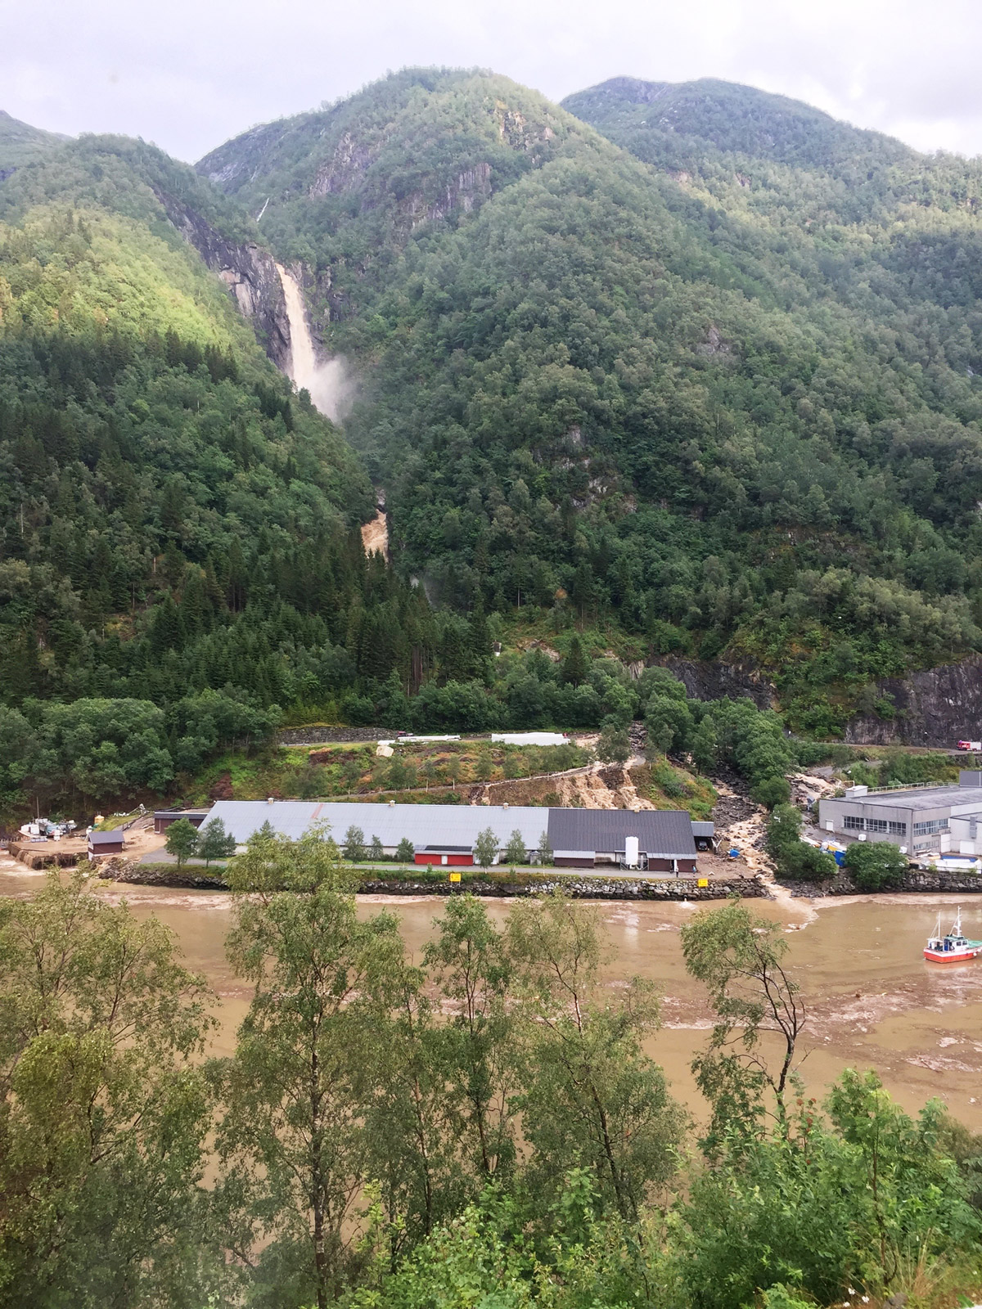
          - The flood in Årneselva river in 2019.
The facilities sustained extensive damage.
Photo: Brødrene Aa
[Boks slutt]

Climate change affects value chains, infrastructure and prices
The indirect impacts, i.e. the ripple effects of climate-related events, will be felt by many businesses. Companies are generally dependent on well-functioning power and communication infrastructure, that employees are able to get to work and that goods can be transported to and from their facilities. Events such as floods and landslides may lead to disruptions and delays in these systems. There are already several examples of production sites with international value chains being isolated as a result of floods and landslides.
Many Norwegian companies are part of cross-border value chains and are thus exposed to the risk of climate change in other countries. Disruptions in important transport networks abroad will also affect Norwegian actors. The same will apply to changes in production conditions elsewhere, such as higher prices of imported input factors for Norwegian businesses. Norway has significant imports of feed products from North and South America and Asia. Norwegian direct investments in real estate and oil and gas installations in other countries are also vulnerable to climate change. Norwegian investment portfolios are also exposed to climate-related risks, especially in parts of the world where the impacts of climate change will be particularly severe.

The insurance industry is affected
Climate change will affect all branches of the financial industry, especially insurance companies. The insurance industry assumes the risk of unforeseen damage, including events caused by nature. Finance Norway points out that there has been an increase in damage to buildings and household contents as a result of weather and nature-related events in recent decades. During the period 2001–2020, the number of reported flood-related claims in Norway increased, and both total compensation costs and the average compensation amount per claim increased. In its most recent climate report, Finance Norway states, among other things, that more than NOK 30 billion has been spent over the past 10 years on compensating damage to buildings and household contents.
The Stormwater Commission, which in 2015 submitted its report on the management of stormwater in urban areas, estimated the total claims costs incurred due to stormwater to be between NOK 1.6 and 3.6 billion annually.
              - Increased reinsurance costs
Reinsurance enables an insurance company to spread part of its insurance risk to other companies, so that more companies jointly cover the risk.
Climate change may bring about a situation internationally where reinsurance providers are no longer as willing to share the insurance risk associated with climate-related claims in Norway. Among other things, they no longer want to cover claims that occur frequently. This may lead to higher reinsurance costs for insurance companies. For example, the price of reinsuring the Norwegian Natural Perils Pool increased by 34 per cent for 2023. This may, in turn, result in higher costs for the insured party – be it a private household, special interest organisation, company or public authority.
Source: Fremtind Forsikring.
[Boks slutt]

Nature and ecosystems

Serious consequences for nature
The effects of climate change on nature are more severe and extensive than previously expected. Both species and habitats are negatively affected. The ecological state of ecosystems, and thus also the ecosystem services nature provides, is deteriorating. The Norwegian Nature Index, which measures the state of biodiversity, shows that climate change has a major negative impact on biodiversity in the oceans, in the seas along the coast and in the mountains.
Loss and degradation of nature exacerbate the effects of climate change, such as droughts and floods. The loss of habitats as a result of encroachments is currently the greatest threat to biodiversity in Norway, and climate change often acts as an additional burden, exacerbating the negative impacts of land encroachment and other encroachments on nature. Nature’s vulnerability to the changing climate could be intensified by the fact that human impacts, including through land use and pollution, reduce species’ and ecosystems’ ability to withstand climate change.
              - Ecosystem services
Ecosystem services are the goods and services that nature provides which contribute to human welfare. This includes food, materials, medicines, clean water, fresh air, pollination, recreation and outdoor activities. Well-functioning ecosystems and a rich biodiversity form the basis for human survival on Earth. Nature has evolved over millions of years into a huge variety of species and genetic forms. This variety makes nature resilient to changes in the climate and other external influences. The loss of biodiversity makes nature less resilient and less able to withstand change – including climate change.
[Boks slutt]

Changing habitats
The Norwegian Red List for Species shows that climate change is one of the major factors affecting habitats in Norway, so much so that they may be lost in the long term.
Climate change is expected to lead to some habitats increasing in size, while others decrease. Forest areas, for instance, are expected to increase, while the extent of mountain moors and ocean beaches will most likely decrease. At the same time, although forests can be expected to grow in size, climate change will also increase the risk of drought, forest fires, plant diseases and the spread of parasites and other species that cause damage.
The Norwegian Scientific Committee for Food and Environment writes the following: ‘The forest ecosystem is more resilient to rapid climate change, including interferences such as fires, temperature stress, damage and disease, when the forest consists of a diversity of species of tree, including various deciduous trees, and when it contains several age classes, high biodiversity, and complete nutrient networks. Mixed stocks are less susceptible to interference than stocks of a single species or age group. Pure, same-age spruce stocks are by far the most vulnerable. Mixed stocks house greater biodiversity, making them, and, on a larger scale, the forest as an ecosystem, more robust and resilient to climate change.
Damage to the forest may reduce carbon uptake and carbon already stored in the Norwegian forest and negatively affect forest-based industries. The Scientific Committee’s report only considers natural distribution and adaptation of forest trees. Through forest plant breeding and active silviculture, spruce forests can be made more resilient to climate change while also increasing production and carbon uptake.
              - Glaciers in Norway are retreating
The glaciers are sensitive to climate change. Analyses show that even though precipitation looks set to increase in the future, it will not compensate for increased ice melt due to rising temperatures. The glaciers will continue to melt with increasing intensity. High levels of greenhouse gas emissions could lead to two thirds of glacier ice in Norway disappearing in 70–100 years.
Glaciers are important landscape elements. They are also important natural water reservoirs that provide water to the rivers during the melting period. A number of hydropower plants use inflows from glaciers. Glacier melt also affects the flora and fauna in the areas around glaciers.
The Norwegian Water Resources and Energy Directorate (NVE) conducts measurements of Norwegian glaciers to monitor developments and document the effects of climate change. All the monitored glaciers have retreated over the past 20 years.
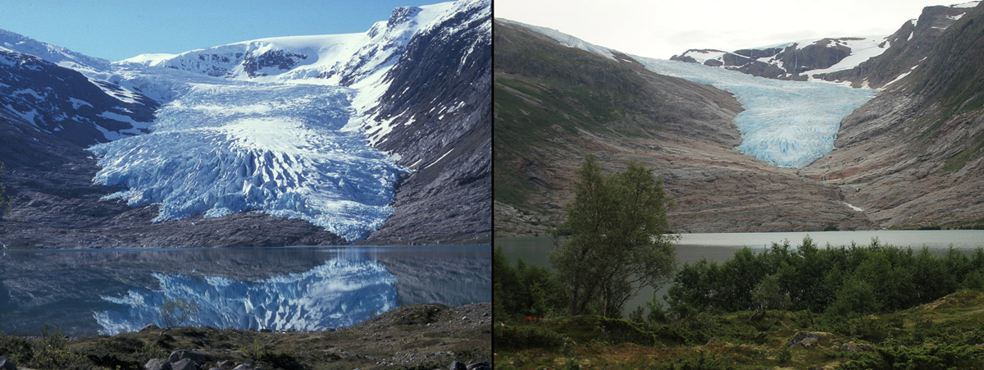
          - Engabreen glacier.
Engabreen is an outlet glacier of the Svartisen glacier. From 1998 to 2021, the glacier retreated 668 metres.
Photo: Hallgeir Elvehøy, NVE.
[Boks slutt]
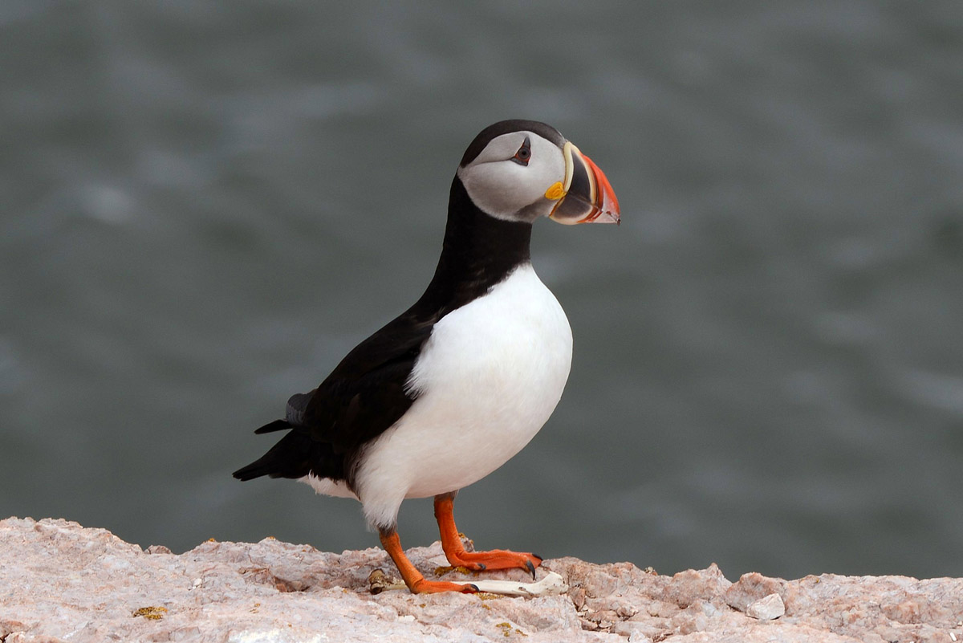
          - Puffin.
Many seabirds are affected by climate change. The puffin, pictured, is one of the species suffering a food shortage because the fish it feeds on has migrated due to warmer waters. The puffin was included in the Norwegian Red List for Species in 2021.
Photo: Geir Wing Gabrielsen, Norwegian Polar Institute.

Many species are vulnerable to climate change
The 2021 Norwegian Red List for Species (the Red List) provides an overview of species that are at risk of disappearing from Norway. Climate change has been cited as a negative impact factor for almost 10 per cent of the endangered species in Norway and Norwegian marine areas on the 2021 Red List. Species that live in Arctic and alpine areas are especially threatened by climate change. Many more species are expected to struggle with increased warming. Time is another important factor in the assessment. Assessments of how endangered the species on the Red List are take a ten-year perspective. Thus, in a longer perspective, many more species may in fact be threatened by climate change.
For species that thrive in warmer environments, a milder climate may be positive, but as species migrate, the interaction and competitive relationship between the species changes. The spread of species to new regions may occur at the expense of species that already have habitats there. One example is the red fox, which is a strong competitor to the arctic fox as it migrates further up into the mountains. Harmful alien species have a negative impact on the state of ecosystems, and climate change enables many such species to becomes established in Norway.

The ocean is getting warmer and more acidic
Climate change affects the ocean through higher temperatures, and through higher carbon content leading to ocean acidification. Temperature and salinity are decisive for the species and diversity we can expect to find in Norwegian waters. Various species of fish and other animals in the ocean and along the coast are migrating further north, altering the conditions for other species in the food chain. Seabirds are affected by changes in access to fish and other prey.
When the ocean becomes more acidic, it loses carbonate, which is an important building block for many animals and algae that build skeletons or shells. A more acidic ocean may therefore cause major changes to ecosystems. Higher sea temperatures may lead to a number of species gradually being forced northwards, affecting the species that already live there, which in turn has major ripple effects in the ecosystems. One example can be found in the North Sea where the copepod Calanus finmarchicus is outcompeted by the more heat tolerant Calanus helolandicus. The latter is less nutritious and is available later in the season, making it less suitable as food for, among other things, the vulnerable North Sea cod. Another example is mackerel migrating north and taking over the habitats of Arctic cod, a key species in Arctic ecosystems.
              - Warmer water affects salmonids and may increase the prevalence of humpback salmon
The climate affects salmon, sea trout and Arctic char throughout their life stages and habitats, among other things through its impact on water temperature, growth conditions in the sea, water quality and other environmental factors. Climate change increases the need to conserve large and genetically diverse salmonid stocks to provide opportunities for them to adapt to the rapid changes.
Humpback salmon is an alien species that is considered to pose a high ecological risk to mainland Norway and its marine areas. Large populations of humpback salmon may have a negative impact on native salmonids and the biodiversity of rivers in general.
Humpback salmon in the Atlantic and Barents Sea appear to be more likely to thrive in ecosystems that have changed as a result of warmer ocean waters, compared to our own Atlantic salmon. The chance of humpback salmon surviving and becoming established will thus probably increase in step with the warming climate.
Source: Forsgren et al. (2018).
[Boks slutt]
In addition to an increase in the average temperature of the ocean, more marine heatwaves are also expected. Marine heatwaves may be more destructive to marine life than terrestrial heatwaves are to flora and fauna since marine species are adapted to relatively stable temperatures and have fewer opportunities to avoid the heat. Kelp forests along the Norwegian coast, which are important natural carbon stores, are also vulnerable to marine heatwaves.
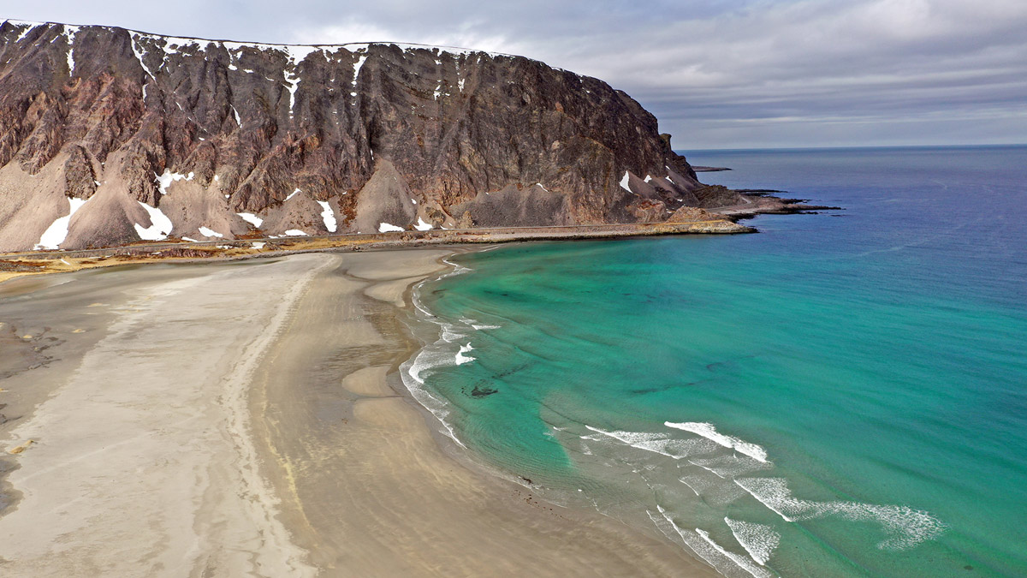
          - The Sandfjord off Berlevåg in Finnmark.
More than half of all the days of heatwaves in the Barents Sea from 1982 to 2020 have come in the past decade.
Photo: Allan Klo, NRK.

Particularly large impacts in the Arctic
Many species adapt to a warmer world by migrating further north or by seeking higher altitudes. For species that already live in high mountain areas or in the Arctic, there are few opportunities for such adaptation. The consequences of this could be vast and unpredictable, and change entire terrestrial and marine ecosystems. In the Arctic part of Finnmark, new attacks by autumnal moths have caused huge damage to birch trees, and lemming years are becoming rarer. In addition, some species, such as Arctic foxes and snowy owls, are endangered.
Arctic sea ice reduction will also threaten many animal species. As the ice disappears and more and more marine and coastal areas become ice-free for all or large parts of the year, some species of seal will lose their habitats, and the polar bear will lose its hunting grounds. Many other species that depend on the sea ice will also disappear from increasingly large parts of the Arctic. Svalbard is one of the places in the Arctic where sea ice is declining fastest, both in summer and winter. There is now more rain during winter in the Arctic than before and thus more rainfall on snow. This can result in ice formation on the ground and prevent animals from reaching grazing lands. This may affect herbivores in Svalbard, such as the Svalbard rock ptarmigan and Svalbard reindeer. At the same time, a longer growing season will increase plant growth and food availability for herbivores during summer.

Outdoor life

The conditions for outdoor life are changing
Climate change will alter the conditions for outdoor life, as it will change what outdoor activities can be done at different times of the year. The biggest changes will be during winter. Less snow will result in significantly fewer days of skiing, especially in the lowlands. Snow depth has been measured at Bjørnholt in Nordmarka in Oslo since 1896. The number of ski days has dropped from 136 to 95 since only 1990. Nationally, the number of days when the conditions are right for skiing is already one month shorter than just 30-40 years ago. At the same time, a lack of snow will allow outdoor activities that have previously mainly been done during the summer months to be practised throughout the year. This applies, for example, to cycling and hiking in outlying land.
Higher temperatures in summer may lead to increased use and more pressure on beach areas along the sea, lakes and watercourses. This, in turn, will lead to more degradation of the natural environment. Higher temperatures and more precipitation will also lead to increased growth, causing outlying land to become overgrown. More precipitation could pose challenges on paths and hiking trails and increase the need for maintenance. In combination with visitor growth at the hiking destinations, the need to build footbridges and facilitate increasingly wet trails, re-route trails near landslide areas and repair bridges in the mountains will increase.

Food security and food production
Climate change has already reduced food security in the world. Food security is defined as all people, at all times, having physical and financial access to sufficient, safe and nutritious food that meets their nutritional needs and food preferences so that they can live active and healthy lives. Food security is affected by climate change in that global warming diminishes the properties of arable land, increases pressure from plant pests and animal diseases, reduces the abundance of terrestrial and marine fauna and impairs important ecosystem services such as pollination. Global food security is also threatened by droughts, floods, heatwaves and rising sea levels.
Vulnerability to reduced food security is exacerbated by underlying conditions such as poverty, social inequality, poor sanitation and limited access to water, macroeconomic and political upheavals, and conflict.

Climate change presents a risk to the food system
The food system consists of a number of actors, processes and activities, in addition to value chains that often cross national borders. From the primary production of food to it ending up on the consumer’s table, factors such as climate, environment, infrastructure, technology and labour have been linked in production and supply chains.
Agriculture in Norway is directly affected by climate change and must be further developed and prepared for a warming climate, with longer frost-free periods, extreme precipitation, drought and changed biodiversity. Crop failures in other parts of the world, and subsequent fluctuations in global food prices will also have spillover effects in Norway. Around 65 per cent of Norway’s food imports come from the EU. Food production in southern Europe is expected to be severely affected by droughts and heatwaves in particular. This may affect Norway’s imports of fruit and vegetables from these areas. There is also an increased risk of important production areas being affected by climate-related events simultaneously. As is the case in other areas, vulnerability is exacerbated when climate-related risk is seen in conjunction with other risk factors.
              - More knowledge about climate risk in the Norwegian food system
The report ‘Climate change challenges the Norwegian food system’ addresses the potential effects of climate change for food production and ‘farm to fork’ value chains by the middle of this century (Norwegian Institute of Bioeconomy Research, 2022). The report concludes that Norway has a generally robust food system with a good ability to adapt to changes in international conditions and variable crops at home. Nevertheless, the Norwegian food system is expected to be put to the test going forward. Extreme weather, warmer oceans, pests and diseases will make it challenging to produce food in the future. The report highlights, among other things, the capacity of the public administration, particularly of the Norwegian Food Safety Authority, as a vulnerable area with respect to the impact of climate change on the food system.
Globally, climate change could result in poorer crops and crop quality. This will also affect Norway, as we import substantial amounts of food, feed and raw materials.
[Boks slutt]

Norwegian agricultural production will be affected
The growing season in Norway is expected to lengthen. At the same time, an increase in extreme weather and drought is also expected, as well as an increased incidence of plant and animal diseases, which could reduce productivity. Increased rainfall will entail more difficult growing and harvesting conditions, while intense episodes of rainfall can damage crops. This also increases the risk of flooding, landslides and erosion with ensuing damage to agricultural land.
Although the annual precipitation in Norway is expected to increase, some areas may experience more drought during summer, which can also affect important areas for the production of food grains and other crops.

Climate change impacts fisheries and aquaculture
Climate change leads to a warmer, more acidic and less oxygen-rich ocean. This may, among other things, lead to lower productivity in marine ecosystems, reproduction failure and the migration of fish stocks. Some of the biggest changes in the world are expected to be observed in the Barents Sea and the northern parts of the Norwegian Sea.
Climate change affects the condition of ecosystems, leading to widespread structural changes. This is, for example, evident in the establishment of heat tolerant species in areas dominated by Arctic species. Such changes affect fish stocks, the state of aquaculture locations and the raw material basis for the fish processing industry. This increases predation pressure on the species already found in these areas. For Arctic species, less ice cover is also expected to lead to loss of habitat and available prey.
For fisheries, higher temperatures will result in more dispersed distribution of fish stocks, making it more costly to monitor and harvest fish. Increased runoff may contribute to eutrophication in the fjords, for example, thereby reducing the quality of nursery and adult habitats for local coastal stocks. At the same time, some stocks are likely to adapt to higher temperatures more efficiently and increase in size, while some migrate from warmer waters.
The size of fishing quotas is calculated based on scientific assessments of the state of different fish stocks. Climate change affects this state and thus also which and how much fish can be harvested. The migration of fish species can make it difficult to calculate fishery quotas because it is not known exactly how the stock will develop, how ecosystems are affected and because the species may migrate to other countries’ marine areas. Fish populations may increase in some areas, but decline in others.
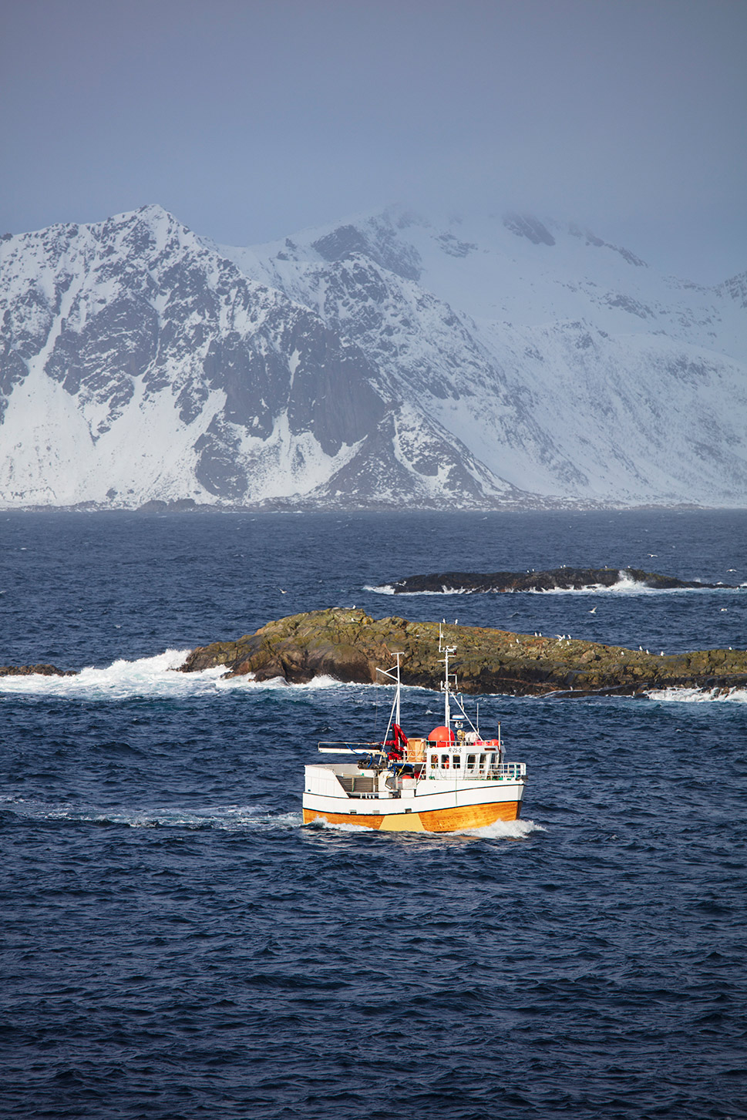
          - Less spawning cod in Nordland.
Climate change will change the cod’s spawning patterns. In the future, the cod may migrate further away from Lofoten towards the northern coast of Russia to spawn, according to a study by the Norwegian Institute of Marine Research (2020). Warmer oceans are the main explanation for these conclusions. The study also shows that there may be other reasons for the cod changing spawning habits. Spawning migration is probably also affected by the location of the sea ice cap. The cod feed throughout the ice-free part of the Barents Sea. When the ice cap draws northwards during warm periods, the distance to the southernmost spawning grounds generally increases.
Photo: Trond Isaksen, Directorate for Cultural Heritage.
The aquaculture industry is also affected by climate change. The industry is vulnerable to temperature increases since farmed species are adapted to current temperatures and any increase will lead to poorer living and growing conditions. Higher sea temperatures also entail higher biological risks associated with disease, algae blooms, salmon lice and other parasites. Rising sea temperatures may therefore in the long term lead to changes both in terms of which species are used in aquaculture, which areas are best suited for production and localisation patterns.
Extreme weather events may affect the fish farms. An increase in the frequency and severity of extreme weather events may require more robust farms. Increased runoff of environmental pollutants from land to the sea as a result of increased precipitation could also have consequences for the fish farms. Drought may affect access to water for land-based facilities.
The industry may also face the risk of potential limitations on the supply of feed and increases in the prices of imported feed. Farmed fish in Norway are fed both animal and vegetable feed, such as fishmeal and soy, and 90 per cent of the raw materials for the fish feed are imported. Research shows that climate change could reduce the world’s soy production by up to 3.3 per cent per decade going forward in this century.

Life and health

The climate crisis is also a health crisis
The World Health Organization (WHO) states that climate change is the greatest health threat facing humanity. Climate change will affect health and living conditions, both physically and mentally. Heatwaves, droughts, forest fires, extreme weather, reduced access to food and clean drinking water and changes in insect-borne diseases are examples of how climate change can impact health and health systems. Climate change thereby contributes to disease, premature death, malnutrition and mental ill-health. There is a global increase in climate-related health challenges. The impact of climate change on health is often unevenly distributed in and across societies – and this will continue because of differences in exposure and vulnerability to climate change. People with underlying, chronic disease, for example, are particularly likely to experience negative health effects.
Norway’s geographical location, robust economy and well-developed healthcare system make it less vulnerable to the effects of climate change on health compared with many other countries. However, there is an increasing incidence of extreme events such as floods, landslides and heatwaves linked to climate change, and the prevalence of some infectious diseases has increased due to the rise in average temperatures. These trends are expected to increase.
              - More heatwaves in Norway
Climate change is causing more heatwaves, also in Norway. According to the Norwegian Meteorological Institute (2022), there has been a significant increase in the number and distribution of heatwave events in Norway in the period 1990–2019 compared with 1961–1990. This trend is expected to continue. In order to be defined as a Norwegian heatwave, the average maximum temperature must be above 28 degrees for five consecutive days. The average must also be a minimum of 16 degrees throughout the day.
Heatwaves can be stressful and potentially dangerous, especially for vulnerable groups. High temperatures over time can lead to dehydration, headaches, difficulty sleeping and a generally reduced state of health. Some people are more vulnerable to heat than others, such as infants, the chronically ill, the elderly and socio-economically disadvantaged groups.
High temperatures also have consequences for the mental health of people both with and without underlying mental illnesses. They exacerbate anxiety and depression, for example, and can generally aggravate symptoms for people with mental illnesses. Heatwaves also affect the ability to think and reason in people without a mental illness.
[Boks slutt]
In Norway, public health and the health service will be affected by various factors relating to climate change, generally speaking an intensification of the risk posed by the current climate. An increase in extreme weather events and more frequent floods and landslides can cause damage and loss of life. It will also threaten critical infrastructure such as health and care institutions, roads, the power supply and phone connections, which in turn pose an increased risk of death and injury. Climate-related events may also affect the accessibility and availability of health and care services, such as home-based services. Furthermore, the number of days with temperatures of around zero degrees Celsius is expected to increase over the next few decades in some parts of the country, leading to more icy conditions on the ground and greater risk of accidents and falls.

Increased prevalence of existing and new infectious diseases
Illness transmitted via a biological carrier, where the carrier is not necessarily ill itself may become more common among people and animals in new parts of the country. Ticks are one example in this context. They spread the bacterial disease Lyme disease and the viral disease tick-borne encephalitis. Ticks are expected to move further inland, further north and higher up as the temperature rises, snow cover decreases and the growth season lengthens. Diseases spread through alien species may also begin to emerge in Norway.
Global warming will also increase the prevalence of existing and new infectious diseases in the world. Norwegians travelling abroad may pick up such diseases and bring infection back to Norway. A new report shows that climate change may increase the risk of pandemics.

Food security and drinking water quality will be affected
Food sold in Norway and drinking water from Norwegian water supply systems are generally safe. However, climate change could also be a challenge in this context. Rising temperatures and more precipitation may lead to undesirable microorganisms thriving in food products. For example, mycotoxins in feed and food are expected to increase, potentially leading to acute poisoning or long-term negative impacts on the health of both people and animals. A warmer and wetter climate may also lead to the release of more environmental toxins from waste disposal sites, which could end up in the food we eat.
Higher temperatures, torrential rain and floods can affect the quality of drinking water and increase the risk of water-borne infections and challenge the capacity of water purifying plants. Floods and landslides can damage the pipe network and thereby cut off the water supply. Periods of drought can lead to water shortages. Cyanobacterial blooms, which produce toxins, could be another consequence of an increase in the sea surface temperature.

Increased risk of allergies and asthma
An increase in temperature will also lead to more air pollution because it increases the amount of small particles and levels of ground-level ozone. This may impact health by reducing lung function, lead to more cases of bronchitis and asthma, a higher risk of respiratory infections and higher mortality from cardiovascular diseases.
An increase in temperature will change the growth conditions for trees and plants that produce pollen. This may intensify and extend the pollen season and expand the areas in which pollen is a problem for health. New plants with very allergenic pollen, such as ragweed, could gain a foothold in Norway. This will aggravate the symptoms for those who are already allergic and may lead to more people developing allergies.

Climate change affects mental health
For many people, and young people in particular, climate change may be a source of concern and may affect mental health. Globally, we have seen an increase in the incidence of post-traumatic stress disorder, depression and anxiety in the aftermath of climate-related disasters caused by extreme weather events such as storms, heatwaves, droughts and forest fires.

Buildings and infrastructure
Climate change brings about the need for buildings and infrastructure to withstand extreme events. This includes more intense precipitation events, floods and landslides. Some areas that are already at risk will become even more so, while some areas that are at present considered safe will become more at risk of such events. The Office of the Auditor General’s study of the authorities’ work on the adaptation of buildings and infrastructure shows that 116,000 of today’s buildings may be in areas at risk of 200-year storm surge events in 2090. This is 60 per cent more than those at risk of a 200-year storm surge today.

Increased impact on buildings
Floods and stormwater increase the risk of water penetrating buildings. For many towns, stormwater is already a major problem, and intense rainfall causes severe damage to buildings in Norway every year.
Increased and more intense rainfall will also result in more problems relating to damp. The risk of rot in wooden structures largely depends on the local weather and climate, and climate change will bring more areas of Norway into the risk zone. Mould in buildings poses a health risk, as it may aggravate or cause allergies and other respiratory problems.
              - Torrential rain and stormwater in Fredrikstad
In September 2019, parts of Fredrikstad experienced torrential rain. One measuring station in the town registered 50 millimetres of rain in just two hours. The rain overwhelmed the water mains, flooding around 250 cellars, making it the most expensive weather event in Norway in 2019 for insurance companies, which had to pay millions of kroner in insurance payouts. Analyses show that climate change will lead to more frequent and intense episodes of torrential rain in Norway.
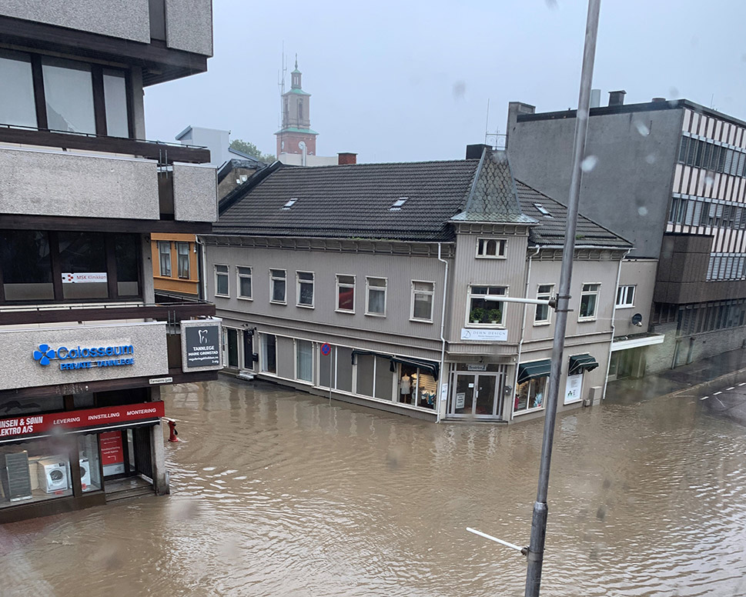
          - Fredrikstad.
The torrential rain in Fredrikstad in 2019 flooded streets and basements.
Photo: Merete Aarøy.
[Boks slutt]

Increased impact on transport infrastructure
The increase in episodes of intense rainfall and flood and landslide events will cause particular problems for roads and railways. In recent years, many water-related events have caused major damage to and economic costs for roads and railways in several parts of the country. The increased likelihood of various types of landslide and rockfalls can impact road safety and lead to more frequent traffic disruption. Higher storm surge levels as a result of rising sea levels could have the same impact. Maritime infrastructure is also affected by rising sea levels, ocean acidification and generally harsher climatic conditions. Climate change will generally lead to higher impact and wear on such infrastructure.
Sea level rise is an important issue for airports, as many airports are only a few metres above sea level and runways are often built on landfills in the sea. Increased rainfall will make higher demands of runway drainage. More water and increased runoff may also create challenges as the water accumulates the chemicals used to de-ice aircraft.
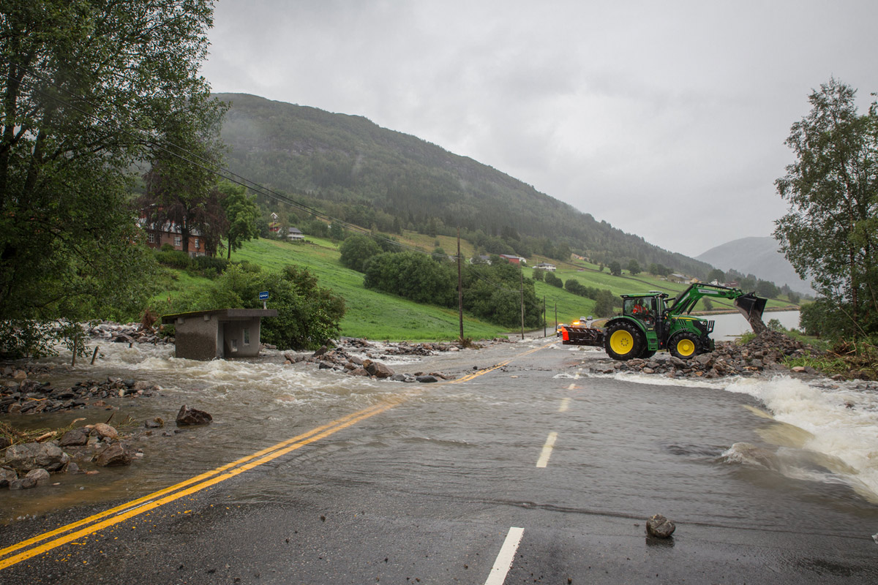
          - Jølster, 30 July 2019.
Clean-up work on the E39 road along Jølstravatnet lake, between Skei and Vassenden, following a landslide as a result of torrential rain.
Photo: Silje Drevdal, Norwegian Public Roads Administration.

Challenges of water and wastewater management
Water and wastewater systems are critical infrastructure, and the water mains and treatment plants in many places sorely need maintenance and upgrading. Increased rainfall, and particularly intense episodes of rainfall, will put a great deal of pressure on the water and wastewater system, thereby exacerbating the challenges.
Inadequate capacity in the water mains may lead to untreated waste water leaking into rivers, lakes or the sea. Overloading waste water treatment plants will make it difficult to treat the waste water effectively, with potential impacts on health and the environment. During heavy rainfall and flood situations, drinking water may be at risk of contamination since pipes and manhole covers may be submerged, and contaminated water may penetrate the water supply. Cities and towns are particularly at risk in the event of a water shortage or contamination of drinking water.

Impact on the power supply
NVE has assessed the vulnerability of power infrastructure with respect to climate change. NVE believes climate change will increasingly affect power infrastructure in the form of major floods that increase pressure on dams, the risk of more icing of power lines and risk of storm damage. Already today, climate and weather conditions cause most of the faults and disruption in the distribution network, for example by trees falling over power lines. Climate change may also bring about an increase in the potential for hydropower production as a result of more rainfall.

Rapid warming affects buildings and infrastructure in Svalbard
Global warming is even stronger in Svalbard than in mainland Norway, and flooding and thawing of permafrost affects its buildings. The rising temperature of the permafrost will lead to poorer bearing strength, an increase in subsidence damage and challenges with erosion. Changed snow and avalanche conditions threaten at-risk buildings in Longyearbyen. Several houses have been destroyed by avalanches, and lives have been lost. The increased risk of avalanches has led to the demolition of several houses in Longyearbyen.
Stormwater management is another major challenge in Svalbard. Due to the permafrost and ice cover, even moderate amounts of rain can result in significant runoff. Poorly developed and, at times, ice-filled culverts and supply pipes may present challenges in the form of closed roads, problems for air traffic and icing of infrastructure. Thawing permafrost already creates challenges for Svalbard Airport with eluviation and altered ground masses under the runway.

Cultural heritage
According to the IPCC, climate change poses a serious threat to both tangible and intangible cultural heritage.

Climate change challenges preservation of the cultural environment
The cultural environment encompasses all traces of human life and activity in our physical environment, including places that tell the story of historical events, beliefs and traditions. The term ‘cultural environment’ is used as a collective term for cultural monuments, cultural environments and landscapes.
As for buildings in general and other physical infrastructure, the cultural environment is at risk of damage from events such as floods, landslides etc., heatwaves, droughts and storm surges and by slow-moving processes as a result of increased temperature, higher humidity and more precipitation. All materials degrade over time, and for the vast majority of materials, degradation is faster in a warmer and humid climate.
The technical condition of a cultural environment has a significant bearing on how vulnerable it is to climate-related stresses. A well-maintained building will be better equipped to withstand climate-related stresses than one that is poorly maintained. The cultural environment underwater, in the High North and in the mountains is particularly at risk. A milder climate makes wooden buildings, which make up a large proportion of the listed building stock in Norway, vulnerable to rot, mould and wood-destroying insects.
Rising sea levels, increased storm surge levels and more coastal erosion will create challenges for the cultural environment along the coast and under water. Longer growing seasons result in cultural landscapes becoming more quickly overgrown. Climate change will also increase the risk of chemical degradation of rock and metals, and mechanical degradation due to more frequent freezing and thawing processes. This will have consequences for, among other things, ruins and archaeological monuments, including the weathering of rock art.

The cultural heritage in Svalbard and in the mountains is already affected by climate change
In the Arctic and high mountains, climate change is already having visible and critical consequences for cultural heritage. In Svalbard, the rapid warming is thawing the permafrost, and leading to higher temperature and less ice in the fjords. This results in rot damage, coastal erosion and altered soil mechanics.
When glaciers in the mountains thaw and retreat, archaeological artefacts that have been well preserved in the ice are revealed. Such finds provide new knowledge, but are vulnerable and will quickly degrade and disappear if left in the open.
              - Glacier archaeology
Climate change is causing glaciers and snow drifts to melt, revealing a large number of historical artefacts that provide knowledge of people’s use of the mountainous areas in earlier times. Shoes, coats, skis, arrows and other transport and hunting equipment have been found. The oldest finds that have been made in Norway are around 6,000 years old, and they are extremely vulnerable. As soon as they emerge from the ice, the degradation process starts and they will decompose if they are not collected, documented and preserved.
Since 2011, Innlandet County Authority has had a glacier archaeology preservation programme in collaboration with the Museum of Cultural History at the University of Oslo. The programme works to collect, preserve and tell the story of the objects, and is co-financed by the Ministry of Climate and Environment. Several of the objects are on display at the Norwegian Mountain Centre in Lom.
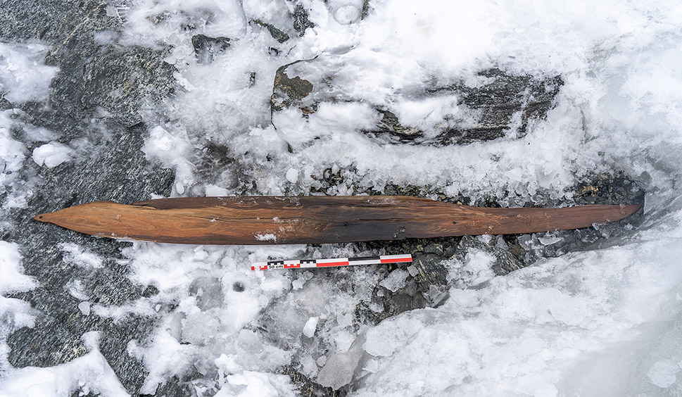
          - Glacier archaeology.
Discovery of 1,300-year-old skis in Reinheimen National Park in 2021.
Photo: Espen Finstad, Innlandet County Authority.
[Boks slutt]

The conditions for cultural practices are changing
The United Nations Educational, Scientific and Cultural Organization (UNESCO) defines intangible cultural heritage as the practices, representations, expressions, knowledge, skills – and associated instruments, objects, artefacts and cultural spaces – that communities, groups and individuals recognise as part of their cultural heritage.
There is a strong link between tangible and intangible cultural heritage. When climate change affects and changes the conditions for the practice of traditional culture, it also affects the practices, representations, expressions, knowledge and skills associated with it. This applies to all cultural practices, but is particularly evident for Sami traditional cultural practices.

Sami culture and society
Close links between nature, culture and industry make Sami society vulnerable to climate change in several ways. Norway’s Sami population is dispersed across the country. In Norway, Sápmi – Samiland – extends from Finnmark to the northern parts of Innlandet. Climate change will play a role in changing the conditions for traditional, nature-based business activities such as reindeer husbandry, agriculture, marine industries, fisheries and outlying industries. These industries are important for employment and settlement, but they are also important carriers of intangible cultural heritage such as language and culture. When climate change affects and changes the conditions for the practice of traditional Sami culture, it also affects practices, representations, expressions, knowledge and skills related thereto.

Climate change is impacting reindeer husbandry
Reindeer husbandry is an important cultural carrier. The industry is small on a Norwegian scale, but important in Sami and local contexts. Reindeer husbandry is based on the reindeer grazing in outlying land all year round. Since the natural conditions and the needs of the reindeer vary during the year, the reindeer move between different pastures. The effects of climate change have led to reindeer being moved in different ways and at different times than previously, since rivers and lakes in some areas now freeze over later in the year. Changes in temperature and precipitation also cause icing and inaccessible pastures, and may also necessitate changes in the use of pastures.
Climate change already affects reindeer husbandry and is expected to do so increasingly towards 2100. The grazing crises in the winter and spring of 2020 and in 2022 have provided insight into the consequences of climate change for the industry. During the grazing crisis in 2020, 75 per cent of the country’s reindeer husbandry was affected by large amounts of snow and inaccessible pastures. This happens when temperatures fluctuate, alternating between snow and rain. This can lead to layers of ice forming that make the pasture inaccessible.
There is also an increased risk of parasites moving further north as the temperature increases. Increased numbers of insects put reindeer herds at risk of more stress and disease. In addition, reindeer husbandry is also experiencing a great deal of pressure on pastureland. Climate change entails a growing need for flexibility in grazing and migration patterns, and encroachments on grazing areas will therefore entail greater challenges for reindeer husbandry.
Changes in the climate will also increase the risk of accidents in reindeer husbandry practice. Lakes and rivers that have previously been safe to cross are no longer as safe, and some areas are now more at risk of avalanches.
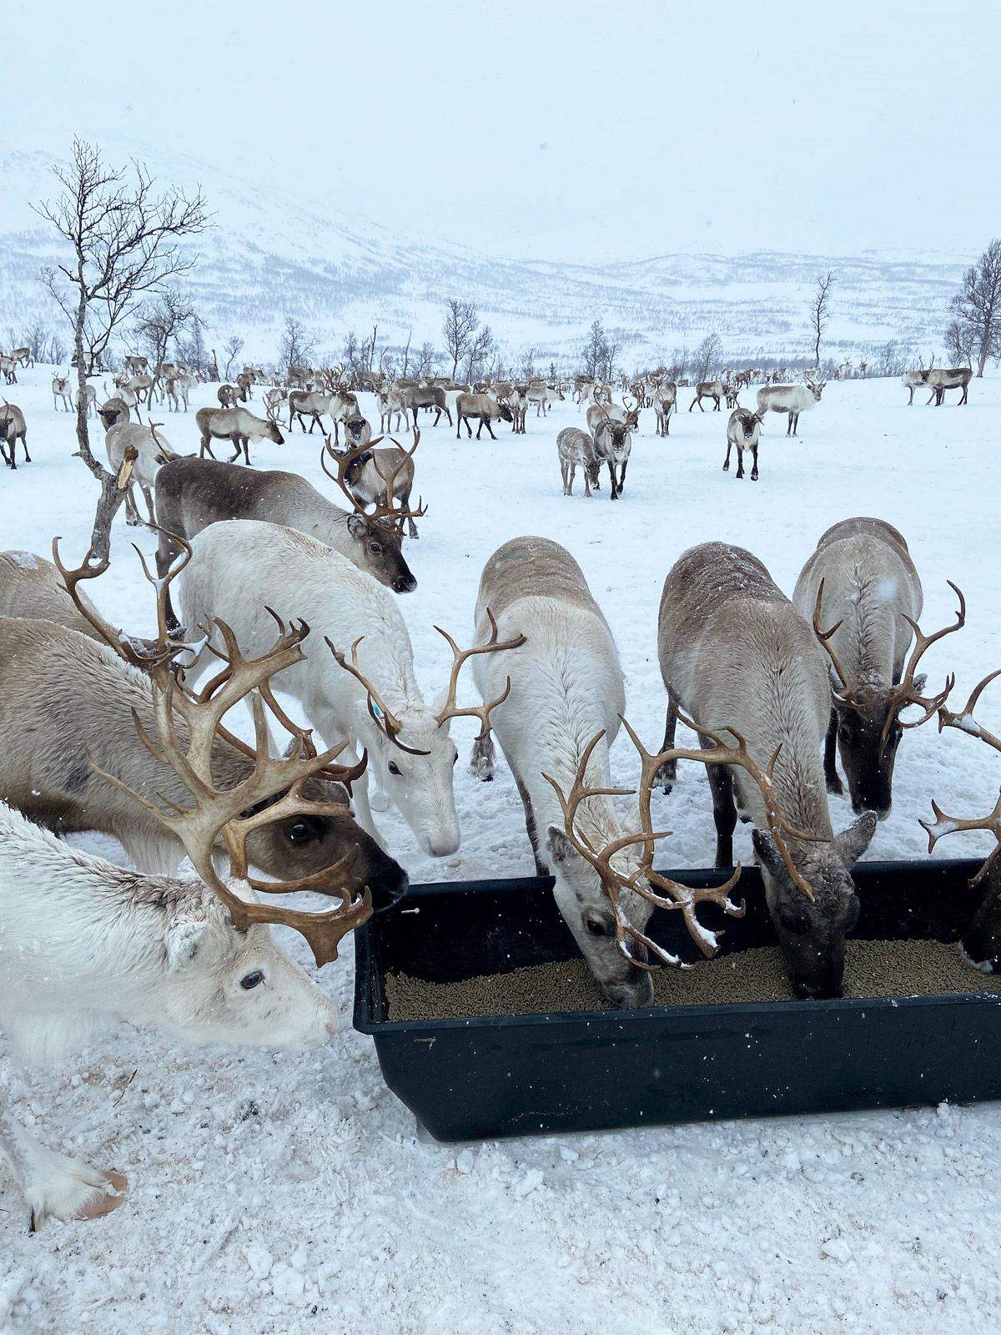
          - Grazing crisis.
Feeding of reindeer in the Ildgruben reindeer grazing district in Nordland during the grazing crisis in 2022.
Photo: Ministry of Agriculture and Food.

Indigenous knowledge
Climate change is particularly felt in the Arctic, and many Sami people have a culture and way of life that is especially adapted to an Arctic climate. The close links between people and nature have led to the Sami population developing unique ways of observing and relating to changes in the environment. Important knowledge of traditional and sustainable use of nature is kept alive through practice and passed down through generations.
Climate change is changing the material basis for cultural practice, such that knowledge that has been passed down the generations may be lost. The IPCC stresses the value of indigenous knowledge, among other things as a means of understanding and evaluating adaptations and for reducing the risks associated with a changing climate.

International relations
Nearly half of the world’s population lives in areas or in ways that make them highly vulnerable to climate change. The IPCC shows that more and more extreme events have already exposed millions of people to acute food insecurity and reduced water security. The productivity of agriculture, fisheries and aquaculture has diminished. Around half of the world’s population experience severe water shortages for parts of the year. All over the world, heatwaves have resulted in health problems and deaths. The incidence of infectious diseases and mental health challenges has increased, and more and more people are being displaced. The world’s poorest and most vulnerable people are hardest hit by climate change. The need for adaptation measures is increasing. Many countries and communities have already experienced loss and damage as a result of climate change.

Vulnerability is unevenly distributed
Vulnerability in the face of climate change is unevenly distributed, and is exacerbated by inequality and marginalisation related to gender, ethnicity, income levels or combinations thereto, especially for many indigenous peoples. For example, the impact of climate change on the food system could have consequences for entire populations, but certain groups of people are more vulnerable than others. Women, the elderly and children from low-income families, indigenous peoples, minorities, small-scale producers and people living in high-risk regions are more likely to experience malnutrition, loss of livelihood and rising costs than others. Observed mortality as a result of flooding and drought is also much greater in areas where the population is particularly vulnerable due to historical, political and socio-economic differences.
The IPCC indicates that climate change hits those who are most vulnerable the hardest. They often live in the most vulnerable regions of the world: East, Central, and West Africa, South Asia, Central America, the Caribbean, and Western Pacific island states.
Climate change will impact the living conditions of the world’s poor, including through crop reduction or failure, negative consequences for health and food security, destruction of homes, and lost income – especially in agriculture.
              - Overlapping vulnerabilities in Syria
The crisis in Syria is among the deadliest conflicts of this century and is one of the largest and most complex humanitarian crises in the world. Millions of Syrians depend on humanitarian aid to meet their basic needs. A report from the Red Cross (2019) shows that conflicts affect groups’ and individuals’ ability to cope with and adapt to climate change. The report also shows how Syria is an example of how humanitarian needs are affected by the double burden of climate-related events and conflict.
The many millions of people who live as internally displaced persons in camps are particularly vulnerable to climate-related events. In April 2019, the Al Hasakah region in the north of the country was hit by flooding after unusually heavy rains. Initial assessments estimated that 118,000 people were affected. Their homes were flooded, damaged, or destroyed. At the same time, the escalation of the conflict in north-eastern Syria resulted in thousands of people being relocated to these flooded areas.
Source: Norwegian Red Cross (2019).
[Boks slutt]

Climate change poses a threat to peace and stability
Climate change is increasingly recognised as a serious risk to peace and stability in the world. First and foremost, the consequences of climate change are seen as a factor that could exacerbate and aggravate underlying causes of conflict. Climate change may thus change the security landscape for the Norwegian Armed Forces and the missions it is assigned.
The impact of climate change is a particular threat to security and stability in the Global South, where it may have a huge impact on vulnerable states. Climate change is expected to lead to shortages of resources such as water and arable land, crops will be more prone to failure, and research shows that there may be more conflicts over scarce resources.
              - Climate change is high on NATO’s agenda
NATO stresses that climate change is the most important overarching challenge of our time, with a major impact on the security of the allies. Climate change may exacerbate conflict and geopolitical competition, disrupt societies and undermine our security.
Climate change also affects the way in which NATO’s armed forces operate: infrastructure and bases are vulnerable to the effects of climate change, while they must operate under more extreme climatic conditions and are more often called upon to assist in disaster relief. This is reflected in NATO’s strategy, which states that NATO will become the leading international organisation when it comes to understanding and adapting to the security consequences of climate change.
[Boks slutt]
Climate change already poses security challenges for the High North. Among other things, warming leads to the retreat of the ice, making it easier for commercial, civilian and military actors to operate in the Arctic. In the High North, it must be borne in mind that climate change creates increased activity, new challenges and new risks. Increased traffic over larger areas in the High North will give the Armed Forces a larger operational area. This could, for instance, lead to longer supply lines and an increased need for logistics for the Coast Guard. The report ‘Climate Change and Security in the Arctic’, produced by the Center for Climate and Security, shows that the security risks associated with a warmer Arctic must be added to the already rising tensions expected in the High North over the next decade.

Climate change could affect migration patterns
Weather events and climatic conditions can both be direct drivers of migration, for example when events destroy homes, and indirect drivers, for example through loss of income or lack of food due to crop failure. Whether or not people migrate is strongly influenced by economic, social, political and demographic processes.
Very few studies have attempted to make systematic projections of regional or global migration in a changing climate. Future migration patterns will depend not only on the physical effects of climate change, but also on other factors such as policy and social development. The link between climate change and migration will vary between regions and over time. Climate-related migration depends on the kind of climate risk people are exposed to, their vulnerability, and their own ability as well as the authorities’ ability to adapt and manage the risk.
Changes in migration patterns and scope in other parts of the world may affect migration to Norway, but there is limited knowledge about the possible consequences of climate-related migration for Norway. Although flight due to climate change is not covered by the UN Refugee Convention, the secondary effects of climate change, such as war and political instability, may trigger a need for protection and thus have consequences for Norway.
Part II
Governance system for climate change adaptation

Framework for integrated and coordinated action
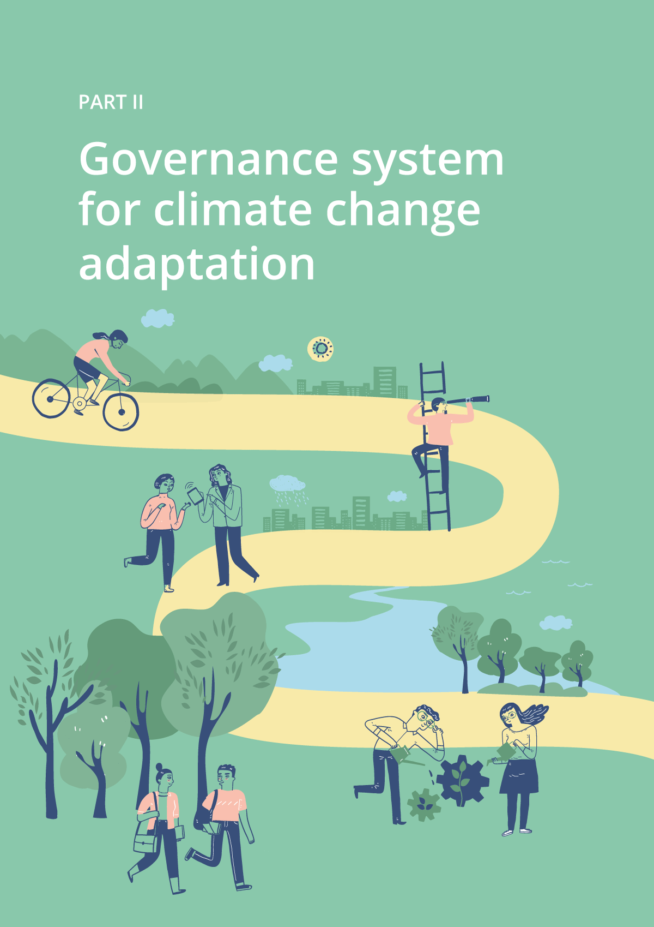

Climate change adaptation – a wicked problem for society
All sectors and areas of society are affected by climate change, or will be. It impacts both directly and indirectly and across sectors, industries and national borders. Different actors, sectors and areas of society are affected in different ways, to different extents and at different times. Thus, the efforts and measures needed vary greatly; climate change adaptation can range from practical solutions for stormwater management to the management of species threatened by climate change and security policy assessments.
How the climate will change and what the consequences will be are uncertain. As such, climate change adaptation can be described as a ‘stubborn problem’ or a ‘wicked problem’. These terms are used to describe tasks that are complex, without simple or easily defined solutions and that span organisational boundaries, and administrative areas and levels. In order to handle such a challenge, it is particularly important to have a common framework that covers the wide range of topics and issues, and facilitates systematic and well-coordinated efforts.
Climate change adaptation is part of the holistic transition to a sustainable society. In order to achieve climate-resilient development, climate change adaptation efforts must be viewed in the context of policies to reduce greenhouse gas emissions, safeguard nature and other environmental assets, and ensure social and economic sustainability.
              - Climate-resilient development
According to the Intergovernmental Panel on Climate Change’s definition, climate-resilient development ‘combines strategies to adapt to climate change with actions to reduce greenhouse gas emissions to support sustainable development for everyone’.
Source: IPCC (2022a).
[Boks slutt]

National goal for climate change adaptation
The Government:
- will expand the national goal for climate change adaptation to ‘society and ecosystems must be prepared for and adapted to climate change’
The IPCC’s Sixth Assessment Report highlights the connection between the state and development of nature and society’s vulnerability to climate change. The report states that securing resilient ecosystems and biodiversity globally will require effective conservation of 30 to 50 per cent of the Earth’s land, freshwater and marine areas. If ecosystems and biodiversity are safeguarded, nature can contribute to climate change adaptation, uptake of greenhouse gases and other important ecosystem services. Conserving ecosystems is thus fundamental to climate-resilient development. The Government therefore proposes to expand the national target for climate change adaptation to include ecosystems. The change is based on the knowledge that ecosystems in good condition play an important role in reducing the impact of climate change on both society and nature.

Different actors’ responsibility for climate change adaptation
Climate change affects all areas of society and all sectors. Everyone is responsible for adapting to climate change – governments, private companies and individuals. Public authorities have a particular responsibility to ensure that nature and society are prepared for and adapted to a changing climate.
The Government is responsible for the overarching climate change adaptation policy. All ministries are responsible for assessing whether and, if applicable, how the consequences of a changed climate affect their respective sectors, and for implementing actions to reduce vulnerability. The Ministry of Climate and Environment coordinates the ministries’ work and is responsible for the Government’s overall efforts to prepare and adapt nature and society to a changing climate. The Norwegian Environment Agency provides support to the Ministry of Climate and Environment in coordinating these efforts.
The municipal and county authorities have key tasks when it comes to adapting to climate change. Climate change affects many of the municipalities and county authorities’ responsibilities. The principle of responsibility implies that the municipal and county authorities must take climate change into account in areas such as land-use planning, pollution, nature management and civil protection and emergency preparedness.
Much of the adaptation work in the municipalities takes place through social and land-use planning pursuant to the Planning and Building Act. Climate change requires greater attention and more effective and targeted social and land-use planning. Facilitating good adaptation to climate change through planning work also requires extensive cooperation across sectors and actors. As planning authority, each municipality must facilitate the participation of the relevant authorities and actively contribute to planning processes.
The municipality’s responsibility for civil protection and emergency preparedness pursuant to the Act relating to Civil Protection is also key to the local adaptation work. The municipality must involve different actors in prevention, emergency preparedness and crisis management. Good cooperation with external social security actors, including NGOs, is important in the municipality’s civil protection efforts.
In addition to the role of planning authority with responsibility for civil protection and emergency preparedness, the municipality has several roles where climate change considerations must be taken into account. The municipality is the owner of buildings, roads and other infrastructure and a supplier of services in areas such as water and sewage, education and health. The municipality also plays an important role as a local community developer and facilitator for the business community.
At the regional level, county governors and the Governor of Svalbard are responsible for important tasks. The county governors coordinate central government governance signals to the municipalities and contribute to the local follow-up of national policy. Providing advice and guidance on municipal planning and coordination of the work on civil protection and emergency preparedness are key tasks for county governors in the area of climate change adaptation. The Governor of Svalbard is the Government’s highest representative on Svalbard. One of the Governor’s tasks is to assess the impact of climate change, taking into account its consequences for the administration of Svalbard.
As regional planning authority, each county authority plays an important role, including through its responsibility for regional development. In order to ensure effective and coordinated efforts, it is important that the county governors work with the county authorities to determine how climate change adaptation can be addressed in the municipalities’ planning work.
The business community and NGOs are important contributors and valuable partners for the authorities in their work on climate change adaptation, nationally, regionally and locally. The business sector plays an important role in developing technology and other solutions and making it attractive to invest in climate change adaptation. NGOs contribute, among other things, to ensuring that different groups and stakeholders’ interests are safeguarded in the adaptation work, and are an important channel for engaging and mobilising people in the work. They also contribute operationally, including in emergency preparedness and by developing and disseminating knowledge.

Systematic efforts and better coordination at the national level
The Government:
- will implement an improved governance system for its national climate change adaptation efforts
- will prepare a national climate change vulnerability analysis every four years
- will introduce procedures for updating the Government’s climate change adaptation policy, and present a new white paper on climate change adaptation in four years’ time
The Government will introduce an improved governance system for national climate change adaptation efforts. Since there is uncertainty about how the climate will change and what impact it will have, it is important that climate change adaptation work is based on the most recent knowledge about vulnerability and learning about what actions and efforts are effective. The governance system therefore has a cyclical approach with procedures for developing national climate vulnerability analyses, updating climate change adaptation policy, reporting and regular evaluation of the efforts. The Government currently reports annually to the Storting on its climate change adaptation work in accordance with the Climate Change Act. Every four years, a more comprehensive report is submitted to the UN Framework Convention on Climate Change. These reporting procedures and obligations will be retained.
The new approach is based on the current framework for climate change adaptation work. The governance system is based on climate change adaptation being a continuous and iterative process, as the circle in Figure 4.2 illustrates. The activities will partly follow each other in time and partly take place simultaneously. This framework is in line with international guidelines on how climate change adaptation should be organised and with the practice in several European countries (see Box 4.3).
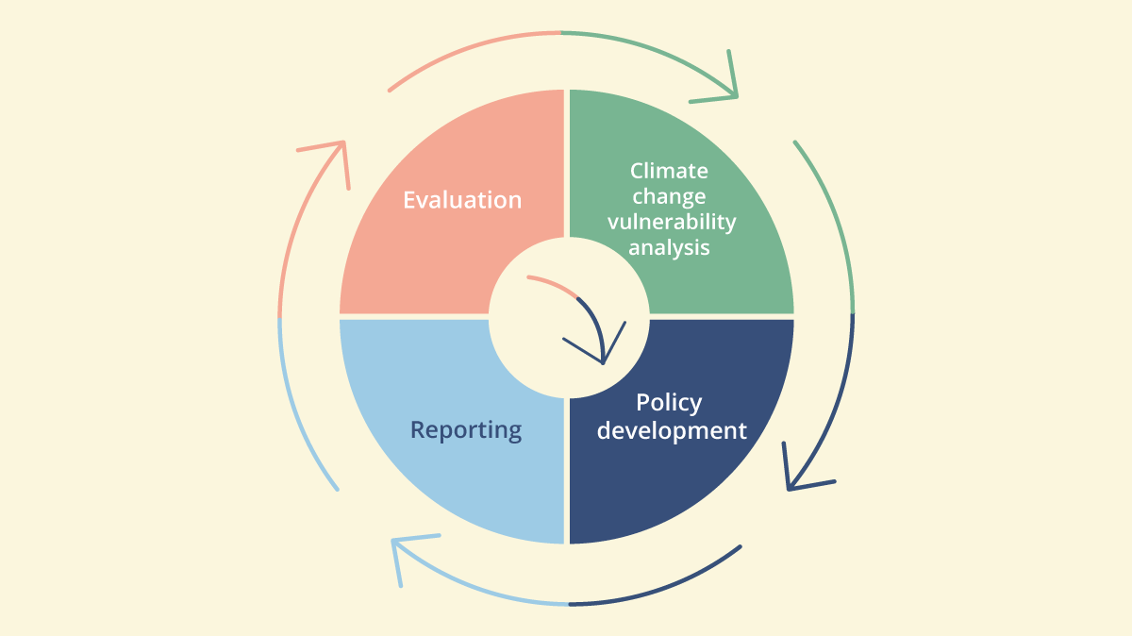
          - Framework for the national climate change adaptation work.
Figure 4.2 illustrates the framework for the national climate change adaptation work, with climate vulnerability analyses, procedures for updating policy, reporting and evaluation, which are carried out in a cycle. The governance system is based on climate change adaptation being a continuous and iterative process, as the circle illustrates. The activities will partly follow each other in time and partly take place simultaneously.
Source: Ministry of Climate and Environment.
The changes in the governance and coordination system are based on the work of the central government authorities. However, the Government deems it important that more systematic and coordinated efforts nationally contribute to a better framework for municipal authorities’ and other actors’ climate change adaptation work. The governance system presented in this white paper is intended to increase predictability in climate change adaptation work and clarify the division of responsibilities. The system is under development, and changes may be relevant as more experience is gained of the organisation and procedures.

National climate change vulnerability analysis
The Government will prepare a national analysis of society’s vulnerability to climate change (climate change vulnerability analysis). The analysis will form an important part of the basis for policy development in the field of climate change adaptation and in order to prioritise efforts and measures.
The Norwegian Environment Agency is responsible for developing national climate change vulnerability analyses, in cooperation with relevant sector authorities and other actors. The first analysis is expected to be completed by the end of 2026. The Norwegian Environment Agency details the organisation of the work, including the content, scope and structure of the analyses, as well as the process and involvement of other actors. This is done in dialogue with the Directorate Group on Climate Change Adaptation and in consultation with the Ministry of Climate and Environment and other relevant ministries.
The climate change vulnerability analysis is intended to provide an overview of current knowledge about the consequences of a changing climate for society. The analysis should include risks that span national borders and areas of society. Interaction between climate-related risk and other social development drivers should also be addressed. Relevant cross-cutting topics include the potential consequences for security, economy and welfare, calculations of economic costs and benefits including distribution effects, gender equality perspectives and factors addressing children and young people, the elderly and other vulnerable groups in particular, and consequences for indigenous people in Norway. The climate change vulnerability analysis should also include geographical differences in risk and vulnerability.
In the first instance, national climate change vulnerability analyses should primarily focus on vulnerability at a more overarching level. However, the analysis may also include topics that impact individual sectors in particular and may be used as a starting point for sector-specific and thematically-defined analyses. Findings from the climate change vulnerability analysis should be widely disseminated. It should be possible for municipalities, businesses, NGOs and others to use the analysis.
Uncertainty about the consequences of climate change and the interaction with other developments in society suggest that the climate change vulnerability analysis should be updated relatively frequently. The Government therefore intends to update the analyses at least every four years, in accordance with the current reporting requirements under the UN Framework Convention on Climate Change. If events or special circumstances so warrant, the analysis may be updated in whole or in part outside the regular procedures. The frequency of updates may also change going forward if reporting procedures or other relevant conditions change.

Procedures for updating the national climate change adaptation policy
The Government will introduce procedures for updating the national climate change adaptation policy, so that its efforts can be adjusted if new knowledge about risk and vulnerability or other relevant considerations so indicate. The Ministry of Climate and Environment will coordinate the work of updating policy. This work will be carried out in collaboration with the sector ministries, which are responsible for addressing climate change in their respective areas. In line with the procedures for updating climate change adaptation policy, the Government has now announced that a new white paper on climate change adaptation will be presented in 2028.
Chapters five and six of this white paper present the Government’s plan for the work to prepare and adapt nature and society to climate change for the period 2024–2028. The plan provides a common basis for the Government’s overall work on climate change adaptation and it will act as a governance tool for the Ministry of Climate and Environment in its coordination of the work.
Under these procedures, a status report and an account of plans and actions in the sectors, as well as any action points for cross-sectoral climate change adaptation work, must be provided in the Government’s annual climate status and plan.
              - Climate status and plan
In 2022, the Government introduced the climate status and plan, which is presented annually together with the proposal for the national budget. The plan covers reporting under the Climate Change Act, including climate change adaptation. It also describes the emission effect of the national budget and presents a governance system for emission reduction efforts. The climate change governance system will contribute to ensuring that climate considerations are addressed in a predictable and systematic manner in relevant decision-making processes. The climate status and plan will provide information on how Norway is positioned to achieve its climate targets, highlight where greater efforts are needed and present the Government’s plan to meet the climate targets.
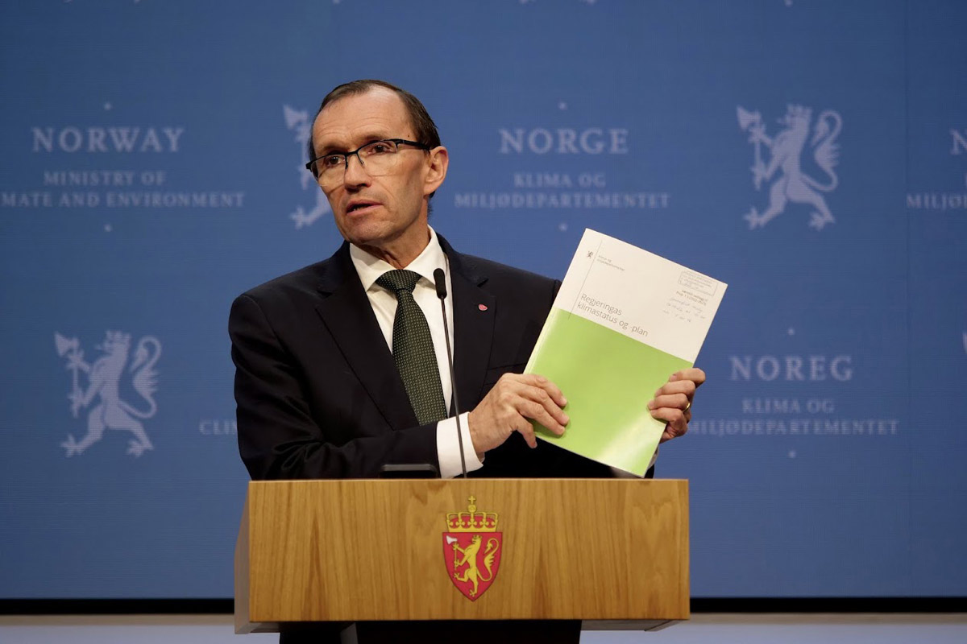
          - Climate status and plan.
The climate status and plan was first presented in 2022 by Minister of Climate and Environment Espen Barth Eide.
Photo: Martin Lerberg Fossum, Ministry of Climate and Environment.
[Boks slutt]

Reporting and evaluation
The current procedures for the Government’s annual reporting to the Storting in accordance with the Climate Change Act are to be retained and slightly expanded. The Government’s annual climate status and plan will provide an account of the status of the work on climate change adaptation in the sectors, including reporting on how the plan for national climate change adaptation work is followed up. The climate status and plan will also contain an overview of the ministries’ plans for the work on climate change adaptation in the future.
Every four years, Norway reports on climate change adaptation to the UN Framework Convention on Climate change. The Government proposes that climate change adaptation work in Norway should be evaluated in connection with this reporting. The evaluation will cover the cross-sectoral work and the sectors’ contributions. Its goal is to provide insight into the development of risk and vulnerability in light of the work on climate change adaptation, so that efforts can be adjusted as needed, in order to reduce vulnerability. The national climate change vulnerability analysis, together with annual reporting on the work on climate change adaptation will form important elements in the basis for evaluation.
Through Recommendation No 218 to the Storting (2021–2022) to Report No 40 to the Storting (2020–2021) Mål med mening – Norges handlingsplan for å nå bærekraftsmålene innen 2030 (Norway's action plan for achieving the Sustainable Development Goals by 2030), the Storting has decided to create a comprehensive system for measuring and evaluating the effect of climate change adaptation at the national, regional and local level. The Government will follow up this decision and look at the work on evaluation procedures in connection with the other elements of the climate change adaptation governance system.
Climate change adaptation has strong links to and potential for synergies with other cross-cutting issues, including sustainable development (the UN Sustainable Development Goals), emission reductions, nature and the environment and security and emergency preparedness. Evaluation of climate change adaptation, including methods, data basis and any indicators, must therefore be viewed in the context of similar systems in other areas.
Assessing goal attainment work in climate change adaptation work is methodically demanding. The Government relies on dialogue with various actors and expert communities to organise the work on climate change adaptation in an optimal manner. The Government is therefore keen to facilitate participation and cooperation in the evaluation of the work, and will, in addition to research groups, also involve municipal and county authorities, NGOs, Sami interests and business representatives in this work.
              - Examples of climate change adaptation work in other countries
Work on climate change adaptation is organised in different ways in the various European countries. However, some countries share certain key elements: Coordination responsibility is clearly assigned at the national level, governing documents such as strategies and/or plans are regularly updated, expectations of sector authorities are rooted in strategy or law, and procedures are in place for regular reporting. Moreover, most countries have a national knowledge base that highlights risk and vulnerability in the face of climate change.
Sweden: In Sweden, sector authorities report to the Swedish Meteorological and Hydrological Institute (SMHI), which summarises this reporting annually to the government. The national climate change adaptation strategy, evaluation reports and sectoral climate risk and vulnerability analyses are updated regularly and at least every five years. Sweden’s work on climate change adaptation is coordinated by the Ministry of Climate and Enterprise and involves many sectors. A national council of experts for climate change adaptation evaluates the efforts and provides input on how the work should be adjusted to achieve the national goals. The council submitted its first evaluation report to the Swedish government in 2022.
The UK: The UK employs a five-year cycle in its work on climate change adaptation. The national work is coordinated by the Department for Environment, Food and Rural Affairs, and several ministries are responsible for climate change adaptation in their sectors. As part of the work, the ministries must define sector-specific goals and implement actions to achieve the goals. A national climate risk analysis is updated every five years and provides a broad picture of developments in climate-related risk. The assessment of the findings in the analysis is used, among other things, to adjust the work under the national action plan. The UK has established an independent Climate Change Adaptation Committee that produces knowledge, assesses the progress of national efforts and makes recommendations to the government on further work. Reporting procedures have been established, among other things to monitor developments in the implementation of actions.
Finland: Finland’s climate change adaptation work is based on the national climate change adaptation strategy being updated at least every other election period and regularly updated climate risk and vulnerability assessments. The government monitors the implementation of the strategy and reports the status of the work to the parliament annually. The work is coordinated by the Ministry of Agriculture and Forestry. Other ministries are responsible for climate change adaptation in their areas. The cycle involves continuous learning and regular adjustment of policy. A wide-ranging group of representatives from different parts of the public administration and various expert communities monitor the implementation of the national strategy. In addition, an independent national climate panel assesses adaptation efforts and provides scientific advice on policy design, which is used to update the national strategy.
Source: Western Norway Research Institute (2023) and European Environment Agency (2021).
[Boks slutt]
Part III
Plan for the national work on climate change adaptation 2024–2028

Priority areas and actions in the cross-sectoral climate change adaptation work
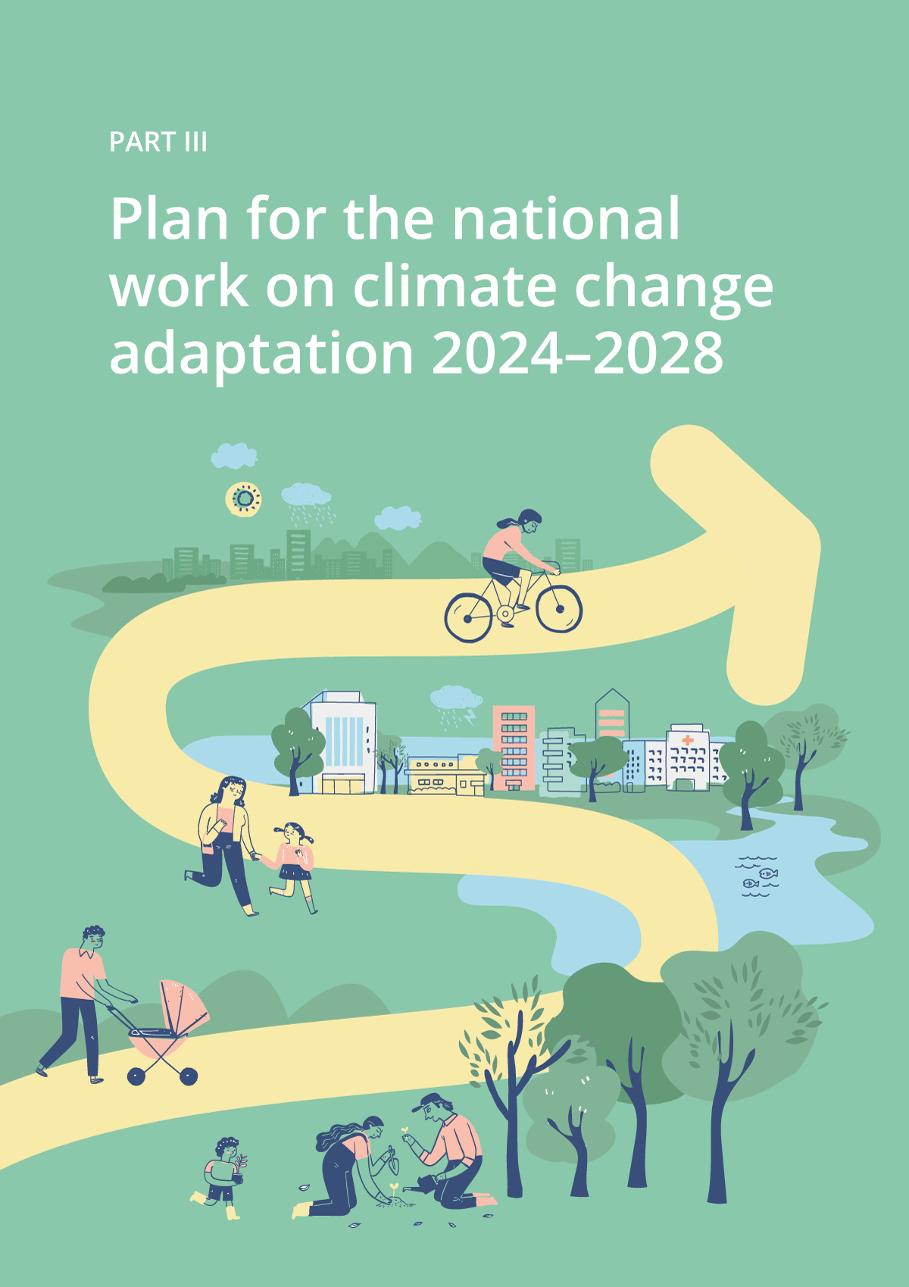

The Government’s plan for the national climate change adaptation work for the period 2024–2028 is twofold: Chapter 5 describes priority areas where cross-sectoral actions and climate change adaptation efforts are needed across multiple sectors. Chapter 6 describes efforts and actions that largely fall within each sector’s area of responsibility. However, the distinction between cross-sectoral priority areas and sectoral climate change adaptation actions is not clear. Several of the areas discussed in Chapter 6 are also largely cross-sectoral, such as national security, civil protection and emergency preparedness, and nature and the environment. However, the plan is twofold to highlight areas that require joint efforts and coordination by the Ministry of Climate and Environment, which is responsible for coordinating the national climate change adaptation work.
The plan is based on new knowledge about the status and challenges in the work on climate change adaptation since the last white paper – Report No 33 to the Storting (2012–2013) Climate change adaptation in Norway (white paper). The knowledge base is somewhat fragmented and there is a significant imbalance in the scope and level of detail between sectors and areas of society. This imbalance is linked to the development of climate change adaptation as a policy area and field of expertise. For a long time, climate change adaptation work was primarily focused on the most immediate and visible consequences of climate change, such as natural disaster events and extreme weather events. There has been less focus on areas where the consequences are more indirect and the risk and vulnerability picture is particularly complex, for example due to chains of effects. This picture is changing, and there is increasing awareness and knowledge about the consequences of climate change in other countries and the risks that climate change may pose to the economy and welfare in the future. Our understanding of how climate change aggravates threats to international peace and security is also increasing.
Despite these ongoing developments, the knowledge base still differs between sectors and areas of society. Similarly, the experience base varies with regard to success criteria, challenges and development needs in the work on climate change adaptation. Among other things, the Office of the Auditor General’s performance audit from 2022 (Document 3:6 (2021–2022)) provides a thorough review of the authorities’ work on climate change adaptation of infrastructure and buildings, while such reviews have not been made in other areas. The discussion of the priority areas and actions in this plan must be viewed in light of this variation in knowledge and experience bases, and the wide range of issues in the field of climate change adaptation. The plan does not provide an exhaustive review of all relevant topics and issues in the field, but describes selected areas where current knowledge indicates that efforts are particularly needed in the next few years.
The governance system described in Chapter 4 of this white paper will strengthen the knowledge base for assessing and prioritising climate change adaptation efforts in and across sectors in the time ahead. National climate change vulnerability analyses will provide a compilation of knowledge about the consequences in different areas. Better procedures for measuring and evaluating the work will also improve the knowledge base.
The municipalities play a key role in the work of developing climate-resilient local communities across Norway, and many of the actions in this plan affect their areas of responsibility. Each municipality has an overall responsibility for social development within their geographical areas and must ensure that consideration for the changing climate becomes an integral part of its municipal duties. Many municipalities have come a long way in this work, and the Government’s aim is that the actions in this plan will further boost local climate change adaptation efforts. Among other things, the Government will consider various actions to clarify the requirements under the Planning and Building Act. This is to ensure that consideration for the changing climate and natural hazards are better addressed in risk and vulnerability analyses in connection with specific building applications and when land-use plans are updated. Among other things, the Government will consider allowing municipalities to charge a separate fee to fund stormwater measures. The Government will also take steps to ensure a better knowledge base for implementing adaptation measures that will generate greater benefits than costs for society and for nature-based climate adaptation solutions. The Government will continue to provide relevant and up-to-date guidance on climate change adaptation in planning, and will emphasise that the guidelines must be readily available and adapted to the municipalities’ needs and expertise.
The Government also emphasises that climate change adaptation work must be carried out through good participatory processes that safeguard indigenous rights and consideration for vulnerable groups.
Cross-sectoral actions
In this plan, the Government presents a number of cross-sectoral actions to create a climate-resilient society. The actions in the plan will help to increase cooperation and knowledge about climate change adaptation, and ensure new solutions are used to equip society and nature in the face of a changing climate. The plan will support Norway’s efforts to achieve the UN Sustainable Development Goals. Climate change adaptation is directly related to goal 13, which addresses individuals’ and institutions’ ability to counteract, adapt to and mitigate the consequences of climate change. Efforts to build a climate-resilient society are also closely linked to several of the other SDGs, including goal 11 on sustainable cities and communities, goal 14 on life below water, goal 15 on life on land and goal 17 on partnerships for the goals.

Address climate change considerations in the sectors
The Government:
- will request each ministry to review relevant instruments and assess whether changes are needed to ensure that the changing climate is taken into consideration
- will request each ministry to review letters of allocation and instructions to government directorates and agencies, and assess whether changes are needed to ensure that the changing climate is taken into consideration
Climate change has profound consequences and requires a systematic response, which makes the changes an integral part of the activities in all sectors and policy areas affected. The consequences and risks resulting from the changing climate affect actors, sectors and areas of society in different ways, and the efforts and actions needed to meet the changes vary widely.
Each ministry is responsible for taking the changing climate into account within its sector and managing subordinate agencies. As far as possible, climate change adaptation should be included in existing decision-making processes and activities rather than being a separate task in addition to other activities. How climate change considerations can best be integrated in individual areas depends on the challenges, work method, available instruments and other conditions in the individual sector. The Government will request that each ministry reviews relevant instruments and assesses whether changes are needed to ensure that climate change considerations are addressed. A systematic review of relevant policy instruments in all sectors will contribute to greater integration of climate change adaptation in the sectors’ work, avoid actions that may make society more vulnerable to climate change and reduce any conflicts between different considerations. The review of policy instruments will also apply to the environmental regulations and other relevant regulations on Svalbard.
In order for climate change adaptation considerations to be well integrated in the sectors’ work, clear and consistent governance signals must be given to subordinate agencies. The Government will therefore request that each ministry reviews relevant allocation letters and instructions to subordinate directorates and agencies, and consider whether changes are needed to ensure that climate change considerations are addressed.
As the body responsible for the Government’s overall work on climate change adaptation, the Ministry of Climate and Environment will coordinate the work on reviewing relevant policy instruments, letters of allocation and instructions. The sectoral principle will form the basis for the review, and each ministry will assess which instruments are relevant to include within its specific areas of responsibility.
The review of relevant policy instruments, letters of allocation and instructions is important to meet the challenges discussed in the Office of the Auditor General’s report, which highlights the need for better coordination and concretisation of actions to ensure progress in climate change adaptation work.

More knowledge about climate change and climate change adaptation
The knowledge base for climate change adaptation has been significantly strengthened in recent years, both in Norway and elsewhere. However, more knowledge is still needed, which the Government also emphasises in Report No 5 to the Storting (2022–2023) Long-term plan for research and higher education 2023–2032. Different risk factors related to climate change impact each other across geography, sectors and actors. More knowledge is needed that illuminates such relationships. We also need to know more about the relationship between climate-related development trends and other features of social development. This includes more knowledge about the economic consequences of climate change as well as its effect on gender equality and social conditions. More knowledge is also needed about instruments and solutions that contribute to climate-resilient development, including nature-based solutions.
The complexity of the climate and environmental challenges require interdisciplinary knowledge. This is also emphasised in the IPCC’s most recent report, which draws on disciplines such as social sciences, humanities and technology, as well as mathematics and natural science sources.
More and more actors need to take climate change into account, including citizens, industry actors and NGOs. Broader participation in knowledge development can provide insight into the vulnerability and adaptation capacity of different actors, and uncover knowledge needs.
Several actors provide funding for knowledge development on climate change adaptation in Norway. Key actors are the Research Council of Norway and the EU Framework Programme for Research and Innovation, Horizon Europe. The Research Council invests in research and innovation through different portfolios. One of these portfolios deals specifically with climate and polar research, but research and innovation in the field of climate change are also included in several of the other portfolios. The sectoral principle for research entails that each ministry must have an overview of its research needs in the short and long term, and fund such research, both through the Research Council of Norway and other channels.
              - Mission on Adaptation to Climate Change in the EU
The increasing pace of global warming and the extent of climate-related risk factors indicate that there is an urgent need to translate knowledge into action. Adopting solutions involves trial and error – and adjusting them based on experience. The EU has adopted a new policy instrument for addressing major challenges facing society, missions. Adaptation to climate change is one of five EU missions towards 2030. Under the mission, researchers, civil society actors and citizens will jointly develop and test solutions for transformative adaptation to climate change. Climate change adaptation will also be included in other missions in the EU’s Horizon Europe research and innovation programme, including on soil health and food, climate-neutral and smart cities, and healthy oceans. Norway participates in the missions through Horizon Europe.
[Boks slutt]

Knowledge of the costs and benefits of climate change adaptation
The Government:
- will appoint an expert committee to obtain more knowledge about the socio-economic consequences of climate change for vulnerable sectors and regions, and identify priority areas where there is good potential to reduce climate-related risk, assessed in relation to the cost of actions
Climate change affects all areas of society and entails considerable costs for society. However, the consequences of climate change are not quantified to any great extent, and it is difficult to estimate exact costs. Both the changes that affect Norway and the spillover effects of climate change in other countries have economic consequences. There is a great deal of uncertainty, among other things related to which climate scenarios are most likely towards 2100. There is still little knowledge about how the consequences of a changed climate will be distributed by type of economic activity, and their geographical impact.
The Climate Risk Commission conducted an overall analysis of the impact of climate change on the Norwegian economy, based on national wealth. The Commission assessed the risks associated with the transition to a low-emission society (transitional risk) and risks associated with the consequences of climate change (physical climate risk). However, the study did not include quantified costs within different areas of society.
The costs of adapting Norway to climate change will vary between sectors and areas of society and depend, among other things, on the actions that are needed and the scope of the effort required. Social and environmental benefits can be difficult to price. A synthesis of existing literature and knowledge update are required in the field.
In order to ensure that the benefits of climate change adaptation exceed the costs wherever possible, we need more knowledge about what climate change will cost Norwegian society now and in the future, and about which priority areas and actions are profitable and cost-effective. It is therefore important to map the economic cost of climate change for society, and to gain more knowledge about which sectors and regions are most vulnerable to the economic impacts. This could contribute to more targeted and cost-effective climate change adaptation and thus enable the authorities and others to prevent the negative impacts of climate change on people, society and the environment as expediently as possible. The Government will therefore appoint an expert committee comprising members from the most affected public agencies, the municipal sector and independent experts, who are tasked with obtaining more knowledge about the socio-economic consequences of climate change for vulnerable sectors and regions in Norway. The committee will also identify priority areas where the potential for reducing climate-related risk is high, assessed in relation to the cost of action. It will, furthermore, provide input to the work of developing indicators to recognise the economic benefits of climate change adaptation actions and the need for adaptation in different sectors and industries.

Knowledge of nature-based solutions for climate change adaptation
The Government:
- will increase knowledge about nature-based solutions for climate change adaptation, including methods of implementation and the criteria for achieving successful outcomes
- will increase knowledge about how climate change, land-use changes, pollution and loss of nature affect each other and how nature-based solutions may simultaneously help solve a number of challenges
- will further develop relevant tools and guidance to better assess nature-based solutions for climate change adaptation through cost-benefit analyses
Nature-based solutions focus on solving the challenges of society by using natural processes and ecosystems as a starting point. They use the known properties of nature to meet challenges, such as reducing flooding or stormwater, stabilising the ground and preventing landslides, while preserving or improving the conditions for biodiversity. Such solutions are based on the nature in the area, and use or restore existing habitats and ecosystems or imitate them. In addition to safeguarding biodiversity, nature-based solutions can also provide a number of other positive effects for society, including better air quality and opportunities for recreation and social meeting places. Nature-based solutions can comprise purely natural measures, such as conservation and ecological restoration, or be used in conjunction with more technical, engineered measures, such as building artificial dams with natural aquatic plants.
The IPCC and the Intergovernmental Science-Policy Platform on Biodiversity and Ecosystem Services (IPBES) highlight nature-based solutions and ecosystem-based approaches as cost-effective means of achieving the SDGs. Nature-based solutions are also highlighted in the Kunming-Montreal Global Biodiversity Framework and by the Nordic environment and climate ministers who have adopted a declaration on nature-based solutions. In the declaration, they commit to scaling up and making more general use of nature-based solutions, and encourage stakeholders in the Nordic region to adopt such solutions.
              - The UN’s definition of nature-based solutions
At the UN Environment Assembly (UNEA5) in 2022, an agreement was reached on a UN definition of nature-based solutions, which has since been adopted by both the UNFCCC and the Convention on Biological Diversity (CBD). The definition states that nature-based solutions must provide benefits for biodiversity, and that ‘nature-based solutions are actions to protect, conserve, restore, sustainably use and manage natural or modified terrestrial, freshwater, coastal and marine ecosystems, which address social, economic and environmental challenges effectively and adaptively, while simultaneously providing human well-being, ecosystem services and resilience and biodiversity benefits’.
Source: United Nations Environment Assembly of the United Nations Environment Programme (2022) and the United Nations Environment Programme (2022).
[Boks slutt]
Nature-based solutions for climate change adaptation are being increasingly employed, but are still less used than more technical and ‘grey’ solutions. The lack of evaluations, effect analyses and long-term monitoring of implemented nature-based actions may be an obstacle to both public and private actors adopting such solutions. More knowledge about how well nature-based solutions work for different purposes is therefore needed to increase the adoption of nature-based solutions in climate change adaptation. Decision-makers and project developers also need better guidance and greater competence about both the benefits and limitations of nature-based solutions for climate change adaptation. The Government will increase knowledge of nature-based solutions for climate change adaptation, including methods of implementation and the criteria for achieving successful outcomes. The Government will also further develop relevant tools and guidance to be able to better assess nature-based solutions for climate change adaptation through cost-benefit analyses. In addition, the Government will increase knowledge about how climate change, land-use changes, pollution and loss of nature affect each other, and how nature-based solutions may simultaneously help solve a number of challenges.
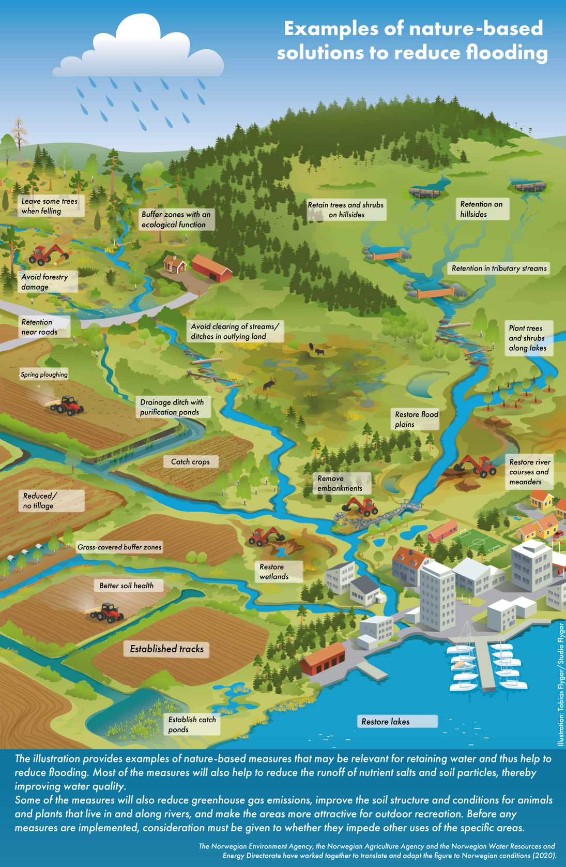
          - Nature-based solutions to reduce flooding.
Source: The figure was developed as part of the project LIFE Rich Waters.

Knowledge of climate change and social justice
The Government:
- will obtain more knowledge about the potential impacts of climate change and climate change adaptation on social inequality in Norway
- will obtain more knowledge about the potential impacts of climate change and climate change adaptation on gender equality in different sectors in Norway
A key principle of the 2030 Agenda is ‘Leave no one behind’. According to the Paris Agreement, climate change adaptation should employ a gender-sensitive, participation-based and fully transparent approach that takes vulnerable groups, communities and ecosystems into account. It is a goal that the transition to a climate-resilient low-emission society should contribute to fair distribution and that it should include and mobilise everyone in society.
There is some knowledge about the connection between gender, climate change and gender equality in the Global South, but there is limited knowledge about gender equality challenges and socio-economic aspects related to the consequences of climate change and adaptation in Norway. The Government will therefore obtain more knowledge about the potential impacts of climate change and climate change adaptation on social inequality in Norway. In addition, the Government will provide more knowledge about the potential impacts of climate change and climate change adaptation on gender equality in different sectors in Norway. The Government intends to develop such knowledge in connection with its work on the national climate change vulnerability analysis, discussed in Chapter 4.
Nordic cooperation is also relevant to the Government’s work on climate change and gender equality. In March 2022, the Nordic Council of Ministers for Gender Equality and LGBTI (MR-JÄM) launched a declaration to strengthen Nordic cooperation on gender equality in climate policy. The declaration is followed up through an interdisciplinary programme to increase awareness, knowledge and exchange of experience on the links between gender and climate actions in the Nordic region and internationally.

Clarify the responsibilities of the county governors and the Governor of Svalbard
The Government:
- will clarify the responsibilities of the county governors and the Governor of Svalbard in the work on climate change adaptation
Several levels of the public administration are responsible for climate change adaptation. In addition to the county authorities and municipalities, the county governors and the Governor of Svalbard have important roles. Through their follow-up of the municipalities, the county governors help ensure that the Government guidelines for climate change adaptation, issued through the central government planning guidelines for climate and energy planning and climate change adaptation, are adequately addressed at the local level. The Governor of Svalbard has many of the same roles as the county governors on the mainland in terms of limiting the negative impacts of climate change on the environment and society. In their dialogue with the municipalities and other regional and local actors, the county governors can, among other things, assess whether climate change adaptation can be integrated into different local and regional networks and forms of cooperation. Such networks may help to develop and test solutions, methods and work methods in local adaptation efforts, and communicate the results of such work. Networks also provide useful competence building and sharing of experience between municipalities and across regional administration levels. The Government will clarify the responsibility of both the county governors and the Governor of Svalbard in the work on climate change adaptation, in light of the policies presented in this white paper. The ministries will look more closely at how this should be concretised through their management dialogue with the county governors and the Governor of Svalbard.
In addition to clarifying the county governors’ responsibility for ensuring that the national guidelines for the overall work on climate change adaptation are applied by municipalities and county authorities, the Government will, among other things, look at how the risk and vulnerability analysis in the counties (fylkesROS) can be developed to ensure that it is used more actively in the county governors’ work on climate change adaptation at the regional and local level, cf. Chapter 6.2.2.
              - Examples of climate change adaptation networks
Networks and other collaboration arenas are important contributions to interdisciplinary efforts and cooperation in climate change adaptation work.
At the directorate level, the sectoral cooperation has been organised as a directorate group on climate change adaptation coordinated by the Norwegian Environment Agency since 2017. The group is an arena for sharing information and experience, dialogue and building competence between the agencies. The group also contributes input to assignments and reports on climate change adaptation. The Directorate Group on Climate Change Adaptation currently comprises members from: Avinor, the Norwegian Building Authority, the Directorate for Civil Protection and Emergency Planning, the Directorate of Fisheries, the Norwegian Institute of Public Health, the Directorate of Health, the Norwegian Railway Directorate, the Norwegian Coastal Administration, the Norwegian Agriculture Agency, the Norwegian Civil Aviation Authority, the Norwegian Food Safety Authority, the Norwegian Environment Agency, the Norwegian Water Resources and Energy Directorate, the Directorate for Cultural Heritage, the Norwegian Mapping Authority and the Norwegian Public Roads Administration. The Norwegian Climate Service Centre participates as an observer.
The Norwegian Environment Agency also operates a municipal network for climate change adaptation, through the ‘I front’ network. The network consists of 13 urban municipalities from all the counties, and is an arena for knowledge development and skills development. The aim is that good examples and experiences from the network municipalities will help to strengthen climate change adaptation work in more Norwegian municipalities. The network’s results and experiences are used to develop the work on national climate change adaptation.
Local and regional networks have been established for climate change adaptation that facilitate cooperation on adaptation across administrative levels. For example, Trøndelag county has had a climate change adaptation network since 2017 where the municipal authorities, the county authority, the county governor, research actors, the voluntary sector, the business sector and national authorities collaborate on the topic and exchange knowledge and experience.
[Boks slutt]

Land-use management for a climate-resilient society

Planning as a tool in climate change adaptation
The Government:
- will consider stipulating regulations in Section 4-3 of the Planning and Building Act, which specify the minimum to be emphasised in the risk and vulnerability analysis when preparing plans for development, including climate considerations and property of significance from a security perspective
- will consider whether requirements should be made in relation to updating, and possibly cancelling, land-use plans where there is new knowledge about hazard areas
Land-use planning provides the framework for using and protecting land and is thus an important tool for adapting nature and society to a changing climate. As the local planning authority, the municipality is responsible for ensuring that land is managed and developed in a way that makes it resilient and adapted to the climate of the future. The Planning and Building Act and Technical Regulations (TEK17) are pivotal to land-use plans and building development in the municipalities.
The Planning and Building Act requires that risk and vulnerability analyses (ROS) be prepared for plans that facilitate such development. According to the Office of the Auditor General’s report (Document 3:6 (2021–2022)), many municipalities find it challenging to conduct risk and vulnerability analyses because the Planning and Building Act only provides that an analysis has to be prepared, and does not set out any explicit requirements or guidelines for methods, process or content. The Gjerdrum Committee in Norwegian Official Report 2022: 3 På trygg grunn – Bedre håndtering av kvikkleirerisiko ('Better management of quick clay landslide risk') also found that clearer requirements should be made in relation to both the content and implementation of ROS analyses under the Planning and Building Act. The Committee therefore proposed that, in the same way as in the Act relating to Civil Protection, ROS analysis regulations should be included in Section 4-3 of the Planning and Building Act. The lack of such requirements or guidelines makes it difficult for the municipalities to know what is expected of the ROS analyses, and may lead to insufficient identification of risk and vulnerability in a given area. The Government will therefore consider stipulating regulations in Section 4-3 of the Planning and Building Act, which specify the minimum to be emphasised in the ROS analysis when preparing plans for development, including climate considerations and property of significance from a security perspective. In collaboration with other relevant stakeholders, the Directorate for Civil Protection and Emergency Planning has been commissioned to prepare proposals for such regulations in 2023. The Ministry of Justice and Public Security and the Ministry of Local Government and Regional Development will then consider the proposal in more detail, in dialogue with the ministries concerned.
The central government planning guidelines for climate and energy planning and climate change adaptation require that a regional and municipal planning strategy must assess whether climate change considerations entail a need to cancel or revise current plans. The Office of the Auditor General’s report (Document 3:6 (2021–2022)) showed that few municipalities change or cancel previously approved plans even if new natural hazards are identified in the planning area. One consequence of the plans not being updated is that natural hazards are not sufficiently taken into account in planning process. The Government will consider whether there should be requirements for updating and possibly cancelling land-use plans where there is new knowledge of hazard areas.
An updated knowledge base about land use is an important prerequisite for taking climate change into account in land-use planning. Many municipalities do not have a sufficient overview of actual land use, or the properties and features of the areas that are being considered or have been proposed for reallocation for development purposes in municipal master plans. The Government recommends that the municipalities prepare land use accounts as part of the municipal planning work. The Ministry of Local Government and Regional Development is in the process of preparing guidance on this topic. In the long term, it is natural that this knowledge base can be combined with ecosystem accounts, which show what types and how much nature we have, what state it is in and what services it provides. This gives each municipality a better overview of nature areas in the municipality and what functions they fulfil. Such an overview can be used in planning work for better climate change adaptation and nature management. Together, land and ecosystem accounts can help municipalities and land-use management stakeholders assess the overall impact on ecosystems, and whether planned land use makes ecosystems more or less resilient to climate change.
              - Climate change adaptation is part of a pilot scheme for municipalities
In spring 2023, the Minister of Local Government and Regional Development, on behalf of the Government, invited municipalities and county authorities to apply to become pilot municipalities. The pilot scheme is one of the actions that will help develop the municipal sector so that we can achieve the goals of the trust reform. The pilot scheme must fall within the applicable regulations. The pilot is an administrative development tool where the public administration can be exempted from acts or regulations in order to test new work methods or changes in the division of tasks between the levels of administration. Climate change adaptation and sustainable land use is one of the relevant areas under the scheme. Good local planning and prevention is an important way of addressing the consequences of climate change at the local level. A sound knowledge base and high-quality environmental data will be pivotal to municipalities and counties succeeding in their work on climate change adaptation and sustainable land use. It is desirable that any trials within these topics also look at whether current regulations are well designed to improve the quality and availability of environmental data, and effective sharing of environmental data in municipalities and counties.
Municipalities and county authorities know best what challenges they face and the legislative obstacles to solving these challenges, and the Government will seek to ensure that any pilot schemes in this area provide a better basis for local decisions.
[Boks slutt]
Several agencies and ministries have prepared guides on how to address climate change considerations and natural hazards in land-use planning. Some information and guidance is available on websites such as klimatilpasning.no and planlegging.no. However, obtaining an overview of all the guides and knowledge that exist is difficult, which can make it challenging to turn knowledge into action. The Government will continue to provide relevant and up-to-date guidance on climate change adaptation in planning, and will emphasise that the guidelines must be easy to access and adapted to the municipalities’ needs and expertise. More accessible and better adapted guidance will also help meet guidance needs relating to land-use planning on Svalbard.

Nature-based solutions and nature’s contribution to climate change adaptation
The Government:
- will further develop guidance on the instructions for nature-based solutions in the central government planning guidelines for climate and energy planning and climate change adaptation
- will raise awareness in land-use management of natural and agricultural areas that bind the soil, store carbon, protect against erosion and are important for stormwater management and flood mitigation
Nature-based solutions can be used as tools for climate change adaptation, but there are currently few government guidelines on the use of such solutions. The central government planning guidelines for climate and energy planning and climate change adaptation state that conservation, restoration or establishment of nature-based solutions should be considered in land-use planning, and that an explanation must be provided if other solutions are chosen instead of nature-based solutions. The Government will further develop guidance on the instructions for nature-based solutions for climate change adaptation in the central government planning guidelines for climate and energy planning and climate change adaptation. This includes guidance on how nature-based solutions for climate change adaptation should be considered in planning processes. The guidance will, among other things, address how aspects related to the implementation and operation of nature-based solutions can be included in the assessments. In order to develop the guidance, it will be relevant to obtain experience of how the guidelines in the central government planning guidelines have been followed up in social and land-use planning since the planning guidelines for climate change adaptation were adopted in 2018.
It will be particularly important going forward to facilitate the sharing of experience, including relevant results from programmes on nature-based solutions under the Nordic Council of Ministers, in which Norway participates. Sharing experience is important to help ensure that nature-based solutions are used to a greater extent than they are today, where they prove effective in bolstering society against climate change.
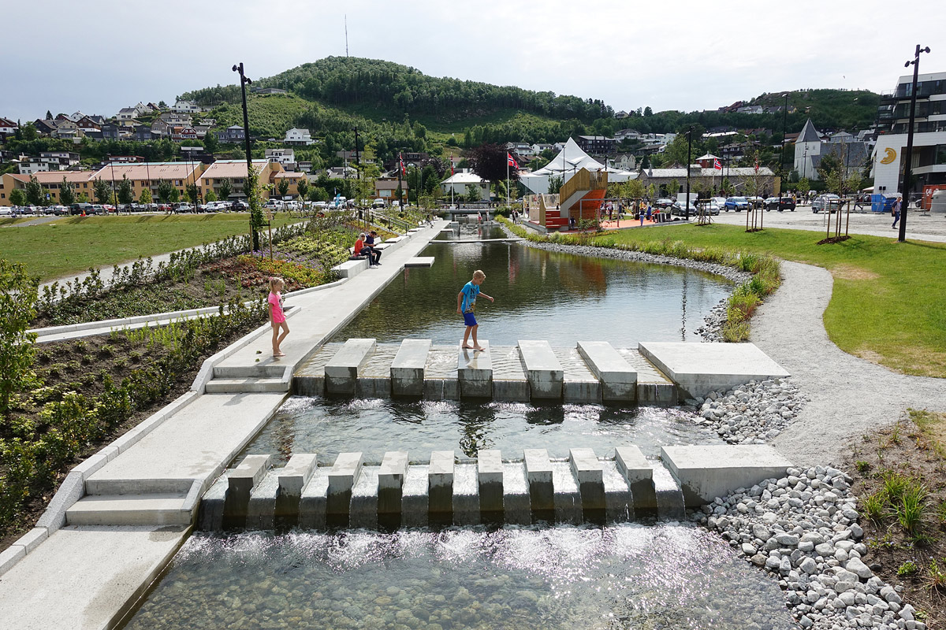
          - Transformation of Ålgård centre
The transformation of Ålgård centre in Gjesdal municipality shows how good planning, cooperation and participation can develop a former industrial area into an attractive meeting place offering activities and attractions for all age groups. The project has drawn nature into the central area of the town and increased the area’s resilience to climate change. The photo shows the canal park and the footpath along the Figgjoelva river. The project won the State Award for Building Quality in 2019.
Photo: Ragnhild Momrak, Dronninga landskap.
              - Restoration of marshland
Intact wetlands play an important role in regulating hydrological conditions and can in some cases mitigate floods. In Adalstjern nature reserve in Horten municipality in Vestfold, an abandoned peat bog was restored from 2019 to 2022. By, among other things, filling previous drainage ditches, more water is retained in the marsh. This will result in a longer detention period for the water and provide a more steady water flow, thereby mitigating floods. Restoring marshland will also be positive for the biodiversity associated with this type of nature, and prevent the carbon stored in the peat from being released into the atmosphere as CO2.
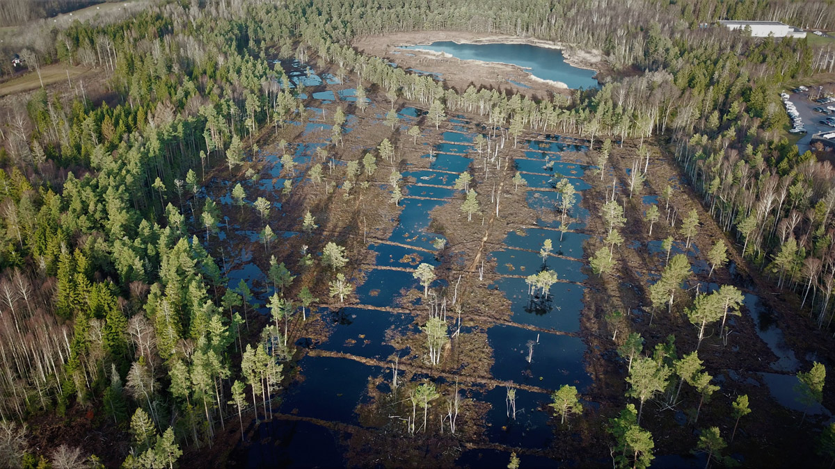
          - Adalstjern nature reserve.
Photo: Pål Martin Eid, Norwegian Nature Inspectorate.
[Boks slutt]
The Government will also raise awareness in land-use management of natural and agricultural areas that bind the soil, store carbon, protect against erosion and are important for stormwater management and flood mitigation. It is important to take ecosystems into account in land-use management so that ecosystems are as resilient as possible to climate change. It is therefore important for municipalities to both maintain and establish blue-green infrastructure in cities and towns. Blue-green infrastructure refers to networks of natural areas, for example parks, outdoor areas, avenues, trees, roadsides, canals, streams, ponds, lakes, private gardens. Blue-green structures can contribute to preserving biodiversity and securing habitats for different species, provide residents with valuable recreational areas, and thus contribute positively to people’s health and quality of life, and make cities and towns more resilient to floods, landslides, stormwater and heat.
Degraded nature is less resilient to climate change and is less able to provide ecosystem services to society, such as improved water quality or reduced runoff. To help ensure that ecosystems are in good condition and can help to reduce the effects of climate change, it is important that municipalities preserve and restore wetlands, watercourses and other nature that is naturally flooded and adapted to this, so that they can continue to serve as natural buffers against flooding. Restoration covers actions that improve the condition of degraded nature and is necessary to stop the loss of biodiversity, limit greenhouse gas emissions from degraded nature and handle the impacts of climate change.
Ensuring sustainable management, and preventing the degradation of agricultural, nature, outdoor recreation and reindeer husbandry areas will be important for bolstering society against climate change, since such areas can bind soil and mitigate erosion, flooding and stormwater.

Better access to climate and geodata
The Government:
- will establish the national data platform ‘Klimakverna’ to make climate and hydrological projections available
- will improve the quality of the Norwegian Public Base of Geospatial Data (DOK)
Climate and environmental data are important for knowledge-based social and land-use planning. The Norwegian Centre for Climate Services (NCCS) – a collaboration between the Norwegian Meteorological Institute, NVE, NORCE Norwegian Research Centre and the Bjerknes Centre for Climate Research – facilitates and disseminates climate and hydrological observations, projections and products for use in adaptation to climate change, such as county-specific climate profiles. Municipal authorities and other public actors are an important target group for the NCCS, but the knowledge base is also used for researching and studying the effects and consequences of a changed climate. In addition, businesses, NGOs, educational institutions, the media and others may benefit from such information. The NCCS will continue to provide the scientific knowledge base for climate change adaptation and make it available to the public administration and other users, through guidance, dialogue and user-friendly climate services.
The Government will establish the national data platform ‘Klimakverna’ to make climate and hydrological projections available. The national data platform ‘Klimakverna’, which is being developed by the NCCS, will make it easier to use climate and hydrological projections. The data will be provided in relevant and standardised formats and communicated in a user-friendly manner. A main objective is to better enable the municipalities in particular to take changing climate conditions into account in their plans and decisions.
Many directorates provide location-based data (geodata) in their own map solutions and in various other formats. However, a number of municipalities find it difficult to gain an overview of and access to geographical data sets that can be used in climate change adaptation efforts. Geonorge, the national website and sharing platform for map data, aims to provide a one-stop-shop for geographic information, making it easier to get an overview of the data. The Government has initiated measures to further develop Geonorge as a sharing platform for geographic data.
Geodata from the Norwegian Public Base of Geospatial Data (DOK) forms an important part of the information basis for municipal and regulatory planning, impact assessments, risk and vulnerability analyses and building applications. DOK is to be used as the basis for planning proposals and building application cases, cf. Section 2-1 of the Planning and Building Act, and currently consists of 148 data sets. DOK is important to increase knowledge about and ensure climate change is addressed in planning. To be used in connection with climate change adaptation, the data sets in DOK must be well-organised and of high quality. To ensure this, the Government will improve the quality of DOK. As part of the national geospatial strategy, several activities have been implemented to support this, and in 2023 the Norwegian Mapping Authority was commissioned to establish a scheme for the receipt and reuse of DOK data in order to improve the public map data.
              - Detailed national elevation model
The entire land area of Norway has been laser scanned to produce detailed elevation data. Data from the elevation model are used, among other things, to create detailed hazard maps for floods and landslides, show areas that may be affected by rising sea levels and storm surges, and model how stormwater moves through the terrain.
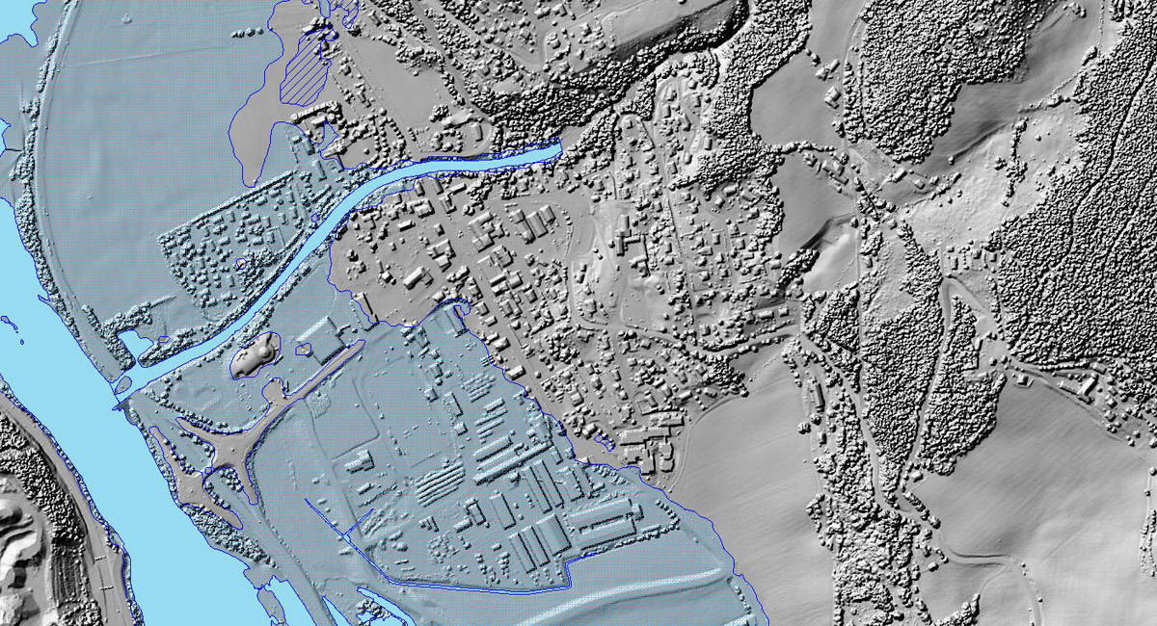
          - Detailed national elevation model.
Source: NVE Atlas.
[Boks slutt]

Handling stormwater in cities and towns
The Government:
- will consider the advantages and disadvantages of introducing a separate stormwater fee, and look at different fee models
- will submit proposals for a new chapter in the Pollution Control Regulations, with requirements for the establishment, emptying and maintenance of sand traps, for consultation
- will look at the need for amendments to the Pollution Control Act’s provisions on liability for damage caused by wastewater treatment installations
The municipalities’ funding scheme for stormwater management needs to be brought up to date. Today, large parts of the municipalities’ costs for wastewater treatment installations are financed through the wastewater fee in accordance with the rules set out in the Act relating to municipal water and wastewater facilities. The current wastewater fee can generally only be used to finance stormwater facilities that consist of pipelines. Local and open solutions for the management of stormwater, such as infiltration zones, detention basins, rainbseds and green roofs, cannot therefore be financed by income from fees. Such solutions are often more suitable for handling sudden, large volumes of water and can be cheaper than traditional stormwater solutions.
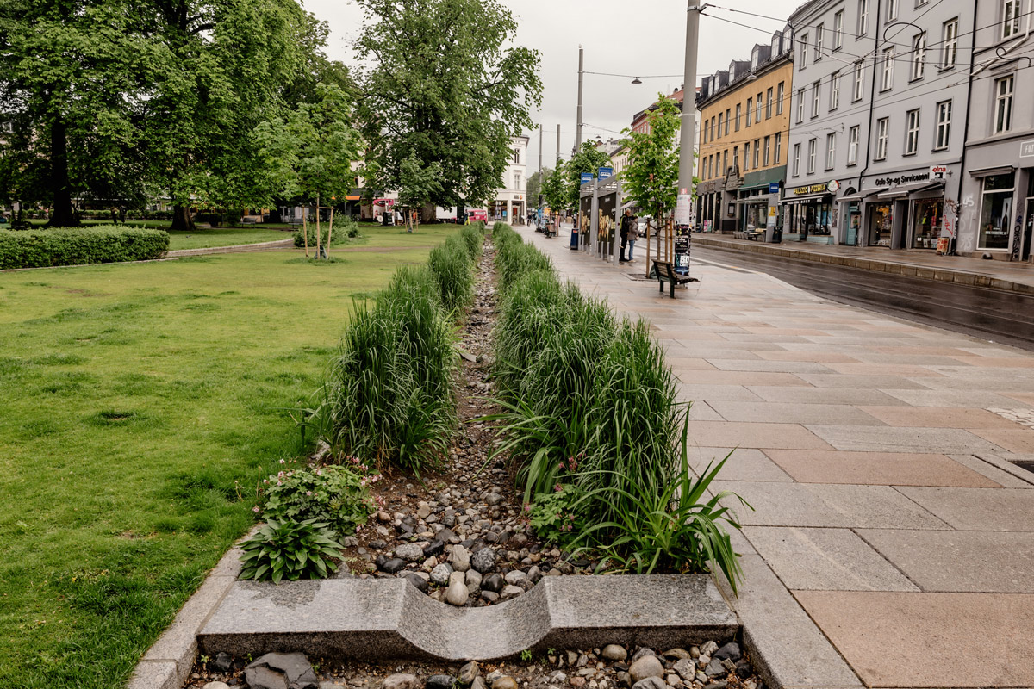
          - Stormwater management in Thorvald Meyers gate.
In Thorvald Meyers gate in the City of Oslo, stormwater management is addressed through open, blue-green measures that contribute to local retention that delays and reduces the pressure on the stormwater system and Akerselva. This also has aesthetic and biological value for the urban environment. The project was one of the finalists for the State Award for Building Quality in 2022.
Photo: Ilja Hendel.
If municipalities want to finance open and local stormwater solutions, they must do so through their ordinary budgets. This provides few incentives for satisfactory stormwater management and is more expensive for society as a whole as well as for the individual municipality. The wastewater fee is calculated according to the individual subscriber’s water consumption and is not related to the amount of stormwater that accumulates and runs off the individual’s property. The wastewater fee therefore provides few incentives for private individuals to take action on their own property, and leads to a skewed distribution of costs. Nor can the current fee be used to finance grants for private stormwater measures. Such measures may reduce the municipality’s need to take action and make investments on behalf of the community, and provide greater flexibility in relation to stormwater solutions.
The Stormwater Commission assessed funding schemes for stormwater measures, and recommended introducing a separate stormwater fee. In 2019, the Norwegian Environment Agency submitted its report on the Stormwater Commission’s fee proposal. The Government will consider the advantages and disadvantages of introducing a separate stormwater fee, and look at different fee models. The Ministry of Climate and Environment has commissioned the Norwegian Environment Agency to conduct an assessment of different fee models and propose legislative and regulatory amendments in 2023.
Roads are a major source of stormwater pollution. Clearer regulation of and responsibility for polluted stormwater from roads is therefore an important measure. Sand traps and similar solutions along roads collect gravel, sand, soil and particles from the stormwater that flows off roads. Sand traps prevent sand, gravel etc. from reaching drainage pipes and thus reduces wear and damage to the wastewater system. Furthermore, sand traps retain certain environmental pollutants and large microplastic particles from the water that is channelled away. Tyre wear and road dust are the main sources of microplastic emissions from land-based sources in Norway, and active use of sand traps is one of the actions that may reduce emissions. In cases where the stormwater is separated from the rest of the wastewater system, sand trapping will often be the only potential purification step for contaminated stormwater. Good emptying and maintenance also prevents sand traps from becoming clogged, which is important to prevent flooding and damage.
The Stormwater Commission found that pollution should be cleaned close to the source and proposed introducing provisions in a new chapter (15 C) of the Pollution Control Regulations to regulate the operation of sand traps and similar solutions. On behalf of the Ministry of Climate and Environment, the Environment Agency investigated the proposal in 2019 and recommended introducing the provisions. The proposal will require the road owner to operate, empty and maintain sand traps and similar solutions in order to maintain function and prevent pollution and damage to wastewater treatment installations. The proposal only applies to urban areas, where there are many activities that can pollute stormwater. It is proposed that the county governors should be assigned pollution control authority. The Government will submit the proposal for a new chapter in the Pollution Control Regulations, with requirements for the establishment, emptying and maintenance of sand traps, for consultation. This work is led by the Ministry of Climate and Environment.
The rules on liability for damage caused by wastewater treatment installations need to be reviewed. The question of who is liable for stormwater damage has led to several legal disputes and conflicts between homeowners and owners of water and wastewater treatment installations, and between their respective insurance companies. The Stormwater Commission proposed making changes to Section 24a of the Pollution Control Act concerning type of liability and possible differentiation of liability for stormwater and contaminated wastewater. The Government will review the need for amendments to the Pollution Control Act’s provisions on liability for damage caused by wastewater treatment installations. This work is led by the Ministry of Climate and Environment.

Addressing rising sea levels
The Government:
- will consider how national authorities’ efforts to address rising sea levels can be improved
As a coastal nation, Norway is particularly vulnerable to sea level rise and storm surges. Natural assets, agricultural land, infrastructure, buildings and the cultural environment along the coast will be among the areas affected. Although we do not know exactly how the sea level will rise in Norway, a long-term perspective is required when planning measures along the coast. Local, regional and national authorities must take rising sea levels into account in their administration. At the same time, good coordination is needed between state actors, among other things to ensure that sea level rise is addressed in the many areas affected and that the state coordinates its efforts with local and regional authorities. The Office of the Auditor General’s assessment is that the municipalities do not currently receive sufficient assistance and follow-up from the government authorities to be able to tackle the issue they are required to address.
The Norwegian Environment Agency is responsible for coordinating and advising the Ministry of Climate and Environment on which prognoses for sea level rise should be used as the planning basis in different parts of the country. As part of its coordinating role in civil protection, the Directorate for Civil Protection and Emergency Planning (DSB) provides advice on how the prognoses should be used in the municipalities’ planning work. However, sea level rise affects many areas of society and poses challenges beyond civil protection considerations. The challenges of rising sea levels are expected to be greater in the future, and the work requires a different planning horizon than much of the other climate change adaptation work. The Government will therefore consider how the authorities’ efforts to address rising sea levels can be improved. The review will include an assessment of how the municipalities can receive adequate assistance, and whether current administrative practices reflect the challenges of sea level rise for Norwegian society.
              - Sea level map solution
The Norwegian Mapping Authority operates the map solution ‘Se havnivå i kart’, which shows areas that may be at risk of sea level rise and storm surges. The solution disseminates municipal statistics about buildings, land and roads that may be exposed to flooding. It can be used to identify risk areas and is an aid for coastal zone planning. New national sea level projections based on the IPCC’s Sixth Assessment Report will be completed in 2023 and will be integrated into the map solution.
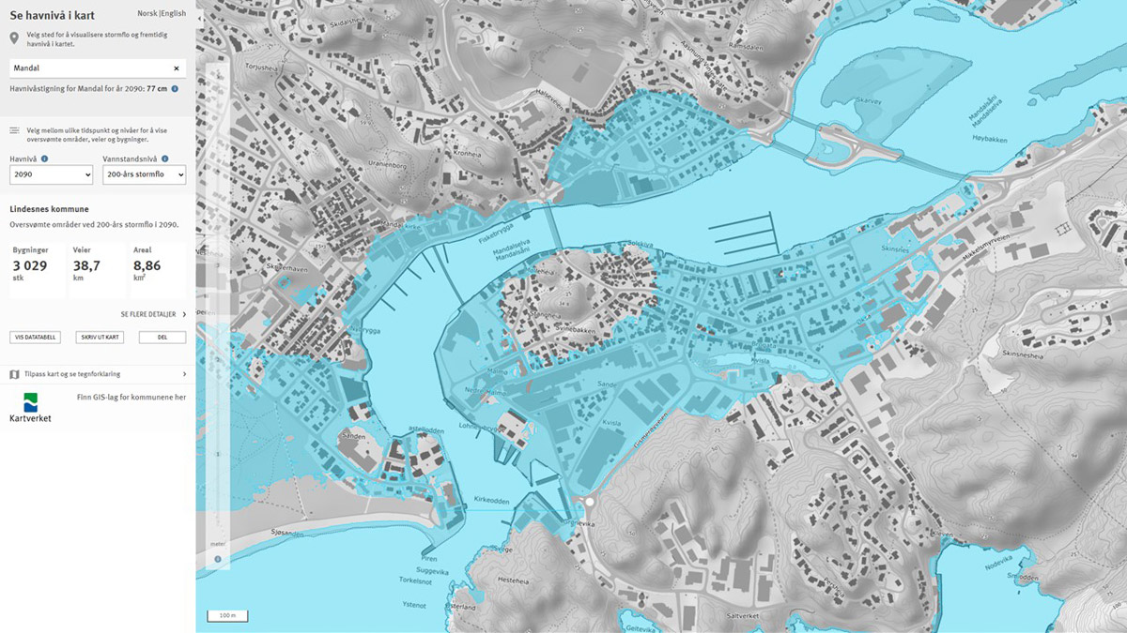
          - Sea level map solution.
Source: Norwegian Mapping Authority.
[Boks slutt]

Food security in a changing climate
The Government:
- will continue the three pillars of Norwegian food security: maintaining the production base, continuous production of food and well-functioning trade systems
The Ministry of Health and Care Services, the Ministry of Agriculture and Food and the Ministry of Trade, Industry and Fisheries are responsible for different parts of the food system: along the value chain from sustainable harvesting and production in the sea and on land, to the population’s consumption of healthy and safe food.
Climate change has consequences for food production both in Norway and globally. Major fluctuations in global food production could contribute to conflicts, which may, in turn, challenge food security including for parts of the Norwegian population. New geopolitical challenges exacerbate the situation. It is difficult to imagine a rich country like Norway not being able to meet the population’s need for food, but we may in fact experience more episodes of limited access to certain types of food, in addition to higher food prices. This will primarily affect those with the worst living conditions. Seafood is one of the few foods in which Norway is self-sufficient, making it important for food security. Food production must be adapted to prevent damage caused by climate change, but also to take advantage of the opportunities that the changes may entail. To achieve this, it is important that companies, businesses and organisations acquire the necessary skills and capacity to work in a structured and planned manner on climate change adaptation. It is also important that public administration capacity is adapted to the coming threats in the areas of food security, animal health and plant health. In light of the report Klimaendring utfordrer det norske matsystemet (‘Climate change challenges the Norwegian food system’ – in Norwegian only) (see box 3.7), the Government, in Report No 15 to the Storting (2022–2023) Folkehelsemeldinga – Nasjonal strategi for utjamning av sosiale helseforskjellar (‘Public Health Report – National strategy for reducing social inequalities in health’ – in Norwegian only) announced that the Norwegian Food Safety Authority will be asked to prepare to meet the challenges posed by climate change and a tense international situation for the Norwegian food system, in order to ensure access to sufficient, safe and healthy food. In order to safeguard Norwegian food security, the Government will also continue to pursue the three pillars of Norwegian food security: maintain the production base, continuous production of food and well-functioning trade systems.
              - Mission on sustainable feed production
Food security is under pressure as a result of population growth, increased pressure on land and resources, climate change and more uncertain supply lines. The availability of safe, high quality feed with low greenhouse gas emissions is a prerequisite for sustainable growth in food production. In the Long-term plan for research and higher education (LTP), the Government has launched missions as a new policy instrument. Targeted missions are innovative and ambitious projects where research is linked with other instruments to solve specific problems by a given deadline. Sustainable feed is one of the two targeted missions that were launched. The aim of this mission is for all feed for farmed fish and livestock to come from sustainable sources and help reduce greenhouse gas emissions in food systems. The Ministry of Agriculture and Food, the Ministry of Climate and Environment, the Ministry of Health and Care Services, the Ministry of Education and Research and the Ministry of Trade, Industry and Fisheries collaborate on the mission to look at how the framework conditions across the sectors can be developed. The goal is to produce more sustainable feed, increase value creation and establish more green jobs across Norway. The mission will be further developed in 2023, in collaboration with relevant actors.
[Boks slutt]
The Farm to Fork strategy is an important element of the EU Green Deal. The strategy describes how the European Commission will work for a fairer, healthier and more environmentally friendly food system that safeguards people’s access to sufficient, healthy and safe food. The strategy is an important basis for further work on sustainable food systems in the EU and could affect Norwegian policy in several areas.
The strategy announces a wide range of initiatives related to new regulations or amendments to existing regulations, including in the field of food. Parts of this legislation will be EEA relevant, while other parts will cover areas outside the EEA Agreement, including agricultural, fisheries and public health policy. The Government is following up the various EEA-relevant regulatory initiatives as part of the ongoing EEA work and promoting Norwegian interests in that context. Follow-up of the Farm to Fork strategy in Norway must also be seen in the context of the assessment of whether a national plan for sustainable food systems should be drawn up, cf. Report No 40 to the Storting (2020–2021) Mål med mening – Norges handlingsplan for å nå bærekraftsmålene innen 2030 (Norway’s action plan to achieve the Sustainable Development Goals by 2030’ – in Norwegian only) and Recommendation No 218 to the Storting (2021–2022).

Safeguard Sami interests and use indigenous peoples’ knowledge in climate change adaptation efforts
The Government:
- will obtain more knowledge about how climate change affects Sami culture and business activity, traditions, ways of life and health
- will involve the Sami Parliament and the Norwegian Reindeer Herders’ Association in climate change adaptation work, where relevant
- will include indigenous peoples’ knowledge/árbediehtu in the work on climate change adaptation
Climate change has major consequences for Sami culture and business activity, and more knowledge is needed about these consequences. The Sami Council’s report ‘Climate Change in Sápmi – an overview and a Path Forward’ points out that more knowledge is needed about the consequences of climate change for Sami culture, business activity and way of life. The Government will obtain more knowledge about how climate change affects Sami culture and business activity, traditions, way of life and health.
Through the Constitution, the Norwegian authorities are obliged to ensure that the Sami people can preserve and develop their language, culture and way of life. The International Covenant on Civil and Political Rights Article 27 and the ILO Convention No 169 on indigenous and tribal peoples in independent states commit Norway to, among other things, preserve the natural basis for Sami reindeer husbandry and set out procedural obligations regarding consultations and participation in decisions that may directly affect Sami interests. In addition to statutory consultations, the Government will also involve the Sami Parliament and the Norwegian Reindeer Herders’ Association in climate change adaptation work, where relevant. It may also be relevant to involve other Sami organisations and institutions in climate change adaptation efforts.
The use of indigenous peoples’ knowledge is highlighted in Article 7 of the Paris Agreement on climate change adaptation and in the Global Biodiversity Framework. In addition, the IPCC and the Nature Panel emphasise the importance of using traditional knowledge and indigenous peoples’ knowledge, together with the scientific knowledge base, in the work on climate change adaptation. This will strengthen the basis for safeguarding Sami interests in adaptation to climate change. The Government will therefore include indigenous knowledge/árbediehtu in its climate change adaptation work, including its work on national climate vulnerability analyses, as described in Chapter 4.

Actions in selected areas
This chapter is the second part of the Government’s plan for national climate change adaptation work for the period 2024–2028. In addition to the priority areas and actions set out in Chapter 5, this chapter describes the Government’s actions in selected sector areas during the period.
The chapter does not provide an exhaustive overview of the national climate change adaptation work. A more thorough report on the individual ministries’ ongoing work on climate change adaptation is provided in the Government’s annual report to the Storting in accordance with the Climate Change Act and can be found in the Government’s climate status and plan. Going forward, plans and actions in the sectors as well as any action points for the cross-sectoral work will also be presented in the climate status and plan.

Nature and the environment

Reduce the overall pressure on ecosystems to enable them to withstand climate change
The Government:
- will integrate climate change adaptation in biodiversity policy, including the work on the white paper on national follow-up of the new global biodiversity framework
- will increase knowledge about the risks to nature as a result of climate change and how it can best be bolstered to tackle these changes
A diversity of species with different characteristics and great genetic variation enables nature to adapt to changes in the climate through natural selection of the fittest. Climate change will affect the living conditions of most species. The variety and good condition of ecosystems is a prerequisite for ecosystems withstanding climate change and continuing to provide ecosystem services (see box 3.4). According to the IPCC, protecting and restoring ecosystems is essential to maintaining and increasing the resilience of the biosphere. The IPCC states that degradation and loss of ecosystems is also a cause of greenhouse gas emissions, which may be exacerbated by climate change, including drought and forest fires. Forests can be adapted to the climate through sustainable management and a varied mix of tree species to increase resistance to pests and climate-related damage such as forest fires. Forests can also be adapted by establishing protective forests, by preservation and other conservation measures and by restoration.
The overall pressure on ecosystems from human activity reduces nature’s ability to adapt to climate change. In addition to climate change, land-use change, overexploitation, the spread of alien species and pollution are the main negative impacts on nature globally. Overall, these impact factors increase the risk of ecosystems reaching tipping points – a point at which they shift into a new and potentially irreversible state.
Ecosystems must be kept in good condition, now and in the future, in line with the national environmental objectives. The Government will integrate climate change adaptation in its biodiversity policy, including its work on the white paper on national follow-up of the new global biodiversity framework.
              - Climate change adaptation and national follow-up of the Global Biodiversity Framework
The Global Biodiversity Framework, adopted in Montreal in December 2022, sets targets for halting and reversing global biodiversity loss. The agreement has four overarching goals to be met by 2050 and 23 targets to be met by 2030. Target 8 states that the impact of climate change on biodiversity must be minimised and its resilience increased by, among other things, reducing emissions and adapting to climate change, and through nature-based solutions. The Government is now considering how this target and the rest of the framework will be followed up in Norway’s biodiversity action plan, which the Government will present as a white paper in 2024. The impact of climate change on biodiversity will be an important factor in the national follow-up of the new global targets.
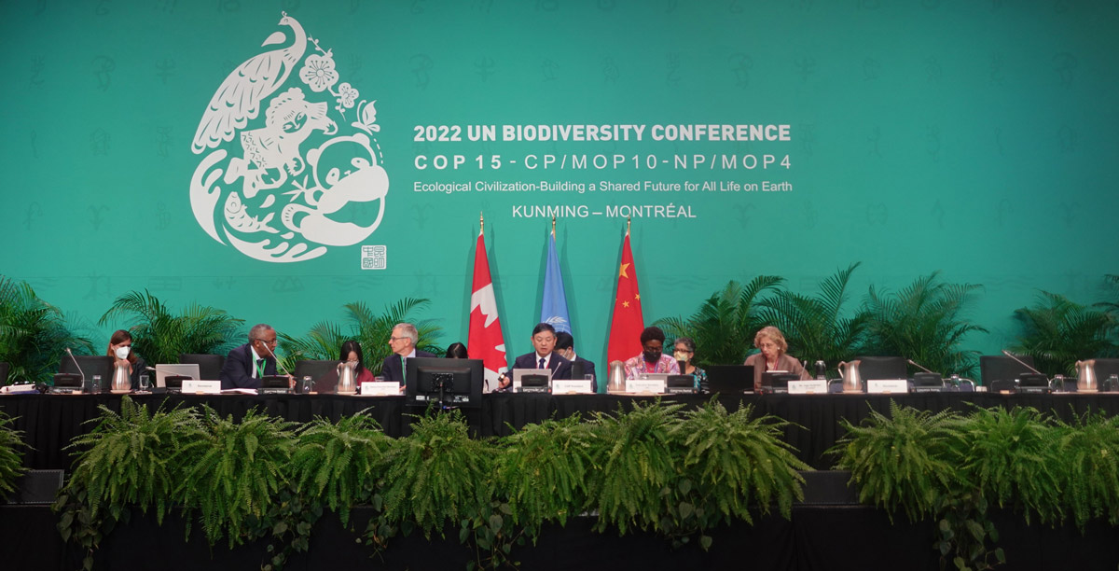
          - Montreal Climate Summit.
The Chinese COP15 President forced through the Global Biodiversity Framework on 19 December 2022, at four o’clock in the morning in Montreal.
Photo: Ministry of Climate and Environment.
[Boks slutt]
The IPCC considers that the impact of climate change on nature is greater and more extensive than previously thought. More knowledge is still sorely needed about the impact of climate change on Norwegian nature and the interaction between climate change and other impacts. The Government will therefore increase knowledge about the risks to nature as a result of climate change and how it can best be bolstered to tackle these changes. A sound knowledge base on the consequences of climate change is pivotal to being able to plan solutions that both reduce emissions and risk and vulnerability. In Report No 5 to the Storting (2022–2023) Long-term plan for research and higher education 2023–2032, the Government has given special priority to research and research-driven innovation on ecosystems in Norway, including nature’s tolerance limits, possible ecosystem tipping points, the value of nature and sustainable land-use management. Together with the efforts to generate new knowledge about the risk climate change poses to nature and actions to ensure that nature maintains its resilience to change, this will provide a good basis for safe social development where Norway also contributes to the world achieving the global biodiversity targets.
              - National hiking trails
Climate change makes increasing and new demands of both the maintenance and establishment of measures to promote outdoor activities. Paths and trails, for example, must be developed to withstand a great deal of precipitation and torrential rain without being destroyed by erosion or landslides. Focusing on comprehensive and long-term planning will enable the national hiking trails scheme, along with the guide ‘Stiskulen – the right path in the right place’, helps to ensure good choices are made in relation to the preparation, operation and maintenance of the trails. Through the annual grant scheme, public, private and voluntary actors can apply for grants for, among other things, the adaptation of trails with very high visitor numbers, so that they can withstand both wear and heavy rainfall.
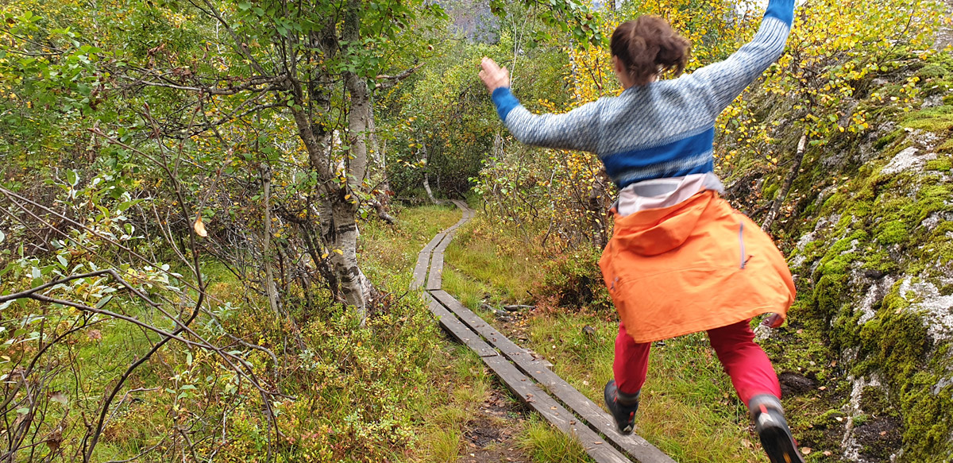
          - Outdoor life.
Climate change is increasing the need for trails and other routes to be maintained in numerous places. Timber planking is one of several measures that can be funded through the national hiking trails scheme.
Photo: Anne Rudsengen, Norwegian Nature Inspectorate.
[Boks slutt]

Prevent loss of and damage to the cultural environment
The Government:
- will help to prevent and reduce loss of and damage to the cultural environment as a result of climate change
The Government will help prevent and reduce loss of and damage to the cultural environment as a result of climate change. A key element in this work is ensuring coordinated land-use planning and that the cultural environment is an integral part of climate change adaptation and emergency preparedness efforts. Good knowledge of the condition, vulnerability and risk of damage to cultural monuments and cultural environments is a prerequisite for implementing the necessary actions. Furthermore, knowledge of material use, craftsmanship and traditional climate change adaptation solutions is needed to make good choices that both safeguard the cultural environment and make them better equipped to withstand climate-related events. Preventive actions such as regular maintenance and good management are the best way of safeguarding the cultural environment.
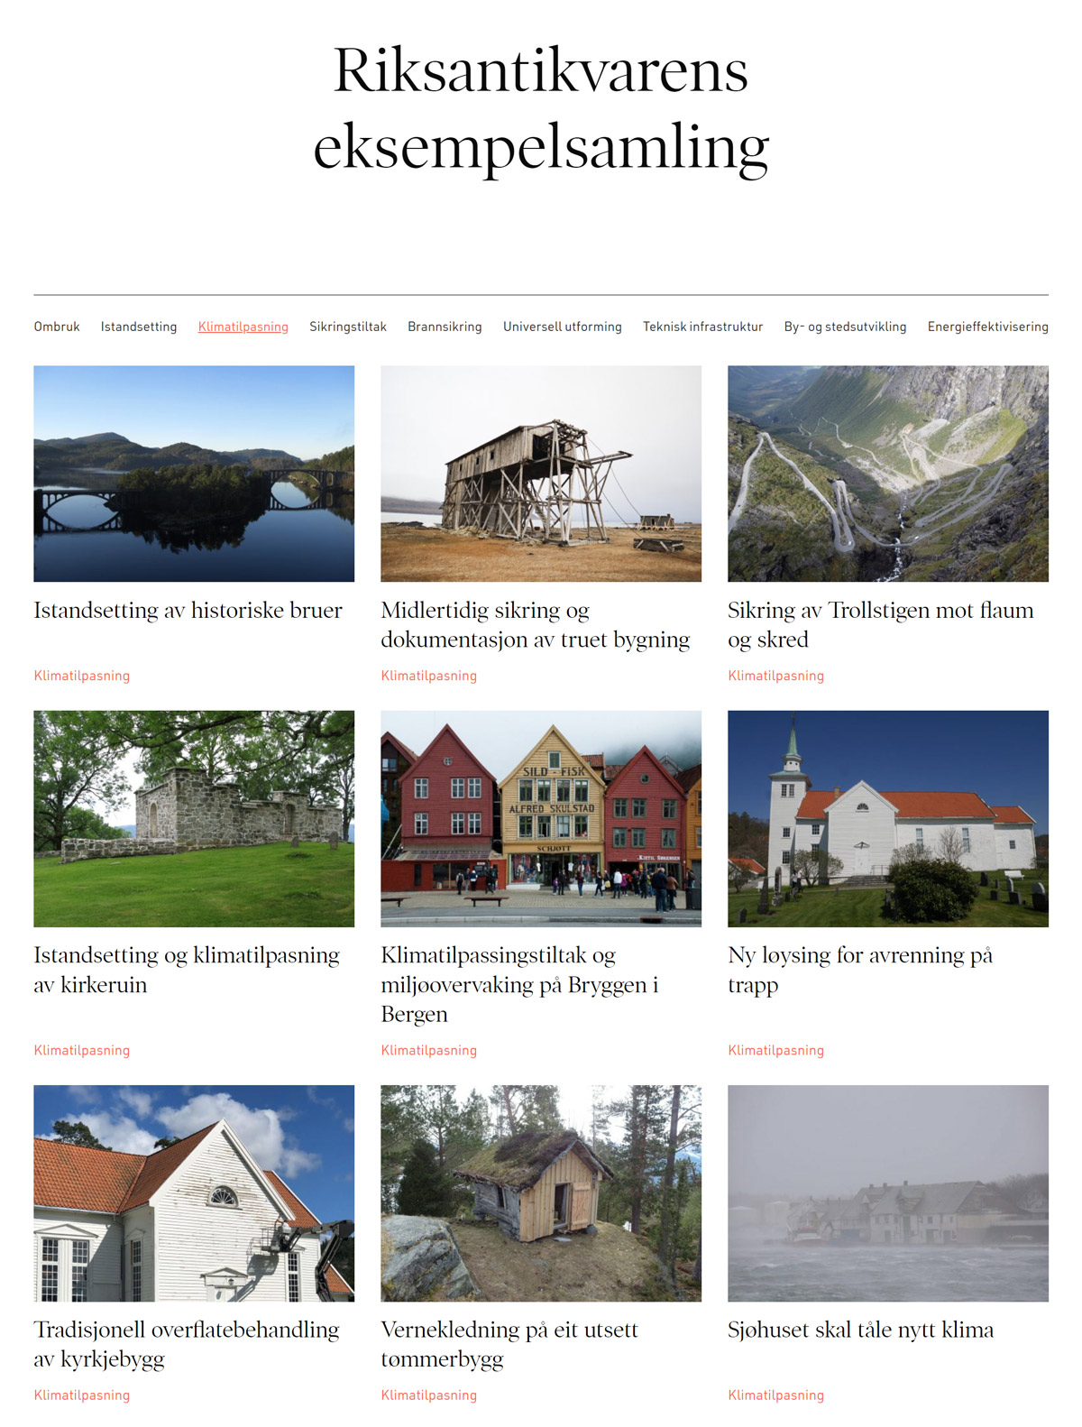
          - Examples for inspiration.
The Norwegian Directorate for Cultural Heritage has several good examples that show that it is possible to implement climate change adaptations, while safeguarding cultural environmental assets. The collection of examples is available digitally and is a tool for the public administration and others who own protected and listed cultural monuments. The website is regularly updated with new examples from across Norway.
Photo: Screenshot of examples in the Norwegian Directorate for Cultural Heritage’s collection.

New white paper on the overall management plans for the marine areas
The overall pressure on ecosystems from human activity reduces nature’s ability to adapt to climate change. Ecosystems in good condition are also important for reducing the impact of climate change in marine areas. In addition to climate change, other important negative impacts are pollution, alien species, impacts on the seabed and other impacts from human activities. The marine ecosystems change rapidly as the climate warms and species shift north. The changes are already significant in both the North Sea and Skagerrak and in the northern parts of the Barents Sea, where sea ice is retreating rapidly. The possibility that new species can become established in Norwegian waters is also increasing, especially in our northernmost marine areas where the cold climate previously acted as an effective barrier. How the management of Norwegian marine areas can adapt to climate change will be an important topic in the forthcoming white paper on management plans for the Norwegian marine areas, which will be presented in spring 2024.

National security, civil protection and emergency preparedness

Climate change considerations in civil protection work
The Government:
- will increase knowledge about how national security and critical social functions are affected by climate change, and make them more resilient for the future
- will map how the ministries work on climate change adaptation as part of their civil protection remit
- will further develop the method for analyses of crisis scenarios to systematically take climate change into account in assessments of future risk
- will protect vulnerable groups in civil contingency planning
Civil protection is about ensuring the safety of citizens. It is about society’s ability to prepare for, protect itself against, and deal with events that threaten fundamental values and functions. Climate change affects civil protection in a number of ways. The increased intensity and frequency of extreme weather increases the risk of serious natural events and can threaten life and health, material assets and critical infrastructure.
In order to facilitate a systematic approach to civil protection work, the Government views the work as a coherent chain comprising prevention, emergency preparedness, management, recovery and learning. In all parts of the chain, knowledge development and adaptation to changes in the risk and vulnerability situation are an integral part of the work. This underscores the importance of increasing our knowledge about climate change in the short and long term. The resilience of critical infrastructure is particularly important in a changing climate. Critical infrastructure comprises the facilities and systems necessary to maintain critical social functions that in turn meet society’s basic needs and make citizens feel secure. These include basic physical needs such as water, food and heat. The Norwegian Directorate for Civil Protection and Emergency Planning (DSB) will therefore work actively to integrate climate risk and vulnerability in all stages of the civil protection chain to an even greater extent than today.
Climate change will affect several critical social functions, as well as national essential functions. It is therefore important to obtain an overview of how they may be affected by a changing climate, for example through status assessments of the critical social functions for which the ministries are responsible. The Government will increase knowledge about how national security and critical social functions are affected by climate change and make them more resilient for the future. The Government will also further develop the method for analysing crisis scenarios to systematically take climate change into account in assessments of future risk. The Government’s political platform, the Hurdal Platform, highlights the importance of developing a better system for identifying how risks in different sectors affect each other. Report No 5 to the Storting (2022–2023) Long-Term Plan for Research and Higher Education 2023–2032 highlights civil protection and emergency preparedness, including knowledge related to the impact of climate change on serious natural events, food security, the spread of infectious diseases and access to vital natural resources, as a priority area. DSB’s analyses of crisis scenarios also help to highlight this in relation to extreme weather events and natural hazards.
              - Analyses of crisis scenarios
DSB’s Analyses of Crisis Scenarios (ACS) are risk analyses of a range of undesirable events with potentially serious consequences for society. These are events that Norwegian society should be aware of in order to assess risk reduction measures. The analyses include natural events, major accidents, supply failures and intentional acts. The risk analyses in ACS cover all sectors and levels of government in order to develop an understanding of, and create awareness about, the broad range of potential consequential events and consequences.
For an event to be included in ACS, the conditions should be present for the events to happen tomorrow. However, climate change implies that we must expect natural events to occur more frequently and with greater force in the future. Changes in the climate also lead to greater unpredictability because it is more difficult than before to predict where events will hit. DSB intends to further develop its analyses of crisis scenarios to take greater account of climate change in its assessments of future risk.
[Boks slutt]
The consequences of a changing climate place increased demands on prevention, but also entail a need to dimension preparedness and crisis management capacity to a changed risk profile. Crisis management is about translating preparedness into effort and cooperation. Good crisis management requires that those tasked with handling the event have the necessary resources in the form of equipment and personnel. It is important that different actors with specialised response skills related to personnel, skills and material assets collaborate, especially in complex events. Our society is generally resilient with good procedures, preparedness and crisis management capabilities. However, we must be prepared for climate-related events occurring at other times of the year than we have been used to and in places that have not previously been at risk.
The impact of climate change on critical social functions can also affect national security, as well as national essential functions. It is therefore important to obtain an overview of how the parts of civil protection that are essential for Norway’s ability to safeguard its national security interests are affected, as defined in the Act relating to National Security.
As part of the Ministry of Justice and Public Security’s supervision of the ministries’ civil protection work in accordance with the Civil Protection Instructions, the Government will map how the ministries work on climate change adaptation as part of their civil protection remit.
Climate change affects different parts of society differently and can exacerbate inequalities. The most vulnerable are often the hardest hit. This is because different population groups have different opportunities and resources, and thus different prerequisites for adapting to the effects of climate change and dealing with crisis situations. For example, research shows that people with disabilities are more likely to be injured in a natural disaster since it can be challenging to evacuate them and they are rarely included in contingency plans.
The Sendai Framework for Disaster Risk Reduction for 2015–2030 underlines the importance of including people with disabilities in the design of climate policy, in the planning of prevention measures and in data collection. The framework also refers to the importance of a gender, age, disability and cultural perspective in the work on reducing disaster risk. This requires empowerment and inclusive, accessible and non-discriminatory participation processes. It is also important to pay special attention to people who are disproportionately affected by disasters and are particularly vulnerable in the face of climate change. In cases where the municipality or other parties are responsible for providing services to vulnerable groups, they are also responsible for preparedness and for ensuring that vulnerable groups receive the services they are entitled to if they are at risk of adverse events. DSB recommends that the municipal responsibility for safeguarding vulnerable groups should be considered a critical service, and that the vulnerability of various services should be assessed and followed up by building capacity in the services’ contingency plans. In light of this, the Government will include vulnerable groups in civil contingency plans, with special emphasis on people with disabilities.

Develop risk and vulnerability analysis in the counties (fylkesROS)
The Government:
- will develop the risk and vulnerability analysis in the counties (fylkesROS) to ensure that it is used more actively in the work on climate change adaptation at the regional and local level
As a coordinating authority, the respective county governors must maintain an overview of risk and vulnerability by preparing a risk and vulnerability analysis for the county. This analysis is a tool that can be used more actively in the work on climate change adaptation both regionally and locally. It can, among other things, be used by the county authority as a knowledge base in regional plans and as a possible basis for the county governor’s authority to file an objection in the area of civil protection. The Government will develop the analysis to enable it to be used more actively in the work on climate change adaptation at the regional and local level.
The Government wants climate events that are included in risk and vulnerability analyses to be followed up with interdisciplinary pilots at the regional level. As such, the county governors, in collaboration with regional actors, will promote local interdisciplinary networks in their respective municipalities.

Better warning system for natural hazard events
The Government:
- will ensure that Norway can make greater use of risk-based natural hazard warnings
- will further develop the possibility of issuing public warnings in the event of extreme weather and natural hazards that pose an acute risk to life and health, through Emergency Alert, the authorities’ new alert system
Good monitoring and warning as a preventive measure against flood and landslide damage will become increasingly important, enabling early warning that allows lives and assets to be saved. Through monitoring and warning, the emergency preparedness system can also be mobilised in time. NVE can provide technical advice to municipalities, county governors and the emergency services, which can then decide on measures such as relocation and evacuation. Monitoring and warning increases the safety of the population in vulnerable areas. The Government will therefore ensure that Norway can make greater use of risk-based natural hazard warnings.
NVE, in cooperation with, among others, the Norwegian Meteorological Institute and the Norwegian Public Roads Administration, is further developing the national alert service so that natural hazard warnings better match the risks and consequences of events and not just the likelihood of an event occurring. By highlighting risks and consequences, i.e. where incidents will cause damage, emergency response efforts and measures can be targeted to where the need is greatest.
Emergency Alert is the authorities’ new mobile-based alert system. The intention behind Emergency Alert is to be able to quickly communicate important information that can save lives and health in the event of sudden and serious events, such as extreme weather and natural hazards. The Government will further develop the possibility of issuing public warnings in the event of extreme weather and natural hazards that pose an acute risk to life and health, through Emergency Alert. Emergency alerts are sent by the police. Other actors that need to send warnings must establish cooperation with the police.

Tackle increasing forest fire hazards
The Government:
- will increase knowledge of how land-use management and various forestry measures can reduce the fire hazard in particularly vulnerable areas
- will ensure that the fire and rescue service is better equipped to meet the future challenges related to extreme weather and climate change through knowledge dissemination and training at the Norwegian Fire and Rescue Academy
Climate change increases the risk of forest fires. In 2019, DSB conducted an analysis of forest fire preparedness in Norway seen in relation to the experience of recent fires in the Nordic region and expected climate change consequences in a ten-year perspective. The analysis shows that future forest fires will be challenging based on today’s preparedness level.
Experience from Europe has shown that it is difficult to maintain emergency preparedness dimensioned for what is referred to as ‘megafires’. These are fires that, due to climate change, are of a size and intensity that make them almost impossible to extinguish using conventional methods. Several EU countries are therefore now promoting various forms of land-use management that, in strategic places, can reduce combustible organic material so that forest fires and wildfires can be limited before they pose a risk to life, health and important social structures. Specifically, this may involve targeted grazing of fire-prone vegetation or pre-burning of at-risk areas, which is currently carried out in coastal heathlands. Another measure may be to consider the composition of tree species in particularly fire-prone areas. Preventing fires through land-use management is considered more cost-effective than combating fires that spread rapidly in vegetation and to settlements. Such measures may also be relevant in Norway, but must at the same time be assessed against other considerations. The Government therefore seeks to increase knowledge of how land-use management and various forestry measures can reduce the fire hazard in particularly vulnerable areas.
The Government will also ensure that the fire and rescue service is better equipped to meet the future challenges related to extreme weather and climate change through knowledge dissemination and training at the Norwegian Fire and Rescue Academy, which educates firefighters and provides training for fire and rescue service managers. It also runs courses such as forest fire courses, which help to disseminate knowledge in the field of prevention and emergency preparedness.
In order for the fire and rescue service to be equipped for the future, including being able to deal with the consequences of climate change such as an increased risk of forest fires, the Government initiated a comprehensive review of the fire and rescue area in autumn 2022. The Government will present a white paper on the topic by the end of 2023.

Floods and landslides

New white paper on floods and landslides
The Government:
- will present a new white paper on flood and landslides
Floods and landslides are natural processes, but are affected by climate change and land use. Efforts are already being made to reduce the negative impact of climate change in the natural hazard field. Among other things, the government authorities assist with mapping, land-use planning, protection measures, monitoring, warning and emergency preparedness to prevent damage from floods and landslides.
Preventing flood and landslide damage may constitute valuable climate change adaptation. Relevant measures in that context include not building in vulnerable areas, or establishing physical safeguards, preferably based on nature-based solutions. Such solutions may involve preserving typical characteristics of watercourses like wetlands, floodplains, forests, edge vegetation, or river restoration with wider rivers to provide adequate space for the watercourse.
The framework for work on the prevention of flood and landslide damage was established through Report No 15 to the Storting (2011–2012) Hvordan leve med farene – om flom og skred (‘How to live with the risks of floods and landslides’ – in Norwegian only). We have since obtained new experience, expertise and knowledge of natural hazards. A changing climate makes the work on prevention increasingly important. The need for prevention is also made more pressing by increased development and other human activities in hazard areas. More knowledge, mapping and development of management practices is needed in the various parts of the natural hazard field.
In Norwegian Official Report NOU 2022: 3 På trygg grunn – Bedre håndtering av kvikkleirerisiko (‘Better management of quick clay landslide risk’ – in Norwegian only), the Gjerdrum Committee pointed out that the current regulations are unclear regarding the responsibility of different parties for securing existing buildings. In its performance audit, the Office of the Auditor General has also recommended, in Document 3:6 (2021–2022), that measures should be considered to better secure existing buildings, along with a clarification of municipal responsibilities for such security measures through guidance or other means. The Gjerdrum Committee also highlighted the need for increased efforts to improve hydro-technical facilities in agriculture and to clarify responsibilities where such areas and facilities are subjected to altered loads from upstream interventions.
The Government believes the framework for the prevention of flood and landslide damage requires review and will therefore present a new white paper on the topic in 2024. A review of the policy area will be important in order to update the knowledge and decision-making basis for managing natural hazards and to explore opportunities to develop management practices. Among other things, the white paper will assess the work related to mapping hazard areas and implementing safeguards, review current regulations and update the knowledge and decision-making basis for natural hazards.

Nature-based solutions for flood and landslide protection
The Government:
- will promote the use of nature-based solutions for flood and landslide protection wherever appropriate
There are a number of nature-based solutions that may be suitable for reducing flood and landslide risk while also improving the environmental condition of watercourses. The most important method is good land-use management. Vegetation should be left along streams and larger watercourses, as well as on steep terrain, to prevent flood and landslide risks. It is important to preserve or restore nature that is naturally flooded and acts as a natural buffer against flooding, such as wetlands and floodplains. The effects of various measures should be seen in context, for example within a catchment area, to assess how best to use the area while taking the increased risk of flooding and landslides into account.
Increased runoff in a catchment area will increase stormwater runoff and erosion, which may increase the risk of landslides. If not taken sufficiently into account, changes in land use, such as the establishment of new roads or activities like logging, may have a significant impact on stormwater runoff. Vegetation can play an important role in nature-based solutions in preventing erosion. Vegetation acts as erosion protection, helps stormwater infiltrate into the ground, reduces the risk of landslides being triggered and helps slow down rock falls.
Forests can be an effective safeguard against landslides, and are used for that purpose in many countries. In Norway, forests reduce the likelihood of landslides in many built-up areas. Good management solutions must be found that balance consideration of forests as a safeguard and as a resource for business.
Watercourse regulations will normally help to stabilise the flow of water in watercourses and can have a significant flood mitigation effect, but may also have adverse consequences for biodiversity. The Government wishes to ensure that nature-based solutions for flood and landslide protection are used wherever appropriate.
Norway’s protected rivers have great national value and together protect a representative sample of Norway’s natural river systems. The protection applies in particular to hydropower development, but the protected assets must also be taken into account in other interventions. In connection with the consideration of Report No 25 to the Storting (2015–2016) Kraft til endring – Energipolitikken mot 2030 (‘Energy policy towards 2030’ – In Norwegian only), cf. Recommendation 401 (2015–2016), the Storting agreed that the river protection system should in principle be permanent, and that power development can only be considered in cases where the objective is flood control. A unanimous committee stated that ‘power development above 1 MW in protected watercourses shall be submitted to the Storting and only be considered in cases where other flood mitigation measures have been tested, lives and health are at stake and the assets will not be significantly affected’.
              - Flooding and the environment in a changing climate
In a collaboration between NVE, Vestland County Authority and the County Governor of Vestland County, NORCE has compiled and developed methods that can improve flood risk management and the environmental status in and along watercourses in the R&D project Flom og miljø i et endret klima (‘Floods and the environment in a changing climate’). NORCE recommends the use of nature-based flood risk management solutions to improve both flood control and environmental conditions. They have created a priority list for nature-based solutions that enable environmental considerations to be taken into account in all flood risk management. Land-use planning where typical characteristics of watercourses, such as wetlands and flood plains, are preserved is the highest priority. Furthermore, watercourse restoration with wider or deeper rivers is highlighted to provide sufficient space for the river and environmentally adapted flood control measures. Mitigating environmental measures are recommended where it is necessary to implement non-nature-based flood control measures.
Source: NORCE (2023).
[Boks slutt]

Incentives for preventing damage to nature
The Government:
- will look at the possibility of adjusting the natural damage insurance scheme so that it better safeguards the interests of prevention, while ensuring that this does not compromise the principle of a solidarity-based and equal determination of premiums for insurance customers throughout the country
Incentives for prevention and climate change adaptation are affected by economic and regulatory instruments, ownership and schemes for financing, insurance and compensation etc. The financial and insurance industry is an important partner for the public sector in its work on climate change adaptation. Several actors point out that the current incentives pose challenges and that the incentive models for prevention should be improved so that more profitable climate change adaptation actions are implemented. Among other things, the Climate Risk Commission (2018), the Stormwater Commission (2015) and the Climate Adaptation Committee (2010) have pointed to shortcomings in the natural damage insurance scheme. The Government will look at the possibility of adjusting the natural damage insurance scheme so that it better safeguards the interests of prevention, while ensuring that this does not compromise the principle of a solidarity-based and equal determination of premiums for insurance customers across Norway. The need to increase incentives to prevent natural hazards must be considered in connection with the forthcoming white paper on floods and landslides.

Assess the requirements for protection against natural hazards
The Government:
- will assess the requirements for protection against natural hazards in the building part of the Planning and Building Act and the Technical Regulations.
Pursuant to Section 28-1 of the Planning and Building Act, it is not permitted to build in areas where a hazard risk or significant inconvenience is indicated due to natural or environmental conditions. The provision gives the Ministry of Local Government and Regional Development the legal authority to stipulate more detailed provisions on requirements for protection against natural hazards in the Technical Regulations (TEK17). The legal provision and TEK17 are very significant for land-use plans and developments. More mapping and knowledge about unstable mountain areas has increased safety in areas at risk of rock falls and flood waves. At the same time, the TEK17 requirements have in some places resulted in disproportionately strict building restrictions and desired development grinding to a halt.
To facilitate further development and value creation for local communities that may be affected by rock falls and flood waves, while also safeguarding personal safety, the Ministry of Local Government and Regional Development changed the requirements in 2022 and 2023. However, more risk-based requirements that are better adapted to local conditions are still needed. The Government will therefore assess the requirements for protection against natural hazards in the building part of the Planning and Building Act and the Technical Regulations. The ministries have appointed a working group comprising the Norwegian Building Authority, DSB and NVE. The working group will look at the possibilities of allowing organisational safeguards and examine whether the safety requirements in TEK17 are at the appropriate level, and how the requirements can more fully take future climate change into account. The affected directorates will be involved in the work.

Buildings, infrastructure and transport

Climate change adaptation of the transport infrastructure
The Government:
- will concretise the work to make transport infrastructure better adapted to the future climate in the National Transport Plan (NTP) 2025–2036
- will present a comprehensive and binding plan in the NTP to reduce the maintenance backlog for county roads in collaboration with the county authorities
- will present a comprehensive and binding plan in the NTP to reduce the maintenance backlog for national roads
- will present a comprehensive and binding plan in the NTP to reduce the maintenance backlog for the railways
- will present a national implementation plan in the NTP for landslide and avalanche protection of all national roads and county roads with a high and medium landslide/avalanche factor
To ensure safe and predictable transport infrastructure, climate change adaptation must form an integral part of the planning, construction, operation and maintenance of the infrastructure. For example, climate change must be taken into account in the location of roads and railways and when dimensioning culverts, manholes and ditches so that they can cope with increased amounts of water. Furthermore, climate change causes more frequent damage to infrastructure with subsequent repair needs and costs. Climate change may also increase the need to maintain infrastructure that is outdated, undersized or in poor condition.
The overall strategic planning of transport infrastructure takes place through the National Transport Plan (NTP). The plan serves as a tool for coordination, investigation, management and prioritisation, and is normally rolled out every four years. The next NTP has been brought forward to spring 2024. The plan will apply for the twelve-year period from 2025 to 2036. The transport companies have provided input related to climate change adaptation of the sector to NTP. As transport infrastructure projects, operation and maintenance are prioritised in the NTP, the Government will also concretise the work to make transport infrastructure better adapted to the future climate in the plan.
The Ministry of Transport and Communications and the Ministry of Trade, Industry and Fisheries are also following up the work on climate change adaptation through management dialogue with the agencies and in owner dialogue with the companies.
County roads, national roads and railways
In order to make existing infrastructure more resilient to climate change, the maintenance backlog on roads, railways, in the shipping lanes and ports must be reduced. Among other things, there is an increased need for landslide and avalanche protection. Climate change also poses challenges in terms of road safety, preparedness and accessibility. Roads and railways must be dimensioned to cope with increased amounts of water. Operation and maintenance will also become more demanding in general.
Large parts of the Norwegian rail network are outdated, under-dimensioned or in poor condition. Over time, a large maintenance backlog has accumulated. The old infrastructure causes many faults that halt rail traffic. More frequent damage caused by climate change increases the vulnerability of the railways and the consequences may be greater than for roads as rail traffic cannot be rerouted. This applies in particular to freight transport. Climate challenges thus contribute to less regular rail freight transport and weaken competitiveness in relation to road transport.
As announced in the Hurdal Platform, the Government will in the upcoming NTP present a comprehensive and binding plan to reduce the maintenance backlog on county roads in collaboration with the county authorities. The Government will present similar plans to reduce the maintenance backlog on the national roads and rail network. The content and scope of the plans must be assessed and prioritised in relation to other projects in connection with the NTP process and within the adopted financial framework.
The Norwegian Public Roads Administration has been tasked with coordinating a survey of the condition of the county roads, in collaboration with the county authorities. A good overview of their condition will be important in order to implement a comprehensive and binding plan to reduce the maintenance backlog, both for the national and county roads.
The Norwegian Railway Directorate and Bane NOR have been asked to prepare a proposal for a comprehensive and binding plan to reduce the maintenance backlog for rail infrastructure. The Government has also decided to return Spordrift AS to Bane NOR. This move will support the Government’s ambition to establish a more unified and holistic rail sector and speed up the development of a comprehensive and modern maintenance system.
Climate change exacerbates the risk of landslides. The Government will present a national implementation plan in the NTP for landslide and avalanche protection of all national roads and county roads with a high and medium landslide/avalanche factor. The plan must be prepared together with the county authorities and affected sector ministries with subordinate agencies.

Climate change adaptation of port infrastructure and fairways
The Government:
- will discuss the work on mapping the condition of the fishing port facilities along the coast in the NTP and assess whether the facilities are adapted to the effects of climate change
- will strengthen the Norwegian Coastal Administration’s role as a knowledge provider and guide on the impact of climate change for the ports
- will assess whether existing grant schemes can provide funding for climate change adaptation measures for port infrastructure within an unchanged grant limit
The state owns fishing port facilities along the entire coast. The Norwegian Coastal Administration is now mapping the condition of these facilities to gain an overview of the need for maintenance and repairs. Part of this mapping is to assess whether the facilities are adapted to the future effects of climate change. In 2022, quays and piers in Finnmark were mapped, and the Norwegian Coastal Administration expects to have a complete overview of all the facilities across Norway by 2024. The mapping can form the basis for outlining a plan for upgrading the state-owned fishing port facilities. Such a plan could contribute to the best possible climate change adaptation of state-owned fishing port facilities. In the NTP, the Government will discuss the work of mapping the state of the state-owned fishing port facilities along the coast, and assess whether they are adapted to the effects of climate change. Measures to upgrade and maintain state-owned fishing port facilities will also be presented in the next NTP in spring 2024.
As port authority, the Norwegian Coastal Administration has knowledge about the potential consequences of a changed climate for maritime infrastructure, including port infrastructure. The Norwegian Coastal Administration uses this knowledge in its role as specialist authority in planning matters concerning the coastal zone and in consultation submissions and objections. The Government will strengthen the Norwegian Coastal Administration’s role as a knowledge provider and guide on the impact of climate change for the ports.
The Norwegian Coastal Administration also manages various grant schemes for ports and maritime transport, including grants for investment in efficient and environmentally friendly ports and grants for municipal fishing port facilities. None of these are currently specifically targeted at climate change adaptation measures. The Government will assess whether existing grant schemes can provide funding for climate change adaptation measures for port infrastructure within an unchanged grant limit.

Climate change adaptation of property in the state civil sector
The Government:
- will implement climate change adaptation measures for property in the state civil sector
The state is a major property manager. Major assets are tied up in property, and the buildings house important functions. Climate-related damage can have far-reaching consequences for property in the state civil sector and may affect the operation of the state-owned enterprises that use the buildings. In extreme cases, damage to the properties may pose a risk to life and health. Damage can also result in loss of architectural and cultural heritage. The Government will therefore implement climate change adaptation measures for property in the state civil sector. In order to adapt existing buildings and property at the right level, state property managers must map the risk of climate-related damage and draw up the necessary plans for implementing and financing climate change adaptation measures. Statsbygg has already mapped the properties that they manage. The Government has now initiated work on obtaining a similar overview of other properties in the state civil sector. Climate risk must also be considered before initiating new building projects. The cheapest measure is to avoid building where the risk is high.
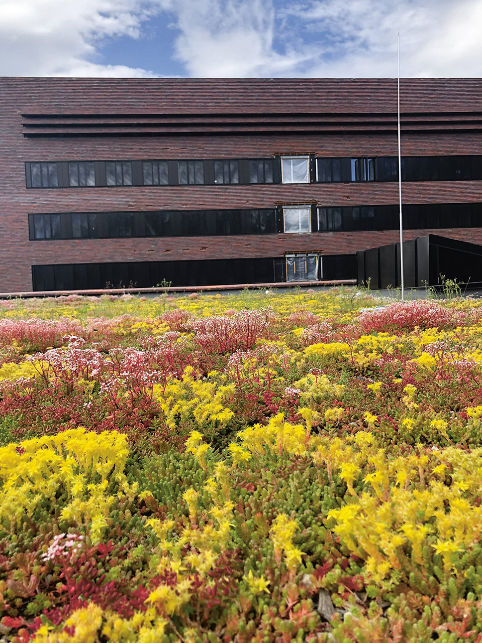
          - Sedum roof on Campus Ås.
Green roofs can have a flood mitigation effect since they retain water. In addition, green roofs contribute to biodiversity and cleaner air. The photo shows a sedum roof at Campus Ås (Norwegian University of Life Sciences).
Photo: Statsbygg.
          - One potato, two potato
The potato is one of the food crops with the largest growing areas in Norway. It has fed us through the ages and can continue to do so. A good potato harvest requires keeping frost, moisture and disease at bay. The photo shows the potato ‘Gulløye’.
Photo: Ulrike Naumann, Tromspotet AS.

Climate change adaptation in the licensing of new energy facilities
The Government:
- will safeguard climate change adaptation through the licensing of new energy facilities, guidance and supervisory activities
A secure power supply is contingent on active efforts to reduce the negative impact of climate change on energy facilities. This requires that climate change is taken into account, both in power production and power distribution. The Government will safeguard climate change adaptation through the licensing of new energy facilities, guidance and supervisory activities. At present, measures are implemented through the licensing of new energy facilities, guidance and supervisory activities. NVE has, among other things, implemented changes in its own case management tools to bring licensing and other exercise of authority in line with the requirements that follow from the central government planning guidelines for climate and energy planning and climate change adaptation.

Agriculture, fisheries and aquaculture

Climate change adaptation in agriculture
The Government:
- will continue to work on climate change adaptation measures and climate resilient farming systems that can contribute to achieving agricultural policy goals and the national target for climate change adaptation, and safeguarding other social interests
- will prepare a mandate and appoint a broadly composed working group with members from research, industry and the public administration to review climate change adaptation in agriculture
- will make an assessment of how the agricultural sector’s policy instruments can be used to facilitate climate change adaptation and climate-resilient farming systems in connection with the follow-up of the working group’s assessments
The agricultural sector must be equipped to ensure the necessary production and climate change adaptation, while reducing its environmental impact. To achieve this, cooperation and joint solutions must be established with farmers, landowners and business actors across the country. Climate change adaptation in agriculture is particularly important in primary production, but also in other parts of the agricultural value chain.
Technology development and new knowledge of agronomy, different farming systems, variety development and livestock breeding will play a key role in the further development of a forward-looking and climate-adapted agricultural sector. The Government will therefore continue working on climate change adaptation measures and climate-resilient farming methods that can contribute to achieving agricultural policy goals and the national target for climate change adaptation, and safeguard other social interests.
The need for climate change adaptation in individual farming and cultivation systems was reviewed by a working group, which submitted the report Landbruk og klimaendringer (‘Agriculture and climate change’ – in Norwegian only) in 2016. The Government will prepare a mandate and appoint a broadly composed working group which will review climate change adaptation in agriculture and update knowledge in accordance with the 2016 report, including new findings from the IPCC’s Sixth Assessment Report. The working group will also review how overriding social considerations can be safeguarded by climate change adaptation on agricultural land. In connection with the follow-up of the working group’s assessments, the Government will assess how the agricultural sector’s policy instruments can be used to facilitate climate change adaptation and climate-resilient farming systems.

Good use and strong protection of agricultural land
Maintaining agriculture across Norway will be important for maintaining opportunities and spreading risk in the face of climate change. Making use of varied resources, including by investing in rough grazing and new feed resources, is an important part of this work. Going forward, cultivation systems must be prepared for a climate that shifts towards higher temperatures, longer frost-free periods, more freeze/thaw episodes, extreme precipitation, drought and changed biodiversity.
Climate change may increase the significance of food production at our latitudes, with more emphasis placed on self-sufficiency and food production in Norway. The Government has recently presented a new soil conservation strategy with a new and more stringent target for the redistribution of arable land and measures to achieve this target. Keeping arable land in good condition is essential for food production and adaptation to a changed climate. It is therefore important for the Government to develop knowledge, practices and incentives that safeguard soil health and soil functions.

Cooperation between the public administration and industry on climate change adaptation in reindeer husbandry
Inaccessible pastures due to ice and heavy snow can pose a risk to animal welfare and production. Reindeer husbandry has undergone major grazing crises in large parts of the northernmost counties in recent years. The parties to the Reindeer Husbandry Agreement engage in regular dialogue about the work on emergency preparedness and handling of grazing crises in reindeer husbandry. An important part of climate change adaptation in reindeer husbandry is to be able to take action quickly in the event of a grazing crisis. Supplementary feeding is an important strategy to reduce the consequences of inaccessible pastures. The reindeer husbandry industry requires expertise in this area and a course has been developed on supplementary feeding for the industry.
Another strategy for managing the consequences of inaccessible pastures is changes in land use, for example changes to when the animals are moved between seasonal pastures. Changes in land use require that enough land is available for reindeer husbandry, and that no other factors reduce the flexibility of the land use, such as developments, livestock grazing or predators. The municipalities must have greater awareness of how climate change can affect reindeer husbandry’s resource base and municipal land-use planning must address the need for flexibility in grazing areas. This is an important element in the county governor’s dialogue with the municipalities.
Climate change can also lead to a rise in reindeer diseases. This requires more attention from the reindeer husbandry industry and increased knowledge in both the industry and the veterinary service. A pilot project has been established for a health service for reindeer. The Norwegian Veterinary Institute plays a key role here as the host organisation for the health service.
Climate change makes reindeer grazing areas more unsafe because rivers and lakes may freeze and thaw at unpredictable times. Through the Reindeer Husbandry Agreement, a health, safety and environment (HSE) service has been established for reindeer husbandry in the Norwegian Agricultural Extension Service. Continued focus on HSE in reindeer husbandry is an important climate change adaptation measure.
In the Reindeer Husbandry Agreement 2023/2024, the parties to the agreement agreed to establish a working group to examine the challenges posed by climate change for reindeer husbandry and how they should be addressed. The working group will assess existing and new policy instruments and how the reindeer husbandry industry’s experience-based knowledge can form the basis for work on climate change adaptation. The working group will also identify research needs and the need for advice on climate change adaptation.

Forestry is important for climate change adaptation
Adaptation measures in forestry pose particular challenges due to forests’ long cutting cycle. The trees planted today must tolerate the climate in 70–100 years, while also being adapted to today’s climate. Therefore, the Ministry of Agriculture and Food has commissioned the Norwegian Forest Seed Centre (Det norske Skogfrøverk) and the Norwegian Institute of Bioeconomy Research (NIBIO) to develop seeds and forest plants that are better adapted to a changing climate. The breeding work has mainly focused on spruce (Picea abies), but a breeding programme for pine (Pinus sylvestris) has now also been initiated. Increased breeding efforts targeting other Norwegian tree species for forestry purposes may also be necessary. The Norwegian Forest Seed Centre also makes recommendations on the use of forest seeds collected in Norwegian and Swedish seed plantations and in forest populations, which are being further developed to address future climate change. In collaboration with NIBIO, the Norwegian Agriculture Agency has also prepared an emergency preparedness plan to handle a major bark beetle infestation in forests in Norway. The reason for the plan is the large bark beetle infestations in parts of Europe, which have given rise to growing concerns about a major outbreak in Norway. This emergency preparedness plan will be an important part of the forestry industry’s climate change adaptation work.
The Forestry Act states that the county governors may issue regulations to the effect that a forest shall be a protective forest when the forest serves as protection for another forest or provides protection against natural damage. In collaboration with the NVE, the Norwegian Agriculture Agency has assessed various management models for using forests and forest management as safeguards against landslides and avalanches. They recommend a solution whereby the protective forest provision in Section 12 of the Forestry Act is used to issue management rules for zones requiring special consideration that can be established in land use and zoning plans under the Planning and Building Act. The Ministry of Agriculture and Food will assess the proposal and investigate the issue in more detail in its work on climate change adaptation.
There are several forest management measures that make forests more resilient in the face of climate change and prevent forest damage. Climate change makes it necessary to consider changing tree species, or establishing mixed forests in places where the currents tree species show signs of not being adapted to the climate or where existing forests are threatened by climate-related forest damage.

Knowledge and tools for climate change adaptation in fisheries and aquaculture
The Government:
- will develop tools and methods to gain more knowledge about the observed and future impact of climate change on the ocean
- will develop knowledge about marine stocks, communities and ecosystems’ vulnerability and resilience to climate change and other simultaneous human impacts, including extreme events
- will develop knowledge about possible measures that mitigate the effects of climate change while reducing greenhouse gas emissions from marine activities or increasing carbon uptake and carbon sequestration
A robust knowledge base is a prerequisite for designing climate change adaptation measures, and more knowledge is needed in several areas. The Government will develop tools and methods to gain more knowledge about the observed and future impact of climate change on the ocean. The Government will also endeavour to develop knowledge about marine stocks, communities and ecosystems’ vulnerability and resilience to climate change, including extreme events, and other simultaneous human impacts. In addition, the Government will develop knowledge about possible measures that mitigate the effects of climate change while reducing greenhouse gas emissions from marine activities or increasing carbon uptake and carbon sequestration. These measures will give the Government a better basis for safeguarding nature and the environment, while ensuring continued sustainable production and harvesting of seafood.
More knowledge is needed about the impact of climate change on fisheries and aquaculture and the measures required to deal with these consequences. Among other things, we need knowledge about nature’s ability to withstand expected changes in the environment. In view of the industry’s further development in a changed climate, it will also be useful to explore new aquaculture species.

Business and industry
The business sector makes an important contribution to the transition to a climate-resilient society in several ways. By exploiting the market opportunities that emerge in a changing climate, the business sector can contribute to better and more affordable adaptation in other sectors while maintaining or increasing its value creation. Climate change adaptation in the business sector must be seen in light of the continuous transformation that is taking place in the sector. A high capacity for innovation and transformation in general could reduce the negative impact of climate change on the business sector as a whole. Policies that contribute to an adaptable, innovative and competitive business sector can therefore also contribute to companies’ adaptation. The Government is working to achieve good overall framework conditions for value creation, innovation and restructuring that enable companies to implement adaptation measures, change business practice in line with changed conditions and exploit the opportunities that climate change presents.

Climate risk and sustainability reporting
The Government:
- will contribute constructively to the EU’s efforts to further develop the taxonomy for sustainable economic activities, with the goal of the system being a useful tool for Norwegian companies
The financial industry can play an important role, for example by channelling capital to climate change adaptation and facilitating risk sharing and equalisation. There is extensive regulatory development in the field of sustainable finance in the EU to fund the transition to a sustainable economy and manage financial risks related to climate change and more stringent climate policies.
The EU’s classification system for sustainable economic activity (known as the taxonomy) is a key measure to help financial markets channel capital to profitable sustainable activities and projects. The fact that the actors in the financial markets have not had common definitions of what is sustainable may have made it difficult to identify which investments are in line with long-term climate and environmental goals. The goal is for the taxonomy to become the tool that banks, investors and companies have so far lacked.
The Taxonomy Regulation establishes the overall framework for the system. A new Act on sustainable finance that implements the Taxonomy Regulation in Norwegian law entered into force on 1 January 2023. Climate change adaptation is one of the six objectives of the Taxonomy Regulation. In order to be defined as sustainable, an activity must contribute significantly to achieving at least one of the objectives and do no significant harm to the other objectives. In addition, the activity must meet minimum social and governance requirements.
The European Commission sets out further criteria for when activities can be defined as sustainable. The first set of taxonomy criteria covers activities that can contribute to climate change adaptation and reduce and prevent greenhouse gas emissions. The set of criteria covers around 90 different activities that can contribute to climate change adaptation, including power production, forestry, insurance, construction and property. The criteria entered into force in the EU on 1 January 2022 and in Norway on 1 January 2023. The European Commission will establish criteria for more of the six objectives and for more activities that can contribute to climate change adaptation and reduce and prevent greenhouse gas emissions. The European Commission is advised by the Platform on Sustainable Finance (PSF) in the process of developing the criteria.
The Government will contribute constructively to the EU’s efforts to further develop the taxonomy for sustainable economic activities, with the goal of the system being a useful tool for Norwegian companies. The goal is to ensure that the system can serve as a tool for Norwegian companies that want to expand operations that are already sustainable or that want to restructure their operations in a sustainable direction. As part of this, the Government provides input to the European Commission’s work in the Member States’ expert group on sustainable finance and in public consultations, and is in dialogue with Norwegian stakeholders on the proposals from the European Commission and the advisory body PSF.

New directive for companies’ sustainability reporting
A new Corporate Sustainability Reporting Directive (CSRD) was adopted in the EU in December 2022. Among other things, the CSRD amends the Accounting Directive, the Reporting Directive, the Statutory Audit Directive and the Statutory Audit Regulation and aims to facilitate the transition to a sustainable economy. The goal is to ensure that sufficient public information is available about the sustainability risks companies are exposed to, and companies’ impact on the environment. The Directive will be complemented by standards for sustainability reporting, which will include the physical climate risk to which individual companies are exposed and how they should work to reduce these risks. The Government is positive to developing common standards for sustainability reporting at the European level that can contribute to better and more comparable information on sustainability.
The Corporate Sustainability Reporting Directive is relevant to the EEA. The Securities Law Committee has been mandated to investigate how the directive is to be incorporated into Norwegian law and submitted its report NOU 2023: 15 Bærekraftsrapportering – gjennomføring av direktivet om bærekraftsrapportering (‘Implementation of the sustainability reporting directive (CSRD)’ – in Norwegian only) in May 2023. The report has been submitted for consultation.
In anticipation of new statutory reporting requirements, the Government stated in Report No 12 to the Storting (2021–2022) Finansmarkedsmeldingen 2022 (‘Financial Market Report 2022’ – in Norwegian only), that large Norwegian companies are expected to include information in their corporate reporting on how they are affected by and deal with climate and environmental risks, and how their activities impact the climate and environment. The Government also encouraged companies that are not subject to legal requirements to report information relevant to the climate and the environment on a voluntary basis.

Climate risk in Norwegian financial institutions
In Report No 12 to the Storting (2021–2022) Finansmarkedsmeldingen 2022 (‘Financial Market Report 2022’ – in Norwegian only), the Government announced that it will enable stress testing of climate risk to be used as a tool in the work on financial stability. The Financial Supervisory Authority of Norway and Norges Bank are working to further develop analyses that may help provide greater knowledge of climate-related risk in Norwegian financial institutions and its impact on financial stability.
Sustainability risk is part of the Financial Supervisory Authority’s supervision of Norwegian financial institutions. Major Norwegian financial institutions are also included in stress tests and other analyses that are carried out jointly at the European level. Furthermore, Norges Bank plans, among other things, to conduct a climate stress test in 2024, which will map how climate change and the transition to a low-emission society will affect the financial institutions and their profitability.

Cooperation between the business sector and the authorities
In its work on climate change adaptation, the Government is keen to have a good dialogue with the business sector. Dialogue and cooperation with the business sector is important for the authorities to obtain advice and input on how climate change affects companies, what adaptation measures may be relevant for the public authorities and business sector to implement themselves, and how to facilitate the greatest possible value creation in the business sector within a sustainable and climate-resilient framework. A good understanding of climate risk is also key to the business sector developing operating systems and business models that adapt to climate change. Existing arenas for cooperation, such as climate partnerships for the business sector, may be relevant as a starting point for closer dialogue also on climate change adaptation.
Climate change poses a risk for companies and businesses in a number of industries. At the same time, the transition to a climate-resilient society can also provide new business opportunities. To limit risk and exploit opportunities, the business sector needs knowledge. It is therefore important that knowledge and data on climate change and its consequences are disseminated to the business sector, to enable it to make decisions and investments. This can apply to how a company should adapt to climate change and maintain its competitiveness, and to the location and design of commercial buildings. The Government must therefore ensure that knowledge of physical climate risk is available to the business sector.

Active owner follow-up to reduce climate risk
In Report No 6 to the Storting (2022–2023) A greener and more active state ownership – The state’s direct ownership of companies, the Government has included sustainability considerations in the state’s goals as owner and clarified its expectations of companies with a state ownership interest as regards the work on climate. As owner, the state is concerned with ensuring that the companies identify risks, opportunities and the need to restructure their operations. This may include conducting scenario analyses to assess risk and mapping their room for manoeuvre. Good risk management can help reduce companies’ cost of capital and increase their competitiveness over time. The state as owner will actively follow up the companies’ work on climate based on the division of responsibilities and roles set out in company law between the owner, the board of directors and the general manager.

Tourism in a changing climate
The Government:
- will consider how Norwegian Official Report NOU 2023: 10 Leve og oppleve – Reisemål for en bærekraftig fremtid (‘Living and experiencing – Destinations for a sustainable future’ – in Norwegian only) can be followed up with a view to climate change adaptation in tourism
The committee for travel destination development Reisemålsutvalget has conducted a comprehensive review of relevant framework conditions for the development of tourism activities in Norwegian municipalities. In its report NOU 2023: 10 Living and experiencing – Destinations for a sustainable future, the Committee has, among other things, looked at greenhouse gas emissions, climate risk and climate change adaptation in Norwegian tourism. Both physical climate risk and transitional risk will depend on the type of tourism activity and its location. The measures in connection with these forms of risk must be assessed on the basis of, among other things, regional climate profiles, expected climate policy and expected technological development. The Committee’s report was presented and distributed for public consultation in spring 2023. After the consultation period, the Government will consider how the report can be followed up with regard to climate change adaptation in tourism.

Health

Follow up the national health impact analysis
The Government:
- will consider how the national analysis of vulnerability and adaptation needs in the healthcare sector as a result of climate-related changes and acute climate events should be followed up
During the UN climate summit in Glasgow 2021 (COP26), Norway endorsed the climate conference’s health programme. The overall goal of the health programme is to contribute to a greener health sector with an adapted health and care service that has plans in place for dealing with climate events and the longer-term effects of climate change. The plans in the health programme must be based on relevant data on the impact of climate change on health, morbidity and mortality and include measures for prevention and adaptation. As part of the health programme, the Norwegian Institute of Public Health recently prepared a national analysis of vulnerability and adaptation needs in the health and care sector as a result of climate-related changes and acute climate events. The analysis includes the impact of climate change on health, morbidity and mortality and has identified the need for more knowledge and data on the impact of climate change on health. The Government will consider how the national analysis should be followed up in its further work on climate change adaptation and health.
In Report No 15 to the Storting (2022–2023) Folkehelsemeldinga – Nasjonal strategi for utjamning av sociale helseforskjellar (‘Public Health Report – National Strategy for reducing social inequalities in health’ – in Norwegian only), the Government emphasises the connection between climate change and public health. Climate change is highlighted as one of three important factors that will affect public health in the future. In the white paper, the Government has, among other things, announced that the municipalities’ knowledge of the consequences of and responses to heatwaves will be strengthened with a view to protecting vulnerable groups.

Foreign, defence and security policy

Climate change, peace and security
The Government:
- will contribute to the integration of climate-related security risks and threats into the decision-making basis of international organisations
- will develop scenario analyses as a tool for highlighting both future conflict potential and opportunities for preventive diplomacy related to climate-related security risks in particularly vulnerable countries/regions
- will follow up and support the UN’s work on climate, peace and security at the country level, including through peace operations and special political missions
- will contribute to the operationalisation of the peace element in the climate, peace and security nexus by actively stimulating local and regional cooperation on climate change adaptation and good nature management, including water, forest and resource management
The Government will contribute to the integration of climate-related security risks and threats into the decision-making basis of international organisations. Research on the security policy effects of climate change points in particular to the increased risk of conflicts over scarce natural resources such as water, food and land. Competition for the use of scarce natural resources is often a trigger for migration, and, in many areas, climate change reinforces this trend. Locally, loss of a business base due to climate change can create conflicts through migration in the region. The threat landscape can take on geopolitical dimensions when the very existence of a country is threatened by a lack of water, sea level rise or deforestation.
However, cooperation on climate change adaptation can also create opportunities for building confidence and peace between groups in conflict. Scenario analyses should increasingly be used to identify the possibilities. This will reveal future conflict potential as a result of climate-related security risks, and also highlight peace-building potential.
The Government will develop scenario analyses as a tool for highlighting both future conflict potential and opportunities for preventive diplomacy related to climate-related security risks in particularly vulnerable countries/regions. Climate and security was a priority topic for Norway during its membership of the UN Security Council. As part of this work, emphasis was placed on strengthening the knowledge, information and analytical basis for the links between climate and security, with a particular focus on relevant country contexts.
The Government will follow up and support the UN’s work on climate, peace and security at the country level, including through peace operations and special political missions. The Government will contribute to the operationalisation of the peace element in the climate, peace and security nexus by actively stimulating local and regional cooperation on climate change adaptation and good nature management, including water, forest and resource management.

Take climate change into account in defence planning
The defence sector must actively contribute to national emission reduction efforts, take account of climate change in defence planning and simultaneously adapt to a potentially changed threat landscape as a result of climate change. Climate change can affect the entire spectrum of the Norwegian Armed Forces’ operational activities and create new challenges for how the defence sector solves missions in times of peace, crisis and war. The melting of sea ice in the Arctic opens up new sea routes for private and military actors, which can lead to increased activity in our neighbouring areas. This increases the need for surveillance and can place new demands on vessels and aircraft that will have to operate further north than before. It can also result in changing logistics and support needs, and additional search and rescue resource needs. Milder winters can have consequences for the use of materials, for example for heavy tracked vehicles that depend on frozen ground and frozen water for accessibility in winter. More frequent extreme weather events place new demands on property, buildings and materials. At the same time, wars and conflicts, wholly or partly due to climate change, may create the need for more assistance to civilian and military crisis management in the coming years.
Knowledge and cooperation are necessary to understand the consequences of climate change. The knowledge base will increase through research activities and studies. The Norwegian Defence Research Establishment works to develop knowledge on how the defence sector is affected by climate change militarily and on measures to reduce greenhouse gas emissions. This work continues and the future shape of the Armed Forces will increasingly be influenced by climate change adaptation.
Climate change adaptation is one of five focus areas in the defence sector’s own climate and environmental strategy, which has been developed by the four agencies in the sector in cooperation. This cooperation will ensure that efforts are made to adapt infrastructure, property, buildings, facilities, materials, exercises, operations and emergency preparedness in line with the changing climate. Furthermore, the defence sector must maintain close cooperation with industry and international partners. This is an important tool in the development of future solutions.
In Report No 10 to the Storting (2021–2022) Prioriterte endringer, status og tiltak i forsvarssektoren (‘Priority changes, status and measures in the defence sector’ – in Norwegian only), the Government announced that the defence sector must adapt to the fact that the threat landscape, operational activities and infrastructure can potentially be affected by climate change. From an operational point of view, it is important for the sector to understand the consequences of climate change and society’s climate measures so that exercises, operations, property, buildings, facilities, materials and emergency preparedness can be adapted to the future climate. This must be assessed comprehensively and specified in defence planning. The defence sector’s long-term plans are presented to the Storting as propositions. The work on a new long-term plan is underway, and the Government will present the updated long-term plan to the Storting in 2024.

Climate change adaptation in international defence and security cooperation
The Government considers it important that the defence sector bases its threat assessments on the broad range of new potential security threats that arise from the consequences of the climate and nature crises. A new strategic concept for NATO was adopted at the summit in June 2022. Among other things, the member states agreed that the Alliance should be at the forefront of the work on assessing the impact of climate change on defence and security and addressing these challenges. At the NATO Summit in June 2021, the Alliance agreed to establish a NATO Climate Change and Security Centre of Excellence (CCASCOE). The centre will contribute to developing and sharing knowledge about the security implications of climate change, develop solutions for adaptation and for how the Alliance can contribute to reducing the climate footprint of military activities. Norway has decided to contribute by staffing a management position at the centre and contributing financially to its operation. The centre is scheduled to open in Montreal in October 2023.

Aid and development cooperation

Reduce climate vulnerability in developing countries
The Government:
- will at least triple Norwegian support for climate change adaptation up until 2026 compared with 2020 within the framework of the strategy Climate change, hunger and vulnerability
- will contribute to reducing climate vulnerability in developing countries, with special emphasis on the most vulnerable countries
Norway’s responsibility to help ensure that poor countries and people affected by climate change have the opportunity to adapt to climate change is a commitment laid down in the UN Framework Convention on Climate Change and in the Paris Agreement. The increasing scale and consequences of climate change have already put pressure on industrialised countries to increase their contributions to the funding of adaptation measures in developing countries. At the COP26 climate summit in 2021, all countries agreed to increase funding for climate change adaptation with the goal of doubling funding for this purpose by 2025.
Climate is a priority area in development policy, and support for climate change adaptation is a key part of this. The Government is stepping up Norwegian efforts to ensure that climate-vulnerable communities can adapt to a changing climate and will at least triple support for climate change adaptation by 2026 compared with 2020. Increasing support for climate change adaptation takes place within the framework of the strategy for climate change adaptation, the prevention of climate-related disasters and the fight against hunger Climate change, hunger and vulnerability.
The Government will contribute to reducing climate vulnerability in developing countries, with special emphasis on the most vulnerable countries. The degree of climate vulnerability is affected by poverty, geographical location, governance challenges, the economic situation, conflicts and crises. The Norwegian support is intended help the countries to develop national adaptation plans and obtain resources to implement them. It will also help to ensure that climate change adaptation measures are integrated into policies, strategies and planning in line with national priorities. In the long term, this will reduce climate vulnerability and hunger in developing countries. It will also help combat inequality and ensure the inclusion of the most vulnerable, women, children and young people, as well as people with disabilities.
Loss and damage caused by climate change is an issue that is high on the international agenda. At the COP27 climate summit in 2022, it was agreed to increase funding for measures to manage loss and damage (avoid, prevent, address) through the establishment of new funding schemes and a new fund for this purpose. The Norwegian support for climate change adaptation will therefore also help to prevent and address loss and damage caused by climate change.

Driver for interaction between humanitarian efforts and long-term development work
The Government:
- will facilitate good interaction between humanitarian efforts and long-term development work and be a driving force for this also internationally
Norwegian humanitarian efforts will contribute to reducing vulnerability and lay the foundation for more lasting solutions. Comprehensive efforts require good interaction and complementarity between humanitarian and long-term funding in the planning and implementation of measures. This must happen at both the national level and in global forums. The Government will facilitate good interaction between humanitarian efforts and long-term development work and be a driving force for this also internationally.
Prevention and good preparedness are key to climate change adaptation and essential to reducing future humanitarian needs. The goal is to avoid and limit the scope of humanitarian crises. Effective management of loss and damage related to climate change also requires seeing humanitarian efforts and long-term development work in context. Norway supports measures such as climate services and early warning of extreme weather as well as mitigation measures. This work will be further strengthened.

Svalbard

New white paper on Svalbard
The Government:
- will further consider the need for climate change adaptation measures in Svalbard in the white paper on Svalbard, to be presented in spring 2024
The need to adapt the public administration to nature that is becoming increasingly vulnerable as a result of climate change has been emphasised in the last two white papers on Svalbard, most recently in Report No 32 to the Storting (2015–2016) Svalbard, and several actions have been taken, including a number of measures to address the increased avalanche risk in Longyearbyen. This includes avalanche protection, flood control, avalanche warning, demolition of housing and construction of replacement housing. The Government will consider the need for climate change adaptation measures in Svalbard in more detail in the white paper on Svalbard, which will be presented in spring 2024. The challenges described in the Office of the Auditor General’s report on Svalbard companies’ management of climate challenges (Document 3:2 (2021–2022)) will also be discussed in the white paper.
Several of the actions announced in chapters 4, 5 and 6 of this white paper are relevant to and will encompass Svalbard. This applies, among other things, to the review of policy instruments and several of the measures related to civil protection, social and land-use planning and knowledge.

Financial and administrative consequences
Climate change affects all areas of society and all sectors, both directly and indirectly, and the effects of climate change are becoming increasingly complex and demanding to handle. With the measures discussed in this white paper, the Government endeavours to make Norway more resilient and better adapted to climate change. The plan for the national climate change adaptation work for the period 2024–2028, discussed in chapters 5 and 6, contains both cross-sectoral and sector-specific measures.
Some of the actions mentioned in the white paper have already been initiated, while others are new. The new measures and policy instruments announced in the white paper will be implemented within the applicable budgetary framework. The Government will return to the financial consequences of any new measures in the budget for each year. The annual budget follow-up will, among other things, depend on economic developments and the budget situation.
This white paper announces the introduction of an improved governance system for national climate change adaptation work – including the preparation of regular climate change vulnerability analyses and procedures for updating adaptation policy. The system will contribute to more systematic and better coordinated efforts in the national climate change adaptation work.
Preparation of a national climate change vulnerability analysis and procedures for updating the Government’s climate change adaptation policy will require cross-sectoral cooperation. The Norwegian Environment Agency is assigned responsibility for developing climate change vulnerability analyses and will cooperate with relevant sector authorities and actors.
The Ministry of Climate and Environment, which is responsible for the Government’s overall work on climate change adaptation, will have the main responsibility for coordinating the work of updating the Government’s climate change adaptation policy and preparing the next white paper in four years’ time. This work will be carried out in collaboration with the sector ministries, which are responsible for addressing climate change in their respective areas. The changes in the governance system may require changes to administrative and budgetary priorities for the Ministry of Climate and Environment, subordinate agencies and other ministries, within the budgetary framework applicable at all times.
Climate change entails major costs for society, but it is difficult to calculate the exact costs associated with climate change in Norway and the spillover effects of climate change in other countries. It is also challenging to price the additional social and environmental benefits of climate change adaptation. The costs of adapting Norway to climate change will vary between sectors and areas of society and depend, among other things, on the type of measures needed and the scope of the effort required.
There is currently no overview of the total costs to society, either related to damage and loss as a result of climate change or expenses for adaptation measures. The European Commission points out that climate change causes damage of around EUR 12 billion in the EU annually, and that this figure is expected to increase to EUR 170 billion if global warming reaches three degrees above pre-industrial levels. Preventing the adverse effects of climate change could help reduce future costs. A 2019 report by the Global Commission on Adaptation estimated that the cost-benefit ratio for climate change adaptation/improved resilience to climate change lies between 1:2 and 1:10 depending on the sector area and type of measures.
In order to ensure that the benefits of climate change adaptation exceed the costs wherever possible, we need more knowledge about what climate change will cost Norwegian society now and in the future, and about which priority areas and measures are profitable and cost-effective. An estimate of the long-term socio-economic consequences for vulnerable sectors and regions will be useful for prioritising measures. In this white paper, the Government therefore announces that an expert committee will be appointed to obtain more knowledge about the socio-economic consequences of climate change for vulnerable sectors and regions in Norway. The committee will also identify priority areas where the potential for reducing climate-related risk is high, assessed in relation to the cost of measures. This will help ensure that profitable climate change adaptation measures can be implemented.
The Ministry of Climate and Environment
recommends:
That the Recommendation by the Ministry of Climate and Environment of 16 June 2023 on A changing climate – united for a climate-resilient society should be sent to the Storting.
Bibliography
Cicero, Vestlandsforskning og Nordlandsforskning. (2022). Barrierer for klimatilpasning på lokalt og regionalt nivå. Cicero rapport 2022:03/Miljødirektoratet rapport M-2263|2022). Cicero.
Coalition for Epidemic Preparedness Innovations. (2023, 3. april). How climate change increases pandemic risk. Coalition for Epidemic Preparedness Innovations (CEPI). https://cepi.net/news_cepi/how-climate-change-increases-pandemic-risk/
Detges, A., Klingenfeld, D., König, C., Pohl, B., Rüttinger, L., Schewe, J., Sedova, B., Vivekananda, J. (2020). 10 insights on climate impacts and peace. A summary of what we know. Adelphi research og Potsdam Institute for Climate Impact Research.
European Commission. (2021). Forging a climate-resilient Europe – the new EU Strategy on Adaptation to Climate Change. European Commision.
European Environment Agency. (2021). Advancing towards climate resilience in Europe: status of reported national adaptation actions in 2021. (EEA Report No11/2022). doi:10.2800/517467
EY. (2018). Utredning om konsekvenser for Norge av klimaendringer i andre land. (rapport M-932|2018). EY.
Fimreite, A. L., Lango, P., Lægreid, P og Rykkja, L.H. (2012). 22. juli-kommisjonen. Organisering, styring og ansvar. Nordiske organisasjonsstudier, 14(4), 49-58
Finans Norge. (2023). Klimarapport Finans Norge 2023. Finans Norge.
Forsgren, E., Hesthagen, T., Finstad, A.G., Wienerroither, R., Nedreaas, K. og Bjelland, O. (2018). Oncorhynchus gorbuscha, vurdering av økologisk risiko. Fremmedartslista 2018. Artsdatabanken. https://artsdatabanken.no/fremmedarter/2018/N/29
Global commission on adaptation. (2019). Adapt now: a global call for leadership on climate resilience. World Resources Institute og Global Center on Adaption.
Goodman, S., Guy, K., Maddox, M., Hansen, V.V., Sending, O.J., Winther, I.N. Femia, F. og Sikorsky, S. (red). (2021). Climate Change and Security in the Arctic. The Center for Climate and Security, an institute of the Council on Strategic Risks, and The Norwegian Institute of International Affairs.
Havforskningsinstituttet. (2020). Blir Lofot-torsken Murmansk-torsk? Havforskningsinstituttet. https://www.hi.no/hi/nyheter/2020/mars/blir-lofot-torsken-murmansk-torsk
Havforskningsinstituttet. (2022). Risikoanalyse for de norske havområdene om direkte og indirekte virkninger av klimaendringer på marine økosystemer under ulike utslippsscenarier – Risikoanalyse hav og klima (Rapport fra havforskningen nr. 2022-41). Havforskningsinstituttet.
Head, B. (2014). Evidence, Uncertainty, and Wicked Problems in Climate Change Decision Making in Australia. Environment and Planning C: Politics and Space, 32(4). https://doi.org/10.1068/c1240
Intergovernmental Panel on Climate Change. (2021). Climate Change 2021: The Physical Science Basis. Contribution of Working Group I to the Sixth Assessment Report of the Intergovernmental Panel on Climate Change (IPCC). Masson-Delmotte, V., Zhai, P., Pirani, A., Connors, S.L., Péan, C., Berger, S., Caud, N., Chen, Y., Goldfarb, L., Gomis, M.I., Huang, M., Leitzell, K., Lonnoy, E., Matthews, J.B.R., Maycock, T.K., Waterfield, T., Yelekçi, O., Yu, R. og Zhou, B. (Red.). Cambridge University Press. doi:10.1017/9781009157896
Intergovernmental Panel on Climate Change. (2022a). Climate Change 2022: Impacts, Adaptation, and Vulnerability. Contribution of Working Group II to the Sixth Assessment Report of the Intergovernmental Panel on Climate Change (IPCC). Pörtner, H.-O., Roberts, D.C., Tignor, M., Poloczanska, E.S., Mintenbeck, K., Alegría, A., Craig, M., Langsdorf, S., Löschke, S., Möller, V., Okem, A. og Rama, B. (Red.). Cambridge University Press.
Intergovernmental Panel on Climate Change. (2022b). Summary for Policymakers. I Pörtner, H.-O., Roberts, D.C., Poloczanska, E.S., Mintenbeck, K., Tignor, M., Alegría, A., Craig, M., Langsdorf, S., Löschke, S., Möller, V., Okem, A. (Red.) Climate Change 2022: Impacts, Adaptation and Vulnerability. Contribution of Working Group II to the Sixth Assessment Report of the Intergovernmental Panel on Climate Change (s. 3-33). Cambridge University Press. doi:10.1017/9781009325844.001
Isaksen, K., Nordli, Ø., Ivanov, B., Køltzow, M.A.Ø., Aaboe, S., Gjelten, H.M., Mezghani, A., Eastwood, S., Førland, E., Benestad, R.E., Hanssen-Bauer, I., Brækkan, R., Sviashchennikov, P., Demin, V., Revina, A. og Karandasheva, T. (2022) Exceptional warming over the Barents area. Scientific Reports, 12(1), 1-18. https://doi.org/10.1038/s41598-022-13568-5
Isaksen, K. og Amdahl, P. (2022). Sommeren 2022: Rekordvarmt på Svalbard. Meteorologisk institutt. https://www.met.no/nyhetsarkiv/sommeren-2022-rekordvarmt-pa-svalbard
Kartverket. (a) Tiltak 17 – Geonorge – nasjonal delingsplattform for geodata. Kartverket. https://www.geonorge.no/Geodataarbeid/nasjonal-geodatastrategi/handlingsplanens-tiltak/tiltak-17/
Kartverket. (b) Tiltak 3 – Heve kvaliteten på det offentlige kartgrunnlaget (DOK). Kartverket. https://www.geonorge.no/Geodataarbeid/nasjonal-geodatastrategi/handlingsplanens-tiltak/tiltak-3/
Meld. St. 33 (2012–2013 Klimatilpasning i Norge. Miljøverndepartementet. [Climate change adaptation in Norway — Meld. St. 33 (2012–2013) Report to the Storting (white paper)]
Meld. St. 12 (2021–2022 Finansmarkedsmeldingen 2022. Finansdepartementet. [Financial Market Report 2022 — Meld. St. 12 (2021–2022) Report to the Storting (white paper)]
Meld. St. 15 (2022–2023) Folkehelsemeldinga: Nasjonal strategi for utjamning av sosiale helseforskjellar. Helse- og omsorgsdepartementet. [Public Health Report – National strategy for reducing social inequalities in health — Meld. St. 15 (2022–2023) Report to the Storting (white paper)]
Meterologisk institutt. (2018) Lightning in Norway under a future climate (Met report no. 9/2018). Meteorologisk institutt.
Meteorologisk institutt (2022). Hetebølger i Norge 1961-2020 (Met report no. 1/2022). Meteorologisk institutt.
Meteorologisk institutt (2022). Sommeren 2022: Rekordvarmt på Svalbard. Meteorologisk institutt. https://www.met.no/nyhetsarkiv/sommeren-2022-rekordvarmt-pa-svalbard
Miljødirektoratet. (2022). Scenarioer for klimaendringer. Miljødirektoratet. https://www.miljodirektoratet.no/ansvarsomrader/klima/fns-klimapanel-ipcc/dette-sier-fns-klimapanel/sjette-hovedrapport/scenarioer-for-klimaendringer/
Nilsen, I.B., Hanssen-Bauser, I., Tveito, O.E. og Wong, W.K. (2021) Projected changes in days with zero-crossings for Norway. International Journal of Climatology, 41 (4), 2173-2188. https://doi.org/10.1002/joc.6913
NORCE Norwegian Research Center. (2023) Flom og miljø i et endret klima – innovative metoder for restaurering og bedre miljøtilstand. NORCE Norwegian Research Centre (NORCE LFI rapport nr. 458/NVE ekstern rapport nr. 3/2023).
Nordisk ministerråd. (2022a). A Green and Gender-equal Nordic Region Commitment by the Nordic Council of Ministers under Generation Equality’s Action Coalition: Feminist Action for Climate Justice. Nordisk ministerråd. https://www.norden.org/da/node/71182
Nordisk ministerråd. (2022b). Nordic Ministerial Declaration on nature-based solutions. Nordisk minsiterråd. https://www.norden.org/en/declaration/nordic-ministerial-declaration-nature-based-solutions
Norges vassdrags- og energidirektorat. (2016). Klimaendringer og fremtidige flommer i Norge (NVE rapport nr. 81-2016). Norges vassdrags- og energidirektorat.
Norges vassdrags- og energidirektorat. (2021). Klimatilpasning i kraftforsyningen (NVE rapport nr. 11/2021). Norges vassdrags- og energidirektorat.
Norges vassdrags- og energidirektorat. (2023). Lær om overvann. Norges vassdrags- og energidirektorat. https://www.nve.no/naturfare/laer-om-naturfare/laer-om-overvann/
Norges Røde Kors (Norwegian Red Cross). (2019). Overlapping vulnerabilities: the impacts of climate change on humanitarian needs. Norwegian Red Cross.
Norsk institutt for bioøkonomi. (2022). Klimaendring utfordrer det norske matsystemet. Kunnskapsgrunnlag for vurdering av klimarisiko i verdikjeder med matsystemet som case (NIBIO rapport vol. 8 nr. 110 | 2022/Miljødirektoratet rapport M-2341|2022).
Norsk institutt for vannforskning. (2022). Klimapåvirkning på viktige kystvannsarter (NIVA rapport nr. 7773-2022/Miljødirektoratet rapport M-2344|2022). Norsk institutt for vannforskning. https://www.miljodirektoratet.no/publikasjoner/2022/november/klimapavirkning-viktige-kystvannsarter/
Norsk klimaservicesenter. (2015a). Sea Level Change for Norway: Past and Present Observations and Projections to 2100 (NCCS report no. 1/2015/Miljødirektoratet rapport M- 405|2015). Norsk klimaservicesenter.
Norsk klimaservicesenter. (2015b). Klima i Norge 2100: Kunnskapsgrunnlag for klimatilpasning oppdatert i 2015 (NCCS report no. 2/2015/Miljødirektoratet rapport M-406|2015). Norsk klimaservicesenter.
Norsk klimaservicesenter. (2019). Climate in Svalbard 2100 – a knowledge base for climate adaptation (NCCS report no. 1/2019/Miljødirektoratet rapport M-1242|2018). Norsk klimaservicesenter.
Norsk klimaservicesenter. (2022). Snø, sludd og regn i fremtiden. Norsk klimaservicesenter. https://klimaservicesenter.no/kss/framskr/sno-sludd-regn
NOU 2010: 10 Tilpassing til eit klima i endring – Samfunnet si sårbarheit og behov for tilpassing til konsekvensar av klimaendringane.
NOU 2015: 16 Overvann i byer og tettsteder – Som problem og ressurs.
NOU 2018: 17 Klimarisiko og norsk økonomi.
NOU 2022: 3 På trygg grunn – Bedre håndtering av kvikkleirerisiko.
NOU 2023: 10 Leve og oppleve – Reisemål for en bærekraftig fremtid.
NOU 2023: 15 Bærekraftsrapportering – Gjennomføring av direktivet om bærekraftsrapportering (CSRD).
Organisation for Economic Co-operation and Development (OECD). (2022) Climate Tipping Points: Insights for Effective Policy Action. Organisation for Economic Co-operation and Development (OECD). https://doi.org/10.1787/abc5a69e-en
Petzold, J., Andrews, N., Ford, J.D., Hedemann, C. og Postigo, J.C. (2020). Indigenous knowledge on climate change adaptation: A global evidence map of academic literature. Environmental Research Letters, 15(113007). doi: 10.1088/1748-9326/abb330
PlanMiljø. (2022). Marine heatwaves in Northern sea areas: Occurrence, effects, and expected frequencies (Miljødirektoratet rapport M-2239|2022). PlanMiljø.
Rittel, H. W. og Webber, M. M. (1973). Dilemmas in a general theory of planning. Policy sciences, 4(2), 155-169. https://doi.org/10.1007/BF01405730
Romanello, M., Di Napoli, C., Drummond, P., Green, C., Kennard, H., Lampard, P., Scamman, D., Arnell, N., Ayeb-Karlsson, S., Ford, L.B., Belesova, K., Bowen, K., Cai, W., Callaghan, M., Campbell-Lendrum, D., Chambers, J., van Daalen, K.R., Dalin, C., Dasandi, N. … Costello, A. (2022). The 2022 report of the Lancet Countdown on health and climate change: health at the mercy of fossil fuels. The Lancet Countdown 400(10363), 1619-1654. https://doi.org/10.1016/S0140-6736(22)01540-9
Sámiráđđi. (2023). Climate Change in Sápmi – an overview and a Path Forward. Sámiráđđi rapport 2023.
Stough, L.M. og Kang, D. (2015) The Sendai Framework for Disaster Risk Reduction and Persons with Disabilities. International Journal of Disaster Risk Science 6, 140–149. doi: 10.1007/s13753-015-0051-8
The Lancet [editorial]. (2018). Heatwaves and health. The Lancet 392 (10145), 359. https://doi.org/10.1016/S0140-6736(18)30434-3
United Nations Environment Assembly of the United Nations Environment Programme. (2022). Resolution 5/5. Nature-based solutions for supporting sustainable development. UNEP/EA.5/Res.5 (2 March 2022).
United Nations Environment Programme. (2022). Nature-based Solutions: Opportunities and Challenges for Scaling Up.
Venter, Z.S., Krog, N.H. og Barton, D.N. (2020) Linking green infrastructure to urban heat and human health risk mitigation in Oslo, Norway. Science of the Total Environment, 709, 136193. https://doi.org/10.1016/j.scitotenv.2019.136193
Vestlandsforskning. (2023). Kartlegging av klimatilpasningsarbeid i utvalgte europeiske land. (rapport M–2483|2023). Vestlandsforskning.
Vindegg, M., Christensen, I., Aall, C., Arnslett, A., Tønnesen, A., Klemetsen, M., Temesgen, A.K., Hovelsrud, G.K. og Selseng T. (2022). Barrierer for klimatilpasning på lokalt og regionalt nivå. Cicero rapport 2022:03/Miljødirektoratet rapport M-2263|2022). Cicero, Vestlandsforskning og Nordlandsforskning.
Vitenskapskomiteen for mat og miljø. (2022). Klimaendringer og virkninger på hovedøkosystem skog (VKM-rapport 2022:15). Vitenskapskomiteen for mat og miljø.
World Health Organization (2021) Climate change and health. World Health Organization. https://www.who.int/news-room/fact-sheets/detail/climate-change-and-health

Intergovernmental Panel on Climate Change [IPCC] (2021)
IPCC (2022a)
IPCC (2021)
IPCC (2021)
IPCC (2022a)
IPCC (2022a)
IPCC (2021)
Globally, warming is compared with the period 1850–1900 since this is the earliest period with sufficient measuring points to be able to observe the global average temperature. In Norway, the year 1900 is used for comparison purposes since the measurements of temperature were good and sufficient enough to be able to observe the national average temperature.
The Norwegian Climate Service Centre [KSS] (2015b)
Isaksen et al. (2022)
The Norwegian Meteorological Institute [MET] (2022)
KSS (2019)
IPCC (2021)
KSS (2015b)
KSS (2015b) and KSS (2019)
KSS (2015b)
IPCC (2021)
KSS (2015b) and the Norwegian Environment Agency (2022)
KSS (2015b)
IPCC (2021)
KSS (2015b)
IPCC (2021) and KSS (2015b)
KSS (2015b)
KSS (2019)
KSS (2015b)
IPCC (2021)
Venter et al. (2020)
KSS (2015b) and KSS (2019)
KSS (2015b)
The Norwegian Water Resources and Energy Directorate [NVE] (2016)
NVE (2023)
KSS (2015b) and KSS (2019)
KSS (2015b)
Nilsen et al. (2021)
Norwegian Climate Service Centre (2015a), Norwegian Climate Service Centre (2019) and Norwegian Climate Service Centre (2022)
Deposits and bedrock where the temperature does not exceed 0 degrees Celsius during two consecutive years.
KSS (2015b) and KSS (2019)
The Institute of Marine Research [HI] (2022) and the Norwegian Institute for Water Research [NIVA] (2022)
KSS (2015b)
KSS (2019)
IPCC (2021)
HI (2022) and NIVA (2022)
Periods of abnormally high temperatures compared with the average seasonal temperature in the area in question.
PlanMiljø (2022)
IPCC (2021)
IPCC (2021)
Land uplift is the process whereby the land is continuing to rise in Norway after the last ice age, when the ice that covered the country pushed the land downwards. Since uplift is slow, the process is still ongoing.
Climate projections apply to the future period 2081-2100 compared with the historical period 1986–2005.
KSS (2015b) and KSS (2019)
IPCC (2021)
MET (2018)
IPCC (2021)
IPCC (2021)
IPCC (2021)
IPCC (2021) and the Organisation for Economic Co-operation and Development [OECD] (2022)
IPCC (2021) and OECD (2022)
OECD (2022)
EY (2018)
The Lancet (2018)
Finance Norway (2023)
Norwegian Scientific Committee for Food and Environment (2022)
The Norwegian Institute of Bioeconomy Research (2022)
World Health Organization [WHO] (2021)
Romanello et al. (2022)
Coalition for Epidemic Preparedness Innovations (2023)
NVE (2021).
Goodman et al. (2021)
Rittel and Webber (1973); Fimreite et al. (2012); Head (2014)
Effective conservation may involve both protection and other effective area-based policy instruments.
Nordic Council of Ministers (2022a)
Cicero et al. (2022)
Norwegian Mapping Authority (a)
Norwegian Mapping Authority (b)
Sámiráđđi (2023)
Article 108 of the Constitution: ‘The authorities of the state shall create conditions enabling the Sami people, as an indigenous people, to preserve and develop its language, culture and way of life.’
Petzold et al. (2020)
IPCC (2022b)
Stough and Kang (2015)
NORCE (2023)
NOU 2018: 17; NOU 2015: 16; NOU 2010: 10
Regulation (EU) 2020/852 of the European Parliament and of the Council of 18 June 2020 on the establishment of a framework to facilitate sustainable investment, and amending Regulation (EU) 2019/2088
Act on the disclosure of sustainability information in the financial sector and a framework for sustainable investments
See more details about the taxonomy in Report No 18 to the Storting (2022–2023) Finansmarkedsmeldingen 2023 (‘Financial Market Report 2023’ – in Norwegian only)
Detges et al. (2020)
European Commission (2021)
Global commission on adaptation (2019)

