National charging strategy

Foreword
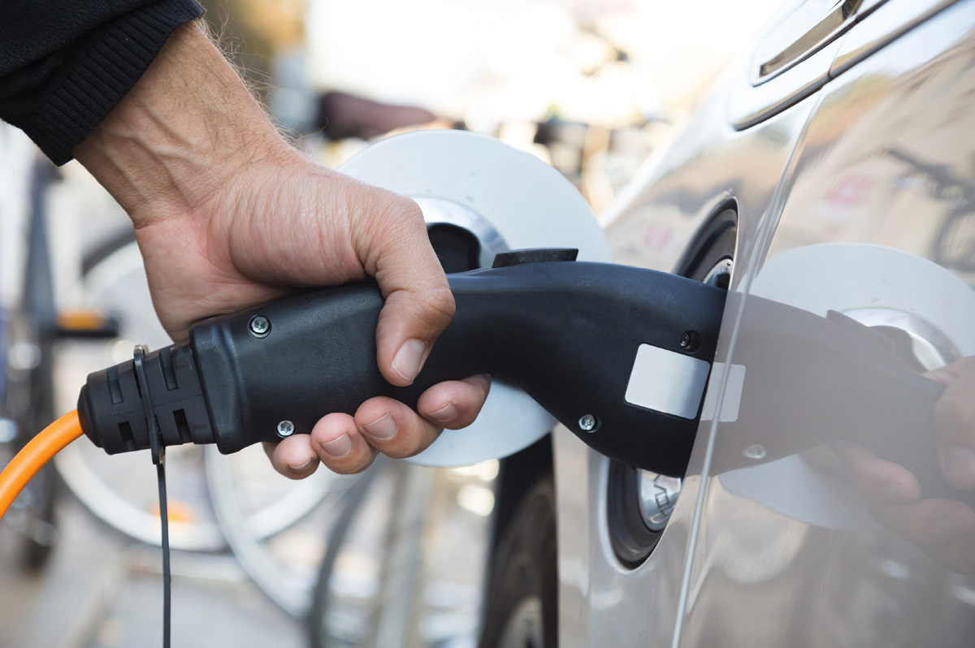
Image: Scandinavian Stockphoto
The government has ambitious goals to reduce Norwegian greenhouse gas emissions and Norway has accepted strict obligations through the Paris Agreement and agreements with the EU. The transport sector is a major source of emissions, and to reach our national goals and international obligations, emissions from transport must be reduced. A transition from fossil fuel-consuming to zero-emission vehicles is the single initiative that contributes the most and the government has clear goals for phasing in these types of vehicles. For passenger cars, zero emissions has for some time been synonymous with electricity and there are a significant number of passenger EVs in Norway. Additionally, for heavy vehicles, it is anticipated that electric power will become an important technology in the future. To ensure a sufficiently rapid phasing in of zero-emission vehicles, it is a premise that the charging infrastructure is established quickly enough to keep pace with vehicle development. This is the background for the Hurdal Platform plan, to present a national strategy for the development of rapid charging services.
The development of rapid charging services has up to this point been largely driven by the market on commercial terms, after a start-up phase with public subsidy for the deployment of charging infrastructure. Through the initiatives in the strategy, the government will help to ensure that this development can continue. Access to appropriate areas and sufficient capacity in the power grid are important premises for ensuring profitable deployment of rapid chargers, and the strategy presents initiatives that will contribute to this. In the capacity of planning and building authorities, municipalities also have a significant responsibility for allocating sufficient areas for the deployment of charging stations in their zoning plans.
The strategy also presents initiatives that will make rapid charging more user-friendly, and thereby electric vehicles more attractive.
The strategy has been developed in a cooperation between the Ministry of Transport, Ministry of Climate and Environment, Ministry of Local Government and Regional Development, Ministry of Petroleum and Energy, Ministry of Trade, Industry and Fisheries, Ministry of Children and Families and the Ministry of Finance. The Norwegian Public Roads Administration and the Norwegian Environment Agency have drafted the technical basis for the strategy. In the work on the strategy, we have received input from organisations, business operators, public authorities and others. We are grateful for all contributions.
Jon-Ivar Nygård
Minister of Transport
Espen Barth Eide
Minister of Climate and Environment
Kjersti Toppe
Minister of Children and Families
Jan Christian Vestre
Minister of Trade and Industry
Sigbjørn Gjelsvik
Minister of Local Government and Regional Development
Terje Aasland
Minister of Petroleum and Energy

Summary
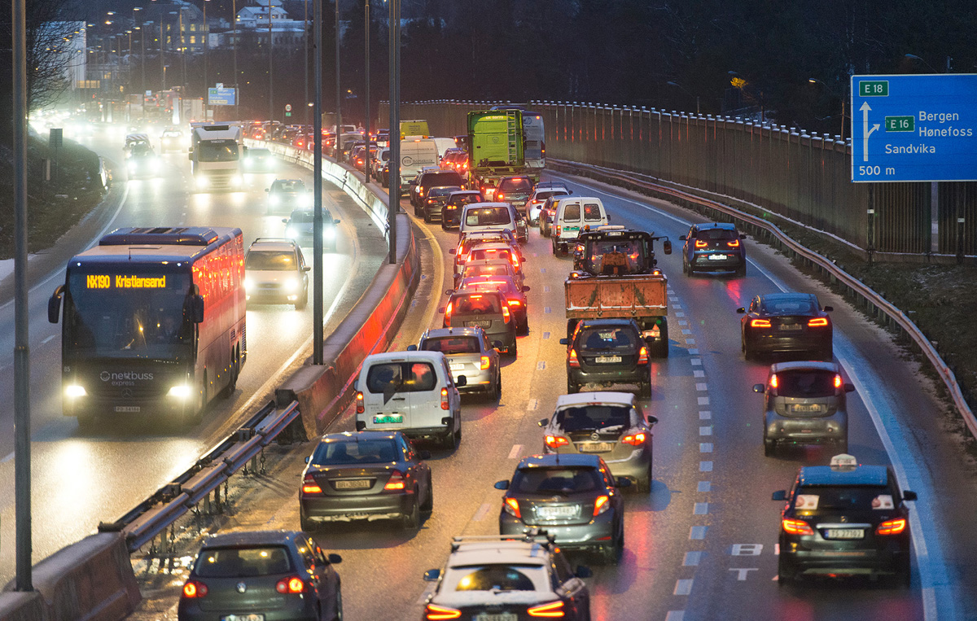
Image: Olav Heggø
Emissions from road traffic must be reduced – continued electrification is an important initiative
In 2021, road transport was responsible for almost 18 percent of Norwegian emissions. These emissions must be greatly reduced if we are to fulfil Norway’s international obligations on the reduction of emissions. This reduction requires less road transport, more use of biofuels and a transition to zero-emission vehicles.
Electric vehicles (EVs) are likely to be the preferred zero-emission technology in many vehicle segments towards 2030, even if other technologies eventually can become more relevant. If we are to achieve the goals for the vehicle population in 2025 and 2030, the provision of publicly accessible rapid charging for light vehicles must continue to grow, and a fundamental network of rapid charging stations for heavy vehicles must be established.
              - Government goals for the development of the vehicle population
- New passenger cars and light vans shall be zero-emission vehicles from 2025.
- New heavy vans shall be zero-emission vehicles from 2030.
- New city buses shall use zero-emission technology or biogas from 2025.
- Before 2030, 75 percent of new coaches and 50 percent of new lorries shall utilise zero-emission technology.

This strategy puts in concrete terms what the government intends to do to further develop the national charging infrastructure for EVs. The charging market for light vehicles is now mature and the infrastructure can be constructed on a commercial basis without further public subsidy. For heavy vehicles, it may be necessary to have public subsidies during the initial phase. In both cases it is important to have appropriate terms and conditions for the use of land areas and grid capacity. It is also necessary to make the charging infrastructure more user-friendly, so that it becomes easy for everyone to be a customer in the charging market.
An effective system for grid connections and grid utilisation
The electricity grid is an important framework for the deployment of charging infrastructure. An effective system for grid connections and grid utilisation is a premise to be able to set up further rapid charging stations and to ensure charging services that are in proportion to demand.
Grid connection is required to set up a charging station. Grid companies are obliged to connect all customers who requires it to the grid, and requests for connections shall be managed based on objective and non-discriminatory criteria. Grid companies and energy authorities are now experiencing great demand from customers who wish rapid connection to the electricity grid. Grid companies must ensure that all customers receive a grid connection with the capacity they require, without undue delay. Many grid customers, including charging operators, find the process with the grid companies challenging and that order processing in many cases restrict their deployment schedules. However, there will not always be sufficient grid capacity available at all locations where a new connection is requested, and grid planning and construction is time consuming.
In June 2022, the Electricity Grid Commission published their Official Norwegian Report (NOU) Future development of the electricity grid in Norway to the Ministry of Petroleum and Energy. The commission proposed several measures to improve the connection process and reduce installation times for grid expansion and grid connection. As a part of the follow-up of the report, the Norwegian Water Resources and Energy Directorate (NVE) has already been requested to implement measures to reduce licence processing times.
The government will:
- Consider the Electricity Grid Commission’s recommendations to reduce the time taken to implement grid expansion and grid connections.
- Reduce the time it takes to process grid licensing applications, and has therefore proposed to expand the case processing capacity in NVE significantly in the state budget for 2023.
- Increase the efficiency of the licensing processes and electricity grid reports that are used in the planning of the electricity grid, through increased digitalisation, and has therefore proposed increased allocations for NVE’s digitialisation projects in the state budget for 2023.
Charging infrastructure requires land area
Set up of rapid chargers places demands on land area – this applies in particular to charging stations for heavy vehicles. Particularly in and around large towns, land areas can be scarce and deployment of charging stations can easily come into conflict with other considerations, requirements, and community interests.
Sites for charging infrastructure are governed by the Planning and Building Act. In the capacity of planning and building authorities, municipalities have a significant responsibility for allocating sufficient sites for charging stations in their zoning plans. State policy instruments in area policies focus particularly on offering guidance and direction.
The government will:
- Offer additional guidance to municipalities in the application of the Planning and Building Act to allocate sufficient land areas for the deployment of charging infrastructure.
- Reference the need for deployment of charging infrastructure in the national strategy for regional and municipal planning 2023–2027.
- Consider setting out national planning guidelines to assist municipalities in allocating areas for the deployment of charging infrastructure.
Enova, the Norwegian Public Roads Administration and Nye Veier
For some time, Enova has been the state’s most important policy instrument in subsidising deployment of publicly accessible charging infrastructure for light vehicles. As the number of EVs has increased, the demand for rapid charging along the road network has also increased and most charging stations have been set up on purely market-related terms and without public subsidies. This development is expected to continue.
The phasing in of heavy EVs has however not progressed quite as far. It is not expected that the number of vehicles will be sufficient to ensure adequate profitability for a purely commercial charging service before the market is more firmly established, and the first charging stations are likely to be dependent on public subsidy. Charging infrastructure for heavy vehicles also requires larger areas and greater capacity in the electricity grid than the charging infrastructure for light vehicles. The two charging services must be physically separated for traffic safety reasons. To avoid time consumption and driver costs becoming significantly higher than for diesel vehicles, charging will have to take place during the drivers’ mandatory rest periods. The development of charging services for heavy vehicles should therefore be seen in context with the development of the road network and overnight rest areas. There is a need for a plan for where and when charging services for heavy vehicles should be installed along the national road network. There will also be a need for charging services close to large towns, at goods terminals, harbours and other locations where goods are loaded and unloaded, as well as depot charging overnight.
The government will:
- Request that the Public Roads Administration continues its work on charting the needs and opportunities for deployment of charging infrastructure along the national road network, for both light and heavy vehicles.
- Request that the Public Roads Administration reduce barriers to the development of charging infrastructure both for heavy and light vehicles, by communicating a clear leasing strategy and terms upon deployment in the agency’s areas, including overnight rest areas and rest stops.
- Use Enova as the state instrument for supporting the development of charging infrastructure for heavy vehicles in an initial phase, where there is a need for public subsidy and where development will not take place on commercial terms
- Appoint the Public Roads Administration, in dialogue with Nye Veier and Enova the task of preparing a plan for charging stations for heavy vehicles along the national road network, showing where and when there is a need to set these up. The plan shall be completed before 1 July 2023 and updated at regular intervals, in line with developments in the market.
- Request that the Public Roads Administration, Nye Veier AS and Enova collaborate on the deployment of the first publicly accessible charging stations for heavy vehicles at overnight rest areas and general rest stops, and if appropriate at other sites along the national road network.
- Ensure that deployment and operation of charging stations for heavy vehicles, as rapidly as possible, will be able to take place on commercial terms without public subsidy.
Ensure that charging services are simple to use
The adequate provision of publicly accessible rapid chargers is a premise for ensuring that the goals for phasing in of zero-emission vehicles can be realised. In addition, the charging infrastructure must be simple to use. Preferably EV charging should be as easy as filling a conventional vehicle tank with diesel or petrol. This is not the case at present.
Firstly, it can be difficult to obtain information on the location of accessible chargers, whether they are in operation or not, and whether they are in use or available. In the heavy vehicle segment in particular, it is important to avoid drivers having to spend time searching for an available and functioning charger or having to wait in a charging queue. Charging should be bookable for bus and lorry drivers.
Secondly, there is a need for a simple standardised payment solution in a market characterised by many and varied methods of payment for rapid charging. Most charging operators have their own solutions based on text message-based payments, mobile applications/apps, QR codes with a link to an app/website, RFID tags associated with the user in a charging service/app, or direct connection with the EV. Very few charging stations offer card payment.
Thirdly, it is often difficult to find price information. Charging operators can use varying calculations and price models and the price can be a combination of the charger output, how many kWh are charged and how long the vehicle occupies the charging point.
The requirement for universal design is founded in several Norwegian laws. However, accessibility of rapid chargers is a challenge, e.g. for wheelchair users and others with reduced mobility. If the goals for phasing in zero-emission vehicles are to be achieved, the charging infrastructure must be accessible to all vehicle users.
Some of the challenges above correlate with the desire of charging operators to minimise investment and operational costs and to ensure customer loyalty through reward programmes and subscriptions. On the one hand, good profitability for charging operators is positive with the setting up of charging stations and new vehicle sale goals in mind. Costly requirements from authorities can dampen both the drive for innovation and the desire to set up additional stations among charging operators and may also increase prices for consumers. On the other hand, the lack of information concerning where one can find a functioning charger, complex payment solutions, absence of price information and inadequate physical adaptation can lead to frustration and longer queues at charging stations than if the service had been more streamlined. In the worst case, low user-friendliness can slow down the phasing in of electric vehicles.
The government will:
- Start a consultation on a proposal to place requirements for card payment and/or contactless payment (NFC) at all new charging points over 50 kW from 2023 and that a deadline is set for post-installation at existing charging points.
- Require uniform price information for charging and that price information shall be easily available before charging so that it is easy to compare prices across charging operators.
- Develop a market portal for rapid charging of light vehicles.
- Introduce a requirement that publicly accessible charging stations must provide real-time information/dynamic data on whether chargers are available or in use, along with operational status to the NOBIL database.
- Request that the Public Roads Administration initiate the development of a user-friendly app for navigation, booking and if applicable, payment solutions for heavy vehicles, in cooperation with market operators.
- Contribute to establishing a Norwegian standard for the universal design of charging infrastructure.

Why a national charging strategy?
Image: Olav Heggø

Climate goals and climate agreements – major reductions required in the transport sector
The agreement to reduce emissions signed in Paris in 2015 – the Paris Agreement – is the first global climate agreement that is legally binding and actually mandatory for all countries. Norway has registered an obligation under the Paris Agreement to reduce greenhouse gas emissions by a minimum of 50 percent and up to 55 percent before 2030, compared to 1990.
Norway has also entered into agreements with the EU concerning emission reductions. The agreement concerning the non-ETS emissions (EU Emission Trading System), which includes transport emissions (apart from most of aviation), states that emissions must be reduced by 40 percent in 2030 compared to 2005. The target for 2030 is translated into an emissions budget with emission ceilings for each year in the period 2021–2030.
Emissions from the transport sector amounts to around 60 percent of the non-ETS emissions. Around half of these emissions stems from road traffic. If Norway is to meet its obligations according to the Paris Agreement and the agreement with the EU, emissions from road transport must be greatly reduced. This can take place through less transport or by a transition to transport methods giving lower emissions compared to the transport involved. A transition from petrol and diesel vehicles to zero-emission vehicles is an example of the latter.

Developments in emissions, vehicle population and charging infrastructure
Through considerable taxation and user incentives, Norway has stimulated the phasing-in of EVs for several years. However, it was first around 2017 that passenger EVs could compete with traditional cars regarding comfort and driving characteristics and sales increased rapidly. In 2021, 63 percent of new passenger cars and around 16 percent of the passenger car population were electric. At the end of November 2022, over 77 percent of passenger car sales were EVs, and the number of passenger EVs amounts to almost 20 percent of all passenger cars.
The breakthrough of the EVs has in recent years become evident in the figures for emissions from road transport, which have fallen from 10.3 million tonnes of CO2- equivalent in 2015 to 8.7 million tonnes in 2021, ref. Figure 2.1. According to Statistics Norway, CO2 emissions from road transport would have been around 13 percent higher in 2021 if all driving on electricity was replaced with driving using petrol or diesel.
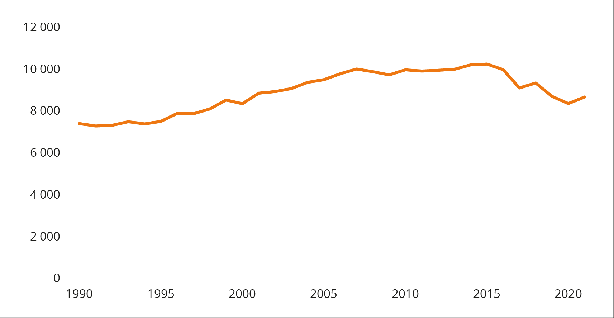
          - Emissions from road transport 1990–2021.
Source: Statistics Norway
In addition to passenger cars, a good number of both light and heavy electric vans have been sold, respectively 29 and 19 percent of new van sales as of 30 November 2022, ref. Figure 2.2. Many new city buses are electric as well – 72 percent of bus sales at the end of November. Coaches are operated differently than city busses, and up to recently sales have been much lower However, at the end of November, 40 percent of new coaches were electric. Sales of electric lorries are increasing significantly compared to previous years and this year 7 percent of new lorries are electric. The differences between the vehicle groups are largely due to technological maturity – whilst many new private EVs with approximately the same driving characteristics and comfort as new petrol and diesel vehicles have gradually been launched, there are still few electric heavy vehicles on the market and prices remain high. Vans and to some degree buses have for some time been in an intermediate position. Tax advantages are also significantly less attractive for vehicles used by the business sector than for private cars, as businesses can deduct VAT and have lower vehicle excise duty to begin with. Driving patterns also play a role – the longer the daily mileage, the greater the demand on battery capacity and technological maturity. The fact that electric city buses have such a major presence is in particular due to frequent demands for zero emissions or biogas when procuring public transport in larger towns/cities. From 2025 this requirement will become statutory.
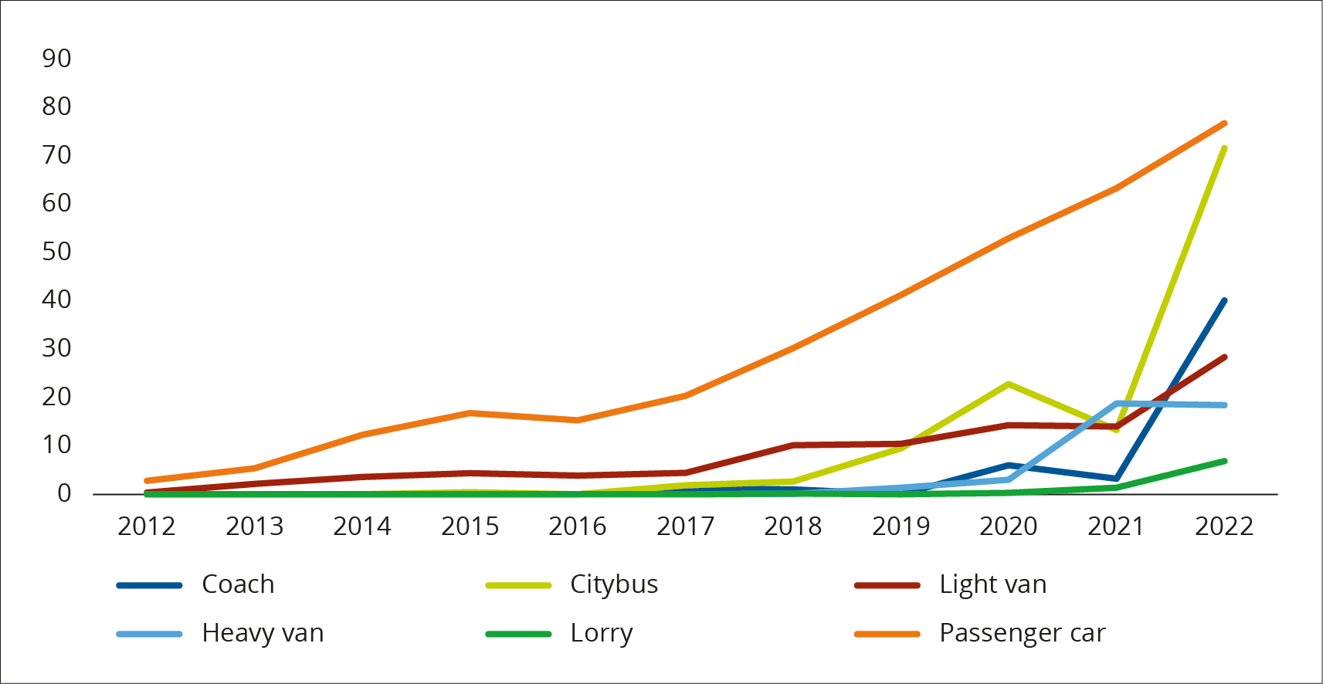
          - Proportion of electric vehicles in new vehicle sales 2012 – December 2022.
Source: Public Roads Administration
Most of those who purchase private EVs can charge them at home, whilst commercial vehicles and city buses charge at a depot. The developments in the EV population had however not been possible without publicly accessible chargers along road routes. The growth in rapid charging services have been parallel with the growth in EVs, ref. Figure 2.3. From being non-existent 10 years ago, there were 5041 publicly accessible rapid chargers (over 50 kW) for light vehicles (passenger cars and vans) in Norway as of the end of September 2022. Of these, as many as 910 have been set up in 2022. Only around 700 of all rapid chargers have been set up with public subsidies. The vast majority have been set up by commercial companies without subsidies. Vans can use the same charging infrastructure as passenger cars. The first and – by November 2022 – only publicly accessible rapid charging station for heavy vehicles (lorries, buses and larger commercial vehicles) was opened in Filipstad in Oslo in October 2022, with financial support from Oslo municipality.
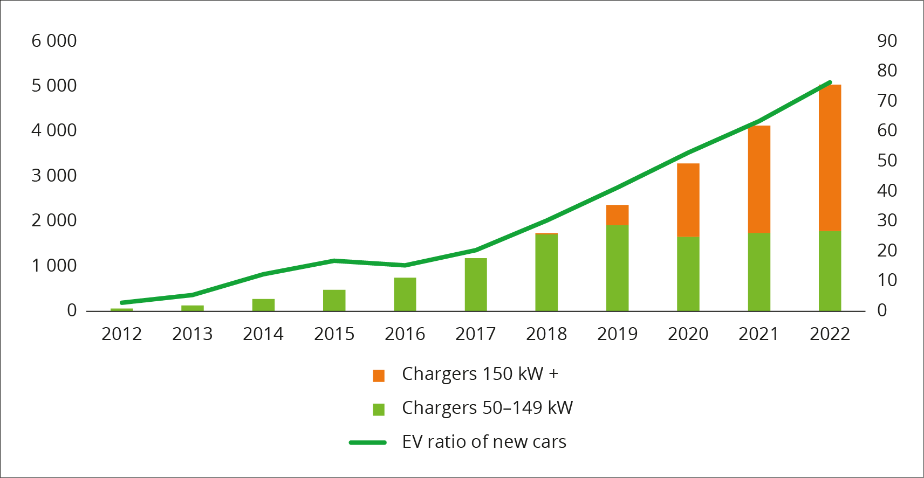
          - Rapid chargers with an output of 50-149 kW and over 150 kW and EVs proportion of new cars.
Source: EV Association based on Nobil, Public Roads Administration
In the technical basis drafted by the Public Roads Administration and the Norwegian Environment Agency in advance of the strategy (“Knowledge Base”), developments in the number of electric vehicles and charging infrastructure are described and explained in greater detail, and reference is made to this document for additional information (in Norwegian only).

Future developments – major need for charging infrastructure
As highlighted above, to fulfil the Paris Agreement and the agreement with the EU, transport emissions must be reduced, which can only take place if transport is reduced, or by the transition to transport with lower emissions, e.g. zero-emission vehicles. In the National Transport Plan 2018–2029 (NTP) sales targets were presented for zero-emission vehicles:
- New passenger cars and light vans shall be zero-emission vehicles from 2025.
- New heavy vans shall be zero-emission vehicles from 2030.
- New city buses shall use zero-emission technology or biogas from 2025.
- Before 2030, 75 percent of new coaches and 50 percent of new lorries shall utilise zero-emission technology.
The sales goals are also part of the Climate Plan 2021–2030 and are continued in the National Transport Plan (2022–2033). It is these sales targets that form the starting point for estimates of the need for rapid chargers in the Knowledge Base from the Public Roads Administration and the Norwegian Environment Agency, on which the strategy is based. The table below shows the number of EVs in various vehicle groups as of the end of November 2022 and the number of publicly accessible rapid chargers as of the end of September 2022. The one rapid charger for heavy vehicles was set up in October 2022. The table also shows the Knowledge Base’s estimate for the number of EVs in 2030 and the estimates for how many publicly accessible rapid chargers should be set up so that demand can be met and charging services do not hinder developments in the EV population.
            - Electric vehicle population December 2022 and rapid chargers September 2022, estimates for 2030

 | 01.12.2022 | 2030
Vehicle population
Passenger cars | 564 720 | 1 700 000
Vans | 20 260 | 230 000
Lorries | 387 | 23 000
City buses | 640 | 9 000
Coaches | 176 | 2 000
Rapid chargers
For passenger cars and vans | 5 0411 | 10 000–14 000
For heavy vehicles | 1 | 1 500–2 500
1 As of 31.09.2022
Source: Knowledge Base for rapid charger infrastructure for road transport, EV Association and Public Roads Administration
Both the estimate for the EV population and the estimate of the need for rapid chargers are subject to significant uncertainty. Uncertainty factors and the premises applied as a basis for the calculations are thoroughly presented in the Knowledge Base, and here we only provide a brief review.
The EV population is calculated given that NTP targets are achieved. In addition, the following assumptions have been applied:
- Battery electric power will be the dominant technology for road transport, with hydrogen systems as a niche technology. If hydrogen becomes more competitive, the number of EVs will be reduced, as will the need for electric rapid charging.
- The number of electric cars and vans is already at such a high level that NTP targets should be able to be achieved. The estimate for the vehicle population in 2030 is thereby relatively reliable. For lorries and coaches however, there is greater uncertainty.
- Dependent on continued technological development
- The NTP goal relates to 75 percent of coaches and 50 percent of lorries. Electrification can be much quicker than this.
- The lack of charging capacity will reduce the rate of electrification. In the heavy vehicle market in particular, the absence of customers can hamper the development of commercial charging services, whilst the lack of charging services can hinder the phasing in of EVs and restrict growth in the number of customers.
Given the number of EVs, the need for publicly accessible rapid chargers is particularly dependent on the following uncertain factors:
- Battery packs. The larger the battery pack, the longer the range of the vehicle, and in turn, charging is required less often. The Knowledge Base applies as a basis that the average battery capacity will increase. Battery packs in new light vehicles are presently around 60 kWh, and the Knowledge Base estimates that 80-90 kWh will eventually become the norm. For heavy vehicles, the estimate is battery packs of around 600–700 kWh.
- Charging speed. The faster a battery can be charged, the fewer charging stations are required in order to serve a given number of vehicles. It is assumed that charging speeds will increase in the coming years. At present, most new light vehicles have an anticipated charging capacity of around 100 kW. It is expected that the charging capacity will increase to around 200 kW from approximately 2025. For heavy vehicles, current chargers are between 100 and 300 kW and in the future, it is expected that these will be of a minimum of 1000 kW.
- Patterns of use. Given present patterns of use, it is assumed that most private car drivers will fulfil the charging requirements at home in their own parking space or at their workplace and that the need for publicly accessible rapid charging becomes particularly evident during recreational journeys. Many heavy vehicle drivers will not have the need for rapid charging during their working day and will only require normal charging overnight. Improved charging facilities close to housing, workplaces, shopping centres, tourist attractions and other destinations reduce the need for publicly accessible rapid charging for light vehicles. Additionally, heavy vehicles used for local/regional transport and for mass transport have a daily mileage that largely does not exceed the anticipated range heavy EVs will have in a few years, and the need for charging can be met based on depot charging only. As the sales goal is 50 percent of new lorries in 2030, it is possible to electrify the proportion of the lorries that are most suitable, and still achieve the goal without publicly accessible rapid charging. According to the Knowledge Base, there will however be a certain need as early as 2025 for charging stations for heavy vehicles used for long-distance transport, partly because the vehicles are likely to be frequently used, to cover the high investment costs. The extent of private, dedicated chargers for heavy vehicles will reduce the need for publicly accessible charging. City buses largely have their own dedicated charging infrastructure.
- User-friendliness. Access to real-time information from chargers, simple payment solutions etc. can improve the utilisation of existing chargers and reduce the need for new installations. For coaches and lorries, the opportunity to book charging time will increase the utilisation of individual charging stations and affect the need for rapid chargers.
- Alternative and/or supplementary technologies. If alternative and/or supplementary charging technologies become the norm, the need for traditional rapid chargers will be reduced. This may include
- Wireless charging via charging plates incorporated in road surfaces (inductive charging)
- Battery exchange stations
- Deployment of battery containers
- Electric roads/dynamic charging
- The EU’s revised directive for infrastructure for alternative fuels, ref. Box 2.1 will stipulate requirements regarding charging services for both heavy and light vehicles.

Summary – what is the charging strategy intended to address?
There is considerable uncertainty regarding the estimates of the need for rapid charging in the future. However, there is no doubt that rapid charging services must expand if sales goals as presented in several government papers are to be reached.
Apart from the first few years with relatively few electric cars, the demand for rapid charging for cars and vans has been high enough to make it commercially profitable to develop charging services. Supply and demand have developed in line on a commercial basis. Access to suitable sites and adequate grid capacity can however become more limiting factors in the future.
Regarding heavy vehicles, development is still in the early phase. There are few vehicles available, they are expensive to buy and the supply of publicly accessible charging services is very limited. It is not commercially profitable to provide such services before the number of vehicles increases. The charging infrastructure for heavy vehicles presents a greater challenge in respect of grid capacity and area required – high energy consumption and larger batteries mean there is a need for high-output rapid charging, and the size of the vehicles and traffic considerations mean the area required is larger.
With this strategy, the government will contribute to the continued commercial development of charging services for passenger cars and vans, and the start-up of commercial development of charging services for heavy EVs. This requires appropriate terms and conditions for the use of land areas and grid capacity. The strategy also includes initiatives that will make the charging infrastructure more user-friendly. Simple charging is an absolute premise for EVs to become a satisfactory alternative to traditional vehicles.
The strategy is also relevant for Norwegian follow-up of the EU Alternative Fuels Directive (AFI) which is expected to be adopted by the EU during the first half of 2023. The directive will stipulate several requirements, regarding the number and location of charging infrastructure, user-friendliness, universal design and technical standards, ref. Box 2.1.
              - Revision of the EU Alternative Fuels Directive (AFIR)
The current EU Alternative Fuels Directive 2014/94 was adopted by the EU in 2014 and embodied in the EEA agreement in 2018. The European Commission has proposed extensive changes to the current directive and that the directive should be replaced by a regulation. Both the Council and the European Parliament have processed the Commission’s proposal and made their respective recommendations.
The overarching objective of the regulation is to ensure an accessible and well-functioning infrastructure for alternative fuels throughout the EU. Electric passenger cars and electric heavy vehicles must be equally easy to use throughout the entire EU and as easy to use as conventional vehicles. The regulation shall also apply to sea and air transport and include the requirement for a provision of hydrogen and LPG in addition to electricity.
The proposal for the regulation stipulates a requirement for a total installed output in charging capacity in relation to the number of battery electric and hybrid light vehicles in the country, in the form of a total kW requirement per vehicle (1 kW per electric car and 0.66 kW per plug-in hybrid). The Council proposes that countries should be able to request an exemption from the requirement when 20 percent of the car population is comprised of EVs – a threshold that Norway is about to achieve – and if the requirement can hinder private investments and is no longer justified. For its part, the European Parliament wishes to differentiate the requirement according to the country’s EV population.
Additionally, the proposal contains a minimum requirement for distances between charging stations on the TEN-T core network and TEN-T road network. In Norway this applies to the highways E6, E18, E39 and E16. The proposed requirement is a maximum of 60 km between charging stations in each direction for light vehicles and the requirement of a minimum output at charging points and stations at various milestones towards 2030. For heavy vehicles, the Council proposes requirements for a gradual deployment of charging stations at distances of 60-100 km in both directions towards 2030. There is also a proposal for charging facilities at overnight rest areas and city intersections. The Parliament wishes to have stricter minimum requirements and more rapid implementation than those proposed by the Commission, whilst the Council proposes a slower pace in the phasing in of requirements for heavy vehicles. Both the Council and the Parliament believe however that less strict requirements should be applied for distances between stations and charging facilities in both directions in areas with little traffic and where the infrastructure cannot be justified from a cost-benefit perspective. The Council also proposes to half the output requirement on these stretches of road compared to the Commission’s proposals. All amendments must be approved in advance by the Commission.
The proposal also includes requirements for user-friendliness, ref. Chapter 6.
The Commission proposes that the regulation should be evaluated, and if applicable amended, at the latest by 31 December 2026. The Council believes that the regulations on charging infrastructure for heavy vehicles must be evaluated, and if applicable amended, as early as by 31 December 2024. Negotiations between the Commission, Council and Parliament are ongoing, and a final regulation is expected during the first half of 2023.
Implementation of the regulation in Norwegian law will be managed through separate processes, which will include an appraisal of economic and administrative consequences. This will among other things require an amendment to the law on infrastructure for alternative fuels, or a new law and a new regulation, as the amendments proposed in the regulation are extensive with a far greater range of application than the current directive.

Grid connection and relation to the grid system
Image: Ministry of Transport
The electricity grid is an important framework in relation to deployment of a charging infrastructure. To deploy additional rapid charging stations and ensure charging services that meet demand, an effective system for grid connection and grid utilisation is important.

Framework terms associated with the grid system
Grid connection and system contribution
Grid connection is required to set up a charging station. Grid companies are obliged to connect all customers that require grid connection to the grid. Operators who wish to deploy charging infrastructure must therefore contact the local grid company (area statutory licence holder) to determine whether there is sufficient capacity in the existing grid. The local grid company is also the customer’s contact point for grid companies at a higher level. The grid company shall give the customer information about the expected processing time to determine whether there is available capacity in the grid. The grid company shall thereafter provide grid connection without undue delay.
If there is no available capacity in the existing grid, the grid company is obliged to make the necessary grid investments to offer a connection without undue delay. If a grid connection entails investments in the grid, the customer must cover all or part of the investment costs (investment contribution). The grid company must enter into a written contract with the customer specifying what the customer has ordered, the estimated investment contribution and estimated time for completion. The final investment contribution will be determined in a settlement based on the actual accrued costs after the system has been fully installed. However, the grid company cannot invoice the customer for costs that exceed the estimated investment contribution by more than 15 percent.
The purpose of the investment contribution is to substantiate the costs for grid connections or expansions of an existing connection, and to distribute the costs across customers who invoke investments and the grid company’s other customers. Depending on the location and capacity requirement, there can be large variations in the measures required in the grid to connect a charging station and thereby large variations in the extent of the investment contribution. When the customer receives an estimate of the investment contribution from the grid company, the customer will have a basis to evaluate the grid connection at the desired location against other alternative solutions.
Licensing requirements and ownership
Most rapid charging stations have a capacity requirement that requires the installation of a transformer in connection with the charging station to convert from high voltage to low voltage. The local grid company, the area licensee, is obliged to supply electrical power to all customers in their area. This also involves an obligation to invest in new grid systems such as transformers when this is necessary. When the grid company builds this type of system there is no licensing process carried out by NVE, and the grid company must seek the necessary authorisations from the municipality, landowner etc.
In some cases, the developer of rapid charging infrastructure will wish to, or is required to, own a transformer himself – for example if alternative technical solutions are required that are not supplied by the grid company. In such cases, the operator must apply to NVE for a system licence for the transformer. NVE will only grant a system licence if the applicant can provide good grounds as to why it is appropriate that the operator owns the system himself. If the operator is granted a system licence for the transformer, the area licensee (grid company) must supply a high voltage supply to the transformer; however, the operator owns the transformer and converts the electricity from high voltage to low voltage. There is no requirement for system licences for charging stations if the operator himself does not own the high voltage system.
Generally, a charging station can therefore be deployed if permission has been granted from the landowner and appropriate authorisations have been cleared with the municipality. For most charging station constructions there is no need to apply for a system licence and the area licensee is responsible for the construction and operation of the network grid.
A trading licence is a permit to sell electricity. The Norwegian Energy Regulatory Authority (RME) has concluded that providers of charging services do not need a trading licence.
Grid tariff
All customers that are connected to the electricity grid pay a grid tariff. Low voltage customers with a consumption of more than 100 000 kWh/year are subject to a capacity-based grid tariff. The capacity-based grid tariff has a fixed component, an energy charge and a capacity charge. Capacity based grid tariffs give incentives to smooth the demand for capacity. Thus, the capacity-based grid tariff allows for better utilisation of the grid which can reduce the need for grid expansion.
Grid companies have different grid tariffs for high voltage and low voltage customers. High voltage customers do not pay grid tariffs for the low voltage grid and therefore largely have lower tariff rates than low voltage customers. Charging stations that have received a system licence for their own transformer, pay the high voltage tariff and will therefore often have lower network charges. On the other hand, the owner of a charging station is himself responsible for, and must cover the cost of, operation, maintenance and reinvestments in the transformer.

Challenges associated with the power grid system
The queue for processing licences has increased in the last few years
Deployment of charging stations requires processes with landowners, municipalities, grid companies and, if applicable, NVE. All these processes can be time-consuming and involve periods without apparent progress.
If the developer of the charging infrastructure has a technical need to own the high voltage system (transformer) himself, the developer must apply for a system licence from NVE. Before the application for a system licence is submitted, NVE requires authorization from the landowner and the local grid company. This is because NVE does not wish to grant licences for the installation of transformers for charging systems without the landowner and grid company authorising deployment of a charging station and appurtenant solutions, and without the system being allocated grid capacity.
In some cases, deployment of larger charging stations will require that the grid companies must upgrade the grid at higher levels to supply electricity to the charging station. If the connection involves investments in grid at higher levels, the network company must apply for a system licence from NVE.
Since 2019, NVE has seen an increase in the number of applications for system licences and anticipates that the number of applications will continue to increase in the years to come. Licence processing by NVE can take some time, and at present there is also a case processing queue, therefore applications can remain pending before a case handler reviews the case. The time the case handler spends processing an application will depend on the complexity of the case. In the autumn of 2022, NVE was requested by the Ministry of Petroleum and Energy to implement measures to reduce grid licence processing times.
Grid capacity
The main rule for grid connections is that customers shall be connected to the grid promptly, according to the principle of “first in time is first in right”. However, at present, many customers are requesting grid capacity, and in many areas there is little or no grid capacity that has not already been allocated or reserved. Grid companies have a supply and connection obligation, which shall ensure that all customers receive a grid connection with the capacity they require, without undue delay. However, it takes time to plan and construct new grid and there will not always be sufficient available grid capacity in all locations where charging infrastructure is desired. This means that there can be some delay before the customer can be connected.
Dialogue with grid companies
Several developers of charging stations believe that the grid companies take too long to provide them with a grid connection, and that the grid companies have few incentives to offer a rapid connection to the electricity grid. RME in particular receives feedback that the time it takes before a customer has a connection contract with an estimated investment contribution is taking far too long.
It is the grid company that has the overview of the grid in its licence area. To identify where there is available capacity in the electricity grid or where a charging station alternatively could be deployed to give a lower investment contribution, the developer of the charging infrastructure must have a dialogue with the grid company. Many developers believe that this dialogue is too time-consuming. Developers of charging infrastructure have also experienced that grid companies to a limited degree provide information about where there is available capacity in the grid company’s area, or offer suggestions for alternative connection points. Grid companies must facilitate a good dialogue with their customers. It is in both the customer’s and the grid companies’ interest that the charging infrastructure is located in a suitable location in the grid.
Connecting a charging station to the grid is largely a two-phased project. The first phase is the time from when the developer contacts the grid company with a request for a grid connection until they are presented with a written quote with an estimated investment contribution. A review of the grid solution and detailed planning can be time consuming, particularly in complex connections and if there is a need for investments in the grid at higher levels. The grid company must determine whether there is capacity in the grid at higher levels, obtain permissions from landowners and in some cases obtain a permit for expropriation. In addition, the grid company must investigate ground conditions and obtain procurements from external contractors. If the connection requires investments in the grid at higher levels, this also requires a licensing process with NVE. The second phase is the time from when the customer accepts the connection quote until the customer is connected to the grid. The grid company is obliged to execute both the first and second phase without undue delay.
If a customer believes that the grid company has not provided a grid connection without undue delay, the matter can be brought before RME. If RME finds that the grid company has breached regulations, the grid company can be ordered to rectify the matter and be subject to sanctions such as daily penalties and fines for violations. RME is receiving an increasing number of complaints regarding grid companies’ connection times.
Grid connection time is important to customers who wish to connect to the grid, and there is a lack of information regarding the grid companies’ time usage on connections. RME has therefore initiated a project to draft a standardised method for measuring and reporting time spent by the grid companies connecting new customers. The project objective is that grid companies gain a better overview of their own time spent on the various phases of connections. The project will also provide RME with a national and comparable overview of time spent by grid companies on connections. The project is expected to be completed at the turn of the year 2023/2024.
On 14 June 2022, the Electricity Grid Commission published their Official Norwegian Report (NOU) Future development of the electricity grid in Norway to the Ministry of Petroleum and Energy (NOU 2022: 6, in Norwegian only). The Commission proposed several measures to improve the connection process and reduce installation times for grid expansion and grid connection. The proposed initiatives relate to all grid connections, including charging stations. As a part of follow-up of the report, NVE has already been requested to implement measures to reduce licence processing times.
The government will:
- Consider the Electricity Grid Commission’s recommendations to reduce the time taken to implement grid expansion and grid connections.
- Reduce the time it takes to process grid licensing applications, and has therefore proposed to expand the case processing capacity in NVE significantly in the state budget for 2023.
- Increase the efficiency of the licensing processes and electricity grid reports that are used in the planning of the electricity grid, through increased digitalisation, and has therefore proposed increased allocations for NVE’s digitalisation projects in the state budget for 2023.

Areas for charging infrastructure
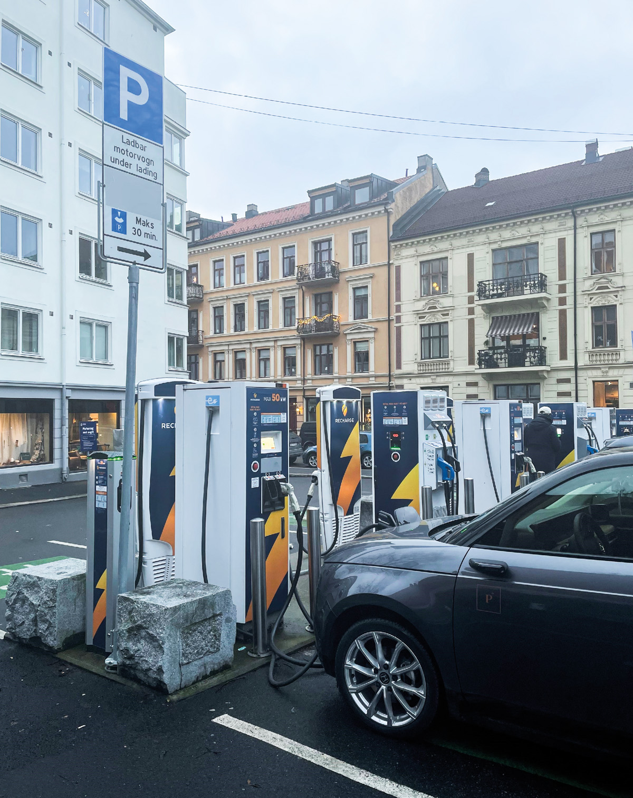
Image: Ministry of Transport
The deployment of charging infrastructure depends on access to sufficiently large and suitable sites in locations that are accessible to users. It is also important that charging stations are located where the need is greatest and where the deployment does not come into conflict with other important needs or community interests. These considerations must also be taken into account when organising the infrastructure for other types of zero-emission vehicles.

Area management in plans according to the Planning and Building Act
Areas for charging infrastructure are governed by the Planning and Building Act, which provides statutory authority to restrict the right of disposal both on public and private land. All areas in Norway are in practice governed by the land-use section in municipal plans. Some areas are also zoned, either in area zoning or detailed zoning plans. To the extent areas in the land-use section in municipal plans are available for “Agricultural, nature and recreational purposes and reindeer husbandry” (LNFR) or “Use and protection of sea and watercourses”, deployment of charging stations will conflict with the plan. In Norway, LNFR areas represent 87 percent of plan areas, whilst land allocated for dwellings and installations represents just 2 percent of the area. Less than 0.2 percent is planned to be used for transport purposes. Around 10 percent of the area falls within the category “Use and protection of sea and watercourses”.
The Ministry of Local Government and Regional Development has published memorandum H-4/21 which accounts for the applicable regulations according to the Planning and Building Act for the deployment of charging stations for electrically powered vehicles (electric cars) and vessels with battery electric propulsion.
Deployment of charging stations for vehicles and vessels must be evaluated according to land use and general regulations in the land use plan and regulations associated with land use and zones requiring special consideration, ref. Planning and Building Act. Section 1-6 par. 2 and Sections 11-6 par. 2 and 12-4 per. 2. The Ministry of Local Government and Regional Development, in memorandum H-4/21 Deployment of charging points and charging stations for electrically powered vehicles (electric cars) and vessels with battery electric propulsion – relation to the Planning and Building Act etc., has provided guidelines that unless expressly stipulated in the land use plan, charging infrastructure can lawfully be deployed in areas allocated for parking spaces, harbours, quayside installations and quays. There are now many public and private car parks that can offer charging facilities to the general public. Even if a plan has not expressly allocated an area for parking, the objective of the plan would in any case indicate that there is the opportunity to set up parking places and thereby also an opportunity to deploy charging infrastructure. This applies, for example, where zoning has been carried out for building purposes without making a more detailed specification of area usage. The municipality can however allocate sites for charging infrastructure and thereby reserve the site for this purpose. In Norway, over several years many of these charging stations have been deployed and some of them can service dozens of vehicles at the same time. These are largely found along existing national road networks.
A lack of sites, long case handling times and a lack of coordination between actors, are – according to the Knowledge Base – some of the most significant barriers to the development of rapid charging. Rapid charging stations for heavy vehicles require larger areas and must be designed differently from rapid charging stations for light vehicles, to provide enough space for safe manoeuvring. It is therefore important that municipalities also give priority to allocating sufficiently large areas to charging infrastructure. Many municipalities have drawn up plans for the deployment of charging infrastructure within their boundaries. Even if municipalities allocate a site, it does not necessarily mean that deployment takes place right away. Some municipalities offer charging infrastructure at municipal parking areas, and they take responsibility for deployment and operation. These are however often smaller installations with a limited capacity for rapid charging. It is therefore essential that commercial operators invest in these types of charging stations. Subsequently, there is a need for access to locations, both on public and private land. Sites in central city areas are sought after, and these can be affected by conflicting interests. In Oslo, the scarcity of sites is the biggest challenge regarding the deployment of rapid charging. In a report from Hafslund Rådgivning, commissioned by the Climate Agency in Oslo, it is estimated that the average area required for a rapid charging station for cars in Oslo is 179 m2. In addition, the stations have an average approach area of 435 m2.
This represents a significant land area that must be allocated for rapid charger installations in the coming years. Therefore, the Ministry of Local Government and Regional Development sees a need to strengthen guidance and steering signals for municipalities when it comes to allocating sufficient land area for charging infrastructure in municipal land-use plans. Deployment of infrastructure should also take place in a coordinated manner so that there is a good correlation in the charging infrastructure, particularly at a regional level. There is however also a need to ensure that sufficient land area is allocated, especially in the larger city municipalities, particularly for charging larger vehicles.
Municipalities may themselves use the Planning and Building Act actively to organise the deployment of necessary infrastructure for charging electric vehicles by allocating sufficient land area for this type of infrastructure in the municipal land use plans. Municipalities can also accept private proposals for detailed plans, where a developer proposes to allocate sites for this type of infrastructure. If the municipality receives a private plan proposal without a site allocated for infrastructure, it can allocate sufficient land area in connection with the final processing of the plan. This should, however, be done in dialogue with the developer, so that charging station requirements do not hamper implementation of the plan. There are also good mechanisms in legislation for coordination between national, regional and municipal interests through planning processes. There is therefore a good basis for effective and coordinated cooperation between relevant public agencies, such as for example the Public Roads Administration, municipalities, NVE and Enova. National overall planning policy guidelines are an important basis for coordinated regional and local planning. To ensure effective and good coordinated planning of charging infrastructure, there are two instruments in particular that are relevant, and that is to give governmental steering signals in the form of national expectations of regional and municipal planning according to the Planning and Building Act Section 6-1 and governmental planning guidelines according to the Planning and Building Act Section 6-2.
The national expectations shall be followed up in the county authorities’ and municipalities’ work on strategies and plans and applied as a basis in national authorities’ contribution to the planning. The Ministry of Local Government and Regional Development is working with the aim of the government adopting national expectations in the spring of 2023 for the period 2023-2027. Applicable national expectations were established by Royal Decree on 14 May 2019.
National planning guidelines are intended to be used to transfer the national expectations for planning into concrete actions. Planning guidelines can relate to the country as a whole or a specific geographic area. The objective of the guidelines is that municipalities, county authorities and the state, in the planning shall contribute to allocating sufficient land areas for further charging stations where there is a need for these. National planning guidelines shall also be applied as a basis in individual decisions where there is room for judgement in the decision. National planning guidelines can be given a binding effect or be more of a guide for exercising judgement. At present, five national planning guidelines apply for:
- Differentiated administration of littoral zones
- Children and planning and Protected watercourses (both are given according to the previous Planning and Building Act
- Climate and energy planning, and climate adaptation,
- Coordinated housing, area and transport planning.
A new guideline regarding the allocation of sufficient land area for the deployment of charging stations will potentially be incorporated in one of the two latter existing guidelines.
It is not considered necessary to amend area planning legislation to safeguard the need for charging infrastructure. The government believes it will be important to influence relevant public agencies to work to increase the number of charging stations by providing steering signals, both in national expectations regarding regional and municipal planning and national planning guidelines.

Building application processing of charging infrastructure and technical requirements
Deployment of a charging station can fall under the case handling regulations for building application processing. A charging station can in some cases be so insignificant that it is not considered a project according to the building application section of the Planning and Building Act. Smaller electrical installations such as a free-standing distribution cabinet have traditionally not been considered projects according to the building application section. The same applies to charging cabinets or wall cabinets for charging electric vehicles on owners’ properties. This means that a free-standing charging point for an electric vehicle is not considered a project according to the building application section of the law. Their location must however be in accordance with the land-use plan. Larger charging stations will however be a project according to the building application section of the Planning and Building Act. Even if the charging station is a project according to the building application section, the municipality must address whether an application and permit are required or whether the project can be considered exempt from the application procedure. This is because a municipality can exempt charging stations according to the Planning and Building Act Section 20-5 (g), if the project, after a specific appraisal, is no more extensive than projects that are explicitly exempt according to the building application regulations section 4-1. However, it is important to be aware that many smaller projects, that together represent a larger installation, can require a building application. For application processing, statutory case handling deadlines apply of 3 weeks and 12 weeks, dependent on the nature of the project. A case processing time of 12 weeks also applies to applications for dispensation. Municipalities have a clear need to be able to control the deployment of larger charging stations, both out of consideration for neighbours and the surroundings otherwise and therefore it is considered inadvisable to introduce further simplifications.
The Norwegian Building Authority (DiBK) is responsible for technical requirements for buildings. Requirements have been drawn up in the building technical regulations (TEK17) for “buildings designed for charging systems” which came into force on 1 July 2021. The regulations are stated in TEK17 Section 8.5 par. 5. There are no requirements regarding the installation of the charging system itself but there are some in relation to the preparation of intake routes and spaces for electrical infrastructure for charging systems for electric vehicles. If the intake routes go from the parking area and in, or through, a building, the intake routes must be prepared in the building.
The Owner-Tenant Act and Housing Cooperatives Act
In the Owner-Tenant Act in Section 25, the right to set up a charging point for an electric vehicle and hybrid vehicle was added in 2020. A corresponding right was at the same time added to the Housing Cooperatives Act Section 5-11 (a).
The government will:
- Offer additional guidance to municipalities in the application of the Planning and Building Act to allocate sufficient land areas for the deployment of charging infrastructure.
- Reference the need for deployment of charging infrastructure in the national strategy for regional and municipal planning 2023–2027.
- Consider setting out national planning guidelines to assist municipalities in allocating areas for deployment of charging infrastructure.

Enova, Public Roads Administration and Nye Veier
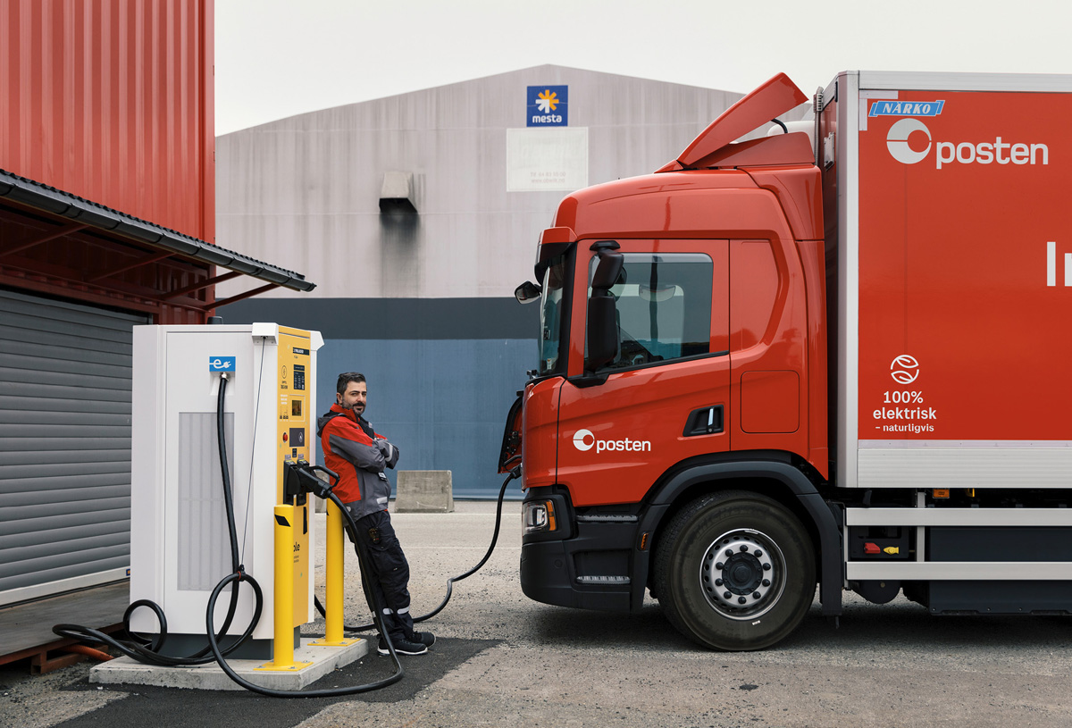
Image: Christian Tunge

Enova
Enova is the national instrument for support to late-phase technology development and early market introduction of climate and energy solutions. Enova utilises the funds in the Climate and Energy Fund, and support from the fund is intended to relieve the risk and cost for those who are the first to test new solutions. Enova’s support programs have hastened lasting market changes and helped private operators to manage without support or assistance in the early phase. Enova has extensive professional freedom to prioritise between areas, to design programs and grant support to individual projects, so that the funds from the Climate and Energy Fund are utilised as effectively as possible.
The government’s intention is that development of charging infrastructure shall in principle be market-driven and that any subsidies shall be phased out as early as possible. Market-driven development means that the demand for charging shall lay the foundations for professional operators to develop and operate charging infrastructure on a commercial basis, in the same manner as conventional fuel stations. For sufficient infrastructure to be developed in the appropriate locations it is critical that it is developed and operated by the operators in the market.
Enova follows the developments in the charging market and adapts its programs so that they support a commercial charging market and contribute to the establishment of the necessary infrastructure.
Light vehicles
Enova had its first support programmes aimed at charging infrastructure in the light EV market in 2015 and 2016. The support programs involved rapid chargers along the main highways in Norway and resulted in 131 rapid charging stations. Subsequently, over several rounds, Enova has supported both rapid charging stations in municipalities with fewer than two previous stations, and they have had competition-based support schemes for broad development of rapid chargers in selected areas where the use of EVs was not yet common. The latter scheme has resulted in several installations in Finnmark, North Troms, Nordland and Namdalen. In the state budget for 2022, the government strengthened Enova with NOK 100 million, so that Enova could contribute to the deployment of rapid chargers in areas without an adequate basis for commercial development. These efforts were intended to make it simpler to choose climate-friendly transport solutions throughout the country. In 2022, Enova announced a competition with three categories, in which charging operators could receive support for up to 100 percent of approved investment costs. The first category was deployment of a new rapid charging station a minimum of 25 km from other, publicly accessible rapid chargers. For deployment in municipalities where there were no previously deployed or planned rapid chargers, the distance requirement was 15 km. The second category was the deployment of normal chargers in areas without a permanent road connection, and the third category was the deployment of normal chargers on mountain passes. In June 2022 Enova awarded support to 58 rapid chargers, 11 normal chargers in areas without a permanent road connection and one normal charger on a mountain pass. When these charging stations are deployed, rapid chargers will be accessible over the entire country, also in areas with low population density and little traffic, ref. Figure 5.1.
          - Rapid chargers in operation as of November 2022 (blue) and rapid chargers supported by Enova June 2022 which will be in operation at the latest June 2023 (yellow).
Source: Enova
It is expected that further deployment of rapid chargers for light vehicles will take place on a commercial basis.
Heavy vehicles
Although sales of heavy EVs increased considerably during 2022, there are still relatively few heavy EVs on Norwegian roads, and many of these have a limited range. There is still a significant additional cost involved in investing in heavy EVs compared to the fossil fuel alternative and there can be disadvantages in use. To support development within this market, Enova supports electric lorries and coaches with up to 40 percent of the additional costs associated with choosing an EV instead of a corresponding fossil fuel vehicle. As of November 2022, Enova has supported 420 electric lorries and 115 electric coaches. The application process is simple, with a rapid response. This contributes to steadily more companies choosing electric heavy vehicles, ref. Figure 2.2. It is expected that the additional costs will fall, and usage areas will increase relatively quickly, as heavy vehicle manufacturers increase their production volumes.
At present, it is primarily the sector of heavy transport that drives relatively short distances that has been electrified. Long-distance transport will often be dependent on being able to charge vehicles along the way. Here we meet the ‘chicken-or-egg’ issue, where few available chargers hinder zero-emission vehicles from being used, and few vehicles make it unattractive to develop charging infrastructure. A more accessible charging infrastructure will make it more attractive to choose zero-emission vehicles, which in turn will make it more profitable to provide charging facilities. To make headway in emissions reductions within heavy transport there is therefore a need for public support for charging infrastructure for these types of vehicles in the early phase. As the main principle, the charging infrastructure shall be developed on commercial terms; however, in an early phase where there is a need for support for this type of development, Enova will be the state instrument.
As part of the offering aimed at zero-emission land transport, Enova is launching the support scheme Dedicated charging for heavy vehicles. The purpose of the scheme will be to increase the pace of deployment of dedicated charging points, i.e. chargers that primarily will be used by one or several pre-identified companies. The support programme is arranged as a competition in which projects applying will be ranked according to cost efficiency, measured in support NOK per kW. Maximum support is 40 percent of approved additional costs, limited upwards to NOK 5 million. Several application rounds are planned during the year and relevant applicants may be transport companies, charging operators, goods terminal owners or similar.

Charging along the national highway network – the roles of the Public Roads Administration and Nye Veier
The charging infrastructure for heavy vehicles is dependent on large land areas and good capacity in the electricity grid. For traffic safety reasons, charging sites for heavy vehicles should be separate from charging sites for light vehicles. Requirements for punctuality and performance times, combined with wage costs for drivers mean that charging should be possible during the driver’s mandatory rest period. Drivers should also be able to buy food and have access to other services. Overnight rest areas therefore emerge as natural charging points for heavy vehicles. For charging of heavy vehicles, planning and construction of roads and charging infrastructure should therefore be seen in context.
If owners of heavy vehicles are to be offered a good charging service, there should be competition between service providers along the national highway network. Competition must be considered when sites are leased out and when terms and conditions for deployment are set.
Public Roads Administration
The Public Roads Administration’s work on rest stops and overnight rest areas along the national highway network is presented in a strategy drafted on assignment from the Ministry of Transport in 2020 and concerns the entire national road network. The strategy states that the deployment of charging stations must be considered during significant upgrades and planning of new rest stops and overnight rest areas. Special arrangements can include obtaining appropriate and adequate sites, considering possibilities for providing adequate electricity, laying conduits and safeguarding other practical considerations. Deployment and operation of the charging station itself will principally be allocated to charging operators based on non-discriminatory competition terms. The need for special arrangements for charging shall be evaluated against existing charging facilities on the particular highway for various vehicle groups and the cost of implementation.
Nye Veier AS
In 2020, Nye Veier AS initiated a pilot project “EL 39” that evaluated where and how it is most appropriate to deploy zero-emission infrastructure along roads. Via the pilot project, Nye Veier has mapped and evaluated which steps can be taken in connection with, among other things, planning processes, technical adaptations and competitions for the operation of overnight rest areas. The objective is to ensure that it is attractive for charging operators to develop good facilities for road users along highways. The results from the pilot project have led to Nye Veier, in the last few years, stipulating minimum requirements for the number of chargers in competitions for the operation of overnight rest areas and road service stations. The company also carries out fundamental technical preliminary work for future charging infrastructure in other areas, for example parking areas for commuters. This will make it simpler to deploy further chargers in the future if the need should arise.
Improved knowledge of charging needs and deployment possibilities
The Knowledge Base from the Public Roads Administration and Norwegian Environment Agency highlights among other things that the lack of information concerning future charging needs, site availability and grid capacity can delay the development of satisfactory charging services. To obtain a better overview of deployment possibilities and the need for charging along the national highway network, the Ministry of Transport has commissioned the Public Roads Administration to draft a complete overview, showing where there is likely to be a need for rapid charging of heavy vehicles in 2025 and 2030, areas along the national highway network controlled by the Public Roads Administration/Nye Veier (e.g. existing rest stops/overnight rest areas) where charging infrastructure can be deployed either for light or heavy vehicles, and where the Public Roads Administration and Nye Veier are planning new – or upgrades to existing – rest stops/overnight rest areas and access to land areas for deployment of charging infrastructure at these places. The Public Roads Administration was also asked to appraise whether the overview of sites along the national highway network that are suitable for charging infrastructure can be supplemented with an overview of grid capacity and involve NVE in this process. The overview will give market operators knowledge of the possibilities found along the national highway network.
The EU Commission’s proposal for a revision of the AFI Directive contains a minimum requirement for distances between charging stations on the TEN-T core network and the TEN-T road network towards 2030, ref. Box 2.1. In Norway this applies to the highways E6, E18, E39 and E16. The regulation will affect where charging stations should be deployed.

Development of charging facilities for heavy vehicles
There are a few fundamental differences in the charging of light and heavy vehicles. Whilst charging stations for light vehicles occupy limited space and there are many appropriate charging sites, the charging infrastructure for heavy vehicles requires large, clear areas. Rapid charging of heavy vehicles also requires a significantly higher output during charging than for light vehicles. Available capacity in the grid is limited in many areas and the development of charging infrastructure for heavy vehicles requires a greater degree of planning regarding the reservation of grid capacity. Heavy vehicles also tend to have more planned and rigid driving patterns than passenger vehicles. The disadvantages of having to take an alternative route to arrive at a charging station or waiting in a charging queue are fewer for personal transport than for commercial transport. The location of charging stations for heavy transport should therefore be seen in context with driving patterns and charging requirements.
In summary, this means that the public road authorities should play a larger role in the planning and coordination of charging infrastructure for heavy vehicles than for light vehicles.
The Public Roads Administration, Nye Veier and Enova should cooperate on the localisation and financing of a necessary number of charging stations along the national highway network or in other areas managed by the Public Roads Administration and Nye Veier. Over time, the development of charging services for heavy vehicles should be based on market-related terms, without public subsidy.
The government will:
- Request that the Public Roads Administration continues its work on charting the needs and opportunities for deployment of charging infrastructure along the national road network, for both light and heavy vehicles.
- Request that the Public Roads Administration reduce barriers to the development of a charging infrastructure both for heavy and light vehicles by communicating a clear leasing strategy and terms upon deployment in the agency’s areas, including overnight rest areas and rest stops.
- Use Enova as the state instrument for supporting the development of charging infrastructure for heavy vehicles in an initial phase, where there is a need for public subsidy and where development will not take place on commercial terms.
- Appoint the Public Roads Administration, in dialogue with Nye Veier and Enova the task of preparing a plan for charging stations for heavy vehicles along the national road network, showing where and when there is a need to set these up. The plan shall be completed before 1 July 2023 and updated at regular intervals, in line with developments in the market.
- Request that the Public Roads Administration, Nye Veier AS and Enova collaborate on the deployment of the first publicly accessible charging stations for heavy vehicles at overnight rest areas and general rest stops, and if appropriate, at other sites along the national road network.
- Ensure that deployment and operation of charging stations for heavy vehicles, as rapidly as possible, will be able to take place on commercial terms without public subsidy.
Through the initiatives stated above, the government will fulfil the Hurdal Platform’s statement, to give the Public Roads Administration a role in planning a coordinated charging infrastructure network and identify sections of highways that require state assistance to develop a charging network.

Improved user solutions
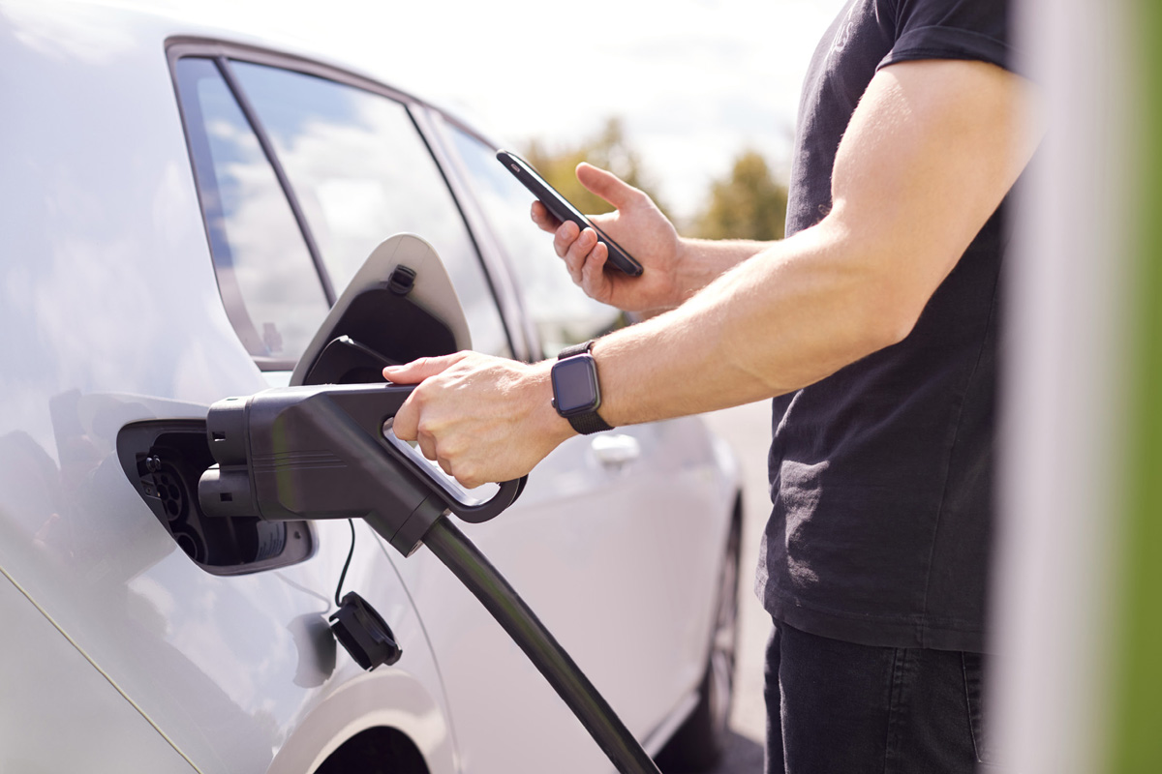
Image: Colourbox
No other country has more electric vehicles per citizen than Norway, and the authorities have set ambitious goals for future development. A sufficiently comprehensive network of publicly accessible rapid chargers is a premise for reaching these goals. Additionally, rapid charging should be no more complicated than filling a conventional vehicle tank. Complicated charging solutions can lead to unnecessary queues, as drivers spend excessive time when charging. This can represent a barrier in the transition from diesel and petrol vehicles to electric vehicles.
User-friendliness when charging is also being discussed in Europe in connection with the ongoing revision of the AFI Directive, ref. Box 2.1. The EU Commission has proposed to introduce standard requirements for payment solutions, price information, user information, data collection and accessibility of data. There is also proposals for requirements regarding which particular standards should apply to the infrastructure and requirements regarding universal design.

Payment solutions
Several operators are presently developing and offering paid charging in Norway. However, payment solutions differ between operators. Most charging operators have their own solutions based on text message-based payments, mobile applications/apps, QR codes with a link to an app/website, RFID tags associated with the user in a charging service/app, or direct connection with the electric vehicle. Very few charging stations offer card payment. According to the Institute of Transport Economics users of EVs must deal with up to 20 different operators, 20-30 apps and 13 payment systems to access all charging infrastructure in Norway. The report characterises the system as dysfunctional.
The Knowledge Base from the Public Roads Administration and Norwegian Environment Agency provides a thorough overview of the characteristics of the various solutions, and we refer to this for a more detailed review.
In a free market, one could assume that the charging operators’ payment solutions would eventually be whittled down to the most effective solution, one that also consumers prefer. However, this is not guaranteed and can take a long time. Additionally, deviating regional payment solutions can arise around larger population centres, so that a nationwide industry standard is not established. This is also not ideal for consumers, and many are already highlighting that the same company does not necessarily have standardised payment solutions across country borders. This presents a challenge to EV owners visiting Norway and vice versa.
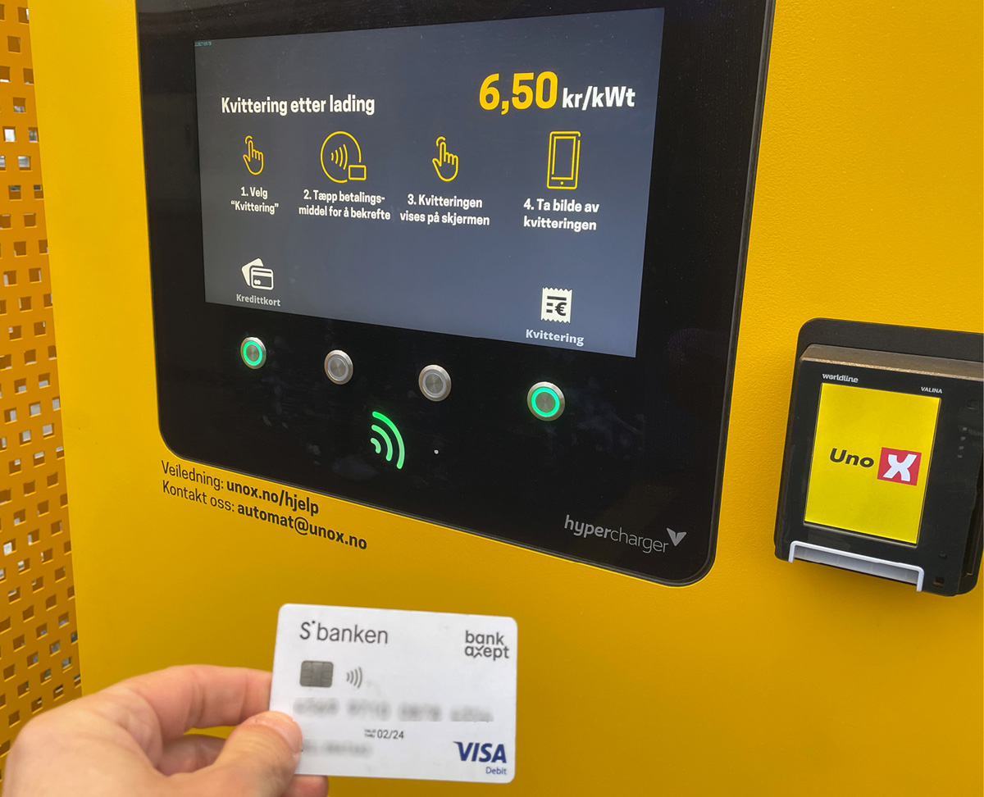
Image: Norwegian Ministry of Transport
According to the EV Association, 90 percent of respondents in the Association’s annual survey in 2022 think that charging is complex, with many apps and operators. This is a significantly higher number than last year when 75 percent gave the same answer. 80 percent of respondents wished to be able to pay with a debit card directly at the charging station (tap-and-pay). This percentage has increased from 71 percent in 2021.
Differing and in some cases unique payment solutions between charging operators can lead to frustration and queues at charging stations. If many drivers experience charging their vehicle to be impractical and difficult, this can dampen the demand for electric vehicles and hamper efforts to reach the goal that all new personal vehicles shall be zero-emission vehicles in 2025. Having to interact with a new payment solutions may also increase the risk that consumers avoid changing between charging operators. These ‘lock-in” mechanisms can weaken price competition between operators.
For charging operators, low operating costs and securing customer loyalty through benefits programs or subscriptions will be incentives to create unique payment solutions. Operating costs can also be one of the reasons why payment terminals are not a particularly widespread payment solution in the charging market. Payment solutions that provide lower costs for charging operators will contribute to enhancing charging operators’ margins and/or be passed on in the form of lower prices for consumers. Increased margins for charging operators will motivate them to develop charging services for consumers and lead to increased competition between the operators. Installing card terminals/contactless payment at existing charging stations that do not have this facility at present will lead to costs for charging operators in connection with software, physical design and eventual transaction costs. New technology can make it cheaper to install card payment systems; however, it can also make card payment obsolete. A requirement that the companies shall use a specific payment solution can weaken incentives to develop new and even better solutions. It is important to find a good balance between innovation and charging operators’ costs on the one side, and a simpler and clearer service to customers on the other.
Although surveys show that there is an overwhelming desire to pay with a debit card, it is however not clear that debit cards will be the preferred payment method for most customers if other payment solutions offer lower prices or other advantages. At present, it is common to find higher charging prices for ad hoc charging than for charging via an app or RFID tag.
In the revision of the AFI Directive, the European Commission is proposing that operators of public chargers with an output of over 50 kW, installed after the regulation comes into force, shall be required to ensure that charging can be carried out ad hoc (without signing up to a contract) and either by using a debit card or contactless payment terminal, which as a minimum must be able to read payment cards. From 1 January 2027, the requirement will apply to all chargers with an output over 50 kW. An evaluation is being made as to whether one single payment solution can cover several charging points. Charging units with an output of less than 50 kW installed after the regulation comes into force can as an alternative apply payment solutions that use an Internet connection, e.g. a QR code.
The European Parliament’s proposal is the same as the Commission’s; however, it will impose the same requirements on chargers with an output of less than 50 kW as those with an output of more than 50 kW. The Council states that before 31 December 2026 an evaluation shall be made as to whether debit cards remain appropriate.
              - E-roaming
The concept of roaming is familiar from mobile telephony, and refers to the use of a telephone in a different mobile network than the network to which one is subscribed. E-roaming is the corresponding solution in the EV charging market, i.e. with one single customer subscription it is possible to charge via other operators without registering as a user. For consumers, full access to e-roaming will be a significant move forward compared with the present complexity of price models, payment solutions and operator subscriptions.
E-roaming requires charging operators – via a third party – to open their charging services to users that are registered with other charging operators, without requiring the user to re-register. This requires agreements between operators, common technical specifications for the charging infrastructure and common, standardised communication protocols. Nothing is standing in the way of forming e-roaming agreements at present. Charging using the EV Association’s RFID tag or app gives for example members access to charging services from four different charging operators in Norway (Recharge, Kople, Ionity and Powered by E.ON Drive & Clever as of November 2022), in addition to some charging services in Europe, without the user having to register payment information with other than the EV Association. The apps Elton and Plugsurfing work in the same manner. Some charging operators have entered into bilateral roaming agreements, so that customers registered with one operator can charge via another without having to register with them. E-roaming is more common in some other European countries than in Norway; however, as far as the ministry is aware it is not a statutory requirement in any of these.
In the proposal for the revision of the AFI Directive (ref. Box 2.1), the European Commission wishes to impose technical requirements for new publicly accessible charging points that allow e-roaming. The Commission is discussing whether e-roaming requirements should be imposed; however, it has concluded that this will not be done at present, both because there are no obstacles at the moment to such agreements being formed and because it believes that a requirement will place excessive restrictions on operators’ freedom of contract. The European Parliament proposes to impose a requirement that operators of publicly accessible charging stations that are based on automatic authentication, e.g. plug and charge, must offer e-roaming. They also propose a requirement that publicly accessible charging stations that are deployed or redesigned after the regulation comes into force, must be digitally connected and have e-roaming functionality. Negotiations concerning the new regulations are not yet finalised; however, it does not appear that there will be a general requirement from the EU for e-roaming at publicly accessible rapid charging stations – although this may come later. The government will continually review the national requirements for e-roaming in context with the EU regulation.

Price information
Easily available, standardised and understandable price information is important so that consumers can take informed choices when making purchases. Inadequate price information weakens consumers’ ability to select the cheapest supplier. This can weaken competition between charging operators.
The Knowledge Base highlights that when charging an EV at a charging station, it is often difficult to work out how much to pay, what one is paying for and which services are most favourable to one’s own needs. Charging operators often utilise different calculation and price models. The final price can depend on several underlying price variables – and this is not necessarily clearly communicated to consumers.
              - The underlying price variables when charging an electric vehicle
Charger output – determines how quickly the vehicle can charge. Charging at a higher output is generally more expensive than charging at a lower output. There are challenges associated with the fact that several electric car models only achieve maximum charging speed for shorter periods. The output the car can accept is also influenced by several other factors, for example temperature/weather conditions, how full the battery is before charging begins and the number of charging cycles the vehicle has undergone during its lifetime (battery condition). Thus, one can end up paying extra for an output that in real terms is only achieved for a short period, and despite the fact it is more expensive, the total charging time is not very much shorter than if one had selected a charger with lower output.
kW charged – generally calculated based on the amount of energy that the charger supplies to the vehicle.
Time the charge is occupied – an electric vehicle will have to remain significantly longer at a charger than a petrol/diesel vehicle would at a fuel pump, and the owner does not need to remain at the vehicle whilst it is charging. To avoid queues, a solution could be hourly/minute pricing to prevent EVs from occupying charging stations longer than necessary.

To make it simpler to compare prices and to allow consumers to know how much they will pay for a charging session, there should be a requirement that information concerning charging prices is communicated in a simple and standardised manner. These requirements should also take into account the need to ensure adequate utilisation and customer flow at charging stations. This will contribute to increased competition between charging operators and allow consumers to make informed choices.
It is also important to ensure that information is easily available. Detailed information about prices must be provided in the immediate facility of the charging point so that consumers can appraise the information before they begin charging. It is not sufficient that this information is only available on the charging company’s website or via an app solution.
It is important that requirements for uniform price information are not so strict that they prevent charging operators from pricing their services in a way that reflects charging operators’ costs. This type of hindrance may lead to increases in the average price level for consumers.
In the EU Commission’s proposal for the revision of the Alternative Fuels Directive, there is a requirement that the price of charging shall be reasonable, transparent, comparable and non-discriminatory. Price information shall be easily visible at charging stations and must contain all price components for each charging session, including price per charge, price per minute or price per kWh.
To make it easier for consumers to compare services at different charging stations, a market portal for the charging market can be created. A market portal is a platform that provides an overview of the characteristics of products and/or services sold in the market. A market portal in the charging market can for example provide information about differing charging station prices, locations and availability. The market portal can be created by, or commissioned by, public authorities. Alternatively, public authorities can make data available that makes it possible for private operators to create a market portal on their own initiative.
A market portal for the charging market will make it easier for the individual consumer to select the most suitable charging service. This will contribute to enhancing competition between charging operators in the market. On the other hand, a market portal will make it easier for charging operators to compare prices at charging stations in the market. This could make it easier for charging operators to establish and maintain tacit cooperation. This type of cooperation will weaken competition between operators, which typically leads to higher prices for consumers.
Whether a market portal has mostly positive or negative effects on competition in the market will depend on several different conditions, including the market structure and design of the portal. It is therefore important that the setup and design of a market portal shall be appraised further before such a portal can be established.
              - Competition regulations
The Competition Act stipulates regulations for competition in the market. The objective of the law is to promote competition to contribute to the effective use of society’s resources. The Competition Act is enforced by the Norwegian Competition Authority. The Authority primarily works within three areas; unlawful cooperation (Section 10), abuse of dominant position (Section 11) and control of concentrations (Section 16).
In January 2022 the Competition Authority introduced a duty to provide information for the five largest operators in the market for rapid charging. This means that the operators must report all acquisitions, mergers and other commercial concentrations to the Competition Authority. The Competition Authority based its initiative on the fact that in several local markets, few operators offer rapid charging.
In connection with the introduction of a duty to provide information, the Competition Authority announced that they will conduct a survey of the market for rapid charging. The Authority consider whether competition in the market is working effectively, among other things by examining eventual hindrances to deployment. In connection with the survey, the Authority has obtained information on agreements between charging companies and the lessors of sites for charging points. During the autumn of 2022, the Competition Authority held meetings with the charging companies to discuss guidelines in the Competition Act relating to agreements for leasing of sites with a particular focus on the problem issue of exclusive agreements.

Information concerning charging services
In the EV Association’s EV survey in 2022, charging queues and chargers that are out of operation were among the disadvantages of owning an EV that were highlighted by most motorists. Half of the respondents experienced that rapid chargers were not working when they went to charge their vehicles. Half responded that they frequently, or occasionally experienced queues. Simple and clear information about which charging stations are available and working will make it easier for EV owners to avoid queues and faulty chargers. The information is available at present but is largely only available on the individual operator’s own app/website. Obtaining an overview of the actual state of services is thereby relatively complicated and time-consuming.
NOBIL is a database that was established in 2010 for the collection and distribution of data relating to charging stations for road transport. The aim of the database is to collect all data in one place to increase the availability of data concerning charging infrastructure. NOBIL contains detailed information about charging stations and is based on voluntary reporting from charging operators. Many of the charging operators currently report data, but not all. Enova is responsible for the operation and development of NOBIL.
Data from NOBIL is freely available and is used by third party operators to communicate information from the database. The NOBIL database has been further developed in the last few years, such that it meets standard protocols for the automatic import of charging station data (static and dynamic) from charging operators. In the next phase of development, the database will also encompass data on charging for heavy EVs and it can be adapted for other alternative infrastructure and energy carriers where this is relevant (for example gas and hydrogen).
Charging stations that have received subsidies from Enova from and including 2020 are required to share data. With user-friendliness in mind, there will be a great deal to gain from all operators sharing real-time data with NOBIL, showing whether a charger is occupied or available and whether it is in operation. This will make it simpler for EV owners to plan their journeys, offer better distribution of users between different charging stations and in turn reduce the risk of having to wait in a long queue at charging stations. Heavy vehicle drivers need to minimise time consumption during charging, and booking should be an option.
The European Commission’s proposal regarding new regulations for infrastructure for alternative fuels (ref. Box 2.1) includes proposals for requirements that operators or owners of publicly accessible charging or filling stations must ensure that specific static and dynamic data is made available free of charge, via a national database that shall be open to all. This applies to, among other things, dynamic data for operational status, usage status and ad hoc prices.

Standardisation
Standardisation involves making requirements and specifications for goods, services and processes. The use of standards contributes to more effective utilisation of society’s resources. Standards reduce trade barriers and ensure that products and services are of the intended quality and characteristics, in accordance with requirements from the market and authorities.
We have three national standardisation organisations in Norway. Standards Norway (SN) has the responsibility for Norwegian standards, Norwegian Electrotechnical Committee (NEK) is responsible for NEK standards, and the Norwegian Communications Authority is responsible for standards in telecommunications.
The Norwegian standards organisations each participate in their corresponding standard organisations at a European level. The Norwegian standardisation organisations are obliged to implement European standards drafted by the European standardisation organisations and appoint these as current standards. The cooperation between the European standardisation organisations, national standardisation organisations, EEA countries and the European Commission is regulated by a separate statutory instrument which has been incorporated into Norwegian law.
International standards such as ISO standards and IEC standards are published as Norwegian Standards or NEK based on professional and requirement-related appraisals carried out by the standardisation organisations. Norway is not obliged to establish ISO or IEC standards as Norwegian standards or NEK.
The authorities can impose requirements in regulations, and if applicable various levels that businesses must adhere to, whilst the standards are a possible method for companies to comply with requirements and adhere to levels in regulations. The use of standards in the implementation of regulations and public policies can give regulators a broad spectrum of benefits, for example
- Broad market acceptance
- Simplification of regulations or policies
- Support for emerging technologies and promotion of innovative approaches without the need to amend regulatory frameworks
- A close relationship to international standards which allows for international market access, thereby promoting Norwegian industry’s competitiveness.
At present, there are no national standards for the design of equipment at charging stations. The relevant standards authority for the development of standards for charging EVs is the Norwegian Electrotechnical Committee (NEK). International work is ongoing to establish standards for charging infrastructure. The work is being carried out in committees in IEC (TC 69) and CENELEC (TC 69x). NEK has established a national committee (NK 69) to safeguard Norwegian interests in processing and voting on documents drafted by the above-mentioned committees.
The proposal for a new Alternative Fuels Directive (AFI) includes several requirements concerning technical specifications for charging infrastructure.

Universal design
The goal that all new private vehicles shall be zero-emission vehicles in 2025 is on the premise that all rapid charging stations are accessible to all drivers. More and more EVs are available in sizes and with adaptations that mean that they can be used by persons with reduced mobility. This means that charging stations must be universally designed, and steps must be taken to ensure a good infrastructure for the use of EV chargers.
In 2022, Standards Norway received funding from the Ministry of Culture and Equality to draft a report on universal design for charging infrastructure. The goal of this work is to ensure that all motorists, including users with special needs, can choose EVs. It should be equally simple to charge a vehicle as to fill it up with conventional fuel.
The working group that will develop the standard will be open to all sections of the industry. Standards Norway will strive to bring in a broad range of operators to participate in the process. The invitations will go to specific persons in business, public authorities, employee organisations, education and research, voluntary organisations, municipalities and consumers. Standards Norway will strive to form a committee that is as balanced as possible.
Image: Colourbox/graja
It is expected that the working group will address the following issues:
- The design of charging stations including proposals for solutions for easy entry and exit
- Payment solutions
- Physical design with a focus on universal design
- Signage, both for finding the charging station and to easily locate which charging unit is suitable for the individual’s car
The proposal for a new Alternative Fuels Directive includes requirements for universal design in relation to adequate spaces in parking areas, level foundations/services, adapted heights of screens/buttons and the weight of charging cables
The government will:
- Start a consultation on a proposal to place requirements for card payment and/or contactless payment (NFC) at all new charging points over 50 kW from 2023 and that a deadline is set for post-installation at existing charging points.
- Require uniform price information for charging and that price information shall be easily available before charging so that it is easy to compare prices across charging operators.
- Develop a market portal for rapid charging of light vehicles.
- Introduce a requirement that publicly accessible charging stations must provide real-time information/dynamic data on whether chargers are available or in use, along with operational status to the NOBIL database.
- Request that the Public Roads Administration initiate the development of a user-friendly app for navigation, booking and if applicable payment solutions for heavy vehicles, in cooperation with market operators.
- Contribute to establishing a Norwegian standard for universal design of charging infrastructure.

Economic and administrative consequences
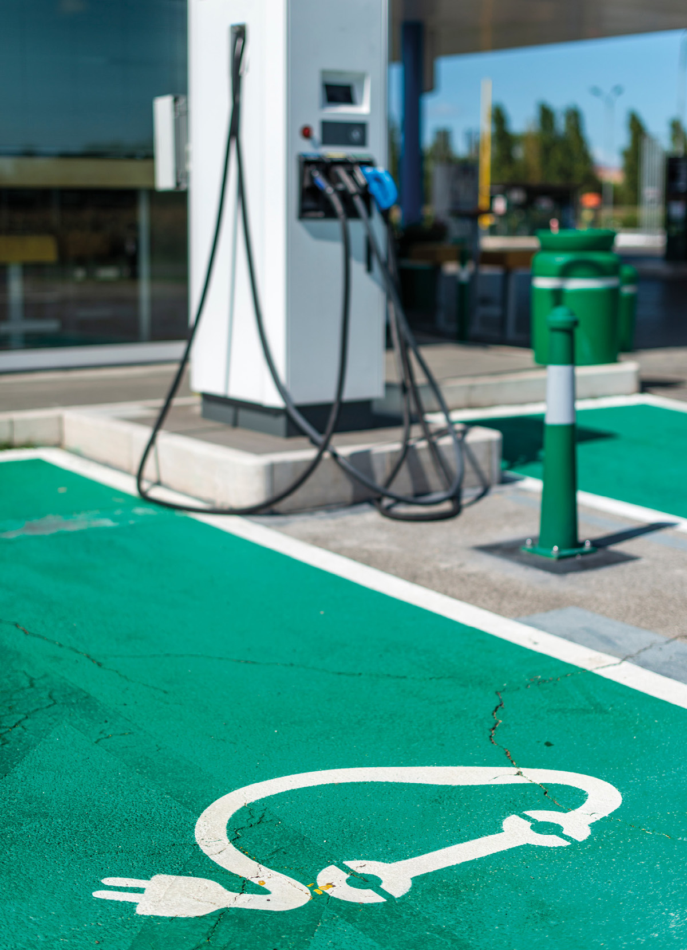
Image: Colourbox/Deyan Georgiev
The initiatives presented in the strategy cover the areas of responsibility of several ministries and underlying enterprises and requires good cooperation between relevant operators.
Some of the strategy’s follow-up points will have financial consequences. The Ministry of Climate and Environment and the Ministry of transport, with underlying enterprises, will be particularly affected. All initiatives referred to in the strategy shall be covered within the affected ministries’ applicable budget frameworks. Some of the initiatives will also require changes to legislation.
The follow-up of EU’s new regulation on infrastructure for alternative fuels is being managed in separate processes, in which financial and administrative consequences are assessed.

Klimagassutslippene gikk ned 0,7 prosent i 2021 (ssb.no)
The EV Association based on NOBIL
Kunnskapsgrunnlag om hurtigladeinfrastruktur for veitransport (regjeringen.no)
Meld. St. 33 (2016–2017) – regjeringen.no
Meld. St. 13 (2020–2021) – regjeringen.no
Meld. St. 20 (2020–2021) – regjeringen.no
As of July 2022, capacity-based grid tariff was introduced for low voltage customers with a consumption of less than 100 000 kWh/year.
Tittel (toi.no)
Regulation (EU) No 1025/2012 of the European Parliament and of the Council

