Strategy for Norwegian engagement with African countries

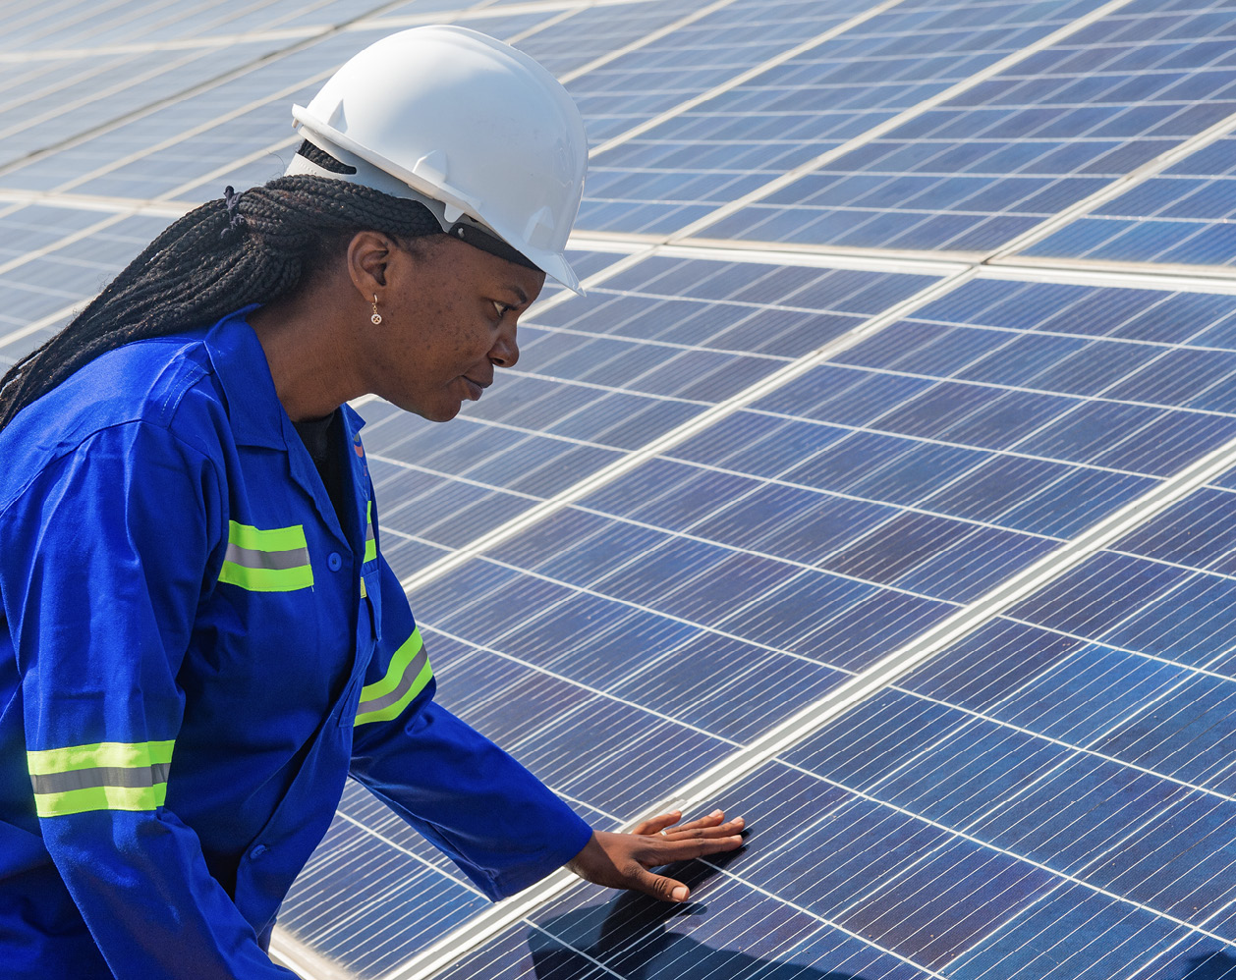

Africa – a continent on the move

Political, economic and demographic development of African countries has enabled them to take on a more prominent role in the international arena. African countries appreciate that broader international cooperation with a variety of partner countries enhances opportunities to advance African interests. In many cases, Norway’s well-established relations with African countries have their origin in Norwegian support for liberation struggles, long-term development cooperation, humanitarian activities and peace and reconciliation efforts. Many Norwegians still associate the African continent mainly with vulnerable states, conflict, poverty and natural disasters. While this may be the case in parts of the continent, many states are experiencing economic growth and progress. African countries are playing an increasingly important role in the global economy and international politics. In order to safeguard its future interests and relationships vis-á-vis Africa, Norway needs to strengthen and adapt its relations to the changes that are taking place. This requires clarity around Norway’s interests and the potential benefits of cooperation. It also means that Norway and African countries need an accurate understanding of one another’s analyses, points of view and priorities.

Today, Norway’s relations with many African countries span a wide array of areas. These range from security, multilateral issues, and finding solutions to global challenges such as environmental degradation and climate change, health crises and future food security, to promoting economic cooperation with a focus on the business sector, investments, technology and knowledge exchange. The Government has therefore drawn up this new, comprehensive strategy for Norwegian engagement with African countries. The aim is to strengthen political and economic cooperation through broad-based involvement and partnerships based on equality, mutual interests, knowledge and understanding.

Foreign policy and development policy are closely intertwined. To reflect this, the various chapters of this strategy focus on overall thematic areas and take an integrated approach in addressing foreign and development policy.

Development trends

Africa is undergoing rapid change. It is a vast continent of more than 50 countries with widely differing development trends. The continent is rich in opportunities, but it is also contending with long-term challenges that must be resolved if the countries and peoples of Africa are to realise their full development potential.

Europe’s neighbouring continent to the south has substantial natural resources on land and at sea. Its economies and markets are growing. Africa has the world’s youngest and fastest-growing population. Urbanisation is widespread and rapid.

African technology and knowledge communities are also expanding, and many countries in Africa are progressive in the application of new technologies.

Emerging economies in Africa have the potential to realise major transformational benefits in the decades ahead. Nevertheless, there is also a danger that poverty will rise and inequality increase, as well as considerable uncertainty about future economic and social progress.

African countries are rightfully playing a greater role in international politics and constitute a significant voting bloc in the UN General Assembly. Competition to win support from the continent has intensified.

Democracy enjoys broad popular support in African countries, but faces challenges and is under pressure in many places. Continued efforts to promote respect for women’s rights and gender equality are essential to safeguard democracy, human rights and development.

Armed conflict, violent extremism and humanitarian crises are a reality in several African countries. Weak governance, inequitable resource distribution and corruption are all part of the picture. Millions of people are facing a vulnerable situation. That African countries and regions are among the areas most severely affected by environmental degradation and climate change further compounds the situation.

Poverty, conflict and climate change are also contributing to a rise in African migration. Europe and the Middle East receive large numbers of refugees and migrants. The main flows, however, are within and between African countries and from rural to urban areas.

Partnership, dialogue and cooperation

Norway has strong, well-established relations with a variety of African countries and organisations. The number and range of contacts between Norwegian and African actors are increasing, and the scope of engagement is expanding and taking new forms.

Norway and countries in Africa often have similar interests in international forums and need to stand together to find solutions to global challenges such as those relating to climate change and the environment, food insecurity and inequality.

International political issues are increasingly in focus in our dialogue. Trade, investment, business collaboration, research and knowledge exchange are becoming more prominent in our cooperation. Development assistance and humanitarian efforts are an integral part of Norway’s relations with many countries. In 2023, 17 % of Norwegian development assistance, amounting to NOK 10.2 billion, was earmarked for Africa. The five largest recipients of Norwegian aid in 2023 were Ethiopia, Malawi, Mozambique, Somalia and South Sudan. Additionally, a large proportion of the support provided to the African continent is channelled through UN organisations, development banks and funds.

Contact with civil society organisations is a key component of our mutual relations. An active civil society is vital to promote social development and hold public authorities and private enterprises accountable. Norway will attach greater priority to support for, and engagement with, local civil society partners in its efforts moving forward.

The younger segments of the population have a pivotal role to play in how their countries and local communities develop, and will form the basis for future relations. Young people must therefore be explicitly included in Norwegian relationship-building with African countries. Efforts targeting young people must emphasise education and jobs.

Various African diaspora groups and diaspora organisations have insights into and an understanding of ongoing developments in Africa and Norway that make them important as dialogue partners for Norway. Financial transfers from Norwegian and international diasporas exceed the total development assistance to African countries and help to reduce poverty and improve living conditions.

There are significant variations between and within the countries in which Norway is represented or involved, which will influence the type of cooperation pursued and set limits for Norwegian engagement. The development trends determining the nature of our cooperation moving forward will vary depending on the region, country, context and relationships.

Norwegian policy highlights the importance of locally led development, dialogue, long-term frameworks, predictability and adequate understanding of the context. Development cooperation is intended to enhance use of resources and lead to lasting social change. This will continue to guide efforts to strengthen and further develop relations with African countries and organisations.

Multilateral and regional cooperation

The multilateral system and the international law and principles underpinning it, are under pressure and international cooperation and common solutions are being challenged. Norway works closely with many African countries on multilateral issues. Norway seeks to expand and increase cooperation on strengthening and protecting multilateralism and the principles that underlie it.

In order to preserve its legitimacy and respect, international law must be implemented universally and consistently. Norway’s clearly stated view is that all states must comply with the same rules, and that all violations of international law are unacceptable, no matter where they occur. Whether in Ukraine or Palestine, Norway has been unequivocal in its criticism of violations of international law, regardless of who is responsible.

African countries are underrepresented in multilateral forums. The demands for influence and reform have increased. African countries are especially concerned about not being in the driving seat during discussions on issues of major importance to the continent, such as those involving peace and security, climate, trade and taxation. Reforms can give greater legitimacy to the multilateral system and multilateral solutions, which is in Norway’s interest as well.

Major international agreements such as the 2030 Agenda for Sustainable Development, the Paris Agreement, the Global Biodiversity Framework and the Addis Ababa Action Agenda are examples of ways in which the multilateral system serves as an important arena for addressing global challenges. Further development of well-established cooperation between Norway and several African countries may help to advance common solutions through multilateral mechanisms. Multilateral institutions are crucial as partners in development cooperation efforts. Norway attaches importance to ensuring close dialogue with relevant African countries on the initiatives being implemented.

There has been a growing tendency to seek political cooperation in regional forums or various intergovernmental organisations rather than in the UN. African representation has increased in for example BRICS+, while the AU has been made a permanent member of the G20[1]. Intraregional cooperation and dialogue with like-minded partners give African countries the opportunity to advance their political and economic interests with greater influence. For Norway, a dilemma arises if such forums undermine multilateral cooperation and become arenas for promoting authoritarian ideologies and dividing the world into blocs. One aim of Norway’s cooperation with African countries is to ensure that these forums complement and support rather than duplicate the role of, or weaken, the multilateral system based on international law.

A well-functioning multilateral system and the successful implementation of common solutions can only be achieved if regional and sub-regional organisations function effectively and there is a balanced distribution of tasks and cooperation with the UN and other multilateral organisations.

Norway supported the Organisation of African Unity (OAU) which was established in 1963, and has continued as an active partner of the African Union (AU) since it succeeded the OAU in 2002. Norway also supports sub-regional organisations and the AU’s Agenda 2063, Africa’s development framework for the continent. After several years of progress in terms of strengthening their architecture, the organisations are experiencing persistent challenges in obtaining funding and achieving consensus between the member countries. It is in our common interest that strong African intergovernmental organisations contribute to address challenges and promote growth and development on the continent.

Norway has a strategic interest in participation and engagement in African-led meetings and initiatives, and in supporting African countries as the host countries for multilateral forums, including the UN Environment Assembly in Nairobi.

Objective: Strengthened cooperation on reforming and promoting the multilateral system and international law

Priorities for strengthening cooperation in this area:

Political dialogue and cooperation: Norway will increase the use of multilateral consultations with African countries. Norway will work together with African countries to pursue multilateral solutions to common challenges that can win broad support in a world contending with heightened tensions. Emphasis will be placed on building cross-regional cooperation with African countries in multilateral forums involving international law, democracy, human rights, humanitarian issues and sustainable development.

Reform: Norway will strengthen efforts to promote reform and refine working methods in multilateral organisations in order to increase African representation and influence. This includes increased representation and influence for African countries in the UN Security Council. Norway will also work to enable African leadership in cases involving African issues. Furthermore, Norway will seek to promote the strengthening of the role of the UN’s African headquarters in Nairobi as a platform for dialogue and discussions on multilateral issues.

Regional architecture: Norway will continue its close cooperation with the AU and sub-regional organisations, with emphasis on implementation of the AU’s normative framework. An additional focus will on support to expanding UN-AU cooperation, including between the UN Security Council and the AU Peace & Security Council.

Engagement in security and peace efforts

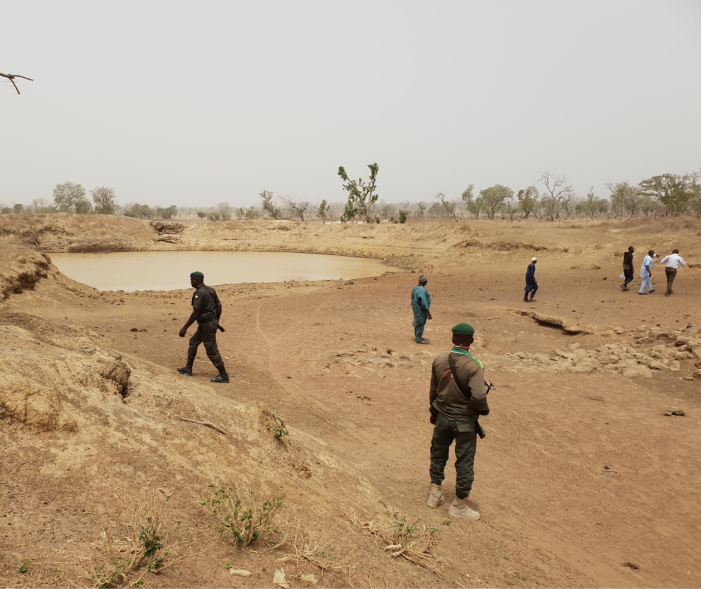

African countries have gained a stronger geopolitical role. A number of different countries are continuing or stepping up their engagement on the continent in various ways. These include the US, Brazil, India, China, Russia, Türkiye, multiple European countries and the Gulf states. The increasing rivalry between major powers factors into this development. China is continuing to maintain its long-term, strategic political and economic presence. China employs a wide range of actors and instruments to advance its interests – interests that are not aligned with Norway’s in all areas. Russia is seeking to consolidate and increase its influence in parts of Africa largely through expanded military cooperation. This can often have a destabilising effect. Such activities have an impact on power relations, governance and efforts to maintain stability. African countries have long sought wider influence and now have greater scope to promote their interests. Norway, with its focus on international law, multilateralism, democracy and good governance, has a security policy interest in seeking cooperation with African countries. Understanding, dialogue and cooperation on global and regional security issues – and the significance of these for our respective countries and regions – will be of increasing importance.

The number of conflicts on the continent has been rising. Security challenges in African countries affect Norwegian interests. Several conflict-affected countries are in Europe’s neighbourhood. The threats to peace and security will be compounded by broader trends related to demographics, weak states, the climate crisis and violent extremism. The spread of disinformation and discriminatory and hateful speech is destabilising, and poses a growing threat. It is in our common interest to combat this.

Attacks on commercial shipping continue to occur and often affect global, African and Norwegian interests. Ensuring free and safe passage at sea is crucial to the transport of critical global goods such as fuel and food. Increased focus on maritime security is an area of importance to all parties. Norway has established cooperation with several African countries to address the issue, often in conjunction with allies and other partners. Together with Ghana, Norway successfully negotiated the adoption of UN Security Council Resolution 2634 on maritime security in the Gulf of Guinea, and will continue working to promote positive developments.

Extensive organised crime generates illicit gains that are then used to fund criminal and extremist, violent groups. Large-scale corruption, tax evasion, money laundering, human trafficking, narcotics trading, environmental crime and cybercrime all transcend national boundaries and require collective responses.

Poverty, inequality, poor governance and lack of inclusion are among the causes of crime, conflict and extremism. Climate change is further exacerbating the situation. Norway’s longstanding tradition of long-term, predictable development cooperation with a focus on inclusion, adaptation to context, locally-led efforts and cooperation with civil society organisations provides a solid basis on which to engage with African countries if invited to do so by local partners.

Promoting peace and security is at the core of the AU’s Agenda 2063. To address the challenges involved, Norway seeks to strengthen its existing cooperation and dialogue with African countries, the AU and sub-regional organisations. Norway will support AU cooperation with the United Nations, as well as with NATO where desirable by African countries. Norway will continue to participate in UN peacekeeping operations and cooperate with African and Western partners to strengthen the continent’s ability to safeguard its own security. Nevertheless, it is the case that African countries are assuming greater responsibility for peacekeeping and conflict management on the continent, and that the number of UN operations has declined. UN peace operations have lacked a mandate to address violent extremism and the spread of misinformation, disinformation and hate speech against peacekeeping operations, and are not considered to have responded adequately to the challenges in African countries. Norwegian security efforts will focus on the underlying causes of conflict and employ an integrated, cohesive approach.

The participation of women in decision-making processes is of vital importance. Norway will continue to cooperate with African partner countries, the AU and sub-regional organisations to promote women’s participation and influence.

|  |
| --- |
| **The Training for Peace programme** is a unique North-South-South partnership between the African Centre for the Constructive Resolution of Disputes, the Institute for Security Studies and the Norwegian Institute of International Affairs. The programme is designed to increase knowledge and strengthen capacity in crisis management, crisis resolution and the participation of civilians in peace missions. It has helped to enhance the quality of efforts to support peace operations, including in relation to international humanitarian law and human rights |

Both Norway and the AU have the common goal of preventing and resolving conflicts. The priorities for Norwegian engagement in peace and reconciliation efforts are established through focused efforts based on requests from parties in the region. While Norwegian engagement and facilitation in various peace processes and initiatives to promote dialogue are intended to reduce violence and support peaceful solutions, they also seek to alleviate humanitarian situations, counter extremism and decrease irregular migration.

Some of the world’s most severe, protracted humanitarian crises are unfolding on the African continent. These are further exacerbated by rising conflict levels. The impacts of climate change are most clearly manifested on the continent in the form of natural disasters, extreme weather events and drought. Africa has a young population and young people and children are especially vulnerable in such crises. Humanitarian needs are expected to grow. The AU is aiming to play a clearer role in humanitarian responses and to expand its response capacity. Norway will continue its humanitarian efforts on the basis of the humanitarian principles. Preventing, alleviating and resolving humanitarian crises requires good coordination between development, prevention, stabilisation, peace engagement, humanitarian response and reconstruction efforts, with the early involvement of long-term development actors.

Armed conflict and climate-related crises are among the main causes of internal displacement. Poverty and unemployment, especially among young people, are other factors that may affect the decision to migrate. In many African countries, internal displacement and migration pose serious challenges. Most displaced Africans remain in their own countries or other African countries, while migrants often seek out destinations farther away, including Europe. Safe, orderly and regular migration may offer major economic benefits to both the country of origin and the recipient country.

Objective: Strengthened political dialogue and cooperation in peace and security efforts, worldwide and on the African continent

Priorities for strengthening dialogue and cooperation in this area:

Consultations: Norway will continue to propose and implement visits by political leaders and senior government officials for dialogue on peace and security, and will incorporate peace and security issues in bilateral and multilateral consultations with African countries when considered appropriate by the parties involved.

African-led initiatives and operations: Norway will support African-led security and peace initiatives and processes. These include peace operations, peacebuilding initiatives and other activities when so requested by African partners and, where relevant, in cooperation with allies and other partners.

Cooperation with the United Nations: Norway will support further development of UN cooperation with the AU, including the use of mandatory contributions from UN member countries to fund AU-led peace support operations, on a case-by-case basis. Norway will support and participate in operations led by the UN and potentially by other actors if deemed appropriate following an overall political assessment.

Women, peace and security: Norway will continue to work with African countries to incorporate the gender perspective as part of the basis for making decisions in peace processes, particularly in priority countries for Norwegian engagement in the women, peace and security agenda. Importance will be attached to building and exchanging knowledge about the links between women, peace and security and climate, peace and security.

Integrated approach: When Norway supports security sector reform and disarmament and demobilisation, particular priority will be given to initiatives under multilateral mechanisms in areas where it will enhance prevention, encourage peacebuilding and promote coherent efforts when dealing with armed conflicts and humanitarian crises. Norway will emphasise a systematic, integrated approach to UN operations and activities that strengthen the ability of countries to safeguard their own security. Norway will also contribute to elevating the role of civil society and to further incorporate local civil society organisations in security and peace processes and stabilisation and humanitarian efforts. Efforts to ensure safe, rapid and unimpeded humanitarian access to people in need, to strengthen protection of civilians and to promote the safety of humanitarian workers in humanitarian crises will be continued. Importance will be attached to prevention, climate change adaptation and integrated approaches to long-term crises. Importance will also be attached, to supporting the AU’s role and capacity to deal with humanitarian crises.

Migration: Norway will seek to strengthen cooperation with the AU and selected African countries on access to existing regular migration channels for people from Africa, and conversely, on limiting irregular migration. Norway will work to improve conditions for refugees and displaced people and for local host communities.

Democracy, human rights and gender equality



After decades of democratic development, human rights and democracy have come under pressure in a number of African countries. There have been rising conflict levels, coups and unconstitutional seizures of power in some of these countries. Growing inequality creates a breeding ground for social unrest and can undermine stability and support for democracy. Weak African democracies have proved vulnerable to external influences and pressures. Even so, Africa is the continent where the greatest number of countries have moved in a democratic direction. The total number of democracies on the African continent remains fairly stable.

Democracy surveys show that most residents in African countries want free and fair elections and military forces that stay out of the political arena. Dissatisfaction with elected leaders and democratic institutions is generally greater in countries where people are seeing a widening gap between their demands and expectations and what is actually being provided. Poverty, inequality and inadequate social services are often part of this picture. In many cases the lack of participation in, and ability to exert influence on, political decision-making processes is a source of conflict and political and social unrest.

African countries and regional organisations are crucial partners in international efforts to curb rising inequality. In this context development cooperation plays an important role in supporting democratic development and a more equitable distribution of social and economic goods. Norway will continue to work to promote locally-led development cooperation that can lead to lasting social change.

The AU’s Agenda 2063 calls for a universal culture of respect for good governance, well-functioning states based on the rule of law, democratic values, gender equality and human rights. These issues are on the agenda in the close, productive dialogue Norway has through annual consultations with a large number of African countries. Norway seeks to further expand its dialogue with the AU, African governments, civil society organisations, businesses, traditional and religious communities and other actors on how to develop accountable institutions and democratic processes that best address challenges in a variety of different contexts.

The interplay between inclusion, participation, respect for human rights, good governance, knowledge, economic progress, climate change adaptation, stability and security implies a need for a broad and integrated approach to cooperation to promote democracy.

Civil society, women, children, minorities and marginalised groups are often the victims when democracy is weakened. Norway will work together with partners in African countries to increase the scope of action of civil society organisations, strengthen gender equality and safeguard the rights of vulnerable groups.

Promoting the right of women to participate in political and public life on an equal footing with men is an integral part of Norwegian partnerships with African countries. Sexual and reproductive health and rights and combatting sexualised and gender-based violence will need to be given increased focus in cooperation moving forward.

Education is of crucial importance in combating poverty, fostering democracy and business development, increasing employment and ensuring sustainable economic growth. Education also has a major role to play in promoting health and gender equality. It is in our common interest to strengthen cooperation to enable more children and young people to pursue quality education.

Digital technology can facilitate more transparent and inclusive ways of governing, but it can also increase inequality if access to technology and other resources is skewed. Social media platforms are used effectively by human rights and democracy advocates, but they can also be used by the authorities for surveillance and control. The spread of hate speech and disinformation through digital channels is a growing problem. It is in our shared interest to work together to address both the opportunities and the challenges digital technology entails.

Objective: Strengthened cooperation on democratic development, human rights and gender equality

Priorities for strengthening cooperation in this area:

Political dialogue: In its dialogue on democracy development with African national authorities, traditional communities and business sectors, Norway will emphasise the participation of civil society organisations, freedom of expression, media freedom and efforts to combat inequality.

Combatting inequality: Norway will strengthen efforts to combat inequality, including by taking a leading role in international cooperation to counter tax evasion, corruption and illicit financial flows. Development cooperation is to be locally-led and help to promote lasting societal change.

Civil society, institutions and media: Norway will attach importance to supporting reform of the justice sector, including promoting independent courts, broad societal engagement in civil society organisations, independent media and trade unions.

Digital technology: Norway will support cooperation to map and counter disinformation and ensure access to reliable information, including through independent media and civil society organisations.

Human rights: Norway will work with country situations via the UN Human Rights Council and the Universal Periodic Review reporting process, with emphasis on the follow-up of recommendations. Importance will be attached to efforts to protect vulnerable groups, including the LGBTIQ+ community.

Gender equality: Norway attaches importance to establishing partnerships between public authorities, the private sector, civil society actors and multilateral organisations in efforts to promote gender equality, the right of women and girls to decide over their own bodies, and the political and economic rights of women and girls.

Young people and children: Norway attaches importance to the rights of young people and children, including the right of all children to quality education. Norway works strategically through funds and partnerships to unlock large-scale investments, strengthen national education systems and facilitate access to education when children are affected by crisis, conflict and displacement. It is of key importance to ensure meaningful and inclusive participation for children and young people.

Cooperation in the business, clean energy and knowledge sectors

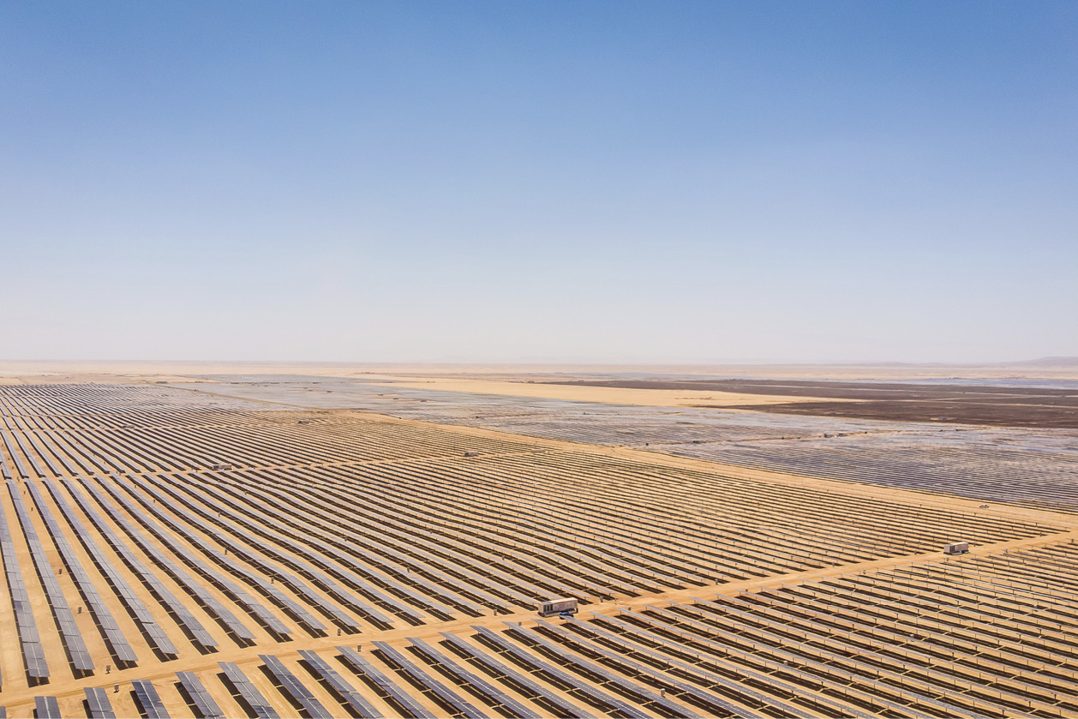

The African continent offers vast economic opportunities with the potential to promote inclusive growth and poverty reduction. By 2050 a quarter of the global population is expected to live in African countries. Economic growth and expanding markets provide new trade and investment opportunities. Urbanisation is expected to continue at a rapid pace, which can spur new growth but will pose challenges as well. When fully realised, the African Continental Free Trade Area (AfCFTA) will be the fifth largest market in the world. It is expected that African countries will continue to make use of fossil energy sources, and, in particular, consumption of natural gas will be maintained in coming years. But more than half of the best solar energy resources in the world are in African countries. In addition to this, energy from fully developed wind power and hydropower would be able to supply both domestic and international markets. African markets are expected to gain an increasingly prominent role in the global economy in the future.

To realise their potential, many African countries are seeking cooperation in the form of increased trade and investment, improved frameworks for companies, support for business development, and more knowledge sharing and capacity building.

Reforms are needed to improve governance, strengthen institutions and increase private and public resource mobilisation. The large proportion of young people in many African countries means there is a need for investment in education, job skills and inclusive job creation. In some countries, the debt burden poses a threat to economic development. The success of countries in Africa will have impacts beyond the continent in areas such as economy, climate and the environment, health, security and migration. Promoting sound economic and social development is in our common interest.

Norway is working to facilitate necessary debt cancellation and to prevent future debt problems in vulnerable countries. Corruption is one of the major challenges impeding sustainable development in Africa. Good governance, effective national resource mobilisation and knowledge exchange are central components of Norway’s development cooperation.

|  |
| --- |
| **Financing for Agricultural Small-and-Medium Enterprises in Africa (FASA)** is a multi-donor fund launched by Norway and the US Agency for International Development (USAID) to improve financing opportunities for small- and medium-sized agricultural enterprises. Donor contributions are used to reduce investment risk and catalyse private financing. The goal is to support 500 small- and medium-sized agricultural enterprises and 1.5 million small-scale farmers while helping to create 60 000 jobs. |

On request, Norway can provide African countries with knowledge, capacity, technology and financing in fields where it has particular strengths, such as sustainable resource management, economic governance and gender equality. Norway employs innovative forms of financing to trigger private investment and support sustainable African business activities and job creation through Norwegian programmes, the World Bank Group and the African Development Bank.

|  |
| --- |
| **Norfund** (the Norwegian Investment Fund for developing countries) has 62 % of its portfolio in Africa. Energy is a major focus under the fund’s Development Mandate and the Climate Investment Fund. In 2023 the Climate Investment Fund invested NOK 368 million in the South African-owned, independent power producer Pele Green Energy. The investment will contribute to the construction of 1 GW in solar and wind projects in South Africa that will provide electricity to the national grid and directly to industrial customers. This is expected to prevent an estimated emission of 2.3 million tonnes new CO2 equivalents annually. |

Norway has common interests with various African countries when it comes to establishing international cooperation to promote sustainable use of natural resources and conditions to ensure that a greater share of productive resources and value creation remain in the countries of origin.

|  |
| --- |
| The Africa Group in the UN is at the forefront of efforts to combat **illicit financial flows and to establish a UN Framework Convention on International Tax Cooperation**. Losses from illicit financial flows out of African countries are estimated to be ten times larger than the official development assistance provided to the continent. Norway gives anti-corruption and combatting of illicit financial flows high priority. There is close cooperation with multilateral organisations to prevent illicit financial flows, combat corruption and tax evasion, and to introduce effective taxation systems for mobilising domestic resources in several African countries. As one out of two Western countries, Norway did not vote against establishing the process for a UN tax convention, and Norway participated in the UN bureau drafting the Terms of Reference for the tax convention negotiations. |

The emerging African markets provide new opportunities for Norwegian business and industry. Many Norwegian companies are present in African markets and are showing greater interest in activities on the continent. Norwegian technology, expertise, goods and services are in demand in several African countries. The markets vary from country to country, which in turn affects which countries are the most relevant. Challenges include fluctuating and unpredictable policies and conditions, corruption, substantial differences in economic size and war and conflict. Norway has a number of export-oriented instruments that can provide advice, market information, loans, subsidies and guarantees to help Norwegian companies seeking to enter African markets. Greater insight into African markets, broader networks and political dialogue with the authorities of African countries on stable and predictable framework conditions for trade and investment are key to enabling Norwegian companies to succeed in positioning themselves and investing in African markets in the long term

|  |
| --- |
| The **Nordic-African Business Summit** is a forum focused on Nordic-African business cooperation. The Norwegian-African Business Association (NABA) organises this annual conference in Oslo. The event has become one of Northern Europe’s leading conferences for businesses and investors interested in African markets and business opportunities. |

Under its membership in the European Free Trade Association, Norway has to date entered into four trade agreements involving eight African countries and has signed declarations of cooperation with two African countries. This network of agreements would benefit from further development to create stable and predictable conditions for trade and investment and to promote a greater degree of reciprocal value creation.

More than 600 million Africans lack access to electricity. Achieving economic growth, industrialisation, greater productivity, poverty reduction and improved public and private services will require a major push to increase access. Ever cheaper and better renewable energy solutions can bring clean electricity to millions of people. When renewable energy is put into production of goods, this gives advantage over goods produced using fossil energy, in European markets. However, to succeed in mobilising private investment in renewable energy, it will be necessary to reform African energy markets and companies in ways that reduce risk. Norway cooperates extensively with the energy sector in several African countries. As an energy nation, Norway can provide sought-after technology and expertise that also extend to energy revenue management and the implementation of transparent, predictable regulation of the energy sector. Norwegian companies are already invested in the oil and gas segment of the energy sector, and are focusing increasingly on solar and wind energy. There is great potential for mutually beneficial cooperation between Norway and African countries in this sector. Renewable energy will remain a priority area in Norwegian development cooperation.

Research, knowledge exchange and education provide the key to solving challenges in achieving sustainable development, enhance relations and expand cooperation. Student exchange programmes are of particular importance in this context. Norwegian and African institutions already cooperate closely in a variety of countries and subject areas, to the benefit of all parties. It is in our mutual interest to expand cooperation based on equal, academic and professional partnerships that have been identified and chosen by Norwegian and African institutions.

|  |
| --- |
| Research capacity on the African continent is growing. For more than 20 years, South Africa and Norway have co-funded a **research partnership** under South Africa’s National Research Foundation and the Research Council of Norway. Thematic areas include the ocean environment, sustainable fisheries management and seawater desalinisation, with a focus on challenges both countries are facing. |

Digitalisation is already an important driver of economic development in African countries. Norway is among the world’s most digitalised societies, and Norwegian solutions can form the basis for developing relevant services in African countries. Through its partnerships in African countries, Norway contributes to lay the foundation for further progress in digitalisation of the public sector to the benefit of the authorities, the people and the business community.

Objective: Strengthened cooperation on business activities, knowledge exchange and clean energy

Priorities for strengthening engagement and cooperation in this area:

Regional and multilateral cooperation: Norway will work to strengthen efforts of the African Development Bank and the World Bank that are targeted towards the African countries. Norway will support reforms to increase development bank lending and efficiency. Norway will also support AfCFTA implementation by helping to develop the organisation’s capacity in areas where Norway has particular strengths.

Trade and investment: Norway will promote sustainable Norwegian solutions and highlight Norway’s role as an economic actor and attractive commercial partner in selected African markets where the Norwegian business community has expressed an interest in operating. Efforts will be made to encourage closer contact between Norwegian and African authorities on framework conditions in countries where Norwegian companies have interests. Norway will look for opportunities for increased business activity and will seek to bring together Norwegian and African actors where this is appropriate.

Resource mobilisation: Norway will further enhance its innovative financing mechanisms to promote resource mobilisation and private investment in African countries. Special focus will be given to risk capital, lending and guarantee schemes directed at sustainable African business enterprises, job creation and investment in the green transition. Support and cooperation to reduce illicit financial flows will be continued. Norway will participate in cooperative efforts to strengthen international debt management.

Tax evasion and illicit financial flows: Norway will continue to contribute to effective and inclusive global tax cooperation in international forums, in order to combat tax- related illicit financial flows as well as contributing to mobilising national resources for sustainable development.

Anti-corruption: Norway will continue to contribute to effective prevention and combatting of corruption on the African continent through cooperation with and support to UN and other multilateral organisations.

Knowledge cooperation and capacity building: Norway will strengthen its cooperation on capacity building and knowledge exchange with countries that carry out economic and social reforms. Cooperation will focus on areas in which Norway has particular strengths and there is a demand for Norwegian expertise.

Clean energy: Norway will seek strategic cooperation to promote the development of renewable energy, increase access to electricity and clean energy sources for cooking, expand grid capacity, and encourage regional trade as well as capacity building and structural reforms. Priorities will reflect needs, potential benefits, degree of local ownership and Norway’s strengths and advantages as a contributor.

Research and education cooperation: Norway will support Norwegian-African research and education cooperation through long-term, equal, mutually beneficial partnerships, and will work to strengthen the higher education and research sector in African countries. Norway will continue its grant schemes for African students who wish to study in Norway, and will support the promotion of reciprocal student exchanges.

Climate and environmental issues, food security and health

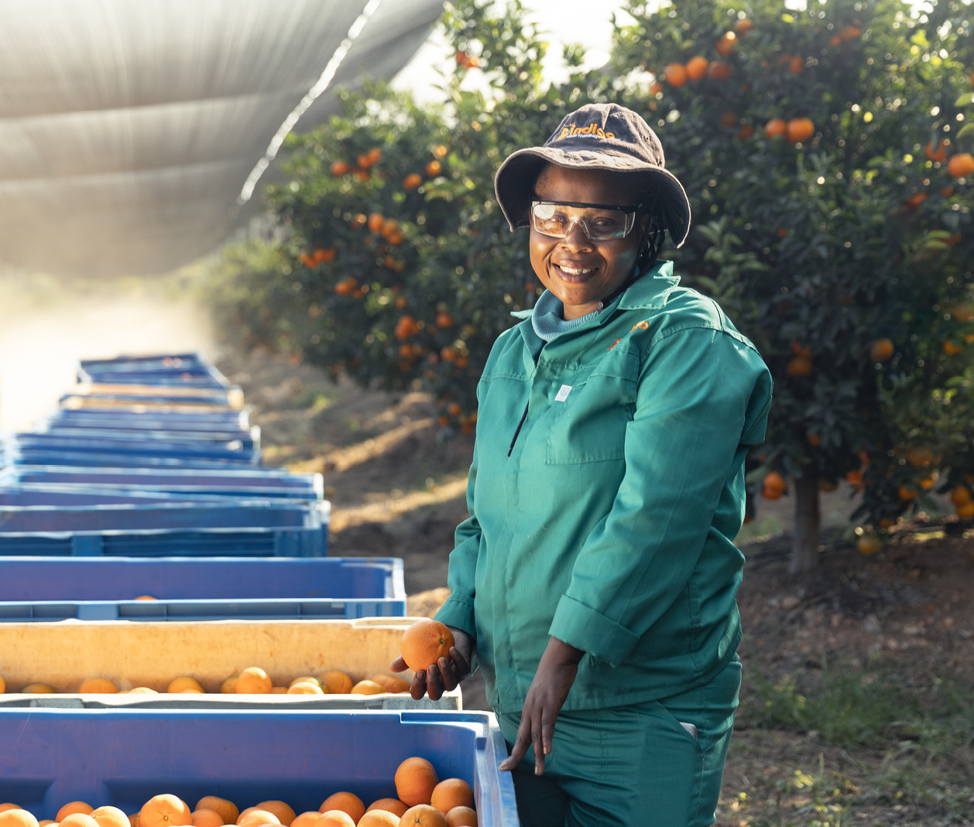

Climate change and the degradation of natural environments and loss of biodiversity have already had a visible effect on African food production and local employment. It exacerbates food insecurity, increases the disease burden, adds to instability and triggers migration, undermining the economic and social progress that has been achieved.

The way in which African countries deal with such challenges will have significance across the globe. While Africa itself has contributed only 2–3 % of the world’s aggregate greenhouse gas emissions, the continent is the most vulnerable to climate change, and there is a widespread need for climate change adaptation. Increased support for adaptation and compensation for loss and damage are among the key demands from African countries in international climate negotiations. A substantial proportion of the world’s most valuable intact ecosystems, including the world’s second-largest rainforest, are found on the African continent. With 38 coastal countries, Africa has a major role to play in promoting sustainable ocean management. Waste and hazardous substances pose a threat to safe food production and human health. Growing urbanisation exerts further pressure on the environment.

The vital role of environmental issues in African social and economic development is reflected in the growing focus of the AU and the African countries on drawing up regional and national strategies, and a steadily increasing international engagement. UN Headquarters, the UN Environment Programme in Nairobi, the AU, the African Ministerial Conference on the Environment and the African Climate Summit are all crucial regional arenas for cooperation.

Norway’s shared interests with African countries have led to broad-based engagement and cooperation on climate, the environment, forests and oceans, which are becoming increasingly important. Norwegian companies and technologies have much to offer in relation to the blue economy and ecosystem-based marine management and monitoring. Climate change adaptation and preservation of rainforests are Norwegian priorities that directly address the vulnerability of African countries to climate change. The positions taken by African countries will help set the stage in the global efforts needed to reduce emissions in line with the Paris Agreement and achieve the goals of the Global Biodiversity Framework. Close cooperation will be needed to fulfil international climate and environmental commitments.

|  |
| --- |
| Norway and Tanzania have entered into a strategic bilateral **climate partnership** that **consolidates efforts related to food security, health, renewable energy and natural resource management.** Access to local knowledge is crucial, and cooperation between Norwegian and Tanzanian research institutions and other expert communities is a key component of the partnership. |

Food security challenges on the African continent are growing. African countries have much of the world’s cultivable land, with great potential to ensure economic value creation, create jobs, alleviate hunger and feed a growing population. More sustainable production and more resilient, sustainable local value chains can benefit the climate, the environment and food security. The use of aquatic food can supplement land-based food production and help to reduce the climate footprint. It is in our common interest to promote efforts to fully realise the potential for food security, and in the process help to prevent conflict, extremism, crime and social unrest. Norway gives priority to efforts to improve food security in African countries that emphasise preparedness, self-sufficiency, climate change adaptation, climate-resilient food production, soil health, stronger value chains and better mobilisation of civil society organisations and the private sector.

|  |
| --- |
| The second largest tropical forest in the world is in Central Africa. Preserving it is critical to safeguard regional rainfall patterns and meet the targets of the Paris Agreement. The main drivers of deforestation are small-scale agriculture and charcoal production, with poverty and rapid population growth as the key underlying causes. Initiated by Norway, the **Central African Forest Initiative (CAFI)** is a collaboration of 10 donor countries and 6 forest countries. The initiative enters into agreements with forest countries to reduce deforestation and promote sustainable development practices. |

Africa’s geography and climate in combination with the impacts of climate change, conflict, poverty and inequality result in a high burden of disease on the continent. This, together with the rapid pace of population growth, places new demands on health services. The COVID-19 pandemic, rising antimicrobial resistance and humanitarian crises have shown the importance of an integrated approach in international cooperation to build resilient health care systems, ensure adequate crisis preparedness and crisis response systems and implement the One Health perspective, which recognises the interconnectedness between human, animal, and environmental health. Cooperation in the research and knowledge sectors is crucial to understanding changes in disease patterns and the risks of cross-contagion and interaction between humans, animals and plants. Good health across a population is essential to economic and social development. The risk of new pandemics underscores the importance of strengthening global, African and Norwegian health preparedness. The AU and the Africa Centres for Disease Control and Prevention (Africa CDC) are spearheading efforts to prepare for future health crises on the continent while ensuring the establishment of sustainable, climate-resilient health systems. The inclusion of African knowledge and expertise is of great importance in global cooperation on health issues, as well as on issues relating to the environment, climate change, the oceans and food security.

|  |
| --- |
| Norway has been a predictable, long-term investor and progressive force in global health efforts. Cooperation between institutions is important in order to exchange knowledge and experience. Several Norwegian actors have established institutional cooperation with the Africa Centres for Disease Control and Prevention (Africa CDC) and other African partners to expand institutional and professional capacity and create opportunities for knowledge exchange. Such activities enhance public health for all the parties involved, and better equip all of us to address future global health challenges. |

The impacts of climate change on food security and health hit women, children and marginalised groups the hardest, and can exacerbate social inequality. It is important to seek an integrated gender perspective with inclusive solutions that emphasise gender equality and the role that women and marginalised groups have to play in health care, food production and the green transition.

Objective: Strengthened cooperation on climate, the environment, food security and health

Priorities for strengthening cooperation in this area:

International forums: Norway will further develop cooperation with African countries in international forums and strengthen bilateral and multilateral cooperation on the environment, climate change and the protection and sustainable use of the world’s oceans. Norway will work to strengthen the UN Headquarters in Nairobi as a centre for multilateral cooperation on the environment and climate.

Climate change adaptation and emissions reductions: Norway will contribute to efforts to promote climate-resilient, low-emission development, increased climate change adaptation and greater resilience in line with national climate and biodiversity targets. Norway will continue to strengthen cooperation on ocean-related issues with relevant countries. It will also work to ensure that African countries have sufficient access to funding from global funds and financing mechanisms. Cooperation to preserve existing rainforests will be continued. To increase access of African countries to financing, technology and expertise, Norway will support funding schemes that encourage increased private-sector investment.

Biodiversity: Norway will assess priorities for strengthening cooperation to preserve biodiversity and restore land areas in African countries with a focus on capacity building, environmental monitoring, land-use planning and sustainable management of wilderness and marine areas. Norway will also work to ensure that urbanisation in African countries is sustainable and provides secure livelihoods both in and outside of urban centres, with a focus on local supply chains.

Food security: Norway will work to enhance climate-resilient local food production, improve soil health, increase local value creation, reduce malnutrition and undernutrition and prevent hunger by promoting sustainable food systems.

Health: Norway will cooperate with African countries and regional institutions to build and strengthen resilient national health systems that can withstand the impacts of climate change and other environmental change, promote universal health care coverage and improve primary health care services. Norway will also work to increase African representation on the boards, councils and management teams of global health organisations and initiatives.

1. In 2024 BRICS+ comprises Brazil, Russia, India, China, South Africa, Iran, Egypt, Ethiopia and the United Arab Emirates.

   G20 comprises Argentina, Australia, Brazil, Canada, China, France, Germany, India, Indonesia, Italy, Japan, Republic of Korea, Mexico, Russia, Saudi Arabia, South Africa, Türkiye, United Kingdom, United States, and the European Union and the African Union.