Ministry of Health and Care Services
A Resilient Health Emergency Preparedness
From Pandemic to War in Europe
Meld. St. 5 (2023–2024) Report to the Storting (white paper)
Ministry of Health and Care Services
A Resilient Health Emergency Preparedness
From Pandemic to War in Europe
Meld. St. 5 (2023–2024) Report to the Storting (white paper)
Recommendation by the Ministry of Health and Care Services of 24 November 2023,
approved by the Council of State on the same day.
(The Støre Government)

Introduction
On 12 March 2020, Norway was shut down. Like the rest of the world, Norway was not prepared to handle a pandemic that affected all of society. Overall, the pandemic was well managed. Nevertheless, health emergency preparedness must be strengthened to ensure that we are better prepared to prevent and respond to future crises.
In this Report, the Norwegian Government provides the political and strategic direction for Norwegian health emergency preparedness. We have been through three years of a pandemic and are now facing more complex and challenging threats. This means that prevention and emergency preparedness must be given greater priority. The Norwegian Government will ensure a resilient health emergency preparedness with the aim of safeguarding and protecting lives and health. The Norwegian Government is focused on organising health emergency preparedness in a manner that protects the most vulnerable groups in society. Equitable services must be provided for the entire population regardless of place of residence and income.
One strength of Norwegian society is the high level of trust we have in one another, and the strong sense of community that unites us. Trust and openness were key factors in Norway’s successful management of the COVID-19 pandemic. Adhering to these values is essential for our resilience and our ability to manage future crises. Knowledge, competence and awareness at all levels of society create a robust and resilient society that can weather crises.
Norway has a good health emergency preparedness system. The health and care sector is the country’s largest emergency preparedness resource. Essential cornerstones are legislation, plans, personnel, emergency services, hospitals, municipalities and the health administration. Over time, this sector has displayed the capacity and willingness to mobilise to protect lives and health in the population in times of crises and disasters.
The Coronavirus Commission’s reports, parts 1 and 2, and the Coronavirus Special Committee outline important lessons learned. The Defence Commission and the Total Preparedness Commission have also made recommendations of relevance to health emergency preparedness. This Report is part of the follow-up of the recommendations concerning health emergency preparedness. The Norwegian Government will submit a Report to the Storting on total preparedness and a long-term plan for the defence sector in 2024. There, the Norwegian Government’s comprehensive work on security and emergency preparedness will be presented.
A more challenging threat environment
A number of developments are setting the premises for future health emergency preparedness. We are now in the midst of the most serious security situation since the Second World War. There is war in Europe. Nuclear emergency preparedness is higher on the agenda. Democracy and human rights are under pressure. The rule-based international order that has benefitted Norway and Norwegian interests since the Second World War is being challenged. Threats against critical infrastructure are increasing. The same applies to hybrid threats. States and actors are seeking to exploit vulnerabilities in Norway for their own gain. Malicious cyber activity, disinformation and human influence are systematically employed.
Climate change is increasingly impacting health emergency preparedness. Globally, climate change will cause more extreme weather. This will, in turn, affect global food production, which could lead to food shortages and affect access to water, conflict levels, migration flows and the spread of communicable diseases. Norway must be prepared to handle crises as a result of climate change. The northern regions of Norway are particularly vulnerable to climate change.
Norway is facing major demographic changes in the coming years. Changes in the composition of the population and settlement will pose significant challenges for health and care services and will affect health emergency preparedness.
Society is characterised by an increasing degree of dependencies. This applies both between and within sectors. Norway is a highly digitised country. Supply chains are long and partially unclear. This requires a strong awareness of the values and functions that must remain intact, as well as a high degree of adaptability. This means that the health and care sector must consider dependencies, complexity, criticality and totality to a greater extent than before. In order to be able to provide good health and care services, the sector is dependent on a number of individual elements. This includes safe water and food supplies, ICT services and a functioning electrical and electronic communications infrastructure.
A new model for health emergency preparedness
The organisation of health emergency preparedness is the constitutional responsibility of the Minister of Health and Care Services. A well-functioning health emergency preparedness is based on defined roles and responsibilities. The foundation for sound crisis management is laid through what is done on a daily basis.. Plans for good health emergency preparedness are essential in order to be prepared for likely and less likely incidents and crises. However, it is not possible to have plans for every eventuality. Flexibility and adaptation are key factors for the health sector’s ability to handle various crises, which the management of the COVID-19 pandemic clearly demonstrated.
A common understanding of risk and vulnerability is an important starting point for health emergency preparedness. By understanding risk and threats and identifying vulnerabilities, we can strengthen our emergency preparedness. This provides a basis for implementing preventive measures and preparing overall scenarios that may result in common prerequisites for local, regional and national plans.
The pandemic showed us that crises can have consequences for all of society, particularly if broad societal measures must be implemented. All sectors must be prepared for health crises and their consequences. They must also be prepared to be part of the measures that society must implement to protect lives and health, while also protecting the economy.
There is a need for strengthened cross-sector cooperation both prior to and during crises. The Norwegian Government is focused on developing the capacity to collaborate across sectors. For health emergency preparedness, it is particularly important to understand and be prepared for cross-sectoral consequences of measures implemented during a health crisis. This means that the sectors must cooperate well on a daily basis..
To strengthen health emergency preparedness, the Norwegian Government will establish a new model for health emergency preparedness. This model includes work on health emergency preparedness in the health and care sector and clarifies roles and responsibilities. The model involves the establishment of a Health Emergency Preparedness Council, which unifies the sector and is chaired by the Ministry of Health and Care Services, six committees at the agency level and an advisory Expert Committee for health crises. This will ensure a better basis for strategic emergency preparedness work through clearer management, prioritisation and coordination of the health sector both on a daily basis and in crises.
A resilient health emergency preparedness – at local, national, European and global level
The purpose of health emergency preparedness is to protect lives and health in crisis and war. A resilient society increases health emergency preparedness and the ability to manage undesirable events and changes in a sustainable and democratic manner.
Public resources and efforts are at the heart of health emergency preparedness. There are approximately 430,000 employees in the health and care services in Norway. Our common health service and health administration form the basis for a robust and resilient health emergency preparedness. The Norwegian Government will facilitate greater flexibility and adaptability of our common health service. This involves prioritisations, an overview of human resources, and the reallocation and mobilisation of resources. Good public health work and appropriately organised health and care services contribute to greater safety and security for the population and make Norway better equipped to face future health crises.
The private sector, civil society, local communities and individuals are important contributors to resilient health emergency preparedness and response. The Norwegian Government is focused on strengthening cooperation across sectors and facilitating closer cooperation with the civil society and private sector. The Norwegian Government will therefore ensure increased involvement and dialogue with the civil society and private sector in the efforts on health emergency preparedness and response. This is about utilising society’s total resources. We are stronger together.
National emergency preparedness is important, but we rely on international cooperation to solve a number of health crises. In this sense, the pandemic was a wake-up call. It revealed that Norway was more vulnerable than we thought. A virus originating in China resulted in the shutting down of society. Markets for personal protective equipment collapsed. There were no pharmaceuticals or vaccines available to protect the population. However, despite this grim situation, the world managed to manufacture safe and effective vaccines in record time.
It was by no means a foregone conclusion that Norway would succeed in securing early access to vaccines for the population. Several vaccine candidates were evaluated, but Norway was not in a position to ensure access to effective vaccines. The only real option to provide the Norwegian population with early access to vaccines was via the EU. In order to manage future health threats, it is in Norway’s interest to have a binding agreement with the EU to ensure that we are covered by the European Union’s health emergency preparedness and response.
The evaluation report on pandemic management, the Defence Commission and the Total Preparedness Commission all note the need to strengthen international cooperation. This is essential if we are to manage future health crises. The Norwegian Government will therefore strengthen international cooperation on health emergency preparedness at the Nordic, European and global levels.
Four key measures for strengthened health emergency preparedness and response
The Norwegian Government will strengthen health emergency preparedness through four main measures. First, the Norwegian Government will establish a model for the work on health emergency preparedness that clarifies roles and responsibilities, which is crucial for a well-functioning health emergency preparedness system. Through systematic work on risks and vulnerabilities, planning and exercises, the health sector must be as prepared as possible to manage incidents throughout the crisis spectrum. Second, the Norwegian Government is taking action to improve our health service’s ability to adapt and flexibility to face future crises. This requires prioritisation, an overview of human resources, and the reallocation and mobilisation of resources. In order to successfully manage a crisis, it is important to train for such incidents. Third, the Norwegian Government is strengthening cooperation across sectors and cooperation with the civil society and private sector. This is about utilising society’s total resources. Together we are strong. And fourth, the Norwegian Government is strengthening international cooperation on health emergency preparedness. The pandemic showed us how vulnerable Norway is on its own. In order to better equip Norway to face future crises, the Norwegian Government is working to ensure Norwegian participation in the EU’s strengthened cooperation on health emergency preparedness. The Norwegian Government will further develop the Nordic cooperation on civil-military collaboration on health emergency preparedness and be a driving force behind investments in global public goods for health emergency preparedness.
Structure of the Report
Chapter 2 addresses strengthening the system for health emergency preparedness.
Chapter 3 discusses key elements of a resilient health emergency preparedness. In the event of a health crisis, the aim is to reduce vulnerability and limit the adverse impacts on society and the population as much as possible. The following elements are of particular importance:
- flexible health and care services
- trust and competence within the population
- strong civil society and private sector
- European and global resilience
Chapter 4 highlights six risk areas that require special attention in the coming years to reduce the probability and/or reduce the adverse consequences of incidents:
- hybrid threats and war
- cyber threats and vulnerabilities
- security of supply with an emphasis on access to medical countermeasures
- pandemic and infection control
- secure supply of safe drinking water
- nuclear incidents that threaten lives and health
In Chapter 5, the Norwegian Government concludes that a more challenging threat and risk situation means that emergency preparedness in society must be given a higher priority going forward. This also applies to health emergency preparedness. With more restrictive economic circumstances in the years to come, it is crucial that emergency preparedness be integrated into all parts of the health and care sector. By standing together, and with knowledge of our vulnerabilities, we will be better equipped to face future crises.

A strengthened system for health emergency preparedness
Health emergency preparedness shall protect lives and health in extraordinary events of varying nature and duration and ensure the provision of essential health services during times of crisis and war. Health emergency preparedness is far more than the emergency medical activities that take place in everyday life within the municipal health and care services and specialist health services. For instance, the Norwegian Food Safety Authority, the Norwegian Institute of Public Health, the Norwegian Radiation and Nuclear Safety Authority and the municipalities are tasked with protecting us against health threats from food and the environment and also manage incidents in these areas. A broad range of agencies and service providers is therefore essential for good health emergency preparedness.
Evaluation reports following major crises in Norway have repeatedly found that the health and care sector has largely handled crises well. The health sector’s handling of the terrorist attacks against the Government Quarter and Utøya on 22 July 2011, and its handling of the COVID-19 pandemic are examples of this. It has been emphasised that the capacity for prioritisation, flexibility and adaptation is crucial for the success of the health sector. In part two of its report, the Coronavirus Commission writes as follows: “Cooperation, flexibility, adaptability and the ability to act were crucial to achieving good results.” Saving lives, protecting health and caring for each individual are fundamental parts of the health service. These services are accustomed to taking action and finding creative ways to achieve their objectives.
Good systems in everyday life enable us to also function well in a crisis. This is why we must be cognisant of security and emergency preparedness on a daily basis. Emergency preparedness must be integrated into all parts of the health sector in the broadest sense and included in everyday work. It is crucial to develop and maintain a health emergency preparedness system that is sufficiently resilient and flexible in the face of both major and minor crises. In the revision of the national health emergency preparedness plan, the Ministry will emphasise the importance of strengthening cooperation in crises that could affect the health sector. The importance of a stronger ability to act, prioritise, adapt and be flexible in the sector’s emergency preparedness planning and handling of extraordinary events will also be emphasised.
No matter how thorough our emergency preparedness efforts, we cannot predict or eliminate all risk. This is something we must help the population to accept. At the same time, we must develop resilience against both known and unforeseen threats through robust and flexible systems. Health emergency preparedness involves setting priorities both in everyday life and during times of crisis. What scenarios we choose to base our emergency preparedness on is a matter of prioritisation. Thus, it is a policy matter. Ensuring compliance with the requirements for emergency preparedness is also a political responsibility. In the healthcare service, priorities must be made every day. A crisis such as COVID-19 tests the health service and requires strict prioritisation. In major crises, consideration for the individual will be weighed against considerations for the community. This also includes weighing costs and benefits across sectors.
Good cross-sectoral cooperation
The pandemic demonstrated that measures taken to control an incident or threat can have broad societal consequences and require coordination between multiple sectors. The Coronavirus Commission and the Coronavirus Special Committee highlighted the weaknesses of cross-sectoral cooperation, not least in connection with comprehensive assessments. This applied, in particular, to assessments of risk and vulnerability, and to the consequences of cross-sectoral measures. The health sector’s crisis management requires cooperation with other sectors and is part of the system for cross-sectoral crisis management. Incidents primarily occurring in the health sector can have serious consequences for multiple sectors, simultaneously.
The basis for good cross-sectoral coordination in a crisis is formed through good structures for cooperation on a daily basis. Through the measures presented in this report, the Norwegian Government will strengthen both health emergency preparedness efforts within its own sector and contribute to better cross-sectoral coordination. The Norwegian Government will also present a Report to the Storting on total preparedness in 2024, where cross-sectoral work will be key.
Emergency preparedness principles
Civil protection measures are based on the four emergency preparedness principles of responsibility, similarity, proximity and collaboration. The principle of responsibility entails that the organisation with responsibility for an area during normalcy will retain this responsibility during a crisis. The principle of similarity entails that organisation in crises should be as similar as possible to the normal organisation. The principle of proximity entails that crises shall be organisationally managed at the lowest possible level. The principle of collaboration entails that authorities, enterprises and agencies each have an independent responsibility for ensuring that they collaborate with relevant actors and enterprises on prevention, planning and crisis management. The Norwegian Government will apply these four principles for future health emergency preparedness in Norway.
Relationship with the Parliament
The rapid and efficient handling of health crises can be decisive for the protection of lives and health and for the maintenance of critical societal functions. Time criticality implies that in such crises, it may be necessary to introduce measures through the Norwegian Government’s power to issue provisions. It should be assessed how the Parliament (Storting) can be involved in such situations after the Norwegian Government has introduced intrusive measures. The Norwegian Government will conduct a review of legislation related to infection control and health emergency preparedness and aims to submit proposals for legislative amendments in the spring of 2025.
The Norwegian Government will regularly inform the Storting of efforts to strengthen health emergency preparedness, preferably in the context of the Report to the Storting on total preparedness and the long-term plan for the defence sector. The Norwegian Government will also provide an account of the status of emergency preparedness work in the health and care sector and respond about measures and follow-up points.

Organisation of civil protection efforts
The Norwegian Government has the ultimate responsibility for emergency preparedness in Norway, including the overall political responsibility for managing and handling crises. The Norwegian Government shall provide good strategic management, balancing various societal interests. Cross-sectoral coordination will be crucial, and it will often be necessary to make decisions quickly. The Norwegian Government’s Security Committee is the highest body for the consideration of matters of a security policy or emergency preparedness nature.
The government ministries that are responsible for a sector during normalcy will also be responsible for emergency preparedness planning and measures during a crisis situation. In the event of a crisis, the government ministries shall coordinate with one another, in particular the government ministry designated as lead ministry.
The Crisis Council is the highest administrative coordinating body at the government ministry level. The Crisis Council’s main function is to conduct strategic assessments, ensure the coordination of measures in various sectors, and make sure that issues requiring political clarification are quickly presented to the ministries’ political leadership or the Norwegian Government. The Crisis Council is a key participant in the discussion and anchoring of overall emergency preparedness and crisis management challenges and in the review of relevant incidents and exercises.
The Lead Ministry is responsible for coordinating crisis management at the government ministry level. The Ministry of Justice and Public Security is the permanent lead ministry for national civil crises, unless otherwise determined.
The Crisis Support Unit shall provide support to the lead ministry and the Crisis Council in its crisis management, as needed. The Crisis Support Unit is the secretariat for the Crisis Council. The Crisis Support Unit also supports the coordinating role of the Ministry of Justice and Public Security in the area of civil protection.
County governors are responsible under the Local Government Act for coordinating state supervision of municipalities and county authorities. The county governor is the link between the local and national levels, with responsibility for coordinating civil protection and emergency preparedness, including health emergency preparedness, in the county. The county governor shall, through facilitation and guidance, contribute to ensuring that regional and local agencies establish plans as part of a coordinated planning system.
Under the Regulations on municipal emergency preparedness duty, municipalities are responsible for ensuring that they are prepared to manage undesirable events, and to provide assistance in the event of accidents or other emergency situations. Furthermore, based on a comprehensive risk and vulnerability analysis, each municipality shall prepare an overall emergency preparedness plan which shall be practiced every two years.

Organisation of health emergency preparedness
The Ministry of Health and Care Services has the national responsibility for health emergency preparedness. The Ministry is responsible for regulating municipal, state and private activities through legislation, supervision, budget and grant administration, management and organisation, as well as through managing the public administration and regional health authorities. The safeguarding of critical societal functions is a prerequisite for good civil protection. Responsibility for these functions is divided between the government ministries.
The Ministry of Health and Care Services is responsible for the critical societal functions of heath and care and water. With respect to national security, the Ministry is also responsible for the basic national functions of health emergency preparedness and the secure supply of safe drinking water, as well as the Ministry of Health and Care Services’ activities, room for maneuver and decision-making capability. The Ministry also coordinates measures and communication with other government ministries concerned.
A number of subordinate agencies have comprehensive and important health emergency preparedness tasks, both on a daily basis and during crises. The key agencies are the Norwegian Directorate of Health, the Norwegian Institute of Public Health, the Norwegian Radiation and Nuclear Safety Authority, the Norwegian Pharmaceutical Agency (Medical Products Agency from 1 January 2024), the Norwegian Food Safety Authority, the Norwegian Health Network and the four state-owned regional health authorities. The organisation of the central health administration will change in some areas from 1 January 2024, cf. Proposition to the Storting No. 1 (2023–2024) Ministry of Health and Care Services. In keeping with the principles of emergency preparedness, the organisation will make corresponding adjustments to the health emergency preparedness tasks for these agencies.
The four state-owned regional health authorities and the municipalities must ensure that the population is offered specialist health services and municipal health and care services, respectively, both during normalcy and in crises. They shall prepare emergency preparedness plans for the services they are responsible for, including plans for input factors and critical infrastructure needed for providing such services on a daily basis and during crises.
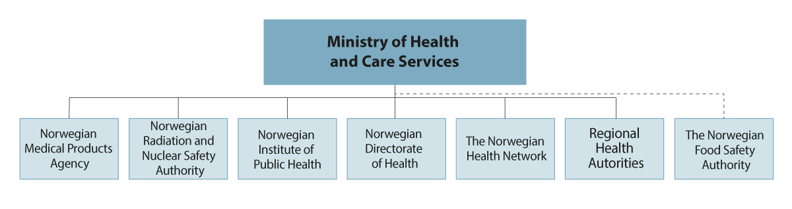
          - The figure shows management and reporting lines between the Ministry of Health and Care Services and central subordinate agencies and enterprises with health emergency preparedness tasks. The Ministry of Agriculture and Food has agency governance responsibility for the Norwegian Food Safety Authority.
Source: Ministry of Health and Care Services.
The national health emergency preparedness plan provides a comprehensive account of the organisation of health emergency preparedness, including the tasks and responsibilities of various agencies and enterprises. The national health emergency preparedness plan will be revised following the Storting’s consideration of this Report.

New health emergency preparedness model
Experiences from the pandemic, and increasingly complex and demanding risk and threats, necessitate changes to the organisation of health emergency preparedness. Well-functioning health emergency preparedness and crisis management require unambiguous and clarified lines of responsibility and reporting. As a rule, general responsibilities will form the basis for responsibilities during a crisis. The organisation of activities and responsibilities during crises should be as similar as possible to everyday organisation.
              - Requirements for the government ministries’ work on civil protection
Activities related to civil protection shall be based on systematic risk management. Each ministry is therefore required to document that it:
1. Clarifies and describes key roles and areas of responsibility for civil protection efforts within its own ministry and sector.
2. Prepares and maintains systematic risk and vulnerability analyses based on assessments of intended and unintended events that may threaten the ministry’s and sector’s ability to function and put lives, health and material assets at risk.
3. Implements the necessary compensatory measures to reduce the probability and consequences of undesirable events in the ministry’s own sector.
4. Describes the ability of emergency preparedness measures to reduce the probability of undesirable events, as well as the consequences of such events in the ministry’s own sector.
5. Prepares goals for civil protection activities in the ministry’s own sector.
6. Coordinates its own work on prevention, emergency preparedness and crisis management with other ministries involved.
7. Ensures responsibility for crisis management within its own sector, including as the potential lead ministry, and is able to support crisis management in other ministries, cf. also Ch. VIII. This includes, among other things, the following:
a. Develop and maintain plans for managing undesirable events. As a minimum, the plans shall contain frameworks and conditions for organisation, crisis communication, reporting procedures and coordination with other ministries. Continuity plans and the ministry’s own underlying plan for the civil emergency preparedness system shall also be made available.
b. Targeted exercises in its own sector and across ministries. The ministry shall have an exercise plan which includes the purpose, dates and forms of exercises. The ministry’s management and others in the ministry who have defined tasks in crisis management shall carry out training exercises in their roles.
8. Evaluate incidents and exercises and ensure that findings and lessons learned are followed up through a management-based assessment and action plan. Follow-up after training exercises and incidents cannot be considered complete until all points in the action plan have been satisfactorily followed up.
9. Submit relevant plans, regulatory amendments and any disagreements to the Ministry of Justice and Public Security.
10. Promote knowledge-based work, research and development within the sector.
[Boks slutt]
To ensure better strategic management and coordination in the health sector’s work on security, emergency preparedness and crisis management, the Norwegian Government is establishing a new model for health emergency preparedness work on a daily basis and during crises. This will not alter established systems across sectors. Rather, it shall improve work within the health and care sector. The purpose of the model is to strengthen compliance with the requirements for the government ministries’ work on civil protection as set out in the Civil Protection Instructions, section IV.
The new health emergency preparedness model reflects the Minister of Health and Care Service’s constitutional responsibility. This model will not alter authority and reporting lines. The Ministry of Health and Care Services will lead the sector’s emergency preparedness work through ordinary agency and corporate governance. Through agency governance, the Ministry shall ensure that the authority of subordinate agencies is clearly specified. This will be reflected in a revised version of the national health emergency preparedness plan. The model is based on the emergency preparedness principles. Incidents shall be managed in accordance with the principles of responsibility, proximity, similarity and collaboration. Matters of significance shall be considered by the King in Council, cf. Article 28 of the Norwegian Constitution.
In the health and care sector, there has been a practice of delegating the national coordination of the health sector’s efforts during crises and for implementing the necessary measures at the state level to the Norwegian Directorate of Health. Such delegation has entailed that, during crises, the Directorate has been authorised to coordinate the health sector and carry out tasks it does not have during normalcy. One example of this is the task of coordinating the specialist health service, the governance of which is not the Directorate’s responsibility.
The new health emergency preparedness model replaces the current practice of delegating authority to the Norwegian Directorate of Health. This means that it is the Ministry of Health and Care Services, and not the Norwegian Directorate of Health that shall coordinate the sector’s management of major, sector-wide and cross-sectoral crises. Decisions will be made along the ordinary line according to the principles of responsibility and proximity and based on recommendations from agencies and specialist environments, where relevant.
In the revision of the health emergency preparedness and infection control legislation, the Norwegian Government will assess whether the roles and responsibilities of the various agencies and organisations are clearly and appropriately defined. The pandemic demonstrated, among other things, that the legislation did not sufﬁciently take into consideration events that could develop into long-term national crises.
The new model shall:
- ensure and strengthen the strategic management of security and emergency preparedness on a daily basis and during crises
- clarify leadership
- facilitate increased cooperation within and across sectors
The model involves the establishment of structures that shall support the government ministry, agencies and enterprises in crisis management, as well as in everyday follow-up of risk and vulnerability assessments, the implementation of exercises, and the coordination of planning and other civil protection work. The following shall be established:
- A Health Emergency Preparedness Council
- A Health Emergency Preparedness Secretariat
- An Advisory Expert Committee for Health Crises
- Committees for Prioritised Risk Areas
The Health Emergency Preparedness Council
Over time, the Norwegian Government has assumed a stronger and clearer management of crises, and the Ministry of Health and Care Services has elevated crisis management in the health sector to the ministerial level. Developments towards an increasingly complex society with growing national and international dependencies reinforce the need for stronger political governance. This means that the Ministry, to a greater extent than before, must assume a stronger political and strategic management of health emergency preparedness through greater overall involvement in the day-to-day work.
In order to strengthen the strategic management of security and emergency preparedness work in the health and care sector, the Ministry of Health and Care Services is establishing the Health Emergency Preparedness Council. The Health Emergency Preparedness Council is an emergency preparedness and crisis management tool for the Ministry of Health and Care Services, which will also chair the Council. The Council shall facilitate better safeguarding of cross-sectoral and interdisciplinary perspectives in health emergency preparedness work. The Ministry of Health and Care Services will use the Health Emergency Preparedness Council in its strategic management of security and emergency preparedness work in the health sector on a daily basis and during crises. The establishment of the Health Emergency Preparedness Council will not involve changes to the ordinary crisis management system at the central level, cf. the Civil Protection Instructions. The Ministry of Health and Care Services will continue to ensure coordination with the lead ministry and other ministries.
The Health Emergency Preparedness Council on a daily basis and during crises
On a daily basis, the Ministry of Health and Care Services will use the Health Emergency Preparedness Council in its work to establish systems and frameworks for security and emergency preparedness work in the sector. This particularly involves work on risk and vulnerability assessments, measures to reduce vulnerabilities and to prevent and secure basic assets, crisis scenarios, competence and exercise plans, and follow-up of lessons learned. The Ministry of Health and Care Services will use the Health Emergency Preparedness Council to ensure common planning assumptions and priorities, contribute to cohesive plans for the sector, and clarify roles and responsibilities in the health sector’s work on security, emergency preparedness and crisis management. As needed, and at least once every four years, there shall be a comprehensive risk and vulnerability assessment and emergency preparedness analyses for health emergency preparedness where the various risk areas are viewed in context.
Scenarios shall be prepared on the basis of identified risks and vulnerabilities. Analyses and scenarios are the starting point for assessing current preventive and risk-reducing measures, and for planning the need for handling of residual risks. According to the Civil Protection Instructions, the Ministry of Health and Care Services is responsible for creating a comprehensive analysis for its own sector, and on this basis, assess the revision of common planning requirements for health emergency preparedness. Overall planning assumptions and criteria for acceptable risk will be discussed in the Health Emergency Preparedness Council. Decisions will be made by the Ministry of Health and Care Services or by the Norwegian Government through ordinary decision-making processes and in dialogue with other government ministries. Expectations and requirements that affect multiple sectors, such as pandemics and nuclear emergency preparedness, will be coordinated with other government ministries and reviewed by the Norwegian Government.
The Health Emergency Preparedness Council shall actively use exercises and training to enhance competence and strengthen crisis management skills. The Ministry of Health and Care Services will determine a multi-year, strategic training exercise plan for national health emergency preparedness exercises to ensure predictability, participation and targeting. This training exercise plan shall complement and be coordinated with the exercise plans of other government ministries. The Ministry will ensure the preparation of a targeted competence enhancement for health emergency preparedness in the health and care sector. The purpose of the competence enhancement is to increase competence within the area of health emergency preparedness at the state and municipal levels. Arrangements shall be made for cross-sectoral participation.
All events and exercises shall be evaluated. Lessons learned from events and exercises are important for improving the capacity to manage future events. Evaluation and implementation of lessons learned is an important part of the systematic and comprehensive emergency preparedness work. The Health Emergency Preparedness Council shall ensure that lessons learned have been registered, and that they contribute to the sharing of experiences and learning in each sector and with relevant actors in other sectors.
In crises that affect the sector, the Health Emergency Preparedness Council’s main tasks will, among other things, be to ensure a common understanding of the situation in the health and care sector, and to ensure the rapid and coordinated implementation of measures in its own sector. The Council shall help to clarify the correct decision-making level when needed, identify challenges or bottlenecks, contribute to coordination and joint prioritisation, and ensure the mobilisation and efficient utilisation of resources in the sector. The Council shall discuss strategy and crisis management and assess the need for adjustments along the way by providing advice in ordinary decision-making processes.
Composition and decision-making structure
In addition to the Ministry, the Council’s permanent members shall consist of the heads of the subordinate agencies, which include the Norwegian Directorate of Health, the Norwegian Institute of Public Health, the Norwegian Radiation and Nuclear Safety Authority, the Norwegian Pharmaceuticals Agency (Directorate for Medical Products from 1 January 2024), the Norwegian Food Safety Authority, as well as the Norwegian Health Network and the four state-owned regional health authorities.
Such a structuring is in line with how the Ministry of Health and Care Services in practice coordinated the pandemic management within its own sector at the state level, and how it leads emergency preparedness activities in the health sector related to the war in Ukraine. County governors shall participate in the Council with one representative to ensure that the municipality perspective is taken into account.
The establishment of the Health Emergency Preparedness Council shall ensure clear and predictable coordination in the sector. In addition to the permanent members, the composition of the Health Emergency Preparedness Council shall be flexible based on needs, both in everyday life and during crises. Other agencies, municipalities and organisations may be invited to participate, as needed. It is the responsibility of the various participants in the Health Emergency Preparedness Council to ensure that the municipal perspective is included in the Council’s work.
The Health Emergency Preparedness Council shall facilitate a comprehensive approach across agencies, health authorities and specialist areas in the health sector, and will provide a better overview and utilisation of the overall resources in the sector than the current model.
Relevant decisions shall be made by the responsible authority. In accordance with Article 28 of the Norwegian Constitution, matters of significance are referred to the King in Council. Decisions are made in line with the emergency preparedness principles and management lines during normalcy. Similar to the practices during the pandemic, it is the Ministry of Health and Care Services that makes decisions on nationally determined infection control measures based on the Infection Control Act It shall continue to be the government ministry that brings before the King in Council matters that trigger the government authorisation provisions of the Health Preparedness Act, and then makes decisions on any application of the government authorisation provisions.
Establishment of the Health Emergency Preparedness Council for the health and care sector does not entail changes to the responsibilities of the agencies in the health administration. Participating enterprises shall continue to perform their duties and make decisions in line with their authorities in accordance with legislation and regulations, or as described in relevant plans.
The Health Emergency Preparedness Secretariat
In order to strengthen the work on national coordination and interaction in health emergency preparedness, the Ministry of Health and Care Services will establish a Health Emergency Preparedness Secretariat. The Secretariat shall provide secretariat functions for the Health Emergency Preparedness Council, in addition to secretariat functions for the Advisory Expert Committee for Health Crises, cf. the section on an advisory expert committee. The Secretariat will be operational during normalcy and in crises.
The Ministry shall chair the Secretariat and will have staff seconded from the subordinate agencies. In times of crisis, underlying agencies will also have liaisons in the Secretariat. Having subordinate agencies participate in the Secretariat ensures involvement and coordination and prevents the distance between the Ministry and subordinate agencies from becoming too wide. Relevant ministries may also be invited to participate in the Secretariat in everyday work and during crises. Such participation will contribute to strengthening cross-sectoral cooperation at the ministry level. The Ministry of Health and Care Services, in close cooperation with the lead ministry and other affected ministries, will ensure good coordination between the Health Emergency Preparedness Secretariat, the Crisis Support Unit and other affected actors, depending on the nature of the crisis and the needs that arise.
Six committees at the agency level
There is a need for cooperation and coordination at the agency and health authority levels, both on a daily basis and during crises. The various risk areas that the health and care sector faces will affect different parts of the health administration and health and care services and, to varying extents, agencies in other sectors. In some areas, such as cross-sectoral nuclear and radiological emergency preparedness, civil-military cooperation and the secure supply of safe drinking water, there is a formal responsibility also outside the Minister of Health and Care Services’ constitutional responsibility that must be ensured.
The Ministry of Health and Care Services will establish a committee for the particular risk areas that have been identified for health emergency preparedness within the Minister of Health and Care Services’ constitutional area of responsibility. For some of the risk areas, corresponding committees have already been established, such as the Crisis Committee for Nuclear Preparedness, the Committee for Civil-Military Health Emergency Preparedness Cooperation and the Preparedness Committee for Biological Incidents. The mandate of the Crisis Committee for Nuclear Emergency Preparedness is established by Royal Decree and will be reviewed in consultation with the government ministries concerned, cf. Chapter 4.6. This Committee will therefore not be described in greater detail here. The Ministry of Health and Care Services, in cooperation with the relevant ministries and subordinate agencies, will establish mandates for the other committees that elaborate and specify roles and responsibilities. The relationship with, and delimitation in relation to the coordination mandates of the Ministry of Justice and Public Security and the Norwegian Directorate for Civil Protection, instructions for the county governors’ and the Governor of Svalbard’s work on civil protection, emergency preparedness and crisis management, as well as the Regulations on municipal emergency preparedness duty, shall be taken into consideration in the preparation of the mandate.
Each individual committee will be chaired by the responsible agency, and each agency is responsible for cross-sectoral anchoring. Participating sectors and agencies in the committees shall be reflected in the mandates. Arrangements shall be made for cross-sectoral participation. Municipalities and county governors shall be able to appropriately contribute and participate.
The committees shall facilitate more systematic and coordinated work on analyses, scenarios and planning – both internally in the health administration and across sectors. In addition to management at a strategic level, it will be necessary to ensure meeting places where specific work is carried out on designing scenarios as a basis for preventive security and emergency preparedness planning.
The committees shall contribute to ensuring that different sectors gain a common understanding of risk, and that the different sectors contribute the emergency preparedness analyses and coordinate the various sector plans. Participation in committees implies an expectation for the participating enterprises to coordinate prevention and emergency preparedness. This will facilitate emergency preparedness and coordination efforts by the authorities, various specialised bodies, the voluntary sector and the business sector, as the cooperation enables actors and resources to find one another and jointly solve the tasks. The model shall be flexible and reflect the current vulnerability and risk assessment. This means that the structure and composition of committees can be adjusted as needed.
The establishment of these committees will not entail any changes to the responsibilities of the agencies, nor will it alter the coordination functions that have already been established for national crisis management. The purpose of the committees is to strengthen cooperation and coordination in preventive and operational emergency preparedness efforts. Participating agencies and enterprises shall continue to perform their duties and make decisions in line with their authorities in accordance with legislation and regulations, or as described in relevant plans.
The committees on a daily basis
A key task for the committees on a daily basis will be to contribute to the updating and coordination of the emergency preparedness plans, and to account for the prerequisites for plans that will apply to each risk area. Important tasks will be linked to risk and vulnerability analyses, contributions to the preparation of scenarios, emergency preparedness analyses and joint prerequisites for plans, as well as the implementation of exercises.
Committee leadership shall be determined along ordinary management lines. The Ministry of Health and Care Services will task the affected agencies with establishing committees for the particular risk areas that have been identified for health emergency preparedness. Each responsible agency will report to the Ministry of Health and Care Services. The Health Emergency Preparedness Council will be the arena for coordinating the work in the committees to ensure a common framework as a basis for prerequisites for plans, scenario definitions and emergency preparedness and exercise plans.
The committees during crises
The committees can play a role during crises by contributing to good cross-sectoral assessments of measures and consequences in different sectors, ensuring good resource utilisation across crises, and by contributing to good decision making at the correct level in the responsible sectors in the established coordination mechanisms. The committees can help to systematise the competence and work with socioeconomic assessments and ensure a broader cross-sectoral basis for assessments and priorities in emergency preparedness and crisis management efforts. In the event of a crisis, the committees will be able to function as a coordinating body between the agencies and contribute to the coordination of risk assessments and advice the government ministries. The committees shall support the responsibilities of the individual enterprise to assess the effects of measures beyond their own enterprise and be prepared for the possibility that plans must be made in a crisis situation that take social impact into account.
The committees:
- The Committee for Civil-Military Health Emergency Preparedness Cooperation will build on the current committee, cf. point 4.1. This Committee will continue to be chaired by the Norwegian Directorate of Health, with the Norwegian Armed Forces as permanent deputy chair.
- The Committee for Cyber Security will be a newly established committee chaired by the Norwegian Directorate of Health, cf. section 4.2.
- The Committee for Security of supply of Medical Products will be a further development of the National Pharmaceutical Emergency Preparedness Council, where medical devices must also be ensured, cf. section 4.3. This Committee will be chaired by the Medical Products Agency.
- The Committee for Infection Control builds on and will be a development of the current Emergency Preparedness Committee for Biological Incidents, cf. section 4.4. This Committee will continue to be chaired by the Norwegian Directorate of Health.
- The Committee for safe Water Supply will be a newly established committee led by the Norwegian Food Safety Authority, cf. section 4.5.
- The Crisis Committee for Nuclear Emergency Preparedness chaired by the Norwegian Radiation and Nuclear Safety Authority is continued, cf. the discussion on nuclear emergency preparedness in Chapter 4.6.
Advisory Expert Committee for Health Crises
Interdisciplinary expert assessments that assess strategies and crisis management are crucial in order to achieve comprehensive assessments where broader societal considerations are safeguarded. The responsibility for comprehensive assessments of societal and cross-sectoral consequences rests with the decision-making authority. These assessments often require interdisciplinary competence, including socioeconomic and legal assessments in addition to health-related competence and competence in the area affected by the measure.
The COVID-19 pandemic showed how intrusive measures, in what was initially a health crisis, can have major and adverse consequences for most areas of society. During the pandemic, an Expert Committee was established for socioeconomic assessments of infection control measures to investigate how the adverse economic consequences of current infection control measures could be reduced through better targeting of the measures. The Advisory Expert Committee issued a total of four reports. The Committee’s analyses and reports formed part of the Norwegian Government’s decision-making basis when assessing the introduction of measures, and when selecting between different measures.
To ensure a better knowledge base for managing crises that broadly affect society, and especially where comprehensive interdisciplinary assessments are necessary, the Ministry will establish a mechanism for the establishment of an Advisory Expert Committee for Health Crises.
The Expert Committee will not have continuous tasks in everyday emergency preparedness work but will instead be established as needed in crisis situations. The need to activate the Expert Committee will be assessed by the Ministry of Health and Care Services in consultation with the Health Emergency Preparedness Council, the lead ministry and other affected ministries, potentially upon clarification by the Norwegian Government. The composition of, and the reporting lines to one or more expert committees will be determined by the affected ministries and, if necessary, by the Norwegian Government. The Ministry assumes that activation of the Expert Committee will be relevant in the management of national infection control incidents, but also for other extraordinary incidents of a certain scope and duration.
The Expert Committee has been included in the model for health emergency preparedness. This mechanism shall be linked with the overall work on civil protection for which the Ministry of Justice and Public Security is constitutionally responsible. There must be flexibility to ensure that composition and reporting procedures are in accordance with the overall civil preparedness efforts.
Appointment of the Expert Committee, including which areas of expertise will be represented, will depend on the specific crisis that has arisen. The Ministry of Health and Care Services will use the Health Emergency Preparedness Secretariat to facilitate a rapid establishment of the Expert Committee. Competence that may be important to the Committee includes medical, health economic, socioeconomic, legal and ethical competence. In its work, the Expert Committee should also obtain assessments from county governors, municipalities, the Norwegian Association of Local and Regional Authorities (KS), specialist health services, non-profit actors, voluntary organisations and the business sector, which can describe how the crisis affects various sectors and assess the consequences of relevant measures.
The Expert Committee will ensure greater access to knowledge resources and contribute to a broader knowledge base in crises, including socioeconomic assessments of current infection control and emergency preparedness measures. The Expert Committee will be useful for highlighting uncertainty and disagreements related to various measures.
The main tasks of the Expert Committee in crisis management are as follows:
- Investigate and perform comprehensive assessments for a broader knowledge base for the strategy and management of crises that fall within the Minister of Health and Care Services’ constitutional area of responsibility.
- Maintain contact with knowledge environments to draw on broader competence and greater resources for analyses.
- Conduct socioeconomic analyses of infection control and emergency preparedness measures and investigate how adverse consequences of measures can be reduced through better targeting of the measures.
- If necessary, set up specific thematic groups to cover the key needs for knowledge (for example, modelling groups).

Municipalities and county governors
The municipalities’ work on emergency preparedness and protection against health threats
Strong municipal health and care services are the basis for sound health emergency preparedness and therefore crucial in reducing the adverse consequences of such crises. The municipalities are responsible for protecting their residents against health threats, and ensuring that municipal residents are offered the necessary health and care services, including in crises.
Common planning assumptions that form the basis for comprehensive health emergency preparedness also apply to the municipal sector. According to the Health Preparedness Act, municipalities are responsible for developing emergency preparedness plans for health and care services and tasks covered by the Public Health Act’s provision on environmental health care. In the upcoming revision of the Health Emergency Act and the Infection Control Act, the rules relating to requirements for emergency preparedness plans will also be considered. The Regulations relating to health emergency preparedness stipulate that actors’ emergency preparedness plans shall be based on assumptions for planning issued by the Ministry of Health and Care Services. The Norwegian Government will facilitate specialist support for the municipalities’ work on health emergency preparedness and ensure that municipal perspectives are taken into consideration in the development and determination of common planning assumptions. The committees shall facilitate that the municipalities’ experiences and perspectives are included in the work on risk areas, cf. the discussion on committees at the agency level in section 2.2.1.
In order to facilitate common frameworks and an understanding of any national measures in the event of a health crisis, the Minister of Health and Care Services will arrange regular dialogue meetings with county governors and the municipalities on the status of the health emergency preparedness work. This dialogue is intended to build a foundation for cooperation during crises that affect health.
Health emergency preparedness in Norway has an advantage in that much of the responsibilities, competence and means are at the municipal level. Knowledge of local conditions provides a more targeted and adjusted management of incidents and crises close to those who are affected, as well as the opportunity for flexibility and adaptability in the response. During the COVID-19 pandemic, the municipalities exerted an exceptional ability to mobilise resources for, among other things, contact tracing, vaccination and adjustment of activities and services to limit infection and safeguard residents. In the development of health emergency preparedness, it is important to ensure the role of the municipalities.
              - Municipal chief medical officers were crucial in the management of the pandemic
During the COVID-19 pandemic, initiatives were adopted both nationally and locally by the country’s municipalities. Municipal chief medical officers had a key role in communicating and implementing national measures in the municipalities, and in assessing, recommending and following up local measures. Both local knowledge and community medicine competence were utilised in this effort.
Part 2 of the Coronavirus Commission’s report emphasised the decisive role that municipal chief medical officers had in managing the pandemic.
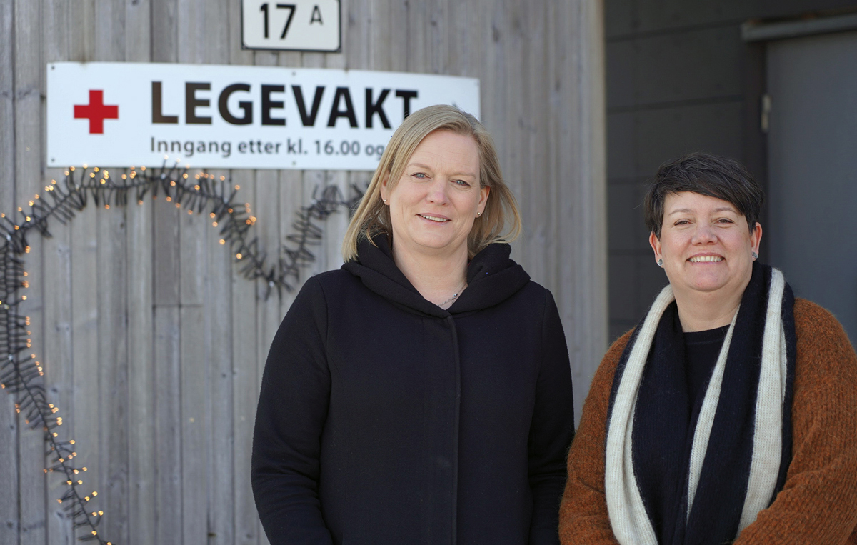
          - The photo shows the Municipal Chief Medical Officer of Frøya Municipality together with the Head of Municipal Affairs for Health.
Photo: Bjørn Lønnum Andreassen, Frøya.no.
[Boks slutt]
The municipalities require sufficient community medical competence, as well as additional competence on infection control, environmental health protection and radiation protection, in order to protect residents against health threats. Capacity and competence for planning and management are also required. There is considerable variation in the size of municipalities in Norway. It can be challenging for individual municipalities to ensure sufficient capacity and competence to prevent and manage health threats.
The situation of the municipalities and municipal chief medical officers was separately assessed by the Coronavirus Commission in part 2 of their report. In their Public Health Report, the Government announced that it will considered how the municipalities’ community medical responsibilities can be ensured through inter-municipal solutions, as well as measures to strengthen the community medical expertise of municipal chief medical officers. In accordance with the recommendations from the Coronavirus Commission, the Norwegian Government will clarify the capacity, availability and tasks related to the municipal chief medical officer’s role. There must be plans for continuous staffing and for scaling up community medicine capacity for events that require greater resources over time. The Ministry of Health and Care Services has ordered the Norwegian Directorate of Health to develop a national guide for the community medicine tasks of the municipalities and for the tasks and role of the municipal chief medical officer. This will also apply in the event of other threats to life and health. This guide will contribute to clarifying the expectations of municipalities in this area.
Municipal infection control efforts require measures that may impact many sectors of a municipality. Infection control and emergency preparedness for other health threats shall be better integrated into the municipality’s cross-sectoral public health work and emergency preparedness than it is today. Among other things, the need for amendments to relevant legislation including the Health Preparedness Act, the Infection Control Act and the Public Health Act will have to be considered.
The municipal chief medical officer’s function is described in more detail in the white paper on Public Health.
The county governor as a link and coordinator in health emergency preparedness
The county governor shall contribute to coordinating, simplifying and streamlining state activities in the county. County governors shall take the initiative for coordination in the county in relation to other state enterprises and other actors where relevant, to ensure that national goals are achieved across levels and sectors, and to ensure the coordination of the state’s governance of the municipalities.
County governors shall contribute to implementing national policies in the area of health emergency preparedness. This involves, among other things, informing municipalities and other actors of what regional planning prerequisites that have been established, which set the premises for municipal health emergency preparedness. Furthermore, county governors shall provide the municipalities with professional support and contribute to ensuring that the municipal sector and central authorities are coordinated in the work on protection against health threats and crisis management.
The pandemic highlighted the central role of county governors as a link between central authorities and the municipal sector. This applied to the collection and coordination of information on the management and challenges of the pandemic in the municipalities, as well as the dissemination of information from central authorities on implemented measures and the coordination between the county’s municipalities. In the work on health emergency preparedness, the Norwegian Government believes it is important to strengthen and further develop the county governor’s role as an initiator and link between the state and municipality. This shall be done by including a representative among the county governors in the Health Emergency Preparedness Council. Furthermore, an annual health emergency preparedness meeting will be arranged between the Ministry of Health and Care Services and the county governors, which is intended as an arena for the mutual exchange of information.
County governors are assigned a coordinating role between state authorities and the municipal sector in health emergency preparedness efforts. It will therefore be essential for them to understand and familiarise themselves with the municipalities’ situations, challenges and needs. Furthermore, all participants in the Health Emergency Preparedness Council shall ensure that the municipal perspective is included in their work. As a coordinating body in the emergency preparedness efforts, it is essential that county governors ensure that the flow of information and involvement is of such a nature that it is perceived as mutual. It is emphasised that county governors have a particular responsibility to ensure that the challenges faced by municipalities reach the central authorities, including the different perspectives emanating from the diversity of municipalities in Norway.

Strengthening our knowledge and knowledge-based management during crises
Good emergency preparedness requires strong professional environments and effective systems for monitoring, analyses and risk assessments as a basis for scenarios, planning work, crisis management and learning. In its first report, the Coronavirus Commission described the need to strengthen health emergency preparedness through improved infrastructure for sharing information and better capacity for monitoring and knowledge production. Insufficient information flow between digital solutions during the pandemic contributed to additional work, inefficient processes and manual processing. The Holden IV Committee also highlighted the need for quick and precise information as a basis for crisis management.
The Norwegian Government is working to establish an effective knowledge system with a focus on structures that are used in everyday life, and that are flexible and can be scaled up in a crisis. This includes comprehensive and efficient systems for collecting data, such as registers, population surveys, measuring equipment, laboratories, national common components and international reporting systems, etc. This also applies to technological systems for the linking and delivery of data, such as common platforms, standards etc. Legal clarifications of what can be linked, both in everyday life and during crises, are essential. Increased digitalisation and automation, as well as the use of previously collected data in various registries and databases, will improve monitoring and reduce the need for manual processes.
Knowledge during crisis management
Another important lesson from the pandemic was the significance of a flexible and quick response adapted to changes in the situation. This offers a better opportunity to maintain control of the crisis, thereby minimising adverse societal impacts. If we had lost control of infection rates, more extensive measures would be required until control was regained. Measures to contain a crisis must be proportionate so that the adverse consequences of the measures are not greater than the consequences of the crisis, in addition to the fact that it must be practical and feasible in terms of resources to implement the measures. This requires a continuous assessment of the crisis, knowledge of effective measures and knowledge of the consequences. At the same time, it is important to be able to implement the measures in time if the situation is very uncertain. Late, imprecise or exceedingly comprehensive measures could have substantial human and societal costs.
              - Inadequate knowledge about measures
Many studies have been conducted to assess the effects of the individual infection control measures. However, such studies are difficult to carry out and often have several limitations and methodological weaknesses, partly because measures are often introduced as complex packages of measures, and not sequentially. The knowledge base for the effects of the individual infection control measures therefore remains limited, which makes it difficult to draw strong conclusions about the effects of infection control or socioeconomic consequences.
Implementing measures in crises in a manner that simultaneously provides knowledge of the effects of the measures requires planning and facilitation before the crisis occurs.
Norway has established a knowledge environment at the Norwegian Institute of Public Health which will contribute towards improving knowledge about each individual measure. The goal is to avoid the future implementation of measures that have a limited infection control effect, as well as major adverse consequences for the population or individuals. During the period 2022–2024, Norway is funding work by the World Health Organization that will contribute to greater knowledge of the effects of the various social measures.
[Boks slutt]
Inter-ministerial review of legislation and infrastructure
The Norwegian Government has formalised and strengthened the inter-ministerial work to assess (i) legal and ethical issues related to the collection, accessibility, sharing and use of data during crises, and (ii) effective and secure infrastructure for access to, and the sharing and use of relevant statistics and data during crises. Two expert groups have been established to investigate each of the two topics.
The expert group that assessed legal and ethical issues relating to the collection, accessibility and use of data proposed several measures to remove obstacles in the legislation. These proposals include, among other things, amendments to the Health Preparedness Act relating to the use of emergency registries, and amendments to the Health Research Act to exempt pure register studies from requirements for approval by the Regional Committees for Medical and Health Research Ethics. Furthermore, it is proposed to give the Regional Committees for Medical and Health Research Ethics the opportunity to grant exemptions from the requirement for consent from research participants if there is no risk of harm, as well as changes to the Health Register Act to ensure that health registers can always be used for research and statistical purposes if the other conditions of the Act have been met.
The Health Research Act has largely remained unchanged since it entered into force in 2009. Based on the recommendations by the expert group, and on medical, technological and organisational changes in general, the Norwegian Government will begin the work of reviewing the Health Research Act and other legislation that governs health research. Several of the expert group’s proposals will also be considered in the Ministry’s ongoing work on the revision of legislation on health emergency preparedness and infection control.
The expert group that has assessed effective and secure infrastructure for the sharing and use of data during crises emphasises that there are already objectives in place for making public data available through the sound management of metadata, the development and use of common services for easier sharing of data, and the reuse of data so that the same data would not have to be collected multiple times. The Norwegian Government will therefore monitor compliance with the expectation that the parties concerned get their house in order.
In times of crisis, the need for updated knowledge is far greater than in normal situations. Knowledge production requires data, analytical capacity, qualified personnel and strong professional environments. Lack of available competence can be critical in a crisis. The Norwegian Government will facilitate easier access to competence and knowledge in a crisis situation by integrating the acquisition of knowledge and data processing to a greater extent in the health emergency preparedness plans.
Norway has good infection control competence, including at the Norwegian Institute of Public Health and the specialist health service. At the same time, there are varying levels of competence relating to infection control in the health and care services as a whole and in the municipalities. This vulnerability can be critical in a crisis. The Norwegian Government will work to facilitate good professional environments in the area of community medicine, including infection control, in municipalities. Any development of infection control competence in the health and care services will be assessed as part of the work to develop an action plan for better infection control. Both the health and care services and municipalities rely on a close dialogue with central authorities for professional advice in crises, which are often characterised by considerable uncertainty.
The Research Council of Norway has been asked to investigate a possible framework for how analysis capacity and infrastructure can be quickly scaled up in a crisis. This investigation will include assessments of scale-up opportunities should there be a need for greater capacity in the government ministries, in subordinate agencies and enterprises, announcements of assignments, and access to research and data infrastructure. The Research Council will present the results of the work in a report in the autumn of 2023.
The Health Preparedness Act authorises the Norwegian Institute of Public Health, the Norwegian Directorate of Health and the Norwegian Radiation and Nuclear Safety Authority to establish emergency preparedness registers containing health data to manage emergency preparedness situations. This authorisation was used during the COVID-19 pandemic to establish the Emergency preparedness registry for COVID-19 (Beredt C19), which was crucial for the ongoing monitoring of the pandemic and as a basis for analyses to gain more knowledge of the management of the pandemic. Experiences from Beredt C19 have been key to both expert groups.
Based on the expert group reports and other ongoing work in the government ministries, the following four areas have been identified for further work:
- Knowledge preparedness must be more clearly specified in Norwegian emergency preparedness efforts.
- The government ministries should encourage better evaluations, including better facilitation of randomised trials and other quasi-experimental methods.
- Rapid access to and proper use of data.
- The data flow between the administrative levels and between the municipalities should be improved.
International data sharing and analyses
Part 2 of the Coronavirus Commission’s report noted that there is considerable potential in strengthening international cooperation for monitoring, analysis and reporting of cross-border health threats. Norway must share data and knowledge internationally in order to contribute to global monitoring and knowledge production. This entails a need to participate in international projects and networks, and to develop infrastructures and legislation that support the sharing of analyses and data. Such cooperation shall be expanded, strengthened and systematised, and the reports shall be included in the analysis of the Health Emergency Preparedness Council.
The World Health Organization (WHO) strongly emphasises the need for countries to have good and robust surveillance systems to detect, report on and manage a threat that may impact other countries. Participation in international surveillance networks and warning systems is therefore an important component of health emergency preparedness.
Through the WHO’s International Health Regulation and the EU’s legislation in the area of health emergency preparedness, Norway is obliged to have systems to detect, assess, report and respond to incidents that may impact other countries. Correspondingly, cooperation has been established with the International Atomic Energy Agency (IAEA), NATO and the OECD. Norway also is also a party to the Nordic Public Health Preparedness Agreement which provides a framework for Nordic cooperation and which, among other things, includes the exchange information in crises.
The European Commission has put forward a legislative proposal on the European Health Data Space (EHDS). A European health data space will be crucial for our national efforts to simplify access to data, including in health crises. The regulation will be a basis for secure access to and use of health data, thereby strengthening our health emergency preparedness.

A Resilient Health Emergency Preparedness
The concept of resilience is broad. It involves society’s ability to withstand and manage major events, restore important functions after events have occurred, and if necessary, adapt to changed conditions. The resilience of civil society is crucial in the face of cross-sectoral challenges related to such elements as security of supply, foreign direct investments, digital infrastructure, disinformation and influence operations. These challenges are relevant to society as a whole, but also to the health and care sector.
Resilient health emergency preparedness requires efforts for good public health, robust health and care services and the capacity to adjust and scale up and down, as needed. It is also crucial that national authorities and our public health and care services have the trust of the population. High levels of trust in society and good health and care services were key reasons why Norway was largely successful in its national pandemic management. The Norwegian Government shall continue to work for good public health, good health and care services and minimising inequality in the population. This Report must therefore be viewed in the context of the Norwegian Government’s comprehensive health policy. It includes, among other things, the Public Health Report, which is the Norwegian Government’s strategy to reduce social health differences and ensure good health in the population through cross-sectoral efforts, and the upcoming National Health and Collaboration Plan, which will provide direction for our common health and care services.
Norway shall have a resilient health emergency preparedness, nationwide. Our vast country, with its varying geographical population density, sets the premises for emergency preparedness. The strategic significance of the High North is increasing. The Norwegian Government believes that our health emergency preparedness should take this development into account. Svalbard’s distinctive characteristics make it impractical to structure the health service in the same manner as on the mainland. In 2024, the Norwegian Government will put forward a separate Report to the Storting on Svalbard, which will include a section on health emergency preparedness.

Flexible health and care services
Our common health and care services are key to resilient health emergency preparedness. Norway’s health and care services are its greatest emergency preparedness resource, employing more than 430,000 people. A well-functioning health emergency preparedness system presupposes access to a sufficient number of personnel with the right competence, organisational flexibility, prioritisations and adaptation, good collaboration across service levels, and the opportunity to mobilise reserve personnel. Health and care services shall facilitate good health and care services in all parts of the crisis spectrum, and they are crucial for the overall resilience of our society. In the most extreme scenario, the health and care services shall be able to deal with a war situation. This would require extraordinary efforts and prioritisations in our health and care services.
General emergency preparedness in the health and care services
Health and care services must be able to handle both small and large crises, and they must deliver equal health and care services throughout the country, including in crisis situations. Factors such as the size of the municipality, the demographic development involving an increasing proportion of elderly persons in the population, access to personnel and relevant competence, as well as the centralisation of settlement in Norway, all pose challenges. The health and care services must therefore plan better for this challenge. This includes the need for an increased demand for emergency preparedness in various situations, including the relocation of larger parts of the services in the event of a loss of infrastructure. Emergency preparedness must be given greater attention in both the planning and organisation of enterprises. A well-functioning everyday life is essential for good emergency preparedness during crises, as good emergency preparedness is based on everyday solutions and capacity across the health sector.
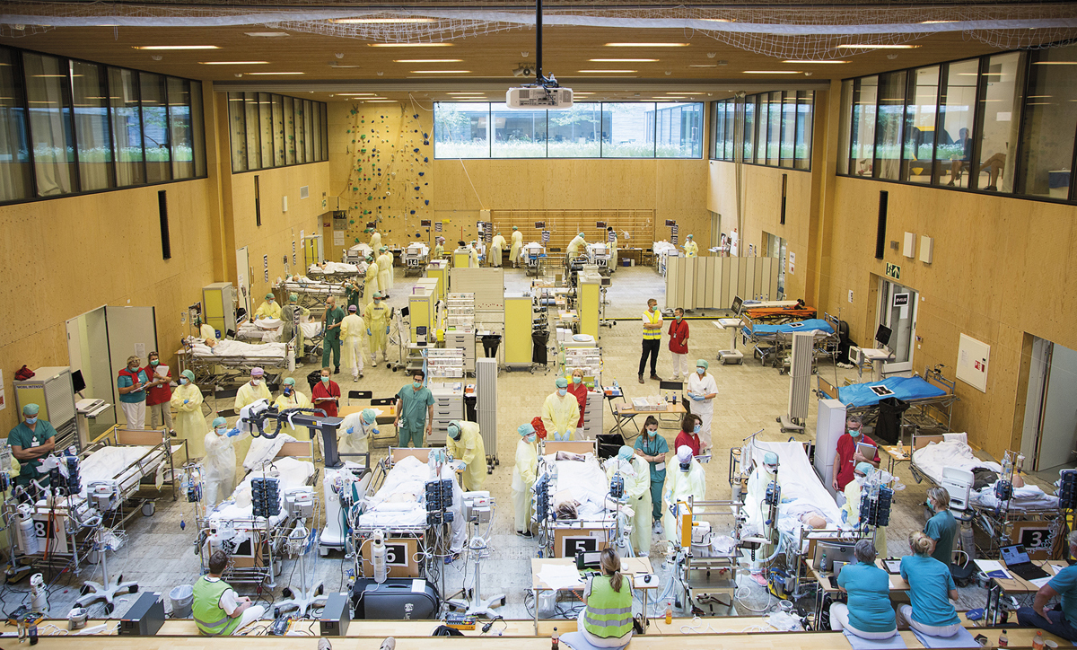
          - In order to successfully manage a crisis, it is important to train for such incidents. This photo was taken at an exercise during the pandemic at Haukeland University Hospital, which has capacity for 100 intensive care patients.
Photo: Bergen Hospital Trust.
Robust municipal health and care services that safeguard core tasks is essential for good health emergency preparedness, and crucial for reducing the consequences of crises. Municipal health and care services must become more resilient. Full-time and permanent positions, the flexible use of personnel, appropriate use of employee competence, well-integrated services in the municipality and good collaboration across service levels must be facilitated. Furthermore, systems to identify and reach out to vulnerable groups in the population are necessary.
The specialist health service consists of four regional health authorities with subordinate hospital trusts and also has agreements and close cooperation with private and non-profit institutions. It is essential for the specialist health service to have emergency preparedness plans in place for various scenarios, and that these are regularly updated. The increased use of simulation and other types of training exercises provide valuable experience and a basis for improvements. Emergency preparedness plans must include systems for flexibility for various scenarios related to, among other things, the need for reallocation and increasing the number of hospital beds, personnel and spaces, flexible use of personnel, competence and spaces, as well as medical countermeasures, home care, and cooperation across health trusts and health authorities.
The emergency medical services are a key component of health emergency preparedness. This relates to the handling of the consequences of acts of terrorism and fighting resulting in mass casualties, burns, medical evacuation – both domestically and abroad, disease outbreaks and pandemics, and incidents involving radioactive and nuclear agents and other chemicals (CBRNE). The health trusts and municipalities are responsible for the emergency medical services. The emergency medical services outside of hospitals consist of a medical emergency reporting service (Emergency Medical Communication Centres and Local Emergency Medical Communication Centres), ambulance services (car, boat and air ambulance services) and municipal emergency assistance services and other 24-hour emergency services. Cooperation with other emergency services, voluntary organisations and the population’s first aid knowledge are also important for overall emergency preparedness.
Norway has excellent emergency medical services. There have been major technical developments in these services and the opportunities for providing advanced treatment are constantly improving as a result of new and improved technology. The Norwegian Government will determine the direction for the future development of these services in a separate Report to the Storting on emergency medical services.
Strengthened collaboration
Collaboration has been challenging, both internally within the individual municipalities and the hospital trusts, between municipalities, between hospital trusts, and between municipalities and hospital trusts. Differences in organisation and funding, as well as differences in tasks and competence all have impact collaboration and cooperation. The Coronavirus Commission notes that cooperation between hospitals and municipalities during the pandemic was of significant value, and that this should be maintained and further developed. Municipalities and hospital trusts have shown that this frequent contact strengthened the cooperative relationships.

          - Together we are strong.
Photo: Getty.
The purpose of the 19 medical communities is as follows: good and sustainable health and care services for patients with major and complex needs and better joint planning. The medical communities shall prioritise planning and developing services for vulnerable groups who are particularly reliant on good collaboration. Better joint planning between municipalities and hospital trusts is essential to ensure that the overall services meet the needs of residents. In emergency preparedness planning and crisis management, both municipalities and the regional health authorities must to a greater extent plan collaboration across levels.
Planning for prioritisation in crises
There is broad political and professional agreement on the national prioritisation principles (benefit, severity and use of resources) that the Storting adopted through the consideration of Report to the Storting No. 34 (2015–2016) Verdier i pasientens helsetjeneste – Melding om prioritering [Values in patient health services – Report on prioritisation] and Report to the Storting No. 38 (2020–2021) Nytte, ressurs og alvorlighet – Prioritering i helse- og omsorgstjenesten [Benefit, resources and severity – Prioritisation in the health and care services]. The Norwegian Government aims to put forward a new report to the Storting on prioritisation.
The right to necessary healthcare is fundamental to the Norwegian health service, and it is expected that health services are equal, nationwide. In a short-term crisis, prioritisations in the health service are made automatically. During long-term crises, this becomes more complicated and more difficult for the health and care services. We must be prepared for situations that may arise where there will be a need to adapt the frameworks for prioritisations to the situation that health and care services are actually in during a crisis. One example is that many elective operations and other treatments during the COVID-19 pandemic were postponed, and patients in need of immediate assistance were prioritised. The health service must plan for such prioritisations. The population must also, to a greater extent, be aware that priorities must be made during a crisis that may affect the provision of health services according to where the country finds itself in the crisis spectrum. Openness about prioritisation and how the authorities and the health service communicate this is crucial for maintaining public trust in a crisis.
Organisational flexibility, adaptation and training exercises
Norway is one of the countries with the highest use of resources in the health and care services in Europe. We have a large share of the employees and are one of the countries that spends the highest share of public funds on these services, relatively speaking. In some countries in the EEA, informal family care remains prevalent, while labour market participation among women is relatively low. In these countries, the provision of public care services is smaller than in Norway. While the use of resources in Norway is high, there has been noticeably greater pressure on access to personnel in the health and care sector in recent years. It is not sustainable to simply hire more staff to manage all the challenges that the health and care services will be facing.
The specialist health service must have established and known plans for the allocation and reallocation of its own personnel, both internally within its own operations, between hospital trusts in the same region, and between the regional health authorities. The regional health authorities have the necessary legal authority to order personnel to perform more specifically assigned work. Highly specialised personnel are a scarce resource. The regional health authorities are responsible for determining how these resources can best be used. Nevertheless, the plans must take into consideration the necessary flexibility and adaptations for the use of available resources, and employees must be informed of these plans.
In principle, the municipal health and care services do not have the same structures for coordinating human resources as the specialist health service. Nevertheless, the municipalities have the opportunity, pursuant to legislation, to reallocate their own personnel within their own operations. Such reallocation, which facilitates flexibility, must be part of the municipal plans, and the employees must be informed of these plans. A municipality can order personnel to perform tasks in a different municipality if the latter requires assistance as a result of accidents or other acute situations that may result in an extraordinary influx of patients. Several municipalities have also entered into agreements on mutual personnel assistance.
Both the specialist health service and the municipal health and care services must engage in regular and systematic training exercises to ensure that personnel develop the competence needed to practice necessary flexibility in emergency preparedness situations. Employers must have an overview of the composition of competence among their employees and facilitate competence measures and training programs that are aimed at such situations. All actors involved must practice and have knowledge of the overall plans, as well as their own roles in such plans. This applies to municipalities, county authorities, county governors and hospital trusts, as well as GPs, contract specialists, and both non-profit and private actors.
Experiences from the pandemic illustrated that the opportunities for flexibility in the legislation were not utilised to the fullest extent. The Coronavirus Commission’s second report provides a good description of the complex reasons for this.
Specialist health services are competence intensive. Necessary flexibility within certain areas that require highly specialised competence requires regular training. Knowledge and competence must be maintained and used correctly. Regular and systematic work is needed to ensure the necessary flexibility. The Norwegian Government expects the plans to be implemented in the specialist health service to facilitate increased organisational flexibility.
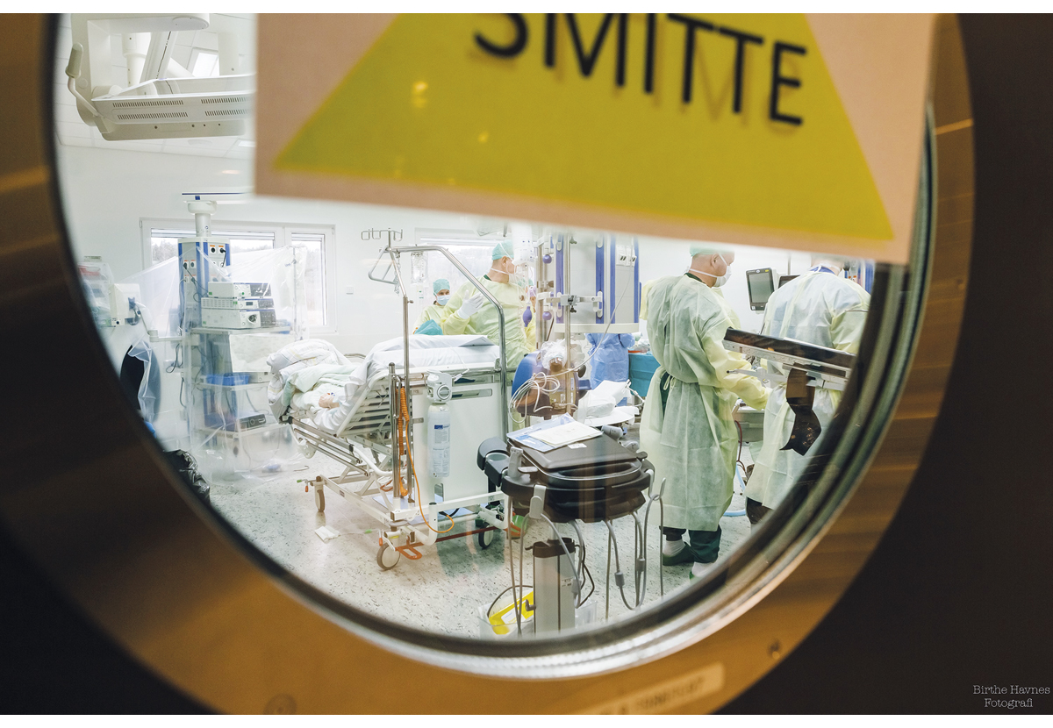
          - An adaptable and flexible health service will increase the capacity to manage future crises.
Photo: Birthe Havnes, Østfold Hospital Trust.
The regional health authorities have been tasked with initiating regionally structured work to promote the correct division of tasks between personnel and a more efficient organisation by assessing and systematising the need for competence in various work processes. They will also work together to establish a suitable arena for sharing experiences from these efforts. The Norwegian National Health and Collaboration Plan will include elements that support the Norwegian Government’s policy for increased flexibility and adaptability.
Intensive-care capacity and intensive care emergency preparedness
The Norwegian Government’s aim is for Norway to have an intensive-care emergency preparedness system that can cope with natural variations, so that hospitals can quickly scale up their capacity during major crises. Intensive care is highly resource intensive, and the need for intensive care beds will vary. Therefore, it is particularly important to ensure flexibility so that the capacity is adapted to the at all times actual need and that it can be rapidly scaled up.
Part two of the Coronavirus Commission’s report recommends increasing the basic capacity in the intensive care and monitoring units somewhat, and that additional intensive care nurses be trained to increase hospital capacity during ordinary operations and to strengthen emergency preparedness. This is supported by the Holden Committee’s fourth report, which recommended that the healthcare system’s capacity to manage a pandemic should be strengthened, but that socioeconomic assessments “…indicate that the isolated benefit of greater permanent capacity during major pandemics and similar crisis situations is clearly less than the costs of establishing a higher permanent capacity. If permanent capacity is to be increased, this must primarily be justified by the fact that it is desirable based on need and cost-benefit assessments in more normal times and because it may be necessary to support the establishment of a variable emergency preparedness capacity”. The Commission further recommends that hospitals use additional personnel groups in intensive care units to a greater extent than today. At the same time, the Commission noted that an increase in the basic capacity of intensive care and monitoring units cannot be considered a substitute for infection control measures in the event of a pandemic as serious and protracted as the COVID-19 pandemic. The regional health authorities have been tasked with following up the Commission’s recommendations and have commenced this work.
The greatest challenge for intensive care capacity has been access to sufficient personnel with the right competence. The Norwegian Government has increased the number of study programme places in the university and university college sector. The same applies to the number of training positions in intensive care units in the health regions. Organisational flexibility, competence-enhancing measures and new training opportunities will contribute to ensuring that more hospital employees can contribute to the work in intensive care units. Increased educational capacity, including more training positions for relevant groups of physicians, will continue to be relevant measures prioritised by the Norwegian Government.
During the pandemic, the manner in which the number of intensive care beds were counted among the hospital trusts varied. There was no consensus on what would constitute an intensive care bed. This led to uncertainty about the number of intensive care beds, and, thus, the actual capacity. In June 2022, a joint report was submitted by the regional health authorities with common definitions of various bed and emergency preparedness categories, which will make it easier to monitor capacity. Intensive care emergency preparedness is a particularly important part of health emergency preparedness. As a basis for assessing the need for further measures, the Norwegian Government will request regular and updated statements of intensive care capacity during both normal operations and in emergency preparedness situations.
Better overview and use of human resources
The need for an overview of the composition of competence, as well as plans for competence enhancement are important elements in the health and care sector’s emergency preparedness work. Plans that have the necessary flexibility require an assessment of competence and an overview of health personnel who can provide services within the frameworks of the health and care sector. A comprehensive overview and an efficient use of resources includes, among other things, cooperation with the municipalities, hospital trusts, GPs and contract specialists. Access to and use of other types of personnel such as dentists and veterinarians should also be included in these plans.
The pandemic highlighted the extensive use of temporary hiring of health personnel in several hospital trusts and municipalities, both in central and rural areas. Temporary hiring of personnel from other Nordic countries was particularly widespread, including temporary-hired personnel with intensive care competence. Emergency preparedness planning that involves the temporary hiring of health personnel represents a significant vulnerability. This particularly applies to the temporary hiring of personnel from abroad, but also within Norway. Full-time and permanent positions in the health and care services should therefore be facilitated. The Norwegian Government will take the initiative for a Nordic cooperation that sets out the principles between the Nordic countries regarding the temporary hiring of health personnel in crises.
The municipalities have rarely involved GPs in the emergency preparedness planning work. GPs have a fairly weak organisational connection to municipal emergency preparedness work. They have central and local agreements that do not sufficiently ensure municipal needs for resources during crises and disasters. Arrangements should be made so that the municipalities can use their GP resources for emergency preparedness work. Agreements should therefore ensure that GPs can be included in the overall municipal plans.
Contract specialists will also be a resource in emergency preparedness. They provide healthcare on behalf of the regional health authorities in accordance with the agreement between the parties. It should be clarified whether the existing framework agreements are sufficient, or whether they should be amended to ensure that these resources can be more easily activated in a crisis.
Physicians and other health personnel who provide privately funded services are, like other health personnel, covered by the provisions of the Health Preparedness Act. However, the threshold for using these groups in emergency preparedness work is probably higher than for contract specialists. Nevertheless, the Ministry of Health and Care Services will assess how this personnel group can be used more effectively in emergency preparedness situations. The same applies to veterinarians and other animal health personnel who are not covered by the provisions of the Health Preparedness Act, but who possess competence that can contribute to strengthening the overall emergency preparedness.
According to the Health Personnel Act, health personnel can delegate certain tasks to other personnel if it is justifiable based on the nature of the task, the personnel’s qualifications and the supervision provided. Those who are assigned such tasks are considered health personnel assistants. Many tasks can be performed by personnel without health-related qualifications, as long as the requirement for responsible conduct is ensured. Assistants will be particularly relevant in municipalities as a means of building sufficient capacity, and must be included in the plans.
Mobilisation of reserve personnel
Reserve personnel include students in health-related study programmes, health personnel who do not work in public health and care services and retired health personnel. Mobilisation of these groups and the use of assistants and voluntary organisations can help ensure access to sufficient and necessary personnel with and without health-related competence. However, experiences from the pandemic indicate that the health and care services should be more predictable and systematic with respect to how reserve personnel can be made available. The Norwegian Government will assess how it facilitates effective mobilisation of human resources and reserve personnel with health-related competence who do not have an employment relationship or other formal connections to the health and care services. The Norwegian Government will design a model that involves the collection and use of information from relevant enterprises, existing registers or other sources to provide an overview of:
- Health personnel who have previously worked in the health and care services, such as pensioners or personnel who now work outside such services.
- Health personnel who have not worked in public health and care services but who have health-related qualifications and experience from abroad or the private sector.
For crisis management, there may also be a need to mobilise more students in health-related studies as reserve personnel for the health and care services, in addition to medicine and pharmacy students who are currently granted student licenses after a certain progression in their studies. During the pandemic, students, pupils and apprentices taking health and social welfare studies were given the opportunity to be granted a student license in their final academic year. During the revision of the Health Preparedness Act, the Norwegian Government will assess whether this should be made a permanent scheme. The scheme offers the benefit of quick utilisation and mobilisation of students, as well as an overview of this labour reserve.
In crises, emphasis should be placed on facilitating the completion of practicums and periods of training to promote study progression and ensure recruitment to the services. During the pandemic, a national hub group was established to coordinate the cooperation between the education sector and the health and care services. During the revision of the Health Preparedness Act, the Norwegian Government will consider whether this should become a permanent scheme that can be implemented in crises.
The design of the pension schemes for the public sector has offered weak incentives to remain in the workforce. Among other things, they have contributed to earlier retirement and weaker financial incentives to accept new employment following retirement. This has diminished the effect of voluntary mobilisation of pensioners for crisis management, and special rules for handling the pandemic were therefore introduced. New pension schemes in the public sector for those born in 1963 or later provide better incentives to continue working longer and the opportunity to combine work and pension without a reduction in pension. However, for groups with special age limits, there are supplementary rules, in accordance with the agreement between the Norwegian Government and public sector parties from August 2023, that contribute to weaker incentives to continue working and where certain pension elements are reduced in relation to earned income, but to a lesser extent than in the old rules. The Storting has recently adopted changes to the pension legislation and at the same time requested the Norwegian Government to, among other things, facilitate good incentives for retired nurses to work in part-time positions in the public sector. The Norwegian Government will follow up on this proposal.
Students who receive loans and grants from the Norwegian State Educational Loan Fund may, through mobilisation, have their grants reduced when their income exceeds the income limits. During the revision of the Health Preparedness Act, the Norwegian Government will assess whether there is a need for more flexible mechanisms for mobilising students and pensioners, so that they can more effectively be made available in future crises.
The Norwegian Government will:
- ensure that emergency preparedness planning in the municipal health and care services and in the specialist health service is, in general, based on personnel who have employment relationships or other contractual connection to the health and care service
- to a greater extent accommodate necessary flexibility, adaptation, reallocation and training for use of available resources in emergency preparedness planning in the health and care service
- ensure a better overview of reserve personnel who can be mobilised for future crises

Trust and competence in the population
In Norway, there is generally a high level of trust in society, including for the authorities. This is of great significance in crises. It increases society’s resilience and capacity for flexibility and adaptation. However, trust cannot be taken for granted. Trust is developed on daily basis through open, knowledge-based and accountable decision-making processes. In order to maintain trust, it is important that decisions are based on fundamental principles such as due process and democracy. Decisions of major societal importance must be rooted in the population and have a clear political basis.
The Defence Commission writes that in order to “safeguard due process, democracy and human rights, we must not initiate measures at the expense of values we are seeking to protect. Therefore, it is necessary to more closely examine measures that promote openness”.
The population’s physical and mental health, knowledge of how to safeguard your own and your family’s health, as well as self-preparedness are also key parts of health emergency preparedness and society’s resilience. Equality and diversity in the population must be taken care of. Complex threats increase the importance of psychosocial resilience. Awareness of influence operations and what influence operations may entail will contribute to reducing the effect of such operations.
Health in the population is unequally distributed. It is important to take this into consideration, especially to safeguard vulnerable groups. Crises affect the mental health of the population. This has not been sufficiently emphasised in emergency preparedness planning and crisis management. Good psychosocial emergency preparedness provides better general emergency preparedness.
Communication in crises
Good crisis communication is essential for the authorities to succeed in crisis management. One element of a crisis is the experience of that the situation is unclear, and uncertainty about what is happening.
During the COVID-19 pandemic, it became evident that fact-based information could be rapidly spread globally with the aid of social media. The term infodemic was used by the World Health Organization to describe the enormous flow of information resulting from the pandemic. However, this also included misinformation, disinformation and conspiracy theories. A 2020 survey by the Norwegian Media Authority indicated that nearly five out of ten Norwegians encountered fake news about the COVID-19 virus during the first week of national comprehensive measures related to the pandemic. Four out of ten came across such fake news on social media. Conspiracy theories and fake news gained a particularly strong foothold during the pandemic in countries where there was generally a low level of trust in the authorities.
The key to good crisis communication is to follow the same principles during crises as in normal situation. According to the Civil Protection Instructions, the Ministry of Justice and Public Security shall facilitate comprehensive and coordinated communication about prevention, emergency preparedness and crisis management between authorities and to the population. This does not alter the requirements placed on each individual government ministry within the relevant area. The Ministry of Justice and Public Security shall annually update a joint plan for how the government ministries will coordinate their crisis communication. The principles of the State’s communication policy are the basis for the communication work within the government ministries and in the subordinate enterprises. These are:
- Openness: The State shall be open, clear and accessible.
- Participation: The State shall consult affected residents and involve them.
- Reaching everyone: The State shall ensure that relevant information reaches all affected parties.
- Active: The State shall actively and in a timely manner inform the public of rights, duties and opportunities.
- Coherency: State communication shall be perceived as uniform and coordinated.
Dialogue with the population shall take place through familiar channels and in familiar ways, such as websites, editor-controlled media and social media. A meta-study by the World Health Organization in 2022 on infodemics emphasised that improving the population’s health literacy and the communication of health matters are the most important countermeasures. Regjeringen.no publishes key information for the population during crises, while helsenorge.no is the health sector’s primary channel for the population in a crisis. It may be necessary for several participants in the health administration to collaborate on the content, for instance by creating joint editorial boards.
Regular press conferences with the Norwegian Government and the leadership of relevant agencies contribute to legitimacy and credibility to decisions. In prolonged crises, regular population surveys should be conducted to monitor whether the authorities’ measures and decisions resonate with the public. Communication must also contain advice on how psychosocial health can be safeguarded if a crisis is serious or expected to be prolonged.
Communication between the authorities and the public must take the diversity of society into consideration. The majority of the population will receive the authorities’ information through live press conferences, from websites and in the media. During the pandemic, it was evident that some information from the authorities did not always reach certain target groups, including immigrants who do not speak Norwegian, even if the information is translated into relevant languages.
In order to communicate information to immigrant groups and vulnerable groups, the authorities must be familiar with arenas and channels for dialogue. This includes plans for how key actors can quickly communicate information to these groups in the event of a crisis. This also applies to the Sámi population. The Norwegian Government will continue or establish new arenas for dialogue with representatives of immigrant groups and vulnerable groups and create channels for communication with these groups. The Norwegian Directorate for Integration and Diversity has produced a guide for how the public sector can communicate information to immigrants. This guide is published on the Directorate’s website.
Protection of vulnerable groups
Special consideration must be given to children and young people when considering measures in the event of a crisis, such as school closures, restrictions on recreational activities, etc. We need more knowledge of how various measures affect children and young people, such as in terms of security, opportunities for contact and learning. When considering measures, there must be particular emphasis on the needs of children and young people, with a focus on the best interests of the child. The participation of children and young people shall also be facilitated.
Monitoring and analysis of data shall ensure that we are able to see how the crisis and measures affect vulnerable groups and health equity. Plans and measures shall consistently be implemented to ensure that vulnerable groups receive special protection. For instance, groups with a higher risk of illness and death shall be protected from additional health risks, at the same time as psychosocial needs and other basic needs are met. Persons with non-communicable diseases such as diabetes, cancer, cardiovascular disease and mental health disorders were impacted by the consequences of reduced health services during the pandemic, as resources were reprioritised. This resulted in many postponed check-ups and treatments, diagnostic and screening delays, as well as fewer preventive activities and rehabilitation services. In sum, this entailed a risk of developing more serious illnesses. A generally good public health improves possibilities to ensure services for those who need them, and it provides better possibilities for health and care services to adapt to managing crises of varying duration.
The number of residents over the age of 70 will increase significantly in the coming decades, and this group will be vulnerable to physical illnesses, loneliness, mental health problems and disorders. To maintain the emergency preparedness resources that a healthy population entails, the Norwegian Government will develop the public health efforts to better support population groups who may be vulnerable terms of mental and physical health. In March 2023, the Norwegian Government presented its Public Health Report, which must be viewed in the context of this report on health emergency preparedness.
Health literacy and self-preparedness
Health literacy is the ability of a person to find, understand, assess and apply healthcare information to make evidence-based decisions concerning their own health. This applies to decisions related to lifestyle choices, measures for preventing illness, coping with illness, and use of health and care services. Health literacy is also important in times of crisis. The population have an individual responsibility to take care of themselves. However, public services must step in when needed. As part of health literacy, the Norwegian Government will contribute to increased knowledge about how the population can strengthen self-preparedness and ensure good mental health.
During a crisis, there may be many people who need help. Health literacy and self-preparedness will ensure that those who need it most will be given help quickly. The five-year national first aid campaign Sammen redder vi liv (Together, we save lives) is a good example of how we can develop health literacy and resilience in the population, while at the same time strengthen our overall emergency preparedness in a tripartite collaboration between the public sector, voluntary organisations and the private sector.
              - The authorities’ recommendations for self-preparedness:
- 9 litres of water per person
- two packs of crispbread per person
- one pack of oatmeal per person
- three tins of canned food or three bags of dry food per person
- three cans of sandwich spreads or jam with a long shelf life per person
- a few bags of dried fruit or nuts, biscuits and chocolate
- any necessary medicines
- wood, gas or kerosene stove for heating
- gas-fuelled grill or cooker
- candles, flashlight with batteries or kerosene lamp
- matches or lighters
- warm clothing, blankets and sleeping bags
- first aid kit
- battery operated DAB radio
- batteries, charged power bank and mobile phone charger for the car
- wet wipes and disinfectants
- kitchen rolls and toilet paper
- some cash
- extra fuel and wood/gas/kerosene/denatured alcohol for heating and cooking
- iodine tablets in the event of a nuclear incident
Source: Retrieved from the Norwegian Directorate for Civil Protection’s brochure with advice on self-preparedness: You are part of Norway’s emergency preparedness.
[Boks slutt]
Psychosocial emergency preparedness
Psychosocial emergency preparedness is about promoting good mental health in the population, and about the ability of the population and the services to attend to psychological and social needs when various crises arise. Examples of events with major psychosocial consequences are the Alexander Kielland accident in 1980, the tsunami disaster in 2004, the terrorist attack on 22 July 2011, the shooting in Oslo in 2022 and the COVID-19 pandemic.
Psychosocial consequences of measures implemented to manage crises shall be taken into consideration when considering measures, to the extent this is possible. Management of the pandemic is an example of fast and effective justified decisions on infection control measures, although the potential psychosocial consequences were not adequately assessed.
Knowledge about the psychosocial consequences of measures is still under development. Updated knowledge must be used as a basis for reviewing plans and emergency preparedness analyses. Measures that will clearly have psychosocial consequences, such as the closure of schools and recreational programmes, bans on visiting nursing homes and other measures that limit people’s opportunities for social interaction must, to the extent possible, be followed by measures to limit adverse consequences in general and for vulnerable groups, in particular.
Individuals and groups who are directly affected by a crisis, such as the injured and their family members, shall be ensured follow-up in order to manage the acute phase, maintain social functioning and help reduce adverse responses and symptoms. The aim is to manage the crisis situation itself, prevent future health problems and/or social problems, and contribute to a good quality of life in the long run. Offering support early is essential. Many who are affected by crises will find that their adverse reactions diminish over time. For some, however, these reactions will persist. Diagnostics and treatment of long-term reactions and disorders will usually be managed by the ordinary health service. Psychosocial crisis teams have an important role in identifying those who need help and ensuring that they are referred for appropriate care. Experiences from major crisis events indicate that the capacity of the health service to attend to the population’s need for psychosocial support can quickly be exceeded. In the escalation plan for mental health, the Government states that it will support municipalities in their work on psychosocial preparedness and follow-up. This includes establishing a framework agreement for psychosocial assistance for municipal health and care services.
Emergency preparedness plans should also include a clear plan for the psychosocial care of helpers. Both professional actors such as the police, fire services, the Norwegian Armed Forces and health and care services, as well as voluntary helpers may require and should be offered the necessary care. Psychological and social factors shall be included in the planning of various scenarios in all relevant crisis plans and exercises.
The Norwegian Government will:
- ensure that decision-making processes are open and knowledge-based, and that the consequences of various options are considered
- safeguard vulnerable groups such as children and young people in the work on health emergency preparedness

Civil society and volunteering – an important emergency preparedness resource
The Total Preparedness Commission highlights the role of civil society and volunteers in emergency preparedness work as a cornerstone of Norwegian society. In Norway, voluntary organisations have longstanding traditions of providing various social functions. Voluntary organisations participate in activities such as search and rescue, assisting the health and care services with transport and communication, and relieving the health service. Voluntary organisations also play an important role in providing care through contact with vulnerable groups, creating social arenas in crises and reaching out with information and measures to groups that are more difficult to reach, including certain minorities. The 22 July Commission writes as follows:
              - Cooperation on infection control
Bergen Hospital Trust and the Norwegian Red Cross held courses in infection control during the COVID-19 pandemic. This resulted in Bergen Hospital Trust, after just two weeks, having 200 volunteers and seven crew vehicles from the Norwegian Red Cross available in the health authority region to assist with the transport of patients with a suspected or confirmed case of COVID-19. Several taxi companies received similar infection control training, so that they could also assist with patient transport. Furthermore, voluntary organisations such as the Norwegian Red Cross and Norwegian People’s Aid assisted several hospitals with emergency ambulances for patient transport and provided additional personnel. The Norwegian Women’s Public Health Association sewed masks, infection isolation gowns and other personal protective equipment.
[Boks slutt]
Community volunteer efforts, such as what we experienced on 22 July, will therefore be an essential resource also in later crisis situations. The professional system must be aware of this resource, value it and use it in the best possible manner. […] the emergency preparedness plans should include how volunteer efforts can best be used in a disaster situation.
The Commission emphasises the need for coordinated efforts between various authorities and voluntary organisations in emergency situations. The Coronavirus Commission’s investigation nine years later found that there was no emergency preparedness or plan in place for how the municipalities were to use various parts of the voluntary sector in an emergency situation. The Coronavirus Commission writes: “[.] a lot seems to have happened randomly and has been based on fairly random personal relationships”. The Commission believes there is a need for a review of the interface between the public administration and the voluntary sector at all administrative levels.
The Norwegian Government will facilitate a better integration of the voluntary sector in the health emergency preparedness system through regulations, in agreements, in plans and exercises. This means, among other things, that municipalities, regional health authorities, hospital trusts and the national health administration have considered volunteers as a resource for health emergency preparedness, that volunteer personnel must receive follow-up when needed, and that consequences for volunteers must be considered when assessing measures. The Norwegian Government will ensure closer dialogue with voluntary organisations through the establishment of an annual dialogue meeting between the Ministry of Health and Care Services and voluntary organisations. The committees in the new health emergency preparedness model shall have a mandate to ensure contact and cooperation with voluntary organisations, where relevant.
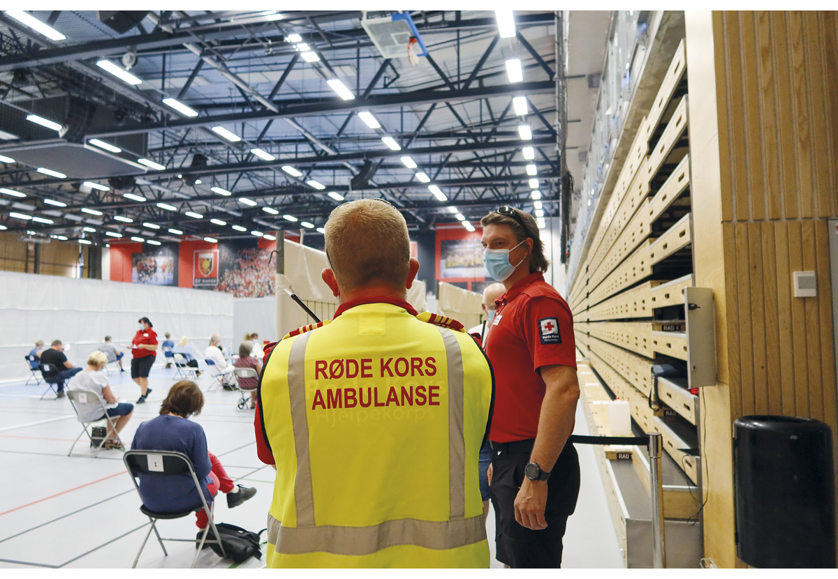
          - Volunteering is an important emergency preparedness resource.
Photo: Id Skrivarhaug, Norwegian Red Cross.
At the same time, volunteering is first and foremost voluntary. Cooperation must therefore be based on reciprocity and trust. The public sector has strong executive powers during crises, but a clear distinction must be made between circumstances where the public sector exercises its authority and where it is a cooperative effort. Volunteering is often led by individuals or groups who are committed to a cause. This is a strength, but also a vulnerability in terms of continuity. Public emergency preparedness cannot rely too heavily on voluntary efforts in its key functions. A number of key tasks can be performed by voluntary organisations, including dialogue with minorities. Nevertheless, public bodies with formal responsibility must have the competence and capacity to assist voluntary organisations or be able to take over the tasks. Volunteering is an important supplement to public health emergency preparedness.
During the pandemic, many volunteers were themselves adversely affected by the measures. Many of the social arenas provided by volunteers were impacted, and the social benefits provided by the volunteers were thereby diminished. Nevertheless, voluntary organisations contributed to innovative thinking and played a key role in establishing measures that helped reduce the adverse consequences for vulnerable groups of the infection control measures. Integrating volunteers into planning and crisis management can prevent certain adverse consequences and reinforce the positive consequences for volunteers and society. Among other things, voluntary work and the consequences of the loss thereof must be considered when designing and implementing measures during crises.
Close involvement in a health crisis can be challenging, and there are varying degrees of professional follow-up by organisations and individuals who participate. Studies show that those who volunteered during and after the terrorist attacks on 22 July 2011 were more vulnerable to long-term effects than the healthcare workers. Such aspects must be taken into consideration in emergency preparedness planning.
The Norwegian Government will:
- facilitate better integration of the voluntary sector into health emergency preparedness, through regulations, agreements, plans and exercises
- ensure a closer dialogue with voluntary organisations through an annual dialogue meeting between the Ministry of Health and Care Services and voluntary organisations
- ensure that the committees in the new health emergency preparedness model maintain contact and cooperation with voluntary organisations, where relevant

Cooperation and dialogue with the private sector
Crises affect society as a whole and are best resolved through joint efforts. It is society’s ability to bring people together that determines how well we will manage a crisis and how much it impacts us. Through good cooperation, the public sector and the private sector can contribute to a successful and robust health emergency preparedness. Our common health service will be a sector that is prepared in the face of crises and disasters. The private sector also plays an important role in its contributions to emergency preparedness.
The efficient mobilisation of the private sector in a crisis requires established cooperative relationships. As part of the health emergency preparedness system, the Norwegian Government will facilitate strategic interaction and dialogue with the private sector and emergency preparedness actors. A shared understanding of the situation is important to ensure good cooperation. In connection with the Norwegian Government’s work on a new strategy and emergency preparedness plan for managing the COVID-19 pandemic in the spring of 2022, sectors impacted by infection control measures, including external actors, were asked to provide further comments on the design of infection control measures. The various actors have the knowledge and experience to assess opportunities and propose the design of measures, which can then be assessed by the infection control environment and the authorities. The Coronavirus Commission noted that “their main impression was that the work to adjust the strategy [the spring of 2022] was more systematic and more similar to anchoring and consultation processes that are carried out in a normal situation”. The mandate of the committees in the new health emergency preparedness model will be to ensure contact and cooperation with relevant parts of the private sector in relevant risk areas, as needed.
A robust and flexible healthcare industry
According to figures from Menon Economics, the Norwegian healthcare industry accounted for a total revenue of NOK 65 billion in 2021 (not included the distribution link), of which approx. NOK 22 billion were export revenue.
A competitive private sector can have positive ripple effects on emergency preparedness and form part of society’s resilience in a crisis. This concerns the efficient use of society’s total resources. Adaptation and flexibility in the manufacturing of items such as hand sanitizer and face masks made a good contribution to the management of the pandemic. During the pandemic, a number of solutions and technologies were also adopted, such as video consultations, contact tracing systems, testing equipment and logistics solutions. A competent and adaptable private sector can thereby help meet the needs that arise in a crisis.
In 2023, the Norwegian Government presented its Road map for the healthcare industry. The roadmap presents the breadth of the Norwegian Government’s policy to promote and strengthen the Norwegian healthcare industry. Many aspects of the healthcare industry are characterised by lengthy research and development that requires access to advanced infrastructure and production capacity. Development pathways are strictly regulated, and access to patients and data from public health and care services is often required. This entails a need for good cooperation between the public and private sectors. In its follow-up of the road map for the healthcare industry, the Norwegian Government will establish an arena for strategic dialogue with the healthcare industry. The Norwegian Government’s ambitions with the roadmap can also result in positive ripple effects for health emergency preparedness, including opportunities for the development and manufacturing of pharmaceuticals and medical devices in Norway.
The Norwegian Government will establish a national initiative for pharmaceutical manufacturing and study how the healthcare industry can benefit more from the catapult scheme, including whether a separate catapult centre should be established for the healthcare industry, or whether adaptations or expansions should be made to other centres. The catapult scheme supports multipurpose centres for testing, simulation and piloting of new products and processes. This could contribute to an infrastructure that stimulates Norwegian pharmaceutical and vaccine manufacturing.
European initiatives for increased resilience
In recent years, the EU has placed an increasing emphasis on developing open strategic autonomy. This is about reducing dependencies and vulnerabilities in supply lines in strategically important areas for society and the economy. It has been proposed to implement measures in a number of policy areas to diversify access to raw materials, increase domestic production capacity and ensure a well-functioning internal market for future crises. This work also entails strengthening the European healthcare industry.
Among the measures used to strengthen the EU’s resilience in business areas experiencing market failure was the more active use of Important Projects of Common European Interest (IPCEI) from 2014. IPCEI is an alternative scheme under state aid law, which allows national authorities to provide increased funding for projects that are considered to be of common European interest. IPCEI projects shall be highly ambitious and contribute to achieving strategic EU goals. It is a requirement that the projects involve several countries and create spillover effects throughout the EEA, and that recipients of funding also have private funding for the projects. Such projects have been established in areas such as microelectronics, hydrogen technology and battery technology. In 2022, IPCEI was also launched in the area of health. To date, Norwegian actors are participating in IPCEI hydrogen and microelectronics projects, and a process has been initiated to connect Norwegian projects to the IPCEI cooperation on batteries. The Norwegian Government will monitor the IPCEI scheme for health and will consider Norwegian participation further.
Norway’s participation in EU programmes provides excellent opportunities for cooperation and funding for Norwegian actors, including in the healthcare industry. The EU’s research programme Horizon Europe, the EU’s EU4Health programme and the DIGITAL capacity building program are the most important arenas for the healthcare industry. There is considerable potential for the Norwegian healthcare industry in achieving EU funding in the near future. Horizon Europe’s overarching goals are to increase European industrial competitiveness, boost economic growth and solve major societal challenges. Through EU4Health, the EU funds and facilitates development initiatives, projects and cooperation between countries in Europe. EU4Health has four priority areas: health emergency preparedness, disease prevention, healthcare systems and digitalisation. Cancer is also a priority in all areas. DIGITAL is Europe’s most important tool for developing digital capacity and infrastructure, and ensuring advanced digital skills in six areas: supercomputing, artificial intelligence and data, cybersecurity, advanced digital competence, ensuring the wide use of the technologies, and dedicated commitment to semiconductor manufacturing (European Chips Act).
The Norwegian Government will:
- establish arenas for strategic interaction and dialogue with the private sector for the effective mobilisation of the private sector during crises
- establish an initiative for pharmaceutical production through the Roadmap for the Health Industry

European resilience
Russia’s war of aggression against Ukraine has strengthened the collective unity in Europe. The war has brought together allies and united democracies. The war in Ukraine has had far-reaching consequences for the European security architecture. NATO remains the bedrock of collective security in Europe. At the same time, the war in Ukraine has demonstrated that the EU also plays an important role in a cooperative and robust Europe. Together with NATO and the EU, Norway is developing increased resilience across sectors and from society to individual.
Health cooperation with the EU
Norway cooperates closely with the EU in the health field, and this cooperation is particularly important as a result of our increasingly shared vulnerabilities. The pandemic and the war in Ukraine demonstrate that Norway cannot address these vulnerabilities alone. Strategic autonomy is highlighted as a key measure based on a recognition of the need for greater control over input factors and supply chains.
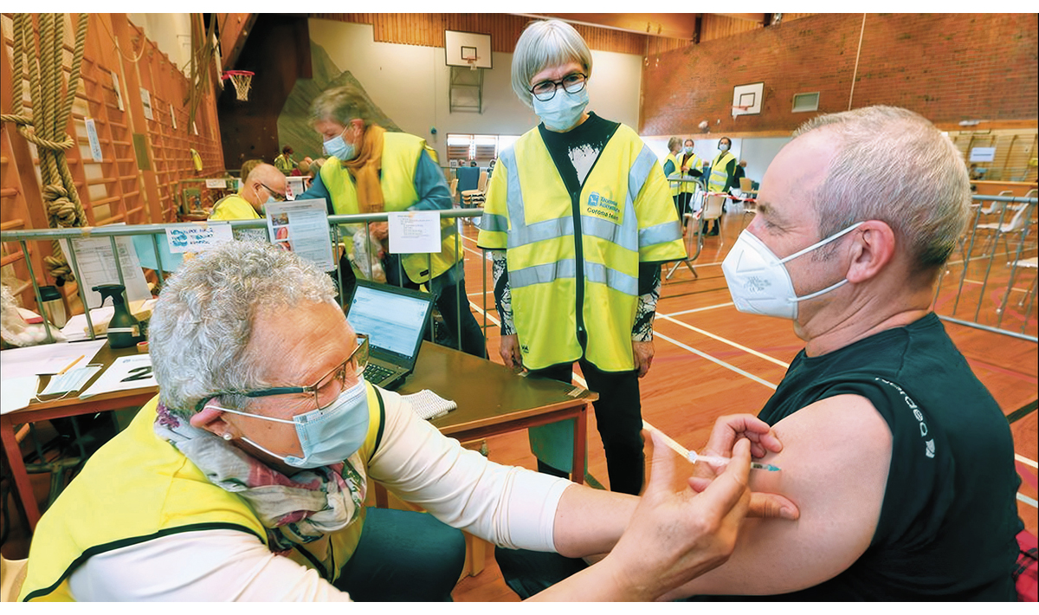
          - Norway vaccinated its population during the COVID-19 pandemic using vaccines procured through the EU.
Photo: Ronald Johansen.
Health emergency preparedness cooperation in the EU has developed at record speed since the COVID-19 pandemic impacted Europe. As early as September 2020, the President of the European Commission launched the ambition of the EU Health Union, which is an enhanced cooperation in the field of health to strengthen health emergency preparedness. In autumn 2021, the Health Emergency Preparedness and Response Authority (HERA) was established. By the end of 2022, four legal acts were in place. These include measures to ensure the supply of medical countermeasures during a crisis. Furthermore, European regulation of cooperation on serious cross-border health threats has been strengthened, and the European Centre for Disease Prevention and Control (ECDC) and the European Medicines Agency (EMA) have been given extended mandates.
For Norway, the COVID-19 pandemic has revealed vulnerabilities in national emergency preparedness that can only be resolved through international cooperation. Norway’s participation in the internal market through the EEA Agreement puts Norway in a special position. At the same time, the EEA Agreement did not provide Norway with access to vaccines and other medical countermeasures. Norway depended on close cooperation with key European countries, and for some time, a tweet from the President of the European Commission was the only written documentation indicating that Norway was included. Sweden’s vaccine negotiator was instrumental in finding a solution that ensured Norway access to the EU’s vaccine procurements. It was not a foregone conclusion that Norway would succeed.
Norway was largely included in the EU’s crisis response. Norway was allowed to participate in the EU Crisis Management Mechanism (IPCR), where EU Member States discussed the COVID-19 pandemic and coordinated measures. Norway also participated in frequent informal meetings of ministers of health. Participation in EU forums was an important source of knowledge for our national management. At the political level, dialogue with Nordic and European ministers of health was also important for national management.
Norway took its share of responsibility and contributed to European solidarity. In April 2020, Norway sent an Emergency Medical Team (EMT) of healthcare professionals to Bergamo, Italy, where the healthcare system was at a breaking point. Norway sent gloves to France when French stockpiles were empty and intensive care medication to Spain and Sweden.
There is no other responsible alternative for Norway than binding cooperation with the EU’s enhanced health emergency preparedness. Therefore, the Norwegian Government is working to participate in EU cooperation on health preparedness and response – on as equal terms as possible to EU Member States. The Norwegian Government is taking this step to ensure a robust and predictable Norwegian health preparedness and response, and to safeguard the Norwegian population.
Health dialogue with the EU and key countries
Systematic and strategic cooperation with key EU actors and selected countries on a day-to-day basis forms the basis for good cooperation in times of crisis. Norway must clearly and at an early stage identify national interests in order to help ensure that EU mechanisms for health emergency preparedness are developed to safeguard Norwegian interests. The Ministry of Health and Care Services prioritises close dialogue with the EU at both political and senior official levels. Furthermore, the Ministry is working to enter into structured cooperation on health emergency preparedness with selected EU countries.
The EU Civil Protection Mechanism
In principle, emergency preparedness and crisis response are part of the internal affairs of EU countries. Nevertheless, developments over time have resulted in the EU receiving a mandate to facilitate enhanced cooperation on emergency preparedness and crisis response. This is primarily done through the EU Civil Protection Mechanism (UCPM).
UCPM is a demand-driven assistance scheme. Countries can request civil assistance, and it is then at the discretion of other countries to offer what available resources they can spare. Both during the pandemic and the war in Ukraine, European countries have shared enormous quantities of medicines, vaccines and medical devices. Under the UCPM, strategic stockpiles for pharmaceuticals and medical devices are being further developed, also for CBRNE incidents in Europe. This does not replace national emergency preparedness, but is intended to function as a reserve. Emergency preparedness is costly, but it is improved and becomes less expensive when resources and expenses are shared.
NATO and Nordic cooperation
NATO is increasingly emphasising resilience, civil protection and civil-military cooperation. This is a prerequisite for the overall emergency preparedness and defence of the individual Allies, and, thus, the Alliance. Allies’ commitment to enhancing their own collective capability and capacity to withstand an armed attack is based on Article 3 of the Washington Treaty. The work is based on fundamental expectations of resilience in critical societal functions (Seven Baseline Requirements). Continuity of government and critical government services, a resilient water supply and the ability to deal with mass casualties are expectations that fall within the health and care sector’s areas of responsibility.
NATO’s increased emphasis on civil-military cooperation and resilience in critical societal functions means that the health sector is to a greater extent integrated into the work of NATO. Active participation in relevant forums is important for safeguarding Norwegian interests in the work on resilience in NATO. The health and care sector will work systematically to meet NATO expectations. Norway has an important role in providing host nation support to Allies in connection with exercises and incidents. Norway has good systems in place for requesting assistance but needs to develop better solutions for host country support.
The increased strategic significance of the High North and the accession of Finland and Sweden to NATO give rise to new needs and opportunities for developing Nordic health emergency preparedness cooperation, including in the civil-military context. Cooperation on enhancing resilience and cooperation on emergency preparedness plans for mass casualties and serious societal crises will be especially important. In March 2022, the Nordic ministers of health adopted a declaration on health preparedness and resilience in the Nordics. The declaration states that the Nordic countries will work together to strengthen Nordic and European health emergency preparedness, resilience and crisis management.
In order to strengthen strategic Nordic cooperation, the Norwegian Government is seeking to further develop the work of the Nordic Group for Public Health Preparedness (the Svalbard Group). One important component will be how the Nordic countries can jointly contribute to good European health emergency preparedness solutions in the EU and NATO. The Norwegian Government will facilitate the preparation of and exercises pertaining to emergency preparedness plans for health emergency preparedness and medical services in cooperation with the Nordic countries and NATO.
The Norwegian Government will:
- work to promote Norway’s association with the EU’s enhanced cooperation on health emergency preparedness on as equal terms as possible to EU Member States
- further develop Nordic cooperation on civil-military health emergency preparedness within the frameworks of NATO and the EU

Global resilience
Norwegian health emergency preparedness does not begin at Norway’s national borders. Even the best prepared societies and the most resilient health system will benefit from the prevention and containment of outbreaks, to avoid them becoming global crises. Generally, the most dangerous pathogens do not arise in Norway, but rather in countries and regions with far weaker health systems, where capacities to detect and contain outbreaks are weaker.
Our health emergency preparedness therefore begins locally, where an outbreak occurs. Weak health systems in other countries and weak systems for international cooperation pose a risk to Norway.
Future Norwegian health emergency preparedness depends on all countries becoming better at avoiding outbreaks, at detecting outbreaks in time and containing them effectively. It is also in Norway’s interests that those outbreaks that are not contained but which become major epidemics or global pandemics, are met by well-functioning multilateral cooperation consisting of strong institutions and effective systems.
Thus, we see that some capacities for health emergency preparedness at the national, regional and global levels benefit all countries. Future global and Norwegian health emergency preparedness should be based on such global public goods.
Evaluations of the response to the COVID-19 pandemic show that these systems are grossly underfunded. For example, the G20 High Level Independent Panel on Financing the Global Commons for Pandemic Preparedness and Response describes a need for annual global investments in global public goods in the amount of USD 15 billion per year over the next five years. The Independent Panel for Pandemic Preparedness and Response notes that although large amounts are needed, failure to make these investments in prevention leaves us vulnerable to crises that are many hundred times more costly.
Traditional health development aid is an important tool for improving health conditions in the recipient countries. But if Norway and the rest of the world are to be better prepared for future crises, targeted and enhanced financing of global public goods for health preparedness is required. Such investments must be based on technical assessments of health needs and supported by dedicated funding.
In the Norwegian Government’s view, there is a clear need for as many countries as possible to invest heavily in health as a global public good. It is particularly important to increase investments in surveillance, warning and research capacity, as well as the development of countermeasures against pandemic threats. There is also a need to ensure appropriate and sustainable investments in organisations that form the backbone of multilateral health cooperation and that benefit all countries, such as the World Health Organization and the Coalition for Epidemic Preparedness Innovations (CEPI).
Countries that allocate too low a share of their national budget to ensure that all their citizens have access to basic health services should primarily increase this share. Through the Sustainable Development Goals, all countries have committed to ensuring basic health services for all by 2030. The world is behind schedule in achieving this goal.
Improved global access to countermeasures and more equal distribution
There are major global inequalities in countries’ abilities to prevent and manage health crises, such as pandemics. All countries have a moral responsibility to contribute to international solidarity and to improve equity. Contributing to a global pandemic response is also in the national interest of all countries.
Balancing national self-interest and international solidarity can be challenging, as shown by global uneven distribution of scarce resources such as vaccines and protective equipment during the COVID-19 pandemic. The cumulative effect of governments individually securing access to scarce resources for their own populations is an unacceptable uneven global distribution.
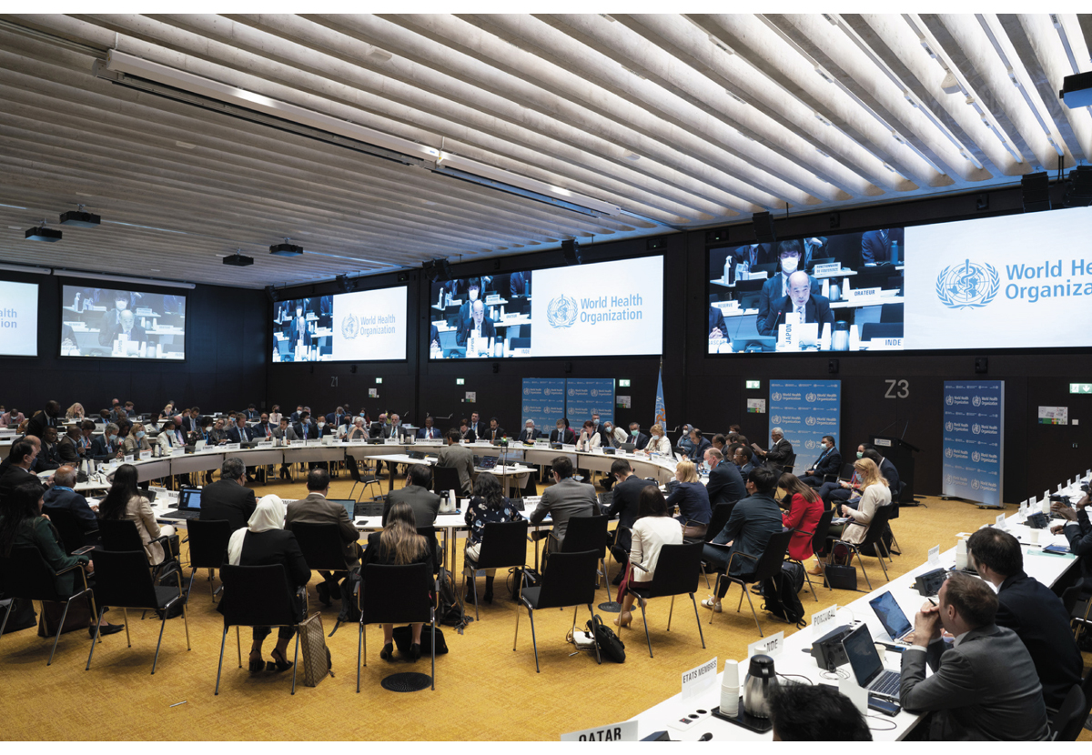
          - Image from a 2022 meeting of the Executive Board of the World Health Organization.
Photo: WHO, Photo Library.
The speed with which safe and effective vaccines against SARS-CoV-2 were developed, was a research and industrial revolution. For the future, we must strive for even shorter development times, even greater and more regionalised production capacity, as well as structures that ensure more equitable access. Immediately available funding is needed when outbreaks occur, as well as a significant strengthening of national health systems. Norway, together with South Africa, took global leadership responsibility for improving access to medical countermeasures during the COVID-19 pandemic, through the Access to COVID-19 Tools-Accelerator (ACT-A) partnership. Norway is therefore well placed to contribute to the further development of global cooperation in this area.
The World Health Organization, International Health Regulations and Pandemic Agreement
When major crises arise, we need predictability based on clear rules and procedures, and a willingness to engage in international cooperation. The World Health Organization, as the UN’s specialised agency for health, is the world’s leading, coordinating and normative agency in international health cooperation. The work to ensure that outbreaks are contained is led internationally by the World Health Organization, and helps prevent many epidemics from spreading to new areas. In order to protect the Norwegian population, it is also important that other countries, including low-income countries, detect and combat epidemics. We need the World Health Organization to strongly lead the global response, provide a well-functioning arena for cooperation between countries, and provide independent technical advice when a crisis occurs. Norway will continue to be a constructive and reliable supporter of the World Health Organization.
Two parallel negotiations have now been initiated at the World Health Organization to strengthen the global regime that regulates management of pandemics. Both are scheduled to be completed by May 2024.
Firstly, countries are revising the International Health Regulations (IHR). The IHRs are a binding international legal agreement which aims to prevent the international spread of disease and ensure internationally coordinated follow-up. The IHRs establish specific rules for cooperation among States Parties and the World Health Organization, and place high and specific demands on the health emergency preparedness systems of the States Parties.
Implementation of the regulations requires major domestic investments for some States Parties. The revision has been initiated due to insufficient compliance with the rules and in order for the text to best support the purpose of the regulations. Norway participates in these negotiations, among other things to help ensure that States Parties detect relevant information about possible events and outbreaks to the greatest extent possible, and are able to assess and report to the World Health Organization as quickly as possible. Norway is also working to ensure that States Parties are given greater opportunities to hold each other accountable.
Furthermore, negotiations have been initiated to develop a new, binding international agreement for the prevention and management of pandemics, which will complement the IHRs. Norway is working to ensure that the treaty, together with the IHRs and future cooperation on medical countermeasures, will contribute to improved equity in countries’ capacities to prevent and respond to pandemics. The treaty should also contribute to a strengthened value chain for the development of and access to medical countermeasures, improved exchange of information on health threats, enhanced cooperation across the human health, animal health and climate sectors, and for the strengthening of health systems.
The Norwegian Government will:
- further develop Norwegian investments in global public goods for health emergency preparedness in the development aid budget and be a driving force for other countries to do the same on the basis of the principle of fair burden-sharing
- work to strengthen multilateral cooperation in the field of health, based around the World Health Organization
- work to strengthen global access to medical countermeasures and achieve a more equitable distribution

Risks and vulnerabilities
The health and care sector is facing changing and more complex risk and threats. Our work on health emergency preparedness must be based on the risks and vulnerabilities we face, so that we are best prepared to address future crises. At the same time, we must have basic emergency preparedness that takes unforeseen events and crises into account. It is particularly important to focus on risk areas involving a high probability and major consequences, as well as risk areas involving a lower probability but major consequences. Six key risk and vulnerability areas are discussed in this Report to the Storting:
- hybrid threats and war
- cybersecurity
- security of supply
- pandemics and infectious diseases
- secure supply of safe drinking water
- nuclear incidents that threaten lives and health
Climate change entails serious consequences. Work on health emergency preparedness must integrate incidents and consequences of climate change. This will apply both to the strategic work of the Health Emergency Preparedness Council and to the committees at the agency level, as well as locally in municipalities and the health service. The Norwegian Government will consider how the national analysis of vulnerability and adaptation needs in the health and care sector as a result of climate-related changes and acute climate events, should be followed up to ensure adequate health emergency preparedness.

Hybrid threats and war
A demanding and more complex security environment
Europe is in the midst of its most serious security situation since the Second World War. Russia’s unlawful invasion of Ukraine marks a watershed moment for Europe and demonstrates the threat that Russia can pose.
The rules-based international order is under attack. Fundamental values and perception of the rules governing international politics are the crux of the conflict between Russia and the West. Democracies and human rights are under pressure in an increasing number of countries. China’s global ambitions are being made clear, and the rivalry between China and the U.S. is growing. China’s development is also increasingly important for Norway. Norway must therefore be aware of China’s increasing ability and capacity to exploit economic instruments for its own gain.
The open society we enjoy is being exploited by threat actors. The instruments used may in isolation be of minor significance, but the total sum challenges Norwegian decision-making processes and our national security interests. Hybrid threats may include instruments such as information gathering, influence operations, the spread of disinformation, cyberattacks, strategic acquisitions of Norwegian enterprises and mapping of critical infrastructure.
The sabotage of the Nord Stream gas pipelines in the Baltic Sea, high levels of mapping activity against critical Norwegian infrastructure and cases of serious insider activity are examples that shed light on the range of challenges we are facing. The health and care sector can be a target for destabilising operations, the purpose of which is to undermine the public’s trust in critical societal functions. The attacks carried out by pro-Russian actors against Norwegian hospitals in January 2023 are an example of this. The attacks posed no real risk to either patients or operations, and this type of operations must be viewed as part of a deliberate and continuous grey zone aggression through influence and propaganda operations. However, these examples show how important it is to protect critical infrastructure.
The intelligence threat against Norway persists. Norwegian emergency response systems will probably be of interest to foreign intelligence services. The intelligence and security services highlight Russia, China, Iran and North Korea as countries that have an interest in conducting intelligence activities in Norway in 2023.
The terrorist threat to Norway is very real. Attacks carried out by individuals with or without links to extremist organisations continue to pose the greatest terrorist threat. The shooting attack in Oslo on 25 June 2022, and the terrorist attacks on the government building complex and Utøya on 22 July 2011, are examples of such attacks in Norway.
Health emergency preparedness – a key component of total defence
Complex instruments, artificial intelligence, technological development and cognitive warfare will influence the threat situation and warfare of the future. Among other things, the Defence Commission points out how it is likely that the distinction between peace, crisis and war will become more blurred in the years to come. This distinction is being challenged by both state and non-state actors. In order to meet the serious security situation, there is a need to strengthen cooperation between the Norwegian Armed Forces and civil society. Total defence constitutes an important framework for this strengthening. Several coordination forums have been established to ensure the cross-sectoral coordination necessary for effective and appropriate development. For example, the Ministry of Justice and Public Security and the Norwegian Directorate for Civil Protection have coordinating tasks related to the further development of Norway’s total defence. The civil-military work of the health and care sector will be viewed in the context of work in the established coordination arenas.
The Defence Commission highlights health emergency preparedness as a vulnerability in total defence and an area that will require particular attention. Measures proposed in the Report to the Storting are a component of strengthening health emergency preparedness and can contribute to a more robust health and care sector with an increased ability to support the Norwegian Armed Forces in war.
Clear procedures for management and governance
The Minister of Health and Care Services is constitutionally responsible for ensuring that health and care services are provided across the crisis spectrum. The Ministry of Health and Care Services will strengthen the strategic governance of civil-military health cooperation. This requires close cooperation with relevant ministries, which includes ensuring coordination in the management of subordinate agencies in areas that affect health emergency preparedness. The Norwegian Government will establish a committee at the agency level for civil-military health emergency preparedness cooperation. This committee will replace the current formalised civil-military cooperation arena. The committee shall be complementary and support the work at the ministerial level, in the Central Total Defence Forum and the Agency Forum for Total Defence.
Although health services have emergency preparedness, training and experience in handling mass casualties, security crises and military conflicts will involve a higher degree of complexity and the rules will differ from those in civilian crises. It may be necessary to subject all health resources in Norway to common national governance for the best possible utilisation and coordination of available resources such as personnel, means of transport, land, pharmaceuticals and equipment. Such an adaptation will include both private and public service providers. The Health Preparedness Act and other health and emergency preparedness legislation contain provisions that provide the necessary powers. At the same time, the Norwegian Armed Forces will play a prominent role in coordinating the necessary resources for national defence or the defence of Alliance members in war.
Currently, civil-military health emergency preparedness cooperation is primarily based on agreements and various cooperation schemes. Furthermore, there is extensive coordination and use of liaisons in the agencies. While the Norwegian Armed Forces’ operational efforts are managed by the Norwegian Armed Forces Joint Headquarters, the health and care sector has several administrative parts and enterprises that are partners of the Norwegian Armed Forces. The Norwegian Directorate of Health is the main administrative focal point for the Norwegian Armed Forces in civil-military cooperation, heads the current formalised civil-military cooperation arena, and administers the cooperation agreement between the health and care sector and the Norwegian Armed Forces. At the same time, cooperation agreements have also been drawn up between the Norwegian Armed Forces and several health authorities. The Norwegian Government will strengthen civil-military cooperation on health emergency preparedness to address mass casualties and war, and will clarify lines of leadership and governance between the Norwegian Armed Forces and the health and care sector.
A unified health service – planning prerequisites and emergency preparedness plans
Health emergency preparedness must be further developed in order to be able to address serious security situations. Health and care services must be coordinated with relevant actors with regard to how the health service is to address the entire crisis spectrum, including war. The starting point is that we have a unified health service in Norway that is responsible for medical evacuation, diagnostics, treatment and rehabilitation including in war and for mass casualties in war. The Norwegian Armed Forces have very limited medical services that are adapted to urgent military needs. It is necessary to look at medical services and the health and care services in context.
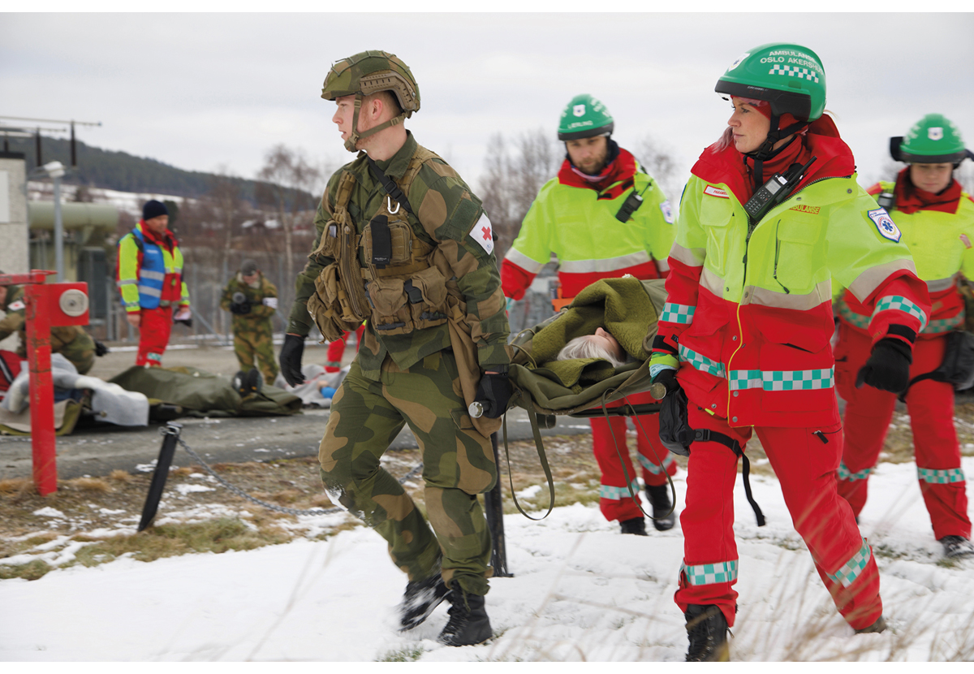
          - Health services and the Norwegian Armed Forces practice the handling of mass casualties during the 2018 National Health Exercise.
Photo: The Norwegian Armed Forces, Ole Sverre Haugli.
A joint risk and vulnerability analysis shall form the basis for the development of scenarios and common planning prerequisites for civil-military health emergency preparedness. This requires unambiguous clarifications of mutual expectations between the Norwegian Armed Forces and the health and care sector. The health and care sector must review what this entails for civilian preparations and preparations coordinated with the defence sector.
A military conflict in which Norway is a warring party will require major restructuring and trigger a need for mobilisation of personnel, competence and resources. A military conflict in which Article 5 is triggered outside of Norwegian territory will also involve the health and care sector. Decisions concerning the control of resources, treatment capacity and prioritisation of patients will be subject to challenging prioritisation assessments in the health and care sector. The Norwegian Government will ensure that the health and care sector develops plans and guidelines for this in cooperation with relevant emergency preparedness actors, and practises interaction in all parts of the crisis spectrum.
              - Pilot project for health emergency preparedness plans and
blood preparedness
Since 2021, the Northern Norway Regional Health Authority has collaborated with the Norwegian Armed Forces in a pilot project that aims to develop operational health emergency preparedness plans coordinated with the Norwegian Armed Forces. The assignment was commissioned by the Ministry of Health and Care Services. In this context, an agreement has been entered into between the Northern Norway Regional Health Authority and the Norwegian Armed Forces on a new model for the allocation of health personnel in peace, crisis, war and international efforts, which entered into force on 1 January 2023. This year, the pilot project has been expanded to all of the regional health authorities, and experiences from the pilot project in Northern Norway are used as a basis for further developing emergency preparedness plans coordinated with the Norwegian Armed Forces in all of the regional health authorities.
The Western Norway Regional Health Authority is working to establish a solution to ensure national security of supply of blood and blood products. The Northern Norway Regional Health Authority is testing solutions to ensure adequate access to blood and blood products locally and regionally (“walking blood banks”).
[Boks slutt]
Healthcare personnel – a limited resource
The Norwegian Armed Forces are dependent on personnel and competence from the health and care services to safeguard functions and their own needs for medical services. Emergency preparedness agreements and mobilisation control are arrangements that ensure the Norwegian Armed Forces health personnel and competence. These personnel work in the health and care services on a daily basis. Health personnel and specialist competence are already a vulnerable resource in the health and care services. It is therefore important to clarify which personnel must be made available to the Norwegian Armed Forces. As part of the pilot project for the development of health emergency preparedness plans, efforts are underway to coordinate the allocation of forces between the regional health authorities and the Norwegian Armed Forces. The general guidelines relating to the use of personnel will be determined by the Norwegian Government.
Real-time information sharing
Shared situational awareness increases our ability to manage crises across the crisis spectrum. Likewise, our ability to handle different events depends on access to information and communication. This requires good and coordinated communication systems between the Norwegian Armed Forces and health and care services, both on a day-to-day basis and in crises. For security reasons, parts of the planning system must be protected, and communication must take place via classified systems. Therefore, it is important that the health and care sector has access to systems for classified communication, personnel with security clearance, and that knowledge and culture in terms of handling classified information are further developed in the sector.
Common capabilities – medical evacuation
In principle, the capacity of the health and care services to carry out medical evacuations is not dimensioned for the handling of mass casualties. Medical evacuation of a large number of casualties over time therefore requires more and different transport solutions than those used in peacetime.
The Norwegian Government is investigating what capacities for medical evacuation Norway will require in the future. In addition to the need for strategic aeromedical evacuation, the Norwegian Government will examine solutions for means of transport by road, rail and sea. The aim is to further develop a generic toolbox where means of transport can quickly be mobilised. One example could be requirements for restructuring transport solutions when entering into agreements with bus companies. The war in Ukraine has shown how repurposed buses can be effective means of transport in an armed conflict. The work is cross-sectoral and involves examining how society’s resources can best be utilised.
              - Medical evacuation from Ukraine
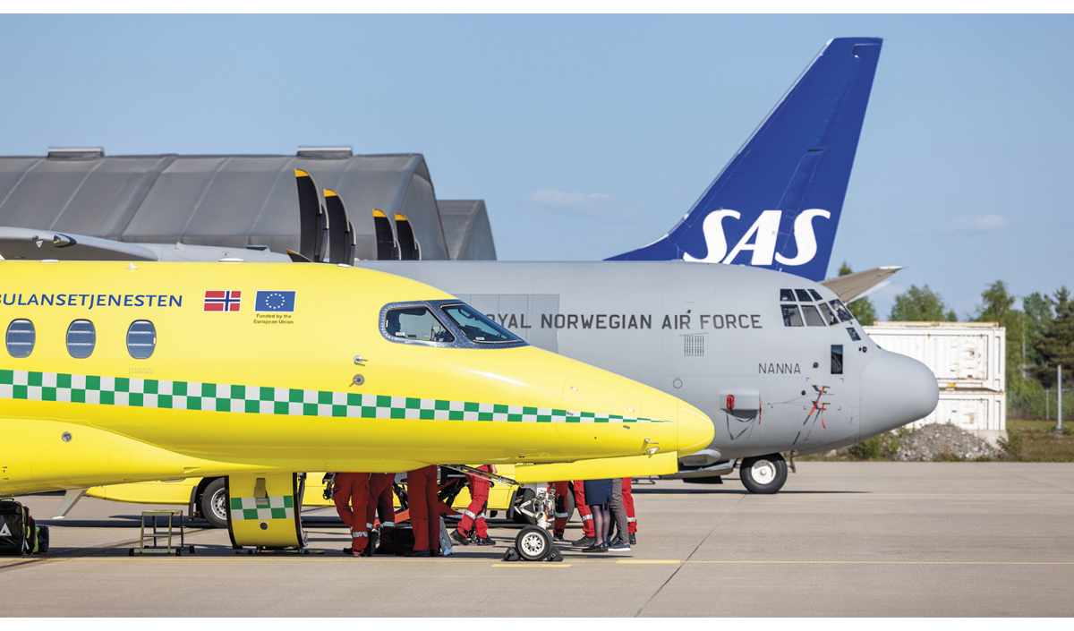

Photo: The Norwegian Armed Forces, Maria Smørholm.
Norway is contributing with aeromedical evacuation of patients from Ukraine for treatment in Norway and in other countries. The medical evacuation from Ukraine is a collaboration between several government ministries, the regional health authorities, the Norwegian Directorate of Health and other Norwegian health services, the Norwegian Armed Forces, SAS, the Directorate for Civil Protection, the Directorate of Immigration and the Directorate of Integration and Diversity. The medical evacuation takes place through the EU’s Civil Protection Mechanism. Since the start of the medical evacuation in August 2022, 333 patients have arrived in Norway as of 15 November 2023. Furthermore, during the same period, Norway has contributed to medical evacuation by flying 1,067 patients to hospitals in other countries. In addition, 591 relatives have been transported with the patients.
SAS makes aircraft available and the Norwegian Armed Forces provide medical personnel and materiel. These are health personnel who work in Norwegian hospitals on a daily basis. The Norwegian Government has decided to extend the provision of transport of patients until the end of February 2024, at the request of the EU. If needed, a further extension of this service will be possible. The current agreement between the Norwegian Armed Forces and SAS on strategic aeromedical evacuation is valid until May 2025. After this time, a new agreement will be in place as a result of SAS’ fleet change.
[Boks slutt]
Inter-ministerial Working Group
The Norwegian Government will better equip health and care services to address security crises and war. The Norwegian Government will therefore appoint a fast-track inter-ministerial working group headed by the Ministry of Health and Care Services and with representatives from the Ministry of Defence and other relevant government ministries, as well as relevant agencies and the Norwegian Armed Forces. Among other things, the working group will prepare a framework for civil-military health emergency preparedness work, clarify the Norwegian Armed Forces’ needs and expectations for services from the health and care sector, help clarify lines of leadership and governance, and prepare a mandate for the Committee for Civil-Military Health Emergency Preparedness Cooperation, cf. section 2.2.1. The working group will submit its report by the end of 2024.
Increased awareness of complex threats
Addressing complex threats places great demands on cooperation across sectors. The establishment of the National Intelligence and Security Centre (NESS) is an important measure in this context, where the three security and intelligence services (the Norwegian Intelligence Service, the Norwegian Police Security Service and the Norwegian National Security Authority) and the ordinary Norwegian Police cooperate on analysing and disseminating information regarding complex threats. The Ministry of Justice and Public Security has the main responsibility for following up and coordinating the Norwegian Government’s work on issues related to complex threats. At the same time, each sector is responsible for establishing sufficient resilience to withstand complex threats based on the overall assessments of central authorities.
              - Complex threats
Complex threats is a term for strategies for competition and confrontation below the threshold of direct armed conflict, which can combine diplomatic, informational, military, economic, financial, intelligence and legal means to achieve strategic objectives. Complex threats can occur in grey areas of security policy, where the purpose is to create discord and destabilisation. The use of instruments may be widely distributed and combine open, covert and hidden methods. The use of instruments may target specific activities or situations, or be designed to create doubt, undermine trust and thereby weaken our democratic values in the long term. Complex threats are inherently compounded and challenge early warning, agreed situational awareness, and effective and coordinated management.
Source: Report to the Storting No. 9 (2022–2023) National control and cyber resilience to safeguard national security – As open as possible, as secure as necessary.
[Boks slutt]
The ability of health emergency preparedness to address complex threats is strengthened through increased resilience. Important components of understanding what complex threats include knowledge of the threat situation, one’s own values and vulnerabilities and having a shared situational awareness, both within the sector and across sectors. The Ministry of Health and Care Services will actively use the newly established Health Emergency Preparedness Council in this work. At the same time, the Ministry will facilitate a competence boost in the areas of security, emergency preparedness and defence as part of the health emergency preparedness through the preparation of a competence plan.
The Norwegian Government will:
- strengthen civil-military cooperation on health emergency preparedness
- appoint a fast-track inter-ministerial working group, chaired by the Ministry of Health and Care Services and with the participation of the Ministry of Defence and other relevant government ministries, to establish an overall framework for civil-military health emergency preparedness work

Cyber threats and vulnerabilities
A heightened digital risk situation
Cyberattacks and the handling of digital threats and incidents have become part of the normal condition. Cyber threats to the health and care service are steadily increasing. The 2021 Defence Commission notes that there is “a heightened digital risk situation”. Digital solutions constitute an increasingly larger part of the health and care sector. This is a desirable development that strengthens patient safety, contributes to better collaboration and documentation and streamlines and simplifies everyday life. Digital systems are also essential for logistics, management, research, procurement and supply lines. At the same time, digitalisation also represents increased complexity and creates new vulnerabilities and attack surfaces. ICT systems and electronic communications infrastructure are exposed to both intended and unintended incidents.
The complexity and diversity of systems increases the risk of user error and system failure, and the threat actors know how to exploit the vulnerabilities. Health data is an attractive target for many and is noted as one reason why the health and care sector is of particular interest to threat actors. Threat actors range from individual hackers and opportunistic criminals, to organised criminals and states with the capacity and willingness to use methods that can have drastic consequences. State actors are willing and able to engage in long-term, strategic operations.
In recent years, accessibility to digital systems in the health and care sector has failed on several occasions. There have been power failures, fires, climate events and cases of viruses or attacks on the systems. The health and care sector has procedures for shutting down and isolating parts of the ICT infrastructure when an incident is detected, in order to avoid spreading and reduce the scope of harm. Given the current threat situation, the sector must prepare for even larger incidents, where it may be necessary to reduce services locally or regionally, relocate patients and reschedule services. This involves planning for scenarios that have major societal consequences. The planning framework for such scenarios must be kept up to date and exercises are necessary for learning and improvement.
Cyberattacks in health and care services can lead to downtime and loss of systems, or that data are affected, damaged or are lost. Cyberattacks can affect patient care and patient safety, or pose a financial and privacy-related threat. Power failure and electronic communications infrastructure can also render ICT systems inaccessible, with many of the same consequences. ICT systems can function locally and in individual departments, even if regional and national services become inaccessible. Emergency power and generators can keep local systems running for a certain period of time, but this is cumbersome and may require manual follow-up work and control on medical records.
              - Examples of events
In January 2018, the South-Eastern Norway Regional Health Authority was subjected to an extensive hacker attack by an advanced and professional actor. The investigation revealed that the suspects had acquired access to the network in the South-Eastern Norway Regional Health Authority, where some systems containing patient data were located.
In May 2022, the Northern Norway Regional Health Authority revealed an installed malware in the ICT systems used by ambulances, helicopter ambulances and emergency medical coordination centres.
There are no indications that personal data have gone astray as a result of these events, but this cannot be ruled out.
[Boks slutt]
Preventive measures adapted to the diversity of actors and needs of the sector
Preventive measures are continuous improvement efforts to which the sector devotes considerable resources. However, the many actors and enterprises in health and care services have different capacities for following up cyber security. Some actors are large enterprises with their own security environments, such as regional health authorities and large municipalities. There are also thousands of small actors such as GP surgeries, private specialists and municipalities. They are dependent on support and guidance to safeguard operational responsibility for ICT systems and infrastructure.
Instruments for preventing cyberattacks must be adapted to the diversity of actors in the health and care sector. The enterprises are subject to a number of requirements and regulations relating to information security and internal control. The GDPR requires “measures to achieve a level of security appropriate to the risk”, and sectoral legislation stipulates requirements for internal control and risk assessments. Agencies in the health administration and the regional health authorities have been tasked with working systematically on cyber security, including the introduction and implementation of the National Security Authority’s Basic Principles, risk and vulnerability analyses, updating of plans and implementation of exercises. Value and damage assessments of health data registries and associated ICT systems shall be included as routine analyses. Independent actors, such as municipalities and GP practices, are subject to the same statutory requirements.
An code of conduct has been prepared for information security in the health and care sector to support the actors. The code of conduct stipulates requirements that specify and supplement the formal legislation. The code of conduct is intended to promote mutual trust in the exchange of information within the sector and to maintain an acceptable level of security therein. The Norwegian Directorate of eHealth is the secretariat for the code of conduct. In the revised 2023 National Budget, the Norwegian Government presented a decision on changes to central health administration. The authorities’ tasks related to digitalisation, including cyber security, will be included in the Norwegian Directorate of Health’s tasks when the Directorate merges with the Directorate of eHealth from 1 January 2024. The Ministry of Health and Care Services will ensure that the code of conduct is updated and further developed as new technologies emerge, when relevant legislation is renewed or new forms of service are adopted.
The Norwegian Health Network state enterprise has established HealthCERT (Computer Emergency Response Team) for the health and care sector. The HealthCERT is a central and important surveillance and competence environment that assists enterprises in the sector. The HealthCERT monitors traffic and incidents in the health network and cooperates with the Norwegian National Security Authority and other actors, both domestically and internationally. It provides security services to all actors in the health and care sector and assists the sector in preventive activities and in the management of incidents. HealthCERT supplements corporate responsibility, but does not replace it.

          - The Norwegian Health Network monitors traffic and incidents in the health network.
Photo: The Norwegian Health Network, Vegar Herstrøm.
Through Proposition to the Storting No. 78 (2021–2022) Economic measures as a result of the war in Ukraine, NOK 40 million have been allocated to funding a CERT to support and strengthen the municipalities’ work on cyber security in general - a cross sectoral CERT for the municipalities. The Norwegian Government has decided that this CERT for the municipalities will be established in affiliation with HealthCERT. The new CERT will function as a front-line service for the municipalities and coordinate inquiries from other response teams so that the municipalities have a single point of contact in the event of incidents.
The Norwegian Government has established a health technology stimulous package to support municipalities in their digitalisation efforts. A guidance service will also be established for the requirements and standards that apply to the sector. Security requirements and how regulations related to privacy and security are to be interpreted will, among other things, be part of the scheme. The health technology scheme is presented in the National Health and Collaboration Plan together with the general digitalisation policy for the sector.
Competence prevents errors and reduces risk
It is crucial that enterprises in the health and care sector acquire the necessary knowledge and keep abreast of the changes in risks and threats. Competence in cyber security at all levels is a prevention element in all enterprises. Weak security behaviour can offer threat actors a pathway into systems. The Norwegian National Security Authority notes that it is often the same mistakes that are made in both public and private enterprises, and that most cyberattacks could have been averted or limited had the Norwegian National Security Authority’s Basic Principles been followed. Errors include weak passwords, sharing access with more people than necessary to perform tasks, outdated systems, and exploitation of human weaknesses. Competence and a security aware culture can have a positive effect on trust in the population in relation to and between health personnel and between enterprises. The Norwegian Government will assess existing competence measures with the aim of ensuring that instruments that function well can be shared and reused throughout the sector. The Norwegian Government follows up the number of student admissions in the annual budget processes and has proposed an increase of 100 admissions to ICT programmes for 2024.
              - ICT security competence
A lack of ICT security competence appears to be a significant challenge in the area of ICT security across sectors, and there are strong indications that this demand will remain unmet in the time ahead. On behalf of the Ministry of Justice and Public Security, the Nordic Institute for Studies in Innovation, Research and Education (NIFU) has updated an earlier study on the future supply of, and demand for, competence in cyber security. The 2023 report shows that the need for competence remains great, but that the gap between supply and demand is narrowing compared to the status in the previous report from 2017.
Source: NIFU, Digital sikkerhetskompetanse i arbeidslivet – behov og tilbud [Cyber security competence in working life – needs and supply] (working paper 8/2017) and NIFU, Arbeidslivets behov for digital sikkerhetskompetanse frem mot 2030 [Need for cyber security competence in working life towards 2030] (Report 2023:4).
[Boks slutt]
Long supply chains that are difficult to control
ICT-systems consist of components from many different manufacturers. Furthermore, the software in each component can use source code and software libraries from many different companies, and not all suppliers have an overview of their own software dependencies. The Defence Commission notes that a “-large proportion of Allied countries’ critical digital infrastructure is owned and operated by private enterprises, often outside their own borders and, jurisdiction. This means that important decisions on development and security in the digital spaces are largely made by commercial and non-state actors outside the traditional inter-governmental arenas.” Managing risk in such chains is demanding at both the enterprise and government levels. It is challenging to have to review all subcontractors and contractual relationships involved.
In Report to the Storting No. 9 (2022–2023) National control and cyber resilience to safeguard national security – As open as possible, as secure as necessary, the Norwegian Government highlights the need for an overview of complex supply chains through preventive security measures pursuant to the Security Act, use of other relevant legislation and national ownership. As a follow-up to the Report, the Norwegian Government presented Proposition to the Storting No. 109 (Bill and Resolution) (2022–2023) Lov om digital sikkerhet [Act related to cyber security] in the spring of 2023.
Artificial intelligence has major security implications
New technologies such as artificial intelligence, synthetic biology and neurotechnology are being developed globally across state and private actors. There are major constructive and destructive possibilities in these technologies.
Artificial intelligence is important for the health and care sector, and although there is considerable activity, we have only just begun to use this technology. Increased competition, large volumes of data and the improvement of machine learning have led to major breakthroughs and advances in recent years. Both the human and non-human contributions in such systems have major security implications – and thus a considerable potential for harm.
The Norwegian Government is increasing its research efforts in artificial intelligence by at least NOK one billion over the next five years. The one-billion kroner research allocation will contribute to greater insight into the consequences of this technological development for society. The health and care sector is well positioned to create good projects as part of this initiative. Norwegian health authorities are also closely following the establishment of basic security principles for the development of artificial intelligence, particularly through the European Commission’s proposed regulation – the AI Act. We are actively working in several environments in the sector to clarify how this technology can be used in a responsible manner, and what is needed for us to maintain sufficient control over any security-threatening aspects of the technology. Artificial intelligence will be one of the topics in the Norwegian Government’s national digitalisation strategy, which is being prepared.
The EU as a driving force for enhanced cyber resilience
The EU is working broadly to develop its resilience and reduce vulnerabilities after its cooperative relationship with Russia ceased in conjunction with the war in Ukraine. Several regulations have been adopted to secure critical infrastructure and information security in enterprises and in digital equipment connected to the Internet. In particular, the directives on security of network and information systems (NIS Directive) and the EU’s Cyber Resilience Act are key to cyber security. The NIS Directive covers enterprises in the health sector, and the implementation of the Directive is part of the Norwegian Government’s proposal for an Act related to cyber security. The Act will set minimum requirements for security in network and information systems and reporting of incidents. The NIS2 Directive, recently adopted by the EU, expands its scope and clarifies the security and reporting requirements. The Directive proposes information security requirements for products connected to the Internet, and that manufacturers of the equipment be held liable for the information security of the equipment. Through this legislation and a number of other directives related to data and digital services, the EU is working to establish itself as a geopolitical centre for digital development. Democratic values such as solidarity, privacy, sustainability and freedom of choice shall be key to the Digital Decade until 2030.
The European Commission’s proposed regulation for the European Health Data Space is intended to contribute to more comprehensive and cohesive requirements for ICT systems in the health sectors in the EU. Minimum requirements for security and privacy in digital solutions are part of the proposal. The proposed regulation is of relevance to the EEA and will be considered for incorporation into the EEA Agreement once a decision has been made in the EU.
Systematic approach for strengthened cyber security
Despite good preventive measures, cyber incidents can hardly be avoided altogether. Incidents in the health and care sector in recent years, such as the attack on the South-Eastern Norway Regional Health Authority in 2018 and the Northern Norway Regional Health Authority in 2022, have highlighted the need for a better integration of the digital space into the sector’s emergency preparedness plans and systems. Significant improvements have been made in the cyber resilience of the regional health authorities in recent years, based on assignments from the Ministry, experience and incidents. Digital solutions are an integral part of enterprises and must be an integral part of corporate governance in the sector. This must be reflected in the emergency preparedness plans. Plans must take into account different types of scenarios, where ICT-systems and electronic communications infrastructure may be a smaller or larger part of the crisis. Plans for addressing disruptions of ICT-systems must be practiced and updated regularly. The same applies to the disruption of electronic communications infrastructure. In the event of major incidents, cross-sectoral cooperation and efforts will have a major impact on the outcome where the objective is to reduce the extent of the damage. This must also be reflected in emergency preparedness and exercise plans.
Risk assessments and security measures must be changed more frequently, and in line with an ever-changing risk situation. A systematic approach throughout the health and care sector will strengthen cyber security. This applies to the preparation of risk and vulnerability analyses, threat assessments, planning frameworks and good scenarios, exercises and updated emergency preparedness plans. The Norwegian Government will ensure that cyber incidents are integrated into planning, scenario descriptions and exercises. The new health emergency preparedness structure will ensure this, cf. section 2.2.
The Norwegian Government will:
- establish a committee at the agency level for cyber security for enterprises in the health and care sector, which will also work across sectors
- develop competence regarding threats and security measures in the health and care sector and further develop competence measures adapted to different target groups
- further develop surveillance, detection and analysis of digital vulnerabilities and threats in health and care services and establish CERT for the municipalities in connection with the CERT already established for the health and care sector.

Security of supply
Significant dependencies and vulnerabilities – complex reasons.
Norway has an open economy and is dependent on access to global markets for imports and exports. A changed geopolitical landscape implies that both Europe and the U.S. are emphasising increased strategic autonomy in their own markets. Economic repercussions of Russia’s invasion of Ukraine have led to shocks on supply and demand aspects of global trade, resulting in increased price pressure on a number of goods.
An inadequate overview of supply chains, long production and supply lines and few alternative suppliers render small countries particularly vulnerable. Major crises are often transboundary. Natural disasters, epidemics, wars and conflicts, or sudden changes in medical needs, can have major impacts on both the supply and demand of pharmaceuticals and medical devices, as well as affect transport and distribution. Normal market mechanisms are then incapacitated, and small markets without major alliance partners are particularly vulnerable. During the pandemic, major countries, such as India and the U.S., implemented export restrictions. This halted deliveries to Europe.
Health emergency preparedness depends on a number of input factors. Access to pharmaceuticals and medical devices is crucial for the provision of health and care services. Water supply is dependent on chemicals for the purification of water. Nuclear emergency preparedness requires measuring equipment in the event of a nuclear incident. The dependencies are equally great for input factors that are outside the constitutional responsibility of the Minister of Health and Care Services. There are significant cross-sectoral dependencies. This places major demands on cross-sectoral cooperation. Without access to chips, the digitised systems in the health administration and the health and care services will not work. Without access to power, systems quickly grind to a halt. Food safety is another example. If one link in the supply chain fails, the consequences for emergency preparedness may be considerable.
For health emergency preparedness, access to pharmaceuticals and medical devices is, as mentioned, a critical input factor. There are approximately 3,000 approved active substances for pharmaceuticals in the world, and the number is rising. More than 500,000 product types are covered by the definition of medical devices. Characteristics of these products, markets and supply chains are highly complex. Therefore, there are special vulnerabilities and dependencies for access to such products. Pfizer’s original COVID-19 vaccine, for example, consisted of 280 inputs from suppliers in 19 countries. Overall, this demonstrates why Norway needs international cooperation to ensure access to pharmaceuticals and medical devices.
              - Collapse of the market for personal protective equipment


Photo: Peder Mathisen.
The pandemic demonstrated the vulnerability of Norway and the rest of the world when the market for personal protective equipment collapsed as a result of demand shocks. Overnight, personal protective equipment became scarce in both the primary and specialist health services. The Ministry of Health and Care Services gave broad powers to the Norwegian Directorate of Health and the South-Eastern Norway Regional Health Authority, which monitored the situation closely. The South-Eastern Norway Regional Health Authority quickly established a transport and logistics organisation and used purchasing competence in the Norwegian Hospital Procurement Trust to probe the market for direct purchases of personal protective equipment. The usual market mechanisms were not functioning and the Health Authority established close cooperation with the Ministry of Foreign Affairs and Avinor. Cargo flights were chartered through Ethiopian Airlines and Qatar Airways. A combination of skill, cooperation and luck enabled Norway to succeed in obtaining the necessary personal protective equipment.
[Boks slutt]
The establishment of the Medical Products Agency
A robust organisation of the security of supply ensures an important foundation for good emergency preparedness. From 1 January 2024, the Norwegian Government will establish a Medical Products Agency. The Agency will be given overarching and full responsibility for monitoring the entire supply chain for pharmaceuticals and medical devices. Covering research and development, as well as placement on the market, emergency preparedness and security of supply. This responsibility is currently shared among different actors in the health and care services and in the health administration. By combining responsibility for monitoring market actors and market regulation of pharmaceuticals and medical devices, together with emergency preparedness and security of supply, a holistic approach is ensured that strengthens health emergency preparedness. One important task for the Agency will be to maintain an overview and insight into the global market and to know the actors. The Agency shall have a clear responsibility of following the developments in the supply chains, including an overview of the supply chains. This will include analyses and monitoring, both in normal circumstances and when circumstances may indicate that access to pharmaceuticals and medical devices is threatened. Further development of the Norwegian Medical Products Agency means that the need for legislative and regulatory amendments will be reviewed.
Procurement mechanism for pharmaceuticals and medical devices
In order for the Norwegian Agency for Medical Products to fulfil its responsibilities for the security of supply, the Norwegian Government will strengthen its work on negotiation and procurement of pharmaceuticals and medical devices for the public sector. Currently, the national responsibility for negotiations and procurement of pharmaceuticals and medical devices is fragmented, where several agencies in the central health administration, municipalities and health trusts are responsible for procurement. This means that no comprehensive assessments are made in relation to use and potential, and that bargaining power is not utilised effectively. By joining professional environments for procurement in the central health administration, specialist competence can be enhanced in an area that has a significant potential to contribute to a more robust health emergency preparedness. Joining negotiations and procurement will also enable Norway to increasingly utilise the opportunities that exist in procurement cooperation at Nordic and European levels. This will contribute to strengthening security of supply, while at the same time not deviating from responsibilities of municipalities and health trusts.
Our participation in the European cooperation on pharmaceuticals is important in the efforts to secure Norway’s access to pharmaceuticals and medical devices. Nordic cooperation can actively support the European cooperation. Through the Nordic Pharmaceutical Forum, the Nordic countries cooperate on procurement to ensure security of supply of selected pharmaceuticals. As a result of the EU’s strengthened cooperation on health emergency preparedness, the Nordic Pharmaceutical Forum has decided to strengthen cooperation in order to contribute a strong Nordic voice in the European cooperation. The Forum’s cooperation has produced results and gained recognition in Europe. This cooperation shows how countries can form a larger market through joint procurement to achieve access to pharmaceuticals that they cannot achieve on their own.
In order to meet the challenges associated with antimicrobial resistance, incentives must be established to facilitate the development of new antibiotics and the production of older antibiotics. Norway’s restrictive use of antibiotics means that we are still one of the few countries that can use narrow-spectrum antibiotics. Nordic cooperation on the procurement of selected older antibiotics has been a success. The use of procurement as an incentive for access to both new and older antibiotics should be further developed and expanded. Both a shortage of antibiotics and antimicrobial resistance can thereby be prevented. Nordic cooperation should be a model for European cooperation.
Stocks of pharmaceuticals and medical devices
Access to pharmaceuticals and medical devices must be based on a balance between national and international measures. Important national measures are implemented through the use of regulatory instruments. This can ensure that pharmaceuticals and medical devices remain in the country, or that dispensing from pharmacies and wholesalers can be rationed and prioritised. Furthermore, there is a need for sound planning that ensures coherence between national and European joint measures.
National stocks of pharmaceuticals and personal protective equipment are important to support security of supply, particularly during the initial phase of a health crisis. In order to strengthen national emergency preparedness, significant circulated stocks of pharmaceuticals were therefore established with pharmaceutical wholesalers during the pandemic. The aim is to put in place a regulation of this system through the legislation on pharmaceuticals in 2023. Large national stocks of personal protective equipment were also established during the pandemic. This has now been established as a permanent national emergency stockpile operated by the regional health authorities. In the event of a new pandemic or crisis where there is a need for withdrawal from the national stocks, the State, represented by the Agency of Medical Products will assume management of the stocks. Furthermore, the Norwegian Government intends to establish regulations stating that all health and care institutions must have stocks corresponding to six months’ normal consumption of personal protective equipment. However, stocks will not be able to meet all our needs for medical countermeasures in a major or prolonged crisis. The pharmaceuticals and medical devices included in the stockpiles should to a greater extent be dynamic and based on risk and vulnerability analyses, while at the same time special arrangements for CBRNE and antimicrobial resistance should be considered. The Norwegian Government will ensure that the emergency stocks for pharmaceuticals and personal protective equipment are maintained and further developed.
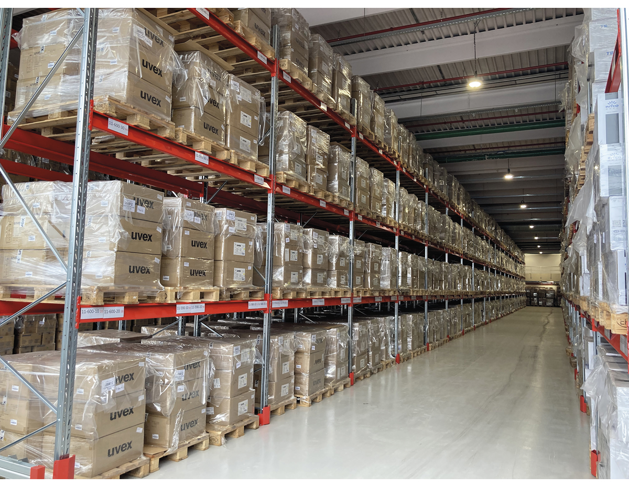
          - Large national stockpiles of personal protective equipment were established during the pandemic.
Photo: South-Eastern Norway Regional Health Authority.
Through the EU Civil Protection Mechanism (UCPM) and HERA, strategic stocks of pharmaceuticals and medical devices are being established in Europe for, among other things, the handling of CBRNE and antimicrobial resistance. These stockpiles are established in different countries and can be distributed in a crisis.
The establishment of a European stocks in Norway will contribute to enhanced emergency preparedness through proximity and integrated participation in an effort that is important for the whole of Europe. The Ministry of Health and Care Services will, in dialogue with the relevant ministries, consider whether Norway should offer to host such a strategic EU stockpile.
An integral part of the European cooperation
Given the number of pharmaceuticals and the wide range of medical devices marketed in Norway and in Europe, it is unrealistic to believe that Norway can become self-sufficient. Norway’s access to pharmaceuticals and medical devices in crises requires cooperation through full affiliation with the strengthened European health emergency preparedness cooperation. In line with the recommendation in the second report of the Coronavirus Commission, the Norwegian Government has therefore decided to conduct negotiations with the EU with a view to concluding an agreement on Norway’s affiliation with the strengthened European health emergency preparedness cooperation.
The EU is stepping up its efforts in the field of emergency preparedness of pharmaceuticals and medical devices. The European Medicines Agency (EMA) has been given an expanded mandate to monitor Europe’s security of supply in this area. The legislation on pharmaceuticals and medical devices is largely fully harmonised within the EEA, and Norway is therefore an integral part of the work of the EMA and the European cooperation.
              - More vulnerable than we thought
Access to medical countermeasures made it clear that we were more vulnerable than we thought. In particular, we experienced this during the vaccine race. Usually, one in ten vaccines that are developed will be approved, and receive what is known marketing authorisation, which shows that the vaccine has a positive benefit-risk ratio. At one stage, more than 200 vaccines were being developed. It was entirely uncertain which would receive marketing authorisation. Never before has the world developed an effective vaccine so quickly. Demand exceeded supply. Vaccine production is subject to strict requirements for both quality and competence, and increasing production capacity quickly is therefore very demanding. Global demand could not be met. For individual countries like Norway, it was not possible to enter into binding agreements. Neither the industry nor individual countries such as the U.S. or the UK wanted to enter into separate procurement agreements with Norway. Our market is too small for the industry, as is the Nordic market.
In part two of its report, the Coronavirus Commission writes as follows: “The most important lesson from the pandemic in terms of procurements and access to vaccines is that Norway has benefitted a lot from working with European countries, and especially the EU. The European procurement cooperation that Norway invested in has provided vaccines to the population at a rapid pace and considerable scale.”
[Boks slutt]
HERA was established to ensure Europe has access to pharmaceuticals and medical devices in a crisis. HERA is to ensure monitoring of supply and access to crisis-relevant pharmaceuticals and medical devices, research and development, tendering, procurement and production of pharmaceuticals and medical devices during a crisis. HERA has been given a major role in joint negotiations and procurement to secure access to pharmaceuticals and medical devices. In addition, the European Commission is working on targeted measures at the European and regional levels to also secure access to pharmaceuticals outside of crises in case of shortages or in circumstances where market dynamics are particularly demanding. This applies, for example, to antibiotics and access to new, expensive pharmaceuticals. Through its strengthened cooperation on health emergency preparedness, the EU has access to various funding mechanisms for joint European procurement. The aim is for Norway to be able to participate in all forms of common European procurements through a future agreement. Because markets for pharmaceuticals and medical devices have special characteristics and challenges, Norway is unable to safeguard the security of supply through national measures alone. In order to safeguard the area from an overall perspective, participation in the EUs cooperation is therefore important to ensure a national security of supply for pharmaceuticals and medical devices.
              - The EU reserve manufacturing capacities for
the EU to produce vaccines
The EU FAB reserves manufacturing capacities for the EU to produce vaccines in case of public health emergencies. The EU FAB facilities ensure their constant readiness to respond to a crisis. On 30 June 2023, the Commission signed an agreement with four pharmaceutical manufacturers of mRNA-based vaccines, vector-based vaccines and protein-based vaccines, established in the EU.1 The agreement, with an annual value of EUR 160 million, ensures that up to 325 million vaccine doses can be manufactured per year in a crisis and reserved for the EU.
1 Framework contract signed under EU4Health to guarantee a fast response to future health crises (europa.eu).
[Boks slutt]
The Norwegian Government will:
- placing the responsibility for security of supply and emergency preparedness for pharmaceuticals and medical devices in the Norwegian Medical Products Agency
- ensure the supply of medical countermeasures through Norway’s participation in the EU’s strengthened health emergency preparedness cooperation

Pandemics and infectious diseases
Infectious diseases remain a threat
The world will come to face new pandemics in the future. Some modelling studies have shown approximately a 25 per cent probability that an outbreak similar to the COVID-19 pandemic will affect us in the next decade, and around a 50 per cent probability that it will occur within the next 25 years.
The risk posed by infectious diseases encompasses a wide range of threats, both nationally and globally. New outbreaks of infectious diseases and pandemics are often caused by diseases transmitted between animals and humans (zoonoses). The number of such diseases has increased substantially in recent decades. Environmental and climate changes, population growth, increased travel activity, lifestyle changes and displacement of large population groups due to war, food shortages, floods, droughts or other natural disasters can make it difficult to contain infectious diseases.
Antimicrobial resistance is a global threat to health, and it amplifies the threat posed by infectious diseases. Antimicrobial resistance entails, among other things, a reduced possibility for treating serious infections with standard medical treatment. Globally, this is a rapidly growing problem, and it also affects Norway. Both the EU and the World Health Organization consider resistance to antimicrobials to be one of the most serious threats to public health.
Lost control of dangerous infectious agents can cause serious illness in humans, animals and plants. This can occur following laboratory accidents, or as an intentional act to cause harm (bioterrorism). Synthetic biology makes it possible to create new, dangerous infectious agents. Readily available methods of synthetic biology increase the risk of unwanted spread of dangerous infectious agents.
The COVID-19 pandemic – a crisis that impacted all of society
In March 2020, Norway and most countries in the world introduced the most comprehensive measures since the Second World War to protect lives and health, followed by comprehensive measures to protect the economy. The COVID-19 pandemic showed how vulnerable Norway and the world are to infectious diseases that easily spread across borders. Norway was not prepared for a protracted health crisis that affected the entire society. Many of the restrictive measures remained in place for almost two years. Future pandemics may have higher infectiousness and higher mortality rates than the COVID-19 pandemic.
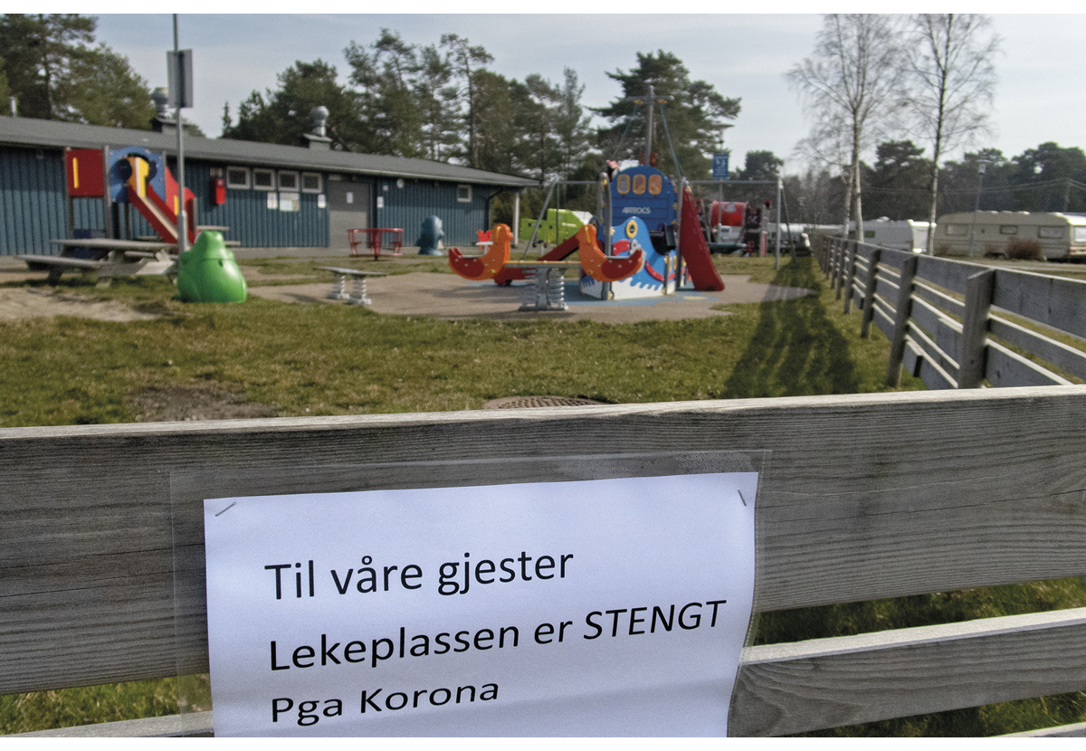
          - In March 2020, comprehensive measures were introduced to protect lives and health. The burden of measures on children and young people was considerable.
Photo: Mimsy Møller, NTB.
Although Norway emerged from the pandemic relatively well in terms of the number of fatalities and economic impact, there was a major social crisis here as well. As of 22 October 2023, 5,824 COVID-19-associated deaths have been registered in the Norwegian Cause of Death Registry. 1,983 of these deaths were persons under 80 years of age. The pandemic exacerbated social inequalities in health in the population, and there were major social differences in morbidity and mortality.
We do not yet have an overview of the long-term consequences of the pandemic, but we do know that it had several major health and psychosocial consequences. A complete socioeconomic assessment of the costs of the pandemic for Norway has not been prepared. The total real economic costs of the pandemic in the period 2020–2023, measured by lower GDP, amount to about 270 billion 2019 Norwegian kroner.
Weaknesses in preventive infection control efforts
The pandemic has revealed weaknesses both in preventive infection control efforts and in emergency preparedness. Infection control competence in the health sector varies. As described in section 2.3, the Coronavirus Commission has highlighted the crucial role that municipalities have played in addressing the pandemic, including the key function of chief municipal medical officers. At the same time, many municipalities, especially smaller municipalities, are vulnerable due to lack of competence in infection control and not enough personnel working in this area. Part 2 of the Coronavirus Commission recommends that the chief municipal medical officer role should be strengthened. The Commission highlights the importance of having a professional environment, which can be difficult to maintain in smaller municipalities. It also notes that inter-municipal schemes can help create professional networks for chief municipal medical officers in smaller municipalities. As discussed in section 2.3, national guidelines for the public health tasks of the municipalities will help to clarify the role of the chief municipal medical officer and the expectations of the municipalities. Municipalities and health and care services should receive better infection control and legal guidance. Cooperation between municipalities and specialist health services should be strengthened. Infection control considerations should be safeguarded in the planning and design of health institutions. Both long-term care facilities and hospitals can lay the groundwork for better isolation, cleaning and ventilation. Good infection control routines are also particularly important for the prevention of antimicrobial resistance. The Norwegian Government will revise the Action Plan for better infection control in the health and care services 2019–2023. Lessons learned from the COVID-19 pandemic will be part of this effort.
Inadequate control of dangerous infectious agents can cause serious illness in humans, animals and plants. This may also be due to acts of terrorism or intentional use to cause fear, disease and harm. The Norwegian Government will develop legislation on biosecurity, including guidance and competence-building in relevant sectors.
Good surveillance systems and registers
Every year, more than 100 infectious disease outbreaks are reported to the Norwegian Institute of Public Health, most of which are followed up locally in the municipalities and healthcare institutions. In the years just before the pandemic, between 30,000 and 50,000 cases of infectious diseases were reported to MSIS annually. Municipalities and regional health authorities need quick and simple solutions for access to data and reporting of infection in control efforts, both during normal routine work and in crises. Good systems to ensure that outbreaks and possible threats are detected quickly, and that provide a knowledge base for situational awareness and risk assessment, are essential for rapid response. The piloting of wastewater surveillance during the pandemic showed that this type of surveillance can contribute to both signals and changes in the distribution of virus variants being detected 1–2 weeks earlier than through ordinary surveillance. Experiences from the pandemic show, among other things, that people who need this information in the health services and municipalities require quick access to data for contact tracing and follow-up of individuals in order to limit further infection.
              - Management tools in infection control work
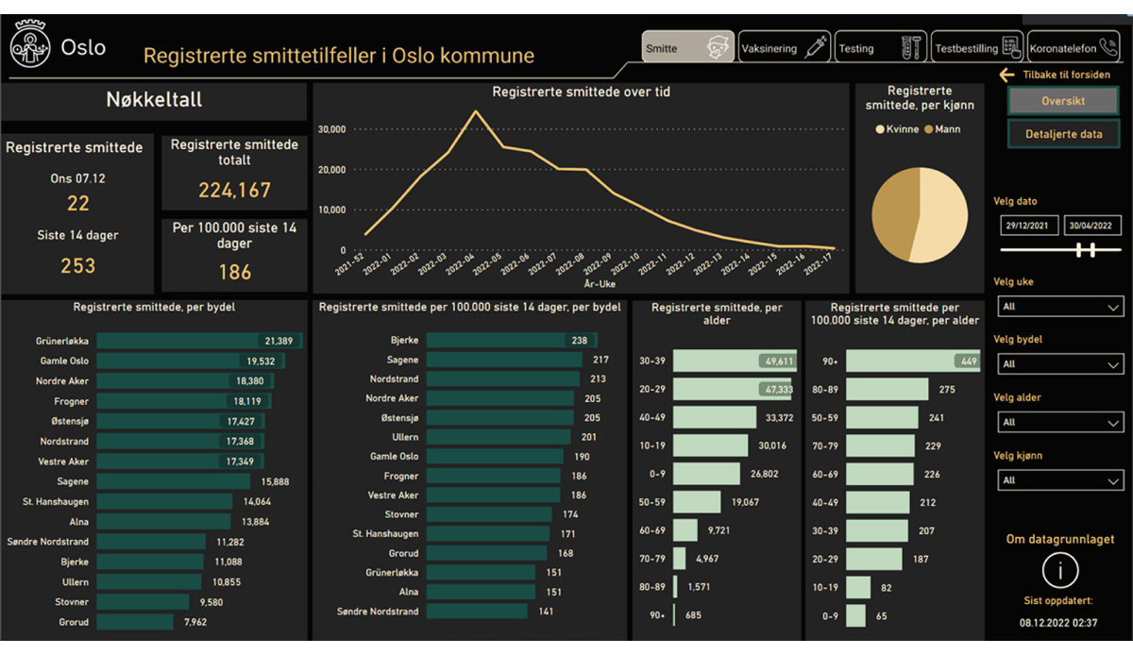

Source: Helseetaten i Oslo kommune.
Both in normal situations and during crises, municipalities must have an overview of the infection situation and developments in their municipality. During the pandemic, the Norwegian Institute of Public Health developed a common national solution that municipalities and county governors could use for an overview of their infection situation. In collaboration with the Norwegian Association of Local and Regional Authorities (KS), the Norwegian Institute of Public Health has initiated a project to establish a more permanent digital solution that can cover more needs and is better integrated into other solutions used by the municipalities.
Several municipalities also developed their own solutions specially adapted to the needs of the municipality. In the City of Oslo, it was important to look at developments in the various districts in order to target efforts involving testing, contact tracing and vaccination. The illustration shows the tool the City of Oslo used during the pandemic for an overview of the infection situation.
[Boks slutt]
In the long term, the infection control registries should be developed into a comprehensive infection registry. Currently, there are five different infection control registries. These have been established at different times and in response to different needs. Data for the various registries are received in different formats, including from the same notifiers. There is currently no common platform for data reception and reporting.
As part of the work to achieve a more comprehensive infection registry, the Norwegian Institute of Public Health has developed a strategy that describes solutions for automated processes for reporting data, message flow, data processing and analysis, quality assurance and accessibility of data. This applies both during normal situations and for adaptation for use in crises. This includes solutions for interaction with users in specialist healthcare services and the municipalities, and to facilitate quick access to necessary data and message exchange.
The aim of a national infection registry is to achieve a faster and better utilisation of existing data for patient treatment, surveillance, infection control measures and research. A comprehensive surveillance system must, among other things, facilitate interaction and access to data in the municipalities and health services. Experiences with the emergency preparedness registry for COVID-19 (Beredt C19) will form the basis for this work.
Based on this, the Norwegian Government will work on a plan for modernising surveillance systems in the area of infection control. This includes, but is not limited to:
- Digital infrastructure for reporting, message flow, interactions and access to data in infection control between municipalities, specialist health services and the central health administration.
- Digital tools and infrastructure for linking and secondary use of existing data sources based on experience with Beredt C19.
- Investigation of legal consequences, including privacy.
In collaboration with the Norwegian Association of Local and Regional Authorities (KS), the Norwegian Institute of Public Health has initiated a project to establish a digital infrastructure that supports seamless services for health surveillance, analysis, statistical production and sharing of data as part of a comprehensive system for digital infection control emergency preparedness in the municipalities.
Contact tracing systems and infection control apps are other sources of knowledge in the area of infection control. The Norwegian Government will consider how data from municipal contact tracing systems can easily be integrated into national systems and from national systems to municipal systems. Experiences with the Smittestopp [Infection Stop] app that was developed during the COVID-19 pandemic will be incorporated into the work on health emergency preparedness.
              - Adult immunisation programme
Immunisation is one of our most important infection control measures. Through immunisation, individuals are protected against serious illness, and the spread of infection is prevented. Not all vaccines in the childhood immunisation programme provide lifelong protection. Immunity wanes over time, and repeated doses in adults are important to maintain individual immunity and herd protection. As described in the Public Health Report, the Norwegian Government will work to introduce an adult immunisation programme to provide the population with protection against infectious and serious diseases throughout their lives. The goal is better and more equal compliance with the immunisation recommendations, clearer division of responsibility, efficient logistics and cost-effective procurement of larger volumes. An adult immunisation programme will also be important for emergency preparedness, as the framework conditions for effective introduction of new vaccines have been established in advance.
[Boks slutt]
Broader involvement in pandemic emergency preparedness and management
The Coronavirus Commission’s first report notes that it was known in advance that pandemic influenza was the most likely national crisis, and the one which would have the greatest adverse impact. Nevertheless, emergency preparedness to handle the COVID-19 pandemic could have been better when it occurred. There was inadequate preparation of scenarios, plans or exercises that take into account the use of instruments such as setting requirements for or shutting down activities in all or parts of the country, as permitted by the Infection Control Act. The plans did not address curbing infection and what this would entail in terms of measures and consequences in other sectors. Other sectors had little involvement in the preparation of the general planning, and had not taken into account being covered or affected by infection control measures in their own emergency preparedness plans. There was little indication that the crisis would last over a longer period. Experiences from the pandemic demonstrated that when different sectors participate in the development of packages of measures, these are more effective and have fewer negative consequences. Packages of national infection control measures that were developed during the latter part of the COVID-19 pandemic will be further developed, following involvement by the various sectors of society.
The Norwegian Government will facilitate broader participation in the organisation of health emergency preparedness, updating relevant plans for pandemic management and in crisis management. Relevant actors are authorities from other sectors, the local government sector, the specialist healthcare service, voluntary organisations, vulnerable groups and the business sector.
Targeted infection control measures in testing and contact tracing
In outbreaks of serious infectious diseases, contact reducing measures, testing, tracing, isolating and quarantining (TTIQ) are all relevant actions. TTIQ are measures that target people who may be infected, and have fewer consequences for society as a whole. Effective TTIQ that enables control of the spread of infection can reduce the need for comprehensive contact-reducing measures. Therefore, the Norwegian Government believes there should be plans and systems for effective testing and tracing, as well as opportunities for isolation and quarantining that can be implemented quickly if needed. There should be assessments of the costs and benefits of different TTIQ schemes.
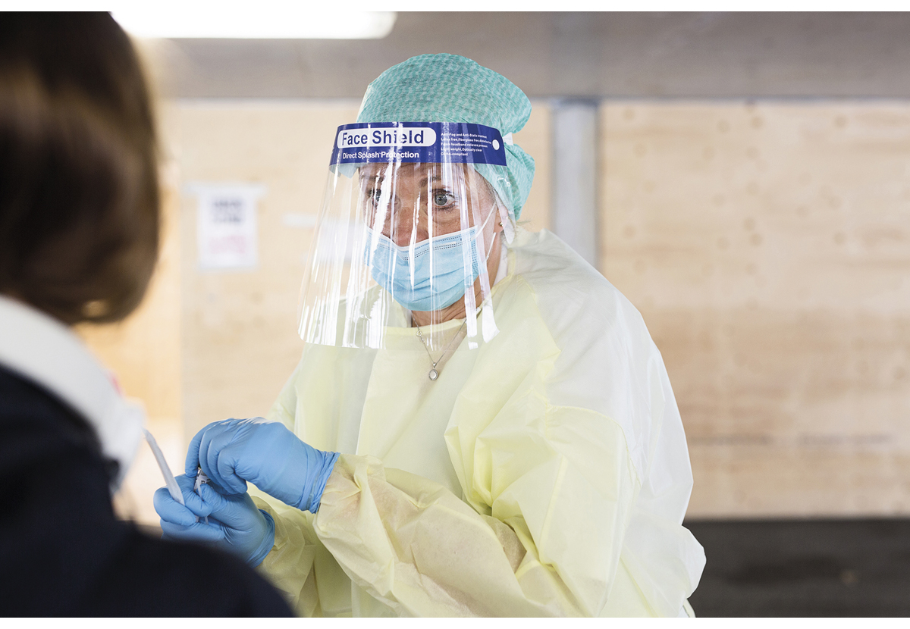
          - Testing and tracing were important measures for controlling the spread of infection during the pandemic.
Photo: Bergen Hospital Trust.
A rapid and flexible response is based on systems for detecting trends in infection and systems for rapid feedback of results to municipalities, the health and care services and the central infection control authority. Digitalisation and modernisation provide opportunities for automatic surveillance and thereby faster reporting and follow-up with infection control measures in relation to individuals, local communities, regionally or nationally. A rapid scaling up of testing and laboratory analyses, including sequencing in the event of larger outbreaks will also be facilitated. Sequencing capacity is important for detecting new virus variants and the development of transmission variants that are of significance for the effective design of infection control measures. Testing capacity will be rapidly scalable, especially if the symptoms are non-specific, as with the COVID-19 virus. This presupposes that there are good national reference laboratories that can quickly set up analyses for new agents, plans for large-scale analyses and plans for scaling up testing capacity in the municipalities using human resources.
The Norwegian Government will clarify the possibilities for rapidly increasing sequencing capacity as part of pandemic emergency preparedness. This may also include capacities in other sectors. Effective contact tracing systems are a key tool in the event of larger outbreaks, in addition to surveillance. In cooperation with the municipal sector, the Norwegian Government will facilitate the development of user-friendly contact tracing tools with data that can be shared and used across municipalities and between municipalities and health trusts.
Strong professional infection control environments
Considerable capacity and strong professional competence are required for managing a pandemic. A strong professional national infection control professional network that ensures a continuously updated knowledge base, good contact with the municipalities, health services and the central administration is crucial to ensure safe handling of outbreak situations.
In addition to professional infection control competence, close organisational links are needed to other professional environments that can contribute knowledge and comprehensive assessments. This includes, among other things, i) professional registry competence for the development of emergency preparedness registries, etc.; ii) competence in other health and societal consequences of measures, such as mental health and socioeconomics; and iii) capacities for dialogue with other parts of the central administration, municipalities, the health and care services and voluntary organisations.
The Norwegian Government will:
- strengthen and modernise surveillance systems in the area of infection control
- maintain strong professional environments in the area of infection control, and facilitate professional support and competence locally

Safe water supply
Contamination of drinking water can pose a risk of loss of lives and health. Loss of water also has other major societal consequences, which may lead to the need for evacuation. Drinking water in Norway is generally safe, and most residents receive drinking water of good quality. Nevertheless, there are several vulnerabilities in the water supply in many municipalities that will require measures to maintain resilience and emergency preparedness in the face of challenges. Safe water supply has been identified as a fundamental national function, cf. Section 2-1 of the Security Act. Drinking water is used for drinking and cooking, but the largest share of it is used for hygienic purposes such as cleaning, showering and toilet flushing. Water supply is necessary to maintain functions in schools, kindergartens, hospitals and other health institutions, as well as in the business sector.
Vulnerabilities in the water supply
The municipal pipe network is generally in poor condition, and the leakage rate is high. On average, 30 per cent of the water leaks out of the pipe network. The renewal rate is low and not sufficient to avoid increasing decay. A report prepared for Norsk Vann [Norwegian Water] describes an investment need of about NOK 330 billion in the period 2021–2040 to secure the infrastructure for water and sewerage. The risk of both loss of water and contamination of the water supply is therefore increasing.
More torrential rain, floods and droughts increase the risk of failure of the water supply systems. The Askøy case in 2019 where more than 2,000 people became ill with gastrointestinal infection, 2018 summer drought, 2021 winter drought involving water shortages in several places along the coast from Western Norway to Troms, the scarcity of water in the Oslo area in the summer of 2022 and the extreme weather Hans in 2023 that had major consequences for the water supply in many parts of the country, are examples of risks and vulnerabilities in the water supply.
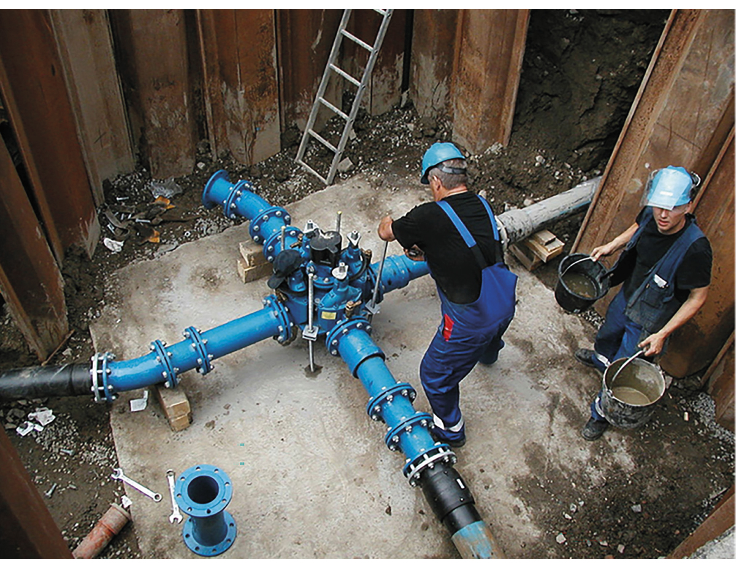
          - Renewal and maintenance of the water supply network is important for safe drinking water.
Photo: City of Oslo Agency for Water and Sewerage Works, Simen Strand Jørgensen.
              - Chinese economic policy instruments
During the work to build a backup water supply for the City of Oslo, the City of Oslo Agency for Water and Sewerage Works discovered that a bidder in the main tendering round was a Chinese company in a joint venture with a Spanish company. This Chinese company is known to have links to the Chinese Government and the People’s Liberation Army. As a result of the links to China, there is a risk that Chinese intelligence may gain access to and information about critical Norwegian infrastructure. The Norwegian National Security Authority assisted the City of Oslo Agency for Water and Sewerage Works with advice and guidance on how to protect important assets. This resulted in the Chinese supplier not being selected in the tendering round.
Source: Norwegian National Security Authority, Risiko 2023 [Risk 2023]
[Boks slutt]
Critical infrastructure can also be the target of acts of sabotage. This includes both physical damages, but also contamination of sources and attacks on digital infrastructure and power supply. Through contracts on the supply of equipment and services, foreign governments can gain access to information about critical Norwegian infrastructure. Norwegian enterprises that manage important assets, including waterworks, must be aware of hidden supplies of equipment and services.
Changes in technology have made water supply systems more vulnerable to shortages of basic intermediate goods. These include both technical equipment and chemicals necessary to maintain the production of drinking water. These products are part of the global trade in goods, and access is often dependent on conditions outside Norway’s borders. Furthermore, the water sector has undergone extensive digitalisation and is potentially more vulnerable to cyber threats.
Based on the current and future threat and risk situation and the identified vulnerabilities, it is necessary to implement actions. This involves reducing vulnerabilities in the water supply systems (especially with regard to the distribution system) and strengthening the work on security and emergency preparedness (competence, planning, exercises, backup water, emergency water, security of supply, ICT security, physical security, supervision, etc.).
Funding and organisation
In 2021, the Ministry of Local Government and Regional Development, the Ministry of Climate and Environment and the Ministry of Health and Care Services commissioned a feasibility study to highlight the potential for improving the efﬁciency of the water and wastewater sector. The report describes that water and wastewater organisations should be equipped to ensure that they are better able to use the appropriate technologies and working methods to catch up with the backlog in improving the water and wastewater network. Smaller municipalities in particular face challenges with access to competence, and the professional environments are small. According to the report, regional organisation of the municipal water and wastewater units, combined with more state governance of the sector, will be the most socioeconomically beneficial to address the challenges in the sector. Municipalities and waterworks companies should consider whether the organisational structure enables them to deliver satisfactory services in the face of the risk situation and identified vulnerabilities in the water supply, or whether other forms of cooperation are necessary with regard to civil protection. A recent report from Norsk Vann describes various organisational forms for the municipal water and wastewater sector. The report presents examples of different forms of inter-municipal cooperation and the factors that should be considered.
              - Example of inter-municipal cooperation in the water and wastewater sector
Glåmdalen Interkommunale vann- og avløpsselskap (Glåmdalen Inter-Municipal Water and Wastewater Company (GIVAS IKS)) stands out among the inter-municipal companies. This is the only inter-municipal company that has taken over responsibility for the entire water and wastewater production chain.
The cooperation started with two municipalities, when the need for a new water source became acute for one of the municipalities. This has subsequently developed as several neighbouring municipalities have seen the benefits from the cooperation. Building a robust and professional environment has been an important motivation, where joint emergency preparedness was a specific topic.
Source: Norsk Vann, report 281/2023
[Boks slutt]
Major investments are needed to increase the rate of renewal in the water mains. Municipal drinking water services are generally fully funded by water fees to subscribers according to the full cost principle. Increases in municipal charges result in increased expenses and living costs for residents, and involve difficult political trade-offs. There is a broad consensus that charges should be kept at a low level. At the same time, a lack of investment will result in a situation involving a low replacement rate. Furthermore, the water supply is in a monopoly situation which may entail insufficient attention to whether operations are efficient or can be optimised. According to the Office of the Auditor General’s report on the authorities’ work on safe drinking water, the chief municipal executives believe that the most important obstacles to the renewal of the water supply network are factors related to funding and to competence and recruitment. The Office of the Auditor General finds it unacceptable that not enough measures have been implemented to achieve the goals of reducing leaks and renewing the water mains for drinking water. They note that there is insufficient management data and knowledge, and that there is a need to look at legislation, policy instruments and funding models. In the feasibility study, identified weaknesses are small professional environments and opposition to inter-municipal cooperation.
The Norwegian Government will consider whether, and how, various measures can contribute to municipalities upgrading water and wastewater facilities and infrastructure in the best possible manner. Measures to be considered include stronger state instructions, measures that can stimulate stronger professional environments and greater inter-municipal cooperation, as well as advantages and disadvantages associated with the funding schemes in the water and wastewater sector. The full cost pricing principle shall continue to be a guiding principle.
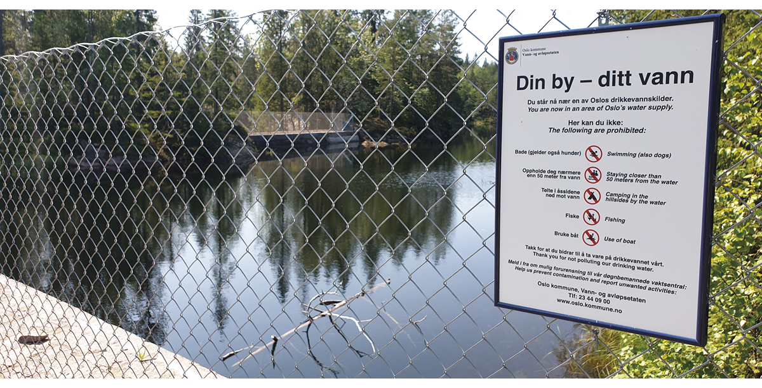
          - Signage and fencing of drinking water sources is an important and sound measure to avoid water contamination.
Photo: Anders Bekkelund.
Competence and knowledge
In Norway, there are just over 1,300 water supply systems supplying more than 50 people. In addition, there are a number of smaller, private water supply systems. In the face of the risk situation and vulnerabilities in the water supply systems, a lack of competence and limited cooperation between municipalities in the water and wastewater sector are challenges. In 2017, the National Waterworks Crisis Support Team was established to ensure support for the waterworks in handling incidents that may affect the water supply. Waterworks owners can receive advice from a broad knowledge environment and persons with extensive experience from waterworks operations. This contributes to reducing the adverse consequences of incidents that affect the water supply, including consequences arising from disruptions.
Stronger professional environments in water and wastewater, for example through more cooperation between municipalities, are necessary to reduce vulnerability and risk. There are also challenges in adopting new and advanced technology, and there are few subscribers among whom costs can be distributed in small municipalities. Knowledge and innovation are needed to reduce vulnerabilities in the water supply.
Increased competence requires further stimulation to increase educational capacity and technological development, as well as the adoption of new technology. A programme for technological development in the water sector shall be evaluated. The evaluation will form a basis for assessing continuation, including the need for adjustment or expansion.
              - Programme for technological development
The programme for technological developments in the water sector aims to stimulate rethinking and innovation, and targets the municipalities as waterworks owners. The goal is to achieve a healthier water supply and greater security of supply of drinking water in a cost-effective and sustainable manner. The programme shall stimulate both the development and testing of new technology. The programme had its first call for proposals in 2021 and awarded grants to 23 projects during the first two years. Examples of projects that have received funding to date are the development and testing of:
- Satellite-based data for streamlining leak detection.
- Sensor networks for monitoring drinking water networks to detect leaks.
- Intelligent membrane system technology for backup water supply.
- Safer water supply through increased use of pipe liners when renovating pipes.
- Stable and energy-efficient water supply in coastal municipalities.
Source: The Norwegian Institute of Public Health
[Boks slutt]
Better reporting systems
The water supply systems annually report a number of data to the Norwegian Food Safety Authority. The current system for reporting drinking water data is outdated, resource-intensive, does not provide an overview of or the opportunity to describe the status when needed, and does not provide sufficient management data to be able to implement targeted measures. The system limits the municipalities’ opportunities to use digital systems the municipalities already have. The Ministry of Health and Care Services has asked the Norwegian Food Safety Authority to commence work on facilitating digital reporting in the area of drinking water. This will contribute to a better knowledge base for targeting efforts to reduce vulnerabilities in the water supply and contribute to safer drinking water, nationwide.
Revision of national goals for water and health
The Norwegian Government will set new goals for water and health with a cross-sectoral implementation plan to reduce vulnerabilities and increase the resilience of the national water supply. The need for stricter regulatory requirements will also be assessed. A more comprehensive discussion of expectations for the municipalities’ work on drinking water supply is included in the National expectations regarding regional and municipal planning (2023–2027).
The role of the Norwegian Food Safety Authority
The Norwegian Food Safety Authority shall guide and supervise the water supply systems, as well as obtain knowledge regarding the status and situation. Where appropriate, drinking water and wastewater should be considered in conjunction with each other. The Norwegian Food Safety Authority and the supervisory authorities in the area of wastewater should be coordinated vis-à-vis the municipalities. The Norwegian Food Safety Authority will be asked to ensure that the municipalities follow up the point in the National expectations regarding regional and municipal planning 2023–2027, that drinking water supply shall be included in the assessment of civil protection in the social part and land-use part of the municipal master plan. In addition, consideration will be given to whether legislation relating to drinking water should be amended with a view to increasing the robustness and security of the water supply.
There are emergency preparedness plans for about 90 per cent of the water supply systems, but only about half of the plans are up to date. Furthermore, emergency exercise have been carried out for around a third of the systems in the past year. Based on the threat and risk situation, the Norwegian Government will consider the need for clarifying the requirements in the Drinking Water Regulations. The Ministry of Health and Care Services has asked the Norwegian Food Safety Authority to enhance guidance and supervision of security and emergency preparedness in the water supply. This will encompass security of supply, updating plans and carrying out emergency preparedness exercises. In order to clarify the Norwegian Food Safety Authority’s coordinating role in relation to security and drinking water emergency preparedness, the Norwegian Government will establish a committee at the agency level for water, cf. section 2.2.1.
Security and emergency preparedness in the water supply
Emergency preparedness in the water and wastewater sector is closely linked to other emergency preparedness in the municipality and the region. Up-to-date planning, interaction and exercises are essential for being able to handle incidents. This involves everything from emergency water cooperation to crisis communication with residents. Practice in incident management and good systems for interaction are key aspects in making this work. The Norwegian Government has designated a response team for cyber security for the municipalities, cf. section 4.2. This will also contribute to strengthening the security work for municipal waterworks.
Together with Finland and Sweden, Norway uses a lot of surface water for drinking water. Therefore, large amounts of water purification chemicals are used for both drinking and wastewater. The countries also have companies that are important in a Scandinavian and European context to ensure access to and production of water purification chemicals. In line with the Nordic Public Health Preparedness Agreement, cooperation has been strengthened, and work is underway to examine the need and opportunities for measures to strengthen own emergency preparedness in the area.
Waterworks owners shall ensure that subscribers have access to drinking water at all times. According to the Norwegian Food Safety Authority, many water supply systems lack plans and measures that provide adequate security of supply. In the period 2018 to 2020, the Norwegian Food Safety Authority implemented an action plan to ensure progress in the work to establish good security of supply. Deficiencies related to backup water supply are being improved, and the proportion of residents connected to alternative water supplies will increase from 67 per cent today to almost 80 per cent when this is implemented in Oslo.
Even with good prevention, situations may arise when the ordinary distribution system cannot be used. In such cases, it will be necessary to distribute drinking water using tanks, water cans or similar – referred to as emergency water supply. Municipalities shall have plans for emergency water supply as part of their emergency preparedness plans. There is currently no national overview of emergency water supply in the municipalities. There is a need to identify the extent to which the municipalities have followed up the work and what proportion of the population can be supplied with emergency water, as well as whether vulnerable groups and hospitals and other health institutions will be covered and have the opportunity to receive emergency water. The Norwegian Directorate of Health’s latest RVA analysis from 2019 highlights partly unclear responsibilities in emergency preparedness for and supervision of emergency water supply to health institutions in situations where ordinary distribution is not available. This includes drinking water, sanitary water and other necessary utility water that health and care services depend on to carry out their social mission. The Norwegian Government will assess the situation for emergency water supply and review any needs and measures.
The Norwegian Government will:
- establish a national committee at the agency level for safe water supply
- assess the situation for emergency water supply and assess the need for measures
- reduce vulnerabilities and increase water supply resilience, including by setting new water and health goals with a cross-sectoral implementation plan

Nuclear emergency preparedness
A changed threat and risk situation for nuclear emergency preparedness
A nuclear incident would affect society as a whole. The release and spread of radioactive substances can have consequences for life, health, the environment and other important public interests. A major nuclear incident abroad would also have major consequences for Norway and Norwegian interests, including major consequences for food production and impacts on food supply. The 1986 nuclear accident in Chernobyl is still the largest source of radioactive contamination in Norwegian food chains, land areas and freshwater systems. Russian warfare in Ukraine has increased the risk of a nuclear incident at Europe’s largest nuclear power plant in Zaporizhzhia. Since Russia’s full-scale invasion of Ukraine on 24 February 2022, nuclear emergency preparedness has been increased.
Europe’s nuclear power plants are aging and the risk of serious accidents is increasing. The Fukushima and Chernobyl accidents showed that nuclear incidents can have major consequences. Furthermore, there are changes in technology that affect the risk situation. This includes new types of weapon systems, mobile reactors and floating nuclear power plants.
A nuclear incident abroad may also have implications for Norwegian citizens travelling to and from or nearby the area. A nuclear incident abroad can also lead to mass migration of people with a need for accommodation and medical follow-up upon entry, which will require considerable efforts from many sectors.
The Total Preparedness Commission highlights the risk of when more countries develop nuclear weapons, there is a greater chance for nuclear material and radioactive sources ending up outside government control and be used to create improvised nuclear or radiological weapons. Furthermore, it notes that security policy changes could jeopardise international cooperation on nuclear safety and non-proliferation of nuclear weapons. The prospects for continued and new agreements on arms control and disarmament of nuclear weapons are uncertain, and there is a risk that new countries will seek to develop nuclear weapons or acquire the capacity to develop them. Russia’s threats to use nuclear weapons under certain conditions in connection with its war against Ukraine are serious. Furthermore, traffic with nuclear-powered vessels along the Norwegian coast is increasing. An accident involving such a vessel could result in radioactive pollution that affect Norway.
The Defence Commission has expressed that developments in the security situation indicate the need to strengthen nuclear emergency preparedness in many sectors. Furthermore, the Defence Commission has noted the need to continue and develop cross-sectoral efforts. The Total Preparedness Commission has also clearly highlighted the strength of today’s cross-sectoral cooperation. The Total Preparedness Commission has also recommended that nuclear emergency preparedness work be subject to a national assessment and prioritisation in light of changes to the risk and threat situation.
Norway is entering a phase where the nuclear reactors at Kjeller and Halden are to be decommissioned. This means that they are to be dismantled, removed and that radioactive waste must be handled. This process involves risk because the plants are old and will undergo major changes during the period in which this will take place. After the research reactors were closed in 2018 and 2019, there has been limited transport of nuclear material in Norway. In the process of decommissioning, there is a risk of undesirable incidents involving both accidental and intentional acts. The risk will vary over time and during the different phases of handling radioactive material, including transport and storage.
There are many radioactive sources in Norway, including in industry. Accidents related to these sources, or loosing control of the sources can also pose a health risk.
Strengthening prevention of nuclear and other radiation protection incidents
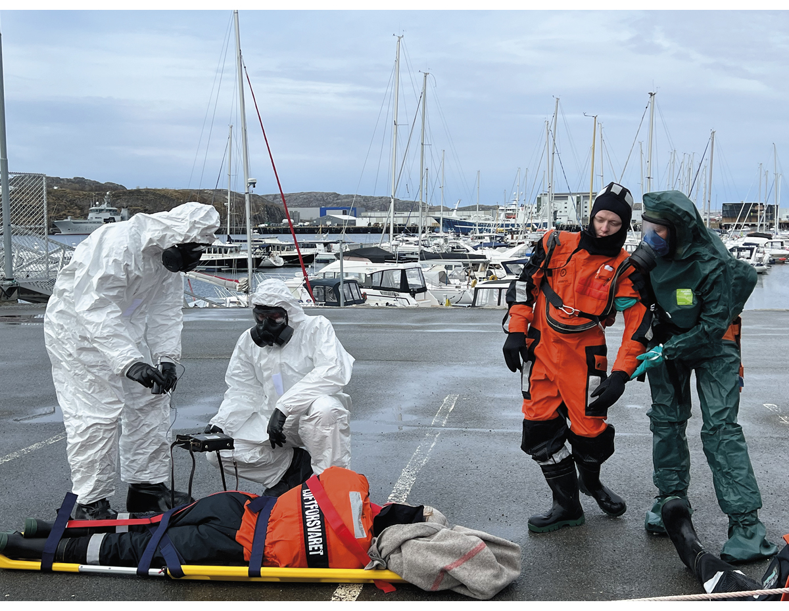
          - In May 2023, Norway’s first full-scale nuclear emergency preparedness exercise, Arctic RHEIN, was conducted.
Photo: Arctic RHEIN, Norwegian Directorate for Civil Protection.
Sound management and clear regulations contribute to strengthening preventive efforts and reducing the risk of nuclear incidents, nationally. For Norway, this includes requirements for – and supervision of – the Norwegian nuclear facilities, the arrival of reactor-powered vessels, other types of use of radioactive sources and the handling of radioactive waste, including used nuclear fuel. In 2019, the International Atomic Energy Agency (IAEA) conducted an audit of the Norwegian public administration to assess the effectiveness of national infrastructure and national legislation on radiation protection and nuclear safety. The review showed that much of this was good. The IAEA noted that the cross-sector and civil-military cooperation in nuclear emergency preparedness was an example of good practice that can be followed by other states. At the same time, the review also indicated a need for improvements. This applied, among other things, to matters surrounding the strategy for handling radioactive waste, security, competence and resources. Follow-up of the recommendations is ongoing and carried out in collaboration with national actors and the IAEA.
Norway works actively internationally to reduce the risk of serious accidents, radioactive contamination and nuklear material getting lost. The international work is an integral part of the work on threat assessment, risk understanding and emergency preparedness in Norway. International cooperation on nuclear safety must be continued and developed, including through the IAEA, the European Atomic Energy Community (Euratom) and the OECD’s Atomic Energy Agency.
Development of warning systems, situational awareness and analysis
There is extensive international cooperation on warning and surveillance capacities, both linked to the IAEA and Euratom. In addition, Norway has a number of bilateral agreements on reporting and information exchange. Norway has a functioning surveillance and reporting system, but there is a need to consider updating the existing system. Among other things, the measuring capacity in Northern Norway will be strengthened.
Nuclear emergency preparedness requires rapid response and coordinated measures in several sectors, at different levels and in different geographical locations. In the event of an incident, there will immediately be a strong need for information in the population and to support decisions regarding measures. Critical factors include data access in order to assess exposure and risk, the capacity to carry out analyses and interpretation, as well as the capacity to communicate updated knowledge adapted to different target groups. It is important to have good systems and plans for this with the actors who are part of nuclear emergency preparedness organisations, which must be ready and practiced regularly, such as the coordinated planning system of the Crisis Committee for Nuclear Preparedness.
Systems and plans must, among other things, include the possibility of as fast as possible establishing an emergency preparedness registry to gain an overview of health risks and consequences, as well as to cover other knowledge needs that are relevant for handling a nuclear incident, cf. the Health Preparedness Act. The Norwegian Radiation and Nuclear Safety Authority and the Norwegian Institute of Public Health shall, in collaboration with other relevant agencies, prepare the establishment of an emergency preparedness registry for nuclear incidents.
              - Norway’s largest nuclear emergency preparedness exercise
In the spring of 2023, the exercise Arctic REIHN (Arctic Radiation Exercise in High North) was conducted in Norway. This was Norway’s largest exercise for a nuclear incident, and was organised in collaboration between the Norwegian Directorate for Civil Protection, the Norwegian Radiation and Nuclear Safety Authority, the Norwegian Coastal Administration and the Joint Rescue Coordination Centre of Northern Norway. The exercise involved broad participation of rescue and emergency resources from Norway and abroad. In total, over 300 participants from seven European countries took part, in addition to observers from 31 countries. The main purpose of the exercise was to practice cross-sectoral cooperation and local, regional and domestic management, as well as practice in receiving international assistance in rescue operations and handling. The planning and implementation of Arctic RHEIN provided useful experiences that are taken into account in the further cross-sectoral work to strengthen nuclear emergency preparedness
Source: Norwegian Directorate for Civil Protection
[Boks slutt]
Review of organisation and decision-making processes in nuclear emergency preparedness
The national nuclear emergency preparedness is dimensioned based on various scenarios for nuclear accidents and incidents that may involve ionizing radiation or the spread of radioactivity. Nuclear incidents include accidents and incidents as a result of intentional acts in peacetime, security crises and armed conflict.
Nuclear emergency preparedness in Norway is the constitutional responsibility of the Minister of Health and Care Services. Furthermore, Section 16 of the Radiation Protection Act grants the King authority to organise nuclear emergency preparedness. During an acute phase, the King may, unimpeded by the allocation of authority in other laws, order state and municipal bodies to implement evacuation, restriction of access to areas and measures related to securing foodstuffs, including drinking water and the protection of animals. Implementation of measures is regulated in sectoral acts, including the Police Act, the Pollution Control Act and the Food Act.
Authority to determine the defined measures in an acute phase has since 2013 been delegated to the Crisis Committee for Nuclear and Radiological Emergency Preparedness and Response by a Royal Decree. The Crisis Committee for Nuclear and Radiological Emergency Preparedness and Response is chaired by the Norwegian Radiation and Nuclear Safety Authority, and is a cross-sectoral committee with representatives from central authorities who have a special responsibility in the event of a nuclear incident. In addition, the Crisis Committee for Nuclear and Radiological Emergency Preparedness and Response has advisers as a professional support system from institutions and agencies with special competence related to nuclear emergency preparedness. The county governors and the Governor of Svalbard comprise the Crisis Committee for Nuclear and Radiological Emergency Preparedness and Response’ regional branches. The Crisis Committee for Nuclear and Radiological Emergency Preparedness and Response’ decisions on the implementation of measures require consensus among the Committee’s members. Measures that affect military matters and operations must always be cleared with the Ministry of Defence. Furthermore, according to the current Royal Decree, government ministries or the Norwegian Government have no powers, entailing that political decisions in a nuclear incident must, pursuant to the Radiation Protection Act, be taken by the King in Council.
The Crisis Committee for Nuclear and Radiological Emergency Preparedness and Response also has tasks in the ongoing emergency preparedness efforts, and serves as an adviser to the authorities in the late phase of a nuclear incident.
In accordance with the sectoral principle, the government ministries are responsible for ensuring that emergency preparedness within their respective sectors is satisfactory and coordinated with other sectors. In the event of any nuclear incidents, the individual government ministries and specialist authorities are responsible for measures where the powers have not been assigned to the Crisis Committee for Nuclear and Radiological Emergency Preparedness and Response. The relevant ministries’ cooperation in the ongoing emergency preparedness efforts is organised through the Civil Servant Group for Coordinating Nuclear and Radiological Preparedness, which is chaired by the Ministry of Health and Care Services. In the event of a serious nuclear incident, the Norwegian Radiation and Nuclear Safety Authority and/or the Crisis Committee for Nuclear and Radiological Emergency Preparedness and Response shall immediately notify the Ministry of Health and Care Services, the designated lead ministry, other affected government ministries and the Office of the Prime Minister. The Crisis Council ensures the coordination at the government ministry level through the lead ministry. In addition, the entire emergency preparedness organisation shall be notified, and the incident shall be reported internationally.
It is important to ensure good emergency preparedness for local incidents with an accident site in Norway. According to the Police Act, the police shall organise and coordinate the relief effort at the scene of the accident until responsibility is taken over by another authority. This also applies to nuclear incidents. A local incident with rapid development will depend on clear and rapid decision-making processes locally, where emergency services, rescue services and municipalities will be the central actors, with assistance and advice from the specialist authorities. The county governors shall ensure the coordination of regional and local measures in the event of a nuclear incident. In the event of incidents that affect Svalbard, the Governor and Longyearbyen Community Council will be included. Nuclear incidents are included in the Governor of Svalbard’s risk and vulnerability analysis 2022–2026.
Experiences from exercises, pandemic management, changes in central health administration and developments in the international security situation, including long-term heightened nuclear emergency preparedness for the Crisis Committee for Nuclear and Radiological Emergency Preparedness and Response in connection with the war in Ukraine, give reason to review current nuclear emergency preparedness to ensure that it is organised and functions appropriately today.
On this basis, the Norwegian Government will review the Radiation Protection Act and the Royal Decree on nuclear emergency preparedness. In the work, it is important to continue the provisions in the current legislation that work well. Based on, among other things, experiences from the COVID-19 pandemic, the review will also assess whether the existing Royal Decree sufficiently clarifies the need for political consideration of intrusive measures of considerable societal significance. At the same time, it must be ensured that measures can be implemented as quickly as possible at the correct level to protect life, health and other values. The emergency preparedness system must allow for flexibility in response so that the measures are adequate to different situations and the development of situations. There must be clear criteria for what does and does not constitute an acute phase, so that there is no uncertainty about the scope and duration of the authorisation given to the Crisis Committee for Nuclear and Radiological Emergency Preparedness and Response. There is also a need to review responsibility and reporting procedures at all levels. The Radiation Protection Act shall be assessed to determine whether it should contain a legal authorisation for the imposition of measures that may be necessary in any nuclear emergency preparedness context. There is also a need for a review of members of the Crisis Committee for Nuclear and Radiological Emergency Preparedness and Response and the advisory group.
A nuclear incident affects society as a whole, and different responsibilities and a wide range of considerations must be safeguarded. The review of the legal framework for nuclear emergency preparedness will therefore involve all affected government ministries and responsible sector authorities.
Strengthen the Norwegian Radiation Protection Authority’s capacity and competence for handling nuclear incidents
The Norwegian Radiation Protection Authority is an agency with considerable professional competence, and with good capacity adapted to a normal situation. The Norwegian Radiation Protection Authority and the Crisis Committee for Nuclear and Radiological Emergency Preparedness and Response have, however, worked for an extended time with heightened emergency preparedness, and on extensive handling and coordination linked to an increased risk of a nuclear incident in Ukraine due to Russia’s warfare. A nuclear incident will, within a very short time, require considerable resources and interdisciplinary competence to analyse the situation and ensure communication, advice and guidance to the Norwegian Government, the health service, other sectors, municipalities, county governors, the business sector and the general population. In addition, there is a need to ensure capacity and competence to assess the societal, environmental, economic and health consequences of nuclear incidents and necessary measures. It is assumed that much can be ensured by the actors in the Crisis Committee for Nuclear and Radiological Emergency Preparedness and Response and the advisory group.
The Norwegian Government will assess how to ensure sufficient capacity and necessary competence for the Norwegian Radiation and Nuclear Safety Authority in a major crisis and war linked to a nuclear incident, including assessing the need for planning and agreements with other agencies and organisations. This includes, among other things, the ability to assist with different types of competence from the Crisis Committee for Nuclear and Radiological Emergency Preparedness and Response’s other members and advisors related to, among other things, analyses, information work and advice. E.g, the Norwegian Directorate of Health shall assist in information work on health matters in the event of nuclear incidents. It must also be considered how an expert group described in Chapter 2 can contribute if there is a need for more long-term comprehensive analyses.
In the event of a major incident linked to war, terror or threats from other states, there is an increased risk of simultaneous or complex incidents. This will entail a challenge related to overall capacity in several sectors and a need for broad cross-sectoral coordination. Challenges involving simultaneous events must be assessed in nuclear emergency preparedness.
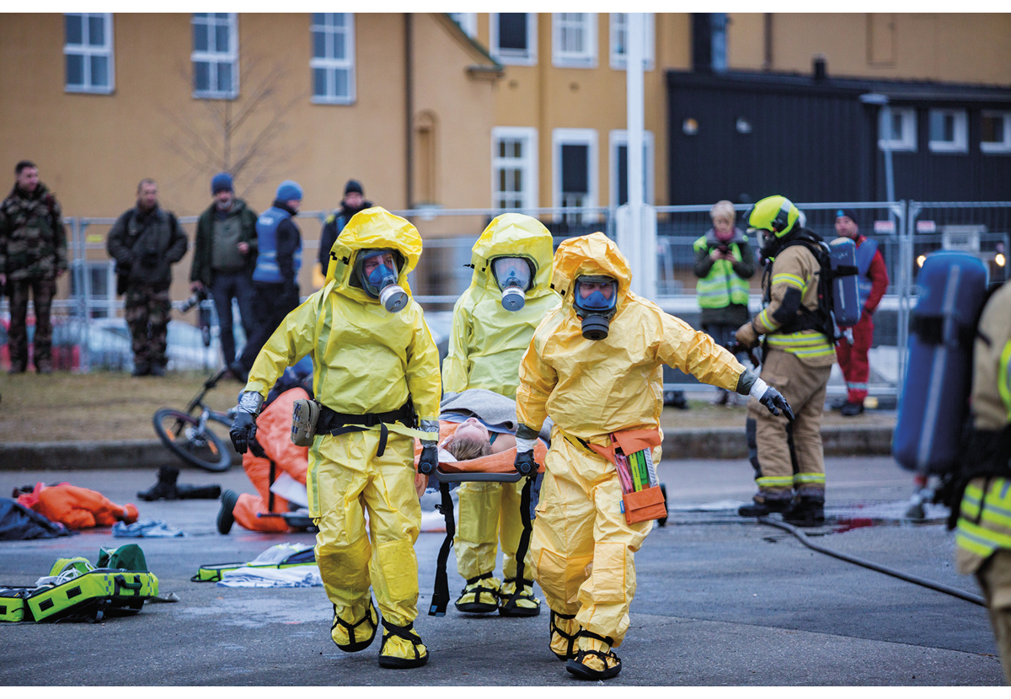
          - Local emergency services and the rescue service practice a nuclear incident in Norway.
Photo: The Norwegian Armed Forces, Frederik Ringnes.
Further develop and strengthen the work with scenarios in nuclear emergency preparedness
Nuclear emergency preparedness is based on six dimensioning scenarios. As part of the work on developing scenarios for health crises in general, the Norwegian Government will assess the scenarios for nuclear incidents, including what these entail in terms of requirements for emergency preparedness in all sectors. This includes access to the necessary equipment for measuring radioactivity and cleaning equipment, in addition to medical devices for, among other things, protection and measures in the environment that also include handling radioactive waste following an incident. Furthermore, health services’ capacity to handle a major nuclear incident with mass casualties shall also be assessed. Through the establishment of the Health Emergency Preparedness Council, where the regional health authorities participate together with the Norwegian Radiation and Nuclear Safety Authority, the Minister of Health and Care Services will strengthen the health service’s work on emergency preparedness to handle casualties related to nuclear incidents.
During an initial phase of a nuclear incident affecting Norwegian territory, the focus area at the municipal level will be characterised by local emergency services, rescue services and local authorities. There is a need for increased competence and capacity to be able to respond to a radioactively contaminated area. There is also a need to assess better national and regional support for municipalities in such crisis management.
The Government will strengthen nuclear emergency preparedness, partly by updating and expanding the scope of public information, including ensuring both broad and targeted dissemination to the population; expand the capacity for measurement and assessment, including the acquisition of more measurement equipment and protective equipment for emergency personnel; competence development, regionally and locally; procurement of modelling and analysis tools; as well as improved capacity to detect any emissions in the High North. The need for the development of classified means of communication will also be relevant to assess in nuclear emergency preparedness, cf. section 4.1.
Against the backdrop of a changed security situation, work is underway to assess a seventh scenario, which concerns the use of nuclear weapons on or near Norwegian territory. Measures shall be considered to address such a scenario.
The Norwegian Government will:
- further develop warning systems and strengthen nuclear emergency preparedness through expanded measurement capacity, competence development and modelling and analysis tools
- review the Radiation Protection Act and the Royal Decree for nuclear emergency preparedness to ensure an appropriate organisation of nuclear emergency preparedness
- strengthen the Norwegian Radiation and Nuclear Safety Authority’s capacity and competence to handle nuclear incidents through cross-sectoral cooperation

Economic and administrative consequences
Norway has enjoyed considerable peace, economic discretion and welfare for a long time. However, today’s threat and risk situation means that emergency preparedness must be given a higher priority than in the past. This is in addition to the fact that the scope of public expenditure in the Norwegian economy is expected to become tighter, which will require tough priorities at the societal level. This means that health emergency preparedness work must to the greatest extent and wherever possible be organised in a manner that is not more cost-driving than necessary.
In this Report, the Norwegian Government makes several recommendations on how we can strengthen the emergency preparedness. Several of the recommendations concern work methods to place emergency preparedness higher on the agenda in the health and care sector, and that considerations of emergency preparedness shall permeate all work in all parts of the sector. These are essentially recommendations that can be covered within the current budget framework. The recommendations that cannot be covered within the current budget framework will be assessed in relation to other priorities in the ordinary budget processes.
The Ministry of Health and Care Services
recommends:
Recommendation by the Ministry of Health and Care Services of 24 November 2023 on A Resilient Health Emergency Preparedness – From Pandemic to War in Europe be sent to the Storting.

Statistics Norway, StatBank Norway, table 13470. Employed as of the fourth quarter of 2023 by industry (SN 2007).
NOU 2023: 16 Evaluering av pandemihåndteringen [Evaluation of the pandemic management], NOU 2023: 14 The Defence Commission of 2021 – Forsvar for fred og frihet [Defence for peace and freedom] and NOU 2023: 17 Nå er det alvor – Rustet for en usikker fremtid [This is serious – Prepared for an uncertain future].
NOU 2012: 14 Rapport fra 22. juli-kommisjonen [Report of the 22 July Commission], Chapter 19, NOU 2022: 5 Myndighetenes håndtering av koronapandemien – del 2 [The authorities’ handling of the coronavirus pandemic – part 2], section 12.4 and NOU 2023: 16 Evaluering av pandemihåndteringen [Evaluation of the pandemic management], section 1.1.
The national health emergency preparedness plan provides a comprehensive overview of the structure of Norway’s health emergency preparedness, including the tasks and responsibilities of various agencies and bodies. The current plan is from 1 January 2018, cf. Nasjonal helseberedskapsplan – Å verne om liv og helse [National health emergency preparedness plan – Protecting lives and health].
Proposition to the Storting No. 1 (Resolution) (2023–2024) Ministry of Health and Care Services, pages 61–62.
Nasjonal helseberedskapsplan – Å verne om liv og helse [National health emergency preparedness plan – Protecting lives and health]. 1 January 2018.
Instructions for the government ministries’ work on civil protection (Civil Protection Instructions).
The Health Emergency Preparedness Council was established after the Second World War as the primary instrument for civil-military cooperation in the area of health. Today, health emergency preparedness has a significantly broader scope. The current civil-military Health Emergency Preparedness Council will henceforth be referred to as the Committee for Civil-Military Health Emergency Preparedness Cooperation, a name that better reflects the delimitation of its scope. The name Health Emergency Preparedness Council will be used for the new health emergency preparedness model described in this Report.
The current formalised civil-military cooperation arena, which in the Royal Decree of 19 November 2004 on the Health Emergency Preparedness Council’s mandate is referred to as the Health Emergency Preparedness Council, will be revised. The Ministry of Health and Care Services will propose that the Council be renamed the Committee for Civil-Military Health Emergency Preparedness Cooperation, a name that better reflects the delimitation of its scope. In this Report to the Storting, the Health Emergency Preparedness Council is used in the description of the new health emergency preparedness model.
Holden-I (COVID-19) 7 April 2020, Holden-II (COVID-19) 22 May 2020, Holden-III (COVID-19) 15 March 2021 and Holden-IV (COVID- 19) Main report, 5 April 2022.
NOU 2022: 5 Myndighetenes håndtering av koronapandemien – del 2 [The authorities’ handling of the coronavirus pandemic – part 2], Chapter 5.
Report to the Storting No. 15 (2022–2023) Folkehelsemeldinga – Nasjonal strategi for utjamning av sosiale helseforskjellar [Public health report – National strategy for equalising social health differences], section 10.4.
Report to the Storting No. 15 (2022–2023) Folkehelsemeldinga – Nasjonal strategi for utjamning av sosiale helseforskjellar [Public health report – National strategy for equalising social health differences], section 10.4.
Virksomhets- og økonomiinstruks for statsforvalteren [Enterprise and economic instructions for the County Governor], published by the Ministry of Local Government and Modernisation, effective from 1 January 2021.
Two expert groups were established, chaired by Simen Markussen, Senior Researcher at the Frisch Centre, and Mari Rege, Professor of Economics at the University of Stavanger, respectively. Markussen’s group was to explore efficient and secure infrastructures for the sharing and use of relevant statistics and data in crises. Rege’s group was to assess legal and ethical issues relating to the collection, accessibility, sharing and use of data, and the use of randomised trials during crises. These reports were published on 30 June 2022.
In this context, getting one’s house in order refers to knowing what data the enterprise is managing, what it means, and how it can be used and shared with others, cf. Veileder for orden i eget hus [Guidelines for getting one’s house in order] published on the Norwegian Digitalisation Agency’s website.
In 2020, the Norwegian Institute of Public Health established the emergency preparedness registry for COVID-19 (Beredt C19). Beredt C19 is an emergency preparedness registry where data from various sources is continuously linked in real time for monitoring and knowledge generation, to support pandemic management.
From regjeringen.no. Norge bør bruke data og analyser bedre i kriser [Norway should use data and improve analyses in crises]
In quasi-experimental studies, the effect is examined by comparing groups that are affected by a factor with groups that are not affected. The difference between such studies and randomised trials is that the groups are not composed randomly (randomisation), nor is the research conducted under controlled conditions.
Statistics Norway, StatBank Norway, table 13470. Employed as of the fourth quarter of 2023 by industry (SN 2007).
NOU 2022: 5 Myndighetenes håndtering av koronapandemien – del 2 [The authorities’ handling of the coronavirus pandemic – part 2].
The OECD’s statistics bank downloaded from stats.oecd.org.
NOU 2023: 4 Tid for handling – Personellet i en bærekraftig helse- og omsorgstjeneste [Time for action – Personnel in sustainable health and care services], Chapter 13.
Holden-IV (COVID-19) Main report, 5 April 2022.
NOU 2023: 4 Tid for handling – Personellet i en bærekraftig helse- og omsorgstjeneste [Time for action – Personnel in sustainable health and care services], section 8.4.7.
Proposition to the Storting No. 120 (Bill) (2022–2023) Endringer i lov om Statens pensjonskasse og enkelte andre lover (opphevelse av minstegrensen for rett til medlemskap) [Amendments to the Act relating to the Norwegian Public Service Pension Fund and certain other acts (rescindment of the minimum limit for the right to membership, cf. Recommendation to the Storting No. 37 (Bill) (2023–2024).
NOU 2023: 14 Defence Commission of 2021 Forsvar for fred og frihet [Commission of 2021 – Defence for peace and freedom], page 224.
The Norwegian Media Authority, 2021, Undersøkelse om kritisk medieforståelse i den norske befolkningen, delrapport 1 [Investigation into critical media literacy in the Norwegian population, partial report 1].
Borges do Nascimento IJ, Pizarro AB, Almeida JM, Azzopardi-Muscat N, Gonçalves MA, Björklund M, Novillo-Ortiz D. Infodemics and health misinformation: a systematic review of reviews. Bull World Health Organ. 2022 Sep 1;100(9):544-561.
Report to the Storting No. 15 (2022–2023) Folkehelsemeldinga — Nasjonal strategi for utjamning av sosiale helseforskjellar [Public health report –National strategy for reducing health unequity].
Psykososiale tiltak ved kriser, ulykker og katastrofer (Mestring, samhørighet og håp) [Psychosocial measures during crises, accidents and disasters (Coping, belonging and hope)] National guide published by the Norwegian Directorate of Health in 2016.
Report to the Storting No. 23 (2022–2023) Opptrappingsplan for psykisk helse 2023–2033 [Escalation plan for mental health 2023–2033].
NOU 2023: 17 Nå er det alvor – Rustet for en usikker fremtid [This is serious – Prepared for an uncertain future], Chapter 23.
NOU 2022: 5 Myndighetenes håndtering av koronapandemien – del 2, kapittel 2 [The authorities’ handling of the coronavirus pandemic – part 2, Chapter 2].
Skogstad et al. Post-traumatic stress among rescue workers after terror attacks in Norway, Occupational Medicine, Volume 66, Issue 7, October 2016, pp. 528–535.
NOU 2023: 16 Evaluering av pandemihåndteringen [Evaluating the pandemic management], Chapter 10.2.2.
Veikart for helsenæringen 2023 [Road map for the healthcare industry], page 10.
At the 2016 NATO Summit in Warsaw, Member States committed to strengthening national civil preparedness. This was concretised through the adoption of the Seven Baseline Requirements.
Report of the G20 High Level Independent Panel on Financing the Global Commons for Pandemic Preparedness and Response.
Norwegian Police Security Service. National Threat Assessment 2023.
NOU 2023: 14 Defence Commission of 2021. Forsvar for fred og frihet [Defence of Peace and Freedom], page 67.
The current formalised civil-military cooperation arena, which in the Royal Decree of 19 November 2004 on the mandate of the Health Emergency Preparedness Council is referred to as the Health Emergency Preparedness Council, will be revised. The Ministry of Health and Care Services will propose that the Council be renamed the Committee for Civil-Military Health Emergency Preparedness Cooperation, a name that better reflects the delimitation of its scope. In this Report to the Storting, the Health Emergency Preparedness Council is used in the description of the new health emergency preparedness model.
Ibid.
NOU 2023: 14 Defence Commission of 2021 – Forsvar for fred og frihet [Defence of Peace and Freedom], page 97.
Norwegian National Security Authority, Nasjonalt digitalt risikobilde 2023 [National Digital Risk Situation 2023].
NOU 2023: 14 Defence Commission of 2021 – Forsvar for fred og frihet [Defence of Peace and Freedom].
Europe’s Digital Decade. – https://digital-strategy.ec.europa.eu/en/policies/europes-digital-decade.
The disease-surveillance company Metabiota.
Norwegian Institute of Public Health, COVID-19, influenza and other respiratory tract infections.
Statistics Norway, COVID-19, tapt verdiskaping og finanspolitikkens rolle [Covid-19, lost value creation and the role of fiscal policy], April 2022.
Action Plan for better infection control with the goal of reducing healthcare-associated infections 2019–2023.
MSIS is a surveillance system for communicable diseases.
In 2020, Norwegian Institute of Public Health established the Emergency preparedness registry for COVID-19 (Beredt C19). Beredt C19 is an emergency preparedness registry where data from different sources are continuously linked in real time for surveillance and knowledge generation to support the handling of the pandemic.
Norsk Vann, report 259/2021. Kommunalt investeringsbehov for vann og avløp 2021–2040 [Municipal investment need for water and sewerage 2021–2040].
National Security Authority, Risiko 2023 [Risk 2023].
Mulighetsstudie for VA-sektoren med samfunnsøkonomiske analyser [Feasibility study for the water and wastewater sector with socioeconomic analyses]. Oslo Economics, COWI and Kinei. 7 January 2022.
Norsk Vann, report 281/2023. Possible organisational forms for the municipal water and wastewater sector.
Office of the Auditor General. Document 3:8 (2022–2023) Myndighetenes arbeid med trygt drikkevann [The Government’s Work on Safe Drinking Water].
Proposition to the Storting No. 1 (Resolution) (2022–2023) Ministry of Health and Care Services.
Reporting of data for water supply systems in Norway for 2021.
Norwegian Directorate for Civil Protection, Risiko og sårbarhetsanalyse av norsk matforsyning, 2017 [Risk and vulnerability analysis of Norwegian food supply, 2017].
NOU 2023: 14 Defence Commission of 2021 – Forsvar for fred og frihet [Defence of Peace and Freedom], Chapter 13.4 and NOU 2023: 17 Nå er det alvor – Rustet for en usikker fremtid [This is serious – Prepared for an uncertain future], Chapter 26.5.

