Gender Equality Strategy for the Maritime Sector
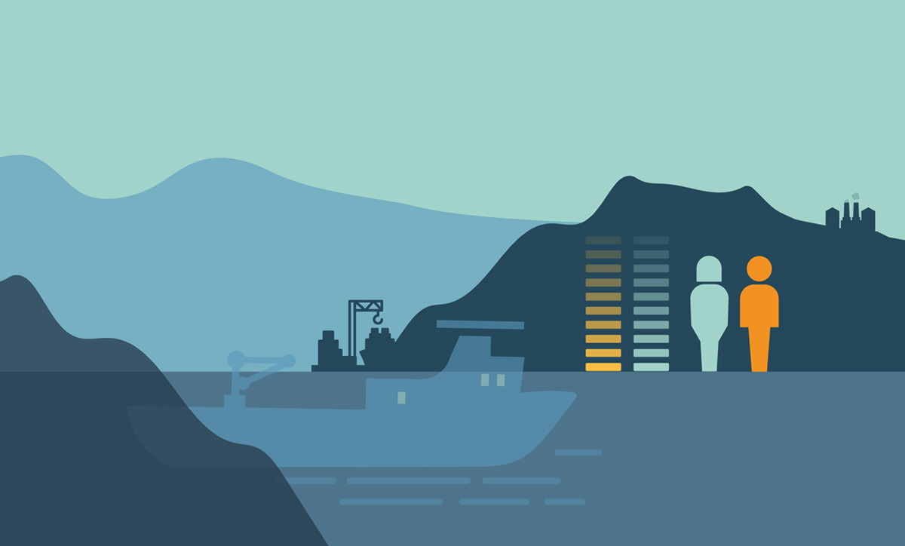

Overview of measures
- The Norwegian Government will take the initiative to draft a declaration of cooperation with the industry to work towards gender equality in the maritime sector, and to document future development concerning gender equality in the sector. The declaration should include objectives and a timeline and shall be prepared in cooperation with the parties to the declataration and the Norwegian Ministry of Culture and Equality.

Recruitment and role models
The Norwegian Government will:
- Initiate dialogue with the maritime educational institutions concerning how to increase recruitment from all genders.
- Initiate information campaigns relating to career opportunities in the maritime sector that are targeted at girls of lower secondary school age.

A working environment that benefits everyone
The Norwegian Government will:
- Include a diversity and gender equality perspective in all maritime policymaking.
- Use international arenas, such as the IMO and ILO, to promote gender equality and diversity in the maritime sector.
- Incorporate diversity and gender equality into the Norwegian mandate for the work on the revision of the International Convention on Standards of Training, Certification and Watchkeeping for Seafarers (STCW) in the IMO.
- Update descriptions for the courses that the Norwegian Maritime Authority prepares in cooperation with the maritime industry to ensure that gender-neutral terms are used.
- Update the wording of Norwegian maritime legislation to ensure that gender-neutral terms are used.
- Strengthen the Norwegian Maritime Authority’s information work on gender equality vis-à-vis the industry and employees.

A working life free from harassment
The Norwegian Government will:
- Ratify ILO Convention No. 190.
- Present a report to the Norwegian Parliament (white paper) on sexual harassment in 2024.
- Consider amendments to Norwegian maritime legislation to highlight and strengthen efforts to combat harassment.
- Strengthen the Norwegian Maritime Authority’s supervisory role in connection with harassment.

An adapted workplace
The Norwegian Government will:
- Assess the need for amendments to Norwegian maritime legislation to promote gender equality.
- Make amendments to the Equality and Anti-Discrimination Act to highlight that employees who are covered by the Ship Labour Act have the same protection under the Act as employees who have an employment relationship pursuant to the Working Environment Act.

Foreword
The maritime sector is part of our nation’s DNA. With its long and proud traditions, it has shaped our country and our culture, and it continues to constitute an economic engine in large parts of the country. In 2020, the industry employed over 60,000 people, the vast majority of which were men. The gender divide is particularly apparent among seafarers, where women only make up about ten percent of the workforce.
In working with the gender equality strategy, the Inland Norway University of Applied Science was tasked with carrying out a comprehensive study. The purpose was to survey the state of gender equality in the sector and to receive input on possible ways forward. As minister, I have had several input-meetings with the relevant stakeholders. And I have made it a point to get direct feedback from those that have their daily jobs in the sector.
What we have found is that the underrepresentation of women in the maritime sector is largely due to working terms and conditions, equipment and uniforms adapted to men, and challenges related to the working environment. Several women have experienced a lack of respect in the workplace, while others have faced harassment. Such conditions are completely unacceptable in our Norwegian labour market.
The good news is that we have the means to do something about this and improve the situation.
For the government, this is about safety for work, and safety at work. Equality is about fairness and equal opportunities and is an important value in itself. But equality is also the key to a good working environment, to innovation and value creation.
The maritime sector is international by nature and competition is high. The industry must go through a green and digital transition, which means that it is crucial to ensure recruitment from the entire population, both women and men. For the industry, it is important that Norwegian maritime jobs are perceived as attractive both for new arrivals and for those already in the industry.
We have identified four focus areas that will serve as building blocks as we promote greater equality in the sector. These are: recruitment and role models, a working environment that benefits everyone, a working life free from harassment, and an adapted workplace.
The launch of this strategy is only the beginning of the road ahead. We will have to follow-up on the proposed measures with commitment and continuous effort.
But what we are witnessing is the creation of a more equal and inclusive future industry.
The industry’s response to the work has been positive. That is encouraging because the most important steps to ensure equality must be taken by the industry itself.
One of the measures we are proposing, is a formal declaration of cooperation with the industry. This will allow us to set concrete targets and identify definite waypoints for evaluating the progress. And if need be, to adjust underway.
The maritime sector is global in reach, and we must continue our efforts for gender equality beyond our national borders. Therefore, the strategy has been translated into English, enabling our government to promote it in dialogue with our international partners.
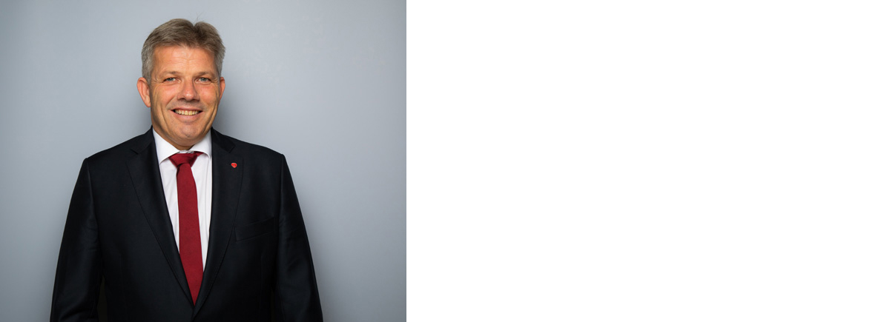
Bjørnar Selnes Skjæran
Minister of Fisheries and Ocean Policies
Photo: NTB Kommunikasjon / Statsministerens kontor

Introduction
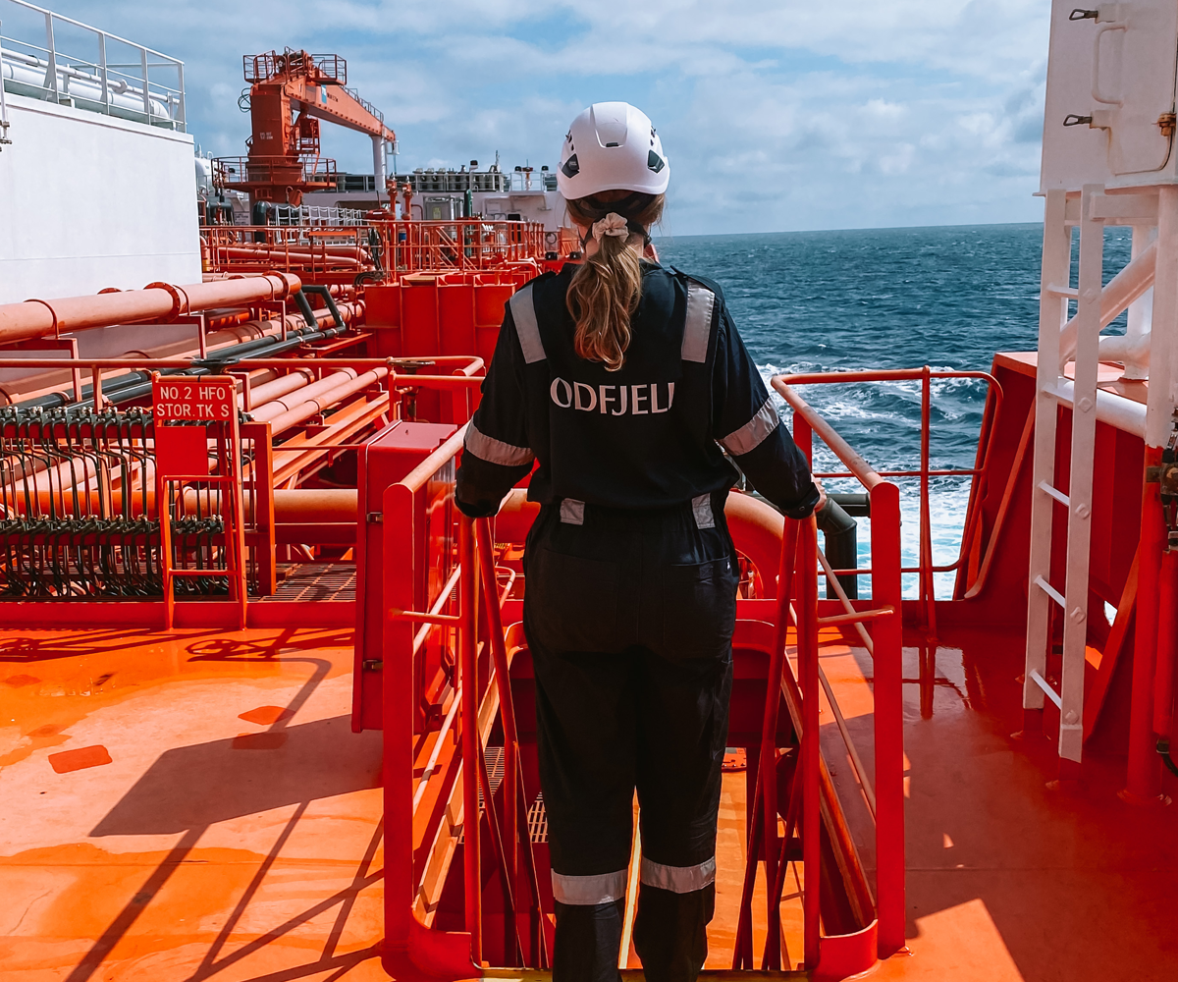
The maritime industry holds a key position among the Norwegian ocean industries. Moving into the future, the maritime industry will become greener and more digital. If we are to succeed with this transition, the industry needs competent people from the entire workforce – including both women and men. Gender equality is not only important in itself, it is also important for innovation, value creation and a good working environment.
Although Norway is one of the countries in the world with the highest gender equality, the Norwegian labour market is characterized by gender segregation. Only 15 per cent of employees in Norway work in a gender-balanced profession. That means a profession in which there are more than 40 per cent of both women and men. Almost 70 per cent of all the people who work in the public sector are women, while over 60 per cent of all the people who work in the private sector are men. In 2021, the overall proportion of women in the maritime industry was 21 per cent, while the proportion of women on board ships was 11 per cent. The fact that fewer women work in the maritime industry means that the industry is ineffective in utilising the potential of the entire workforce.
At the same time, until recent times, there has been little focus on gender equality and diversity in maritime policy and in maritime policy discourse. In 2021, the Norwegian Parliament (Storting) unanimously adopted a resolution mandating the Norwegian Government to draft a gender equality strategy for the maritime sector. This strategy follows up on the Parliament’s request and the Norwegian Government’s goal of increasing diversity in the labour market and improving gender representation in gender-segregated industries.
There are many and complex factors that influence the level of gender equality in the maritime sector. Gender-segregation manifests itself as early as in the choice of education. Factors such as interests, stereotypes, academic performance, and social background can affect educational choices. Women who work in the maritime industry have also referred to challenges relating to the working environment, attitudes, harassment, adaptation of equipment, the practical design of the workplace, working conditions and terms of employment. Some of these challenges are perceived as being more significant at sea than in the onshore maritime industry. There are also significant disparities between companies, positions, and different segments of the industry.
Work on gender equality and diversity in business is important for both gender equality policy as well as business policy objectives. The objective of the Norwegian Government’s work and this strategy is to strengthen gender equality and diversity in the maritime sector and to enable the industry to attract employees as well as maintaining its competitive advantage in the face of changes in the market and to society. The companies, and especially their management are responsible for facilitating equality and diversity in the workplace. The strategy has a particular focus on gender equality, and it is the Norwegian Government’s desire that more girls choose maritime education programmes and a maritime career path. There should be equal opportunities to participate at all levels of the maritime industry, including both on board ships and in onshore positions, irrespective of one’s gender. It is of decisive importance to gender equality in the maritime industry that women, not least those women who already work in the industry, consider it a safe place to work, free from harassment, and with the same opportunities as men in terms of career development. Increased gender equality in the industry will provide for a broader recruitment base, increased innovation ability and value creation.

Supporting documentation
The background documentation for this strategy primarily consists of Inland Norway University of Applied Sciences’ Report no. 8/2022 Likestilling og mangfold i maritim næring og utdanning – en kartlegging (Gender equality and diversity in the maritime industry and education – an assessment), which was commissioned by the Ministry of Trade, Industry and Fisheries. The report sheds light on the status and development of diversity and gender equality in the industry and in maritime education programmes, and the conditions that prevent and promote gender equality in the industry. When this strategy does not refer to other sources, the background figures and other basic information have been sourced from this report.
Between the autumn of 2021 and the autumn of 2022, input meetings were arranged with relevant stakeholders in the industry, including employee and employer organisations, companies, and educational institutions. The Ministry received a number of submissions during the meetings both in the form of reported experiences and proposed measures.

The Norwegian maritime industry
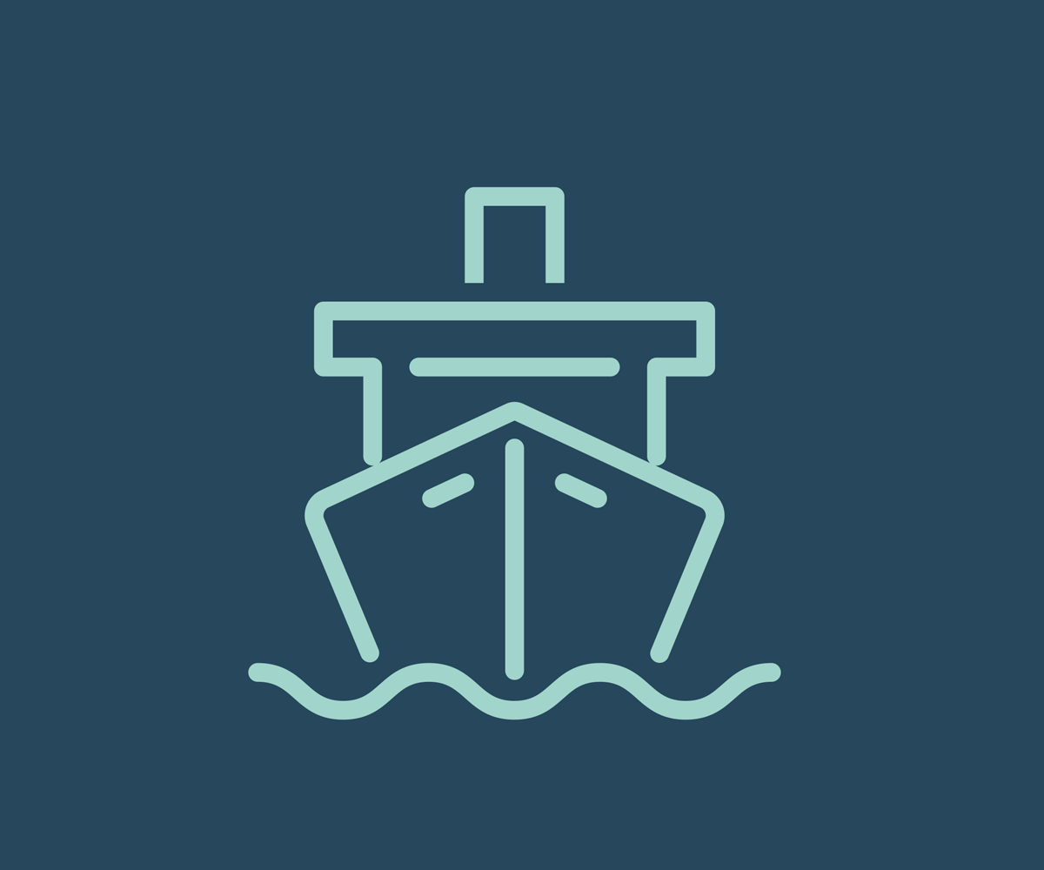
Norway’s maritime traditions date back a long time and we’ve been a significant shipping nation with a global presence for more than 150 years. The Norwegian maritime industry has developed into what is now one of the world’s most complete maritime communities, comprising enterprises in all parts of the value chain and with strong positions within specialised segments. The Norwegian maritime industry is made up of shipping companies, shipyards, equipment suppliers and specialised service providers. In 2020, the maritime industry saw added value worth around NOK 57 billion and employed some 60,500 people.
The Norwegian maritime industry’s competitive advantage is based on its ability to adapt when faced with changes in the market and in society. The maritime industry is currently undergoing one of the largest restructuring processes in modern times. At the same time as the market is changing and demanding new types of maritime products and services, maritime transport is to be decarbonised and digitalised. The ability of Norwegian maritime companies to be innovative has contributed to them taking a leading position in new and emerging market segments as well as within technologies relating to green shipping and digitalisation.
The Norwegian business sector and labour market are characterised by high levels of productivity and income when compared with other countries. In the maritime industry, Norwegian companies primarily compete within specialised segments and in parts of the value chain with a high level of knowledge, where advanced technology and expertise can offset part of the cost level. However, parts of the sector also use foreign labour with a lower cost level in parts of their production and services, including both in parts of the maritime industry and in shipping. Like the rest of the business sector, it can be expected that competition in the maritime industry in the coming years will be shaped by continuously more rapid technological development and the need for a continued high degree of innovation and expertise.

The industry’s access to expertise
The maritime industry recruits and is reliant upon expertise from a number of specialist fields and different levels of education. Access to a competent workforce is of major importance to the competitiveness of the Norwegian fleet and the maritime industry in general. The lack of expertise is considered one of the biggest barriers to further growth in the industry. The industry itself considers access to digital expertise to be of particular importance in the coming years due to the rapid development and use of new digital technology. The maritime industry is also characterized by the mobility of the workforce between different segments and between sea and land. Practical and operational experience from working at sea is considered important for the onshore maritime industry. Hence, the transfer of expertise between different segments is important for the industry’s competitiveness.
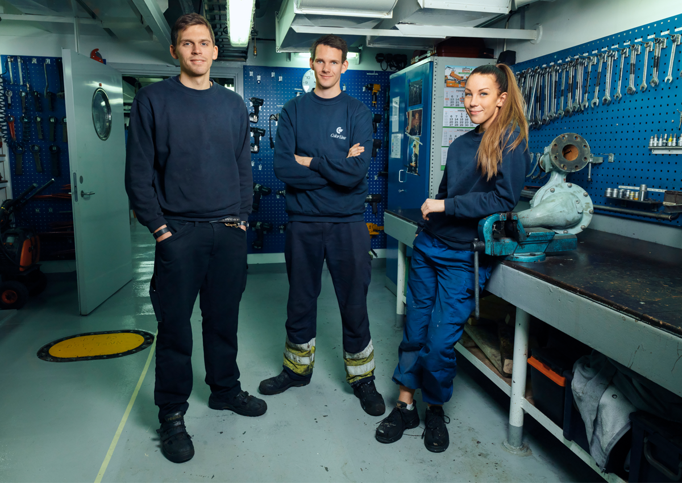
The maritime industry is dependent on recruiting and keeping skilled workers. Source: Arild Danielsen
In Norway, maritime education programmes are offered at a number of different educational levels. Maritime educational pathways at upper secondary and vocational school level, in addition to selected maritime education programmes at university and university college level, result in professional certificates.
The Norwegian certification system is based on requirements stipulated in international conventions such as the International Convention on Standards of Training, Certification and Watchkeeping for Seafarers (STCW). Several countries offer upper secondary education that combine vocational qualifications and university and college admissions certification, such as vocational competence and qualification for admission to university and college (Norwegian abbreviation YSK) and technical and general subjects (Norwegian abbreviation TAF). YSK and TAF give students the possibility to obtain both a trade certificate and university and college admissions certification within four years. These types of combined study programmes are offered in maritime courses at several upper secondary schools. The county authorities are responsible for upper secondary education.
I addition to skills linked with the running of the actual ship, the maritime industry is in demand of skills linked with other maritime activities, and recruits from a range of disciplines and educational levels. The need for skills in the service based sectors of the industry and the onshore organisations for the shipping companies include technology and engineering, computer science, finance and administration. Skilled workers and engineers are paramount to the equipment and shipbuilding industries. Finally, the industry needs workers with specialised maritime education and training, such as study programmes in shipping, logistics and ship design.
The maritime industry has traditionally been male dominated. The proportion of women in maritime study programmes is somewhat higher than the workforce in the maritime industry, however men make up a significant majority here as well. This means that in the coming years there will continue to be a preponderance of men among the graduates in maritime education programmes. The industry recruits workers from large parts of the world. While the Norwegian maritime industry primarily uses Norwegian labour, almost a quarter of the workforce has a different nationality.
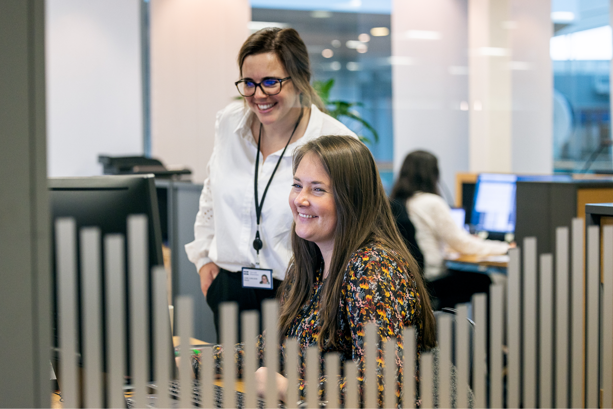
There are a number of different job opportunities in the maritime industry. Source: Torvald Klaveness
              - MARKOM
The MARKOM2020 project was established in 2011 to strengthen cooperation between educational institutions that offer maritime education and training. During the project period from 2011 to 2020, MARKOM2020 resulted in strengthened cooperation between educational institutions, knowledge-sharing and joint curriculum development. The project, financed by the Ministry of Education and Research, was in 2021transferred to the Norwegian Directorate for Higher Education and Skills (HK-dir). The continued initiative has been renamed MARKOM II and will have a particular focus on digitalisation and green shipping.

              - Stiftelsen Norsk Maritim Kompetanse (The Norwegian Maritime Competence Foundation)
Shipping companies that are part of the subsidy scheme for employing seafarers pay a monthly amount per employee eligible for subsidy to Stiftelsen Norsk Maritim Kompetanse (Norwegian Maritime Competence Foundation). The foundation administers the funds that are contributed. The purpose is to promote skills development and recruitment initiatives for Norwegian seafarers. The funds are used to finance training positions, to promote recruitment to the industry and for other projects in line with the foundation’s objectives.

Legislation
Working conditions in the onshore maritime industry are regulated by the Norwegian Working Environment Act and associated regulations. However, the Working Environment Act does not apply to «shipping, hunting and fishing». Working conditions at sea are regulated by the Ship Labour Act and the Ship Safety and Security Act with regulations. Nevertheless, both the general employment legislation and maritime legislation share the same primary features. The latter entails specific conditions that apply when working on board ships and reflect special requirements stipulated by international rules.
In many instances, working on board ships can be described as a «24-hour society», where employees have both their work and free time in the same place for extended periods of time. Against this backdrop, employees under the Ship Labour Act enjoy certain rights that are not found in the Working Environment Act. However, the opposite is also true. For example, the Ship Labour Act does not grant the right to leave of absence for breastfeeding, however employees have other rights, such as the right to full pay for up to 12 months in the event of incapacity for work caused by illness or injury.
Discrimination is prohibited in the labour market. The prohibition against discrimination based on gender, pregnancy, leave in connection with childbirth and adoption, care duties, ethnicity, religion, belief system, disability, sexual orientation, gender identity or gender expression is regulated in the Equality and Anti-Discrimination Act. Pursuant to Chapter 4 of the Equality and Anti-Discrimination Act, all employers have an obligation to make active, targeted, and systematic efforts to promote equality and prevent discrimination in the workplace. This is known as the activity- and reporting obligation.

International regulations
The maritime industry is a global industry. Based on the Convention on the Law of the Sea, the framework is primarily defined internationally through government organisations such as the International Maritime Organization (IMO) and the International Labour Organization (ILO).

IMO
The International Maritime Organization (IMO) develops global regulations for shipping. The organisation’s primary objective is to promote safe, efficient, eco-friendly, and sustainable shipping. Norway has been an active participant in IMO bodies since its establishment. Participating in areas where decisions are made will allow Norway to help lay the foundation for new and improved international regulations.
An important convention adopted by the IMO is the International Convention on Standards of Training, Certification and Watchkeeping for Seafarers (STCW). The Convention sets out qualification requirements for masters, officers, and other watch personnel on seagoing merchant vessels, and forms the basis for Norwegian maritime education programmes that result in the awarding of certificates. At Meeting No. 105 (April 2022) of the IMO Maritime Safety Committee (MSC), the MSC instructed the «Human Element, Training and Watchkeeping» subcommittee to prepare and finalise draft amendments to the training requirements in the STCW Convention targeting harassment and bullying, including sexual harassment as a priority.

ILO
The International Labour Organization (ILO) develops, monitors, and enforces international labour standards through conventions and recommendations. The organisation’s primary objective is to ensure decent work for all, including productive work that ensures social protection, dialogue between the parties in the labour market and workplace rights. Norway is a permanent member of the ILO’s governing bodies. ILO Member States are divided into different regional groups. Norway is a member of the group of industrialized market economy countries (IMEC) and can promote its interests through this group. Norway also has good cooperation with the other Nordic countries and with the EU, and often supports EU positions. The ILO has adopted 190 conventions and 206 recommendations. Norway has ratified 111 conventions, 74 of which have entered into force. The ILO’s 187 Member States are expected to submit annual reports on both ratified and non-ratified conventions.
The ILO plays a key role as regards working and living conditions for employees on board ships. Through the ILO, Norway actively contributes to developing good working conditions on board ships in the form of international social standards for shipping. ILO Convention No. 186 on the working and living conditions of seafarers (Maritime Labour Convention (MLC)) covers all essential aspects of working and living conditions on board ships. This includes the minimum age, health requirements, recruitment and work placements, employment contracts, payment of salaries, working hours and rest time, the shipping company’s responsibility in the event of illness and injury, cabins and leisure areas on board, work environment requirements and protection against occupational accidents. In Norway, the MLC has been implemented in the Ship Labour Act and the Ship Safety and Security Act, and the Norwegian Maritime Authority supervises compliance. The MLC is also included in the basis for port state inspection. ILO Convention No. 188 is intended to protect the working and living conditions of all fishers working on board fishing vessels. The Convention has been implemented into Norwegian law, and the Norwegian Maritime Authority overlooks the compliance.

Status of diversity and gender equality in the maritime industry and education
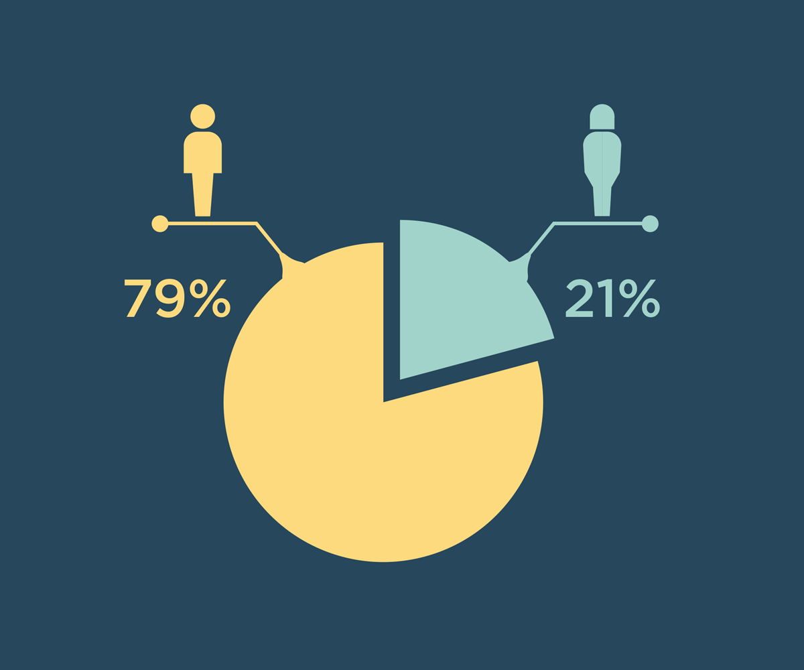
Inland Norway University of Applied Sciences was commissioned by the Ministry of Trade, Industry and Fisheries to assess the gender distribution in the various segments of the industry, the gender distribution in selected maritime education programmes and differences in pay between women and men. The resulting report shows that there is generally a low proportion of women in the maritime industry and in maritime education programmes and that women on average earn less than men. However, the industry has initiated several measures to recruit and retain women in the industry. These measures are discussed in more detail in Chapter 4.
In 2021, the proportion of women in the maritime industry was 21 per cent. For shipping and transport, the proportion of women was 11 per cent among employees on board ships, and 33 per cent among employees in onshore positions within shipping companies. As regards employees on board ships the proportion of women was particularly low in the categories of freight traffic and supply. The passenger transport category generally has a higher proportion of women than other categories classified as shipping and transport. This stems from a significant proportion of the workforce in this part of the industry being employed in female dominated occupations, such as cleaners, wait staff, cafe and shop employees and chefs. At the input meetings that the Norwegian Government held in connection with the work on this strategy it became clear that women in administrative positions make up a significant part of the proportion of women in the broader maritime industry.
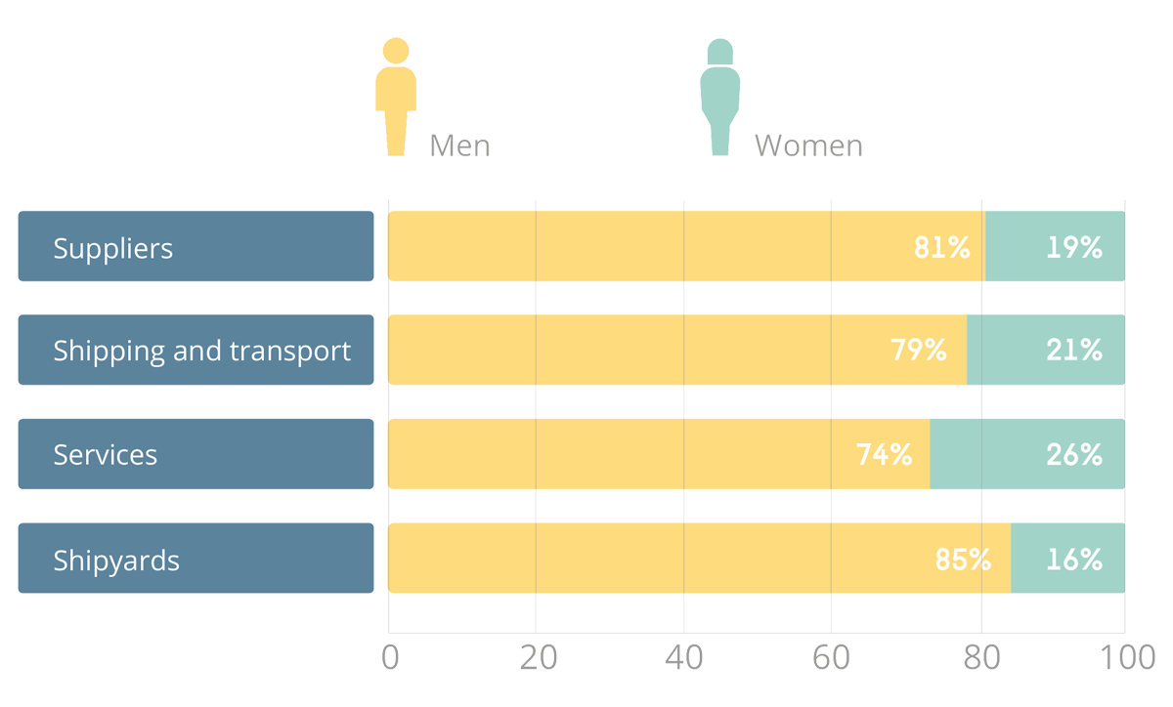
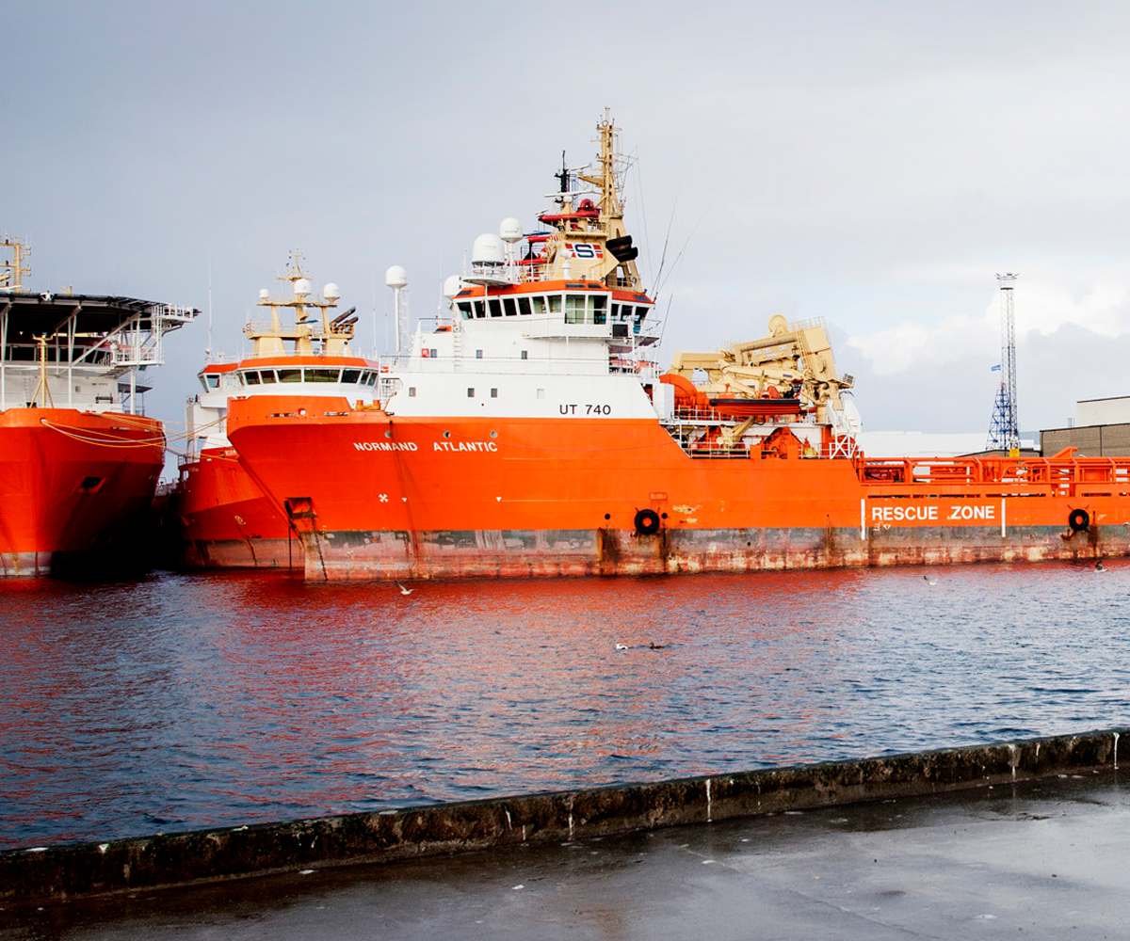
Norwegian vessels in Haugesund
Source: Tri Dinh / Norsk Sjømannsforbund
Women generally earn less than men in the maritime sector, also when controlling for education, occupation and age. Due to instances of remarkably high wages in the industry, median income provides an insight into the wage levels that apply for most employees. The difference in pay between women and men is greatest in shipping and transport, where the female median income is 64 per cent of the male median income (70 per cent average).
The difference is significantly less in the shipyard segment, where women earn 95 per cent of what men earn (93 per cent average). In the maritime industry as a whole, the female median income is 83 per cent of the male median income (82 per cent average). The wage gap between women and men in all segments, except for shipping and transport, is greater among those with a university and college education than among those with a lower level of education.
Women who work on board ships belong to households with very few children (0.28) compared to the general average for the population, which is 0.85 for women and 0.83 for men. This may indicate that women do not continue to work on board ships after they have had children.
The proportion of women among applicants to maritime education programmes at universities and colleges in the Norwegian Universities and Colleges Admission Service (NUCAS) was 29.7 per cent in 2022. Since 2010, the proportion of women among registered students on bachelor and one-year units in maritime education programmes in the university and university college sector has been relatively stable at approximately 20 per cent. At master’s level, the proportion of women among registered students is somewhat lower. The data available regarding gender distribution in higher vocational education is limited. However, it shows a significantly lower proportion of women in maritime vocational education and at maritime vocational schools than in the university and university college sector. The proportion of women in maritime study programmes at upper secondary schools is particularly low. In second year upper secondary school maritime courses, 11 per cent of the students are women. Furthermore, the respective percentages of women who are apprentice deckhands and marine engine mechanics are 8.5 and 7 per cent.
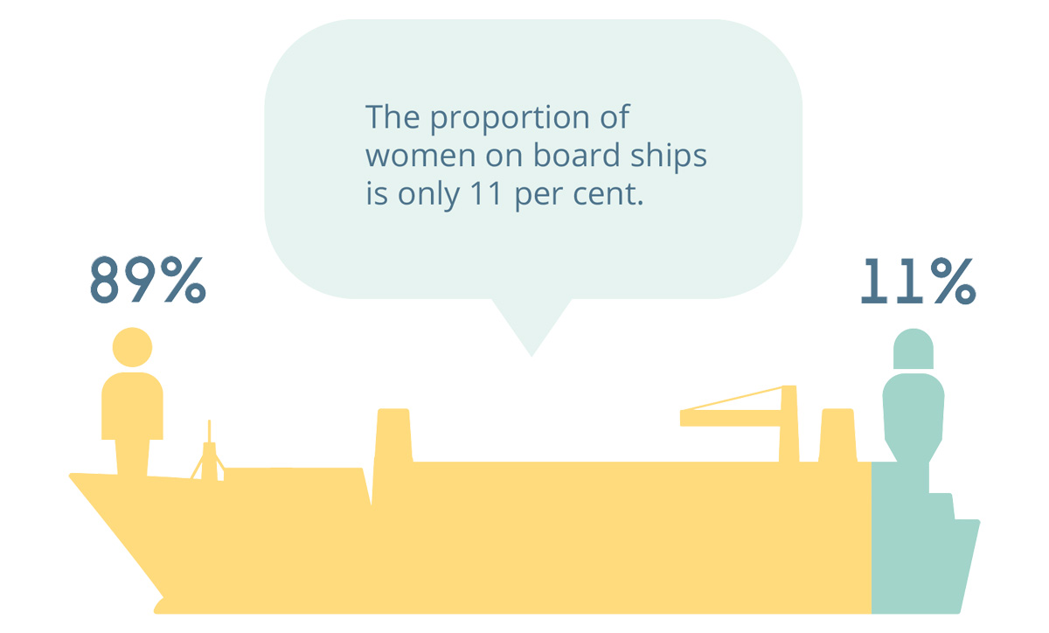

Factors that impact gender equality in the maritime industry
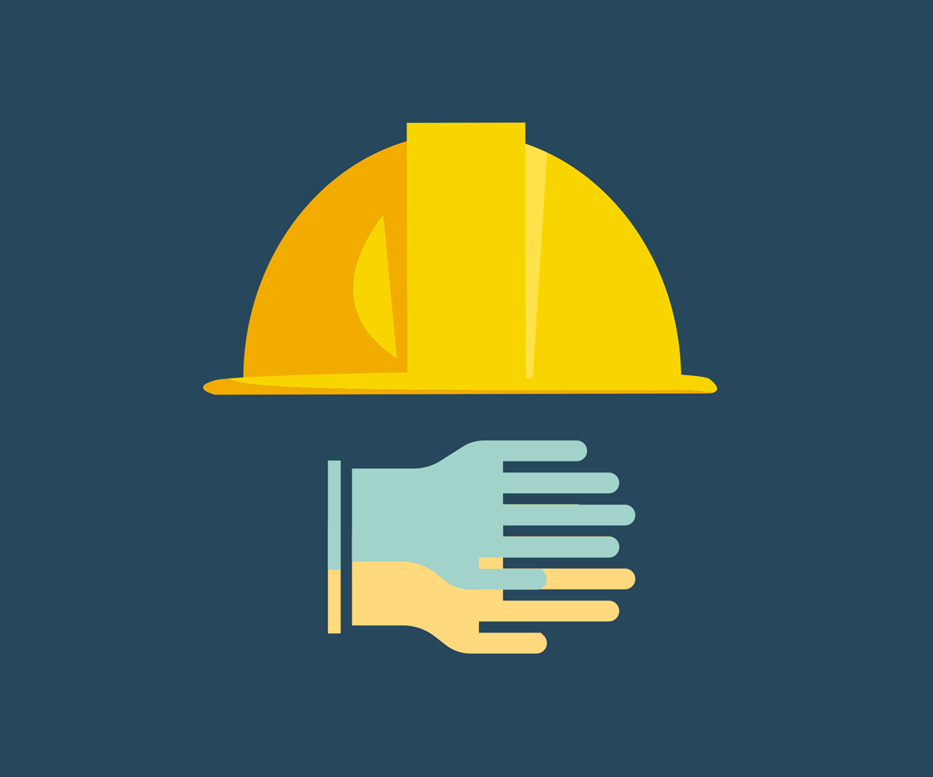
There are many and complex factors that influence the level of gender equality in the maritime sector.
On the one hand, a lack of knowledge about the maritime industry and challenges related to the working environment, attitudes, harassment, adaptation of equipment, the practical design of the workplace, working conditions and terms of employment may represent obstacles to female participation in the industry. Some of these challenges are perceived as being more significant at sea than in onshore part of the maritime sector.
On the other hand, the use of role models, inclusive recruitment strategies, awareness-raising work, good whistleblowing routines and life-phase-oriented personnel policies can aid in recruiting and retaining of women in the industry. It is the companies, and especially company managements who are responsible for facilitating gender equality in the workplace. To what extent companies focus on gender equality work and the types of measures they are working with vary considerably.

Recruitment
The Norwegian labour market is gender-segregated. Only 15 per cent of Norwegian employees hold occupations that are gender balanced, i.e., more than 40 per cent of both women and men among the employees. Among other things, this is due to young people making gender-segregated choices when choosing enducation and career path. Norwegian Official Report (NOU) 2019: 19 sheds light on challenges relating to gender equality among children and young people, and notes that the scope they have when selecting their future careers is shaped and limited by gender stereotypes at a structural level. Children and young people develop an early impression of the typical jobs that women and men have, and this influences the part of the labour market that they imagine could suit them.
The same is also the case when choosing maritime education programmes and occupations. The figures in Chapter 3 showed that there is a low proportion of women in maritime education programmes and occupations. The proportion of women is particularly low in maritime study programmes at upper secondary schools and vocational schools, and women start maritime study programmes at a later stage than men. When a study programme or occupation is strongly dominated by one gender, this dominance creates a barrier for those in the minority. The gender-segregated labour market impacts recruitment to various occupations, industries, and sectors. The low proportion of women in the maritime industry means that there are few female role models in the industry and reduces the likelihood of girls considering a maritime career path.
It is a challenge for the maritime industry that children and young people, irrespective of gender, are not aware of the career opportunities in the industry, and that career counsellors at schools do not have sufficient knowledge about the various pathways to a maritime career. This can make it challenging to recruit more young people to the industry. This applies to both girls and boys. Lack of knowledge is also one of the explanations for why young people generally choose educational pathways that are traditionally dominated by one gender. Research shows the importance of recruiting young people to specific industries at an early age. The fact that women start maritime study programmes later than men indicates that early efforts and knowledge work targeted especially at girls may contribute to increasing the proportion of women in the maritime industry and education.
The use of role models and women in senior positions can help recruit women, retain the women who are already working in the industry and show girls and younger women that it is possible to carve out a career in the maritime industry. Among other things, it has been shown that the use of role models has had a positive effect on the recruitment of girls to educational programmes in which they are significantly underrepresented.
The report from Inland Norway University of Applied Sciences notes that companies focusing on gender equality and diversity in their recruitment efforts can have a significant effect. Highlighting the fact that both women and men in different phases of life can be a suitable fit for the company can make a positive contribution to gender equality and diversity, for example, by using gender-neutral language and advertising and using images when promoting the company.
              - Initiatives from the industry
The Norwegian Shipowners’ Association and Maritime Forum have established the Maritime Career Ambassador Programme, which aims to showcase young people who are currently studying or at an early phase of their careers in the industry as active role models. The intention is to present them as examples of the opportunities that exist in the maritime industry in order to inspire the target groups in the 13-17 and 18-25 age ranges to explore what this industry has to offer. Today, half of the ambassadors are women.
Maritime Bergen’s Et hav av muligheter (A Sea of Opportunities), is a science, technical and maritime recruitment event for girls and boys in lower and upper secondary school in the Bergen area. Kvinner i Kuling (Women in a Gale), which is also an initiative from Maritime Bergen, aims to promote the maritime industry as an attractive career path for female students and to connect students and maritime companies.

              - Velg Teknologi (Choose Technology)
The Federation of Norwegian Industries’ Velg teknologi (Choose Technology) campaign is aimed at getting more girls and boys to choose technology courses at upper secondary school. The campaign involves various social media influencers visiting industrial companies and using their channels to talk about industrial career opportunities. In the five years that the Federation of Norwegian Industries has carried out these campaigns, there has been a 135 % increase in the number of girls applying for technology courses in first year upper secondary school.

              - Girls and Technology
Norwegian maritime companies are reporting a major need for digital and technological expertise. Technical professionals, engineers and realists are in demand, and these are specialist fields with a very low proportion of women. To ensure that companies acquire the best and broadest expertise, the Confederation of Norwegian Enterprise (NHO), Norwegian Society of Engineers and Technologists (NITO) and the Norwegian Centre for STEM Recruitment are working to get more girls to apply for technology education programmes through the Jenter og teknologi (Girls and Technology) project.
Through collaboration with a number of different stakeholders, annual conferences and open days are arranged for girls in lower and upper secondary schools, where role models and companies inspire and show girls the opportunities that exist within science and technology. The goal of the project is to increase the proportion of women in technical vocational courses, vocational colleges and colleges and universities.

Attitudes, culture and working environment
The report from Innland Norway University of Applied Sciences and input meetings with the industry revealed that the maritime industry is characterized by having a rough work environment, particularly at sea. The work environment can be found to be inflexible, with an expectation that young people and those who are new to the industry must accept course language and brusque attitudes. This can result in young people and new employees not feeling welcome and may be a possible reason for them dropping out during or after their apprenticeship.
There are several challenges associated with being a minority in the workplace. In male-dominated professions women might find that they are not taken seriously and must prove their competence. They might also be held accountable for the efforts of other women based on generalised attitudes and at times limited experience with women in similar positions. This can also manifest itself in the form of different expectations to women and men in terms of work life balance, and through communication. Many women experience that their gender is pointed out, for example by being referred to as a «female captain».
To improve gender equality it is necessary to change attitudes and focus on attitudes towards women in all parts of the maritime industry, especially at sea. This requires preventive, long-term, and targeted work. Educational institutions and companies need to actively challenge stereotypes and raise awareness among students and staff about issues such as the language that is used. Establishing gender equality work with the company’s executive management and as part of the company’s strategy can be an effective mean to improve gender equality and diversity. Mentor programmes can also assist in promoting inclusion and changing work culture by creating an arena for dialogue and learning between young women in the industry and experienced managers.
Since women are often a minority in the workplace, networks, and events for women in the industry can create a space for them to share experiences and discuss how they experience being a minority. It can also create a forum for obtaining guidance in connection with incidents such as harassment and discrimination.

An international industry
While the Norwegian maritime industry primarily uses Norwegian labour, almost a quarter of the workforce is of foreign nationality. The industry employs people from many parts of the world. This expands the recruitment pool and contributes to greater diversity but can also result in challenges for the working environment. In the report from Inland Norway University of Applied Sciences and in the input meetings arranged by the Norwegian Government in connection with its work on the strategy, it was revealed that demographic differences in among other things age and culture can have an impact on gender equality in the maritime industry. This appears to be a particularly relevant issue in the offshore part of the industry. It is therefore important that the employer is aware of potential cultural differences between different nationalities in the workplace and how this impacts the working environment.
              - WISTA
The Women’s International Shipping & Trading Association (WISTA) is an international organisation that works towards achieving greater diversity. WISTA Norway has over 200 members. The organisation engages in information and promotional work and serves as a meeting place for women in the industry and has been highlighted as an important stakeholder in gender equality work in the maritime industry. Among other things, the organisation offers the mentor programme WISTA Maritime Meet-Up Program. The programme offers women in the maritime industry guidance from mentors who work as managers in the industry.

Harassment and the threshold for whistleblowing
Harassment and sexual harassment hinder gender equality in the labour market. Gender, age, and employment status are key risk factors for being subjected to harassment in the workplace. The report from Inland Norway University of Applied Sciences revealed that many women have experienced or know others who have experienced harassment and sexual harassment in the workplace in the maritime industry, especially among seafarers. However, there are significant differences between different enterprises, as well as between ships and crews. The reasons for this include how management deals with inappropriate attitudes and behaviour, and the extent to which management and employees know how to handle instances of harassment.
In accordance with the activity – and reporting obligation, companies are obliged to work actively, purposefully, and systematically to prevent harassment, sexual harassment, and gender-based violence. Many of the companies in the maritime industry have systems for whistleblowing and routines for following up on harassment. However, there may be several obstacles to using these types of channels, including inadequate information about the whistleblowing channel and a high threshold for reporting incidents due to close ties between superior and subordinate crew members and between employees. Some companies do not have a whistleblowing channel. It is also a problem that whistleblowing is not taken seriously and that there are consequences for the whistle-blower, rather than for the person committing the harassment. Both harassment and poor whistleblowing routines can deter women from wanting to work in the maritime industry and cause women who are already working in the industry to leave. Good routines and systems for handling whistleblowing cases and undesired incidents are crucial for preventing and dealing with harassment. The Equality and Anti-Discrimination Ombud has, in cooperation with the Labour Inspection Authority, prepared a guide on sexual harassment. The guide provides practical assistance for preventing and managing sexual harassment through six necessary measures (see box).
              - The Equality and Anti-Discrimination Ombud and Norwegian Labour Inspection Authority’s guide to prevent and deal with sexual harassment
- Assess risks
- Codes of conduct
- Standard operating procedures
- Violation must lead to consequence
- Clarify management’s responsibility
- Talk about sexual harassment
As a supervisory authority the Norwegian Maritime Authority plays a role in preventing seafarers from experiencing sexual harassment at work. In May 2022 inspectors at the Norwegian Maritime Authority participated in the «Course in preventing sexual harassment through supervision». The course was digital and was held by the Norwegian Labour Inspection Authority and the Equality and Anti-discrimination Ombud. The goal was to provide the participants with knowledge about sexual harassment and other forms of harassment, how this can be prevented and how to handle this if instances of harassment should occur. This will better equip the Norwegian Maritime Authority’s inspectors to carry out their duty to provide guidance in these types of cases. The inspectors’ checklists are an important tool in the Norwegian Maritime Authority’s supervisory work. An analysis of the checklists has been initiated to ensure this issue is addressed in an even more effective manner. The Norwegian Maritime Authority also has information regarding harassment and sexual harassment on its website. The information refers to the steps the Norwegian Maritime Authority has taken to prevent harassment and specifies what services to contact for those who experience harassment.
              - Collaboration agreement to prevent and stop sexual harassment
The Norwegian Maritime Authority has entered into a collaboration agreement with the Norwegian Fishermen’s Association, Norwegian Coastal Fishermen’s Association, Norwegian Seafood Federation, Norwegian Seamen’s Association, Pelagic Association, pressure group Hun Fisker and the Equality and Anti-discrimination Ombud. The objective of the agreement is to contribute to better understanding of harassment and sexual harassment, and how this can be combated. The work includes the development of course materials, training and skills development for managers, safety representatives and employee representatives, as well as a review of whistleblowing routines. The partnership is initially foreseen to last until September 2023.

Working conditions and terms of employment
Gender segregation in the labour market is closely linked to wages, working hours, working conditions and career development. If the working conditions in the industry are worse for women than men, this can contribute to a gender imbalance. In addition to impacting recruitment, pay differences or different prerequisites for career development can make it difficult to keep women in the industry.
Maritime enterprises face challenges in retaining women during a phase of life in which they want to start a family. This particularly applies to women who work on board ships. Chapter 3 showed that women working on board ships belong to households with very few children compared to the average for the population. This may indicate that life-phase-based care tasks related to pregnancy and responsibility for young children have an impact on whether women remain in sailing positions, and that many women move into onshore positions after having started a family. The threshold for returning to a sailing position after a period in an onshore position is influenced by the need to renew certificates. There is a higher cost associated with renewing expired certificates. This is where differences may arise between men and women for example due to pregnancy and maternity leave.
More women experience negative social and financial consequences in the workplace after they have been on parental leave among other things because they often take longer periods of leave than their male colleagues. Some companies might lack in awareness of this. Furthermore, there are reports of instances in which men are encouraged to take shorter parental leave which reinforces this imbalance. Parental leave can be perceived as particularly poorly adapted to the everyday work of seafarers, who often have working hours that require them to be away for extended periods of time. This is considered especially challenging when both parents work at sea.
Life-phase-oriented personnel policy is therefore highlighted as being an important measure for greater gender equality in the maritime industry and especially for work at sea. Efforts need to be made for there to be greater acceptance of women and men taking necessary leave, and to ensure that the involvement of fathers in the caregiving work can also provide women with greater opportunities to practise their profession. It is important that each individual enterprise has the necessary knowledge about the rules for leave of absence in the Ship Labour Act and Working Environment Act to prevent an extra burden being placed on the employee who will be taking leave. Arrangements that enable employees to maintain the necessary certificates for a period while working in an onshore position can contribute to more people returning to sailing positions after having established a family.

Specific information concerning the rules governing leave of absence for seafarers
Chapter 7 of the Ship Labour Act contains provisions relating to leave of absence. The chapter covers the right to leave of absence for employees in connection with pregnancy, childbirth, and adoption, in the event of illness to children and childminders and in connection with the care and nursing of close relatives. It also grants the right to leave of absence in connection with education, military service, and the exercise of public office. The entitlement to financial benefits, which are supposed to replace lost income during a leave of absence, is stipulated in the National Insurance Act. The chapter also contains a provision concerning the employee’s duty to notify the employer of a leave of absence.
The provisions pertaining to leave of absence in the Ship Labour Act correspond with the provisions concerning leave of absence in the Working Environment Act. However, there are some differences to reflect the special conditions that apply at sea. For example, for employees on board ships on longer voyages it may be difficult to have leave approved at short notice and to take time-off in the event of illness to a child or childminder. Submissions were received in connection with work on the strategy which stated that there may be a need for more flexible arrangements to contribute towards women remaining in the maritime industry.
Chapter 4 of the Ship Safety and Security Act relating to working environment and personal safety contains special rules for women who are pregnant or have recently given birth and are breastfeeding and working on board ships. This includes the right of pregnant women to take leave of absence and a duty to facilitate. The latter relates to changes in working conditions and working hours, as well as transfer to other work in the shipowner’s service, among other things.
              - The certification system for seafarers
The certification system for seafarers is based on the International Convention on Standards of Training, Certification and Watchkeeping for Seafarers (STCW). The STCW has been implemented in Norway through the Ship Safety and Security Act and the Qualifications Regulations.
The educational pathway for a deck officer or engineer officer is broadly structured into three parts: a theoretical part, mandatory courses, and a practical part. The theoretical part primarily takes place at colleges/universities and vocational schools. The practical part is referred to as the seagoing service (NO: fartstid) and must be accrued on board a ship. A certificate of competency can be applied for upon completion of the study programme.
A certificate of competence may be renewed for up to five more years if the holder can document that the requirements for maintenance of the certificate of competency have been met. The prerequisites for renewing a certificate of competency are seagoing service with a valid certificate of competency and repetition of mandatory courses. Seagoing service must be accrued on board a ship, however it is also possible to perform other work that is equivalent to seagoing service, for example, teaching the subjects required by STCW.
If the requirement for seagoing service is not met, it is still possible to renew the certificate of competency by completing an extended course and passing a certification test.

Adaptation of equipment
The physical organisation of the workplace can represent an obstacle to gender equality in the maritime industry. Clothing and equipment do not have gender-neutral functionality and are often adapted for men in male-dominated industries. Women may experience not having access to correct sizes of gloves, work clothes, safety shoes and other equipment. If women do not have access to the right equipment, this can impact their ability to safely perform certain work tasks. It is also an obstacle that some vessels do not have separate changing rooms and toilets for female employees, and that there is no access to necessary sanitary products. At an input meeting organised by the Minister of Fisheries and Ocean Policy it was pointed out that vessels that do not have the necessary facilities are still being built.
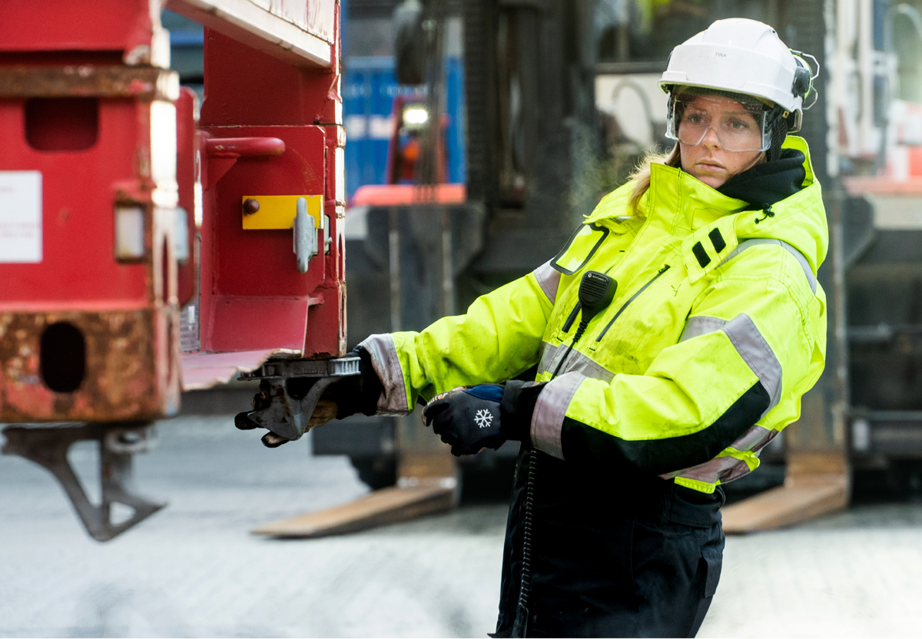
Adapted equipment and work clothes are necessary to ensure a safe workplace.
Source: Thought Leader Global Media
Research shows that adapting equipment to all body sizes can signal that the workplace and work tasks are suited for everyone. Adapting the clothing and uniform to the different needs of female personnel has been a recruitment strategy of the Royal Norwegian Navy in order to meet the needs and requests that women might have. Chapter 4 of the Ship Safety and Security Act regulates the working environment and personal safety and includes provisions relating to the adaptation of work on board. Regulation no. 8 of 1 January 2005 relating to the working environment, safety, and health of employees on board ships was laid down pursuant to this Act. Among other things, the Regulations stipulate requirements for personal protective equipment for people who work on board ships, however this does not include other work clothes. There is also a requirement for separate toilets/sanitary rooms in specific cases.

International work to promote gender equality and diversity in the maritime industry
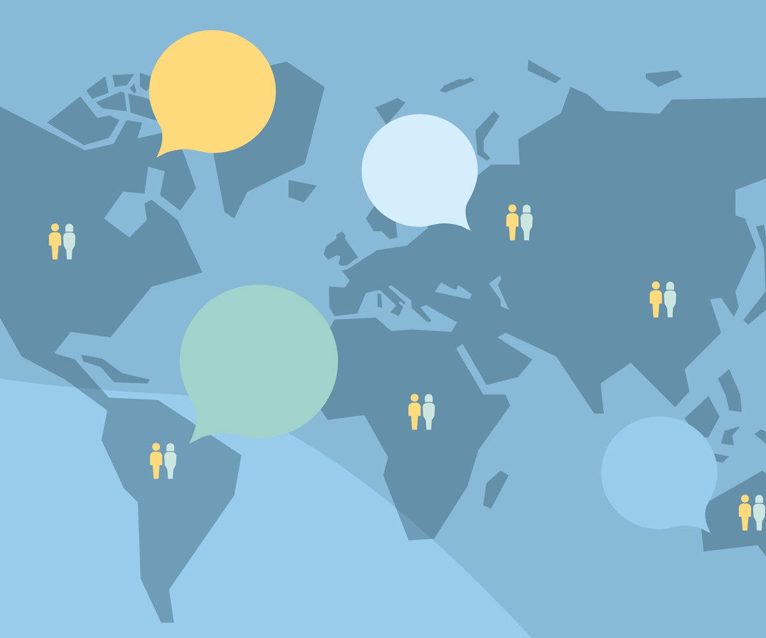
There is already a great deal of work taking place internationally that should be built upon further. Since its establishment in 1988, the IMO’s gender equality programme has contributed to strengthening gender equality for women in the maritime sector in developing countries.
For many years Norway has earmarked NOK 1 million to support field-specific IMO projects. In 2022 the Norwegian Government chose to allocate Norway’s contribution to the IMO’s gender equality programme. Norway’s contribution is divided into two activities, including the «Maritime SheEO virtual leadership accelerator programme» and a database for female maritime experts.
The «Maritime SheEO Leadership Accelerator» programme was launched on International Day for Women in Maritime 2022. The programme was developed in consultation with key industry experts in the IMO and WISTA and aims at equipping women who work in the maritime sector at government level with the leadership skills and the confidence to take an active part in decision-making processes. The IMO has already sponsored 60 women from developing countries to participate in the programme, which is divided into two rounds of courses. Norway’s contribution will result in a third course, by which time nearly 100 women will have participated in the programme.
The database of female maritime experts was created through a collaborative agreement between the IMO and WISTA. The purpose is to increase the visibility of women in the maritime sector and promote the different skills and perspectives that women possess. The database will also contribute towards expanding and enriching the diversity of speakers at various maritime events. Norway’s financial contribution will be used to further develop the database.
The International Chamber of Shipping (ICS) works actively to contribute to gender equality and diversity in international shipping. The ICS has developed a toolkit with the aim to create awareness about diversity and to help companies work actively and purposefully towards an inclusive industry, among other things. The International Transport Workers’ Federation (ITF) and ICS have developed a guide to prevent harassment and bullying on board ships. The objective is to assist shipping companies in consultation with seafarers and seafarers’ organisations, in developing guidelines and routines for eliminating harassment and bullying.

Focus areas
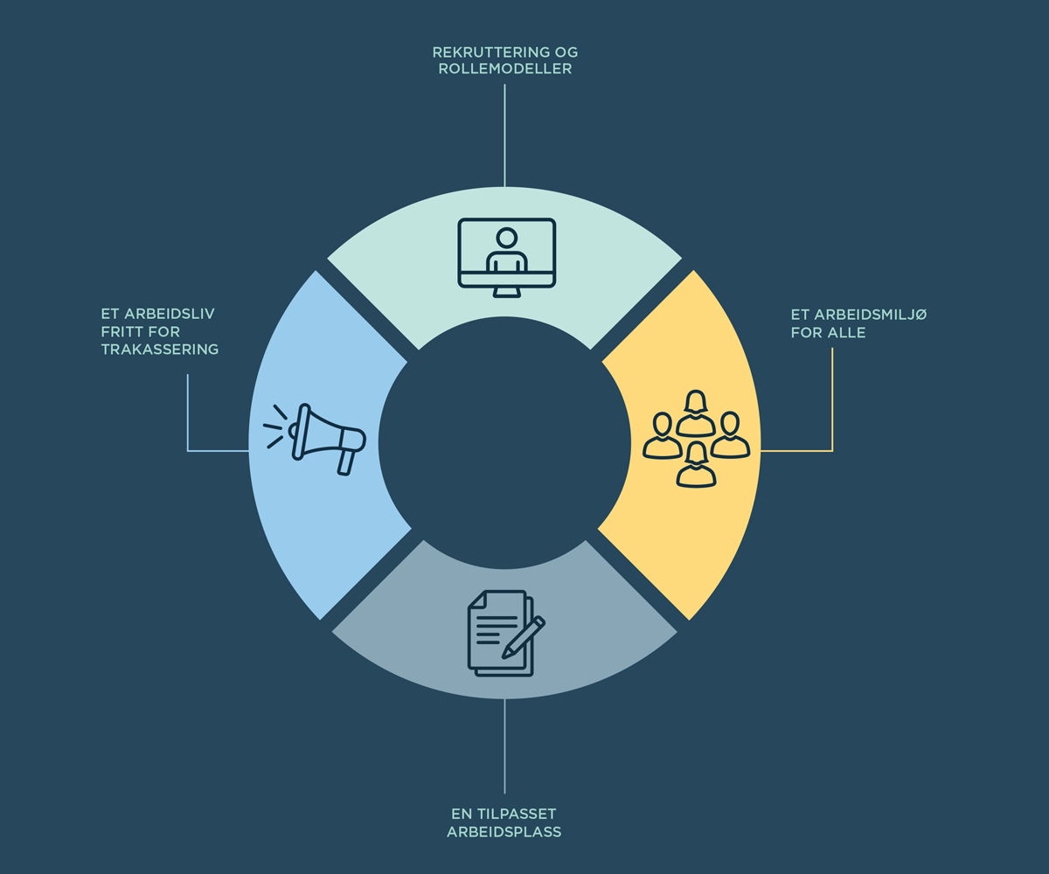
The reasons for why few women choose a maritime career path are many and complex. There are many factors that influence the level of gender equality in the industry, and especially at sea. Working with these factors requires active, structured, and targeted efforts over time. The Norwegian Government wants a strengthened tripartite cooperation that is closer, more binding and more strategic to support greater gender equality and diversity in the maritime industry.
Gender equality is both important in itself and good commercial policy. The Norwegian Government is pursuing a proactive gender equality policy which is intended to ensure that everyone is included in society, irrespective of gender, sexual orientation, functional ability, and ethnicity. Targeted efforts must be made to increase diversity in the labour market and improve gender representation in gender-segregated industries, including the maritime industry. Increased gender equality and diversity may contribute to enhancing the reputation of the maritime industry.
In the Norwegian Government’s view increased gender equality and diversity in the business sector can, in the long run, result in more innovation, a better working environment, better decisions and value creation. To continue the ability of the Norwegian maritime industry to create value and innovate, it is vital that the industry is able to recruit and employ talent from the entire workforce. In other words, gender equality and diversity are crucial for the maritime industry to attract the labour that is necessary and to maintain its competitive advantage in the face of changes in the market and society.
To address the challenges described in Chapter 4, the Norwegian Government has identified four focus areas: recruitment and role models, a working environment that benefits everyone, a working life free from harassment and an adapted workplace. The focus areas described in this chapter require efforts from companies in the maritime industry, employee and employer organisations and government authorities. The Norwegian Government will take the initiative to draft a declaration of cooperation with the industry that targets the four focus areas.
- The Norwegian Government will take the initiative to draft a declaration of cooperation with the industry to work towards gender equality in the maritime sector, and to document future development concerning gender equality in the sector. The declaration should include objectives and a timeline and shall be prepared in cooperation with the parties to the declataration and the Norwegian Ministry of Culture and Equality.

Recruitment and role models
Moving into the future the maritime industry will experience a green and digital transition. Access to a competent workforce will be important to the competitiveness of both the Norwegian fleet and the maritime industry in general. Girls and young women who have chosen maritime education programmes and occupations can be good role models and ambassadors for the maritime industry. There is much to indicate that it is hugely significant to see that others have made choices that do not conform with gender norms. The Norwegian Government will contribute towards more girls becoming aware of and applying for maritime education programmes and maritime occupations.
The Norwegian Government will:
- Initiate dialogue with the maritime educational institutions concerning how to increase recruitment from all genders.
- Initiate information campaigns relating to career opportunities in the maritime sector that are targeted at girls of lower secondary school age.

A working environment that benefits everyone
For the maritime industry to be an attractive workplace, it is crucial that the workplace is seen as inclusive. The Norwegian Government will contribute to focusing on the importance of diversity and gender equality in all maritime policymaking. For an international industry that recruits from large parts of the world, successful gender equality work requires that measures are not only implemented in Norway, but that relevant international forums are used to promote this work. The Norwegian Government will therefore use relevant international arenas to promote diversity and gender equality in the maritime industry.
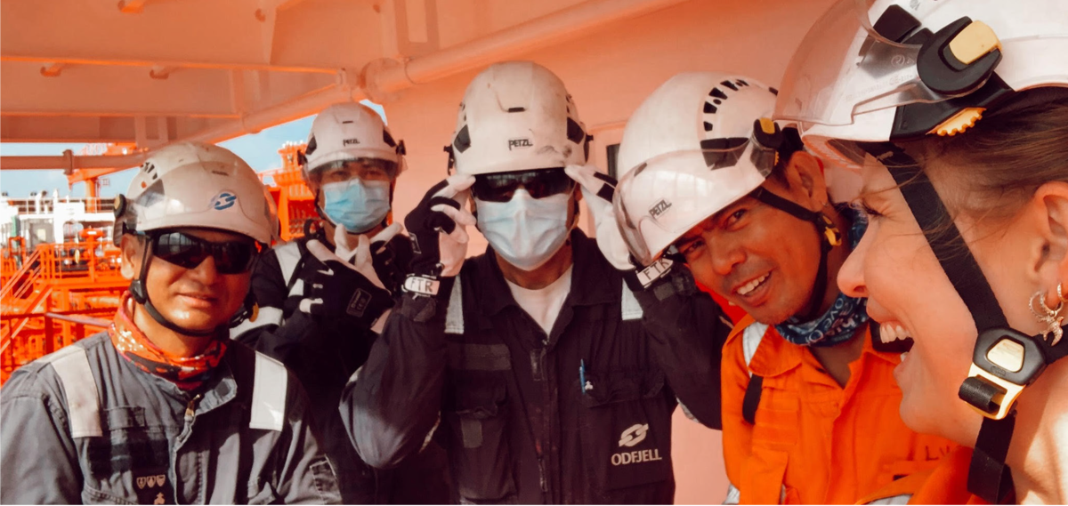
It is important that the workplace is seen as safe and inclusive for all. Source: Odfjell
The Norwegian Government will:
- Include a diversity and gender equality perspective in all maritime policymaking.
- Use international arenas, such as the IMO and ILO, to promote gender equality and diversity in the maritime sector.
- Incorporate diversity and gender equality into the Norwegian mandate for the work on the revision of the International Convention on Standards of Training, Certification and Watchkeeping for Seafarers (STCW) in the IMO.
- Update descriptions for the courses that the Norwegian Maritime Authority prepares in cooperation with the maritime industry to ensure that gender-neutral terms are used.
- Update the wording of Norwegian maritime legislation to ensure that gender-neutral terms are used.
- Strengthen the Norwegian Maritime Authority’s information work on gender equality vis-à-vis the industry and employees.

A working life free from harassment
Harassment, including sexual harassment, is prohibited, cf. the Equality and Anti-Discrimination Act (Section 13). A work life free from harassment is the responsibility of everyone. Managers in a workplace, in an organisation and in an educational institution have an obligation to work actively to prevent harassment.
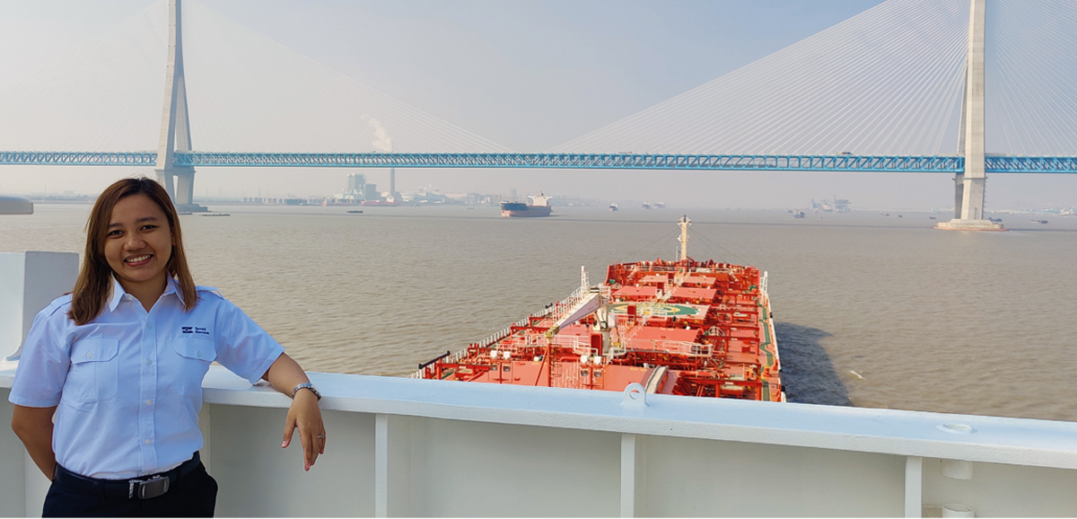
Norwegian shipping companies operate in all parts of the world.
Source: Torvald Klaveness
The Government will ratify ILO Convention No. 190 on the Elimination of Violence and Harassment in the World of Work, cf. Proposition 48 LS (2022–2023), which was presented on 3 March 2023. Norway has an extensive system of rules that are intended to ensure that employees are protected against violence and harassment in their work life. The Convention is not considered to require amendments to Norwegian law. However, the Norwegian Government still wishes to pursue a proactive gender equality policy and is focussed on women and men having the same rights. No one shall be subjected to violence and harassment at work. In connection with the ratification of the ILO Convention, the Norwegian Government has proposed: to specify that the protection against harassment in the Working Environment Act also entails protection against sexual harassment, to include definitions of harassment and sexual harassment in the Working Environment Act, and to specify the duties of safety representatives when concerning the psychosocial working environment. To ensure that seafarers enjoy the same protection against harassment as employees onshore there will be an assessment of whether amendments must be made to Norwegian maritime legislation. Furthermore, it is important that the Norwegian Maritime Authority’s supervisory activities are organised in a manner that makes it possible for the Authority’s inspectors to detect situations such as harassment.
The Norwegian Government will:
- Ratify ILO Convention No. 190.
- Present a report to the Norwegian Parliament (white paper) on sexual harassment in 2024.
- Consider amendments to Norwegian maritime legislation to highlight and strengthen efforts to combat harassment.
- Strengthen the Norwegian Maritime Authority’s supervisory role in connection with harassment.

An adapted workplace
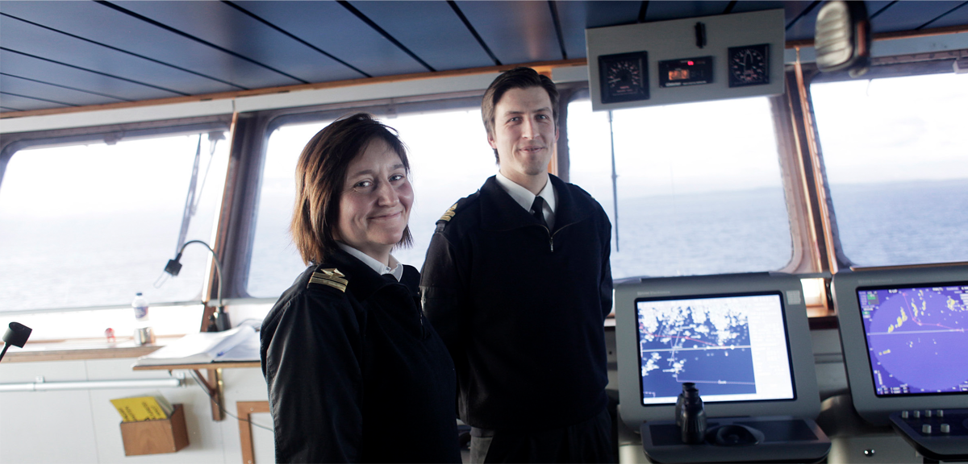
Seafarers on the bridge. Source: Tri Dinh / Norsk Sjømannsforbund
Working conditions and terms of employment are key factors for an industry to be considered attractive. The starting point and framework for active gender equality work in working life have been established through important legislative work. 2020 saw the introduction of an enhanced activity duty and duty to issue a statement in the Equality and Anti-Discrimination Act. The activity duty and duty to issue a statement constitute an obligation for all employers to work actively for equality and non-discrimination and must as a minimum cover the areas of recruitment, pay and working conditions, promotion and development opportunities, adaptation, and the opportunity to combine work and family life.
More flexible solutions for maternity and parental leave can contribute to more women remaining in the maritime industry. Similarly, the well-facilitated physical organisation of the workplace may contribute to it being perceived as inclusive. The Norwegian Government will assess the need for potential amendments to the Ship Labour Act and the Ship Safety and Security Act and associated regulations which can contribute towards promoting gender equality.
The Norwegian Government will:
- Assess the need for amendments to Norwegian maritime legislation to promote gender equality.
- Make amendments to the Equality and Anti-Discrimination Act to highlight that employees who are covered by the Ship Labour Act have the same protection under the Act as employees who have an employment relationship pursuant to the Working Environment Act.

UNDP Gender Inequality Index, undp.org, Gender Inequality Index | Human Development Reports (undp.org)
Reisel, Liza; Skorge, Øyvind Søraas; Uvaag, Stian (2019), Kjønnsdelte utdannings- og yrkesvalg: En kunnskapsoppsummering, Institutt for samfunnsforskning (Gender-segregated educational and career choices: A knowledge summary) Norwegian Institute for Social Research.
Østbakken, Kjersti Misje; Reisel, Liza; Schoen, Paul; Barth, Erling; Hardoy, Inés (2017), Kjønnssegregering og mobilitet i det norske arbeidsmarkedet (Gender segregation and mobility in the Norwegian labour market), Report 2017:9, Norwegian Institute for Social Research.
Statistics Norway, Slik kan lønnsforksjellen mellom kvinner og menn forklarer (How to explain the pay gap between women and men), ssb.no.
Reisel, Liza; Skorge, Øyvind Søraas; Uvaag, Stian (2019), Kjønnsdelte utdannings- og yrkesvalg: En kunnskapsoppsummering, Institutt for samfunnsforskning (Gender-segregated educational and career choices: A knowledge summary), Norwegian Institute for Social Research.
The report is available from: https://kommunikasjon.ntb.no/data/attachments/00767/5abab07c-93f5-4650-a450-bb0e8a9b3da0.pdf
Statistics Norway, the figures are based on preliminary calculations in the national accounts.
Norwegian Official Report (NOU) 2022:4 Grunnlaget for inntektsoppgjørene 2022 (The Basis for the Wage Settlements 2022).
Menon Economics (2022), Kompetansebehov og kompetansestrategier som følge av teknologiutvikling i maritim næring (Competence needs and competence strategies resulting from technology development in the maritime industry).
Menon Economics (2019), Fra sjø til land – Maritime karriereveier (From sea to land – Maritime career paths).
Norwegian Directorate for Education and Training, Elevtall i videregående skole – utdanningsprogram og trinn (udir.no) (Number of pupils at upper secondary school – education programme and grade), udir.no.
Reisel, Liza; Skorge, Øyvind Søraas; Uvaag, Stian (2019), Kjønnsdelte utdannings- og yrkesvalg: En kunnskapsoppsummering, Institutt for samfunnsforskning (Gender-segregated educational and career choices: A knowledge summary), Norwegian Institute for Social Research.
Norwegian Official Report (NOU) 2019: 19.
Norwegian Official Report (NOU) 2019: 19, page 134.
Norwegian Official Report (NOU) 2019: 19, page 153.
Norwegian Official Report (NOU) 2019: 19, pages 133-134.
Breda, Thomas; Grenet, Julien; Monnet, Marion; Van Effenterre, Clémentine (2020), Do Female Role Models Reduce the Gender Gap in Science?, IZA Discussion Paper No. 13163.
Norwegian Maritime Authority, Trakassering og seksuell trakassering (sdir.no) (Harassment and Sexual Harassment), sdir.no.
Vestvik, Marit; Bjerck, Mari (2012), Sjøforsvaret i ny drakt; Utviklingen av ny uniform for Sjøforsvaret med vekt på tilpasning til det kvinnelige og mannlige personellets ulike behov for arbeidsbekledning.(A new outfit for the Royal Norwegian Navy: The development of a new uniform for the Royal Norwegian Navy with an emphasis on adaptation to the different needs of female and male personnel when concerning work clothing). National Institute for Consumer Research, Commissioned Report 3-2012.

