Official Norwegian Reports NOU 2024: 3 Summary

Joint efforts against extremism: Better conditions for preventive work

Translation from Norwegian. For information only.

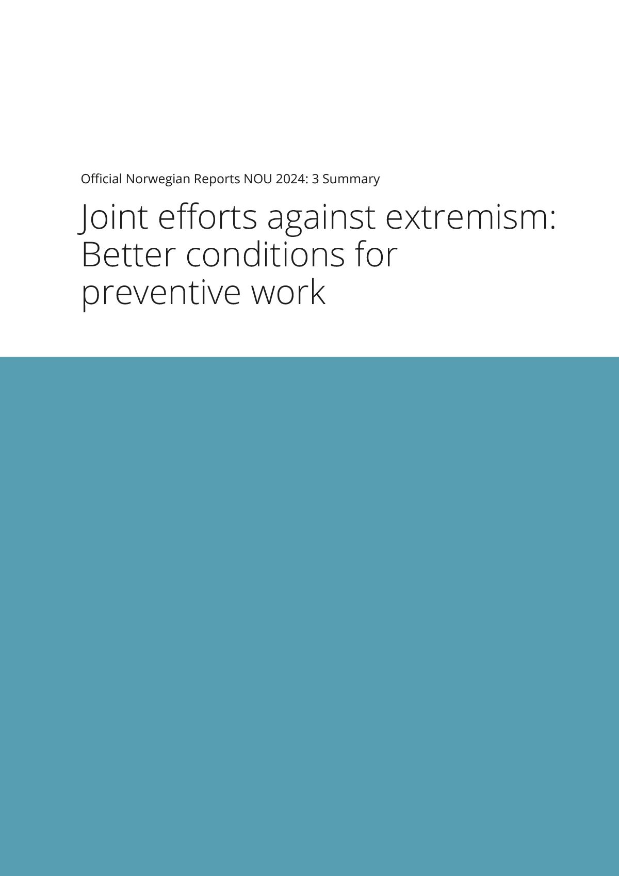

Report from a commission appointed by Royal Decree of 10 June 2022.

Submitted to the Ministry of Labour and Social Inclusion on 1 March 2024.

The Commission on Extremism was appointed by Royal Decree on 10 June 2022 with the objective of generating and analysing knowledge and making recommendations to improve Norway’s ability to prevent radicalisation and the rise of extremism.

The report is an important source for the Norwegian Government’s white paper which will be presented to the Norwegian parliament in spring 2025.

This pamphlet is a condensed presentation of the Commission’s main findings and its 41 recommendations to the Norwegian government.

|  |  |  |
| --- | --- | --- |
|  | Oslo, 1 March 2024 |  |
|  | Marie Cathrine Moe Thorleifsson  Chair |  |
| Kari Mangrud Alvsvåg | Anders Bo Christensen | Kari Eilertsen |
| Kim Henrik Gronert | Pål Tore Haga | Cecilie Hellestveit |
| Espen Rutle Johansson | Erik Lindbæk Kruse | Claudia Sabine Lenz |
| Hawa Abshir Muuse | Petter Nesser | Lisbeth Røyneland |
| Gaute Børstad Skjervø | Ingvild Næss Stub | Sylo Taraku |
| Snorre Serigstad Valen |  |  |
|  |  | Elisabeth Krüger Østbøll  Head of Secretariat |
|  |  | Ane Marte Nordvik |
|  |  | Marianne Rusten |
|  |  | Anne Talsnes |
|  |  | Ingrid Egeland Thorsnes |
|  |  | Gunder Nordgården |
|  |  | Steinar Riksaasen |

# Summary

Introduction

The Commission on Extremism hereby submits its report following a year and a half of work. The Commission is composed of 17 members with different competence and experience. The composition and mandate of the Commission formed the basis for a broad, whole-of-society approach to preventing and countering extremism. The Commission’s mandate reflects a two-pronged approach to prevention; countering violent extremism while fostering democratic resilience.

The Commission on Extremism was appointed eleven years following the deadliest domestic terrorist attack in Norway since the Second World War. On 22 July 2011, a right-wing extremist attacked the Norwegian Government Quarter and Utøya Island killing 77 people and severely injuring many more. This devastating attack has not been the only terrorist attack in Norway. On 10 August 2019, a right-wing extremist inspired by the Christchurch terrorist attacks killed a 17-year-old girl in her own home before attacking the Al-Noor Mosque in Bærum. On 25 June 2022, two weeks after the Commission’s appointment, an Islamist extremist carried out an attack in downtown Oslo, killing two and injuring more than twenty.

The consequences of violent extremism, both for those directly affected and for society are large. No democratic and open society can protect itself fully against terrorism, but best practices have shown that it is possible to prevent radicalisation to violent extremism. Early prevention and the fostering of resilience to extremism is of vital importance and must be prioritised with consistency and resources over time. Prevention is inexpensive compared to the enormous short and long-term effects and costs of terrorist attacks and the cost in fundamental rights and freedoms if extremist forces achieve their objectives.

The Commission’s working methods

The Commission’s findings and recommendations are based on an extensive body of knowledge.

The Commission has reviewed and analysed existing knowledge and practice as found in the academic literature, public reports and documents. Furthermore, the Commission has gathered knowledge through extensive meetings across the country with representatives from groups affected by extremism, national, regional and local authorities, first-line practitioners (representing multi-agency work involving municipalities, schools, the police, social services), civil society organisations and research and education. The Commission has also gathered knowledge about preventing and countering violent extremism (P/CVE) programming and practices internationally. The Commission has strived to include the voices and experiences of a multiplicity of actors, including young people.

The Commission was mandated to review and assess severe cases of violent extremism in Norway. In its case review, the Commission analysed 20 individual cases involving offences with a penalty limit of imprisonment for a term of minimum six years. Through an act that set aside the duty of confidentiality for anyone who wished to share information with the Commission, the Commission obtained information from, among others, the Norwegian Police Security Service, the Norwegian Police, the Norwegian Labour and Welfare Administration, the Norwegian Correctional Service and several Norwegian municipalities. The Commission has gained a unique insight into the lives of radicalised Norwegians who have been involved in serious crimes, including the underlying factors, individual radicalisation processes and their interactions with public services.

The Commission has also gathered examples of best practices for P/CVE and examined the factors that have led to successful prevention.

In line with its mandate, the Commission has applied a broad approach to extremism. The report has employed two different definitions of extremism: one narrow and one broad. According to the narrow definition, extremism is the acceptance and use of violence to achieve political, ideological or religious goals. According to the broad definition, extremism is attitudes and actions that reject democracy and human rights. Therefore, the report covers not only radicalisation to violent extremism, but also views and actions that may undermine democracy and human rights.

The Commission has found it productive to apply the prevention triangle, which is often used to represent various prevention levels, from the individual to the societal level. The Commission introduces a revised model that includes new levels, highlighting the importance of early prevention and the fostering of resilience to radicalisation through social inclusion and practices grounded in an encompassing framework of democracy and human rights. Thus, the Commission presents a model consisting of five levels, from the “building” resilience level, which includes strengthening the conditions and facilitation of a good quality of life and community, to the reintegration of already radicalised individuals. Democracy and human rights constitute the framework for this work and must form the basis for all preventive efforts.

The Commission’s findings

In Norway, the population has a relatively high level of trust in the authorities and the political system. Continuous efforts are required to maintain a high level of trust and further strengthen democracy. This requires the joint efforts of the whole of society.

Extremist attitudes foment unrest and insecurity and erode the foundations of democratic society. Extremist actors and currents that undermine trust therefore pose a profound threat to social cohesion. The Commission believes that clear steps must be taken to bolster democracy and human rights, going forward.

Extremism severely impacts individuals, groups and society. Various groups that form part of extremists’ enemy images are subjected to racism, discrimination and hate crimes. They are also burdened with the negative impact of extremism on safety, security and well-being. The Commission believes that persons who are part of extremists’ enemy images must be afforded stronger protection.

Authoritarian states, political parties and movements are contributing to democratic erosion worldwide and are subverting fundamental human rights. Extremist ideologies and actors move and network across national borders. The scope, character and direction of extremism in Norway is affected by changes in society, politics, economy, culture and technology. Digitalisation and new and emerging technologies are utilised for extremists’ purposes. Innovations in technology, including artificial intelligence (AI), also offer new P/CVE tools and opportunities for states and tech companies. The use of such technologies must always be in conformity with human rights.

Although violent extremist ideologies enjoy little support in Norway, several terrorist attacks have either been carried out or averted. The greatest terrorist threats to Norway are currently believed to emanate from extreme Islamism and right-wing extremism. However, the evolving landscape necessitates continued vigilance against emergent extremist currents.

Although most people in Norway enjoy a good quality of life and participate in society in various ways, not everyone does. In line with existing knowledge, the Commission’s case review confirms that many of those who become radicalised into violent extremism exhibit challenges in educational attainment, have tenuous connections to working life, and experience other socio-economic adversities. Social exclusion can render individuals more vulnerable to the influence of extremist groups who offer a sense of belonging and who promote hatred or justify violence. Although there are many factors at play, it is difficult to point to a clear correlation between specific vulnerability and risk factors and violent extremism.

Many vulnerability and risk factors can render individuals more vulnerable to the influence of extremist communities. However, the vast majority of persons identified with such vulnerability and risk factors never become extremists. Nevertheless, the Commission’s case review has shown that within extreme Islamism, certain ideologically-driven radicalisers can significantly influence the radicalisation of individuals and groups. Radicalisers engage in active recruitment and create and maintain extremist environments that provide a sense of belonging. The case review also showed that for many, international conflicts, politics and ideology have impacted their radicalisation process. Through the case review, the Commission observed a complex interaction between vulnerability and risk factors, group affiliation, ideology and international politics.

Sound P/CVE presupposes that society has access to precise and updated knowledge of the phenomenon, in particular its causes and characteristics. Furthermore, clear roles and mandates must be assigned to the various societal actors. The Commission has found considerable variation in practice and knowledge among key P/CVE actors. An inadequate understanding of phenomena or assignments diminishes the precision and effectiveness of P/CVE, entailing a need for considerable knowledge building and competence enhancement. Currently, a myriad of actors are involved in P/CVE. Through the case review and knowledge gathering in various regions, the Commission has observed a lot of solid P/CVE efforts and considerable commitment to the cause. Nevertheless, there is a dearth of clear organisational and regulatory frameworks to govern these efforts. In particular, there is an absence of unambiguous mandates, arenas for cooperation, legal authorities for information sharing and proper tools for assessing concerns.

Recommendations

Preventing extremism is a shared responsibility that requires a whole of society approach. Both the efforts of responsible authorities and the daily acts of engaged ordinary citizens are critical to foster democratic resilience. Acknowledging the necessity of combined efforts for successful prevention and resilience building, the Commission issues the following key recommendations to improve P/CVE in Norway.

Improved organisation and increased binding cooperation

P/CVE in Norway should be better organised. In the Commission’s view, a national hub that can assist both the national authorities and actors working in the field, is needed. Therefore, the Commission recommends the establishment of a national centre for efforts against violent extremism. The Commission believes such a centre can carry out several relevant tasks and functions that society needs. It can help develop strategies and coordinate P/CVE, nationally. The centre can provide advice and offer guidance and competence enhancement to various actors, including in understanding phenomena, prevention strategies, reintegration, assessment tools and legislation. Furthermore, the centre can connect research and practice and continuously disseminate updated knowledge regarding trends and phenomena. The centre can also serve as a hub for international actors and participate in international cooperation. It can also establish and maintain a national counselling service in case of radicalisation concerns. Such a counselling service is intended as a low-threshold service available to relatives, closely associated persons and various actors. It will supplement the existing tip schemes used by the Norwegian Police and the Norwegian Police Security Service.

For prevention to be organised and regulated in a manner conducive to interdisciplinary cooperation, the Commission proposes a new, binding model for interaction. The model will clarify the role of the municipalities in P/CVE, establish and further develop local and regional cooperation forums, expand the possibility of sharing otherwise confidential information in interagency cooperation and develop a common assessment tool for radicalisation cases.

As extremism is a global phenomenon, international cooperation and efforts are of vital importance. The Commission recommends that the Norwegian authorities promote continuous and long-term representation and participation in international forums and international collaborative P/CVE efforts.

The Commission also recommends that the division of responsibility between the Norwegian Police Security Service and the Norwegian Police be clarified, that the Norwegian Labour and Welfare Administration be given a greater role in P/CVE, and that the Norwegian Correctional Service be allocated sufficient resources to implement necessary internal measures on preventing radicalisation.

Knowledge building and competence enhancement in P/CVE

P/CVE presupposes up-to-date knowledge. Therefore, the Commission recommends further investment in research on extremism, in particular research on how new technologies affect P/CVE, the effects of measures, various forms of extremism, and the factors that influence the radicalisation processes. The Commission recommends that the Centre for Research on Extremism (C-REX) become a permanent centre, and that the TERRA Project Series at the Norwegian Defence Research Establishment be strengthened and ensured additional funding.

Currently, the Norwegian Police and municipal actors are expected to carry out preventive and investigative work online. In the Commission’s view, there is no professional basis for such work, including privacy assessments. The Commission believes a separate report on online P/CVE efforts is needed. Democratic control is necessary when national authorities such as the Norwegian Police Security Service and the Norwegian Intelligence Service adopt new technologies to prevent extremism. For this reason, the Commission also recommends that the Norwegian Parliamentary Oversight Committee on Intelligence and Security Services be strengthened.

The Commission further recommends the establishment of a cross-sectoral course on P/CVE and competence enhancement directed at persons working in schools.

Better safeguarding and participation opportunities for vulnerable groups

The Commission has held several meetings with groups that are part of extremists’ simplified enemy images or who are otherwise marginalised or subjected to incitement to hatred, harassment and violence. Overall, the Commission finds that many people feel inadequately protected and safeguarded and that they are left to shoulder the responsibility for their security. Against this backdrop, the Commission recommends that the Norwegian Police and Norwegian Police Security Service take greater responsibility for establishing regular meetings with groups subjected to threats and acquire more knowledge and competence concerning such groups. The Commission also makes recommendations regarding hate crimes, including the development of an action plan.

Strengthened support for democracy and human rights

A hallmark of extremist ideologies is that they reject democracy and human rights for all. Therefore, the strengthening of democracy and human rights and the support thereof must be a goal of P/CVE. Currently, various actors offer educational programs on democratic citizenship and human rights education. The Commission proposes strengthening this work and making it more targeted, e.g., by creating additional teaching positions within the Network of Norwegian Peace and Human Rights Centres. The Commission also makes several recommendations regarding the work on democratic citizenship and human rights in schools. This includes strengthening the competence enhancement programme Dembra and formalising pathfinding programs for additional minorities.

The Commission also recommends the establishment of a plan to secure traces and objects following terrorist attacks, as this should be considered cultural heritage. Furthermore, the Commission also recommends that civil society be involved to a greater extent in P/CVE efforts at the various governmental levels. The Commission also wishes to ensure that all inmates in Norwegian prisons have the opportunity to practise their religion and beliefs. The Commission recommends the establishment of a grant scheme to facilitate this.

# Overview of the Commission’s recommendations

Below is a full overview of the Commission’s 41 recommendations on how to improve Norway’s ability to prevent radicalisation and the rise of extremism

## Better organisation and more binding cooperation

New national initiatives

* A national centre for efforts to combat radicalisation and violent extremism must be established
* A national counselling service for concerns about radicalisation should be established

A binding collaboration model

Municipal mandate and hub for preventing radicalisation and violent extremism (P/CVE)

* The function of a local hub for P/CVE should be established in all municipalities. The municipality’s role in P/CVE and the hub function shall be laid down in law.

Local and regional cooperation arenas

* All municipalities must be included in binding cooperation structures for the prevention of violent extremism
* Regional cooperation forums for P/CVE should be established

Information sharing

* The Ministry of Justice and Public Security must update its guidelines on the duty of confidentiality, the right to information and the duty to provide information in the public administration to include specific issues related to P/CVE
* Courses and training in the rules concerning the duty of confidentiality and information sharing should be made available to actors in the front-line services[1]
* The Ministry of Justice and Public Security must lay down regulations on the sharing of confidential information in P/CVE in accordance with Section 13 g of the Public Administration Act
* Necessary legislative changes should be made in the health services area for greater access to sharing confidential information in P/CVE

Assessment tool

* A common assessment tool modelled on the Danish assessment tool but adapted to Norwegian conditions and legal frameworks must be developed for efforts to combat radicalisation and violent extremism in Norway

Reintegration

* Persons who may radicalise others must be prioritised in preventive and reintegration work
* The authorities’ guidelines on exit work should be updated in line with new knowledge, including greater involvement of civil society and a greater focus on the role of politics, ideology and religion

Recommendations concerning certain key actors

The police

* A separate professional development unit for P/CVE should be established, with the National Police Directorate serving as the lead expert body
* The Ministry of Justice and Public Security should clarify the division of responsibilities between the Norwegian Police Security Service (PST) and the police in cases involving violent extremism. PST must share more information with the police about its assessments in those instances where the case is to be followed up by the police
* The Ministry of Justice and Public Security should clarify the legal basis for preventive interviews in the Police Act for persons over the age of 18 and children who are not covered by Section 13(4) of the Police Act. Guidelines for the use of preventive counselling should also be drawn up

Correctional Services

* The Ministry of Justice and Public Security should provide clear guidelines that the Correctional Services must prioritise P/CVE, and ensure that the Correctional Services have the resources to carry out skills development and other relevant measures

Norwegian Labour and Welfare Administration (NAV)

* The Ministry of Labour and Social Inclusion must ensure that NAV raises its awareness and competence about its role in P/CVE. The Ministry must also ensure that the national counselling function is given a clear position and resources for skills development in NAV. The counselling function should be moved from NAV Grünerløkka to the Norwegian Directorate of Labour and Welfare

International cooperation

* The Norwegian authorities must work for continuous and long-term representation and participation in international forums and international cooperation against extremism

## Knowledge building and competence enhancement in P/CVE

More research and stable framework conditions

* Research on extremism should be bolstered. This applies to both violent extremism and extremism as a rejection of democracy and human rights. The Commission is of the opinion that special research should be carried out in the areas of extremism and new technology, prevention, various forms of extremism and related phenomena, and those who become radicalised
* The Centre for Research on Extremism, C-REX, should become a permanent centre and continue operating under its current mandate on right-wing extremism and related topics
* The Norwegian Defence Research Establishment’s Terra research project should be continued and financially strengthened

A cross-sectoral course for those working to prevent radicalisation and extremism

* A cross-sectoral course for those working to prevent radicalisation and extremism should be established

Strengthened expertise among school staff

* Skills-building programmes in P/CVE should systematically be made available to school staff

P/CVE in a digital age

* A committee should be set up to discuss online outreach and prevention work for the police and municipalities
* The Ministry of Digitalisation and Public Governance must prioritise the implementation of the EU’s regulation on digital services in Norway and ensure that the body designated as the supervisory authority is allocated funds and personnel resources to establish a strong professional environment
* The responsible ministries must have expertise and work faster to ensure that the regulations for the prevention of violent extremism are updated in line with technological developments
* The Norwegian Parliamentary Intelligence Oversight Committee (EOS Committee) must be ensured sufficient personnel and financial resources to be able to monitor the services. The possibility of Nordic or European cooperation between oversight bodies should be explored

## Better protection and participation opportunities for vulnerable groups

Police and PST initiatives towards groups exposed to threats

* The police and PST must work to acquire better knowledge and continuously improve their expertise about threatened groups and their situation in a changing threat environment
* The police and PST shall be responsible for establishing regular meeting points for dialogue and exchange of information with groups exposed to threats.

Efforts to combat hate crime

* The police’s intensified efforts to prevent hate crime must continue and should be anchored in guidelines from the Ministry of Justice and Public Security. Local police must use the expertise of the national centre of expertise when dealing with cases involving hate crime
* A national action plan against hate crime should be drawn up in cooperation with affected groups
* The support centres for crime prevention must increase their expertise in hate crime and should be made known among groups exposed to threats

## Strengthened support for democracy and human rights

Strengthening work on democracy, democratic citizenship and remembrance

Strengthening teaching at the peace and human rights centres

* More teaching positions at the peace and human rights centres should be established, earmarked for their work on democratic citizenship and human rights

Evaluation of the grant scheme for field trips to sites of remembrance and learning

* The national grant scheme for school trips administered by the Norwegian Directorate for Education and Training should be evaluated with a particular focus on its academic foundation and equal treatment of pupils

Democracy and human rights in schools

Inclusive learning environment, democracy education and pupils’ democratic participation

* The implementation of the guidelines in the National Curriculum for Knowledge Promotion in Primary and Secondary Education and Training 2020 (LK20) on inclusive learning environments, democracy education and pupils’ democratic participation in schools throughout Norway must be bolstered through the skills development grant scheme

Strengthening of Dembra (Democratic Preparedness Against Antisemitism and Racism)

* Dembra must be strengthened as a nationwide programme for pupils and teachers, also for schools in rural areas

Pathfinder projects

* The Muslim pathfinder project should be formalised with the necessary adaptations

An affiliation with a research institution is required, as is the case for the already established Jewish and Sami pathfinder projects. Another requirement is reflection of the diversity of the Norwegian-Muslim minority

* Consideration should be given to similar pathfinder projects for other minorities or groups exposed to prejudice, hatred and marginalisation, such as formalising a pathfinder project for Roma

A plan for securing traces and objects after terrorist attacks in Norway

* A plan for securing traces and objects from terrorist attacks in Norway must be drawn up

This must include assessments of the safeguarding of objects and traces of terrorist incidents to ensure that this process is carried out in accordance with museum standards for collection management

The role of civil society in P/CVE

* Civil society, including organisations, religious and life stance communities, social partners and gaming communities, must be more involved in P/CVE at the local, regional and national level

Religious and life stance support in prisons

* A state-funded grant scheme must be established to carry out religious and life stance work in prisons and to train and guide those who carry it out

1. By front line, the Commission means public services at the local level. This could be the health service or the police in the municipality or county.