National Transport Plan 2025–2036

Meld. St. 14 (2023–2024) Report to the Storting (white paper)

Foreword

On 22 March 2024, the Støre Government presented Report to the Storting (white paper) No. 14 (2023–2024) National Transport Plan 2025–2036. The Norwegian Parliament (Storting) considered the report during the spring of 2024. This document is a summary of The National Transport Plan 2025–2036. Together with the Parliament’s consideration, The National Transport Plan constitutes the framework for how we will develop the transport system in Norway over the coming years.

The choices and priorities we make today are crucial for the future of our transport system. The Government aims to utilise the entire country, making traveling easier and increasing the competitiveness of the business sector. Addressing the climate and environmental crises is our generation’s most pressing challenge. The Government’s political platform emphasises that climate and nature should frame all policies, including the national transport policy. As a result of the changed security policy situation, the Government will place greater emphasis on military mobility in its assessment and prioritisation of measures pertaining to transport infrastructure.

In recent years, substantial efforts in the transport sector have enabled the necessary development and modernisation of the transport system, particularly through major investment projects in the national road network and railways. However, the existing transport infrastructure has been burdened by significant and persistent maintenance backlogs. The condition of infrastructure, coupled with the growing pressures from climate change and the urgent need to reduce greenhouse gas emissions and environmental impact, demands a reallocation of resources in order to meet our transport policy goals.

During the planning period, the Government will base its prioritisation of resources on the following:

* we shall preserve existing transport infrastructure;
* we shall improve transport infrastructure where possible and better utilise the capacity of the existing infrastructure and transport services;
* we shall construct new infrastructure when necessary.

Jon-Ivar Nygård

Minister of Transport (Labour Party)

National Transport Plan 2025–2036

Meld. St. 14 (2023–2024) Report to the Storting (white paper)

# Facts about Norway and the Norwegian transport system[1]

Population: 5,550,200 inhabitants (2023)

Inhabitants per sq. km land area: 18

Norway is among the countries in Europe with the lowest population density. However, more than 80 per cent of the population lives in urban areas, where the population density is 2,009 per sq. km (2023).

Area (mainland): 323,808 sq. km

Length of coastline (mainland, including fjords and bays): 28,953 km

Land use and topography

02N0xt2

|  |  |
| --- | --- |
| Built-up area | 1.8 per cent |
| Agricultural land | 3.5 per cent |
| Forest | 37.0 per cent |
| Open firm ground | 34.5 per cent |
| Bogs | 6.1 per cent |
| Bare rock, gravel and boulder fields | 10.0 per cent |
| Permanent snow and glaciers | 0.9 per cent |
| Inland waters | 6.2 per cent |

Transport infrastructure

03N0tx2

|  |  |  |
| --- | --- | --- |
| Public roads (total) | | 95,052 km |
| National roads | | 10,565 km |
| County roads | | 44,590 km |
| Municipal roads | | 39,897 km |
| Total number of road tunnels | | more than 1,260 |
| Total length of road tunnels | | approx. 1,550 km |
| Railway network (total) | | 4,247 km |
|  | – Electrified | 2,456 km |
|  | – Single track | 3,900 km |
|  | – Double track | 296 km |
| Airports with scheduled flights | | 47 |
| Ports and docks | | more than 3,000 |

# The National Transport Plan – a white paper for long-term policies

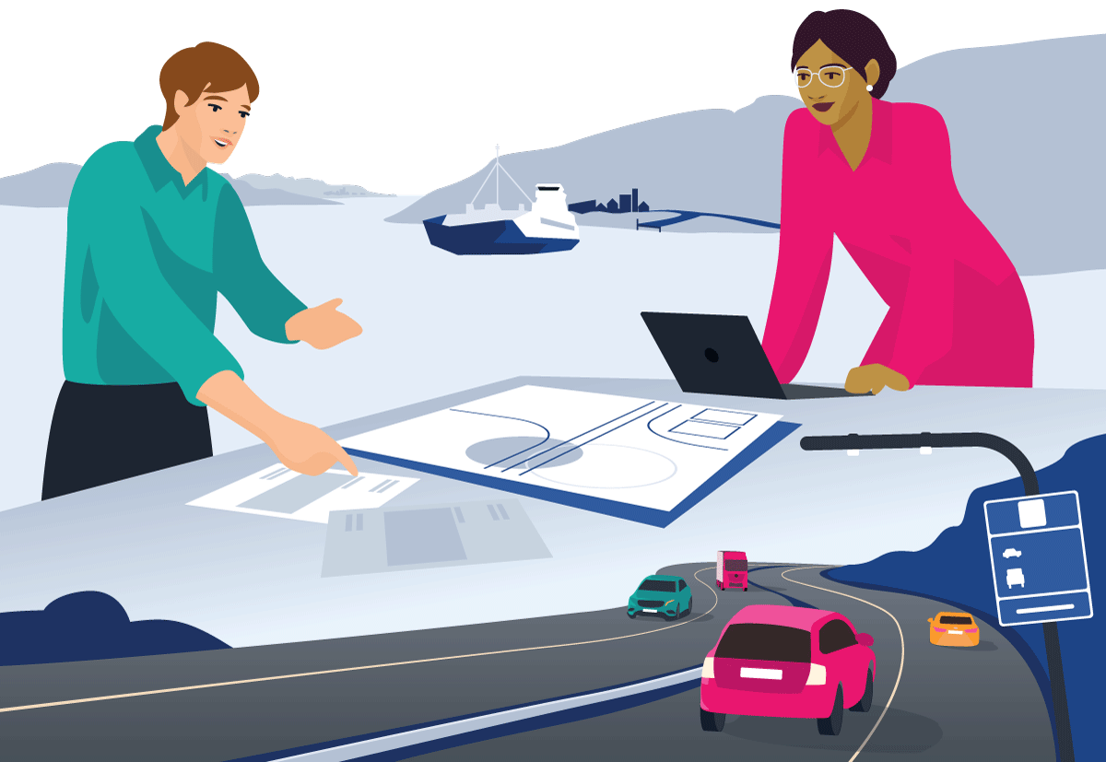

Chapter illustration

The National Transport Plan is submitted to the Storting (the Norwegian Parliament) as a white paper every four years. The white paper sets forth the Government’s national transport policy in terms of transport goals, strategies and priorities in a long-term perspective.

The National Transport Plan 2025–2036 (Report to the Storting (white paper) No. 14 (2023–2024)) was submitted to the Storting in March 2024. This is the seventh plan under the current planning system, covering all modes of transport. The plan presents policies and priorities within an economic frame for a twelve-year period and provides perspectives towards 2050 and 2060.

The preparation of the white paper is backed by an extensive process, involving input from ministries, agencies, county authorities, the four largest municipalities, the Sámi Parliament, business, industry and other user and interest groups. An important objective is to ensure an inclusive process while aiming to create a strategic and dynamic plan that identifies and addresses the main challenges for future transport.

The transport agencies (the Norwegian Public Roads Administration, the Norwegian Railway Directorate, the Norwegian Coastal Administration, Bane NOR SF, Nye Veier AS and Avinor AS) were given several assignments and tasks by the Ministry of Transport and the Ministry of Trade, Industry and Fisheries on a wide range of topics during this process. Their responses and reports were subject to public consultation. In sum, these contributions have provided a broad insight into the future needs and opportunities for the transport sector.

The follow-up of the National Transport Plan each year of the planning period, with specific measures and resource allocation, is presented in the annual National Budget.

The National Transport Plan encompasses the tools available to the Government in the field of transport. Relevant areas connected to transport policy include tax policy, climate and environmental policy, and the local government sector. Responsibility for these areas at the ministerial level lies with the Ministry of Finance, the Ministry of Climate and Environment, and the Ministry of Local Government and Regional Development.

# The strategic direction of the National Transport Plan 2025–2036



Chapter illustration

The Government is presenting the National Transport Plan 2025–2036 during a time of transition, amidst significant challenges related to climate and nature. The policies must be developed within the framework of national climate and environmental goals and international commitments. Global unrest and war in Europe impact Norway, demanding increased attention to preparedness and defence. Going forward, society will see a growing elderly population and a decreasing proportion of working-age individuals. The skills and labour shortages is already noticeable, including in the transport sector. At the same time, continued population growth and economic development will lead to increased mobility needs.

The Government’s overall goal for transport policy is an efficient, environmentally friendly, and safe transport system, nationwide in 2050. Investments in the transport sector have resulted in shorter travel times on roads and railways, more frequent train departures, improved maritime safety, and positive urban development. Transport services in rural areas have become more attractive, partly due to lower ferry prices and reduced ticket prices on government-procured regional flight routes. The Government will continue to build new infrastructure but aims to reverse the trend of roads, bridges, signalling systems, and other critical transport infrastructure not being renewed in line with maintenance needs. Neglected maintenance increases the risk of accidents, reduces accessibility, and causes uncertainty for businesses. Infrastructure failures pose a threat to civil protection, while climate change adds further challenges to mobility and traffic safety.

The Government will pursue a responsible transport policy, prioritising maintenance and improvements. The country’s transport system should become safer and more resilient to extreme weather events, landslides, avalanches, and floods. Investments in operation and maintenance will ensure that infrastructure can remain operational even under pressure. County authorities shall be better equipped to prioritise maintenance of county road networks.

New investment projects will be carried out where necessary for societal development. At the same time, efforts will be made to reduce greenhouse gas emissions. Nature conservation will play a more significant role in shaping the transport system of the future, avoiding the degradation of valuable natural areas and cultivated land.

The Government has ambitious goals for transport safety and will intensify efforts to achieve the vision of zero fatalities and serious injuries in the transport sector.

To achieve the transport policy objectives, the Government will focus on smarter solutions. Technological advancements offer opportunities for more efficient use of public resources, from targeted maintenance to better utilisation of transport capacity. Emphasis will be placed on technological solutions that contribute to environmentally friendly transport and improved safety.

Significant financial resources have been allocated to the transport sector for many years. The share of the National Budget allocated to the transport sector has increased from 3.1 per cent in 2009 to nearly 5 per cent in 2024. The 2024 budget includes close to NOK 90 billion for purposes included in the National Transport Plan. The Government will continue its high level of resource allocation in the upcoming planning period, while also considering the growing needs in other sectors.

The Government’s priorities aim to create a forward-looking transport system by preserving existing infrastructure, improving transport infrastructure where possible, utilising capacity in the existing infrastructure and transport services better – and constructing new infrastructure when necessary.

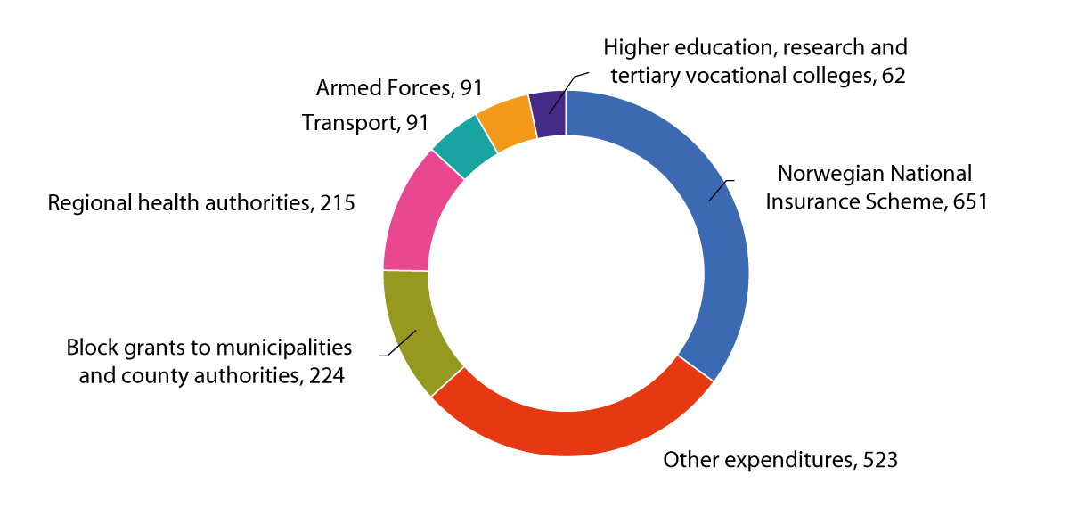

The National Budget’s largest expenditure areas in 2024 (in billion 2024-NOK).

Source: Meld. St. 1 (2023–2024) Report to the Storting (white paper) The National Budget 2024

# The Government’s goals and strategies for the future transport sector

The Government presents a comprehensive strategy based on the national transport policy goals in the report on the National Transport Plan 2025–2036. A goal structure involving an overarching goal and five main objectives for transport policy is continued (Figure 4.1). The overriding goal for transport policy is an efficient, environmentally friendly, and safe transport system nationwide in 2050.

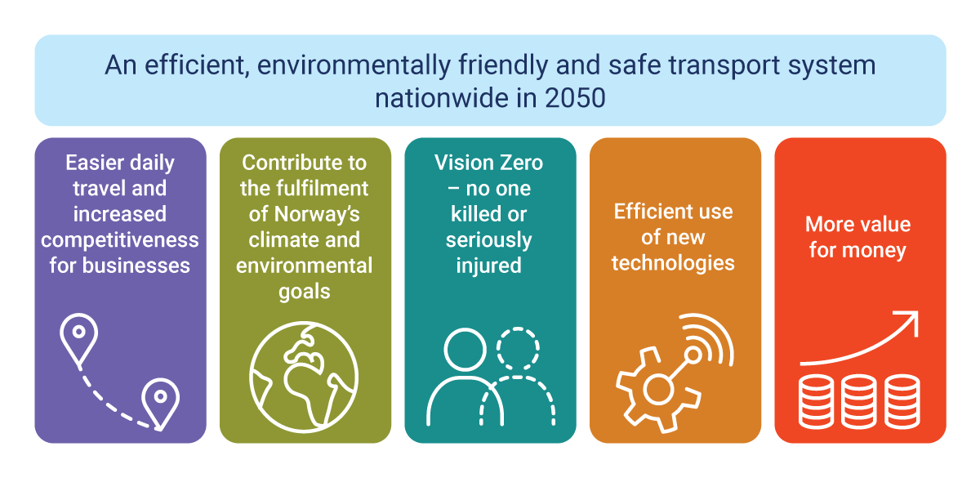

Transport policy goals

The goals outline what is to be achieved through policy. Although the goals have been continued over time, their content and significance will vary based on short-term and long-term political priorities and challenges. The report on the National Transport Plan 2025–2036 is presented during a period of international instability, which, among other things, means that civil protection and preparedness play a more significant role in transport policy. On the other hand, the climate and nature crises lead to a greater emphasis on measures that reduce greenhouse gas emissions, mitigate adverse impacts on nature, and adapt infrastructure to climate change. Furthermore, the Government’s commitments to combating social dumping and ensuring decent working conditions also impact transport policy.

The transport policy goals, along with the priorities outlined in the white paper and the Storting’s consideration thereof, will form the basis for implementing the National Transport Plan. This will take place through the annual National Budgets and subsequent efforts within the transport sector.

The transport policy goals are aligned with and contribute to Norway’s pursuit of the United Nations’ Sustainable Development Goals.

## Improved mobility for people and businesses nationwide



Chapter illustration

The National Transport Plan 2025–2036 aims to facilitate daily travel for people and enhance competitiveness for businesses.

Mobility is the purpose of the transport system. It contributes to economic growth by enabling workforce participation, utilisation of the country’s resources, and trade with the rest of the world.

Economic growth and population trends significantly impact future transport demand. Statistics Norway’s population projections from 2022 indicate that Norway’s population will grow from 5.4 million to 6.1 million by 2060. The growth is expected to be particularly significant in densely populated areas such as the Greater Oslo Region and around the major cities. Projections and forecasts form part of the basis for the Government’s policy development and proposed measures.

Over time, a framework and empirical knowledge have been developed to assess future transport demand, similar to the population projections, based on historical trends. The Government will initiate efforts to improve analytical methods so that future national transport plans can facilitate an even better decision-making basis, with the aim of reducing greenhouse gas emissions in the transport sector and contribute to the fulfilment of Norway’s international climate and environmental commitments.

Together with the Government’s focus on regional aviation and ferries, the priorities in the National Transport Plan 2025–2036 aim to make living and working throughout the country an attractive prospect. The Government intends this focus to alleviate centralisation pressure by making it more appealing to establish workplaces and settle outside the largest urban areas.

The road network will continue to evolve to securely connect the country. The Government will maintain the existing airport structure and facilitate a robust domestic and international flight network within Norway.

At the same time, the transport plan aims to create favourable conditions for continued climate and environmentally friendly urban development with good mobility and accessibility. The Government will renegotiate and extend existing Urban Growth Agreements. During the planning period, negotiations may extend to the Buskerudbyen and Grenland areas. The zero-growth goal for passenger car traffic will continue to guide collaboration between central and local government. The new railway strategy proposed by the Government will contribute to efficient and environmentally friendly transportation to and from cities.

The Government will invest in maintaining the nationwide transport infrastructure. A strong focus on improvement projects and smaller investments in existing road and rail infrastructure will enhance infrastructure utilisation, improve punctuality on railways, enhance safety, and increase resilience against climate change. Prioritising small-scale investments over larger projects also contributes to reduced greenhouse gas emissions and environmental disruption. The Government aims to empower the county authorities to prioritise efforts to upgrade county road networks.

In freight transport, the Government encourages all modes of transport to develop their strengths in relevant markets. Enhancing the competitiveness of businesses involves facilitating efficient, safe, and environmentally friendly transport nationwide.

Geographically dispersed port services are crucial for the competitiveness of maritime transport, especially along the coast. The Government will support and further develop a decentralised port structure. Fishing ports are essential components of the infrastructure for fishing-dependent coastal communities and other maritime economic activities. During the planning period, the Government will increase capacity and efficiency in fishing ports through investments in state-owned fishing port facilities and grants for municipal fishing port initiatives.

Based on completed concept studies, consultations, and external quality assurance, the Government will decide which concepts to adopt for further development of transport solutions in Northern Norway.

## More climate and environmentally friendly transport



Chapter illustration

The National Transport Plan 2025–2036 aims to contribute to the fulfilment of Norway’s climate and environmental goals.

The transport sector accounts for approximately one-third of Norway’s greenhouse gas emissions. During the planning period, the Government will focus efforts on segments within the transport sector that are expected to have significant residual emissions after 2030. These segments include heavy road vehicles, construction machinery, and maritime transport. The Government also aims to facilitate the transition of aviation to zero- and low-emission solutions.

In road transport, heavy vehicles represent the largest source of emissions going forward. The Government will implement a package of measures to reduce emissions from such vehicles. The key measures presented in the National Transport Plan 2025–2036 to reduce emissions from heavy vehicles are to accelerate the provision of rest areas and overnight stops and ensure the establishment of charging infrastructure at such stops.

To reduce emissions from construction machinery, the Government will, among other measures, continue the subsidy programme for emission-free construction sites until 2027.

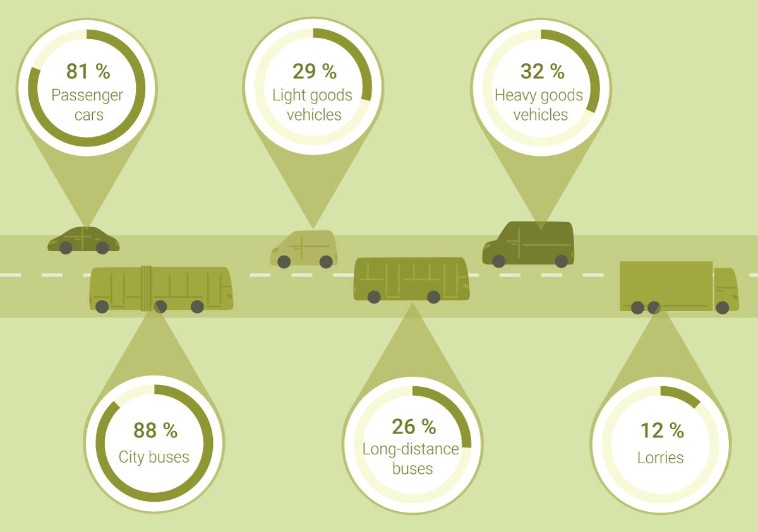

Percentage of zero-emission vehicles of all first time-registered vehicles in 2023

Source: The Norwegian Public Roads Administration

Regarding maritime transport, the Government will, among other measures, assess the transport needs that coastal route operations should meet, evaluate their environmental impact and explore the potential for further tightening of environmental requirements. Additionally, the Government will investigate whether ports can require vessels to use electricity or other low- or zero-emission fuels when calling at and using the port.

Emissions from the aviation sector must be reduced. Therefore, for the first time, funds are prioritised to accelerate the adoption of zero- and low-emission aviation in Norway.

In addition to emissions, the development, operation, and maintenance of transport infrastructure has adverse consequences for nature and the environment, local air pollution and noise levels. The Government will shift focus from large investment projects to improvement, operation, and maintenance during the planning period, benefiting both the climate and nature.

Biodiversity loss is also a serious concern. The transport sector adversely impacts biodiversity and aquatic environments through infrastructure construction, maintenance, and traffic. Pre-assessment studies and planning under the Planning and Building Act are essential tools for safeguarding nature.

When developing transport infrastructure, the planning of projects through areas of national or significant regional climate and environmental interest should be avoided.

Reducing land use impact is crucial for the transport sector. The new road standards established in autumn 2023 support this goal. To prevent unnecessary destruction of natural areas and cultivated land and to reduce the overall impact of transport, it is essential to promote less car dependency, improve public transportation, densify around transit hubs, and encourage cycling and walking.

Moving forward, it will be important to quantify the extent of natural areas with varying values that are affected by development. The Ministry of Transport will encourage the transport agencies to continue developing a land account and biodiversity indicator during the planning period.

## New and reinforced measures for enhanced transport safety

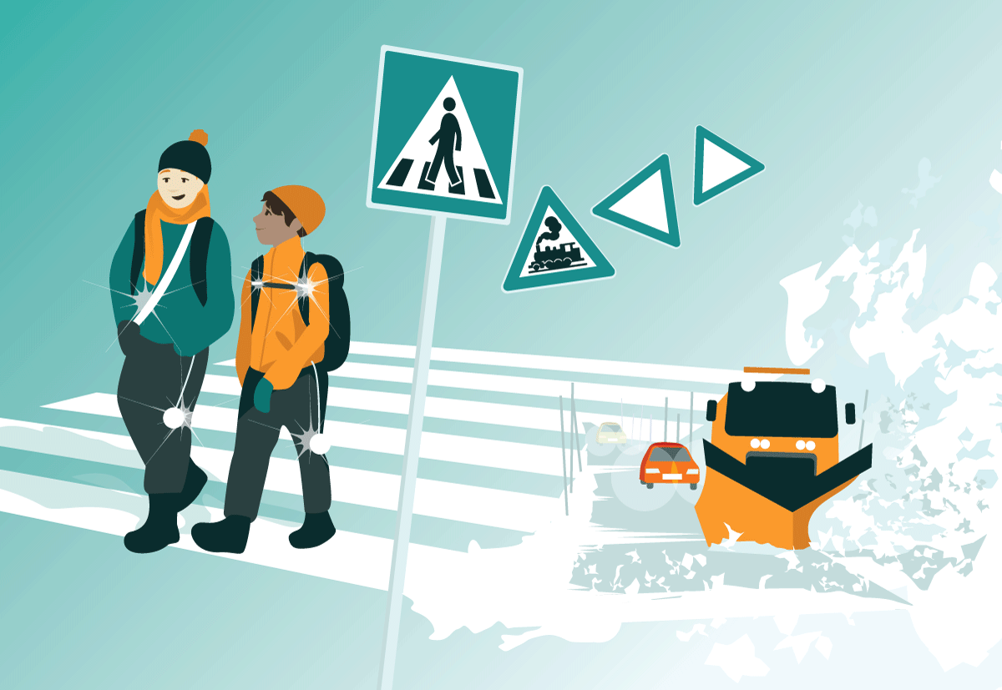

Chapter illustration

The National Transport Plan 2025–2036 aims to eliminate accidents resulting in fatalities or serious injuries within the transport sector (“Vision Zero”).

Safety levels for rail, air, and sea transport are consistently high, and the Government intends to maintain this low accident risk. The most significant safety challenge lies within the road sector. Despite years of declining fatalities in road traffic, the number of deaths has increased in the last two years, and the favourable trend has plateaued. This is illustrated in Figure 4.6.

To achieve Vision Zero for transport accidents, the Government has set intermediate goals for the planning period. By 2030, the target is a maximum of 350 fatalities and serious injuries in road traffic, of which no more than 50 are fatalities. Ultimately, the goal is to eliminate fatalities in road traffic by 2050. Additionally, the Government has established Vision Zero for the elimination of fatalities or serious injuries on vessels and facilities under the jurisdiction of the Norwegian Maritime Authority.

The 2030 intermediate goal entails reducing the number of fatalities in road traffic by more than half during the first six-year period. To achieve this, the Government will intensify efforts in road safety work, including increased control and enforcement, targeted campaigns, and smaller infrastructure measures on segments with documented safety needs. The use of automatic traffic control will be expanded, and regulatory changes will address unwanted risky behaviour on the roads including through the confiscation of vehicles in cases of high-speed driving and prohibiting any use of mobile phones while driving. The Government will also consider prohibiting warning services that reduce the effectiveness of police control activities on the roads. Furthermore, targeted efforts will address specific accident types and vulnerable road user groups, including motorcyclists, heavy goods vehicles, young people and young drivers, elderly road users, pedestrians and cyclists.

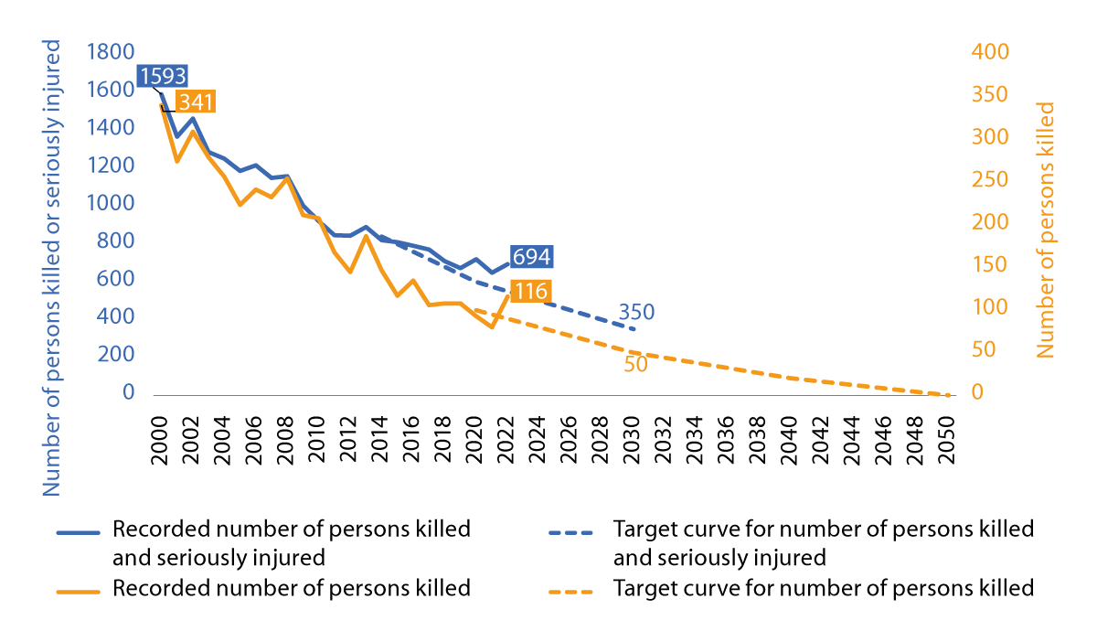

Development of fatalities and serious injuries in road traffic, and targets for 2030 and 2050

Source: The Norwegian Public Roads Administration

The level of ambition is high and requires sustained and increased national road safety efforts. Norway’s road safety efforts are based on science and cooperation between central, regional and local authorities in addition to interest groups and businesses. The National Action Plan for Road Safety contains a wide range of knowledge-based measures with various stakeholders assigned responsibility for implementing them.

Continuous work on the operation and maintenance of road infrastructure is crucial for road safety. The Government’s prioritisation of maintenance, improvements, and renewal during the planning period will contribute to enhanced safety on our roads.

## Increased emphasis on civil protection and climate adaption

Russia’s full-scale invasion of Ukraine in 2022 has altered Norway’s security environment. Norway’s significance as a host nation and transit area for allied forces has grown following the accession of Finland and Sweden to NATO. Civil protection efforts in the transport sector must adapt to changes in the security environment.

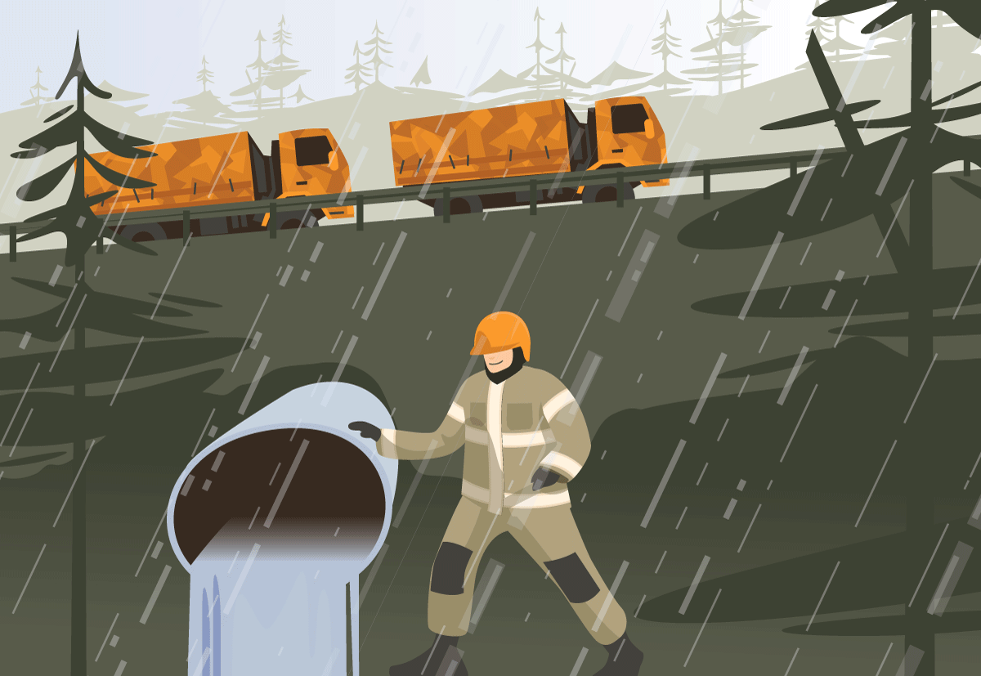

Chapter illustration

Several prioritised projects and measures in the planning period will have significant benefits for civil protection and safety. During the planning period, civil protection and safety, including military mobility, will also be taken into account when assessing measures. Such measures will be prioritised where they have the greatest effect in accordance with military plans and identified operational demands.

The total defence concept encompasses mutual support between the Norwegian Armed Forces and civil society across the entire crisis spectrum, from peacetime through security crises to armed conflict. The Government aims to establish a clearer framework for collaboration between the transport and defence sectors to ensure effective identification and prioritisation of military needs within the total defence concept in the years ahead.

The county authorities play a vital role in civil protection and safety on county road networks, particularly as these roads serve as detour routes. Many county road segments are also critical for military mobility. The Government plans to introduce a dedicated funding scheme for the county authorities to upgrade critical bridges for military mobility.

Transport preparedness is a crucial part of national emergency preparedness and total defence. The Government will enhance cooperation between the central government, private stakeholders, and county authorities to maintain sufficient transport capacity during crises. Additionally, the Government will further develop the Nordic cooperation on resilience and civil emergency preparedness in the transport domain.

Complex digital systems and services, including intelligent transport systems, are increasingly important in the transport sector. While this development has several positive implications for transport, it also introduces digital dependence as a significant vulnerability for the entire transport system. The Government therefore aims to enhance the ability to handle unwanted cyber incidents in the transport sector.

Climate change is occurring faster, and its consequences are more extensive than previously anticipated. This has implications for transport safety, accessibility, and capacity. The Government’s prioritisation of operation and maintenance is a crucial step toward adapting transport infrastructure to a changing climate.

## Digitalisation and new technologies for a more efficient transport system

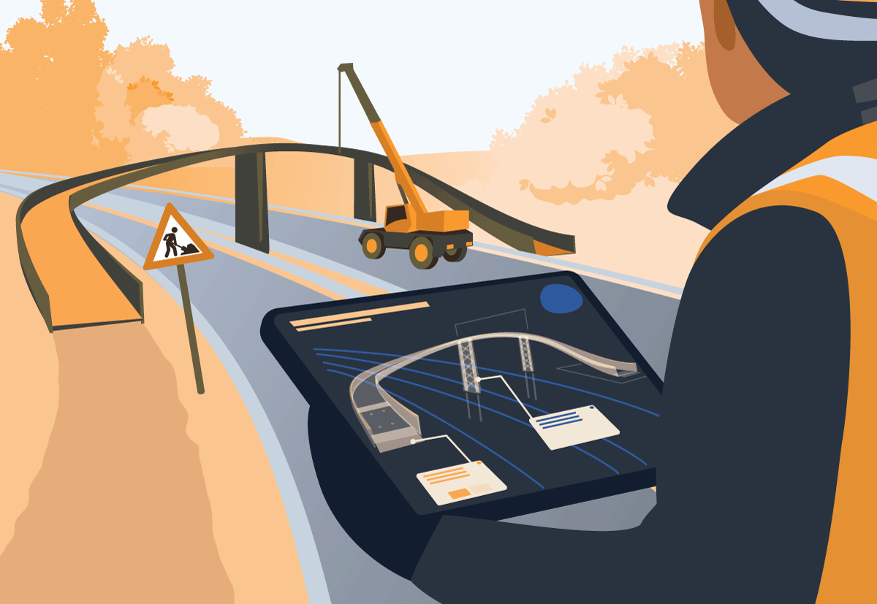

Chapter illustration

Transport in the future will be more automated, more shared, and more connected, and will have to be low or zero-emission, all enabled by new technologies. The effective use of new technologies has the potential to profoundly transform the Norwegian transport system and will contribute to achieving policy objectives such as improved accessibility, fewer traffic accidents, and reduced greenhouse gas emissions and adverse environmental impact. Thus, the use of new technologies is a priority of the National Transport Plan 2025–2036.

New technologies enable better utilisation of the capacity of existing infrastructure and transport services. There is residual capacity in the transport system that needs to be more effectively harnessed by developing and deploying new digital applications and solutions that enable higher capacity utilisation. It will also be important in the coming years to make use of the vast amounts of data generated in the transport system, to improve the management of traffic and road users’ behaviour.

The Government has prioritised digitalisation of the transport system, more and better use of transport data and harnessing the possibilities brought on by artificial intelligence. The Government will also aim to develop digitalisation-friendly regulations, to as far as possible avoid situations where regulation poses an obstacle to digitalised mobility solutions. Furthermore, the Government will support research, development and pilot projects, both within the transport agencies and public enterprises, and through established R&D funding mechanisms. In addition, the Government plans to establish one or more new research centres (known as Transport 2050). These centres will carry out research that is intended to support the knowledge base for decision-making processes in the Norwegian transport sector, particularly in relation to the Green Transition.

# Priorities in the planning period – allocation of resources

## Redirect resources toward existing transport infrastructure

The Government’s priorities for the planning period are based on a financial framework involving a total planned expenditure of NOK 1,308 billion, of which NOK 1,208 billion from central government funds and NOK 100 billion from road toll revenues. The central government funding in the plan is comparable to the level outlined in Report to the Storting (white paper) No. 20 (2020–2021) National Transport Plan 2022–2033.

Given the condition of transport infrastructure, added strain due to climate change, and the need to reduce greenhouse gas emissions and minimise environmental impact, a different resource allocation approach is required to achieve the transport policy goals compared to the National Transport Plan 2022–2033.

The Government believes that persistent maintenance backlog in transport infrastructure and the impact of extreme weather events necessitate prioritising operation and maintenance moving forward. The heightened vulnerability resulting from climate change requires a more resilient infrastructure. In the railway sector, significant portions of the infrastructure are approaching or have exceeded their technical lifespan. Several railway lines have catenary systems that are over 70 years old. The national road network has undergone a gradual deterioration, while parts of the infrastructure are nearing their technical lifespan. Many bridges and ferry docks are over 50 years old. The existing transport system must be upgraded, and maintenance efforts should be directed where the needs are greatest.

The Government aims to shift focus from large investment projects to maintenance, renewal, and smaller investment measures during the planning period. Renewal and smaller investments in existing infrastructure will contribute to improved punctuality in rail transport, enhanced traffic safety, and reduced landslide risk.

The Government has prioritised an annual average of a total of NOK 40 billion for maintenance, operation, and smaller investment measures, along with NOK 35 billion for major investments during the planning period. The overall financial framework is distributed with 40 per cent to maintenance, operation, and smaller investments and 34 per cent to major investments. In the National Transport Plan 2022–2033, the corresponding distribution was 34 per cent and 44 per cent, respectively.

## Large investment projects, urban areas, and county authority transport

In addition to maintaining, improving, and renewing infrastructure, the Government is planning new investment projects where necessary. A total of NOK 350 billion is prioritised for major investments during the planning period. Additionally, Nye Veier’s planning framework amounts to NOK 78 billion. The completion of major investment projects initiated before the beginning of the planning period is currently estimated to cost NOK 144 billion in central government funds. Of this total, 45 per cent is to road investments, including existing Public-Private Partnership (PPP) contracts, 41 per cent to railway investments, 8 per cent to state contributions for major public transport projects in urban areas, 3 per cent to maritime investments (including reimbursement obligations), and 3 per cent for the completion of airports in Mo i Rana and Bodø. These projects include those that were approved for commencement in the 2024 National Budget or earlier.

The Government will revisit these priorities each year during the planning period through the annual National Budgets.

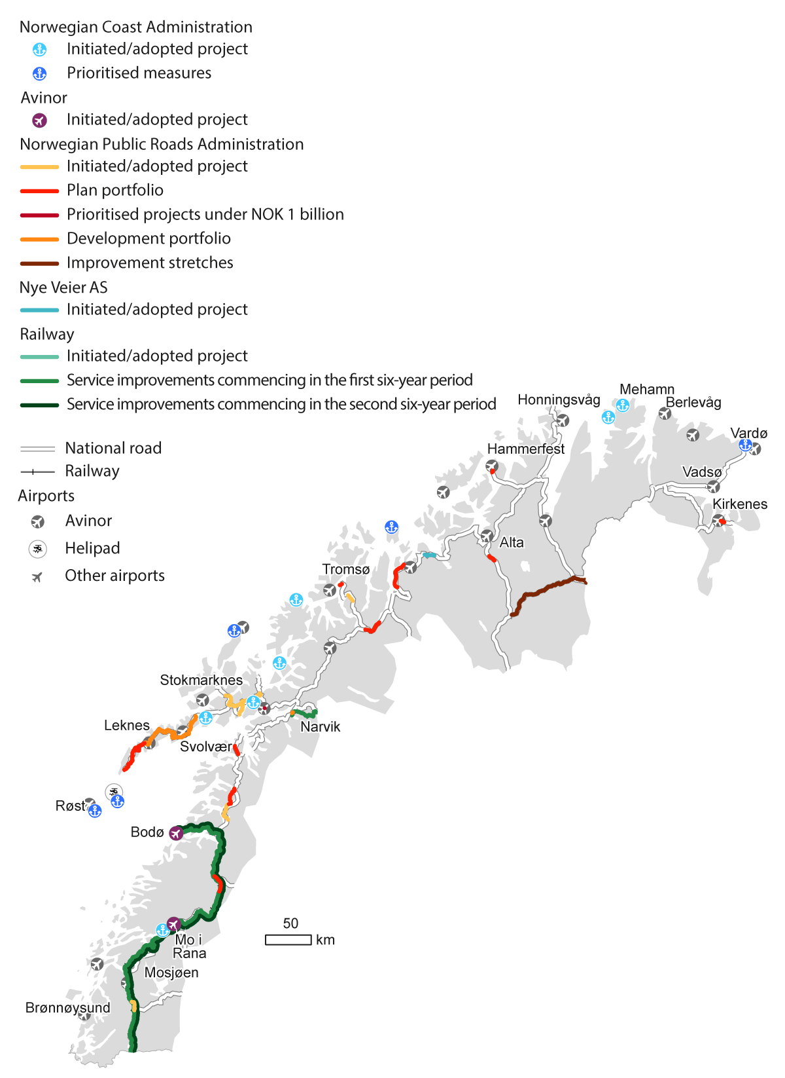

Projects for all modes of transportation in Northern Norway

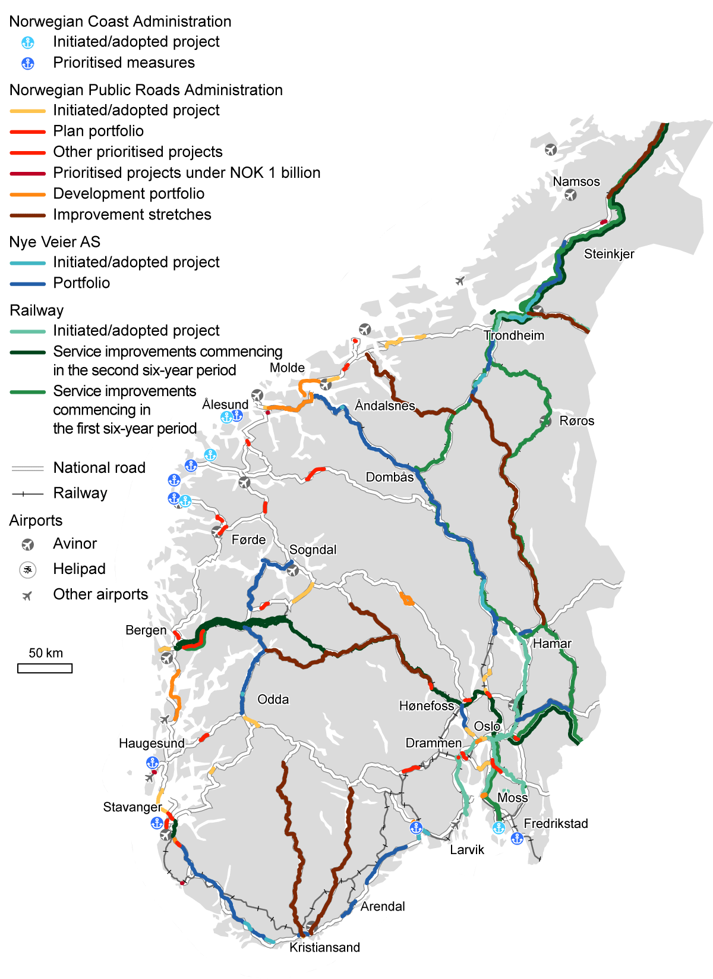

Projects for all modes of transportation in Southern Norway

The investment projects aim to increase railway capacity, reduce travel times on the national road network, and lower transport costs. The portfolio management system for major investment projects will continue during the planning period. The transport agencies will continue to optimise investment projects and use resources as efficiently as possible, including by adopting new technologies.

For urban areas, including follow-up on the central government’s contributions to Urban Growth Agreements and major public transport projects, a total of NOK 88 billion is prioritised in the planning period. These efforts aim to help cities achieve the zero-growth goal for passenger car traffic.

The county authorities receive the majority of funds for their responsibilities in the transport sector through the General Purpose Grant Scheme, which distributes unrestricted funds to the municipalities and county authorities. The Government prioritises additional funds for county roads distributed through the General Purpose Grant Scheme, as well as certain grants managed by the Norwegian Public Roads Administration. A total of NOK 65 billion is prioritised during the planning period.

The total average annual level in government funding is NOK 100.7 billion in the twelve-year period. Table 5.1 illustrates the distribution of the overall budget for the National Transport Plan 2025–2036 (central government funds) as annual averages across various purposes.

Total financial framework distributed across purposes. Central government funding. Billion 2024-NOK

05J1tx2

|  |  |  |  |  |
| --- | --- | --- | --- | --- |
| Purpose | | Budget 2024 | Annual average NTP 2022–2033 | Annual average NTP 2025–2036 |
| Administration | | 7.7 | 7.5 | 8.2 |
| Operations and maintenance | | 15.8 | 17.5 | 21.4 |
| Investments, of which: | | 49.7 | 61.0 | 53.5 |
|  | – smaller investments etc. | 11.7 | 17.0 | 18.9 |
|  | – large investments | 38.0 | 44.0 | 34.6 |
| Central government procurement of transport services | | 8.0 | 5.7 | 7.8 |
| Grant schemes | | 8.8 | 8.9 | 9.8 |
| Total central government funds | | 90.0 | 100.7 | 100.7 |

The central government funds over twelve years are distributed as follows in the National Transport Plan 2025–2036; NOK 574 billion for national roads, NOK 65 billion for grants for county roads, NOK 436 billion for railway purposes, NOK 34 billion for coastal administration and maritime infrastructure, NOK 88 billion for urban area measures, NOK 5.5 billion for aviation, and NOK 5 billion for cross-sector initiatives.

Table 5.2 illustrates the distribution between sectors in the National Transport Plan 2025–2036 as annual averages compared to the National Transport Plan 2022–2033.

Distribution between sectors. Billion 2024-NOK

04J1xt2

|  |  |  |  |
| --- | --- | --- | --- |
| Sector | Budget 2024 | Annual average NTP 2022–2033 | Annual average NTP 2025–2036 |
| National roads | 40.8 | 47.9 | 47.9 |
| Grants for county roads | 4.1 | 4.9 | 5.4 |
| Urban areas | 7.2 | 7.5 | 7.3 |
| Rail sector | 32.3 | 36.6 | 36.3 |
| Coastal administration | 2.3 | 3.1 | 2.8 |
| Airports | 2.9 | 0.4 | 0.5 |
| Initiatives across transport sectors | 0.3 | 0.3 | 0.4 |
| Total central government funds | 90.0 | 100.7 | 100.7 |
| Estimated road tolls | 14.8 | 11.6 | 8.4 |
| Overall economic framework | 104.8 | 112.3 | 109.1 |

## Priorities within the individual sectors

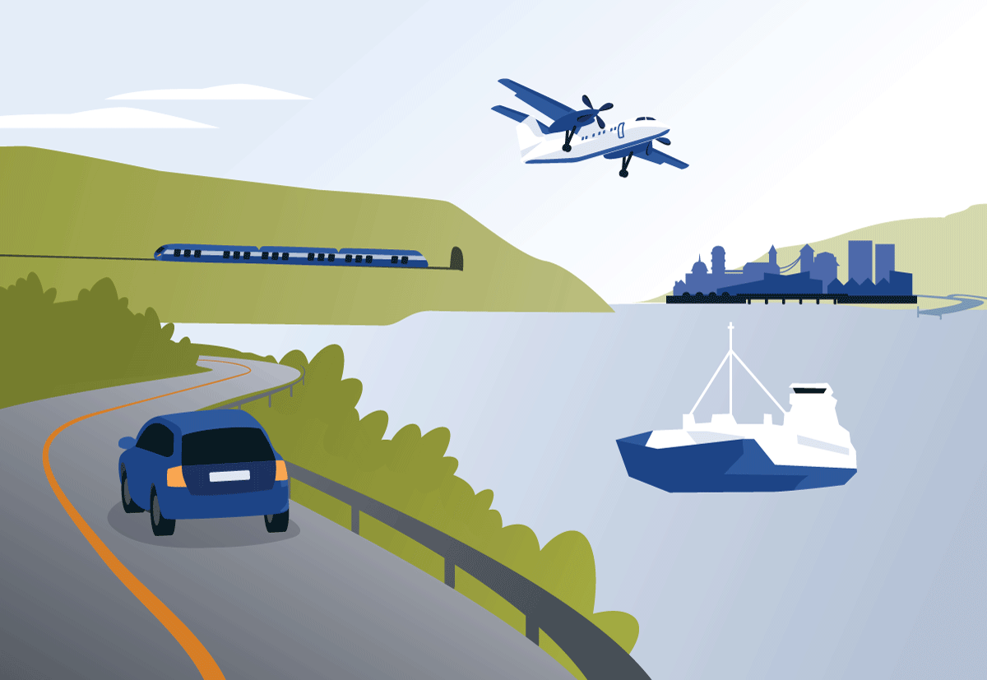

Chapter illustration

### The Road Sector

Roads play a crucial role in mobility, business, and emergency preparedness in Norway. Road transport accounted for 86 per cent of passenger transport work and 54 per cent of domestic freight transport work in Norway in 2022. Ferries also represent an important part of the road network. Improved facilities for pedestrians and cyclists have been developed, especially in the largest urban areas, which is essential for vulnerable road users.

The road network is divided between national, county and municipal roads. The overall condition of the national road network is good, though there is a need to eliminate bottlenecks and upgrade infrastructure. Challenges include a maintenance backlog and increased demands on what the road network must withstand.

Strategy for the National Road Network

The Government’s main strategy for the national road network is to preserve existing infrastructure, improve infrastructure where possible, and construct new where necessary. The strategy will contribute to a better everyday life for people nationwide. By prioritising operation, maintenance, renewal and improvements, more measures can be implemented across larger geographical areas. Increased funding for maintenance helps prevent unwanted incidents, which is especially important considering climate change and more frequent extreme weather events. Taking action on existing roads also reduces land use impact.

Improvement of bridges, road structures, and tunnel upgrades is necessary. Large investment projects, such as those by the Norwegian Public Roads Administration and Nye Veier AS, connect the country, eliminate bottlenecks, and reduce the risk of accidents and landslides.

Military Mobility Needs

The road network must be able to handle military transport, especially considering allied and national military materiel transport. The accession of Finland and Sweden to NATO increases the importance of cross-border west-to-east axes. There is a significant need to upgrade the national road network to ensure the capacity of road and bridge infrastructure to handle national defence needs in Norway and serve as a transit area for allied forces with heavy military equipment and logistics.

Technology

Efficient use of technology and information for travellers is critical in a vast and weather-prone country. To realise the strategy for the national road network, it is necessary to adopt new working methods and increase the use of technology in the road sector. The Government prioritises Intelligent Transport Systems (ITS), which are technological solutions to make transportation safer, more efficient, and more sustainable.

Reduced Emissions

Greenhouse gas emissions from road transport must be reduced. Electrification of the heavy truck fleet is a crucial part of the Government’s climate measures, and to ensure predictable charging conditions, more rest areas with charging facilities are needed. This will not only support electrification but also improve working conditions for professional drivers. During the planning period, NOK 3.7 billion is prioritised for heavy vehicle charging and the development of rest areas. The goal is to meet the estimated need for rest areas along the national road network during the first six-year period.

Initiated Major National Road Projects

At the beginning of the new planning period, activity in ongoing road sector projects is high. The Norwegian Public Roads Administration has several major projects under construction that will require significant resources in the coming years. The need for central government funding to maintain efficient construction operations in already initiated projects is estimated at NOK 64 billion in the first six-year period, including operation and maintenance for Public-Private Partnership-funded (PPP) stretches of road. Additionally, toll fees amount to NOK 38.5 billion.

Portfolio Management Continues

The Government plans to divide the portfolio of major investment projects for the Norwegian Public Roads Administration into a planning portfolio and a development portfolio. The planning portfolio should be achievable within 12 years, while the development portfolio will include sections where larger expansions are not currently feasible but where there may be room for smaller activities.

The planning portfolio consists of 29 projects with estimated costs exceeding NOK 1 billion. Additionally, the Government prioritises the development of European route E16 between Arna and Stanghelle as a joint project with the expansion of the Voss Line. The project is part of the main transport corridor between Oslo and Bergen. It aims to address current challenges on the route related to landslide risk and traffic safety, as well as compliance with the EU directive on road tunnel safety.

Financial Framework for the Road Sector

The Government has prioritised NOK 574 billion in central funds for developing the national road network during the planning period, with NOK 496 billion for the Norwegian Public Roads Administration and NOK 78 billion for Nye Veier AS. In addition, NOK 100 billion in funding will derive from toll fees. Despite significant commitments related to ongoing investment projects at the beginning of the planning period, the Government aims to gradually increase the funds for the national roads, with a greater emphasis on operation, maintenance, and smaller investments rather than large projects.

County Road Network

The county road network is extensive and serves essential functions for personal transportation and business. The 15 county authorities manage and ensure operation, maintenance and investment in their respective road networks. The Government prioritises upgrading the county road network, focusing on traffic safety and climate adaptation. Increased budgets provide county authorities with the means to maintain roads and achieve national transportation goals. The Ministry of Transport will also obtain more information regarding operation and maintenance on both national and county roads, including tunnel improvements on county roads.

### The Role of Railways in the Transport System

Projected Population Growth and Transport Needs

The Norwegian population is projected to reach 6.1 million by 2060, with most people living in urban areas. This urban concentration necessitates the further development of the transport system to meet the demands for mobility. By 2050, the population in the Greater Oslo Region is expected to increase by about 350,000. Effective transport solutions, including public transport agreements aiming for zero growth in passenger car traffic, have been crucial in these areas. A well-coordinated public transport network, where buses, trams, metro, and trains complement each other, is essential. Notably, railways constitute the backbone of the public transport system in urban areas, handling a third of daily commutes in and out of Oslo and playing a significant role in the overall transport system.

Growth in Railway Usage

In response to increasing transport needs, significant investments have been made in the railway sector over the past decade, resulting in a marked rise in both passenger and freight traffic. Passenger numbers grew from 62 million in 2012 to 80 million in 2019. By 2023, passenger numbers had returned to pre-pandemic levels, with over 150,000 daily passengers at Oslo Central Station. Freight transport has also seen significant growth, with a 30 per cent increase in track slot applications in 2023 compared to 2022.

Capacity and Punctuality Issues

The increased demand has led to a significant rise in train departures, fully utilising and sometimes overloading the rail network, which in turn impacts punctuality. In 2023, only 87.6 per cent of passenger trains and 75.5 per cent of freight trains met the established targets for punctuality. Infrastructure problems on crucial routes impact approximately 80 per cent of train traffic.

Challenges and Future Needs

Without further development, the railway system will struggle to meet the growing demand for both passenger and freight transport. Road systems are also under pressure due to congestion and environmental issues, despite electrification efforts. Addressing these challenges requires a coordinated approach among different modes of transport and may involve increased regulations and pricing strategies to align with environmental goals.

The Government recognises the need for sustainable transport solutions and aims to continue developing the railway system, particularly in urban areas and for long-distance freight. The focus will be on enhancing capacity, efficiency, and environmental sustainability, especially in the densely populated regions in Eastern Norway. Increased funding and plans for reducing infrastructure maintenance backlog is especially important considering climate change and more frequent bouts of extreme weather.

Strategic Development of the Railway Towards 2050

The Norwegian railway system has evolved through three main phases:

1. Expansion (1850–1960): Continuous network growth and increased train traffic.
2. Deterioration (1960–2010): Limited renewals and maintenance, leading to a growing infrastructure backlog and route closures.
3. Reform (2010–2024): Significant funding increases and sector restructuring.

The Government now aims to usher the railway into a fourth phase by 2050, adapting to contemporary challenges with a long-term, sustainable strategy summarised in seven main points:

1. Upgrade and Maintain Existing Infrastructure. This will ensure that the trains are reliable and arrive on time. Customer satisfaction is prioritised through better and increased maintenance.
2. Complete service improvements currently underway around the largest cities by 2030. In the coming years, travelers will have access to better train services in various parts of the country, such as to the cities of Tønsberg, Hamar, and Moss.
3. Increase Capacity in Urban Areas in the period 2025–2036 through developing the infrastructure in areas with the highest population growth, focusing on the Greater Oslo Region and Trondheim, upgrading overloaded lines and exploring potential benefits of double-decker trains.
4. Promote Growth in Freight Transport and Military Mobility. Transporting goods by rail is climate-friendly and measures taken to strengthen freight transport also benefit military logistical needs.
5. Digital Initiatives for Seamless Travel and Better Data Usage. Improving data sharing will facilitate smoother journeys through digital initiatives and improve service development and traffic management.
6. Increase National Railway Capacity Long-term. To meet the increased demand for transport, rail capacity in Eastern Norway as well as connections between major cities and abroad should be improved. A key issue will be to start planning a new national rail tunnel to address capacity issues by the 2040s.
7. Initiate Key Studies for the Next National Transport Plan, including a comprehensive public transport study for Eastern Norway, a new freight train strategy, and a long-distance train strategy.

### The Coastal Sector

The Government has prioritised NOK 34 billion to support efficient, safe, and environmentally friendly maritime transport.

Good accessibility, suitable port infrastructure, and strong connections between the coast and road networks are important for businesses along the entire coastline. As much as 91 per cent of all goods transported between Norway and other countries are transported by sea, with maritime transport accounting for approximately 41 per cent of domestic freight transport. Although maritime passenger transport constitutes a smaller portion of total transportation, it remains crucial for many coastal communities. The maritime transport system includes fairways, ports, and port terminals.

Norwegian waters pose challenges due to topography, weather conditions, and traffic density. While safety for maritime transport in Norway is generally at a high level, the consequences of accidents can be significant. The Government will prioritise safety measures to ensure the continued high standard of safety in Norwegian waters.

Although the environmental impact of maritime transport is lower than that of land-based transport, vessels must transition to zero-emission solutions to achieve the climate goals. The Government will encourage the development and adoption of climate-friendly energy carriers such as hydrogen, ammonia, and biofuel for large vessels.

The maintenance backlog for piers, breakwaters, and fairways associated with fishing ports has grown in recent years. The Government reinstated central government responsibility for fishing ports as of 1 January 2023, and tasked the Norwegian Coastal Administration with assessing the condition of all fishing port facilities. This assessment includes identifying maintenance, repair, and improvement needs.

Main Priorities

In line with the Government’s prioritisation of maintenance and improvements, the plan emphasises maintenance and renewal of fairways, navigation infrastructure, and digital infrastructure and services. This will facilitate safe, environmentally friendly, and efficient maritime transport while preventing or limiting environmental harm caused by acute pollution.

Maritime transport plays an important role in military mobility, and customised port facilities across the country are essential for receiving allied reinforcements. The Norwegian Coastal Administration contributes to Norway`s total defence system through services such as navigation guidance, maritime surveillance, and securing port facilities. Fairway improvements that increase depth and capacity for vessel movements also reduce the risk of accidents, provide alternative shipping routes and contribute to military mobility. Fishing port measures enhance maritime accessibility and support settlement and development in coastal communities in the northern regions.

The Government has prioritised NOK 900 million for minor fairway measures. These are measures with an investment cost of less than NOK 100 million. Although smaller in scale, these combined efforts can significantly improve ship traffic and are more flexible and quicker to implement than larger fairway projects. Similar to major investments, these measures contribute to increased maritime safety and improved accessibility by offering alternative fairways.

The grant scheme for efficient and environmentally friendly ports aims to streamline the logistics chain through port initiatives. This can lead to cost savings, improved quality, intermodal cooperation, and positive environmental effects. The Government is prioritising NOK 125 million for the grant scheme. Similarly, the grant scheme for fishing ports aims to stimulate local and regional economic development by partially financing municipal fishing port facilities. The Government is prioritising NOK 80 million for the grant scheme for fishing ports.

Ongoing and New Major Investment Projects

During the first six-year period, initiated fairway projects will be completed, including, among others, the Stad Ship Tunnel. A total of NOK 4.3 billion is prioritised for the completion of initiated measures during the planning period.

The Government is prioritising seven new fairway projects during the initial six-year period to enhance accessibility and safety along the entire Norwegian coast. These will enhance accessibility and safety along the Norwegian coast with safer fairways and the ability for ports to accommodate larger ships.

Fishing ports are pivotal to supporting the fishing-dependent coastal communities and other maritime-related economic activities. It is essential to implement measures that enable fishing ports to serve a modern coastal fleet. The most significant projects are concentrated in the counties of Northern Norway.

Opportunities in the Second Six-Year Period

Maritime transport is evolving, and fairways and fishing ports must be adapted to future needs. The Norwegian Coastal Administration continuously investigates initiatives to enhance accessibility and safety along the coast, in close dialogue with municipalities and county authorities. In 2024, the Norwegian Coastal Administration will conduct assessments for the Nordkapp–Kirkenes, Tromsø–Nordkapp, and Mo i Rana–Bodø stretches.

### The Aviation Sector

Aviation plays a crucial role in Norway’s transport system. Vast distances, a dispersed population and challenging topography and climate make aviation essential for ensuring the population’s access to healthcare, education, and other public services, as well as facilitating efficient business and personal travel, tourism development, and the transport of post and time-sensitive goods.

The fundamental prerequisites for Norwegian aviation are that the central government provides a well-functioning infrastructure and air traffic services and a competitive aviation market with a good quality of service. Where the market alone does not provide satisfactory air services on commercial terms, the central government ensures the transport needs of residents and businesses through the procurement of scheduled air services, known as Public Service Obligation (PSO) routes.

Figure 5.4 shows the Norwegian domestic air transport network in 2023. In addition to a well-developed domestic route network, aviation is crucial for Norway’s international accessibility.

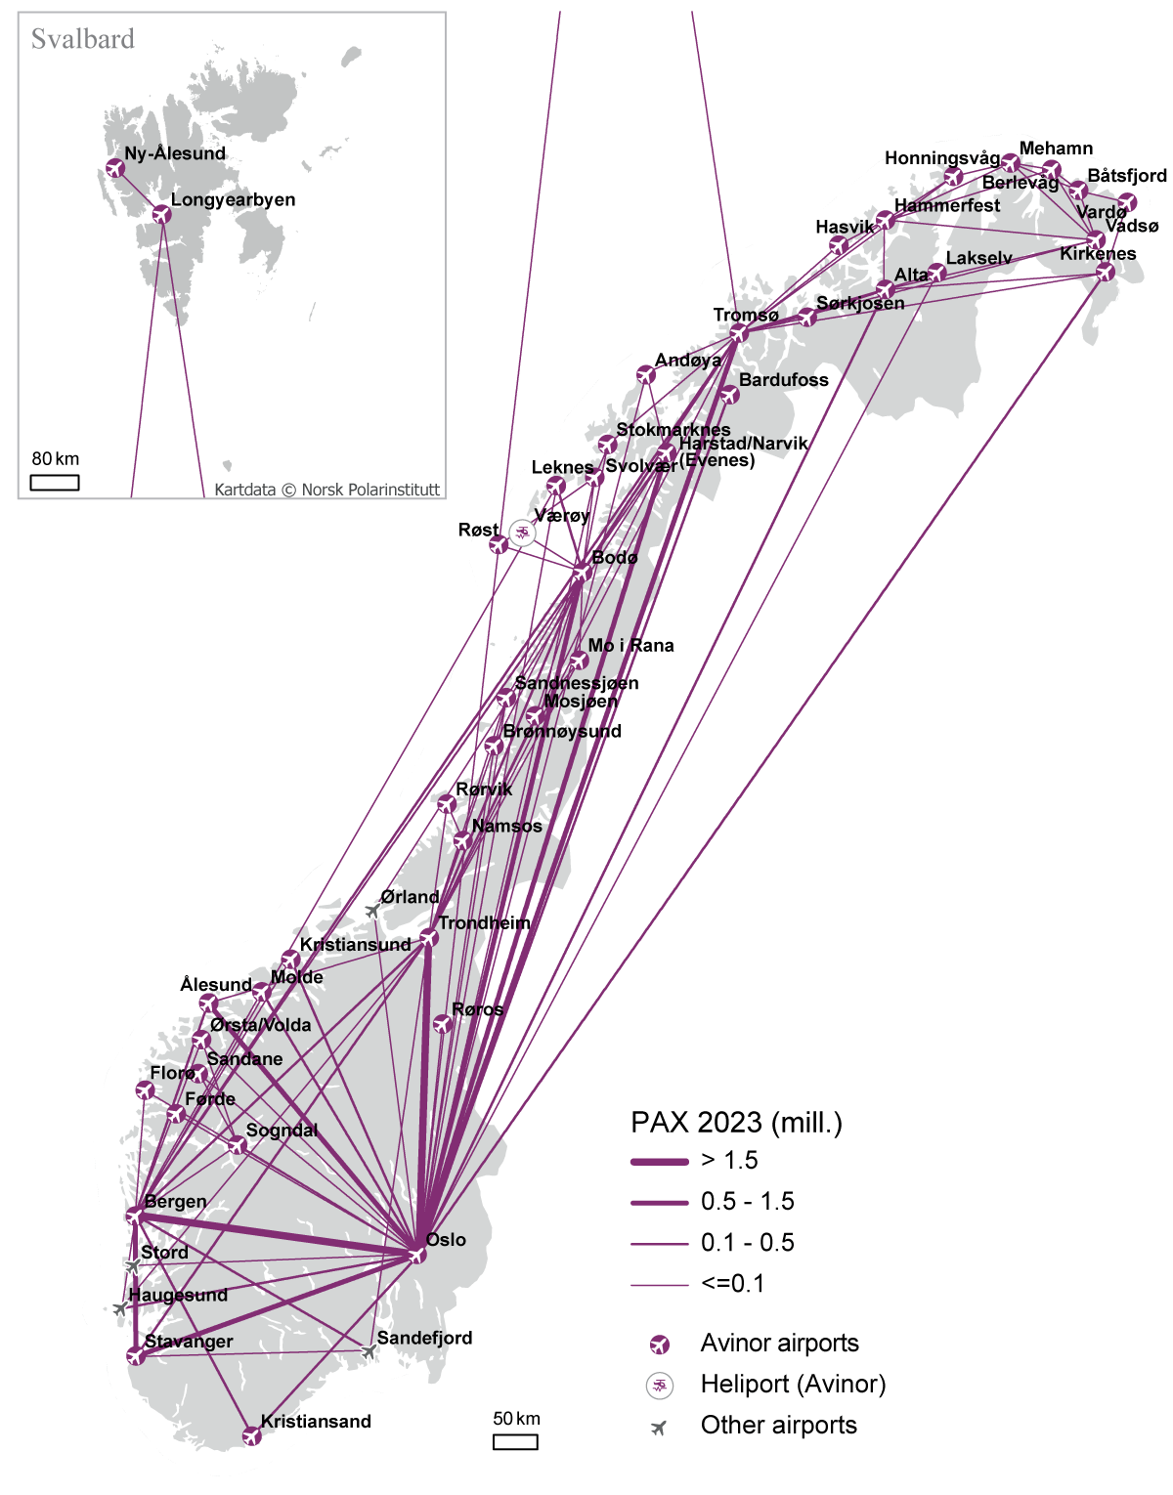

Domestic aviation in 2023 (in million passengers)

Source: Avinor AS

The Government published a white paper in January 2023, titled “Sustainable and Safe Aviation – National Aviation Strategy”, cf. Report to the Storting (white paper) No. 10 (2022–2023). This strategy, considered by the Storting in May 2023, outlines goals, instruments, and measures for sustainable aviation, addressing environmental, social, geographical, and economic aspects, including the development of a socially beneficial and sustainable drone industry. The National Transport Plan follows up and reaffirms many of the policy goals and measures in the National Aviation Strategy.

Aviation is characterised by a strong safety focus, high investment costs, and long lead times for new technology development. There is still uncertainty regarding when major technological shifts will occur. However, it is reasonable to expect the testing of new technology and the introduction of new types of aircraft into commercial operation during the planning period. At the same time, conventionally powered aircraft will continue to operate for their lifespan. This will place potentially significant demands on the wholly state-owned airport operator Avinor and the Civil Aviation Authority Norway as a regulatory body. The Ministry of Transport will ensure they have the necessary funds and frameworks to fulfil their respective roles safely and effectively.

Avinor is required to be primarily self-financed. The COVID-19 pandemic has severely impacted Avinor’s finances, and future traffic levels are more uncertain. The Government aims to secure sustainable financial conditions for Avinor and is working on concrete measures to achieve a lasting, annual improvement in Avinor’s results.

Aviation will have to undergo a major transition towards climate- and environmentally-friendly solutions if it is to contribute to national and international climate goals. A key measure, especially for larger aircraft, will be the increased use of sustainable aviation fuel (SAF) in conventional aircraft, likely even after 2050. The Government also aims to facilitate an accelerated introduction of zero- and low-emission aircraft. This requires a comprehensive transformation, including developing and adapting regulations, standards, operational concepts, and other public authority tasks for new energy carriers. The ageing regional fleet and challenging Norwegian conditions, such as topography, climate and many short runways, highlight the importance of timely sustainable alternatives. The Ministry of Transport is currently conducting a surveying exercise to implement targeted measures in Norway and to introduce technology suited to Norwegian conditions while reducing emissions.

Even if there is still a lot of uncertainty linked to technological development, the Government has identified a need to strengthen the professional and regulatory facilitation and development of the necessary infrastructure at the airports. The Government has therefore prioritised NOK 1 billion for the transition to more environmentally sustainable solutions in aviation within the planning period. Increased resources will therefore be allocated to the Civil Aviation Authority Norway and Avinor, with market involvement being crucial for finding and operationalising the right measures. Additionally, a forum including the Confederation of Norwegian Enterprise (NHO) and the Norwegian Confederation of Trade Unions (LO) has been established to share viewpoints and develop a unified knowledge base.

As with other transport sectors, technology will be crucial for infrastructure development and mobility. This includes increased drone use and facilitation for new forms of air mobility, eVTOLS (electric vertical take-off and landing) etc. Norway has a leading position in the drone sector which the Government wishes to maintain.

### Urban Areas



Chapter illustration

The expected population growth in the Greater Oslo Region and around other major cities in Norway will lead to increased demand for transport. Without policy changes, a significant increase in car traffic is expected. This trend is also partly due to the low operating costs of electric vehicles in Norway, for instance, lower toll rates for this category of vehicles, which encourages more people to choose cars for their daily travels.

Road traffic contributes to congestion and local air and noise pollution, particularly in the largest urban areas. Additionally, in cities, road infrastructure occupies considerable space, which is a scarce resource.

The Urban Growth Agreements and the zero-growth goal for passenger car traffic are well-established and essential tools for addressing mobility and congestion challenges and mitigating the adverse impacts of road traffic in urban areas. The zero-growth goal covers several important aspects and is formulated as follows: Greenhouse gas emissions, congestion, local air pollution and noise levels should be reduced through efficient land use and by shifting growth in passenger transport to public transport, cycling and walking.

In the Urban Growth Agreements, central, regional and local government commit to a joint and long-term effort to achieve the zero-growth goal. The agreements aim to strengthen coordination in land use and transport policies. The central government contributes to increased financing of public transport, cycling, and walking, supported by local measures such as restrictive measures against car traffic, efficient land use, and funding for public transport infrastructure and operation.

The four largest urban areas in Norway; Oslo, Bergen, Trondheim and Nord-Jæren (Greater Stavanger), have well-established Urban Growth Agreements, and a new agreement was reached for Tromsø in 2023. Negotiations with Greater Kristiansand and Nedre Glomma (Fredrikstad and Sarpsborg) began in the spring of 2024.

Following a period of decline in passenger traffic by car in the largest urban areas, there has been a growth in recent years. While the cities have achieved the zero-growth goal so far, further traffic growth could pose a threat to goal attainment. Therefore, robust and targeted measures will be necessary in the coming years.

The Government will continue its work with the Urban Growth Agreements to achieve the zero-growth goal during the planning period. Funding for these agreements has increased significantly over time, with a continued focus on public transport, cycling, and walking. However, limited fiscal space will impact the work on these agreements, emphasising the need to effectively maintain and utilise existing infrastructure. Restrictive measures against car traffic and increased urban density around transport hubs are cost-effective solutions with high goal attainment.

The Government also plans to simplify the funding structure within the Urban Growth Agreements providing more local flexibility in prioritisation. This approach places more responsibility on the local parties to achieve the zero-growth goal.

Main Priorities

During the planning period, the Government’s financial framework includes NOK 88 billion to Urban Growth Agreements, reward agreements, and grants for climate-friendly urban development and improved mobility. This amounts to approximately NOK 7.3 billion per year.

A key priority is to facilitate renegotiations of Urban Growth Agreements in the four largest urban areas. This will provide predictability for local authorities beyond the current agreement period (up to 2029). Additionally, negotiations may extend to Buskerudbyen and Grenland. These urban areas currently have reward agreements, and the Government intends to continue these while considering future Urban Growth Agreements. The Urban Growth Agreement for Tromsø may be renegotiated and extended beyond the current period (up to 2032). A similar approach may be considered for Greater Kristiansand and Nedre Glomma if ongoing negotiations in the spring of 2024 result in agreements being reached.

The Government prioritises a 70 per cent central government contribution to the county authority public transport project Bergen Light Rail to Åsane. A final decision from the central government will depend on the outcome of an ongoing assessment regarding route selection and decisions by the City Council, as well as subsequent negotiations between the central government and local authorities.

Additionally, the Government will continue a grant program for climate-friendly urban development and improved mobility in five urban areas not covered by the Urban Growth Agreements. This programme is specifically earmarked for the cities of Bodø, Ålesund, Haugesund, Arendal/Grimstad, and the Vestfold region (Tønsberg, Sandefjord, and Larvik).

Road Tolls Policy

The Norwegian Government aims to allow local authorities to continue contributing to the development of the national road network through toll financing as well as a tool for urban development by regulating traffic and funding investments in public transport and road infrastructure. However, it is essential that road toll financing is at a level that ensures its legitimacy. To this end, the overall toll burden should be considered both during the revision of the National Transport Plan and in the further planning of new projects.

The increasing number of light electric vehicles (passenger cars) poses challenges, leading to more road traffic in cities. To address this, it may be an option during the planning period to increase toll rates for light electric vehicles beyond the current 70 per cent of the regular rate.

Regarding heavy vehicles, the Government plans to continue the current practice of exempting heavy zero-emission vehicles from road tolls. There will be no toll charges for heavy zero-emission vehicles until 2030.

For projects focused on improving traffic flow near urban areas, while also aligning with the zero-growth goal, the Government is considering time- and environment-based differentiated toll rates for specific road projects that pass through or near urban areas covered by toll-financed urban packages.

To enhance resource utilisation, the Government is prioritising smaller investments and renewal projects over large investment projects. The Norwegian Public Roads Administration and Nye Veier can therefore explore road tolls in these kinds of projects if there is local political interest.

# Implementation and risks

The allocation of resources in each budget year will be adjusted according to the overall economic framework in the central government budget, within the limits set by the fiscal rule and the state of the Norwegian economy.

Unforeseen cost increases, particularly in large investment projects, pose a risk to plan implementation. Portfolio management and effective cost control measures aim to mitigate this risk. Shifting resource allocation from major investment projects to smaller investment measures, maintenance, and operations contributes to increased flexibility in the execution of the plan.

Additionally, several factors outside the transport sector can influence implementation. Economic growth, resource needs in other societal areas, availability of sufficient workforce and appropriate expertise, access to clean energy, unforeseen effects of climate change, and land-use conflicts are among the key risk factors. Technological advancements that enhance resource efficiency and accelerate goal attainment are critical factors that can positively impact the execution of the plan.

1. References: Statistics Norway, Great Norwegian Encyclopaedia, Bane NOR SF, the Norwegian Railway Directorate, the Norwegian Coastal Administration