Klima- og miljødepartementet
Meld. St. 29
(2020–2021)
Norway’s integrated plan for the conservation of areas of special importance for marine biodiversity
Recommendation of 9 April 2021, approved in the Council of State the same day (Solberg Government)

Introduction: the conservation of marine biodiversity
The Government considers it vital to safeguard Norway’s ecosystems. Biodiversity is an essential basis for human survival, and its loss may have major consequences. Safeguarding nature is also part of the solution to reducing global warming. One of Norway’s national environmental targets is to maintain a representative selection of Norwegian nature for future generations.
Norway’s goal is to play a pioneering role in developing an integrated, ecosystem-based system of ocean management that protects biodiversity and provides a basis for sustainable use of resources. Norway already has a well-developed ocean marine management regime, and its ocean management plan system has attracted a great deal of international recognition. Norway is playing a leading role in developing knowledge about the environment and resources in the seas and oceans and on the continental shelf, and about their management. However, climate change and increasing ocean-based activity are creating new challenges. As a maritime nation, Norway therefore has a strong interest in maintaining and further developing its role as a responsible steward of the oceans.
Environmental status in Norwegian waters is generally good, but there are some areas where human activity is having substantial impacts. The effects are greatest in coastal waters of the North Sea and Skagerrak. Climate change is resulting in rising ocean temperatures and an increase in runoff from land to sea, and is also intensifying the impacts of other factors. At the same time, growing activity is expected in Norwegian waters, particularly in emerging and future ocean industries such as offshore wind, carbon storage below the seabed and hydrogen production. These developments make it vital for Norway to have an integrated national plan for the protection of areas of importance for marine biodiversity.

Conservation of marine biodiversity as part of integrated ocean management
Conservation measures, sustainable use and knowledge development are key components of integrated ocean management. One of the basic principles of the Government’s ocean policy is to promote the conservation and sustainable use of marine ecosystems. Knowledge about the marine environment has been developing rapidly in recent years. Efforts to protect valuable biodiversity and marine ecosystem services are based on the new knowledge acquired through mapping, monitoring and research.
In this white paper, the term conservation measures is used to mean both marine protection and other effective area-based conservation measures. Measures and policy instruments are referred to as ‘area-based’ if they apply to geographically delimited areas. Marine protection in Norway refers to the establishment of protected areas under the Nature Diversity Act. These may be either marine protected areas (MPAs), which are a separate category, or for example national parks or nature reserves that include marine areas. Establishing such areas provides long-term protection against environmental pressures and impacts across sectors. The term ‘other effective area-based conservation measures’ applies to measures in particular sectors, for example under the Marine Resources Act, that have positive long-term effects on biodiversity in specific areas.
Marine protected areas and other effective area-based conservation measures are intended to safeguard valuable ocean biodiversity and ecological functions. Rich biodiversity and high biological production, ecosystem services that offer a potential for harvesting, and the value creation that can be achieved by harvesting renewable resources, are all closely interlinked.
Marine ecosystems and their functions relating to biodiversity, production and harvesting from the oceans must be managed in a way that strengthens ecosystems resilience and safeguards biological production in the future.
This white paper presents the Government’s proposals for further development of the element of its ocean management regime concerning the conservation of areas of importance for marine biodiversity.

Developments in the conservation of marine biodiversity
One important conclusion of the 2016 OECD report The Ocean Economy in 2030 was that conservation of marine biodiversity is vital to maintain ecosystem functioning, which in turn is an essential basis for a sustainable ocean economy and long-term value creation from the oceans. The work of the High-level Panel for a Sustainable Ocean Economy (Ocean Panel) from its establishment in 2018 and until it published its conclusions in December 2020 has enhanced our understanding of these relationships.
In 1999, the Norwegian Government presented a white paper on conservation and use in coastal waters and the relationships between conservation interests and the fisheries industry. The white paper identified marine ecosystems, species and habitats as an important part of Norway’s nature. It pointed out that in future, it will also be necessary to safeguard representative and distinctive species and habitats in the marine environment, and to protect endangered and vulnerable species and habitats. In addition, it is vital to establish reference areas where ecosystem functioning is as undisturbed as possible. Reference areas are intended to provide a comparison with other areas where there is more disturbance from human activities. This means that the long-term aspect of conservation is of key importance. Another important motive for establishing such areas is to safeguard some undisturbed areas for future generations.
In response to the white paper, an advisory committee was appointed in 2001 to develop a marine protection plan. The committee included representatives from the public administration and relevant interest organisations. In 2004, the committee presented its recommendations and identified 36 areas which together made up a good, representative selection of marine nature. See Chapter 4 for more detail. With only a few exceptions, the areas proposed were near the coast. The committee also pointed to the need to continue the work and give priority to areas further from the coast in the second phase.
The white paper Nature for life – Norway’s national biodiversity action plan (Meld. St. 14 (2015–2016)) states that the Government’s policy is to continue cross-sectoral marine protection under section 39 of the Nature Diversity Act to ensure that a selection of representative, distinctive and threatened underwater habitats along the coast and in territorial waters is safeguarded for future generations. The objective is for these areas, together with areas that are protected under other legislation, to form a network of marine protected areas that will safeguard ecosystems, habitats and species.
Since then, the Storting (Norwegian parliament) has several times dealt with questions about marine protected areas in connection with white papers and private member’s motions. In 2016, when considering the white paper Nature for life, the Storting requested the Government to draw up a plan for marine protected areas and present this to the Storting.
The Government’s response to this request was described in the white paper Update of the integrated management plan for the Norwegian Sea (Meld. St. 35 (2016–2017)), as follows:
‘The Government is developing a plan for establishing more marine protected areas. As part of this work, the status of efforts to establish marine protected areas will be evaluated, and any further need for protection to achieve national and international targets will be identified. The findings will form part of the basis for further marine protection efforts both in Norway’s territorial waters and outside the 12 nautical mile limit. Under the management plans for Norway’s sea areas, regular assessments of the need for new measures to protect marine species and habitats will be conducted on the basis of existing knowledge.’
During its consideration of the updated Norwegian Sea management plan, the Storting requested the Government to follow up work on an overall national plan for marine protected areas, giving priority to areas that had been identified as particularly valuable and vulnerable. The Government was asked to report back on the issue at the latest in the course of 2020. The present white paper is the Government’s response to these requests from the Storting.
The white paper Norway’s integrated ocean management plans for the Barents Sea–Lofoten area; the Norwegian Sea; and the North Sea and Skagerrak (Meld. St. 20 (2019–2020)) stated as follows:
‘The Government will:
  - continue work on the establishment of marine protected areas;
  - draw up an overall national plan for marine protected areas in the course of 2020;
  - assess the need to protect distinctive and rare species and habitats in deep-sea areas.’
In addition, there have been significant developments internationally during the same period. These are further discussed in Chapter 3. Through its membership of the Ocean Panel, Norway has recently given its support to a global target of protecting 30 % of the oceans by 2030 through marine protected areas and other effective area-based conservation measures. This will also be a key issue in the preparations for the post-2020 global biodiversity framework, which according to plan is to be adopted under the Convention on Biological Diversity in autumn 2021.
A new understanding of the wider benefits of marine protected areas and other effective area-based conservation measures, beyond classical nature conservation, has also developed internationally. This has been highlighted for example in the work of the Ocean Panel, in recent research and in knowledge syntheses from bodies including the Intergovernmental Science-Policy Platform on Biodiversity and Ecosystem Services (IPBES) and the Intergovernmental Panel on Climate Change (IPCC). These benefits include the conservation and restoration of areas that are important for fish and shellfish stocks, the restoration of marine ecosystems, carbon capture and sequestration and protection against the impacts of climate change.
In this white paper, the Government presents an overview of knowledge and policy instruments and a status report on work on marine protected areas and other effective area-based conservation measures. The white paper also describes work on marine protected areas and other effective area-based conservation measures in international forums, international developments in this field and Norway’s reporting on progress towards international targets. Chapter 5 describes the measures the Government will use for the conservation of areas of importance for marine biodiversity.

Areas of special importance for marine biodiversity in Norwegian waters
There are many areas in Norwegian seas and oceans where species diversity, habitat diversity and biological production are high. The marine environment is very varied, and different elements of ecosystems may be associated with features of the surface water, the water column or the seabed. This is a dynamic environment, and there are wide fluctuations in physical and biological conditions. Ocean currents and the topography of the seabed are two elements that are important in shaping marine ecosystems. Some habitat types are found across wide geographical areas, while others have a more limited distribution. Species and life stages may be spread by ocean currents. Biodiversity in different parts of the oceans depends on physical conditions such as water depth, currents, temperature, salinity, oxygen content and nutrient levels. About 7000 species have been registered in Norwegian waters.
Norway’s marine nature includes valuable species and habitats and areas with specific ecological functions for different species. Shallow coastal waters support some of the most biologically productive habitat types in the world. Habitats in Norway’s coastal waters include cold-water coral reefs, river mouths, areas of shallow water and various types of marine wetlands, which are spawning and nursery areas for important fish stocks and other marine organisms. The Norwegian Sea is relatively shallow close to the mainland, but further from land there are deep-sea areas where water depths reach as much as 3000–4000 m. The Barents Sea and the North Sea and Skagerrak are shallower seas. All of these seas support a rich variety of species and habitats. Biodiversity and biological production are particularly high in certain areas where environmental conditions are favourable where there are specific types of seabed. Areas that are important for biodiversity and biological production are often associated with specific oceanographic or topographic conditions. These areas are not discussed in detail here, but the text below describes some important features and examples of valuable areas in Norwegian marine and coastal waters.

Areas of importance in coastal waters
The belt of coastal waters closest to the shoreline supports a wide variety of habitats, ecosystems and species. Kelp forests and eelgrass meadows are examples of habitat types where species diversity and biological production are high. Many species use coastal areas as a habitat and feeding area, and there are many areas of special importance for local fish stocks and seabirds along the coast.
Biodiversity has declined from its previous levels in some parts of Norway’s coastal waters. Some species, stocks and habitats need to be rebuilt and restored. The dynamic nature of coastal ecosystems, particularly kelp forests, is of vital importance for fish and crustaceans and in maintaining food supplies for coastal seabirds such as common eider, gulls, terns and cormorants and shags. Environmental pressures are having particularly marked impacts in the North Sea and Skagerrak. Much of the Oslofjord is seriously affected by nutrient inputs as a result of factors including agricultural runoff, climate change and turbid floodwater. Reduced light penetration in the water results in poorer growth of phytoplankton, seaweeds, kelp forests and eelgrass meadows. In addition, it results in oxygen depletion in the bottom water. This can have serious impacts on pelagic and benthic animals and affects species such as cod and sprat that are further up the food chains.
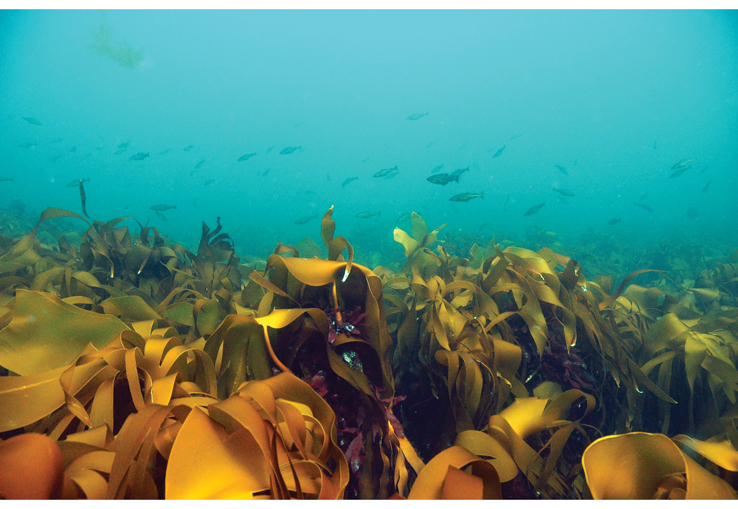
          - Kelp forest, Jærkysten marine protected area, Rogaland.
Photo: Rudolf Svensen
If the environmental status of an area is to be improved through restoration measures, negative pressures must be reduced. The Institute of Marine Research has headed a project on coastal cod in the Oslofjord, which in 2021 published a report on the decline of fish stocks and the ecological status of the Oslofjord. The report discusses the environmental problems mentioned above, but concludes that the outer Oslofjord still offers a suitable habitat for cod and other severely depleted fish stocks. It would therefore be possible to improve ecosystem status by reducing environmental pressures.
Many fjords and harbours along the coast of Norway have been affected by inputs of nutrients and hazardous substances from land. This has resulted in depletion of biodiversity, which has particularly affected the benthic fauna. Remediation of contaminated sediments has been carried out at a number of sites. Action can be taken to remove hazardous substances from biogeochemical cycles and achieve good environmental status for the seabed. In the long term, remediation efforts will allow species and habitats to become re-established, restoring healthy levels of biodiversity. The white paper Working together towards a non-toxic environment and a safer future – Norway’s chemicals policy (Report No. 14 (2006–2007) to the Storting) presented an action plan for contaminated sediments, which focused particularly on removing hazardous substances from biogeochemical cycles in the 17 highest-priority areas. In the 15 years since then, remediation action has been taken in many of these areas, and the results in several of them are encouraging. A renewed, clean seabed provides a basis for the reestablishment of fish stocks and healthy habitats. Both ecological and chemical status are improving, and many species that had been lost are returning.

Areas in the Barents Sea
The Barents Sea is shallow and includes large bank areas. The marine environment is strongly influenced by the inflow of warm Atlantic water from the southwest and by Arctic water and drift ice in the northeast. These factors enhance nutrient supplies in the upper water layers, thus increasing the growth potential of phyto- and zooplankton and providing the foundation for high biological production in Barents Sea ecosystems. The Barents Sea is the most important nursery and feeding area for several of the large fish stocks that support Norway’s fishing industry. Herring, capelin, cod, haddock, redfish and Greenland halibut use large areas of the Barents Sea throughout their life cycle or at certain stages of it. Eggs and larvae from spawning grounds along the Norwegian mainland coast and in the western part of the Barents Sea drift northwards along the coast and into the central, northern and eastern parts of the Barents Sea, where the fish grow to maturity. The cod and haddock stocks in the Barents Sea are some of the largest and most productive demersal fish stocks in the world, and this is also a nursery area for Norwegian spring-spawning herring, which is one of the world’s largest pelagic fish stocks. The Barents Sea also supports some of the largest concentrations of seabirds in the world. In addition, the northern part of the Barents Sea is an important habitat for a number of marine mammal and seabird species that are not found in areas without ice cover. Several of these populations are of major national and international importance.
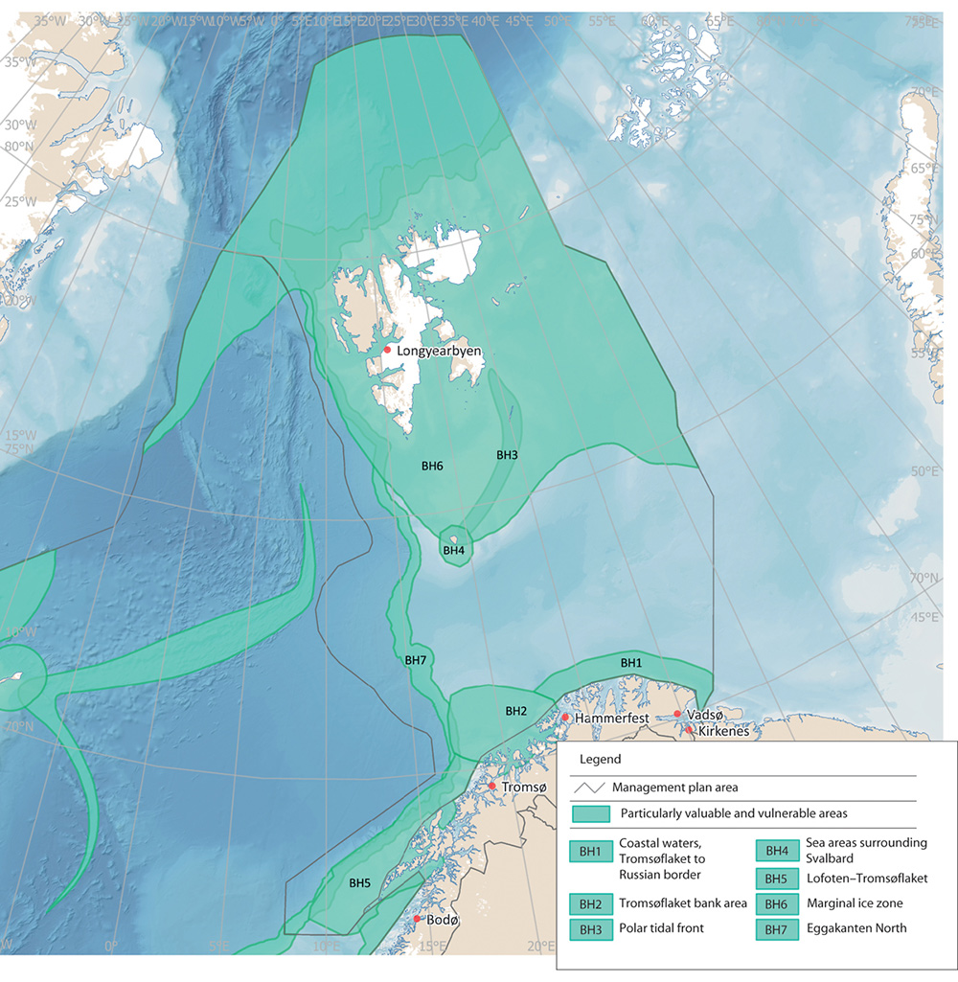
          - Particularly valuable and vulnerable areas in the Barents Sea-Lofoten management plan area.
Norwegian Environment Agency
Sea areas surrounding Svalbard
Biodiversity in and around Svalbard is strongly dependent on the sea areas surrounding the archipelago, which form a continuous marine environment. This provides vital food supplies for seabirds, polar bears, whales, walruses, seals and many other species at different levels of the food chains. A number of species are red-listed or are key or indicator species in the ecosystem. Several million seabirds breed in Svalbard, particularly in the parts of the archipelago that face the productive parts of the Barents Sea. The most abundant species are little auk, fulmar, Brünnich’s guillemot and kittiwake.
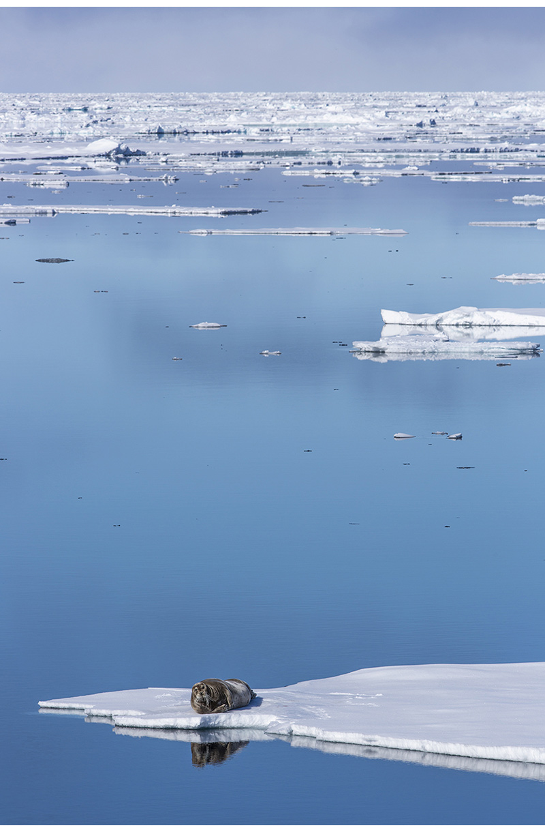
          - Bearded seal in the marginal ice zone.
Photo: Kim Abel/Naturarkivet
Svalbard’s coastal and marine areas are very varied. Biodiversity is high, and there is a wide variety of habitat types, including different types of fjords, mudflats, steep cliffs, strandflats, areas where currents are strong, glacier terminuses, sea ice and marine valleys and bank areas. Sea ice may be present in large parts of the waters around Svalbard, but the marginal ice zone and the production associated with it are highly dynamic, and the position of the zone shifts from Bjørnøya in the south to north of Spitsbergen depending on the time of year. The main concentration of ice is in the area east of Spitsbergen. The seabed in areas where sea ice is present generally has a rich benthic fauna because it is ‘fed’ by ice algae sinking to the bottom. The rich benthic fauna is important for species that feed on the seabed near the coast and in bank areas, including bearded seals, walruses and various seabird species. There are several polynyas (areas of open water surrounded by ice) in the waters around Svalbard. Biological production in these areas is higher than elsewhere, and seabirds and marine mammals therefore congregate in them, particularly during the winter.
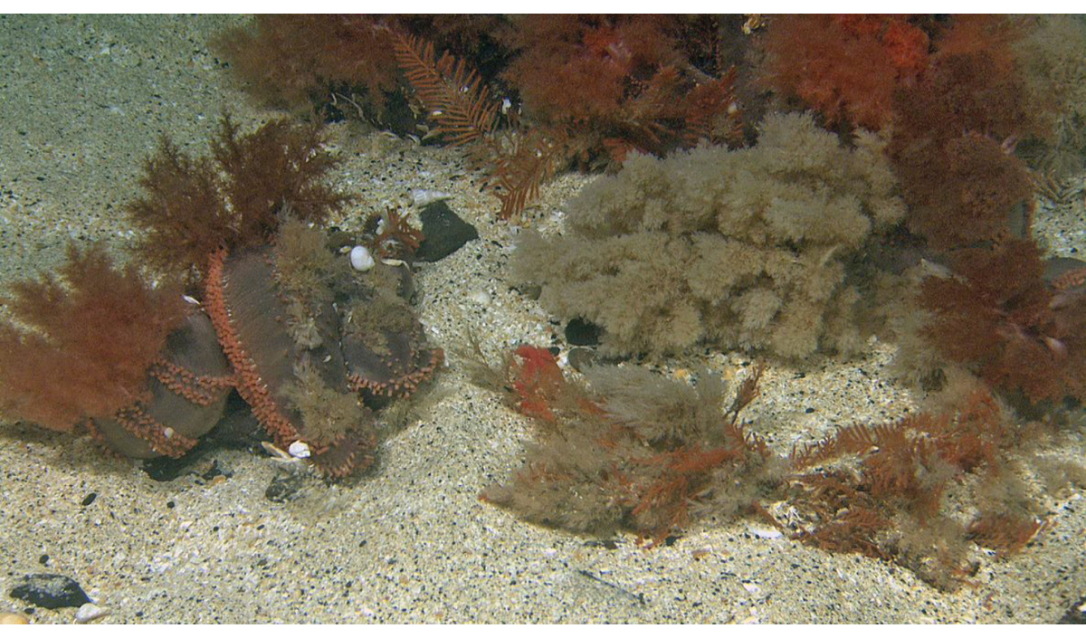
          - Orange-footed sea cucumber (Cucumaria frondosa), Spitsbergen Bank.
Photo: Mareano/Institute of Marine Research
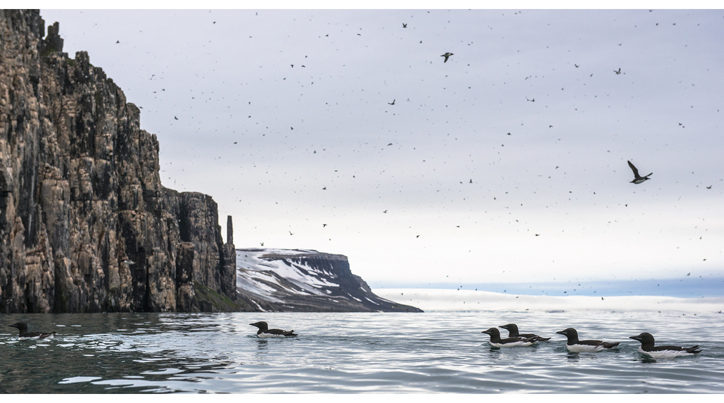
          - Brünnich’s guillemots on the sea in Nordaust-Svalbard nature reserve.
Photo: Bård Bredesen/Naturarkivet
              - Eggakanten in the Norwegian Sea and Barents Sea
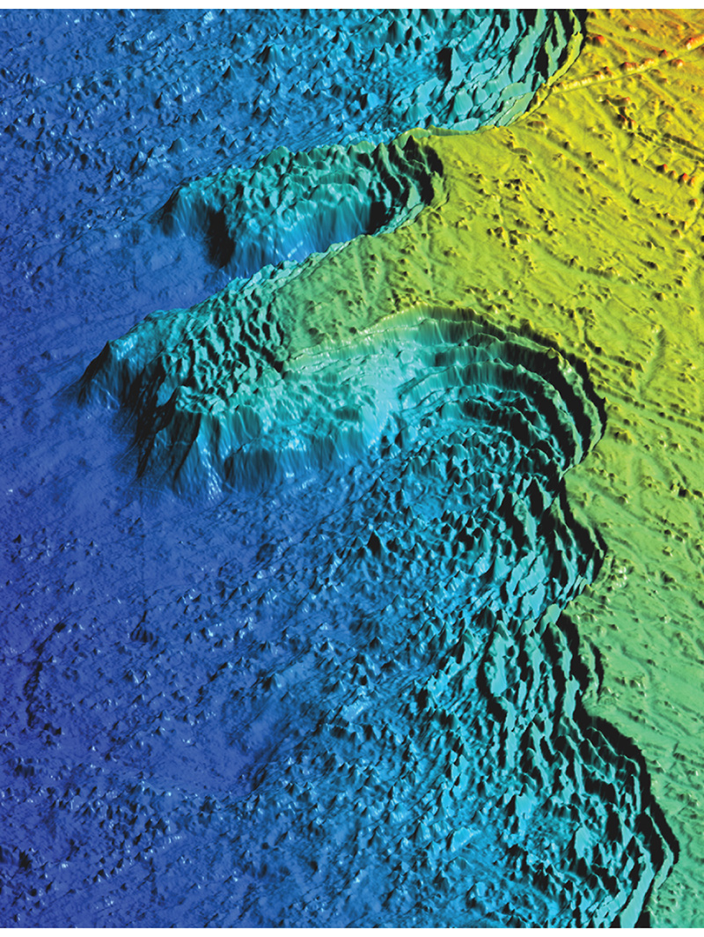
          - Three-dimensional model of Eggakanten (the edge of the continental shelf) west of the island of Røst.
Mareano/Geological Survey of Norway, T. Thorsnes
The Eggakanten area runs all the way from Stad at latitude 62 °N to northwestern Svalbard, through both the Norwegian Sea and the Barents Sea. It includes the entire continental slope and extends about 10 km on to the continental shelf. The southern section of Eggakanten is particularly important for a number of fish stocks, several of which are of great commercial value. The topography of the area, the ocean currents and the availability of zooplankton provide excellent conditions for hatching and the earliest life stages of fish. Where the continental slope is steep, environmental conditions change rapidly. There is a strong northerly current that carries heat, nutrients, plankton and fish larvae northwards.
The availability of various life stages and sizes of plankton and fish makes the area important for foraging seabirds and marine mammals. Both fin and blue whales feed on zooplankton, and seabirds feed on fish larvae drifting with the coastal current.
Biological production and biodiversity are generally high along Eggakanten, and the area supports a number of vulnerable habitat types and red-listed species. There are large coral reef complexes, and also biotopes dominated by other species, for example gorgonian forests and sponge communities. The Røstrevet reef complex, the world’s largest known reef of the stony coral Lophelia pertusa, lies in the Eggakanten area, in the upper part of a major underwater landslide.
[Boks slutt]
There are several important bank areas in the Barents Sea. Biological production is particularly high on the Spitsbergen Bank, which has a characteristic benthic fauna and is extremely important for foraging and overwintering seabirds. The high primary production on the Spitsbergen Bank is a crucial feature of the ecosystem in this area. The Spitsbergen Bank is an important feeding and nursery area for several fish species, and also an important foraging area for the nearest large seabird colonies. Unattached calcareous algae on the seabed (rhodoliths) provide a habitat for many benthic species and have an important ecological function on the continental shelf around Svalbard.

Areas in the Norwegian Sea
There are three main water masses in the Norwegian Sea: Atlantic waters, Arctic waters and coastal waters. Every second, around 8 million tonnes of warm, salty water flows into the Norwegian Sea from the North Atlantic. The mix of water masses with different temperatures and salinities strongly affects the distribution of plankton and fish. Zooplankton such as Calanus finmarchicus and crustaceans like krill are found in large quantities, and are important food for fish stocks such as Norwegian spring-spawning herring, blue whiting and mackerel.
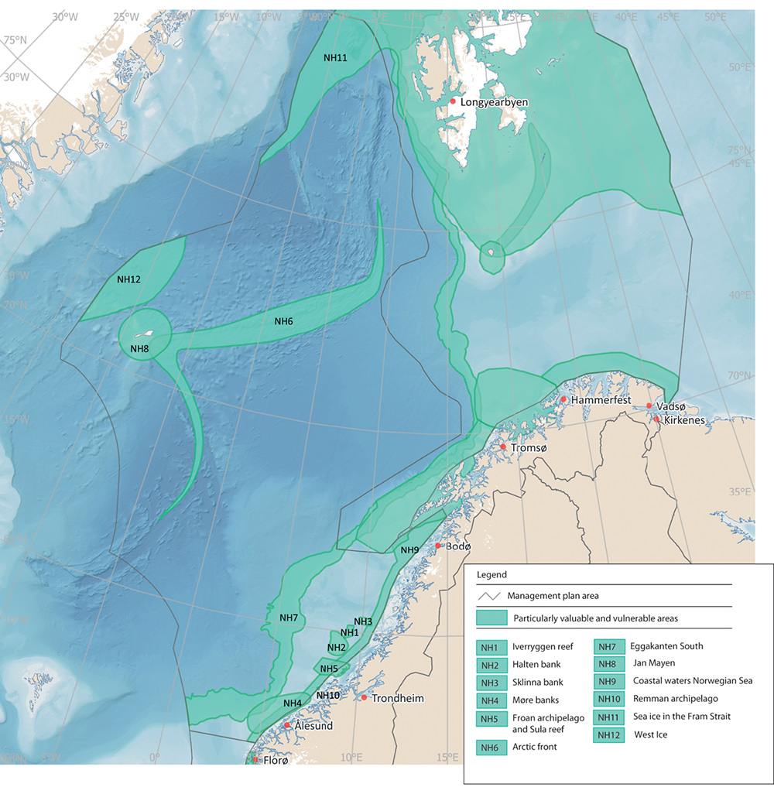
          - Particularly valuable and vulnerable areas in the Norwegian Sea management plan area.
Norwegian Environment Agency
The Mid-Atlantic Ridge stretches all the way through the Norwegian Sea from Iceland towards the Arctic Ocean. The ridge system includes several different ridges, deep-sea mountains and fracture zones. In the far north of the Norwegian Sea, just west of the northern part of Spitsbergen, lies the deep-water basin Molloydjupet. Here, the greatest water depth in the North Atlantic has been recorded, 5569 m. The largest mud volcano in the North Atlantic, Håkon Mosby, lies at a depth of 1 270 metres between Svalbard and the Norwegian coast. Mud and methane gas flow upwards from deeper layers in the volcano and support an ecosystem containing an assemblage of species adapted to life with no sunlight. Little is known about other habitat types in such areas and their role in the ecosystems.
              - The Mid-Atlantic Ridge
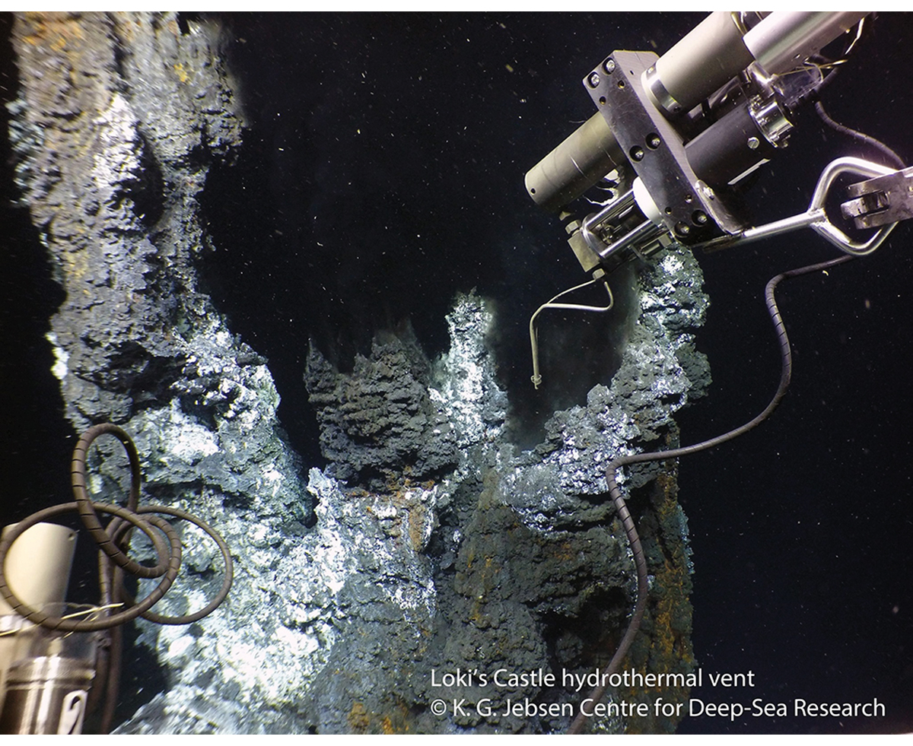
          - Sampling from Loki’s Castle hydrothermal vent field.
Centre for Deep Sea Research, University of Bergen
There are several hydrothermal vent fields along the Mid-Atlantic Ridge and around Jan Mayen, including Loki’s Castle, Ægirs kilde and Fåvne, and several extinct fields. A distinctive fauna including a number of red-listed species is found in areas around hydrothermal vents. Seafloor spreading is very slow along the Knipovich Ridge, and the hydrothermal vents in this area are therefore very old by global standards. The Loki’s Castle vent field on Mohn’s Ridge is estimated to be about 10 000 years old.
The fauna around hydrothermal vent fields is specialised to survive in the absence of sunlight, instead making use of chemical energy (chemosynthesis), and includes animals living in symbiosis with chemosynthetic bacteria. The fauna is dependent on the hydrothermal vents and the characteristic chemical and physical environment around them. Organisms living in extreme deep-sea environments have unique adaptations to enable them to survive in the extreme conditions. Microorganisms and biomolecules can be harvested from hydrothermal vent fields for industrial and medical uses (marine bioprospecting). Little is known about interactions between benthic ecosystems and those in the water column above, and this will require further research in future.
Important mineral deposits have been found along the Mid-Atlantic Ridge, and parts of it may therefore be of interest for mineral extraction from the seabed.
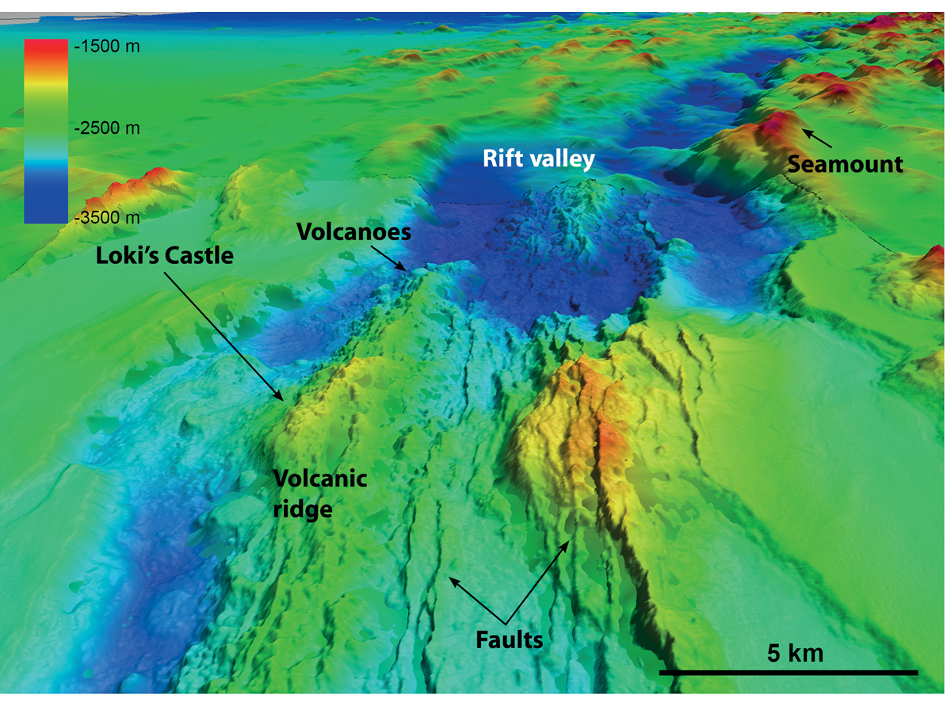
          - Northern part of Mohn’s Ridge, a section of the Mid-Atlantic Ridge.
Geological Survey of Norway, Mareano, Norwegian Petroleum Directorate and Norwegian Mapping Authority
[Boks slutt]

Areas in the North Sea and Skagerrak
Phytoplankton production (primary production) is generally high in the North Sea. This is mainly because the water is relatively shallow, and effective mixing in the water column carries nutrient-rich bottom water into the surface layers where sunlight penetrates.
Areas of sandeel habitat in the North Sea have a characteristic bottom habitat where the seabed consists of coarse sand and gravel, and are important nursery and spawning areas for lesser sandeels. Sandeels are a key species that provide food for seabirds, larger fish and marine mammals, and are also an important commercial fish stock. Parts of the North Sea are also important wintering areas for seabirds including the common guillemot.
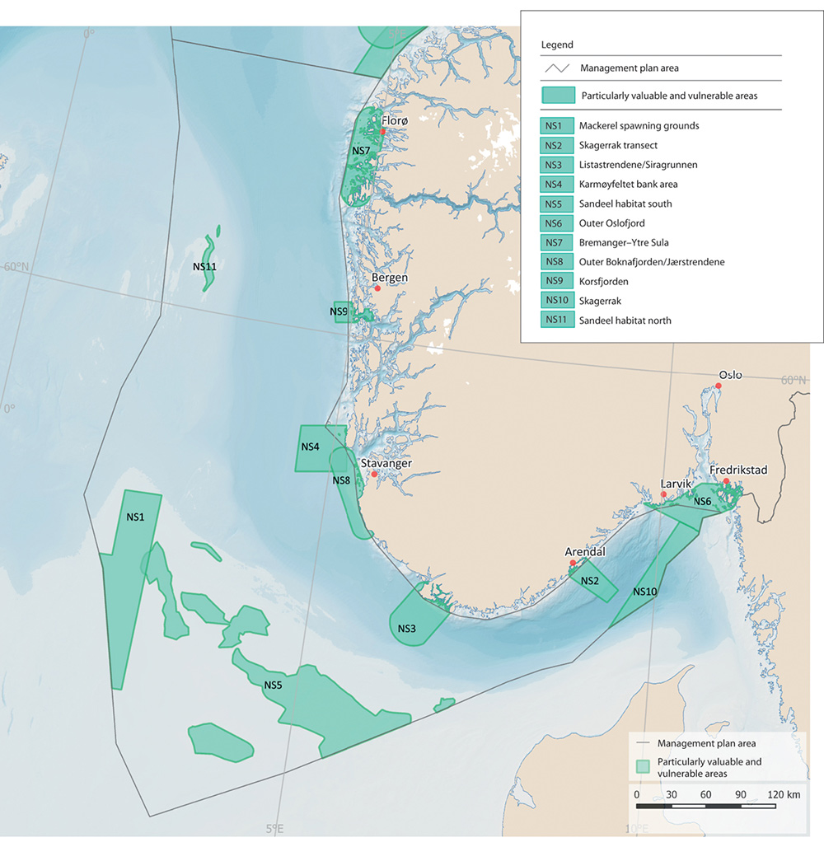
          - Particularly valuable and vulnerable areas in the North Sea–Skagerrak management plan area.
Norwegian Environment Agency
              - Kelp forests and carbon storage in inshore waters
Kelp forests are recognised as some of the most productive and dynamic ecosystems on Earth, and have important ecological functions for algae, molluscs, crustaceans, birds and marine mammals. Because of their high biodiversity, these areas are sometimes referred to as rainforests of the sea. Kelp forests are spawning, nursery and feeding areas for many fish species, and they also support a wide variety of other species. Various species of algae and sessile animal species live on the kelp itself (epiphytic organisms), while other mobile species may be found on the kelp plants, on the seabed below or in the water column within and above the kelp forest. Fish such as pollack, saithe and cod often use the water column just above kelp forests, while wrasses, cod, saithe, various small crustaceans, sea urchins, starfish, sea anemones, gastropods and molluscs find shelter among the kelp plants.
Several kelp species occur in Norway, but kelp forests most commonly consist of Laminaria hyperborea or sugar kelp (Saccharina latissima). In addition to kelp forests, there are seaweed beds, eelgrass meadows and soft-bottom areas in inshore waters, all of which have important functions for many species, both purely aquatic species and species that spend most of their time above the water surface, such as seabirds and otters. Many fish populations, including several of the commercially harvested stocks, visit coastal waters to spawn. A number of the spawning areas are clearly delimited geographically, and fish spawn in the same areas every year.
The same habitat types play an important role in carbon storage in coastal waters. Norwegian research results indicate that the quantity of carbon from kelp forests transferred to sediments in Norwegian waters may be similar to the quantity stored in Norwegian forest soils. However, it is uncertain how much of this can be said to be long-term storage, or sequestration, of carbon, because the carbon is not stored where the vegetation grows, but is transported to deep-sea areas.
[Boks slutt]
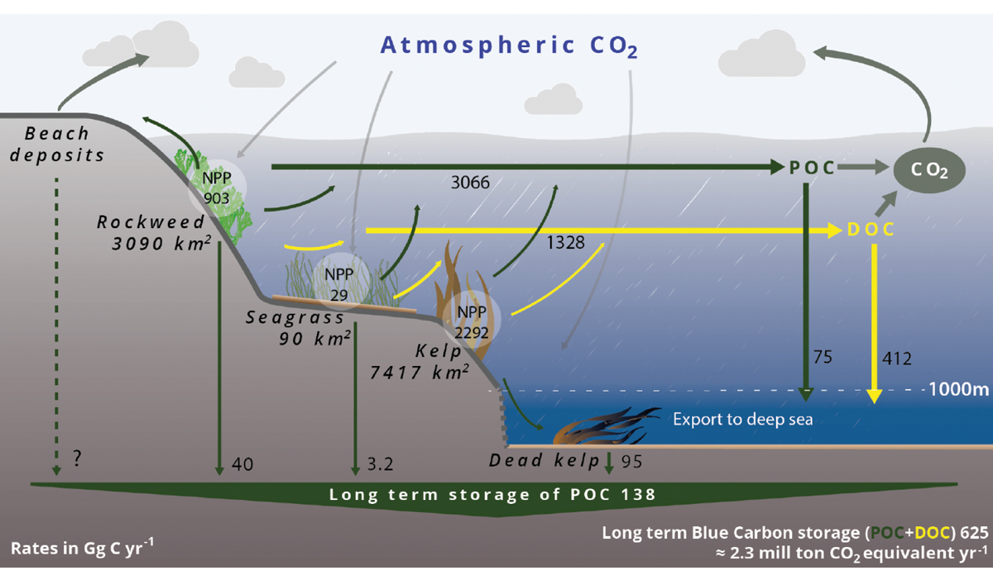
          - Norwegian blue carbon budget including kelp forests, seaweed (rockweed) beds and eelgrass meadows. Estimated area, rates of net primary production (NPP), export rates, and sequestration of particulate organic carbon (POC) and dissolved organic carbon (DOC) are given for each habitat. POC sequestration occurs in sediments on the continental shelf and in the deep sea (below 1 000 m, termed `long-term storage’), while DOC sequestration occurs only in the deep sea (below 1 000 m).
Nordic Blue Carbon Project, H. Frigstad et al., 2020
The Norwegian Trench, which is 200–700 m deep, separates Norwegian coastal waters from the shallower parts of the North Sea further west and south. The coastal side of the Norwegian Trench slopes steeply to the deepest water just off the Norwegian coast, while the offshore side rises more gently to the North Sea Plateau west and south of the Trench. The deepest area is in the Skagerrak south of Arendal. The Norwegian Trench is the only place where the copepod Calanus finmarchicus overwinters in the North Sea–Skagerrak management plan area. It also supports large quantities of krill and is the only area where the North Sea has a mesopelagic fauna, including fish. There are greater concentrations of bamboo coral (Isidella) in the Norwegian Trench than anywhere else in Norway except in certain fjords. It also supports one of the largest populations of the shrimp Pandalus borealis anywhere in the Northeast Atlantic.
The outer Oslofjord is an important area for breeding, migrating and overwintering seabirds. The largest known cold-water coral reef in sheltered waters is also in this area. In addition, both the Norwegian and the Swedish waters of the outer Oslofjord are important for seals.

Areas of habitats that are important for carbon storage
The oceans represent the planet’s largest pool of organic carbon (carbon originating from the decomposition of living organisms). According to the Intergovernmental Panel on Climate Change (IPCC), most carbon in the oceans is in the form of dissolved inorganic carbon in the water column. In addition, a large quantity of carbon is stored in surface sediments on the seabed and as dissolved organic carbon in the water column, and smaller amounts in marine biota (see Figure 2.11). The IPCC also highlights the potential of ‘coastal blue carbon ecosystems’ for reducing the risks and impacts of climate change. Coastal ecosystems that are important for carbon storage include kelp forests, seaweed beds, eelgrass meadows, saltmarshes and soft-bottom areas in the intertidal zone.
In a recent report from the Nordic Blue Carbon Project, it was estimated that Norwegian kelp forests alone account for 46 % of long-term storage of CO2 from blue forests in the Nordic region, corresponding to around 3.6 % of total annual Norwegian emissions.
The Geological Survey of Norway investigated organic carbon stocks and accumulation rates in the North Sea and Skagerrak. The study found that of the overall stock of organic carbon in the upper 0.1 m of sediments in these areas, about 26 % is stored in the Norwegian Trough, which only makes up about 11 % of the entire area. Accumulation rates are highest in the Norwegian Trough, which accounts for 87 % of total organic carbon accumulation in the North Sea and Skagerrak.
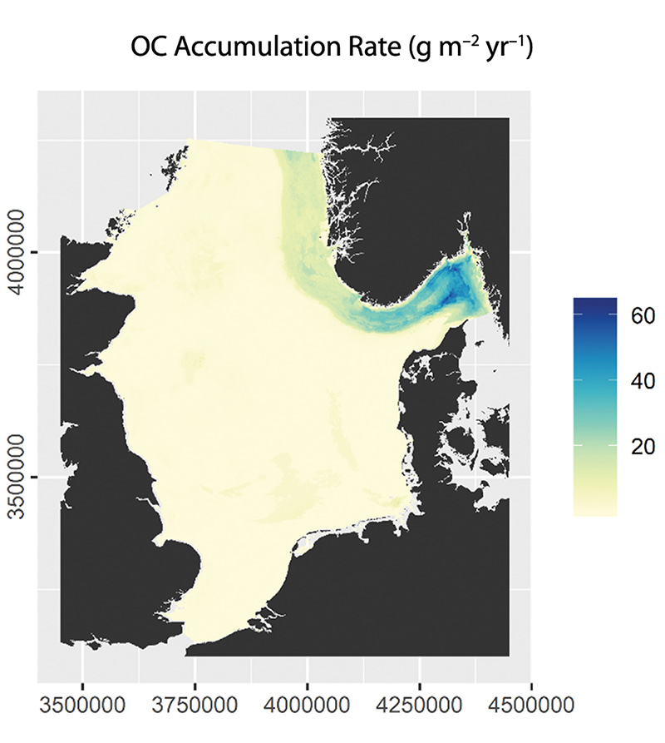
          - Estimated annual organic carbon accumulation rate in sediments in the North Sea and Skagerrak. The accumulation rate is highest in the Norwegian Trough, but there are uncertainties associated with the modelled figures for accumulation of carbon in the seabed.
Organic carbon densities and accumulation rates in surface sediments of the North Sea and Skagerrak, Diesing et al., 2021
Although kelp forests cover a relatively small area compared with terrestrial vegetation, their annual production is high and they therefore make a substantial contribution to carbon storage, see Figure 2.13.
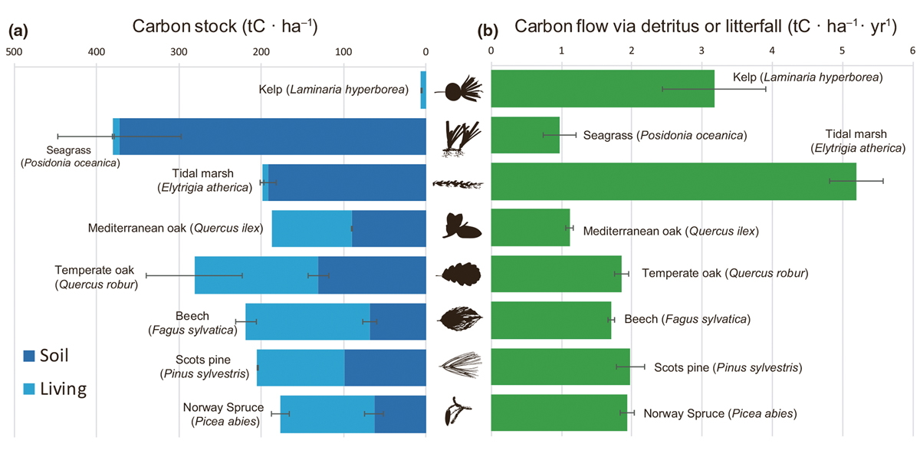
          - Per area carbon standing stock and carbon flux via detritus for dominant habitat-forming primary producers in Europe. The carbon stock contained within each habitat is partitioned into the amount stored in soils (dark blue bars) and in living plant tissues (light blue bars), which includes above and below-ground living biomass.
Carbon assimilation and transfer through kelp forests in the NE Atlantic is diminished under a warmer ocean climate, A. Pessarrodona et al., 2018
As part of the scientific basis for the work of the Ocean Panel, the potential contribution from climate action areas to mitigating climate change in 2050 has been calculated, as shown in Figure 2.14. This shows the possible contribution of ecosystems to carbon storage together with other ocean-based action areas.
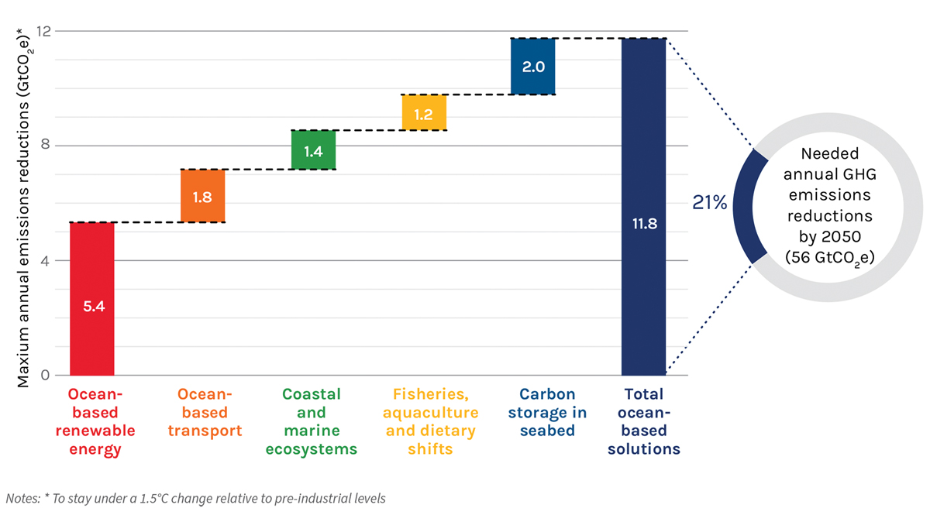
          - Potential contribution of ocean-based action areas to mitigating climate change in 2050.
Hoegh-Guldberg et al. 2019 (Ocean Panel)
Recent research has also focused on the implications of bottom trawling for the release of carbon stored in seabed sediments. The results indicate that establishing marine protected areas may have benefits in three different ways – by protecting biodiversity, by increasing the yield from fisheries and by safeguarding marine carbon stocks that are threatened by human activity.

Mapping and building up knowledge about areas of importance for marine biodiversity
Sound scientific knowledge is an essential basis for ocean management and conservation. Norway’s ocean management regime is based on a substantial body of knowledge acquired through mapping, research and environmental monitoring. Norway is investing considerable effort in building up more knowledge about its seas and oceans. Some key initiatives are described below. However, there are still major gaps in our knowledge and understanding of the marine environment, and further knowledge development is needed. Further developing our understanding is a vital basis for sustainable management of marine ecosystems.

The MAREANO programme
The MAREANO programme was begun in 2005 to satisfy the need for more knowledge of conditions on the seabed in Norwegian waters. The programme has provided valuable information through mapping of depth and topography, species diversity, habitat types, chemical conditions and pollutants in sediments, and geological formations on the seabed. Data from the MAREANO surveys are made available on the programme’s website and through the Norway Digital programme.
Mapping of the seabed generates a great deal of new information on the distribution of habitats and species and the pressures and impacts associated with human activity. The information can be used to improve the management regime and provide better protection for vulnerable habitat types. Priority has been given to areas where there are or may be important species and habitat types or natural resources that could be affected by existing or new human activities. In the process of developing the scientific basis for the ocean management plans, data obtained through MAREANO has confirmed the environmental value of the areas identified as particularly valuable and vulnerable.
The MAREANO programme has mapped many new coral reefs. As a result of the new information, ten new areas of cold-water coral reefs in Norwegian waters have been given special protection by designation as marine protected areas under the Marine Resources Act. Knowledge acquired through the MAREANO programme is an important basis for sustainable management of the seabed, for example by adding to the knowledge base on vulnerable habitat types such as corals and sponge communities, and reduces the risk of damage to such habitats during fisheries and other activities.
Knowledge is also needed to ensure a representative selection and ecological coherence when using areas-based conservation measures in Norwegian waters, and the information gathered through the MAREANO programme is an important part of the knowledge base.
The petroleum industry has also provided a great deal of new, valuable knowledge about the seabed in Norwegian waters in connection with baseline surveys carried out before well drilling and during the planning phase of field development and pipeline route surveys. This knowledge has provided a vital basis for planning and regulating activities in areas where there are vulnerable species and habitats.
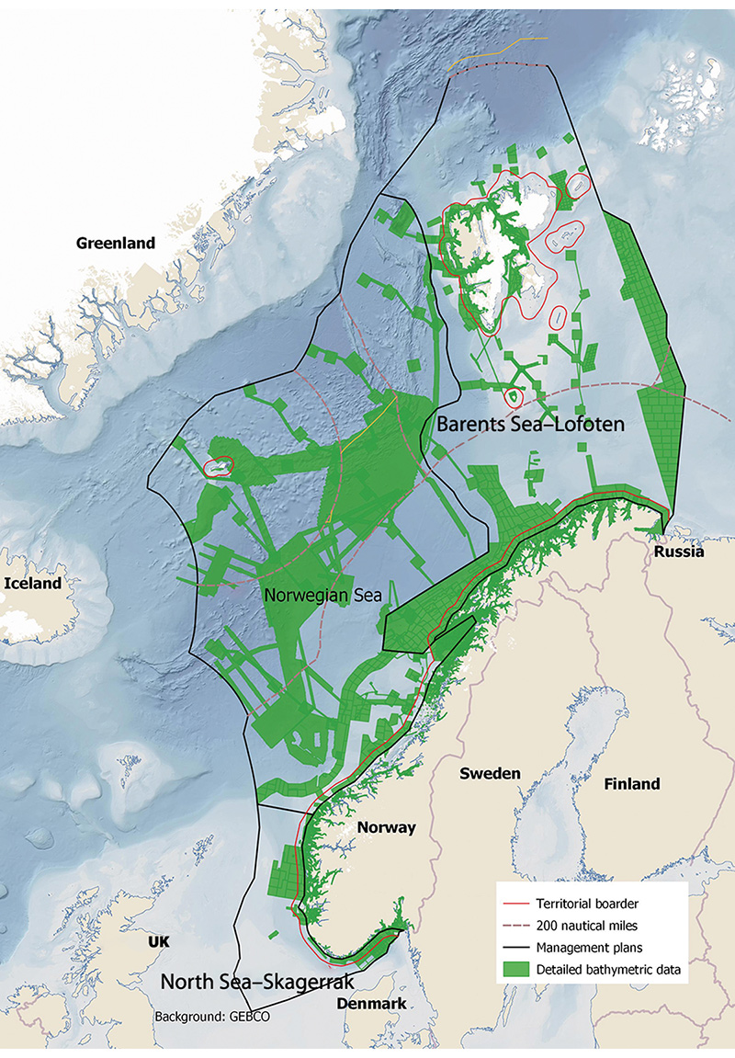
          - Areas mapped by the MAREANO programme.
MAREANO

Mapping biodiversity in coastal waters
In the period 2003–2019, habitats in coastal waters that support high biodiversity were mapped and their value classified as part of the national programme for mapping coastal marine biodiversity. The habitats included eelgrass meadows, shell sand deposits, kelp forests and soft-bottom areas, and in addition key areas for certain species such as scallops and coastal cod (spawning areas). Various sectors and the municipalities use the data in planning processes, and they can also be accessed through various map portals (Naturbase and Yggdrasil) and the map catalogue Geonorge. Habitats can be classified as being of national, regional or local value.
The programme has built up more knowledge about valuable habitats, and this is used as part of the basis for planning and decisions on development projects and other decisions relating to activities in coastal waters.
Further mapping of habitats in coastal waters is now under way, starting in the Oslofjord.
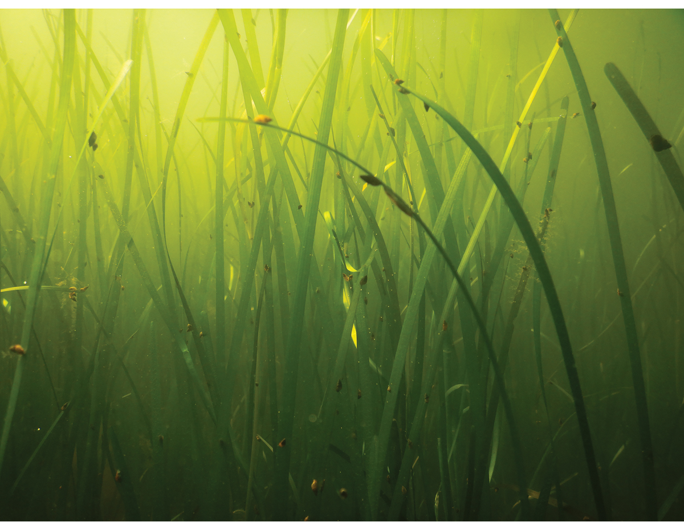
          - Eelgrass meadow.
Photo: Eli Rinde/Norwegian Institute for Water Research
The Norwegian Mapping Authority, the Geological Survey of Norway and the Institute of Marine Research are cooperating on a project to develop seabed maps for Norwegian coastal waters. The project will map the seabed along the coast of Norway and compile geological, chemical and biological data. The data will be made publicly available, and the purpose of the project is to ensure a greater degree of knowledge-based management and sustainable use of Norwegian waters. In 2020, mapping was started in three pilot areas: Kvænangen and Skjervøy municipalities in Troms og Finnmark county, Stavanger municipality in Rogaland, and Ålesund and Giske municipalities in Møre og Romsdal.

SEAPOP and SEATRACK
SEAPOP is a long-term mapping and monitoring programme for Norwegian seabirds, and was established in 2005. The programme covers the Norwegian mainland coast, Svalbard and adjacent sea areas, and is intended to provide and maintain baseline information on seabirds. The aim is to improve management of the marine environment. There is a special focus on acquiring data that make it possible to distinguish the effects of human activity from those that are largely a result of natural variability. Data and knowledge acquired through the programme are processed and organised on an ongoing basis so that they can be made available to different user groups through the programme’s website.
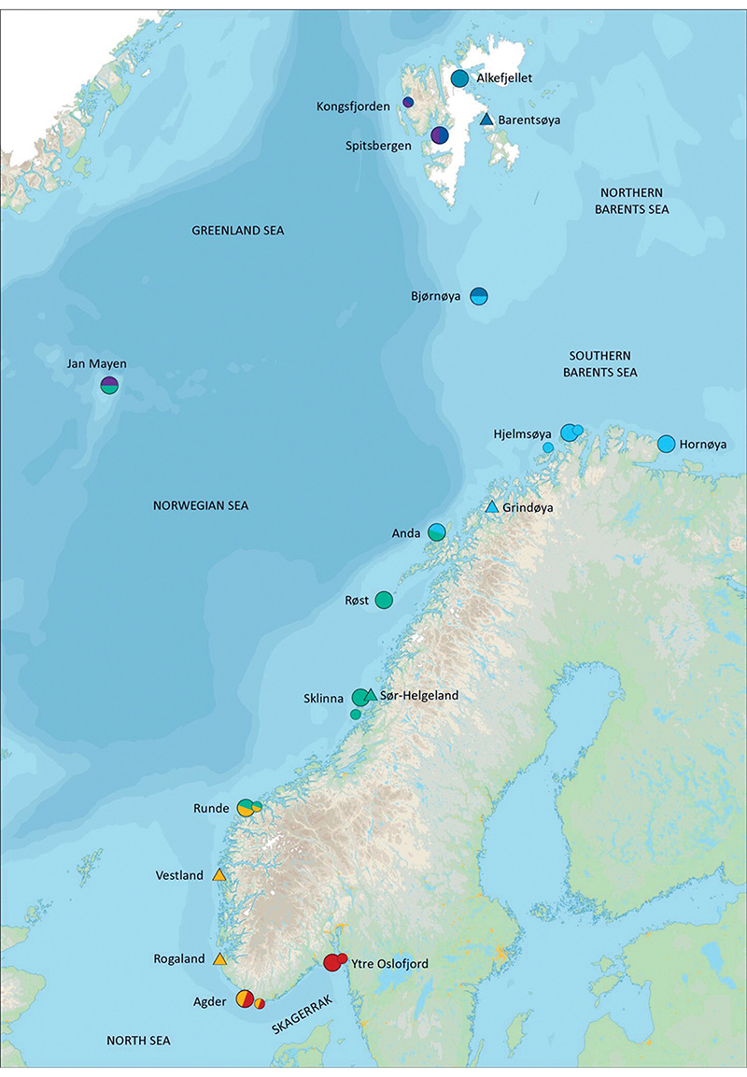
          - The key sites used by the SEAPOP programme. The colours of the symbols indicate the seas the different sites represent: the northern Barents Sea (dark blue), the southern Barents Sea (light blue), the Norwegian Sea (green), the North Sea (orange) and the Skagerrak (red). Split colours indicate that a site represents two different seas. Large circles indicate the main sites, and small circles the nearby sub-localities. Triangles indicate key sites where the focus is on a single species: ivory gull (Barentsøya), common eider (Grindøya), lesser black-backed gull (Sør-Helgeland) and shag (Rogaland).
SEAPOP
The SEAPOP programme aims to map the spatial and temporal distribution of breeding, moulting, staging and wintering seabirds along the entire coast of Norway, including Svalbard and Jan Mayen, in a ten-year cycle. Seabird distribution in the large open sea areas covered by the programme will largely be predicted using multidisciplinary models that include various environmental factors that influence seabirds. This work is being carried out in close cooperation with the Institute of Marine Research, and will to a large extent be based on data collected during the Institute’s ecosystem surveys in these areas.
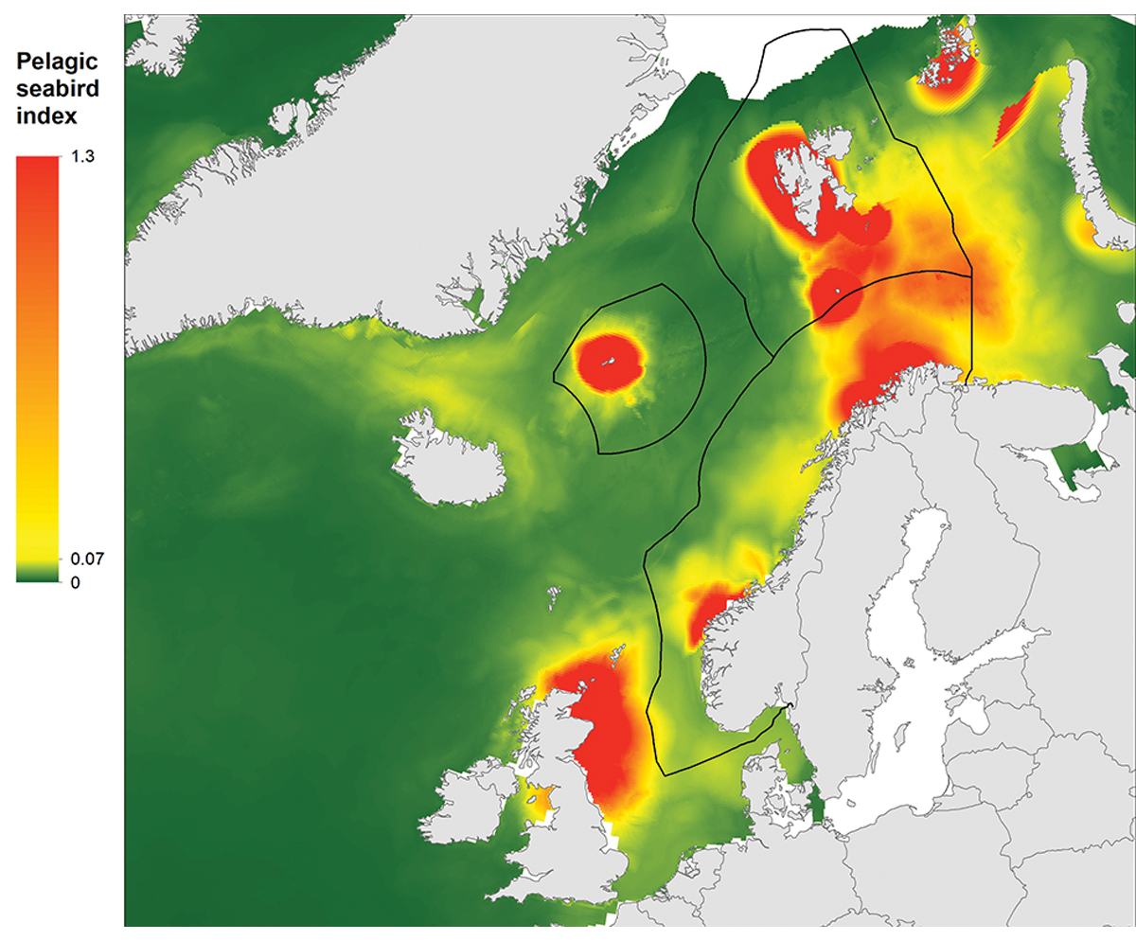
          - Map showing important areas for pelagic seabirds. The figure shows the maximum monthly sum of the share of populations of common guillemot, Brünnich’s guillemot, puffin and kittiwake from Norwegian, Russian and British seabird colonies using different areas. The birds in these populations breed around the North Sea, Norwegian Sea, Barents Sea and Greenland Sea.
SEAPOP
The SEATRACK module is mapping the non-breeding distribution of seabirds, originally for Norwegian breeding populations and populations in neighbouring countries that use Norwegian waters, but now expanded to include the whole North Atlantic. By following birds from breeding populations that are being monitored (numbers, reproductive success and survival), it has proved possible to develop new and revolutionary insights into patterns of use of different areas, which populations seabirds belong to, their migration routes and wintering areas, and how vulnerable seabird populations are in Norwegian waters.

Particularly valuable and vulnerable areas
Particularly valuable and vulnerable areas have been identified as being of great importance for biodiversity and biological production in an entire management plan area. They are selected using predefined criteria, the main ones being that the area concerned is important for biodiversity or for biological production. The criteria used in a review of all these areas in 2021 were the same as the criteria for identifying ecologically or biologically significant marine areas (EBSAs) under the Convention on Biological Diversity (CBD). As a result of the progress that has been made in mapping Norwegian waters, we now know more about the importance of the particularly valuable and vulnerable areas. Mapping of the seabed and of seabird distribution and habitat use have been especially important in confirming and strengthening the knowledge base.
Marine areas of importance for biodiversity and biological production are often found where there are special topographic or oceanographic features or transitional zones between the sea and land or ice.
Vulnerability can be defined as a measure of how prone an area is to be negatively affected by human activity or changes in environmental conditions; conversely, its resilience is a measure of how well it can resist or recover from damage. In other words, vulnerability is assessed as an attribute of the area or species and habitats, regardless of whether or not human activity or other environmental pressures exist in the area. This means that an area can be identified as vulnerable to one or more human activities even if these are not being carried out at present and are unlikely to be started up in the near future. Because physical, chemical and biological parameters vary from one area to another, so does vulnerability. In addition, a specific area is rarely equally vulnerable throughout the year or to all types of pressures. The vulnerability of the different species found in an area also differs. We do not know enough to quantify vulnerability to all types of environmental pressures for all of the particularly valuable and vulnerable areas, but general vulnerability to acute oil pollution has been analysed at fairly high resolution. The ecological value of the particularly valuable and vulnerable areas stretches beyond their own boundaries, because they are key to maintaining ecological functions, biodiversity and productivity in wider areas.

The importance of area-based conservation of the marine environment
Both the IPCC and the Intergovernmental Science-Policy Platform on Biodiversity and Ecosystem Services (IPBES) have concluded that ocean governance must be adapted to the accelerating pace of climate and environmental change. Ocean governance must take into account the potential impacts of climate change in combination with other drivers of change, and it must be possible to adapt quickly as the situation changes. The IPCC and IPBES have highlighted the importance of developing well designed networks of protected areas to safeguard key marine biodiversity areas. This can help to reduce cumulative impacts on areas and ecosystems that are given special protection, and to protect areas that will become important as the distribution of species and ecosystems changes in response to climate change.
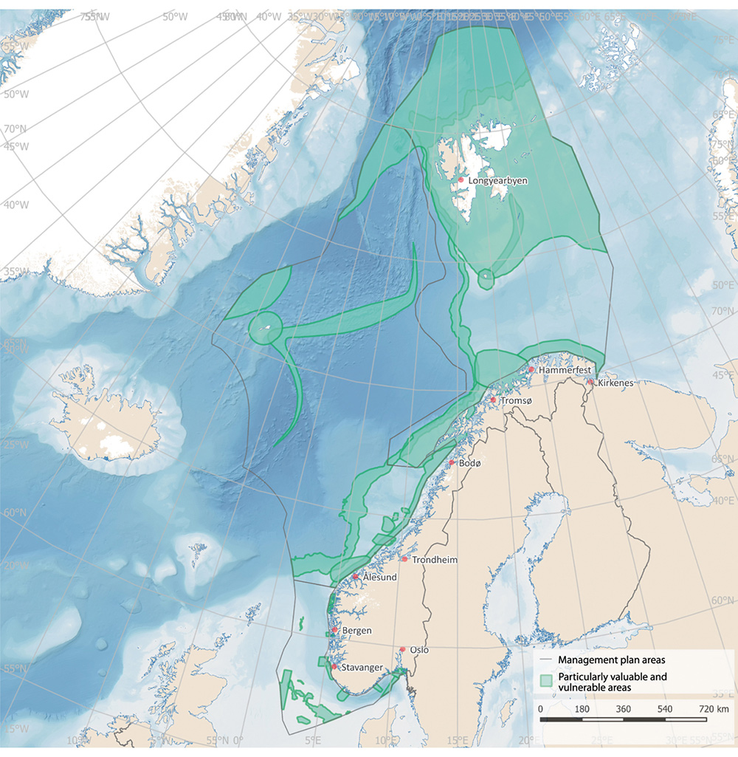
          - Overview of particularly valuable and vulnerable areas in the Norwegian ocean management plan areas.
Norwegian Environment Agency
IPBES has estimated that more than 40 % of the world’s ocean area is already strongly affected by human activity, and that cumulative impacts are increasing across two thirds of the total area. There are wide variations between different ocean areas. Coastal marine ecosystems in densely populated areas and in tropical waters are under the greatest pressure. However, climate change is also putting considerable pressure on the polar seas.
According to IPBES, there are four main direct drivers of change in marine ecosystems. The most important of these globally is fishing and other harvesting of marine organisms, followed by land- and sea-use change, including the development of infrastructure and aquaculture in the coastal zone. The third driver is climate change, and the fourth is inputs of pollutants and waste. The relative importance of these drivers varies between different parts of the world’s oceans. Climate change is often identified as a driver that is increasingly intensifying the impacts of other factors.
The changing status of Arctic ecosystems and tropical coral reefs is a frequently used example of this effect of climate change. The environmental status of Norway’s seas is in many respects good, but the impacts of climate change are becoming stronger, and are clearly affecting the status of ecosystems in both the North Sea and the Barents Sea. Conservation measures are a tool for safeguarding marine biodiversity and ecological functions as conditions change in the marine environment.
The oceans play a vital role in the climate system as a carbon pool and heat store, but at the same time marine ecosystems are being strongly affected by climate change and ocean acidification. As the seawater becomes warmer and more acidic, living conditions in the marine environment change, and this may also have serious impacts for people who rely on ocean resources. Climate change will have particularly serious impacts in northerly waters, and temperatures and pH levels will change. In addition, the sea ice is melting and run-off from Arctic rivers is increasing. Climate change adaptation and mitigation measures must go hand in hand to counteract serious consequences of climate change. At the same time, marine ecosystems can play a key role in the fight against climate change and in adaptation to climate change. ‘Blue forests’ such as kelp forests, seaweed beds and eelgrass meadows have substantial carbon storage capacity and can protect the coastline against erosion, storms, and flooding. Blue forests are also important for marine productivity and biodiversity.
According to IPBES, a mix of policy instruments and measures is needed to conserve fish stocks and marine species and ecosystems, implemented on land, in freshwater and in the oceans. Coordination across sectors and stakeholders on the use of open oceans will also be needed. One type of action that IPBES highlights as effective is the expansion and strengthening of representative networks of protected areas. Others are ecosystem-based management, effective fisheries quota systems, marine spatial management, protecting key marine biodiversity areas, and reducing pollution from land.
The IPCC emphasises that adaptation of ocean governance frameworks to make them climate-resilient to a large extent involves reducing or limiting other direct drivers of change in marine and coastal environments, such as land- and sea-use change, pollution and harvesting. Conservation of ecosystems through marine protected areas and networks of such areas, and other effective area-based conservation measures, is highlighted as particularly important. This can help to reduce cumulative impacts on areas and ecosystems that are given special protection, and to ensure that species can maintain viable, productive populations and that ecosystem functioning is maintained as distribution patterns shift towards the poles in response to climate change.
The International Union for the Conservation of Nature (IUCN) and the Food and Agriculture Organization of the United Nations (FAO) are two international organisations that are playing a particularly important role in developing the scientific basis for marine protection and other effective area-based conservation measures. They also provide countries with advice on the establishment and management of such areas.
IUCN considers MPAs to be an important tool for conserving and rebuilding marine biodiversity, which in turn is important for human livelihoods, health and food security. According to IUCN, proven benefits from MPAs include:
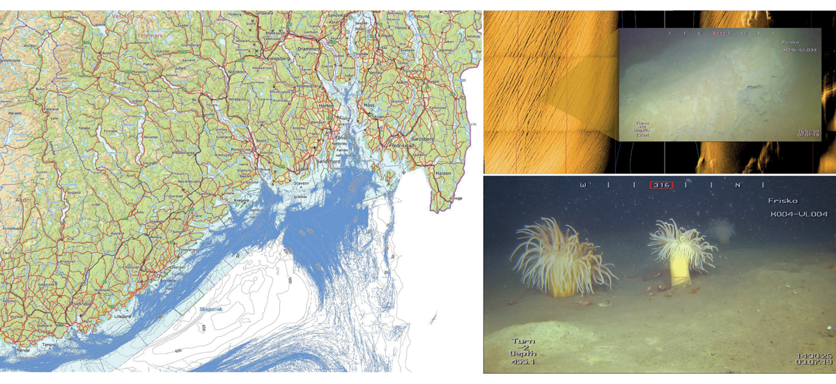
          - Impacts of human activity on the seabed. Left: map of trawl tracks (blue) from vessels over 15 m in length in the period 2011–2019. Right: sonar images of the seabed in the outer Oslofjord showing the impacts of trawling. Close-up of trawl tracks at a depth of 139 m in the outer Oslofjord. Deeplet sea anemones (Bolocera tuediae) in an area where the benthic fauna is intact, at a depth of 455 m in the outer Oslofjord.
Photo: Frisk Oslofjord project/Institute of Marine Research
Map: Directorate of Fisheries. Sonar images: Frisk Oslofjord project/Kongsberg Maritime.
- conservation of biodiversity and ecosystems;
- improved fisheries management;
- greater resilience to the impacts of climate change;
- carbon capture and storage (‘blue carbon’);
- disaster risk reduction – protection of coastal areas against extreme weather, tsunamis and coastal erosion;
- restoration of ecosystems such as coral reefs, mangroves and seagrass meadows;
- tourism and recreation – economic and health benefits to coastal communities;
- protection of cultural and spiritual resources and values;
- research and education;
- models of fair and open governance.
These benefits depend on good design, the resources available to support protection measures, whether protection goals are met through fair governance and effective management, and the scale at which MPAs work together as a conservation network. The benefits and opportunities associated with well designed and managed MPAs have been shown to increase over time. Other factors that are important for achieving satisfactory results from marine protection are restrictions on fishing, proper enforcement and that the protected areas are large enough.
According to FAO, the two primary reasons for establishing MPAs are for biodiversity conservation and sustainable fisheries management. In the context of fisheries management, FAO describes MPAs as geographically defined areas that afford natural resources greater protection than in other areas. FAO views MPAs as an integral part of spatial management and larger frameworks for integrated ocean management, integrated coastal zone management and marine spatial planning. FAO also emphasises the importance of designing and managing an MPA network as a synergistic system that may be more resilient to threats such as climate change. At the same time, FAO makes it clear that MPAs cannot solve all fishery management problems or improve food security, but that the best results are achieved by including marine protection as one of several instruments in an integrated, ecosystem-based management regime.

Marine ecosystem restoration
Ecosystem restoration is the process of assisting the recovery of an ecosystem that has been degraded, damaged, or destroyed. Conservation measures can contribute to the restoration of such areas. Both active restoration measures and passive restoration can be used in the recovery of marine ecosystems or in improving their status. Large-scale natural restoration and recolonisation in selected conservation areas where this is appropriate can make ecosystems more resilient and provide space and time for ecosystems to recover naturally. In areas where human activity has caused environmental degradation, resulting in deterioration of ecological status and disruption of natural processes, passive restoration will allow species to recolonise such areas naturally, populations to develop a healthy age structure and ecosystem functions to recover. These processes will provide refuges for biodiversity, increase biological production, allow the development of a basis for harvesting and recharge carbon pools. Areas restored in this way will also play a part in making ecosystems more resilient to current and future climate change. According to recent scientific research, up to 10 years is required to restore benthic communities in the North Sea, while the average time needed to restore entire ecosystems is estimated at 20 years.
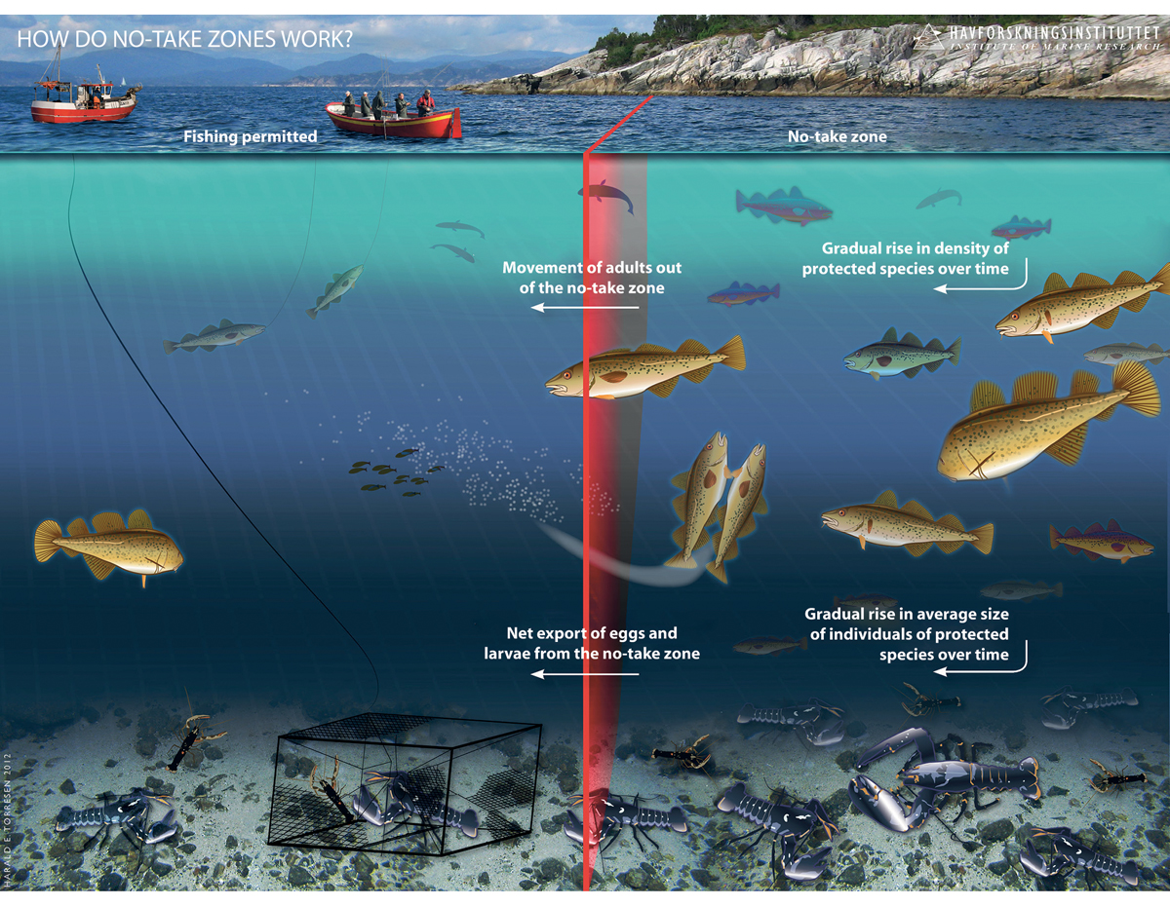
          - A no-take zone for lobster. Illustration of documented and anticipated effects of strict conservation measures, based on research carried out by the Institute of Marine Research in connection with no-take zones for lobster in the Skagerrak.
H. E. Tørresen/Institute of Marine Research
Passive restoration – ‘rewilding’
A passive restoration approach involves moderating or eliminating factors that cause ecological degradation and allowing natural recovery to improve the ecological status of an area. This is often referred to as ‘rewilding’. For rewilding to be successful, it is important that protected areas are large enough to avoid too much pressure from external factors.
Allowing benthic communities to recover can improve the ecological status of larger parts of an ecosystem. Benthic communities play an important role in the entire ecosystem, but in many areas they have been damaged and depleted, for instance by prolonged periods of bottom trawling, by releases of organic material or hazardous substances, or by the deposition of waste, which blankets the natural seabed. Soft bottom areas that remain undisturbed can also play a part in carbon sequestration.
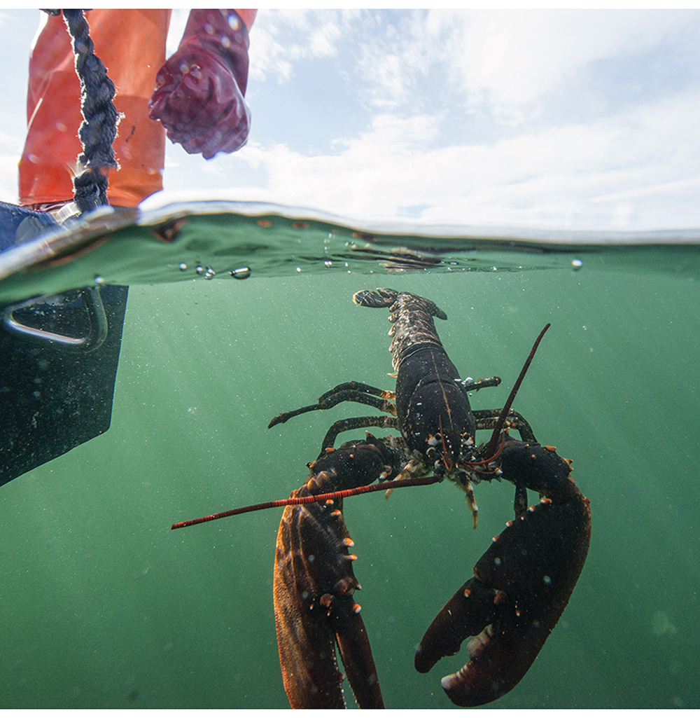
          - Releasing a lobster as part of an experimental fishery.
Photo: Bård Bredesen/Naturarkivet
One conservation measure that can be categorised as rewilding is the establishment of no-take zones for lobster. A number of no-take zones have been established in the southern half of Norway, and the lobster populations have been found to grow when fishing pressure is reduced. The effect is not restricted to the no-take zone, but can also be registered in the surrounding area. No-take zones appear to have a positive effect on fish stocks as well as lobster populations.
Various other measures can also be used within fisheries management to rebuild fish stocks. A restoration plan has been prepared for coastal cod, and is now being revised. The common eel is red-listed as vulnerable, and catches of the species have therefore been banned.
Active restoration measures
In addition to marine protection and other effective area-based conservation measures as nature-based solutions, ecosystem restoration includes measures to re-establish or improve vulnerable habitats in areas where the processes of natural species recruitment and recolonisation have been weakened. Examples are re-establishing eelgrass meadows and planting sugar kelp. Restoration also includes larger-scale work to rebuild entire habitats.
A great deal of work has been done on marine restoration internationally, and many projects involve the restoration of different marine habitats. In Norway, some of the largest-scale examples of active restoration of marine biodiversity involve remediation of contaminated sediments in ports. At some sites, habitat enhancement measures have been implemented on the seabed to encourage certain species to return, for example providing shelter for lobsters or spreading shell sand and pebbles on the clean seabed. Monitoring in these areas shows that a restored, clean seabed provides a basis for the re-establishment of fish and healthy habitats. Many species that had disappeared are returning. Successful remediation projects have been carried out in a number of highly polluted ports, including Oslo, Trondheim, Sandefjord, Bergen (Puddefjorden), Harstad, Tromsø and Horten.

Policy instruments and the legal framework for area-based conservation in marine areas

National legal framework and policy instruments
Norway has for many years been using a variety of area-based conservation measures, which contribute in different ways to safeguarding the marine environment. In some cases, measures are introduced specifically to safeguard marine biodiversity. In other cases, the primary purpose is to regulate the harvesting and other use of natural resources, but the measures are nevertheless an important part of the overall framework for maintaining marine biodiversity through sustainable ocean management. Area-based conservation measures operate in combination with other measures that are not area-based.

Marine protection under the Nature Diversity Act
How is marine protection organised in Norway?
In the 1970 Nature Conservation Act, protected areas were divided into the categories national parks, protected landscapes, nature reserves and natural monuments, on the basis that these categories could also be used in the marine environment. In the 2009 Nature Diversity Act, marine protected areas (MPAs) were introduced as a new category. According to the legislative history of the Act (Proposition No. 52 (2008–2009) to the Storting), this was done to ‘take into account differences between marine and terrestrial environments’, and because it was considered to be ‘appropriate and more flexible not to be tied to different protection categories as is the case on land.’
An area that is entirely marine should be designated as an MPA under section 39 of the Nature Diversity Act. MPAs may be established on the grounds of their marine conservation value, but also to safeguard valuable marine areas that are ecologically necessary for terrestrial species. Other categories, for example national park or nature reserve, should still be used to provide protection for areas that include both land and sea.
The Nature Diversity Act applies to Norwegian land territory and territorial waters. Certain of its provisions, for example general principles and rules on genetic material, also apply to Norway’s 200-nautical-mile economic zone and on the continental shelf to the extent they are appropriate, as set out in section 2, third paragraph, of the Act. A number of fundamental principles therefore apply throughout Norwegian waters. For example, all official decision-making must be based on knowledge about biodiversity and the anticipated impacts of planned developments on biodiversity (section 8), the precautionary principle must be used as a basis (section 9), and the cumulative environmental effects on the ecosystem now or in the future must be assessed (section 10).
MPAs established under section 39 of the Nature Diversity Act may extend up to 12 nautical miles beyond the baselines. Decisions to establish protected areas in the sea must state whether the purpose of the protection and any restrictions apply to the seabed, water column, surface water or to a combination of these elements. The relationship between the Nature Diversity Act and the Marine Resources Act in this area has been clarified, so that if fishing is the only activity that must be regulated to achieve the purpose of protecting an area, restrictions should be imposed under the Marine Resources Act.
What does marine protection involve?
Section 39 of the Nature Diversity Act states that ‘in a marine protected area no person must do anything that reduces the conservation value of the area as described in the purpose of protection.’ At the same time, the Act requires that ‘any restrictions imposed on activity shall be proportional to the purpose of protection’. This reflects a basic principle of work on marine protection. The conservation value of a protected area and the purpose of protection are the factors that govern which activities are permitted there. Restrictions should be as strict as necessary to safeguard the value of the area, but no stricter.
In other words, it is not the case that all or even most activities are prohibited in MPAs. As a general rule, the regulations for each MPA should allow for the continuation of the types of activity that are being conducted in the area at the time when it receives protection. Ordinary outdoor activities such as bathing, diving, hunting and recreational fishing will be permitted in line with the provisions of other legislation. Harvesting of living marine resources in accordance with the Marine Resources Act will also be permitted, but where appropriate the protection regulations may regulate activities such as kelp trawling, bottom trawling and other specific types of harvesting in all or part of an MPA.
Activities that are not normally permitted in MPAs include those that result in major physical disturbance such as land reclamation, dredging and removal and deposition of material, blasting and anchoring and mooring. In addition, permits will not normally be issued for polluting activities, for example discharges of waste water.
MPAs are managed either at local or at regional level. The administrative authority for smaller protected areas is normally the relevant municipality. If an MPA is adjacent to an area where the board of a national park board or other protected areas is the administrative authority, the MPA may be included in the board’s responsibilities to ensure integrated management of contiguous areas. If an MPA stretches across several municipalities or is a Ramsar site (i.e. designated as a wetland of international importance under the Ramsar Convention), the county governor is generally the administrative authority. In addition, an administrative authority may appoint an advisory committee to assist in managing an MPA.
An administrative authority may on application grant exemptions for activities that are generally forbidden in an MPA. The protection regulations for each area include a list of activities for which it is envisaged that exemptions may be granted. These may for example include installing aids to navigation, laying cables and pipelines, and aquaculture activities. The administrative authority for an MPA assesses applications for exemptions on a case-by-case basis, and the purpose of protection and the conservation value of the area will be determining factors in its decisions. An administrative authority may also set conditions for exemptions to ensure that the conservation value of an area is not adversely affected.
Under section 48 of the Nature Diversity Act, an administrative authority may also grant exemptions from the protection regulations provided that this is not in conflict with the purpose of the protection decision and cannot make a significant impact on the conservation value, or if safety considerations or important public interests make it necessary. The legislative history of the Act (Proposition No. 52 (2008–2009) to the Storting) explains that this general exemption provision is intended to provide an opening in the event of unforeseen circumstances or special cases that were not considered at the time of the protection decision. The administrative authority is also responsible for preparing a management plan for each MPA.
Administrative procedures for protection
Before a new protected area is established, all relevant concerns, including current plans under the Planning and Building Act, current permits and user interests, must be registered and evaluated. In addition to the general rules following for example from the Public Administration Act, sections 41–43 of the Nature Diversity Act set out specific rules for the procedures to be followed in establishing protected areas. These rules are intended to ensure that anyone with an interest in the matter is invited to take part and has an opportunity to influence the process. A key element of the procedures is weighing up the protection of an area against other important public interests (section 14 of the Nature Diversity Act). Where Sami interests are relevant, due importance must also be attached to the natural resource base for Sami culture (section 14, second paragraph, of the Act).
A protection process formally begins when the Ministry of Climate and Environment asks the Norwegian Environment Agency and the relevant county governor(s) to assess a protection proposal. The county governors have the chief responsibility for carrying out the protection process. This starts with a broad-based announcement that a planning process is being started, giving all interested parties the opportunity to express their opinions. Once the formal announcement has been published, section 44 of the Nature Diversity Act applies, meaning that permits for projects under other legislation may only be granted if such projects will have no significant impact on the purpose of the protection proposal.
Next, the county governor considers the input received in response to the notification and prepares a consultation document describing the area to which the proposal applies, the purpose of protection, the delimitation of the area concerned, any qualities of the area in addition to its conservation value, and the anticipated consequences of the proposal. Before the consultation process, the county governor sends the consultation document to the Norwegian Environment Agency for review. The subsequent consultation process may include information meetings and consultative meetings at both local and regional level.
After the consultation process, the county governor reviews the input that has been received and sends a recommendation to the Norwegian Environment Agency. The Agency considers this, and then sends its n recommendation to the Ministry of Climate and Environment. The Ministry prepares the matter for consideration by the Government. The final decision is made by the King in Council.
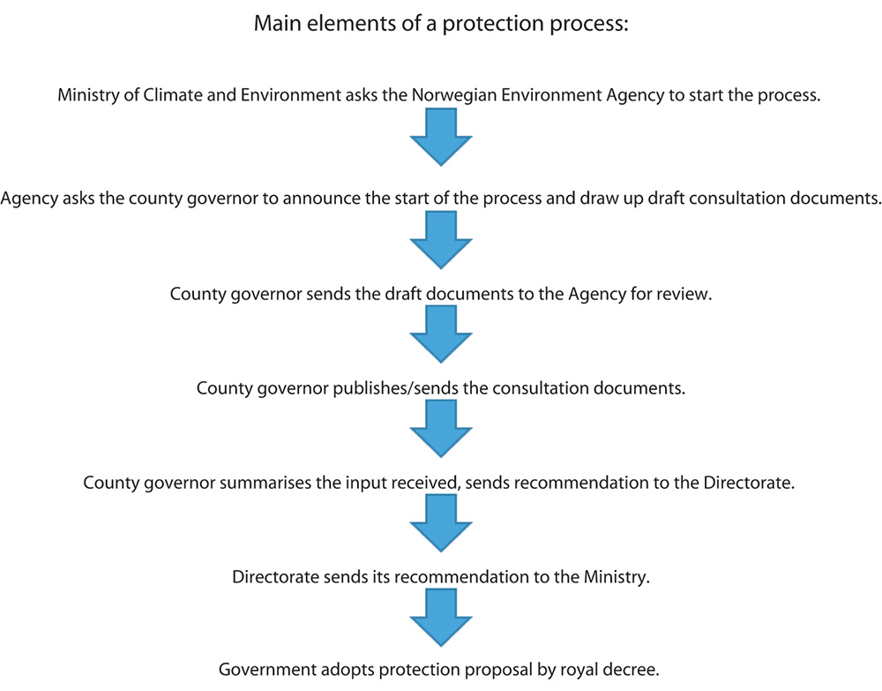
          - The main elements of administrative procedures for protection.
Norwegian Environment Agency
It is vital for the success of a protection process that anyone who has an interest in the matter, especially at municipal level, can participate actively and provide input as early as possible. Assessing such matters at local and regional level makes it easier to find good solutions for the substance of protection measures and to resolve any conflicts of interest.

Protection under the Svalbard Environmental Protection Act, the Act relating to Jan Mayen and the Act relating to the Norwegian dependencies
The Svalbard Environmental Protection Act
The Svalbard Environmental Protection Act applies to the entire land area of Svalbard and its waters out to the territorial limit (section 2 of the Act). Protected areas under the Act are divided into four categories: national parks, nature reserves, protected biotopes and geotopes, and cultural environments. Marine protected areas are not a separate category under the Act. However, this does not preclude the protection of marine areas in Svalbard. Under the rules for the different categories of protected areas, both the seabed and areas of sea can be protected.
Section 11 of the Svalbard Environmental Protection Act sets out the fundamental principle for the establishment of protected areas in Svalbard to ensure that the full variation range of habitats and landscape types in Svalbard is maintained. Its provisions require the protection of areas for both terrestrial and marine ecosystems. Section 12 of the Act states that protected areas are to be established by regulations, and determines what may be included in regulations on protected areas. It also provides the legal authority for protection regulations to prohibit or otherwise regulate any type of activity or project in protected areas.
When new protected areas are selected and protection regulations adopted for Svalbard, they must be in line with the strict provisions of the purpose clause of the Act. This states that the Act is intended ‘to preserve a virtually untouched environment in Svalbard with respect to continuous areas of wilderness, landscape, flora, fauna and cultural heritage’ (section 1 of the Act).
Section 16 of the Svalbard Environmental Protection Act states that no activity that has a lasting effect on the natural environment or cultural heritage is permitted in national parks. The provisions require the protection of the landscape and if applicable the seabed with plants, animal life and geological formations in a national park. Areas that are untouched or largely untouched may be protected as nature reserves. These areas must contain distinctive or vulnerable ecosystems, comprise a special type of habitat or special geological formations, otherwise be of special importance for the flora and fauna, or be of special scientific interest (section 17 of the Act). A nature reserve may be given absolute protection.
According to section 18 of the Act, areas of particular importance to the flora or fauna or that contain important or distinctive geological formations may be given protected status as biotopes or geotopes. In such areas, activities that may affect or disturb the flora or fauna or damage geological formations contrary to the purpose of the protection measure must be avoided. Under section 19 of the Act, areas of particular value in terms of cultural history may be protected as cultural environments. In such areas, activities that may reduce the historical value of the area must be avoided.
It is the conservation value and the purpose of protection that govern which activities are permitted in protected areas established under this Act, in the same way as for those established under the Nature Diversity Act. One general principle is that protected areas in Svalbard should contribute to the maintenance of wilderness and untouched nature.
The Governor of Svalbard is the administrative authority for protected areas in Svalbard. The Governor may on application issue permits or grant exemptions for activities that are generally prohibited. This may be done either under the specific rules on exemptions listed in each set of protection regulations, or under the general provision on exemptions in section 22 of the Act.
In addition, the Svalbard Environmental Protection Act includes specific provisions on administrative procedures for the establishment of protected areas (sections 13–15). The procedures are similar to those under the Nature Diversity Act, but the Governor of Svalbard is responsible for matters that are the responsibility of the county governors on the mainland.
The Act relating to Jan Mayen
Section 2 of the Act relating to Jan Mayen states that the King may lay down regulations relating to environmental protection on Jan Mayen. Under this provision, Jan Mayen and the territorial waters surrounding it have been protected as a nature reserve. The fauna, flora and landscapes are all protected.
The Act relating to the Norwegian dependencies
This Act applies to the Norwegian dependencies Bouvet Island, Peter I’s Island and Dronning Maud’s Land. According to section 2 of the Act, the King may issue regulations relating to environmental protection for the dependencies. Under this provision, Bouvet Island and the territorial waters surrounding it have been protected as a nature reserve. The fauna, flora and landscapes are all protected.

Area-based conservation under the Marine Resources Act
Marine protected areas under section 19 of the Act
Norway has also used been using area-based measures for many years as part of its fisheries management system. The 2008 Marine Resources Act applies in territorial waters, the economic zone of Norway, the fisheries protection zone around Svalbard and the fisheries zone around Jan Mayen, and on the entire continental shelf, including the part beyond the 200-nautical-mile limit (section 4 of the Act). The precautionary principle is one of the fundamental principles on which the Act is based. Section 19 of the Act provides the legal authority to ‘establish marine protected areas where harvesting and other forms of use of wild living marine resources is prohibited’.
Area-based conservation measures may apply to the surface water, the water column and/or the seabed. Furthermore, the Act states that ‘exemptions may be granted for harvesting activities and other forms of use that will not be in conflict with the purpose’ of the measure. According to the legislative history of the Act (Proposition No. 20 (2007–2008) to the Storting), it is important that restrictions on harvesting are no more extensive than is necessary to achieve the purpose of a conservation measure. This means that pelagic fisheries may be permitted in an area that is established to safeguard benthic habitats. The same applies to the use of conventional gear such as pole-lines and drift nets, provided that there is no risk of damage as a result of the loss of gear or the like.
Area-based conservation under the Marine Resources Act is similar to protection under the Nature Diversity Act, but restrictions apply only to harvesting and other utilisation of living marine resources. All such activities that are in conflict with the purpose of a measure are prohibited. Marine areas where the only conservation measures are specific provisions regulating fishing activities must be established under the Marine Resources Act.
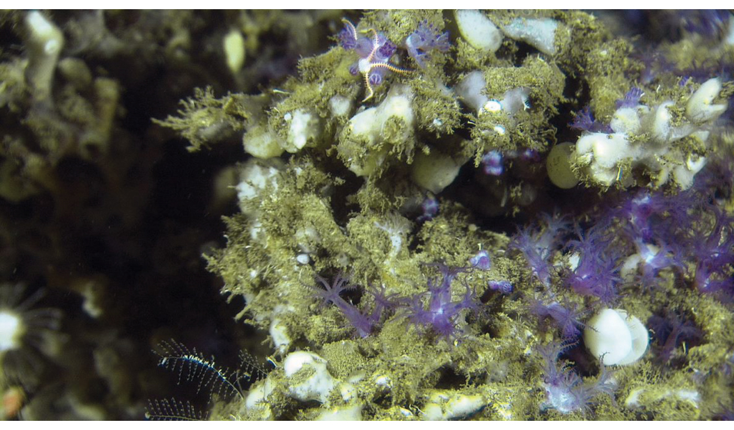
          - The gorgonian coral Anthelia borealis growing on a Lophelia coral reef on the edge of the continental shelf, at a depth of 300 m.
Mareano/Institute of Marine Research
The regulations relating to protection of coral reefs against damage as a result of fisheries activities are issued under section 19 of the Marine Resources Act. Their purpose is to protect a representative selection of coral reefs against damage from fisheries activities. The coral reef areas guarded in this way are considered as MPAs in the OSPAR system. The regulations include provisions prohibiting the use of certain types of gear in delimited geographical areas. They apply to gear that is towed during fishing and that may touch the seabed during these operations, and in addition pots, gill nets, longlining gear, and all other gear with hooks.
Other area-based measures under the Marine Resources Act
Other sections of the Marine Resources Act also provide the legal authority for various types of area-based measures. Section 20 prohibits harvesting using trawls inside the territorial limit around the Norwegian mainland, and also provides the legal authority to prohibit trawling or the use of other gear in certain areas. The prohibition is intended to enable smaller vessels to fish in coastal waters and harvest coastal stocks without having to compete with trawlers that are more effective and can operate over larger areas. The prohibition on trawling also protects resources and ecosystems in shallower waters against damage from trawling.
Section 21 of the Act gives the Ministry of Trade, Industry and Fisheries the authority to prohibit or limit harvesting in areas or of species that may be affected by pollution. The Ministry can use this provision to prohibit or limit harvesting in an area, on condition that the area or species may be affected by pollution.
Section 16 of the Act provides the authority for a range of area-based measures. A number of such measures have been adopted under the Regulations relating to sea-water fisheries sets out a number of these, including provisions on trawl-free zones and a requirement to show special care during fishing operations near known coral reefs. Most of these measures do not have the specific purpose of protecting marine biodiversity, but some of them nevertheless make an important contribution to its conservation, for example by prohibiting trawling or other specific types of fishing in particular areas. The Regulations relating to regulatory measures for fishing to protect vulnerable marine ecosystems, which were adopted under section 16 of the Marine Resources Act, apply to very large areas. They prohibit fishing using gear that may come into contact with the seabed during use. In order to implement international regulatory measures for fisheries, similar rules have been introduced that apply to all Norwegian vessels, regardless of where they are fishing throughout the North Atlantic Ocean. Thus, area-based conservation measures and a wide range of other measures under the Marine Resources Act are an important part of the regulatory framework that ensures sustainable ocean management in Norway.

Planning under the Planning and Building Act
Planning processes
Regional and municipal plans play an important part in ensuring long-term, integrated and predictable management of the coastal zone. Planning processes under the Planning and Building Act are also intended to ensure local support for and involvement in spatial management policy. The geographical scope of the Planning and Building Act extends to one nautical mile beyond the baselines. Under the Act, responsibilities for planning are divided between the municipalities, counties and central government, and there is a hierarchy of plan types, where overall plans determine the framework for more detailed plans and projects.
            - Planning processes and types of spatial plans.
03J1xx2
Level | Guidelines | Binding spatial plans
National | Government expectations for regional and municipal planning  Central government planning guidelines | Central government spatial plans
Regional | Regional planning strategy  Regional master plans with guidelines | Regional planning regulations
Local | Municipal planning strategy  Municipal master plan, social element; thematic municipal sub-plans | Municipal sub-plans  Area zoning plans  Detailed zoning plans

County authorities and municipalities must cooperate with central government authorities, business and industry and the general population to find sustainable solutions and ensure close coordination between the Planning and Building Act and other legislation. The Nature Diversity Act sets out general principles for how the authorities are expected to include biodiversity considerations in their decision-making and demonstrate that they have done so. These principles apply to planning activities as well. If biodiversity considerations are assessed at an early stage of the process, more options are available and it is easier to make adjustments and take steps to reduce conflict.
Furthermore, the rules on public disclosure and environmental impact assessment are very important for ensuring that plans are adequately assessed and enabling all relevant stakeholders to provide input. This applies to biodiversity issue as well. The Regulations relating to environmental impact assessment (21 June 2017 No. 854) include provisions intended to ensure that projects are assessed thoroughly. For plans under the Planning and Building Act, the geographical scope of the regulations extends to one nautical mile beyond the baselines. For projects and plans under other acts, the geographical scope of the regulations is determined by the relevant act. The Government is considering a mechanism for coordinating the Nature Diversity Act and the Planning and Building Act to ensure better spatial management, in line with the international Sustainable Development Goals.
Municipal planning in the coastal zone
Plans at municipal level must follow up guidelines and rules issued at regional and national level. This means that in areas where there are proposals to establish marine protected areas, the municipalities must take this into account in planning processes. Establishing MPAs also requires coordination and cooperation with a range of stakeholders. These processes are essential in the development of sustainable, integrated coastal zone management in Norway.
Municipalities can set aside areas of sea for various purposes. In many cases, an area is designated for multiple purposes, which requires knowledge about purposes that can suitably be combined. It is normally possible to combine access and passage, fishing, nature and outdoor recreation in the same area. Municipal master plans may include rules on use of the surface waters, the water column and the seabed. The spatial planning categories natural environment and outdoor recreation may for example be combined to safeguard benthic biodiversity. The categories that can in practice be combined with maintaining the natural environment will depend on which species and habitats are present. For example, fishing and outdoor recreation can generally be combined with maintaining benthic habitats such as eelgrass meadows or shellsand deposits.
The Planning and Building Act also allows for conservation measures for the natural environment in specific areas, as set out in section 11-8 on the designation of zones where specific considerations apply in the land-use element of municipal master plans.
In addition, municipalities may include rules to ensure sound nature management in the land-use element of their master plans, as set out for example in sections 11-9 (6), and 11-11 (3 and 6) of the Planning and Building Act. Rules may also be laid down determining which species, including species of aquatic plants, may be produced in areas designated for aquaculture, and access and passage may be prohibited in delimited areas. The municipalities must also take other matters into account in their planning processes, for example climate change mitigation and adaptation to anticipated climate change.
Municipalities can also use zoning plans to safeguard areas of the marine environment, as set out in section 12-5 (6) of the Act. This may be a suitable approach for river deltas, eelgrass meadows and other shallow-water marine areas. In such areas, rules on permitted types of use may be issued under section 12-7 (6) of the Act to ensure that the extent of habitat types etc is not reduced and that their ecological status does not deteriorate.

Area-based conservation measures under other legislation
The Aquaculture Act
Under section 14 of the Aquaculture Act, which also applies in Norway’s exclusive economic zone and on the Norwegian continental shelf, the Ministry of Trade, Industry and Fisheries may prohibit aquaculture operations, require them to be moved or other restrict aquaculture operations if this is necessary for the conservation of areas of particular value for aquatic organisms. This provision has for example been used to set rules for national salmon fjords in order to protect selected wild salmon stocks.
Legislation on ports and navigable waters
The Act relating to ports and navigable waters sets out rules for the administration and management of these areas. Its purpose is to facilitate safe, secure, effective and environmentally friendly operation of ports and use of navigable waters, and it is also intended as a tool for weighing up different user interests. The expression ‘environmentally friendly’ is to be interpreted broadly, so that environmental problems that are relevant at any given time are taken into account. Both the central government and the municipalities have powers to regulate passage and traffic at sea, and rules may apply generally or to delimited areas. Regulatory measures may for example be introduced on environmental grounds. The Act also includes requirements relating to permits for works in the sea. The authorities may include environmental considerations when considering such applications.
Petroleum legislation
The Petroleum Act applies to petroleum activities in connection with subsea petroleum deposits under Norwegian jurisdiction. It applies to activities both within and outside Norway and the Norwegian continental shelf to the extent provided by international law or a treaty with a foreign state. Licences are required for all petroleum activities. Only the state may conduct petroleum activities without any licence, approval or consent required under the Act. Production licences are most important. They are allocated to qualified petroleum companies through competitive procedures, and give the licensees exclusive rights to explore for and extract oil and gas in the area covered by a licence. Production licences are granted for specified time periods and defined areas in parts of the continental shelf that have been opened for petroleum activities. In addition, permits are required under the Pollution Control Act and the health, safety and working environment legislation.
The Petroleum Act does not contain provisions making it possible to use area-based conservation measures, but petroleum activities are regulated through licensing conditions. These may be included in licences, either when new production licences are issued or plans for field development and operation are approved, and/or in connection with infrastructure development. To safeguard species and habitats in an area, it is possible for example to restrict exploration drilling to certain times of year. Before field development starts, conditions may specify the location of installations or the choice of routes for pipelines and cables in order to protect coral reefs or other species and habitats. Such conditions apply for the duration of the production licence.
Activities of the Norwegian Armed Forces
The Norwegian Armed Forces currently have 87 offshore military shooting and exercise areas, from parts of the Oslofjord in the south to Kvænangen in the far north. They are intended to meet training and exercise needs for personnel, for testing equipment and for operational training for Norwegian forces alone and together with allies. Areas have been designated to permit training for airborne, naval and underwater operations. When using these areas for exercises or other purposes, the Armed Forces take environmental impacts into consideration, for example by restricting use at times of year when the fauna is vulnerable, by restricting traffic and passage, physical disturbance and installations, or by requiring minimum distances to areas of importance for biodiversity. Several of the current shooting and exercise areas overlap with marine protected areas. In these cases, the rules that apply to the MPA are incorporated into the instructions for use of the shooting and exercise area. The defence sector is currently working on a proposal to formalise a new nationwide structure for offshore military shooting and exercise areas. The Ministry of Defence is planning to adopt this in the course of 2021.
Access has been prohibited to a number of marine areas under section 7-5 of the Act relating to national security and the regulations on areas of importance to the Norwegian Navy where access is prohibited (20 December 2018 No. 2058). Most of these areas are near naval installations and other areas of naval importance. They are often relatively undisturbed, and may therefore have qualities of importance for the marine fauna and flora.
The Cultural Heritage Act
Under section 15 of the Cultural Heritage Act, the Directorate for Cultural Heritage may adopt individual protection orders for shipwrecks and underwater installations. This has for example been done to protect the wreck of the German warship Blücher in the Oslofjord. The area around such structures and sites may also be protected under section 19 of the Act. In addition, monuments and sites dating from before 1537 are automatically protected under the Cultural Heritage Act. The Act applies out to 24 nautical miles from the baselines, which is the outer limit of the contiguous zone. Section 14 of the Act regulates the right of ownership to shipwrecks, remains of shipwrecks and other objects that have been on board ships. Such finds are considered to be ‘ship finds’ under the Act. According to the Act, the State has the right of ownership if finds are more than 100 years old calculated from the date the vessel was launched. Section 14 also prohibits any measures that may damage ship finds, regardless of who is the owner. The cultural heritage on the seabed in Norwegian territorial waters consists largely of finds from the Stone Age and ship finds.

A local approach to the conservation of marine biodiversity

Coordination between local and central administrative levels
All the areas that have been proposed for inclusion as marine protected areas have special conservation value, and have also been selected because it is of national importance to safeguard their special qualities. Their importance may also encourage local involvement in the establishment and management of conservation areas. Protecting areas for example as MPAs or as national parks including marine areas may increase interest in them and raise their status. Protected areas may for instance be attractive for tourists who are interested in outdoor activities and as research areas for scientists.
              - Lurefjorden and Lindåsosane MPA
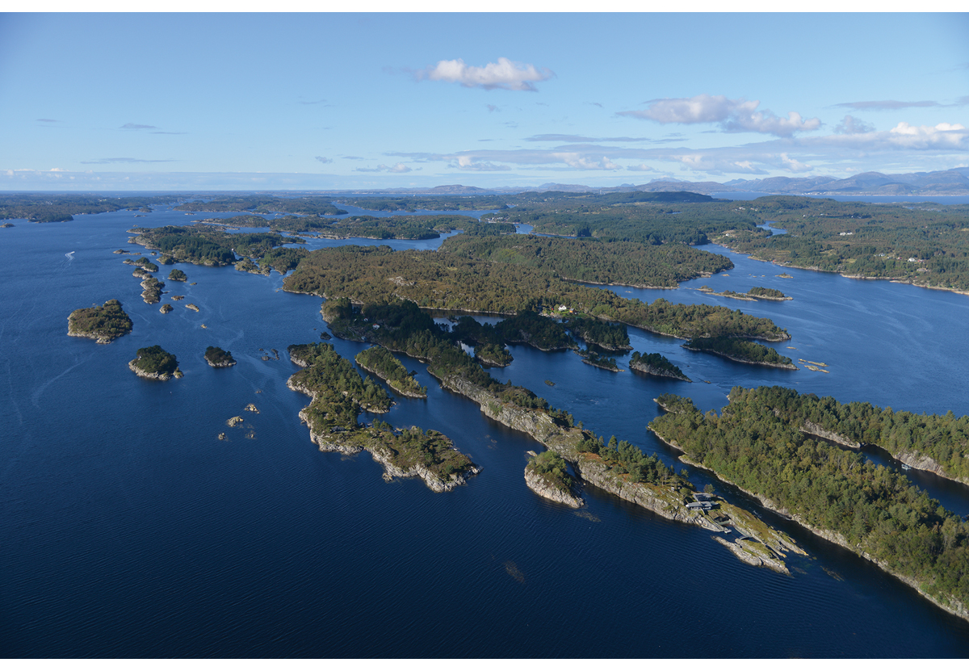
          - Lurefjorden and Lindåsosane MPA in Vestland county.
Photo: Magnus Johan Steinsvåg
This fjord system in Vestland county is unlike any other in the whole world. It includes Lurefjorden, which is deep but with shallow sills, and Lindåsosane, a system of small, shallow fjords. The Lurefjorden and Lindåsosane MPA was established in 2020. There was little conflict and attitudes to the protection process were generally positive. The decision to establish the MPA was widely welcomed. Protection of this area was an essential basis for the designation of the Norhordland Biosphere Reserve as part of the UNESCO Man and Biosphere Programme in June 2019. The municipalities in the region had been working towards this for several years.
[Boks slutt]
Under the Planning and Building Act, the municipalities are responsible for planning the use and conservation of coastal waters out to one nautical mile beyond the baselines. This work includes setting aside areas for purposes such as commercial and industrial development, including aquaculture, or as areas of natural environment, outdoor recreation areas, or for fisheries or navigational purposes. This is dealt with further in Chapter 3.1. Sound municipal spatial management is vital for safeguarding the entire coastal zone in Norway.
Coordination between the central government, municipal authorities and relevant interest groups is essential when MPAs and other area-based conservation measures are established. In practice, the situation varies widely from one process to another. In some cases, coordination and cooperation function smoothly from the start of the process. In other cases, the pieces fall into place as the scope of the conservation measure becomes clear. In certain cases, difficulties have arisen because municipal and central government authorities have not been in agreement. This can be a result of different priorities for the use of an area, misunderstandings, or a situation where the implications of the conservation measure for use of the area and future developments are unclear.
              - Saltstraumen MPA
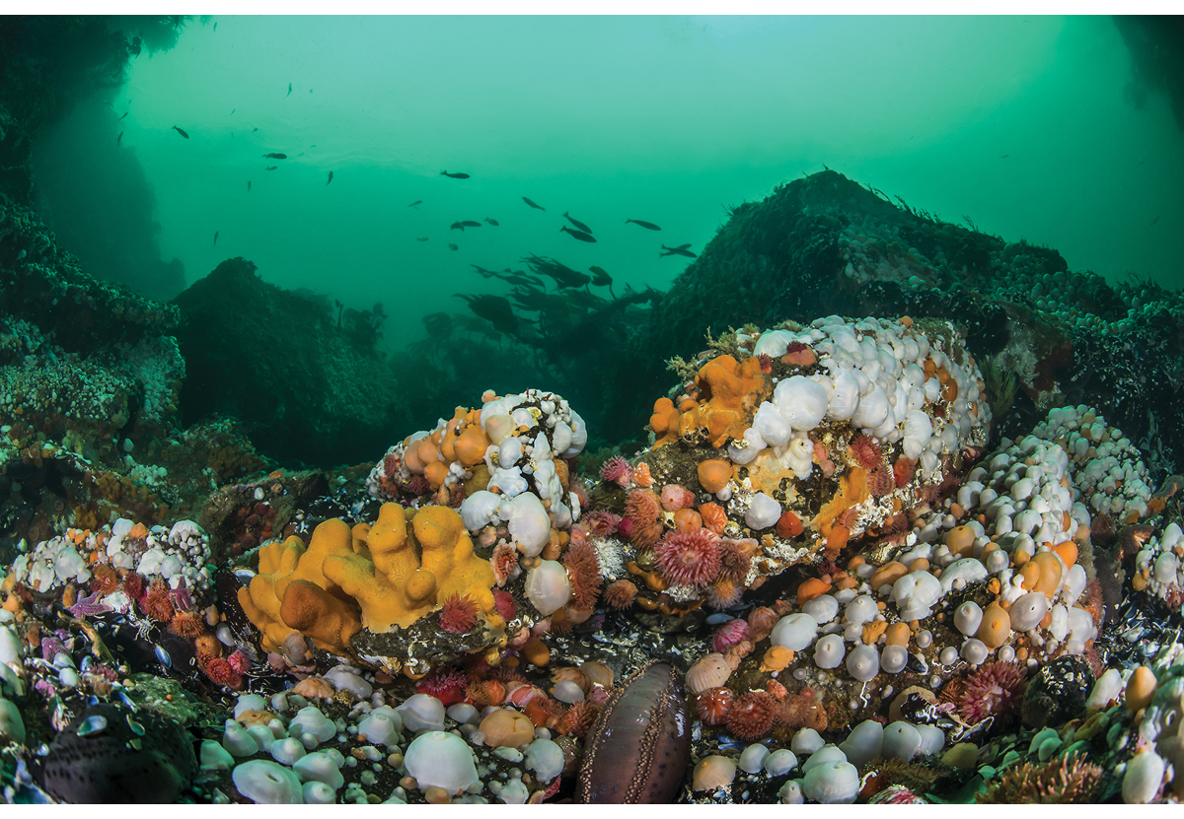
          - From Saltstraumen in Nordland county.
Photo: Erling Svensen
Saltstraumen MPA was established in 2013. Bodø municipality markets the area actively as a global attraction and a spectacular outdoor recreation area. The area is very popular for sports fishing from land and small craft, and for sports diving. In addition, there is a good network of paths near the shore, and various sites where there is information about the cultural heritage, provided through a project on traces of human activity around Saltstraumen from the past 10 000 years.
The tidal current through Saltstraumen is recognised as the strongest in the world. The area supports a rich fauna, including sessile species such as sea anemones, molluscs, sponges and corals. The current patterns are determined by the geological structures in the area and strongly influence the fauna and flora. Saltstraumen is also an important and popular outdoor recreation area. When the protection process for Saltstraumen began in 2009, there was some local scepticism because people were unsure how their use of the intertidal zone might be affected. During the protection process, a number of general exceptions and rules on exemptions were included in the protection regulations, without affecting the purpose of the protection or the conservation value of the area. This helped in achieving a satisfactory solution.
[Boks slutt]
Experience shows that well-organised, transparent processes with clear communication between stakeholders are needed to reach a common understanding of the purpose of protection and the implications of conservation measures for user interests. In many cases, good solutions can be found by making minor adjustments to the originally proposed boundaries of a protected area or by including local exceptions or the possibility of applying for exemptions. It is often possible to make adjustments of this kind while at the same time maintaining the conservation value of an area.
The establishment of no-take zones for lobster is a good example of processes based on local initiatives. Proposals are developed by local stakeholders, then considered by the municipal council and sent on to the Directorate of Fisheries. If it is difficult to reconcile conflicting interests, the matter may be postponed or the proposal can be adjusted locally. These processes have given good results.

A local approach to environmental impact assessment
Ensuring broad local participation is a vital part of protection processes such as those under the Nature Diversity Act. Local reference groups representing a range of different interests are often established by the county governors to provide advice and assistance during a protection process. In addition, meetings with relevant municipalities and open information meetings are held. The northernmost counties, Nordland, Troms and Finnmark also have a joint working group that provides advice to the county governors during such processes.
All proposals for protection under the Nature Diversity Act and other conservation measures must be reviewed in accordance with Norway’s official instructions for planning and management of central government programmes and projects. These include requirements for different alternatives to be assessed. Proposals for conservation measures therefore often include two or more options for delimitation of the area and for regulatory measures. In some cases, the consultation documents have included two options for the form of protection to be used.
Another key requirement is that both positive and negative impacts of a proposal must be assessed. Here, it is particularly important to ensure coordination between local and central stakeholders. To ensure that a protection process is successful, local stakeholders must be as clear as possible about how they envisage future use of the area. This information is essential for evaluating the likely effects on local employment. Employment might be likely to increase with growth in tourism or research and other activities; on the other hand, restrictions on use could hinder the development of commercial activities and result in shrinking employment.
Protection proposals for areas exceeding 250 km2 in size are assessed under the Regulations of 21 June 2017 No. 854 relating to environmental impact assessment, which include a requirement to draw up a study programme.
              - Protection process for the Andfjorden transect
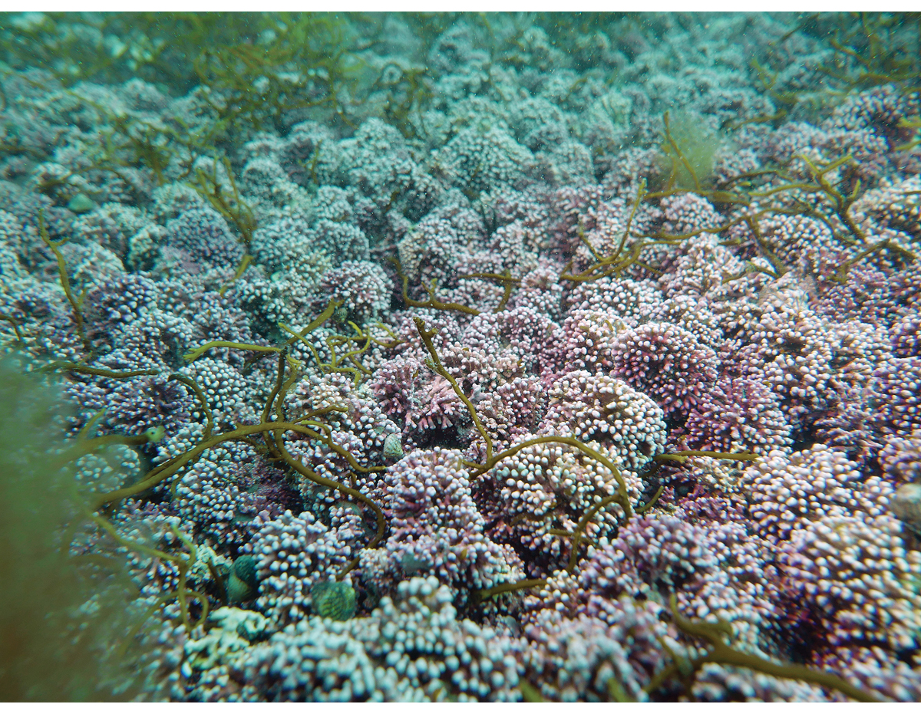
          - Maerl bed near Krøttøya island in Andfjorden.
Photo: Eli Rinde/ Norwegian Institute for Water Research
It is vital to obtain as much information as possible on biodiversity and conservation value for all protected areas. The Andfjorden transect is a relatively large area that has been proposed as an MPA. A study programme has been drawn up as part of the environmental impact assessment. The county governors of Nordland and Troms announced the start of the protection process in 2018. In 2019, the area covered by the environmental impact assessment was extended by 304 km2 on the basis of new finds. This brought the total area to 1964 km2.
The Institute of Marine Research has carried out supplementary mapping as part of the impact assessment, and has found rare types of coral habitats and maerl beds. The coral reef complexes in Andfjorden may be some of the largest in the world, and are unique in Norway.
These unique coral finds have aroused a great deal of interest. However, in such a large area there will generally be a range of interests that need to be taken into consideration. In the Andfjorden transect, these include aquaculture, fisheries and defence activities. A thorough evaluation of how all these interests can be reconciled with safeguarding unique species and habitats for the future will therefore be included in the administrative procedures.
[Boks slutt]

Private ownership rights
Proposals for marine protection do not include much privately-owned land. An MPA may include the intertidal zone up to mean high tide level, but in many cases only areas where the water depth exceeds two metres are included, or the MPA extends only to where a steep underwater slope starts near the shoreline. In some cases, the boundary is deeper than this. The delimitation of the landward boundary of an MPA is assessed on a case-to-case basis, and will depend on the purpose of protecting the area. In cases where a proposal for protection does include areas in private ownership, the administrative process may be more challenging. However, it is generally possible to find good solutions that make it possible to use the shoreline and intertidal zone in ways that are not in conflict with the purpose of protection. Often, these are established traditional forms of use.

MPAs and local commercial activities
Aquaculture, fisheries, and other activities involving harvesting of marine resources are an important consideration in protection processes, at both local and central level. Maximising sustainable value creation and employment in the Norwegian ocean industries is one of the main aims of the Norwegian Government’s ocean strategy. Many settlements along the coast are hoping that these industries will result in growth and development, although it is not always clear what kinds of use or development projects may be involved.
The operation and maintenance of existing aquaculture installations is explicitly permitted in marine protected areas. The regulations for most MPAs also include a specific provision on exemptions, so that new aquaculture activities can be permitted if they will not be contrary to the purpose of protection. In addition, aquaculture installations must be licensed under the Aquaculture Act, and aquaculture activities must be in accordance with the land-use element of the municipal master plan. The establishment of an MPA may nevertheless be perceived as limiting local self-government by restricting future sites for aquaculture installations. If local stakeholders are as specific as possible about where they envisage such activities being located, it is often possible to resolve any difficulties. This can for example be done by adjusting the boundary of an MPA, by setting aside areas around existing installations to allow for expansion, or by finding alternative areas that are suitable and can be set aside for future aquaculture activities.
Harvesting of living marine resources in accordance with the Marine Resources Act is generally permitted in MPAs. In addition, protection against harmful environmental pressures will safeguard marine ecosystem functions and harvestable resources in the area, and thus provide benefits for local fishing activities. The regulations for some MPAs prohibit fishing operations using towed gear that may come into contact with the seabed, in order to avoid damage to corals and other vulnerable biodiversity. In such cases, the need for restrictions appears to be generally accepted by local fishermen and other stakeholders.
Some regulations for MPAs include prohibitions on harvesting vegetation. Opinions on such restrictions may be mixed locally. In some cases, commercial stakeholders may have objections while the municipalities agree with a ban on harvesting. This situation may arise where harvesting is largely driven by companies that are not local and the community perceives that it derives little benefit from their activities.
Fisheries-related measures that are intended to safeguard biodiversity often apply to areas well out to sea. In many cases, only the fisheries sector will be affected by rules of this kind. The Directorate of Fisheries follows the normal regulatory procedures when introducing such measures. The authorities and the fishery organisations have been cooperating closely in this field ever since the first coral reefs received protection in 1999, and this cooperation has been successful right up to the present. Public consultations are held on all proposals for new rules. This ensures transparency and gives organisations and others with an interest in the matter an opportunity to put forward their views, for example at the annual regulatory meetings with stakeholders.

Sami and Kven interests
Ensuring the participation of Sami (including Sea Sami) interests is an important aspect of work on marine protection. In some areas, the interests of the Kven people may also be relevant.
Sami interests are safeguarded through the procedures for consultations between the authorities and the Sámediggi (Sami parliament) and through guidelines for work on the marine protection plan in Sami areas. The Sámediggi and other Sami organisations have considered it particularly important to ensure that protection measures do not interfere with Sami culture and economic activities, and that they safeguard the natural resource base for these activities. In response to input from the Sámediggi, the section describing the purpose of protection in new regulations for MPAs now includes conservation of the natural resource base for Sami activities. Several MPAs have been given official Sami names in addition to the Norwegian names.

International framework, obligations, goals and instruments
Norway’s work on the conservation of areas of importance for marine biodiversity is also used to implement international legal obligations and political goals that the country has undertaken. Generally, international law combines a duty to protect marine biodiversity with a right to make use of marine resources. Countries decide for themselves how to implement international law and which measures to use. Norway plays an active part in international cooperation at both global and regional level. The international legal framework and the international agenda, which is constantly evolving, therefore also influence the conservation of marine areas at national level.

The Law of the Sea
The 1982 UN Convention on the Law of the Sea constitutes the basic international legal framework for all maritime activity. It sets out both rights to use resources and clear duties for coastal states to protect the marine environment. Some important obligations are contained in Part XII of the Convention. Article 192 sets out the absolute obligation for states to protect and preserve the marine environment. Under Article 194 (5), states are required to take necessary steps to protect rare or fragile ecosystems and the habitats of depleted, threatened or endangered species and other forms of marine life. The parties to the Convention are as a general rule free to choose the tools and instruments they consider to be appropriate within the framework of their own ocean management regime. According to Article 197, the parties also have an obligation to cooperate on a regional basis to protect and preserve the marine environment. The Convention does not include a specific obligation to establish marine protected areas, but MPAs and other area-based conservation measures are widely applied tools that can be used to implement the general obligations of coastal states as regards conservation of the marine environment.

The Convention on Biological Diversity
The Convention on Biological Diversity (CBD) is one of the multilateral environmental agreements that were adopted at the UN Earth Summit in Rio de Janeiro in 1992. It is considered to be an important global instrument for the conservation and sustainable use of biodiversity. It is based on the principle that states have the right to exploit their own resources in accordance with their own environmental policies, but that they must also as far as possible and appropriate conserve ecosystems and natural habitats and maintain and take steps for the recovery of viable populations of species.
In 2020, the parties to the CBD adopted a strategic plan for biodiversity 2011–2020. This includes 20 global targets, grouped under five strategic goals, for saving biodiversity by 2020, known as the Aichi targets. Strategic goal C is to improve the status of biodiversity by safeguarding ecosystems, species and genetic diversity. Under target 11, at least 10 % of coastal and marine areas should by 2020 have been conserved through effectively and equitably managed, ecologically representative and well connected systems of protected areas and other effective area-based conservation measures. This is a global political target and not legally binding. The parties are therefore not obliged to set specific quantitative national conservation targets, but the Aichi target can to some extent function as guidance for how different countries and regions can contribute to progress. The Aichi targets provide a flexible framework for developing national targets and measures based on countries’ own ocean policies and the problems they have to deal with in their own waters. Area-based conservation measures in areas beyond national jurisdiction can also play a part in achieving the targets.
Target 11 does not merely specify a percentage for conservation areas. It is not sufficient if conservation measures are introduced globally for a certain percentage of ocean area. The parties must take action to achieve the target, and especially for ‘areas of particular importance for biodiversity and ecosystem services’. In addition, networks of protected areas must be ‘ecologically representative and well connected systems’. The target also mentions protected areas and other effective area-based conservation measures separately. In 2018, the parties to the CBD adopted criteria for the identification of other effective area-based conservation measures, which are further discussed in Chapter 4.
Strategic goal B in the Aichi system, which is to reduce the direct pressures on biodiversity and promote sustainable use, is also important. According to Aichi target 6, all fish and invertebrate stocks and aquatic plants were to be managed and harvested sustainably, legally and applying ecosystem-based approaches by 2020.
              - New global conservation targets
The Aichi targets are for the period up to and including 2020, and are to be replaced by new global biodiversity targets. Negotiations on a post-2020 global biodiversity framework are in progress under the CBD [and were to be completed in autumn 2021. The scientific basis for the negotiations includes assessments by the Intergovernmental Science-Policy Platform on Biodiversity and Ecosystem Services (IPBES). It is estimated that one million species are threatened, and ecosystems in many parts of the world are degraded. IPBES has said that ‘transformative changes’ will be needed to protect and restore nature.
The new biodiversity framework is expected to include about 20 global targets that all parties will be expected to work towards. A key issue in the negotiations is the possible inclusion of a new global target of protecting at least 30 % of land and ocean. Norway is playing an active role in the negotiations, and has proposed a new planning, reporting and review mechanism similar to that under the Paris Agreement. The idea is to synchronise reporting by countries in regular reporting and review cycles and make reporting more comparable between countries, so that overall progress towards the global targets can more easily be measured.
[Boks slutt]

The Sustainable Development Goals
A number of the Sustainable Development Goals (SDGs) correspond quite closely to the Aichi targets. SDG 14 on life below water is for people to conserve and sustainably use the oceans, sea and marine resources for sustainable development. Target 14.5 is also of key importance in this context. It states that by 2020, at least 10 % of coastal and marine areas should be conserved, consistent with national and international law and based on the best available scientific information.

High-level Panel for a Sustainable Ocean Economy
The High-level Panel for a Sustainable Ocean Economy, or Ocean Panel, was established in 2018 by serving heads of state and government from 14 coastal states, with Norway’s prime minister and Palau’s president as the co-chairs. The goal was to build momentum towards a sustainable ocean economy globally. The countries that are members of the Ocean Panel have adopted the aim of sustainably managing 100 % of the ocean area under national jurisdiction.
The Ocean Panel’s view is that rather than hindering economic development, conservation and restoration of ecosystems and habitats in the oceans and along the coast will ensure that the oceans can continue to deliver the ecosystem services we all depend on. The scientific basis for the Panel’s work highlights both the role of intact coral reefs and mangrove forests in protecting coastal areas against storms and sea level rise, and the role of marine protected areas in conserving and restoring biodiversity, ensuring the uptake and sequestration of CO2 and increasing the productivity of fisheries in areas adjacent to protected areas. The Ocean Panel’s main recommendation is that countries should manage 100 % of marine and coastal areas within national jurisdiction in an integrated and sustainable manner. The states that are members of the Panel have undertaken to achieve this by 2025. Sustainable ocean plans will be developed as the most important tool for this work. In the Norwegian context, the system of ocean management plans fulfils this function.
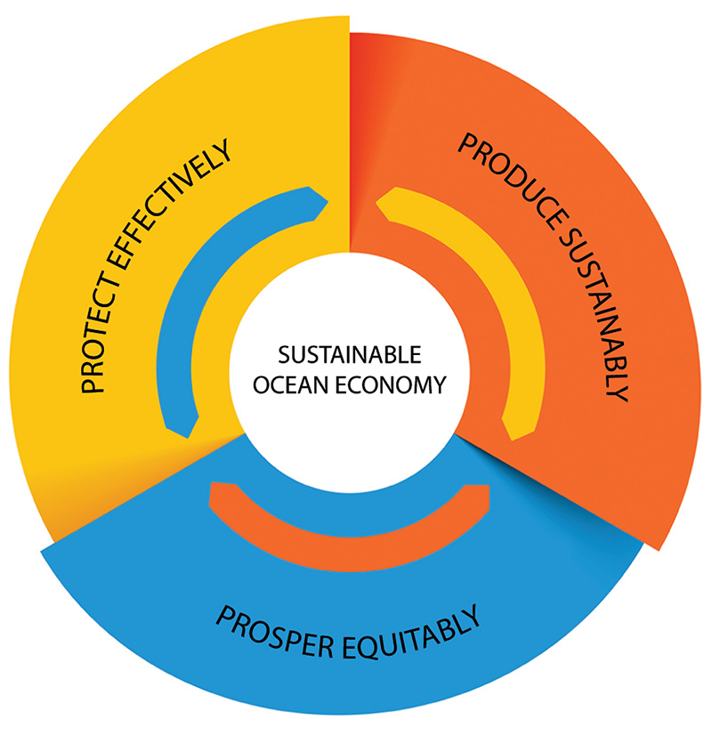
          - The Ocean Panel’s model for a sustainable ocean economy.
Ocean Panel/Norwegian Ministry of Foreign Affairs
The Ocean Panel supports the global target of protecting 30 % of the oceans by 2030 through marine protected areas and other effective area-based conservation measures. The Panel has specified, in the same way as was done in the Aichi targets, that this global target would not be binding for individual states. National decisions on the use of ocean areas and on MPAs and other effective area-based conservation measures will depend on ecosystem status and the scope and quality of ocean management regimes, and must take into account human welfare, sustainable food from the oceans and climate change.

New global instrument on biodiversity in areas beyond national jurisdiction
In accordance with a UN General Assembly resolution, negotiations have been started on a new international instrument on the conservation and sustainable use of marine biodiversity of areas beyond national jurisdiction. This is intended to strengthen implementation of the provisions of the Law of the Sea on protection of the marine environment, much as the Fish Stocks Agreement does for provisions on fisheries. It will take a precautionary approach. Norway has been actively supporting the process for a new instrument, and wishes the conference of the parties for the agreement to play an important part in global ocean management.
One of the major challenges in global ocean management is to achieve cooperation and coordination between organisations representing different parts of the ocean management regime. Cooperation under the OSPAR Convention has in many ways been groundbreaking by encouraging active coordination with the North East Atlantic Fisheries Commission (NEAFC), the International Maritime Organization (IMO) and the International Seabed Authority (ISA). In the new international instrument, rules are envisaged to ensure such cooperation and coordination between existing instruments and bodies involved in ocean management and as regards procedures for the use of environmental impact assessment and area-based management measures in areas beyond national jurisdiction. Parties should also have obligations relating to the goals for conservation and sustainable use in the new instrument in all forums where they are active. Global percentage targets, such as those under the CBD, include areas beyond national jurisdiction. They can therefore also be achieved through area-based measures in the high seas. The new instrument can become an important tool for achieving such targets by facilitating decisions to implement area-based conservation measures at regional level and through sectoral bodies.

Regional cooperation
OSPAR
The contracting parties to the OSPAR Convention for the Protection of the Marine Environment of the North-East Atlantic are the governments of Belgium, Denmark, Finland, France, Germany, Iceland, Ireland, Luxembourg, the Netherlands, Norway, Portugal, Spain, Sweden, Switzerland, and in addition the EU. These countries have been involved in close, binding cooperation on a wide range of ocean environment issues for almost 50 years. Their general obligations under the Convention are to ‘take all possible steps to prevent and eliminate pollution and […] take the necessary measures to protect the maritime area against the adverse effects of human activities.’
Work under the OSPAR Convention is based on the ecosystem approach to management, and the OSPAR Commission can adopt legally binding decisions and recommendations and guidelines. One of OSPAR’s objectives is the establishment of an ecologically coherent and representative network of marine protected areas. The parties to the OSPAR Convention nominate protected areas in their own waters as MPAs. This does not have any implications for the status of such areas nationally. The network of MPAs also includes areas beyond national jurisdiction. The MPA network now includes more than 400 areas, including seven in areas beyond national jurisdiction.
OSPAR and the North East Atlantic Fisheries Commission (NEAFC) have entered into cooperation on area-based management measures, and have in several cases taken action in roughly the same areas. The part of the OSPAR Area beyond national jurisdiction coincides to some extent geographically with the areas where NEAFC has adopted decisions prohibiting the use of bottom gear that may damage benthic habitats such as corals. Norway has been an advocate of the close cooperation between OSPAR and NEAFC.
              - 2010 Ministerial Meeting of the OSPAR Commission: first MPAs established in areas beyond the national jurisdiction of coastal states
Vulnerable areas are not restricted to waters where coastal states have jurisdiction, but are also found in the deep sea and far from the coast. The 2020 Ministerial Meeting of the OSPAR Commission, which was held in Bergen, is often described as a groundbreaking event in the development of marine protection in areas beyond national jurisdiction. At the meeting, OSPAR decided to establish what are considered to be the world’s first MPAs in areas beyond national jurisdiction. The meeting established six MPAs in areas beyond national jurisdiction: the southern part of the Charlie-Gibbs Fracture Zone (Charlie-Gibbs South MPA), the Milne Seamount Complex, and the water column over four areas where Portugal had already established national protected areas on the seabed outside its economic zone. In 2012, the Charlie-Gibbs North MPA was established to protect the water column in the northern part of the fracture zone. The conservation value of all these areas, with the exception of the Milne Seamount Complex, is related to the distinctive environmental conditions along the Mid-Atlantic Ridge, which is a subsea mountain chain along the junction between the North American and Eurasian tectonic plates. A proposal to establish a new MPA in an area beyond national jurisdiction, the North Atlantic Current and Evlanov Seamount high-seas MPA, is to be considered at the 2021 OSPAR Ministerial Meeting.
Once a decision is made to establish a high-seas MPA, the parties have a general obligation to protect the conservation value of the area through their own management activities, and have obligations relating to matters such as knowledge development, research and new developments in the area. Third countries are not bound by these decisions, and they do not regulate fisheries or shipping in an MPA. These activities are regulated by NEAFC and IMO respectively. The OSPAR Commission therefore cooperates with other competent bodies and seeks to ensure that the protection regime is as fully integrated as possible. Fishing is the activity that has the greatest impact on marine biodiversity in the North East Atlantic. It is therefore of crucial importance that the areas protected by NEAFC against harmful fishing activities to a large extent overlap with the MPAs established by OSPAR.
Work within the framework of OSPAR and NEAFC shows that the Law of the Sea provides a framework for protecting marine areas both within and beyond national jurisdiction.
[Boks slutt]
The Arctic Council
The Arctic Council has prepared a framework of common goals and principles both for ecosystem-based management and for the establishment of marine protected areas, which member states can use when establishing such areas in the Arctic. Various management tools for marine protection have been developed, and states can use these in national work on MPAs and networks of MPAs and other area-based management measures. The member states themselves are responsible for identifying and selecting which marine areas are to be protected. However, cooperation between states can be used to coordinate marine protection and other area-based management measures in Arctic waters. Norway is working actively to strengthen cooperation under the Arctic Council.
The North East Atlantic Fisheries Commission
NEAFC is the regional fisheries management organisation for international waters in the North East Atlantic. Its objective is to ensure the long-term conservation and optimum utilisation of the fishery resources in the Convention Area, while also taking due account of the impact of fisheries on marine ecosystems and the need to conserve marine biodiversity.
In 2004, NEAFC decided for the first time to close certain areas to bottom trawling and fishing with fixed gear in order to protect vulnerable marine ecosystems. Since then, NEAFC has at intervals adjusted the boundaries of these areas and closed new areas, in line with advice from the International Council for the Exploration of the Sea (ICES). There are currently 13 areas in the Convention Area that are closed to bottom fishing. All these management measures are part of NEAFC’s follow-up of the UN 2006 resolution on fisheries and FAO’s deep-sea fisheries guidelines for the period from 2008 onwards. These include guidelines for identifying vulnerable marine habitats (VMEs), which are similar to the CBD criteria for identifying ecologically or biologically significant marine areas (EBSAs). The UN General Assembly is to review the status of regulatory measures for the conservation of benthic habitats again in 2022.
In 2014, NEAFC adopted a recommendation on a new and improved regulatory framework for bottom fishing and the protection of vulnerable marine ecosystems. This divides the NEAFC Regulatory Area into three parts: closed areas, existing bottom fishing areas and restricted bottom fishing areas. The closed areas are areas where vulnerable marine ecosystems have been identified and ICES has therefore recommended closure. In all, 98.1 % of the Regulatory Area is closed to bottom fishing. Areas that are neither closed nor classified as existing bottom fishing areas are the restricted bottom fishing areas, where strictly regulated exploratory fishing may be permitted.
As part of the regulatory framework, VME indicators have been developed for identifying vulnerable marine ecosystems (coral and sponge habitats). If vessels come into contact with such ecosystems, they are required to stop fishing, report the incident and move at least two nautical miles away from the area in question.
The Convention on the Conservation of Antarctic Marine Living Resources (CAMLR Convention)
The CAMLR Convention regulates the management of marine living resources in the geographical area within the scope of the Antarctic Treaty and in waters south of the Antarctic Convergence. The objective of the convention is the conservation and rational use of Antarctic marine living resources. The convention defines the Antarctic marine ecosystem as the complex of relationships of Antarctic marine living resources with each other and with their physical environment. This means that an ecosystem-based management approach is needed, which seeks to maintain the natural relationships between different species, both those that are harvested and those that are dependent on species that are harvested.
Management is the responsibility of the Commission for the Conservation of Antarctic Marine Living Resources (CCAMLR). CCAMLR uses scientific data reviewed by its advisory body, the Scientific Committee, as a basis for adopting regulatory measures on matters such as authorisation to take part in fisheries, quotas, bycatches, fishing gear, fishing areas and catch seasons, and various area-based management measures, including marine protected areas. In 2009, the parties represented in CCAMLR agreed on the objective of establishing a representative network of MPAs around Antarctica. In the same year, CCAMLR established its first MPA, the South Orkney Islands southern shelf MPA, with an area of 94 000 km2. The Ross Sea region MPA was established in 2016 and is the largest MPA in the world to date, with an area of 1.55 million km2. The parties are continuing to work on proposals to establish MPAs around the Antarctic Peninsula, off East Antarctica and in the Weddell Sea/Kong Haakon VII Sea (off Dronning Maud Land).
Norway is actively supporting efforts to establish MPAs under CCAMLR, and is seeking to ensure that the form and substance of proposals for specific measures are such that all parties can agree on them.
The EU
The EU’s Natura 2000 programme is often referred to as the largest coordinated network of protected areas in the world. It includes protected areas established under the Habitat Directive (Directive 92/43/EEC) and the Birds Directive (Directive 2009/147/EC). Coastal and marine areas have been given high priority in this work, which is intended to protect and conserve biodiversity. MPAs are one of the types of measures that member states use to achieve ‘good environmental status’ in the marine environment under the Marine Strategy Framework Directive.
In the EU system, areas of ecological and biological importance are identified before regulatory measures are adopted, and MPAs can be established once this has been done. In this respect, MPAs established by the EU are similar to the particularly valuable and vulnerable areas in the Norwegian management plan system. After this, economic activities in the MPAs can be regulated under relevant legislation, for example by introducing measures under the EU Common Fisheries Policy. In Norway, these two processes are carried out at the same time.
The directives mentioned above have not been incorporated into the EEA Agreement, and have therefore not been implemented in Norwegian legislation. Nevertheless, Norway is cooperating closely with the EU in this area on the basis of similar instruments and tools in the Norwegian management system.
Towards the end of 2016, the EU reported that it had already achieved Achi target 11. In May 2020, the EU published its biodiversity strategy for 2030. This includes a target of protecting 30 % of the EU’s seas by 2030.

Status of marine conservation in Norway and future developments
Norway has jurisdiction over ocean areas that support important species and habitat types, and where ocean-based activity is increasing and there are emerging ocean industries. Clean and healthy oceans are an essential basis for a sustainable ocean economy. Biodiversity underpins ecological productivity, providing a basis for harvesting; it also makes ecosystems adaptable and is the basis for food production from the oceans. Value creation in the future will depend on maintaining good environmental status and high biodiversity in seas and oceans.
Over the years, a great deal of work has been put into developing an integrated, sustainable management regime for all Norway’s marine areas. The Norwegian ocean management plans have provided a model for the work of the Ocean Panel. Marine protection and other effective area-based conservation measures, together with policy instruments for sustainable use, are key elements of integrated, sustainable ocean management. By focusing more on conservation measures, Norway can strengthen its integrated ocean management regime and follow up the Ocean Panel’s conclusions.
There is growing activity in emerging ocean industries such as offshore wind, offshore aquaculture and marine bioprospecting. Carbon storage below the seabed, hydrogen production and mineral extraction from the seabed also have potential as future ocean industries.
Valuable biodiversity is identified through sustained knowledge building. Knowledge about the marine environment has been developing rapidly in recent years. Instruments for the conservation of valuable biodiversity and marine ecosystem services will be developed on the basis of new knowledge acquired through mapping, monitoring and research.
Norway’s position is that decisions to establish marine protected areas (MPAs) must have a sound scientific basis. The purpose of protection must be clearly defined. Conservation measures must be effective and targeted, and also appropriate for ensuring long-term protection of the natural environment and ecosystems. It is not a requirement under the Nature Diversity Act that an area must be under pressure to be designated as an MPA.
In international forums, Norway has emphasised that it is not sufficient to set ambitious percentage targets for marine protection and other conservation measures. It is also necessary to define requirements for the substance of protection measures, including their scientific basis and their governance and management. Norway’s ocean management regime is still being developed and has many important features that can be included in reporting to international forums. This applies both to conservation measures and to instruments to ensure sustainable use.

Status report on the 2004 marine protection plan
Norway has been working on area-based conservation of the marine environment for many years. The 1954 Nature Conservation Act applied explicitly to areas of both land and water. In this connection, the legislative history of the Act pointed out that it might be appropriate to introduce protection of coral reefs, and that fishing and kelp trawling could be prohibited. The 1970 Nature Conservation Act did not specify how it applied to marine areas, and therefore applied to Norwegian territory out to the territorial limit.
The 1999 white paper on conservation and use in coastal waters and the relationships between conservation interests and the fisheries industry set out guiding principles for further work on marine protection. The white paper concluded that in the context of conservation, the coastal zone was more poorly represented than inland areas. At the same time, it was decided to appoint an advisory committee to develop a marine protection plan. The committee included representatives from the public administration and relevant interest organisations.
In 2001, the committee was appointed by the Ministry of the Environment, in consultation with the Ministry of Fisheries. On the basis of an analysis of the distribution of benthic marine species and other information, the coast was divided into three biogeographical regions. Possible protected areas were divided into six categories. The committee sought to select areas from all six categories in each of the three biogeographical regions. It was also considered important to find distinctive and representative areas for each region and stretch of coastline, and that the areas selected were relatively undisturbed and could serve as reference areas for research and monitoring.
In its final recommendations in 2004, the committee identified 36 areas which together provided a good, representative selection of marine nature along the mainland coast, including islands and skerries. Fifteen of these have since been established as marine protected areas under the Nature Diversity Act. Additionally, one area has been protected as part of Raet National Park. For a further three areas, which are partly or entirely outside the territorial limit, marine protected areas under the Marine Resources Act have been implemented. Protection processes under the Nature Diversity Act have been announced for several other areas.
In its recommendations, the advisory committee focused on coastal waters, including islands and skerries. At the same time, the committee called attention to the need to expand the scope of this work to areas further from the coast during phase 2 of the development of the marine protection plan. Implementation of the 2004 plan and preparation of phase 2, to include areas further from the coast, will be important in the time ahead.
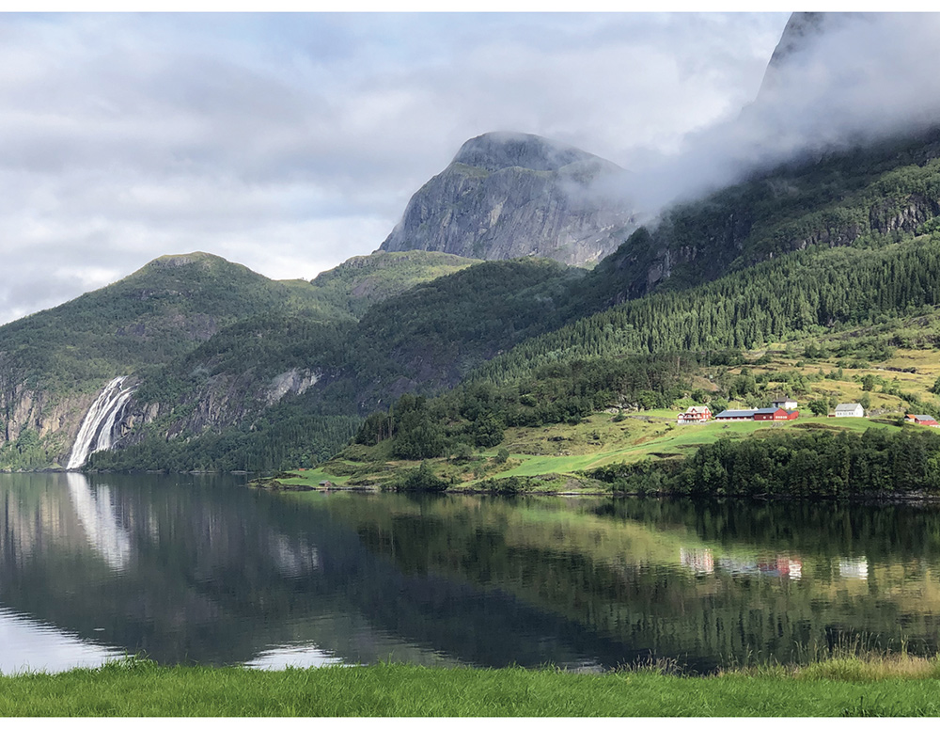
          - Dalsfjorden.
Vestland County Governor’s Office/Maria Knagenhjelm
            - Status of areas recommended for inclusion in the marine protection plan in 2004.
03J1xx2
County | Area | Status
 | North Sea–Skagerrak
Viken | Rauerfjorden (Østfold) | Ongoing protection process (coral reef already protected under fisheries legislation)
Agder | Skagerrak transect | Protected in 2016 as part of Raet National Park
Agder | Framvaren | Protected in 2013
Rogaland | Jærkysten | Protected in 2016
Vestland | Ytre Hardangerfjorden | Ongoing protection process
 | Lurefjorden and Lindåsosane | Protected in 2020
 | Krossfjorden | Ongoing protection process
Vestland | Sognefjorden | Not started
 | Dalsfjorden | Ongoing protection process
 | Norwegian Sea
 | Stad | Ongoing protection process
Møre og Romsdal | Giske | Ongoing protection process
 | Griphølen | Ongoing protection process
 | Remman archipelago | Ongoing protection process, part designated as a nature reserve
Trøndelag | Gaulosen | Protected in 2016
 | Rødberget | Protected in 2016
 | Froan archipelago and Sula reef | Not started, Sula reef protected under fisheries legislation
 | Kråkvåg and Bjugnfjorden | Ongoing protection process
Trøndelag | Tauterryggen | Protected in 2013
 | Børgin | Ongoing protection process
 | Skarnsundet | Protected in 2020
 | Borgan–Frelsøy | Protection process initiated
Nordland | Saltstraumen | Protected in 2013
 | Innervisten | Protected in 2020
 | Nordfjorden (Rødøy municipality) | Protected in 2020
 | Karlsøyvær | Protected in 2020
 | Kaldvågfjorden and Innhavet | Protected in 2020
 | Tysfjorden | Not started
 | Barents Sea–Lofoten area
Nordland/Troms og Finnmark | Andfjorden transect | Ongoing protection process
Troms og Finnmark | Rossfjordstraumen | Protected in 2020
 | Rystraumen | Protected in 2020
 | Ytre Karlsøy | Protected in 2020
Troms og Finnmark | Lopphavet | Ongoing protection process
 | Indre Porsangerfjord | Not started
 | Tanafjorden transect | Not started
Outside territorial waters | Iverryggen reef  Røstrevet reef | Protected under fisheries legislation  Protected under fisheries legislation

Norwegian Environment Agency/Ministry of Climate and Environment
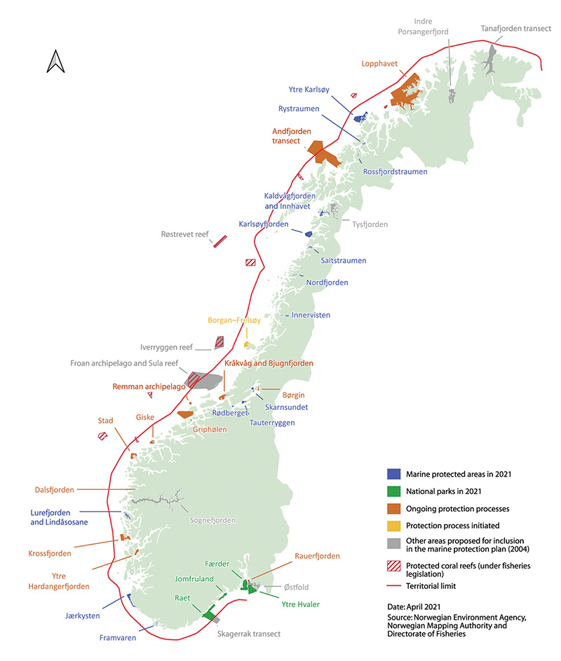
          - Map of existing and planned marine protected areas.
Norwegian Environment Agency, Norwegian Mapping Authority and Directorate of Fisheries
Progress in implementing marine protection in Norway
As mentioned before, 15 MPAs have so far been established under the Nature Diversity Act. These are situated along much of the mainland coast of Norway, with three MPAs in Troms og Finnmark county, four in Nordland, four in Trøndelag, one in Vestland, one in Rogaland and one in Agder. However, more MPAs are needed to supplement the list and provide a representative selection of habitat types in coastal waters. In addition, the current MPAs provide little coverage of areas further from the coast.
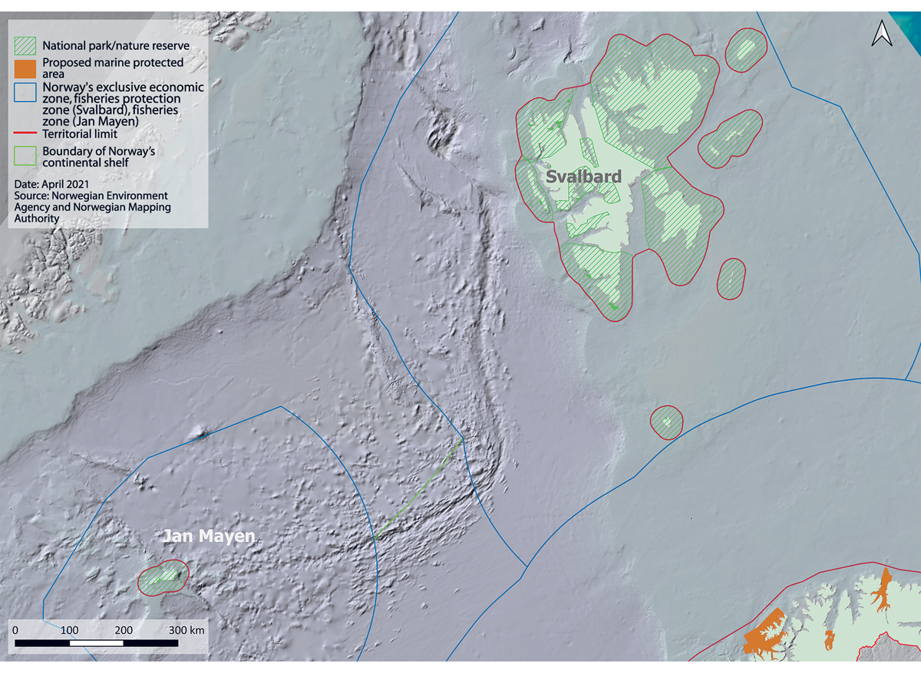
          - Protected areas in and around Svalbard and Jan Mayen.
Norwegian Environment Agency
Several national parks also include marine areas, including Ytre Hvaler national park in Viken county, Færder national park in Vestfold og Telemark, and Raet national park in Agder. Protection of the marine environment is an important part of the purpose of protecting these areas. In all, areas protected under the Nature Diversity Act cover about 3.6 % of the territorial waters around mainland Norway.
About 87 % of the territorial waters surrounding Svalbard are included in areas that are protected under the Svalbard Environmental Protection Act. The Jan Mayen nature reserve includes the territorial waters around the island. The territorial waters around Bouvet Island are protected under the Act relating to the Norwegian dependencies.
In total, areas protected under environmental legislation cover about 4.2 % of Norwegian waters.

Future conservation efforts, particularly for areas beyond the 12 nautical mile limit
There is growing recognition that there are areas of importance for marine biodiversity in all parts of the oceans. As explained in Chapter 1, the conservation of areas of importance for marine biodiversity is an integral part of a sustainable ocean economy.

Knowledge about and identification of important areas
There is a generally sound knowledge base for assessing species and habitats and areas of particular conservation value in Norway’s coastal waters, as discussed for example in Chapter 2. This knowledge base was used to identify the coastal areas proposed as MPAs in the 2004 marine protection plan. It has also been important for the establishment of other area-based conservation measures within the territorial limit, for example no-take zones for lobster and reference areas for kelp forest. In addition, when more candidate MPAs are proposed for coastal areas in the future, this knowledge will be a sound basis for adopting clearly targeted, effective conservation measures.
For areas further from the coast, the level of knowledge on areas that are particularly important for biodiversity and ecosystem services is more variable and there is often less detailed information. Assessments of knowledge and information that can be used to identify areas of importance for marine biodiversity are generally carried out in connection with Norway’s ocean management plans. This applies especially to the identification of particularly valuable and vulnerable areas, which involves a thorough scientific process involving all relevant research institutes and government agencies. The existing system of particularly valuable and vulnerable areas covers 42 % of Norwegian waters.
As explained in the ocean management plans, the designation of areas as particularly valuable and vulnerable does not have any direct effect in the form of restrictions on commercial activities, but indicates how important it is to show special caution in these areas, and to ensure that activities are carried out in a way that does not threaten their ecological functioning or biodiversity. To protect valuable species and habitats, it is for example possible to use current legislation to introduce special requirements for activities in such areas. Such requirements may apply to the whole of a particularly valuable and vulnerable area or part of it, and must be considered on a case-by-case basis.
The current set of particularly valuable and vulnerable areas is being reviewed and updated on the basis of new knowledge. The review is to be completed early in 2022 and will be used in the preparation of the next white paper on the ocean management plans, to be published in 2024. The review of the particularly valuable and vulnerable areas will also provide a good basis for developing a more systematic approach to assessing how various measures contribute to the effective conservation of areas of importance for biodiversity in Norwegian waters. There are also large ocean areas that are afforded effective protection through measures under sectoral legislation, based on knowledge of biodiversity built up through long-term, extensive marine scientific research.

Marine protection
The Nature Diversity Act generally applies out to the territorial limit, except for certain provisions, including those on general principles, which also apply to Norway’s 200 nautical mile economic zone and on the continental shelf to the extent they are appropriate. This means that the authorities must for example base their decisions on scientific knowledge and the cumulative environmental effects on ecosystems. The precautionary principle also applies to waters beyond the 12 nautical mile limit. The provisions of the Nature Diversity Act on marine protected areas do not apply beyond 12 nautical miles. On the other hand, sectoral legislation such as the Marine Resources Act provides the authority for various types of area-based conservation measures, which make an important contribution to the conservation and sustainable use of ocean areas. The same applies to conditions set for oil and gas activities under the petroleum legislation.
In areas inside the territorial limit where there are distinctive and rare species and habitats, it has been decided that it is necessary to be able to provide protection across sectors, so that the activities that can be permitted in an area are determined by its conservation value. If an area is used for several different types of activities, it is useful to introduce measures that take into account the cumulative effects of all the activities on the marine environment. The establishment of protected areas is based on their conservation value, not a specific activity, in order to maintain species and habitats in the long term, and regardless of whether or not an area is currently under pressure.
Norway’s system of ocean management plans provides an overview of environmental pressures and impacts and of regulatory measures. In the white paper Norway’s integrated ocean management plans for the Barents Sea–Lofoten area; the Norwegian Sea; and the North Sea and Skagerrak (Meld. St. 20 (2019–2020)), the Government called attention to the need to consider marine protection and other area-based conservation measures for distinctive and rare species and habitats in deep-sea areas.
The Institute of Marine Research has recently published an expert evaluation of work on marine protection in Norway. This identified a need to protect coral reef areas against other activities in addition to fisheries. In the report, the Institute also mentions the importance of protecting transects stretching from the coast to deep-water areas. Raet national park is an example of a protected area that is delimited by the territorial limit, even though important species and habitats and the need for protection extend further out from the coast. The 2004 marine protection plan includes the Froan archipelago/Sula reef area and the Andfjorden transect, which are other examples of where of conservation value that extend further out to sea than the 12 nautical mile limit.
According to the legislative history of the Nature Diversity Act (Proposition No. 52 (2008–2009) to the Storting), an assessment of the relationship of certain provisions of the Act to international law revealed that amendments and adjustments would be needed if they were to be made applicable beyond 12 nautical miles from the baselines. It would also be necessary to make a thorough evaluation of the relationship of these provisions to sectoral legislation and of the social and environmental consequences of making them applicable to Norway’s continental shelf and areas of jurisdiction established outside the territorial limit. The Government stated that it would therefore make a thorough assessment of whether and how other provisions of the Nature Diversity Act should be made applicable beyond the 12-nautical-mile limit. This assessment has not yet been carried out.
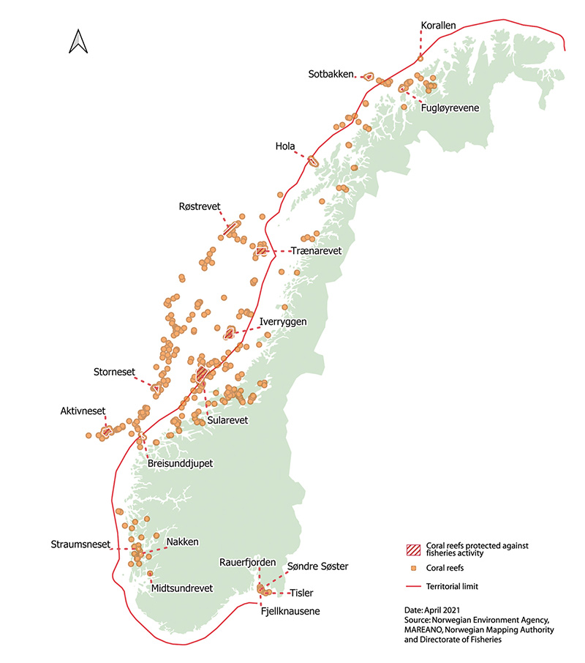
          - Protection of coral reefs against damage from fisheries activities.
Norwegian Environment Agency, Norwegian Mapping Authority and Directorate of Fisheries

Other effective area-based conservation measures
Other effective area-based conservation measures (OECMs) are measures under sectoral legislation that make an important contribution to the conservation of areas of importance for marine biodiversity. OECMs must be managed to deliver sustained positive outcomes for the conservation of biodiversity in an area. OECMs may be established both within and beyond the 12 nautical mile limit.
In the white paper on Norway’s national biodiversity action plan (Meld. St. 14 (2014–2015)), the Government stated that not only protected areas under the Nature Diversity Act, but also conservation measures under other legislation, may be identified as ‘other effective area-based conservation measures’ as mentioned in Aichi target 11. To be designated as OECMs, measures must provide a sustained and effective contribution to the conservation of geographically delineated areas that support valuable biodiversity. In 2018, the parties to the Convention on Biological Diversity (CBD) adopted voluntary guidance on OECMs, including criteria for the types of area-based regulatory measures that can be identified as OECMs. The criteria are divided into the following categories:
A. The areas is not currently recognised or reported as a marine protected area (MPA).
B. The area is governed and managed by the competent authorities and its boundaries are geographically delineated.
C. Regulation achieves sustained and effective contribution to in situ conservation of biodiversity in the area.
D. Associated ecosystem functions and services and cultural, spiritual, socio-economic and other locally relevant values are supported and upheld.
As mentioned in Chapter 3, the parties must take action to achieve Aichi target 11, especially for ‘areas of particular importance for biodiversity and ecosystem services’. In other words, the use of OECMs should focus particularly on areas of the marine environment that are considered to be most important. These include communities including rare or threatened species, representative natural ecosystems, species with a limited distribution, key biodiversity areas, areas that support critical ecosystem functions and services, and areas of importance for ecological coherence. It is also important to consider areas where the environment is undisturbed, particularly on the seabed, even though we often lack detailed knowledge about such areas.
Norway has not yet developed a systematic approach to identifying measures in the fisheries sector and other sectors, such as the petroleum sector, that can be defined as OECMs. A systematic approach will be needed to assess the overall effect of conservation measures on areas of importance for biodiversity in Norwegian waters. This will become increasingly important with the anticipated expansion of activities in Norway’s ocean areas, for example the development of offshore wind power and mineral extraction from the seabed in deep-water areas on the Norwegian continental shelf.
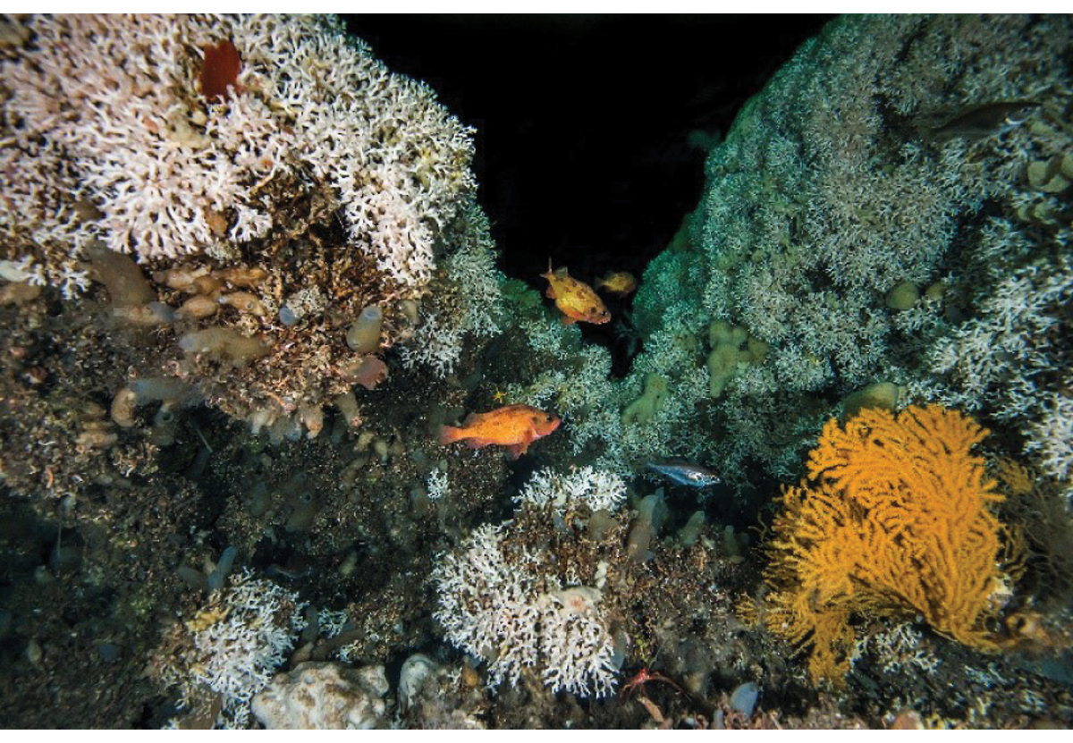
          - Part of a coral reef. Norwegian coral reefs are largely formed by the cold-water coral Lophelia pertusa. Coral reefs are biodiversity hotspots that provide a habitat for many other species, and play an important role in the carbon cycle on the seabed.
Erling Svensen/Institute of Marine Research
Protection of coral reefs under fisheries legislation
Eighteen cold-water coral reef areas along the coast have been designated as marine protected areas under the Marine Resources Act. This makes an important contribution to the conservation of the marine environment. The 18 areas are shown on the map in Figure 1.4:
- Korallen
- Fugløyrevene
- Sotbakken
- Hola
- Røstrevet
- Trænarevet
- Iverryggen
- Sularevet
- Breisunddjupet
- Storneset
- Aktivneset
- Straumsneset
- Nakken
- Midtsundrevet
- Tisler (in Ytre Hvaler nastional park)
- Fjellknausane
- Rauerfjorden
- Søndre Søster
The Froan archipelago/Sula reef area and the Iverryggen reef
When it considered the white paper Update of the integrated management plan for the Norwegian Sea (Meld. St. 35 (2016–2017)), the Storting (Norwegian parliament) asked the Government not to initiate new petroleum activities, including exploration and seismic surveys, in the Froan archipelago/Sula reef area and the Iverryggen reef area until an overall marine protection plan for all Norwegian sea areas was presented to the Storting. This decision was retained as part of the framework for petroleum activities in the Barents Sea–Lofoten area in the white paper Norway’s integrated ocean management plans for the Barents Sea–Lofoten area; the Norwegian Sea; and the North Sea and Skagerrak (Meld. St. 20 (2019–2020)).
There is no new knowledge to indicate that this decision should be reassessed in connection with the present white paper. As mentioned earlier, all the particularly valuable and vulnerable areas are being reviewed as part of the work on Norway’s ocean management plans. The Government will therefore retain the decision not to initiate new petroleum activities in the Froan archipelago/Sula reef area and the Iverryggen reef area until the next white paper on the ocean management plans, which is scheduled for 2024.
Other measures in the fisheries sector
In addition to measures to protect coral reefs, other conservation measures under fisheries legislation may be recognised as effective area-based conservation measures. Regulatory measures that prohibit or limit the use of fisheries gear may make an important contribution to the conservation of biodiversity, particularly on the seabed. Prohibiting trawling in areas that are important for marine biodiversity can for example have a positive effect by reducing disturbance to benthic habitats.
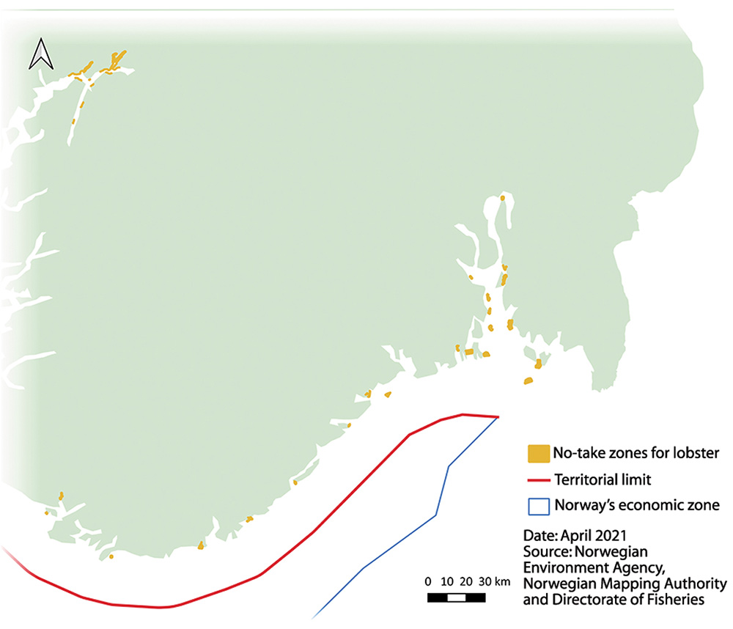
          - No-take zones for lobster along the Skagerrak coast.
Norwegian Environment Agency, Norwegian Mapping Authority and Directorate of Fisheries
During the preparation of this white paper, the Norwegian Environment Agency and the Directorate of Fisheries, with support from the Institute of Marine Research, have made an initial evaluation of the extent to which other relevant measures under fisheries legislation can be recognised as OECMs. In addition to measures to protect coral reefs, these include no-take zones for lobster, regulatory measures for kelp trawling and the closure of areas around Svalbard to fisheries.
No-take zones for lobster. The establishment of no-take zones is a suitable approach for a relatively stationary species like the lobster, and has been shown to boost lobster numbers locally. A number of no-take zones have been established along the Skagerrak coast, and lobster numbers have risen both within these zones and in surrounding waters. No-take zones have had positive effects for cod and wrasses as well as lobsters. A number of the no-take zones have now been made permanent.
Reference areas for kelp. Regulations on kelp harvesting specify a five-year rotation system for harvesting areas, which are divided into strips with a breadth of one nautical mile. Within the harvesting areas, there are reference areas where harvesting is prohibited and kelp forests remain undisturbed.
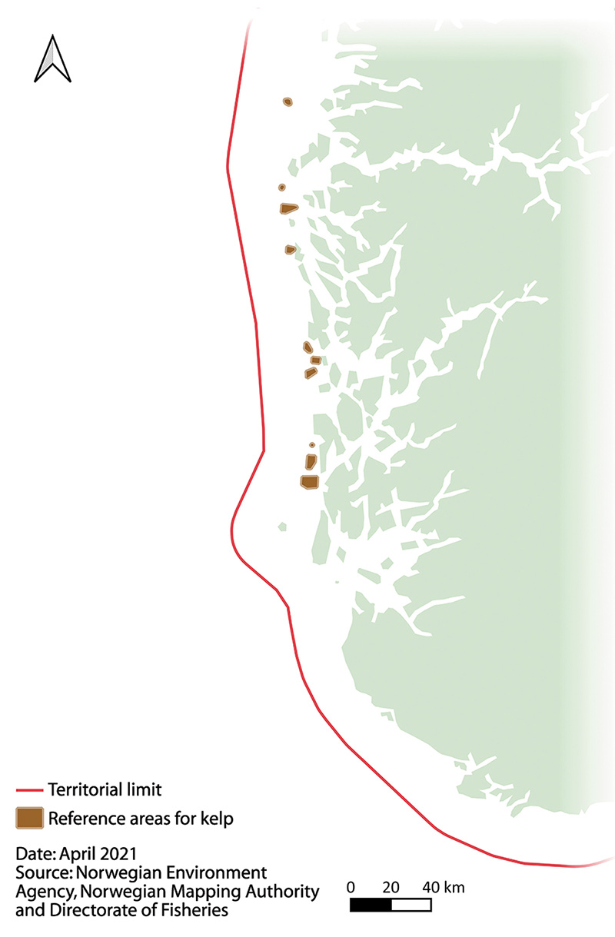
          - Reference areas for kelp.
Norwegian Environment Agency, Norwegian Mapping Authority and Directorate of Fisheries
Areas around Svalbard that are closed to bottom fisheries. Section 5 of the Regulations relating to regulatory measures for fishing to protect vulnerable marine ecosystems prohibits fishing with bottom gear in ten selected areas. The basis for these closures is that the information available indicates that there are vulnerable species and habitats in the areas in question. In addition, they have not previously been fished, or only to a limited extent. The areas closed under section 5 of the regulations are a parallel to the restrictions on fishing activities in coral reef areas described above.
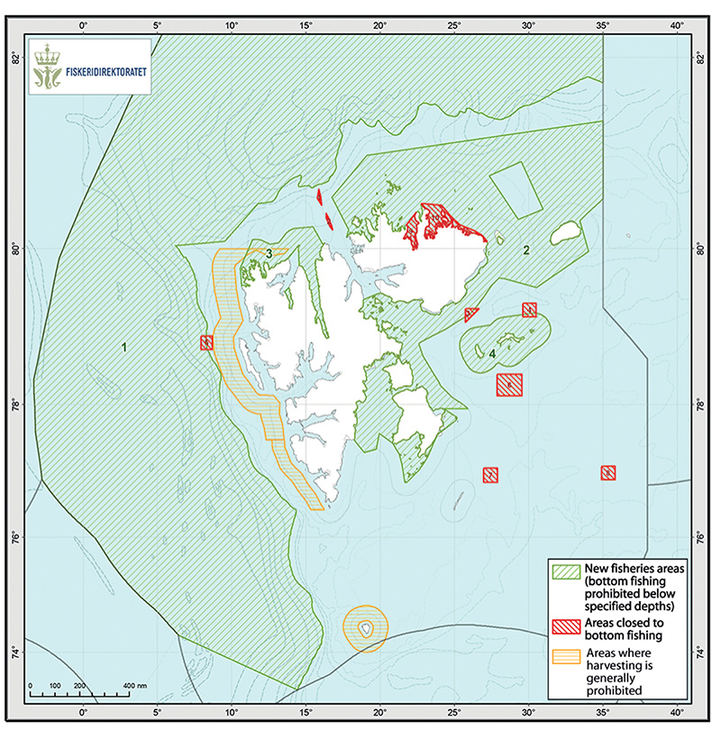
          - Map showing different categories of areas around Svalbard where fishing is restricted or prohibited.
Directorate of Fisheries
Areas where fishing using bottom gear is prohibited below certain depths in order to protect vulnerable marine ecosystems. South of Bjørnøya, fishing is prohibited at depths of more than 1000 metres. North of Bjørnøya, the limit is 800 metres, with one important exception, a large shallow area known as the Yermak Plateau north of the island of Spitsbergen, where the limit is only 300 metres. These areas are generally closed to fisheries, but it is possible to apply for permits for exploratory fishing, which will only be granted subject to strict conditions. In their evaluation of fisheries measures, the Norwegian Environment Agency and the Directorate of Fisheries concluded that this measure in itself makes an effective contribution to the conservation of marine biodiversity. In its evaluation of work on marine protection in Norway, the Institute of Marine Research concluded that area-based measures that prohibit or restrict the use of trawling gear can make an important contribution to the conservation of biodiversity, and that areas where bottom trawling is prohibited could therefore generally be recognised as OECMs if there are no other significant threats from human activity. The Institute also pointed out that benthic communities play an important role in the entire ecosystem, but have in many areas been depleted, for instance by prolonged, frequent bottom trawling. Soft sediments that remain undisturbed also make an important contribution to carbon sequestration, which is important in the context of climate change.
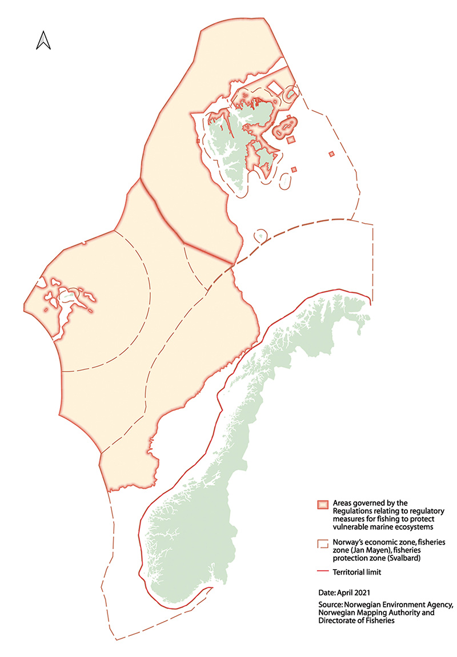
          - Areas deeper than 1000 metres where fishing with bottom gear is prohibited (the limit is 800 metres from Bjørnøya and northwards).
Norwegian Environment Agency, Norwegian Mapping Authority and Directorate of Fisheries
Other measures that have been assessed for inclusion as OECMs are the prohibition on harvesting of European flat oysters in parts of Sørlandsleia (sheltered waters between the mainland and islands and skerries near Arendal), and the general prohibition on harvesting in specified areas in the fisheries protection zone around Svalbard.
The preliminary conclusion is that the measures discussed above meet several of the criteria for recognition as ‘other effective area-based conservation measures’. In all, these measures apply to 44 % of Norwegian waters. If all the area-based fisheries measures are recognised as OECMs, this would increase the proportion of Norway’s waters covered by marine protection or OECMs to about 49 %.
Measures in other sectors
A systematic approach to identifying measures that can be considered as OECMs must also include the conservation effect of measures in sectors other than the fisheries. One obvious example is the framework for petroleum activities in specific geographical areas set out in the ocean management plans, which includes areas where petroleum activities are restricted. For example, licences for petroleum activities will not be issued for areas where the management plans specify that there are to be no petroleum activities. Nor will petroleum activities be permitted at times of year when a decision has been taken not to permit exploration drilling. The framework for petroleum activities includes restrictions of these kinds covering about 11 % of the area covered by the management plan for the Barents Sea–Lofoten area, about 12 % of the Norwegian Sea management plan area, and about 2 % of the North Sea–Skagerrak management plan area.
Similarly, areas subject to measures included in the framework for other types of activities, such as offshore wind power, could be candidates for inclusion as OECMs in the future.
The need for further work
The initial evaluation of fisheries measures by the Directorate of Fisheries and the Norwegian Environment Agency is a good starting point for a more systematic approach to identifying the sectoral measures that can be recognised as OECMs. Relevant conservation measures need to be further assessed. This work should include assessments of the components of marine biodiversity for which areas are important and overall evaluations of pressures and impacts on biodiversity from different activities.
The Institute of Marine Research has pointed out that several types of activity that are now restricted to coastal waters may be expanded further offshore in the future. Further, regulating only one of several activities causing environmental pressures in an area will not necessarily be sufficient to satisfy the criteria for identifying the area as an OECM. According to the Institute, this means that in areas where there are also significant pressures from human activities (for example petroleum activities, aquaculture, defence activities, seabed mineral extraction or substantial pressure from other types of fisheries), area-based measures that only involve a prohibition on bottom trawling may not be sufficient to provide effective protection of biodiversity.
In order to determine which fisheries measures can be recognised as OECMs, overall assessments are needed that also include activities in other sectors and how they are regulated. Among other things, this is necessary to ensure that the effects of conservation measures in one sector are not cancelled out by activities in other sectors. In some cases, measures in different sectors may amplify each other’s effects.

Reporting on progress towards international conservation targets in the future
Now that Norway has given its support to the Ocean Panel’s global target of protecting 30 % of the oceans by 2030 through marine protected areas and other effective area-based conservation measures, and the same target has been proposed for the post-2020 global biodiversity framework under the CBD, it is natural to reassess Norwegian routines for reporting on progress towards targets. Norway has until now provided status reports in line with the guidelines set out in the white paper on Norway’s national biodiversity action plan (Meld. St. 14 (2015–2016)) and further guidelines adopted by the Storting during consideration of the white paper. The Standing Committee on Energy and the Environment concluded that only measures that make a sustained contribution to conservation, such as protection under the Nature Diversity Act and protection of marine areas under other legislation, together with protection under the Svalbard Environmental Protection Act, that can be included in reporting on progress towards Aichi target 11. Marine areas protected under the Nature Diversity Act, the Svalbard Environmental Protection Act and the Act relating to the Norwegian dependencies make up about 4.2 % of Norwegian waters around mainland Norway, Svalbard, Jan Mayen and Bouvet Island. If coral reef areas designated as marine protected areas under the Marine Resources Act are included, this rises to about 4.5 %.
Compared with other countries, Norway has so far taken a relatively restrictive approach to reporting on its contributions to achieving international conservation targets. It is particularly natural to adjust the current reporting routines by considering how more OECMs, for example in the fisheries sector, can be included in the figures when Norway reports to the CBD. At the same time, the fundamental standards for the substance and quality of conservation measures in the areas that are included in reports must be maintained. In adjusting the routines, there will be a special emphasis on areas of particular importance for biodiversity and ecosystem services and on whether conservation measures protect their value effectively.
Integrated, sustainable ocean management involves a combination of marine protection, OECMs and measures to ensure value creation through sustainable use. This was emphasised by the Ocean Panel, which based its commitment to sustainable management 100 % of the ocean area under national jurisdiction on the conclusion that both conservation and sustainable use are essential components of a sustainable ocean economy. To follow up the commitment by the Ocean Panel, it may be appropriate to develop a separate reporting system to show whether countries are meeting the 100 % target for sustainable ocean management.

Measures for the conservation of areas of importance for marine biodiversity
In this white paper, the Norwegian Government presents its integrated national plan for the conservation of areas of importance for marine biodiversity. The plan will ensure that conservation measures described are targeted and effective. It builds on the conservation policy set out in the white paper Nature for life – Norway’s national biodiversity action plan (Meld. St. 14 (2014–2015)). The conservation of areas of importance for marine biodiversity will influence the provision of marine ecosystem services such as biological production, maintenance of the basis for harvesting and value creation, and how resilient ecosystem services are to the impacts of climate change.
One of the basic principles of the Government’s ocean policy is to promote conservation and sustainable use of marine ecosystems, as set out in the white paper Norway’s integrated ocean management plans for the Barents Sea–Lofoten area; the Norwegian Sea; and the North Sea and Skagerrak (Meld. St. 20 (2019–2020)). Sustainable use refers to measures and methods that minimise the impact of activities and avoid or limit damage to biodiversity and ecosystems. Conservation measures give priority to nature and involve some form of protection of geographically delimited areas that support valuable biodiversity.
Norway’s integrated plan for the conservation of areas of importance for marine biodiversity will play an important role in the further development of Norway’s integrated, sustainable ocean management regime.

Implementation of Norway’s 2004 marine protection plan
Marine protection under the Nature Diversity Act is intended to safeguard a selection of representative, distinctive and threatened underwater habitats, species, communities and landscapes along the coast and in territorial waters for the future. The objective is for these areas, together with areas that are safeguarded under other legislation, to form a network of marine protected areas (MPAs) that will safeguard ecosystems, habitats and species. Together, these areas should cover the full range of variation in marine nature in Norway.
Implementation of the marine protection plan from 2004 will be continued. Of the 36 possible MPAs in the 2004 plan, 16 have so far been protected under the Nature Diversity Act and three under the Marine Resources Act. Some of the remaining areas cannot be protected under the Nature Diversity Act, because they are outside the territorial limit and therefore outside the geographical scope of the Act. In order to protect a representative selection of habitat types in Norwegian waters, it will also be necessary add supplementary areas to the 2004 list.
It is important to ensure broad local participation at an early stage in protection processes under the Nature Diversity Act, for example by using local reference groups or holding workshops. It is also important to ensure that all relevant sectors are involved. All proposals for protection under the Nature Diversity Act or other legislation must be reviewed in accordance with Norway’s official instructions for planning and management of central government programmes and projects. This means among other things that different alternatives must be assessed and that both positive and negative impacts of a proposal must be assessed. It is important to aim for transparency in such processes and to ensure access to information for interested parties.
The Government will:
- seek to initiate protection processes for the remaining areas included in the 2004 marine protection plan by 2024, based on current knowledge about their conservation value and relevant activity in the areas;
- ensure that sectoral authorities, counties, municipalities and other local stakeholders are involved in these processes;
- initiate a process linked to the system of integrated ocean management plans to assess how supplementary areas can be added to the 2004 marine protection plan.

Conservation measures outside the 12 nautical mile territorial limit
There are areas of considerable conservation value outside Norway’s territorial limit as well. In the white paper on all three integrated ocean management plans (Meld. St. 20 (2019–2020)), the Government announced that it would assess the need to protect distinctive and rare species and habitats in deep-sea areas.
At present, steps to safeguard marine areas outside the territorial limit are taken under legislation for specific sectors and according to the general principles set out in the Nature Diversity Act. This is further discussed in Chapter 3. Norway’s environmental legislation does not currently provide the legal authority to establish marine protected areas or other conservation measures outside the territorial limit, and activities in such areas are instead regulated under the Marine Resources Act, the Petroleum Act, the Seabed Mineral Act, the Pollution Control Act and other legislation. Both existing and emerging industries are making increasing use of ocean areas. When the Nature Diversity Act was adopted, the Storting (Norwegian parliament) agreed that the Government would undertake a review of whether the geographical scope of the Act should in future be extended to include waters and the continental shelf outside the territorial limit.
The scope of the review should also include whether and how the current legislation could be improved.
The Government will:
- review whether and how the current legislation on conservation measures outside the 12 nautical mile limit can be improved.

Effective conservation through area-based measures under sectoral legislation
Legislation for a specific sector can be used to protect marine biodiversity against damage caused by activities in the relevant sector. Together with protected areas under the Nature Diversity Act, various area-based measures under sectoral legislation therefore make an important contribution to the protection of marine areas that support valuable biodiversity. For example, 18 cold-water coral reefs along the coast have been given protection against damage from fisheries activities under the Marine Resources Act. However, Norway has not adopted a systematic approach to evaluating the effectiveness of conservation measures under legislation for different sectors.
Such evaluations must be based on knowledge of the biodiversity that is to be protected by a conservation measure. There is a generally sound knowledge base for Norway’s coastal waters, including information on species and habitats and where there are areas of conservation value. For areas further from the coast, the level of knowledge is more variable and there is often less detailed information. Assessments of current knowledge are generally made during the process of identifying particularly valuable and vulnerable areas in the management plan areas. However, there are also large ocean areas that are afforded effective protection through measures under sectoral legislation, based on knowledge of biodiversity built up through long-term, extensive marine scientific research.
The Directorate of Fisheries and the Norwegian Environment Agency have recently evaluated the geographical extent of relevant fisheries measures and their importance in conservation terms. For more information, see Chapter 4. The Government will use this evaluation and work on the particularly valuable and vulnerable areas as a basis for a systematic review of the contribution of how sectoral area-based measures contribute to effective conservation. The review will also consider whether conservation measures in one sector are consistent with the framework for activities in other sectors.
The Government will:
- establish a more systematic approach to the conservation of areas of importance for marine biodiversity through the use of marine protected areas under the Nature Diversity Act and other effective area-based conservation measures (OECMs). A review of such measures will focus especially on the particularly valuable and vulnerable areas that have been identified and will also include areas covered by the most relevant conservation measures under sectoral legislation.

Reporting by Norway on progress towards international conservation targets
As Norway adopts new and more ambitious targets for the protection of areas of importance for marine biodiversity, it is natural to reassess Norwegian routines for reporting on progress.
Compared with other countries, Norway has so far taken a relatively restrictive approach to reporting on its contributions to achieving international conservation targets.
The Government will assess how other effective area-based conservation measures, for example in the fisheries sector, can be included in the figures when Norway reports to the Convention on Biological Diversity (CBD) on the percentage of its coastal and marine areas covered by conservation measures. At the same time, the fundamental standards for the substance and quality of conservation measures in the areas that are included in reports must be maintained. The assessment will put special emphasis on areas of particular importance for biodiversity and ecosystem services and on whether conservation measures protect their value effectively.
The Government will:
- start a review and assessment of Norway’s approach to reporting on its contributions towards international conservation targets. The lead agencies in this work will be the Norwegian Environment Agency and the Directorate of Fisheries, with assistance from the Institute of Marine Research and others.

Marine protected areas and carbon sequestration
Marine protection and ecological restoration are considered to be nature-based solutions to climate change, because of the capacity of various marine ecosystems to absorb and store carbon. An MPA may for example provide protection for marine species or areas of sediment that play an important role in carbon uptake and storage, so that their function as a carbon pool is safeguarded and enhanced. Establishing MPAs and networks of MPAs is also a way of building resilience to climate change in marine ecosystems.
The Government is planning to initiate mapping and review processes to identify areas in coastal waters that are valuable for biodiversity and carbon storage, and that are therefore suitable conservation areas. These processes will be organised by the county governors in cooperation with the municipalities. The purpose is to take action to counteract the loss of marine habitat types of particular value both for biodiversity and for carbon sequestration, such as marine wetlands.
The Nature Diversity Act does not explicitly list climate change considerations as grounds for protection, although climate change may be a relevant factor in considering which areas can be protected under section 39 of the Act. If climate change considerations are part of the reason for considering conservation measures in the marine environment, the process should also include marine wetlands, carbon storage in the littoral zone and saltmarshes, and rich, productive areas, for example where there is also an inflow of freshwater to the sea. Another question is whether the current legislation is adequate, or whether policy instruments or their use will need to be adjusted. The Government will consider these matters further as part of its work on marine protected areas and other conservation measures.
The Government will:
- map marine areas that are important for carbon storage with a view to their conservation;
- review the need for amendments to the legislation so that climate change considerations can be used as independent grounds for conservation measures.

Conservation project to enhance biodiversity and increase biological production
Restoring ecosystems to good environmental status or restoring areas where human activity has caused severe environmental degradation can be an appropriate in approach in marine environments. There are some areas in Norwegian waters, especially near the coast, where ecosystems have been greatly affected by human activity. It has often proved to be possible to restore such marine ecosystems over time, provided that local pressures are reduced or eliminated in all or part of the relevant areas. This allows species to recolonise such areas naturally, while populations can develop a healthy age structure and ecosystem functions can be restored, thus improving ecological quality and building up natural processes and biological production.
As part of its work on conservation measures and nature-based solutions, the Government intends to establish a project involving one or more large marine protected areas in the North Sea–Skagerrak–Oslofjord area, to be selected on the basis of scientific advice. The purpose of the project will be to allow natural restoration of the ecosystem and the basis for harvesting, and at the same time build up knowledge about the effects of such MPAs. Mapping and monitoring of ecological status and research on the effects of conservation measures should be part of the project. The project can be based on scientific work that has been done in recent years, for example relating to the two national parks in the outer Oslofjord, Færder and Ytre Hvaler.
Norwegian institutions have leading expertise on the marine environment. They will be able to further develop knowledge and expertise on ocean management through new, targeted initiatives focusing on area-based conservation and its effects on ecosystems. Such initiatives to improve the marine environment would be expected to have a positive effect on ecosystems and harvesting potential. They would also be important scientific initiatives as part of Norway’s contributions to the UN Decade of Ocean Science for Sustainable Development (2021–2030) and the UN Decade on Ecosystem Restoration (2021–2030).
The Government will:
- As part of its work on conservation measures and nature-based solutions, establish a pilot project linked to one or more of the national parks in the Skagerrak–Oslofjord area to restore ecosystems and build up knowledge of the effects of such initiatives;
- initiate research and analysis of the effects of establishing and managing marine protected areas;
- promote the development of knowledge and technology that can be used in restoring marine ecosystems;
- prepare a synthesis of knowledge about the effects of marine protected areas on ecosystem functioning and the potential for harvesting in surrounding areas.

Economic and administrative consequences
This white paper focuses mainly on the follow-up and further development of policy instruments and measures. It includes proposals for assessments and measures for the further development of conservation efforts as part of Norway’s integrated, ecosystem-based ocean management regime. Conservation measures in Norwegian waters are to be based on the best available knowledge.
Measures announced in this white paper will be funded within the existing budgetary framework. If any additional funding is needed, proposals for priority areas will be put forward in the ordinary budgetary processes. Follow-up of measures in the years to come will depend on economic developments and the budget situation.
The economic and administrative consequences of the measures proposed in the white paper can be predicted with varying degrees of accuracy, but as the proposals are implemented, the consequences for public and private actors will be assessed in the usual way as set out in Norway’s official instructions for planning and management of central government programmes and projects.
The Ministry of Climate and Environment
recommends:
that the Recommendation from the Ministry of the Environment concerning Norway’s integrated plan for the conservation of areas of special importance for marine biodiversity dated 9 April 2021 should be submitted to the Storting.

This terminology largely coincides with that used in the framework of the Convention on Biological Diversity (CBD). However, the way these terms are used may vary somewhat depending on context. Further, note that the term, ‘marine protected area’, is also used in the English translation of the Marine Resources Act, where it refers to areas with defined conservation values that are protected against harmful fisheries activities to which the Act applies. In the following, these areas are referred to as marine protected areas under the Marine Resources Act.
https://www.ipcc.ch/site/assets/uploads/sites/3/2019/11/09_SROCC_Ch05_FINAL.pdf (side 454)
«Blue Carbon – climate adaptation, CO2 uptake and sequestration of carbon in Nordic blue forests – Final report 2017 – 2020» (TemaNord 2020:541)
This is known as ‘marbakke’ in Norwegian, and marks the limit of private ownership rights according to customary law.

