The Ministry of Justice and Public Security

Svalbard

Meld. St. 26 (2023–2024) Report to the Storting (white paper)

The Ministry of Justice and Public Security

Svalbard

Meld. St. 26 (2023–2024) Report to the Storting (white paper)

Recommendation of the Ministry of Justice and Public Security, 31 May 2024,   
approved by the Council of State on the same day.   
(Støre Government)

# Svalbard – the path ahead

## Background for the new Report to the Storting on Svalbard

In order to lay the foundation for stable and predictable governance, the Government regularly presents white papers to the Storting, reviewing all aspects of the administration of Svalbard (Svalbard white papers). The first such comprehensive white paper was presented in 1975. Since then, the white papers have been presented every seven to ten years, with the fifth white paper being presented in 2016.

The Svalbard white papers signal the Government’s objectives and ambitions for the administration of Svalbard, which are anchored in the Storting via its consideration of the white papers. The practical follow-up takes place in the form of the implementation of specific measures and the Government’s continuous work on Svalbard-related matters. The Svalbard policy is composed of various policy domains, all of which are framed within the context of the five overriding Svalbard policy objectives. There is broad political support for these objectives, which were initially expressed in the Storting’s consideration of the 1985 white paper and which have remained a permanent fixture of policy ever since. All activities must be considered within the framework of these objectives.

The five overriding objectives of Svalbard policy are as follows:

* Consistent and firm enforcement of sovereignty
* Proper observance of the Svalbard Treaty and control to ensure compliance with the treaty
* Maintenance of peace and stability in the area
* Preservation of the area’s distinctive natural wilderness
* Maintenance of Norwegian communities on the archipelago

The white papers have contributed to establishing the frameworks for activities on the archipelago and have contributed to a harmonised development within the framework of these five overriding objectives. The objectives remained fixed. Consistent and predictable governance of Svalbard, in line with the objectives, contributes to security for the population and the maintenance of peace and stability in the region.

The developments since the presentation of the previous white paper in 2016 (Report Storting No. 32 (2015–2016) Svalbard) can be summarised as follows: As Longyearbyen has evolved from a coal-mining community to a more modern family community with a differentiated business sector, the composition of the population has changed. More people are residing in Svalbard than ever before. Svalbard is characterised by increased activity, not least in the form of ship-based tourism around the archipelago. There is growing interest in using Svalbard for research purposes, including from the international research community.

Climate change forms an important backdrop for the development and for several of the measures proposed in this white paper. Nowhere on the planet is warming faster than Svalbard, where temperatures are rising five to seven times faster than the global average. This is causing rapid changes in nature and increasing its vulnerability. With a warmer climate, Svalbard’s coastal areas have also become more accessible to cruise ships, fishing vessels and research vessels.

The security policy situation globally and in our immediate surroundings is characterised by greater precariousness and unpredictability compared to when the previous white paper was presented in 2016, and increased geopolitical tension originating outside the High North is now also being felt in our immediate surroundings. In the presentation of Report Storting No. 9 (2022–2023) National control and cyber resilience to safeguard national security, the Government laid out how the security policy situation necessitates forceful measures to safeguard national security throughout the country. The administration of Svalbard has always been associated with strong national interests. This is also reflected in this white paper, while at the same time proposing measures that further strengthen the degree of national control over activities in the archipelago.

In the formulation of Svalbard policy, as in all other policy domains, various considerations and interests must be assessed in context and weighed against one another. In Svalbard, this weighting of considerations and interests is carried out within the framework of the five overriding main objectives. For example, the objective of maintaining Norwegian communities on the archipelago must be met in a manner that is consistent with the objective of preserving the distinctive natural wilderness of the area.

Similarly, other considerations will also have to be weighed against one another. For example, the need for national control must be weighed against the need for value creation and social development. Risk acceptance and ongoing cost-benefit assessments will therefore be important elements in such assessments and in the formulation of Svalbard policy.

As in the previous white papers, this report will also describe objectives, challenges and possible measures for Svalbard and its territorial waters.

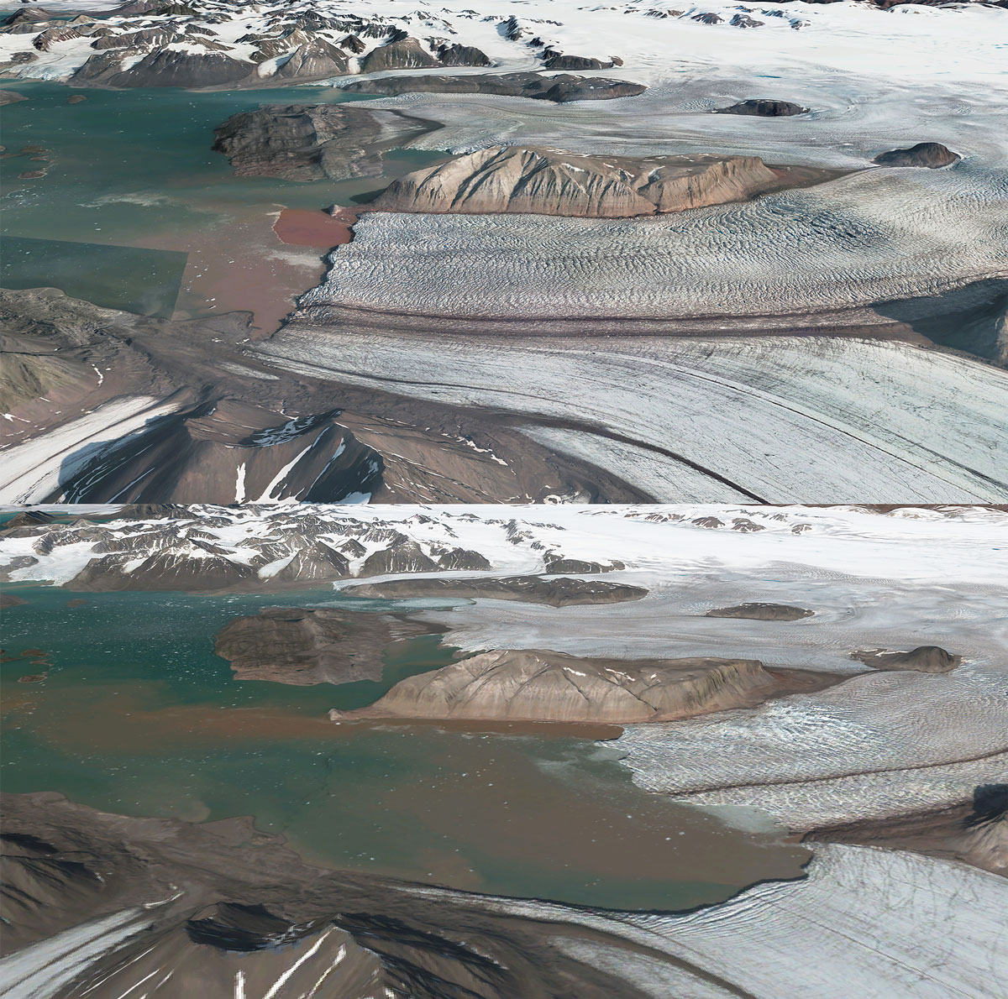

The illustrations show the positions of the glacier fronts in 2009 and 2023, respectively, for the Kongsvegen and Kronebreen glaciers. The glacial retreat spans a distance of approximately 3 km. (3D illustrations based on digital terrain model, aerial images and satellite images).

Illustrations: Norwegian Polar Institute

## The way forward – the Government’s plans for Svalbard

The overriding objective of maintaining Norwegian communities on the archipelago is achieved through the local community in Longyearbyen. When the 2016 white paper was presented, it was clear that coal mining could no longer remain a cornerstone of Longyearbyen, and that the community was facing a necessary transition. Through the Storting’s consideration of this white paper, the continued development of existing activities such as tourism, research and higher education was facilitated, as well as broad and varied commercial activity, preferably involving year-round and stable jobs.

The restructuring of Longyearbyen has been successful in many ways. Today, Longyearbyen is a modern family community with a diverse business sector. In particular, the Longyearbyen-based tourism industry has developed in the direction of increasingly year-round activity. The Government will work to ensure that tourism continues to be a key pillar of the Longyearbyen community. This development shall be based on increased quality, rather than quantity, and in line with the environmental objectives set for the archipelago. Other industries, such as communications, the service industry and construction, also contribute to making Longyearbyen a community with a variety of enterprises. Furthermore, since its establishment in 1993, the University Centre in Svalbard (UNIS) has become an important actor in the development of the Longyearbyen community, and today it represents a significant contribution to the local community. The Government wants UNIS to be the sole provider of higher education in Svalbard. There have also been other valuable additions to Longyearbyen since the presentation of the previous white paper, including Svalbard Folk High School.

While activity in Longyearbyen has become more differentiated, the population has also grown and its composition has changed. There are currently just under 2,600 inhabitants in Longyearbyen, around 930 of whom (i.e. approximately 36 per cent) are foreign nationals from more than 50 different countries. Both services and infrastructure are under pressure.

The Government’s objective is for Longyearbyen to remain a viable family community, thereby contributing to meeting the objective of Norwegian communities on the archipelago. Although the number of children in school and kindergarten has increased in recent years, the average length of residence has somewhat decreased. The Government is concerned with ensuring that Norwegians regard Svalbard as an attractive place to live, and will introduce incentives to facilitate this aim.

Living in Longyearbyen offers access to unique nature and excellent opportunities for outdoor recreational activities. Permanent residents therefore have greater opportunities for travel and hunting than visitors. For example, permanent residents are permitted to drive snowmobiles in a broader range of areas than visitors, as the use of snowmobiles is important both for recreational activities and to be able to travel outside the local communities. It is also important that the inhabitants of Svalbard enjoy broad and diverse access to high-quality culture, as is the case in the rest of the country. A well-functioning cultural life contributes to residential quality and desirability. Longyearbyen-based tourism contributes to this aim.

Facilitating a family community with a diverse business sector is expensive, and the growth in population and activity entails an increase in costs. The Government will continue to facilitate a low tax rate. However, it is not desirable for Longyearbyen to grow beyond its current level, meaning that no development should be facilitated that would result in the need for major investments in infrastructure or expansion of services. Nor should the housing stock be expanded beyond the level prior to the avalanches of 2015 and 2017.

People from various countries have always been drawn to Svalbard, as evidenced by its rich history. Today, this contributes to making Longyearbyen a vibrant and diverse community, where foreign residents contribute valuable activity and labour, while gaining access to certain welfare and other services offered by Longyearbyen. Longyearbyen fulfils the main objective of Norwegian communities on the archipelago, and it is therefore important to strike a good balance between Norwegian and foreign residents. A good balance is also important for national control purposes, and it is important to monitor developments. National control is also one of the considerations underlying the Government’s decision in the spring of 2022 to introduce identity control and control of the movement of goods to and from Svalbard.

The Immigration Act does not apply to Svalbard. Thus, there is a distinction between residents who move directly to Svalbard from abroad and those who have a connection to the mainland, a distinction that, for example, impacts elections to Longyearbyen Community Council. Following amendments to the Regulations relating to Longyearbyen Community Council elections in 2022, persons who are not Norwegian nationals have the right to vote if they have been registered in the National Population Register as residents in a Norwegian municipality for the last three years before they were entered in the Population Register of Svalbard as resident in Longyearbyen.

Furthermore, residents with a connection to the mainland usually have insurance under the National Insurance Scheme, which is continued during their stay in Longyearbyen. Persons who are not insured under the National Insurance Scheme prior to their stay in Longyearbyen can only become insured if they are employed by a Norwegian employer, which entitles this group to full coverage for the duration of their employment.

Currently, the rate of employer’s National Insurance contributions in Svalbard is set to zero. The Government will continue this rate, but will consider whether the rate should be increased for Norwegian employers who employ persons who become insured under the National Insurance Scheme as a result of their employment in Svalbard. The Government will also consider increasing the rate for contributions from this group of employees. Furthermore, the Government is committed to ensuring orderly pay and working conditions for all employees in Longyearbyen, and will, by the end of 2024, present a proposal to make the Act relating to general application of collective agreements (the General Application Act) applicable to Svalbard.

In an Arctic context, Longyearbyen has a well-developed infrastructure. However, there is a significant maintenance backlog. The infrastructure is designed to serve a mining community, not today’s community or the significant number of tourists who have visited Longyearbyen since the early 1990s. A well-functioning infrastructure has been a fundamental prerequisite for the emergence of tourism activity, and thus also an asset. Therefore, the Government will draft legislation to introduce visitor fees for visitors to Longyearbyen. The revenue from the contributions will be earmarked for infrastructure and other public service expenses that are essential for tourism activity in Longyearbyen. Part of the revenue will be allocated to Longyearbyen Community Council.

Electricity and heating are of fundamental importance for the population and business development in Longyearbyen. The vast distances to the mainland underscore the importance of a stable security of supply. Until October 2023, the power supply in Longyearbyen was based on a coal-fired power station from 1983, supplied with coal from Mine 7. Today, power is supplied by diesel generators, although renewable energy is to be phased in as soon as possible.

Longyearbyen Community Council owns and operates the power supply in Longyearbyen, and is responsible for the energy transition. At the same time, the Norwegian company Store Norske is continuously working to develop its activities within the framework of Svalbard policy objectives and the State’s objectives as the owner of the company. The Government’s intention is for the State to take greater responsibility for power supply in Longyearbyen, e.g., through Store Norske, and to clarify responsibility for power supply as soon as possible.

The Government has commissioned Store Norske to carry out a concept study of the various alternatives for future power supply in Longyearbyen and a condition assessment of existing infrastructure.

This work is taking place in dialogue with Longyearbyen Community Council and other local actors. A tripartite collaboration has also been established between the Community Council, Store Norske and the University Centre in Svalbard (UNIS) with the aim of accelerating the development of renewable solutions for power supply in Longyearbyen while also facilitating new knowledge and business development. It is desirable that this collaboration continues and that the efforts relating to energy transition contribute to developing local competence and value-creating activity. Thereby, the transition work can provide valuable synergies for the local community.

As a result of the transition from coal to diesel, energy production costs have increased. In the updated 2023 budget, the Storting increased the allocation to Longyearbyen Community Council by NOK 50 million, based on a proposal from the Government. This increase is intended to contribute to reduced electricity prices in Longyearbyen. In the Revised National Budget for 2024, the Government proposed allocating an additional NOK 125 million for the same purpose, as well as NOK 42 million for investments in infrastructure that strengthen redundancy and security of supply for energy in Longyearbyen.

There have always been strong state interests related to infrastructure in Svalbard. In the white paper, the Government provides instructions for the use of publicly owned infrastructure to contribute to ensuring that it is used for purposes that support the objectives of Svalbard policy. The Government will also review the responsibility for critical infrastructure in Longyearbyen.

Business development is not an objective of Svalbard policy, but it is one of the means of achieving the overall objective of Norwegian communities on the archipelago. The current frameworks for the further development of Longyearbyen entail that the continued development of the business sector cannot occur in the form of increased volume, but rather as increased value creation.

A ban on heavy fuel oil has been introduced for all ships in Svalbard’s territorial waters, and the current Government has also amended environmental legislation to ensure that traffic occurs in line with the frameworks for the high environmental objectives for Svalbard. Among other things, restrictions have been imposed on where tourists are permitted to go ashore within the protected areas, as well as the number of passengers permitted on board ships that call at the protected areas. The Government has also held a public consultation on safety rules during field operations, which aim to make travel in Svalbard safer and more secure. In this white paper, the Government signals further measures to address the trend of increasing traffic on and around the archipelago. The Government will introduce a limit on the number of passengers on board cruise ships sailing in Svalbard’s territorial waters, and will also consider a limit on the number of cruise ships sailing in these waters.

The purpose of these amendments is the consideration for preparedness, as well as protection of the environment and fauna. At the same time, these changes will entail changes to the framework conditions for tourism and other business sectors, while also contributing to the protection of the unique nature on which the tourism industry bases its products. The Government is therefore seeking to ensure that future activities and development take place in line with the framework of the environmental objectives.

For many years, research and higher education have been an important focus in Svalbard. There is considerable interest in research on Svalbard within both Norwegian and international environments. Currently, Svalbard represents a successful platform for high-quality Norwegian and international research and is therefore an important part of national knowledge policy. At the same time, research and education are important components of Svalbard policy and contribute to fulfilling the overriding Svalbard policy objective, such as maintaining Norwegian communities on the archipelago.

As a follow-up to the 2016 white paper, a strategy for research and higher education in Svalbard has been prepared, which describes objectives and ambitions and sets the frameworks and general principles for research and higher education activities in Svalbard. Within the framework of this strategy, a separate research strategy has also been prepared for the Ny-Ålesund Research Station. The strategies are working as intended and will be continued.

In this white paper, the Government will describe the main principles applicable to research in Svalbard, based on the lines that have been drawn in these two strategies. The Government will also strengthen research management in Svalbard by establishing a Svalbard research office run by the Research Council of Norway and the Norwegian Polar Institute. While this will contribute to providing further good assistance to actors interested in conducting research in Svalbard, it will also strengthen national control of research activities.

Research in Svalbard makes very valuable contributions to the overall research frontier. However, research activity, in conjunction with other activities, also contributes to the overall strain on Svalbard’s vulnerable nature and fauna. Therefore, it is necessary to align such activities with the high environmental objectives for Svalbard. The Government will therefore continue the principle that research shall primarily be based in established local communities and research stations. Permits to establish new research stations or other major, permanent research infrastructure outside the land use planning areas should not be expected.

## General information about Svalbard and the local communities

Svalbard has been part of the Kingdom of Norway since the Svalbard Act entered into force on 14 August 1925.

Svalbard is the northernmost part of Norway. The archipelago consists of Spitsbergen, Prins Karls Forland, Nordaustlandet, Kong Karls Land, Barentsøya, Edgeøya, Hopen, Bjørnøya and all islets and skerries within the coordinates 10 and 35° east longitude and 74 and 81° north latitude. With a land area covering 61,022 km2, Svalbard accounts for approximately 16 per cent of the Kingdom of Norway’s total land area. Spitsbergen is the largest island in Norway and is about the size of Nordland and Troms counties, combined.

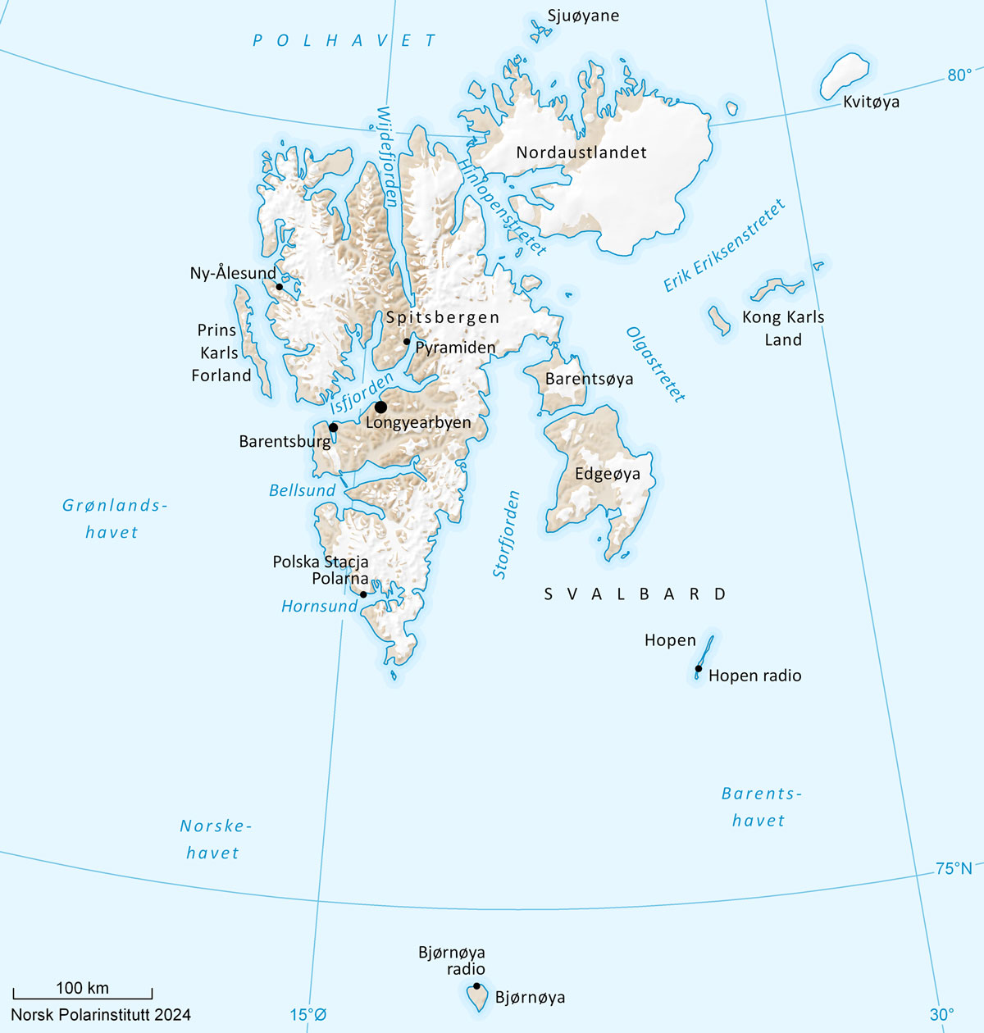

Map of Svalbard.

Map: Anders Skoglund, Norwegian Polar Institute

A contiguous continental shelf extends north from mainland Norway past Svalbard. Svalbard has a high-arctic climate, albeit relatively mild compared to other areas at the same latitude due to the Gulf Stream current. For the same reason, the archipelago has a very rich bird and animal life compared to other High Arctic areas.

Most of Svalbard consists of vast and pristine wilderness areas. Only seven locations are inhabited or have permanent activity or operations. As of 1 January 2024, the population of Svalbard was 2,993. This represents a decrease from 2023, primarily due to a decline in the population in Barentsburg and Pyramiden. Approx. 82 per cent of the population lives in Longyearbyen. There are no roads between the communities in Svalbard. Ny-Ålesund has an airport for short take-off and landing operations with flights to and from Longyearbyen.

Longyearbyen

As the administrative centre and hub for most of the activity on the archipelago, Longyearbyen is the largest community in Svalbard. Administration is discussed in more detail in Chapter 2 and activities are discussed in Chapter 4.

Today, Longyearbyen has a greater variety of enterprises and a different demographic composition in terms of age, gender and country of origin than a few years ago. The population fluctuates throughout the year. However, population growth has been the trend for the past 20 years. See Chapter 4 on community development and business activities in Longyearbyen.

Ny-Ålesund

Ny-Ålesund is the most northerly community in Svalbard and is located approximately 100 km north of Longyearbyen. As of 1 September 2023, there were 44 year-round residents in Ny-Ålesund, 29 of whom are employed by Kings Bay and 7 by the Norwegian Polar Institute.

Ny-Ålesund is a Norwegian research station with facilities for international scientific research collaboration. The Norwegian Polar Institute is in charge of the Ny-Ålesund Research Station and hosts the station. The Norwegian Polar Institute is also responsible for implementing and following up the research strategy for Ny-Ålesund.

Kings Bay AS, which is wholly owned by the Norwegian State, owns the land and most of the buildings. Kings Bay AS is responsible for power supply, water and sewage, harbour, airport, air transport, accommodation and catering, as well as various services to the research institutions. Kings Bay AS rents out accommodation capacity and access to research buildings and laboratories. Research institutions from ten different countries are present in Ny-Ålesund with fixed rental agreements. In addition, there are visiting researchers from all over the world throughout the year. Every year, universities and research institutions from around 20 countries conduct research projects in Ny-Ålesund.

Barentsburg

Barentsburg is located in Grønfjorden. The mining company Trust Arktikugol owns most of the land in the planning area and operates a coal mine at the site. As of January 2024, 354 residents were registered in Barentsburg. Barentsburg and Pyramiden are structured according to a company-town model.

In recent years, tourism and research have been added as new activities in addition to mining. The Russian Academy of Sciences has long had a research centre at the site.

Russia has a consulate general in Barentsburg.

Pyramiden

The former mining town of Pyramiden is located in Billefjorden. The site is operated by Trust Arktikugol, which is also the landowner of the site. Pyramiden was abandoned as a mining town in 1998. Trust Arktikugol has upgraded the site for use in tourism, among other things. A hotel is currently staffed and open during parts of the year. At the start of 2024, 12 people were registered as living in Pyramiden.

Hornsund

Hornsund is a fjord in South Spitsbergen National Park, and in the 1950s a research station was built in Isbjørnhamna on the north side of the fjord. There has been year-round activity at the station since 1978 under the auspices of the Institute of Geophysics of the Polish Academy of Sciences. The number of researchers at the site varies, but there are ten permanent staff members year-round.

Bjørnøya and Hopen

Geographically, Bjørnøya is located almost exactly halfway between the mainland and the southern tip of the island of Spitsbergen. The meteorological station on the island has nine permanent staff members year-round. Hopen is an island approximately 100 km southeast of Edgeøya. The meteorological station on the island has four year-round staff members. Both Bjørnøya and Hopen and their adjacent territorial waters are protected as nature reserves.

Sveagruva

Sveagruva (hereinafter referred to as Svea), located at the innermost part of Van Mijenfjorden, was originally built by the Swedish company AB Spetsbergens Svenska Kolfält in 1917. In 1934, the property and mining facilities were acquired by Store Norske Spitsbergen Kullkompani (Store Norske). In the summer of 2015, the Norwegian State acquired both the land and buildings in Svea from Store Norske.

From 2002 to 2016, the Svea Nord mine, the largest mine in Svalbard, was in regular operation. The plan was to continue operations in Lunckefjell, however, due to low coal prices, operations at Lunckefjell and the rest of the mining facility in Svea were initially suspended. In connection with the Storting’s consideration of the National Budget for 2018, the decision was made to discontinue mining operations at Svea and Lunckefjell, and that the area would be cleaned up for the future.

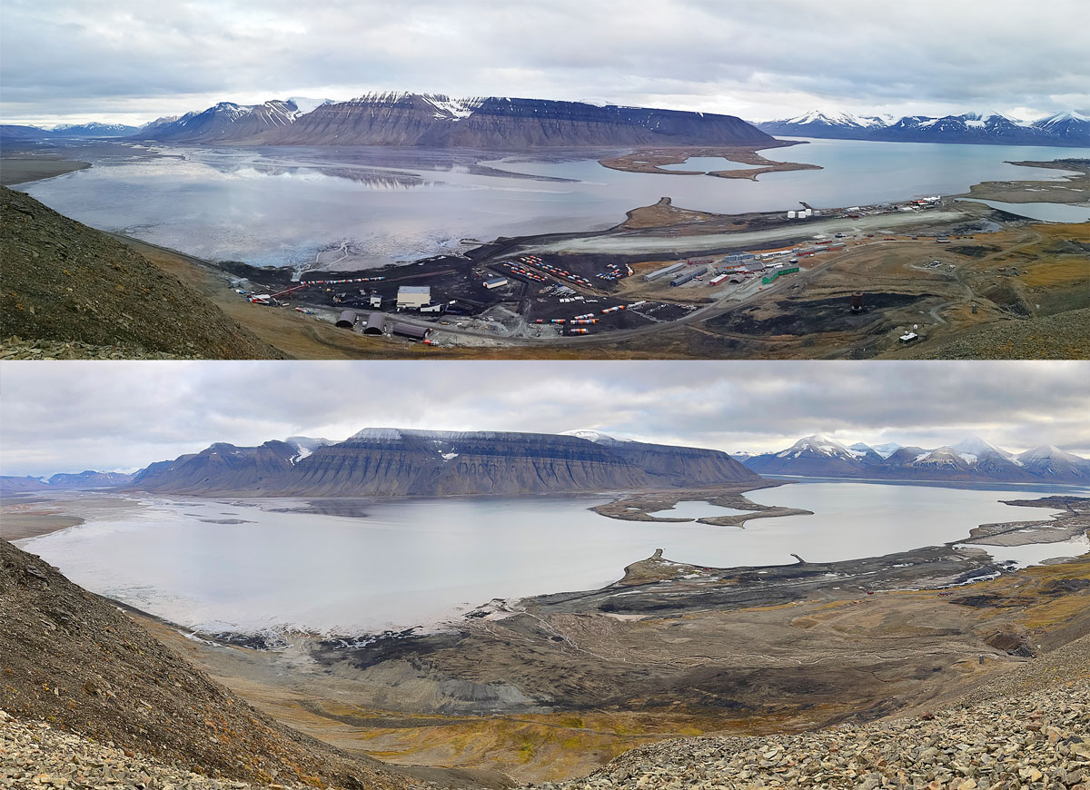

Svea before and after cleanup.

Photo: Store Norske Spitsbergen Kulkompani

The work of cleaning up Svea and Lunckefjell is one of the most ambitious environmental projects in Norway. All infrastructure and waste have been removed, including roads and buildings, with the exception of four protected buildings. Materials are deposited so that the glacier surface and mountainside appear unaffected. The protected buildings owned by the Norwegian State represented by the Ministry of Trade, Industry and Fisheries will be used by UNIS for research and teaching. Store Norske has been the responsible client for the cleanup project. The last part of the project was completed in the autumn of 2023, and the project will be handed over in August 2024.

Hunting stations

Some hunting stations are or have recently been in operation in Svalbard: Akseløya in Van Mijenfjorden, Kapp Wijk in Isfjorden and Farmhamna in Forlandsundet.

# Frameworks and policy instruments

## General information about the use of policy instruments in Svalbard

The frameworks for the administration of Svalbard differ in certain areas from those of the mainland. For example, the Immigration Act does not apply to Svalbard, and no visa or residence permit is required there. This is related to the Svalbard Treaty and the provision stipulating that nationals of contracting parties shall have equal liberty of access to Svalbard. Svalbard is outside the Schengen Area and is otherwise characterised by vast distances, with often challenging weather and climatic conditions. There are no roads connecting the local communities, which in turn are structured and administered differently from communities on the mainland.

The distinctive frameworks are also reflected in the use of policy instruments. In the administration of Svalbard, continuous assessments are made of which measures are necessary to ensure positive social development at all times, in line with the overriding objectives of Svalbard policy. The comprehensive white papers and the Storting’s considerations thereof provide the overall frameworks and instructions for administration, and lay the foundation for a long-term approach and predictability. Another distinctive feature of Svalbard is the special coordination of Svalbard issues in the central government administration via the Interministerial Committee on the Polar Regions.

In Report Storting No. 9 (2022–2023) National control and cyber resilience to safeguard national security, the Government shows how changes to the security policy situation necessitate measures to safeguard national security. The white paper provides a review of the challenges facing Norway as a whole. It also contains a separate section on the Government’s most important policy instruments in the administration of Svalbard.

Maintaining peace and stability is a key objective of Svalbard policy, and there have always been strong national interests related to the management of the archipelago. State ownership of property, companies and infrastructure is key. For example, the State currently owns 98.75 per cent of the land in Svalbard, including all the land in Longyearbyen that is managed by the Svalbard office of the Ministry of Trade, Industry and Fisheries. The State also has direct ownership of the companies Store Norske Spitsbergen Kulkompani AS, Kings Bay AS, Bjørnøen AS and the University Centre in Svalbard, all of which aim to support the overriding objectives of Svalbard policy.

Legislation is a fundamental policy instrument in all administration, including that of Svalbard. Developments in recent years have necessitated new acts and regulations in several domains. Economic policy instruments in the form of tax policy, the presentation of the annual Svalbard budget and the acquisition of e.g., property and housing are examples of other important policy instruments in the administration of Svalbard.

Local administration at various levels is also an important policy instrument. The Governor of Svalbard, the Government’s highest representative on the archipelago, is the chief of police and has the same authority as a county governor. Longyearbyen Community Council manages basic social functions within the Longyearbyen planning area and shall, according to the Svalbard Act, ensure “rational and effective administration of common interests within the framework of Norwegian Svalbard policy”.

## International legal framework

### Norwegian sovereignty

Norway’s sovereignty over Svalbard is undisputed. Sovereignty means that a state has supreme authority within its territory and the exclusive right to exercise authority there, including the right to enact and enforce laws and other regulations. Norway’s sovereignty is confirmed in the Svalbard Treaty and, in accordance with public international law, by the tacit acceptance of the other states. Therefore, all states have a duty to respect Norwegian sovereignty over Svalbard in the same manner as Norwegian sovereignty over other parts of Norwegian territory.

Sovereignty over Svalbard encompasses not only the land territory, but also the territorial waters around the archipelago, i.e., the internal waters and territorial sea extending 12 nautical miles seaward from the baselines, as well as the airspace above.

As a result of its sovereignty, Norway has the exclusive right to exercise authority over all nationals and companies – Norwegian and foreign – throughout its territory. No other states may exercise public authority in Svalbard. Such an exercise would infringe on Norwegian sovereignty.

All private legal entities in Svalbard, both individuals and companies, must comply with Norwegian legislation and administration in the same manner as on the mainland. International agreements to which Norway is a party also apply to Svalbard, unless specific exceptions have been made. Such an exception has, for example, been made for the EEA Agreement. Chapter 2.2.2 discusses the Svalbard Treaty and certain other international agreements of particular significance to Svalbard.

### The Svalbard Treaty

Introduction

The Svalbard Treaty was signed on 9 February 1920 and entered into force on 14 August 1925. From that day on, Svalbard became an indivisible and inalienable part of the Kingdom of Norway via a separate act, the Svalbard Act of 17 July 1925 No. 11 (the Svalbard Act). The Svalbard Treaty is open for accession and currently has more than 40 States Parties.

The Treaty contains a number of provisions on the treatment of nationals and companies from States Parties. Through the Treaty, Norway has assumed a limited international legal obligation to treat nationals and companies from the parties to the treaty equally. This obligation applies within certain domains enumerated in the Treaty. In addition, the Treaty contains provisions on restrictions on taxation and military activity on the archipelago. Since the Treaty is an agreement under international law, only States Parties may demand equal treatment from Norway on behalf of their nationals and companies.

The following is a review of the history of the Svalbard Treaty and a discussion of some of its provisions. A general description of the Svalbard Treaty has also been provided in previous white papers on Svalbard. Reference is made to Report to the Storting (white paper) No. 39 (1974–75), Report to the Storting (white paper) No. 40 (1985–86), Report to the Storting (white paper) No. 9 (1999–2000), Report to the Storting (white paper) No. 22 (2008–2009) and Report Storting (white paper) No. 32 (2015–2016).

One of the key objectives of the Treaty was to achieve a final clarification of all outstanding issues of international law, through the recognition of Norwegian sovereignty. This ensures predictability and clarity, including for other treaty parties.

History of the negotiations

The Svalbard Treaty came about as a result of negotiations during the Paris Peace Conference after the First World War in 1919. The increasingly extensive economic activity in Svalbard in the early 1900s made it necessary to clarify the status of the archipelago. Before the First World War, Norway organised three international conferences (the Kristiania Conferences) to discuss the possibility of establishing international joint governance of the archipelago, with a view to addressing the growing need for regulation and control of coal mining operations. The proposals put forward at the Kristiania Conferences were met with resistance and considered unfeasible. The First World War put an end to further discussions.

Norway then brought the matter into the peace negotiations in 1919, noting that the only “satisfactory and lasting solution would be to return the archipelago to Norway”. At the same time, Norway indicated that it would not object to granting certain rights to foreign nationals.

The matter was included on the conference agenda even though the archipelago had not been affected by military operations during the war. A key reason was the losses Norway had suffered during the war despite its neutrality. A significant part of its merchant fleet was sunk, resulting in considerable loss of life and tonnage, while Norway had secured uninterrupted communication and supply lines by sea throughout the war. The great powers felt they owed Norway a debt of gratitude, while at the same time expressing an understanding for the Norwegian arguments presented to the Peace Conference. US Secretary of State Lansing had previously indicated that a final clarification of sovereignty over Svalbard, in Norway’s favour, would be one of the prerequisites for lasting peace in Europe. In 1919, Norwegian Minister of Foreign Affairs Ihlen assured that Norway would not create any difficulties with regard to Denmark’s claim to Greenland. Part of the mutual understanding with the Danes was that Denmark would also refrain from creating any difficulties with regard to Norway’s claim to Svalbard.

Various proposals for solutions were discussed. The commission tasked with considering the matter rejected a proposal that Norway should only administer the archipelago on behalf of the international community. Instead, the commission unanimously decided to recognise full Norwegian sovereignty over Svalbard, subject to certain conditions. In doing so, the Conference rejected any notion that the territory should be administered by Norway on behalf of other states. The Treaty was also opened for accession by any state through a simple notification procedure. This provided a means of quickly gaining broad support for this final clarification of the issue of sovereignty. This is essential for both the understanding and interpretation of the Svalbard Treaty.

The outcome of the negotiations is reflected in Article 1 of the Svalbard Treaty, which recognises Norway’s “full and absolute sovereignty” over Svalbard. Norway has full jurisdiction over Svalbard in accordance with the general rules of international law. The Svalbard Treaty stipulates certain limitations imposed by international law on Norway’s right to exercise authority. This is discussed below.

The states that signed the Treaty on 9 February 1920 were Norway, the United States, Denmark, France, Italy, Japan, the Netherlands, the United Kingdom and Sweden. Since then, a number of other states have acceded to the Treaty.

The Soviet Union formally recognised Norwegian sovereignty over the archipelago in an exchange of notes with Norway in 1924. The recognition was unconditional, 11 years before the Soviet Union joined the treaty in 1935. As stated in the communication, the recognition entailed that the Soviet Union would not raise any future objections to the Treaty.

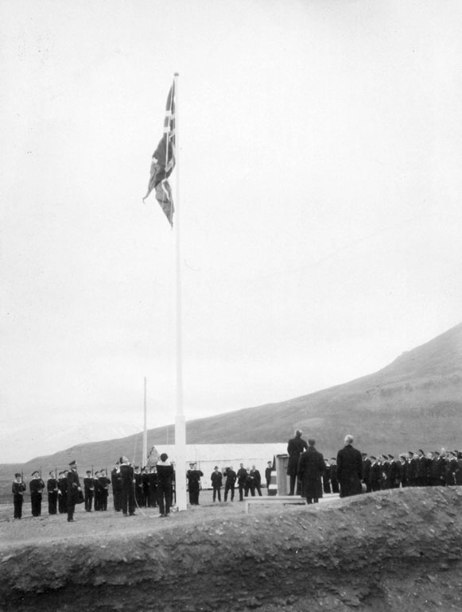

The incorporation of Svalbard into the Kingdom of Norway is celebrated in Longyearbyen on 14 August 1925. In 2025, the Government will mark 100 years since Svalbard was incorporated into the Kingdom.

Source: Norwegian Polar Institute

Principles of interpretation

Article 31 of the 1969 Vienna Convention on the Law of Treaties specifies the general rule of interpretation for treaties. The provision states that a treaty must be interpreted in good faith in accordance with the ordinary meaning to be given to the terms of the treaty in their context and in the light of its object and purpose. Norway is not a party to the Vienna Convention, however, the rule of interpretation expresses customary law by which all states are bound.

The principles of international law for treaty interpretation provide a methodical approach based on the wording of the treaty, whereby provisions are read in context and are supported in other objective sources for the parties’ intentions. An expression may be given a special meaning – i.e., a meaning that differs from ordinary usage in international state and treaty practice – only if it can be established that this was the intention of the parties.

Therefore, in line with general principles of international law governing treaty interpretation, the Svalbard Treaty shall primarily be interpreted on the basis of the terms and expressions in the actual text. The original texts of the Treaty are in French and English. It is the wording of these texts that determines the legal content of the Treaty. These texts form the basis for interpreting the rights and obligations set forth in the Treaty, and no interpretative weight may be accorded to translations, including into Norwegian.

The starting point for interpretation is the ordinary, contextual, linguistic understanding of the terms and expressions in the Treaty. The wording of the Treaty expressly states that Norway shall have full sovereignty. The wording and expressions contained in the Treaty also clearly indicate the geographical scope of application for the respective provisions.

Geographical scope

The Svalbard archipelago is geographically defined in the Svalbard Treaty as all the islands, islets and skerries located between the geographical coordinates 10° and 35° E longitude and 74° and 81° N latitude. The wording makes clear that only the actual islands within these coordinates are covered; i.e., the land territory and not the surrounding maritime areas.

It is clear from the wording of certain provisions in the Treaty that they apply to both the land territory and the territorial waters. The latter consists of internal waters and the territorial sea.

When the Treaty entered into force, Norway had territorial sea extending four nautical miles. In 2004, the territorial sea was extended to 12 nautical miles from the baselines. Thereby, the Treaty provisions applicable to the territorial waters also became applicable to the area between four and 12 nautical miles.

The special rules stipulated in the Treaty do not apply to the continental shelf or in zones that were created in accordance with provisions in the United Nations Convention on Law of the Sea governing exclusive economic zones. This follows from the wording of the Treaty and is supported by the background of the Treaty and by its development and system.

There is a significant difference between the territorial waters and the maritime zones beyond its outer limits. Unlike the territorial waters, the continental shelf and the 200 nautical mile zones are not part of Norwegian territory. Therein, Norway only has specifically defined rights that follow from the Law of the Sea.

The Supreme Court of Norway has confirmed the understanding that the provisions concerning equal treatment in Articles 2 and 3 of the Treaty do not apply to the continental shelf beyond the territorial waters. This was clarified in a case concerning a ban on the harvesting of snow crab on the Norwegian continental shelf. In a unanimous ruling on 20 March 2023 (HR-2023-491-P), the Supreme Court, sitting in grand chamber, ruled that a Latvian shipping company did not have an equal right to harvest snow crab on the Norwegian continental shelf off Svalbard.

Treaty limitations on the exercise of authority

In Article 1 of the Svalbard Treaty, Norwegian sovereignty is recognised on the terms set forth in the Treaty. Limitations have not been placed on sovereignty as such, but rather on how Norwegian authority may be exercised in certain specifically defined areas. Thus, Norway has an exclusive right to exercise authority in these areas as well.

Norway’s obligations under the Svalbard Treaty are especially linked to three issues. These involve specifically defined requirements concerning equal treatment, collection of taxes and duties, and military matters.

Equal treatment/non-discrimination

Under the Svalbard Treaty, Norway has an obligation to ensure equal rights for nationals and companies from States Parties in areas defined in the Treaty. This is a requirement of non-discrimination based on nationality for persons and on national affiliation for companies. Among the areas covered are hunting and fishing, access to the archipelago, engaging in certain types of commercial and industrial activity, and property rights including mineral rights.

Nationals or companies from States Parties may not be placed at a disadvantage compared to Norwegian nationals or companies in these areas, and no distinction is permitted between nationals or companies from States Parties on the basis of nationality.

Although the Treaty prohibits discrimination based on nationality in specified areas, it does not provide unlimited or unconditional liberty for any party to engage in activities in these areas. The rule concerning equal treatment is not an obstacle to regulating or, if necessary, prohibiting an activity for other reasons. The right to issue such regulations derives from Norway’s sovereignty. The Norwegian authorities are generally concerned with ensuring sound regulation of activities in Svalbard. The regulation of various forms of activities is discussed in the remaining chapters of the white paper.

The Svalbard Treaty presupposes observance of local regulations as a condition for exercising some of the rights specified in the Treaty; e.g., in Article 3 concerning certain types of commercial activity.

The requirement of non-discrimination does not apply to all types of activity in Svalbard, but only to the areas specifically set forth in articles 2 and 3 of the Treaty. Hunting and fishing and maritime, industrial, mining and commercial operations are covered by the requirement for equal treatment. What the requirement for equal treatment covers in each individual case must be determined based on an interpretation of the Treaty, in accordance with the principles on, among other things, wording and context, as mentioned above. Examples of activities that are not covered by the right to equal treatment are research, education and aviation.

The equal right of access to the archipelago does not prevent Norway from inspecting persons travelling to and from the archipelago and requiring such persons to identify themselves. Norway may also refuse entry or expel persons who are nationals of States Parties, provided such measures are not based on nationality. For example, the Svalbard Treaty does not preclude the refusal of entry or expulsion of persons who are unable to financially support themselves.

To the extent the Norwegian authorities stipulate regulations for or practice equal treatment in areas other than those mentioned in the Treaty, it is done so for reasons other than obligations under international law.

Taxes, duties, etc.

Pursuant to the first paragraph of Article 8 in the Svalbard Treaty, Norway is obliged to adopt mining regulations. The Mining Code was established by Norway by the Royal Decree of 7 August 1925. The second paragraph of Article 8 of the Svalbard Treaty stipulates that taxes, dues and duties levied shall be devoted exclusively to Svalbard and shall not exceed what is required for the object in view. According to its wording, Article 8 applies specifically to mining activities. Furthermore, such taxes, dues and duties must be used to the exclusive benefit of Svalbard, and may not be used for purposes on the mainland. However, as long as the effect of the use of such revenues occurs in Svalbard, it follows from the wording and intent of the provision that the actual spending of tax revenues may occur elsewhere, such as in the case of purchases of equipment etc. made on the mainland for use in Svalbard.

The purpose of such taxation is to meet needs in Svalbard, and such needs are a discretionary matter. Administration, public services and infrastructure, such as airports and search and rescue services, are needs that warrant such taxation. Previous deficits in the Svalbard budgets may be covered by such taxation, since these are central government expenditures for operations, measures, investments, etc. that have exclusively benefited Svalbard.

The restrictions in the second paragraph of Article 8 do not cover payment for public services where there is legal basis to require such payment. Payment for private services in accordance with an agreement is also not covered by the restrictions.

Pursuant to the third paragraph of Article 8, Norway may levy an export duty on exports of minerals, and instructions have been issued on how much duty is payable.

In practice, Norway has chosen to maintain a generally low level of taxes and duties in Svalbard, including for activities other than mining. This policy has contributed to the development of businesses and communities in Svalbard.

Use for warlike purposes, and other military matters

By virtue of its sovereignty, Norway also has full right of control of military and defence matters. However, Article 9 of the Svalbard Treaty sets out limitations with regard to establishing – or permitting the establishment of – naval bases, constructing fortifications, and using Svalbard for warlike purposes. These limitations – and particularly the prohibition against use for warlike purposes – must be viewed in light of the preamble of the Treaty. Therein, the States Parties express that in recognising Norwegian sovereignty they desire for Svalbard to be “provided with an equitable regime” to assure the archipelago’s development and peaceful utilisation.

The prohibition against using Svalbard for warlike purposes is generally applicable and applies to all States Parties. By virtue of its sovereignty, Norway has a special duty to ensure the inviolability of this prohibition.

However, Article 9 is not a blanket ban on all military activity. It only applies to the construction of naval bases or infrastructure that can be classified as fortifications, as well as activities that have warlike purposes. Defensive measures and other military measures are permitted. The archipelago is covered by provisions of the North Atlantic Treaty, including Article 5 concerning collective self-defence. Norway may unilaterally and collectively implement defensive measures in wartime or under the threat of war.

The prohibition against fortification pertains to specific physical structures that are reinforced to withstand attack and that are usually equipped with artillery positions. Therefore, it does not affect all installations or structures of a military nature or significance.

The prohibition against naval bases entails that no permanent military installation may be established for the purpose of stationing and provisioning military vessels with supplies or services normally offered at a naval base. However, the provision poses no obstacle to the Norwegian Coast Guard or other vessels making port calls in Svalbard to receive services and supplies from civilian suppliers, as needed.

Visits by Norwegian naval vessels, Coast Guard vessels, Armed Forces’ aircraft or Norwegian military personnel do not infringe the Treaty and are in keeping with long-standing practice.

Norwegian policy has been designed to ensure proper compliance with the Treaty and a restrictive practice with regard to Norwegian military activities in Svalbard. Aspects such as frequency and duration, the nature of the units and the need to carry out the mission have been given particular weight in the practical handling of issues concerning military visits to the archipelago. For example, frequent calls by Norwegian Coast Guard vessels are deemed natural, given the nature of their duties in the maritime areas surrounding Svalbard.

All foreign military activity in Svalbard without the consent of Norway is prohibited, and would constitute a gross infringement of Norwegian sovereignty. Unless they are involved in innocent passage through the territorial sea, foreign military and civilian government vessels wishing to enter the Norwegian territorial waters around Svalbard must apply for diplomatic clearance well in advance. The same applies to port calls in Svalbard and to aircraft overflights and landings at airports. The requirement for such clearance derives from general international law, but for the sake of clarity it is also laid down in the Regulations of 2 May 1997 concerning access and entry to Norwegian territory in peacetime for foreign military and civilian government vessels.

Norwegian authorities practice a highly restrictive policy with regard to granting diplomatic clearance to foreign military aircraft and vessels. Foreign government craft with military purposes are not granted diplomatic clearance. Dispensation may be granted on certain conditions to foreign aircraft that are registered as military aircraft, but that are being used for civilian purposes. That may be the case, for example, when Norwegian authorities invite high-level representatives of foreign government authorities to Svalbard for civilian purposes and the use of scheduled or other civilian aircraft is impractical or impossible. An additional requirement is that government craft used in such a manner must have a civilian appearance.

In a 1971 declaration to States Parties, Norway stated that the airport in Longyearbyen “is to be reserved exclusively for civil aviation”. This declaration was issued independently of the Svalbard Treaty and is a self-imposed restriction. The purpose of a flight will determine whether or not it is deemed “civil aviation”. Consequently, military aircraft on civilian missions may be granted permission to use the airport. For example, permission is granted to the Norwegian Armed Forces’ aircraft in connection with search and rescue operations, coastguard operations and training flights for such operations.

The prohibition against using Svalbard for warlike purposes has been taken into account in the regulation of ground stations in Svalbard. The Regulation concerning satellite ground stations in Svalbard of 21 April 2017 no. 493, stipulates that it is not permitted to use a ground station to transmit data to or download data from a satellite that performs functions specifically for military purposes, or if the downloaded data in whole or in part is made available for military purposes. This avoids situations where it can be called into question whether ground stations in Svalbard are being used for warlike purposes.

Research

The Svalbard Treaty does not regulate research activities. Nationals of States Parties have neither a right nor equal right to conduct research activities in the archipelago. Since the 1960s, Norwegian authorities have chosen to actively facilitate international polar research in Svalbard by, among other things, developing Ny-Ålesund as a research platform. Research activities in Svalbard must be conducted in accordance with relevant Norwegian legislation, including the Svalbard Environmental Protection Act. This is discussed in more detail in Chapter 5.

Article 5, second paragraph of the Treaty stipulates that conventions shall be concluded laying down the conditions under which scientific investigations may be conducted. The provision says nothing about which conditions must apply; nor was this ever followed up. There has been an increase in the number of international cooperation agreements, projects and networks of significance for scientific research in Svalbard over the past decade. It is no longer relevant to negotiate separate agreements on the conditions for scientific research in the archipelago. It is therefore up to the Norwegian authorities, by virtue of Norway’s sovereignty, to regulate research activity.

Scientific marine research is regulated by the United Nations Convention on the Law of the Sea. Normally, coastal states must consent to foreign scientific research in their maritime areas. However, this does not apply within the territory of a state. Norway is therefore free to refuse or set limitations on research in the territorial waters around Svalbard.

### Interrelation with certain international agreements

The EEA Agreement and the Schengen Agreement

When Norway ratified the EEA (European Economic Area) Agreement in 1992, Svalbard was excluded from its scope of application because of the special circumstances ensuing from Norway’s international legal obligations under the Svalbard Treaty. However, the free trade agreements between Norway and the European Economic Community and the EFTA Convention are applicable to Svalbard.

The Schengen Agreement was entered into in 1985. The purpose of the agreement is to abolish border posts and border controls between member states and reinforce external border controls. Norway acceded to the Schengen Agreement in 1996. As a consequence of the provision in Article 3 of the Svalbard Treaty governing access, Svalbard is not covered by the agreement concerning association with the Schengen cooperation.

The WTO Agreement, including the General Agreement on Tariffs and Trade (GATT)

No general reservations concerning Svalbard were made in connection with the establishment of the World Trade Organization (WTO). The WTO was established on the basis of the previously concluded General Agreement on Tariffs and Trade (GATT), which entered into force on 1 January 1948. Similarly, GATT contains no reservations for Svalbard. Among GATT’s key objectives are non-discrimination and the reduction and elimination of tariff and trade barriers, and in essence the agreement harmonises with the Svalbard Treaty’s provisions related to non-discrimination.

## Legislation

### Introduction

Legislation is a key policy instrument for achieving the objectives of Svalbard policy, and is necessary to manage social development within the framework of these objectives. Important acts and regulations for the implementation of Svalbard policy are also described in more detail in Chapter 3 “Climate and environment”, Chapter 4 “Societal development and commercial activity in Longyearbyen” and Chapter 6 “Civil protection, search and rescue and emergency preparedness”.

Activity in Svalbard is increasing. This situation, in conjunction with rapid climate change and more varied activities in several local communities, contribute to the need for renewing and developing the legislation governing the archipelago.

This chapter reviews the principles of the legislation governing Svalbard. The chapter also discusses various areas of law of particular significance to the development of society, and a description of legislative work in specific areas.

### Legislative principles

By virtue of its sovereignty, Norway can make all legislation governing the mainland applicable to Svalbard. The Svalbard Treaty stipulates certain limitations imposed by international law on Norway’s right to exercise authority. See section 2.2 for a more detailed discussion of the international legal frameworks.

In previous white papers on Svalbard, it has been established that the legal framework for Svalbard should be as similar as possible to that of the mainland and that new legislation governing the mainland should as, a general rule, be applied to Svalbard unless special circumstances indicate otherwise or there is a need for exceptions or adaptations. Another important point of departure is that, in general, all legislation applicable to Svalbard should be applied and enforced equally throughout the entire archipelago. This forms the basis for the Government’s legislative work for Svalbard.

However, not all legislation is automatically made applicable to Svalbard. Section 2 of the Svalbard Act sets out the methodological basis for the applied regulatory technique. The first paragraph states that Norwegian civil and penal law and the Norwegian legislation relating to the administration of justice apply to Svalbard, where nothing to the contrary has been provided. The Svalbard Act contains no definition of the term “civil law”, but it is generally considered to be a generic term for all regulation of the relationship between private parties.

Section 2, second paragraph states that other statutory provisions do not apply to Svalbard unless specifically provided. This means that other legislation, which in practice is referred to as public law, only applies where this is specifically provided.

The requirement that it must be “specifically provided” that legislation applies to Svalbard is understood to require a reasonably clear basis for applicability to the archipelago in legislation or the preparatory works, cf. the Supreme Court of Norway’s ruling in Rt. 2007 p. 801 Nordpol Telecom. In the ruling, it was stated that it would be particularly important to state that the issue of application to Svalbard has been specifically considered.

New legislation cannot always be applied to Svalbard without adaptations being made. Particularly in the case of public law, it must be decided whether the legislation in question is suitable for Svalbard and whether there is a need for local adaptations. For instance, there may be a need for transitional arrangements or for the legislation to enter into force for Svalbard at a later date. Other forms of phasing-in may also be necessary, e.g., because of local businesses’ needs for restructuring. Adaptations may be necessary due to, e.g., international legal obligations or administrative, climatic or geographical conditions. Regarding administrative conditions, adaptations may be necessary due to the fact that there are no administrative bodies in Svalbard equivalent to those on the mainland. In recent years, there has been a trend towards expert bodies and other authorities with supervisory responsibility on the mainland also being responsible for supervision in Svalbard. The Governor of Svalbard assists in the implementation of such supervision. It is not desirable to develop expert roles with the Governor of Svalbard that can be managed by expert bodies and authorities on the mainland. The Government believes this is an appropriate way to structure supervision and will continue this practice.

Previous white papers on Svalbard have discussed whether the principle in Section 2 of the Svalbard Act should be amended so that the starting point would be that all legislation applies to Svalbard unless otherwise expressly stated. However, such an amendment has not been deemed necessary. The Standing Committee on Foreign Affairs and Defence has supported this position in its consideration of the white papers. The Government sees no reason to amend the principle in Section 2 of the Svalbard Act, and refers to what has been written on this topic in previous white papers.

Section 3 of the Svalbard Act stipulates that certain legislation applies to Svalbard, with the amendments laid down by the King out of regard for the local conditions. This applies, among other things, to the Civil Servants Act, the Working Environment Act, the Postal Act and the Electronic Communications Act.

Furthermore, Section 4 of the Svalbard Act grants the King the authority to issue general regulations concerning the matters mentioned in the provision. Currently, the application of legislation to Svalbard is often regulated in the individual acts, meaning that the authority to issue separate regulations concerning the matters enumerated in Section 4 is used to a lesser extent than before.

Chapter 5 of the Svalbard Act contains rules that apply to Longyearbyen Community Council. Certain provisions that are specifically adapted to Longyearbyen Community Council are provided in the Svalbard Act. Furthermore, the rules of the Local Government Act largely apply correspondingly to Longyearbyen Community Council. Regulations governing the right to vote and eligibility to stand for election are provided in the Regulations relating to elections to Longyearbyen Community Council. In 2022, new regulations were issued on the right to vote and eligibility to stand for election. Persons who are not Norwegian nationals have the right to vote if they have been registered in the National Population Register as residents in a Norwegian municipality for the last three years before they were entered in the Population Register of Svalbard as resident in Longyearbyen. This is due to the fact that a significant proportion of the population moves to Svalbard directly from abroad. It must be ensured that those who manage the local community, and thereby also contribute to the implementation of Norwegian Svalbard policy, have good knowledge and understanding of the frameworks that apply to the administration of Svalbard.

The Svalbard Act was passed in 1925 and has subsequently been amended several times. Many of the Act’s provisions have been repealed. The Government now sees a need to review the Svalbard Act with a view to updating and modernising it, and hereby announces that it will initiate a review of the Act.

### EEA rules and Svalbard

The EEA Agreement does not apply to Svalbard. This pertains to the special circumstances ensuing from Norway’s international legal obligations under the Svalbard Treaty. Nevertheless, Norway may choose to apply acts and regulations that implement EEA obligations to Svalbard on a purely national basis. However, the possibility of doing so must be specifically assessed. Rules that presuppose a mutual international legal obligation between states, such as binding cooperation between authorities in the various EEA states, cannot be applied on a purely national basis. Furthermore, specific assessments must be made to determine if it is appropriate to apply the legislation to Svalbard and whether it will affect Norwegian obligations under the Svalbard Treaty. The need for local adaptations should also be considered.

### Tax legislation

Svalbard has its own taxation regulations. The Svalbard Taxation Act makes Svalbard a separate area for tax purposes. In Svalbard, salary and pension are taxed at a rate of 8 per cent up to 12 B.a. (B.a. = National Insurance basic amount) and at a rate of 22 per cent for income exceeding 12 G. Other income such as investment income and income from self-employment are taxed at a rate of 16 per cent. The Government will continue the low tax rates for Svalbard. In addition, there are national insurance contributions for employees who are insured under the Norwegian National Insurance Scheme.

It is important that the taxation system in Svalbard is adapted to the conditions in the archipelago and that it is based on solutions that ensure competitive conditions. A basic starting point is that persons resident in Svalbard are subject to global tax liability to Svalbard. However, persons resident abroad who move directly to Svalbard without having previously lived in Svalbard are subject to limited tax liability for the first five years. Furthermore, companies or individuals that conduct commercial activity in Svalbard for at least 30 consecutive days will be liable to pay tax to Svalbard on profits from the commercial activity conducted in Svalbard. The tax liability to Svalbard ceases to apply from and including the income year in which the person has stayed outside Svalbard for more than 183 days in a 12-month period.

Since the last white paper on Svalbard was presented, it has become more common to work from home or engage in other forms of remote work. This is enabled by digital solutions. These circumstances raise questions related to, among other things, where the taxable activity is carried out. The Government will assess whether the Svalbard Taxation Act is adapted to the times and whether there is a need to update the Act. The Government has noted that the Longyearbyen Youth Council is requesting that amendments be made to the Svalbard Taxation Act to make it possible to take odd jobs without having to pay income tax. The Government will investigate a scheme that makes it possible for young people in Svalbard to earn smaller amounts without having to pay income tax.

### Regulations relating to the Population Register of Svalbard

Social developments in Svalbard and generally greater mobility than 10–15 years ago make it more challenging to obtain a complete overview of the population, both in Longyearbyen and in the other local communities. Increasing mobility and population growth in Longyearbyen impact, among other things, emergency preparedness and regional planning, including the scaling of services and infrastructure such as housing, energy and water. Therefore, it is important to have an overview of the number of inhabitants.

The Regulations relating to the Population Register of Svalbard were adopted in 1994, and the legislation has since remained largely unchanged. The Government believes there is a need to review the Regulations relating to the Population Register of Svalbard.

Such a review should, among other things, scrutinise the requirement of a period of residence in Svalbard in order to be registered as a permanent resident. Questions that need to be considered are whether documentation of the basis for the stay should be required, and whether a requirement should be introduced that settlement can only be registered in dwellings that are designated for residential purposes. Measures should also be considered that can lead to improved compliance with the obligation to report relocation to, within and from Svalbard.

### Immigration legislation, control of border and movement of goods and citizenship legislation

Article 3 of the Svalbard Treaty imposes an international legal obligation on Norway to treat nationals of States Parties equally in certain areas. This applies to access to the archipelago, among other things. In practice, Norway has not discriminated between nationals of States Parties and nationals of non-States Parties. The legislation regulating foreign nationals’ access and entry to the realm is not suitable in Svalbard. Therefore, the Immigration Act and Regulations issued pursuant to the Act have not been made applicable to Svalbard.

No work permit, residence permit or visa is required for travel to Svalbard. Furthermore, Svalbard is not included in the Schengen cooperation. The rules governing entry and exit control across the external Schengen border therefore apply to travel between the Norwegian mainland and Svalbard. When crossing the Schengen external border, all persons are required to submit to entry and exit checks, cf. Section 13, second paragraph of the Border Act and Section 1-3 of the Border Regulations. Foreign nationals staying in Svalbard must, in the same manner as other foreign nationals, comply with the rules in the Border Act and Immigration Act when traveling between the mainland and Svalbard. Foreign nationals subject to visa requirements must have a visa when travelling to the mainland. Currently, the Governor of Svalbard issues such visas upon application, in accordance with Section 13 of the Immigration Act.

In 2022, rules regarding identity checks were introduced in the Regulations relating to the control of travellers to and from Svalbard. The Regulations apply to checks carried out in Svalbard. The purpose of such checks is, among other things, to prevent cross-border crime and maintain public order. Travellers to and from Svalbard must submit to checks when requested by the Governor of Svalbard. Checks may be carried out upon arrival in and departure from Svalbard, where the traveller reports or is encountered, and in the territorial sea aboard vessels travelling to or from port or internal waters. The Svalbard Treaty’s provision concerning access in Article 3 does not preclude such checks.

Svalbard is not part of the customs territory, which consists of the mainland and adjacent territorial waters. Svalbard is established as a separate customs area in the Regulations relating to the control of movement of goods in Svalbard. The Regulations are issued pursuant to Section 1-2, sixth paragraph of the Movement of Goods Act. The Svalbard customs area includes Svalbard and its adjacent territorial waters. The Regulations contain rules on the tasks of the customs authorities and provisions on the control of movement of goods. See section 6.4.2 for a more detailed discussion of the topic of control of travellers and the movement of goods.

The Government has decided to carry out a review of the Citizenship Act. One question in this regard is whether the Citizenship Act should apply to Svalbard, and to what extent it should be possible to accumulate a period of residence in Svalbard. The Integration Act regulates introduction programs and other regulatory measures for newly arrived immigrants. The Act is not suitable for Svalbard and is therefore not applicable to the archipelago.

### Legislation governing refusal of entry or stay and expulsion

There is no unconditional right to stay in Svalbard even if a visa is not required. The Governor of Svalbard may, among other things, refuse entry to or expel persons who lack sufficient entails to remain in Svalbard or who are unable to adequately care for themselves. Persons suspected or convicted of having contravened laws that apply to Svalbard may also be refused entry or expelled under certain conditions. This follows from the Regulations relating to the refusal of entry or stay and to the expulsion of persons from Svalbard. These Regulations were issued pursuant to Section 4 of the Svalbard Act. The Regulations also contain provisions concerning expulsion.

The Regulations also stipulate that persons arriving in Svalbard shall be refused entry or stay by the Governor of Svalbard upon entry or subsequently when necessary to implement binding decisions issued by the UN Security Council or when the person is subject to international restrictive measures that contain travel restrictions that Norway has aligned itself with and which have been implemented for the rest of the country. The Immigration Act is a key component of the system that implements travel restrictions on the mainland. Therefore, it is appropriate to regulate the implementation of entry restrictions in the Regulations relating to refusal of entry or stay.

### Social Insurance legislation and general health legislation

In order for a person to be entitled to receive benefits from the National Insurance Scheme, it is a prerequisite that they are or have been insured under the National Insurance Scheme, or that they have derived rights from someone who is or has been insured under the National Insurance Scheme. Section 2-3 of the National Insurance Act contains a special provision on insurance under the National Insurance Scheme for persons living in Svalbard.

Persons who are insured under the National Insurance Scheme upon arrival in Svalbard retain their insurance if they settle or take up residence in Svalbard, cf. Section 2-3, first paragraph. Pursuant to Section 2-3, second paragraph, persons who are not insured under the Norwegian National Insurance Scheme prior to their stay in Svalbard will become compulsory insured under the National Insurance Scheme if they are employed by a Norwegian employer that operates in Svalbard. The compulsory insurance is maintained as long as the person is employed by a Norwegian employer, and for up to one month after the end of the employment, if the person remains in Svalbard during this period. Only employees may become members. Freelancers, owners of sole proprietorships and self-employed persons are not covered.

Insurance under Section 2-3, second paragraph of the National Insurance Act does not in itself entail a right to all benefits regulated in the National Insurance Act. Furthermore, the specific conditions for the benefits in question must be met. For example, a prerequisite for entitlement to unemployment benefits is that the person is considered a genuine job seeker. For third-country nationals, this entails that they must first have a residence permit in mainland Norway. Secondly, the residence permit must grant the holder the right to engage in any type of work in Norway, which migrant workers normally do not have. Therefore, third-country nationals will not be entitled to unemployment benefits in Svalbard.

The Child Benefit Act and the Cash Benefit Act apply to children staying in Svalbard who are insured under the National Insurance Scheme pursuant to Section 2-3 of the National Insurance Act, cf. Section 3 of the Child Benefit Act and Section 2, third paragraph of the Cash Benefit Act. The Government will assess whether the arrangements for Svalbard are appropriate or whether they should be adapted in line with the objective of maintaining Norwegian communities on the archipelago. See a further discussion in section 4.2.

In 2015, a number of health acts and regulations were made wholly or partially applicable to Svalbard, cf. the Regulations relating to the application of health acts and regulations for Svalbard and Jan Mayen. Among other things, the acts relating to health personnel, health supervision, the specialist health service and control of communicable diseases have been applied in whole or in part. Neither the Health and Care Services Act nor the Patient and User Rights Act are applicable, as the provision of services on the archipelago is intended to be limited.

The County Governor of Troms and Finnmark oversees health personnel and the health service in Svalbard. The structuring of health services in Svalbard is discussed in more detail in section 4.3.2.

### General overview of economic and social rights in the kindergarten and education sectors, and the principle of the best interests of the child

The human rights provisions enshrined in the Constitution of Norway are applicable to Svalbard. However, the unique circumstances and framework conditions in Svalbard have consequences for the requirements set for the fulfilment of rights in the area of education. Article 109 of the Constitution on the right to education and Article 98 on equality under the law are particularly relevant for education. According to Section 2 of the Human Rights Act, the UN Convention on the Rights of the Child and the UN Covenant on Economic, Social and Cultural Rights (ICESCR) have the force of Norwegian law. The Human Rights Act applies to Svalbard, cf. Section 5. Article 28 of the Convention on the Rights of the Child and Article 13 of the ICESCR concern the right to education. Article 24 of the UN Convention on the Rights of Persons with Disabilities (CRPD) on the right of persons with disabilities to education is also relevant in this context.

The abovementioned human rights provisions are general in nature. Norway complies with its human rights obligations in relation to all persons staying in Svalbard. However, the unique circumstances and framework conditions that apply to staying in the archipelago entail that not all rights can be fulfilled in the same manner on Svalbard as on the mainland. The unique conditions in Svalbard may also entail that any differential treatment is objective and proportionate, and thereby not contrary to the various anti-discrimination provisions in human rights law.

It follows from Article 104 of the Constitution of Norway and Article 3(1) of the Convention on the Rights of the Child that the best interests of the child shall be a primary consideration for all actions and decisions that affect children. What is in the best interests of the child must be decided specifically. When deciding whether to settle in Svalbard, a strong consideration should be the fact that the provision of public services, including schooling, is limited. Parents have the primary responsibility for ensuring that the interests of children staying in Svalbard are preserved. It is particularly important that parents familiarise themselves with the structuring of public services in Svalbard prior to settling there. Because the provision of public services is limited, it may not always be in the best interests of the child to live in Svalbard. This may especially apply to foreign nationals who, for various reasons, are unable to make use of the services offered on the mainland. However, Norwegian nationals must also take into account that public services are not fully developed in Svalbard.

If individuals require services beyond those available in Longyearbyen, they will have to contact their municipality or county authority on the mainland, or their home country if this is not Norway. This also applies to areas other than kindergarten and school.

### The Education Act and the Kindergarten Act etc.

As announced in the previous white paper, a more detailed review and clarification of Longyearbyen Community Council’s obligations under the Education Act and the Kindergarten Act has been carried out. By the Royal Decree of 17 June 2022, the Government issued new Regulations relating to primary, lower secondary and upper secondary education in Longyearbyen and new Regulations relating to kindergarten activities in Longyearbyen. The regulations entered into force on 1 August 2022 and apply within the Longyearbyen planning area.

Only Longyearbyen Community Council is permitted to operate primary, lower secondary and kindergarten activities in Longyearbyen. The Community Council is not required to provide upper secondary education, but may choose to provide this service. The right to an individually adapted kindergarten service does not apply in Longyearbyen.

The objective is for children and young people in Longyearbyen to receive high-quality kindergarten and school services that form the basis for their continuing education and working life. The special framework conditions for Longyearbyen restrict the scale of kindergarten and school services and thereby guide residents’ expectations in this regard. Certain rules in the Education Act and the Kindergarten Act that apply in Longyearbyen have been adapted to the local conditions in Svalbard. Among other things, more detailed rules have been issued on the right and obligation to attend primary and lower secondary education and a limited right to special education in the primary and lower secondary school. The legislation sets the frameworks for the available educational provisions in Longyearbyen. This includes instructions that the provision of services is not to be expanded. Longyearbyen Community Council is not required to offer a homework help service, after-school care, school camp or school of music and performing arts.

Parents have an independent responsibility to ensure that their children’s needs are met in Longyearbyen. Various rules in the Education Act and the Kindergarten Act affecting children and young people with special needs for adaptation are partially applied or not applied in Longyearbyen. The educational and kindergarten provisions are not to compensate for services that are not available in Longyearbyen. This may entail that children and young people whose needs cannot be met in Longyearbyen will have to travel to the mainland or their home country for their special needs to be accommodated.

The new Education Act was adopted by the Storting on 5 June 2023 and is scheduled to enter into force on 1 August 2024. The Government will issue new regulations relating to primary, lower secondary and upper secondary education in Longyearbyen, to ensure that the regulations are adapted to the new Education Act. The substantive content of the current Regulations will be retained, entailing a continuation of the limited provision of services.

The 2017 Equality and Anti-Discrimination Act is applicable to Svalbard, however, Chapter 3 on universal design and individual adaptation, as well as sections 24, 25 and 26 on active equality efforts with regard to disabilities, do not apply to Svalbard. This represents a continuation of the state of the law under the Anti-Discrimination and Accessibility Act.

The new Child Welfare Act entered into force on 1 January 2023, and applies to Svalbard with the special rules issued in regulations. Foster homes cannot be established or approved in Svalbard. Longyearbyen Community Council does not have the capacity to accommodate children with special needs and problems. Exceptions may be made with the consent of the Office of the Governor of Svalbard or its delegated authority, which will cover the costs of the measures.

### On the implementation of international sanctions and export control legislation

The UN Security Council can impose sanctions that are binding as a matter of international law on states, persons or entities. Norway has an obligation to implement such sanctions, an obligation that takes precedence over other obligations under international law. Such obligations apply as much to Svalbard as to the rest of Norway.

The EU adopts sanctions, known as restrictive measures, as part of its common foreign and security policy. Norway has aligned itself with the EU’s restrictive measures with a few exceptions. EU sanctions implemented by Norway apply to Svalbard, unless otherwise stated in the relevant regulations.

The sanctions against Russia are of particular relevance to Svalbard, and these are implemented in the Regulations of 15 August 2014 No. 1076 relating to restrictive measures in respect of actions undermining or threatening the territorial integrity, sovereignty, independence and stability of Ukraine. The Regulations apply to Svalbard, unless otherwise stated in the individual provision.

In 2021, the Export Control Act was made applicable to Svalbard. The Government has decided to establish a new agency for export control and sanctions by 1 January 2025. The agency will be placed under the Ministry of Foreign Affairs.

### Accounting, auditing and bookkeeping rules

There is currently no clear regulation of accounting, bookkeeping and auditing obligations in Svalbard. Rules governing accounting, bookkeeping and auditing have an important function. Financial statements make it possible to assess the financial development and situation of the reporting entity. A number of stakeholders are dependent on the information that good accounting can provide. Good accounting rules contribute to ensuring that financial statements provide accurate information and ensure that the interests of the various user groups are safeguarded. The Government is of the opinion that accounting, bookkeeping and auditing obligations in Svalbard should be subject to clearer regulation and will prioritise efforts in this regard.

### Company and registry legislation in Svalbard

The Private Limited Liability Companies Act, the Public Limited Liability Companies Act, the Partnership Act, the Act relating to the Central Coordinating Register of Legal Entities and the Act relating to the Register of Business Enterprises contain provisions authorising the King to issue regulations on the application of each act to Svalbard. These authorisations have not yet been used. The Government will consider issuing more detailed provisions on the application of company and registry legislation in Svalbard.

### The Mining Code for Svalbard

The rules on land claims (mining rights) are regulated in more detail in the 1925 Mining Code for Svalbard, and they regulate the relationship between claim holders, the relationship with the landowner, the obligation to work a claim, etc. Possession of a claim does not confer the right to encroach on Svalbard’s natural environment. Establishing mining activities in Svalbard requires a permit under the Svalbard Environmental Protection Act and Regulations issued pursuant to the Act.

Only persons from or companies resident in States Parties to the Svalbard Treaty have the right to acquire mining rights in Svalbard. The Mining Code is based on the principle of first finder’s right. Whoever first discovers a mineral deposit has first right to the find and to demand a land claim (mining rights). The owner of land where a claim has been awarded has a right to participate in the operation at a level of up to 25 per cent. The Mining Code sets minimum requirements for the effort that must be expended to retain a claim. However, the obligation to work a claim is not absolute. On specified terms set forth in the Mining Code, dispensation may be granted from the work obligation. Upon application by the claim holder and recommendation by the Directorate of Mining, a dispensation from the work obligation is granted by the Ministry of Trade, Industry and Fisheries for five years, which constitutes a work obligation period. If a claim holder has neither fulfilled the work obligation nor applied for and been granted dispensation, the claim lapses at the end of the following calendar year. Others may then apply for new claims in the freed-up area.

Mineral deposits in the territorial waters around Svalbard are covered by the Seabed Minerals Act. When the Act was passed, it was assumed that this area would not be opened for exploration and explotation.

### Other legislation

Svalbard has separate Regulations relating to fire protection. In addition, the Act relating to flammable liquids and gases under pressure and the Act relating to explosive goods apply. These acts only apply to Svalbard. In Longyearbyen, the Longyearbyen Community Council manages fire and emergency preparedness in the same manner as the municipalities on the mainland, while the individual enterprises are responsible for this in the other communities. It has been established in Svalbard white papers that legislation governing the mainland generally applies to Svalbard, unless special circumstances indicate otherwise. The Ministry of Justice and Public Security is currently working to make the Fire and Explosion Prevention Act applicable to Svalbard with some adaptations. A draft is scheduled for consultation during 2024.

The Act relating to dog ownership currently does not apply to Svalbard, but the Ministry of Agriculture and Food has begun work on regulations relating to the application of the Act to Svalbard.

The Act relating to veterinarians and other animal health personnel does not apply to Svalbard. The Act contains a regulatory authority that allows for the Act or parts thereof to also apply to Svalbard. This authority has not been used, but the Ministry of Agriculture and Food has begun work on regulations relating to the application of the Act to Svalbard.

The Animal Welfare Act is applicable to Svalbard. The Act also authorises the establishment of special rules for Svalbard, taking into account local conditions, including exemptions from the provisions of the Act. This regulatory authority has not been used.

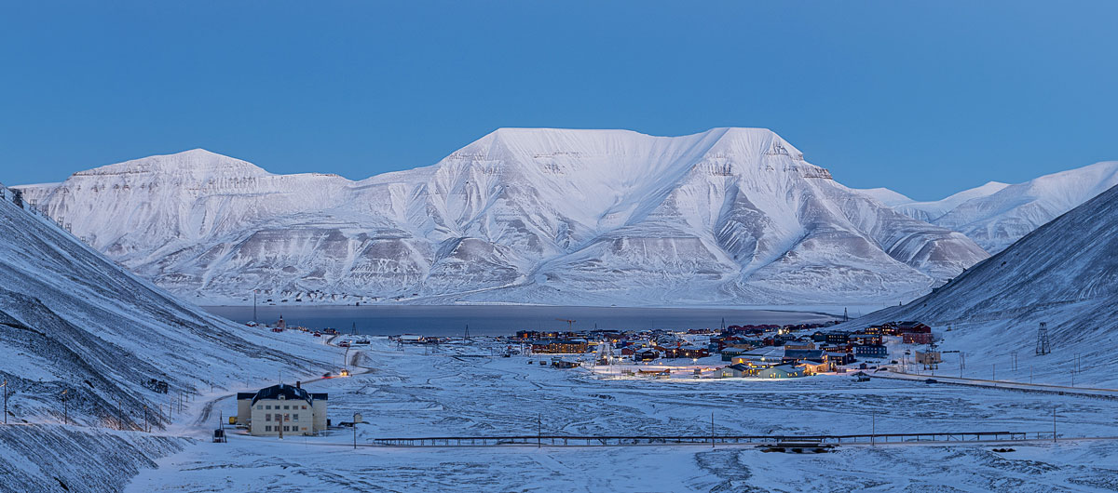

View down Longyeardalen towards Hiortfjellet with Huset in the foreground.

Photo: Tommy Dahl Markussen

## State ownership as a policy instrument in Svalbard

There is a long tradition of state ownership in Svalbard. State ownership of companies, land, infrastructure, property and housing are and have been important instruments in Svalbard policy.

The Government is keen to ensure Norwegian ownership of important infrastructure and property, among other things, both on Svalbard and on the mainland, cf. Report to the Storting (white paper) No. 9 (2022–2023) National control and digital resistance to safeguard national security.

### State ownership of companies in Svalbard

The State directly or indirectly owns several companies that have their main activities in Svalbard. The direct ownership currently consists of the state-owned companies Store Norske Spitsbergen Kulkompani AS (Store Norske), Kings Bay AS, Bjørnøen AS and the University Centre in Svalbard. The State indirectly owns Svalbard Airport, via Avinor AS. The State also owns shares in other companies with activities of varying scope in Svalbard. The State owns half of Kongsberg Satellite Services (KSAT) indirectly, via Space Norway (which is wholly owned by the Ministry of Trade, Industry and Fisheries). The other half is owned by the Kongsberg Group, in which the state has a 50.004 per cent stake. KSAT is subject to the Security Act as the company is of vital importance to fundamental national functions. The State also owns 53.97 per cent of the shares in Telenor ASA, which operates in Svalbard via its subsidiary Telenor Svalbard AS.

State ownership of Store Norske Spitsbergen Kulkompani AS

Store Norske engages coal mining in Mine 7, housing and commercial property management, logistics services, renewable energy projects and a visitor mine in Svalbard. In addition, Store Norske is responsible for cleaning up the former coal operations in Svea and Lunckefjell. The company was founded in 1916 and the State became the owner of the company in the 1930s.

The State is the owner of Store Norske in order to contribute to ensuring that the Longyearbyen community is maintained and further developed in a manner that supports the objectives of Svalbard policy, cf. Report to the Storting (white paper) No. 6 (2022–2023) A greener and more active state ownership – The State’s direct ownership of companies (ownership report). The State owns 100 per cent of the shares in the company.

In the ownership report, Store Norske is listed as a category 2 company. This category includes companies where the State’s goal is sustainable and with the most efficient possible attainment of public policy goals. These are companies that do not primarily operate in competition with other companies. The State’s public policy goals vary between companies, and for Store Norske, the State’s goals as owner include cost-effective management and development of housing in Longyearbyen. For commercial buildings, industrial operations and other activities, the State’s goal as owner is the highest possible return over time within a sustainable framework. All the company’s activities shall, as the primary consideration, be conducted in support of the Svalbard policy objectives.

The company’s mining operations have been gradually reduced in recent years, and the remaining operations in Mine 7 are scheduled for closure in the summer of 2025. The closure of mining operations has been announced for some time, and Store Norske is working to continuously develop the business within the framework of Svalbard policy objectives and the State’s objectives as owner. One of Store Norske’s strategic initiatives has been the rental and management of residential and commercial buildings, and in 2021 and 2022 Store Norske acquired Hurtigruten Svalbard’s homes and hotels in Longyearbyen and Huset. Store Norske owns around 40 per cent of the homes in Longyearbyen.

As the owner of Store Norske, the State is keen to understand what role the company can play in the local energy transition and whether there are opportunities for the transition to contribute to synergies for the local community. The Government intends to take greater responsibility for energy supply in Longyearbyen, e.g., through Store Norske, and clarify responsibility for energy supply as soon as possible. The Government has commissioned Store Norske to carry out a concept study of the various alternatives for future power supply in Longyearbyen and a condition assessment of existing infrastructure.

### Ownership and management of land

The State is the largest landowner in Svalbard, and directly owns 98.75 per cent of all land via the Ministry of Trade, Industry and Fisheries. Trust Arktikugol and AS Kulspids own 0.4 per cent and 0.1 per cent of the land, respectively. The State also owns 0.75 per cent of the land in Svalbard through its ownership of Kings Bay AS and Bjørnøen AS.

Since 2020, the Ministry of Trade, Industry and Fisheries has managed the state-owned land in Svalbard directly, from a local office in Longyearbyen. This includes the areas that make up the Longyearbyen planning area. All use of state-owned land in Svalbard requires the consent of the Ministry of Trade, Industry and Fisheries, and the Ministry sets requirements and premises for the use of the land. The Ministry of Trade, Industry and Fisheries also manages the ownership of a number of buildings constructed on state-owned land. By managing the ownership of the land, the Ministry of Trade, Industry and Fisheries facilitates activities that support the objectives of Svalbard policy.

Consideration will be given to whether Kings Bay AS and Bjørnøen AS’ ownership rights to the land in Ny-Ålesund and on Bjørnøya should be transferred to the Ministry of Trade, Industry and Fisheries in order to consolidate state management of the land on Svalbard.

### Ownership of homes

State control of housing is an important tool to contribute to maintaining Norwegian communities on the archipelago. More than 70 per cent of the housing stock in Longyearbyen is owned by public and partly public owners, via Store Norske Boliger AS (a subsidiary of Store Norske), Statsbygg, Telenor, KSAT and Longyearbyen Community Council. The housing supply is a key policy instrument for managing and stabilising development in Longyearbyen in accordance with the objectives of Svalbard policy. See section 4.6.1 on the Government’s housing policy in Longyearbyen.

### Ownership of infrastructure

There are significant national interests associated with the archipelago, which indicate a strong government involvement in infrastructure. Furthermore, infrastructure at an appropriate level is a prerequisite for commercial activity and value creation, security and emergency preparedness, as well as good social development. Chapter 4 provides a description of infrastructure, including ports, airports, water, power supply, etc.

State ownership of important infrastructure in Svalbard facilitates long-term planning and development of the archipelago in line with the objectives of Svalbard policy. It is important that the use of state-owned infrastructure supports these objectives.

## Budget and financial policy instruments in Svalbard

### The rationale for a separate Svalbard budget

Funds are transferred to Svalbard both via the Svalbard budget itself and via the various government ministries’ chapters in the National Budget.

The Ministry of Justice and Public Security coordinates and presents an annual budget proposition, Proposition to the Storting 1 S (Draft Resolution) Svalbard Budget, to highlight revenues and expenses in Svalbard. The proposition also provides an overview of the Government’s initiatives and priorities pertaining to Svalbard, as well as an annual summary of developments on the archipelago. The arrangement involving a separate Svalbard Budget will be continued.

### Developments in the budget

Government expenditure in Svalbard exceeds corresponding government revenue. A subsidy is therefore provided each year in the National Budget to cover the deficit in the Svalbard Budget.

Since the previous white paper was presented, there has been a steady development in tax revenues in Svalbard. The subsidy to the Svalbard Budget from the National Budget has varied from year to year, with increases allocated for extraordinary situations and needs. Examples include the increase in avalanche protection in Longyearbyen, as well as COVID-19 and subsequent infection control measures.

The trend has been that Government expenditure in Svalbard has increasingly exceeded revenue, and the difference between revenue and expenditure in Svalbard has increased significantly since 2015. The increase in expenditure reflects both the increase in activity in Svalbard during the period and the fact that Svalbard is and has been a priority. In particular, expenses related to emergency preparedness in Svalbard have increased significantly during the period, including expenses for avalanche protection and expenses for the Governor of Svalbard’s transportation resources.

It is not desirable to facilitate further growth in activity and society, thereby contributing to an increase in the gap between expenses and revenues, nor is it desirable to develop in a manner that creates new demands for greater investments in infrastructure or expansion of services.

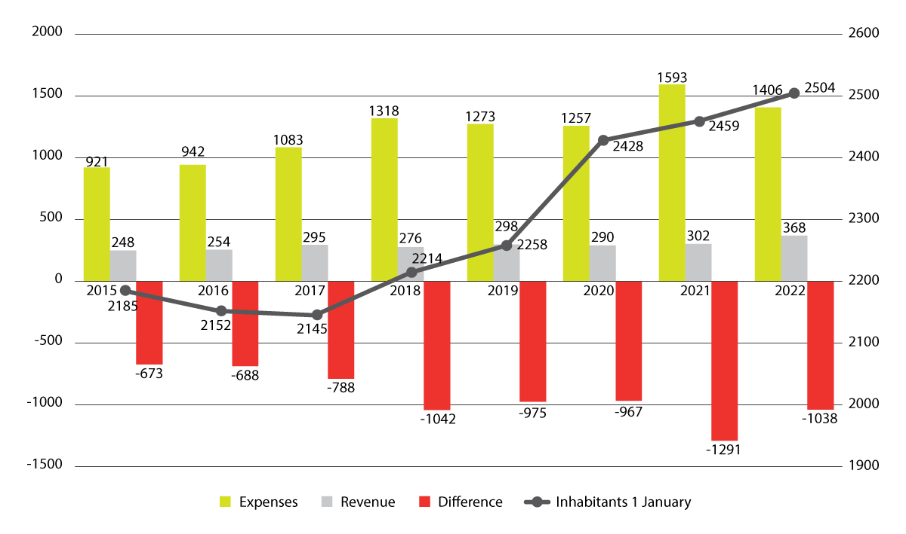

Government revenue and expenditure in Svalbard (NOK million)1

1 Expenses for cleanup in Svea and Lunckefjell are excluded

Source: Proposition to the Storting 1 S (Draft Resolution) The Svalbard Budget for the budget years 2015–2022.

### Economic policy instruments in Svalbard

The Government will prepare a proposal for regulations on visitor fees for Longyearbyen aimed at ensuring that tourists contribute more to the funding of expenses related to infrastructure and other public services that are essential for tourism. See section 4.5.2 for more information on visitor fees.

The Government will introduce various incentives to encourage more Norwegians to stay in Longyearbyen and increase their length of stay. This relates in particular to measures that will make it more attractive for Norwegian families with children to settle in Longyearbyen.

## Administration as an instrument in Svalbard policy

### Central administration

Until the late 1980s, Longyearbyen was a community characterised by one industry and one large business, which was reflected in the administration of Svalbard. Since then, society and the business sector have become more complex.

All the government ministries currently have a role in formulating and following up Svalbard policy, and several government ministries have subordinate agencies with activities in Svalbard. The government ministries’ sectoral responsibilities apply to Svalbard in the same manner as on the mainland. Cabinet ministers are constitutionally responsible for their respective subject areas in Svalbard in the same manner as in the rest of the country. Good administration of Svalbard requires good coordination of Svalbard issues between government ministries and across administrative levels.

The Interministerial Committee on the Polar Regions

The Ministry of Justice and Public Security has the overall responsibility for coordinating government policy that affects Svalbard, across sectors and administrative levels. An important instrument in this work is the Interministerial Committee on the Polar Regions. The Interministerial Committee on the Polar Regions is a coordinating and consultative body for the consideration of polar issues in the central administration, and serves as a special advisory body for the Government in matters concerning the polar regions. The Committee meets around 10 times a year and works according to its own instructions laid down by the Royal Decree of 18 October 2002. The decision-making authority of the competent ministries and the constitutional responsibility of the cabinet ministers remain the same regardless of whether a case is brought before the Interministerial Committee on the Polar Regions.

### The Governor of Svalbard

The Governor of Svalbard is the Government’s highest-ranking representative in the archipelago, and acts in the capacities of both chief of police and county governor. The Governor of Svalbard’s main tasks are search and rescue and emergency preparedness work, responsibility for the police and prosecuting authority and responsibility for environmental management. The Governor of Svalbard participates in the formulation, implementation and follow-up of Svalbard policy.

As chief of police, the Governor of Svalbard is in charge of prosecution and other police activities, and has the same responsibilities and authority as the chiefs of police on the mainland. The overall management of the Governor of Svalbard as chief of police is directly overseen by the Ministry of Justice and Public Security. The National Police Directorate has no authority to issue instructions to the Governor of Svalbard, neither in terms of policing nor financially. The Governor of Svalbard’s police work is carried out, to the extent possible, in accordance with the directives and guidelines issued by the Norwegian Police Service. These instructions are also set out in the Ministry of Justice and Public Security’s main instructions to the Governor of Svalbard.

Having the same authority as a county governor, the Governor of Svalbard carries out a number of civilian tasks delegated by various government ministries. The Governor of Svalbard also serves as the regional and state environmental authority in Svalbard, enforcing environmental legislation and overseeing legislative compliance.

Increased and more diverse activity in and around Svalbard generates additional tasks for the local administration and creates different and new conditions for how the Governor of Svalbard fulfils their mission. For this reason, the sailing season for the Governor of Svalbard’s service vessel has been extended to the whole year. Furthermore, a joint contract has been entered into for the operation of the rescue helicopter base in Tromsø and the Governor of Svalbard’s helicopter service, which provides synergies and a more robust solution. The Governor of Svalbard has been strengthened with a police prosecutor, and the allocation has been increased due to the introduction of identity checks in Svalbard.

### Longyearbyen Community Council

Longyearbyen Community Council was established in 2002 and represents local democracy in Longyearbyen. The Council’s jurisdiction is limited to the Longyearbyen planning area as stipulated in the Regulations relating to impact assessments and delimitation of planning areas in Svalbard under the Svalbard Environmental Protection Act. Longyearbyen Community Council carries out important functions in Longyearbyen within the framework of Svalbard policy. The tasks are the same as those of the municipalities, but the area of responsibility is narrower, and fewer welfare services are provided compared to the mainland. As is the case for the municipalities, tasks and responsibilities are governed by special legislation. However, the responsibility for infrastructure is assigned to Longyearbyen Community Council directly via the Svalbard Act. The legal framework for Longyearbyen Community Council is set out in Chapter 5 of the Svalbard Act, which directly applies many provisions of the Local Government Act. Chapter 5 of the Svalbard Act was revised with the new Local Government Act in 2018, but some differences between Longyearbyen Community Council and the municipalities were continued and clarified. An important difference is that Longyearbyen Community Council exercises its authority and activities within national frameworks and the framework of Norwegian Svalbard policy.

## Measures

The Government will:

* Maintain the principle that legislation applicable to Svalbard shall be applied and enforced equally throughout the entire archipelago.
* Maintain the practice that expert bodies with supervisory responsibilities on the mainland carry out supervision in Svalbard with the assistance of the Governor of Svalbard.
* Carry out a review of the Svalbard Act.
* Continue the low tax rates for Svalbard.
* Assess whether the Svalbard Taxation Act is adapted to the times and whether there is a need to update the Act.
* Conduct a review of the Regulations relating to the Population Register of Svalbard, including an assessment of the criteria for being registered as a permanent resident.
* Consider the application of the Citizenship Act to Svalbard in connection with the review of the Act.
* Introduce incentives to make it more attractive for Norwegians to move to and remain in Svalbard.
* Investigate a scheme that enables young people in Svalbard to earn smaller amounts without having to pay income tax.
* Consider whether the child benefit and cash-for-care schemes should be adapted in line with the objective of maintaining Norwegian communities on the archipelago.
* Issue new regulations relating to primary, lower secondary and upper secondary education in Longyearbyen, to ensure that the regulations are adapted to the new Education Act.
* Make the Act relating to dog ownership and the Act relating to veterinarians applicable to Svalbard.
* Prioritise the work of clarifying accounting, bookkeeping and auditing obligations in Svalbard.
* Consider issuing more detailed provisions on the application of company and registry legislation in Svalbard.
* Consider whether Kings Bay AS and Bjørnøen AS’s ownership rights to the land in Ny-Ålesund and on Bjørnøya should be transferred to the Ministry of Trade, Industry and Fisheries.
* Use housing policy in Longyearbyen as an instrument in Svalbard policy.
* Consider whether registration at an approved place of residence should be a prerequisite for inclusion in the population register.
* Continue the arrangement involving a separate Svalbard Budget.
* Prepare a proposal for regulations relating to visitor fees for travellers to Longyearbyen.

# Climate and environment

## The objectives for environmental protection in Svalbard

The preservation of Svalbard’s unique natural wilderness is one of the key elements of Svalbard policy, and has long been one of the overriding objectives since they were first enunciated in Report to the Storting (white paper) No. 40 (1985–86) Svalbard. Svalbard has an internationally significant and valuable natural and cultural heritage that Norway has a special responsibility to preserve. This has been emphasised in the three previous white papers on Svalbard and through the Storting’s consideration of these reports. This policy remains fixed. In addition to the overriding goal of preserving Svalbard’s unique natural wilderness, more detailed objectives have been set for environmental protection in Svalbard. With some minor adjustments, the objectives are the same as those endorsed by the Storting in its consideration of Report to the Storting (white paper) No. 9 (1999–2000) Svalbard (Draft Resolution No. 196 (1999–2000)).

These objectives are as follows:

* On the basis of its internationally significant natural and cultural heritage, Svalbard shall be one of the world’s best-managed wilderness areas.
* Within the framework set by the Treaty and considerations of sovereignty, environmental considerations shall prevail in the event of conflicts between environmental protection and other interests.
* The extent of wilderness areas shall be maintained.
* Flora, fauna and cultural heritage sites that warrant protection shall be preserved virtually untouched, and natural ecological processes and biodiversity shall be allowed to evolve virtually undisturbed by local activity in Svalbard.
* There shall be large and essentially pristine nature areas in Svalbard that meet the need for reference areas for climate and environmental research.
* The possibility to experience Svalbard’s natural environment undisturbed by motorised traffic and noise shall be ensured, including areas that are easily accessible from the inhabited locations.

These objectives set the frameworks for all activities in Svalbard.

Today, Svalbard is one of Europe’s last remaining large wilderness areas. The vast majority of the archipelago is free of major encroachment into the natural environment, and the flora and fauna are largely intact. Svalbard is a unique nature area both in a European context and in the Arctic region at large. Here, the cold Arctic Ocean meets the warm waters of the Atlantic in an area with islands, fjords and large, relatively shallow waters that are covered in ice and drift ice for parts of the year. These conditions produce a wide variety of ocean, coastal and terrestrial habitats. This results in higher biological production and a richer fauna than anywhere else this far north. Svalbard’s wildlife includes Arctic mammals such as polar bears, Svalbard reindeer, walrus and various whale species. Svalbard and the Barents Sea have one of the world’s highest densities of seabirds, with around 20 million seabirds in summer. Svalbard is also home to some bird species that do not nest anywhere else in Europe.

There is also a unique cultural heritage following many countries’ activities in Svalbard and the surrounding waters for more than 400 years.

Svalbard’s nature is more accessible than any other High Arctic region. Nowhere else so far north is the sea ice-free for so much of the year. At the same time, the distance to mainland Europe is relatively short. Svalbard also has a unique infrastructure that contributes to making the area accessible. Svalbard’s pristine nature is an important source of knowledge of climate change and the environment.

Today, climate change and activity on and around the archipelago are putting pressure on the objective of preserving Svalbard’s unique natural wilderness.

## Climate change

Nowhere in the world is warming as fast as Svalbard, where temperatures are rising five to seven times faster than the global average.[1] In Longyearbyen, the annual temperature has increased by almost 5°C since 1971, and the winter temperature by almost 8°C. Precipitation has increased by almost 20 per cent in the same period. Since satellite measurements began in 1979, there has been a loss of sea ice around Svalbard in April and September of 9.8 per cent and 17.7 per cent per decade, respectively. Parts of Svalbard can expect an increase in average annual temperature of 7–10°C and an increase in annual precipitation of 45–65 per cent by the year 2100.

The consequences of climate change include significant loss of glacial mass, strong warming and permafrost thaw, which increases the risk of erosion, the likelihood of landslides and a decrease in sea ice.

Climate change is by far the most significant anthropogenic impact on species and ecosystems in Svalbard, both on land and at sea. The habitats of many species have already been altered, particularly for species that depend on ice such as ringed seals and polar bears. Many former tidewater glaciers have retreated so far that the glacier termini are now on land. This is problematic for seabirds and seals, for whom these glacier front areas are important feeding areas during the summer. The west coast of Svalbard has warmer waters and the seasons with fjord ice cover have become shorter. There is still considerable winter sea ice on the east side of Svalbard. An increasingly warmer climate will put further pressure on many of the species and their habitats in Svalbard. At the same time, new species are establishing themselves as a result of these changes. On Bjørnøya, for example, northern gannets have established a breeding colony, and in the fjords of West Spitsbergen, harbour seals, cod and haddock have become more common.

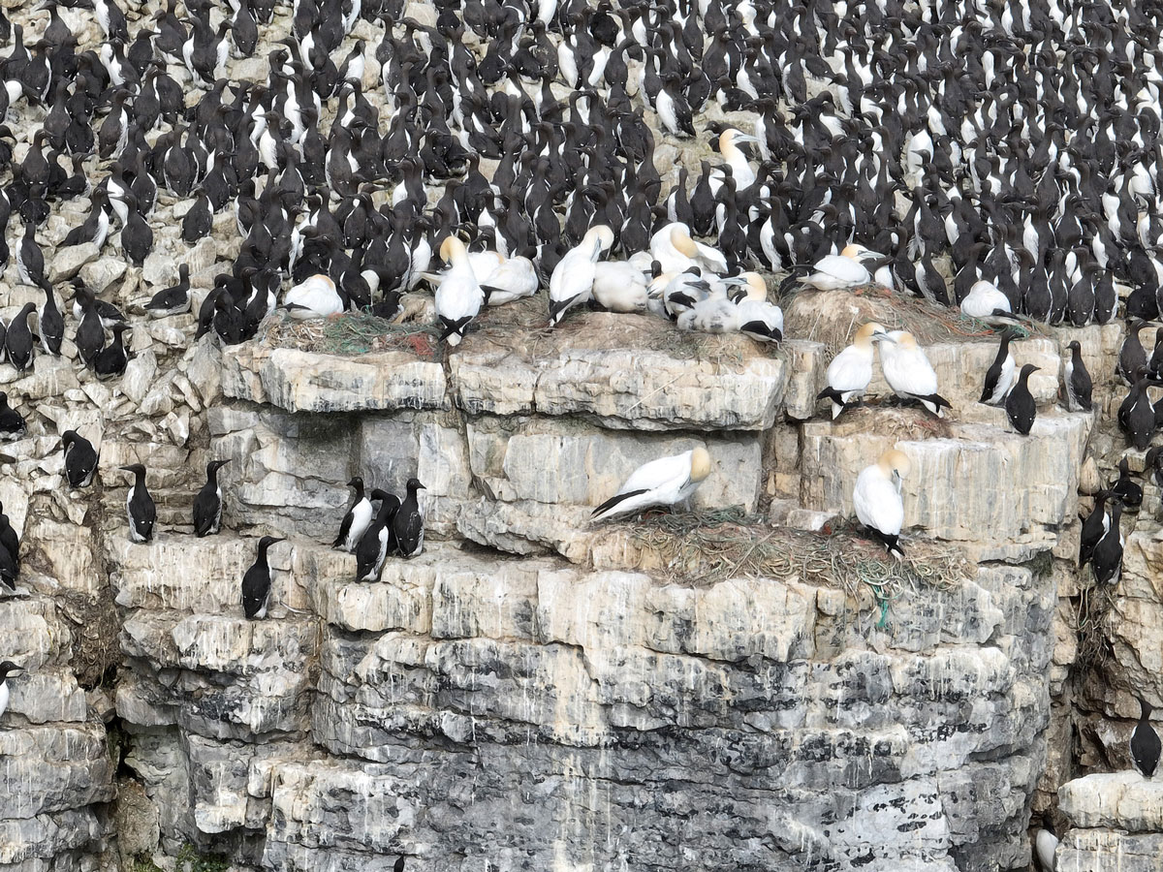

Image of northern gannet and common guillemot on a cliff face on Bjørnøya.

Photo: Norwegian Polar Institute

Svalbard is exposed to long-range transport of environmental contaminants through air and ocean currents. Most of the environmental contaminants found in the Arctic are long-range transported. Although the levels of several environmental contaminants have decreased in the Arctic, they remain high in polar bears, ivory gulls, glaucous gulls, northern fulmars and many other species. Climate change involving rising temperatures is expected to increase the spread of environmental contaminants, globally. Melting sea ice and permafrost thaw can cause remobilisation and evaporation of environmental contaminants to the Arctic atmosphere.

In Svalbard, the main challenge is to ensure that the objective of preserving Svalbard’s unique natural wilderness is maintained at a time when climate change, in conjunction with activity and traffic, is putting pressure on wilderness areas. In order to achieve the environmental objectives in Svalbard, it is important to limit the impact of local activity.

## Increased activity

Traffic in Svalbard has increased, posing a challenge to achieving the environmental objectives. Tourism has expanded to new areas and sea-based tourism has in recent years extended its season. Much of the increased activity has taken place within nature reserves and national parks. This entails a greater potential for the disturbance of wildlife and the degradation of nature and cultural heritage sites, especially in coastal areas. There is also the risk of shipping accidents and acute pollution. Many species and areas are also becoming more vulnerable to disturbance from local activity as a result of climate change. Climate change, in conjunction with increased traffic, has led to a greater overall strain on flora and fauna.

## Policy instruments

The Svalbard Environmental Protection Act and accompanying regulations are the most important policy instruments for achieving the environmental objectives for Svalbard. The purpose of the Svalbard Environmental Protection Act is to maintain a virtually pristine environment. Within this framework, the Act allows for environmentally responsible settlement, research and business operations. The Act sets the framework for all activities and land use that may impact the environment. The Svalbard Environmental Protection Act contains provisions on area protection, flora, fauna, cultural heritage sites, land-use planning in the local communities, encroachment into the natural environment, traffic and pollution and waste. In the land-use planning areas, the Svalbard Environmental Protection Act and accompanying regulations define the framework for land-use planning and activity that may impact the environment. Within the protected areas, the protection regulations have their own provisions to safeguard the protection purpose.

The protected areas in Svalbard cover 68 per cent of the land areas and 88 per cent of the territorial sea, and are important for the preservation of the natural wilderness. In 2021, the protected area around the Van Mijenfjord was expanded by almost 3,000 square kilometres. Van Mijenfjorden is an important habitat for ringed seals and polar bears, and one of the aims of protection is to safeguard important habitats for species that are dependent on ice. A small area around Svea is not included in the expansion of the national park.

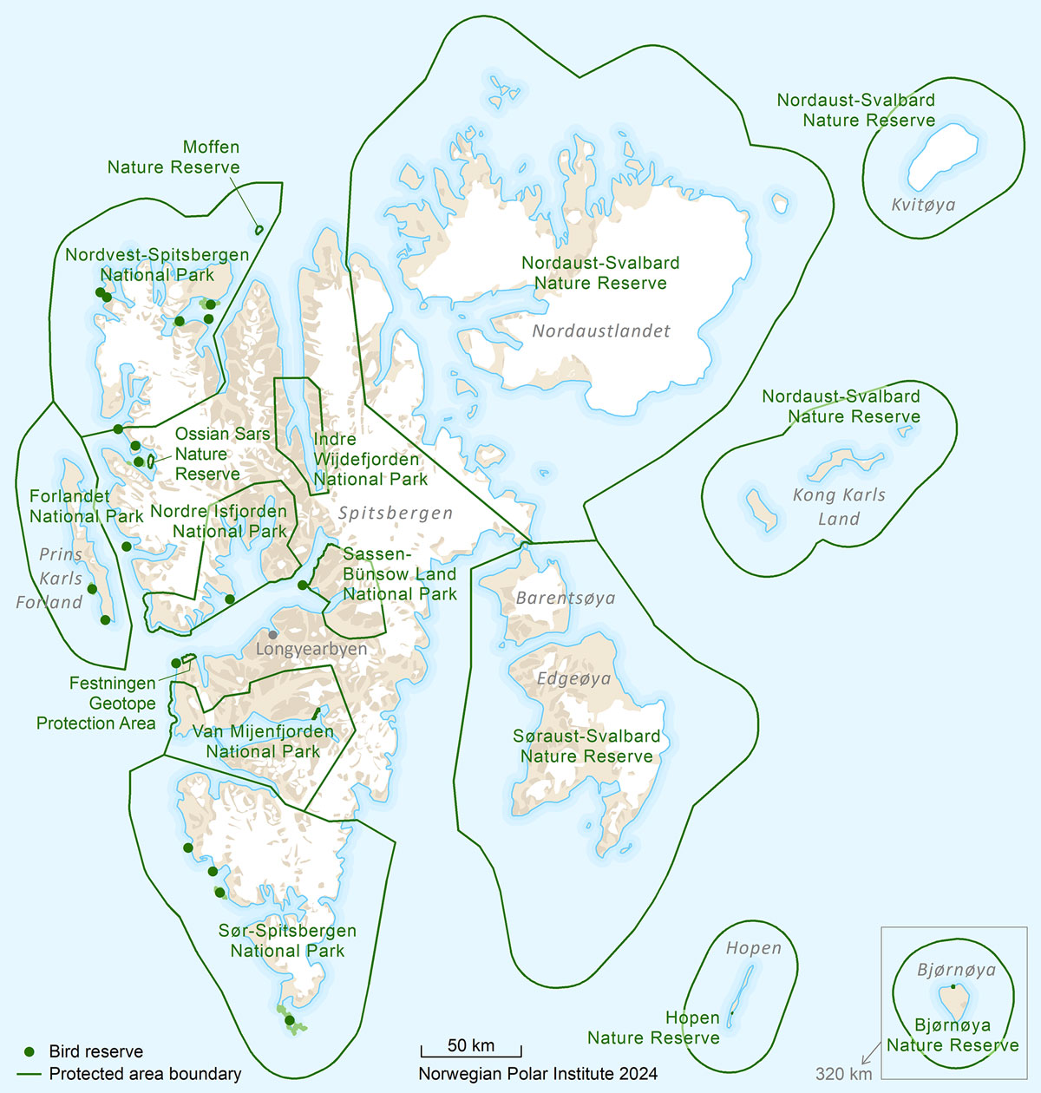

Map of protected areas in Svalbard.

Map: Anders Skoglund, Norwegian Polar Institute

Management plans have been drawn up for the nature reserves in East Svalbard, Bjørnøya and Hopen. Work on management plans for the national parks, nature reserves for birds on the west side of Spitsbergen and the Isfjorden area was put on hold in 2020 pending other regulatory work. Amendments to the protection regulations were adopted in February 2024 and will enter into force on 1 January 2025. Work on drawing up management plans will be resumed in order to clarify the content of the protection regulations, so that activities and traffic are in accordance with the purpose of protection. The Government will also consider preparing an overall strategy for traffic in the Isfjord area, including both protected and unprotected areas, in order to ensure that the activity takes place in line with environmental objectives and legislation.

A general heavy fuel oil ban has been introduced in the territorial sea around Svalbard, effective from 2022. Shipping accidents involving oil spills are considered one of the greatest threats to Arctic ecosystems. Vast distances, challenging weather, ice and temperature conditions, as well as limited access to oil spill response resources, make oil spill preparedness difficult in Svalbard.

The current legislation, which aims to maintain a virtually pristine environment, provides a good starting point for addressing the current challenges. The Government will maintain the current protected areas. At the same time, it must be assessed whether the current protection provisions are sufficient to address the consequences of climate change and future activity.

## Challenges

### Preservation of wilderness

The natural wilderness in Svalbard is well preserved. With the exception of the areas around the local communities and the mining facilities, Svalbard is a large, contiguous wilderness area. The proportion of Svalbard’s land areas that are characterised by wilderness based on the definition of heavy infrastructure development used on the mainland is 96 per cent. Wilderness areas are areas located more than five kilometres great-circle distance from heavy infrastructure development. The corresponding figure for the mainland is 11.5 per cent.

The preservation of natural wilderness in Svalbard is the result of a long-term policy and effective measures. In protected areas, encroachment into the natural environment is generally not permitted. Section 56 of the Svalbard Environmental Protection Act stipulates that settlements and commercial activities shall, as a general rule, be located in the land-use planning areas.

For areas that are not protected, the Svalbard Environmental Protection Act stipulates that a permit is required for activities that involve encroachment into the natural environment. The establishment of mining activities, for example, requires a permit under the Svalbard Environmental Protection Act, and the possession of land does not entitle the owner to carry out encroachments into the natural environment in Svalbard. In areas that are not protected, the Svalbard Environmental Protection Act provides for a restrictive practice in terms of permits and conditions for activities that encroach on the natural environment. For example, it is not expected that permits will be granted to establish new research stations or other major, permanent research infrastructure outside the planning areas.

Section 59 of the Svalbard Environmental Protection Act stipulates the requirement for environmental impact assessments for all activities that may have a more than an insignificant effect on the natural environment outside land-use planning areas. This means that when applying for test drilling for minerals, for example, the overall impact of the exploration activities on the environment, both in terms of scope and time, must be assessed. If, following such an assessment, the head of undertaking is granted a permit for test drilling for minerals, this does not automatically mean that a permit will later be granted to commence mineral extraction. This will be an independent assessment under the Svalbard Environmental Protection Act, which is based on the objective of preserving a virtually pristine environment and the objective of maintaining the extent of wilderness areas in Svalbard.

The Svalbard Environmental Protection Act stipulates that also inside the land-use planning areas new or expanded activities must safeguard considerations for the natural environment. For encroachments within or in the extension of established mining areas and local communities, strict conditions will be imposed to safeguard environmental considerations in the event of new or expanded activities.

The clean-up and restoration of nature after operations have ended is also important to maintain the scope of natural wilderness in the long term. When a permit was granted in 2011 for a new mine in Lunckefjell, it was subject to the condition that the affected area be returned to its original state after the end of operations. Emphasis was also placed on the fact that the period of operation would only last for five years before reversion, and that the encroachments were therefore of a temporary nature. Clean-up and reversion have now been successfully completed. Similar requirements must be expected if permits are to be granted for other expansions of existing mining sites or other activities that entail more extensive encroachments on nature. The clean-up in Svea is Norway’s largest nature restoration project to date.

### Traffic

In Svalbard, approximately 10 per cent of the land area is covered by vegetation. Most types of vegetation in polar regions have a limited capacity for regrowth. Climate change is resulting in increased precipitation and permafrost thaw, which in turn makes the terrain more vulnerable. Traces of activity in the terrain can remain visible for many decades after use has ceased. Significant degradation has been documented at several frequently used landing sites for cruise ships, as well as older track damage from off-road driving several decades ago. There is currently no adequate overview of the status and development of terrain damage. In recent years, the Norwegian Polar Institute has been working on establishing a monitoring programme that will eventually provide the administration with more knowledge about the environmental impact of traffic.

The increase in tourism from 2012 to 2019, and in particular the increase in expedition cruise tourism, was considered a challenge for the environmental objectives and legislation. Regulatory work was therefore initiated, which has now been finalised. From 2025, new rules will apply to traffic under the Svalbard Environmental Protection Act and accompanying regulations.

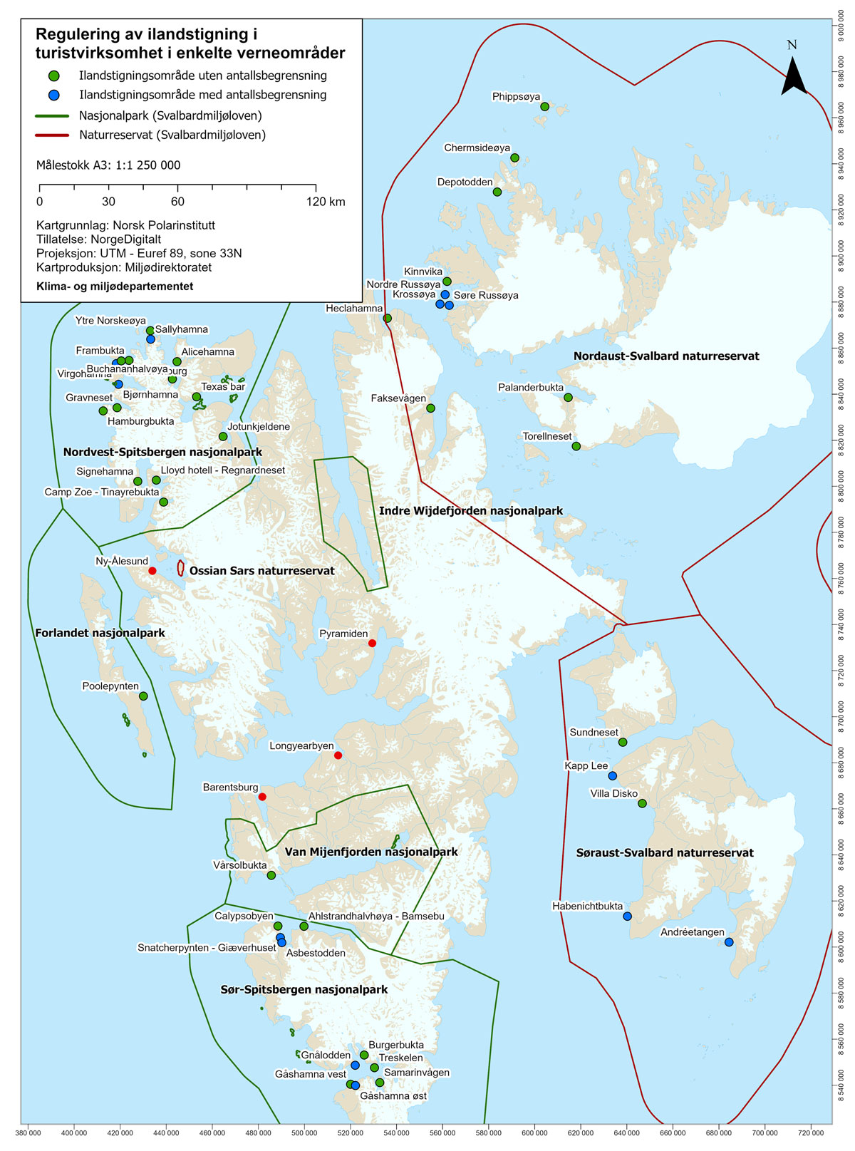

Map showing landing sites for tourism activities.

Map: Anders Skoglund, Norwegian Polar Institute

In order to safeguard the overriding goal of preserving natural wilderness, there is still a need to consider measures to reduce the overall environmental impact of cruise operations. See section 6.6.

The use of snowmobiles is the most common form of transport during winter, and it is an attractive activity for the tourism industry. Permanent residents are permitted to drive snowmobiles in a broader range of areas than visitors, as the use of snowmobiles is important both for recreational activities and to be able to travel outside the local communities. Snowmobiles are also widely used in connection with research, monitoring and teaching.

Snowmobile traffic in Svalbard has increased. Wildlife is subject to greater disturbance today than when the existing legislation governing motorised traffic was drawn up in the early 2000s. In addition, climate change has altered the possibilities for motorised traffic. The Government will revise the Regulations relating to motorised traffic in light of changing natural conditions, traffic patterns and forms of traffic.

The peak season for snowmobile excursions coincides with the most vulnerable period for species that depend on ice. Ringed seals moult (give birth) and female polar bears venture out of the den with their cubs during this period in search of food. There are fewer ice-covered fjord areas on the west coast now than before. At the same time, the same areas are attractive destinations for snowmobile excursions. This increases the possibility of disturbing polar bears and seals. To prevent the disturbance of these species, the Governor of Svalbard has since 2018 laid down temporary traffic regulations pertaining to the sea ice in Billefjorden, Tempelfjorden and Rindersbukta in Van Mijenfjorden. From 1 January 2025, the traffic regulations will become permanent following an amendment to the Regulations relating to motorised traffic in Svalbard, and also encompass Van Keulenfjorden and Van Mijenfjorden, as well as Dicksonfjorden for visitors.

The Arctic is home to a number of marine species that use sound to communicate, navigate and search for food. Activities that produce underwater noise can affect these functions. However, there are major knowledge gaps regarding the effects of underwater noise. In 2022, the Norwegian Polar Institute conducted studies in Kongsfjorden and in the areas south of Kvitøya. The peak season for boat traffic in Kongsfjorden is from June to September. During this period, noise levels often exceed the internationally accepted acoustic thresholds for the disturbance of marine mammals. The Government recognises that there is a need to assess the impact of noise on life in the most heavily trafficked fjords of Svalbard, including Isfjorden and Kongsfjorden, and to consider the need for measures.

### Species management

Harvesting

In principle, all fauna in Svalbard is protected under Section 25 of the Svalbard Environmental Protection Act. However, harvesting, including hunting, trapping and gathering of eggs and down, is permitted to a limited extent, mainly by the local population. For the local population, opportunities for such limited harvesting are important for recreation and well-being. According to Section 5 of the Regulations of 24 June No. 712 relating to harvesting of the fauna on Svalbard, harvesting must not significantly alter the composition and development of the populations. There are set rules for which species may be harvested and during which periods.

Climate change affects many species, as do various diseases, parasites, pollution and marine litter. In order to ensure that harvesting does not impact populations, the Governor of Svalbard has in 2024 been tasked with creating a comprehensive strategy for managing harvestable species. Work has also been initiated on revising the legislation governing harvesting.

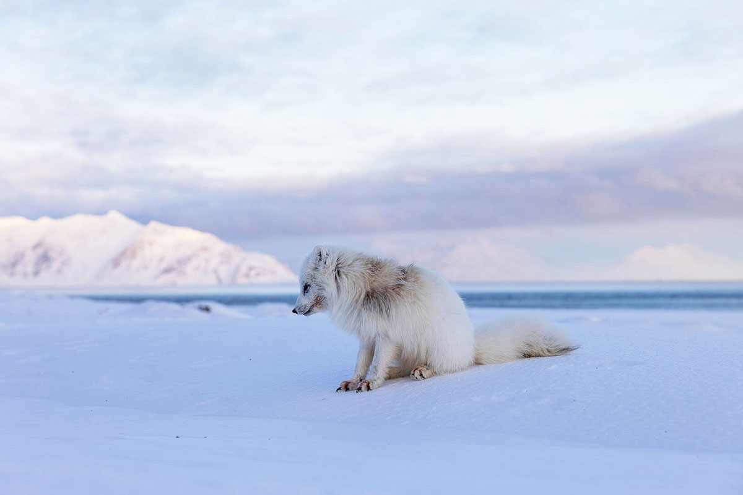

Fox with sucking lice – the area with lice is slightly darker and the fur is in the process of being scratched away. For the 2023/2024 harvesting season, the prevalence of sucking lice in all foxes totalled 45 per cent, approximately the same prevalence as in 2022/2023.

Photo: Tommy Dahl Markussen

The environmental objective that flora and fauna shall be preserved virtually untouched by activity in Svalbard also applies in the territorial sea. Bottom trawling is one of the local activities with the greatest impact on the marine environment. This is particularly true of benthic life, which is vulnerable in the waters around Svalbard. According to the protection regulations, shrimp trawling is permitted in all the major protected areas in waters with depths greater than 100 metres. The sea ice is now retreating, making new areas accessible and increasing the opportunities for bottom trawling. In areas that have rarely or never been trawled, shrimp trawling is currently not permitted under the regulations governing fisheries. However, it is possible to apply for a test-fishing permit. Strict requirements must be met in order for such an application to be granted, and then only at depths greater than 100 metres. Consequently, the threshold for granting authorisation is high. The authorities have not received any such applications to date. Furthermore, an applicant is not automatically entitled to a permit, even if the conditions are met. Furthermore, regular shrimp trawling at depths greater than 100 meters cannot be allowed without further consideration.

Alien species

Alien species are considered one of the greatest threats to biodiversity. Alien species are species that are not endemic to Svalbard’s nature and that have arrived there by human activity. Species that occur naturally in the areas south of Svalbard and expand their range northwards as a result of climate change are not considered alien species, even though they may be new to Svalbard.

Several new species have been observed, partly as a result of a warmer climate and partly through the introduction of species. Rapid warming is weakening the climatic barrier against the spread of alien species from temperate regions. This increases the risk of such species gaining a foothold and spreading to Svalbard and in Arctic waters, where they risk displacing naturally occurring species. Under sections 26 and 27 of the Svalbard Environmental Protection Act, a permit is required for the import, release and transport of flora, fauna and organisms that do not occur naturally in Svalbard.

In the Norwegian Biodiversity Information Centre’s Black List of alien species from 2023, 67 alien species are registered in Svalbard. An action plan against alien species in Svalbard has been drawn up, which the Governor of Svalbard is responsible for following up.

The Norwegian Polar Institute has been commissioned to update the state of knowledge about alien species in Svalbard. The need for measures will be assessed when new and updated knowledge is available.

### Pollution and waste

No separate goals have been set for pollution in Svalbard. However, the following national goals apply:

* Pollution shall not harm health or the environment.
* The use and release of chemicals on the list of priority substances shall cease.

Currently, mercury, PCBs, brominated flame retardants, chlorinated pesticides and PFAS are among the environmental contaminants regarded as most problematic in the Arctic. In addition to long-range pollution, there are also local sources of pollution in Svalbard. Following the closure of the coal-fired power station in Longyearbyen and the closure of Mine 7 in 2025, these local sources of pollution will become less significant. Barentsburg still has coal mining operations and a coal-fired power station.

Permafrost has acted as a barrier to the spread of pollution. Increased permafrost thaw, increased coastal erosion and physical encroachments can lead to leaching and the spread of pollution. Former mining activities, landfills, the use of PFAS on firefighting training sites and other activities have contributed to the contamination of large parts of the ground in the planning areas. It is necessary to gain a better overall understanding of soil contamination in order to assess where there is contamination in the soil that poses a risk of harm to health and the environment, and where measures are needed. The planning areas will be prioritised first.

Large amounts of litter drift ashore every year. The fishing fleet in the Norwegian and Barents Seas appears to be the largest source of beach litter in Svalbard. Mammals, birds and fish risk getting caught in old lines, ghost nets and other litter. Such litter can kill them or cause them significant external injuries. Plastic fragments are ingested by seabirds, fish and whales. Plastics can damage internal organs and, in the worst case, kill the animals that ingest them. In addition to having a direct effect on animals, microplastics can act as dispersal and absorption pathways for environmental contaminants.

National and international efforts on measures to reduce marine litter from marine activities and fisheries are needed. Since the year 2000, the Governor of Svalbard has worked with the local population to clean up beach litter through organised beach clean-ups and on separate expeditions to limit the spread of litter. The expedition cruise industry has also contributed to cleaning up considerable amounts of marine litter. In addition, the Governor of Svalbard has drawn up a strategy to reduce marine litter in and around Svalbard. Further work will include a systematic assessment of such waste, and examining it in the context of knowledge regarding habitats for vulnerable species. Beach cleaning, both voluntary and professional, should be prioritised in these areas.

### Land-use planning in the local communities

Increased activity in the local communities and their surrounding areas can affect the environment both within and outside the planning areas.

Chapter VI of the Svalbard Environmental Protection Act regulates the planning of land use in the land-use planning areas. The purpose of the provisions is to ensure that development in the planning areas occurs in accordance with the objectives of the Act. Each planning area has a designated party responsible for land-use planning that, in addition to carrying out ongoing planning, shall ensure that the plan is adhered to and followed up. In Barentsburg, Pyramiden and Ny-Ålesund, the landowner is the party responsible for land-use planning. In Longyearbyen, the Longyearbyen Community Council has been delegated authority for land-use planning within the Longyearbyen planning area.

Climate change

In Svalbard, as in the rest of the country, climate change is leading to an increased risk of natural hazards and damage, including a greater risk of landslides and flooding, more extreme weather and higher storm surges.1 Physical infrastructure such as roads, buildings and harbours will therefore be more vulnerable to these types of climate-related events. Climate-related events can pose a threat to life and health. Climate change is putting additional strain on an already vulnerable infrastructure, creating a need for upgrades and adaptation. Therefore, it is crucial that land use and community planning in the planning areas take climate change into account.

1 Norwegian Centre for Climate Services, “Climate in Svalbard 2100”, January 2019

[Boks slutt]

The local communities in Svalbard vary greatly in nature, and there are different types of land conflicts to be resolved. The planning system under the Svalbard Environmental Protection Act is flexible, and allows for the details to be adapted according to the needs of the communities.

One of the main purposes of land-use planning is to provide instructions for where and how construction can take place. It is also important for the sake of predictability for residents in local communities. The land-use plan must be sufficiently detailed to provide a basis for subsequent planning and building decisions. For some areas it will be necessary to prepare separate sub-plans.

Adventdalen

Adventdalen is considered one of the most important areas for waders and freshwater birds in Svalbard, and a total of 16 of Svalbard’s red-listed bird species are found here. A proposal for the protection of lower Adventdalen has been submitted for consultation.

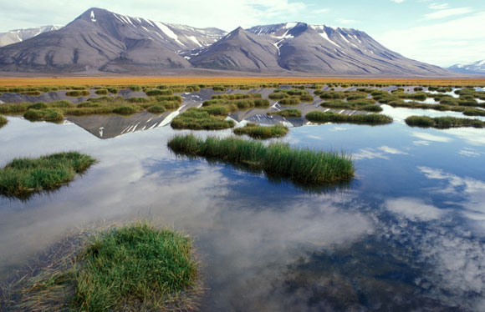

Adventdalen – Trolltjern.

Photo: Bjørn Lytskjold, Norwegian Polar Institute

[Boks slutt]

Mine 7 is scheduled for closure in the summer of 2025. Any subsequent use of the mining area involving a change in land use must be based on the land-use plan for the Longyearbyen planning area.

In Barentsburg, the land-use plan from 2004 is being revised. A new planning programme was adopted in autumn 2015, and the party responsible for planning, Trust Arktikugol, has continued to work on updating the plan. Pyramiden had its first land-use plan adopted by the Governor of Svalbard in 2014, and activities at the site will take place within the framework of this land-use plan. Trust Arktikugol is the party responsible for planning in relation to Pyramiden.

At Sveagruva, the land-use plan was revised in 2012, and from 2017, clean-up efforts were carried out in accordance with the closure plans approved by the Governor of Svalbard. The clean-up project was completed in the autumn of 2023. In Ny-Ålesund, the work of reviewing the current land-use plan from 2009 is now being finalised.

The planning provisions in the Svalbard Environmental Protection Act have remained largely unchanged since 2002. Local communities in Svalbard have undergone major changes, particularly in terms of activity and land use in the planning areas. It is natural to consider whether the Svalbard Environmental Protection Act’s provisions on land-use planning meet the current needs in terms of land-use planning in Svalbard. The Government will initiate work to review the planning provisions in the Svalbard Environmental Protection Act, aiming to organise, clarify and update the legislation.

### Cultural environments

With its distinctive history, Svalbard has a unique and valuable cultural heritage. Traces from the earlier periods are fragile and vulnerable, and all cultural heritage sites dating from before 1946 are therefore automatically protected under Section 39 of the Svalbard Environmental Protection Act. The cultural environments offer experiences and knowledge of polar history for both permanent residents and visitors, and are partly in active use.

The national objectives for cultural environment policy are anchored in Report to the Storting (white paper) No. 16 (2019–2020). In Svalbard, the goal is to safeguard the “100 most important cultural heritage sites” by way of active management. The national goal is followed up by carrying out prioritised measures and tasks in the Cultural Environment Plan for Svalbard.

Climate change in Svalbard and increasing traffic have a major impact on the cultural environment. Many of the cultural heritage sites are located on the coast, and retreating sea ice, more erosion, increased precipitation and permafrost thaw mean that more cultural heritage sites are at risk of being lost. It is necessary to clarify which cultural heritage sites should be preserved through active measures, and which should only be passively protected against encroachment or wear that can accelerate degradation. It is also necessary to consider climate adaptation measures and clarify how the administration should address the loss of cultural heritage sites, for example through documentation or emergency excavations.

The vast majority of the more than 300 automatically protected buildings in Svalbard are located on government-owned land. Those located outside the planning areas are mainly cabins and traces of various forms of human activity. In order to have an adequate overview of the condition and need for refurbishment, the Governor of Svalbard has been tasked with assessing and registering the condition of the state-owned cabins in Svalbard. The condition assessments will form the basis for future prioritisations under the Cultural Environment Plan.

Together with the Ministry of Trade, Industry and Fisheries, the Governor of Svalbard established a two-year trial project in the spring of 2023 with the Center for Cultural Heritage Protection at Svalbard Museum. The goal is to bring together craftsmen to share their expertise and ensure a good quality of restoration and maintenance of cultural environments. At the same time, such a measure can contribute to cultivating the Governor of Svalbard’s role as the administrative authority on the subject.

The consequences of climate change

The cultural environment and individual objects in Hiorthhamn are exposed to a number of destructive forces that have, in part, dramatic effects on the cultural heritage sites and the environment. This includes soilfluction, changes in the active layer of the soil that thaws during the summer months, rot, coastal erosion and wear and tear caused by visitors. For the time being, only temporary measures have been taken in the form of relocating the forge and laying rocks on the most critically exposed side of the building. The manner in which the cultural environment in Hiorthhamn can be preserved is being assessed. In the background of this photo, the forge is being moved.

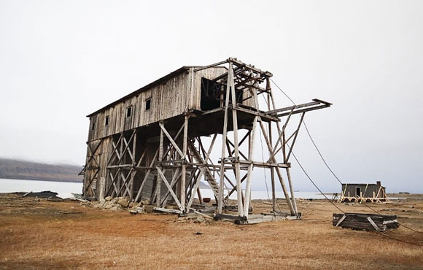

Hiorthhamn.

Photo: Edvard Undall, Norwegian Institute for Cultural Heritage Research

[Boks slutt]

In Svalbard, the Directorate for Cultural Heritage is the cultural environment authority for automatically protected cultural heritage sites, and makes decisions on exemptions under Section 44 of the Svalbard Environmental Protection Act. On the mainland, the county authority has been delegated the administration of most of the automatically protected cultural heritage sites.

The Government will delegate the Directorate for Cultural Heritage’s exemption authority for cultural heritage sites in Svalbard to the Governor of Svalbard. Delegation will contribute to cultivating the Governor of Svalbard’s role as the administrative authority and the Directorate for Cultural Heritage’s role as the specialised directorate, and it will reduce the distance between the applicant and the decision-making authority with shorter case processing times. The appeals and review authority will remain with the Directorate for Cultural Heritage.

### Environmental management’s need for knowledge

Good and up-to-date knowledge about the state of the environment and possible development trends is essential for effective environmental management. Knowledge from environmental monitoring is the basis for assessing the extent to which the national environmental objectives for Svalbard are being achieved and whether the implemented environmental measures are having the desired effect. Long and continuous time series are important for monitoring changes in the environment and nature. They are also important for assessing whether management is in line with the environmental objectives for Svalbard, or whether there is a need for new measures and policy instruments.

There are still major knowledge gaps regarding climate and environment in Svalbard, and there is a need to strengthen the knowledge base. In general, there is a considerable need for better knowledge about the effects of climate change and how they interact with the environmental impact of local activities in Svalbard. Furthermore, there is a need for knowledge about the expected rapid future climate change and the environmental effects thereof. There is also a need for better monitoring of the effects of traffic on vegetation and wildlife, as well as underwater noise and its effects on wildlife. Furthermore, there is a need to further develop knowledge about endangered and vulnerable species and habitats in Svalbard, with an emphasis on marine habitats and habitats associated with sea ice. There is also a need to examine the development of ecosystems as a whole and not just individual species. Efforts are also being made to improve the environmental monitoring of cultural heritage sites. Environmental monitoring is necessary to obtain the knowledge that is important for the administration of Svalbard, and also as a basis for international processes and agreements on climate and the environment.

Environmental monitoring from the Zeppelin Observatory in Ny-Ålesund comprises long-range transboundary air pollution, heavy metals, organic environmental contaminants and chlorinated and fluorinated greenhouse gases. There is also significant monitoring of several animal populations in Svalbard, and environmental contaminants are also being monitored in several of these animals. This knowledge gathering is and will continue to be important in order to obtain an overview of how long-range pollution is added to and concentrated in the Arctic environment. Furthermore, it will contribute to understanding the impact of the pollution on exposed and vulnerable species in Svalbard, such as marine mammals and seabirds.

The Governor of Svalbard, Longyearbyen Community Council, Svalbard Museum and the Norwegian Polar Institute have jointly worked to establish a nature information centre. The nature information centre will communicate the values of the natural and cultural environment in Svalbard and can be a tourist attraction that will contribute to local value creation. The Government is working to establish a nature information centre as part of the Svalbard Museum in Longyearbyen.

## Measures

The Government will:

* Safeguard the unique natural wilderness in Svalbard, continue the environmental objectives and the Svalbard Environmental Protection Act’s provisions and restrictive practice for authorisation of major encroachments into the natural environment outside the planning areas.
* Maintain current protected areas through management in line with the purpose of the protection. At the same time, it must be assessed whether the current protection provisions are sufficient to address the consequences of climate change and future activity.
* Continue work on management plans for the protected areas, so that traffic and activities take place in accordance with the protection purpose.
* Consider developing an overall strategy for traffic in the Isfjord area, including both protected and unprotected areas, so that activities take place in line with environmental objectives and legislation.
* Revise the Regulations relating to motorised traffic in light of changing natural conditions, traffic patterns and forms of traffic.
* Assess the impact of noise on life in the most heavily trafficked fjords in Svalbard, including Isfjorden and Kongsfjorden, and consider the need for measures.
* Implement the necessary changes to the legislation governing harvesting under the Svalbard Environmental Protection Act.
* Update the knowledge base on alien species and consider new measures.
* Ensure that a comprehensive overview of soil contamination in Svalbard is prepared, giving priority to the planning areas.
* Ensure a systematic assessment of marine litter in Svalbard, and consider the areas with considerable amounts of marine litter in the context of knowledge about habitats of vulnerable species. Beach cleaning should be prioritised in these areas.
* Review the planning provisions in the Svalbard Environmental Protection Act and propose possible amendments.
* Assess the condition of the State’s protected cabins in Svalbard as a basis for future prioritisation under the Cultural Environment Plan.
* Delegate the Norwegian Directorate for Cultural Heritage’s exemption authority for cultural heritage sites in Svalbard to the Governor of Svalbard.
* Strengthen the knowledge base for environmental management with an emphasis on monitoring the effects of climate change and traffic, and the impact this has on the natural environment, cultural heritage sites and wildlife.
* Strengthen communication and knowledge about the unique environmental values of Svalbard by working to establish a nature information centre as part of the Svalbard Museum in Longyearbyen.

# Community development and commercial activities in Longyearbyen

## Introduction – objectives and overall framework

One of the overriding objectives of Svalbard policy is the maintenance of Norwegian communities in the archipelago. This objective is achieved through the family community in Longyearbyen. Commercial activity is not intrinsically an objective of Svalbard policy, but rather a means of supporting the objective of maintaining Norwegian communities. When the 2016 Svalbard white paper was presented, it was clear that coal mining, traditionally the mainstay of Longyearbyen, had declined in significance and that the community was facing a necessary transition. The Storting’s consideration of the report facilitated the continued development of existing activities such as tourism, research and higher education, as well as a broad and varied commercial activity, preferably involving secure, year-round jobs. At the same time, it was emphasised that it is not an aim in itself for the community to grow beyond the current level, meaning that no development should be facilitated that would result in the need for an expansion of services or major investments in infrastructure.

The restructuring has been successful in many ways. Today, Longyearbyen has a differentiated business community consisting of companies involved in tourism, communications, the service industry, building and construction. However, it also has clear elements of research and higher education. At the same time, Longyearbyen has developed into a more modern family community. The population has increased and there are now just under 2,600 residents, compared with around 2,130 in 2016. As well as businesses, education and research contribute to maintaining a stable family community and the active participation of students in culture and outdoor recreational activities represents a positive contribution to the local community. In addition, there are public and governmental functions necessary to operate and govern the community which are adapted to developments in the community in general.

Going forward, Longyearbyen shall remain an attractive place for Norwegian families, thereby contributing to fulfilling the objective of Norwegian communities on the archipelago. Facilitating a family community so far north is expensive, and an increase in population and activity also entails increased costs for the State. The instruction that Longyearbyen is not to be a community for lifelong residence remains fixed, and it is not desirable for the community to grow beyond its current level. Development triggering the need for considerable investments in infrastructure or the expansion services offered in Longyearbyen shall not be facilitated. At the same time, Longyearbyen shall be a good place to live for its inhabitants. There shall be activities that contribute to the fulfilment of the overriding objectives of Svalbard policy. To ensure development corresponding with these instructions, it is necessary to adjust the relevant policy instruments. Below, the Government describes community development and commercial activity in Longyearbyen, and proposes certain measures to ensure continued development in line with the objective of maintaining Norwegian communities on the archipelago.

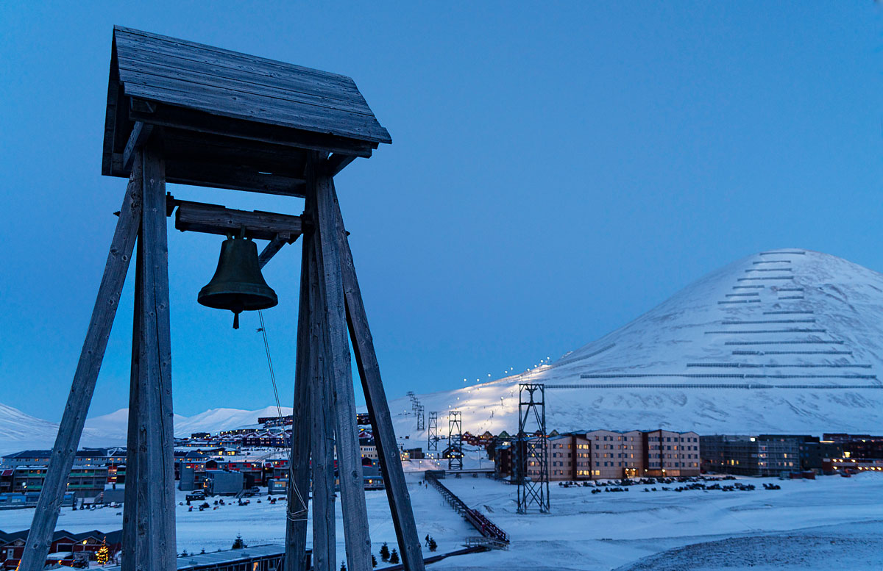

View from Skjæringa towards the town centre with avalanche barriers and slalom slope in the background.

Photo: Eva Grøndal, Grøndal Foto

## The objective of maintaining Norwegian communities on the archipelago

People from different countries have always been drawn to Svalbard, which today contributes to making Longyearbyen a vibrant and diverse community. This is valuable. While the number of inhabitants has increased in recent years, the composition of the population has also changed. Today, the proportion of foreign nationals is around 36 per cent, while in 2009 and 2016 it was around 15 per cent and 26 per cent, respectively. Research, education and the tourism industry employ a wider range of nationalities than, for example, the mining industry. Therefore, this is a natural development. However, it must also be considered in relation to the fact that the Immigration Act does not apply to Svalbard. There is cause to monitor developments in the composition of the population. Longyearbyen fulfils the overall objective of Norwegian communities on the archipelago, and it is important to facilitate a good balance between Norwegian and foreign nationals.

A well-developed infrastructure, good provision of services, as well as a wealth of cultural and recreational offerings are factors that can make settlement in Longyearbyen an attractive prospect. Figures from Statistics Norway (report 2023/36) indicate that, on the whole, living conditions in Svalbard appear to be somewhat above the average for communities on the mainland, although there is considerable variation between groups. It is also noted that the average duration of residence among Norwegians is decreasing. Figures from Statistics Norway (SSB 2023/36) illustrate that the median duration of residence for Norwegian nationals was 3.4 years as of January 2024. This is a decrease of more than 20 per cent since the previous white paper was presented. This development must partly be considered with reference to the downsizing of the mining operations, but may also be related to higher price and cost levels, partly as a result of two households. In 2022, residents from several foreign countries had a higher median duration of residence than Norwegians, especially Thai nationals, who also have the highest average duration of residence at more than 10 years. More knowledge is required about the conditions that affect the residential desirability in Longyearbyen. In order to monitor developments in Longyearbyen, the Government will consider conducting a survey on living conditions. Such surveys have been conducted in the past and will provide a useful basis for governance. It is important to have a strong Norwegian presence, including to ensure an effective and credible exercise of authority. Therefore, the Government will introduce incentives to render it more attractive for Norwegians to move to and remain in Svalbard.

The Government is committed to Longyearbyen remaining a good setting for those who live and work there. For example, foreign residents with no connection to the mainland have access to services in Longyearbyen, while their children will be entitled to a school place after three months of settlement. Foreign residents will also have access to other services, although persons with no connection to the mainland may be required to pay for services such as healthcare at Longyearbyen Hospital.

Access to benefits from the National Insurance Scheme will also vary. Persons who are insured under the National Insurance Scheme when they arrive in Svalbard will retain their insurance, regardless of whether or not they are Norwegian citizens. Other foreign nationals may be entitled to insurance if they are employed by a Norwegian employer.

It is the State that administers the National Insurance Scheme and, together with Longyearbyen Community Council, it largely facilitates the services offered in Longyearbyen. Considering recent years’ developments in terms of the demographic composition of Longyearbyen, the Government sees a need to distinguish to a greater extent between residents with a mainland connection and residents arriving directly from abroad. At present, the rate of employer’s National Insurance contributions in Svalbard is set at zero, while contributions from employees are 7.8 per cent. The Government will consider whether to introduce an employer’s National Insurance contribution for Norwegian employers that employ persons who become insured under the National Insurance Scheme through their employment. The Government will also consider whether persons who gain insurance through their employment should have a higher National Insurance contribution rate, and whether they should be entitled to accrue benefits such as child benefits and cash-for-care benefits. A similar distinction has already been established by requiring three years’ residence on the mainland for foreign nationals to be able to vote and stand for election in Longyearbyen.

At the same time, the Government is committed to ensuring orderly pay and working conditions for all employees in Longyearbyen, and will, by the end of 2024, present a proposal to make the Act relating to general application of collective agreements (the General Application Act) applicable to Svalbard. Based on a more detailed assessment of local development trends and needs, the Government will consider deferred implementation for parts of the archipelago. The Government will also consider other measures to promote a legitimate working life for employees and employers, such as formalising the requirement for public sector actors to ensure that pay and working conditions for employees comply with the applicable national collective agreement for the industry in question when entering into various types of agreements.

Business development

Business development has led to an increase in the number of businesses, and there are currently just over 400 businesses in Svalbard compared with just under 300 in 2015. The figures also indicate that since 2015 there has been an increase in the proportion of employees who work part-time and seasonally. This increase has to do with tourism-related industries such as lodging and food service activities, business services and cultural and entertainment activities. There has also been an increase in unregistered residents who work in the tourism industries for shorter periods and who are not entered in the Population Register of Svalbard.

[Boks slutt]

Population growth increases pressure on the provision of services, as well as on infrastructure such as energy, roads and water supply. Public sector actors fund and maintains a large part of the public infrastructure, including health, emergency preparedness and rescue services. Since 2016, one of the main challenges has been to protect the population of Longyearbyen from avalanches and to build avalanche-proof dwellings, replacing those that were lost or had to be demolished following the avalanches in 2015 and 2017. Recently, challenges related to energy transition, water supply and other infrastructure have become more pronounced. Investment and maintenance of such infrastructure is very costly. Parts of the infrastructure are currently funded by the residents of Longyearbyen in the form of municipal fees and charges, while other parts are funded by the central government through annual allocations.

Energy prices in Longyearbyen have increased significantly since the closure of the coal fired power plant and the transition to diesel as a source of energy. In the updated 2023 budget, the Storting therefore increased the allocation to Longyearbyen Community Council by NOK 50 million, based on a proposal from the Government, to contribute to reducing electricity prices. In the Revised National Budget for 2024, the Government proposed allocating an additional NOK 125 million for this purpose, as well as NOK 42 million for investments in infrastructure that strengthen redundancy and security of energy supply in Longyearbyen. At the same time, the Government proposed allocating NOK 3 million for state co-financing of a preliminary project to establish a reserve drinking water source in Longyearbyen. The Government will continue to assess the need for investments in critical infrastructure in Longyearbyen, including matters of financing.

The principle that no development shall be facilitated triggering the requirement for considerable investments in infrastructure, remains fixed. This entails that the scope of the housing stock shall not be expanded beyond the level prior to the avalanches in 2015 and 2017. However, in order to carry out necessary rehabilitation of the housing stock, property managers will need to have some excess inventory. Any replacement of dwellings should preferably be solved through transformation and densification rather than utilising undeveloped areas. These instructions, in conjunction with other frameworks for activity and the overall Svalbard policy goals, will contribute to determining the scope of action for commercial activities and community development in Longyearbyen.

## Provision of services in Longyearbyen

### Frameworks and instructions for the provision of services

In short, Longyearbyen can be described as a “robust family community” and has developed into a qualitatively good community with a provision of services adapted to the size and structure of the community within an environmentally sound framework. At the same time, the established policy is that Longyearbyen is not to be a cradle-to-grave community. A certain level of benefits has been facilitated in Longyearbyen, adapted to what has been necessary for a “robust family community” with residents who mainly reside in the community by virtue of their employment. For example, key acts such as the Act relating to social services in the labour and welfare administration (Social Services Act) do not apply to Svalbard, and health services are limited. The level of benefits available in Longyearbyen must be viewed in the context of the low taxation level that the Government will continue to facilitate, but is also a consequence of the fact that there is no requirement for a residence permit for foreign nationals who want to come to Svalbard. In conjunction with other framework conditions, this establishes clear guidelines for the level of service provision in Longyearbyen.

The Government is committed to ensuring that everyone who lives and works in Longyearbyen has opportunities and security during their time there. With a limited range of social and other services, adapted to a mainly working population, the established policy is that residents with a mainland connection will have to enquire with their home municipalities on the mainland should they have needs beyond the capacity of services offered locally, while residents without an association to the mainland will have to avail themselves to their home countries. Even a prolonged stay in Longyearbyen will not in itself provide an opportunity for residence on the mainland for foreign nationals. While Norwegian citizens can travel to the mainland for continued schooling and studies, and to their respective mainland municipalities to fulfil any needs for nursing and care services, foreign nationals without such an association do not have this option, apart from limited access to upper secondary education.

This can pose a challenge, not least for children born during their parents’ stay in Longyearbyen, where ties to their home country may have gradually weakened. It is important to emphasise that the responsibility in such cases lies with the parents. Emphasis must therefore be placed on ensuring that foreign nationals arriving in Longyearbyen are given good and targeted information about the legal and practical framework conditions that apply to residence in Svalbard, and that it is therefore important to maintain contact with their home country.

Services in Longyearbyen are provided by both central and local actors. Basic services are provided by Longyearbyen Community Council, Longyearbyen Hospital, the Governor of Svalbard and several other actors. Following the presentation of the white paper in 2016, it has been necessary to clarify some of the frameworks for the provision of services, for example by determining that children with more than minor and moderate needs for adapted education are not entitled to enrolment in school in Longyearbyen.

In order to maintain the frameworks for service provisions in Longyearbyen, it is important that all such decisions are in line with Svalbard policy. The established practice is therefore for the Governor of Svalbard to assist the mainland authorities in such matters. Accordingly, the Government will consider establishing regulations providing that the County Governor’s supervision of kindergarten operations and education in Longyearbyen shall be carried out in consultation with the Governor of Svalbard. The Government will also consider establishing regulations providing that appeals against individual administrative decisions concerning Longyearbyen Community Council’s obligations under the regulations relating to kindergarten activities and primary and lower secondary education, etc. in Longyearbyen, together with the County Governor’s proposed decision, shall be submitted to the Governor of Svalbard for comment.

### Health and other services

Through the University Hospital of North Norway (UNN Tromsø), the Northern Norway Regional Health Authority is responsible for public health services in Svalbard. The University Hospital of North Norway Health Trust – Longyearbyen Hospital (UNN Longyearbyen) provides necessary health services. Health services in Svalbard are not structured in the same manner as on the mainland, where the municipalities are required to provide local health and care services. Longyearbyen Community Council has no such responsibility.

Longyearbyen is not a cradle-to-grave community. Therefore, no care services or other long-term services are provided, such as homecare, stays in nursing homes, respite care, practical assistance, etc. Individuals who require such services must therefore receive them in their home municipalities or in their home countries.

Longyearbyen Hospital has six beds for hospitalisation and observation. The hospital is on emergency standby 24/7. Some medical treatment and minor surgical procedures can usually be performed at the outpatient clinic, while patients who require assessment or referral to a specialist other than those offered by Longyearbyen Hospital will have to receive such services either on the mainland or in their home countries. Emergency medical services are also provided to travellers. In Barentsburg, the mining company Trust Arktikugol has an occupational health service, but Longyearbyen Hospital contributes when required.

Emergency medical services in Svalbard consist of an emergency medical communication centre (operated by AMK Tromsø), urgent care, ambulance services, off-road rescue in cooperation with volunteers, rescue helicopter services organised via and in cooperation with the Governor of Svalbard and air ambulance to the mainland. Longyearbyen Hospital cooperates with UNN Tromsø by, among other things, using a video-based system for emergency medical interaction. This enables medical consultation and guidance from UNN Tromsø to personnel at Longyearbyen Hospital.

Longyearbyen Hospital provides some types of services that are not normally provided in hospitals, including services comparable to primary healthcare on the mainland. This includes general practitioner services, midwifery and public health nursing and physiotherapy services. The hospital also has a dental service, but no permanent psychologist service.

Expenses for treatment and user fees for health services provided at Longyearbyen Hospital are largely covered in accordance with the rules and rates applicable on the mainland. In cases where the patient is neither covered by the Norwegian National Insurance Scheme nor the Nordic Convention on Social Security during their stay in Svalbard, the patient must either have insurance that covers the expenses or pay out of pocket.

### Children and young people

The number of children and young people has increased in step with the development of Longyearbyen as a family community. While there were 372 children and young people aged 0–19 years in Longyearbyen in 2008, the corresponding number was 464 in 2023.

Longyearbyen has two kindergartens, both of which are run by Longyearbyen Community Council. The kindergartens in Longyearbyen offer kindergarten places to children of permanent residents who intend to stay in Svalbard for more than six months. According to the Norwegian Directorate for Education and Training, as of 15 December 2023 there were 74 children in kindergartens in Longyearbyen, 20 of whom were speakers of minority languages (i.e., with a mother tongue other than Norwegian, Sámi, Danish, Swedish and English). As of 15 December 2022, the number of children in kindergartens was 88, while in 2015 the corresponding number was 107.

Longyearbyen Community Council is the owner of the school and is responsible for the provision of education in Longyearbyen. Longyearbyen School has a primary and lower secondary school, a section for upper secondary education and training, as well as an after-school programme and a cultural school. The school has a scheme for pupils from the mainland limited to eight pupils who have completed their first year of upper secondary school (Vg1) on the mainland. In the 2023–2024 school year, the school has 219 pupils in primary and lower secondary school and a total of 33 pupils in upper secondary education.

Longyearbyen School, Section for Upper Secondary Education and Training offers the education programmes Specialisation in General Studies and Building and Construction. From the 2024–2025 school year, the school will establish a new education programme for Sales, Service and Tourism, while the education programme for Building and Construction will be discontinued. Norwegian pupils in Svalbard can apply for other education services in their home county. Norwegian and foreign pupils admitted to Longyearbyen School’s section for upper secondary education and training can also apply for upper secondary education and training in Troms and Finnmark county authorities if Longyearbyen School is unable to provide their preferred programme.

Troms County Authority is also responsible for administering vocational training in companies in Svalbard on behalf of Longyearbyen Community Council, and the apprenticeship period can be completed both in Svalbard and on the mainland. However, foreign pupils must be admitted to Longyearbyen School before they can apply for an apprenticeship.

The County Governor of Troms and Finnmark oversees kindergarten operations and education, in consultation with the Governor of Svalbard. As mentioned above in section 4.3.1, the Government will consider establishing the Governor of Svalbard’s role in inspection and appeal cases in this topic area in regulations.

The legislation governing schools and kindergartens in Longyearbyen is described in more detail in section 2.3.10. The previous rules resulted in demanding considerations for Longyearbyen Community Council in terms of both what duties are actually incumbent on the Community Council and what the individual pupil is entitled to. Therefore, it has been necessary to clarify the regulations. The Regulations relating to primary, lower secondary and upper secondary education in Longyearbyen now stipulate that children with more than minor and moderate needs for adapted education are not entitled to a school place in Longyearbyen. This is a clarification that reflects the broader provision of services in Longyearbyen, where children whose needs exceed the capacity of available services will not receive services corresponding to those in mainland municipalities. This clarification also establishes the current framework for the available education services in Longyearbyen. This entails an instruction that the provision of services is not to be expanded.

The Government emphasises once more that the low tax level and the fact that immigration legislation does not apply to Svalbard create unique framework conditions for the local community in Longyearbyen. Longyearbyen is not intended to be a cradle-to-grave community, and the aforementioned framework conditions are scaled for the services that are to be provided, and thus also for the expectations that residents may have, e.g., for adapted services for children and young people. This entails that Longyearbyen Community Council is not to provide benefits that have a clear social-policy character.

The Government has noted that the Longyearbyen Youth Council wants to amend the Svalbard Taxation Act to make it possible to take odd jobs without having to pay income tax. The Government will investigate a scheme which makes it possible for young people in Svalbard to earn small sums without having to pay income tax.

### Svalbard Science Centre and Svalbard Folk High School

Svalbard Science Centre opened in 2005, and it is the main arena for education and research in Longyearbyen. In addition to being a major workplace, the Science Centre is used as a venue for the local population in various settings, including academic lectures and events. Svalbard Museum is also located in the Science Centre.

Svalbard Folk High School was opened in the autumn of 2019, and is owned by YMCA-YWCA of Norway jointly with Longyearbyen Community Council. The school initially operated at reduced capacity in temporary premises, but in February 2023 the school moved into a new building at Sjøskrenten. The school is approved for 125 pupils and has eight different programmes, all of which relate to the unique nature and/or cultural life in Svalbard. The Folk High School has approximately 20 employees in the 2023–2024 school year.

### Cultural activity

It is important that the inhabitants of Svalbard enjoy broad and varied access to high-quality culture, as is the case in the rest of the country. A well-functioning cultural life contributes to quality of life and the desirability of Longyearbyen as a place of residence. Culture can also make important contributions to tourism, both in the form of cultural expertise and cultural content in tourism products.

Culture and sports are strong focal points in Longyearbyen. Although institutionalised cultural offerings are naturally somewhat limited, Longyearbyen has an extensive cultural life. Offerings include both professional organisations and volunteer activities in most areas of the cultural sector.

Longyearbyen Cultural Centre holds both a cinema and stage. Galleri Svalbard hosts permanent and temporary art exhibitions. The gallery also offers a residence for visiting artists. Longyearbyen has a public library, and Svalbard Museum displays exhibits from Svalbard’s culture and history to the present day.

The Northern Norwegian Art Museum has established an exhibition arena for visual art, which since 2022 has been located in new and expanded premises in the Nordover Art Centre in central Longyearbyen. The initiative is a collaborative project between Longyearbyen Community Council and the Northern Norwegian Art Museum.

In autumn 2016, the Fritt Ord Foundation, the former Ministry of Culture and Sparebank1 Northern Norway established the Artica Svalbard Foundation. The purpose of the foundation is, among other things, to facilitate art and cultural activities in Svalbard, develop the Norwegian cultural sector and enhance the cultural industry in Svalbard. Artica Svalbard has an artist’s workshop and artist’s residence in Longyearbyen, where artists from all genres create and disseminate art. The foundation receives operating support from the Ministry of Culture and Equality.

The Cultural School offers children and young people academically rigorous cultural education in various fields. There are a number of clubs and associations covering a wide range of activities, including several sports clubs. Sports offerings include a multi-purpose hall, swimming pool, downhill ski slope and preparation of cross-country ski trails.

Svalbard Church is located in Longyearbyen and is part of the Church of Norway. The church is an important culture-bearing institution in the local community, and a cultural actor as well. The church serves a unifying function and it plays a central role in emergency preparedness.

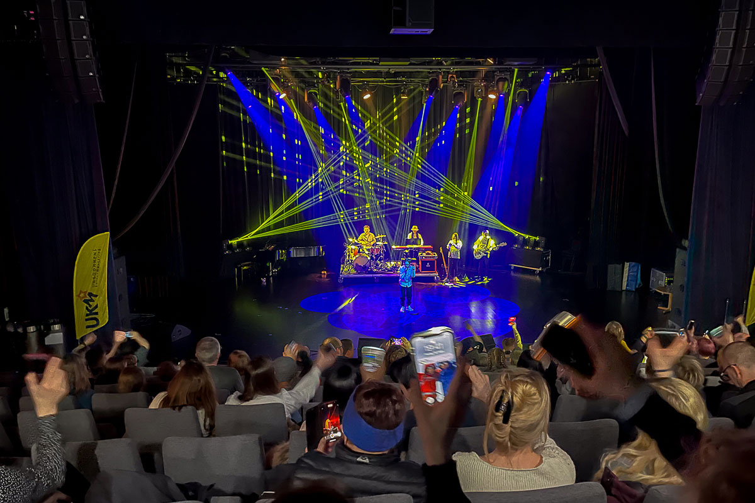

Longyearbyen has a rich cultural life, with programmes for children, young people and adults.

Photo: Tommy Dahl Markussen

## Essential infrastructure in Longyearbyen

### Basic features – frameworks and guidelines

In an Arctic context, Longyearbyen has a well-developed and modern infrastructure in several areas. Significant national interests are associated with Svalbard, indicating a strong government involvement. An appropriate level of infrastructure is a prerequisite for commercial activity and value creation, security and emergency preparedness, as well as for good social development. The sum of these factors determines Longyearbyen’s attractiveness as a place to live and work. The physical infrastructure of Longyearbyen thereby contributes to maintaining Norwegian communities on the archipelago.

In accordance with the Svalbard Act, Longyearbyen Community Council is responsible for infrastructure in Longyearbyen when such responsibility is not assigned to the State or other actors. Thereby, the Community Council is responsible for the primary segment of the harbour, roads, water and power supply, while Avinor owns and operates the airport. The Government is determined to ensure that the infrastructure is used for purposes that support the objectives of Svalbard policy, and sections 4.4.3 and 4.4.5 provide certain instructions for the use of the airport and harbour facilities.

Although the infrastructure in Longyearbyen is at a developed level in an Arctic context, there is still a significant maintenance backlog, for example in the power supply, water supply and housing stock. This, in turn, reflects the importance of not facilitating a development that triggers the need for major new investments in infrastructure. In recent years, Longyearbyen Community Council has been allocated funds to reduce the maintenance backlog, including during COVID-19.

Svalbard is experiencing some of the fastest impacts of climate change in the world. This renders the physical infrastructure more vulnerable to climate-related events, and climate change creates a need for upgrading and adaptation. Since the avalanches in 2015 and 2017, considerable funds have therefore been spent on protection in Longyearbyen, as well as building new dwellings capable of withstanding avalanches. As it is not desirable for Longyearbyen to grow beyond its current level, the housing stock will not be expanded beyond the level prior to these avalanches.

Establishing, operating and maintaining infrastructure in the Arctic is challenging and costly. The infrastructure in Longyearbyen was designed to serve a mining community, not the local community as it has developed, with a significant number of visitors throughout much of the year. Tourism activity in Longyearbyen is leading to increased wear and tear on an already strained infrastructure, resulting in higher maintenance costs and increased need for investment. Therefore, the Government will prepare a proposal for legislation governing visitor fees for Longyearbyen. This will be a pilot project. The revenue generated from such visitor fees shall be designated for expenditure on infrastructure and other public services that are a prerequisite for tourism in Longyearbyen, and part of this revenue shall be allocated to Longyearbyen Community Council.

### Water supply

Longyearbyen Community Council is responsible for Longyearbyen Waterworks, which supplies the town with drinking water. The waterworks currently has two sources: Isdammen and Steintippdalselva. During the winter season, there is no reserve source available.

There are challenges related to the sources and condition of the waterworks, which are amplified by climate change, among other things. The infrastructure associated with the waterworks is vulnerable to natural events, acute pollution and deliberate acts. Water is essential for almost all functions in a society, including the provision of basic services. Unlike the municipalities on the mainland, Longyearbyen is not connected to a larger system. There is therefore a need to assess the robustness and reserve solutions in the current system, which has been highlighted by the Total Preparedness Commission, among others. In 2022, the Norwegian Food Safety Authority issued a report that also confirmed this assessment.

Longyearbyen Community Council is investigating a future reserve solution for Longyearbyen’s water supply. Preliminary assessments indicate seawater as the most relevant alternative raw water source in a new reserve drinking water solution. Water supply in Longyearbyen represents critical infrastructure. Therefore, the work of investigating future reserve solutions for water supply is important and must be prioritised. As noted in section 4.2 above, the Government proposed in the Revised National Budget for 2024 to allocate NOK 3 million for government co-financing of a preliminary project to establish a drinking water source in Longyearbyen.

### Port facilities

Svalbard is dependent on good port facilities for the shipping of goods to and from the archipelago. Longyearbyen has three quays, Gamlekaia and Bykaia, which are owned by Longyearbyen Community Council, and Kullkaia, which is owned by Store Norske Spitsbergen Kulkompani. In addition, Turistkaia, a floating landing stage, has been established and is also owned by the Community Council. Capacity at the quays in Longyearbyen is limited. Most of the traffic is serviced over a short season, which limits the time each ship spends at the quay.

The previous Svalbard white paper noted the need for expanded port capacity in Longyearbyen. Expanded port capacity in Longyearbyen was discussed in the context of the facilitation of increased passenger traffic in Report to the Storting (white paper) No. 33 (2016–2017) National Transport Plan 2018–2029.

Since the last white paper was presented, the trend has been a significant increase in maritime activity around Svalbard. The growth in maritime activity is also reflected in the figures for passengers visiting the Port of Longyearbyen on cruise ships. Figures from the Norwegian Coastal Administration show that Longyearbyen was Norway’s third most visited cruise destination in 2023, measured in number of calls.

Report to the Storting (white paper) No. 20 (2020–2021) National Transport Plan 2022–2033 states that the needs related to new port facilities in Longyearbyen have changed. For example, it is not relevant to facilitate port facilities to support overseas cruise ships. On this basis, the Norwegian Coastal Administration will assess current needs before conducting a new assessment of the scope, approach and timeline for a possible government-led port project in Longyearbyen. Should it emerge that there is a basis for proceeding with the project, the Norwegian Coastal Administration will be able to propose specific measures as comments to the National Transport Plan 2029–2040.

The Government is determined to ensure that infrastructure is used for purposes supporting the objectives of Svalbard policy. Within the framework of limited capacity, it is therefore important that government vessels, such as the Governor of Svalbard’s service vessels and the vessels of the Norwegian Coast Guard, are given priority for berthing. The same applies to vessels of benefit to society such as postal and supply ships. In terms of sea-based tourism, locally-based activities in the Isfjord area should be prioritised in the use of port facilities in line with the Government’s guidelines related to tourism.

### Postal services

The Norwegian postal service, Posten Bring AS (Posten), provides a wide range of postal and goods delivery services to Svalbard. The transport of postal deliveries by Posten that fall under the delivery obligation is currently carried out by chartered aircraft, scheduled flights and cargo ships.

Section 10 of the Postal Services Act stipulates that postal services subject to a delivery obligation shall be cost-oriented and affordably priced. Since 2004, light goods to and from Svalbard have been subject to a surcharge. In 2023, this surcharge was lifted for the Norgespakke Small and Norgespakke Large services, as such parcels are now sent by cargo ship to and from Svalbard.

### Svalbard Airport

Svalbard Airport Longyear is the most important connection between the mainland and the archipelago. The airport is crucial for communication and the transport of goods and people.

The airport became operational in 1975 and was expanded with a new terminal in 2007. In 2017, the airport’s status was changed from international to national, which means, among other things, that scheduled flights cannot be established directly to Svalbard from abroad. Charter traffic was not affected by this restructuring.

Flight movements and passengers at Svalbard Airport, Longyear

03J1xt1

|  |  |  |
| --- | --- | --- |
| Year | Aircraft movement | Passengers |
| 2015 | 6 469 | 167 347 |
| 2016 | 5 505 | 171 012 |
| 2017 | 5 142 | 170 069 |
| 2018 | 5 213 | 182 352 |
| 2019 | 5 055 | 187 911 |
| 2020 | 3 853 | 74 274 |
| 2021 | 4 043 | 88 284 |
| 2022 | 4 438 | 175 815 |
| 2023 | 3 803 | 169 017 |

Source: Avinor

The increased activity in and around Svalbard is reflected in the number of passengers at the airport in the years leading up to the pandemic, as illustrated in Table 5.1. The airport’s infrastructure and operational concept are scaled to handle one aircraft at a time, and capacity is set at six daily arrivals and departures.

As a result of the heavy load caused by the simultaneous arrival of multiple aircraft, specific time slots have been allocated for take-offs and landings that must be adhered to. In light of the limited capacity, it is important to ensure that the airport is utilised as much as possible for purposes supporting the goals of Svalbard policy. At times, it has been difficult for the local population and businesses to access flights at a reasonable cost. However, the Government finds that the flight routes to/from Svalbard function satisfactorily on commercial terms and does not believe there is a need for the State to provide public funding for the flight routes to/from Svalbard. At the same time, the Government finds that air traffic supporting the local population and businesses must be prioritised. Furthermore, it is not desirable for the airport to be used as a hub for connecting flights northwards in support of activities taking place in these areas.

Identity control and control of movement of goods to and from the archipelago were introduced in Svalbard in 2022. The Governor of Svalbard conducts identity control at Svalbard Airport in temporary premises. Any expansion of identity controls and physical control of the movement of goods at the airport presupposes an expansion of the premises at the airport for such purposes.

## Commercial activity

### Frameworks and instructions for commercial activity

Natural advantages are the reason why there is activity in Svalbard today. Coal mining contributed to the emergence of the present-day communities in Svalbard, and society has developed around this activity. Since the 1990s, the authorities have worked to facilitate a more diverse business community on the archipelago. In this context, the authorities emphasised that new businesses should mainly be operating in industries that benefit from Svalbard’s distinctive nature or location. To ensure a stable society over time, it was also emphasised that the new businesses ought to create year-round jobs that support the Svalbard policy objectives.

At the time the previous white paper was presented, there was uncertainty regarding the consequences of the closure of activities in Svea and Lunckefjell for the Longyearbyen community. The authorities continued their already stated business policy within the same framework as before – that the businesses should have natural advantages in Svalbard and contribute to year-round jobs that support the objective of a Norwegian community in Longyearbyen. The business community responded well to the restructuring measures enunciated in the previous white paper. Longyearbyen has developed into a community with diverse activity in the tourism, building and construction, service, retail and public administrations sectors. Furthermore, Longyearbyen has a high level of activity in research and education, as well as a wide range of available activities. The long-term policy to transition Longyearbyen away from a one-sided industrial society has proved successful.

Commercial activity in Svalbard has changed over time. The same applies to the framework for activities. Global warming is one of the greatest challenges of our time, and we recognise that Svalbard is one of the places in the world experiencing the fastest impacts of climate change. The changes this will bring about in terms of sea ice extent, Arctic species and the vulnerability of ecosystems will affect activity in and around Svalbard both at present and in the years to come.

In order to maintain a varied and stable business community in Svalbard, businesses must recognise the changing framework conditions. Commercial activities that alleviate pressure on infrastructure, reduce impact on the natural environment, adopt new green solutions, and contribute in a positive manner to the local community are desirable. For parts of the business community, the unique natural and cultural values of Svalbard are the very foundation of their business. A prerequisite for the future development of commercial activity in Longyearbyen is that the activity preserves the unique natural wilderness, in line with the environmental objectives set for Svalbard.

Climate change and the development towards a low-carbon society may lead to changes in demand and the customer base for tourism products, transport services and other energy- and emissions-intensive commercial activities. Changes in market awareness and increased attention to individual environmental and climate impact also compel businesses to consider these aspects in their development. This creates a need for restructuring and adaptation to a commercial activity with a lower climate and environmental footprint. Actors that develop their business in a more sustainable direction, and are able to both prove and highlight this, will be more competitive in the future.

### Tourism

Svalbard’s special nature and wildlife have made it an attractive tourist destination. Since 2015, Longyearbyen has seen a gradual growth in tourism-related industries such as lodging and food service activities, transport, experiences and communication. The tourism industry has become one of the most important industries in Svalbard.

Development in Longyearbyen tourism activity from 2016 to 2023

09J1xt2

|  |  |  |  |  |  |  |  |  |
| --- | --- | --- | --- | --- | --- | --- | --- | --- |
|  | 2016 | 2017 | 2018 | 2019 | 2020 | 2021 | 2022 | 2023 |
| Visitors arrived | 65 200 | 68 100 | 72 500 | 76 400 | 25 500 | 29 800 | 68 000 | 63 000 |
| Guest nights | 142 300 | 147 600 | 156 200 | 161 200 | 65 100 | 79 100 | 147 800 | 139 400 |
| Conventional cruise  passengers | 41 600 | 44 300 | 45 900 | 41 800 | 0 | 0 | 19 500 | 47 100 |
| Expedition cruise  passengers | 14 000 | 17 000 | 17 400 | 16 1001 | 1 400 | 382 | 24 100 | 24 600 |
| Lodging capacity (rooms) | 373 | 405 | 457 |  | 488 |  | 488 | 488 |
| Persons employed in lodging and food service activities | 454 | 461 | 463 | 425 | 323 | 410 | 484 |  |
| Grants to Visit Svalbard  (NOK million) | 2,2 | 2,2 | 2,25 | 2,315 | 3,05 | 6,15 | 3,2 | 3,3 |

1 This figure is not comparable with the figures for 2016–2018 due to a change in data sources

Source: Visit Svalbard and Statistics Norway

The tourism industry is often divided into the two main categories of land-based tourism and sea-based tourism, of which the latter is divided into expedition cruises and overseas cruises. Land-based tourism activity largely consists of activities and experience products concentrated in Longyearbyen and areas accessible within a day trip from the community. Much of the activity consists of experiences related to nature and the cultural heritage sites found in these areas. Overseas cruise ships are usually larger vessels with a high number of passengers. Such ships have a number of amenities on board and are characterised by relatively short berth times. Expedition cruises have a long history in Svalbard and are characterised by smaller vessels with a turn-around port in Longyearbyen. This means that passengers on expedition ships arrive in Longyearbyen by plane. While there has traditionally been a predominance of overseas cruise passengers, the composition has changed in recent years. The expedition cruise segment has grown and now accounts for a significant proportion of cruise tourism in Svalbard.

Figures from the Norwegian Coastal Administration show that Longyearbyen was Norway’s third most visited cruise destination in 2023, measured in number of calls. When the overseas cruise ships arrive in Longyearbyen, a large number of travellers disembark at the same time. Although some tourists pay for experiences in Longyearbyen while the cruise ship is docked, there has been a perception that tourists on overseas ships contribute less to local value creation than their expedition cruise counterparts. In 2019, Visit Svalbard and AECO, assisted by research and consulting agency Epinion, collaborated to investigate cruise operator spending in Svalbard. The study found that expedition cruises have an average local value creation of NOK 4,235 per passenger, while overseas cruise ships have a corresponding average value creation of NOK 810. Expedition cruise passengers contribute to 5.2 times more local value creation than overseas cruise passengers. The total revenue from cruise traffic to Svalbard in 2018 was estimated at NOK 110 million.

Overall cruise activity is on the rise, putting pressure on the environment, emergency preparedness and infrastructure. For emergency preparedness reasons, the Government is proposing to introduce a limit on the number of persons on board cruise ships in the territorial waters around Svalbard. The Government will also consider limiting the number of ships sailing there. For more information on the measure, see section 6.6.

Tourism activity is highly visible in Longyearbyen. Responsible and competent operators have contributed to a positive development of the tourism industry. Since the last Svalbard report was presented there has been a significant increase in activity levels. Lodging capacity has increased and new experience products have been developed. Tourism activity in Svalbard is still characterised by seasonal variations. However, systematic efforts have been made over time to establish attractive offerings during the shoulder seasons in order to harness the available capacity and contribute to year-round jobs in the tourism industry. A diversity of local actors has emerged and the product range is more varied than before. Production and design from Svalbard also have intrinsic value in a branding context. This is seen in clothing, jewellery and food and beverages.

A fundamental prerequisite for the growth of tourism activity is well-functioning infrastructure and other public services. Increased activity leads to increased wear and tear on an already strained infrastructure, resulting in higher maintenance costs and a need for investment. Therefore, the Government will prepare a proposal for legislation governing visitor fees. Part of the revenue will be allocated to Longyearbyen Community Council. See section 4.4.1 for further information.

Svalbard’s natural advantages in a tourism context are changing relatively rapidly. At the same time as climate change is affecting the scope of what is achievable in terms of tourism activity, the increase in the number of travellers to Svalbard is impacting the environment. Therefore, it is necessary to monitor the development of activity in and around Svalbard, as well as the impact of climate change on nature and wildlife. It is particularly important to protect vulnerable nature so that the unique resource base in which the tourism industry grounds many of its products is safeguarded to the greatest extent possible. This will lay the foundation for the tourism industry to be able to continue offering attractive experiences in the future.

In 2015, Visit Svalbard, in collaboration with local tourism operators, developed a Svalbard Master Plan for tourism, which was revised in 2022. The revised masterplan emphasises increased value creation, as opposed to the previous goal of volume growth. Efforts are now focused on developing quality offerings that attract the right guests, to the right places, at the right time and at the right volume. Longyearbyen is designated as one of Norway’s sustainable destinations through Innovation Norway’s national labelling scheme. This labelling scheme is a tool for systematising sustainability efforts related to a destination. Businesses and destinations that invest in emission reductions and eco-labelling are not only doing their part for the community, but are also helping to secure their own future.

In 2020, a major regulatory work was initiated for Svalbard, including a number of proposed amendments to the Svalbard Environmental Protection Act and accompanying regulations. The amendments to the environmental legislation will contribute to the objective of making Svalbard one of the world’s best-managed wilderness areas.

Travelling outside the local communities is associated with risks that increase with distance from Longyearbyen. To reduce the risk, activities are being organised in Longyearbyen and in the Isfjord area. For individual travellers, i.e., visitors not participating in an organised tour, the Government proposes in the new Regulations relating to field safety that the requirement of notifying of travel takes effect once persons travel outside the Isfjord area (Management Area 10). This will also apply to students and others with short-term stays in Svalbard. Permanent residents are required to report travels in the large, protected areas, as is currently the case. A guide certification scheme is also being developed which will contribute to safer and more environmentally friendly travel in the field. This scheme will also contribute to enhancing competence in the tourism industry and further raise the level of knowledge that forms the basis for developing the products on offer.

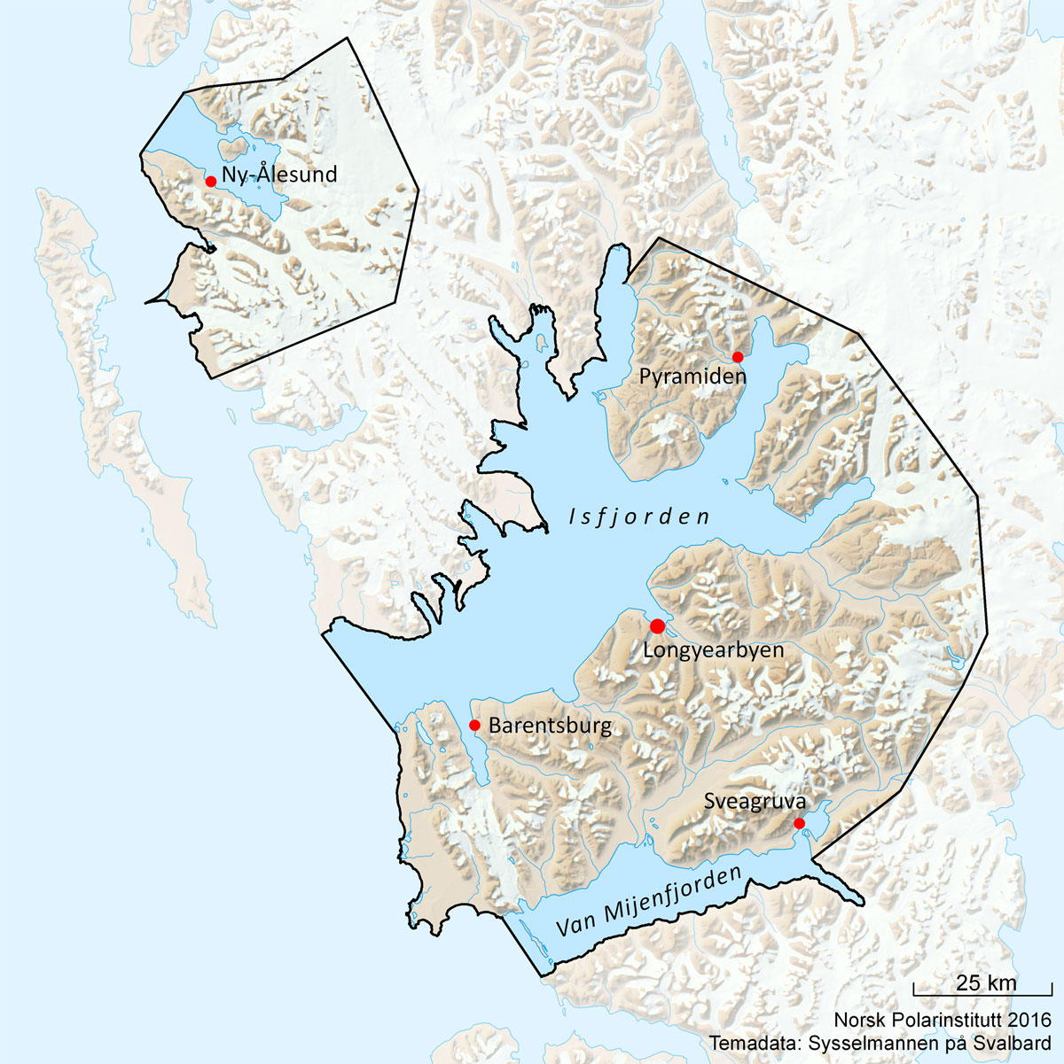

Map of Management Area 10

Map: Anders Skoglund, Norwegian Polar Institute

Changes that are now being made will contribute to more stable framework conditions for the tourism industry through clear rules for what is permissible.

Going forward, the Government wants to facilitate the sustainable development of the tourism industry within the framework of the environmental objectives, mainly concentrated in the local communities and the area around Isfjorden. The current framework entails that further development of the tourism industry cannot take place in the form of growth in volume, but rather in the form of increased value creation.

Visit Svalbard’s sustainability efforts

Although the local tourism industry has little impact on the major sources of emissions in Longyearbyen, such as transport and energy supply, the tourism industry will now be working on four new projects that will make a concrete contribution to reducing emissions. The primary focus of investigation will be whether longer stays in Svalbard will result in lower carbon intensity. Furthermore, Visit Svalbard aims to have as many travellers as possible purchase biofuel quotas and develop carbon accounting for tourism activities in Visit Svalbard’s booking system.

Climate will also become a more integral part of the tourism industry’s narrative. By communicating the challenges in vulnerable areas and the impact of climate change, guides and others will help to ignite a sense of responsibility and inspire change among guests.

[Boks slutt]

Organisation of the tourism industry

Visit Svalbard is the destination company for Svalbard. Visit Svalbard is owned by, and operates on the basis of, an annual action plan adopted by the Svalbard Tourism Council. The Svalbard Tourism Council is an association of several actors with interests related to tourism in Svalbard.

The Association of Arctic Expedition Cruise Operators (AECO) is an international organisation for expedition cruise operators. The organisation’s purpose is to ensure that expedition cruises and tourism in the Arctic are carried out with the utmost consideration for the vulnerable natural environment, local cultures and cultural remains. Svalbard Cruise Forum was established in 2023 and consists of Avinor, the Port of Longyearbyen, Visit Svalbard and AECO, in addition to activity providers. The forum works to increase local value creation and implement measures to combat the adverse effects of cruise tourism.

[Boks slutt]

### Space ventures in Svalbard

Space ventures are an important part of the basis for livelihoods in Svalbard. At the same time, space activities in Svalbard are also a prerequisite for societal development on the mainland, and are of immense importance for a number of services in Europe and the rest of the world. Space activity in Svalbard is an important national contribution to international cooperation. In the coming years, new national, European and commercial satellites are expected to provide entirely new opportunities to observe, communicate and develop new services based on satellite data for the areas in and around Svalbard. This will provide opportunities for new and increased activity, as well as contribute to sustainability and emergency preparedness.

SvalSat

Through a long-term effort, the Svalbard Satellite Station (SvalSat) has developed into the world’s largest commercial satellite station for polar orbiting satellites. Svalsat is located on Platåberget outside Longyearbyen and is owned and operated by Kongsberg Satellite Services (KSAT). The investment in Svalsat has made KSAT a world leader in data downloading and satellite control.

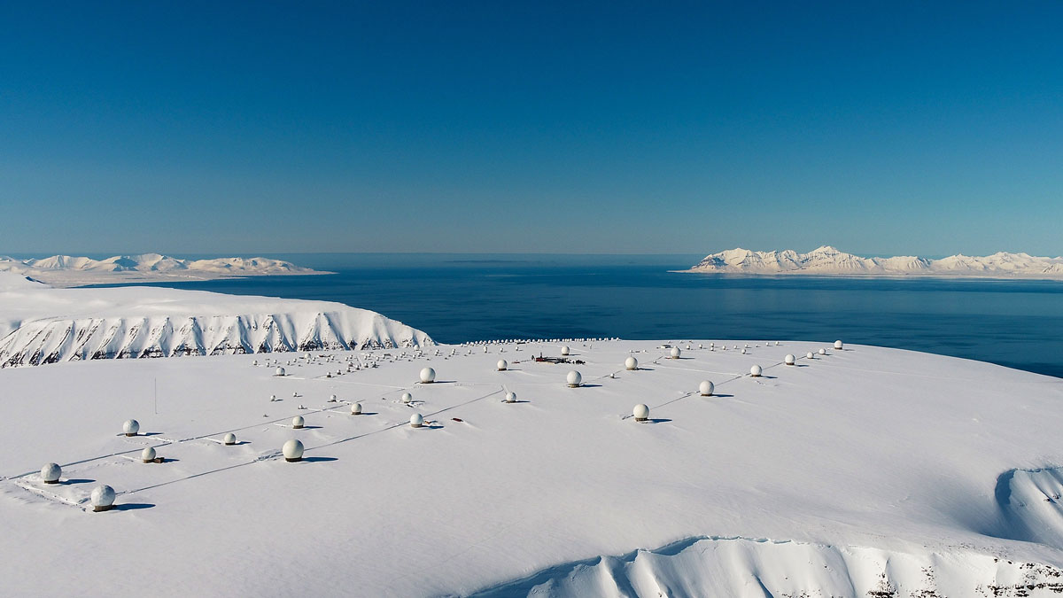

SvalSat

Photo: KSAT – Svalbard Satellite Services

SvalSat is a prerequisite for KSAT to deliver services to Norwegian and European initiatives, as well as some of the world’s largest space agencies and commercial actors.

SvalSat has ambitions to expand by 10–15 antennas annually in the coming years. This development may result in positive externalities for the local community, including long-term and stable jobs, the purchase of services, competence and personnel from suppliers in Longyearbyen, and the facilitation of research, innovation and development of new solutions in the Arctic in collaboration with local actors and businesses. Expansion is subject to authorisation from the relevant authorities.

KSAT has chosen to explore whether alternative energy sources work in the Arctic. Solar cells have now been installed on the antenna foundations, and plans are underway to establish a solar farm that will reduce the carbon footprint of the station.

World-leading space weather research

Svalbard’s geographical location offers unique opportunities for space research, including space weather. This is a relevant field of research as powerful solar storms have the capacity to disrupt or, in the worst case, render satellites and other technology and infrastructure inoperable. Space weather research in Svalbard has become internationally recognised because of the local research infrastructure and the competence of the scientists involved. The Kjell Henriksen Observatory (KHO) outside Longyearbyen (UNIS), which is co-located with the Super Dual Auroral Radar Network (SuperDARN) and the EISCAT Svalbard Radar, jointly represent a unique ground-based research platform for space weather in a global context.

Research rockets are also launched from Svalbard to study space weather and other unique Arctic atmospheric phenomena. The Svalbard Rocket Range (SvalRak) is a launch site for research rockets near Ny-Ålesund. SvalRak is owned by Andøya Space AS, a state-owned company under the Ministry of Trade, Industry and Fisheries.

[Boks slutt]

Space research in Svalbard

Copernicus is the Earth observation component of the European Union’s Space programme, which provides opportunities to monitor environmental and climate developments in Svalbard. As climate change has a greater impact in polar regions, it is of global interest to carefully assess and communicate the changes in the archipelago, to which the Copernicus Programme and local research are making a significant contribution.

Several projects have also been initiated to integrate data from satellites with other observation platforms, such as the Svalbard Integrated Arctic Earth Observing System (SIOS). SIOS is an international partnership on research infrastructure that contributes to better access to climate, environmental and Earth observation data of Svalbard and the surrounding regions (see also section 5.4.2).

In 2018, the Norwegian Mapping Authority’s new Geodetic Earth Observatory opened in Ny-Ålesund. From the Observatory, movements of the Earth’s surface, the Earth’s rotation and the Earth’s exact location in space are mapped. This information is crucial for understanding global climate and environmental developments, and it represents an important contribution to strengthening efforts to improve the Global Geodetic Reference Frame and related work in the UN system. Thus, it provides important information for decision-makers, globally.

[Boks slutt]

### Fisheries activities

Fish resources are currently regulated through a comprehensive management and control system, including harvesting and participation regulations. This also applies to fisheries in the areas around Svalbard. Whether or not it is possible to increase activity depends on the fish stock status at any given time. It is crucial that marine resources are managed in such a manner that they can continue to be harvested in the future.

Traditionally, there has been no commercial landing and reception of fish and seafood in Svalbard. The seafood that has been sold has therefore mainly come from the mainland.

The landing and sale of seafood on the mainland is subject to detailed regulations, and in 2015–2016 the Food Act and Marine Resources Act were made applicable to Svalbard. The Norwegian Food Safety Authority and the Directorate of Fisheries are the competent supervisory authorities.

The Landing Regulations, which stipulate requirements for registering information about the catch for use in resource control and quota control, were introduced in Svalbard on 1 September 2018.

The Fish Sales Act applies on the mainland of Norway and in the sea areas around Svalbard, but not on the land territory of Svalbard. In addition, Norwegian fishermen, regardless of where they land the raw material, are required to sell first-hand through a fishermen’s sales organisation.

There are significant limitations in the basic infrastructure on Svalbard, in addition to the fact that Svalbard falls outside the scope of the EEA Agreement, cf. section 2.3.3. The Government will not implement special measures for the establishment of a fishing industry in Svalbard.

### Mineral activity

Mineral activity in Svalbard began in the early 1900s with the extraction of coal. Today, there are two coal mines left in Svalbard. Store Norske runs the coal operations in Mine 7 in Longyearbyen, while coal operations in Barentsburg are run by Trust Arktikugol. Previously, there were also operations in Ny-Ålesund, Pyramiden, Svea and Lunckefjell. In 2017, the Storting decided that Store Norske’s coal operations in Svea and Lunckefjell were to be discontinued and the area cleaned. The clean-up project in Svea and Lunckefjell was completed in autumn 2023. Store Norske’s mining operations in Svalbard have been gradually reduced in recent years and operations in Mine 7 are scheduled to cease in the summer of 2025.

### Petroleum activity

The marine areas surrounding Svalbard have not been opened for petroleum activity and no licences have been granted for exploration drilling in the territorial sea around Svalbard. Furthermore, since the Svalbard Environmental Protection Act entered into force in 2002, no licences have been granted for onshore exploration drilling. The Government will continue the current policy regarding petroleum activities on land and in the territorial sea around Svalbard.

## Framework conditions for future commercial activity

The purpose of commercial activity in Svalbard is to support the Svalbard policy objectives. This entails that the activity should contribute to achieving the objective of a Norwegian community on the archipelago and also safeguard Svalbard’s distinctive natural wilderness. At the same time, it is expensive to facilitate activity and infrastructure in the Arctic, and it is therefore not desirable for the community to continue to grow or develop in a manner that requires greater investment in infrastructure or expansion of services. This means that further development of commercial activity cannot take place in the form of growth in volume, but rather in the form of increased value creation.

Predictability is key to facilitating the desired commercial activity on the archipelago. Several factors affect companies’ competitiveness, such as research and education policy, innovation policy, competition policy and sector-specific policy. In addition, there are the more specific framework conditions for activity such as energy prices, the housing market, access to competence, digital and physical infrastructure and communication. For businesses, it is important that the framework conditions are as clear and predictable as possible. In light of the development trends in Longyearbyen, the Government wishes to contribute to clarifying the framework conditions and creating greater predictability for commercial activity in line with the Svalbard policy objectives.

### Housing

Access to housing is a fundamental prerequisite for being able to live and work in Longyearbyen. Following the avalanches in 2015 and 2017, a number of dwellings vulnerable to avalanches were demolished and work began on replacing these dwellings. The purpose of the housing policy is to facilitate the development of Longyearbyen within the objectives and framework of Svalbard policy. It is not an aim for the Longyearbyen community to grow, and it is therefore not desirable to facilitate growth in the housing stock beyond the levels prior to the avalanches. At the same time, the Government will proceed with efforts in order to improve the quality of housing in Longyearbyen.

The frameworks for the governance of Svalbard differ somewhat from those on the mainland. The same applies to the housing market. Currently, the public sector owns more than 70 per cent of dwellings in Longyearbyen, while the rest are privately owned. The considerable public ownership is partly historically grounded, dating back to the company town era. However, it is also the result of a deliberate development. Limiting the number of dwellings will determine the population size and level of activity. This entails that the ownership of dwellings and the management of access thereto is an important means of contributing to the development of Longyearbyen in accordance with the objectives of Svalbard policy.

The Longyearbyen housing stock shall not increase beyond the 2015 and 2017 pre-avalanche levels. However, in order to carry out the necessary rehabilitation of the housing stock, property managers will need to have some excess inventory. In addition, there may be a need to establish temporary accommodation to house craftsmen, etc. in cases where this cannot be solved by using short-term rental of existing housing stock. In such circumstances, this should be carried out under the auspices of the government property managers in Longyearbyen. When replacing dwellings exposed to landslides and avalanches, the Government is seeking to ensure that the number of family dwellings is not reduced.

Property management – the actors

Following the previous white paper, efforts were made to consolidate the management of the publicly owned housing stock in the company Store Norske Boliger (SNB) and the government property manager Statsbygg. This resulted in Statsbygg purchasing the dwellings of the University Centre in Svalbard AS (UNIS) in 2021. Efforts to transfer dwellings owned by the Community Council to Statsbygg are still ongoing. By acquiring the dwellings, Statsbygg will also be responsible for meeting the housing needs of UNIS and the Community Council.

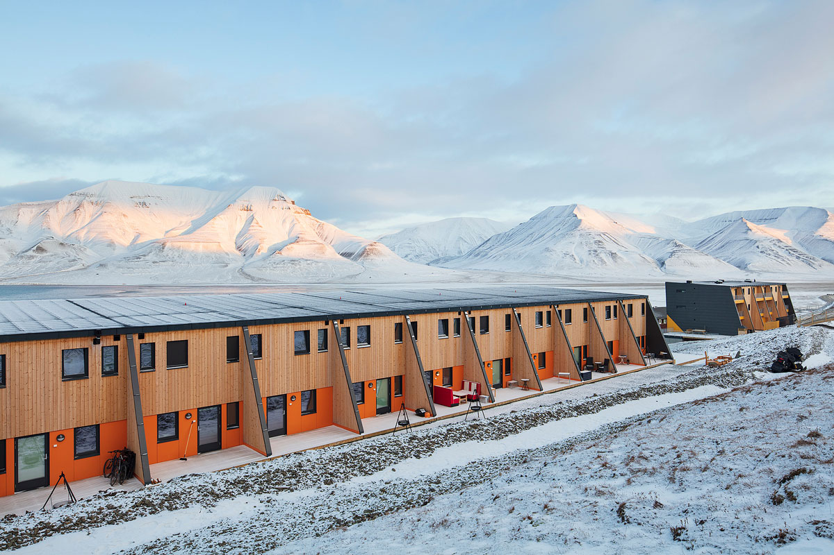

New dwellings in Gruvedalen

Photo: Trond Isaksen, Statsbygg

There are currently 1,309 dwellings in Longyearbyen. At year-end 2023, SNB owned and managed around 500 residential units, or around 40 per cent of the dwellings in Longyearbyen. SNB is undertaking a concept study, which will form the basis for a long-term and comprehensive plan for climate proofing. energy efficiency and general raising of standards of the company’s dwellings. In parallel with this work, rehabilitation measures should be carried out on dwellings suitable. SNB currently owns 110 residential units at the Blåmyra dwellings in Longyearbyen, which accounts for approximately 20 per cent of the company’s dwellings. The dwellings at Blåmyra are well founded and therefore suitable for rehabilitation. In the Revised National Budget for 2024, the Government has proposed an allocation of NOK 130 million in loans to Store Norske, partly to enable the rehabilitation of the Blåmyra dwellings.

Statsbygg manages the housing stock for government employers in Longyearbyen, meeting their needs. Currently, this housing stock consists of approximately 260 dwellings. In the event of demand exceeding this Statsbygg will have to acquire dwellings in the rental market. Statsbygg currently rents more than 60 dwellings in addition to those owned by the company. Furthermore, Statsbygg is preparing a plan to raise the standard of the dwellings in its portfolio.

New construction/transformation

Since the avalanches in 2015 and 2017, NOK 275 million has been spent on avalanche protection in Longyearbyen. In 2018/2019, Statsbygg completed 60 new dwellings in Gruvedalen, and a total of around NOK 645 million will have been spent on new, avalanche-proof dwellings once Statsbygg has completed planned purchases and new constructions. Today, Longyearbyen has roughly the same number of dwellings as before the avalanches. However, the population has increased during this period, which must also be viewed in connection with the establishment of the Svalbard Folk High School. The Folk High School has provided its own student accommodation, which is not counted towards the ordinary housing stock.

There are currently few areas available for housing construction. Preparing areas for housing construction in Longyearbyen can be challenging, as such areas must have adequate protection against avalanches and have the possibility of foundation on rock. Investments in new infrastructure in connection with housing construction are also exceedingly costly in the Arctic. At the same time, new energy-efficient dwellings can contribute to reducing energy consumption and contribute to energy balance. Any replacement of dwellings must be undertaken through transformation and densification rather than utilising undeveloped areas. Both SNB and Statsbygg are drawing up plans for transformation and new construction. Longyearbyen Community Council is the planning authority for the Longyearbyen planning area. Through its ownership of the land in Longyearbyen, the central government, in consultation with Longyearbyen Community Council, will facilitate development within the framework of the goals of Svalbard policy.

Future property management

Central government control of housing is a key tool for guiding the future administration of Longyearbyen. Therefore, continued government ownership of a significant proportion of the housing stock is desirable. Property management shall also contribute to comprehensive pricing and value-preserving management and development of the housing stock. The housing stock must be of a quality and composition that is attractive to Norwegian employees and families. The Government will consider adjusting the criteria for registration in the Population Register of Svalbard so that documented residence in an approved dwelling becomes a condition for inclusion in the Population Register.

The limitation in the number of dwellings could lead to housing being perceived as a scarce resource. At the same time, the Government does not wish to facilitate housing development with the aim of meeting the housing needs of an ever-growing population in Longyearbyen. There is insufficient land, infrastructure and services available for such a development. Future activity must therefore take place within the established supply of housing.

Access to housing is linked to the need to be able to work and live in Longyearbyen. Therefore, the plan is for dwellings as a general rule to be rented out to employers and distributed to employees. Employers who are unable to offer housing to their employees must scale their activities accordingly.

With a limited housing supply, meeting the housing needs of the most important community actors in Longyearbyen, in both the public and private sectors, is an essential consideration. This means that there is and should be an allocation whereby important societal tasks are prioritised above others. Other publicly owned housing can be rented out to private employers who contribute to achieving the objectives of Svalbard policy.

### Energy supply

According to the Svalbard Act, Longyearbyen Community Council is responsible for infrastructure when such responsibility is not assigned to the State or other actors. For many years, Store Norske was responsible for supplying energy to Longyearbyen. In 2002, in connection with the establishment of Longyearbyen Community Council, ownership of the cogeneration plant and responsibility for energy supply was transferred to Longyearbyen Community Council.

Until the establishment of the wholly owned limited company Svalbard Energi AS (SEAS) in January 2023, energy supply was organised as an integrated entity under Longyearbyen Community Council’s administration. The rationale for the establishment of SEAS in 2023 was a requirement in the 2022 Svalbard Budget for an accounting and organisational separation between the operation of energy supply and other activities in Longyearbyen Community Council. Thus, Longyearbyen Community Council is now exercising its responsibility for the energy supply in Longyearbyen via its ownership of SEAS.

Although the energy supply is owned and operated by SEAS, the Community Council sets the fees for the supply of electricity and heating to customers. In accordance with the Svalbard Act, the Community Council is permitted to set such fees as long as the responsibility for energy supply in Longyearbyen remains with the Council.

Until the autumn of 2023, Longyearbyen’s power supply was based on a coal-fired power plant from 1983. The condition and age of the coal-fired power plant, as well as uncertainty surrounding the future supply of coal as a fuel source, form the background against which efforts have been underway for several years to explore various alternative supply solutions. The energy system differs from solutions on the mainland, among other things due to Svalbard’s physical isolation and the fact that the Energy Act does not apply. Longyearbyen Community Council was commissioned by the Ministry of Justice and Public Security and the former Ministry of Petroleum and Energy (now Ministry of Energy) to submit an energy plan for Longyearbyen in 2023. Among the conditions of the plan were that renewable energy be phased in as quickly as possible with the aim that renewable solutions will constitute the main supply, and that the energy supply shall be in line with, and underpin, Norway’s climate targets for 2030 and 2050. The energy plan revealed, among other things, a need to establish an appropriate regulatory framework for energy supply in Longyearbyen. The Ministry of Energy is currently following up on this together with the Norwegian Water Resources and Energy Directorate.

As part of the follow-up of the energy plan, Longyearbyen Community Council decided to close down the coal-fired power plant in October 2023 followed by a switch to diesel heating. Since the transition, problems have arisen with the diesel generators, and in March 2024, generators from the Norwegian Armed Forces were put into use in order to ensure adequate security of supply. Diesel generators from the former mining operations in Lunckefjell will also be connected to the energy system to bolster security of supply.

Efforts to convert the energy supply in Longyearbyen from coal to more renewable energy sources are underway, but considerable work remains. As the owner, the central government is determined to explore the role of Store Norske in the local energy supply. Therefore, in November 2023, the Ministry of Trade, Industry and Fisheries tasked Store Norske with conducting an assessment of this in dialogue with the Community Council and other relevant actors. The Ministry of Trade, Industry and Fisheries received Store Norske’s assessments in December 2023. To follow up these assessments, the Government has commissioned Store Norske to conduct a concept study of the various alternatives for power supply in Longyearbyen and a condition assessment of existing infrastructure.

Electricity and heating are essential for maintaining the population and businesses in Longyearbyen. Vast distances to the mainland and climatic conditions entail that considerations such as security of supply and a stable energy supply must be given particular emphasis. The Government’s intention is for the State to take greater responsibility for power supply in Longyearbyen, e.g., through Store Norske, and that responsibility for power supply shall be clarified as soon as possible.

The cost of energy production has increased as a result of the transition from coal to diesel. In the updated 2023 budget, the Storting increased the allocation to Longyearbyen Community Council by NOK 50 million, based on a proposal from the Government, to contribute to reducing electricity prices in Longyearbyen. In the Revised National Budget for 2024, the Government proposed allocating an additional NOK 125 million to reduce electricity prices, as well as NOK 42 million for investments in infrastructure that strengthen redundancy and security of supply.

### Communication

Considering the archipelago’s location and infrastructure, electronic communication services are particularly important in Svalbard. Communication links both internally in Svalbard and to the mainland are crucial for residents, businesses, research and higher education, public administration, civil protection and emergency preparedness, as well as for achieving the objectives of Svalbard policy.

The fibre-optic connection

Svalbard and the mainland are connected by two subsea fibre-optic cables. The fibre-optic cable connection constitutes critical infrastructure and provides the same level of electronic communication services as on the mainland due to the virtually unlimited capacity of the cables. The cables are owned and operated by Space Norway.

Various businesses and public sector actors use the fibre-optic cable connection for their communication needs, including the Svalbard Satellite Station (SvalSat). Avinor uses the fibre-optic cable connection for traffic management at Svalbard Airport.

The fibre-optic cable between Svalbard and the mainland has been operational since 2004 and has an estimated technical lifespan until the end of 2028. In the winter of 2022, there was a disruption of service to one of the two fibre-optic cables. The cable has since been repaired and is now operational. Other measures have also been implemented to bolster the existing fibre-optic network. Efforts are underway to find a new solution that provide a secure and robust communication link with good capacity to Svalbard.

In 2015, a fibre-optic connection was established between Ny-Ålesund and Longyearbyen. The connection is superfluos with two separate cables and is the world’s northernmost high-speed connection.

Broadband and mobile coverage and satellite-based communication

Mobile network coverage it possible to harness the benefits of mobile communication in a research context and improves safety in the field. The mobile networks in Svalbard have been upgraded to the latest mobile standard, entailing 5G access in large parts of Longyearbyen and Barentsburg. Ny-Ålesund received mobile coverage in 2023. An enhanced reserve satellite link has been operational for Svalbard since 2022. Services from low Earth orbit satellite systems will become available in Svalbard during 2024.

Management of critical communication infrastructure

The Norwegian Communications Authority (Nkom) supervises critical infrastructure in the electronic communications sector, including the fibre-optic cable connection between Svalbard and the mainland.

Satellite activities in Svalbard are particularly regulated and Nkom is responsible for supervising satellite stations in Svalbard, including SvalSat. The supervisory activities are to ensure that the establishment and use of satellite ground stations in Svalbard take place within the framework of the provisions of the Regulations relating to the establishment, operation and use of ground stations for satellites in Svalbard. The supervisory regime has been developed and enhanced in recent years.

### Access to labour and competence

With some exceptions, the Working Environment Act also applies to Svalbard. A safe and legitimate labour market is important in order to protect employees against health hazards and exploitation, and also makes a significant contribution towards a sustainable and value-creating business sector. The Norwegian Labour Inspection Authority supervises the legislation governing working environment and safety in Svalbard. The agency is tasked with facilitating and following up on enterprises maintaining high standards for health, safety and working environment. In addition, the Norwegian Labour Inspection Authority works to counteract censurable conditions and social dumping.

Sufficient access to suitable competence is crucial for enterprises’ ability to operate efficiently and create value. Knowledge and competence are significant competitive factors in the business sector. The business sector may experience challenges in recruiting employees with suitable competence, the reasons for this being complex. Important factors may be linked to limited mobility in the workforce, a limited labour market, small specialist environments and vast distances. Challenges related to access to labour and competence can adversely impact innovation and technology development in enterprises, which in turn can affect value creation.

Access to labour is affected by the salary levels offered by the various enterprises. To ensure that the business sector in Svalbard has adequate access to labour, it is therefore important to ensure satisfactory working conditions in the various industries. Good working conditions are also an important element in ensuring a socially sustainable business sector.

The purpose of the general application of collective agreements is to ensure that foreign employees receive pay and working conditions that are equivalent to those enjoyed by their Norwegian counterparts, and to facilitate fair competition in the Norwegian labour market. Therefore, the general application scheme is an important measure to counteract social dumping and work-related crime. The Tariff Board may, at the request of one of the parties to a nationwide collective agreement, decide that the collective agreement shall apply in whole or in part to all employees who perform work within the scope of the collective agreement, if this is necessary to achieve the purpose of the Act.

Based on developments in the business sector and labour market and the importance of ensuring a legitimate and well-functioning working life, the Government will present a proposal to make the General Application Act applicable to Svalbard by the end of 2024. Based on a more detailed assessment of local development trends and needs, the Government will consider deferred implementation for parts of the archipelago. The Government will also consider other measures to promote a legitimate labour market, such as regulating public contracting authorities’ requirements for pay and working conditions based on the model of the Regulations relating to pay and working conditions in public contracts.

### Network of policy instruments

The nationwide policy instruments and schemes of Innovation Norway and the Research Council of Norway are available to enterprises in Svalbard. However, Svalbard does not have access to county authority funds. In 2022, a special business-oriented initiative was launched in Svalbard for the restructuring of the business sector, modelled on regional policy instruments. Longyearbyen Community Council manages the project. At the request of the Community Council, the launch of the initiative has been postponed until 2025 pending a new business plan.

The Research Council of Norway’s Project Bank states that NOK 3.8 million has been allocated to the Framsteg Longyearbyen [Progress Longyearbyen] project from Research-based Regional Innovation (FORREGION) funds for the period 2021–2025. The project will stimulate sustainable restructuring and development, as well as stabilise activity levels in the business sector.

Innovation Norway has an earmarked initiative for business measures in Svalbard that aims to mobilise and support projects in Svalbard based on the model of rural and regional policy instruments. These initiatives will occur in line with the goals and frameworks of Svalbard policy, meaning that further development of the business sector cannot occur in the form of growth in volume, but rather in the form of increased value creation.

With its experience of regional restructuring, Innovation Norway can be an important contributor to the changes facing Svalbard. Regional restructuring is an extraordinary effort for municipalities or regions where a large number of jobs are being lost. Innovation Norway is funding the Næringsvennlig kommune [Business-friendly municipality] project.

From 2016 to 2023, just over NOK 10 million in loans and NOK 48 million in grants have been allocated to Svalbard, of which around NOK 20 million is from extraordinary measures introduced in connection with the adverse impacts of the COVID-19 pandemic. Business services have received the largest share of the funds, followed by industry and tourism.

## Measures

The Government will:

* Introduce incentives to make it more attractive for Norwegians to move to and remain in Svalbard.
* Consider whether cash-for-care benefits and child benefits should be discontinued for employees who have no connection to the mainland.
* Consider introducing an employer’s National Insurance contribution for Norwegian employers that employ persons who become insured under the National Insurance Scheme through their employment in Svalbard.
* Consider a change in National Insurance contributions for foreign employees with no connection to the mainland.
* Make the General Application Act applicable to Svalbard.
* Assess the need for further measures to promote a legitimate labour market.
* Consider a scheme whereby public sector actors require pay and working conditions for employees to comply with the applicable national collective agreement for the industry in question when entering into agreements.
* Consider establishing in regulations the role of the Governor of Svalbard in matters relating to education.
* Review the responsibility for critical infrastructure in Longyearbyen.
* Consider conducting a survey on living conditions for Longyearbyen.
* Facilitate sustainable business development in Longyearbyen by ensuring stable framework conditions for the business sector.
* Promote a robust fibre-optic cable connection with good capacity to Svalbard.
* Work on the basis that the State shall take greater responsibility for power supply in Longyearbyen, e.g., through Store Norske, and that responsibility for power supply shall be clarified as soon as possible.
* Introduce a certification scheme for Svalbard guides to ensure that all guides possess sufficient competence to reduce the risk of accidents to people and avoid environmental harm.
* In the new Regulations relating to field safety, initialise that the requirement of notifying of travel for individual travellers takes effect upon traveling outside Management Area 10.
* Prepare a proposal for visitor fees for travellers to Longyearbyen.
* Introduce a limit on the number of passengers on board cruise ships in the territorial sea around Svalbard, and consider limiting the number of cruise ships sailing in Svalbard’s territorial sea.
* That infrastructure such as airports and ports are used for purposes underpinning the goals of Svalbard policy.
* Continue to utilise the ownership of dwellings and the management of access thereto as a means of contributing to the development of Longyearbyen in accordance with the objectives of Svalbard policy.
* Continue efforts to reduce the number of public property managers in Longyearbyen in the interests of efficient management.
* Uphold the instruction that the total housing stock shall not increase beyond the levels prior to the avalanches in 2015 and 2017.
* Continue efforts to raise the standard of housing in Longyearbyen.
* Ensure that the number of family dwellings is not reduced when the Government replaces dwellings exposed to landslides and avalanches.
* Consider whether registration at an approved place of residence should be a prerequisite for inclusion in the Population Register of Svalbard, as well as a possible requirement of registration from day one.
* Investigate a scheme that makes it possible for young people in Svalbard to earn small amounts without having to pay income tax.

# Knowledge, research and higher education

## Introduction

Research and higher education is one of the most important areas for Norwegian activity and presence in Svalbard.

Svalbard is an important platform for research and higher education, as well as for international cooperation. Norway will continue to be a strong polar research nation, while maintaining a high quality of teaching in higher education. Svalbard has a unique location in the Arctic and is the starting point for a number of research activities, including national and international collaborative expeditions.

Knowledge of climate change and environmental impact in the polar regions is important for managing a rapidly changing natural environment. By researching polar ecosystems, we also gain valuable knowledge about future developments in other areas. The research on Svalbard thus contributes to a strong knowledge base for Norwegian administration and policy development. The educational programmes at the University Centre in Svalbard (UNIS) provide valuable polar expertise for graduates going into business and administration and develop a competence base for polar researchers of the future. Knowledge is also important for the restructuring and development of commercial activity. Research and higher education are a central part of Svalbard policy and contribute to fulfilling its overriding objectives, including regarding Norwegian communities on the archipelago.

Svalbard is of interest to researchers from all over the world and provides the basis for significant international cooperation on environmental, climate and polar research. Svalbard must be regarded as a limited resource, also as a research arena. A number of policy instruments and platforms for cooperation and sharing have been established, which contribute to reducing the impact on nature and to ensure that research facilities are better utilised. There is considerable value in bringing together researchers from different disciplines and countries to collaborate for the purpose of generating new knowledge and development. Research in Svalbard requires extensive planning and anyone conducting research on the archipelago must familiarise themselves with applicable legislation. All research activities are to take place in accordance with current Svalbard policy, and as the host of international research activities, Norwegian authorities have clear expectations of research actors.

## Objectives for research and higher education in Svalbard

The Government’s objectives regarding knowledge, research and higher education in Svalbard remain unchanged. These were most recently enunciated in the Storting’s consideration of Report to the Storting (white paper) No. 32 (2015–2016) Svalbard, cf. Recommendation 88 S (2016–2017):

* Research and higher education shall be key elements of Norwegian activity in Svalbard in the years to come.
* Svalbard shall be further developed as a platform for international research, higher education and environmental monitoring. The archipelago’s infrastructure and unique research possibilities shall be exploited even better than they are at present. The infrastructure must be supplemented with measures that further strengthen Svalbard’s position in international knowledge development.
* Norway shall be a key actor in the development of knowledge in and about Svalbard, not just a facilitator. A professional leading role must be ensured, in particular through the professional standing and quality of Norwegian polar research.
* All activity shall be in accordance with an overriding consideration of the environment. Research and higher education in climate and the environment are natural focus areas, and the research itself relies on ensuring that the area remains as unaffected as possible by local impact.

Based on these objectives a strategy for research and higher education in Svalbard was developed as a follow-up of the previous white paper on Svalbard. The strategy also included some additional goals and frameworks, which are also to be continued and followed up.

## Constellation of actors

### University Centre in Svalbard (UNIS)

The University Centre in Svalbard AS is a state-owned limited company, owned by the Ministry of Education and Research. UNIS is the core institution of the Science Centre in Longyearbyen. The Svalbard Science Centre opened in 2005 and is the main arena for education and research in Longyearbyen.

UNIS offers higher education and conducts research based on the natural advantages of Svalbard. UNIS does not have the right to conduct its own exams, however, the courses offered are part of ordinary study programmes at the mainland universities. UNIS offers courses in five thematic categories: Arctic biology, Arctic geology, Arctic geophysics, Arctic technology and Arctic security with associated research. UNIS also offers courses in renewable energy. The teaching is largely field- and expedition-based, and the facilities at the Ny-Ålesund Research Station are utilised when relevant. UNIS also rents the remaining protected buildings in Svea for teaching and research purposes, as this is the only area of Western Svalbard with stable and predictable sea ice during the winter.

In 2022, UNIS had 106 permanent employees, 60 of whom held academic positions. About half of the staff members are Norwegian citizens. In accordance with current practice in academia, academic positions are advertised internationally to attract the best applicants. However, it is desirable to increase the share of Norwegian staff. The proportion of Norwegian students and the recruitment of Norwegian researchers are important if UNIS is to continue to be an important contribution to a Norwegian family community in Longyearbyen. UNIS participates in several centres of excellence in research, a centre of excellence in education and major EU projects. UNIS operates an Arctic Safety Centre (ASC), which aims to enhance competence on safe and sustainable human activity in the Arctic.

UNIS is a collaborative arena with staff and students from many countries. It has cooperation agreements with all the Norwegian universities and good relations with a number of Norwegian and international institutions. Many research projects at UNIS are of direct relevance to Svalbard, and the results are utilised at the local level. See Box 6.1.

With the exception of 2020 and 2021, UNIS has produced between 208 and 217 student labour years during the period 2016–2022, with more than 700 students per year. The goal is for half of the students to be from Norwegian institutions. In the period 2016–2022, 45–51 per cent of students at UNIS were from Norwegian universities.

Norwegian students travelling abroad on a student exchange programme through Erasmus+ receive a monthly grant. Students pursuing education outside Europe also receive funding. There is no equivalent support scheme for stays at UNIS, and students who choose UNIS instead of stays abroad are therefore at a financial disadvantage. This can make the recruitment of Norwegian students more challenging. The Government will consider various measures to increase the proportion of Norwegian students at UNIS.

Longyearbyen was voted Norway’s most popular university town in 2023 in a survey conducted by studentum.no. Nightlife and student accommodation received top marks, with study environment and academic quality close behind.

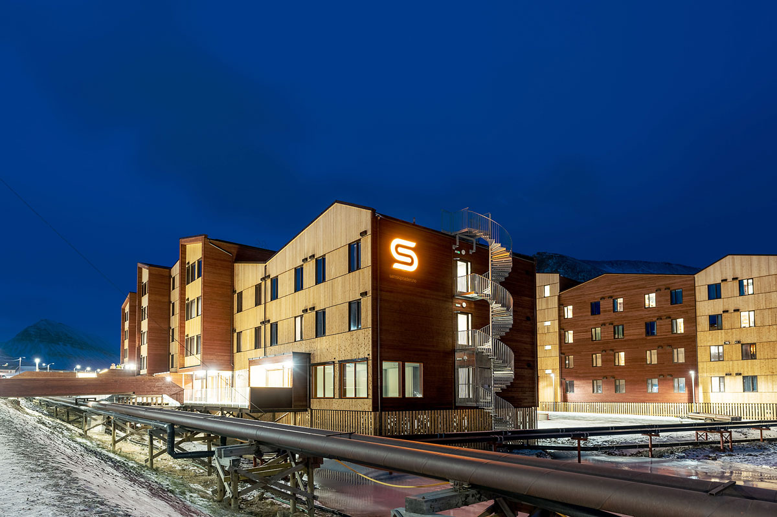

New student accommodation at Elvesletta.

Photo: Norwegian Arctic Student Welfare Organisation

The new student housing facilities at Elvesletta officially opened in October 2021. The student housing facilities can accommodate a total of 300 students. These facilities replaced the old student housing located in an avalanche-prone area in Nybyen.

### Research Council of Norway – Svalbard Office

The Research Council of Norway’s Svalbard Office is located at the Science Centre in Longyearbyen. Its main task is to ensure and contribute to clear Norwegian coordination of research activities in Svalbard. The Svalbard Office’s goals and policy instruments are therefore aimed at strengthening domestic and international research cooperation.

The Svalbard Office manages and serves as the secretariat for the Svalbard Science Forum (SSF), cf. section 5.4.2. The office is responsible for the Research in Svalbard (RiS) database, see section 5.4.2, and provides support for cooperation and fieldwork in Svalbard through its own grant schemes. An important component of the Svalbard Office’s work is to provide expert advice to the Governor of Svalbard on the processing of applications for research permits.

### The Norwegian Polar Institute

The Norwegian Polar Institute is a directorate under the Ministry of Climate and Environment. The institute is responsible for mapping, environmental monitoring and management-related research in the Arctic and Antarctic. Furthermore, the institute also serves as an expert and strategic advisor to the central administration, sits on the Interministerial Committee on the Polar Regions and is an expert advisor to the Norwegian Environment Agency and the Governor of Svalbard. The institute conducts extensive activities in Svalbard, including research, environmental monitoring, topographic mapping, geologic mapping, research and logistics services, lighthouse inspection and advisory tasks. It is a key knowledge producer and possesses broad research-based expertise in areas where the environmental management authorities have direct management responsibility in the High North and polar regions or serve as a key driving force in both national and international processes. Furthermore, the Norwegian Polar Institute develops, revises and leads the Environmental Monitoring of Svalbard and Jan Mayen (MOSJ). Another important task of the institute is to actively participate in international research cooperation, to serve as an international focal point on polar matters and to facilitate contact between Norwegian and international academic communities. The institute also engages in cooperation by granting access to its infrastructure, such as office space, field equipment and transport. Together with UNIS, the Norwegian Polar Institute provides important logistics services to a number of Norwegian and international research partners in Svalbard. In addition to its facilities in Longyearbyen, the institute has offices in Ny-Ålesund and owns the air monitoring station on Zeppelin Mountain. The institute regularly uses the research vessel Kronprins Haakon around Svalbard. It also manages the Ny-Ålesund Research Station and follows up the research strategy for Ny-Ålesund. The institute’s portfolio in Svalbard is continuously evaluated and adapted to the needs of the authorities, and was most recently evaluated by the Research Council of Norway in 2023 (EVALBIOVIT). The institute’s research received highly favourable reviews, and was generally evaluated as excellent. Its researchers are well represented on the lists of the most published and cited researchers, both domestically and internationally.

### Kings Bay AS

Kings Bay AS is a state-owned company with its head office in Ny-Ålesund. The company owns the infrastructure, land and most of the buildings in Ny-Ålesund, and is responsible for operations and development in Ny-Ålesund. Kings Bay AS lets 13 buildings to research institutes from 10 different countries, and around 20 research institutes carry out research projects in Ny-Ålesund every year. Kings Bay AS owns and maintains Svalbard’s largest collection of automatically protected buildings in Svalbard. The Ministry of Climate and Environment has strengthened Kings Bay AS’s operating and investment budget so that the company will have NOK 79.1 million in operating and investment grants in 2024, which is NOK 57.5 million more than in 2018.

## Policy instruments and research activity

### Norwegian research management – overall framework and principles for research and higher education

No other place in the Arctic can offer a research platform that has such readily accessible and well-developed research infrastructure for climate and environmental research as Svalbard. At the same time, the goal of preserving the area’s distinctive wilderness nature and local infrastructure sets limits in terms of scope and activity.

The Government emphasises the future-oriented and sustainable development of research and higher education in Svalbard. Activities shall be in accordance with established international standards for scientific practice and take place within the framework of Norwegian research policy and Norwegian research management in Svalbard, in compliance with Norwegian legislation. Norway is facilitating higher education through UNIS, which is to be the only institution for higher research-based education in Svalbard. This means that no other higher education programmes or courses will be facilitated in Svalbard outside of UNIS.

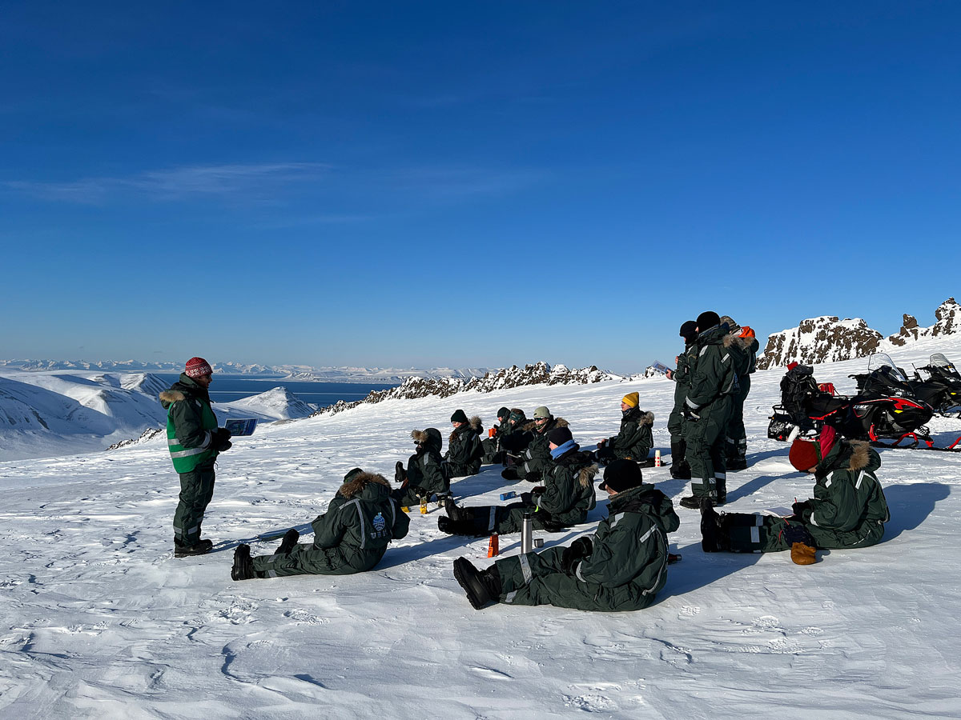

UNIS students from the bachelor’s courses in Arctic geology conducting fieldwork at Botneheia in central Spitsbergen.

Photo: Marjolaine Verret, UNIS

A strategy for research and higher education in Svalbard was drawn up in 2018 based on the previous white paper on Svalbard. This strategy describes objectives and ambitions, as well as frameworks and general principles for research and higher education in Svalbard. Within the framework of the overarching strategy, the Research Council of Norway presented a separate research strategy for the Ny-Ålesund Research Station in 2019.

The Government believes the strategies have succeeded in achieving the goal of developing knowledge and expertise at a high scientific level. The strategies provide good frameworks and principles for research activities and research collaboration. They express ambitions and policy instruments for better resource utilisation and coordination, clearer prioritisation of the natural sciences, improved quality and academic management, cooperation and sharing of equipment and data. The Government will continue the strategies as well as the objectives and frameworks for research and higher education in Svalbard derived from them.

Through these strategies, Norwegian authorities have clear expectations of research actors. Norwegian research management is exercised by monitoring, regulating and coordinating research activities in order to reduce the overall impact on the natural environment in Svalbard and to ensure that research activities take place in accordance with the applicable Svalbard policy.

The Government expects that the research environments in Svalbard have the highest scientific ambitions for their research and strive for quality through international cooperation. Research results and data shall be made openly available and published in such a manner that they contribute to the development of the research front and are utilisable. The Government continues to see the potential in more systematic and binding cooperation on the research infrastructure in Svalbard. The aim is for all the research institutes operating in Svalbard to recognise the added value of increased cooperation, sharing and mutual access to research infrastructure.

Research activities and educational programmes shall be based on the natural advantages offered by Svalbard’s location, meaning that climate, nature and the environment shall be focus areas. Activities shall be of such a nature that they can only or best be carried out in Svalbard.

All research and educational activities shall take into account the need to minimise the footprint and overall impact on the environment. This can be achieved by coordinating activities and sharing data and results from fieldwork. Research data shall be made available and shared in line with internationally recognised principles.

Research in Svalbard shall primarily be conducted from established local communities and research stations. This applies to research activity in all local communities. The restrictive practice with regard to permits and requirements under the Svalbard Environmental Protection Act for activities that interfere with the nature and landscape outside the planning areas will be continued. This means that it cannot be expected that permits will be granted to establish new research stations or other major permanent research infrastructure outside the planning areas.

Within the planning areas, there is a strain on existing infrastructure. In both Longyearbyen and Ny-Ålesund, the management of land and property, and the establishment and use of buildings for research and education purposes shall comply with the land-use plan and regulations, as well as principles and frameworks for higher education and research.

The principle that research shall primarily take place in established local communities and at established research stations is also of significance for research activities conducted from cabins on state-owned land in Svalbard. The Government will review the regulations governing cabins on state-owned land, with the aim of updating the legal framework to reflect the current situation. Research activities in the protected areas of the archipelago should be limited to activities that cannot be conducted elsewhere.

As a rule, most activities will require permission from the Governor of Svalbard. For activities in the territorial sea, it may be necessary to obtain permission from other authorities, including the Norwegian Directorate of Fisheries and the Norwegian Offshore Directorate. Traffic in the field requires a high degree of safety management, safety training and logistical support for both students and researchers. The Government will consider how to ensure that all research activities in the field take place following adequate safety training and with the necessary logistical support.

### Cooperation forums and support schemes

The overarching principles for research and education in Svalbard form the basis for the work in various coordination and cooperation forums.

Svalbard Science Forum (SSF)

SSF is a forum for cooperation between all the most important research facilities and actors in Svalbard. This also includes the actors in Hornsund and Barentsburg. However, the actors in Barentsburg are temporarily suspended. The Research Council of Norway’s Svalbard Office provides the chair and secretariat for the forum. SSF has its own mandate adopted by the Ministry of Education and Research, most recently revised in 2019. The most important purpose of SSF is to contribute to high scientific quality in all research in Svalbard through good coordination of research activities, provide readily accessible information about the research and strengthen cooperation between both individual researchers and institutions.

Research in Svalbard (RiS)

The RiS database is a searchable portal providing an overview of ongoing research projects in Svalbard. The database is managed by the Research Council of Norway and has undergone significant improvements in recent years. Most research projects in Svalbard are registered in the database and all projects that apply to the Governor of Svalbard for permits, or the Research Council of Norway for funding, are to be registered in RiS. The same applies to all projects that involve stays in Ny-Ålesund. The Research Council of Norway quality controls that the research actors and research projects registered with projects in the RiS database are genuine.

The Arctic Field Grant (AFG) and the Svalbard Strategic Grant (SSG)

The Arctic Field Grant and the Svalbard Strategic Grant are part of the Research Council of Norway’s support schemes to promote polar research. The Arctic Field Grant supports graduate students, doctoral students and researchers who are not already established in Svalbard. Up to NOK 4 million is normally awarded. The funding is mainly intended to cover costs associated with fieldwork in Svalbard, thereby stimulating increased Norwegian research activity at the Ny-Ålesund Research Station.

The Svalbard Strategic Grant is a policy instrument that aims to promote coordination, collaboration and data sharing between researchers with relevance to Svalbard. SSG is a policy instrument that supports research networks. However, a Norwegian institution must be listed as the responsible applicant.

Svalbard Integrated Arctic Earth Observing System (SIOS)

The Svalbard Integrated Arctic Earth Observing System (SIOS) is a Norwegian-initiated international collaboration on research infrastructure and data sharing. SIOS has a total of 29 members from 10 countries. The collaboration is structured as an association whose chair must be employed by one of the Norwegian member institutions.

Joint activities in SIOS are organised through SIOS Svalbard AS, which is a wholly-owned subsidiary of UNIS. These activities are mainly funded by the Research Council of Norway’s project, the SIOS Knowledge Centre, as well as by a membership fee.

SIOS members shall make their observation data comprehensible and available to each other. The Observation Facility Catalogue is a map-based service that provides an overview of all observation facilities that collect SIOS data. SIOS contributes to reducing unnecessary duplication of observations, thereby reducing the footprint on the vulnerable environment in Svalbard.

SIOS publishes the State of Environmental Science in Svalbard (SESS) report which describes the status and needs of the observation system for Earth System Science in several different domains.

The fact that several institutions are not members of SIOS remains a challenge. Changing this is a long-term goal. It is necessary to conduct an evaluation of SIOS and the Research Council of Norway has initiated such a process of the SIOS Knowledge Centre. The evaluation is expected to be finalised in 2024.

The Svalbard Science Conference

The Svalbard Science Conference was first organised in 2017 and has since been held every two years. Each conference has attracted around 300 participants, making it a key international meeting place for dialogue on research in Svalbard. The Svalbard Science Conference is organised by the Research Council of Norway and the Norwegian Polar Institute in collaboration with the Ny-Ålesund Science Managers Committee (NySMAC).

The Ny-Ålesund Science Managers Committee (NySMAC)

The Ny-Ålesund Science Managers Committee (NySMAC) is an informal cooperation and coordination body for the research institutions conducting research at the Ny-Ålesund Research Station. NySMAC has 18 member institutions, and the Norwegian Polar Institute is the forum’s secretariat. NySMAC has been central to the development of the four joint flagship programmes, covering the marine system in Kongsfjorden, terrestrial ecosystems, the state of the atmosphere and glaciological research.

### Scope and quality of Svalbard-related research

Norway is one of the largest contributors to global polar research, particularly in the Arctic. Norway is also by far the leader in terms of number of publications from Svalbard. Researchers at Norwegian institutions contribute to the majority of the particularly highly cited Svalbard articles. Although no assessment of resource efforts in Norwegian polar research has been carried out since 2018, the Research Council of Norway has commissioned the Nordic Institute for Studies in Innovation, Research and Education (NIFU) to conduct such a review, which is expected to be completed in summer 2024.

In the 2018 statistical year, approximately 500 full-time equivalents (FTEs) were dedicated to research and development in Svalbard. This includes the international contributions, as well as teaching and support functions.

The Research Council of Norway’s 2014 Assessment and Publication Analysis revealed that Norwegian researchers are cited somewhat less often than other major polar research nations, and that Svalbard research is cited less than other polar research. The reason for the latter may be that the results are too location-specific. In response, the Research Council of Norway announced up to NOK 50 million for Svalbard in a pan-Arctic context in 2023, through the earmarked programme for polar research, all of which was allocated to natural science research.

The Research Council of Norway’s evaluation of Norwegian polar research from 2017 and the follow-up plan from 2020 especially highlighted the importance of competition-based schemes to improve the quality of Norwegian polar research. Competition-based funding for polar research through the Research Council of Norway has been increased by NOK 15 million since the 2020 budget year, from around NOK 50 million to around NOK 65 million. Projects involving Svalbard-relevant research account for around 30 per cent of the Research Council of Norway’s competition-based polar research funding.

Both the evaluation and the follow-up plan emphasised the importance of major interdisciplinary initiatives. The two major Arctic Ocean programmes – The Nansen Legacy and GoNorth – are good examples of such initiatives. These two large research consortia have operated in the Barents Sea and the Arctic Ocean north of Svalbard, with Svalbard as the starting point for their expeditions. Norway’s icebreaker-class research vessel FF Kronprins Haakon has enabled pioneering and management-oriented research on the marine ecosystem and studies of the water column from the seabed, including marine geology, to the sea ice. The Nansen Legacy has had a total budget of NOK 740 million over seven years, of which 50 per cent is funded by the Ministry of Education and Research through the Research Council of Norway, and the remaining 50 per cent is self-funded by the institutions. GoNorth has consisted of several sub-projects, each with its own external funding. The institutions are working on plans for the continuation of the projects, and thereby continued cooperation with other countries’ icebreaker-class research vessels.

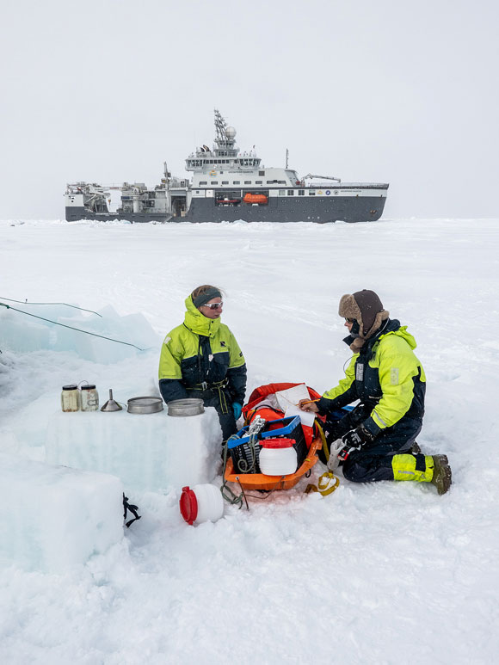

The first plastics expedition with FF Kronprins Haakon in 2021. Approximately 1,200 samples were collected and analysed for microplastics at the Fram Centre in Tromsø.

Photo: Trine Lise Sviggum Helgerud, Norwegian Polar Institute

Infrastructure

The scope and quality of research activity is dependent on modern and accessible infrastructure. The fibre-optic cables between Svalbard and the mainland are crucial in this regard. Data volumes are increasing, and the use of digital sensors of various kinds produces data without the researcher being physically present. This requires a fast and stable internet connection.

The research vessel FF Kronprins Haakon was commissioned in January 2018. The vessel is designed to support all types of marine research in both open and ice-covered waters. FF Kronprins Haakon is owned by the Norwegian Polar Institute and is operated by the Institute of Marine Research. The Norwegian Coast Guard also provides valuable support to Norwegian polar research by granting access to research expeditions on the vessel KV Svalbard.

The Ny-Ålesund Research Station is an important infrastructure facility, with its research activities and the shared infrastructure that has been developed there.

The EISCAT Svalbard Radar

EISCAT (European Incoherent Scatter) operates radars on the mainland of Norway, Sweden and Finland, as well as in Svalbard. The EISCAT Svalbard Radar (ESR) contributes data to climate and atmospheric models. EISCAT has two radars in Svalbard. Together with the mainland facility, they are able to provide a nearly continuous picture of the upper atmosphere from Tromsø to the areas north of Svalbard. The radars have a limited lifespan due to wear and tear and difficulties with certain spare parts, and a future upgrade to phased array radars is desirable. Since the location is complementary to the mainland facility, it is important to continue their operation.

[Boks slutt]

## Development trends and challenges

The need for and interest in climate and environmental research based on the polar regions, as well as considerations for national control, both reinforce and create new challenges for research and higher education in Svalbard.

There is growing interest in research in Svalbard among foreign institutions. As of May 2024, there were 678 active research projects led by researchers from 192 institutions from a total of 30 countries. Norwegian institutions account for almost half of the activity, leading 291 projects registered in the Research in Svalbard (RiS) database, and they are partners in another 69 projects. Research into how climate change in the Arctic affects weather and climate in other parts of the world attracts scientists from all over the Northern Hemisphere.

National guidelines for responsible international cooperation

Balancing openness and due diligence is a challenge for the entire higher education and research sector. In 2023, the Government launched national guidelines for responsible international cooperation as an online resource/tool for Norwegian higher education and research institutions.

[Boks slutt]

Clear and strong Norwegian research leadership is needed in Svalbard. The review of actors and policy instruments in research and higher education reveals a strong foundation. Nevertheless, the Government recognizes the need for additional measures. Therefore, the Government will establish a separate Svalbard Science Office within the current budget framework, consisting of resources from the Norwegian Polar Institute and the Research Council of Norway, in order to achieve a clearer Norwegian research management and an even better overview of the development of research in Svalbard. The office will follow up and implement the research strategy for Svalbard, serve as a clear focal point for foreign research environments and prepare an annual report on all research activities in Svalbard. The Svalbard Science Office should be located in the Science Centre in Longyearbyen.

The Government will continue its investment in polar research and the special emphasis on Svalbard research. For Norway as a polar nation, promoting strong and visible polar research is a prioritised research policy task. This applies to Svalbard, but also to research related to the Arctic and Antarctic, including the polar seas. The Research Council of Norway, as the Government’s advisor, research policy actor and funder, has an important role to play in this context. There is a need for good and strategic use of available funding for polar research in line with the enunciated policy priorities, and further development of strong academic environments with good recruitment.

The EU’s interest in Svalbard and the Arctic has increased, and cooperation is expanding. Similarly, polar cooperation and polar research are receiving increasing attention in bilateral cooperation with several countries. The Government will facilitate international cooperation through bilateral and multilateral arrangements. The general policy instruments through the Research Council of Norway and Norwegian participation in the European Framework Programmes will contribute to this. Norway should have a strong and clear voice in this cooperation.

Several coordination mechanisms and policy instruments have been developed for cooperation and sharing of infrastructure and data. Although several cooperation arenas exist, the potential for sharing and cooperation has not been fully realised. Open research and cooperation are essential in Svalbard, especially for reducing the overall strain on nature.

Continued work is needed on policy instruments to encourage more Norwegian researchers to use the Ny-Ålesund Research Station, including assessing the models for payment for stays in Ny-Ålesund, as well as the funding models for research support. In 2023, the Government bolstered the Arctic Field Grant funding programme with a lump sum allocation.

UNIS is the largest research institution in Svalbard in terms of publications (NIFU 2017:6) and number of projects (RiS database). They contribute greatly to international research cooperation and to the recruitment of new polar researchers.

UNIS has developed considerable local knowledge on natural conditions, geology, permafrost and technology for Arctic conditions, which makes an important contribution to social development in Longyearbyen and to the management of nature and the environment on the archipelago. UNIS has also built competence that is relevant to the development of renewable energy solutions in Svalbard. The Arctic Safety Centre (ASC) has the potential for further development by linking science, technology and safety.

With a high proportion of Norwegian students and researchers, UNIS contributes positively to a Norwegian family community in Longyearbyen. However, there continues to be a need for policy instruments that make UNIS more attractive to Norwegian applicants for both studies and academic positions. The Government will consider a target for employing Norwegian professionals at UNIS. It is desirable that more students attending programmes at Norwegian universities take a semester at UNIS, and the Government will continue to work on measures to achieve this. It is important that UNIS continues its good cooperation with the mainland universities to strengthen the recruitment of Norwegian students and the quality of its study programmes. The Government wants UNIS to be the sole provider of higher education in Svalbard.

Development and use of zero- or low-emission technology

On behalf of the Ministry of Energy, the Research Council of Norway has conducted an assessment of whether there is a scientific basis for establishing a combined research and testing centre in Svalbard for the development and use of zero- or low-emission energy technology in Arctic conditions. The report concludes that there is no scientific basis for establishing such a centre in Svalbard. Instead, the Research Council of Norway recommends establishing other types of concepts for testing, which are more cost-effective and environmentally friendly, both in terms of construction and operation. Based on the Research Council of Norway’s report, the Government believes it would be unsuitable to establish a research and testing centre, but that there is a basis for developing the knowledge and research environment in Svalbard related to the development and use of zero- or low-emission energy technology in Svalbard. A requirement must be that Svalbard is the best place to carry out the research and testing, so that there is an added value to conducting the activity there compared to what can be achieved by existing research environments and activities on the mainland.

[Boks slutt]

## Specific information about the Ny-Ålesund Research Station

### Introduction

The Ny-Ålesund Research Station is an important part of Norway’s Svalbard policy as a Norwegian platform for international natural science research cooperation. The Norwegian Polar Institute manages the Ny-Ålesund Research Station and Kings Bay AS manages the local community. Buildings and other important infrastructure at the Ny-Ålesund Research Station, including larger/shared research infrastructure, are owned and operated by the Norwegian state institutions and state-owned companies.

Ny-Ålesund continues to develop as the leading research station for polar research in the Arctic. Kings Bay AS lets 13 buildings to research institutes from 10 different countries, and around 20 research institutes carry out research projects in Ny-Ålesund every year. In 2023, 267 research projects were registered in Ny-Ålesund, maintaining a level consistent with the previous five years. The number of guest nights by researchers has varied between 15,115 (2019), 13,906 (2022) and 13,473 (2023). The Norwegian share of visiting researchers varies between approximately 3,500 and 6,500. Over time, this activity has paid off in the form of lengthy and valuable time series. Several time series are now 50 years old.

The Norwegian Mapping Authority conducts Earth observations from its facility outside Ny-Ålesund. This is included in the production of a global reference frame and forms the basis for all positioning services used worldwide.

### Research strategy for Ny-Ålesund

As a follow-up to the 2016 white paper on Svalbard, the Research Council of Norway was tasked with preparing a research strategy for Ny-Ålesund, which was published in the spring of 2019. The Norwegian Polar Institute is responsible for coordinating research and the day-to-day implementation and follow-up of the research strategy for Ny-Ålesund. The Government will continue to pursue the research strategy for Ny-Ålesund as well as the objectives and frameworks for research and higher education derived from it.

### Research activity

The entire area and the surroundings of the Ny-Ålesund Research Station is in itself a scientific laboratory in a pristine Arctic natural environment, where the local environmental impact and the strain of traffic shall be reduced to a minimum. Therefore, it is essential to limit the impact of activities other than research, particularly the impact of vessels and tourists in the area. Teaching is limited to research-related teaching at the graduate level, with the exception of UNIS, which, due to its unique position in Svalbard, also can make use of Ny-Ålesund in undergraduate-level teaching.

In 2022, the Norwegian Polar Institute conducted studies in Kongsfjorden. There is considerable boat traffic in Kongsfjorden, peaking between the months of June and September. During this period, noise levels often exceed the internationally accepted acoustic thresholds for the disturbance of marine mammals. The Government recognises that there is a need to assess the impact of noise on life in the most heavily trafficked fjords of Svalbard, including Isfjorden and Kongsfjorden, and to consider the need for measures. In addition, ship calls result in breaches of the regulatory prohibition radio transmitters with signals in the 2–32 GHz frequency range and interference with the Norwegian Mapping Authority’s Earth observations.

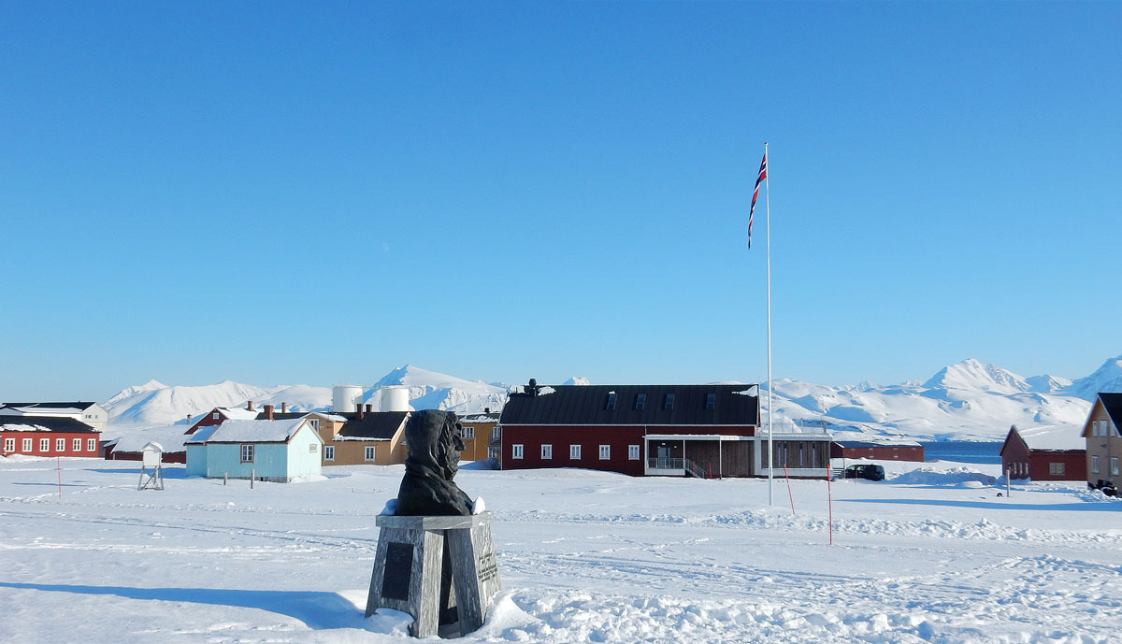

Ny Ålesund – Kings Bay Veksthuset, including laboratories for researchers working on terrestrial research.

Photo: Roar Blomstrand, Kings Bay AS

Kings Bay AS and the Norwegian Polar Institute have ensured a development whereby the research institutes make greater use of thematic centres linked to prioritised areas with equipment for joint use, operated by Kings Bay AS. This work will continue.

Kings Bay AS, the Research Council of Norway and the Norwegian Polar Institute have assessed measures to encourage Norwegian researchers to make greater use of the research opportunities in Ny-Ålesund. Among other things, there is a need to assess the models for payment for stays in Ny-Ålesund and the funding models for research support.

Climate challenges and changes in the permafrost are causing damage to the building stock in Ny-Ålesund due to unstable ground conditions. Foundation reinforcement is required for a large number of buildings in addition to damage repairs. Therefore, the Government has bolstered Kings Bay AS financially by increasing the operating and investment grant. Energy supply in Ny-Ålesund is diesel-based. The systems are relatively old and will eventually need to be renewed. In this context, it will be necessary to consider more future-oriented, green energy sources.

Ny-Ålesund received mobile phone coverage in 2023. To prevent interference with research instruments, the use of wireless internet and Bluetooth is not permitted.

The Earth Observatory in Ny-Ålesund

The new antennas at the Norwegian Mapping Authority’s new Geodetic Earth Observatory have been put into operation. The facility observes weak radio waves from distant quasars, and in Ny-Ålesund there is a regulatory prohibition on radio transmitters operating in the 2–32 GHz frequency range. Interference from wireless networks and Bluetooth locally and from visiting cruise ships significantly degrades the Norwegian Mapping Authority’s measurements. The Norwegian Communications Authority has recently established measuring stations in Ny-Ålesund that register illegal and unwanted use of radio equipment. Illegal use will be followed up by the supervisory authorities to prevent interference with the Norwegian Mapping Authority’s measurements. Furthermore, international efforts are underway to assess whether to change the frequency ranges for the measurements to avoid interference from wireless networks and Bluetooth in the future.

[Boks slutt]

## Measures

The Government will:

* Continue the strategies as well as the following objectives and frameworks for research and higher education in Svalbard derived from them:
  + Research activities and educational programmes shall be based on the natural advantages provided by Svalbard’s location.
  + The research environments shall have the highest scientific ambitions for their research and strive for quality through international cooperation.
  + Research data and results shall be made openly available, shared and published in such a manner that they contribute to the development of the research front.
  + All research and educational activities shall take into account the need to minimise the footprint and overall impact on the environment.
  + Work towards a more systematic and binding cooperation regarding the research infrastructure in Svalbard.
  + The research environments shall share information about planned projects in the field and coordinate activities as far as possible.
  + All researchers, students and institutions that are active in the field must possess the appropriate competence and have the necessary logistical support.
  + Research in Svalbard shall primarily be conducted from established local communities and research stations.
  + UNIS shall be the sole provider of higher education in Svalbard.
* Continue investment in polar research and the special emphasis on Svalbard research.
* Within the current budget framework, establish a separate Svalbard Science Office consisting of resources from the Norwegian Polar Institute and the Research Council of Norway in order to achieve clearer Norwegian research management in Svalbard.
* Ensure that the Svalbard Science Office is responsible for preparing an annual report on research activities in Svalbard.
* Facilitate international cooperation through bilateral and multilateral arrangements, including through the funding schemes.
* Review the regulations governing cabins on state-owned land, with the aim of updating the state of the law to reflect the current situation.
* Ensure that UNIS continues to develop its role and profile as one of the most important institutions in Norwegian polar and Svalbard research and higher education.
* Ensure that UNIS further develops its collaboration with the mainland universities in order to strengthen recruitment and the quality of the courses offered.
* Consider a target of employing Norwegian professionals at UNIS.
* Consider various measures to increase the proportion of Norwegian students at UNIS.
* Ensure that the Arctic Safety Centre (ASC) is further developed for research and education purposes.
* Continue to work on measures to encourage more Norwegian researchers to use the Ny-Ålesund Research Station.

# Civil protection, rescue and emergency preparedness

## Introduction

In the period since the last report to the Storting on Svalbard was presented, considerable attention has been focused on strengthening the work on civil protection, rescue and emergency preparedness in and around Svalbard. The sector principle is applicable in Svalbard as it is elsewhere in the country, meaning that each sector is responsible for assessing risks, vulnerabilities, and potential mitigation measures.

Local emergency preparedness capacity is good. There is both a significant ability and willingness to handle incidents on the part of the established resources, the local population, the commercial sector and other actors in Svalbard. This has been illustrated repeatedly when locally available capacities and resources have assisted in managing various incidents. However, local emergency preparedness is not scaled to handle major incidents or incidents occurring simultaneously over an extended period of time. In such circumstances, resources will need to be provided from the mainland.

The chapter provides a description of developments and challenges, the actors involved and their roles, responsibilities and resources, as well as measures.

## Developments and challenges

### Climate change and increased activity

In 2019, the Norwegian Centre for Climate Services presented a climate profile for Longyearbyen.[2] In the future, Longyearbyen will experience more precipitation in the form of rain, as well as increased snow- and glacier melting. These changes will result in an increase in the number and severity of floods, as well as more frequent avalanches and mudslides. Warmer weather and increased precipitation lead to increased wear and tear on buildings and infrastructure, which must be better protected against erosion and landslides.

ARCT-RISK (Risk governance of climate-related systemic risk in the Arctic)

The ARCT-RISK research project aims to develop knowledge and tools to understand and manage the effects of climate change on civil protection.

The results have already been utilised in risk and vulnerability analyses in Longyearbyen to develop sensor systems for monitoring avalanche terrain and for risk management of mudslides.

UNIS is establishing a monitoring system for permafrost-related avalanches in Longyearbyen to be able to warn of changes in mountain slopes, especially in extreme weather conditions.

[Boks slutt]

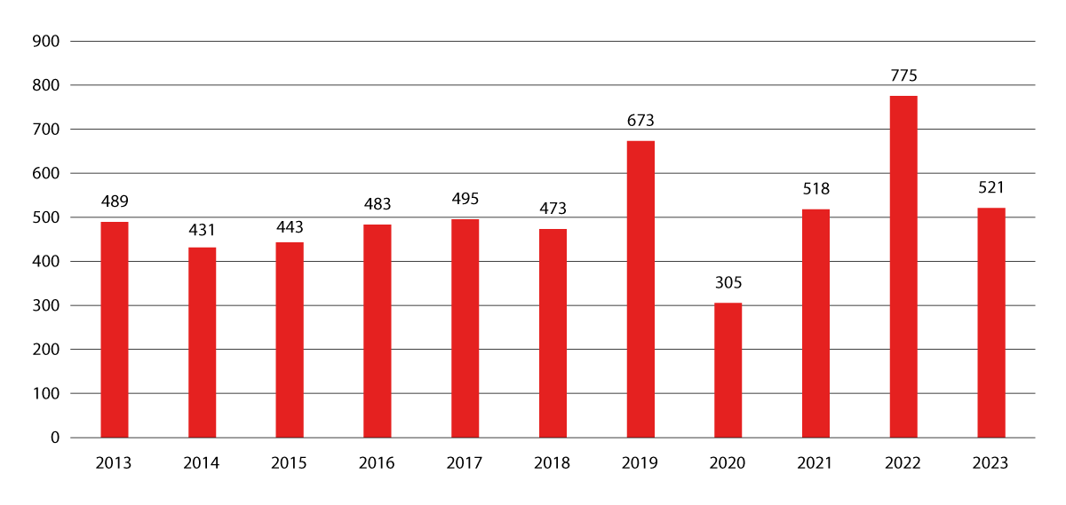

Total number of vessels sailing in the waters around Svalbard.

Source:Norwegian Coastal Administration/Norwegian Directorate of Fisheries

Sea ice loss extends the sailing season and increases the navigable area around Svalbard, while the operational area for search and rescue is correspondingly enlarged. The risk of maritime accidents in remote and vulnerable areas increases as a result of increased activity, in addition to a greater risk and need for medical evacuation from vessels located far from Longyearbyen. Growth in activity in and around Svalbard entails that at times the population greatly exceeds the capacity of available emergency preparedness resources. In the Governor of Svalbard’s risk and vulnerability analysis for 2022–2026, the overall risk of accidents at sea is considered to be high.

## Actors and their policy instruments

### The Governor of Svalbard

The Governor of Svalbard is the central authority for the planning and implementation of civil protection and emergency preparedness measures on the archipelago and is responsible for rescue services in and around Svalbard.

The Governor of Svalbard chairs the Svalbard Emergency Preparedness Council in the capacity of having the same authority as a state administrator. The Emergency Preparedness Council is made up of the Governor of Svalbard, Longyearbyen Community Council, Kings Bay AS, CHC Helikopter Service AS, COOP Svalbard, Avinor Svalbard, the Norwegian Water Resources and Energy Directorate, Svalbard church, the Norwegian Meteorological Institute, Longyearbyen Fire and Rescue Service, Store Norske Spitsbergen Kulkompani AS, Telenor Svalbard, the Longyearbyen Norwegian Red Cross Search and Rescue Corps, the University Centre in Svalbard, Leonard Nilsen & Sønner AS, the University Hospital of Northern Norway Longyearbyen and the University Hospital of Northern Norway Tromsø.

As Chief of Police, the Governor of Svalbard is the head of rescue management with the Local Emergency Response Centre in Svalbard. The members of the rescue management team overlap to an extent with the members of the Emergency Preparedness Council. In the event of an incident, management is dependent on the efforts of volunteers and the provision of resources from the mainland when needed.

Emergency medical communication service in Svalbard

The Ministry of Justice and Public Security is examining how the emergency medical communication service (the 112 emergency telephone number) in Svalbard can be organised and operated most appropriately. The examination will be finalised in 2024.

Svalbard-ROS

The Governor of Svalbard prepares a risk-and-vulnerability-analysis (RVA) for the Governor of Svalbard’s area of responsibility. The current Svalbard RVA is valid for the period 2022–2026. The assessment includes a consideration of acute pollution, nuclear incidents, accidents at sea, avalanches, floods and cyberattacks. The Governor of Svalbard has drawn up a comprehensive plan for following up the assessment, with an overview of mitigation measures, clarification of responsibilities and status descriptions. Furthermore, the Governor of Svalbard has procedures regarding security of supply and other matters.

The Governor of Svalbard’s resources

The combined transport resources of the Governor of Svalbard are necessary for carrying out supervision and exercising authority, for an effective police and rescue service, and for ambulance and medical transport in and outside the territorial waters of Svalbard. From 2016 to 2024, the budget allocation for the Governor of Svalbard’s transport service (Ch. 0006 of the Svalbard Budget) increased by approximately 33 per cent. During the same period, the allocation for the Governor of Svalbard’s operating budget (Ch. 0005 of the Svalbard Budged) increased by nearly 72 per cent. The increase in allocations strengthens the ability of the Governor to exercise control in Svalbard. Furthermore, the increase in allocations reflects the increased activity in and around Svalbard in general, and thus additional for the Governor of Svalbard.

Helicopters

The Governor of Svalbard commands two Super Puma Helicopters for All-Weather Search and Rescue in Svalbard and the surrounding areas. Response time is two hours. Each helicopter can transport up to 18 passengers within a radius of 120 nautical miles.

In 2021, the Ministry of Justice and Public Security entered into a new contract with a private operator for the operation of a new civilian rescue helicopter base in Tromsø and joint operations with the Governor of Svalbard’s helicopter service. CHC Helikopter Service assumed responsibility for the operation of the Svalbard base in 2022.

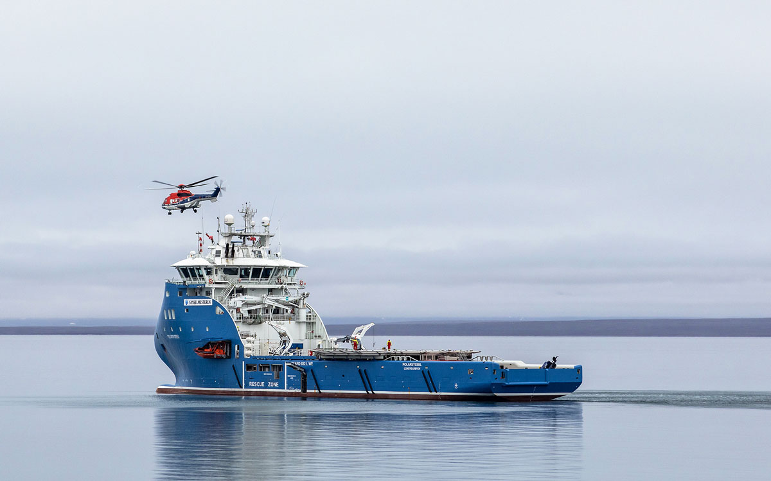

The Governor of Svalbard’s service vessel MS Polarsyssel and Super Puma Helicopter for All-Weather Search and Rescue.

Foto: Stein Olav Bredli, Governor of Svalbard

Service vessel

Since 2014, the Governor of Svalbard has commanded the chartered service vessel M/S Polarsyssel. The service vessel is built to an ice class and has a helicopter deck. Since 2020, the sailing season of the vessel has been extended to cover the whole year. The Governor of Svalbard also commands the smaller vessel Fjordsyssel.

Sailing days for the Governor of Svalbard’s service vessel MS Polarsyssel

02J1xt1

|  |  |
| --- | --- |
| Year | Sailing days |
| 2017 | 204 |
| 2018 | 210 |
| 2019 | 197 |
| 2020 | 190 |
| 2021 | 204 |
| 2022 | 181 |
| 2023 | 203 |

Source: The Governor of Svalbard

### The Norwegian Coast Guard

The Norwegian Coast Guard and the Governor of Svalbard have cooperation agreements concerning the Coast Guard’s support to the Governor of Svalbard in the exercise of authority, search and rescue, oil spill response operations, the supervision of protected areas and in connection with towing capacity. The Norwegian Coast Guard, the Governor of Svalbard, Norwegian Customs and the Norwegian Maritime Directorate cooperate on inspection duties related to vessels calling in Svalbard. The Norwegian Coast Guard and the Governor of Svalbard regularly carry out joint training exercises, and the Norwegian Coast Guard has ice-class vessels as well as helicopter decks that can be used by the Governor of Svalbard’s helicopters. The Norwegian Coast Guard normally has a continuous presence in the fisheries protection zone around Svalbard.

About training exercises

Training exercises are an important element in strengthening interaction between various actors.

The Arctic Mass Rescue Operation (AMRO) project of 2021 aimed to develop relevant procedures for a mass rescue operation in the Arctic for all actors in Svalbard that contribute to the rescue service.

The AMRO 2021 training exercise illustrated that under optimal conditions, at best one person per minute can be evacuated by helicopter from a cruise ship to a land-based camp, provided the distance to the vessel in distress does not exceed 20 nautical miles. Longyearbyen Hospital’s treatment capacity is limited to two intensive care patients.

Primarily, injured persons must be evacuated to the mainland.

[Boks slutt]

### The Norwegian Meteorological Institute

The Norwegian Meteorological Institute issues weather and sea forecasts covering the sea areas north of the 65° N latitude. Additionally, the Institute maps ice conditions for use in navigation around Svalbard, and publishes updated ice maps on weekdays. Weather forecasts are updated twice daily. The Institute issues ordinary weather forecasts for the land areas on the island of Spitsbergen.

The Institute’s staff in Bjørnøya and Hopen represent a significant part of the infrastructure for emergency preparedness and search and rescue in the Arctic Ocean. Activities on Hopen and Bjørnøya include emergency preparedness and fuel storage for helicopter traffic.

### Longyearbyen Community Council

Longyearbyen Community Council revised its overall emergency preparedness plan for Longyearbyen in 2023. The plan provides the framework for the work of the Community Council on emergency preparedness and crisis management.

Longyearbyen Community Council provides fire and emergency services, fire prevention tasks, alert services and ambulance services on behalf of Longyearbyen Hospital. In 2023, Longyearbyen Community Council prepared a risk and vulnerability analysis concerning adverse events.

### Svalbard Airport

Svalbard Airport serves as an evacuation route for emergencies and medical evacuations, ensuring a continuous supply chain of critical personnel and equipment. Avinor has plans in place for dealing with accidents, acute pollution, threats, terrorism, sabotage and epidemics. The airport constitutes critical infrastructure for activities taking place on the archipelago. Health emergency preparedness, the business sector and the local community in general rely on access to efficient passenger transport to and from the mainland as well as easy access to goods and services from the mainland. Disruptions in air traffic can rapidly generate serious consequences for Svalbard’s inhabitants. The Government considers it important to prioritise air traffic supporting the needs of the local population as well as the needs of local businesses.

### Norwegian Customs

Svalbard was established as a separate customs territory in May 2022. Norwegian Customs has established a physical presence in Svalbard with six customs officers, carrying out physical inspections of shipments being imported or exported. Over time, the aim is for the controls to align as closely as possible with those applied to the movement of goods to and from the mainland, with necessary adjustments for the local conditions in Svalbard, and with the obligations this entails for those involved in the transport of goods. See section 6.4.2 for a more detailed discussion of the control of movement of goods.

### Health emergency preparedness

Health emergency preparedness for acute illness and injury in Svalbard and the surrounding waters is based on the staffing and competence at Longyearbyen Hospital, communication with the University Hospital of North Norway in Tromsø, and rapid evacuation to the mainland. Emergency medical services in Svalbard consist of an emergency medical communication service, emergency care, ambulance service, an anaesthetist from the emergency medical clinic in the ordinary air ambulance service with the Governor of Svalbard’s rescue helicopters, and air ambulances to the mainland if needed.

In 2022, the Northern Norway Regional Health Authority transferred all medical emergency calls from Longyearbyen Hospital to the Emergency Medical Communication Centre in Tromsø to increase the capacity of the service.

A process will be initiated for a review of the status of psychosocial emergency preparedness and follow-up in Svalbard.

Air ambulances

The Air Ambulance Services of Norway, the four regional health authorities’ national air ambulance service, is essential to efficient treatment, transport and emergency response in cases of acute illness and injury in Svalbard. The Air Ambulance Service has pre-positioned some equipment in Svalbard, enabling both short-range and jet air ambulances to be used for emergency response in Svalbard.

The Norwegian Directorate of Health has agreements with the relevant actors concerning reinforcement resources from the Norwegian Armed Forces, from civil aviation and from other countries. These agreements may be triggered in the event of major incidents, and are used to transport medical equipment and personnel from the mainland to Svalbard, or to evacuate injured patients from Longyearbyen.

Infection control and COVID-19

Neither resources, local emergency preparedness nor capacity in Svalbard were or are scaled to handle a prolonged epidemic. Therefore, Svalbard was prioritised when allocating vaccines during the COVID-19 pandemic. Quantitative restrictions for the tourism industry and testing requirements were introduced, and routines were established for the evacuation of infected persons to the mainland. In 2020, one of the Governor of Svalbard’s helicopters was equipped with an EpiShuttle, a medical isolation unit for the transportation of highly infectious patients.

The Longyearbyen Norwegian Red Cross Search and Rescue Corps

The rescue service in Svalbard is organised in the same manner as on the mainland, with a significant component of voluntary contributions. The Longyearbyen Norwegian Red Cross Search and Rescue Corps is a key actor, with 80 active volunteers and two specialised groups, an avalanche group and a glacier group. The Search and Rescue Corps has extensive material resources.

### Other actors

A number of actors in Svalbard that are not primarily tasked with civil protection, rescue or emergency preparedness nevertheless have considerable emergency preparedness competence and are important for the overall emergency preparedness in Svalbard. This is reflected in the fact that the Svalbard Emergency Preparedness Council is made up of a wide range of public, voluntary and private actors, each of which possesses specialist knowledge of emergency preparedness work, as well as resources and equipment that are essential in the event of an incident. Local public, voluntary and private actors also have extensive knowledge of local conditions, which is crucial to the overall emergency response on the archipelago.

## Specific topics

### Emergency communication and coastal radio

Coastal radio service

A good coastal radio service is important for maritime activity around Svalbard. Telenor Kystradio provides a coastal radio service on behalf of the central government and continuously listens for emergency alerts over VHF (very high frequency) and MF (medium frequency/medium wave) from two manned coastal radio stations on the mainland, co-located with the Joint Rescue Coordination Centre. During rescue missions, the coastal radio stations ensure contact between the rescue service and the distressed party, as well as contact between ships providing assistance.

In 2021, improved HF (high-frequency/shortwave) coverage was established in the High North to strengthen emergency preparedness and ensure that Norway’s rescue responsibilities in the northern maritime areas are upheld. Emergency alerts are continuously monitored over HF (high-frequency) radio.

New emergency and preparedness communication system

On the mainland, emergency services and other preparedness actors use the Norwegian critical communication network Nødnett as their communication system when performing their tasks, while on Svalbard, Sysselnett is used as the main channel for such communication.

The existing Nødnett is based on outdated technology and will have to be replaced within a few years. In 2024, the Norwegian Directorate for Civil Protection (DSB) received an additional allocation of NOK 40 million to conduct a feasibility study for a new emergency and preparedness communication system. The feasibility study includes assessments of the possibility and need for additionally establishing a new critical communication network in Svalbard. The feasibility study is scheduled for completion in 2024.

Establishing a new, modern communication system in Svalbard would improve incident management and enhance the ability to swiftly mobilise resources from the mainland when needed. Similarly, this can provide emergency services and other preparedness actors with enhanced and more effective opportunities to support ongoing incidents and crises in Svalbard.

Emergency alert system

The central government’s new emergency alert system for mobile phones, Nødvarsel, was launched in February 2023. The population of Svalbard will receive national alerts in the same manner as the rest of the country, and local alerts can be sent exclusively to Svalbard if necessary.

Upgraded reserve satellite link

An enhanced reserve satellite link between Svalbard and the mainland has been operational since August 2022 and will initially last for three years. The reserve satellite link can be used in the event of a disruption to the fibre-optic cable connection, ensuring the continuity of basic telephone and mobile data services for all mobile phone users in Longyearbyen.

Communication, weather and Earth observation satellites

New communication and Earth observation satellites have been launched and additional satellites are planned with coverage in the Svalbard area. The Arctic Broadband Mission, owned by Space Norway, will provide broadband north of the 65° N latitude.

Several national small satellites can monitor ships or provide two-way communication between ships, satellites and land, and more satellites are planned through a collaboration between national authorities and commercial actors. This includes Arctic Ocean Surveillance a constellation of small satellites for maritime surveillance with good coverage in the Arctic. Satellites are currently used to map and warn of avalanches on the mainland, and the service will be extended to some areas in Svalbard in the coming years.

The Norwegian Meteorological Institute uses available satellite data for weather and climate mapping of Svalbard and the surrounding waters. Measurements from weather balloons in the atmosphere launched from Ny-Ålesund and Bjørnøya are important for good weather forecasting.

### Identity control and control of movement of goods to and from Svalbard

Identity control in Svalbard

Identity controls in Svalbard were introduced in May 2022, cf. section 2.3.6. The Governor of Svalbard carries out identity controls in order to enforce the Regulations relating to refusal of entry or stay and expulsion of persons from Svalbard. Norway has a duty to refuse entry throughout its territory to persons covered by travel bans adopted by the United Nations and must also be able to loyally follow up other internationally adopted travel bans that Norway has endorsed. The introduction of identity controls in Svalbard means that the Governor of Svalbard’s authority and ability to inspect travellers’ identities has been enhanced and corresponds to the authority of the police on the mainland to carry out such controls.

Identity controls are mainly carried out at Svalbard Airport in temporary premises, in the field and on board vessels. Since its implementation in May 2022, identity controls in Svalbard have been sporadic, meaning that the Governor of Svalbard makes a selection based on various criteria, including checking passenger lists, and verifies the identities of passengers.

Control of movement of goods to and from Svalbard

Control of the movement of goods to and from Svalbard was introduced in May 2022, cf. section 2.3.6. Control of the movement of goods in Svalbard is important for the same reasons as those applicable for the mainland, including contributing to protecting society against the illegal import and export of goods by ensuring that restrictions imposed for reasons including public safety are observed, and to ensure that Norway complies with its international obligations. This includes preventing Svalbard from being used to circumvent sanctions and export control legislation.

In May 2022, Norwegian Customs established a separate unit for the implementation of control of movement of goods in Svalbard. Norwegian Customs carries out physical inspections of shipments imported to or exported from the archipelago. At Svalbard Airport, the extent of physical control of movement of goods is currently limited. Norwegian Customs also carries out control of movement of goods on ships arriving in Svalbard. The current level of control is based on a minimum solution without, among other things, the notification, reporting and disclosure obligations that apply on the mainland. Expanding the scope of identity checks and the control of movement of goods at Svalbard Airport will require an expansion of the airport premises.

It is the Government’s intention that, over time, the control of movement of goods should, as far as possible, correspond to the control carried out on the mainland, with any adaptations to local conditions. This will entail the introduction of obligations for actors involved in the movement of goods compared to the current situation. Any proposals for legislative amendments will be presented for public consultation.

### Floods, avalanches and safety measures

Longyearbyen is vulnerable to avalanches, a risk that is exacerbated by climate change. Longyearbyen has been affected by two major avalanches in recent years. Two lives were lost in the avalanche in 2015. The avalanche in 2017 led to major material damage. In the aftermath of the avalanches, considerable resources have been used to prevent new avalanche accidents in central Longyearbyen.

The Norwegian Water Resources and Energy Directorate (NVE) has the overall responsibility for state administrative tasks in the prevention of flood and avalanche damage.

Since 2013, Svalbard has been covered by the assistance NVE provides to prevent flood and avalanche damage on par with municipalities on the mainland.

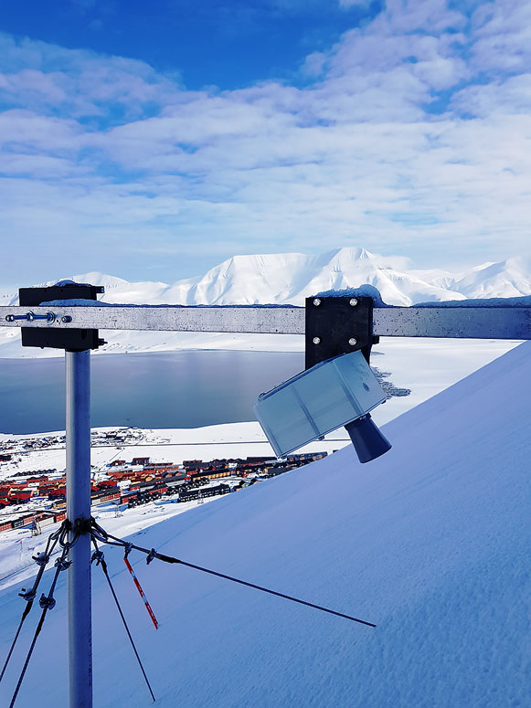

UNIS’ snow sensor for avalanche warning above Longyearbyen.

Foto: Martin Indreiten, Arctic Safety Centre

Alterting and evacuation

Longyearbyen Community Council is responsible for the safety of the inhabitants of Longyearbyen pursuant to the Regulations relating to the application of the Act relating to municipal emergency preparedness, civil protection measures and the civil defence and the emergency preparedness duty of Longyearbyen Community Council. Monitoring and alerting of floods and avalanches contribute to reducing the consequences of incidents and increasing the safety of persons residing and travelling in at-risk areas. The Norwegian Meteorological Institute issues warnings about precipitation that can lead to localised flooding and various forms of avalanches. The Governor of Svalbard, NVE and Longyearbyen Community Council are cooperating to prevent flood and avalanche damage in Svalbard. In addition to physical avalanche protection measures, the most important measures are alerting and possible evacuation in the event of avalanche danger. The Governor of Svalbard makes the decision to evacuate or restrict traffic, based on expert avalanche advice. NVE conducts regional avalanche forecasts for the Nordenskiöld Land region. There is also a local avalanche warning for Longyearbyen in collaboration between Longyearbyen Community Council, the University Centre in Svalbard and NVE.

Mapping of floods and avalanches

Hazard and risk mapping provides knowledge about which areas are at risk and the consequences of floods and avalanches. This is a prerequisite for systematic and effective flood and avalanche risk management.

The avalanche assessment carried out in 2023 shows that the risk of avalanches is significantly greater than previous mapping has shown. Several dwellings under the Sukkertoppen peak cannot be secured by physical installations. The report shows that Longyearbyen will continue to be vulnerable to various types of avalanches after the commenced physical safety measures have been established. Once the centre of Longyearbyen has been secured, the risk will be greatest for buildings in Nybyen and parts of the port area. For a number of reasons, it is not desirable to accommodate residency in Nybyen, including dwellings, and the area will not be prioritised for avalanche protection measures.

Flood and avalanche protection

In this context, protection measures involve physical installations and other measures to reduce harmful effects of floods and avalanches on people, buildings and infrastructure. Safety measures in Svalbard are funded in the Svalbard Budget and through the allocation to NVE from the Ministry of Energy.

The consequences of avalanches in Longyearbyen are particularly great for the town centre below the Lia and Sukkertoppen peak area, as well as the area along Vannledningsdalen. These areas were particularly vulnerable to both snow and slush avalanches. On this basis, these areas have been prioritised for avalanche protection.

The avalanche protection measures in the Lia area were initiated in 2019 and completed in 2023 at a cost of NOK 170 million. The safety measures consist of support structures on the mountainside and a retaining wall below the mountainside.

The protection measures against mudslides from Vannledningsdalen were initiated in 2022 and are expected to be completed in 2024 at a cost of NOK 105 million. The protection measures consist of an avalanche net and an erosion-control berm along the river. NVE has been responsible for implementing the safety measures below Sukkertoppen and in Vannledningsdalen.

NVE completed the flood and erosion protection of the Longyearelva river in 2019. Following subsequent floods, the protection measures have undergone upgrades and maintenance. A total of around NOK 50 million has been spent on the protection system along the Longyearelva river.

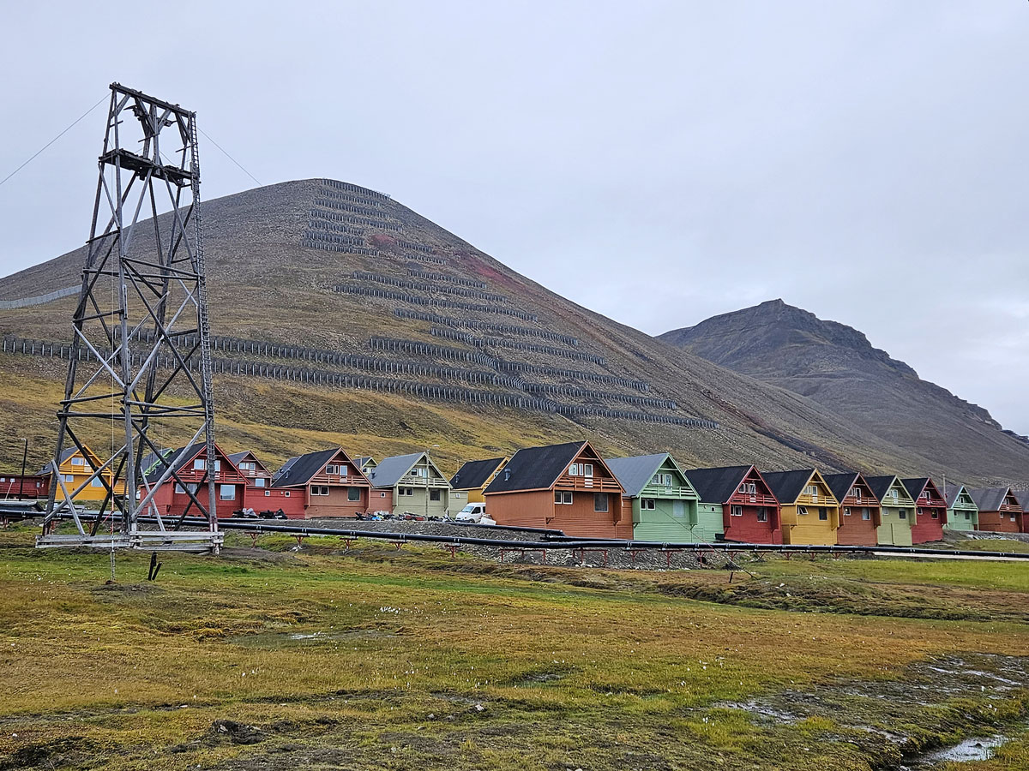

Protection measures in Lia.

Photo: Eva Therese Jenssen, Governor of Svalbard

### The Total Preparedness Commission

In June 2023, the Total Preparedness Commission submitted Norwegian Official Report (NOU) 2023:17 The time is now – Prepared for an uncertain future to the Minister of Justice and Public Security. The Commission’s report addresses, among other topics, emergency preparedness in Svalbard. In the report, the Commission emphasises various strengths of the emergency preparedness in Svalbard.

The report highlights security of supply as a challenge, and that there is a need to clarify what businesses and suppliers are expected to deliver to Svalbard in a crisis situation. The Commission recommends measures to ensure increased resilience and redundancy in Svalbard in various areas such as electronic communications, water supply and energy sources. In addition, the Commission highlights the limitations of health emergency preparedness in Svalbard in the event of major incidents. The Commission points out the need for guidelines in cases of accidents involving cruise ships.

### Security of supply

Longyearbyen is not connected to a larger, external system for water or energy. This underscores the importance of having adequate local emergency preparedness for critical infrastructure.

Longyearbyen relies on the importation of virtually everything that is used on the archipelago, including food and other consumer goods, medicines, fuel and spare parts. Longyearbyen is thereby vulnerable to supply line disruptions. The Governor of Svalbard has established plans regarding security of supply.

By virtue of authority as county governor, the Governor of Svalbard has the coordinating responsibility for public safety and emergency preparedness in Svalbard. This includes security of supply for energy. In March 2024, the Governor of Svalbard requested assistance from the Norwegian Armed Forces via the Norwegian Directorate for Civil Protection in implementing measures that would improve the redundancy of energy supply in Longyearbyen in the short-term. The Governor of Svalbard requested assistance following a comprehensive assessment, whereby it was determined that there was a need to quickly improve security of energy supply. Throughout the process, Longyearbyen maintained sufficient energy capacity. However, it was determined that there was a need to enhance the reserve capacity.

The Norwegian Armed Forces was the authority that could most rapidly deliver compatible generators to Svalbard. It is established customary practice that the Norwegian Armed Forces can assist in incidents in Svalbard, and the Norwegian Armed Forces carried out a civilian mission using a C-17 Globemaster aircraft. The Norwegian Armed Forces provided generators to the local community in Longyearbyen and provided the necessary personnel for connection and training. To increase the redundancy of energy supply in the longer term, two former mining generators belonging to Store Norske Spitsbergen Kulkompani, which Svalbard Energi has been authorised to use, were integrated into the Longyearbyen energy system. The incident illustrates the overall impact of total preparedness in Norway, where resources from the mainland were rapidly transported to, and installed in, Svalbard, and where locally-available resources were gradually phased in.



C-17 Globemaster at Svalbard Airport, Longyearbyen.

Photo: Stein Olav Bredli, The Governor’s office

## Shipping, maritime safety and emergency response against acute pollution

### General information about maritime activity and navigation in the Arctic

Maritime activity and navigation in the waters around Svalbard has increased in recent years. This type of maritime activity entails specific operational challenges, while the geographical area where the activity takes place encompasses significant natural values vulnerable to impact. The location of the archipelago and its climatic conditions pose challenges to maritime safety and emergency preparedness around the archipelago. In order to ensure sustainable development in the High North and to prevent accidents and harmful discharges, it is important that maritime activity operates with high safety and environmental standards, and that the legislation is adapted to the prevailing conditions. Measures to prevent accidents include requirements for ships and crews, maritime infrastructure, traffic monitoring and services such as the pilot service. In addition, it is important to be prepared in the event of an accident.

Compulsory pilotage

Compulsory pilotage in Svalbard applies within the baseline and generally to vessels of 70 metres in length or more, but with a lower limit of 50 metres for passenger vessels and vessels carrying hazardous and polluting cargo. The Norwegian Coastal Administration has its own pilot station in Longyearbyen, which is staffed by pilots from the Troms and Finnmark pilot crews. The pilot boat is operated by the Port of Longyearbyen.

Lighthouses and beacons

Lighthouses and beacons are visual or radar-based devices used for position tracking and safe navigation along coastlines. The Norwegian Coastal Administration and the Norwegian Polar Institute cooperate on the operation and maintenance of navigational aids in Svalbard. The extent of the marking is concentrated around the areas with most maritime activity. The establishment of virtual navigational aids is being assessed and is viewed in the context of the development of other maritime safety measures in Svalbard.

### Legislation

The 1982 United Nations Convention on the Law of the Sea forms the legal framework for the use of the sea. As with maritime activity in other waters, shipping in polar waters is covered by international conventions laid down by the International Maritime Organization (IMO), a specialised agency of the United Nations. The Polar Code was adopted by the IMO in 2014 and entered into force on 1 January 2017. It contains globally binding rules for ships operating in polar waters. The Polar Code consists of two parts: a safety part and a pollution prevention part.

The code sets specific requirements for ship design and construction, equipment, operation, protection of the marine environment, navigation and crew certification. The most important environmental requirements concern discharges of oil, chemicals, sewage and litter.

One significant contribution to regulating and facilitating safe maritime traffic around Svalbard has been the adoption of the same legal framework for maritime safety that applies to the mainland. For Norwegian ships, the Act of 16 February 2007 No.9 relating to ship safety (the Ship Safety Act) applies regardless of where they are located. The Ship Safety Act applies to all ships, including foreign ships, within the territorial waters of Svalbard, with certain adaptations. According to the legislation, the Norwegian Maritime Directorate has the authority to carry out port state control of foreign-registered ships. The Act of 21 June 2013 No. 102 relating to employment protection, etc. for ship workers (the Ship Labour Act) applies to employees who work on board Norwegian ships, regardless of sailing location, including Svalbard.

On the 7th of June 2019, the Norwegian Maritime Directorate adopted new regulations on the construction, equipping and operation of passenger ships in the territorial waters of Svalbard. The purpose of the rules was to raise the safety level for all passenger ships operating in the territorial waters of Svalbard.

The new Port Act entered into force on 1 January 2020. The Act replaces the 2009 Port Act and the 2014 Pilotage Act, and consists of a section on navigable waters and a section on ports. The Act was made applicable to Svalbard by the Regulation of 12 March 2021 No. 721 relating to ports and navigable waters in Svalbard, with certain adaptations.The Ministry of Trade, Industry and Fisheries, represented by the Norwegian Coastal Administration, is responsible for the management of navigable waters and has the authority to stipulate specific navigation measures such as traffic restrictions.

The International Ship and Port Facility Security (ISPS) Code has been made applicable to Svalbard. There are five port facilities approved for international shipping – four in Longyearbyen and one in Ny-Ålesund.

### Satellite communication and digital information systems

Well-functioning communication systems are a necessary prerequisite for safe navigation and for efficient and safe rescue services and emergency communication. However, existing satellite communication systems have little or no coverage north of the 75° N latitude. It is important to establish good communication solutions for the seas of the High North.

The Automatic Identification System (AIS) is an automatic identification system that contributes to enhancing the safety of ships and the environment and improving traffic monitoring and maritime traffic services. There are 21 AIS base stations in Svalbard, providing an overview of maritime traffic in most of the fjords, along the coast and extending out to a distance of about 100 kilometres. Further from the coast, maritime traffic is monitored using satellites with AIS receivers. The Norwegian Coastal Administration publishes traffic information from Svalbard. The information is available to all maritime authorities, fisheries authorities and border control authorities.

ArcticInfo is a service specifically aimed at fishing boats, cruise traffic and research and expedition vessels, which dominate traffic in Arctic areas. The service contributes to providing seafarers with information about sailing conditions in Arctic waters and offers a range of services that are important for safety, accessibility and the environment in the Arctic. ArcticInfo is developed by BarentsWatch.

The Iridium SafetyCast satellite service has been operational since 2021. The service ensures that vessels travelling in polar regions receive emergency and safety alerts.

### Reference routes and maritime security in Svalbard

A reference route is a quality-assured and recommended route from the Norwegian Coastal Administration, containing information relevant to the voyage, providing support for the vessels’ route planning. The Norwegian Coastal Administration has prepared 22 reference routes for maritime traffic in Svalbard, which have now been made available to shipping.

### Emergency preparedness against acute pollution

The Svalbard Environmental Protection Act stipulates that anyone engaged in activity in Svalbard has a duty to prevent acute pollution and to ensure that measures are taken if pollution occurs. The Norwegian Environment Agency sets requirements for the emergency preparedness of businesses in Svalbard. The Norwegian Coastal Administration is the supervisory authority and may delegate this authority to the Governor of Svalbard. Acute pollution is included in the Governor of Svalbard’s risk and vulnerability analysis for 2022–2026. A ban on heavy fuel oil has been introduced for ships calling at the territorial waters around Svalbard, see section 3.4.

In 2022, the Norwegian Coastal Administration conducted an environmental risk and preparedness analysis for all of Norway. The analysis indicates that the response time to incidents in Svalbard can be long and that access to resources is limited. Therefore, the Norwegian Coastal Administration has expanded its emergency response capacity by entering into agreements with four new vessels for coastal preparedness located in Longyearbyen.

## NOU 2022: Cruise traffic in Norwegian waters and adjacent sea areas

In February 2022, the Cruise Committee submitted the report NOU 2022: Cruise traffic in Norwegian waters and adjacent sea areas to the Minister of Justice and Public Security. The Committee concluded that it is not possible to scale the emergency preparedness and response system for an incident involving a cruise ship with several thousand passengers on board. The report focused primarily on probability-reducing measures to reduce the risks of cruise activity, as well as measures to strengthen existing emergency preparedness. The consequence-reducing recommendations regarding reducing the consequences of potential incidents are aimed at improving the quality of the existing emergency preparedness and management where appropriate. Some of the recommendations of the Committee relate specifically to maritime safety in Svalbard. The report states that there are limited rescue resources available locally, and that an incident involving a cruise ship in the waters around Svalbard could have major consequences.



Cruise ship in Adventfjorden near Longyearbyen.

Photo: Tommy Dahl Markussen

Limiting the number of cruise ships and the number of people on board cruise ships

A majority of the Committee members recommended introducing a limit of 500–750 people on board cruise ships in the territorial waters of Svalbard. The majority of the Committee members noted that regulating the number of people on board is necessary from an emergency preparedness perspective, due to the aforementioned capacity limitations in emergency preparedness.

A considerable regulatory effort for Svalbard was initiated in 2020, in part in order to ensure that the relevant legislation contributes to limiting the adverse environmental impact of traffic and improving the safety of persons travelling in the field. The proposed amendments are not intended to limit the number of tourists that may visit Svalbard, but rather regulate where and how access and passage can take place.

Cruise activity on aggregate is increasing, putting pressure on the environment, emergency preparedness and infrastructure. It is therefore necessary to assess the extent of this activity. The Government will introduce a limit on the number of persons on board cruise ships in the territorial waters around Svalbard. The Government will additionally consider limiting the number of cruise ships in the territorial waters around Svalbard. It will be further investigated how such regulations can be designed. and the tourism industry will be consulted.

Risk assessment guide and sailing in close proximity

The Cruise Committee recommends developing a risk assessment guide for the cruise industry, and that the authorities should encourage the cruise industry to cooperate with other vessels to sail in close enough proximity to one another in order to provide aid when sailing in areas with a long response time for rescue resources.

As a coastal and port state, it is important for Norway that risk assessments are carried out based on the most up-to-date information possible on risk conditions specific to Norwegian waters. Furthermore, an encouragement from the authorities to the cruise industry to sail in close proximity to each other could be a risk-reducing measure to alleviate limitations in expected assistance from emergency resources. This is particularly true for shipping companies aiming to offer tours in very remote areas or in shoulder seasons with little other traffic.

The Ministry of Trade, Industry and Fisheries has commissioned the Norwegian Maritime Authority to prepare a risk assessment guide for the cruise industry. The guide shall encourage the cruise industry to partner with other vessels on sailing in close enough proximity in areas with a long response time for rescue resources.

Moreover, the guide shall emphasise that cruise ships have limitations as rescue vessels, and that in certain situations they risk endangering their own ship and those on board by providing assistance to a casualty. The guide will be prepared as a collaboration between the Norwegian Coastal Administration, the Joint Rescue Coordination Centres, the Governor of Svalbard and relevant industry actors.

The Norwegian Civil Defence

The Cruise Committee recommends that the Norwegian Civil Defence be given the opportunity and resources to provide assistance in Svalbard in the event of serious incidents. The Norwegian Directorate for Civil Protection has been commissioned to commence work on establishing the Norwegian Civil Defence as a reinforcement resource in Svalbard.This includes pre-stocking equipment for the Norwegian Civil Defence in Svalbard, as well as entering into an agreement with a civil defence unit on the mainland to assist as a reinforcement resource in Svalbard in the event of serious incidents.

Competence building

The Cruise Committee recommends that the Norwegian authorities should require all deck and engineer officers on passenger ships operating in Svalbard to have basic qualifications and adapted courses based on the Polar Code.

Operating ships in polar waters poses special operational challenges for both ship and crew. The competence of seafarers is a key element in ensuring good maritime safety and reducing the likelihood of adverse events at sea. Therefore, it is important to work on general competence building for all actors operating in polar waters.

Ships with a certificate for international voyages are required to have a Polar Ship Certificate, and deck officers certified in accordance with the Polar Code are already required to take basic courses based on the Code. Currently, ships over 24 meters in length but with a gross tonnage of less than 500 that transport up to 12 passengers in Svalbard are not subject to certification. The Ministry of Trade, Industry and Fisheries has commissioned the Norwegian Maritime Authority to make the necessary regulatory amendments so that such ships are also subject to the requirements for basic courses based on the Polar Code.

The Ministry of Trade, Industry and Fisheries considers the existing basic training programme for engineer officers to provide sufficient training and competence in handling technical equipment exposed to low temperatures.

The Cruise Committee further recommends that Norwegian authorities, in cooperation with the cruise industry, establish requirements for employees on board who play a key role in connection with evacuation from passenger ships operating in Svalbard to have completed a supplementary course in passenger and crisis management with a focus on the challenges in polar waters.

The current international regulatory framework does not adequately cover training in handling additional risks that may arise in connection with crisis management in polar waters. The Government aims to strengthen the competence of seafarers in crisis management on passenger vessels operating within the entire scope of the Polar Code, and will therefore work to establish global, binding requirements through the IMO’s ongoing revision of the International Convention on Standards of Training, Certification and Watchkeeping for Seafarers (STCW).

Hydrographic surveying and nautical charts

The Cruise Committee recommends strengthening the Norwegian Mapping Authority’s capacity for work on nautical mapping and nautical chart production. In the period since the last report to the Storting on Svalbard was presented, there has been an increase in hydrographic surveying around Svalbard. No hydrographic surveys were carried out in 2020 or 2023 due to COVID-19 and maintenance of the Norwegian Mapping Authority’s ships respectively. Surveys from 2017 to 2023 have totalled 8,286 square kilometres. The Norwegian Mapping Authority is working on the Nautilus IT project, which will improve the capacity for producing nautical charts and distributing collected data. This will benefit the waters around Svalbard by shortening the time it takes from surveys are conducted until the data can be utilised.

Aviation safety level

The Arctic climate increases the aviation safety risk in Svalbard compared to similar operations on the mainland. At present, Svalbard Airport has a local aerodrome flight information service (AFIS officers) but no air traffic control service (air traffic controllers). The Regulation on additional requirements for air transport operations in Svalbard and other polar regions imposes a number of additional requirements for flight operations internally in Svalbard, both in the form of additional training requirements for the crew and special equipment requirements pertaining to the aircraft. Meteorological specialists are also stationed at Svalbard Airport.

Svalbard Airport is a Class C Airport, which allows the Norwegian Civil Aviation Authority to set special requirements for routes, areas or airports based on specific conditions. The Norwegian Civil Aviation Authority notes a slight increase in reported aviation safety incidents in Svalbard in recent years. However, the overall figures are few, and it cannot readily be concluded that the increase reflects a trend.

## Measures

* Follow up various risk and vulnerability analyses for Svalbard together with the Governor of Svalbard, Longyearbyen Community Council and other relevant actors.
* Finalise the commenced avalanche protection measures in Longyearbyen.
* Transfer local avalanche warnings in Longyearbyen to Longyearbyen Community Council in the long term.
* Facilitate the gradual development of control of movement of goods in Svalbard, and present any proposals for regulatory amendments for consultation.
* Assess how the current system for emergency and preparedness communication in Svalbard can be replaced by a new critical communication network.
* Introduce a limit on the number of persons on board cruise ships in the territorial waters around Svalbard.
* Consider limiting the number of cruise ships in the territorial waters around Svalbard.
* Prepare a risk assessment guide for the cruise industry.
* Introduce a requirement for deck officers on ships over 24 meters in length but with a gross tonnage of less than 500 which transport up to 12 passengers in Svalbard to have completed a basic course based on the Polar Code.
* Work within the framework of the IMO to establish global, binding requirements for refresher courses in passenger and crisis management with a focus on the challenges in polar waters.
* Ensure that priority is given to air traffic at Svalbard Airport that supports the needs of the local population and local business.

# Economic and administrative consequences

The Government will continue to actively use policy instruments in its Svalbard policy and strengthen central government management and national control in Svalbard in line with the development trends described in this report. In the report, the Government has presented various measures which will be considered in connection with the Government’s continued efforts related to Svalbard. Some of the measures represent a continuation and clarification of current principles and practices. Such measures can be covered within the current budget framework. Other measures require budget allocation in order to be implemented. Measures requiring budget allocation will be assessed and, if necessary, proposed in the ordinary budget process, and subsequently discussed in the annual budget propositions. Where measures require legislative or regulatory amendments, these will be investigated and presented for consultation.

## Substantial infrastructure in Svalbard

There are significant national interests related to Svalbard, resulting in a strong national commitment to and involvement in its infrastructure. As discussed in this report, critical infrastructure is a fundamental prerequisite for both activity and residence in Svalbard. The physical infrastructure of Longyearbyen thereby contributes to maintaining Norwegian communities on the archipelago.

Longyearbyen Community Council is responsible for infrastructure in Longyearbyen that is not assigned to the State or other actors. In many cases, major investments in Svalbard can be more costly than similar investments on the mainland, as different conditions apply to infrastructure in an arctic archipelago involving vast distances. Furthermore, the population of Longyearbyen is relatively small, meaning that there are fewer users to share the investment cost in cases where all or part of the costs are to be charged to the users.

Much of the infrastructure in Longyearbyen was built in the 1950s, ‘60s and ‘70s, intended for a different era, a different community and different use and utilisation than is currently the case. Parts of the infrastructure are beginning to show signs of wear and tear or maintenance backlog as a result of their relatively long service life, which is exacerbated by climate change, including permafrost thaw. In many cases, rehabilitating buildings and infrastructure can be nearly as costly as new construction.

The Government does not want to facilitate growth in Longyearbyen that would trigger new needs for major infrastructure investments. In the short and medium term, however, it is likely that investments will be required in order to maintain the level of current infrastructure. This may, for example, apply to the energy supply, drinking water supply, roads, water supply and sewerage, housing stock and the fibre-optic cable connection to the mainland. Investment needs for various infrastructure components may overlap in time, partly due to the fact that much of the existing infrastructure was established around the same time.

The cost of energy production has increased as a result of the transition from coal to diesel. In the updated 2023 budget, the Storting increased its allocation to Longyearbyen Community Council by NOK 50 million, based on a proposal from the Government, to contribute to reducing energy prices in Longyearbyen. In the Revised National Budget for 2024, the Government proposed allocating an additional NOK 125 million in order to contribute to reduced energy prices in Longyearbyen, as well as NOK 42 million for investments in infrastructure that strengthen redundancy and security of supply for energy in Longyearbyen. At the same time, the Government proposed allocating NOK 3 million for state co-financing of a preliminary project to establish a reserve drinking water source in Longyearbyen.

The Government will continue to assess the need for investments in critical infrastructure in Longyearbyen, including matters of financing.

## Measures with limited or no budgetary consequences

In order to support the objectives of Svalbard policy, the Government is proposing measures to contribute to maintaining Norwegian communities on the archipelago. The housing policy principles outlined in this report will bolster housing policy as an instrument to steer development in Longyearbyen in the desired direction.

The strong national commitment to, among other things, state ownership of important infrastructure in Svalbard facilitates long-term planning and development of the archipelago in line with the objectives of Svalbard policy. This report provides instructions for the use of publicly owned infrastructure such as airports and ports, to ensure that their use supports the objectives of Svalbard policy.

The Government will establish a separate Svalbard Research Office to provide clearer Norwegian research leadership in Svalbard within the current budget framework and facilitate UNIS’ role as the sole provider of higher education in Svalbard. Research in Svalbard will continue to be based on Svalbard’s natural advantages and established communities. The established strategies for research and higher education in Svalbard and the research strategy for Ny-Ålesund Research Station will be maintained.

The Government will ensure that decisions concerning education, welfare and services are in line with the Svalbard policy framework, and will investigate proposals for regulatory amendments.

## Substantial measures already initiated

The Government will prioritise completing the commenced avalanche protection of Longyearbyen centre.

Identity control and control of movement of goods were introduced in Svalbard in 2022. The Government will continue to implement and develop identity control and control of movement of goods in Svalbard, based on acquired experience since the introduction.

The Government has commissioned Store Norske Spitsbergen Kulkompani AS (SNSK) to carry out a concept selection study of various alternatives for power supply in Longyearbyen and a condition assessment of existing infrastructure, including finance requirements. The Government’s intention is for the State to take greater responsibility for power supply in Longyearbyen, e.g., through SNSK, and that responsibility for power supply be clarified as soon as possible.

## Other measures

In this report, the Government proposes that measures in various domains be investigated further, including in the form of legislative or regulatory proposals. The economic and administrative consequences of the proposals for the central government and local authorities, the business sector and private individuals will be assessed in greater detail as part of this investigation. The economic consequences of the proposals will have to be managed within the existing budget framework, or in the ordinary budget process.

The proportion of Norwegian citizens in Longyearbyen has declined since the last report to the Storting on Svalbard was presented. To support the objective of maintaining Norwegian communities on the archipelago, the Government will introduce incentives that make it more attractive for Norwegians to move to and reside in Svalbard. At the same time, the Government will consider measures to reduce the pressure on the provision of social- and other services in Longyearbyen. Any measures will be managed in the ordinary budget process.

The Government will present a bill to make the General Application Act applicable to Svalbard. The Government will continue its work on assessing whether there is a need for further regulation of salary- and working conditions in Svalbard, and will investigate the regulation of public contractors’ requirements for salary- and working conditions.

The Government recognises the need for tourists in Svalbard to provide a greater contribution to funding infrastructure and other public services that are a prerequisite for tourism in Longyearbyen, and it will prepare a proposal for regulations on visitor fees for Svalbard. The economic and administrative consequences will be investigated as part of this proposal. Part of the revenue from visitor fees will be allocated to Longyearbyen Community Council.

The increase in maritime activity around Svalbard presents challenges for public safety and emergency preparedness. The Government will introduce a limit on the number of passengers on board cruise ships in the territorial sea around Svalbard and consider limiting the number of cruise ships sailing in those waters. The economic and administrative consequences will be investigated as part of this proposal.

Longyearbyen is not connected to larger systems for power and water supply, and robust local supply systems are therefore particularly important. The Government will consider measures to follow up the recommendations of the Total Preparedness Commission, including measures related to security of supply in Svalbard. This includes assessments of the future organisation of power and water supply with the possible establishment of a reserve drinking water source.

The capacity of port infrastructure in Longyearbyen is limited. The Norwegian Coastal Administration will assess current needs before conducting a new assessment of the scope, approach and timeline for a possible government-led port project in Longyearbyen. If it emerges that there is a basis for proceeding with the project, the Norwegian Coastal Administration will be able to propose specific measures as comments for the next report to the Storting on a National Transport Plan.

The Government will work towards ensuring a new, robust, high-capacity fibre-optic cable connection between Svalbard and the mainland to replace the current cable.

The Government aims to transfer the dwellings of Longyearbyen Community Council to the Norwegian Directorate of Public Construction and Property.

All of these proposed measures will have to be managed within the existing budget framework, or in the ordinary budget process.

The Ministry of Justice and Public Security

recommends:

that the recommendation from the Ministry of Justice and Public Security concerning Svalbard dated 31 May 2024 should be submitted to the Storting.

1. Institute of Meteorology, “Warming in Svalbard is exceptional”, 15 June 2022.
2. A collaboration between the Norwegian Meteorological Institute, the Norwegian Water Resources and Energy Directorate, NORCE, the Bjerknes Centre and, since 2023, the Norwegian Mapping Authority.